Effect of focus flood water spreading on recharge in semi-arid climate: case of water spreading weirs in Burkina Faso
Fatoumata KABORE^{1,}*, Philippe ORBAN¹, Aurore DEGRE², Issoufou OUEDRAOGO³, Eric HALLOT⁴, and Serge BROUYERE¹
- Hydrogeology and Environmental Geology, Urban and Environmental Engineering Unit, University of Liege, Quartier Polytech 1, allée de la Decouverte 9, B52, 4000 Liège, Belgium; PO: p.orban@uliege.be
- Faculty of Gembloux Agro-Bio Tech, University de Liège, Gembloux 5030, Belgium; aurore.degre@uliege.be
- Ecole Supérieure d’Ingénierie (ESI), University of Fada N’Gourma, BP 54, Fada N’Gourma, Burkina Faso; ouedraogo.issoufou03@gmail.com
- Scientific Institute for Public Services, 4000 Liège, Belgium; e.hallot@issep.be

*Correspondence: fatoumkabore@gmail.com ; Tel.: 00226 75530147 (FK)
Abstract:
In recent years, water spreading weirs have been implemented on watercourses in West Africa. This study investigates the hydrological impact of water spreading weirs (WSWs) in the semi-arid Wedbila watershed of Burkina Faso, a region challenged by soil degradation and scarce water resources. The study employs an integrated, multidisciplinary approach combining in situ monitoring of surface water levels, soil moisture at multiple depths, and piezometric fluctuations to capture the influence of WSWs on soil water dynamics and aquifer recharge. Comparative analyses between zones impacted by water spreading and control zones provide a robust empirical basis—making this one of the few West African studies to comprehensively combine these measurements in assessing WSW effects on infiltration and groundwater recharge.
Results demonstrate that WSWs significantly enhance soil moisture retention near the surface and notable rises in piezometric levels observed during and after flood events. Correlation analysis of monitored parameters indicated that groundwater recharge is dependent on rainfall distribution, surface water levels, and soil properties.
Using soil water balance, the annual infiltration calculated in the spreading zone was 568 mm, significantly exceeding that observed outside the spreading zone. Cumulative infiltration during spreading periods accounted for 57% of annual infiltration.
This water spreading weirs positive impact demonstrates, contingent upon spreading duration, topography and soil characteristics.
Importantly, the WSWs as a low-cost managed aquifer recharge (MAR) solution suitable for data-poor, semi-arid regions like Burkina Faso. By enhancing the landscape’s capacity to capture scarce and erratic rainfall, WSWs contribute to climate resilience and agricultural productivity in vulnerable rural communities facing increasing water scarcity due to climate change. They serve as a complementary technique for raising the groundwater level when conditions are favorable in Burkina Faso
Keywords: water spreading weirs, effect, aquifer recharge, multidimensional approach, runoff water management, Burkina Faso

- Introduction
In arid regions like the Sahel, where precipitation is limited to a few months annually, rainfall events are typically characterized by high intensity, resulting in exceptional floods that are rapidly drained from watersheds within hours (Dunglas et al., 2020; Karambiri, 2017; Mando et al., 2001; MEEA, 2022; Zougmore et al., 2019). This hydrological regime, combined with climate change (ex : high evapotranspiration rates), restricts water availability for agriculture and domestic use, challenging water resource management and food security. Tomitigate rapid runoff and enhance water storage within watersheds, various techniques have been implemented. These include hydraulic structures such as dams, filter dikes, diversion weirs, and water spreading weirs, all designed to increase available water quantities to meet population needs (MEE, 2001; Saeid Eslamian, 2014; Woessner, 2020). From a hydrological perspective, research confirms that hydraulic structures and related structures contribute to groundwater recharge by increasing infiltration opportunities through prolonged water retention on the surface (Bambara et al., 2020; Boughanmi et al., 2018; Ghazavi et al., 2012; Ghazavi & Ebrahimi, 2018; GIZ, 2012; Hashemi et al., 2013; Heinz et al., 2009; Naghibi et al., 2018, 2020; Pakparvar, 2015; SOGREAH, 2005; Zarkesh, 2005; Mohammed et al.,2022 ), , but the specific contribution of water spreading weirs to aquifer recharge remains relatively understudied and calls for robust integrated assessments combining field measurements and modeling. In Burkina Faso, characterized by low rainfall and water demands reliant on groundwater, which has decreased over the past twenty years, the Ministry of Water has implemented water spreading weirs (WSW) in specific valleys to improve soil fertility, enhance sediment retention, and increase groundwater levels. This is interesting because the locally recharged water could also constitute a complementary resource for irrigation when the surface water reserve is depleted.
Water spreading weirs are small-scale structures consisting of a weir installed on the riverbed with lateral buttresses and wing walls (Figure 1). These structures facilitate water distribution over adjacent land for a limited duration, dependent on the flood hydrograph.
Figure 1: Composition and functioning of a water spreading weir adapted from Heinz Bender (Heinz et al., 2009): a) small floods remain channeled into the riverbed, b) a medium flood overflows and spreads over the low wings, c) a large flood overflows the low and high wings. Non-submerged buttresses protect the banks immediately downstream of the weirs. An exceptional flood may submerge the buttresses.
Several studies have demonstrated beneficial effects of WSWs on soil moisture dynamics, crop yields, and sediment deposition, underscoring their importance for sustainable land and water management in semi-arid regions (Getnet et al., 2022; Mesbah et al., 2016). Water spreading weirs also contribute to upstream sediment retention, mitigating erosion and reducing runoff (GIZ, 2012; Heinz et al., 2009; Ouattara, 2015; Jabar et al., 2023). While WSWs have been used to improve soil moisture and agriculture, their role in enhancing groundwater recharge remains underexplored, especially in West Africa. A main investigation conducted by GIZ ( 2012) compared piezometric levels in wells before and after weirs implementation, revealing a rise in the water table post-construction. However, this comparative approach did not allow for quantification of recharge associated with the rising water table, nor did it determine the extent to which this water spreading weir-induced water storage constituted a potentially mobilizable resource.
The literature presents various approaches for estimating floodwater recharge (Mohammed et al., 2023; Allison et al., 1994; Besbes, 2006; Gee & Hillel, 1988; Healy, 2010; HUET, 2015; King et al., 2017; Mare et al., 2006; Min et al., 2015; Nazoumou & Besbes, 2001; Scanlon et al., 2002). Most researchers advocate for combining multiple proposed methods, which are summarized in Table 1.
Table 1: Recharge estimation methods
Methods | Recharge estimation approach | References
Water balances | use of hydrometric and meteorological data | (Allison, 1988; de Vries & Simmers, 2002; Woessner, 2020)
Piezometric fluctuation | analysis of water table variation data | (Dahan et al., 2008; Heinz et al., 2009; M Nassri & Farhat, 2016; Morin et al., 2009)
Hydrochemistry and isotopy | analysis of the chemical and isotopic composition of water | (Scanlon et al., 2002)
Darcy law | Application of Darcy's law based on soil parameters | (Besbes, 2006; Boughanmi et al., 2018; Scanlon et al., 2002)
Numerical models | Numerical simulation of data to reproduce observations | (Dassargues, 2020)

By advancing knowledge on the role of water spreading weirs in semi-arid in water cycle processes, this study supports sustainable water resource management and agricultural resilience in increasingly climate-stressed environments. WSWs contribute directly to climate resilience by enhancing the capacity of landscapes to capture and store scarce and erratic rainfall, thus buffering communities against the adverse impacts of droughts and extreme rainfall variability. Furthermore, WSWs exemplify a nature-based, low-cost technology that aligns with integrated water resources management principles, fostering the sustainable use and equitable distribution of water resources while mitigating land degradation (GIZ, 2012; Ouattara, 2015). This makes them a vital component of climate adaptation strategies in semi-arid regions facing growing water scarcity challenges under global climate change.
This research aims to fill existing knowledge gaps by developing and implementing a comprehensive methodology to evaluate the hydrological impacts of WSWs in the semi-arid Wedbila watershed in Burkina Faso. The study focuses on:
- Assessing the influence of water spreading by WSWs on soil moisture dynamics and groundwater recharge through monitoring of surface water levels, soil water content at multiple depths, and piezometric fluctuations, with comparative analysis between spreading and control zones.
- Quantifying infiltration linked to these structures using a soil water balance approach and estimating their contribution to groundwater recharge at the watershed scale.
By providing a deeper understanding of water spreading weirs’ role in semi-arid hydrology, this study aims also to inform sustainable water resource management and boost climate resilience for vulnerable agricultural communities.

- Description of study zone
  - Description of Wedbila watershed
The study area is located in Burkina Faso, within the Centre-South region (municipality of Sapone), specifically in the Wedbila watershed (Figure 2). The Wedbila watershed encompasses an area of 148 Km² (Ouattara, 2015), with its outlet situated in the village of Koubri at UTM coordinates 672,432.79 E and 1,343,482.94 N. The climate is characterized as semi-arid Sudano-Sahelian, featuring a distinct dry season from October to April and a rainy season from May to September. According to the National Meteorological Agency isohyet map, the average annual precipitation in the basin ranges between 600 and 800 mm. The climate is hot and arid, with temperatures ranging from 17°C to 44°C, with average range 28 °C to 30 °C the last ten years.
The hydrographic network is dense, with surface water flowing predominantly from south to northeast across the basin. The topography is relatively flat, with elevations varying between 285 m and 340 m. The basin contains four upstream dams: Yansaré, Gana, Seloghin, and Pissy.
Geologically, the basin is composed of Precambrian rocks, primarily granitoids. Gravimetric and magnetic measurements surveys reveal a network of multiple discontinuous fractures throughout the basin (Nakolendousse, 1991). The predominant soil types are eutrophic, ferruginous, hydromorphic and lithosols on bedrock (Sawadogo, 2019).
The hydrogeology is typical of fractured crystalline environments (Savadogo, 1984), characterized by two aquifers: a shallow aquifer in the weathered zone and a deeper aquifer developed within the fracture network of the crystalline basement. The Wedbila basin shows a sparsely fractured subsurface with a northwest-northeast orientation of the lineaments. The depth of the static water table during the high water period is approximately 2 meters relative to the natural ground level, and the fracture aquifer is located at 21 meters depth. The drinking water supply boreholes are tapped at depths greater than 60 meters, whereas the water table is at 7 meters depth. The hydraulic conductivity is on the order of 10⁻⁷, with a storage coefficient on the order of 10⁻⁴. Deep wells in the area exhibit low production rates, ranging from 0.5 to 20 m³/h (YONI, 2018). Groundwater flows generally mirror the surface water pattern, moving from south to northeast.
Figure 2: Location and geology of the Wedbila basin in Burkina Faso with Africa image take on the net (https://fr.dreamstime.com/r%C3%A9gion-l-afrique-ouest-carte-politique-image109655890).
  - Estimated recharge in the watershed
The Thornthwaite (1948) method is employed to calculate recharge in the basin, using the following water balance equation:
$$P=ETR+∆S+R_{off}+R$$
Where,
P: precipitation (mm)
ETR: actual evapotranspiration (mm)
ΔS: change in soil water storage (mm)
R_{off}: runoff (mm)
R: recharge (mm)
Precipitation data are obtained by the arithmetically average of three meteorological stations located around. Monthly soil water storage is determined based on maximum average storage. The maximum water storage capacity is estimated at 189 mm on average (Supplementary material, table 1), based on soils classification in the basin (Jippe, 2002). The soil water storage is assumed to be at its maximum in July (Dembele & Some, 1991).
Potential evapotranspiration (PET) is calculated using the Penmann-Montheith method recommended by FAO (Allen et al., 2006), with daily values ranging from 2 to 10 mm. Meteorological data required for PET calculations (relative humidity, wind speed, temperature, atmospheric pressure) were obtained from the National Meteorology Agency at the Ouagadougou weather station. Monthly PET is derived by summing daily values.
Actual monthly evapotranspiration ETR is estimated using Thornthwaite's method, considering rainfall, PET and soil water storage.
Runoff is calculated from measurements did in Nariaré area with approximation and represents 6% of rainfall (DGRE, 2022), which is typical for semi-arid zones with silty to clay soils (Mahe et al., 2010).
The average annual recharge over the past decade is finally estimated to 83.9 mm (Supplementary material, table 2). Such values are consistent with other recharge estimates for the Nakambé watershed (Bambara et al., 2020; Koïta et al., 2018; Ouandaogo-Yameogo et al., 2013; Soro, 2017) and other arid and semiarid regions (Bethune et al., 2008; Bonn et al., 2009; Coes & Pool, 2005; Hamdi et al., 2015; Mutin & Soeiro, 1969; Pakparvar et al., 2017; Pool, 2005; Shanafield & Cook, 2014; Stephens et al., 1988). Notably, the 2021-2022 hydrological year exhibited higher recharge (247.7 mm), more closely aligning with values observed in sedimentary zones (Chenini & Ben Mammou, 2010; Dakoure, 2003; de Condappa, 2005; Kouamé et al., 2005; Kouanda, 2019; Koussoube, 2010; Sauret, 2013). This elevated recharge can be attributed to increased precipitation and soil characteristics.
  - Description of the experimental site
Two water spreading weirs were constructed on the primary tributary of the Wedbila watershed. Weir 1 is situated at UTM coordinates 669,846.83 E and 1,341,147.73 N, while Weir 2 is positioned upstream of weir 1 at UTM coordinates 669,294.61 E and 1,339,897.02 N. The subsequent description focuses on the specific characteristics of the spreading area, which encompasses a maximum surface area of 80 ha (Figure 3) covered the two weirs, and the downstream region of these weirs. The elevation gradient ranges from 312 m upstream at weir 2 to 308 m downstream at weir 1.
Figure 3: Location of weirs and spreading zone in the Wedbila basin
Within the spreading area, the river exhibits intermittent flow characteristics and extends approximately 2.7 km in length. Land use patterns in the spreading zone vary, with rice cultivation predominating upstream of weir 2. The area between weirs 1 and 2, is primarily dedicated to sorghum and millet production during the rainy season. To facilitate comprehensive characterization of the experimental site, a monitoring system has been implemented.
- Soil and aquifer monitoring system for physical and hydrodynamic characteristics
To evaluate the impact of water spreading weir on groundwater recharge, a comprehensive measurement and monitoring system was implemented (Figure 4) for surface water levels, soil water contents and piezometric levels from September 2020 to January 2024. The 2021-2022 hydrological year was selected for detailed analysis due to its comprehensive dataset, allowing for a thorough assessment of the water spreading weirs’ effects.
The monitoring system includes 23 micro-piezometers for measuring groundwater levels, 2 surface water gauging stations and 4 soil moisture probes. The soil moisture probes are strategically placed upstream of weir 2, between weirs 1 and 2, immediately upstream of weir 1 and downstream of both weirs.
Soils were excavated adjacent to the micro-piezometers and used to describe soil profile texture and structure, and to collect samples for laboratory analysis of physical properties. Saturated hydraulic conductivity is measured in situ on the same soil at different depth.
This multi-faceted approach allows for a comprehensive evaluation of the soil-water dynamics in response to the water spreading weirs.
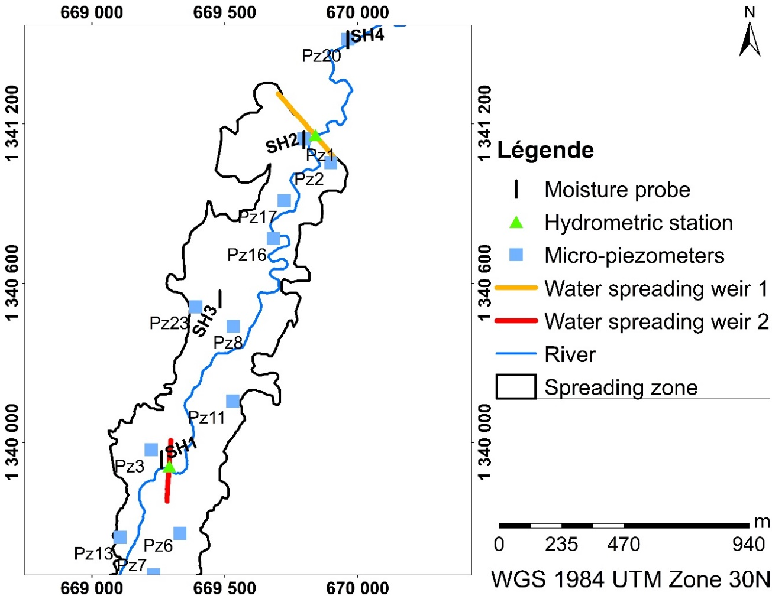a)
b)
Figure 4: Illustration of the comprehensive monitoring setup: a) Measurement system and b) schematic cross-section of monitoring equipment installation
  - Surface water level monitoring
The surface water levels were monitored using Diver pressiometric probes, with measurements recorded at hourly intervals. A single probe was installed in the riverbed at each weir location. Due to the intermittent nature of the river flow, the probes were removed from mid-November until the subsequent rainy season in May.
During the 2021–2022 hydrological year, above-average precipitation was recorded, with the watershed receiving a total rainfall of 1051 mm. Statistical analysis of rainfall data indicated a standard deviation of 8.31 mm, reflecting significant variability. Surface water levels exhibited considerable fluctuations throughout the year, with an average level standard deviation of 38.14, highlighting the dynamic nature of the river system in response to precipitation inputs.
Analysis of surface water level fluctuations throughout the 2021-2022 hydrological year revealed nine distinct spreading episodes (Figure 5). Each spreading episode exhibited unique characteristics in terms of the maximum water level reached and duration of spreading.
September experienced the highest frequency of flooding events, with five consecutive episodes observed. Two additional spreading episodes were observed on April 16, 2022, and May 23, 2022. However automatic probe measurements were not available for these events, precluding detailed analysis.
The Pearson correlation coefficient calculated between rainfall and surface water level was 0.315, indicating a moderate positive linear relationship. This suggests that increases in rainfall generally correspond to increases in surface water levels, although other hydrological factors also influence these dynamics.
This high-resolution monitoring approach provides critical data for understanding the temporal dynamics of water spreading events and their implications for groundwater recharge associated with to the installed weirs. The observed variability among spreading episodes underscores the complexity of surface water evolution driven by climatic and hydrological conditions.
Figure 5: Temporal variation of surface water levels and identified spreading episodes during the 2021-2022 hydrological year
  - Soil profiles analysis
Soil profiles were excavated adjacent to moisture probes and micro-piezometers within the spreading zone and downstream areas, revealing numerous pores and soil cracks. Twenty-four soil samples from various depths were collected and analyzed at the National Office of Soils (BUNASOLS) in Burkina Faso. The following parameters were determined:
- Real density is determined by using particle liquid volume method, and values range from 2.19 to 2.77
- Bulk density is measured by the oven-drying method at 105° C. Values range from 1.35 to 1.41.
- Porosity: calculated from dry and true densities, ranging from 36.89% to 47.46%
- Saturated hydraulic conductivity: determined using the Muntz double ring permeameter method. Data monitored were analyzed using a “Minitab” program developed by the International Institute for Water and the Environment (2IE). Values range from 3.3 x 10⁻⁸ m/s to 5.5 x 10⁻⁵ m/s. These values are consistent with silty-clay soils exhibiting moderate water permeability, aligning with findings from similar soil conditions in other studies (Bruand et al., 1996; Farooq et al., 2019; Fu et al., 2021; Khaledian et al., 2017).
- Field capacity: determined using the porous porcelain press method at 250 kPa and range from 18.23 to 31.34%.
- Wilting point: determined with the 1500 kPa membrane press and range from 7.58 to 18.52%. These humidities align with FAO estimates for similar soil types.
- Particle Size Distribution: analyzed using the pipetting and sieving method for five fractions. According to the USDA system classification, soils are categorized as fine silty to silty clay (Figure 7).
Figure 7: Soil texture classification based on particle size distribution analysis at the experimental site.
  - Soil water content measurement and infiltration dynamics
    - Implementation
Soil water contents were measured using Sentek's Drill & Drop moisture probes. These multi-level probes employ “frequency-domain-reflectrometry (FDR)” capacitive technology. The probes feature a conical spiral design, facilitating insertion into the soil through coring. Each probe is equipped with 12 sensors that measure water content at 10 cm intervals, spanning a total depth of 120 cm. Measurements were taken at the 10 cm depth intervals from [0-10 cm] to [110-120 cm]. Water content was recorded with an accuracy of ± 0.03% and a resolution of 1/10000, at 6-hour intervals.
Temporal water content profiles were plotted for each depth. Analysis of the 12 measured depths revealed different horizons. Horizon delineation was based on similarities in water content curves. The identified horizons are upper horizon (0-50 cm), intermediate horizon (50-80 cm) and lower horizon (80-120 cm).
    - Soil moisture response
The infiltration process in the unsaturated zone was analyzed based on water content measurements at various depths, with particular focus on periods of water spreading.
Statistical analysis of soil moisture data revealed that the volumetric water content at PZ20 and PZ3 exhibited low variability throughout the measuring period, as indicated by their standard deviations of 0.062 and 0.063, respectively. These low standard deviations reflect relatively stable moisture conditions within these soil zones.
Pearson correlation analysis further demonstrated distinct relationships between precipitation and soil moisture dynamics: the correlation coefficient between rainfall and water content at PZ20 was -0.070, indicating a negligible negative linear association but the correlation coefficient between surface water levell and water content at PZ20 was 0.42 and indicating a moderate correlation. In contrast, a strong positive correlation (r = 0.878) was found between surface water level and water content at PZ3, suggesting that fluctuations observed in the hydrograph closely track soil moisture variations.
The confidence interval of wter content at spreading zone is 0.00008, and 0.0002 at no spreading zone further confirms the reliability and precision of these measurements.

Analysis of Figure 8 reveals the following:
- The dry season, which extended from November 2021 to March 2022, was characterized by a decrease in soil water content for all soil horizons. During this period, the water content fell below the wilting point, both within and outside the spreading zone. Soil water content exceeding field capacity (FC) indicates the onset of percolation to the aquifer.
- The upper horizon (0-50 cm) exhibits rapid response to rainfall events. It displays variable water content, especially in the 0-10 cm layer, indicating sensitivity to meteorological parameters. Soil saturation is achieved from August to late September, followed by desaturation from October. This horizon also shows great water content variations upstream of the water spreading weirs compared to downstream.
- The intermediate horizon (50-80 cm) is characterized by abrupt saturation and desaturation patterns. The rapid desaturation post-saturation may be attributed to evaporative recovery, deep percolation, or field capacity. It reaches full saturation in August, maintaining constant levels until late September. Demonstrates greater water content variations upstream of the water spreading weirs. The analysis shows that water percolation began in May 2022 upstream, compared to downstream where percolation started in July.
- The lower horizon (80-120 cm) exhibits minimal variations in water content. Consistent behavior observed both within and outside the spreading zone.
- During spreading periods, the water contents reach peak levels. The wetting front appears to propagate sequentially through soil horizons, from upper to lower. When horizons are saturated (e.g., due to consistent rainfall from August 2022), the effect of spreading periods becomes less discernible in water content evolution. Upon cessation of spreading, soil water content decreases, leading to desaturation until subsequent rainfall event.
Figure 8: Evolution of water content at various depths in spreading zone (upstream) and outside the spreading zone (downstream)

  - Piezometric fluctuations
Twenty-three micro-piezometers were drilled at the experimental site, with depths ranging from 5 to 12 m. To obtain local estimates of hydraulic conductivity values of the geological formations, slug tests were conducted in micro-piezometers located upstream and downstream of the water spreading weirs, employing both injection and withdrawal methods. Results were analyzed using the Bouwer and Rice solution (Bouwer & Rice, 1976), yielding hydraulic conductivity (K) values ranging from 1 x 10⁻¹⁰ m/s to 2 x 10⁻⁰⁵ m/s (details not presented) with average of 10⁻⁷.
Piezometric levels were monitored at hourly intervals using Diver-type pressiometric probes installed in six micro-piezometers. The remaining 17 micro-piezometers were manually measured monthly using a piezometric probe.
Figure 6 illustrates an example of groundwater level evolution for micro-piezometer PZ3. The groundwater level exhibits an annual cyclic pattern characterized by:
- Initiation of water table rise in June, approximately one month after the onset of the rainy season
- Continued increase in water levels through June and July
- Peak levels observed in August-September
- Decline in water levels beginning mid-October
The Pearson correlation coefficient between soil water content and groundwater level was calculated to be 0.73, indicating a strong positive linear relationship. This suggests that soil moisture variations are closely associated with fluctuations in groundwater level, reflecting hydrological connectivity between soil moisture and groundwater recharge processes at this site.
Conversely, the correlation between rainfall and groundwater depth is weaker (r = 0.25), indicating a modest tendency for groundwater levels to respond to precipitation inputs.
The observed annual cyclicity combined with the spatial and temporal variability of the hydraulic conductivity highlight the complex dynamics governingthe groundwater recharge in this semi-arid environment.
Figure 6: Dynamic fluctuations in groundwater level in micro-piezometer PZ3 upstream of water spreading weirs.
  - Impact of water spreading weirs on groundwater recharge in the experimental zone
Analysis of piezometric levels in micro-piezometers reveals a strong correlation with soil water content, surface water level and precipitation (Figure 9).
Pearson correlation analyses elucidate the strength of linear relationships among the measured variables. Notably, rainfall and hydrograph measurements show a moderate positive correlation (r = 0.315), indicating that increases in precipitation generally correspond to rises in surface water levels, though the relationship is influenced by other hydrological factors. Soil moisture correlates strongly with hydrograph data (r = 0.878), underscoring a close coupling between soil water dynamics and surface water fluctuations, correlation between soil water content and groundwater level was 0.73, indicating a strong positive linear relationship. Conversely, the correlation between rainfall and groundwater depth is weaker for downstream and upstream water spreading weir, indicating a modest tendency for groundwater levels to respond to precipitation inputs. The groundwater rise is possible due to cracks that can extend up to 1 meter in depth."
Soil water content increases over time in conjunction with surface water levels, stabilizing from August onward upon complete soil saturation. These periods of saturation facilitate deeper percolation, contributing to groundwater recharge. This process occurs when plant water requirements are met and soil pores are water-filled, allowing for downward water movement to recharge the aquifer. The magnitude of water table rise is influenced by soil physical characteristics, as well as the presence of cracks and fissures (Hillel, 2003; Shukla, 2023; Asano, 1985; Bachir & Ousmane, 2019; Hillel, 2003; Koïta et al., 2017; Koussoube, 2010; Sakakibara et al., 2017; Savadogo, 1984).
Spreading episodes appear to exert a significant influence on piezometric levels, as evidenced by micro-piezometers PZ11, PZ16, and PZ2, which exhibit higher peaks compared to areas outside the spreading zone (represented by micro-piezometer PZ20). The increase in groundwater levels within the spreading zone is substantially greater than that observed outside the zone. Notably, micro-piezometer PZ20, located outside the spreading zone, does not show a response until August, in contrast to the micro-piezometers within the spreading zone. These latter piezometers react to the spreading episode of July 19, 2022, initiating a rise in groundwater level from that date onward.
This analysis underscores the potential efficacy of water spreading weirs in enhancing groundwater recharge, as evidenced by the differential responses of piezometric levels within and outside the spreading zone. The observed patterns suggest that the weirs facilitate more rapid and pronounced groundwater level increases, particularly in response to specific spreading events.
Figure 9: Temporal evolution of piezometric levels in relation to soil water content, surface water level, and precipitation
- Estimating the contribution of water spreading weirs to groundwater recharge
  - Infiltration estimation
Infiltration was quantified using the soil water balance method, which comprises two primary components (Healy, 2010): a water model for the soil or root zone, estimating the volume of water drained at the base of the root zone or effective soil profile, and a sub-model that transports the drained water to the piezometric surface (Figure 10).
The quantity of drained water which is our prior, considered as infiltration I (Allen et al., 2006; Healy, 2010; Hillel, 2013), is determined using the following equation:
$I=P-{ET}^{uz}-∆S^{uz}-R_{off}$ (Equation 1)
Where:
P : precipitation (mm)
ET^{uz} : actual evapotranspiration in the unsaturated zone (mm)
$∆S^{uz}$: change in soil water storage (mm)
R : runoff (mm)
I : infiltration (mm)
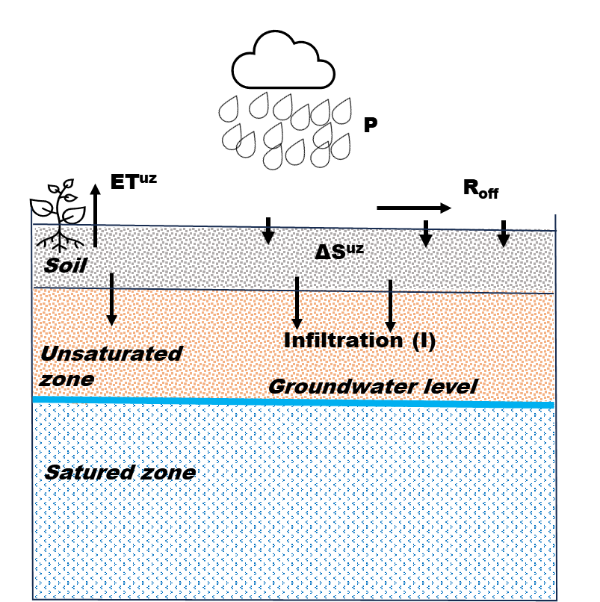
Figure 10: Infiltration model from the unsaturated zone
The different terms of equation 1 were determined following several methods to estimate in fine the infiltration which can reach piezometric level.
    - Precipitation
Daily precipitation (P) data were derived from the arithmetic mean of measurements from three weather stations located in proximity to the study watershed. This daily precipitation is used in equation (1) to determine infiltration. For day with spreading period, to account for the influence of water spreading events, the maximum surface water level (Hmax) attained during spreading episodes was substituted for precipitation in the water balance equation. This modification allows for the consideration of both standing water height and spreading duration. Consequently, the water balance equation (1), for spreading episodes is modified as follows:
$I=H_{max}-{ET}^{uz}-∆S^{uz}-R_{off}$ (Equation 2)
Where:
Hmax: Maximum surface water level reached during spreading (mm)
    - Change in soil water storage
Soil water stock variation is derived from soil water content measurements. The water stock is calculated for the soil profile from 0 to 120 cm depth using the following equation :
$S^{uz}=\int_{z}^{0}{θdz}$ (Equation 3)
Where:
S^{uz}: Soil water stock (mm)
θ: Volumetric water content
z: Depth (cm)
The variation in water stock for a given time step is determined as follows:
${∆S}^{uz}=\left(S_{i}^{uz}-S_{i-1}^{uz}\right)∕\left(t_{i}-t_{i-1}\right)$ (Equation 4)
The temporal evolution of water content facilitates the calculation of daily water stock variations. These variations represent either evapotranspiration or infiltration towards deeper soil horizons.
A positive variation indicates inflow of surface water into the soil. A negative variation indicates an outflow of water, particularly in the absence of rainfall.
Two distinct patterns of positive water stock variation are observed (Figure 11):
- Prior to full soil saturation (April to mid-August), Sharp increases in soil water stock variation coincide with rainfall events, with higher variations during spreading episodes.
- Post soil saturation (from August onwards), water stock variation becomes negligible, regardless of rainfall events or spreading episodes.
Under saturated conditions, the infiltration equation simplifies to:
$I=P-{ET}^{uz}-R_{off}$ (Equation 5)
Calculated stock variations range from -64 mm/d to 188 mm/d in the spreading zone. Water stock variations range from -32 mm/d to 123 mm/d outside the spreading zone. Notably, positive water stock variations in the spreading zone are followed by high negative variations the subsequent day.
Figure 11: Variation in water stock as a function of initial soil condition and rainfall event
    - Evapotranspiration estimation
Evapotranspiration in the unsaturated zone (ET^{uz}) is calculated using reference evapotranspiration (Eto) data obtained via the Penman-Monteith method, as recommended by the FAO(Allen et al., 2006), in conjunction with observed variations in soil water stock.
The calculation follows these criteria:
- When |ΔS^{uz}| > ETo ; ET^{uz} = Eto
- When |ΔS^{uz}| ≤ ETo ; ET^{uz} = |ΔS^{uz}|
Where:
ET^{uz}: Evapotranspiration in the unsaturated zone (mm)
ETo: Reference evapotranspiration (mm)
ΔS^{uz}: Change in soil water stock (mm)
Estimated annual evapotranspiration ET^{uz} is 683 mm within the spreading zone and 704 mm outside the spreading zone. The lower evapotranspiration value within the spreading zone could potentially indicate enhanced water conservation or more efficient water use in this area, which may contribute to increased groundwater recharge. However, further analysis would be required to confirm this hypothesis and understand the underlying mechanisms.
    - Runoff estimation
Runoff (Roff) is calculated using the curve number (CN) method developed by the US Soil Conservation Service. This method considers soil type and land use characteristics (Mishra & Singh, 2003). The runoff equation is as follows:
$R_{off}={\left(P-0.2S\right)}^{2}÷\left(P+0.8S\right)$ (Equation 6)
with
$S=\left(\frac{1000}{CN}-10\right)×25.4$ (Equation 7)
Where
Roff: runoff,
P: precipitation,
S: maximum potential retention after runoff initiation (mm)
CN: curve number.
The Curve Number (CN) is determined using hydrological soil classifications, which categorize soils into four groups as proposed by the National Engineering Handbook (Service, 1972; USDA-NRCS, 2004). These classifications are summarized in Table 2.
Table 2: Curve number for hydrological soil groups and land use on the study site.
Land use | Curve number for hydrologic soil groups
 | A | B | C | D
 | Soils have low runoff potential and high infiltration rates. They consist of sand or deep gravel and have a high hydraulic conductivity rate (greater than 75mm/h). | The soils have moderate infiltration rates and consist of shallow to deep soils with fine to coarse textures. Their hydraulic conductivity is 37.5-75mm/h. | The soils have low infiltration rates and are made up of slightly fine to fine textured soils. Their hydraulic conductivity ranges from 12.5 to 37.5mm/h | With a high runoff potential, they have very low infiltration rates and are composed of clayey soilsHydraulic conductivity is very low, from 0 to 12.5mm/h.
Crops | 64 | 75 | 82 | 85
River | 77 | 86 | 91 | 94
Trees | 45 | 66 | 77 | 83
Pastures | 68 | 79 | 86 | 89

Based on soil characterization in the study area, soils were classified into four hydrological groups. The weighted Curve Number (CN) for soils in the spreading zone, accounting for land use distribution, is estimated at 84 (Supplementary Table 3). For the downstream area of the spreading zone, which is predominantly tree-covered, a CN value of 83 is applied. Estimated runoff in the spreading zone reaches up to 80% of rainfall, with daily values ranging from 0 to 1,143 mm. In contrast, the non-spreading zone exhibits runoff values ranging from 0 to 34.5 mm/day.
    - Estimated infiltration
The Infiltration estimate results from the introduction of all the parameters detailed in equations 1, 2 and 5.
Calculated infiltration rates vary significantly between the spreading zone (0 to 52 mm/day) and non-spreading zone (0 to 22.5 mm/day), as illustrated in Figure 12. These infiltration rates suggest favorable soil characteristics for water infiltration. Peak infiltration values correspond to spreading events and periods when water levels exceed the weir height in the riverbed.
Statistical analysis reveals that the infiltration in the spreading zone variable demonstrates high variability, with a standard deviation of 6.65 mm/day, a maximum (4th quartile) value of 52.17 mm/day, and a confidence interval of 0.0218. This substantial variability is particularly linked to dynamic spreading events that enhance infiltration. Conversely, infiltration-outside the spreading zone shows moderate variability, with an standard deviation of 3.13 mm/day, a maximum quartile value of 22.53 mm/day, and a confidence interval of 0.0103, reflecting comparatively stable infiltration rates in the non-spreading zone.
The annual water infiltration is 568 mm in the spreading zone and 286 mm outside the spreading zone. A part of this infiltration is expected to contribute to groundwater recharge.
Annual infiltration within the spreading zone is approximately double that of the non-spreading, indicating a positive effect of water spreading weirs on infiltration. Infiltration during spreading periods accounts for 327 mm, representing 57% of the annual infiltration in the spreading zone. The additional infiltration in the spreading zone corresponds to a potential water volume of 262 m³, which could be utilized for agricultural and related purposes.
These results demonstrate the significant contribution of water spreading weirs on enhancing infiltration and potentially increasing groundwater recharge. The substantial difference in infiltration between the spreading and non-spreading zones underscores the effectiveness of this water management strategy in semi-arid environments.
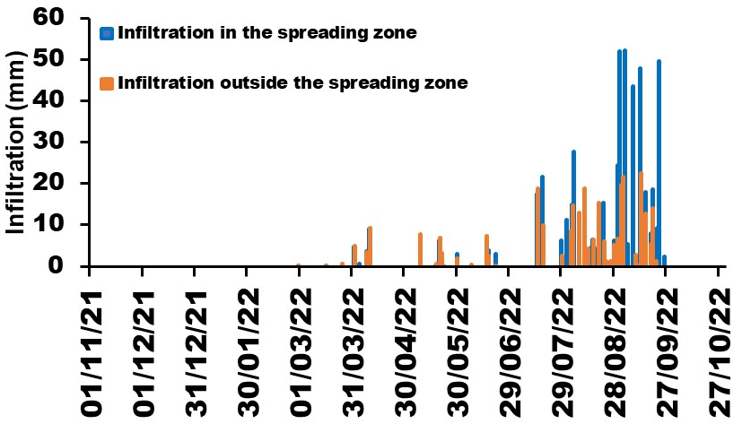
Figure 12: Temporal variation of infiltration rates in spreading and non-spreading zones
  - Comparative Analysis of Potential Recharge: Water Spreading Weirs vs. Watershed-wide Recharge
The quantified annual infiltration over the spreading area (800,000 m²) amounts to 568 mm, equivalent to a water volume of 454,400 m³. This infiltration contributes to an average groundwater level rise of 3.48 m within the spreading area (local scale). Specifically, infiltration during spreading periods accounts for 327.47 mm, or 261,976 m³ of water.
Several studies (Batelaan & De Smedt, 2007; Dahan et al., 2008; Flint & Flint, 2007; Morin et al., 2009; Pakparvar et al., 2017), consider that calculated infiltration can be equivalent to potential groundwater recharge.
Taking this into account, potential recharge during spreading periods represents 57% of recharge in local scale and 0.7% of total recharge in watershed (regional scale). As a reminder, total recharge over the 148,000,000 m² watershed is estimated at 247.7 mm, equivalent to 36,408,000 m³ of water.
While the recharge contribution from spreading periods appears minimal in relation to the entire watershed, it remains significant at the local scale. This localized enhancement of water availability could prove beneficial for agricultural activities through large-diameter wells or boreholes.
It is not negligible regarding water requirements for crops and in view of the integrated water resource management policy advocated by Burkina Faso. This would increase arable land and double agricultural production.
The observed groundwater level rise (3.48 m) induced by the water spreading weirs is notably lower than values reported by Heinz et al.(Heinz et al., 2009) or similar structures in Burkina Faso, Niger, and Chad, where rises of up to 20 m were observed. However, this comparison should be interpreted cautiously due to the multitude of parameters involved in recharge estimation.
These findings underscore the complexity of recharge estimation and highlight the numerous factors influencing surface water infiltration into aquifers. While the contribution to overall watershed recharge may be small, the localized benefits align with Burkina Faso's integrated water resource management policy. The discrepancy between observed and previously reported groundwater level rises emphasizes the need for site-specific assessments and consideration of local hydrogeological conditions when implementing water spreading weirs.
  - Limitations of study
Although the soil water balance approach was successful in estimating recharge, there are limitations. The monitoring system may contain measurement errors such as moisture probes, water potential which is not measured to identify the zero-flux plane, and which could allow the use of other methods to estimate infiltration. Estimating runoff is based on land use and soil types, which may have different characteristics over short distances, even though our study site is small in area. Caution is advised in generalizing these results to all contexts, as some parameters may contain errors and soil properties are different. The soil water balance approach, while successful in estimating recharge, has inherent limitations. The control area was not monitored for as extended a duration as the upstream zones equipped with water spreading weirs; however, it provides valuable insight into infiltration processes in the absence of these structures. Given that the soils are subject to climatic variability and agricultural pressures, their physical and hydraulic properties may evolve over time, thereby influencing infiltration and groundwater recharge. This dynamic state affects the correlations observed between climatic variables and hydrological processes governing surface runoff and subsurface flow. Therefore, results should not be generalized to all contexts; it is essential to always verify soil characteristics before any comparison or upscaling.
- Conclusion
This study has elucidated the role of water spreading weirs in Wedbila watershed in aquifer recharge through experiments on soil water movement. Water spreading weirs enhances soil water storage, mitigating the effects of irregular rainfall distribution on crop development. The spreading zone exhibits superior infiltration compared to areas without weirs, demonstrating the positive impact of these structures. While the potential recharge induced by water spreading weirs (57% of annual infiltration in local scale) is relatively small compared to basin-wide recharge, it contributes significantly to local groundwater reserves. The water spreading weirs can be installed in the dried valleys of Burkina Faso to enhance soil water retention capacity and, correspondingly, recharge the aquifer, which will serve as a water source for off-season agricultural production. These structures strengthen climate resilience by improving water availability during dry spells and mitigating the impacts of sudden flood events, which is essential for agriculture and food security in local communities. Water spreading weirs can be considered a supplementary method for raising groundwater levels where resources and field conditions permit. In any case, minimum soil characteristics favorable to infiltration should be evaluated prior to weir construction. Primary understanding of soil properties is essential for the experimental design of these weirs.
The study combines hydrological, hydraulic, and civil engineering analyses along with field monitoring focuses on semi-arid regions with limited and concentrated rainfall, where water spreading weirs are particularly suited to optimizing floodwater capture and use—a critical issue for sustainable water resource management in these vulnerable areas. This comprehensive approach provides detailed insights into infiltration and water storage mechanisms.
This is one of the few empirical studies in West Africa combining in situ monitoring of surface water, soil moisture, and aquifer responses to water spreading weirs with limited data.
The results of the study on water spreading weirs in Burkina Faso provide important insights into climate resilience, managed aquifer recharge (MAR), and water management in data-scarce semi-arid environments. This study contributes valuable insights into the effectiveness of water spreading weirs for enhancing local water resources in semi-arid regions. However, site-specific assessments and consideration of local hydrogeological conditions remain crucial for optimal implementation and management of these structures.
The effect of water spreading weirs should also be assessed on silty-sandy to sandy soils, and the estimation of induced recharge by a numerical method that separates transpiration, water storage in lower horizons and recharge that reach the aquifer. Their ability to promote groundwater recharge and improve soil moisture availability helps maintain agricultural productivity during dry spells and reduces vulnerability to climate-induced water shortages.

Future research should focus on refining recharge estimation methods and understanding the long-term impacts of these structures on local and regional water resources.
Supplementary Materials: Table S1 maximum soil water storage according to the watershed soils; Table S2: water budget parameters estimated; Table S3: CN estimation.
Declaration of interests: I have nothing to declare
CRediT authorship contribution statement: conceptualization: F.K, S.B, P.O; methodology: F.K, S.B, P.O; format analysis: S.B, P.O; investigation: F.K; resources: S.B, P.O, MC; data curation: A.D, S.B, P.O; writing-original draft: F.K; writing-review and editing: S.B, F.K, P.O, A.D, E.H, I.O; supervision: P.O, S.B; project administration: P.O, S.B, F.K; funding acquisition: S.B, P.O, M.C; all authors have read and agreed to the published version of this manuscript.
Funding: This study was made possible thanks to the financial support of Wallonia Brussels International of Belgium and the logistical support of the Permanent Secretariat for the Integrated Management of Water Resources of Burkina Faso specially Moustapha CONGO. We would like to thank them all.
Declaration of Generative AI and AI-assisted technologies in the writing process: During the preparation of this work the authors used DeepL software to improve readability and language of the manuscript. After using this tool, the authors reviewed and edited the content as needed and took full responsibility for the content of the publication.
Acknowledgments: the authors would like to acknowledge the support of the Ministry of Water and in particular the Permanent Secretariat of Integrate Water Resources Management (SPGIRE) in Burkina Faso, which provided the necessary logistics for the investigation and data collection. They thank KOUDOUGOU Audrey, intern at SPGIRE in 2020-2021, and the SPGIRE drivers for the instigations and data collection in the field.

References
Allison, G. B. (1988). A review of some of the physical, chemical and isotopic techniques available for estimating groundwater recharge. Estimation of natural groundwater recharge, 49‑72.
Allison, G. B., Gee, G. W., & Tyler, S. W. (1994). Vadose-Zone Techniques for Estimating Groundwater Recharge in Arid and Semiarid Regions. Soil Science Society of America Journal, 58(1), 6‑14. https://doi.org/10.2136/sssaj1994.03615995005800010002x
Bambara, A., Orban, P., Ouedraogo, I., Hallot, E., Guyon, F., Zangré, A., & Brouyère, S. (2020). Quantifying Focused Groundwater Recharge Induced by Irrigation Surface Water Reservoirs in Crystalline Basement Areas for Complementary Irrigation. Water, 12(10), 23. https://doi.org/10.3390/w12102880
Batelaan, O., & De Smedt, F. (2007). GIS-based recharge estimation by coupling surface–subsurface water balances. Journal of hydrology, 337(3‑4), 337‑355.
Besbes, M. (2006). Recharge des aquifères par les crues d’oueds. IAHS-AISH Publication, 43‑72.
Bethune, M. G., Selle, B., & Wang, Q. J. (2008). Understanding and predicting deep percolation under surface irrigation. Water Resources Research, 44(12).
Bonn, D., Eggers, J., Indekeu, J., Meunier, J., & Rolley, E. (2009). Wetting and spreading. 81(June), 739‑805. https://doi.org/10.1103/RevModPhys.81.739
Boughanmi, M., Dridi, L., Hamdi, M., Majdoub, R., & Schäfer, G. (2018). Impact of floodwaters on vertical water fluxes in the deep vadose zone of an alluvial aquifer in a semi-arid region. Hydrological Sciences Journal, 63(1), 136‑153. https://doi.org/10.1080/02626667.2017.1410281
Bouwer, H., & Rice, R. C. (1976). A slug test for determining hydraulic conductivity of unconfined aquifers with completely or partially penetrating wells. Water resources research, 12(3), 423‑428.
Chenini, I., & Ben Mammou, A. (2010). Groundwater recharge study in arid region : An approach using GIS techniques and numerical modeling. Computers and Geosciences, 36(6), 801‑817. https://doi.org/10.1016/j.cageo.2009.06.014.
Dahan, O., Tatarsky, B., Enzel, Y., Kulls, C., Seely, M., & Benito, G. (2008). Dynamics of flood water infiltration and ground water recharge in hyperarid desert. Groundwater, 46(3), 450‑461.
Dembele, Y., & Some, L. (1991). Proprietes hydrodynamiques des principaux types de sol du Burkina Faso. IAHS-AISH Publication, 199, 217‑227.
de Vries, J. J., & Simmers, I. (2002). Groundwater recharge : An overview of process and challenges. Hydrogeology Journal, 10(1), 5‑17. https://doi.org/10.1007/s10040-001-0171-7.
Farooq, T. H., Ma, X., Rashid, M. H. U., Wu, W., Xu, J., Tarin, M. W. K., He, Z., & Wu, P. (2019). Impact of stand density on soil quality in Chinese fir (Cunninghamia lanceolata) monoculture. Applied Ecology & Environmental Research, 17(2).
Fu, Y., Lu, Y., Heitman, J., & Ren, T. (2021). Root influences on soil bulk density measurements with thermo-time domain reflectometry. Geoderma, 403, 115195. https://doi.org/10.1016/j.geoderma.2021.115195
Gee, G. W., & Hillel, D. (1988). Groundwater recharge in arid regions : Review and critique of estimation methods. Hydrological Processes, 2(3), 255‑266. https://doi.org/10.1002/hyp.3360020306
Getnet, M., Amede, T., Tilahun, G., Legesse, G., Gumma, M. K., Abebe, H., ... & Akker, E. V. (2022). Water spreading weirs altering flood, nutrient distribution and crop productivity in upstream–downstream settings in dry lowlands of Afar, Ethiopia. Renewable Agriculture and Food Systems, 37(S1), S17-S27.
Ghazavi, R., Vali, A. B., & Eslamian, S. (2012). Impact of Flood Spreading on Groundwater Level Variation and Groundwater Quality in an Arid Environment. Water Resources Management, 26(6), 1651‑1663. https://doi.org/10.1007/s11269-012-9977-4.
Hashemi, H., Berndtsson, R., Kompani-Zare, M., & Persson, M. (2013). Natural vs. Artificial groundwater recharge, quantification through inverse modeling. Hydrology and Earth System Sciences, 17(2), 637‑650. https://doi.org/10.5194/hess-17-637-2013
Hillel, D. (2003). Introduction to environmental soil physics. Elsevier.
Hillel, D. (2013). Introduction to soil physics. Academic press
Jabar, B. S., Sayl, K. N., & Rashid, R. S. (2023, July). Approaches to modeling soil erosion caused by water: A review. In AIP Conference Proceedings (Vol. 2775, No. 1, p. 040001). AIP Publishing LLC.
Khaledian, Y., Kiani, F., Ebrahimi, S., Brevik, E. C., & Aitkenhead-Peterson, J. (2017). Assessment and monitoring of soil degradation during land use change using multivariate analysis. Land Degradation & Development, 28(1), 128‑141.
King, A. C., Raiber, M., Cox, M. E., & Cendón, D. I. (2017). Comparaison de techniques d’estimation de recharge des eaux souterraines pour un système aquifère alluvial lié à un cours d’eau temporaire (Queensland, Australie). Hydrogeology Journal, 25(6), 1759‑1777. https://doi.org/10.1007/s10040-017-1565-5
Koïta, M., Yonli, H. F., Soro, D. D., Dara, A. E., & Vouillamoz, J. M. (2018). Groundwater storage change estimation using combination of hydrogeophysical and groundwater table fluctuation methods in hard rock aquifers. Resources, 7(1). https://doi.org/10.3390/resources7010005
Mahe, G., Diello, P., Paturel, J.-E., Barbier, B., Karambiri, H., Dezetter, A., Dieulin, C., & Rouche, N. (2010). Baisse des pluies et augmentation des écoulements au Sahel : Impact climatique et anthropique sur les écoulements du Nakambe au Burkina Faso. Sécheresse, 21(4), 330‑332. https://doi.org/10.1684/sec.2010.0268
Mare, J. C., Dewandel, B., Ahmed, S., Galeazzi, L., & Zaidi, F. K. (2006). Combined estimation of specific yield and natural recharge in a semi-arid groundwater basin with irrigated agriculture. Journal of Hydrology, 281‑293. https://doi.org/10.1016/j.jhydrol.2006.02.022
Mesbah, S. H., Mohammadnia, M., & Kowsar, S. A. (2016). Long-term improvement of agricultural vegetation by floodwater spreading in the Gareh Bygone Plain, Iran. In the pursuit of human security, is artificial recharge of groundwater more lucrative than selling soil Hydrogeology Journal, 24(2), 303-317
Min, L., Shen, Y., & Pei, H. (2015). Estimating groundwater recharge using deep vadose zone data under typical irrigated cropland in the piedmont region of the North China Plain. Journal of Hydrology, 527, 305‑315. https://doi.org/10.1016/j.jhydrol.2015.04.064
Morin, E., Grodek, T., Dahan, O., Benito, G., Kulls, C., Jacoby, Y., Van Langenhove, G., Seely, M., & Enzel, Y. (2009). Flood routing and alluvial aquifer recharge along the ephemeral arid Kuiseb River, Namibia. Journal of Hydrology, 368(1‑4), 262‑275
Mohammed, S. S., Sayl, K. N., & Kamel, A. H. (2023, July). Ground water recharging methods: review study. In 2ND INTERNATIONAL CONFERENCE ON ENGINEERING AND ADVANCED TECHNOLOGY:(ICEAT 2022) (Vol. 2787, No. 1, p. 060016). AIP Publishing LLC
Mohammed, S.S., Sayl, K.N., Kamel, A.H. (2022). Ground water recharge mapping in Iraqi Western Desert. International Journal of Design & Nature and Ecodynamics, Vol. 17, No. 6, pp. 913-920. https://doi.org/10.18280/ijdne.170612
Mutin, P., & Soeiro, F.-A. (1969). Infiltration en milieu naturel argileux interprétation physique des phénomènes. La Houille Blanche, 55(8), 897‑906. https://doi.org/10.1051/lhb/1969069
Naghibi, S. A., Vafakhah, M., Hashemi, H., Pradhan, B., & Alavi, S. J. (2018). Groundwater augmentation through the site selection of floodwater spreading using a data mining approach (case study : Mashhad Plain, Iran). Water (Switzerland), 10(10). https://doi.org/10.3390/w10101405
Naghibi, S. A., Vafakhah, M., Hashemi, H., Pradhan, B., & Alavi, S. J. (2020). Water Resources Management Through Flood Spreading Project Suitability Mapping Using Frequency Ratio, k-nearest Neighbours, and Random Forest Algorithms. Natural Resources Research, 29(3), 1915‑1933. https://doi.org/10.1007/s11053-019-09530-4
Nazoumou, Y., & Besbes, M. (2001). Estimation de la recharge et modélisation de nappe en zone aride : Cas de la nappe de Kairouan, Tunisie. IAHS-AISH Publication, 269, 75‑88.
Ouandaogo-Yameogo, S., Blavoux, B., Nikiema, J., & Savadogo, A. (2013). Caractérisation du fonctionnement des aquifères de socle dans la région de Ouagadougou à partir d’une étude de la qualité chimique des eaux. Revue des sciences de l’eau/Journal of Water Science, 26(3), 173‑191.
Pakparvar, M., Walraevens, K., Cheraghi, S. A. M., Ghahari, G., Cornelis, W., Gabriels, D., & Kowsar, S. A. (2017). Assessment of groundwater recharge influenced by floodwater spreading : An integrated approach with limited accessible data. Hydrological Sciences Journal, 62(1), 147‑164. https://doi.org/10.1080/02626667.2016.1183164
Pool, D. R. (2005). Variations in climate and ephemeral channel recharge in southeastern Arizona, United States. Water resources research, 41(11).
Scanlon, B. R., Healy, R. W., & Cook, P. G. (2002). Choosing appropriate techniques for quantifying groundwater recharge. Hydrogeology Journal, 10(1), 18‑39. https://doi.org/10.1007/s10040-001-0176-2
Shanafield, M., & Cook, P. G. (2014). Transmission losses, infiltration and groundwater recharge through ephemeral and intermittent streambeds : A review of applied methods. Journal of Hydrology, 511, 518‑529. https://doi.org/10.1016/j.jhydrol.2014.01.068
Woessner, W. W. (2020). Groundwater-Surface Water Exchange. In The Groundwater Project (p. 158).

