Supplementary Materials

Uncertainty management for In Silico Screening of Reversed-phase Liquid Chromatography Methods for Small Compounds
Thomas Van Laethem ^{1,2,}*, Priyanka Kumari ^{1,2}, Bruno Boulanger ³, Philippe Hubert ², Marianne Fillet ¹, Pierre-Yves Sacré ² and Cédric Hubert ^{2,}*
1 Laboratory for the Analysis of Medicines, University of Liège (ULiège), CIRM, +3 B36 Tower 4 Avenue Hippocrate 15, 4000 Liège, Belgium
2 Laboratory of Pharmaceutical Analytical Chemistry, University of Liège (ULiège), CIRM,+2 B36 Tower 4 Avenue Hippocrate 15, 4000 Liège, Belgium
3 Pharmalex Belgium, 1435 Mont-Saint-Guibert, Belgium
* Correspondence: tvanlaethem@uliege.be (T.V.L.); chubert@uliege.be (C.H.)

Table S1. Molecular descriptors and structure of test compounds produced with the Chemicalize and Marvin tools of Chemaxon (Budapest, Hungary).
Compounds | Molecular weight [g/mol] | logP | pKa | Structure
2,2′-bipyridine | 156.188 | 1.96 | 0.70, 3.30 | 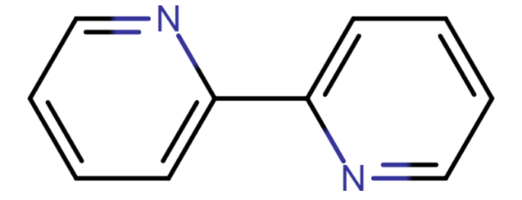
4-nitrophenol | 139.11 | 1.35 | 7.07 | 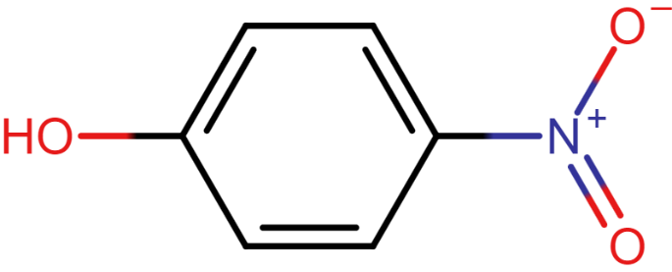
ibuprofen | 206.285 | 1.71 | 4.85 | 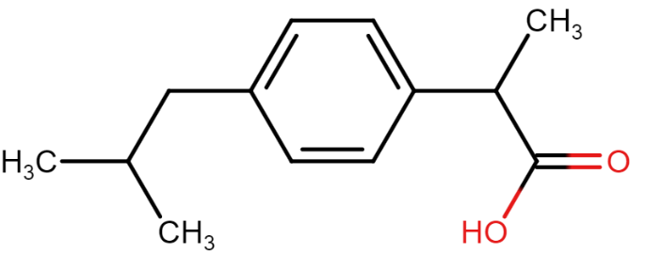
metoclopramide | 299.8 | -0.64 | 1.64, 9.04, 14.49 | 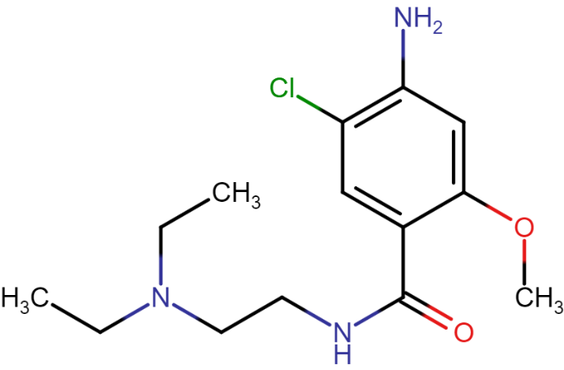
papaverine | 339.391 | 3.04 | 6.03 | 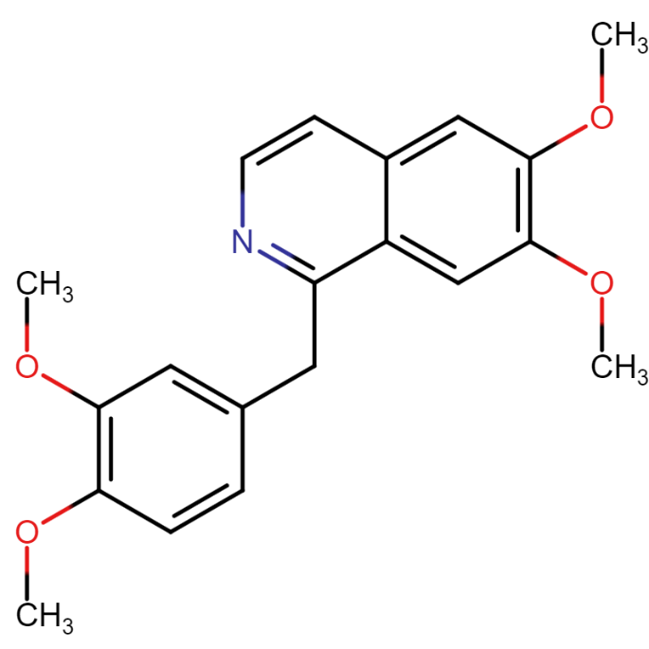
pindolol | 248.326 | -0.87 | 9.67, 14.09 | 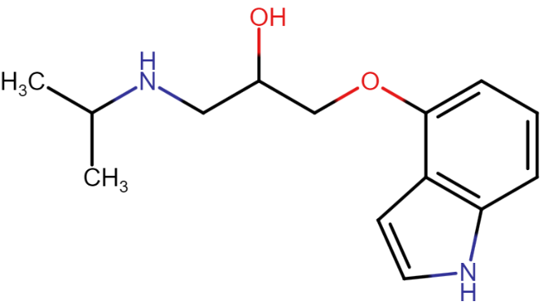
verapamil | 454.611 | 2.42 | 9.68 | 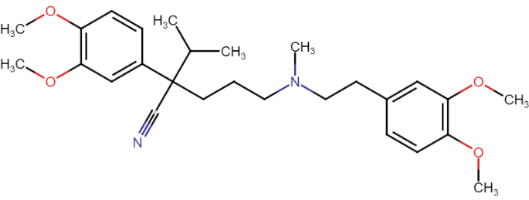

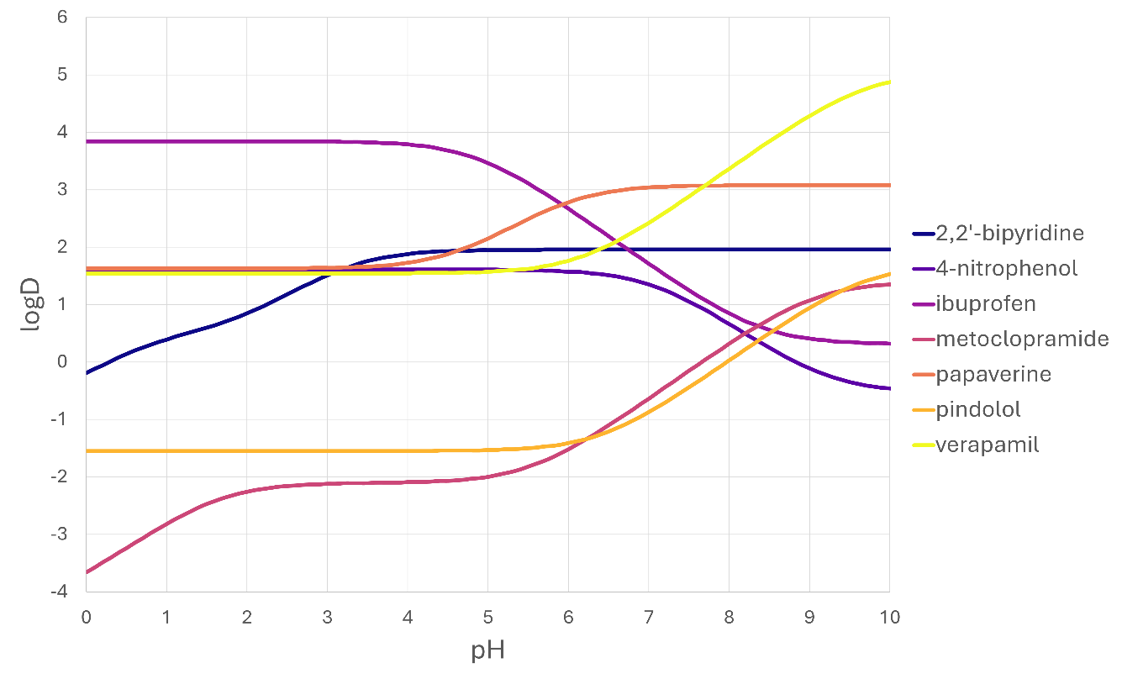
Figure S1. LogD values for the pH range from 0 to 10 calculated with the Chemicalize tool of Chemaxon (Budapest, Hungary).

Table S2. Experimental retention times of compounds at the beginning, apex, and end of the peak.
Compound | pH | tG  [min] | tR_begin  [min] | tR_apex  [min] | tR_end  [min]
2,2′-bipyridine | 2,7 | 60 | 11,43 | 11,70 | 12,85
ibuprofen | 2,7 | 60 | 48,62 | 48,89 | 49,18
papaverine | 2,7 | 60 | 25,77 | 26,01 | 26,92
4-nitrophenol | 2,7 | 60 | 20,92 | 21,43 | 22,11
pindolol | 2,7 | 60 | 15,34 | 15,61 | 16,16
metoclopramide | 2,7 | 60 | 18,89 | 19,20 | 20,12
verapamil | 2,7 | 60 | 34,78 | 35,02 | 35,70
2,2′-bipyridine | 2,7 | 48 | 10,40 | 10,61 | 11,62
papaverine | 2,7 | 48 | 21,72 | 21,93 | 22,97
ibuprofen | 2,7 | 48 | 40,57 | 40,77 | 41,04
pindolol | 2,7 | 48 | 13,82 | 13,98 | 14,25
4-nitrophenol | 2,7 | 48 | 18,93 | 19,36 | 20,08
metoclopramide | 2,7 | 48 | 16,57 | 16,80 | 17,65
verapamil | 2,7 | 48 | 29,12 | 29,35 | 30,07
2,2′-bipyridine | 2,7 | 35 | 9,45 | 9,67 | 10,48
papaverine | 2,7 | 35 | 17,77 | 17,96 | 18,87
ibuprofen | 2,7 | 35 | 31,80 | 31,97 | 32,17
pindolol | 2,7 | 35 | 11,98 | 12,13 | 12,35
4-nitrophenol | 2,7 | 35 | 16,65 | 16,99 | 17,43
metoclopramide | 2,7 | 35 | 13,90 | 14,13 | 14,85
verapamil | 2,7 | 35 | 23,07 | 23,24 | 23,68
2,2′-bipyridine | 3,5 | 60 | 18,32 | 18,72 | 19,53
papaverine | 3,5 | 60 | 27,38 | 27,67 | 28,43
ibuprofen | 3,5 | 60 | 48,50 | 48,73 | 49,00
pindolol | 3,5 | 60 | 16,83 | 17,04 | 17,33
4-nitrophenol | 3,5 | 60 | 20,97 | 21,43 | 22,27
metoclopramide | 3,5 | 60 | 20,27 | 20,60 | 21,55
verapamil | 3,5 | 60 | 36,22 | 36,55 | 37,03
2,2′-bipyridine | 3,5 | 48 | 16,58 | 16,96 | 17,72
papaverine | 3,5 | 48 | 23,38 | 23,65 | 24,35
ibuprofen | 3,5 | 48 | 40,52 | 40,72 | 40,99
pindolol | 3,5 | 48 | 14,92 | 15,13 | 15,42
4-nitrophenol | 3,5 | 48 | 18,97 | 19,43 | 20,23
metoclopramide | 3,5 | 48 | 17,70 | 17,98 | 18,83
verapamil | 3,5 | 48 | 30,40 | 30,66 | 31,17
2,2′-bipyridine | 3,5 | 35 | 14,48 | 14,74 | 15,33
papaverine | 3,5 | 35 | 18,83 | 19,06 | 19,63
ibuprofen | 3,5 | 35 | 31,60 | 31,77 | 31,98
pindolol | 3,5 | 35 | 12,72 | 12,87 | 13,12
4-nitrophenol | 3,5 | 35 | 16,52 | 16,85 | 17,53
metoclopramide | 3,5 | 35 | 14,80 | 15,02 | 15,68
verapamil | 3,5 | 35 | 24,00 | 24,22 | 24,57
2,2′-bipyridine | 3,2 | 48 | 14,08 | 14,35 | 15,12
pindolol | 3,2 | 48 | 14,85 | 15,06 | 15,47
metoclopramide | 3,2 | 48 | 17,77 | 18,00 | 18,63
4-nitrophenol | 3,2 | 48 | 19,17 | 19,52 | 20,13
papaverine | 3,2 | 48 | 23,18 | 23,47 | 24,22
verapamil | 3,2 | 48 | 30,45 | 30,65 | 31,07
ibuprofen | 3,2 | 48 | 40,17 | 40,85 | 41,15

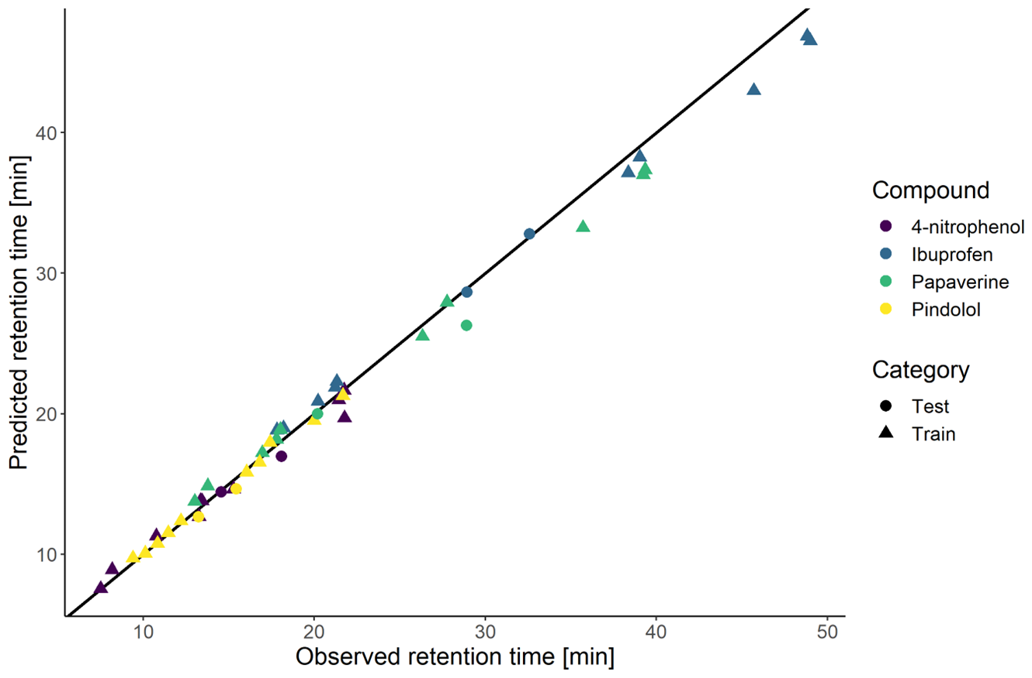
Figure S2. Predicted retention times versus observed retention times of the first test set for the training (triangles) and the test (discs) conditions. Each compound is assigned a different color.

