Impact of deodorisation time and temperature on the removal of different MOAH structures: a lab-scale study on spiked coconut oil
Aleksandra Gorskaª, Sabine Danthine^{b}, Nicolas Jacquet^{b} and Giorgia Purcaroª*
ª Analytical Chemistry, Gembloux Agro-Bio Tech, University of Liège, Gembloux, 5030, Belgium; ^{b} Food Technology, Gembloux Agro-Bio Tech, University of Liège, Gembloux, 5030, Belgium

Contact information:
*Giorgia Purcaro, gpurcaro@uliege.be
Gembloux Agro-Bio Tech, University of Liège
Bât. ABT01 G8-Chemistry for Sustainable Food and Environmental Systems,
Passage des Déportés 2,
5030 Gembloux, Belgium
Office phone: +32 (0)81 62 22 20

Figure S1 – GC×GC chromatogram of the spiked coconut oil showing the integration and interpretation strategy in terms of C fraction (orange rectangles), number of aromatic rings (dashed blue zones), and alkylation degree (white lines). The alkylation degree lines were determined using the elution zones of alkylated benz[a]pyrene, as indicated in the legend. The yellow line represents the retention trend of a parent polycyclic aromatic hydrocarbon (PAH) compound as its alkyl chain length increases (+1C indicates the addition of a methyl group to the parent PAH, +2C indicates the addition of an ethyl group, and so on).
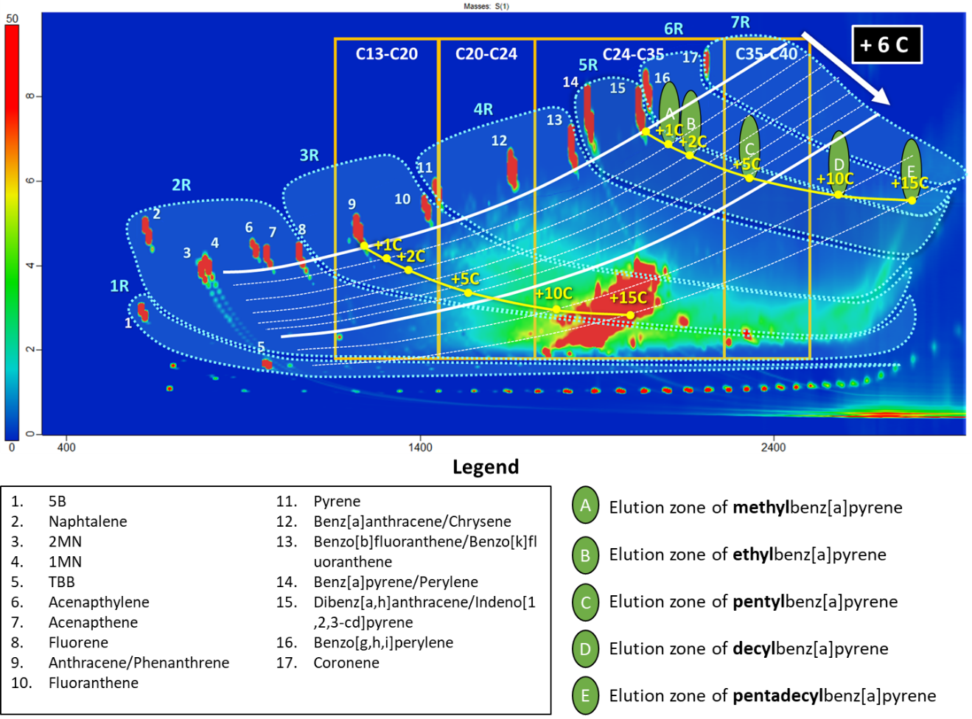

 |  | Total |  |  | C13-C20 |  |  |  |  |  | C20-C24 |  |  |  |  |  | C24-C35 |  |  |  |  |  | C35-C40
Temperature (°C) | Time (h) |  |  |  | <3AR |  |  | >3AR |  |  | <3AR |  |  | >3AR |  |  | <3AR |  |  | >3AR |  |  | <3AR |  |  | >3AR
 |  | Before | After | Loss | Before | After | Loss | Before | After | Loss | Before | After | Loss | Before | After | Loss | Before | After | Loss | Before | After | Loss | Before | After | Loss | Before | After | Loss
195 | 2.25 | 13.3 | 10.8 | 19% | 0.3 | 0.0 | 91% | 0.1 | 0.0 | 91% | 1.2 | 0.6 | 49% | 1.2 | 0.8 | 37% | 5.0 | 4.7 | 6% | 3.8 | 4.0 | -6% | 0.8 | 1.0 | -21% | 0.8 | 1.1 | -28%
195 | 2.25 | 7.4 | 6.2 | 16% | 0.2 | 0.0 | 98% | 0.0 | 0.0 | 99% | 1.4 | 0.6 | 55% | 1.0 | 0.6 | 45% | 1.8 | 1.5 | 17% | 2.0 | 1.9 | 6% | 0.3 | 0.4 | -8% | 0.5 | 0.6 | -11%
195 | 2.25 | 7.4 | 6.0 | 19% | 0.2 | 0.0 | 95% | 0.0 | 0.0 | 93% | 1.4 | 0.7 | 52% | 1.0 | 0.6 | 40% | 1.8 | 1.6 | 11% | 2.0 | 2.1 | -2% | 0.3 | 0.4 | -16% | 0.5 | 0.6 | -16%
195 | 0.5 | 12.0 | 11.1 | 8% | 0.3 | 0.1 | 55% | 0.1 | 0.0 | 50% | 1.2 | 1.0 | 19% | 1.2 | 1.0 | 15% | 5.0 | 4.8 | 5% | 3.8 | 3.8 | 1% | 0.8 | 0.9 | -1% | 0.8 | 0.8 | -3%
195 | 4 | 8.9 | 6.6 | 26% | 0.2 | 0.0 | 100% | 0.0 | 0.0 | 100% | 1.6 | 0.4 | 79% | 1.2 | 0.4 | 69% | 2.1 | 1.4 | 31% | 2.5 | 2.1 | 16% | 0.5 | 0.5 | -8% | 0.7 | 0.8 | -13%
150 | 2.25 | 9.5 | 9.1 | 5% | 0.3 | 0.1 | 44% | 0.0 | 0.0 | 32% | 1.8 | 1.6 | 11% | 1.3 | 1.2 | 8% | 2.3 | 2.2 | 4% | 2.7 | 2.6 | 2% | 0.5 | 0.5 | 1% | 0.8 | 0.8 | 3%
163 | 1 | 9.0 | 8.6 | 4% | 0.2 | 0.1 | 38% | 0.0 | 0.0 | 31% | 1.6 | 1.5 | 8% | 1.2 | 1.1 | 6% | 2.1 | 2.1 | 0% | 2.5 | 2.5 | 0% | 0.5 | 0.5 | -2% | 0.8 | 0.8 | -3%
163 | 3.5 | 9.8 | 8.7 | 11% | 0.3 | 0.1 | 76% | 0.0 | 0.0 | 69% | 1.7 | 1.3 | 23% | 1.3 | 1.0 | 19% | 2.3 | 2.2 | 5% | 2.7 | 2.7 | 2% | 0.6 | 0.6 | -2% | 0.8 | 0.8 | 0%
227 | 3.5 | 9.1 | 4.6 | 49% | 0.2 | 0.0 | 99% | 0.0 | 0.0 | 98% | 1.7 | 0.0 | 98% | 1.2 | 0.1 | 95% | 2.2 | 0.8 | 65% | 2.6 | 1.2 | 54% | 0.4 | 0.4 | 2% | 0.7 | 0.7 | -1%
227 | 1 | 7.1 | 5.1 | 28% | 0.2 | 0.0 | 100% | 0.0 | 0.0 | 100% | 1.3 | 0.2 | 84% | 0.9 | 0.2 | 75% | 1.6 | 1.0 | 39% | 2.0 | 1.6 | 22% | 0.4 | 0.5 | -10% | 0.6 | 0.7 | -11%
240 | 2.25 | 8.3 | 4.2 | 50% | 0.2 | 0.0 | 99% | 0.0 | 0.0 | 100% | 1.5 | 0.0 | 98% | 1.1 | 0.0 | 98% | 2.0 | 0.7 | 67% | 2.3 | 0.9 | 60% | 0.5 | 0.5 | 0% | 0.7 | 0.7 | -2%
Table S1 – MOAH content in the spiked coconut oil before and after deodorization at different times and temperatures (expressed in mg/kg) and percentage of MOAH loss (%)

