IMPROVED MICROWAVE-ASSISTED SAPONIFICATION TO REDUCE THE VARIABILITY OF MOAH DETERMINATION IN EDIBLE OILS

Grégory Bauwens, Giorgia Purcaro*

Analytical Chemistry Lab, Gembloux Agro-Bio Tech, University of Liège, Gembloux, 5030, Belgium

Contact information:
Giorgia Purcaro, gpurcaro@uliege.be
Gembloux Agro-Bio Tech, University of Liège
Bât. G1 Chimie des Agro-Biosystèmes, Passage des Déportés 2,
5030 Gembloux, Belgium
Office phone: +32 (0)81 62 22 20

Abstract
Background: Mineral oil aromatic hydrocarbon (MOAH) analysis in foods is a major analytical challenge. Quantification is associated with a high uncertainty. The sources of uncertainty are multiple, but the major one is related to data interpretation and integration, which is partially derived from insufficiently efficient sample preparation. Recently, an updated ISO method for the analysis of mineral oil in fats and oils and a standard operating procedure for infant formula analysis have been published. Both methods reported significantly different (up to 1.25) distributions of the internal standards used for quantification (i.e., tri-tert-butyl benzene (TBB) and 2-methyl naphthalene (2MN)) over the different solvent phases used in the saponification step.

Results: In this work, a microwave-assisted saponification and extraction method was optimized for MOAH analysis to solve the problem related to the MOAH internal standards partition. The paper examines the impact of the solvent mixture used, the concentration of KOH on the partition of TBB and 2MN, and the effect of the matrix and the washing step to extract the unsaponifiable fraction containing the mineral oils.

Significance: The optimized procedure achieved a TBB/2MN ratio of 1.05±0.01 tested in five different fats and oils, namely, sunflower, rapeseed, coconut, palm, and extra virgin olive oils. The method can significantly contribute to reducing the uncertainty of the MOAH quantification when saponification is applied.

Keywords: Mineral oil aromatic hydrocarbon (MOAH); saponification; fats and oils; LC-GC-FID

Table S1. Summary of the reference methods considered in this paper.
 |  | Menegoz-Ursol et al 2022 [22] | Bauwens et al 2022 [23] | DGF/ISO- 20122 [18] | JRC-IF [19] | IOC Sterols [24]
Brief description | Saponification | 1g oil + 10 mL 1.5 M KOH (1.5 M)/MeOH + 10 mL C6. Saponification at 120 °C for 20 min. | 5 g of sample + 10 mL KOHsat/MeOH + 10 mL C6. Saponification at 120 °C for 20 min. | 3 g oil in 30 mL C6/EtOH (1:1 v/v). 10 mL of this added with 3 mL KOH in H2O (0.5 g/mL). Saponification at 60 °C for 30min | 5 g infant formula + 10 mL H2O. Add 10 mL of KOH (4.8 M) in EtOH/water (1:1 v/v) + 5mL EtOH. Saponification at 60°C for 30 min | 5g oil + 50 mL KOH (2M) in EtOH/H2O (4/1 v/v). Saponification: boiling for 20 min
Brief description | washing | 40 mL of H2O + 3 mL of MeOH added in the vessel. Store at -18 °C for 30 min. Collected the C6 lyer, concentrate to 4 mL and wash with 3 mL MeOH/H2O (2/1 v/v) | 40 mL of H2O + 2 mL of MeOH added in the vessel. Store at -18 °C for 30 min. 5mL of C6 concentrated for further analysis. | Add 5mL C6 + 5 mL EtOH/H2O (1/1 v/v). Repeat twice and combine the C6 phases. | 15 mL C6 + 2.5 mL EtOH twice. Wash C6 with 15 mL of EtOH/ H2O (1/1 v/v) | Unsaponifiable extracted with EtOH and washed with H2O
Mass sample |  | 1g oil | 5 g of sample | 1 g oil in 10 mL C6/EtOH (1:1 v/v) | 5 g IF + 5 mL H2O | 5 g
[KOH] |  | 1.5 M KOH | saturated KOH | ~3.4 M | 4.8 M | 2 M
Solvent mixture Sap |  | MeOH (+ 10 mL C6) | MeOH (+ 10 mL C6) | EtOH/H2O (5/3 v/v) + (5mL C6) | EtOH/H2O (3/2 v/v) | EtOH/H2O (4/1 v/v)
Apparatus |  | MAS | MAS | Water Bath | Water Bath | Reflux
Temperature |  | 120°C | 120 °C | 60 °C | 60 °C | Boiling
Time |  | 20 min | 20 min | 30 min | 30 min | 20 min

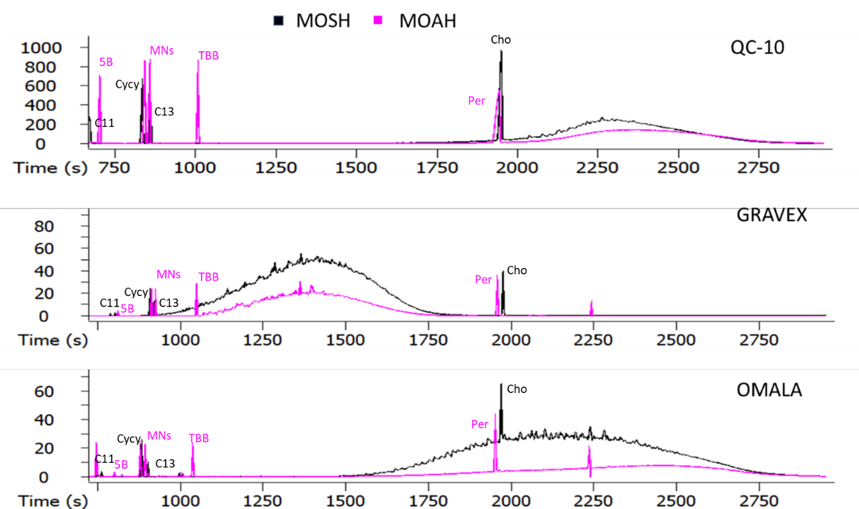
Figure S1. LC-GC-FID MOSH and MOAH profile of the pure mineral oil hydrocarbons used for spiking, namely QC-10, Gravex and Omala.

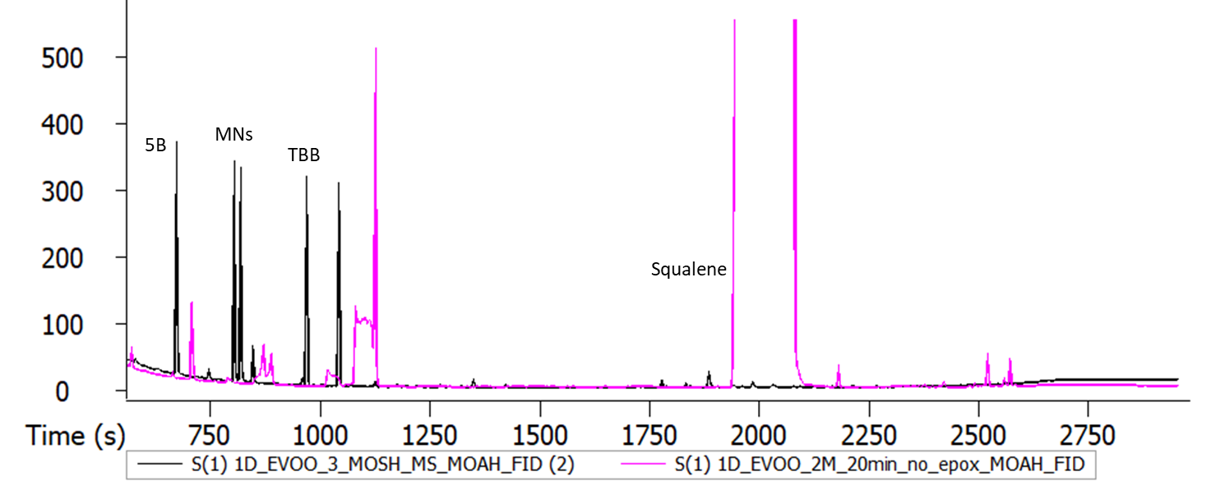
Figure S2. LC-GC-FID MOAH profile of the EVOO without epoxidation (pink) and with epoxidation (black).

Figure S3. Average of the TBB/2MN ratio obtained for each laboratory during the interalaboratory trial to validate the actual DGF/ISO-20122 method for fats and oils. The ratios are the average of 8 different samples, split blindly in 2 (so 16) all repeated in double for a total of 32 analysis. The samples were: refined grapeseed oil, refined palm olein, virgin coconut oil, refined rapeseed oil, extravirgin olive oil, cold pressed rapeseed oil spiked, refined sunflower oil spiked, virgin coconut oil spiked

