Supporting Information

Diversely Substituted Poly(N-Vinyl Amide) Derivatives towards Non-Toxic, Stealth and pH-Responsive Lipid Nanocapsules.
François Toussaint¹, Elise Lepeltier^{2, 3}, Florence Franconi², Vincent Pautu², Christine Jérôme¹, Catherine Passirani²*, Antoine Debuigne¹*
¹ Center for Education and Research on Macromolecules (CERM), Complex and Entangled Systems from Atoms to Materials Research Unit (CESAM‐RU), University of Liège, 4000 Liège, Belgium.² Micro et Nanomédecines Translationnelles, MINT, UNIV Angers, INSERM 1066, CNRS 6021, Angers, France. ³ Institut Universitaire de France (IUF)
* Corresponding authors : adebuigne@uliege.be and catherine.passirani@univ-angers.fr
Protocol 1 | Synthesis of OD-PNVP. | Page 2
Protocol 2 | Synthesis of DiOD-PNVP | Page 2
Protocol 3 | Synthesis of DSPE-PNVP | Page 3
Protocol 4 | Synthesis of OD-PNMVA | Page 3
Protocol 5 | Synthesis of DSPE-PNMVA | Page 4
Protocol 6 | RAFT copolymerization of NVP and VIm | Page 4
Protocol 7 | Synthesis of OD-P(NVP-co-VIm) | Page 5
Protocol 8 | Synthesis of DiOD-P(NVP-co-VIm). | Page 5
Protocol 9 | Reactivity ratio determination | Page 6
Table S1 | Synthesis of NVP- and NMVA-based LNC modifiers | Page 7
Table S2 | RAFT copolymerization of NVP and VIm initiated by Et-XA. | Page 8
Table S3 | Synthesis of NVP- and VIm-based LNC modifiers. | Page 9
Table S4 | Determination of reactivity ratios for the RAFT copolymerization of NVP/VIm | Page 10
Figure S1 | ¹H NMR spectra in CDCl₃ of OD-PNVP₃₁, OD-PNVP₄₆, DiOD-PNVP₄₄ and DSPE-PNVP₄₇. | Page 11
Figure S2 | ¹H NMR spectra in CDCl₃ and CD₂Cl₂ of OD-PNMVA₃₁ and DSPE-PNMVA₄₄. | Page 12
Figure S3 | ¹H NMR spectra in D₂O of Et-P(NVP-co-VIm) | Page 13
Figure S4 | ¹H NMR spectra in D₂O of OD-P(NVP₂₇-co-VIm₂₁) and DiOD-P(NVP₂₂-co-VIm₁₅). | Page 14
Figure S5 | Determination of the reactivity ratios of the RAFT of NVP/VIm. NL, FR and KT methods | Page 15
Figure S6 | Evolution of the comonomer fraction in the feed and in the copolymer with the conversion for the RAFT copolymerization of NVP/VIm. | Page 16
Figure S7 | Representative dynamic light scattering (DLS) graphs of the different LNC formulations at pH 7.4. | Page 17
Figure S8 | Physicochemical characterization after 14 days by DLS and zeta potential | Page 18

Materials. Calcium hydride (Aldrich), triethylamine (99 %, Acros organic), 2,2'-azobis(4-methoxy-2,4-dimethylvaleronitrile) (V70, t½ = 10 h at 30 °C) (Wako), 1,3,5-trioxane (Aldrich), diethyl ether (VWR), n-hexane (> 99 %, VWR), acetonitrile (≥ 99.99 %, Fisher), sodium phosphate monobasic monohydrate (Aldrich) and sodium phosphate dibasic heptahydrate (Aldrich) were used as received. 2,2'-azobisisobutyronitrile (AIBN, t½ = 10 h at 65 °C) (98 %, Aldrich) was recrystalized in methanol prior use. 1-Vinyl-2-pyrrolidone (NVP) (> 99 %, TCI) was distilled under reduced pressure prior to use. 1-Vinylimidazole (Aldrich) and N-methyl-N-vinylacetamide (Aldrich) were dried over calcium hydride and distilled under reduced pressure prior to use. N,N-dimethylformamide (DMF, > 99 %, VWR) and dichloromethane (CH₂Cl₂) were dried over molecular sieves and degassed prior to use. Caprylic-capric acid triglycerides (Labrafac WL 1349®, Gatefossé S.A., France), hydroxystearate-PEG (Kolliphor® HS 15, BASF, Germany), NaCl (VWR) and lecithin (Lipoid S100®, Lipoid GmbH, Germany) were used as received for the preparation of the LNC. OD-XA, DiOD-XA, SC-XA were prepared by a previously reported procedure (Berger, M. et al J. Control. Release 2023, 361, 87–101).
Protocol 1 : Synthesis of OD-PNVP. OD-XA (721 mg, 1.619 mmol) and AIBN (53.1 mg, 0.324 mmol) were placed under inert atmosphere in a Schenck tube and added with distilled and degassed NVP (9.00 g, 81 mmol). The reaction mixture was then stirred at 60 °C. After 10 h, the reaction was stopped and the monomer conversion measured by ¹H NMR in CD₂Cl₂ reached 50%. The mixture was diluted in 1,4-dioxane followed by precipitation in n-hexane. The polymer was recovered by filtration, dried under vacuum at 40 °C for 12 h. The polymer was further purified by dialysis in miliQ water through a 1 kDa porous membrane for 24 h followed by lyophilization. The desired OD-PNVP₃₁ (4.78 g) was recovered as a pale-yellow powder and characterized by SEC in DMF using a PS calibration (M_{n, SEC} = 3500 g/mol, Ð =1.21) and ¹H NMR in CDCl₃ (M_{n, NMR PNVP} = 3400 g/mol, DP = 31). This procedure was adapted to produce OD-PNVP₄₆.
Protocol 2 : Synthesis of DiOD-PNVP. DiOD-XA (744 mg, 1.08 mmol) was placed in a Schenck tube under nitrogen and added with distilled and degassed NVP (3.00 g, 26.98 mmol). The mixture was stirred for 20 min at 80 °C until complete dissolution of DiOD-XA followed by cooling down the mixture at 65 °C in 15 min. This solution was then transferred in another Schenck tube containing AIBN (88.5 mg, 0.54 mmol) and the reaction mixture was stirred at 65 °C. After 5 h, the reaction was stopped and the monomer conversion measured by ¹H NMR in CDCl₃ reached 66 %. The mixture was diluted in CH₂Cl₂ followed by precipitation in n-hexane. The polymer was recovered by filtration, dried under vacuum at 60 °C for 12 h. The polymer was further purified by dialysis in milliQ water through a 1 kDa porous membrane for 24 h followed by lyophilization. The DiOD-PNVP₄₄ (0.80 g) was recovered as a pale-yellow powder and characterized by SEC in DMF using a PS calibration (M_{n, SEC} = 4400 g/mol, Ð =1.26) and ¹H NMR in CDCl₃ (M_{n, NMR PNVP} = 4900 g/mol, DP = 44).

Protocol 3 : Synthesis of DSPE-PNVP. SC-XA (204.8 mg, 0.54 mmol) and AIBN (17.7 mg, 0.108 mmol) were placed under inert atmosphere in a Schenck tube and added with distilled and degassed NVP (4.80 g, 43.2 mmol). The reaction mixture was then stirred at 60 °C. After 8 h, the reaction was stopped and the monomer conversion measured by ¹H NMR in CDCl₃ reached 22 %. The mixture was diluted in dichloromethane and the polymer was purified twice by precipitation in diethyl ether. After drying under vacuum at 40 °C for 24 h, SC-PNVP₃₆ (1.33 g) was collected as a pale-yellow powder and characterized by SEC in DMF using a PS calibration (M_{n, SEC} = 3800 g/mol, Ð = 1.22) and ¹H NMR in CDCl₃ (M_{n, NMR PNVP} = 4000 g/mol, DP = 36). Next, SC-PNVP₃₆ (1.25 g, 0.327 mmol), DSPE (246 mg, 0.327 mmol) and triethylamine (139 mg, 1.315 mmol) were placed in a 50 mL round-bottom flask under nitrogen atmosphere and dissolved in dried and degassed dichloromethane (20 mL). The mixture was then stirred at 40 °C for 1 h before evaporation of the solvent. The residue was dissolved in acetonitrile (20 mL) and stored at 6 °C overnight. The resulting solution was then centrifugated two times (10 000 rpm, 15 min, 6 °C). The supernatant was collected and evaporated under vacuum affording a white powder (1.16 g). The latter was then diluted in milliQ water and dialyzed through a 1 kDa porous membrane sequentially against an aqueous sodium chloride solution (0.3 M) for 12 h and distilled water for 6 h. After lyophilization, the desired DSPE-PNVP₄₇ (964 mg) was obtained a as white powder and characterized by SEC in DMF using a PS calibration (M_{n, SEC} = 4100 g/mol, Ð = 1.19) and ¹H NMR in CDCl₃ (M_{n, NMR PNVP} = 5200 g/mol, DP = 47).

Protocol 4: Synthesis of OD-PNMVA. OD-XA (703 mg, 1.58 mmol) and V70 (487 mg, 1.58 mmol) were placed under inert atmosphere in a Schenck tube and added with dried, distilled and degassed NMVA (7.8 g, 79 mmol). The reaction mixture was then stirred at 35 °C. After 6 h, the reaction was stopped and the monomer conversion measured by ¹H NMR in CD₂Cl₂ reached 50 %. The mixture was diluted in dichloromethane followed by precipitation in diethyl ether (1.65 g obtained). The polymer was recovered by filtration, dried under vacuum at 40 °C for 12 h. The polymer was further purified by dialysis in acetone through a 1 kDa porous membrane for 24 h and in water through a 500 Da porous membrane for 12 h followed by lyophilization. The desired OD-PNMVA₃₁ (0.98 g) was recovered as a pale-yellow powder and characterized by SEC in DMF using a PS calibration (M_{n, SEC} = 1800 g/mol, Ð = 1.21) and ¹H NMR in CD₂Cl₂ (M_{n, NMR} = 3100 g/mol, DP = 31).

Protocol 5 : Synthesis of DSPE-PNMVA. SC-XA (346 mg, 0.91 mmol) and V70 (280 mg, 0.91 mmol) were placed under inert atmosphere in a Schenck tube and added with dried, distilled and degassed NMVA (4.5 g, 45.4 mmol). The reaction mixture was then stirred at 35 °C. After 5 h, the reaction was stopped and the monomer conversion measured by ¹H NMR in CDCl₃ reached 63 %. The mixture was diluted in dichloromethane and the polymer was purified twice by precipitation in diethyl ether. After drying under vacuum at 40 °C for 24 h, SC-PNMVA (1.08 g) was collected as a pale-yellow powder and characterized by SEC in DMF using a PS calibration (M_{n, SEC} = 3600 g/mol, Ð = 1.14) and MALS (dn/dc = 0.071) (M_{n, MALS} = 6500 g/mol, Ð = 1.64). Next, SC-PNMVA (1 g, 0.286 mmol), DSPE (214 mg, 0.286 mmol) and triethylamine (122 mg, 1.207 mmol) were placed in a 50 mL round-bottom flask under nitrogen atmosphere and dissolved in dried and degassed dichloromethane (20 mL). The mixture was stirred at 40 °C for 1 h before evaporation of the solvent. The residue was dissolved in acetonitrile (20 mL) and stored at 6 °C overnight. The solution was then centrifugated two times (10 000 rpm, 15 min, 6°C). The supernatant was collected and evaporated under vacuum affording a white powder (943 mg). The latter was then diluted in milliQ water and dialyzed through a 1 kDa porous membrane sequentially against an aqueous sodium chloride solution (0.3M) for 12 h and distilled water for 6 h. After lyophilization, the desired DSPE-PNMVA₄₄ (698 mg) was obtained a as white powder and characterized by SEC in DMF using a PS calibration (M_{n, SEC} = 4900 g/mol, Ð = 1.13) and ¹H NMR in CDCl₃ (M_{n, NMR PNMVA} = 4400 g/mol, DP = 44).

Protocol 6: RAFT copolymerization of NVP and VIm. CTA (Et-XA, OD-XA or DiOD-X) and AIBN were introduced in a Schenck tube under inert atmosphere and diluted in DMF (1 mL/mL of monomer). NVP and VIm were introduced with a glass syringe and the tube was heated at temperature ranging from 65 to 80 °C. Samples were collected regularly for conversion, M_{n, SEC}, and Đ determination by ¹H NMR and SEC-RI (GPC DMF/LiBr, PS calibration). The polymer was dissolved in dichloromethane, precipitated in diethyl ether and dried under vacuum at 40 °C overnight before dialysis against water through a 1 kDa porous membrane. Final polymer was characterized by ¹H NMR in D₂O and SEC-RI (GPC DMF/LiBr, PS calibration).

Protocol 7: Synthesis of OD-P(NVP-co-VIm). OD-XA (192 mg, 0.43 mmol) and AIBN (14 mg, 0.086 mmol) were placed under inert atmosphere in a Schenck tube and added with distilled and degassed NVP (3.35 g, 30.16 mmol), distilled and degassed VIm (1.22 g, 19.92 mmol) and 4.6 mL of dried and degassed DMF. The reaction mixture was then stirred at 80 °C. After 4 h, the reaction was stopped and the monomers conversions measured by ¹H NMR in CD₂Cl₂ reached 29% (NVP) and 50 % (VIm). The mixture was diluted in dichloromethane followed by precipitation in diethylether. The polymer was recovered by centrifugation (10000 rpm, 10 min, 6 °C) and dried under vacuum at 40 °C for 12 h. The polymer was further purified by dialysis in miliQ water through a 1 kDa porous membrane for 24 h followed by lyophilization. The desired OD-P(NVP₂₇coVIm₂₁)-XA (1.40 g) was recovered as a white powder and characterized by SEC in DMF using a PS calibration (M_{n, SEC} = 8700 g/mol, Đ = 1.63) and ¹H NMR in CD₂Cl₂ (M_{n, NMR} = 5000 g/mol, DP_{NVP} = 27, DP_{VIm} = 21).

Protocol 8: Synthesis of DiOD-P(NVP-co-VIm). DiOD-XA (628 mg, 0.90 mmol) and AIBN (73.5 mg, 0.45 mmol) were placed under inert atmosphere in a Schenck tube and added with distilled and degassed NVP (3.5 g, 31.50 mmol), distilled and degassed VIm (1.27 g, 13.50 mmol) and 4.5 mL of dried and degassed DMF. The reaction mixture was then stirred at 80 °C. After 24 h, the reaction was stopped and the monomers conversions measured by ¹H NMR in CD₂Cl₂ reached 63 % (NVP) and 88 % (VIm). The mixture was diluted in dichloromethane followed by precipitation in diethyl ether. The polymer was recovered by centrifugation (10000 rpm, 10 min, 6 °C) and dried under vacuum at 40 °C for 12 h. The polymer was further purified by dialysis in miliQ water through a 1 kDa porous membrane for 24 h followed by lyophilization. The desired DiOD-P(NVP₂₂coVIm₁₅)-XA (2.44 g) was recovered as a pale-yellow powder and characterized by SEC in DMF using a PS calibration (M_{n, SEC} = 5400 g/mol, Đ = 1.64) and ¹H NMR in CD₂Cl₂ (M_{n, NMR} = 3900 g/mol, DP_{NVP} = 22, DP_{VIm} = 15).

Protocol 9: Reactivity ratio determination. A series of NVP/VIm copolymerizations was carried out in DMF (1 g of monomer/mL of DMF) at 80 °C with different comonomer feed ratios (0.1 ≤ f°_{NVP} ≤ 0.8) using OD-XA and AIBN as RAFT agent radical initiator, respectively ([monomers]₀/[OD-XA]₀/[AIBN]₀ ₌ 360/1/0.1). Copolymerizations were stopped at low conversion in order to avoid significant composition drift. The copolymers were purified by precipitation in diethyl ether, dialysis against water and lyophilization. The molar fractions of the comonomers in the copolymer (F_{NVP} and F_{VIm}) were determined by ¹H NMR in D₂O. These data, provided in Table S4, were then used for the determination of the reactivity ratios via three methods described below.
The Fineman-Ross linearization method generates a straight line whose slope and intercept with the ordinate (Y-axe) correspond, respectively, to r₁ and r₂ (Equation 1).⁴¹ Kelen-Tudos method involves parameters η and ζ, mathematical functions of the mole ratios in the monomer feed (f) and in the copolymer (F) and of a parameter α calculated on the basis of the lowest and highest values of (f²/F).⁴² The determination of r₁ and r₂ is made possible by the extrapolation and the interception at ξ=1 and ξ=0, giving respectively r₁ and (-r₂/α) (Equation 2). The last method is the non-linear least squares method^{43,44} using the Mayo-Lewis equation (Equation 3).
f(F-1)/F = r₁ (f²/F) - r₂ , where f = f₁/f₂ and F = F₁/F₂ (eq. 1)
η = (r₁ + (r₂/α)) ζ – (r₂/ α) (eq. 2)
where η = (f (F-1)) / (F (α + (f² / F)); ζ = (f²/F) / (α + (f²/F)); α = ((f²/F)_{max}(f²/F)_{min})^{0.5}
F₁ = (r₁ f₁² + f₁ f₂) / (r₁ f₁² + 2 f₁ f₂ + r₂ f₂²) (eq. 3)
Based on the reactivity ratios, the Skeist’s model⁴⁵ (Equations 4 and 5) was also used to predict the cumulative and instantaneous copolymer composition at any monomer conversion and describe the possible composition drift along the chains leading to gradient copolymers.
Conversion = 1 – (M/M₀) = 1- [(f₁/f₁°)^{α} (f₂/f₂°)^{β} [(f₁°- δ)/ (f₁- δ)]^{γ}] (eq. 4)
where M₀ and M are the initial and the instantaneous monomer concentration, f° and f correspond to the initial and the instantaneous mole fraction in the feed and α, β, δ, γ are defined as follows: α = r₂ / (1 – r₂) ; β = r₁ / (1 – r₁) ; γ = (1 – r₁r₂) / (1 - r₁) (1 - r₂); δ = (1 - r₂) / (2 - r₁ - r₂)
F_{1cumul} = (f₁° - f₁ (1 – conversion))/ conversion (eq. 5)

Table S1. Synthesis of NVP- and NMVA-based LNC modifiers.
Entry | Conditions | T  (°C) | Time  (h) | Conv.ª  (%) | M_{n, th}^{b}  (g/mol) | M_{n, SEC}^{c}  (g/mol) | Ð ^{c} | M_{n, NMR}^{d} (g/mol) | DP ^{e} | Polymer
1 | [NVP]/[OD-XA]/[AIBN]  50/1/0.2 | 60 | 10 | 52 | 3700 | 3500 | 1.21 | 3400 | 31 | OD-PNVP₃₁
2 | [NVP]/[OD-XA]/[AIBN]  100/1/0.2 | 60 | 6 | 26 | 3300 | 4100 | 1.29 | 5100 | 46 | OD-PNVP₄₆
3 | [NVP]/[DiOD-XA]/[AIBN]  25/1/0.5 | 65 | 7 | 66 | 2500 | 4400 | 1.26 | 4900 | 44 | DiOD-PNVP₄₄
4 | [NVP]/[SC-XA]/[AIBN]  80/1/0.2 | 60 | 8 | 22 | 2300 | 3800 | 1.22 | 4000 | 36 | SC-PNVP₃₆
5 | [SC-PNVP]/[DSPE]/[NEt₃]  1/1/4 | 40 | 1 | >99 | / | 4100 | 1.19 | 5200 | 47 | DSPE-PNVP₄₇
6 | [NMVA]/[OD-XA]/[V70]  50/1/1 | 35 | 6 | 50 | 2900 | 1800 | 1.21 | 3100 | 31 | OD-PNMVA₃₁
7 | [NMVA]/[SC-XA]/[V70]  50/1/1 | 35 | 5 | 63 | 3500 | 3600 | 1.14 | / ^{f} | 35 | SC-PNMVA₃₅
8 | [SC-PNMVA]/[DSPE]/[NEt₃]  1/1/4 | 40 | 1 | >99 | / | 4900 | 1.13 | 4400 | 44 | DSPE-PNMVA₄₄
ª Measured by ¹H NMR on the crude mixture. ^{b} M_{n, th} = [Monomer]₀/[CTA]_{0 ×} conv. × MM _{Monomer} + MM_{CTA}. ^{c} Determined by SEC DMF/LiBr (PS calibration) on the purified polymer. ^{d} Measured by ¹H NMR on the purified polymer by comparing intensities of signal corresponding to the methyl of the hydrophobic groups with the -CH₂-N(CO)- signals of PNVP or CH₃N(CO)- signal of PNMVA. ^{e} Degree of polymerization of the polymer segment calculated based on the M_{n,NMR}. ^{f} Signals corresponding to the terminal groups are buried in the peaks of the main polymer chain.

Table S2. RAFT copolymerization of NVP and VIm initiated by Et-XA.
Entry | [NVP]₀/[VIm]₀/  [Et-XA]₀/[AIBN]₀ | T  (°C) | Time  (h) | Conv (%)ª  NVP/VIm | M_{n th}^{b}  (g/mol) | M_{n SEC}^{c}  (g/mol) | Ð ^{c} | F_{VIm}^{d}
1 | 70/30/1/0.2 | 65 | 2 | 1/7 | 400 | 1600 | 1.34
 |  |  | 4 | 4/13 | 1400 | 2000 | 1.48
 |  |  | 6 | 11/24 | 1800 | 2200 | 1.60
 |  |  | 24 | 14/34 | 2300 | 2900 | 1.81
 |  |  |  |  |  | 1500^{d} | 1.51e | 0.43
2 | 70/30/1/0.2 | 80 | 2 | 16/26 | 2200 | 1600 | 1.27
 |  |  | 4 | 17/31 | 2400 | 2400 | 1.48
 |  |  | 24 | 23/39 | 3100 | 3200 | 1.62
 |  |  |  |  |  | 5500^{d} | 1.53e | 0.42
3 | 70/30/1/0.5 | 80 | 2 | 45/67 | 5600 | 3600 | 1.83
 |  |  | 4 | 50/74 | 6200 | 5600 | 2.21
 |  |  | 24 | 59/83 | 7200 | 6800 | 2.33
 |  |  |  |  |  | 7400^{d} | 1.70e | 0.39
Polymerization in DMF (1 mL/mL monomers). ª Determined by ¹H NMR in CD₂Cl₂ based on the decrease of the methylidene signals of NVP (at 4.35 ppm, 2H) and of methine signal of VIm (at 4.91 ppm, 1H) using 1,3,5-trioxane as internal standard (5.15 ppm, 3H). ^{b} M_{n th} = ([NVP]₀/[Et-XA]₀ × conv_{.NVP} × MM_{NVP} ) + ([VIm]₀/[Et-XA]₀ × conv._{VIm} × MM _{VIm}) + MM_{Et-XA}. ^{c} Determined by SEC DMF/LiBr using a PS calibration. ^{d} Determined by SEC DMF/LiBr (PS calibration) on the polymer purified by precipitation in diethyl ether and aqueous dialysis.^{f} Molar fraction of VIm in the copolymer determined by ¹H NMR in CD₂Cl₂.

Table S3. Synthesis of NVP- and VIm-based LNC modifiers.
Entry | Conditions | Time  (h) | Conv (%)ª  NVP/VIm | M_{n th}^{b}  (g/mol) | M_{n SEC}^{c}  (g/mol) | Ð ^{c} | M_{n NMR} ^{d}  (g/mol) | F_{VIm}^{f} | Polymer
1 | [NVP]/[VIm]/[OD-XA]/[AIBN]  70/30/1/0.2 | 24 | 29/50 | 3700 | 8700e | 1.63e | 5000 | 0.43 | OD-P(NVP₂₇coVIm₂₁)
2 | [NVP]/[VIm]/[DiOD-XA]/[AIBN]  70/30/1/0.2 | 24 | 0/0 | / | / | / | / | / | /
3 | [NVP]/[VIm]/[DiOD-XA]/[AIBN] | 24 | 50/72 | 6600 | 6300 | 1.92
 | 70/30/1/0.5 |  |  |  | 5900e | 1.60e | 5800 | 0.46 | DiOD-P(NVP₃₀coVIm₂₆)
4 | [NVP]/[VIm]/[DiOD-XA]/[AIBN] | 24 | 63/88 | 4400 | 3500 | 1.72
 | 35/15/1/0.5 |  |  |  | 5400e | 1.64e | 3900 | 0.41 | DiOD-P(NVP₂₂coVIm₁₅)
Polymerization performed at 80 °C in DMF (monomer /DMF : 1/1 v/v). ª Determined by ¹H NMR in CD₂Cl₂ based on the decrease of the methylidene signals of NVP (at 4.35 ppm, 2H) and of methine signal of VIm (at 4.91 ppm, 1H) using 1,3,5-trioxane as internal standard (5.15 ppm, 3H). ^{b} M_{n th} = ([NVP]₀/[CTA]₀ × conv_{.NVP} × MM_{NVP} ) + ([VIm]₀/[CTA]₀ × conv._{VIm} × MM _{VIm}) + MM_{Et-XA}. ^{c} Determined by SEC DMF/LiBr using a PS calibration. ^{d} Determined by ¹H NMR in CD₂Cl₂ on the purified polymer based on the relative intensities of the methine and methylene groups of PNVP (3.0-4.0 ppm, 3H), the methine groups of PVIm (6.6-7.6 ppm, 3H) and the signal of the α-terminal methyl group (at 1.23 ppm, 6H). ^{e} Determined by SEC DMF/LiBr (PS calibration) on the polymer purified by precipitation in diethyl ether and aqueous dialysis. ^{f} Molar fraction of VIm in the copolymer determined by ¹H NMR in CD₂Cl₂.

Table S4. Determination of reactivity ratios for the RAFT copolymerization of NVP/VIm.
f°_{NVP} | f°_{VIm} | Time (min) | Conv (%) | F_{NVP}ª | F_{VIm}ª
0.1 | 0.9 | 180 | 5 | 0.08 | 0.92
0.3 | 0.7 | 130 | 5 | 0.26 | 0.74
0.4 | 0.6 | 110 | 2 | 0.32 | 0.68
0.5 | 0.5 | 90 | 10 | 0.42 | 0.58
0.6 | 0.4 | 80 | 4 | 0.49 | 0.51
0.7 | 0.3 | 70 | 8 | 0.61 | 0.39
0.8 | 0.2 | 60 | 14 | 0.71 | 0.29
Conditions: RAFT in DMF (1g of monomer per mL of DMF) at 80°C. [monomers]₀/[OD-XA]₀/[AIBN]₀ ₌ 360/1/0.1). f°_{NVP} and f°_{VIm} corresponds to the initial mole fraction of the comonomers in the feed; F_{NVP} and F_{VIm} corresponds to the molar fraction of the comonomers in the copolymer determined by ¹H NMR in D₂O after purification by precipitation in diethyl ether and dialysis against water.

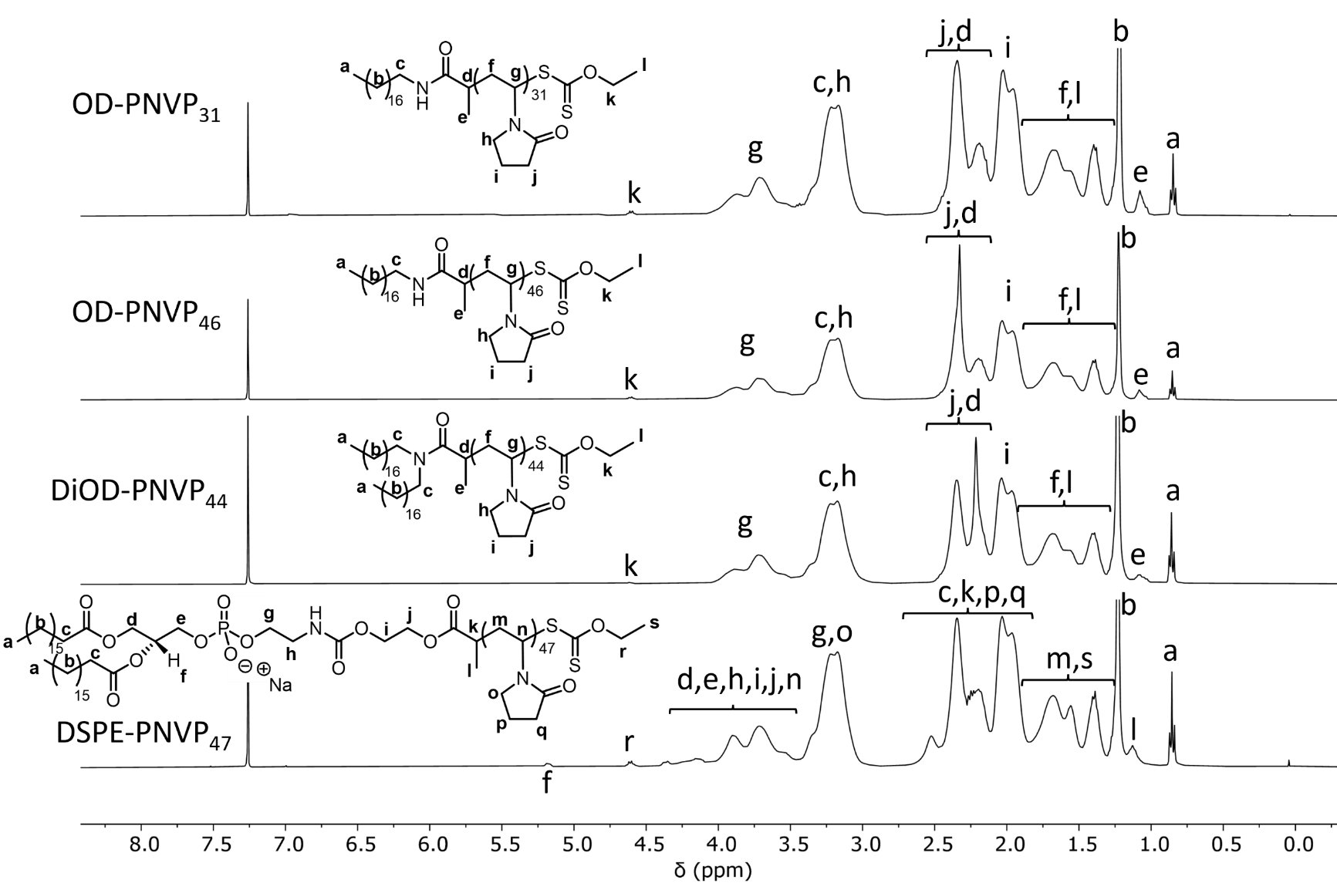
Figure S1. ¹H NMR spectra in CDCl₃ of OD-PNVP₃₁, OD-PNVP₄₆, DiOD-PNVP₄₄and DSPE-PNVP₄₇.

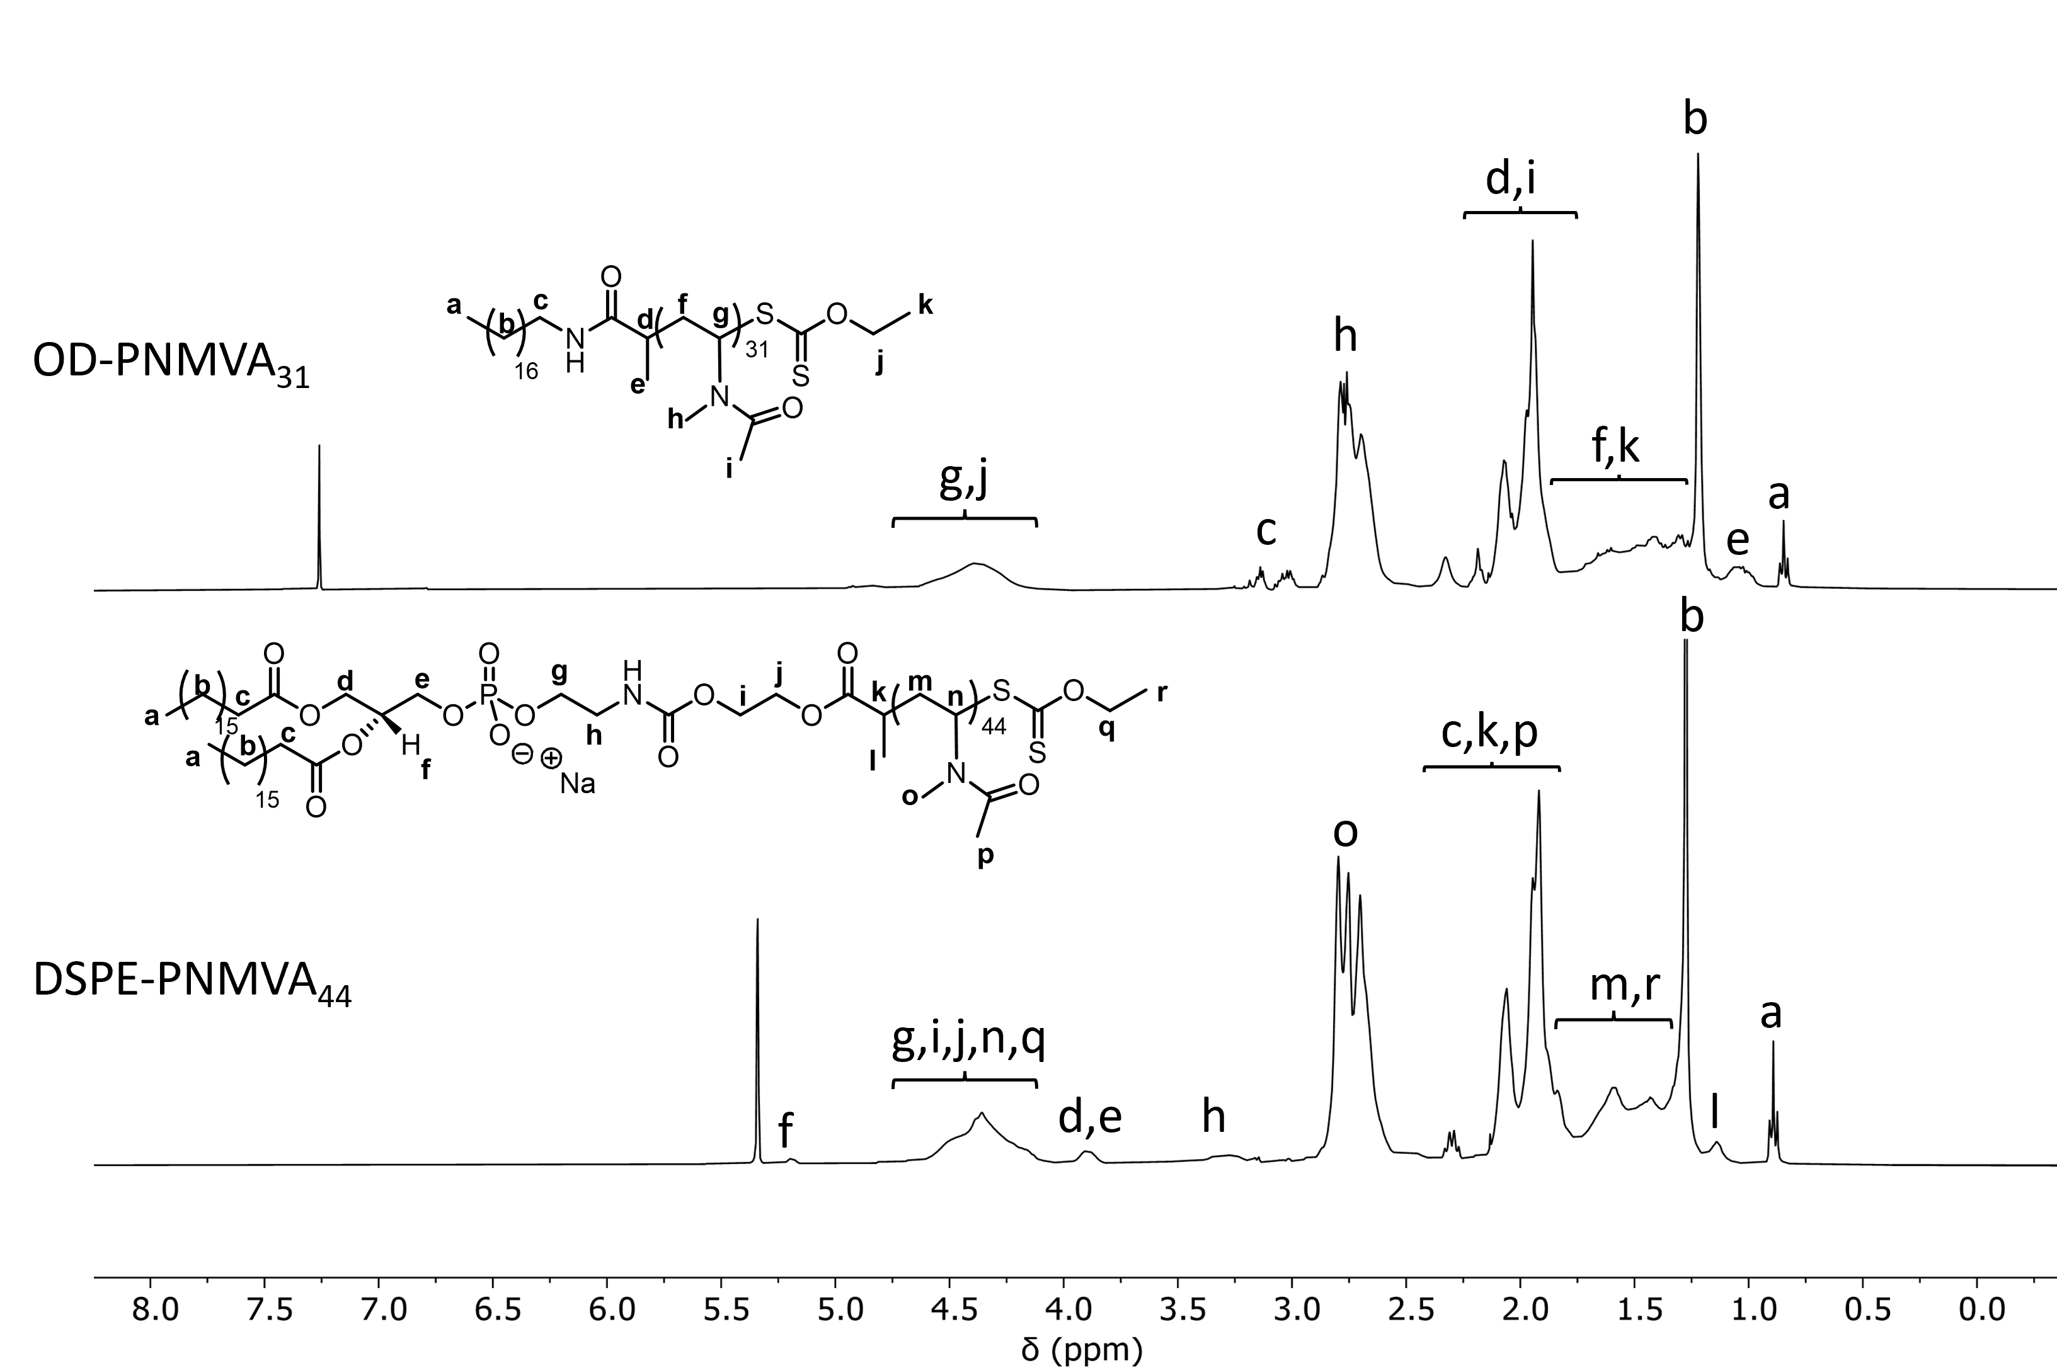
Figure S2. ¹H NMR spectra in CDCl₃ and CD₂Cl₂ of OD-PNMVA₃₁ and DSPE-PNMVA₄₄.

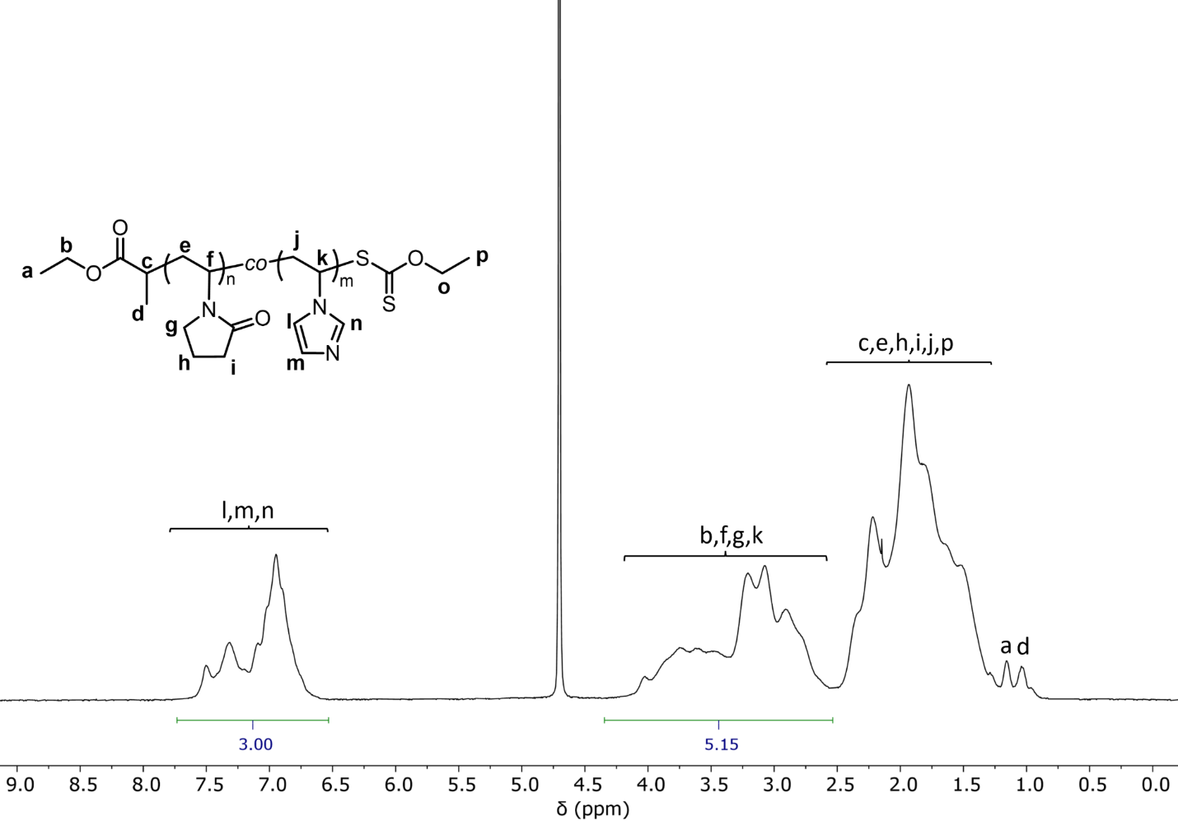
Figure S3. ¹H NMR spectra in D₂O of Et-P(NVP-co-VIm) (see Table S2, entry 2). Composition of the copolymer was measured as follows: F_{VIm} = (ʃ_{6.5-7.7 ppm}/3) / [(ʃ_{2.5-4.2 ppm} – (ʃ_{6.5-7.7 ppm}/3))/3] and F_{NVP} = 1 - F_{VIm} .

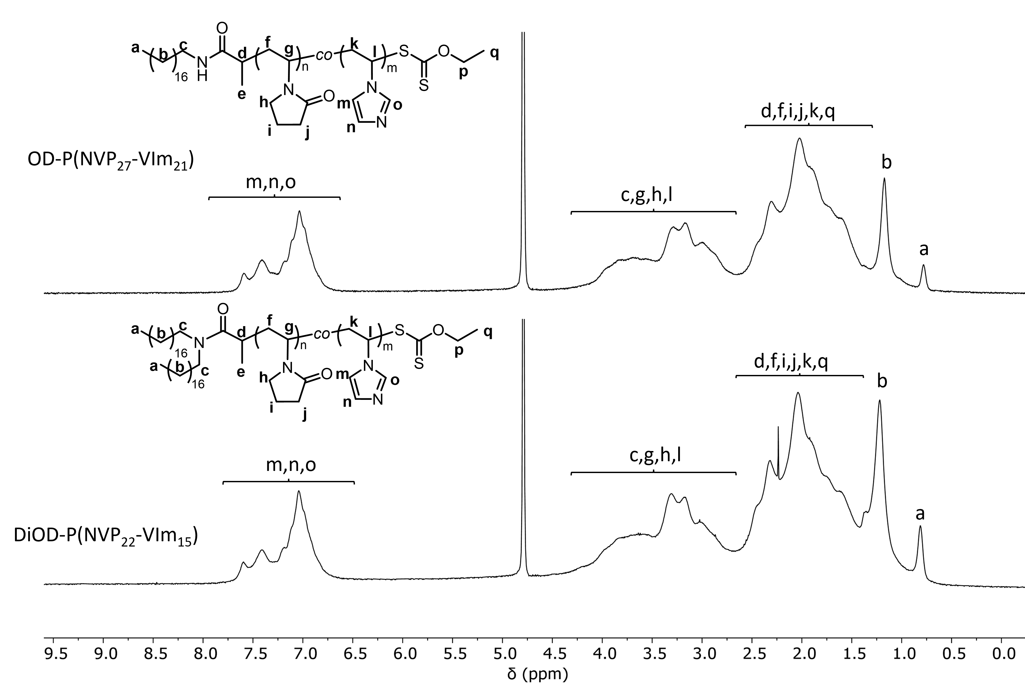
Figure S4. ¹H NMR spectra in D₂O of OD-P(NVP₂₇-co-VIm₂₁) and DiOD-P(NVP₂₂-co-VIm₁₅).

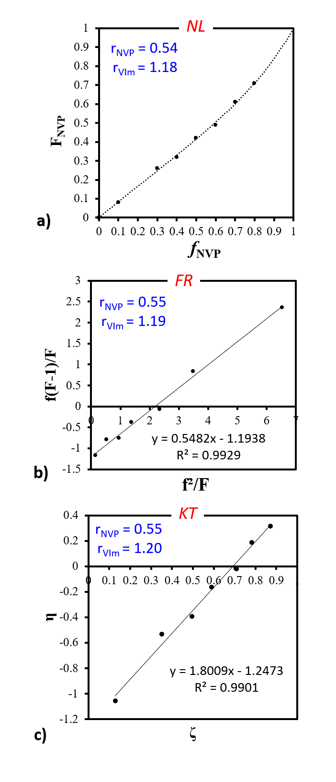
Figure S5. Determination of the reactivity ratios for the RAFT of NVP/VIm initiated in DMF at 80 °C by OD-XA via (a) the non-linear least squares fitting curve method according to the Mayo-Lewis equation, (b) the Finemann–Ross and (c) the Kelen–Tüdös methods. Experimental data are presented in Table S4.

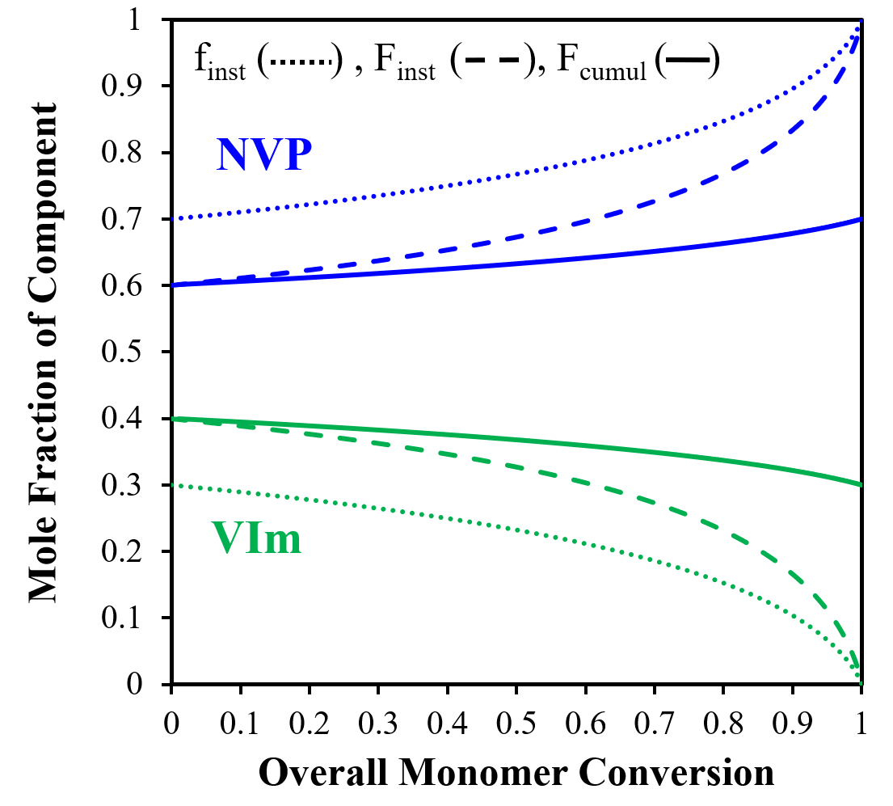
Figure S6. Evolution of the instantaneous molar fraction in the feed (f) but also of the cumulative (F) and instantaneous (F_{inst}) molar fraction of the comonomers in the copolymer with the overall molar monomer conversion for RAFT copolymerization of NVP/VIm (molar feed ratio of 0.7/0.3). Compositions are calculated based on Skeist’s model.

Figure S7. Representative dynamic light scattering (DLS) graphs of blank LNC (BLK LNC) and LNC post-inserted by OD-PNVP₃₁ (LNC P1), OD-PNVP₄₆ (LNC P2), DiOD-PNVP₄₄ (LNC P3), DSPE-PNVP₄₇ (LNC P4), OD-PNMVA₃₁ (LNC P5), DSPE-PNMVA₄₄ (LNC P6), OD-P(NVP₂₇coVIm₂₁) (LNC P7) and DiOD-P(NVP₂₂coVIm₁₅) (LNC P8) and per-formulated with OD-P(NVP₂₇coVIm₂₁) (LNC P7*) and DiOD-P(NVP₂₂coVIm₁₅) (LNC P8*) at pH 7.4.

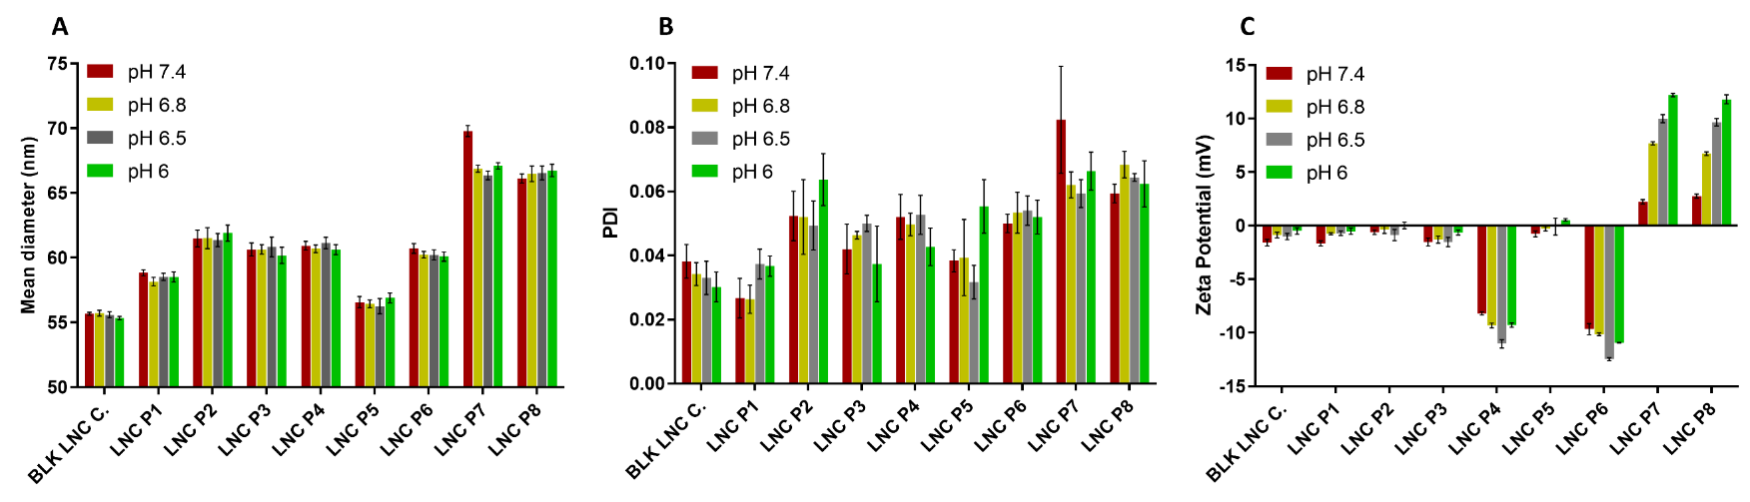
Figure S8. Physicochemical characterization of blank LNC (BLK LNC) and LNC post-inserted by OD-PNVP₃₁ (P1), OD-PNVP₄₆ (P2), DiOD-PNVP₄₄ (P3), DSPE-PNVP₄₇ (P4), OD-PNMVA₃₁ (P5), DSPE-PNMVA₄₄ (P6), OD-P(NVP₂₇coVIm₂₁) (P7) and DiOD-P(NVP₂₂coVIm₁₅) (P8) after 14 days: hydrodynamic diameter determined with mean intensity (nm) (A), polydispersity index (PDI) (B) and Zeta potential (mV) (C) at different pH: 7.4, 6.8, 6.5 and 6. Results (n = 3) are expressed as mean measure ± SEM.

