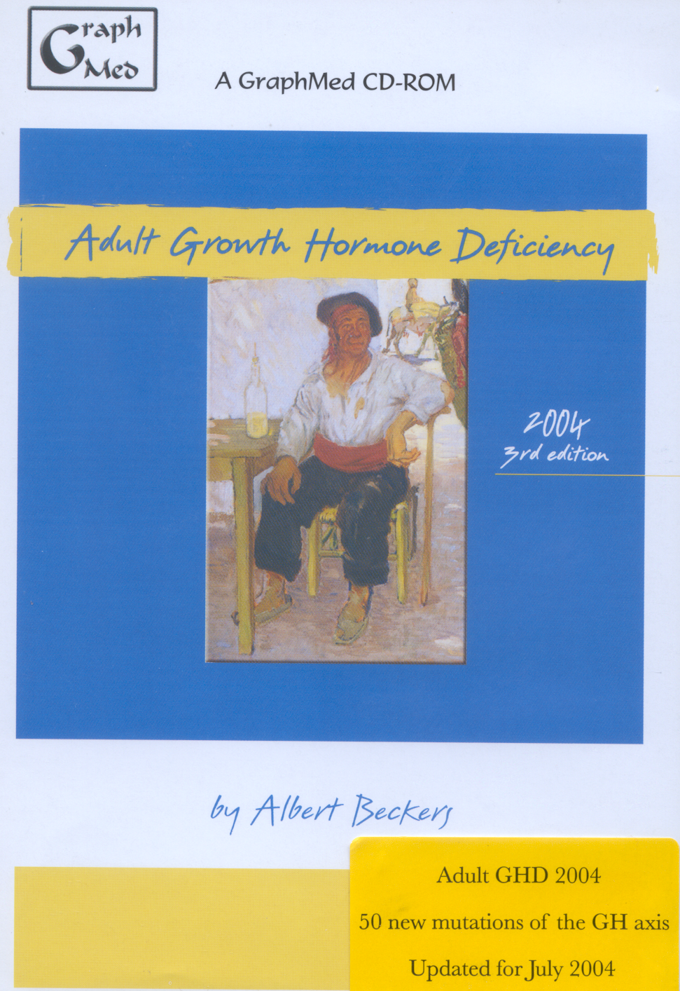 ADULT GROWTH HORMONE DEFICIENCY
– 3RD EDITION

