Meta user movement data for analysing disaster-related mobility: sensitivity, bias, and usability
Abstract
This study provides the first systematic evaluation of the Meta Movement Distribution Maps (MDM) dataset for analysing hazard-related mobility. Using a full year of data for Türkiye (2023), we assess MDM’s sensitivity to both routine disruptions—such as weekends, holidays, and school breaks—and acute hazard events, including a medium-scale storm and a localized wildfire. MDM, which aggregates anonymized Facebook users’ geolocation data, effectively captures shifts in immobility, short-range (0–10 km), and medium-range (10–100 km) mobility categories. Statistical analyses reveal significant associations between mobility patterns and socio-demographic factors, with population size, age, and literacy emerging as the strongest predictors. The July storm generated clear regional-scale mobility anomalies, while the August wildfire, though smaller in scale, still produced detectable short-range displacements. Limitations remain, notably demographic bias toward urban and literate users and the absence of information on the motivations behind movements. Despite these constraints, MDM offers a valuable, transparent, and near-real-time proxy for monitoring mobility during natural hazards. Its integration with complementary data sources could enhance disaster preparedness, targeted aid delivery, and recovery planning.
Keywords: Meta (Facebook), Social Media Data, Human Mobility, Population Displacement, Disaster Risk Reduction, Türkiye
1. Introduction
Human mobility is a key dimension of natural disaster risk reduction, both for immediate emergency responses and longer-term recovery processes. Displacement caused by natural hazards is not only a physical phenomenon but also a reflection of underlying social vulnerabilities [1], risk perceptions, and adaptive capacities [2-4]. The concept of displacement in disaster studies refers to sudden, often involuntary, movements of people triggered by acute events such as earthquakes, floods, or storms, and is commonly defined in disaster risk literature as the forced movement of people away from their habitual places of residence due to the impact of hazardous events [3, 5, 6]. These movements are shaped by socioeconomic status, accessibility of infrastructure [7], and the presence or absence of community support systems [8]. Displacement can be temporary or permanent and may affect entire populations or specific vulnerable groups such as the elderly, women, or those with limited financial means [9, 10].
In recent years, social media platforms have become valuable tools in disaster risk research, offering new ways to monitor population movements and capture real-time reactions to hazardous events [11, 12], as well as strengthen community resilience [13]. Most of these applications rely on textual data derived from posts and online conversations, which have been used to assess evacuation dynamics [14], map flood extent by integrating volunteered geographic information and satellite imagery [15], assess population space-time patterns and anthropic pressure using user-generated geodata [16], map shelter needs [17], trace hazard-related discussions [18, 19], and even infer emotional responses during crises [20, 21]. However, text-based approaches suffer from poor spatial resolution, user bias, and difficulties in verifying the representativeness of observed behaviour [22, 23]. This creates a need for complementary datasets that capture population mobility more directly. In this context, the Meta Movement Distribution Maps (MDM) dataset represents a novel and underexplored opportunity by providing aggregated mobility information derived from phone geolocation, independent of text-based activity.
Developed under Meta’s “AI for good” initiative, MDM offers anonymized, aggregated mobility data at the district level, based on daily records of Facebook app users who have opted into location sharing [24]. User movement is classified into four distance categories: immobility, short-range (0–10 km), medium-range (10–100 km), and long-range (>100 km). These records reflect population-level trends in daily travel behaviour and are valuable for capturing both routine and disrupted mobility patterns. Importantly, MDM is the successor to the earlier “Movement Range Maps,” which primarily measured the degree to which users stayed in place [25]. While Meta promotes MDM as a resource for humanitarian planning, urban development, and emergency response, no systematic sensitivity analysis has yet been conducted, a prerequisite for its application to natural hazard-induced displacement.
Previous research on Meta’s mobility datasets has focused mainly on the COVID-19 pandemic [26-29]. The datasets themselves were first introduced through Facebook Disaster Maps, designed to provide aggregate mobility insights for crisis response and recovery [30]. Since then, studies have demonstrated the usefulness of mobile phone–based and social media–derived mobility data for hazard contexts, such as monitoring recovery dynamics [31] and anticipating displacement [32], while also highlighting methodological challenges including representativeness and geolocation uncertainties [33, 34]. More recently, evidence from a previous version of the MDM dataset has shown how population dynamics shape social vulnerability on daily, weekly, and seasonal scales, underscoring that exposure is not static [35]. Despite this emerging literature, applications of Meta’s MDM to acute, hazard-induced displacement remain absent. Because mobility shifts during hazards are highly sensitive to spatial, temporal, and socio-demographic variability, the representativeness and stability of the MDM dataset must be rigorously tested before it can be used in disaster risk applications.
This study addresses that gap. Our objective is to evaluate the usability and reliability of the MDM dataset for analysing displacement patterns under both normal mobility conditions and hazard-induced disruptions, using Türkiye as a case study. First, we validate the internal coherence of the dataset and its sensitivity to routine temporal mobility variations, including weekly, seasonal, and holiday-related patterns. Second, we quantify how socio-demographic indicators, including population size, sex ratio, literacy rate, and rural-urban structure, statistically relate to both baseline mobility patterns and the magnitude of these temporal variations using Pearson correlations and ANOVA. These first two objectives are conducted on aggregated mobility data and do not focus on specific hazard events. Finally, we evaluate MDM’s responsiveness to acute disruptions by analysing two natural hazards of different intensity and spatial imprint at the district and provincial scales in the affected areas: a medium-scale storm impacting multiple provinces in July 2023 and a localized wildfire in August 2023 that displaced over 1,000 people. By comparing MDM-derived anomalies with official displacement records, we assess both the dataset’s potential and its limitations as a tool for disaster risk research.
This paper is organized around a progressive evaluation of the MDM dataset, from its study context to its application in hazard settings. We first introduce the Turkish study area and the two contrasting case studies selected to test the dataset under different hazard conditions. We then present the Materials and Methods section, which describes the Meta mobility data, the complementary socio-demographic, temporal, and hazard datasets, and the methodological workflow used to validate MDM and analyse the two events. The results subsequently document baseline mobility patterns, quantify the effects of privacy-related noise and socio-demographic variability, and evaluate hazard-related mobility anomalies at multiple spatial scales. Finally, the discussion examines the strengths, biases, and limitations of MDM for displacement research, before the conclusion summarizes the main implications of this dataset for disaster-risk applications.
2. Study area and case studies
The analysis focuses on Türkiye, a country frequently affected by natural hazards and characterized by strong regional contrasts in demography, infrastructure, and Facebook usage rates (Figure 1). The study covers the full year 2023, a period that included both expected and exceptional mobility events, such as weekends, seasonal holidays, national celebrations, and several natural hazards. This temporal breadth allows ordinary weekly or seasonal mobility variations to be distinguished from those induced by hazard-related disruptions.
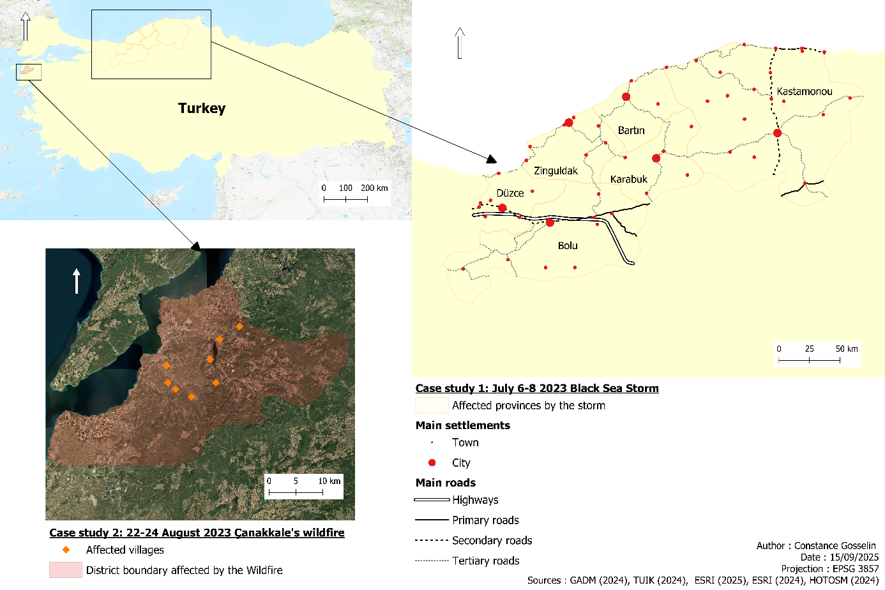
Figure 1: Areas impacted by the studied small- to medium-size natural hazards in Türkiye. The lower-left inset shows the wildfire area and the localities impacted in orange, according to IDMC reports of internal displacement [49]. The right-hand inset shows the provinces affected by the storm, together with the main road network and settlements from the Turkish Statistical Institute [45].
The first case study is a severe storm accompanied by torrential rainfall that struck northern Türkiye between 6 and 8 July 2023. The event primarily affected the Black Sea coastal provinces of Düzce, Kastamonu, Karabük, Bolu, Zonguldak, and Bartın, located northeast of Istanbul [3, 36]. Intense precipitation, locally exceeding 120 mm per day [37, 38], triggered flooding, flash floods, and landslides, particularly in river valley systems [39, 40]. Major urban and rural districts were impacted, including Yığılca in Düzce, Cide in Kastamonu, Devrek and Gökçebey in Zonguldak, Kurucaşile and Amasra in Bartın, and several areas in Karabük and Bolu. In total, more than 700 people were temporarily displaced, more than 6,000 were affected, and substantial disruptions to transportation infrastructure were reported, including damaged roads and isolated communities [3, 40].
The second case study is a wildfire of smaller spatial extent that affected low-population areas in Çanakkale Province, northwestern Türkiye, near the Dardanelles Strait. The fire broke out on 22 August 2023 near Damyeri and was declared under control on 24 August, although its impacts extended until 25 August [41]. According to official reports, 1,428 people were evacuated from nine villages: Kayadere, Damyeri (Fevzi Çakmak Mahallesi), Yağcılar, Ulupınar, Belen, Kalabaklı, Aşağıokçular, Kızılcaören, and Taşlıtarla [3, 41]. The wildfire burned approximately 4,400 hectares and affected 395 houses [42]. Firefighting operations mobilized substantial resources, with more than 2,600 personnel, 10 aircraft, and 26 helicopters involved in the response [43]. The event also caused major transport disruptions, including the temporary closure of the Çanakkale–Çan highway and the suspension of maritime traffic in the Çanakkale Strait to facilitate seawater collection by firefighting aircraft. Although no human casualties were reported, the wildfire caused substantial material and environmental damage.
The storm and wildfire were selected because they represent contrasting hazard profiles. The July storm covered a broad spatial extent, affecting both rural and densely populated areas across several provinces. This widespread impact, combined with higher user density in affected regions, increases the likelihood that changes in mobility would be detectable in the MDM dataset. By contrast, the Çanakkale wildfire was a localized but high-intensity disruption in a sparsely populated, semi-rural setting. Its detection in MDM is expected to be more challenging because displacement was probably short-distance, the affected population was limited, and the event lasted only a few days. Together, the two events provide complementary test cases for evaluating the sensitivity of MDM to hazards of different magnitude, spatial footprint, and demographic context.
3. Materials and Methods
3.1 Data
This study is based on MDM dataset, made available through the AI for Good initiative launched by Meta, formerly Facebook. The dataset provides anonymized, aggregated mobility information derived from geotagged locations of Facebook app users who have opted into location sharing via the mobile application. For each district and day, MDM reports the fraction of users whose travel distances fall within one of four categories: immobility, short-range mobility (0–10 km), medium-range mobility (10–100 km), and long-range mobility (>100 km). These categories are computed by comparing a user’s nighttime location, interpreted as the place of residence, with a randomly sampled daytime location from the same user’s app activity [25]. Because the four-distance classes partition the same district-day user population, their proportions should theoretically sum to one.
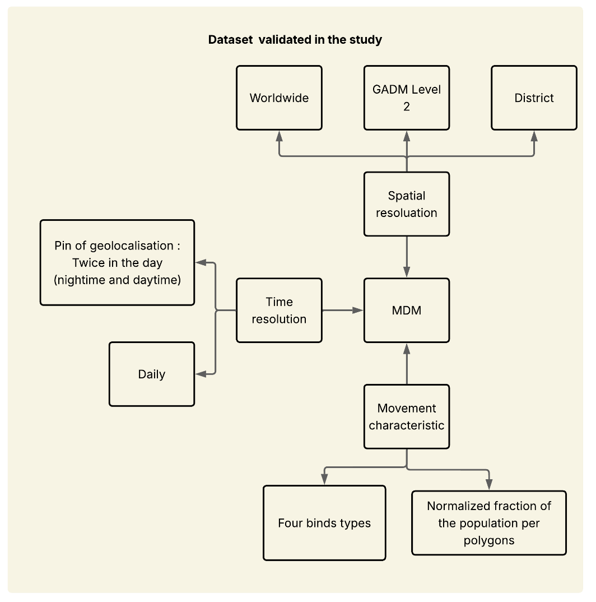
Figure 2: Diagram summarizing the main characteristics of the MDM dataset validated in this study.
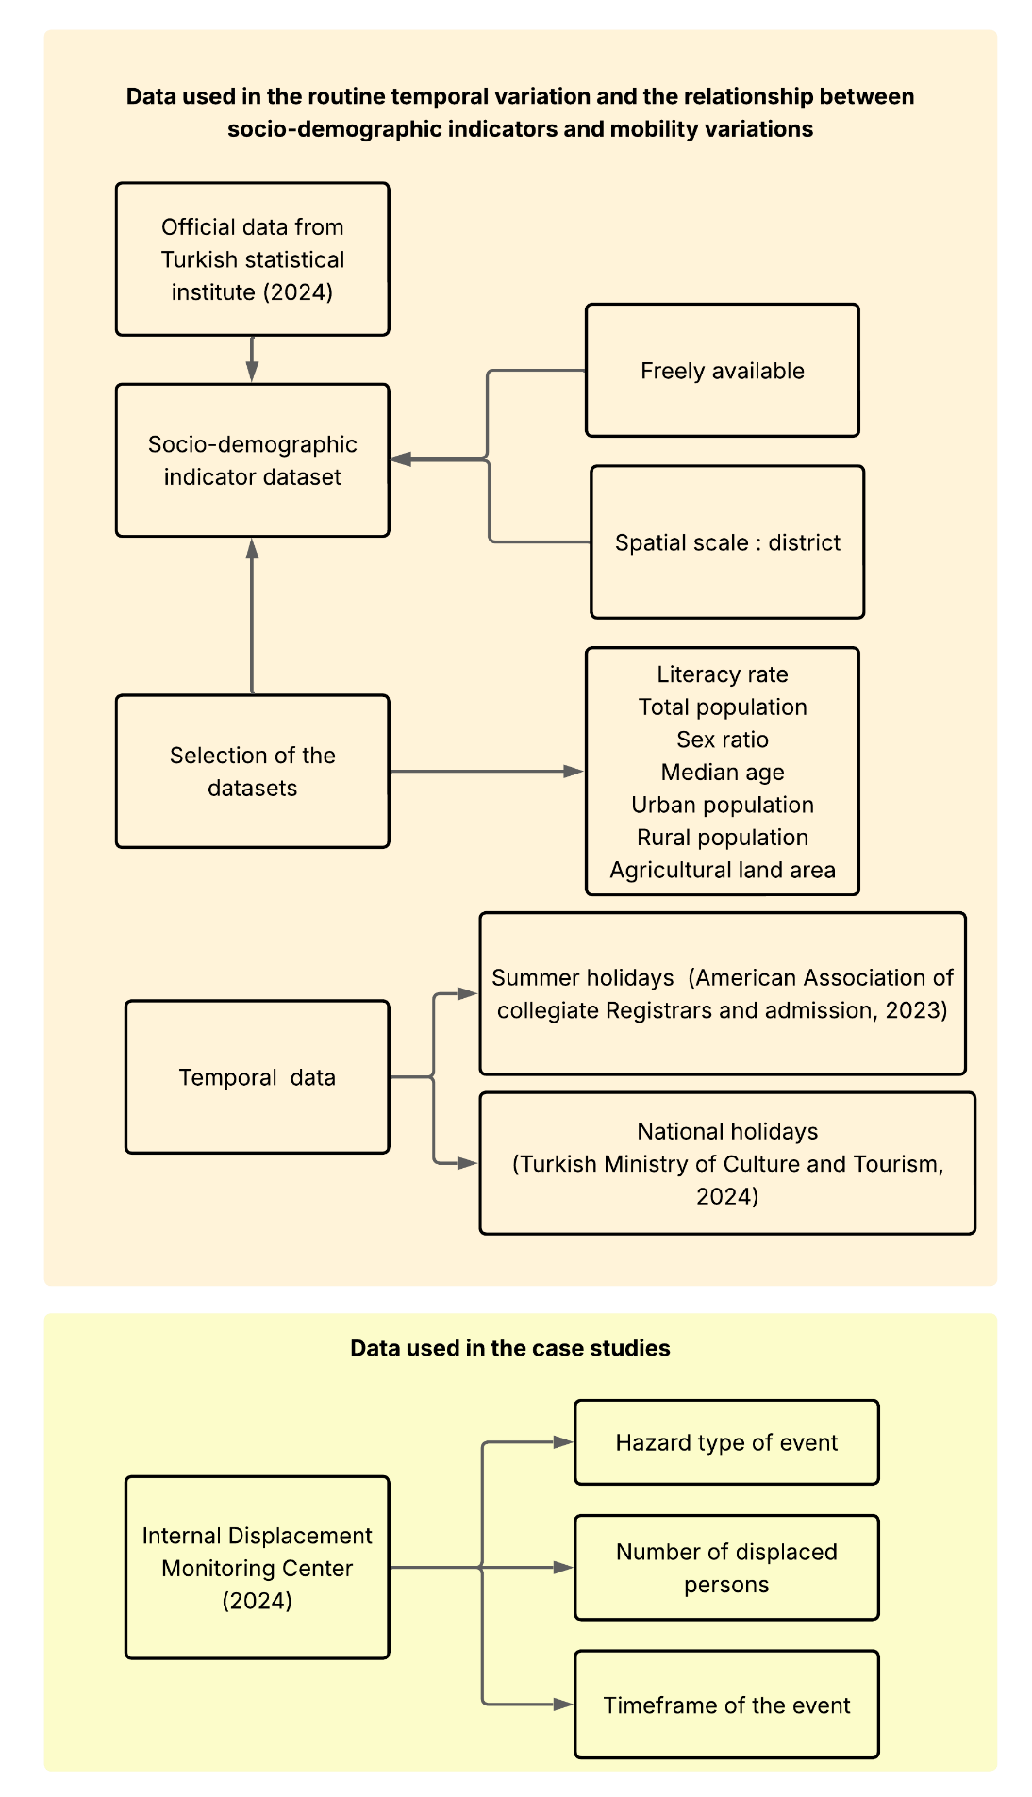
Figure 3: Diagram summarizing the complementary socio-demographic, temporal, and hazard-related datasets used for validation and case-study selection.
For this research, MDM data were downloaded from the Humanitarian Data Exchange platform for the period from 1 December 2022 to 31 March 2024. The dataset is distributed as monthly table files. Only records corresponding to the GADM identifier “TUR” were used, as this identifier corresponds to Türkiye. Geolocation is based on GADM Level 2 administrative boundaries [44], providing district-level resolution. To ensure user privacy, Meta applies differential privacy techniques, including the addition of Laplace noise with a privacy budget ε = 1 and the suppression of records with fewer than 10 users in a given administrative unit [25]. Despite limitations introduced by anonymization and possible spatial inconsistencies in administrative divisions, MDM remains one of the few open-access resources providing daily mobility trends at a relatively fine spatial scale.
Several complementary datasets were integrated to contextualize and interpret the MDM data. Socio-demographic indicators were drawn from the Turkish Statistical Institute (TÜİK) [45] and include literacy rate, total population, sex ratio, median age, proportions of urban and rural populations, and the share of agricultural land at the district level. These annually updated variables, all referring to 2023, were used to test correlations with observed mobility patterns and to assess whether specific demographic profiles are over- or under-represented in the MDM dataset. Temporal event datasets were also used to evaluate mobility responses to planned or recurrent disruptions. Summer holiday dates were compiled from the American Association of Collegiate Registrars and Admissions Officers [46] and Feiertagskalender [47], while national holidays were identified from the Turkish Ministry of Culture and Tourism [48] and Feiertagskalender [47], including major religious celebrations such as Eid. Hazard-related data were drawn from the Internal Displacement Monitoring Centre (IDMC) database [49], which provides event-by-event information on hazard-induced displacement, including the type, timing, and estimated number of displaced persons. These hazard data were used to select and contextualize the storm and wildfire case studies.
3.2 Methodological workflow
The methodology was designed to evaluate both the internal consistency of MDM and its ability to detect mobility disruptions associated with natural hazards in Türkiye (Figures 4 and 5). It is organized into two complementary components. The first component validates and interprets the MDM mobility indicators by characterizing baseline mobility patterns, assessing the impact of privacy-preserving noise, and identifying potential socio-demographic biases. The second component applies the validated framework to the two case studies described above, in order to assess the robustness and sensitivity of MDM under real-world hazard conditions at different spatial scales. All data processing and statistical analyses were performed in Python using the geopandas, datetime, pandas, numpy, scipy, matplotlib, and seaborn libraries.

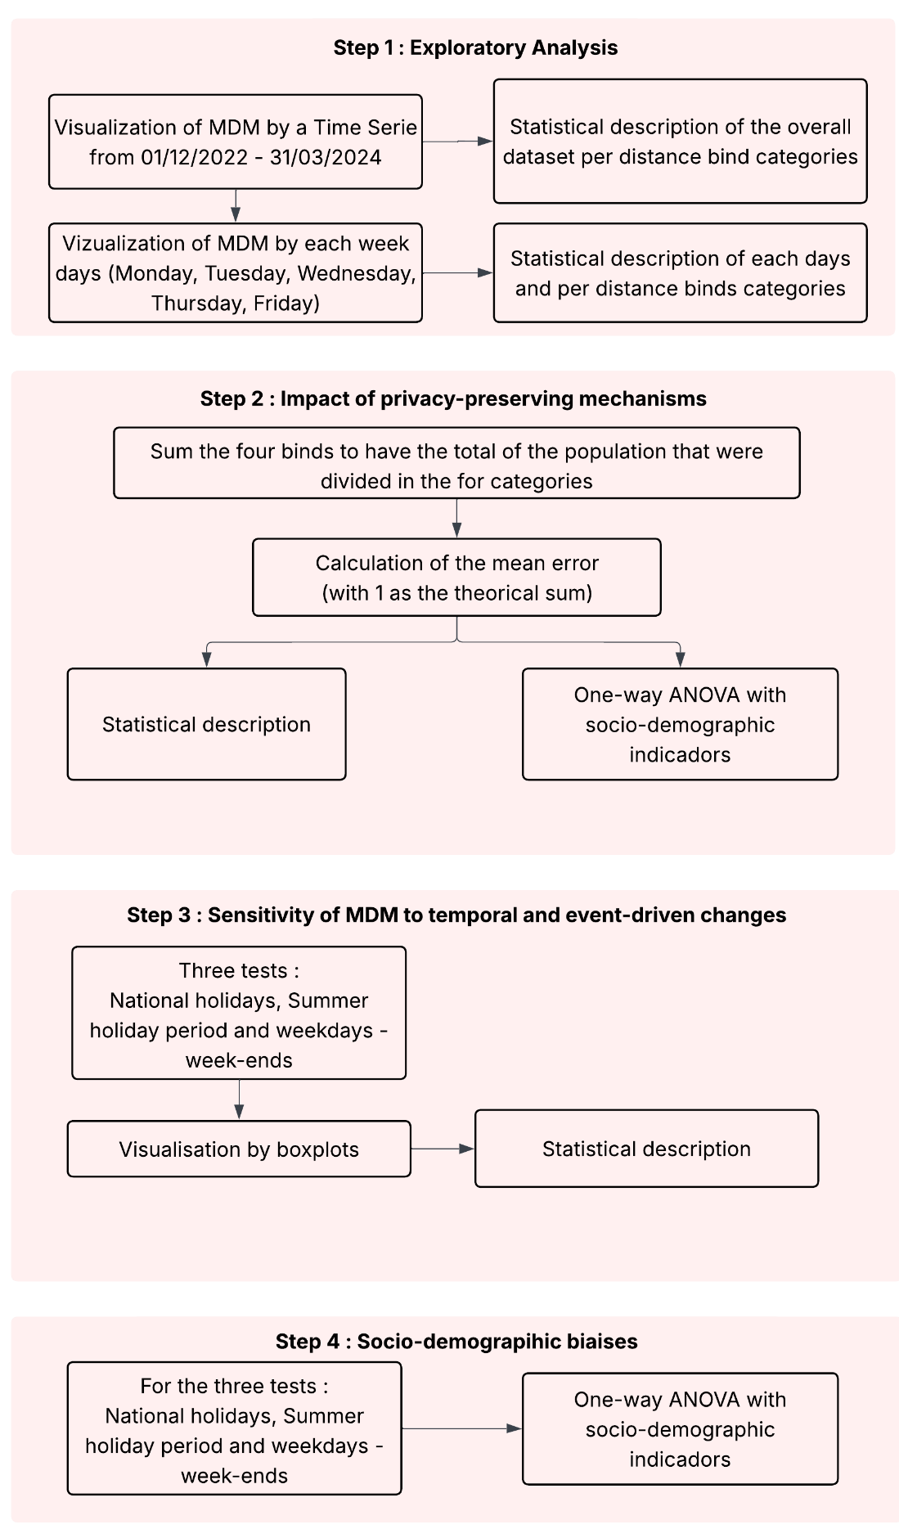

Figure 4: Main steps used to validate MDM internal coherence, temporal sensitivity, and socio-demographic relationships.

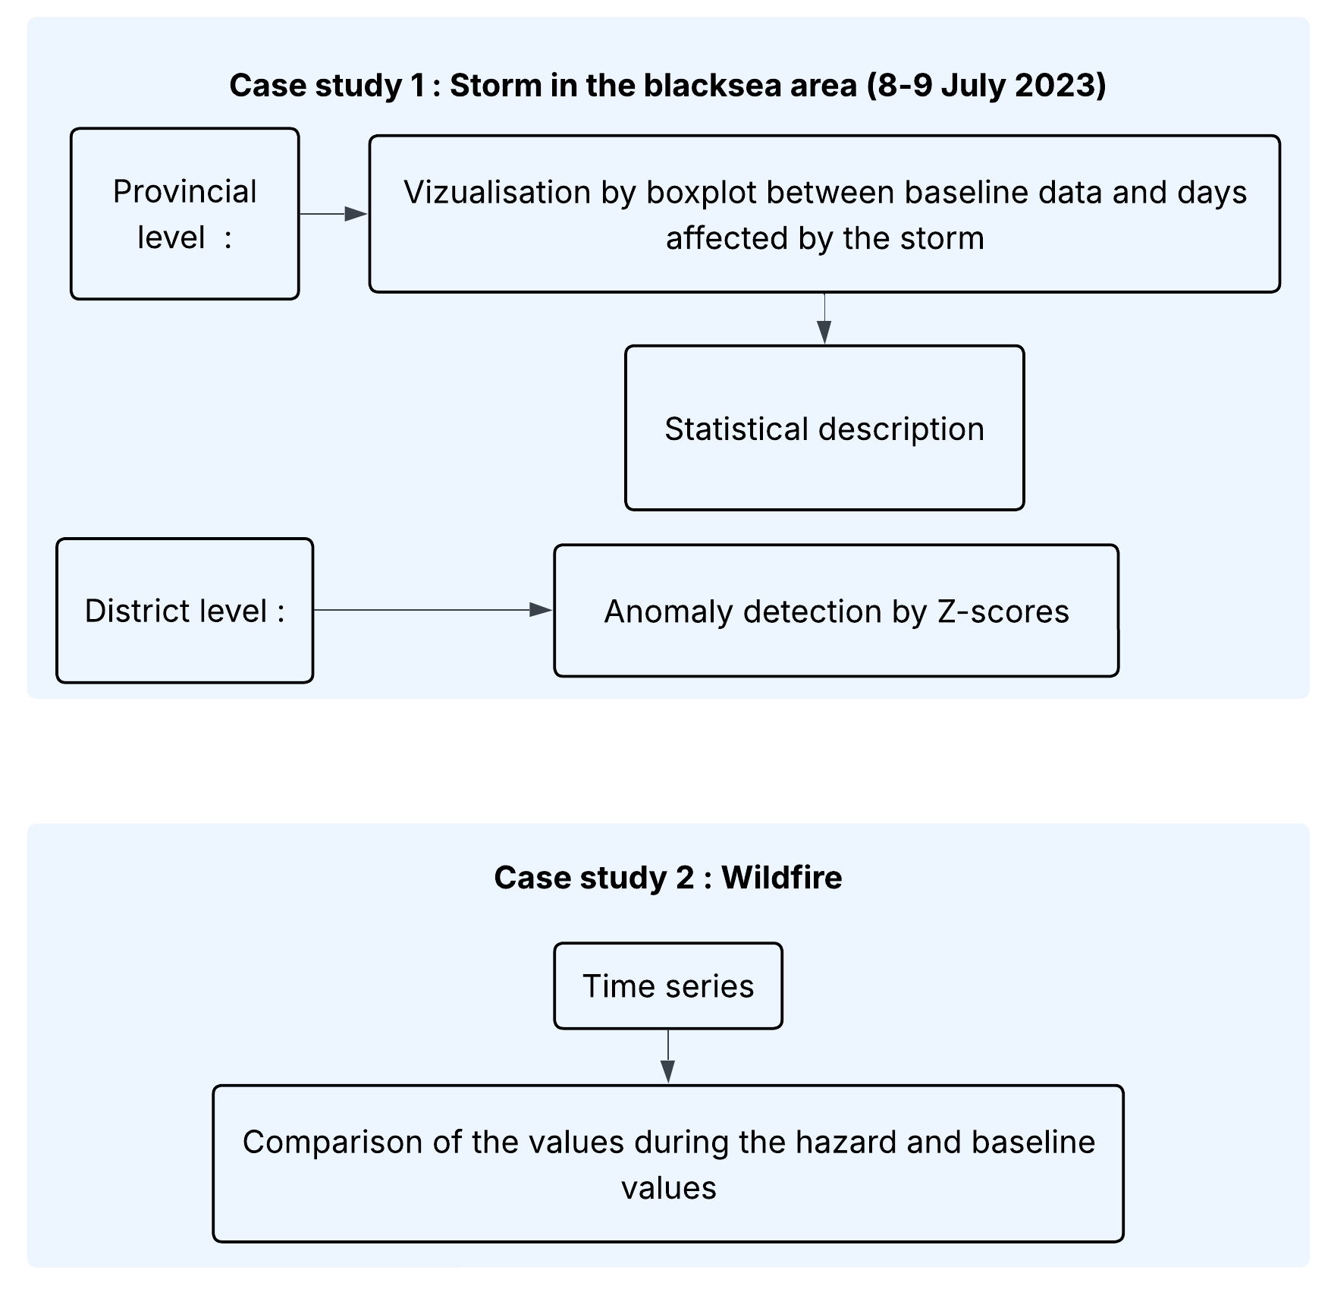
Figure 5: Main methodological steps used for the two natural-hazard case studies.
The validation of MDM was structured into four sequential steps. First, an exploratory analysis characterized usual mobility patterns and identified temporal variations within the dataset. MDM observations were analysed at the district-day level for the full territory of Türkiye, and national daily values were computed by averaging across districts for each mobility category. Boxplots grouped by day of the week and descriptive statistics, including mean, variance, and skewness, were used to establish baseline mobility behaviours. Second, the effect of Meta’s privacy-preserving procedure was evaluated by testing the internal closure of the four published mobility fractions. For each district-day observation, the four fractions should theoretically sum to one. Deviations from this value were quantified using the absolute difference between the published sum and unity, and their distribution was analysed through descriptive statistics and outlier detection. These closure errors were then compared with normalized socio-demographic indicators using Pearson correlations and one-way ANOVA to assess whether privacy-related deviations were randomly distributed or associated with specific territorial and demographic contexts.
The third validation step assessed the sensitivity of MDM to temporal and event-driven changes. Mobility variations were analysed for weekday-weekend transitions, for the summer holiday period from 15 June to 11 September 2023, and for national holidays. National holidays were compared with reference days corresponding to the same weekday during the preceding three weeks. For each event type, mobility values were aggregated at the national level, distributions were visualized with boxplots, and mean, variance, and skewness were calculated for both event and baseline periods. The fourth step examined whether observed mobility shifts were influenced by socio-demographic factors. Mobility change was defined as the difference between event and baseline values, and Pearson correlation coefficients were calculated between these shifts and district-level indicators for each mobility category. ANOVA tests were also used to compare mobility changes across demographic groups, enabling evaluation of whether observed responses reflected actual population behaviour, privacy-preserving noise, or the interaction of both.
The case-study component applied this framework to the storm and wildfire events. For the July storm, mobility was first analysed at the provincial level by comparing MDM values on 8 and 9 July 2023 with a baseline derived from the same weekdays during the post-event summer period, from 11 July to 4 September 2023. Analysis was restricted to districts within affected provinces, and deviations from baseline were visualized using boxplots and summarized with descriptive statistics. At the district level, anomalies were detected using z-scores, calculated as the difference between observed mobility and the baseline mean divided by the baseline standard deviation. Values with |z| ≥ 2 were interpreted as moderate anomalies and values with |z| ≥ 3 as strong anomalies. Positive values indicate an increased fraction of Facebook users in a given distance category, whereas negative values indicate a decrease.
For the wildfire, the analysis focused on a localized disruption affecting villages within Çanakkale Province. This event provided an opportunity to evaluate MDM sensitivity under low-intensity and fine-scale conditions. Mobility was analysed as a time series by comparing daily values during the wildfire with baseline values derived from the same weekday over the three preceding weeks. The aim was to detect localized shifts in immobility and short-range mobility while accounting for the potential influence of privacy-preserving noise in small-population areas.
4. Results
4.1 Baseline mobility patterns and temporal variations
From December 1, 2022, to March 31, 2024, MDM indicate that everyday movement in Türkiye is predominantly local (Figure 6). In 2023, 39% of Facebook users did not move on a given day, 54% travelled short distances (0–10 km), 6% travelled medium distances (10–100 km), and fewer than 1% undertook long-range trips (>100 km). These patterns highlight that most mobility occurs within local districts, with longer-distance travel being relatively rare (Figure 6).
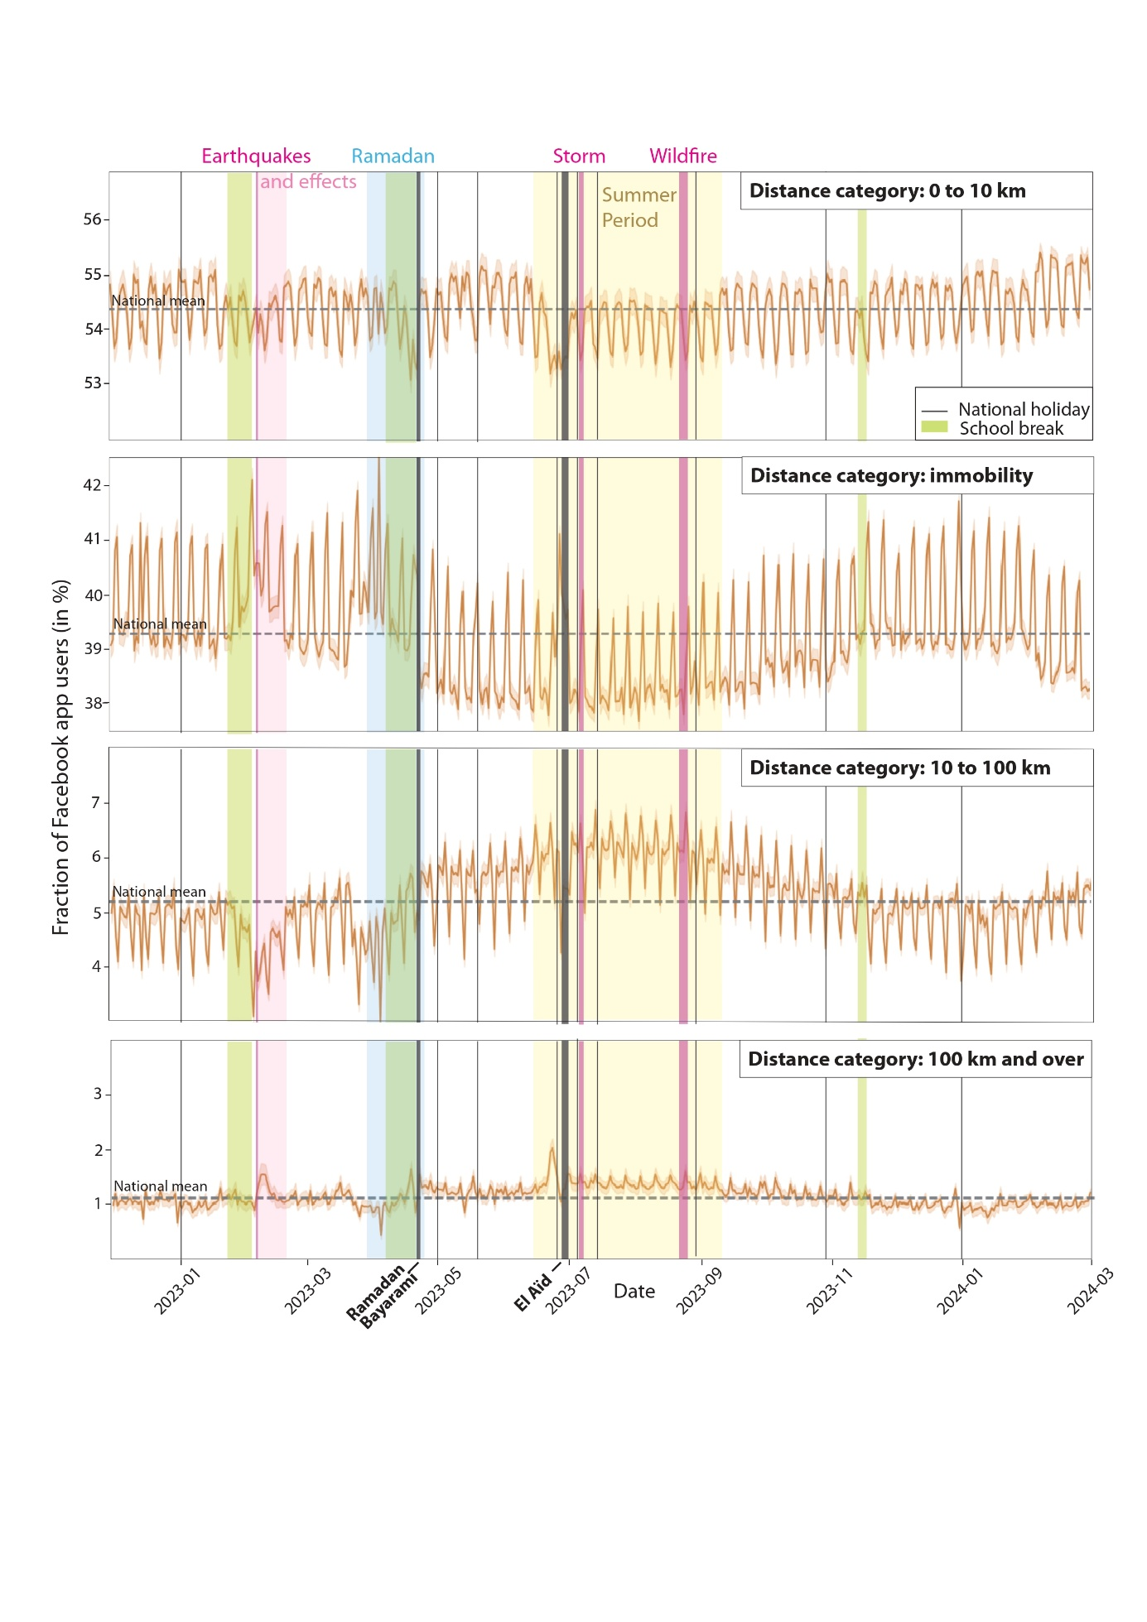
Figure 6: Oscillations of the four MDM distance categories from December 2022 to March 2024. The time series highlights recurrent mobility changes linked to weekends, national and religious holidays, and the summer vacation period. In addition to these regular variations, the dataset also captures exceptional disruptions, most notably the large-magnitude earthquakes of 6 February 2023, which strongly affected mobility patterns at the national scale.
Daily and weekly cycles reveal systematic fluctuations (Figures 6 and 7). Immobility and short-range travel exhibit clear inverse weekly oscillations: short-range mobility slightly increases during weekdays (≈54–55%) while immobility decreases (≈40–38%), with the pattern reversing on weekends (Figure 7). Medium- and long-range travel show smaller but notable variations. Medium-range trips dip by ≈0.4% on weekends, consistent with reduced long-distance commuting, and peak by up to 0.6% on Fridays, particularly between May and November, but are absent in winter (Figure 6). Both medium- and long-range mobility distributions are highly skewed and leptokurtic (skewness = 1.52 / 2.95; kurtosis = 9.4 / 30.2), reflecting that most districts record low levels of such trips, while a few districts experience much higher mobility, creating long right-hand tails.
Mobility also follows broader seasonal patterns (Figures 6 and 8). From Ramazan Bayramı (23 April) onward, increasing temperatures and school closures reduce immobility by about 1.1 percentage points, while medium-range travel rises by ≈1.0%. This trend peaks during the summer holiday period (mid-June to late August), when routine commuting nearly disappears. During this period, the weekday–weekend difference in immobility narrows to less than 1.2%, medium-range mobility shows a Friday peak (+0.26%) and a smaller return on Sundays, short-range travel decreases modestly (≈–0.4%), and long-range trips rise slightly (≈+0.05%). In late autumn, as schools reopen and colder weather sets in, immobility rises again while medium-range travel returns to pre-summer levels (Figure 6).
Calendar events further modulate mobility in ways that confirm the temporal sensitivity of the dataset (Figures 6 and 8). During Ramadan (23 March-20 April), immobility increased by +0.5%, while medium-range and long-range travel declined by -0.4% and -0.1%, respectively. During the school break marking the end of Ramadan (17-20 April), immobility and short-range travel decreased (-0.3% and -0.9%), whereas medium-range mobility increased by +0.3%. In the three days preceding Bayram (21-23 April), medium-range travel continued to rise (+0.1%), and a modest long-range peak also appeared (+0.02%), consistent with departures from major cities toward hometowns and coastal areas. A stronger mobility response occurred during Kurban Bayramı (Eid al-Adha, 28 June-1 July), when additional administrative leave on 26-27 June and 2 July effectively created a nine-day public-sector holiday. This period produced the highest immobility spike in the dataset (+3%) and the largest increase in long-range travel (+0.6%).
The MDM time series also records unplanned disruptions, with the 6 February 2023 earthquakes producing the strongest anomaly observed in the dataset (Figure 6). The Mw 7.8 and Mw 7.6 earthquakes devastated 11 provinces in southeastern Türkiye [50], with more than 120,000 km² exposed to shaking of intensity VII or higher on the EMS scale. At the national level, the anomaly persisted for approximately three weeks: immobility increased by +5%, while long-range travel fell by -0.4%. Medium-range movements remained limited during the first week but rose by about 0.2% during the second week, consistent with post-crisis evacuations once highways and coach services reopened [51, 52]. Short-range travel remained comparatively stable, reflecting continued local activity associated with essential needs and aid delivery. This pattern shows that MDM captures both the immediate immobilization caused by a large-scale disruption and the subsequent recovery or evacuation phase linked to infrastructure reopening and organized movements.
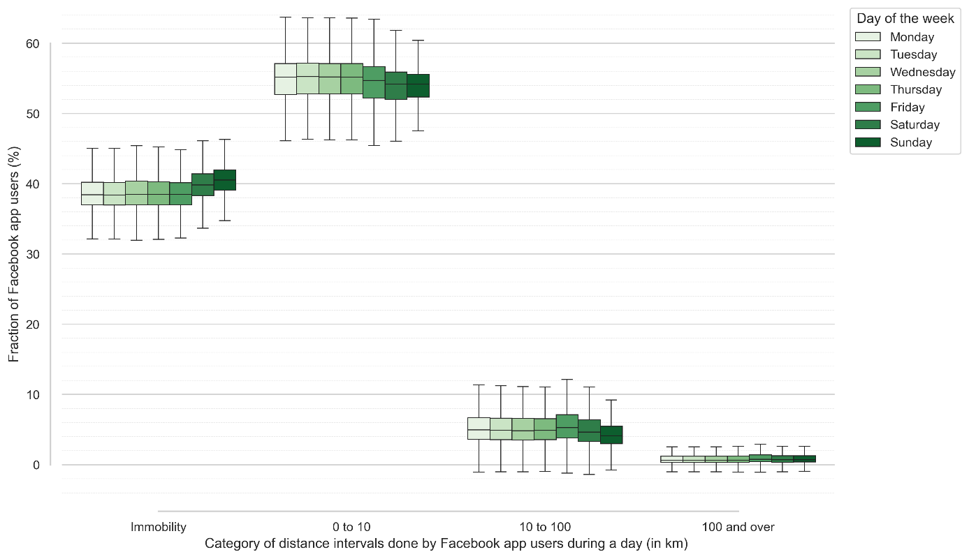
Figure 7: Weekly oscillations in mobility behaviour across Türkiye from January to December 2023. The immobility and short-range (0–10 km) categories display clear inverse weekly patterns, with immobility peaking on Sundays and local mobility higher on weekdays.
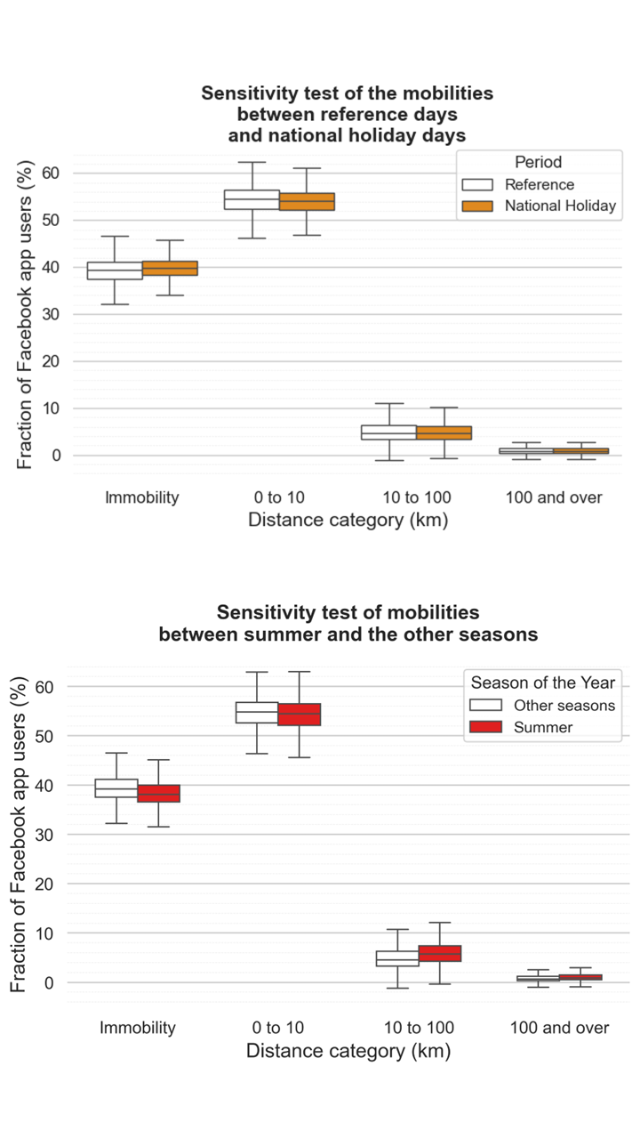
Figure 8: Mobility changes during Turkish national holidays and the summer period. The left panel compares national holidays with same-weekday reference days from the three weeks preceding each holiday. The right panel compares the summer period (15 June–11 September 2023, corresponding to the official school holiday period) with the non-summer period.
4.2 Data consistency, privacy noise, and closure errors
To evaluate the integrity of the MDM dataset, daily fractions across the four distance categories were summed for every district-day. Despite the addition of Laplace noise (privacy budget ε = 1) and the suppression of polygons with fewer than ten users, the sums cluster tightly around unity (mean = 1.00; mean absolute error ≈ 0.057), indicating that differential-privacy safeguards do not distort the data at the aggregate level. Although the average error is small, the distribution of daily sums is highly leptokurtic (kurtosis = 247), revealing occasional extreme deviations that require closer examination.
The analysis of these deviations shows that closure errors are not entirely random but follow systematic socio-demographic patterns (Figure 9). Pearson correlation coefficients (r) were used to measure the direction and strength of linear relationships, while F-values from one-way ANOVA indicate whether differences between district groups are statistically significant. Larger errors are associated with higher rural population ratios (r = 0.41; F = 17.0), lower literacy (r = 0.59; F = 87.7), higher proportions of women (r = 0.38; F = 44.6), and smaller total populations (r = -0.71; F = 32.8). These relationships indicate that the effect of privacy-preserving noise is strongest in less populated and more rural districts, where the underlying number of Facebook users is likely to be lower.
4.3 Mobility sensitivity to socio-demographic indicators
The socio-demographic analyses show that total district population is one of the most pervasive controls on mobility patterns (Figure 9). Urban districts display pronounced commuting periodicity and stronger holiday exodus, while their larger user counts also provide more stable estimates. By contrast, sparsely populated districts show more stable routine mobility but are disproportionately affected by privacy-related noise. Median age is the strongest predictor of mobility variability: younger districts display the largest weekday-weekend swings (F = 913 for immobility; F = 851 for medium-range trips) and the sharpest summer decline in immobility (F ≈ 108-132). Literacy further modulates distance choice. During summer, high-literacy districts show small but significant increases in long-range trips (F = 4.9; r = 0.14), whereas low-literacy districts register stronger shifts in medium-range mobility (F = 7.8; r = -0.12). Age and literacy together amplify fluctuations in immobility during national holidays (F = 18; r = -0.24) and weekday-weekend contrasts (F = 19; r = -0.27).
Sex composition and rural-urban context have secondary but still interpretable effects (Figure 9). Districts with a higher proportion of women maintain steadier immobility between weekdays and weekends (F = 198; r = -0.48), whereas male-dominated districts show modest increases in long-range trips on Fridays (F = 8.96; r = 0.20) and during national holidays (F = 6.03; r = -0.16). During summer breaks, female-dominated districts contribute slightly more to long-range mobility (F = 15.23; r = 0.20). Rural districts show weekend increases in medium-range trips, likely reflecting travel to access services in nearby towns, whereas urban mobility remains concentrated in the short-range category.
Taken together, these results demonstrate that the Meta MDM dataset, despite strong differential-privacy safeguards, is sensitive enough to capture fine-grained behavioural differences rooted in demography (Figure 9). Population size predicts the extent of mobility, while age and literacy determine distance travelled choice. Sex composition and rurality exert only secondary, context-specific effects such as national holidays or school holidays. This multi-scalar sensitivity underscores the value of the dataset for studying routine mobility patterns in Türkiye [53]. A summary figure illustrating the influence of socio-demographic indicators is provided in Figure 9.
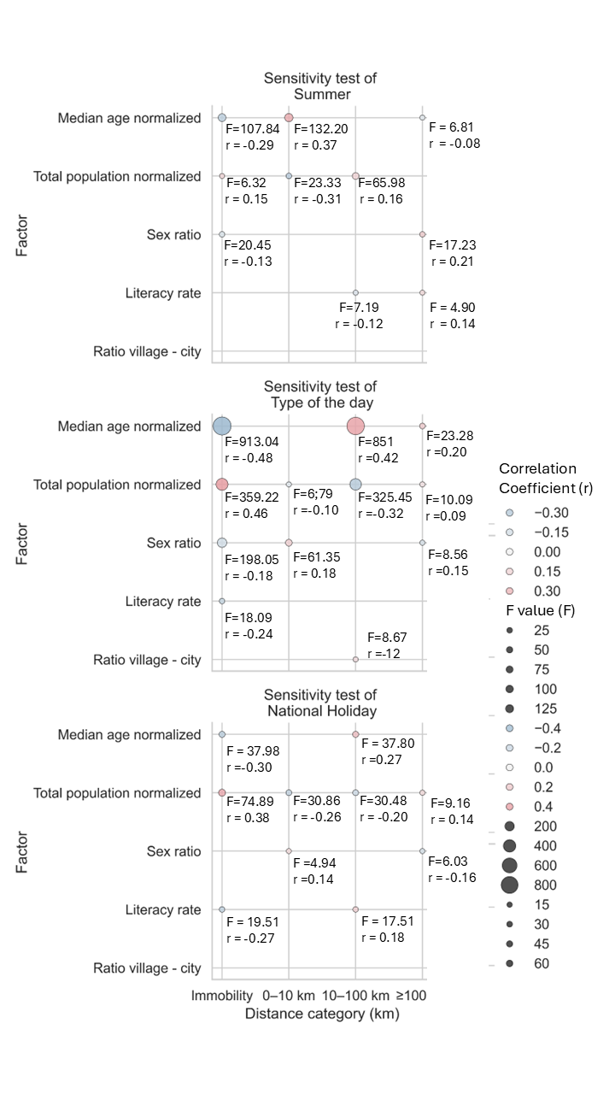
Figure 9: Significant relationships between mobility categories and socio-demographic/contextual factor pairs. The horizontal axis shows the four mobility categories (immobility, short-range 0–10 km, medium-range 10–100 km, and long-range >100 km). The vertical axis lists pairs of socio-demographic indicators and contextual factors for which ANOVA tests returned statistically significant p-values. Colours indicate the strength and direction of the Pearson correlation coefficient, while dot size represents F-values.
4.4 Response to two natural hazards with different spatial imprints
To assess the MDM dataset's ability to detect displacement linked to hazard events that do not disrupt mobility at the national scale, two case studies were analysed: the July 2023 storm and the August 2023 wildfire. This part of the analysis therefore tests MDM sensitivity at smaller spatial scales, namely the province and district levels, and compares a regional event affecting several provinces with a more localized disturbance in a sparsely populated area.
For the July storm, province-level analysis provides a first indication of how MDM captures mobility changes associated with a medium-intensity hazard affecting six Turkish provinces (Figures 10 and 11). The most consistent responses occur in the immobility and medium-range mobility categories, which vary in opposite directions as the storm moved eastward across the Black Sea region.
On 8 July, mobility disturbances first appeared in the medium-range category across three coastal provinces. Düzce, the westernmost province and the first to be struck, shows a -1.32% drop in medium-range mobility, likely linked to major highway disruptions and official travel advisories. In Bartın, mobility decreased both in the medium-range (-1.88%) and long-range categories, mainly because of the closure of the main access road to the province. Zonguldak, located between Düzce and Bartın, shows a similar pattern, with immobility increasing by +0.88%, although the medium-range decrease is not statistically significant. At the peak of the storm on 9 July, the six affected provinces combined show significant changes: immobility increased by +1.38%, mirrored by a -1.76% fall in medium-range travel. The strongest effects were recorded in the coastal provinces of Zonguldak and Bartın, where immobility rose by +1.56% and +2.86%, respectively, and medium-range mobility fell by -1.42% and -2.97%. In contrast, the interior provinces of Bolu, Düzce, Karabük, and Kastamonu do not display statistically significant province-level changes, suggesting that localized or heterogeneous disruptions may be masked when aggregated at the provincial scale.
District-level anomalies expressed as z-scores confirm that the strongest disruptions were concentrated in coastal areas, while also revealing spatial heterogeneity that is not visible in the province-level analysis (Figures 12 and 13). In Düzce, only one district shows a significant anomaly, whereas all districts in Bartın are affected. Strong negative anomalies are also recorded in several districts of Kastamonu and Karabük on 9 July. In Bolu, some districts show strong but opposing anomalies, which likely explains why the aggregated provincial signal remains weak. In the medium-range category, the strongest negative anomalies correspond to documented traffic disruptions, again highlighting the sensitivity of MDM to accessibility constraints.

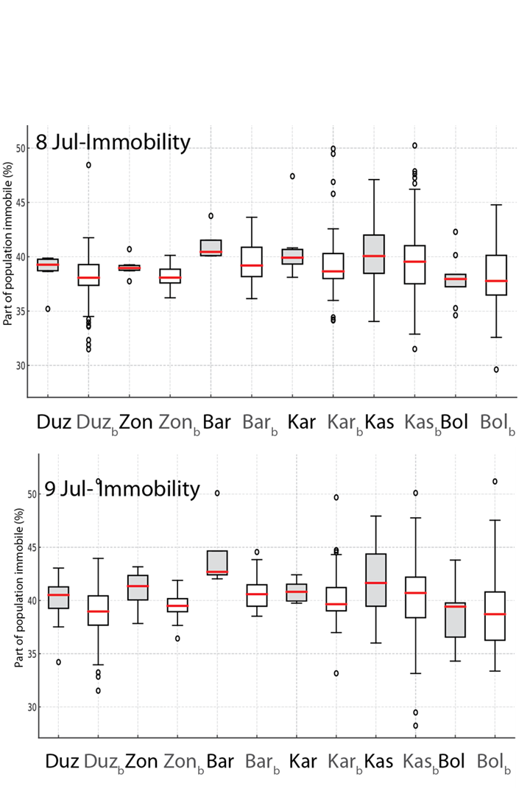

Figure 10: Changes in immobility by province during the 8 July and 9 July storm. For each panel, grey boxplots show the mobility distribution of the affected provinces for the day of the storm, while white boxplots represent the reference baseline constructed from the same weekday during the post-storm period up to 4 September 2023. Province abbreviations are Duz: Düzce; Zon: Zonguldak; Bar: Bartın; Kar: Karabük; Kas: Kastamonu; Bol: Bolu; the subscript b indicates the baseline of each province.

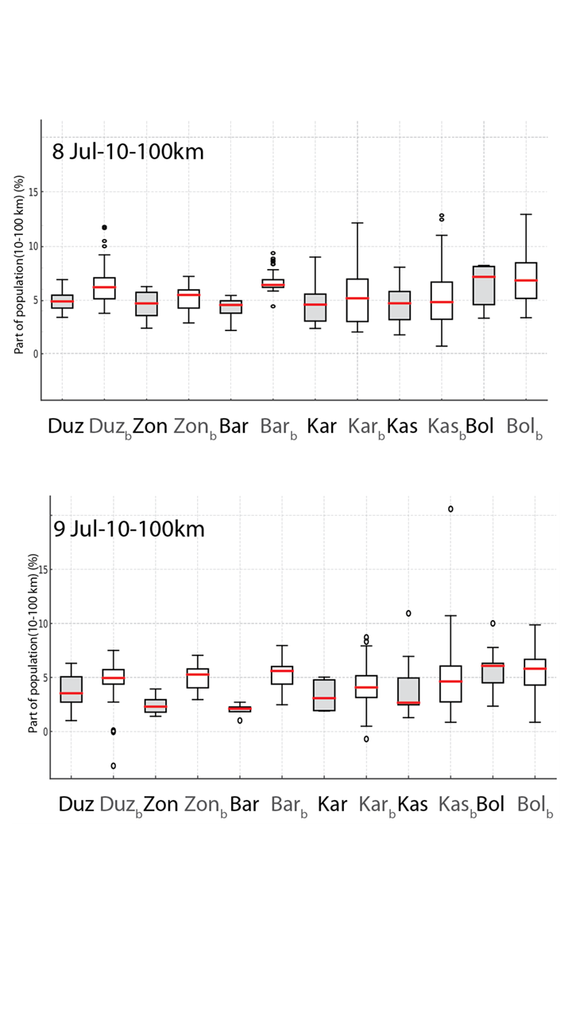
Figure 11: Changes in medium-range mobility (10–100 km) by province during the 8 July and 9 July storm. Grey boxplots show the mobility distribution of the affected provinces for the day of the storm, while white boxplots represent the reference baseline constructed from the same weekday during the post-storm period up to 4 September 2023. Province abbreviations are Duz: Düzce; Zon: Zonguldak; Bar: Bartın; Kar: Karabük; Kas: Kastamonu; Bol: Bolu; the subscript b indicates the baseline of each province.

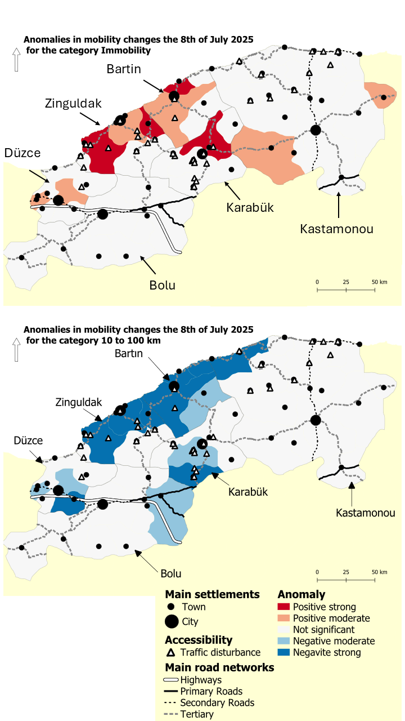

Figure 12: District-level anomalies in mobility patterns during the 8 July 2023 storm event. The upper map shows immobility and the lower map shows medium-range mobility (10–100 km). Anomalies are calculated as z-scores by comparing the event-day value with the mean and standard deviation of the same weekday across the summer holiday period (11 July–4 September, excluding event days). Z-scores ≥ 3 are classified as strong anomalies, while values ≥ 2 represent moderate anomalies. Positive values indicate a higher-than-expected fraction of the population in the mobility category, whereas negative values indicate a lower-than-expected fraction.

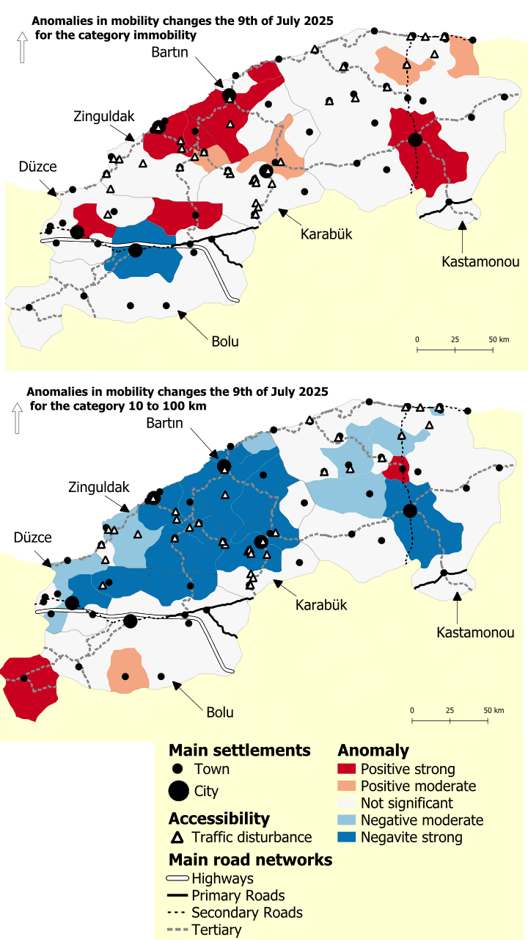
Figure 13: District-level anomalies in mobility patterns during the 9 July 2023 storm event. The upper map shows immobility and the lower map shows medium-range mobility (10–100 km). Anomalies are calculated as z-scores by comparing the event-day value with the mean and standard deviation of the same weekday across the summer holiday period (11 July–4 September, excluding event days). Z-scores ≥ 3 are classified as strong anomalies, while values ≥ 2 represent moderate anomalies. Positive values indicate a higher-than-expected fraction of the population in the mobility category, whereas negative values indicate a lower-than-expected fraction.
The wildfire produces a more modest but still interpretable mobility signal (Table 1). MDM values mainly change in the immobility and short-range travel categories, which show an inverse relationship. On the first day of the fire, the proportion of users travelling 0-10 km increased by +0.4%, while immobility decreased by a similar amount. These variations were most pronounced on the first day and persisted, although less clearly, until the final day of the event.
Timeline | Category | No Movement | 0–10 km | 10–100 km | 100+ km
Reference | Before Mean | 37.0 | 58.2 | 3.94 | 0.79
2023-08-22 | During | 36.6 | 58.6 | 3.79 | 0.10
2023-08-23 | During | 36.7 | 58.8 | 3.78 | 0.72
2023-08-24 | During | 37.3 | 57.9 | 4.05 | 0.72
2023-08-25 | After | 36.6 | 58.3 | 3.96 | 0.11
Table 1: Daily mobility percentages during the 22–25 August wildfire case study. Values are raw MDM percentages for the affected district (Damyeri), expressed as percentages of Facebook app users.
Taken together, the storm and wildfire case studies show that the MDM dataset can detect mobility anomalies in response to hazards with contrasting spatial footprints. The storm produced clear and spatially extensive signals at both the provincial and district levels, especially in the medium-range category. The wildfire generated weaker but still detectable short-range changes in the affected area, consistent with a localized displacement response. This comparison shows that MDM is most effective for widespread disruptions but may still capture localized events when the affected share of the user population is sufficiently large.
5. Discussion
5.1. MDM dataset sensitivity to national-level mobility changes
This study evaluated the usability of MDM dataset for analysing displacement patterns associated with natural hazards. Through a detailed validation of its internal structure, temporal sensitivity, and responsiveness to actual hazard events, we identified both the strengths and the limitations of this novel data source.
The findings confirm that the MDM dataset is well-structured, internally consistent, and capable of detecting meaningful variations in population mobility, particularly those linked to socially structured time disruptions such as weekends, holidays, and school vacations. Its daily resolution and district-level granularity make it especially valuable for capturing short-term changes in movement patterns, a key feature when studying fast-onset hazards like storms or wildfires. Moreover, its public availability and transparent processing position it as a valuable alternative to proprietary mobile phone data, which often remain inaccessible to academic or humanitarian institutions due to privacy and licensing constraints [23, 54].
Baseline results show that the majority of Facebook users in Türkiye travel no more than 10 km per day. Comparable ratios are reported for Istanbul, where 81% of trips are <10 km and two-thirds are <5 km [55]. Similarly, Masoumi [56] reported a mean one-way commute of 10.8 km in Istanbul, placing most daily trips in the short-range category. A national household survey from 2018 likewise found that 79% of Turkish households travel between cities less than once a month [53]. These external sources corroborate the national MDM picture of mobility being heavily confined to the immobility and short-range categories.
The weekday–weekend oscillation provides further insights, mirroring findings from Apple and Google mobility datasets [57], the Microsoft GeoLife GPS Trajectory Dataset [58], and global mobile-phone records [59]. The observed swing reflects the well-documented shift from weekday commuting to higher immobility on rest days [58]. The Friday peak likely combines early leisure departures and weekly returns of long-distance workers, since Türkiye has a significant population of employees who work in another city during the week and travel home on Friday evenings. Another factor may be families leaving major cities for secondary residences or coastal resorts.
The dataset also demonstrates strong sensitivity to national holidays and Ramadan. National holidays produce the largest mobility changes, with overlapping school holidays acting as amplifiers. Importantly, this mobility remains stratified by socio-demographic factors, underscoring that the most vulnerable populations often face reduced capacity for mobility.
The large-magnitude earthquakes of 6 February 2023—described by the Turkish president as the “disaster of the century” [60]—triggered the most severe unplanned disruption captured by the dataset. A three-month state of emergency was declared in the ten most affected provinces to accelerate relief operations. MDM registered a nation-wide anomaly comparable in magnitude to national holiday effects. According to IOM’s Displacement Tracking Matrix, approximately 2.7 million people left the affected region in the first month [51]. Flowminder’s telecom analysis likewise showed a sharp initial contraction of regional mobility followed by progressive out-migration after 13 February [61]. These external validations confirm that MDM captures both the immediate immobilization and the subsequent evacuation phase of this unprecedented hazard.
5.2. MDM dataset sensitivity to socio-demographic factors
The socio-demographic analyses indicate that age and literacy are the strongest predictors of distance-choice habits. These gradients likely reflect two complementary mechanisms. Younger and better-educated districts tend to be more urban and affluent; the 2023 TÜİK Household Budget Survey links higher literacy with greater income, car ownership, and air-travel use, all of which may support more frequent long-range journeys.
In contrast, low-literacy districts are often more rural and agrarian, where access to services, markets, or social networks may require travel over 10-100 km. When schools close or agricultural constraints ease, these trips may become more frequent and concentrate in the medium-range category. This interpretation is broadly consistent with evidence from Istanbul showing that mobility varies with educational attainment: higher-educated individuals make more motorized and longer trips overall, whereas lower-educated groups show lower motorized mobility and greater reliance on walking [55].
Sex ratio also shows statistically significant, although weaker, effects. Male-dominated districts, such as industrial hubs or border provinces with military bases and recent refugee inflows, exhibit long-range commuting patterns, including Friday peaks linked to weekly labour migration. TÜİK statistics [45] confirm that inter-provincial labour migration remains strongly male-skewed from eastern rural regions toward western cities. Conversely, female-dominated districts, mainly ageing rural provinces along the Black Sea and within the storm-affected area, show limited medium-range travel but a modest rise in short-range trips and in long-range family journeys during summer. Reliability therefore decreases in small, rural, or less connected districts where Facebook penetration is lower and noise inflation is stronger [62].
Two additional findings reinforce MDM’s socio-demographic sensitivity. First, in the Laplace noise test, error levels were higher in rural areas with small populations, consistent with previous research showing that Facebook users in Türkiye are predominantly urban, young, and male [63]. Second, the global mobility distribution shows a heavy-tailed pattern, reflecting the concentration of flows around major metropolitan areas and main transport axes, especially during weekends and holidays.
5.3. MDM dataset sensitivity to natural hazards
The storm case study illustrates MDM's ability to capture heterogeneous mobility responses across provinces. In Bartın, the most affected province, major disruptions were linked to flooding in the main urban centre, closure of key routes, and landslides. Kastamonu experienced impacts on secondary and coastal connections due to mudflows and flooding across alluvial plains. Karabük recorded landslides and flash floods disrupting secondary routes, while Zonguldak faced road closures on major axes to Ankara, İstanbul, and Ereğli. In contrast, Düzce and Bolu registered more localized effects linked to temporary road closures, with mobility returning quickly as axes reopened.
At the district scale, MDM anomalies align closely with observed damages and closures, underscoring the dataset’s sensitivity and its potential to document the granularity of hazard impacts. By comparison, the IDMC database [49] reported only 731 displaced individuals across all provinces, whereas MDM anomalies in the medium-range category suggest much broader disruptions. This discrepancy likely reflects methodological differences: IDMC relies primarily on official evacuation counts, whereas MDM also captures informal or self-initiated mobility changes, thus offering a more comprehensive view of displacement.
The wildfire case study highlights MDM’s capacity to capture even modest signals. While the IDMC database [49] reported 1,428 displaced individuals over three days, MDM indicates that on the first day alone, 0.4% of the local population (≈782 individuals) shifted from immobility to short-range mobility. This suggests that MDM provides a more granular timeline and reveals self-evacuations not reflected in official statistics.
Overall, these findings show that the MDM dataset is sensitive to hazard-related mobility responses across contrasting spatial footprints and levels of intensity. The storm generated clear signals at both the provincial and district levels, whereas the wildfire produced weaker but still interpretable short-range changes in a sparsely populated setting. This contrast suggests that MDM is particularly effective for detecting widespread disruptions, while remaining capable of capturing more localized events when the mobility response is sufficiently marked.
5.4. Limitations of the MDM dataset
The hazard case studies reveal methodological and interpretive limitations that must be considered before MDM can be used as a robust proxy for hazard-related displacement. Unlike GPS-based or telecom-derived mobility datasets, MDM lacks a formally established validation framework. This study addressed this gap by developing custom tests, including the sum of fractions and correlations with census variables, but these procedures would benefit from future standardization and benchmarking against established displacement models [26].
A major concern is the socio-demographic bias inherent in the dataset. Because MDM reflects Facebook users who have enabled location sharing, it is not representative of the general population. Districts with lower literacy rates, smaller populations, or higher rurality exhibit stronger Laplace-noise effects and reduced stability in movement fractions. This bias is particularly problematic in regions where hazard vulnerability is high and where detailed mobility data are most needed.
The absence of systematic ground-truth data at the district level, such as economic losses, infrastructure damage, or shelter occupancy, also prevents direct validation of the origin, direction, or permanence of observed displacements. This highlights the need to integrate MDM with complementary sources, including operational data and field reports [64].
The wildfire case further illustrates that MDM is less effective at capturing highly localized disruptions unless they affect a sufficiently large share of the user base.
A final limitation is the lack of behavioural context. MDM records movement distances but not motivations, and therefore cannot distinguish voluntary travel, such as leisure or family visits, from forced displacement caused by evacuation or hazard exposure. This limitation constrains humanitarian applications where understanding the drivers of mobility is essential [3, 9]. Future research could address this issue by integrating MDM with spatially explicit indicators such as road networks, river basins, socio-demographic vulnerability, and risk perception.
Despite these caveats, the results demonstrate that MDM holds substantial promise as a scalable and rapid proxy for assessing mobility changes during natural hazards. Unlike censuses or household surveys, which are delayed and costly, MDM provides near-real-time insights at high spatial resolution. When triangulated with other sources—such as ground reports, remote sensing, or telecom data—MDM could become a robust tool for hazard response and recovery monitoring. To maximize its potential, further research should focus on cross-validation with ground-truth observations, integration with vulnerability indices, and correction for demographic biases, ensuring that MDM-derived insights are both accurate and actionable.
6. Conclusion
This study provides the first systematic evaluation of MDM dataset in the context of hazard-related population displacement. By analysing a full year of mobility data in Türkiye, we demonstrate that MDM is a structurally coherent and temporally sensitive dataset, capable of capturing meaningful fluctuations in movement patterns associated with both routine behaviours and exceptional events.
Nevertheless, several limitations remain. The representativeness of the dataset is constrained by demographic and geographic disparities in Facebook usage and by the effects of differential privacy mechanisms, particularly in low-density or rural regions. Furthermore, MDM records only movement distances, without information on the motivations behind them, limiting its ability to differentiate voluntary from forced displacement.
Despite these constraints, this study establishes a foundation for applying MDM to hazard research. Future work should integrate MDM with complementary sources such as remote sensing, mobile phone metadata, and ground-based displacement records. Such multimodal approaches will be essential for developing reliable, real-time mobility monitoring systems that can support early warning, targeted aid distribution, and post-disaster recovery planning.
Beyond documenting hazard-induced displacement, our findings show that MDM is sensitive to socio-demographic gradients and to hazard impacts across multiple spatial scales, from the national to the district level. While MDM alone cannot provide a full picture of displacement processes, its ability to detect both widespread and localized anomalies makes it a promising proxy for capturing the diversity of human mobility responses.
In a context of increasingly frequent and intense natural hazards, scalable and transparent mobility data are more important than ever. The MDM dataset represents a promising step in that direction—one that merits continued exploration, methodological refinement, and integration into operational disaster risk management frameworks.

Declarations
Funding
This research received no specific funding.
Data availability
The MDM dataset is available from the Humanitarian Data Exchange: https://data.humdata.org/dataset/movement-distribution. Socio-demographic indicator data are available from the Turkish Statistical Institute: https://biruni.tuik.gov.tr/medas/?kn=130&locale=en. The IDMC displacement data are available from the Internal Displacement Monitoring Centre: https://www.internal-displacement.org/database/displacement-data/.
Author contributions
CG designed the study, collected and analysed the data, interpreted the results, and wrote the manuscript. AH and GD supervised the project. AH also contributed substantially to writing, additional interpretation of results, and guidance during the writing process. SD contributed to the initial conceptualization of the study. All authors reviewed and approved the final manuscript.
Competing interests
The authors declare no competing interests.
References
1. Castillo Betancourt, T., & Zickgraf, C. (2024). It’s not just about women: broadening perspectives in gendered environmental mobilities research. Climate and Development, 1–22. https://doi.org/10.1080/17565529.2024.2393305
2. Sharp, T. W., & Beadling, C. W. (2013). Disasters, complex emergencies, and population displacement. In A. J. Magill, D. R. Hill, T. Solomon, & E. T. Ryan (Eds.), Hunter’s Tropical Medicine and Emerging Infectious Disease (9th ed., pp. 148–156). W.B. Saunders.
3. Internal Displacement Monitoring Centre (IDMC). (2023). Global Report on Internal Displacement 2023. Internal Displacement Monitoring Centre. https://www.internal-displacement.org/global-report/grid2023/
4. Zickgraf, C. (2018). Immobility. In R. McLeman & F. Gemenne (Eds.), Routledge Handbook of Environmental Displacement and Migration. Routledge. https://doi.org/10.4324/9781315638843-5
5. International Organization for Migration (IOM). (2019). Disaster-related Displacement: A Global Review of Policy and Practice. International Organization for Migration. https://publications.iom.int
6. Oliver-Smith, A. (2009). Development and Dispossession: The Crisis of Forced Displacement and Resettlement. School for Advanced Research Press.
7. Wang, F., Tian, J., Shi, C., Ling, J., Chen, Z., & Xu, Z. (2024). A multi-stage quantitative resilience analysis and optimization framework considering dynamic decisions for urban infrastructure systems. Reliability Engineering & System Safety, 243, 109851. https://doi.org/10.1016/j.ress.2023.109851
8. Aguilera, N., & Villagra, P. (2023). Contrastes multidimensionales y territoriales en resiliencia comunitaria ante el desastre entre zonas urbanas y rurales de la comuna de Corral. Revista de Urbanismo, 49, 66–92.
9. Castillo Betancourt, S., & Zickgraf, C. (2023). Not moving, not invisible: Understanding immobility in disaster contexts. Geoforum, 144, 103849. https://doi.org/10.1016/j.geoforum.2023.103849
10. Komatsuzaki, N., Otsuyama, K., & Hiroi, U. (2022). How the choice of temporary housing impacts on widespread displacement after large-scale flooding? A disaster recovery simulation in Tokyo metropolitan area. International Journal of Disaster Risk Reduction, 81, 103243. https://doi.org/10.1016/j.ijdrr.2021.103243
11. de Albuquerque, J. P., Herfort, B., Brenning, A., & Zipf, A. (2015). A geographical approach for combining social media and authoritative data in flood risk management. International Journal of Geographical Information Science, 29(4), 668–689. https://doi.org/10.1080/13658816.2014.1002494
12. Wang, Q., & Taylor, J. E. (2018). Quantifying human mobility perturbation and resilience in Hurricane Sandy. PLoS ONE, 13(11), e0207841. https://doi.org/10.1371/journal.pone.0207841
13. Ginzarly, M., Teller, J., & Dujardin, S. (2025). Social media use in disaster response: Empowering community resilience. International Journal of Digital Earth, 18(1). https://doi.org/10.1080/17538947.2025.2521791
14. Muniz-Rodriguez, K., Ofori, S. K., Bayliss, L. C., Schwind, J. S., Diallo, K., Liu, M., Yin, J., Chowell, G., & Fung, I. C. H. (2020). Social media use in emergency response to natural disasters: A systematic review with a public health perspective. Disaster Medicine and Public Health Preparedness, 14(1), 139–149. https://doi.org/10.1017/dmp.2019.54
15. Vavassori, A., Carrion, D., Zaragozi, B., & Migliaccio, F. (2022). VGI and satellite imagery integration for crisis mapping of flood events. ISPRS International Journal of Geo-Information, 11(12), 611. https://doi.org/10.3390/ijgi11120611
16. Vavassori, A., Oxoli, D., & Brovelli, M. A. (2022). Population space-time patterns analysis and anthropic pressure assessment of the Insubric lakes using user-generated geodata. ISPRS International Journal of Geo-Information, 11(3), 206. https://doi.org/10.3390/ijgi11030206
17. Lam, N. S. N., Meyer, M., Reams, M., Yang, S., Lee, K., Zou, L., Mihunov, V., Wang, K., Kirby, R., & Cai, H. (2023). Improving social media use for disaster resilience: Challenges and strategies. International Journal of Digital Earth, 16(1), 3023–3044. https://doi.org/10.1080/17538947.2023.2221230
18. Dujardin, S., Arifi, D., Schmidt, S., Linard, C., & Resch, B. (2025). Tracing online flood conversations across borders: A watershed-level analysis of geo-social media topics during the 2021 European flood. Natural Hazards and Earth System Sciences, 25, 2351–2369. https://doi.org/10.5194/nhess-25-2351-2025
19. Han, J., Zheng, Z., Lu, X.-Z., Chen, K.-Y., & Lin, J.-R. (2024). Enhanced earthquake impact analysis based on social media texts via large language model. International Journal of Disaster Risk Reduction, 109, 104574. https://doi.org/10.1016/j.ijdrr.2024.104574
20. Schwaller, N. L., El-Khattabi, A. R., & Nguyen, M. T. (2024). Networks matter: Examining migration networks using cellphone data following Hurricane Maria. International Journal of Disaster Risk Reduction, 100, 104139. https://doi.org/10.1016/j.ijdrr.2023.104139
21. Li, H., Han, Y., Wang, X., & Li, Z. (2024). Risk perception and resilience assessment of flood disasters based on social media big data. International Journal of Disaster Risk Reduction, 101, 104249. https://doi.org/10.1016/j.ijdrr.2024.104249
22. Li, Z., Wang, C., Emrich, C. T., & Wang, S. (2021). Social media data for rapid damage assessment following catastrophic events: Methods and challenges. Computers, Environment and Urban Systems, 85, 101569. https://doi.org/10.1016/j.compenvurbsys.2020.101569
23. Tufekci, Z. (2014). Big questions for social media big data: Representativeness, validity and other methodological pitfalls. In Proceedings of the 8th International AAAI Conference on Weblogs and Social Media. https://ojs.aaai.org/index.php/ICWSM/article/view/14517
24. Meta. (2024). Data for Good: Empowering Organizations with Privacy-Protected Data Tools. Meta Platforms Inc. https://dataforgood.facebook.com/
25. Meta. (2022). Movement Range Maps and Methodology Documentation. Meta Data for Good. https://dataforgood.facebook.com/dfg/docs/movement-range-maps-methodology/
26. Heydari, S., Karami, A., & Evans, R. (2023). Evaluation of Facebook movement range maps during COVID-19 in the U.S. ISPRS International Journal of Geo-Information, 12(1), 38. https://doi.org/10.3390/ijgi12010038
27. Shepherd, H. E. R., Atherden, F. S., Chan, H. M. T., Dolan, D., Rees, B., Gibbs, H., et al. (2021). Domestic and international mobility trends in the United Kingdom during the COVID-19 pandemic: An analysis of Facebook data. International Journal of Health Geographics, 20(1), 46. https://doi.org/10.1186/s12942-021-00299-5
28. Rowe, F., Calafiore, A., Arribas-Bel, D., Samardzhiev, K., & Fleischmann, M. (2022). Urban exodus? Understanding human mobility in Britain during the COVID-19 pandemic using Meta-Facebook data. Population, Space and Place, 28(8), e2637. https://doi.org/10.1002/psp.2637
29. Rowe, F., Nguyen, Q. C., & Kandt, J. (2022). Mobility patterns during the COVID-19 pandemic: Evidence from Meta data. Computers, Environment and Urban Systems, 95, 101814. https://doi.org/10.1016/j.compenvurbsys.2022.101814
30. Maas, P., Iyer, S., Gros, A., Park, W., McGorman, L., Nayak, C., et al. (2019). Facebook Disaster Maps: Aggregate Insights for Crisis Response & Recovery. Universitat Politècnica de València.
31. Eyre, R., De Luca, F., & Simini, F. (2020). Social media usage reveals recovery of small businesses after natural hazard events. Nature Communications, 11, 1629. https://doi.org/10.1038/s41467-020-15446-3
32. Aydoğdu, B., Bilgili, Ö., Güneş, S., & Salah, A. A. (2025). Mobile phone data for anticipating displacements: Practices, opportunities, and challenges. Data & Policy, 7, e5. https://doi.org/10.1017/dap.2024.47
33. Yabe, T., Jones, N. K., Rao, P. S. C., Gonzalez, M. C., & Ukkusuri, S. V. (2022). Mobile phone location data for disasters: A review from natural hazards and epidemics. Computers, Environment and Urban Systems, 94, 101777. https://doi.org/10.1016/j.compenvurbsys.2022.101777
34. Mandal, D., Zou, L., Abedin, J., Zhou, B., Yang, M., Lin, B., & Cai, H. (2024). Algorithmic uncertainties in geolocating social media data for disaster management. Cartography and Geographic Information Science, 51(4), 565–582. https://doi.org/10.1080/15230406.2024.2301612
35. Dujardin, S., Vibar, A. A. B., Paulus, R., Kienberger, S., & Linard, C. (2025). Dynamic social vulnerability mapping using Facebook data. Population, Space and Place, 31, e70022. https://doi.org/10.1002/psp.70022
36. Afet ve Acil Durum Yönetimi Başkanlığı (AFAD). (2023a). Regarding the Excessive Rainfalls throughout the Country [Basın Bülteni: Ülke genelinde aşırı yağışlarla ilgili]. https://en.afad.gov.tr/regarding-the-excessive-rainfalls-throughout-the-country---press-release
37. Meteorology General Directorate (MGM). (2023). 2023 Meteorological Disaster Assessment Report [2023 yılı meteorolojik afetler değerlendirmesi]. https://www.mgm.gov.tr/FILES/genel/raporlar/2023-metafet-raporu.pdf
38. Afet ve Acil Durum Yönetimi Başkanlığı (AFAD). (2023b). AFAD’dan Karadeniz’deki sel felaketiyle ilgili açıklama [AFAD statement on the flood disaster in the Black Sea region]. Ekonomim. https://www.ekonomim.com/gundem/afaddan-karadenizdeki-sel-felaketiyle-ilgili-aciklama-haberi-700215
39. Bartın Provincial Government. (2023, July 9). İlimizde meydana gelen sel afeti ile ilgili zarar ve hasar tespit çalışmaları gerçekleştirilmektedir [Damage and loss assessment studies regarding the flood disaster in our province are being carried out]. https://bartin.csb.gov.tr/ilimizde-meydana-gelen-sel-afeti-ile-ilgili-zarar-ve-hasar-tespit-calismalari-gerceklestirilmektedir-haber-283495
40. Davies, R. (2023, July 10). Turkey – One dead, hundreds displaced after floods in Black Sea region. Floodlist. https://floodlist.com/asia/turkey-black-sea-floods-july-2023
41. Afet ve Acil Durum Yönetimi Başkanlığı (AFAD). (2023c). Regarding the Forest Fire in Çanakkale – Press Bulletin [Çanakkale orman yangını ile ilgili basın bülteni]. https://en.afad.gov.tr/regarding-the-forest-fire-in-canakkale---press-bulletin
42. Bitek, D., Sanli, F. B., & Erenoglu, R. C. (2025). Spatial and statistical analysis of burned areas with Landsat-8/9 and Sentinel-2 satellites: 2023 Çanakkale forest fires. Environmental Monitoring and Assessment, 197(1), 1–15. https://doi.org/10.1007/s10661-024-13602-8
43. Reuters. (2023, August 23). Turkish firefighters battle to contain wildfire in northwest. https://www.reuters.com/world/middle-east/turkish-firefighters-battle-contain-wildfire-northwest-2023-08-23/
44. GADM. (2025). Download GADM Data (Version 4.1). https://gadm.org/download_country.html
45. Turkish Statistical Institute (TÜİK). (2024). Central Dissemination System (MEDAS). https://biruni.tuik.gov.tr/medas/?kn=130&locale=en
46. American Association of Collegiate Registrars and Admissions Officers. (2023). MEB 2023–2024 Academic Year Calendar. https://www.aacrao.org/edge/emergent-news/meb-2023-2024-academic-year-calendar
47.Feiertagskalender. (2023). Archiv – Schulferien 2023. https://www.feiertagskalender.ch/ferien.php?geo=3539&jahr=2023
48. Turkish Ministry of Culture and Tourism. (2024). Jours fériés. https://turquietourisme.ktb.gov.tr/FR-135775/jours-fris.html
49. Internal Displacement Monitoring Centre (IDMC). (n.d.). IDMC Data Portal. https://www.internal-displacement.org/database/displacement-data/
50. United Nations Office for the Coordination of Humanitarian Affairs (OCHA). (2023). Türkiye: 2023 Earthquakes Situation Report No. 12, as of 30 March 2023. https://kobocat.unhcr.org/media/original?media_file=imturkey%2Fattachments%2F0a03b9467be64673b19fc7c13fab7df5%2F7df7a200-4789-4a88-8a93-1613b4c8536c%2FOCHA_SitRep_30March-11_22_3.pdf
51. UNHCR. (2023). Türkiye Earthquake Emergency Response: Meeting Minutes, EQ Response Protection Sector Meeting, Friday, 17 March 2023. https://reliefweb.int/report/turkiye/turkiye-earthquake-emergency-response-meeting-minutes-eq-response-protection-sector-meeting-friday-17-march-2023-1700-1900
52. Disaster Philanthropy Organization. (2023). 2023 Turkey-Syria Earthquake. https://disasterphilanthropy.org/disasters/2023-turkey-syria-earthquake/
53. Ünal, L., Tuydes-Yaman, H., Özdek, N., & Sandıraz, C. (2023). Early responses of intercity travelers to the threat of COVID-19: The case of Turkey. Gazi University Journal of Science, 36(2), 529–553. https://doi.org/10.35378/gujs.1015878
54. Lazer, D., Kennedy, R., King, G., & Vespignani, A. (2014). The parable of Google Flu: Traps in big data analysis. Science, 343(6176), 1203–1205. https://doi.org/10.1126/science.1248506
55. Akın, D., & Çelik, M. (2010). Effects of urban form, density and land value on urban mobility in a large metropolitan area: Istanbul, Turkey. In 12th World Conference on Transport Research (WCTR), Lisbon, Portugal.
56. Masoumi, H. (2020). Urban commute travel distances in Tehran, Istanbul, and Cairo: Weighted least square models. Urban Science, 4(3), 39. https://doi.org/10.3390/urbansci4030039
57. Kartal, M. T., Depren, Ö., & Depren, S. K. (2021). The relationship between mobility and COVID-19 pandemic: Daily evidence from an emerging country by causality analysis. Transportation Research Interdisciplinary Perspectives, 10, 100366. https://doi.org/10.1016/j.trip.2021.100366
58. Herder, E., & Siehndel, P. (2012). Daily and weekly patterns in human mobility. In UMAP Workshops (pp. 338–340).
59. Thuillier, E., Moalic, L., Lamrous, S., & Caminada, A. (2017). Clustering weekly patterns of human mobility through mobile phone data. IEEE Transactions on Mobile Computing, 17(4), 817–830. https://doi.org/10.1109/TMC.2017.2723399
60. Presidency of the Republic of Türkiye, Directorate of Communications. (2024). Disaster of the Century’s First Anniversary: Reconstruction and Recovery Efforts. Presidency of the Republic of Türkiye, Directorate of Communications. ISBN 978-625-7377-90-4.
61. UNHCR. (2024). Türkiye: 2023 Post-Earthquake Population Dynamics Analysis. United Nations High Commissioner for Refugees.
62. Duan, Q., Steele, J., Cheng, Z., Cleary, E., Ruktanonchai, N., Voepel, H., O’Riordan, T., Tatem, A. J., Sorichetta, A., Lai, S., & Eigenbrod, F. (2024). Identifying counter-urbanisation using Facebook’s user count data. Habitat International, 150, 103113. https://doi.org/10.1016/j.habitatint.2024.103113
63. Demirtaş, M. (2012). An analysis in purpose to the Facebook and Twitter users in Turkey. British Journal of Arts and Social Sciences, 9(2), 116–123. http://www.bjournal.co.uk/BJASS.aspx
64. McKitrick, R., Roberts, A., & Leung, L. (2023). The accuracy and bias of location-based social media data in disaster research. Computers, Environment and Urban Systems, 97, 101960. https://doi.org/10.1016/j.compenvurbsys.2022.101960

