Supplementary information
Accelerating electrode optimization for Alkaline Water Splitting with SECCM and SEM/EDX for a Ni-Co gradient alloy

Anton Voronkin ª, Sebastian Costea ª, Xinhua Zhu ª, Jean-François Vanhumbeeck ^{b},
Nathalie Job ^{c}, Jon Ustarroz ^{ad*}

^{a.} ChemSIN – Chemistry of Surfaces, Interfaces and Nanomaterials, Université libre de Bruxelles (ULB), Campus de la Plaine, Boulevard du Triomphe 2, CP 255. 1050, Brussels, Belgium.
^{b.} Centre de Recherches Métallurgiques, Avenue du Bois Saint-Jean 21. 4000, Liège, Belgium.
^{c.} Department of Chemical Engineering – NCE (Nanomaterials, Catalysis, Electrochemistry), University of Liège. 4000, Liège, Belgium.
^{d.} SURF – Research Group Electrochemical and Surface Engineering, Vrije Universiteit Brussel, Pleinlaan 2, 1050, Brussels, Belgium.

* Corresponding Author: jon.ustarroz@ulb.be
Contents

SUPPLEMENTARY FIGURES 3
METHODS 11
M1. SECCM principles 11
M2. SECCM setup 11
M3. Sample preparation 13
M4. SEM/EDX and correlations 15
M5. Probes 17
M6. QRCE 18
SUPPLEMENTARY DISCUSSIONS 20
Effect of PVP on cyclic voltammograms of Ni 20
Rationalizing the OH⁻ diffusion-limited OER current value 22
Grain structure of the sample 22
REFERENCES 23

SUPPLEMENTARY FIGURES

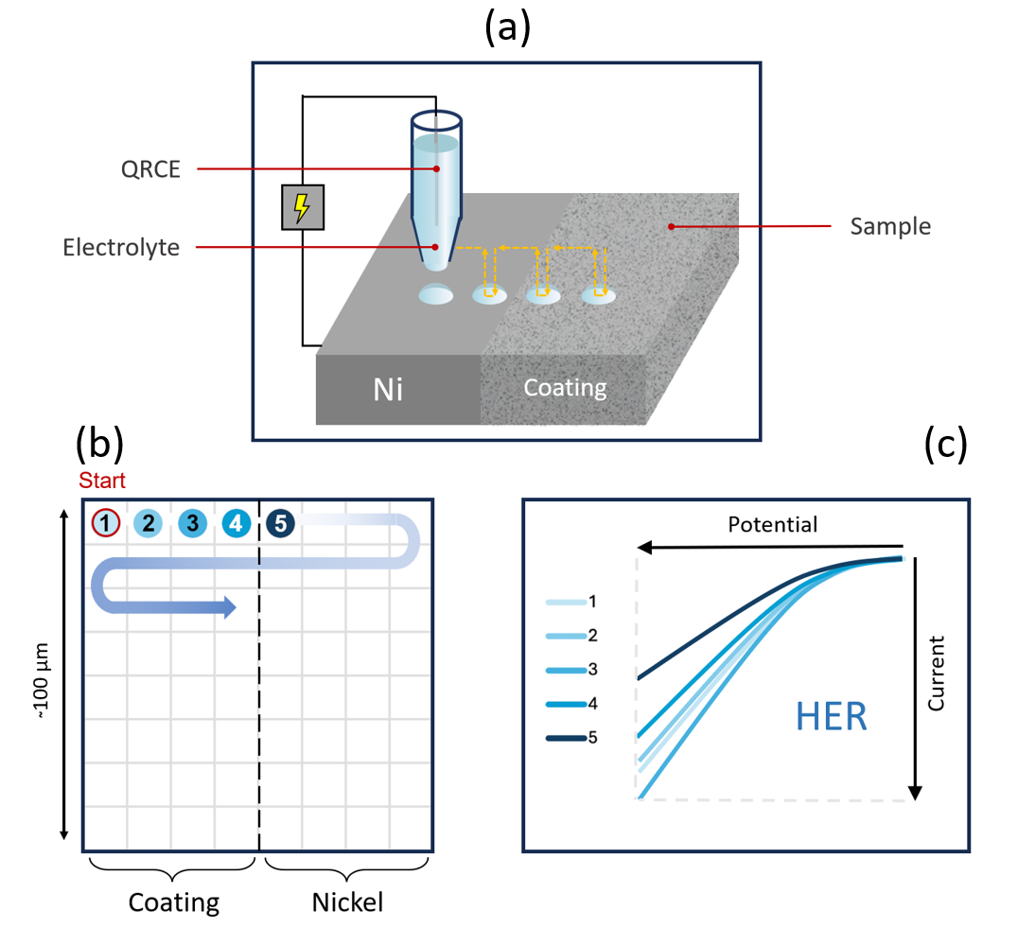
Fig. S1: (a) Scheme of SECCM’s hopping mode, (b) scheme of SECCM’s snake-like scanning protocol, (c) sample CVs for studying the HER.
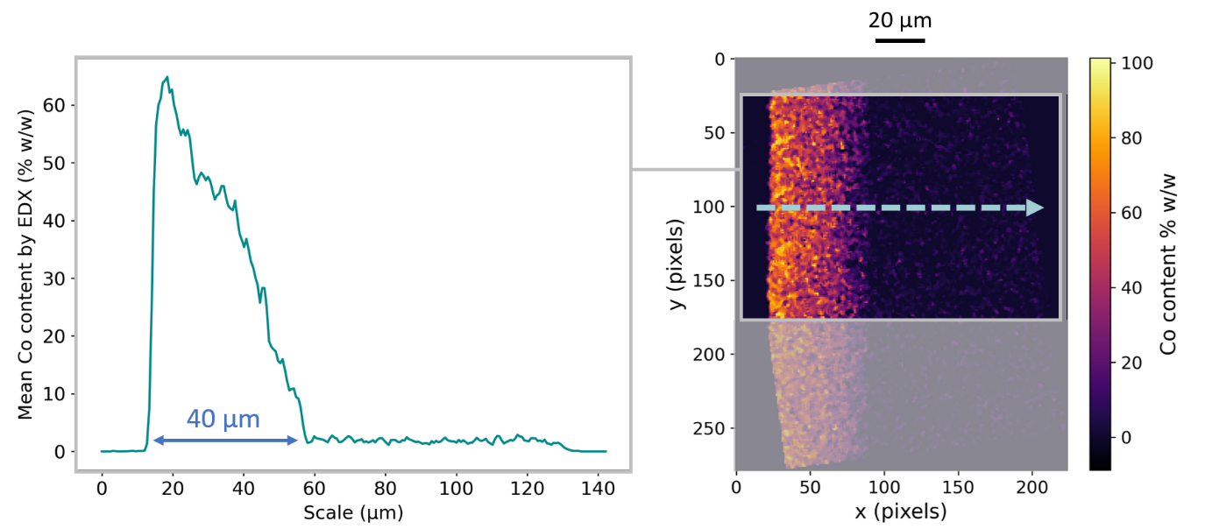
Fig. S2: Average linear profile of EDX Co quantification in the outlined region of a Ni-Co coated sample. The direction of the linear profile averaged over the outlined rectangle is shown by a dashed arrow. A nearly linear increase in cobalt content is observed across the coating thickness.

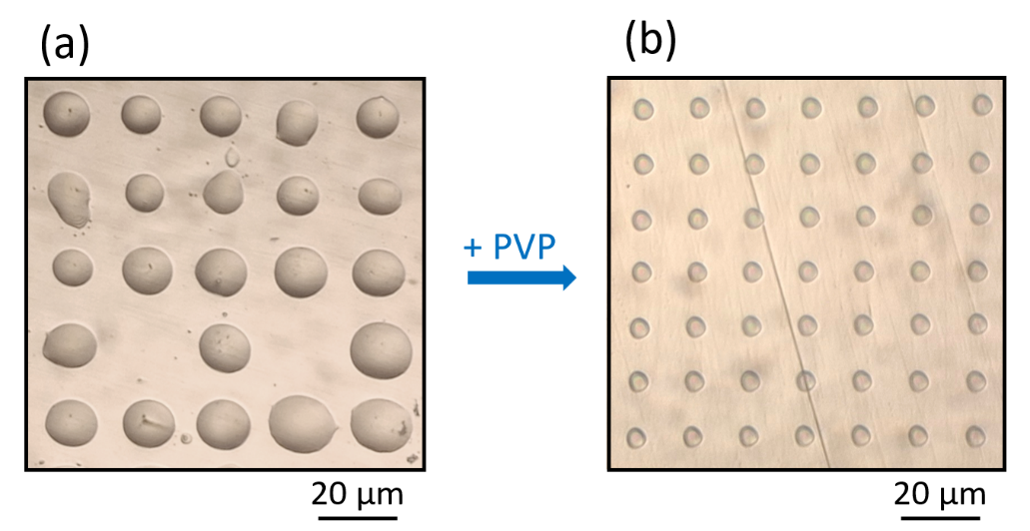
Fig. S3: Side-by-side comparison of optical microscopy images showing residual electrolyte footprints from SECCM mappings on polished Ni using (a) 10 mM KOH and (b) 10 mM KOH with 0.04 %_{w/v} PVP with the same pipette pulling program.
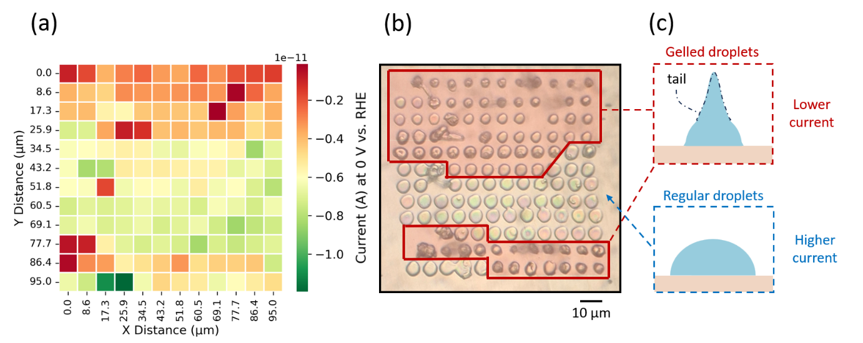
Fig. S4: (a) Heatmap of the current at 0 V vs. RHE in 10 mM KOH + 0.04 %_{w/v} PVP on a Ni sample with a special pipette pulling program for small tips (pulling program 2; Supplementary Information, M5). (b) Complementary optical microscopy image of the residual droplets. (c) Schemes of gelled and regular electrolyte droplets.

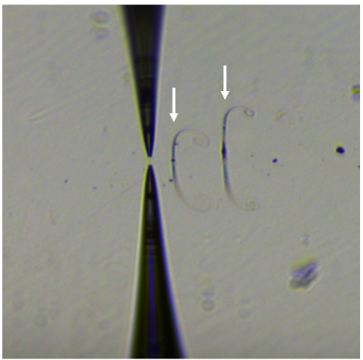
Fig. S5: Image of gelled electrolyte droplets with tails. Reflections of the tails (and the probe) are also visible because of the surface mirror-polishing. Image taken with the IDS camera coupled with the HEKA ELP1 system.

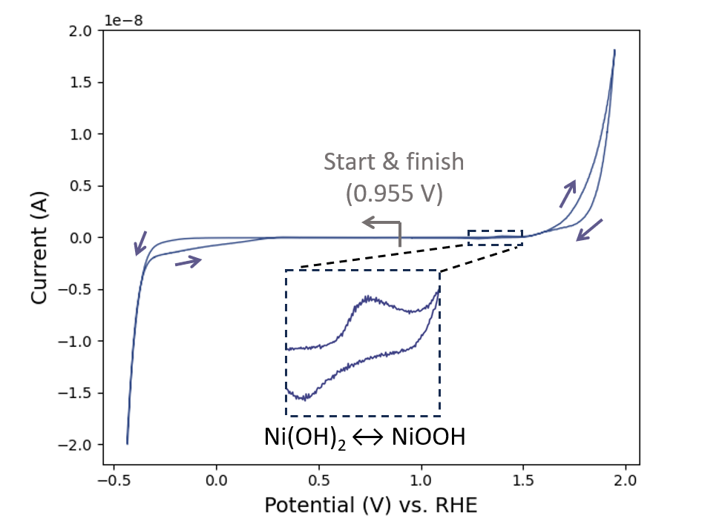
Fig. S6: Representative CV on Ni in 1 M KOH + 0.04 %_{w/v} PVP with SECCM on a wide potential domain.

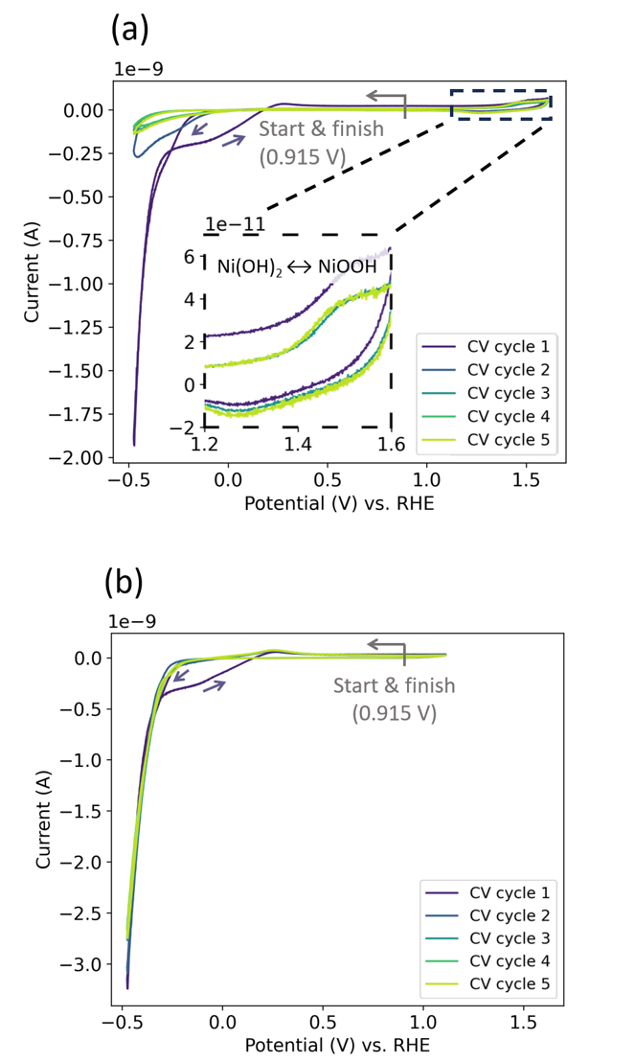
Fig. S7: Representative cyclic voltammograms of HER on Ni (a) including and (b) excluding Ni(OH)₂/NiOOH transitions, with 0.7 and 0.2 V vs QRCE (i.e., 1.615 V and 1.115 V vs RHE) as anodic boundaries, respectively.
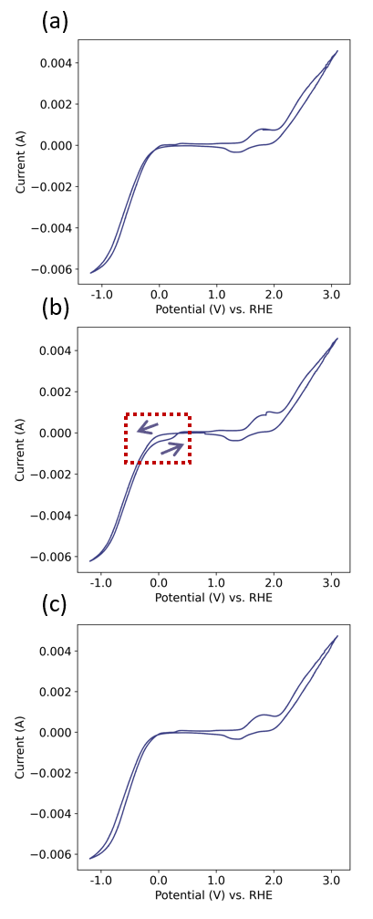
Fig. S8: Cyclic voltammograms on Ni recorded at 10 mV s⁻¹ in 10 mM KOH + 0.04 %_{w/v} PVP over a broad potential range, with a standard 3 electrode setup. Working electrode: Ni, counter electrode: Pt mesh, reference electrode: HgO/Hg (1M KOH). (a) CV recorded before bubbling O₂, (b) CV recorded immediately after bubbling O₂ through the electrolyte for 30 min, (c) CV recorded after allowing the solution to degas. A sigmoidal current response during the anodic scan (indicated in red) is observed exclusively after O₂ bubbling and when the measurement is started immediately thereafter.
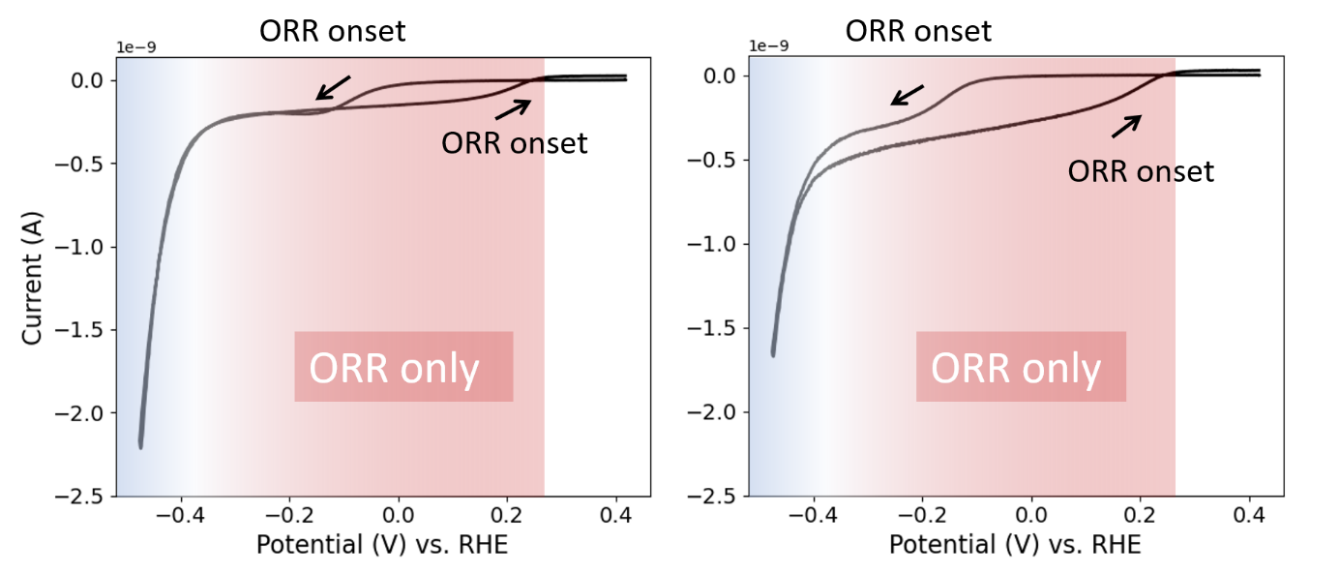
Fig. S9: Two sample CVs recorded on Ni in 10 mM KOH + 0.04 % PVP with SECCM, showing distinguishable ORR onset potentials without overlap with the HER.
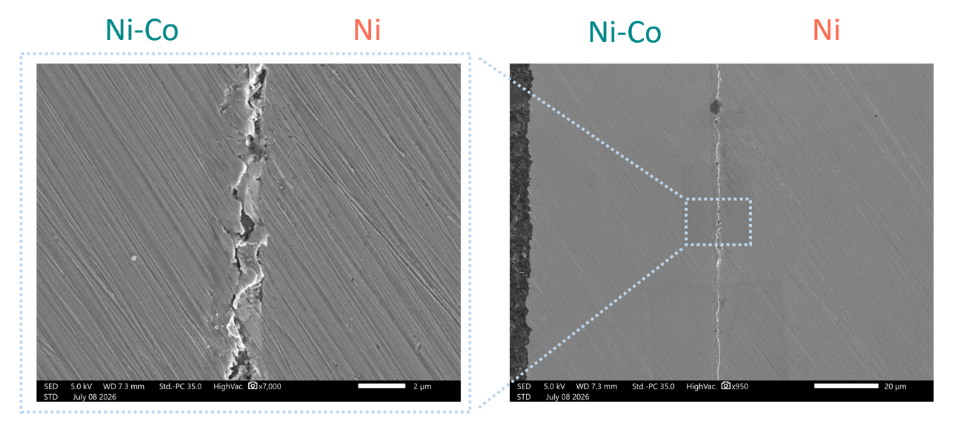
Fig. S10: High magnification side-by-side roughness comparison between Ni and Ni-Co by SEM. Polishing lines are visible due to the sample preparation procedure intended to even out the roughness of both materials.

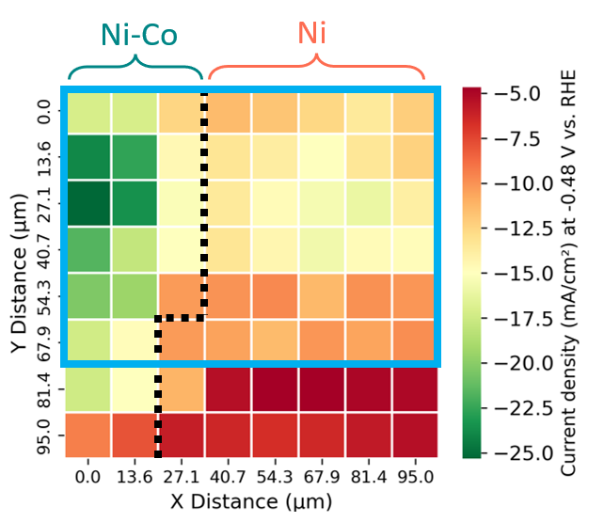
Fig. S11: Heatmap of the current density at -0.48 V vs. RHE in 10 mM KOH + 0.04 %_{w/v} PVP on the Ni/Ni-Co sample.
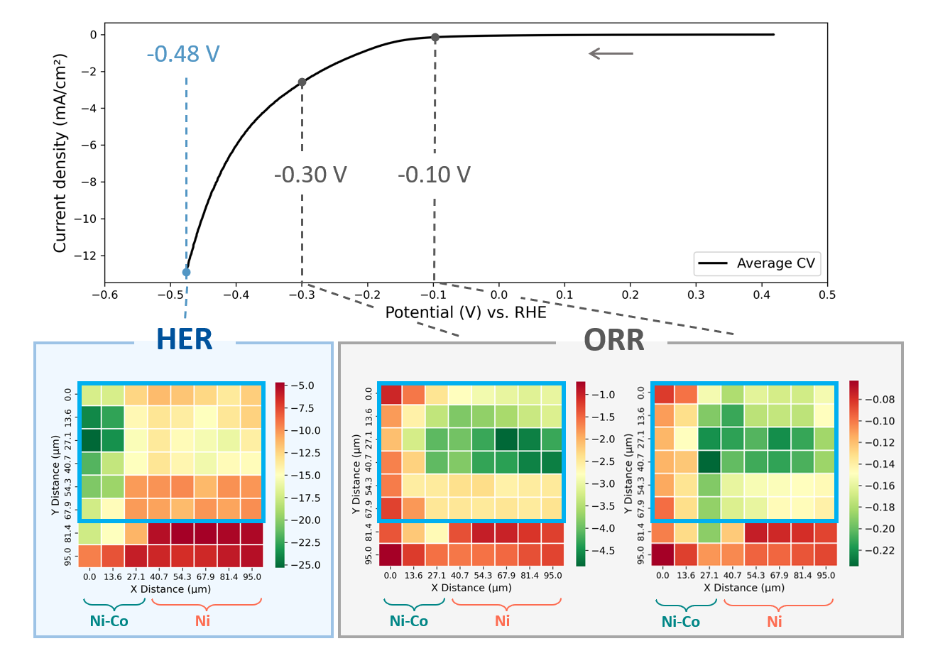
Fig. S12: Average linear sweep voltammetry (cathodic direction) on Ni and Ni-Co and heatmaps of the HER current density (mA/cm²) at selected potentials in 10 mM KOH + 0.04 %_{w/v} PVP. The areas used for quantitative analysis, without significant gelling of droplets, are outlined in blue.

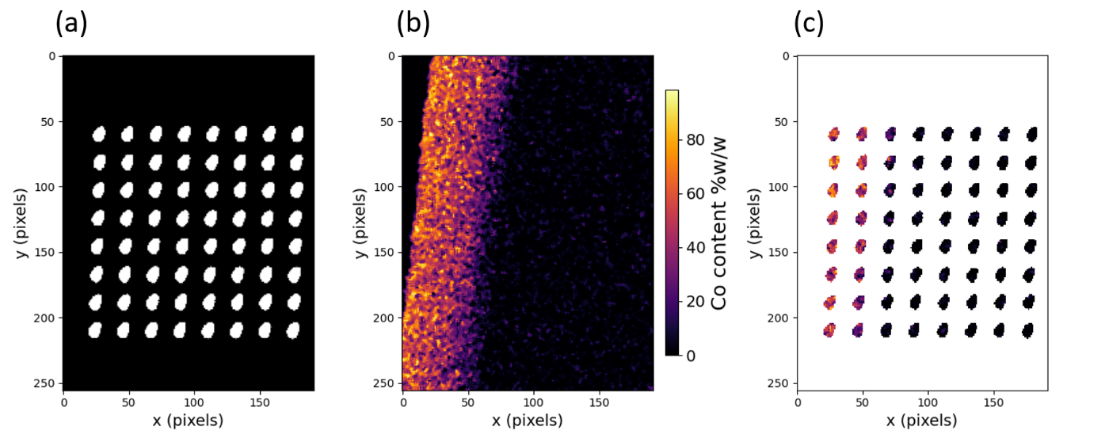
Fig. S13: OER mapping: (a) Electrolyte droplet mask, (b) identical location EDX quantification map of Co, (c) EDX quantification map underneath the droplet locations.

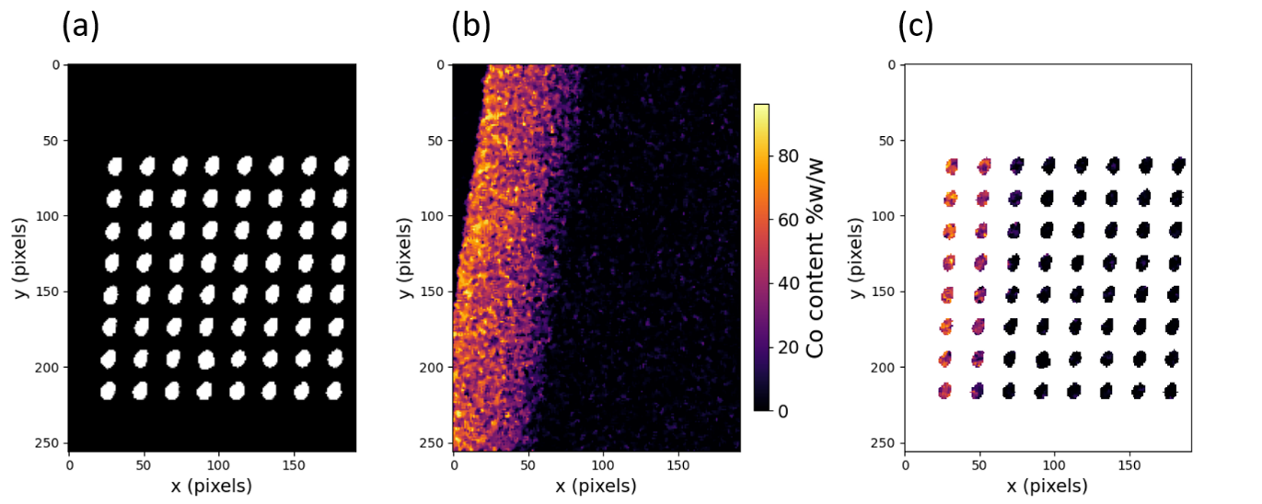
Fig. S14: HER mapping: (a) Electrolyte droplet mask, (b) identical location EDX quantification map of Co, (c) EDX quantification map underneath the droplet locations.

METHODS

M1. SECCM principles
SECCM is a pipette-based technique used to locally probe a material’s activity for the HER or the OER at micrometric scale. This method relies on a probe containing an electrolyte of interest and a Quasi Reference Counter Electrode (QRCE) wire. Due to the small surface area of the wire and the careful selection of its material, its potential is often considered sufficiently stable to serve as a reference electrode. The probe is slowly approached to the sample (~ 0.1 to 1 µm/s) while a potential is applied to the surface. When the pipette deposits an electrolyte droplet on the sample, thereby closing the circuit, a current response is recorded, which stops the approach. This forms a localized electrochemical cell, enabling micro-scale electrochemical experiments such as cyclic voltammetry (CV). The pipette might further be retracted and moved laterally to perform identical experiments in other independent confined areas. This procedure can be automatized, since the probe can be sequentially approached to the sample following a hopping mode protocol (Fig. S1a) in a snake-like pattern (Fig. S1b). A series of measurements (e.g., CVs, Fig. S1c) is thus arranged in a matrix grid of independent droplets ^{[1,2]}.

M2. SECCM setup
The SECCM experiments were conducted with the ElProScan1 (ELP1) system coupled with a PG618USB Bipotentiostat from HEKA Elektronik (Fig. S15). The probe was mounted using a 2.0 mm O.D. SMA holder (multichannel systems). A 0.25 mm-thin Pt wire (Thermofisher, 99.9 %, 045093.BY) was soldered to the 1 mm pin connector of the SMA holder. A copper tape was attached to the sample, allowing its connection to the potentiostat.
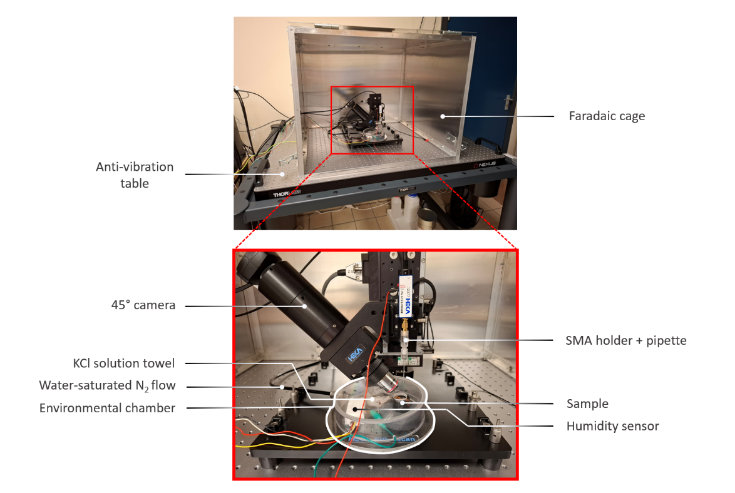
Fig. S15: Description of the SECCM setup.
A rough vertical approach was first carried out while viewed by the 45° camera until the probe was positioned ~ 5-10 µm above the sample. The pipette was then approached to the sample (1 µm/s speed) with an applied potential of 0.5 V (mapping of OER) or -0.5 V (HER) vs. Pt QRCE. The current threshold criteria to stop the pipette was set as the deviation from initial current value by a minimum of 2 times the width of the background noise. Once landed, cyclic voltammetry (CV) was executed to verify the state of the pipette tip (no unusual CV shape) and to select appropriate potential boundaries to study HER and OER. The pipette was then pulled up and moved above the sample’s coating using ELP1’s joystick. A snake-like hopping mode protocol (“Fast Constant Distance Matrix Scan” from HEKA’s Potmaster software) was then carried out on a 95 µm x 95 µm area covering coating and nickel areas. After landing, a cyclic voltammetry (CV) was immediately launched with a scan rate of 100 mV s⁻¹ from 0.5 V to 1.4 V vs. Pt QRCE for the OER map or from -0.5 V to -1.4 V vs. Pt QRCE for the HER map. The pipette was then retracted by 20 µm from the surface before moving laterally to the next surface point. Unlike the approach, which is done in a continuous 1 µm/s motion, for the retraction and lateral movements, the probe moves from point to point within only 10 ms step time, allowing rapid map acquisition in less than 40 min.
Over the whole duration of the experiment, the sample was contained in a home-built environmental chamber (box). The humidity inside the chamber was increased by bubbling N₂ in water and by placing a saturated KCl-soaked paper towel next to the sample. The humidity within the box was monitored using a SHT30 temperature and humidity sensor (Adafruit industries) coupled with an Arduino Uno Rev3 microcontroller board. The humidity was maintained around 70 % ± 5 % in the environmental chamber to minimize risks of crystallization/gelling of the electrolyte ^{[1,2]}. To minimize noise coming from surrounding sounds and mechanical vibrations, the HEKA setup was shielded inside of a home-made faradaic cage mounted on an anti-vibration table (THORLABS, 2.5’ × 3’ ScienceDesk, Nexus Breadboard). The equipment allowed us to maintain the peak-to-peak background noise below 0.5 pA.

M3. Sample preparation
A nickel foil cut to 2 cm x 10 cm (Flowell, 201 Nickel of 1 mm thickness) was used as substrate. Before deposition, the foil was alkaline degreased in 50 g/L Ridoline 1206 for 10 min at 60°C with mild stirring, then rubbed with paper and rinsed. The foil was dipped (~ 3 s) into 10 % v/v HCl to facilitate the adhesion of the coating. The plate was then immediately rinsed and a rectangular area measuring 2 cm x 4 cm (width x length) was immersed in 400 mL of Watts plating bath with a dimensionally stable anode as counter electrode (CE). The Co concentration in the bath was increased during the plating by additions of 5 g/L cobalt sulfate every 9 min. The deposition was carried out with a standard 2 electrode setup in galvanostatic mode using an Autolab, Metrohm potentiostat. NiSO₄.6H₂O (Thermofisher, 98 %, 012514.A3), NiCl.6H₂O (VWR, ≥ 98 %, 25851.293), H₃BO₃ (Merck, 1.00165), CoSO₄.7H₂O (Merck, ≥ 99 %, C6768) were used. The deposition parameters are indicated in Table 1, while a scheme of the setup is provided in Fig. S16.
Table 1: Deposition parameters of the Ni-Co coating
Coating | Ni-Co
Bath composition | 250 g/L NiSO₄.6H₂O  15 g/L NiCl.6H₂O  40 g/L H₃BO₃  5 g/L to 50 g/L CoSO₄.7H₂O
Deposition time (min) | 90
Applied current (A) | -0.4
Bath T (°C) | 54
pH | Starting: 3.7  Ending: 2.2  (adjusted with NaOH)
Magnetic stirring speed (RPM) | 100
Immersed Ni area facing the CE (cm²) | 2 x 4
Distance between electrodes (cm) | ~ 5

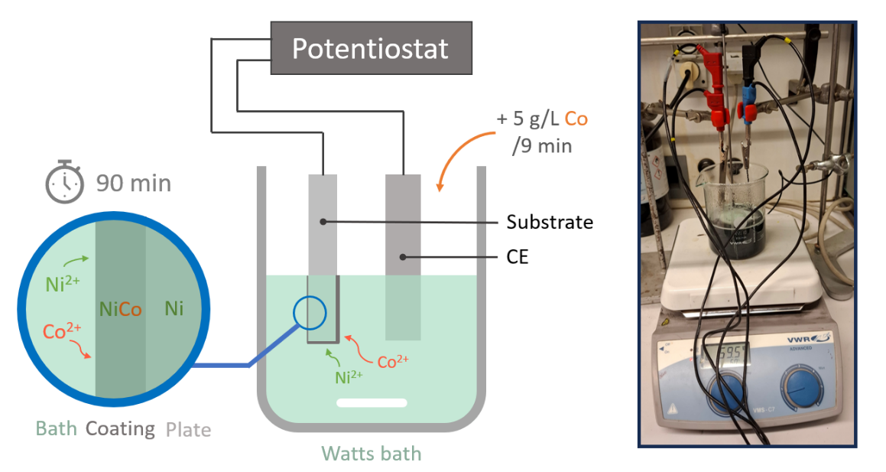
Fig. S16: Electrodeposition setup of the Ni-Co sample.

The coated Ni plate was sliced using a dedicated cut-off machine (Secotom-60). The sample was then hot mounted in a resin. The cross-section was polished using SiC paper (320, 500, 800, 1200 grits) and diamond solutions on different polishing cloths (6 µm – MD Dac, 3 µm – MD Plus, 1 µm – MD Nap).
The preparation procedure led to partial detachment of the coating from the Ni substrate. However, the adhesion was sufficient in some areas of the cross section for SECCM analysis. In another Ni-Co electrodeposition experiment, a bond coat was found to be effective in ensuring a better adhesion of the coating. For that purpose, a Wood’s bath composed of 240 g/l NiCl₂.6H₂O and 10%_{v/v} HCl was used to form an adhesive layer to facilitate subsequent Watts bath deposition. This deposition step was carried out for 5 min at 25 ± 5°C with a current of -0.4 A, before immediate deposition using Watts bath.
It is worth noting that this sample preparation methodology is more interesting with thick coatings, in order to have the necessary area for a significant number of SECCM landing locations. Additionally, the electrodeposited coatings should not be porous for the SECCM analysis to be relevant to studies of the material’s intrinsic activity. Otherwise, the electrolyte droplets deposited by SECCM could be soaked up by the pores, leading to higher measured currents without accurate information about the electroactive surface area covered.

M4. SEM/EDX and correlations
Fig. S17 shows examples of SEM images of a surface previously analyzed by SECCM, (a) after and (b) before removing the residual electrolyte droplets. The local cobalt content for the same surface region as in SEM image (a), determined by EDX, is shown in Fig. S17c. A binary mask representing the detected droplets by adaptive thresholding from SEM image (b) is shown in (d). Cobalt quantification beneath each droplet is presented in (e).
Following the SECCM analyses, one SEM image per mapped area was acquired, covering all the corresponding droplets (Fig. S17b). Afterwards, to expose the surface underneath for an EDX analysis, the droplets were removed. The droplets could not be simply washed away with water. Therefore, they were removed by gently rubbing the sample with a KIMTECH wipe soaked in Milli-Q water.
The mapping areas were relocated using SEM, guided by the earlier images with the droplets. The area was then mapped with EDX (Fig. S17c) and a complementary secondary electron (SE) image on the same location (Fig. S17a). Slight scratches - not critical for the analyses - due to the rubbing could be seen by SEM on the surface. Then, by superimposing the SEM images before and after removal of the droplets (Fig. S17ab) using a code from Université Paris Cité, ITODYS ^{[3,4]}, an image of the droplets could be precisely superimposed to the raw data of the EDX map. Adaptive thresholding was applied to this repositioned image with droplets to obtain a binary image (mask) indicating the location of the droplets on the EDX map (Fig. S17d). The EDX Co quantification data matrix was filtered with this mask (Fig. S17e) to later be used for calculating the average Co content in the surface under each droplet, providing one mean surface composition per footprint.
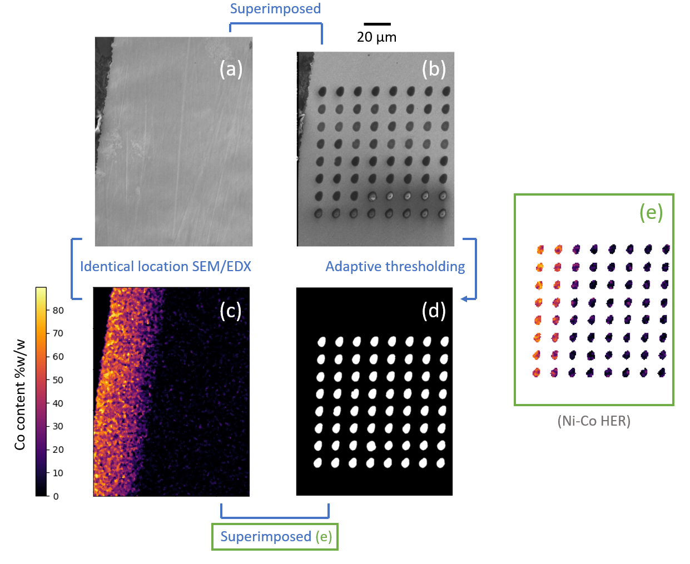
Fig. S17: Schematic explanation of the Co quantification procedure underneath the droplets (mapping of the HER). SEM images of the surface scanned earlier by SECCM: (a) after removal of the droplets and (b) before removal. (c) EDX quantification map of cobalt corresponding to SEM image (a). (d) Binary image showing the droplet-covered areas detected by adaptive thresholding of SEM image (b). (e) Quantification of cobalt content beneath each droplet.

A JSM-IT710HR JEOL Scanning Electron Microscope was employed for the EDX and SEM data. The SEM images simultaneously acquired with EDX (after removal of the droplets, Fig. S17ac) were obtained with an acceleration voltage of 10 kV. Regarding the SEM images of droplets, such as in Fig. S17b, the acceleration voltage was set to 5 kV. The EDX maps were recorded with a resolution of 256 x 192 pixels, dwell time of 0.2 ms, 5 frames per map, using the ZAF method for quantification. The quantification map was subjected to median averaging to reduce noise.

M5. Probes
Single-barrel borosilicate pipettes were used for this study (G120T-4, multichannel systems). For comparison, capillaries containing a filament facilitating their filling were also used (Fig. S18a): TW120F-4, World Precision Instruments. The capillaries were pulled using a laser-based micropipette puller (P-2000, Sutter Instruments). For the first stage of the main pulling program, the parameters were heat 280, filament 3, velocity 30, delay 220. For the second stage, the parameters were heat 280, filament 3, velocity 40, delay 180, pull 110.
For the mapping from Fig. 3, pulling program 2 was used to achieve a smaller tip size (~4 µm diameter droplets). The parameters were heat 340, filament 3, velocity 30, delay 220 for the first stage. The settings were heat 350, filament 3, velocity 40, delay 180, pull 200 for the second stage.
Potassium hydroxide (KOH, ACROS ORGANICS, 85 %, hygroscopic) and polyvinylpyrrolidone (PVP, Merck, 856568, M_{w} ~ 55000) were used as is, to prepare the electrolyte solutions, using Milli-Q® ultrapure water. The pipettes were backfilled with a MicroFil Flexible Needle (World Precision Instruments, MF34G-5). To ensure that they had been properly filled before the SECCM experiments, the tips of the probes were verified with an optical microscope (x4 or x10 magnification).
The choice of capillaries to fabricate pipettes is essential to maximize the chances of success of a mapping of electrochemical activity. Some capillaries are fabricated with a glass filament along their inner walls, to facilitate their filling. However, the counterpart is that this filament is quite fragile. When inserting the Pt wire inside the pipette, the inner filament tends to scratch the wire, resulting in some Pt flakes or glass debris which might later fall and potentially clog the pipette tip during the matrix scans (Fig. S18a). Hence, the use of capillaries without filament significantly reduces the risk of mapping failures, due to the lower risk of damaging the Pt wire or the filament. When using capillaries without a filament, contaminants (Fig. S18b) may still reach the tip of the probe several minutes to an hour after filling the pipette. However, these impurities did not show any clear effect on the electrochemical signals.
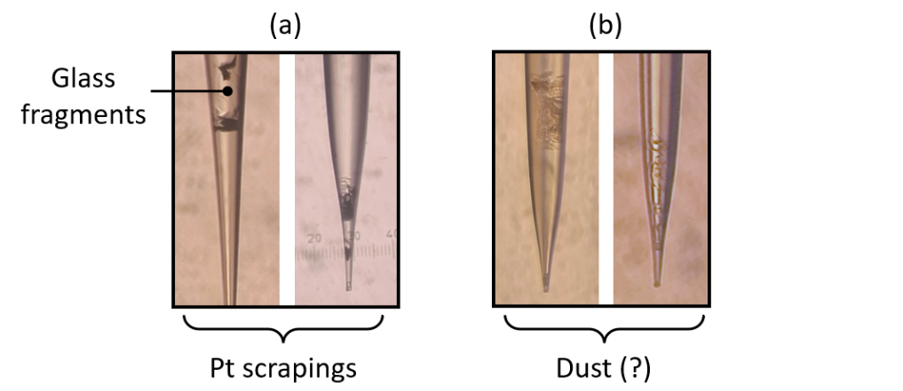
Fig. S18: Optical microscopy images: (a) glass fragments (transparent) and Pt scrapings (black), (b) example of typical solid contaminants inside pipettes.

M6. QRCE
A platinum wire (0.25 mm, 99.9 %, thermo scientific) was cut to ~ 5 cm of length to be used as a QRCE. The wire was soldered to the 1 mm pin connector. Before measurements, the Pt wire was heated with a flame to get rid of eventual organic contaminants. Afterwards, the wire was treated with 5 sets of 20 s applications of +3 V and -3 V against a Pt mesh used as a counter electrode in a 0.5 M H₂SO₄ solution, finishing at -3 V to reduce eventual Pt oxides.
The open circuit potential (OCP) of the Pt wire in 10 mM KOH + 0.04 %_{w/v} PVP was monitored in the electrolyte against a 1 M KOH Hg/HgO reference electrode (Origalys, OGR001, KOH 1 M internal solution) for ~ 4 h (419). For reference, a typical 8 x 8 SECCM mapping experiment lasts ~ 40 min. This experiment was done three times. Before each experiment, the QRCE was treated with the usual preparation procedure (described above) and immersed in some electrolyte dispensed from a polyethylene container. After a stabilization period of 30 min, the wire shows an average shift in the anodic direction of 2 ± 0.5 mV/h, which is deemed acceptable. The potential of the wire was averaged during 3.5 h after the stabilization period (averaging boundaries indicated by stars in Fig. S19). The mean OCP of the wire for three experiments was 0.915 V vs. RHE, with a potential drift lower than 10 mV inside the averaging boundaries (3.5 h). The conversion of potential from HgO/Hg (1 M KOH) to RHE was done considering that the potential of HgO/Hg is 0.098 V vs. SHE and the theoretical pH of the electrolyte is 12. It is noteworthy that the theoretical value of HgO/Hg (1 M KOH) potential has been recently reconsidered as 0.1053 V ^{[5]}. The resulting shift is approximately 7 mV and does not affect any of the conclusions of the work. Because a pseudo-reference electrode (QRCE) is used with SECCM, it is important to evaluate whether a stable QRCE potential is maintained both at OCP and during current flow. The stability during current flow was evaluated through dedicated experiments using a three-electrode setup (Fig. S19). Galvanostatic applications of ± 10 nA for 1 min each result in potential drifts of ~ ± 15 mV. It is noteworthy that the maximal recorded current values during SECCM measurements are typically lower (< 5 nA) and occur over much shorter timescales, which means this represents an upper boundary of the expected shift of the QRCE potential.
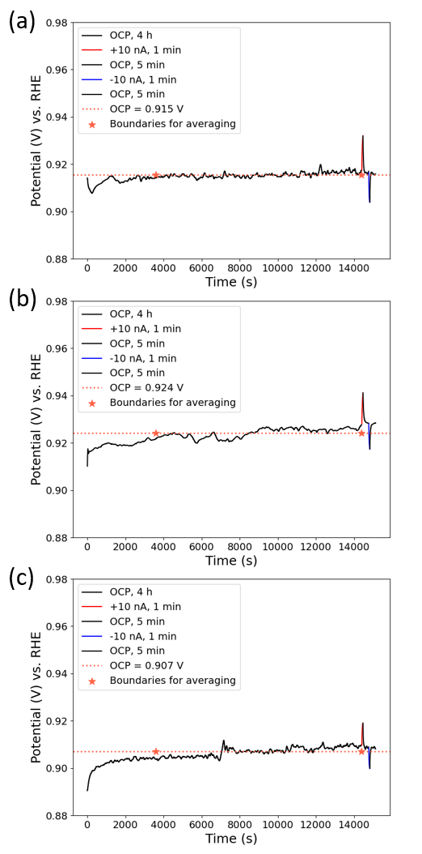
Fig. S19: Evaluation of the stability of a Pt QRCE immersed in 10 mM KOH and 0.04 %_{w/v} PVP. The OCP was calculated as the average of the recorded Pt’s potential without application of current after 30 min of stabilization time (averaging window indicated with stars).

SUPPLEMENTARY DISCUSSIONS

Effect of PVP on cyclic voltammograms of Ni
As already evidenced by several reports ^{[6,7]}, it is essential to assess the effect of electrolyte additives on the electrochemical signal. The effect of PVP on the electrochemical properties of Ni was evaluated in a 3-electrode setup (working electrode: Ni disk mounted on a RDE, counter electrode: Pt mesh, reference electrode: HgO/Hg), following a protocol similar to one previously reported (Fig. S20a) ^{[6]}. Cyclic voltammograms of Ni were recorded in 10 mM KOH with (a) no PVP, (b) 0.04 %_{w/v} PVP; as used in SECCM, (c) 5 %_{w/v} PVP; to amplify potential effects.
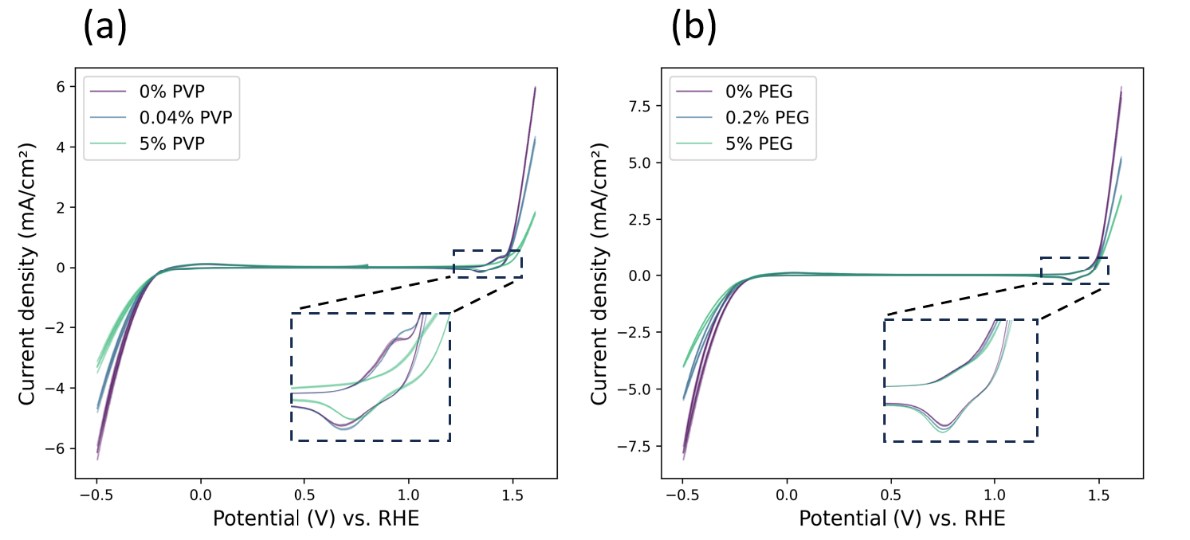
Fig. S20: Cyclic voltammograms of Ni recorded at 10 mV s⁻¹ in 10 mM KOH with various PVP (a) and PEG (b) concentrations, averaged over three consecutive scans, on a broad potential range with a 3-electrode setup. The standard deviations associated to three scans are shown. The RDE (Ni) was continuously rotated by 3000 RPM over the course of the measurement. 90 % IR compensation was applied.
As shown by the figure, there is a non-negligible decrease in HER/OER current associated to the addition of PVP. Nevertheless, this is also expected for other additives ^{[6]}, and qualitative comparisons of activity for different materials compositions are still feasible. A similar analysis was performed for polyethylene glycol (alternative additive recommended by Janjani et. Al. ^{[6]}) with an appropriate concentration for SECCM (0.2 %_{w/v}) and an excessive concentration (5 %_{w/v}), showing an effect on the HER/OER currents comparable to that of PVP (25-35 % activity decrease, Fig. S20b).
Fig. S21 shows CVs recorded on Ni using SECCM with and without PVP. Upon addition of PVP, a decrease in current is observed, which can be attributed to differences in wetting and/or inhibition of activity. However, the overall shapes of the CVs remain unchanged, exhibiting two OER regimes and the coexistence of the HER and ORR.

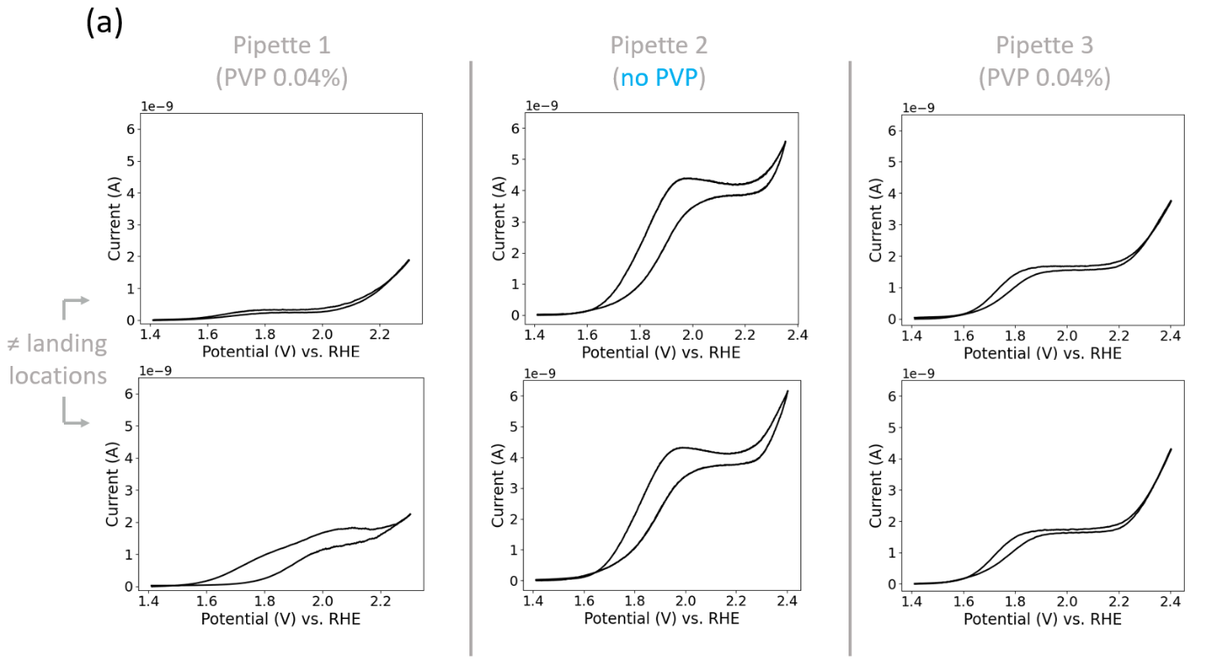
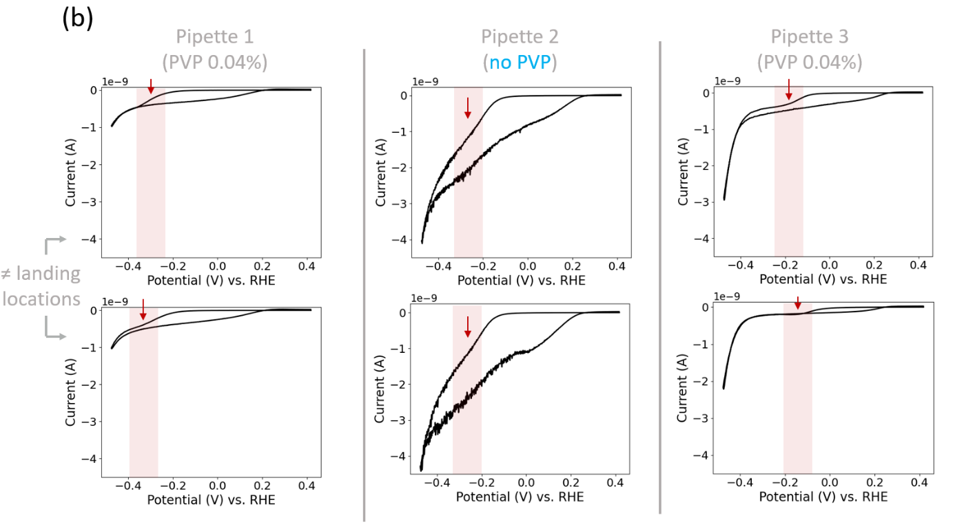
Fig. S21: Representative CVs of (a) the OER and (b) the HER on a complementary Ni sample with/without PVP. For the HER, a sigmoidal plateau during the cathodic scan attributed to the ORR is highlighted and indicated with an arrow on the cathodic scan.

Rationalizing the OH⁻ diffusion-limited OER current value
The commonly used expression to estimate the diffusion-limited current in SECCM is ^{[8]}:
$$I_{L (SECCM)}=\frac{1}{10} ×I_{L \left(microelectrode\right)}=\frac{1}{10} ×4nFCrD_{OH^{-}}$$
Where:
- $n$ is the number of electrons transferred: 4
- $F$ is Faraday’s Constant: 96 485.3 C/mol
- $C$ is the concentration of OH⁻: 1 10⁻⁵ mol/cm³
- $r$ is the average radius of the electrode or the electrolyte footprints: 3.4 10⁻⁴ cm
- $D_{OH^{-}}$is the diffusion coefficient of OH⁻: as a first approximation, can be estimated as 5.3 10⁻⁵ cm² s⁻¹ (at infinite dilution in water) ^{[9]}
Based on the equation, the expected OER current limited by OH⁻ diffusion is 2.8 10⁻⁸ A. Practically, the average limiting current on Ni lies one order of magnitude below (~ 10⁻⁹ A, Fig. 3a). This is an expected behavior, since this PVP concentration range (0.02 - 0.06 %_{w/v}) has already been reported to increase the viscosity - and to reduce the diffusion coefficient - of KOH-based solutions by one order of magnitude compared to the corresponding additive-free electrolyte.

Grain structure of the sample
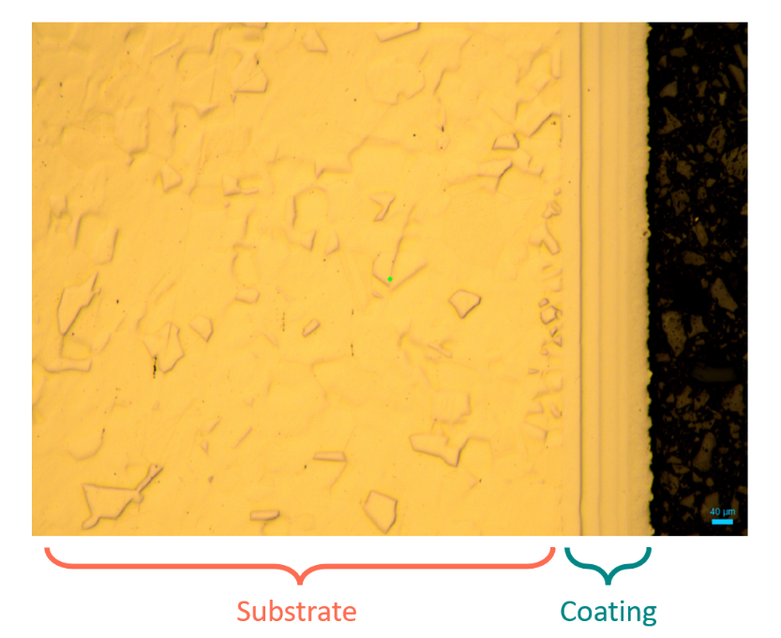
Fig. S22: Optical microscopy image of a coated Ni sample. The sample was fine-polished (OP-S) to reveal its grain size.
As shown in Fig. S22, the Ni substrate revealed a polycrystalline structure with large grains (> 20 µm) once it was finely polished. On the other hand, the coating exhibits a nanocrystalline surface.

REFERENCES
1. Jayamaha, G., Maleki, M., Bentley, C. L., & Kang, M. (2024). Practical guidelines for the use of scanning electrochemical cell microscopy (SECCM). The Analyst, 149(9), 2542‑2555. https://doi.org/10.1039/D4AN00117F
2. Anderson, K. L., & Edwards, M. A. (2025). A Tutorial for Scanning Electrochemical Cell Microscopy (SECCM) Measurements : Step-by-Step Instructions, Visual Resources, and Guidance for First Experiments. ACS Measurement Science Au, 5(2), 160‑177. https://doi.org/10.1021/acsmeasuresciau.4c00091
3. Godeffroy, L., Lemineur, J., Shkirskiy, V., Miranda Vieira, M., Noël, J., & Kanoufi, F. (2022). Bridging the Gap between Single Nanoparticle Imaging and Global Electrochemical Response by Correlative Microscopy Assisted By Machine Vision. Small Methods, 6(9), 2200659. https://doi.org/10.1002/smtd.202200659
4. Raffin, F., Makogon, A., Kanoufi, F., Echouard, J., Shkirskiy, V., & Volovitch, P. (2024). Initial cathodic reactivity of intermetallic particles in 7175 aluminum alloy buried under 6 µm thick anodized oxide layer revealed by in-situ reflective microscopy. Electrochimica Acta, 492, 144155. https://doi.org/10.1016/j.electacta.2024.144155
5. Kawashima, K., Márquez, R. A., Son, Y. J., Guo, C., Vaidyula, R. R., Smith, L. A., Chukwuneke, C. E., & Mullins, C. B. (2023). Accurate Potentials of Hg/HgO Electrodes : Practical Parameters for Reporting Alkaline Water Electrolysis Overpotentials. ACS Catalysis, 13(3), 1893‑1898. https://doi.org/10.1021/acscatal.2c05655
6. Janjani, P., Swan, H. B., Dy, L., Sarkar, A., & Bentley, C. L. (2025). Enabling Alkaline Scanning Electrochemical Cell Microscopy (SECCM) for the Study of Water-Splitting Electrocatalysts. Analytical Chemistry, acs.analchem.5c04020. https://doi.org/10.1021/acs.analchem.5c04020
7. Arruda De Oliveira, G., Kim, M., Santos, C. S., Limani, N., Chung, T. D., Tetteh, E. B., & Schuhmann, W. (2024). Controlling Surface Wetting in High-Alkaline Electrolytes for Single Facet Pt Oxygen Evolution Electrocatalytic Activity Mapping by Scanning Electrochemical Cell Microscopy. Chemical Science, 15(39), 16331‑16337. https://doi.org/10.1039/D4SC04407J
8. Anderson, K. L., & Edwards, M. A. (2023). Evaluating Analytical Expressions for Scanning Electrochemical Cell Microscopy (SECCM). Analytical Chemistry, 95(21), 8258‑8266. https://doi.org/10.1021/acs.analchem.3c00216
9. Lide, D. R., Baysinger, G., Chemistry, S., Berger, L. I., Goldberg, R. N., & Kehiaian, H. V. (s. d.). CRC Handbook of Chemistry and Physics.

