Supplementary material for:

The Liege Mind-Blanking Scale: a comprehensive scale to assess the heterogeneity of mind-blanking cognitive and experiential aspects

Paradeisios Alexandros Boulakis^{1,2}, Marion Balla², Agustina Aragón-Daud^{2,3}, David Stawarczyk^{1,4}, Giovanni Briganti^{5,6,7,8}, Athena Demertzi*^{1,2}, and Steve Majerus*^{1,4}
¹Psychology and Neuroscience of Cognition Unit (PsyNCog), University of Liege, Belgium
²Physiology of Cognition Lab, GIGA CRC Human Imaging, University of Liege, Belgium
³Applied Machine Learning Lab, Institute of Neuroscience and Medicine: Brain & Behaviour (INM-7), Forschungszentrum Jülich, Germany
⁴GIGA CRC Human Imaging, University of Liege, Belgium
⁵Unit of Computational Medicine and Neuropsychiatry, Faculty of Medicine, Pharmacy, and Biomedical Sciences, University of Mons, Belgium
⁶Digital Health, Department of Clinical Sciences, Faculty of Medicine, University of Liege, Belgium
⁷Faculty of Medicine, Université Libre de Bruxelles, Belgium
⁸Department of Psychiatry, Oxford University

Supplementary Tables
Supplementary Table S1. External content validation of the proposed Liege Mind-Blanking Scale
Proposed Questions | External Content Panel |  |  |  |  |  |  |  |  | N Agreed | I-CVI | UA
Proposed Questions | JW | KS | MR | NU | SM | AD | CD | TS | AK | N Agreed | I-CVI | UA
There are moments when I pay attention to nothing at all. | 1 | 1 | 1 | 1 | 1 | 1 | 1 | 1 | 0 | 8 | 0.89 | 0
When I am tired of paying attention to someone speaking, my mind empties. | 1 | 1 | 0 | 1 | 0 | 1 | 1 | 1 | 1 | 7 | 0.78 | 0
I do not notice when I stop paying attention to something. | 1 | 0 | 1 | 1 | 0 | 0 | 0 | 1 | 0 | 4 | 0.44 | 0
When many people talk at once, my mind feels empty because I can’t follow anything. | 1 | 1 | 0 | 0 | 0 | 0 | 1 | 0 | 1 | 4 | 0.44 | 0
When watching a movie, I need to rewind because it feels like I skipped a couple of moments. | 1 | 1 | 0 | 1 | 1 | 0 | 0 | 1 | 0 | 5 | 0.56 | 0
The moment I have a thought, I feel like it slips away, and I cannot remember it. | 0 | 0 | 1 | 1 | 1 | 0 | 0 | 1 | 0 | 4 | 0.44 | 0
I lose track of my thoughts and can’t remember what I was thinking. | 0 | 1 | 0 | 1 | 1 | 0 | 1 | 1 | 1 | 6 | 0.67 | 0
When reading a book, I must reread pages because I ended at the end of the page but I do not remember how I got there. | 1 | 1 | 1 | 1 | 1 | 0 | 1 | 1 | 1 | 8 | 0.89 | 0
When talking to someone, I must pause mid-sentence because I have lost what I was about to say. | 1 | 0 | 0 | 0 | 1 | 0 | 1 | 1 | 0 | 4 | 0.44 | 0
When I am about to speak, I forget what I was about to say. | 0 | 0 | 0 | 0 | 1 | 0 | 1 | 1 | 1 | 4 | 0.44 | 0
There are moments when I am sure that I had a thought, but I am not sure what. | 1 | 0 | 0 | 1 | 1 | 0 | 1 | 1 | 1 | 6 | 0.67 | 0
There are moments when I know I was thinking of something, but I cannot recover it. | 1 | 0 | 0 | 1 | 1 | 0 | 1 | 1 | 1 | 6 | 0.67 | 0
During the day, I notice that I am thinking of nothing. | 1 | 1 | 1 | 1 | 1 | 1 | 0 | 1 | 1 | 8 | 0.89 | 0
I enjoy not thinking of anything. | 1 | 0 | 1 | 1 | 0 | 0 | 0 | 1 | 0 | 4 | 0.44 | 0
I clear my mind to help me cope with negative emotions. | 1 | 1 | 0 | 1 | 0 | 0 | 0 | 0 | 0 | 3 | 0.33 | 0
I silence all the thoughts in my mind. | 1 | 1 | 0 | 0 | 1 | 0 | 0 | 1 | 1 | 5 | 0.56 | 0
When I need to focus, I empty all thoughts from my head. | 1 | 1 | 0 | 0 | 0 | 0 | 0 | 1 | 1 | 4 | 0.44 | 0
When I am calm, it feels like my mind is empty. | 1 | 1 | 0 | 1 | 0 | 1 | 0 | 1 | 1 | 6 | 0.67 | 0
When I am stressed, my mind goes blank. | 0 | 1 | 0 | 1 | 0 | 1 | 0 | 1 | 1 | 5 | 0.56 | 0
When I am under pressure, it feels like I cannot think. | 0 | 0 | 0 | 1 | 0 | 0 | 0 | 1 | 1 | 3 | 0.33 | 0
My thoughts change so fast that it feels like I cannot think of anything specific. | 0 | 0 | 0 | 0 | 0 | 0 | 1 | 1 | 0 | 2 | 0.22 | 0
My mind blanks when I am under pressure. | 1 | 1 | 0 | 1 | 1 | 1 | 1 | 1 | 1 | 8 | 0.89 | 0
When something bad happens and I need to think of solutions, my mind goes blank. | 1 | 1 | 0 | 0 | 1 | 1 | 0 | 1 | 1 | 6 | 0.67 | 0
When I am bored, I zone out without thinking of anything. | 1 | 1 | 1 | 1 | 1 | 1 | 0 | 1 | 1 | 8 | 0.89 | 0
When I am sleepy, I feel like I cannot hold a coherent thought. | 0 | 0 | 1 | 1 | 0 | 0 | 1 | 1 | 1 | 5 | 0.56 | 0
When I am sleepy, I easily forget what I am thinking about. | 0 | 0 | 1 | 1 | 1 | 0 | 1 | 1 | 1 | 6 | 0.67 | 0
There are moments when it feels like I am not thinking about anything in particular. | 0 | 1 | 1 | 1 | 1 | 1 | 1 | 1 | 1 | 8 | 0.89 | 0
When people ask me what I am thinking, I respond that I am thinking about nothing. | 1 | 1 | 0 | 1 | 1 | 1 | 1 | 1 | 1 | 8 | 0.89 | 0
When I have a lot of different thoughts, it is difficult to have one thought clearly. | 0 | 0 | 0 | 0 | 0 | 0 | 1 | 1 | 0 | 2 | 0.22 | 0
I lose track of how one thought led to another. | 0 | 0 | 0 | 0 | 0 | 0 | 1 | 1 | 0 | 2 | 0.22 | 0
There are moments when I try to trace how one thought led to another, but it feels as if there are gaps between some of them. | 1 | 0 | 1 | 1 | 1 | 0 | 1 | 0 | 0 | 5 | 0.56 | 0
Periods of time can pass when I am not thinking of anything. | 1 | 1 | 1 | 1 | 1 | 1 | 0 | 1 | 1 | 8 | 0.89 | 0
I notice myself staring at nothing without realising how long it’s been. | 1 | 1 | 1 | 1 | 1 | 1 | 0 | 1 | 1 | 8 | 0.89 | 0
I catch myself halfway through an action without knowing how I started it. | 1 | 1 | 1 | 0 | 1 | 0 | 1 | 1 | 1 | 7 | 0.78 | 0
During the day, I feel like I had brief time-skips, as if I missed the last few seconds. | 1 | 1 | 1 | 1 | 1 | 1 | 1 | 1 | 1 | 9 | 1 | 1
 |  |  |  |  |  |  |  |  |  | S-CVI/Ave | 0.62
Proportion of relevance | 0.69 | 0.6 | 0.43 | 0.71 | 0.63 | 0.37 | 0.57 | 0.91 | 0.69 | S-CVI/UA |  | 0.02
Notes. I-CVI = item content validity index; UA = universal agreement; S-CVI/Ave = Average Scale-Level Content Validity Index; S-UA/Ave = Universal agreement of Scale-Level Content Validity Index
Supplementary Table S2. Exploratory Factor Analysis of the Liege Mind-Blanking Scale using a 4-latent factor structure.
Questionnaire Item | Factor 1 | Factor 2 | Factor 3 | Factor 4
There are moments when I pay attention to nothing at all. | 0,55 | 0,03 | 0,3 | -0,05
When I am tired of paying attention to someone speaking, my mind empties. | 0,28 | 0,24 | 0,32 | -0,04
I lose track of my thoughts and can’t remember what I was thinking. | 0,1 | 0,68 | 0,1 | -0,05
When reading a book, I must reread pages because I ended at the end of the page but I do not remember how I got there. | -0,06 | 0,46 | 0,18 | 0,03
There are moments when I am sure that I had a thought, but I am not sure what. | -0,04 | 0,94 | -0,03 | 0,01
There are moments when I know I was thinking of something, but I cannot recover it. | 0,01 | 0,89 | -0,02 | 0,01
During the day, I notice that I am thinking of nothing. | 0,83 | -0,02 | 0,05 | -0,01
When I am calm, it feels like my mind is empty. | 0,69 | -0,03 | 0 | 0,09
My mind blanks when I am under pressure. | 0,14 | 0,1 | -0,12 | 0,66
When something bad happens and I need to think of solutions, my mind goes blank. | -0,02 | -0,03 | 0,06 | 0,97
When I am bored, I zone out without thinking of anything. | 0,66 | 0,09 | 0,04 | 0,02
When I am sleepy, I easily forget what I am thinking about. | 0,33 | 0,27 | -0,02 | 0,19
There are moments when it feels like I am not thinking about anything in particular. | 0,91 | 0,01 | -0,06 | -0,02
When people ask me what I am thinking, I respond that I am thinking about nothing. | 0,29 | 0,06 | 0,37 | -0,08
Periods of time can pass when I am not thinking of anything. | 0,84 | -0,03 | -0,02 | 0,06
I notice myself staring at nothing without realizing how long it’s been. | 0,11 | 0,03 | 0,73 | -0,06
I catch myself halfway through an action without knowing how I started it. | -0,07 | 0,3 | 0,45 | 0,07
During the day, I feel like I had brief time-skips, as if I missed the last few seconds. | -0,04 | 0 | 0,82 | 0,11
Note. Bold items were retained when they loaded > .40 on their primary factor and at least .40 higher than their loading on any other factor

Supplementary Table S3. Exploratory Factor Analysis of the Liege Mind-Blanking Scale joint with the Mind-Wandering Questionnaire.
Item ID | Factor 1 | Factor 2 | Factor 3 | Factor 4 | Complexity | Uniqueness
MBS 1 | 0,65 | 0,21 | 0 | -0,04 | 1,22 | 0,51
MBS 3 | 0,12 | 0,17 | 0,62 | -0,02 | 1,23 | 0,41
MBS 4 | -0,01 | 0,37 | 0,36 | 0,02 | 2,01 | 0,6
MBS 5 | -0,01 | -0,04 | 0,92 | -0,01 | 1 | 0,2
MBS 6 | -0,01 | -0,01 | 0,87 | 0,02 | 1 | 0,25
MBS 7 | 0,86 | -0,03 | 0,01 | 0,01 | 1 | 0,27
MBS 8 | 0,68 | -0,05 | 0,02 | 0,03 | 1,02 | 0,51
MBS 9 | 0,03 | -0,01 | -0,03 | 0,8 | 1 | 0,35
MBS 10 | -0,02 | 0,02 | 0,02 | 0,82 | 1 | 0,33
MBS 11 | 0,67 | 0,08 | 0,02 | 0 | 1,03 | 0,51
MBS 13 | 0,89 | 0 | -0,02 | -0,04 | 1,01 | 0,25
MBS 15 | 0,8 | -0,09 | 0,03 | 0,09 | 1,05 | 0,31
MBS 17 | 0,14 | 0,14 | 0,32 | 0,1 | 2 | 0,73
MWQ 1 | 0,02 | 0,56 | 0,07 | 0,03 | 1,04 | 0,62
MWQ 2 | 0 | 0,56 | 0,21 | 0,05 | 1,3 | 0,49
MWQ 3 | 0,09 | 0,71 | -0,05 | 0,04 | 1,05 | 0,49
MWQ 4 | -0,04 | 0,75 | -0,01 | -0,01 | 1,01 | 0,46
MWQ 5 | -0,04 | 0,72 | -0,02 | -0,01 | 1,01 | 0,5

Supplementary Table S4. 2-factor solution of the QAM questionnaire
Questionnaire Item | Factor 1 | Factor 2 | Complexity | Uniqueness
Do you have difficulty following a conversation with one person because you forget what has just been said? | 0.51 | 0.12 | 1.12 | 0.67
Do you have difficulty following a conversation with several people because you forget what has just been said? | 0.51 | 0.19 | 1.28 | 0.61
During a conversation, do you repeat the same thing several times because you have forgotten that you have just said it? | 0.52 | 0.01 | 1 | 0.72
Do you ever tell the same story several times because you have forgotten that you already told it a few hours or days ago? | 0.44 | 0.09 | 1.09 | 0.75
Do you forget the content of a conversation that took place a few days ago? | 0.51 | 0.12 | 1.11 | 0.66
Do you forget the content of a conversation that just took place? | 0.61 | 0.01 | 1 | 0.62
Do you have difficulty reading because you forget what you have just read as you go along, forcing you to reread? | 0.27 | 0.23 | 1.95 | 0.81
Do you have difficulty remembering what you read a few days ago? | 0.39 | 0.2 | 1.49 | 0.73
Do you have difficulty following the plot of a film or programme because you forget what has just happened? | 0.45 | 0.08 | 1.06 | 0.76
Do you have difficulty remembering the plot of a film you saw a few days ago? | 0.45 | 0.03 | 1.01 | 0.78
Do you forget where you just put something down and can't remember what you did with it? | 0.47 | 0.12 | 1.13 | 0.71
Do you forget to take certain personal items with you when you leave a place? (e.g. an umbrella, keys, a hat, your change, etc.) | 0.37 | 0.11 | 1.17 | 0.82
You are used to doing something in a certain way; there is a change in this habit; do you find it difficult to break your old routine and adopt the change? (To help you understand this question, here are a few examples; however, please answer the question above and not the examples below: a) You are used to salting your food; you are put on a salt-free diet, but you still reach for the salt shaker out of habit. b) When you come home, you immediately find the light switch in the dark. The switch is moved, but when you come home, you still automatically look for it in its old place. | 0.24 | 0.29 | 1.92 | 0.79
Do you ever go into a room to get something and come out having taken or done something else? | 0.43 | 0.23 | 1.53 | 0.67
Do you ever go into a room to do something and then forget what it was? | 0.44 | 0.26 | 1.63 | 0.63
Do you forget to do something that you used to do automatically, without thinking? To help you understand this question, here are a few examples; however, please answer the question above and not the following examples: a) Forgetting to turn off the gas when removing a pan from the hob. b) Forgetting to turn off the tap after using water. c) Forgetting to release the handbrake when starting the car. | 0.46 | 0.02 | 1.01 | 0.77
If the usual place of objects or furniture in your home is changed, do you have difficulty learning the new location? | 0.33 | 0.23 | 1.8 | 0.76
Do you forget the names of people you have known for a long time and whom you see regularly? | 0.55 | -0.25 | 1.38 | 0.77
Do you forget certain information about the lives of people you have known for a long time and whom you see regularly? (For example, you forget a person's job and/or tastes and/or hobbies.) | 0.63 | -0.16 | 1.12 | 0.67
Do you have difficulty learning the name of someone you have known for a short time and whom you currently see regularly? | 0.51 | -0.19 | 1.29 | 0.8
Do you forget the names of famous people? (E.g., the names of film actors, certain sports stars, or politicians.) | 0.41 | 0.05 | 1.03 | 0.82
Do you have difficulty recognising the faces of people you have known for a long time and see regularly? | 0.59 | -0.29 | 1.47 | 0.73
Do you have difficulty recognising the faces of people you have known for a short time and currently see regularly? | 0.53 | -0.2 | 1.27 | 0.78
Do you have difficulty recognising the faces of famous people? | 0.44 | -0.11 | 1.12 | 0.84
Do you have difficulty remembering how to use certain objects? | 0.41 | 0.1 | 1.11 | 0.79
Do you have difficulty learning how to use objects you have never used before? | 0.29 | 0.2 | 1.77 | 0.83
Do you have difficulty remembering recent events? (Events that occurred within the last month at most) | 0.58 | 0.03 | 1 | 0.65
Do you have difficulty remembering older events? (Events that occurred several months ago) | 0.48 | 0.09 | 1.07 | 0.72
Do you have difficulty retrieving information about general knowledge you have acquired in the past? (E.g., academic, domestic, professional or other knowledge) | 0.31 | 0.29 | 1.99 | 0.73
Do you have difficulty memorising new knowledge? (E.g., academic, domestic, professional or other knowledge) | 0.31 | 0.3 | 2 | 0.73
Do you ever get lost in places you have known for a long time and visit regularly? | 0.52 | -0.03 | 1.01 | 0.75
Do you have difficulty learning a route that you have only recently become familiar with and now need to use? | 0.45 | 0.14 | 1.19 | 0.71
Do you forget the name of a street that you know well? | 0.55 | 0 | 1 | 0.69
Do you have difficulty explaining a route that you have known for a long time to someone else? (E.g. explaining a route to someone on the telephone.) | 0.38 | 0.23 | 1.64 | 0.72
Do you have difficulty recognising places you know well? | 0.52 | 0 | 1 | 0.73
At home, do you sometimes have trouble finding objects that are always in the same place? | 0.53 | -0.06 | 1.03 | 0.74
Do you forget to do something you had planned to do? | 0.5 | 0.18 | 1.26 | 0.63
Do you forget to say something you had planned to say? | 0.49 | 0.28 | 1.58 | 0.55
Do you forget appointments? | 0.5 | 0.01 | 1 | 0.75
Do you ever hesitate about whether you have already done something a few minutes ago, which leads you to do it again? | 0.46 | 0.21 | 1.38 | 0.65
Do you ever hesitate about whether you did something a few days ago, which leads you to do it again? | 0.55 | 0.14 | 1.13 | 0.61
Do you forget events that happened to you personally a few years ago? | 0.6 | 0.02 | 1 | 0.63
Do you forget recent events that happened to you personally a few days or weeks ago? | 0.45 | -0.12 | 1.13 | 0.83
Do you ever buy items (e.g., books, tools, food, etc.) that you already own because you forgot you had them? | 0.48 | -0.08 | 1.05 | 0.8
Do you hesitate to buy something because you are no longer sure whether you already own it? | 0.47 | 0.03 | 1.01 | 0.77
Do you have difficulty remembering personal information that you know by heart? (e.g. your bank account number, telephone number, birth dates, etc.) | 0.4 | 0.16 | 1.31 | 0.75
Do you have difficulty memorising new personal information? (e.g. a new bank account number, a new telephone number, etc.) | 0.08 | 0.66 | 1.03 | 0.51
Do you find it more difficult to learn something when you are tired? | 0.14 | 0.63 | 1.1 | 0.5
Do you find it more difficult to remember something when you are tired? | -0.03 | 0.7 | 1 | 0.53
Do you find it more difficult to learn something when you are stressed? | 0.03 | 0.69 | 1 | 0.51
Do you find it more difficult to remember something when you are stressed? | -0.02 | 0.71 | 1 | 0.51
Do you find it more difficult to learn something when you are in a particular emotional state? | 0.03 | 0.68 | 1 | 0.51
Do you find it more difficult to remember something when you are in a particular emotional state? | -0.08 | 0.65 | 1.03 | 0.63
Do you find it more difficult to learn something when you have a headache? | -0.02 | 0.59 | 1 | 0.66
Do you find it more difficult to remember something when you have a headache? | -0.08 | 0.62 | 1.03 | 0.66
Do you find it more difficult to learn something in a noisy environment? | 0.02 | 0.56 | 1 | 0.68
Do you find it more difficult to remember something in a noisy environment? | 0.04 | 0.64 | 1.01 | 0.56
Do you find it more difficult to learn something when you have several things to learn at the same time? | 0.09 | 0.63 | 1.04 | 0.55
Do you find it more difficult to remember something when you have to remember several things at the same time? | 0.04 | 0.64 | 1.01 | 0.56
Do you find it more difficult to learn something when you are busy doing something else? | 0.08 | 0.63 | 1.03 | 0.55
Note. Bold items were retained when they loaded > .40 on their primary factor and at least .40 higher than their loading on any other factor

Supplementary Table S5. Correlation matrix between the scales and subscales of the L-MBS, MWQ, ESS, MCQ, ATTC and QAM
Variable | 1 | 2 | 3 | 4 | 5 | 6 | 7 | 8 | 9 | 10 | 11 | 12 | 13 | 14 | 15 | 16 | 17
1. L-MBS Total | —
2. L-MBS Experience of Blank | 0.836*** | —
3. L-MBS Memory Failure | 0.736*** | 0.320*** | —
4. L-MBS Stress Overflow | 0.528*** | 0.277*** | 0.224*** | —
5. MWQ Total | 0.433*** | 0.204*** | 0.563*** | 0.142*** | —
6. ESS Total | 0.272*** | 0.182*** | 0.284*** | 0.090* | 0.269*** | —
7. MCQ Total | 0.228*** | 0.033 | 0.373*** | 0.108* | 0.369*** | 0.228*** | —
8. MCQ Positive Beliefs about Worry | 0.133** | 0.061 | 0.184*** | 0.026 | 0.146*** | 0.149*** | 0.686*** | —
9. MCQ Uncontrollability and Danger of Thoughts | 0.187*** | 0.021 | 0.317*** | 0.079 | 0.353*** | 0.232*** | 0.724*** | 0.318*** | —
10. MCQ Cognitive Confidence | 0.358*** | 0.179*** | 0.401*** | 0.214*** | 0.354*** | 0.195*** | 0.601*** | 0.308*** | 0.224*** | —
11. MCQ Need for Control Over Thoughts | 0.200*** | 0.062 | 0.294*** | 0.078 | 0.324*** | 0.161*** | 0.786*** | 0.408*** | 0.533*** | 0.527*** | —
12. MCQ Cognitive Self-Consciousness | -0.059 | -0.175*** | 0.105* | -0.010 | 0.106* | 0.052 | 0.633*** | 0.334*** | 0.361*** | 0.097* | 0.286*** | —
13. ATTC Total | -0.261*** | -0.117** | -0.308*** | -0.162*** | -0.340*** | -0.192*** | -0.159*** | -0.060 | -0.187*** | -0.215*** | -0.190*** | 0.081 | —
14. ATTC Attentional Focus | -0.213*** | -0.062 | -0.288*** | -0.142*** | -0.346*** | -0.163*** | -0.161*** | -0.058 | -0.203*** | -0.177*** | -0.191*** | 0.058 | 0.912*** | —
15. ATTC Attentional Shifting | -0.232*** | -0.158*** | -0.213*** | -0.127** | -0.189*** | -0.159*** | -0.091* | -0.038 | -0.084* | -0.190*** | -0.110** | 0.085* | 0.730*** | 0.385*** | —
16. QAM Total | 0.547*** | 0.302*** | 0.627*** | 0.235*** | 0.580*** | 0.301*** | 0.441*** | 0.155*** | 0.332*** | 0.596*** | 0.456*** | 0.028 | -0.429*** | -0.395*** | -0.306*** | —
17. QAM Autobiographical Memory | 0.486*** | 0.268*** | 0.557*** | 0.207*** | 0.446*** | 0.240*** | 0.360*** | 0.107* | 0.232*** | 0.554*** | 0.386*** | 0.011 | -0.299*** | -0.247*** | -0.261*** | 0.875*** | —
18. QAM Memory Control | 0.419*** | 0.239*** | 0.461*** | 0.199*** | 0.490*** | 0.309*** | 0.353*** | 0.140*** | 0.351*** | 0.389*** | 0.353*** | 0.010 | -0.476*** | -0.476*** | -0.278*** | 0.774*** | 0.448***

Supplementary Figures

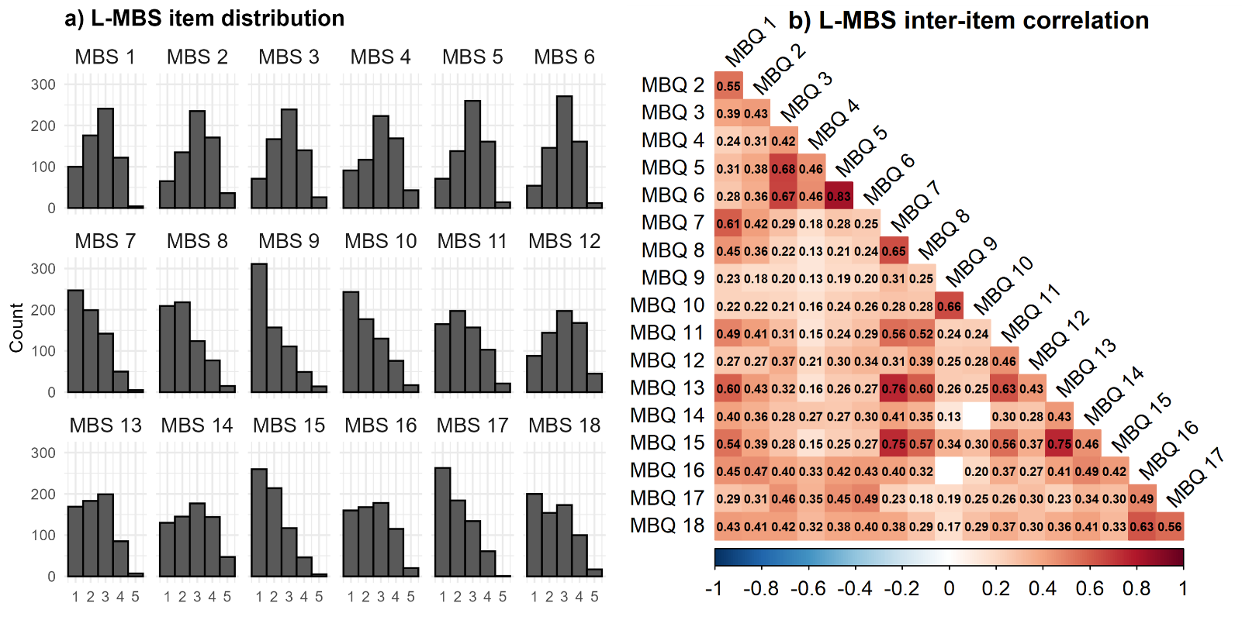
Supplementary Figure S1. Distribution properties of the items of the Liege Mind-Blanking scale (L-MBS). a) The items of the L-MBS show a moderate degree of rightward skewness. B) The items of the L-MBS show positive intercorrelations. Correlations were estimated using polychoric correlations and FDR-corrected. Empty cells in the heatmap indicate the absence of statistical significance.

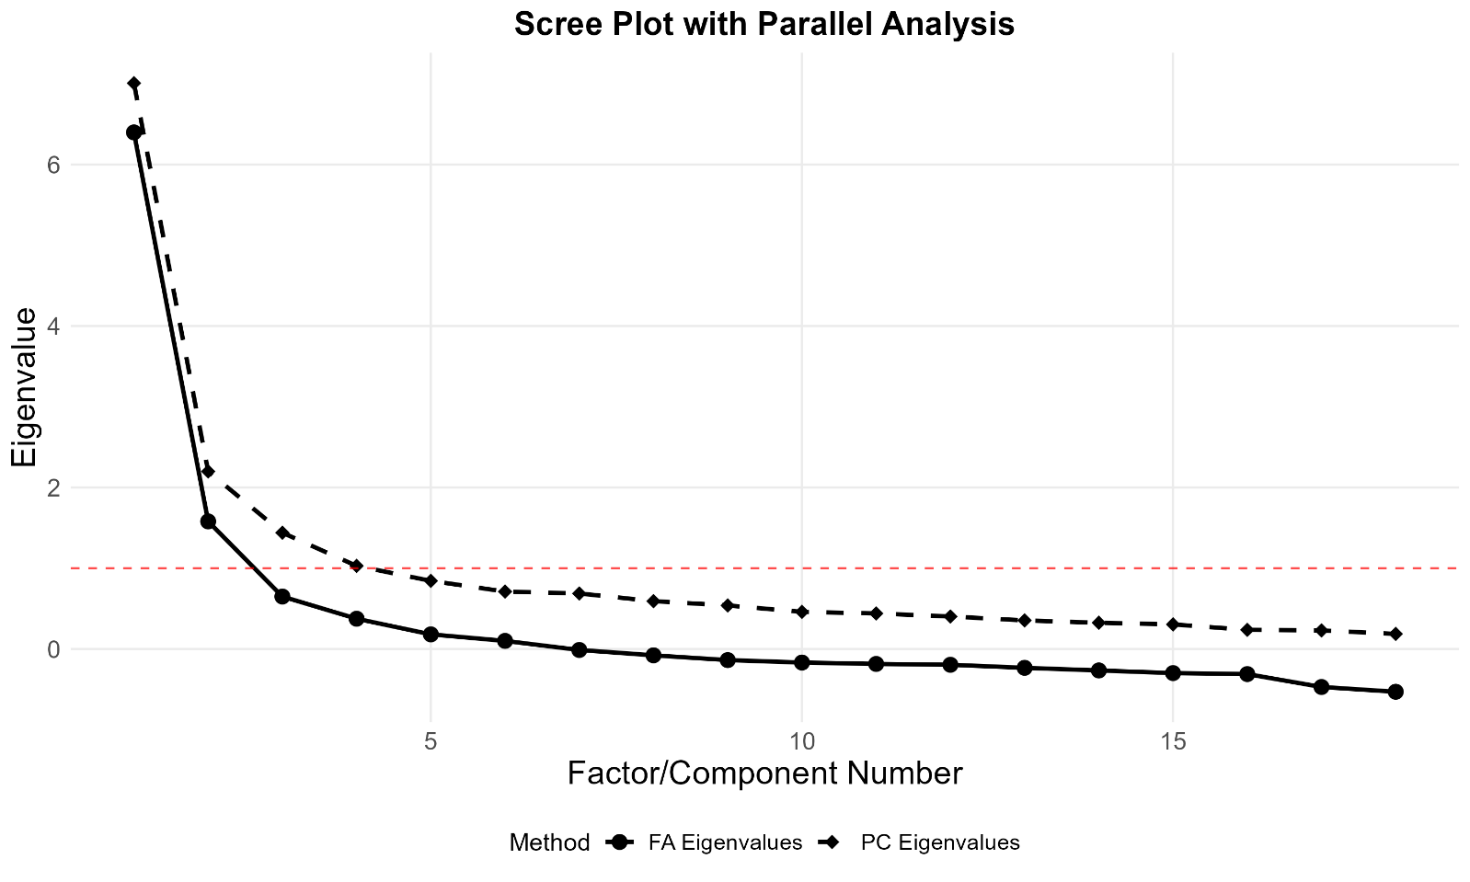
Supplementary Figure S2. Scree plot and parallel analysis of the Liege Mind-Blanking Scale (L-MBS). Solid circles represent eigenvalues obtained from factor analysis (FA), whereas dashed diamonds represent eigenvalues from principal component analysis (PCA). The red dashed line indicates an eigenvalue = 1. Parallel analysis was fit using the polychronic correlation matrix using the weighted least squares factoring method.
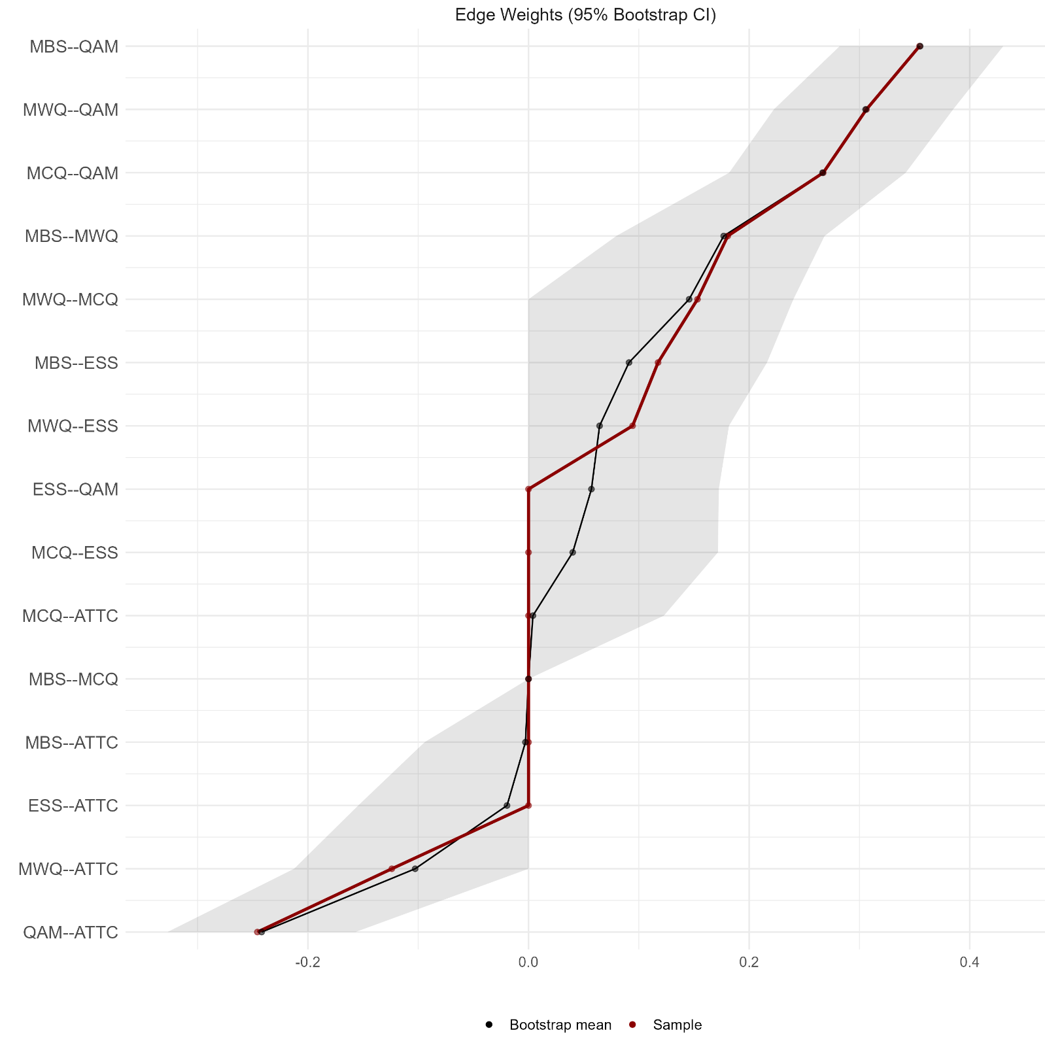Supplementary Figure S3. Edge weights and 95% confidence intervals for the Gaussian Graphical Model fitted on the global level, on the questionnaire dataset. The red line indicates the estimated partial correlations. The black line indicates the bootstrap-estimated partial correlations. The grey shaded regions indicate the 95% bootstrap confidence intervals. ATTC = Attentional Control Scale; MBS = Liege Mind Blanking Scale; MWQ = Mind Wandering Questionnaire; MCQ = Metacognitions-30 Questionnaire; ESS = Epworth Sleepiness Scale; QAM = Memory Self-Evaluation Questionnaire.

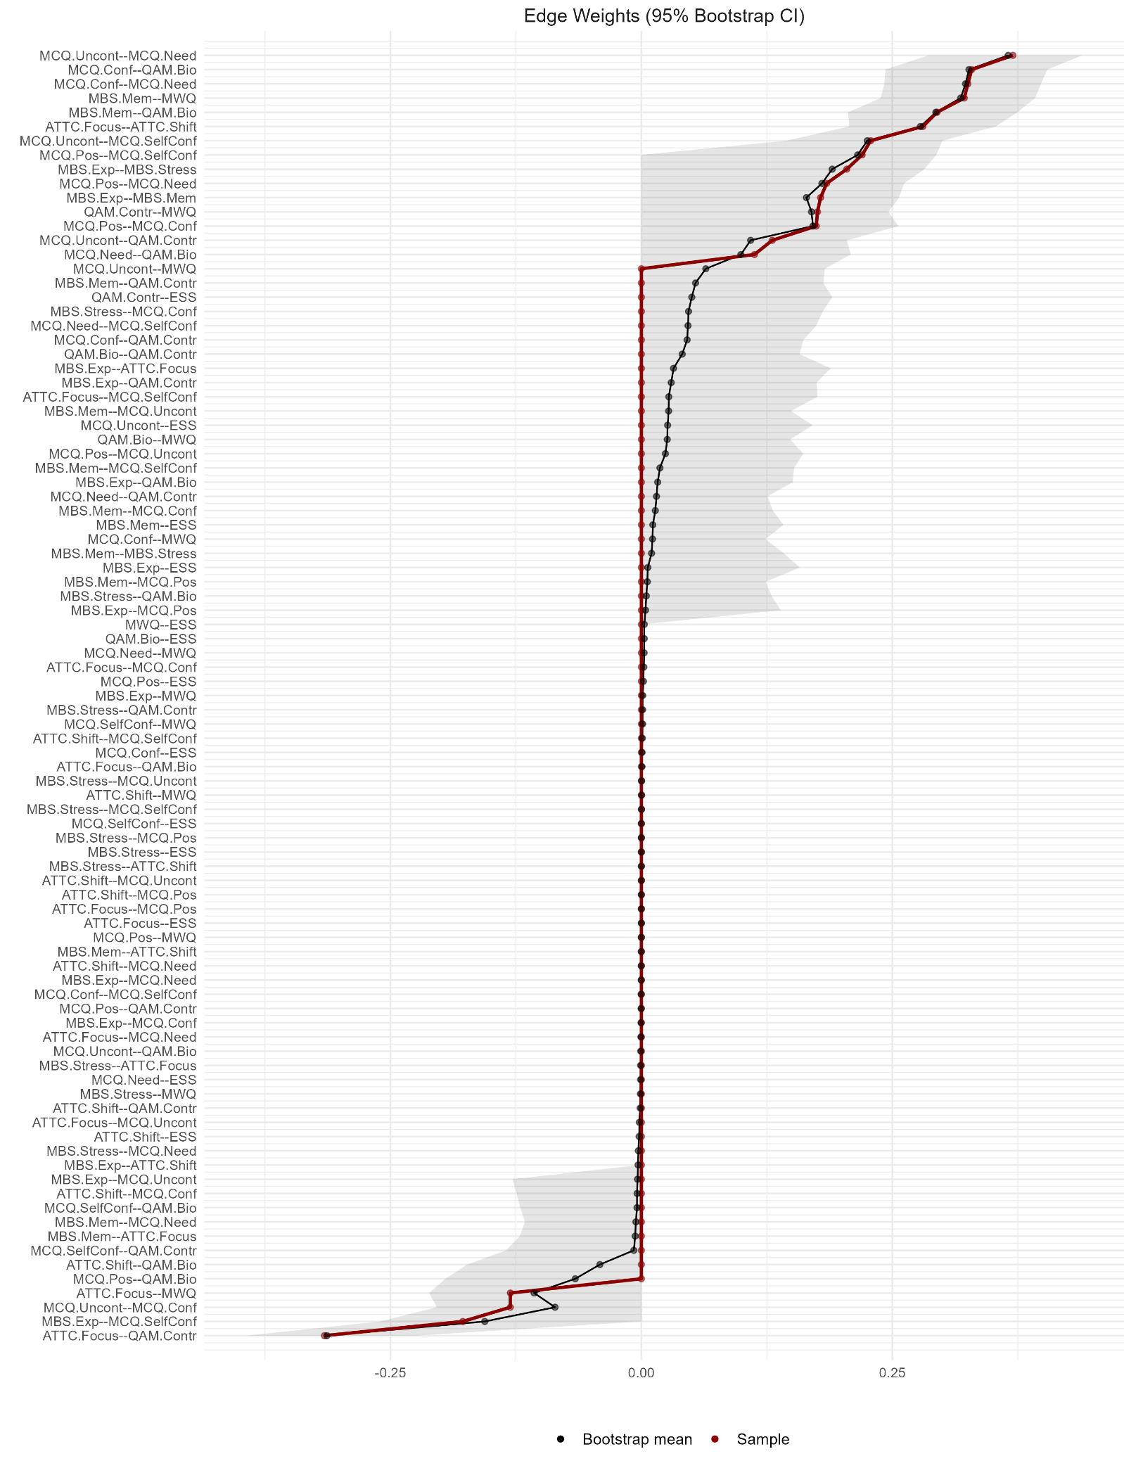
Supplementary Figure S4. Edge weights and 95% confidence intervals for the Gaussian Graphical Model fitted on the local level, on the questionnaire subscales. The red line indicates the estimated partial correlations. The black line indicates the bootstrap-estimated partial correlations. The grey shaded regions indicate the 95% bootstrap confidence intervals. ATTC = Attentional Control Scale; MBS = Liege Mind Blanking Scale; MWQ = Mind Wandering Questionnaire; MCQ = Metacognitions-30 Questionnaire; ESS = Epworth Sleepiness Scale; QAM = Memory Self-Evaluation Questionnaire.
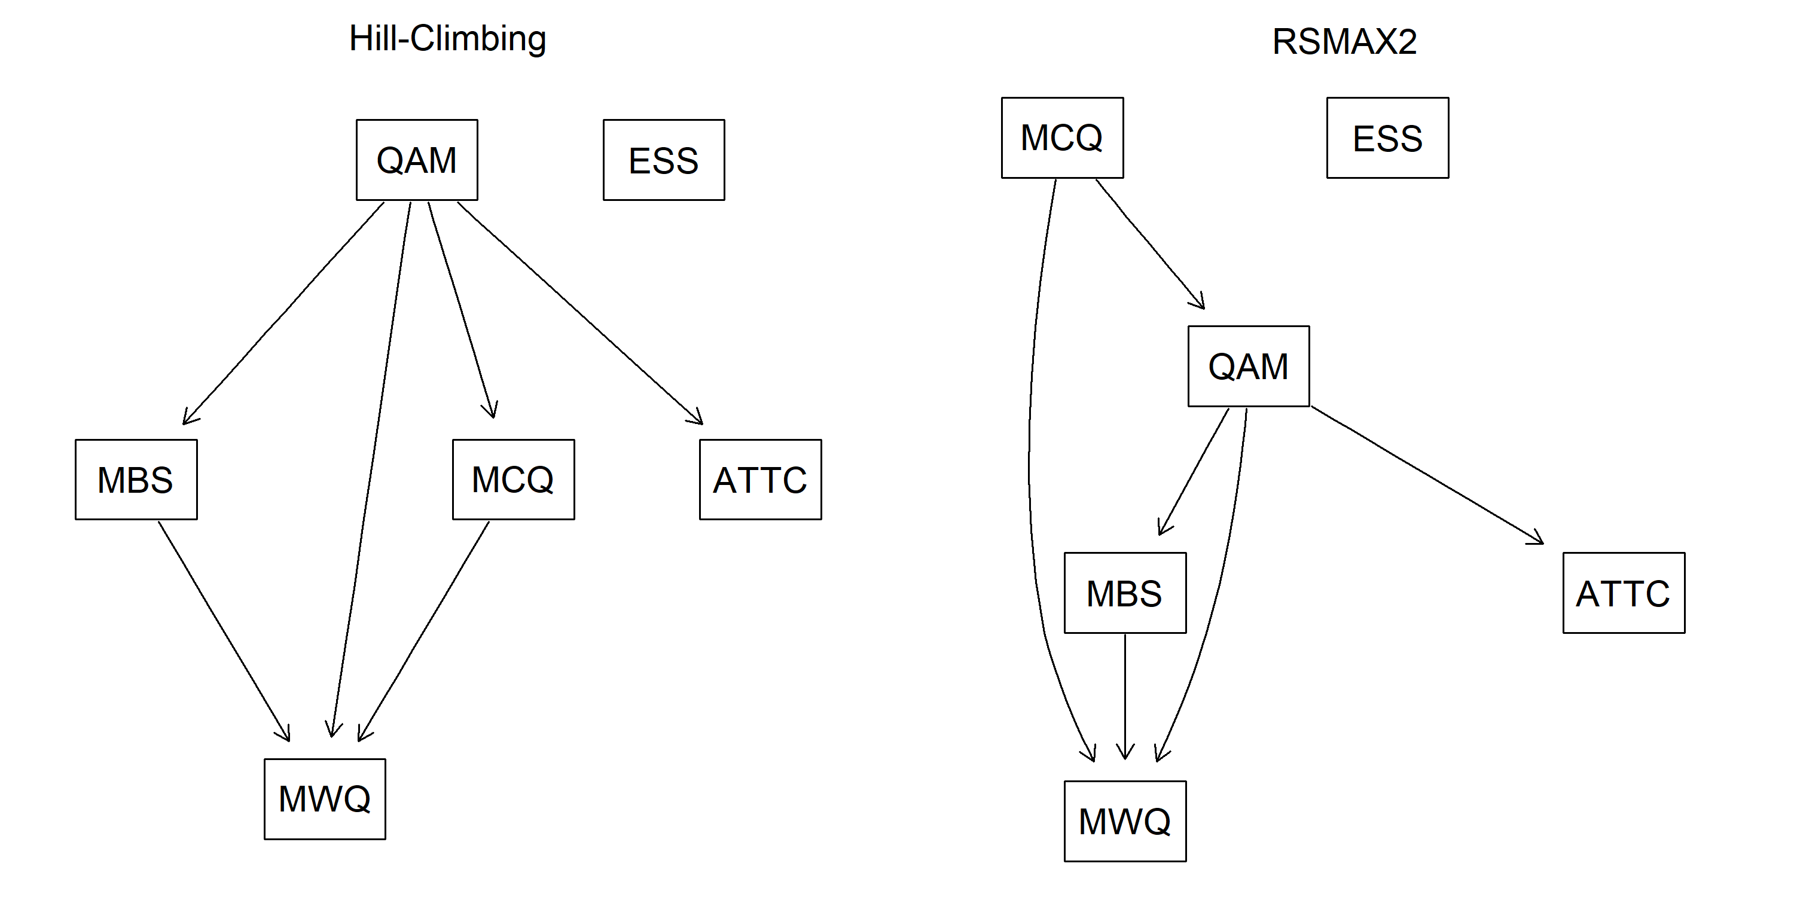
Supplementary Figure S5. Algorithm comparison for the Bayesian Networks fitted on questionnaire data. ATTC = Attentional Control Scale; MBS = Liege Mind Blanking Scale; MWQ = Mind Wandering Questionnaire; MCQ = Metacognitions-30 Questionnaire; ESS = Epworth Sleepiness Scale; QAM = Memory Self-Evaluation Questionnaire.
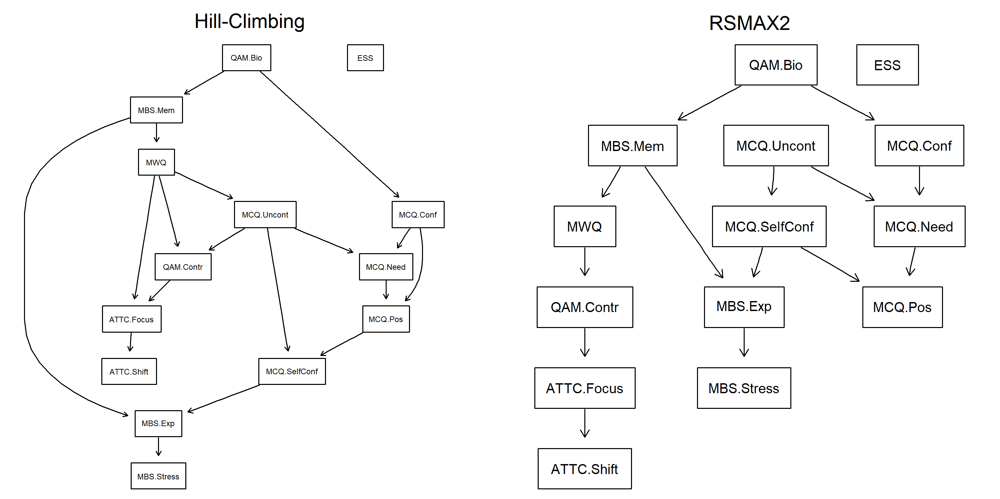
Supplementary Figure S6. Algorithm comparison for the Bayesian Networks fitted on the subscales of the questionnaire data. ATTC = Attentional Control Scale; MBS = Liege Mind Blanking Scale; MWQ = Mind Wandering Questionnaire; MCQ = Metacognitions-30 Questionnaire; ESS = Epworth Sleepiness Scale; QAM = Memory Self-Evaluation Questionnaire.

Supplementary Methods
QAM Latent Structure
Before examining how the L-MBS covaries with the other questionnaires, we first wanted to test whether the QAM (N=595) has a latent structure. The structure was evaluated as factorizable (KMO: 0.91; Bartlett's test of sphericity: χ2 = 19696.02, p < .001). Our analysis equally favoured a 1-factor and a 2-factor solution, yet we retained the 2-factor solution to potentially extract information from different memory domains. Item loadings can be found in Supplementary Table S4. The first factor, consisting of 16 items, included items such as “Do you forget the name of a street that you know well?” “Do you forget recent events that happened to you personally a few days or weeks ago?” and “Do you have difficulty remembering recent events?” were termed “Autobiographical Memory”. The second factor, consisting of 14 items, included items such as “Do you find it more difficult to learn something when you are tired?” “Do you find it more difficult to remember something in a noisy environment?” and “Do you find it more difficult to remember something when you are busy doing several things at once?” and was subsequently termed “Memory Control”.

Excluding participants who had missing reports in any item of the QAM

