The Liège Mind-Blanking Scale: a comprehensive scale to assess the heterogeneity of mind-blanking cognitive and experiential aspects

Paradeisios Alexandros Boulakis^{1,2}, Marion Balla², Agustina Aragón-Daud^{2,3}, David Stawarczyk^{1,4}, Giovanni Briganti^{5,6,7,8}, Athena Demertzi*^{1,2}, and Steve Majerus*^{1,4}
¹Psychology and Neuroscience of Cognition Unit (PsyNCog), University of Liège, Belgium
²Physiology of Cognition Lab, GIGA CRC Human Imaging, University of Liège, Belgium
³Applied Machine Learning Lab, Institute of Neuroscience and Medicine: Brain & Behaviour (INM-7), Forschungszentrum Jülich, Germany
⁴GIGA CRC Human Imaging, University of Liège, Belgium
⁵Unit of Computational Medicine and Neuropsychiatry, Faculty of Medicine, Pharmacy, and Biomedical Sciences, University of Mons, Belgium
⁶Digital Health, Department of Clinical Sciences, Faculty of Medicine, University of Liège, Belgium
⁷Faculty of Medicine, Université Libre de Bruxelles, Belgium
⁸Department of Psychiatry, Oxford University

Author Note
Paradeisios A. Boulakis  https://orcid.org/0000-0003-3885-5947
Marion Balla https://orcid.org/0009-0005-5096-9500
Agustina Aragón-Daud https://orcid.org/0000-0003-4539-4114
David Stawarczyk https://orcid.org/0000-0001-5504-5976
Giovanni Briganti https://orcid.org/0000-0002-4038-3363
Athena Demertzi https://orcid.org/0000-0001-8021-3759
Steve Majerus https://orcid.org/0000-0002-8206-8097
*Steve Majerus and Athena Demertzi contributed equally to this work and share last authorship.
Correspondence concerning this article should be addressed to Dr Athena Demertzi, Physiology of Cognition Lab, CRC Human Imaging, Allée du 6 Août, 8, 4000 Liège, Belgium. Email: a.demertzi@uliege.be. Telephone: +32 4 3662360
Abstract
Our minds are not always full of thoughts. Occasionally, people will report absence of any mental content, an experience termed mind-blanking (MB). So far, MB has been primarily quantified through experience-sampling paradigms. While experience-sampling has allowed researchers to study the behavioural and neurophysiological profile of MB, the practice of asking participants for thought categories, such as “an empty mind”, might undermine the richness and diversity of MB instances. In the present study, we adopted a self-reported, trait approach to MB. We developed a novel MB scale, the Liège Mind-Blanking Scale (L-MBS), with the aim to probe distinct types of MB experiences and relate them to different cognitive functions. A sample of 644 participants completed the L-MBS alongside a cohort of self-report questionnaires measuring trait mind-wandering, attention, memory, metacognition and arousal. The L-MBS showed adequate psychometric properties. Factor analysis validated the presence of 3 discrete factors: one related to the perceived experience of MB, one related to memory failures, and one related to blanking under pressure. Network analysis linked these factors to discrete cognitive domains. The experience of blanking correlated with metacognitive monitoring, while memory failures were associated with autobiographical memory difficulties. Overall, the L-MBS provides a quick, accessible and psychometrically validated measure of an individual’s beliefs about their blank experiences. At the same time, the presence of multiple MB factors suggests that MB is not necessarily a unitary phenomenon and most likely represents a clustering of different moments of no content.
Keywords: mind-blanking, mind-wandering, questionnaire, metacognition, memory difficulties, network analysis, Bayesian networks

Introduction
While we tend to think of consciousness as a continuous stream of thoughts, emotions, perceptions, and sensations, there are moments when people cannot bring forth any mental content. This experience, termed mind-blanking (MB), captures moments in which people report having no mental content to reflect upon or are unable to describe any experience at all (Andrillon et al., 2025; Boulakis & Demertzi, 2025; Ward & Wegner, 2013). Unlike mind-wandering, in which attention is redirected toward thoughts whose content is unrelated to the here and now (e.g., thinking about lunch during a work presentation), MB represents a form of perceptual decoupling in which subjective mental content appears absent rather than simply directed elsewhere (Andrillon et al., 2025). That is to say, ΜΒ arises either from genuine void content or from an inability to bring forth immediate past content. In both cases, MB is typically recognised retrospectively, once thought has resumed, because of the impression of a brief period of emptiness. As such, it challenges the assumption that being conscious necessarily means constantly being conscious of something.
So far, MB has been primarily assessed using experience-sampling paradigms, in which participants receive intermittent probes and report what was on their minds just before each probe. When participants are given the option to report an absence of content or thought, MB is typically reported in about 10% of probes, suggesting that such episodes, while infrequent, represent a recurring feature of spontaneous cognition (for a meta-analysis of MB report rates, see Boulakis et al., 2026). Experience-sampling provides further evidence for the universality of MB. First, experience-sampling studies show that MB reports are elicited both when participants are explicitly offered an MB response option among other thought-related categories and when they are asked to describe their experience freely, without predefined response labels (Lal et al., 2025; Van Calster et al., 2017; Van den Driessche et al., 2025). Second, MB reports are reliably elicited across diverse experimental and linguistic contexts, including controlled laboratory tasks, resting-state paradigms, and naturalistic everyday environments, in populations of different linguistic origins (Anderson & McDaniel, 2019; Andrillon et al., 2021; Aragón-Daud et al., 2026; Boulakis, Simos, et al., 2025; Kawagoe et al., 2019; Moraitou & Efklides, 2009; Mortaheb et al., 2022; Van Calster et al., 2017). Finally, the phenomenal experiences reported via experience-sampling probes map to distinct neuronal events, suggesting that MB is dissociable both at the phenomenal and the neurocognitive level (Andrillon et al., 2021; Boulakis et al., 2023; Boulakis, Kusztor, et al., 2025; Boulakis, Simos, et al., 2025; Mortaheb et al., 2022; Munoz-Musat et al., 2025). Taken together, experience-sampling methods substantiate the validity and distinctiveness of MB reports as a core feature of ongoing mentation.
The studies described above are examples of state-level approaches to the stream of thought (Chaplin et al., 1988). State-level approaches capture fluctuations in thought content using thought-sampling methods. The advantages of state-level approaches are clear: they provide a quantification of how frequently people experience different contents during experimental and ecological settings (Boulakis et al., 2026; Kawashima et al., 2023). However, they also come with significant caveats. Experience-sampling studies, especially ones targeting low-frequency events such as MB, can be time-consuming, requiring extensive sampling periods to establish an accurate estimate of the underlying MB probability. Additionally, state-level studies are constrained by the mental-state sampling interval, the frequency at which participants are probed to report their mental states. Since MB might represent a briefer mental state than others (Ward & Wegner, 2013), individuals might identify it more quickly and recover from it, and probes might underestimate the frequency of MB occurrences. Finally, experience-sampling reports are constrained by motivational and contextual factors, which can bias momentary reports and limit their generalizability to stable trait-level characteristics, such as an individual’s overall propensity to wander or blank (Kawagoe et al., 2020; Seli et al., 2019).
Apart from methodological limitations attributed to experience-sampling, research on MB is further constrained by conceptual haziness. MB has been described as a) an attentional lapse, suggesting that there might be mental content, but a failure of attention leads to not attending to it (Andrillon et al., 2021; Munoz-Musat et al., 2025), b) absence of any content, akin to moments of reduced consciousness during wakefulness (Mortaheb et al., 2022), c) metacognitive failure, whereby individuals misjudge whether mental content was present immediately beforehand, akin to an erroneous feeling of knowing that content is present (Alcaraz Sánchez, 2026; Van Calster et al., 2017), d) metacognitive awareness of memory failure (Efklides, 2014), in which people fail to retrieve a prospective goal but remain aware that there is an intended goal that is not immediately recoverable, or e) drowsiness / local sleep (Andrillon et al., 2025). While all these formulations may describe “blank” reports, they point to distinct psychological phenomena, namely attention, memory or metacognition (Boulakis & Demertzi, 2025; Fell, 2022). This issue is further complicated when considering what people report when they experience “nothing”. For example, Lal et al. (2025) found that MB reports represent a cluster of qualitatively different experiences, with some participants describing a complete absence of thought and others reporting more diffuse or unclear mental content, suggesting variability rather than a single, uniform state. In practice, state-level MB reflects the introspective evaluation of one’s immediate, pre-probe mental content in response to a probe. Typical MB responses are “no thought” (awareness of absence when people know their mind was empty) and “inability to recover anything” (absence of awareness when people briefly forget their content and cannot ascribe it anywhere). Therefore, it is more likely that MB represents an umbrella term, grouping different blank experiences (Boulakis et al., 2023; Boulakis & Demertzi, 2025; Kaufmann et al., 2024) and grouping them together might undercut the nuances of MB.
Self-report questionnaires can complement experience-sampling by circumventing its methodological limitations and the theoretical confusion arising from broad MB categories. Unlike experience-sampling, trait, self-report questionnaires tap into relatively stable characteristics, tendencies, beliefs or habitual patterns of experience through psychometrically validated scales. Additionally, data-driven approaches, such as factor analysis, can highlight substructures in the scales by identifying sources of common variance. In turn, these common sources can inform the development of questionnaire subscales by grouping items that reflect similar underlying constructs. This is especially pertinent to resolving the issue of definitional and cognitive heterogeneity in MB. The first effort in a psychometrically validated, MB questionnaire was the Blank in the Mind Questionnaire (BIMQ; Moraitou & Efklides, 2009). The BIMQ was constructed to isolate metacognitive experiences of people becoming aware of no mental content as a result of memory failure. Consequently, items primarily reflect occurrences when memory failures elicit a feeling that content is lost (i.e. “I knew that I had some things to talk about but, at that moment, I forgot them”). Recently, another validated questionnaire was proposed to examine trait-level MB: the Mind-Blanking Questionnaire (MBQ; Kawagoe et al., 2024). The MBQ is a 5-item Likert-scale questionnaire containing items such as “There are moments that I cannot remember what I was just thinking about” and “There are times when my mind goes completely blank”. The items were developed based on the theoretical construct of MB, with a heavy focus on “blank” or “spacing out” moments. When the MBQ items were pooled with those from a trait mind-wandering questionnaire, the MBQ demonstrated adequate discriminant validity, as MB items and mind-wandering items loaded onto separate factors. This pattern suggests that trait MB and trait mind-wandering represent distinct psychological constructs, and items describing one do not necessarily translate to the other.
The MBQ appears to adequately track true instances of MB rather than momentary memory failures (Kawagoe et al., 2026). However, due to its item content, the MBQ primarily targets spontaneous MB occurrence. As previously shown, MB may emerge spontaneously or through intentional effort (Boulakis et al., 2023; Kawagoe et al., 2019). Additionally, the practice of grouping together questionnaire items reflecting memory failures with the experience of MB might underscore the fact that these reflect different phenomena (Kawagoe et al., 2026). Finally, MB experiences include broader moments of degraded content (Lal et al., 2025). Overall, the first major contribution of an extensive MB scale is to clearly examine whether MB reports converge on the same underlying psychological construct, or whether individuals’ reports of MB instead reflect a heterogeneous mix of loosely related phenomena.
A second advantage of such a comprehensive MB questionnaire is that it enables us to examine how it covaries with the proposed explanations of MB. The multiple explanatory cognitive domains, namely attention, memory, and metacognition, suggest that MB is more likely to emerge through the reciprocal interactions among these domains (Andrillon et al., 2025) rather than a simple cause-and-effect relationship with one sole domain. These interactions can share common physiological origins, such as arousal, and can have differential phenomenological outputs, such as mind-wandering or MB (Andrillon et al., 2025). Therefore, to capture the full psychological structure within which MB is embedded, a network approach is more appropriate (Hevey, 2018). By shifting to a multidimensional description of all potential descriptions, we can estimate which psychological domains meaningfully contribute to MB while controlling for the influence of other psychological variables. Therefore, an extensive MB questionnaire alongside a characterisation of an individual’s cognitive capacities can advance the discussion of the cognitive underpinnings of MB.
The present study aimed to develop a psychometrically validated, comprehensive tool to describe the broader spectrum of MB experiences, the Liège Mind-Blanking Scale (L-MBS). By moving beyond prior correlational approaches, we aimed to provide a detailed, systematic account of the cognitive and experiential aspects of MB. Specifically, we hypothesised that a) a comprehensive MB scale would be decomposed into latent components reflecting different types of blank experiences, b) trait MW questionnaire items would load on a different latent factor than MB items, and c) MB subscales would differentially correlate with established measures of attention, memory, metacognition and arousal. While we had no strong a-priori assumptions about the different MB subscales, we expected a putative split between reports of inability to recall immediate past mental events and moments of degraded mental content, reflecting an established literature distinction (Andrillon et al., 2021; Kawagoe et al., 2026; Van den Driessche et al., 2017). In turn, we expected that the former subscale would more strongly correlate with questionnaires measuring memory and metacognitive evaluation of goals (Efklides, 2014), while the latter would correlate with meta-monitoring and attentional mechanisms (Andrillon et al., 2021; Boulakis et al., 2023). However, following recent arousal-driven accounts of MB (Andrillon et al., 2025), we expected that all components would correlate with overall self-reported sleepiness.

Methods
Participants
Six hundred and sixty-six participants anonymously completed either the English or the French version of the L-MBS and a set of complementary self-evaluation questionnaires spanning memory, attention, metacognition, sleepiness and mind-wandering. Sample size justification for factor analysis studies has provided mixed recommendations, primarily because the required sample size depends on factor analysis parameters that are not known a-priori to researchers, such as the number of latent factors and their loading strength, the strength of item correlations and the communality of items (Kyriazos, 2018; Schreiber, 2021). Based on a pre-allocated explanatory (EFA) / confirmatory (CFA) factor analysis split of 2:1 and following the conservative heuristic of 20:1 subjects to questionnaire item ratio (Dimitrov, 2012; Jackson, 2003; Kyriazos, 2018), we reasoned that 600 participants (400 in EFA and 200 in CFA) would be sufficient for a questionnaire of 18 items and expected latent structure with 1-4 latent factors (Efklides, 2014; Kawagoe et al., 2024; Lopez et al., 2023; Mrazek et al., 2013). After excluding participants with low proficiency in their selected language (n=22), the final sample comprised 644 participants (median age = 26, s.d. = 18, range = [18, 91], N female = 473; N French = 606; N English = 38). Since English speaking participants represented less than 6% of the sample (see Table 1) we decided to pool all the participants together for subsequent analyses. Occasionally, participants did not complete all items on every questionnaire, resulting in missing data points. To preserve as much data as possible, these participants were excluded only at the level of each specific analysis rather than entirely. As a result, analyses conducted at the level of entire questionnaires, rather than the factor level, included fewer data points due to the accumulation of missing values across items. Additionally, 47 participants incorrectly coded their age (negative numbers or empty responses). We excluded these participants only from age-related analyses. The final samples per analysis are reported at the analysis level. We recruited participants through campus posters, intranet electronic invitations, and the ULiège e-campus platform. Additionally, participants were recruited through the undergraduate participant pool of the University of Liège’s Faculty of Psychology, Speech Therapy, and Educational Sciences using SONA. The study was completed online via the Gorilla platform (https://gorilla.sc/). Descriptive statistics stratified by recruitment platform are presented in Table 1.

Table 1
Demographic Characteristics
Demographic | Overall | Announcements | Sona
Demographic | N = 644 | N = 406 | N = 238
Assigned Sex
Female | 473 (73%) | 273 (67%) | 200 (84%)
Male | 169 (26%) | 132 (33%) | 37 (16%)
No Response | 2 (0.3%) | 1 (0.2%) | 1 (0.4%)
Preferred Gender
Female | 463 (72%) | 266 (66%) | 197 (83%)
Male | 172 (27%) | 132 (33%) | 40 (17%)
Non-Binary | 7 (1.1%) | 7 (1.7%) | 0 (0%)
No Response | 2 (0.3%) | 1 (0.2%) | 1 (0.4%)
Education
Advanced university degree | 271 (42%) | 265 (65%) | 6 (2.5%)
Undergraduate university degree | 91 (14%) | 80 (20%) | 11 (4.6%)
Vocational training | 8 (1.2%) | 7 (1.7%) | 1 (0.4%)
Higher education | 143 (22%) | 39 (9.6%) | 104 (44%)
Secondary or lower education | 125 (19%) | 11 (2.7%) | 114 (48%)
No response | 5 (0.8%) | 3 (0.7%) | 2 (0.8%)
Handedness
Ambidextrous | 13 (2.0%) | 10 (2.5%) | 3 (1.3%)
Left | 57 (8.9%) | 28 (6.9%) | 29 (12%)
Right | 573 (89%) | 367 (91%) | 206 (87%)
Native Language
English | 38 (5.9%) | 32 (7.9%) | 6 (2.5%)
French | 606 (94%) | 374 (92%) | 232 (97%)

Questionnaire Development
One author (PAB) reviewed the MB literature to identify items that may reflect MB occurrences. The overarching aim was to generate a comprehensive list that captures the full range of ways individuals may describe their MB experiences. This review focused on two main axes: (1) a recent systematic review compiling instances in which MB was used as a probe in experience-sampling studies (Boulakis et al., 2026), and (2) theoretical work defining MB and describing the heterogeneity of MB experiences (Andrillon et al., 2025; Boulakis & Demertzi, 2025; Fell, 2022; Kaufmann et al., 2024). This process yielded a set of descriptions capturing complementary features, such as “forgetting immediate past thoughts” or “not paying attention”, as well as situational instances in which MB may occur, including “blanking during intense anxiety” or “intentionally emptying one’s thoughts.” AAD, DS, AD and SM reviewed the initial item pool and reached consensus on 35 preliminary items. Two native French-speaking authors (DS and SM) independently translated the items into French. Two independent French speakers then back-translated these translations into English and compared them with the original versions. Through an iterative translation and back-translation process, we revised items that were unclear to independent French speakers without prior knowledge of MB. The initial list is available in Supplementary Table S1. Items are rated on a 5-point Likert scale, ranging from 1 (almost never) to 5 (almost always).
Content Validity
To improve content validity, a panel of 9 independent researchers in MB and spontaneous thinking reviewed the proposed item pool. Each expert evaluated the relevance of every item using a Likert scale (“completely irrelevant”, “somewhat relevant”, “quite relevant”, “highly relevant”). The item content validity index (I-CVI) was estimated by averaging “quite relevant” and “highly relevant” responses per item. While typical recommendations suggest keeping items with I-CVI >= 0.79 (Polit et al., 2007; Polit & Beck, 2006), we adopted a more liberal threshold of I-CVI >= 0.6. This liberal threshold still indicates acceptable content validity based on ratings from nine reviewers. At the same time, it acknowledges that MB is a relatively novel and debated phenomenon. As such, an exploratory approach is warranted. Items below that threshold were dropped. Supplementary Table S1 provides content validation indices for each external reviewer. After excluding items with low I-CVI, we reduced the proposed scale structure to 18 items.
Construct Validity
To examine the latent structure of the L-MBS, we performed exploratory (EFA) / confirmatory (CFA) factor analysis. First, we evaluated the scale’s adequacy for factor analysis using the Kaiser-Meyer-Olkin value and Bartlett’s test. After confirming that the correlation matrix was indeed factorisable, we performed EFA on 66% of the questionnaire dataset. Since our aim was to identify latent variables rather than simply reduce the questionnaire’s dimensionality, we conducted factor analysis (Costello & Osborzne, 2005; Schreiber, 2021). As we had no strong justification, we allowed latent factors to be correlated by applying an oblimin rotation (Jennrich & Sampson, 1966). EFA was fit using weighted least-squares estimation on the polychoric correlation matrix to account for the ordinal nature of the Likert-scale items. This approach is appropriate for non-normally distributed ordinal data (Schreiber, 2021). We estimated the optimal number of latent factors using a consensus-based approach. Specifically, we utilised 27 different methods to determine the number of factors and selected the solution with the greatest agreement across methods. To assess the robustness of the consensus approach to sample size, we repeated the estimation on subsamples ranging from 30% to the full dataset. In addition, we implemented a 5-fold cross-validation procedure, estimating the number of factors using 4 of the 5 folds in each iteration. This combined strategy ensured that the identified number of factors remained stable across sample-size variations and across different samples from the same data-partitioning scheme. To complement this approach and test whether the consensus approach converges with the standard factor analysis practices, we further conducted parallel analysis. To ensure each item loads strongly on a single factor, minimises cross-loadings, and improves factor interpretability, we retained only items with a loading > 0.4 on at least one factor and a loading > 0.4 relative to other factors. For example, if the strongest loading of an item was 0.30, it did not meet the first criterion and was therefore dropped, as it did not load sufficiently strongly on any factor. Likewise, if an item loaded 0.60 on one factor and 0.40 on another, it did not meet the second criterion, as the difference between the two loadings was only 0.20 rather than the required 0.40, and was therefore dropped. While this approach may be conservative, it allows for robust pruning of questionnaire items (Blekić et al., 2023; Matsunaga, 2010). The final proposed structure was further inspected by the authors to ensure factor interpretability.
Second, we performed CFA on the remaining 33% of the dataset to validate the proposed latent factor structure. We originally tested the weighted least squares estimator, but due to convergence issues, we reverted to maximum likelihood estimation with robust standard errors. We compared the proposed EFA solution to three alternative models: a simplified solution with one latent factor, a simplified solution with uncorrelated factors, and a more complex bifactor solution in which all items loaded on both a global factor and their respective latent factors. We assessed goodness of fit by considering a set of fit indices following standard fit quality guidelines, namely the root mean square error of approximation (RMSEA < .06), the Tucker–Lewis fit index (TLI > .9), the comparative fit index (CFI > .9) and the standardised root mean square residual (SRMR < .08) (Byrne & Byrne, 2013; Fan et al., 1999; Hu & Bentler, 1999; Kline, 2016; Tucker & Lewis, 1973).
Additional questionnaires
Alongside the L-MBS scale, participants completed a set of questionnaires evaluating arousal, metacognitive monitoring of thoughts, attentional capacities, memory difficulties, and mind-wandering.
Epworth Sleepiness Scale (ESS)
The ESS (Johns, 1991; Kaminska et al., 2010) is a widely utilised self-report scale that measures daytime sleepiness. The ESS consists of eight items, each describing a common real-life scenario (e.g., sitting and reading, watching TV, or sitting in a car stopped in traffic). Respondents rate their likelihood of dozing off on a 4-point Likert scale (0 = no chance of dozing off to 3 = high chance of dozing off). Total scores range from 0 to 24, with higher scores indicating greater daytime sleepiness. In the present sample, the ESS showed acceptable internal consistency (Cronbach's α = .74).
Metacognitions Questionnaire 30 (MCQ-30)
The MCQ-30 (Larøi et al., 2009; Wells & Cartwright-Hatton, 2004) is a self-report tool that assesses an individual’s metacognitive beliefs across five domains: a) cognitive confidence, b) positive beliefs about worry, c) cognitive self-consciousness, d) uncontrollability and danger of thoughts, and e) need for control over thoughts. It comprises 30 items rated on a 4-point Likert scale (1 = do not agree to 4 = agree completely). In the present sample, the MCQ showed good internal consistency (Cronbach's α = .87). Of particular interest to our study was the cognitive self-consciousness factor, consisting of items such as “I think a lot about my thoughts” and “I am aware of the way my mind works when I am thinking through a problem”. Because these items directly reflect thought monitoring, we expected an inverse relationship with the L-MBS.
Attentional Control Scale (ATTC)
The ATTC (Blekić et al., 2023; Leleu et al., 2022) is a self-report scale that measures individual differences in attentional control, specifically the ability to voluntarily focus attention while suppressing distractors and the capacity to shift attention from one task to another. The ATTC uses a 4-point Likert scale (1 = almost never to 4 = always) for items like “It’s very hard for me to concentrate on a difficult task when there are noises around” and “I can quickly switch from one task to another”. We utilised the 9-item forward-coding version and the factor decomposition proposed by Blekic et al. (2023). In the present sample, the ATTC showed good internal consistency (Cronbach's α = .84).
Memory Self-Evaluation Questionnaire (QAM)
The QAM (Van der Linden et al., 1989, 1997) is a 62-item questionnaire designed to assess everyday memory difficulties. Its items are detailed and grounded in real-life situations to capture ecologically relevant memory lapses. The questionnaire is organised into 10 sections, each targeting a specific domain of daily functioning, such as conversations, personal events or attention slips. One item (QAM 42: “Do you forget to take your medication? (Only answer this question if you take medication regularly)”) was dropped, as it contained null values in 21% of the sample size (137/644 participants). In the present sample, the QAM showed excellent internal consistency (Cronbach's α = .95). We also examined whether the QAM could be decomposed into distinct latent factors, as a central question of our study concerned the relationship between the L-MBS latent factor and distinct cognitive domains. To date, the latent structure of the QAM has not been formally investigated. We therefore adopted an exploratory approach to determine whether the questionnaire captures underlying cognitive capacities, such as working memory, rather than merely reflecting the content domains of everyday memory difficulties (See Supplementary Methods).
Mind-Wandering Questionnaire (MWQ)
The MWQ (Mrazek et al., 2013; Perche et al., 2025) is a 5-item self-report questionnaire rated on a 6-point Likert scale that measures perceived mind-wandering. Items include “I have difficulty maintaining focus on simple or repetitive work” or “I find myself listening with one ear, thinking about something else at the same time”. Since MB and mind-wandering both involve decoupling attention from task engagement, but one signals no content and the other signals content reorientation, we reasoned that the MWQ would provide a concrete test of our scale’s ability to discriminate between the two psychological phenomena. In the present sample, the MWQ showed good internal consistency (Cronbach's α = .8).
Network Analysis
Our goal was not only to develop a MB scale capable of capturing the heterogeneity of MB experiences but also to embed it within a broader network of psychological constructs, such as attention and memory. By doing so, we aimed to identify the cognitive processes that may drive both the overall scale and its constituent subscales. Therefore, we opted for a network analysis.
Gaussian Graphical Models (GGM)
We estimated regularised Gaussian Graphical Models (GGM) with EBICglasso (Costantini et al., 2015; Hevey, 2018). We selected GGMs because they allow estimation of networks from polychoric correlations in ordinal data, which is often more appropriate for psychological variables measured on Likert-type scales (Epskamp, 2017). EBICglasso regularises the network by using the least absolute shrinkage and selection operator (LASSO; Tibshirani, 1996) to shrink small edge weights toward zero. This results in a sparse network in which edge weights represent regularised partial correlations between nodes. The degree of regularisation was controlled by setting the tuning parameter γ to its default value of 0.5.
We used bootstrapping to estimate confidence intervals around edge weights by repeatedly re-estimating the network 2,000 times from samples drawn with replacement. This procedure also enabled statistical comparisons of edge strength between pairs of connections. The stability of centrality estimate, a network metric reflecting a node’s importance within the network, was assessed using a bootstrap drop-case procedure, following the approach described in Epskamp et al. (2018). In each iteration, progressively smaller subsamples were drawn, and the correlation between the centrality indices estimated from the subsamples and those from the full sample was computed. This provided an index of the robustness of centrality estimates to the removal of cases. A correlation stability coefficient was deemed acceptable when it was above 0.5 (Epskamp et al., 2018). Finally, centrality differences were estimated from the bootstrapped samples.
Bayesian Networks (BN)
We complemented our GGMs by estimating directed acyclic graphs (DAGs). A DAG is a directed graphical representation of a network that does not permit feedback loops. Therefore, it describes the directional dependency from node A to node B, while prohibiting a route backwards from B to A. As such, DAGs describe the conditional independencies between a set of parameters. For example, if node A leads to node B and node B leads to node C, then A and C are conditionally independent given node B. In psychological networks, this allows the estimation of variable influences within a structure that separates direct relations from dependencies explained by other nodes (Briganti et al., 2023). Of particular interest in this study are the Markov Blankets of the MB nodes. The Markov Blanket of a target node refers to the set of nodes, based on which the target node is conditionally independent from the rest of the network. In practical terms, if an observer knows the state of every node in the Markov blanket, then knowing anything about the remaining nodes outside the blanket provides no additional information about the node in question. The blanket, therefore, acts as a complete informational boundary. In the case of MB, we can use the graphical representation of the DAGs to extract Markov Blankets for both the scale as a whole and the latent subscales to see which cognitive domains are parent nodes to MB and which domains are children nodes, while excluding non-informational cognitive domains.
We estimated the Bayesian Network using the Hill Climbing algorithm. Hill Climbing is a greedy search algorithm within the score-based algorithm family (Norvig & Russell, 2011; Scutari et al., 2019). The algorithm starts with an initial graph, repeatedly applies local modifications (such as adding or removing edges), and retains the change that yields the greatest improvement in the model’s Bayesian Information Criterion until no further improvement is possible. To ensure the stability of the estimated network, we bootstrapped 2000 samples. Then, we retained edges with average strength above .85 and average directionality above .5, indicating that the connections were both consistently present and reliably directional across bootstrap resamples rather than arising from sampling variability (Briganti et al., 2023). Finally, to ensure the network’s robustness to the choice of algorithm, we also tested the Sparse Candidate algorithm (Friedman et al., 2013). This algorithm belongs to the family of hybrid algorithms. If different families of algorithms produce similar structures, we consider the network to be robust to the choice of learning algorithm (Briganti et al., 2023).
Network Analysis Strategy
Our aim was to examine the relationship between the aggregate questionnaire scores and the scores of the various questionnaire subscales. Therefore, we estimated GGMs and DAGs for both a dataset containing the total score for each questionnaire and a dataset comprised of the subscales of the questionnaires. This way, we aim to provide a “global” account of MB, representing cognitive domains that lead to more self-reported MB, as well as a “local” account of MB, in which different MB subscales are influenced by and influence different cognitive domains. These two levels of analysis provide a complementary examination of the interactions between MB and different cognitive domains. At the global level, we examine whether there exists a general trend between any cognitive domain and the overall tendency to report moments of no thought. At the local level, we examine whether these trends are linked to specific facets of MB, identified through factor analysis, or instead dissipate once this global tendency is decomposed.
Statistical Analysis
Internal consistency was examined using Guttman’s lambda (Guttman, 1945) and McDonald’s omega (McDonald, 1999). Mean comparison was conducted using Welch’s t-test (Delacre et al., 2017). All statistical analyses were performed at a p-value < 0.01. Given the large sample size, this more stringent criterion avoids the pitfall of providing evidence for the null hypothesis for significant p-values > .02 (Lindley, 1957; Maier & Lakens, 2022).
Software
Data extraction and formatting were performed using custom Python scripts. All analyses were conducted using R v4.5.1 (R Core Team, 2025). Exploratory factor analysis was conducted using the psych v2.5.6 (Revelle, 2026) and easystats v0.7.5 (Lüdecke et al., 2022) packages. Confirmatory factor analysis was conducted using the lavaan v0.6-21 (Rosseel, 2012) package. Network analysis was performed using the bootnet v1.8 (Epskamp et al., 2018) and bnlearn v5.1 (Scutari, 2017) packages.

Results
Exploratory Factor Analysis
Before EFA, we inspected the properties of the content-validated scale (N=628). The L-MBS exhibited low to moderate positive skewness across items (Supplementary Figure S1a), along with strong positive inter-item correlations (Supplementary Figure S1b). The scale also showed high internal consistency (McDonald’s ω_{t} = .92, Gutmann λ₂ = .91, Gutmann λ₆ = .93). Finally, the questionnaire met the assumptions of EFA (KMO = .9; Bartlett’s test of sphericity: χ²(153) = 6152.23, p < .001), indicating that the sample is factorisable.
We split the data into a 2:1 ratio for EFA and CFA, resulting in an EFA sample of 416 participants. The optimal number of factors was estimated using a consensus-based approach. The majority of the estimated metrics strongly favoured a 4-factor latent structure, followed by a 3-factor solution (see Supplementary Figure S2 for a scree plot). The eigenvalues for the 4-factor EFA for the first four factors were: F1 = 4.07, F2 = 2.86, F3 = 2.15, F4 = 1.52. However, the latent 4-factor structure was uninterpretable, with no clear separation between the factors (See Supplementary Table S2 for factor loadings). Therefore, we retained the 3-factor latent structure, which accounted for 53% of the total scale variance (eigenvalues: F1 = 4.4, F2 = 3.78, F3 = 1.39). We termed the first factor “experience of blank”, consisting of 6 items such as “There are moments when I pay attention to nothing at all”, “Periods of time can pass when I am not thinking of anything” and “During the day, I notice that I am thinking of nothing”. The second factor was termed “memory lapses” and consisted of 5 items that referred to short-term memory failures, such as “I lose track of my thoughts and can’t remember what I was thinking” and “There are moments when I know I was thinking of something, but I cannot recover it”. The final factor consisted of 2 items and was termed “stress overflow”, as it consisted of items reflecting MB during stress, such as “When something bad happens, and I need to think of solutions, my mind goes blank” and “My mind blanks when I am under pressure”. Item loadings can be found in Table 2. Based on the items with sufficient factor loadings in the 3-factor model, we further pruned our scale, resulting in a final structure of 13 items (Table 2; Items highlighted in bold).

Table 2
Exploratory Factor Analysis of the Liège Mind-Blanking Scale (L-MBS) Using a 3-Latent Factor Structure
ID | Questionnaire Item | F1 | F2 | F3 | Complexity | Uniqueness
L-MBS 1 | There are moments when I pay attention to nothing at all. | 0,65 | 0,21 | -0,1 | 1,25 | 0,46
L-MBS 2 | When I am tired of paying attention to someone speaking, my mind empties. | 0,36 | 0,44 | -0,08 | 2,02 | 0,57
L-MBS 3 | I lose track of my thoughts and can’t remember what I was thinking. | 0,05 | 0,73 | 0 | 1,01 | 0,43
L-MBS 4 | When reading a book, I must reread pages because I ended at the end of the page but I do not remember how I got there. | -0,05 | 0,58 | 0,03 | 1,02 | 0,68
L-MBS 5 | There are moments when I am sure that I had a thought, but I am not sure what. | -0,11 | 0,84 | 0,09 | 1,06 | 0,33
L-MBS 6 | There are moments when I know I was thinking of something, but I cannot recover it. | -0,06 | 0,81 | 0,08 | 1,03 | 0,34
L-MBS 7 | During the day, I notice that I am thinking of nothing. | 0,84 | -0,02 | 0,02 | 1 | 0,3
L-MBS 8 | When I am calm, it feels like my mind is empty. | 0,71 | -0,06 | 0,11 | 1,06 | 0,47
L-MBS 9 | My mind blanks when I am under pressure. | 0,06 | 0,03 | 0,79 | 1,01 | 0,34
L-MBS 10 | When something bad happens and I need to think of solutions, my mind goes blank. | 0,07 | 0,07 | 0,74 | 1,03 | 0,39
L-MBS 11 | When I am bored, I zone out without thinking of anything. | 0,66 | 0,09 | 0,05 | 1,05 | 0,47
L-MBS 12 | When I am sleepy, I easily forget what I am thinking about. | 0,29 | 0,25 | 0,23 | 2,9 | 0,67
L-MBS 13 | There are moments when it feels like I am not thinking about anything in particular. | 0,88 | -0,06 | 0,03 | 1,01 | 0,26
L-MBS 14 | When people ask me what I am thinking, I respond that I am thinking about nothing. | 0,4 | 0,29 | -0,12 | 2,04 | 0,69
L-MBS 15 | Periods of time can pass when I am not thinking of anything. | 0,82 | -0,06 | 0,1 | 1,04 | 0,31
L-MBS 16 | I notice myself staring at nothing without realizing how long it’s been. | 0,35 | 0,49 | -0,18 | 2,13 | 0,54
L-MBS 17 | I catch myself halfway through an action without knowing how I started it. | 0,05 | 0,6 | 0 | 1,01 | 0,61
L-MBS 18 | During the day, I feel like I had brief time-skips, as if I missed the last few seconds. | 0,25 | 0,51 | -0,04 | 1,46 | 0,58
Note. Bold items were retained when they loaded > .40 on their primary factor and at least .40 higher than their loading on any other factor. Complexity indicates whether an item loads solely on one or multiple factors. Values ~1 indicate the item is mainly associated with one factor. Uniqueness indicates the proportion of an item’s variance not shared by the common factor.

Confirmatory Factor Analysis
The remaining 212 participants (33% of the dataset) were held out to test the 3-factor structure on novel data during CFA, minimising overfitting and providing a more rigorous test of the factor solution’s generalisability. We compared the 3-factor structure with a simplified 1-factor solution, a 3-factor structure with uncorrelated latent variables, and a bifactor model in which all items could simultaneously load onto a global factor and their respective latent factors. The bifactor model did not reach an acceptable solution; therefore, it was not considered in the model comparison. Fit statistics are presented in Table 3. The 3-factor model with correlated latent factors showed acceptable goodness of fit and outperformed the simpler models. The factors showed a moderate degree of correlation (F1-F2 = 0.36, p < .000; F1-F3 = 0.35, p < .000; F2-F3 =0.38, p < .001). Figure 1 shows the post-confirmation scale structure.

Table 3
Model Comparison of Confirmatory Factor Analysis Models
Model | χ² | df | CFI | TLI | RMSEA | RMSEA 90% CI | SRMR
Three-Factor Correlated | 71.67 | 62 | 0.99 | 0.988 | 0.027 | [0, 0.051] | 0.051
Three-Factor Uncorrelated | 118.18 | 65 | 0.947 | 0.936 | 0.062 | [0.045, 0.079] | 0.167
One-Factor | 463.28 | 65 | 0.603 | 0.524 | 0.17 | [0.17, 0.184] | 0.141
Note. Models were fit using the maximum likelihood estimation with robust standard errors. CFI=comparative fit index; TLI=Tucker–Lewis index; RMSEA=root mean square error of approximation; SRMR = standardised root mean square residual

Figure 1
The Liège Mind-Blanking Scale (L-MBS) Decomposes Into 3 Latent Factors
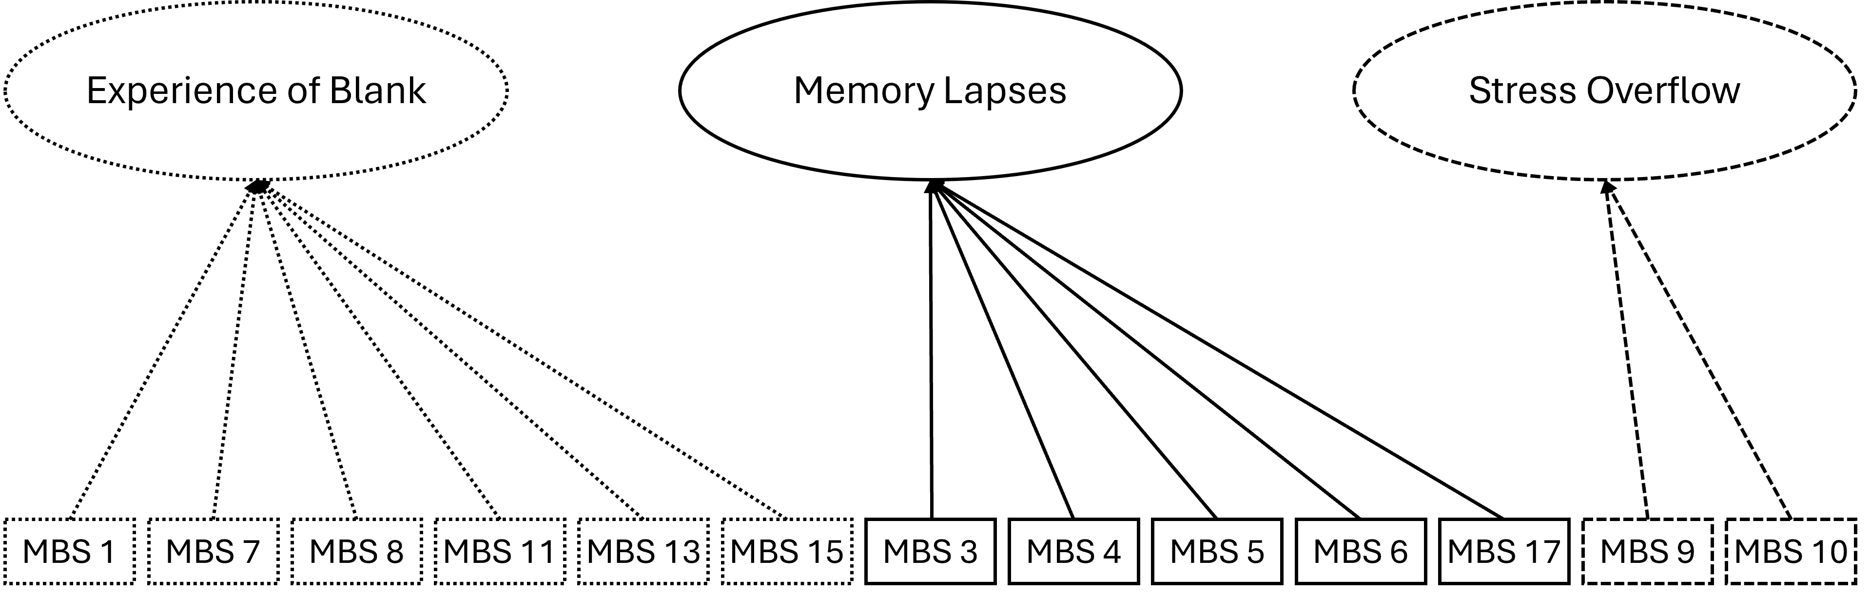
Note. Factor 1 is termed “experience of blank” and comprises 6 items reflecting the phenomenological experience and awareness of MB. Factor 2 is termed “memory lapses” and comprises 5 items that reflect short-term memory errors. Finally, Factor 3 is termed “stress overflow” and comprises 2 items that indicate MB experiences under stressful conditions.

Control analysis
To ensure that the L-MBS captures MB rather than mind-wandering, we combined the CFA-validated L-MBS items with the MWQ items (N=631) and conducted an exploratory factor analysis (EFA) specifying four factors (three corresponding to the L-MBS and one to the MWQ). Item loadings are reported in Supplementary Table S3. The resulting four-factor solution clearly separated the latent structures of the two questionnaires, yielding a three-factor structure for the L-MBS and a distinct single-factor structure for the MWQ. All MWQ items loaded primarily on the same factor, with only one item exhibiting a weak cross-loading (MWQ 2 = 0.21), while still predominantly loading on the latent factor consisting of MWQ items. Within the L-MBS, two items (L-MBS 4: “When reading a book, I must reread pages because I reached the end of the page but do not remember how I got there” and L-MBS 17: “I catch myself halfway through an action without knowing how I started it”) did not load exclusively on the “memory lapses” and the “experience of blank” latent factors respectively. Overall, beyond the correlation between the L-MBS and the MWQ, this analysis shows that the latent factors have discriminant validity, as they reflect distinct latent groupings.
Demographic Comparison
We further examined whether the total L-MBS score and the latent factor scores differed across age, preferred gender, and language. It should be noted that most of our sample were French speakers (94%); therefore, the English and French samples are quite disproportionate (Table 1). Regarding age, we found a significant decrease in MB scores with age (r = -.23, t(583) = -5.83 [-.33, -.13], p < .001). This effect was driven by a decrease in MB scores in the “experience of blank” (r = -.16, t(588) = -3.84, [-.26, -.05]) and “memory lapse” factors (r = -.29, t(592) = -7.32 [-.38, -.19], p < .001). We did not find any statistically significant relationship between the “stress overflow” factor and age (r = -.01, t(593) = -.31 [-.12, .09], p = .75) (Figure 2a). When we examined the relationship between the MB scale and preferred gender, we found that women scored higher in the “memory lapse” factor (ANOVA: F(2) = 10.4, p < .001, ω² = .03 [.01, 1]; Games-Howell post-hoc: M_{diff} = -1.53 [-2.53, -.54], p < .001, Hedges’ g = .4 [.17, .64]). The remaining factors did not show a statistically significant effect (Experience of Blank: F(2) = 2.36, p = .11, ω² = 0 [0, 1]; Stress Overflow: F(2) = .29, p = .75, ω² = 0 [0, 1]; Total L-MBS: F(2) = .51, p = .6, ω² = 0 [.01, 1]) (Figure 2b). Finally, we found no statistical differences between language background and MB scores (Experience of Blank: t(41.36) = .56 [-1.8, 2.76], p = .58, Hedges’ g = .09 [-.34, .53]; Memory Failure: t(40.44) = -.93 [-2.7, 1.3], p = 0.36, Hedges’ g = -.16 [-.62, .29]; Stress Overflow: t(41.81) = .37, p =.72, Hedges’ g = .06 [-.36, .48]; Total L-MBS: t(40.1) = -.07, p = .95, Hedges’ g = -.01 [-.47, .45]) (Figure 2c).

Figure 2
Population Characteristics Vary Across the Liège Mind-Blanking Scale (L-MBS) Factors
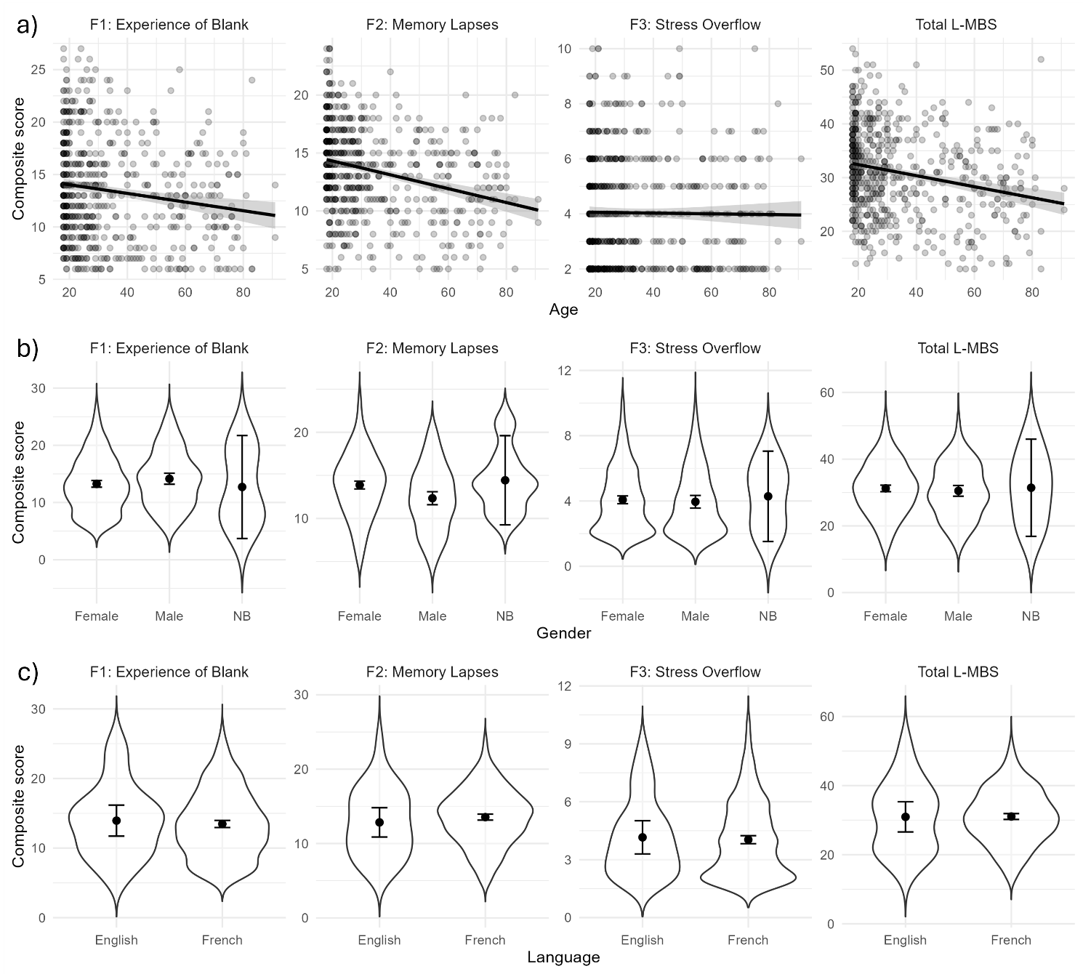
Note. a) We found that age inversely correlates with the L-MBS scores. This effect is primarily driven by a decrease in the latent factors of “Experience of Blank” and “Memory Failures”. b) We found a statistically significant difference between males and females in the latent factor of “Memory Failures”. c) We did not find evidence for a statistically significant difference across languages, either in the composite L-MBS scores or in its latent factors. Error bars indicate 99% confidence intervals. Grey shaded intervals indicate the standard error of the line plot.

Network Analysis
Having validated the structure of the L-MBS questionnaire, we wanted to examine how self-reported MB is embedded within a network of different psychological phenomena. The correlation matrix of aggregate and partial factor scores across all questionnaires indicated that the composite L-MBS score was positively associated with mind-wandering, memory difficulties, metacognition, and sleepiness, and negatively associated with attention (Supplementary Table S5). However, examining the subscales revealed more nuanced patterns, with different L-MBS factors showing opposing relationships with subscales from other questionnaires, while some associations were specific to individual L-MBS factors. Therefore, we adopted a 2-level strategy. The first level, termed here the “global” level, consists of the composite scores of each questionnaire and examines interactions among cognitive domains. The second level, termed here the “local” level, consists of the subscales of each questionnaire when available and examines how different components of cognitive domains interact with different MB latent factors.
Gaussian Graphical Models (GGM)
For the global level, we estimated GGMs on the full sample with complete data (N= 570), representing the regularised partial correlations between the L-MBS and self-evaluated memory (QAM), attention (ATTC), sleepiness (ESS), metacognition (MCQ) and mind-wandering (MWQ). The full network structure can be inspected in Figure 3a-b. Bootstrap confidence intervals can be found in Supplementary Figure S3. Overall, we found a positive relationship between the L-MBS and self-reported memory difficulties (partial r = 0.36), mind-wandering (partial r = 0.16) and sleepiness (partial r = 0.11). Before network inference, we validated the network’s stability. Case-dropping bootstrapping showed an edge and centrality CS-coefficient of 0.751, above the standard threshold of 0.5 (Epskamp et al., 2018). Since our analysis mainly focused on MB, we tested whether the L-MBS was more strongly related to a cognitive domain than the MWQ. Therefore, differences in edges indicate whether the partial correlation between the L-MBS and a questionnaire was different from the corresponding partial correlation involving the MWQ (Figure 3c). Differences between L-MBS and MWQ connections did not reach statistical significance. Finally, we estimated the centrality of each node (Figure 3d). Self-reported memory difficulties were the most central to the network, while sleepiness was the weakest. We found no statistically significant differences between mind-wandering and MB. Overall, the global analysis suggests that the composite L-MBS score correlates with sleepiness, memory difficulties and mind-wandering.
For the local level, we estimate GGMs on a complete subsample 581⁴ participants. This time, we split the following questionnaires into their subscales: a) the L-MBS into its 3 factors, representing the experience of blank, memory failures and stress overflow, b) the ATTC into attentional focus and attentional shifting, c) the QAM into autobiographical memories and memory control, and d) the MCQ into positive beliefs, cognitive confidence, uncontrollability, need to control thoughts and cognitive self-consciousness. The full network structure can be inspected in Figure 4a-b. Bootstrap confidence intervals are provided in Supplementary Figure S4. Overall, different L-MBS factors correlated with different cognitive subscales. The factor of “experience of blanking” negatively correlated with the cognitive self-consciousness scale of the MCQ (partial r= -0.18) and positively correlated with the “memory lapses” factor of the L-MBS (partial r= 0.18). The factor of “memory lapses” correlated with the MWQ (partial r = 0.32) and the autobiographical component of the QAM (partial r = 0.29). Finally, the “stress overflow” factor of the L-MBS only correlated with the first factor of the L-MBS (partial r = 0.2). Importantly, we did not observe a correlation between the second and the third factor of the L-MBS. Case-dropping bootstrapping showed adequate edge (CS-coefficient = 0.67) and centrality (CS-coefficient = 0.52) stability. When examining pairwise differences in the edge strength of the edges that survived regularisation, we found no further differences between the 3 latent factors.

Figure 3
The Liège Mind-Blanking Scale (L-MBS) Correlates With Mind-Wandering, Memory and Sleepiness
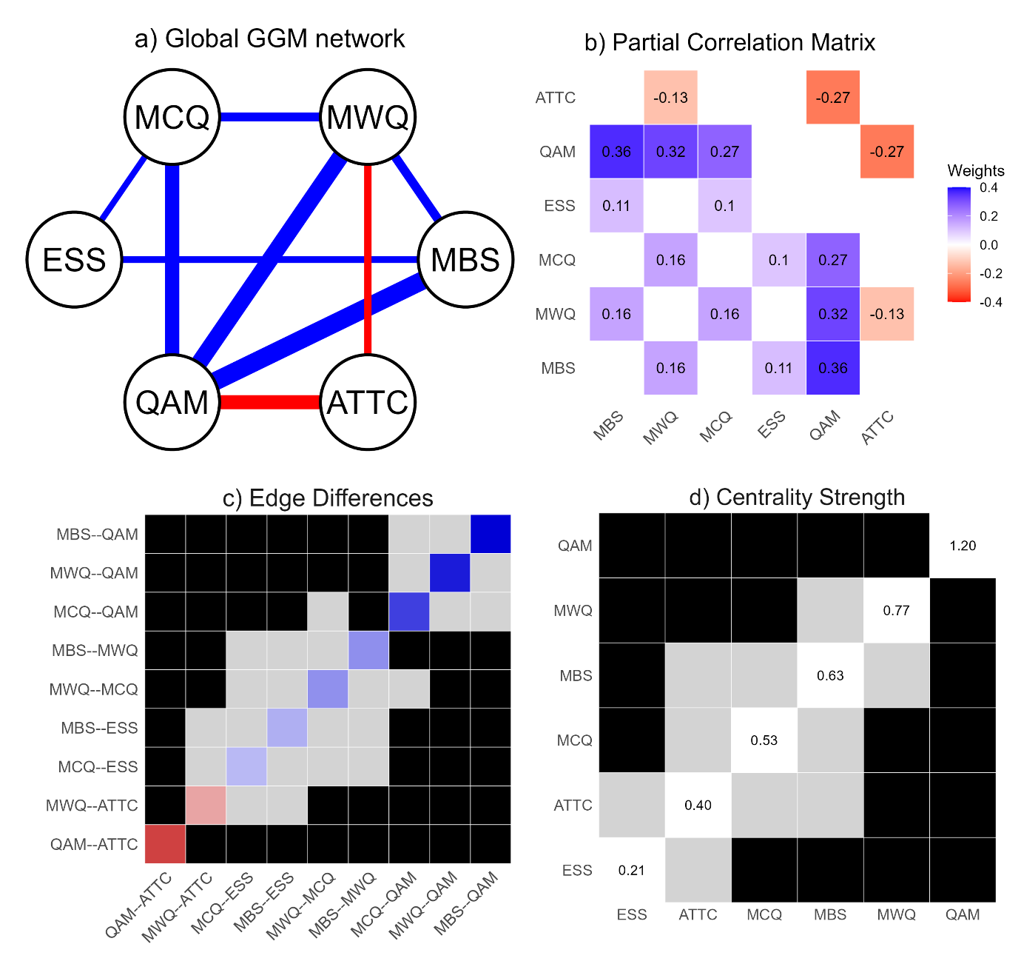
Note. a) We fit a regularized Gaussian Graphical Model to uncover the partial correlation structure across our questionnaires (global level). The L-MBS correlated with the MWQ, the QAM and the ESS. Nodes reflect the questionnaires. The thickness of the edges reflects the strength of the connection between nodes. Blue indicates a positive relationship. Red color indicates a negative relationship. b) Edge weight matrix of the GMM model, reflecting the partial correlations between the questionnaires. c) Pairwise edge weight comparison. We did not observe a statistically significant difference between the L-MBS and the MWQ. Diagonal cells display the strength of each edge. Off-diagonal cells represent bootstrap-based differences in edge weights between pairs of connections. Black cells indicate statistically significant differences, whereas grey cells indicate non-significant differences. d) Node centrality comparison. We did not observe a statistically significant difference between the L-MBS and the MWQ. Diagonal cells represent the estimated centrality of each node, while off-diagonal cells represent pairwise bootstrap comparisons of centrality differences. Black-shaded cells indicate statistically significant differences, whereas grey-shaded cells indicate non-significant differences. ATTC = Attentional Control Scale; MBS = Liège Mind-Blanking Scale; MWQ = Mind-Wandering Questionnaire; MCQ = Metacognitions-30 Questionnaire; ESS = Epworth Sleepiness Scale; QAM = Memory Self-Evaluation Questionnaire.

Figure 4
The Liège Mind-Blanking Scale (L-MBS) Subscales Correlate With Different Cognitive Domains
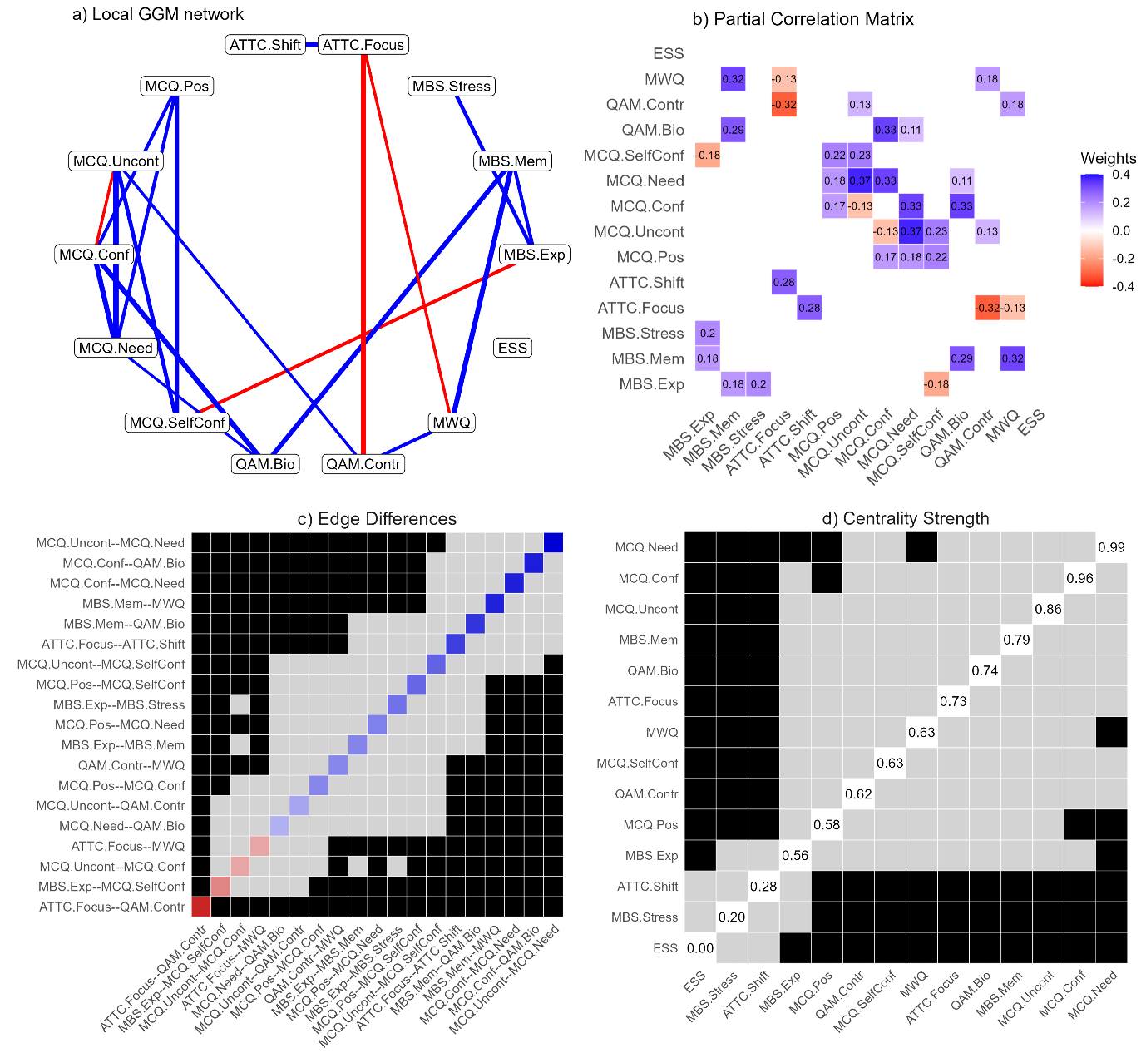
Note. a) We fit a regularized Gaussian Graphical Model to uncover the partial correlation structure across the subscales of our questionnaires (“local” level). The “experience of blank” factor correlated with cognitive self-consciousness and the “memory lapses” factor correlated with mind-wandering and autobiographical memory difficulties. The factor of “stress overflow” solely correlated with the “experience of blank” factor and no other questionnaire. The thickness of the edges reflects the strength of the connection between nodes. Blue indicates a positive relationship. Red color indicates a negative relationship. b) Edge weight matrix of the GMM model, reflecting the partial correlations between the questionnaires. c) Pairwise edge weight comparison. We did not observe a statistically significant difference across the factors. Diagonal cells display the strength of each edge. Off-diagonal cells represent bootstrap-based differences in edge weights between pairs of connections. Black cells indicate statistically significant differences, whereas grey cells indicate non-significant differences. d) Node centrality comparison. The “memory lapses” factor showed greater centrality to the “stress overflow” factor. Diagonal cells represent the estimated centrality of each node, while off-diagonal cells represent pairwise bootstrap comparisons of centrality differences. Black-shaded cells indicate statistically significant differences, whereas grey-shaded cells indicate non-significant differences. ATTC = Attentional Control Scale; MBS = Liège Mind-Blanking Scale; MWQ = Mind-Wandering Questionnaire; MCQ = Metacognitions-30 Questionnaire; ESS = Epworth Sleepiness Scale; QAM = Memory Self-Evaluation Questionnaire

Bayesian Networks (BN)
Finally, we estimated directed Bayesian Networks (BN) to test whether we could uncover data-driven causal relationships between our questionnaires. The global BN can be found in Figure 5a. The Markov Blanket of the global BN suggests that self-evaluated memory difficulties affect the L-MBS, while the L-MBS affects the MWQ (Figure 5b). A control analysis using an algorithm from another family replicated the proposed causal structure (Supplementary Figure S5).
The local BN can be found in Figure 6a. We examined Markov blankets for each factor separately. The first factor of the L-MBS, the experience of blank, is influenced jointly by the “memory lapses” factor of the L-MBS and the “cognitive self-consciousness” factor of the MCQ. In turn, it influences the L-MBS “stress overflow” factor (Figure 6b). The “memory lapses” factor was predicted by the autobiographical factor of the QAM and, in turn, influences self-reported mind-wandering and the first L-MBS factor (Figure 6c). In contrast, the “stress overflow” factor, although receiving a path from the first L-MBS factor, had no outgoing connections (Figure 6d). A control analysis using an algorithm from another family replicated the proposed causal structure for MBS and produced a similar causal structure for the other cognitive domains (Supplementary Figure S6).

Figure 5
Bayesian Network Analysis Uncovers A Directional Structure for the Liège Mind-Blanking Scale (L-MBS)
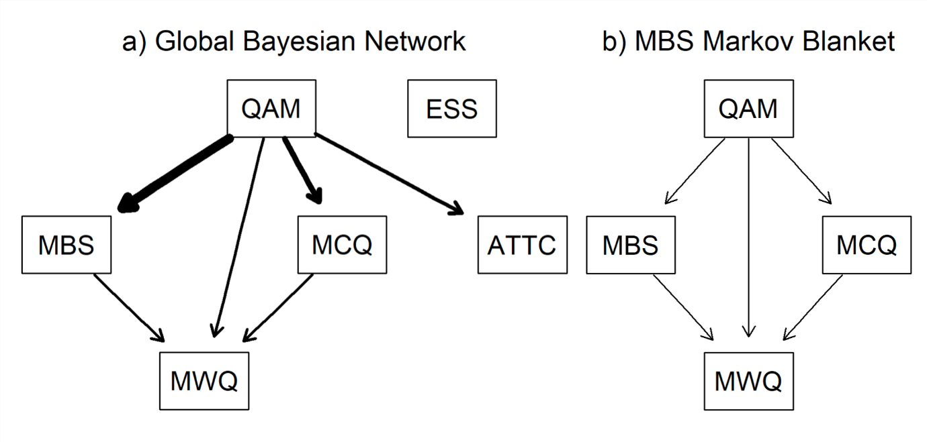
Note. a) We fitted a directed acyclic graph using the Hill Climbing algorithm. Edges indicate directional links between questionnaires. The thickness of edges indicates the strength of the relationship. b) The Markov Blanket of the L-MBS comprises the set of nodes that render it conditionally independent from the rest of the directed graph. This set includes its parent nodes, which exert direct influence on the L-MBS, and its child nodes, which are directly influenced by the L-MBS. In our graph, the L-MBS is influenced by self-evaluated memory difficulties and influences self-reported mind-wandering. ATTC = Attentional Control Scale; MBS = Liège Mind-Blanking Scale; MWQ = Mind-Wandering Questionnaire; MCQ = Metacognitions-30 Questionnaire; ESS = Epworth Sleepiness Scale; QAM = Memory Self-Evaluation Questionnaire

Figure 6
Bayesian Network Analysis Uncovers a Directional Structure for the Subscales of the Liège Mind-Blanking Scale (L-MBS)
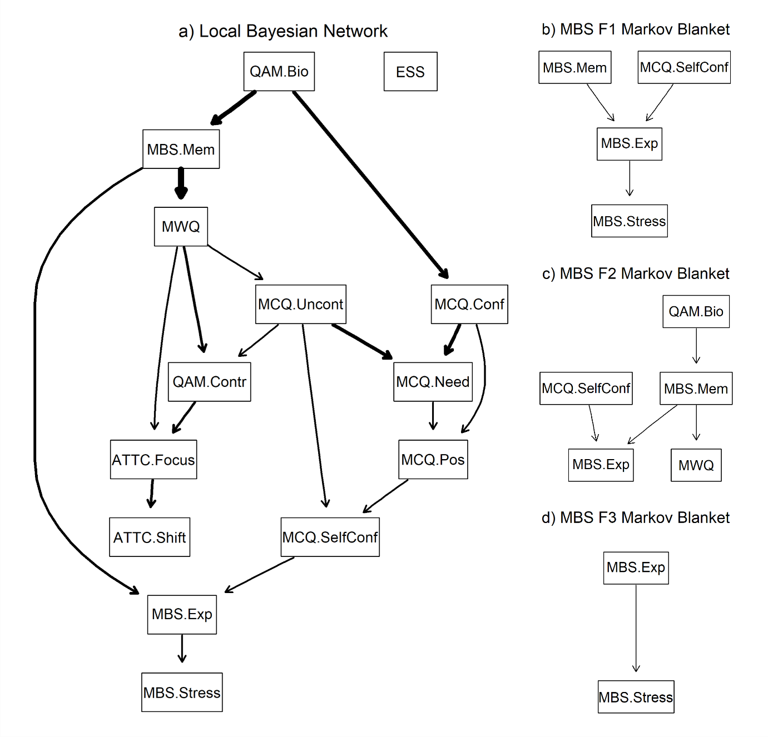
Note. a) We fitted a directed acyclic graph using the Hill Climbing algorithm on the subscales of our questionnaires. Edges indicate directional links between questionnaires. The thickness of edges indicates the strength of the relationship. b-d) The Markov Blanket of a node comprises the set of nodes that render that node conditionally independent from the rest of the directed graph. This set includes its parent nodes, which exert direct influence on the latent factors, and its child nodes, which are directly influenced by the latent factors. The “experience of blank” factor (graph b) is influenced by the “memory lapses” L-MBS factor and the “cognitive self-consciousness” scale of the MCQ-30 and influences the “stress overflow” factor. The “memory lapses” factor (graph c) is influenced by the autobiographical memory difficulties subscale of the QAM and influences self-reported mind-wandering and the first L-MBS factor. Finally, the “stress overflow” factor (graph d) is influenced by the first L-MBS factor, yet we found no children nodes that are influenced by it. ATTC = Attentional Control Scale; MBS = Liège Mind-Blanking Scale; MWQ = Mind-Wandering Questionnaire; MCQ = Metacognitions-30 Questionnaire; ESS = Epworth Sleepiness Scale; QAM = Memory Self-Evaluation Questionnaire

Discussion
In the present study, we developed the L-MBS scale to capture the cognitive and experiential heterogeneity when self-reporting MB. Overall, our results suggest that the measured items decompose into distinct latent factors, each associated with a different set of cognitive variables.
Psychometric Properties and Structure of the L-MBS
We derived an extensive list of potential MB instances following recent theoretical accounts of MB (Andrillon et al., 2025; Boulakis & Demertzi, 2025; Kaufmann et al., 2024) and a recent meta-analysis examining how MB has been studied in experience- sampling studies (Boulakis et al., 2026). A panel of external experts with prior research experience in MB and spontaneous thought evaluated the content validity of these items, ensuring they were conceptually relevant and representative of the MB construct. The scale demonstrated high internal consistency. Furthermore, the L-MBS showed high within-item correlations, suggesting it captures variability across related aspects of MB. The L-MBS composite scores correlated positively with self-reported memory difficulties, mind-wandering, and daytime sleepiness. These results align well with previous exploration of trait MB, where MB scores substantially correlated with mind-wandering and sleepiness (Kawagoe et al., 2024) and cognitive capacity (Kawagoe et al., 2024; Moraitou & Efklides, 2009). At the same time, pooling together the MB and MW questionnaires yielded a latent structure that separated MB and MW items well, supporting the idea that the L-MBS does indeed capture MB and not mind wandering. Finally, the overall relationship between sleepiness and the composite score of the L-MBS provides evidence for the convergent validity of the L-MBS with recent arousal-driven accounts of MB (Andrillon et al., 2025).
The Factors of the L-MBS Describe Distinct MB Experiences
When we decomposed the L-MBS, we found three latent factors: “experience of blank”, “memory lapses”, and “stress overflow”, supporting our hypothesis that the scale has a multidimensional structure.
The “experience of blank” consisted of various items that pointed to experiencing moments of reduced mental content or becoming aware of such moments. The items ranged from “There are moments when I pay attention to nothing at all” to “When I am calm, it feels like my mind is empty” and “When I am bored, I zone out without thinking of anything”. Importantly, this factor included a heterogeneous set of items pointing to the absence of attentional orientation, awareness of the absence of thoughts, and instances when MB may manifest. Therefore, we cannot ascribe this factor to a specific type of MB, such as aware vs unaware or deliberate vs spontaneous (Andrillon et al., 2025; Boulakis & Demertzi, 2025). While this factor aggregates different MB definitions (absence of attentional orientation, failure to monitor content), it did not include any items describing short-term memory errors or forgetfulness, suggesting that people can dissociate what constitutes MB from what constitutes a memory failure. Therefore, this factor most likely reflects the shared experience of reduced content, a common phenomenological component regardless of its cognitive or physiological origin.
Instead, items relating to memory errors loaded exclusively on the “memory lapses” factor. For example, the factor included items such as “I lose track of my thoughts and can’t remember what I was thinking” and “There are moments when I know I was thinking of something, but I cannot recover it”. The items in this factor mainly reflect a feeling of immediate past lost content and a meta-awareness of this absence. Previously, the “blank-in-the-mind” experience was defined as a metamemory judgement, where individuals are unable to bring forth prospective memory goals (i.e. what was I about to do?; what was I about to say?) (Efklides, 2014; Moraitou & Efklides, 2009). In contrast to definitions that stress the absence of conscious awareness (Andrillon et al., 2021), the second factor describes awareness of having forgotten a prior goal or intention. In terms of probe-caught experience-sampling, this factor would most likely correspond to reports of no recall rather than to MB. While no recall reports are extremely sparse (Boulakis et al., 2026; Lal et al., 2025), they are selected independently from MB, suggesting that a no recall option can disentangle the introspective haze introduced by ambiguity between MB and forgetting (Kawagoe et al., 2026; Lal et al., 2025). Similarly, our results suggest that reduced content and metamemory judgements of content are discrete events that map to different items of the L-MBS.
The final factor consisted solely of two items, “My mind blanks when I am under pressure” and “When something bad happens, and I need to think of solutions, my mind goes blank”, and was therefore termed “Stress overflow”. It is of interest that the feeling of “the mind going blank” is part of the diagnostic criteria for generalised anxiety disorder (Diagnostic and Statistical Manual of Mental Disorders, 2022), hence substantiating a relationship between anxiety and MB. Previously, higher trait anxiety was associated with greater discontinuity of mind, a factor of the Amsterdam Resting State Questionnaire that reflects rapidly shifting thoughts, restlessness, and difficulties with thought control (Diaz et al., 2013; Gehrt et al., 2020). Higher trait anxiety was also associated with greater scores on the Racing and Crowded Thoughts Questionnaire (Weiner et al., 2019). While the direct link between MB and anxiety has not yet been explored, the presence of a unique factor suggests that MB can also arise under pressure to respond to an immediate demand. Such situations may trigger a surge in thought generation, and when this influx becomes excessive, the resulting density can hinder the clear delineation of individual mental states, which is experienced as MB. Along similar lines, Garg et al. (2025) found that thinking-aloud experience-sampling elicited more frequent retrospective MB reports than a silent condition, which they interpreted as reflecting gaps in cognition arising from the pressure to continuously produce speech. As such, future research could investigate how trait anxiety influences the frequency of MB episodes when participants are pressured to provide immediate responses.
The Factors of the L-MBS Map to Distinct Cognitive Domains
The 3-factor structure of the L-MBS confirmed our first hypothesis that MB experiences are heterogeneous, as we observed multiple latent factors. Our second hypothesis predicted that different MB factors would correlate with different cognitive variables. Already, the phrasing of specific items within each factor provides initial support for this idea: the first factor points to attention and metacognitive monitoring, while the second item directly relates to memory. To obtain a more granular view of the relationship between cognitive constructs and the L-MBS factors, we adopted a network approach, estimating GGMs and Bayesian networks.
Regarding metacognitive monitoring, we found a direct link between the cognitive self-consciousness scale and the “experience of blank”. The cognitive self-consciousness factor describes the tendency to focus attention on thought processes (Wells & Cartwright-Hatton, 2004), consisting of items such as “I think a lot about my thoughts” and “I monitor my thoughts”. Our results suggest that individuals who monitor their thoughts more frequently report less frequent MB. One potential explanation is that constant self-monitoring reorients thoughts toward specific content, preventing a drift to blank. Consistent with this idea, higher cognitive self-consciousness scores have been associated with more frequent rumination (Tamm et al., 2024) and mind-wandering (Forster & Lavie, 2014).
In the memory domain, we found a direct link between autobiographical lapses and the L-MBS “memory lapses” factor. The relationship between MB and memory is not clearly understood. Looking at the autobiographical lapses factor of QAM, it represents a heterogeneous mixture of autobiographical memory failures, such as remembering recent events, forgetting familiar people, repeating actions/discussions, or forgetting to do previously automated actions. A potential explanation is that some autobiographical lapses arise when an intended memory or thought is partially activated, leaving the person with a sense that something was present but is no longer accessible (Ryals & Cleary, 2012). In this sense, the subjective experience of “I know I was thinking something, but I can’t recover it” reflects a failure to complete retrieval, reported as a feeling-of-knowing that the content is present but inaccessible.
MB and Mind-Wandering Are Reported Differently in Self-Reports
While the L-MBS and MWQ showed a positive and significant correlation, the structures of the two questionnaires were dissociable. The two questionnaires showed very weak cross-correlations. This suggests that people are about to differentiate between the two experiences. Network path analysis revealed a path from L-MBS to MWQ, suggesting that increasing L-MBS scores should increase MWQ scores. Given that both these questionnaires receive a path from the QAM memory difficulties questionnaire, we hypothesise that memory errors are associated with diffuse attentional lapses. However, the mediating link from MB to MW further suggests that more frequent MB would lead to more frequent MW. This is consistent with MB not merely being a parallel phenomenon to MW, but rather a transitional state (Boulakis & Demertzi, 2025). In this sense, eliciting MB would set up the conditions for further transition to other content-oriented states, such as MW, as mentation moves from an empty state back toward content. This hypothesis suggests that MB is not a degraded version of MW, in which the level of decoupling between attention and perception is so strong that no content can be formulated (Mittner et al., 2016); rather, MB sets up the conditions for further contentful states.
Relationship Between L-MBS and Existing MB Questionnaires
Notably, the L-MBS is not the first questionnaire developed to measure MB. Both the MBQ and the BIM already target MB experiences, and we consider these instruments to be complementary. For example, the “experience of blank” factors most likely corresponds to the one-factor solution of the Mind-Blanking Questionnaire (Kawagoe et al., 2024), while the “memory lapses” factor resembles the “blank in the mind” factor of the Blank in the Mind Questionnaire (Moraitou & Efklides, 2009). A notable discrepancy, however, between the previous questionnaires and the L-MBS is that both the MBQ and the BIM contain a single MB factor, whereas the L-MBS identifies three distinct MB factors. We do not consider these results contradictory to the previous questionnaires as we developed the L-MBS with the overarching aim of capturing the inherent variability in MB experiences, not capturing one unitary MB experience. An analogous situation can be observed in the MWQ. The original MWQ contained 5 items and targeted self-report instances of MW (Mrazek et al., 2013). However, a more comprehensive scale with 16 items decomposed into multiple latent factors, highlighting different manifestations of MW (Lopez et al., 2023). Overall, the L-MBS should not be viewed as opposed to previous MB questionnaires, but rather as an extension that captures the heterogeneous nature of MB experiences.
Limitations and Perspectives
Our study is not without limitations. First and foremost, all the tools utilised are self-report questionnaires. Therefore, it is not possible to dissociate accurate self-evaluation of cognitive capacities from subjective beliefs of one’s cognitive capacities or memory bias when retrospectively reporting everyday experiences (Gilles et al., 2025). In turn, this limits the translation of our results from trait- to state-level explorations of MB, such as MB report frequency during experience-sampling. Another limitation is the small sample size of the English-speaking population (~6%). This necessitates further language-specific psychometric validation of the L-MBS. To identify directional relationships between our variables, we attempted to develop a data-driven model of MB using Bayesian Networks. While the edges of the BNs reflect conditional dependence, these need to be validated by intervention studies targeting nodes that influence MB. Given the questionnaire nature of our dataset, we cannot currently make any further causal claim about the psychological origins of MB. A final issue pertains to the L-MBS stress subscale. Our questionnaire included only two items for the Stress Overflow factor, which provides limited score variability and likely reduces reliability. This constraint may have attenuated associations between this factor and other cognitive domains, potentially explaining why we did not observe any relationships with other cognitive domains.
In summary, we adopted an agnostic stance toward MB and developed a psychometric scale to better understand how people experience different MB. The L-MBS is a short, psychometrically validated tool with good internal consistency and convergent and divergent validity. Our results suggest that experiences commonly grouped together, such as no-thought and no-recall reports, correspond to different questionnaire factors and, in turn, different underlying cognitive processes. Future work can examine the generalizability of the L-MBS factor structure across cultural and linguistic settings and use the scale with physiological and neural measures to characterise how trait MB relates to brain activity.
Declarations
Funding
The article was supported by the Belgian Fund for Scientific Research (FRS-FNRS), the European Union’s Horizon 2020 Research and Innovation Marie Skłodowska-Curie RISE programme NeuronsXnets (grant agreement 101007926), the European Cooperation in Science and Technology COST Action “NeuralArchCon” (CA18106), the Léon Fredericq Foundation, and the University and the University Hospital of Liège. The funders had no role in study design, data collection and analysis, decision to publish, or manuscript preparation.
Conflicts of interest
The authors have no relevant financial or non-financial interests to disclose.
Ethics approval
This study was performed in line with the principles of the Declaration of Helsinki. The study was approved by the local ethics committee at the Faculty of Psychology, Logopedics, and Educational Sciences at the University of Liège (Project ID: 2526-002).
Consent to participate
Informed consent was obtained from all individual participants included in the study.
Consent to publication
No identifying information was collected in the study.
Availability of data and materials
All data are available at https://gitlab.uliege.be/poc/lmbs.
Code availability
All code is available at https://gitlab.uliege.be/poc/lmbs.
Authors' contributions
Conceptualization: Paradeisios A. Boulakis, Steve Majerus; Data curation: Paradeisios A. Boulakis; Formal analysis: Paradeisios A. Boulakis, Marion Balla; Funding acquisition: Athena Demertzi; Investigation: Paradeisios A. Boulakis; Methodology: Paradeisios A. Boulakis, Marion Balla, Giovanni Briganti, David Stawarczyk, Steve Majerus; Project administration: Paradeisios A. Boulakis; Resources: Paradeisios A. Boulakis; Software: Paradeisios A. Boulakis, Giovanni Briganti; Supervision: Athena Demertzi, Steve Majerus; Validation: Paradeisios A. Boulakis; Visualization: Paradeisios A. Boulakis; Writing—original draft: Paradeisios A. Boulakis, Steve Majerus; Writing—review and editing: Marion Balla, Agustina Aragón-Daud, David Stawarczyk, Giovanni Briganti, Athena Demertzi.
Open practices statement
Materials and analysis code are available at https://gitlab.uliege.be/poc/lmbs. The study was not preregistered.

References
Alcaraz Sánchez, A. (2026). Did I have a dream last night? White dreaming as metacognitive feelings. Mind & Language, 1–19. https://doi.org/10.1111/mila.70027
Anderson, F. T., & McDaniel, M. A. (2019). Hey buddy, why don’t we take it outside: An experience sampling study of prospective memory. Memory & Cognition, 47(1), 47–62. https://doi.org/10.3758/s13421-018-0849-x
Andrillon, T., Burns, A., Mackay, T., Windt, J., & Tsuchiya, N. (2021). Predicting lapses of attention with sleep-like slow waves. Nature Communications, 12(1), 3657. https://doi.org/10.1038/s41467-021-23890-7
Andrillon, T., Lutz, A., Windt, J., & Demertzi, A. (2025). Where is my mind? A neurocognitive investigation of mind blanking. Trends in Cognitive Sciences, 29(7), 600–613. https://doi.org/10.1016/j.tics.2025.02.002.
Aragón-Daud, A., Boulakis, P. A., Mortaheb, S., Vandewalle, G., Collette, F., Patil, K. R., Demertzi, A., & Raimondo, F. (2026). How to Catch a Blank Mind? Brain Similarities and Differences between Self- and Probe-Caught Mind Blanking (p. 2026.06.10.731344). bioRxiv. https://doi.org/10.64898/2026.06.10.731344
Blekić, W., Bellaert, N., Rossignol, M., & Schultebraucks, K. (2023). Validation and Adaptation of the Attentional Control Scale Among a French-Speaking Population Through Factor and Network Analysis. Journal of Psychopathology and Behavioral Assessment, 45(3), 884–895. https://doi.org/10.1007/s10862-023-10050-y
Boulakis, P. A., Aragón-Daud, A., Stawarczyk, D., & Demertzi, A. (2026). How often do we blank? A systematic review and Bayesian meta-analysis of mind blanking report rates during experience-sampling (4ah3j_v1). PsyArXiv. https://osf.io/preprints/psyarxiv/4ah3j_v1/
Boulakis, P. A., & Demertzi, A. (2025). Relating mind-blanking to the content and dynamics of spontaneous thinking. Current Opinion in Behavioral Sciences, 61, 101481. https://doi.org/10.1016/j.cobeha.2024.101481
Boulakis, P. A., Kusztor, A., Tsuchiya, N., Andrillon, T., & Demertzi, A. (2025). Distinct cortical profiles underlie the common reportability of thought-free experiences (p. 2025.10.14.681984). bioRxiv. https://doi.org/10.1101/2025.10.14.681984
Boulakis, P. A., Mortaheb, S., van Calster, L., Majerus, S., & Demertzi, A. (2023). Whole-Brain Deactivations Precede Uninduced Mind-Blanking Reports. The Journal of Neuroscience, 43(40), 6807–6815. https://doi.org/10.1523/JNEUROSCI.0696-23.2023
Boulakis, P. A., Simos, N. J., Zoi, S., Mortaheb, S., Schmidt, C., Raimondo, F., & Demertzi, A. (2025). Variations of autonomic arousal mediate the reportability of mind blanking occurrences. Scientific Reports, 15(1), 4956. https://doi.org/10.1038/s41598-024-81618-1
Briganti, G., Scutari, M., & McNally, R. J. (2023). A tutorial on bayesian networks for psychopathology researchers. Psychological Methods, 28(4), 947–961. https://doi.org/10.1037/met0000479
Byrne, B. M., & Byrne, B. M. (2013). Structural Equation Modeling With EQS: Basic Concepts, Applications, and Programming, Second Edition (2nd ed.). Routledge. https://doi.org/10.4324/9780203726532
Chaplin, W. F., John, O. P., & Goldberg, L. R. (1988). Conceptions of states and traits: Dimensional attributes with ideals as prototypes. Journal of Personality and Social Psychology, 54(4), 541–557. https://doi.org/10.1037/0022-3514.54.4.541
Costantini, G., Epskamp, S., Borsboom, D., Perugini, M., Mõttus, R., Waldorp, L. J., & Cramer, A. O. J. (2015). State of the aRt personality research: A tutorial on network analysis of personality data in R. Journal of Research in Personality, R Special Issue, 54, 13–29. https://doi.org/10.1016/j.jrp.2014.07.003
Costello, A., & Osborne, J. (2005). Best Practices in Exploratory Factor Analysis: Four Recommendations for Getting the Most From Your Analysis. Practical Assessment, Research & Evaluation, 10, 1–9. https://doi.org/10.4135/9781412995627.d8
Delacre, M., Lakens, D., & Leys, C. (2017). Why Psychologists Should by Default Use Welch’s t-test Instead of Student’s t-test. International Review of Social Psychology, 30(1). https://doi.org/10.5334/irsp.82
Diagnostic and statistical manual of mental disorders (Fifth Edition, Text Revision (DSM-5-TR)). (2022). American Psychiatric Publishing. https://doi.org/10.1176/appi.books.9780890425787
Diaz, B. A., Van Der Sluis, S., Moens, S., Benjamins, J. S., Migliorati, F., Stoffers, D., Den Braber, A., Poil, S.-S., Hardstone, R., Van ’t Ent, D., Boomsma, D. I., De Geus, E., Mansvelder, H. D., Van Someren, E. J. W., & Linkenkaer-Hansen, K. (2013). The Amsterdam Resting-State Questionnaire reveals multiple phenotypes of resting-state cognition. Frontiers in Human Neuroscience, 7. https://doi.org/10.3389/fnhum.2013.00446
Dimitrov, D. M. (2012). Statistical methods for validation of assessment scale data in counseling and related fields. American Counseling Association.
Efklides, A. (2014). The Blank-in-the-Mind Experience: Another Manifestation of the Tip-of-the-Tongue State or Something Else? In A. S. Brown & B. L. Schwartz (Eds.), Tip-of-the-Tongue States and Related Phenomena (pp. 232–263). Cambridge University Press. https://doi.org/10.1017/CBO9781139547383.011
Epskamp, S. (2017). Brief Report on Estimating Regularized Gaussian Networks from Continuous and Ordinal Data. https://doi.org/10.48550/arXiv.1606.05771
Epskamp, S., Borsboom, D., & Fried, E. I. (2018). Estimating psychological networks and their accuracy: A tutorial paper. Behavior Research Methods, 50(1), 195–212. https://doi.org/10.3758/s13428-017-0862-1
Fan, X., Thompson, B., & Wang, L. (1999). Effects of sample size, estimation methods, and model specification on structural equation modeling fit indexes. Structural Equation Modeling: A Multidisciplinary Journal, 6(1), 56–83. https://doi.org/10.1080/10705519909540119
Fell, J. (2022). What is mind blanking: A conceptual clarification. The European Journal of Neuroscience, 56(6), 4837–4842. https://doi.org/10.1111/ejn.15782
Forster, S., & Lavie, N. (2014). Distracted by your mind? Individual differences in distractibility predict mind wandering. Journal of Experimental Psychology: Learning, Memory, and Cognition, 40(1), 251–260. https://doi.org/10.1037/a0034108
Friedman, N., Nachman, I., & Pe’er, D. (2013). Learning Bayesian Network Structure from Massive Datasets: The “Sparse Candidate” Algorithm (arXiv:1301.6696). arXiv. https://doi.org/10.48550/arXiv.1301.6696
Gehrt, T. B., Frostholm, L., Pallesen, K. J., Obermann, M.-L., & Berntsen, D. (2020). Conscious thought during the resting state in patients with severe health anxiety and patients with obsessive–compulsive disorder. Psychology of Consciousness: Theory, Research, and Practice, 7(3), 207–217. https://doi.org/10.1037/cns0000256
Gilles, A., Panneels, G., D’Argembeau, A., & Stawarczyk, D. (2025). Validity of the think-aloud procedure in comparison to other methods for studying the phenomenological features and memory of spontaneous thought. Consciousness and Cognition, 134, 103910. https://doi.org/10.1016/j.concog.2025.103910
Guttman, L. (1945). A basis for analyzing test-retest reliability. Psychometrika, 10(4), 255–282. https://doi.org/10.1007/BF02288892
Hevey, D. (2018). Network analysis: A brief overview and tutorial. Health Psychology and Behavioral Medicine, 6(1), 301–328. https://doi.org/10.1080/21642850.2018.1521283
Hu, L., & Bentler, P. M. (1999). Cutoff criteria for fit indexes in covariance structure analysis: Conventional criteria versus new alternatives. Structural Equation Modeling: A Multidisciplinary Journal, 6(1), 1–55. https://doi.org/10.1080/10705519909540118
Jackson, D. L. (2003). Revisiting Sample Size and Number of Parameter Estimates: Some Support for the N:q Hypothesis. Structural Equation Modeling: A Multidisciplinary Journal, 10(1), 128–141. https://doi.org/10.1207/S15328007SEM1001_6
Jennrich, R. I., & Sampson, P. F. (1966). Rotation for simple loadings. Psychometrika, 31(3), 313–323. https://doi.org/10.1007/BF02289465
Johns, M. W. (1991). A new method for measuring daytime sleepiness: The Epworth sleepiness scale. Sleep, 14(6), 540–545. https://doi.org/10.1093/sleep/14.6.540
Kaminska, M., Jobin, V., Mayer, P., Amyot, R., Perraton-Brillon, M., & Bellemare, F. (2010). The Epworth Sleepiness Scale: Self-administration versus administration by the physician, and validation of a French version. Canadian Respiratory Journal, 17(2), e27-34. https://doi.org/10.1155/2010/438676
Kaufmann, A., Parmigiani, S., Kawagoe, T., Zabaroff, E., & Wells, B. (2024). Two models of mind blanking. European Journal of Neuroscience, 59(5), 786–795. https://doi.org/10.1111/ejn.16164
Kawagoe, T., Onoda, K., & Yamaguchi, S. (2019). The neural correlates of “mind blanking”: When the mind goes away. Human Brain Mapping, 40(17), 4934–4940. https://doi.org/10.1002/hbm.24748
Kawagoe, T., Onoda, K., & Yamaguchi, S. (2020). The association of motivation with mind wandering in trait and state levels. PLOS ONE, 15(8), e0237461. https://doi.org/10.1371/journal.pone.0237461
Kawagoe, T., Onoda, K., & Yoshimura, S. (2026). Forgetting or blanking? Evaluating the role of a forgot option in a thought sampling method for mind blanking research. BMC Psychology. https://doi.org/10.1186/s40359-026-04517-2
Kawagoe, T., Yoshimura, S., Muranaka, S., Xethakis, L., & Onoda, K. (2024). Developing the Japanese and English versions of the Mind Blanking Questionnaire (MBQ): Validation and reliability. Personality and Individual Differences, 220, 112539-. https://doi.org/10.1016/j.paid.2023.112539
Kawashima, I., Hinuma, T., & Tanaka, S. C. (2023). Ecological momentary assessment of mind-wandering: Meta-analysis and systematic review. Scientific Reports, 13(1), 2873. https://doi.org/10.1038/s41598-023-29854-9
Kline, R. B. (2016). Principles and practice of structural equation modeling, 4th ed (pp. xvii, 534). The Guilford Press.
Kyriazos, T. A. (2018). Applied Psychometrics: Sample Size and Sample Power Considerations in Factor Analysis (EFA, CFA) and SEM in General. Psychology, 09(08), Article 08. https://doi.org/10.4236/psych.2018.98126
Lal, C., Welhaf, M., & Kane, M. J. (2025). What Is a “Blank” Mind? Testing the Meaning and Construct Validity of Mind-Blanking Reports to Thought Probes (Ubwae_v1). PsyArXiv. https://doi.org/10.31234/osf.io/ubwae_v1
Larøi, F., Van der Linden, M., & D’acremont, M. (2009). Validity and Reliability of a French Version of the Metacognitions Questionnaire in a Nonclinical Population. Swiss Journal of Psychology, 68. https://doi.org/10.1024/1421-0185.68.3.125
Leleu, V., Rusinek, S., & Douilliez, C. (2022). French adaptation of the Attentional Control Scale: Confirmatory factor analyses and relationship with trait anxiety and efficiency of orienting, alerting, and executive control attentional networks. European Review of Applied Psychology, 72(2), 100712. https://doi.org/10.1016/j.erap.2021.100712
Lindley, D. V. (1957). A Statistical Paradox. Biometrika, 44(1/2), 187–192. https://doi.org/10.2307/2333251
Lopez, A., Caffò, A. O., Tinella, L., & Bosco, A. (2023). The Four Factors of Mind Wandering Questionnaire: Content, Construct, and Clinical Validity. Assessment, 30(2), 433–447. https://doi.org/10.1177/10731911211058688
Lüdecke, D., Ben-Shachar, M. S., Patil, I., Wiernik, B. M., Bacher, E., Thériault, R., & Makowski, D. (2022). easystats: Framework for Easy Statistical Modeling, Visualization, and Reporting. CRAN. https://doi.org/10.32614/CRAN.package.easystats
Maier, M., & Lakens, D. (2022). Justify Your Alpha: A Primer on Two Practical Approaches. Advances in Methods and Practices in Psychological Science, 5(2), 25152459221080396. https://doi.org/10.1177/25152459221080396
Matsunaga, M. (2010). How to factor-analyze your data right: Do’s, don’ts, and how-to’s. International Journal of Psychological Research, 3(1), 97–110. https://doi.org/10.21500/20112084.854
McDonald, R. P. (1999). Test theory: A unified treatment. Lawrence Erlbaum Associates Publishers.
Mittner, M., Hawkins, G. E., Boekel, W., & Forstmann, B. U. (2016). A neural model of mind wandering. Trends in Cognitive Sciences, 20(8), 570–578. https://doi.org/10.1016/j.tics.2016.06.004
Moraitou, D., & Efklides, A. (2009). The blank in the mind questionnaire (BIMQ). European Journal of Psychological Assessment, 25(2), 115–122. https://doi.org/10.1027/1015-5759.25.2.115
Mortaheb, S., Van Calster, L., Raimondo, F., Klados, M. A., Boulakis, P. A., Georgoula, K., Majerus, S., Van De Ville, D., & Demertzi, A. (2022). Mind blanking is a distinct mental state linked to a recurrent brain profile of globally positive connectivity during ongoing mentation. Proceedings of the National Academy of Sciences, 119(41), e2200511119. https://doi.org/10.1073/pnas.2200511119
Mrazek, M. D., Phillips, D. T., Franklin, M. S., Broadway, J. M., & Schooler, J. W. (2013). Young and restless: Validation of the Mind-Wandering Questionnaire (MWQ) reveals disruptive impact of mind-wandering for youth. Frontiers in Psychology, 4. https://doi.org/10.3389/fpsyg.2013.00560
Munoz-Musat, E., Le Coz, A., Corcoran, A. W., Belloli, L., Naccache, L., & Andrillon, T. (2025). Behavioral, experiential, and physiological signatures of mind blanking. Proceedings of the National Academy of Sciences, 122(52), e2510262122. https://doi.org/10.1073/pnas.2510262122
Norvig, P., & Russell, S. (2011). Artificial Intelligence: A Modern Approach. Pearson Education.
Perche, L., Yennek, N., & Léger, L. (2025). Interest and mind wandering: How do individual and situational characteristics impact learning? Learning and Motivation, 92, 102177. https://doi.org/10.1016/j.lmot.2025.102177
R Core Team. (2025). R: A Language and Environment for Statistical Computing. R Foundation for Statistical Computing. https://www.R-project.org/
Revelle, W. (2026). psych: Procedures for Psychological, Psychometric, and Personality Research. Northwestern University. https://CRAN.R-project.org/package=psych
Rosseel, Y. (2012). lavaan: An R Package for Structural Equation Modeling. Journal of Statistical Software, 48, 1–36. https://doi.org/10.18637/jss.v048.i02
Ryals, A. J., & Cleary, A. M. (2012). The recognition without cued recall phenomenon: Support for a feature-matching theory over a partial recollection account. Journal of Memory and Language, 66(4), 747–762. https://doi.org/10.1016/j.jml.2012.01.002
Schreiber, J. B. (2021). Issues and recommendations for exploratory factor analysis and principal component analysis. Research in Social and Administrative Pharmacy, 17(5), 1004–1011. https://doi.org/10.1016/j.sapharm.2020.07.027
Scutari, M. (2017). Bayesian Network Constraint-Based Structure Learning Algorithms: Parallel and Optimized Implementations in the bnlearn R Package. Journal of Statistical Software, 77(2), 1–20. https://doi.org/10.18637/jss.v077.i02
Scutari, M., Vitolo, C., & Tucker, A. (2019). Learning Bayesian networks from big data with greedy search: Computational complexity and efficient implementation. Statistics and Computing, 29(5), 1095–1108. https://doi.org/10.1007/s11222-019-09857-1
Seli, P., Schacter, D. L., Risko, E. F., & Smilek, D. (2019). Increasing participant motivation reduces rates of intentional and unintentional mind wandering. Psychological Research, 83(5), 1057–1069. https://doi.org/10.1007/s00426-017-0914-2
Tamm, G., Koster, E. H. W., & Hoorelbeke, K. (2024). Multiple paths to rumination within a network analytical framework. Scientific Reports, 14(1), 10874. https://doi.org/10.1038/s41598-024-61469-6
Tibshirani, R. (1996). Regression Shrinkage and Selection Via the Lasso. Journal of the Royal Statistical Society: Series B (Methodological), 58(1), 267–288. https://doi.org/10.1111/j.2517-6161.1996.tb02080.x
Tucker, L. R., & Lewis, C. (1973). A reliability coefficient for maximum likelihood factor analysis. Psychometrika, 38(1), 1–10. https://doi.org/10.1007/BF02291170
Van Calster, L., D’Argembeau, A., Salmon, E., Peters, F., & Majerus, S. (2017). Fluctuations of attentional networks and default mode network during the resting state reflect variations in cognitive states: Evidence from a novel resting-state experience sampling method. Journal of Cognitive Neuroscience, 29(1), 95–113. https://doi.org/10.1162/jocn_a_01025
Van den Driessche, C., Bastian, M., Peyre, H., Stordeur, C., Acquaviva, É., Bahadori, S., Delorme, R., & Sackur, J. (2017). Attentional lapses in attention-deficit/hyperactivity disorder: Blank rather than wandering thoughts. Psychological Science, 28(10), 1375–1386. https://doi.org/10.1177/0956797617708234
Van den Driessche, C., Chappé, C., Konishi, M., Cleeremans, A., & Sackur, J. (2025). States of mind: Towards a common classification of mental states. Consciousness and Cognition, 129, 103828. https://doi.org/10.1016/j.concog.2025.103828
Van der Linden, M., Philippot, P., & Heinen, P. (1997). Effect of age, education and verbal efficiency on memory performance and memory self-assessment. Archives de Psychologie, 65, 171–185.
Van der Linden, M., Wijns, C., von Frenckell, R., Coyette, F., & Seron, X. (1989). Un questionnaire d’auto-évaluation de la mémoire (QAM).
Ward, A., & Wegner, D. (2013). Mind-blanking: When the mind goes away. Frontiers in Psychology, 4, 650. https://doi.org/10.3389/fpsyg.2013.00650
Weiner, L., Ossola, P., Causin, J.-B., Desseilles, M., Keizer, I., Metzger, J.-Y., Krafes, E. G., Monteil, C., Morali, A., Garcia, S., Marchesi, C., Giersch, A., Bertschy, G., & Weibel, S. (2019). Racing thoughts revisited: A key dimension of activation in bipolar disorder. Journal of Affective Disorders, 255, 69–76. https://doi.org/10.1016/j.jad.2019.05.033
Wells, A., & Cartwright-Hatton, S. (2004). A short form of the metacognitions questionnaire: Properties of the MCQ-30. Behaviour Research and Therapy, 42(4), 385–396. https://doi.org/10.1016/S0005-7967(03)00147-5

Excluding participants who had missing reports on any item of the L-MBS
Items in brackets indicate 99% confidence intervals.
For each questionnaire, item scores were summed to obtain a total score. Participants with missing responses were excluded. See Methods for full explanation.
r indicates partial correlations

