Karl Benjamin’s formative years. The main steps to Hard-Edge (1950-1959)
Daniel Droixhe

Acknowledgement
My wife Alice and myself thank for their help: Kate Austin (Norton Simon Museum, Pasadena, CA, USA); Muriel Collart (Université Libre de Bruxelles, Brussels, Belgium); George Mather (University of Lincoln, Lincoln, UK); David Pagel (Claremont Graduate University, Claremont, CA, USA); Grace Pickup (Roche Court Sculpture Park, Salisbury, Wiltshire, GB); Dane Reeb (Norton Simon Museum, Pasadena, CA, USA); Edward Ripp (Albuquerque, NM, USA); Robin Dubin (Louis Stern Fine Arts, West Hollywood, CA, USA);

Karl Benjamin, born in Chicago, Illinois in 1925, moved to Southern California in 1946, where he earned his BA in English, Literature, History, and Philosophy in 1949 from the University of Redlands. He then began his career as a public school teacher. His interest in visual arts began in the early 1950s, “when he was required to develop art lessons for his young students” (Biography on Louis Stern Fine Art / Karl Benjamin). He subsequently undertook an MFA at the Claremont Graduate School (now Claremont Graduate University) and obtained it in 1960.
However, “Benjamin’s work blossomed amid the lively mi-twentieth century art, design, and architecture scene in Los Angeles”, where his first solo exhibition was held in 1954 at the Pasadena Art Museum, now the Norton Simon Museum. Numerous exhibitions led to his participation in a legendary 1959 exhibition entitled Four Abstract Classicists. West Coast Hard-Edge, curated by Jules Langsner, which featured with Benjamin’s work that of Lorer Feitelson, Frederick Hammersley and John McLaughlin. It was opened at the San Francisco Museum of Art (now SFMOMA) and traveled to the Los Angeles County Museum in Exposition Park (now LACMA).
The exhibition quickly reached Europe, where the term “Hard-Edge,” coined by Langsner to characterize the style of the four artists, would gain wide currency during the 1960s, particularly in Germany. It was held at the Institute of Contemporary Arts in London and at Queen’s University in Belfast, Northern Ireland, under the title West Coast Hard-Edge. Catalogues were published on these occasions. Shown below are two copies from our personal collection, one of which bears an indication that it was addressed to Frederick Hammersley in the United States (Figs. a–b).
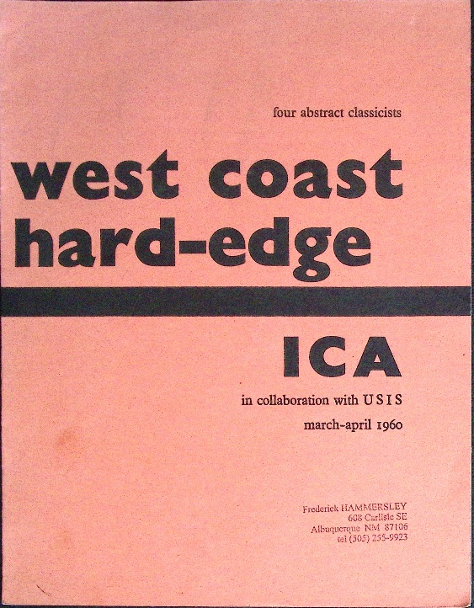  Figure a.  Four Abstract Classicists. WestCoast Hard-Edge. ICA in collaboration with USIS, march-april 1960, London: Graphic Press Ltd. Copy sent to Frederick Hammersley. D. Droixhe & A. Piette collection. | 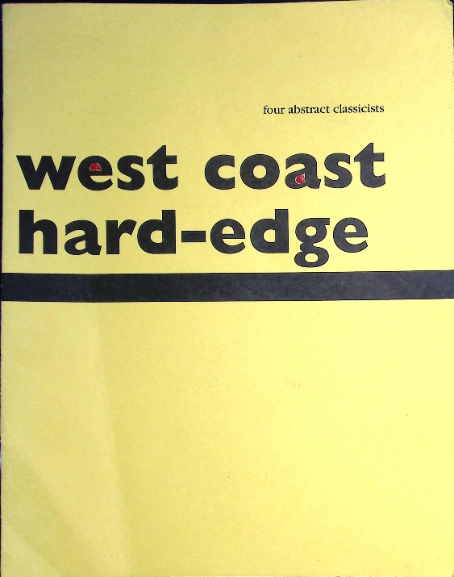  Figure b.  Four Abstract Classicists, West Coast Hqrd-Edge, San Francisco: Modernism, March4 – April 24, 1993. D. Droixhe & A.Piette collection.

Part One
Chapter 1. Reconstructing Benjamin’s artistic development: a contradictory undertaking?
This study aims to reconstruct the path followed by Karl Benjamin from his earliest works around 1950 to the point at which he attained the Hard-Edge style in 1959. It is based on the Catalogue Raisonné established by Louis Stern Fine Arts in Los Angeles, accessible on the website Louis Stern Fine Art / Karl Benjamin. Louis Stern Fine Arts provided me with several reference works that have been used in the present study. First and foremost, mention should be made of: Karl Benjamin and the Evolution of Abstraction 1950-1980, catalog of an exhibition held from September 24 to December 24, 2011, with Acknowledgment by Louis Stern, Fill’ Up the Space and Don’t Mess Around, a presentation by Suzanne Muchnic, and The Artist at Home, a poem by Beth Benjamin.
Another documentary source available on the Louis Stern Fine Arts / Karl Benjamin website is the catalogue of the exhibition Dance the Line : Paintings by Karl Benjamin September 29 – December 22 2007.
A particularly valuable source used in the present study is the 1977 volume California: 5 Footnotes to Modern Art History, edited by Stephanie Barron and prefaced by Maurice Tuchman. Published in conjunction with an exhibition at the Los Angeles County Museum of Art, the volume contains, among other contributions, Tuchman’s essay Los Angeles Hard-Edge: The Fifties and the Seventies and an essay devoted to Karl Benjamin by Merle Schipper.
The attempt to reconstruct Benjamin’s artistic development might appear self-contradictory if one accepts the artist’s own view, as reported by Suzanne Muchnic. “To this day - more than 60 years after he embarked on a journey that would make him a master of geometric abstraction – he squints at a deftly composed early work and remarks, ‘I don’t know how I did that. I had no background’”. When he considers a grid of thickering triangles made some twenty years later, he attributes its success to “restless luck”.” In recounting his beginnings, he invokes a procedure that is not borne out by the works of 1950. “It started as four quadrants, all the same. But that got boring, so I cut them in half. It’s fun to do things you didn’t intend to do, but something comes up.”
Such a procedure might apply to a work such as Gironde by Ellsworth Kelly, in which a division into four squares, themselves subdivided into four smaller squares, gives rise to the multiplication of forms, as in Spectrum Colors Arranged by Chance, Sanary, Colors for a Large Wall (1951–1953), and related compositions (Kelly1951, Nos. 70, 72, 73, 74, etc.). Such arrangements may, in fact, come to appear somewhat “boring,” even to the artist who conceived them. Thus, S. Muchnic argues that “the evolution of his work can be baffling,” to the point that “any attempt to analyze his art in terms of a linear progression is destined to fail.”
We readily concede that, if a strictly “linear progression” is impossible, a discontinuous analysis organized into blocks or stages of investigation may itself be a risky undertaking. Such an approach nevertheless remains necessary if one wishes to identify the phases that, through multiple channels of development, led toward creations increasingly close to a form of Hard-Edge painting that had assimilated the fundamental “rules” of geometric abstraction.
What are we to make of what Benjamin told his sixth-grade students in Bloomington in 1949, when he found himself confronted with the unwelcome task of adding art instruction to his teaching duties? The school served children from a modest community in San Bernardino County, where most lived in trailers and had little access to books. Since Benjamin had a gift for writing, he helped them compose poems and short stories. Teaching them to draw for forty-five minutes a week, however, was another matter. Was it enough to show them, or have them copy, a Joan Miró painting hanging above his sofa? Was it enough, when he handed out paper and colored pencils, for them to draw houses, trees, and cars as best they could? Seeing, in his own words, “no point in wasting the allotted time on such brainless activity,” he instead encouraged them to fill their sheets with colored shapes, working with “seriousness and concentration.” In this way, he himself acquired a taste for a form of experimentation that was both playful and disciplined, and that he learned to share with his students.
Chapter 2. The figurative and para-figurative state

It may be argued that classifying Benjamin’s formative works according to the relationship they maintain with external reality is at once methodologically sound, theoretically grounded, and consistent with the history of painting. From this perspective, his production may first be divided into two general categories: figurative / parafigurative / cubist works, on one side, and abstract works, on the other.

In the first category, figurative works are for example illustrated by Bud’s Bike Shop, 1953 (Fig. 1). Reference to the number in the Catalogue raisonné is provided in the following manner to ensure the easy identification of a given work when several paintings bear the same title: Catalog # Nr.
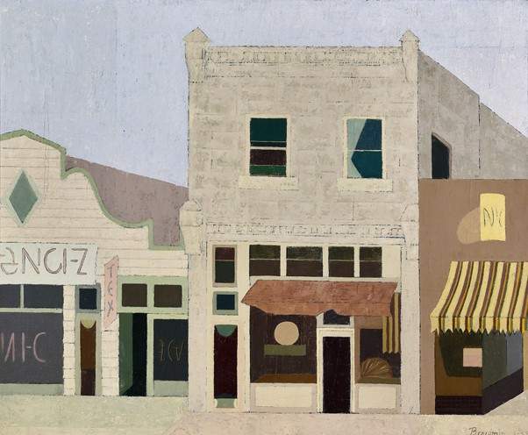
Figure 1.
Bud’s Bike Shop, 1953, Catalog #323

As figurative means that a work depicts rather closely what S. Muchnik calls “recognizable subjects” provided by the real world – here without undergoing the process of analysis, decomposition, and recomposition typical of Cubist practice – we may call parafigurative paintings showing the treatment of recognizable subjects that involves a formal or chromatic modification of its constituent elements. This process, in the present case, may lead in particular to a structural simplification or reduction that moves the representation toward a Cubist perspective.

At least two works that may be described as para-figurative were among the twenty-nine paintings exhibited in the Contemporary Galleries of the Pasadena Art Museum – now the Norton Simon Museum–from July 30 to August 29, 1954: Poppies and Statice, both dated 1953 (Figs. 2–3).

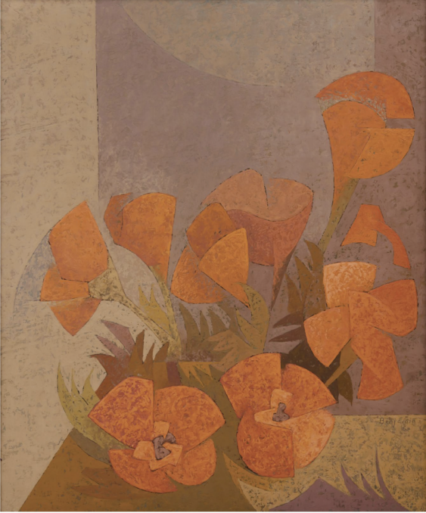  Figure 2.  Poppies, 1953, Catalog #968 | 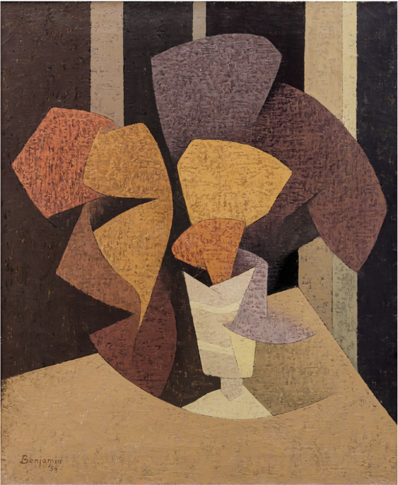  Figure 3.  Statice, 1953, Catalog #1032

These works appear on the handwritten checklist of the twenty-nine paintings shown in the exhibition Karl S. Benjamin, held in the Contemporary Galleries of the Pasadena Art Museum in 1954 (Figs. 4–6). Poppies is listed as No. 13 and priced at $125; Statice appears as No. 14 under the spelling Statis, at the same price. Henceforth, the inclusion of a given work in the Pasadena Art Museum exhibition will be indicated, on the basis of the handwritten checklist, by the reference: PMA/L 1954, no.

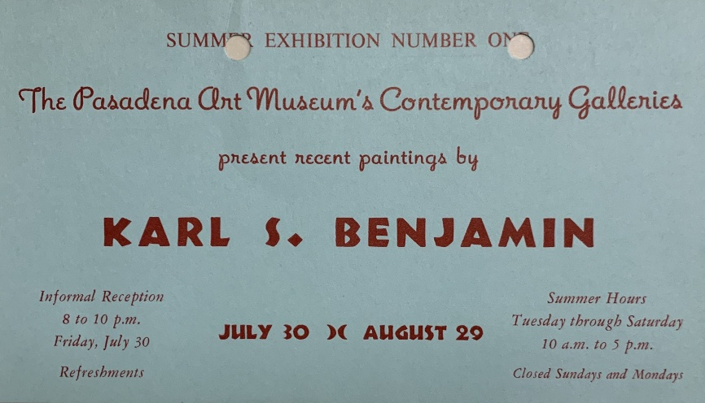

Figure 4.

Collection of the Norton Simon Museum (Pasadena, CA).
Reproduced by courtesy of Dane Reeb, Curatorial Associate,
and Kate Austin, Digital Assets and Rights Manager

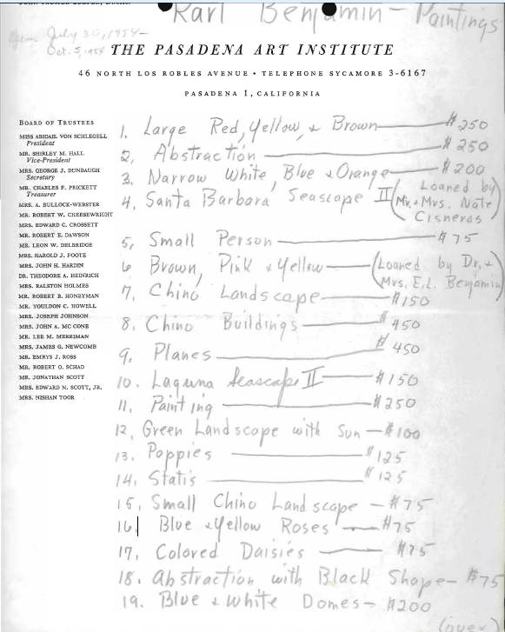  Figure 5.  Collection of the Norton Simon Museum (Pasadena, CA).  Reproduced by courtesy of Dane Reeb, Curatorial Associate,  and Kate Austin, Digital Assets and Rights Manager | 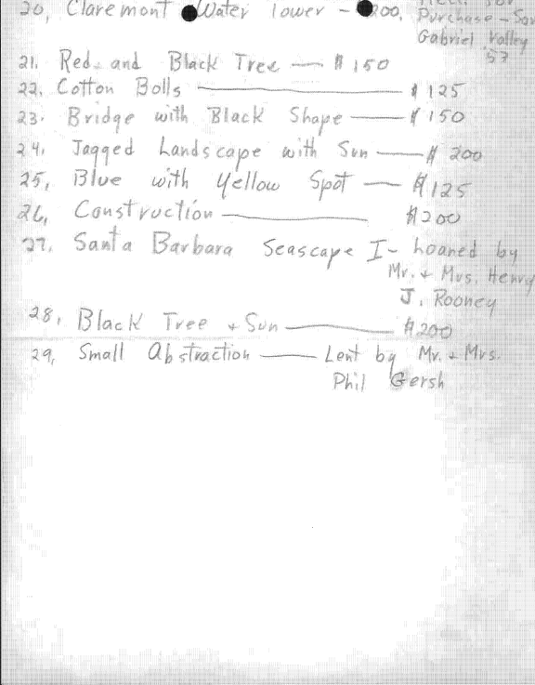  Figure 6.  Collection of the Norton Simon Museum (Pasadena, CA).  Reproduced by courtesy of Dane Reeb, Curatorial Associate,  and Kate Austin, Digital Assets and Rights Manager
The entry for Poppies correctly notes that the painting was exhibited at the Pasadena Art Museum, but makes no reference to the handwritten checklist. The entry for Statis refers to an article by Jarvis Barlow entitled “Benjamin’s New Oil: ‘Status’… Pressing His Good Fortune?”, published in the Pasadena Independent on September 5, 1954. Although the entry notes that the work was reproduced in the newspaper, neither the reproduction nor Barlow’s article itself is included in the Catalogue raisonné, with the result that the article remained unknown.
Muchnic emphasizes the importance of the summer 1954 exhibition as a decisive stage in Benjamin’s development. “Exhibition opportunities came early for Benjamin. In 1954, a mere three years after he started painting, he had his first major solo show at the Pasadena Art Museum, one of Southern California’s few significant venues for contemporary art at the time. Seen in retrospect, the event was a turning point. About half of the works displayed were modernist interpretations of landscapes and still lifes; the rest were abstractions, largely drawn from nature. But when the exhibition ended, he was ready to move on to what would become his signature work: geometric abstractions packed with the energy of vibrant color relationships.
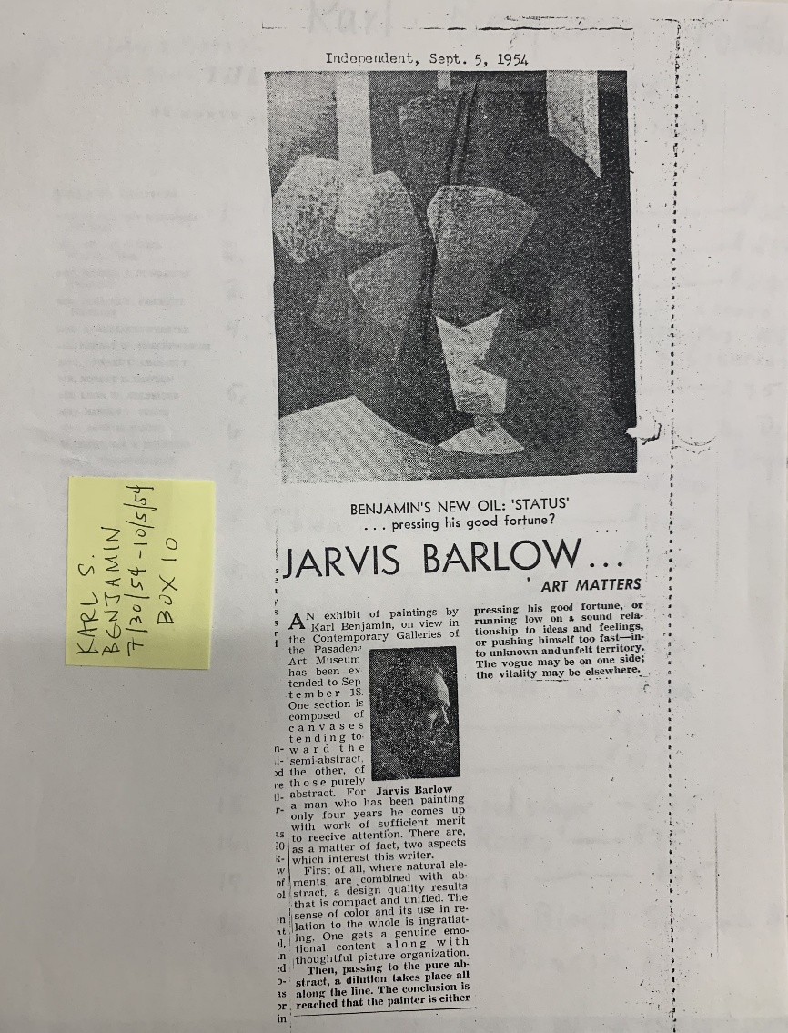
Figure 7.

Collection of the Norton Simon Museum (Pasadena, CA).
Reproduced by courtesy of Dane Reeb, Curatorial Associate,
and Kate Austin, Digital Assets and Rights Manager
Muchnic must have seen the checklist discussed above, which establishes the terminus ad quem of the works it records. Jarvis Barlow, however, proposes a different division of the exhibition (Fig. 7). “One section is composed of canvases tending toward the semi-abstract, the other, of those purely abstract (…). There are, as a matter of fact, two aspects which interest this writer. First of all, where natural elements are combined with abstract, a design quality results that is compact and unified. The sense of color and its use in relation to the whole is ingratiating. One gets a genuine emotional content along with thoughtful picture organization. Then passing to the pure abstract, a dilution takes place along the line. The conclusion is reached that the painter is either pressing his good fortune, or running low on a sound relationship to ideas and feelings, or pushing himself too fast-into unknown and unfelt territory. The vogue may be on one side; the vitality may be elsewhere”.
For the moment, it may be retained that, in Barlow’s view, a semi-abstract tendency toward compactness and unity exercises an “insinuating” appeal insofar as it reconciles the natural, the emotional, and the thoughtful aspects of the overall organization. Barlow seems to regret that the line undergoes a certain “dilution” when representation becomes abstract and loses its rigor. Would the talent Benjamin had been granted mature through a gradual exploration of the relationship between intellect and sensibility, or would it respond to a premature call toward the unknown? The opposition—or dilemma—between personal development and fashion, thesis and antithesis, remains unclear and ambiguous. What follows will show how the forces still at work eventually produced a historical synthesis.
It is noticeable that the exposition of summer 1954 at the Pasadena Art Museum was also reviewed in an article entitled “A First Show” published in the Los Angeles Times of October 3 1954. But we had no access to this paper, signed “A.M.”.
The Cubist orientation of para-figurative representation is even more pronounced in works such as Seascape North of Santa Barbara II and Yellow and Blue Roses (Figs. 8–9).
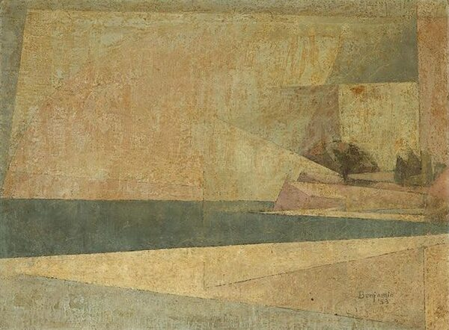  Figure 8.  Seascape North of Santa Barbara II, 1953, Catalog #982 / Santa Barbara Seascape, PMA/L 1954, no. 4. | 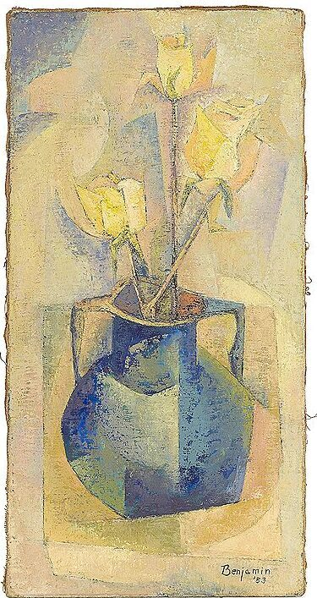  Figure 9.  Yellow & Blue Roses, 1953, Catalog #1046 / Blue & Yellow Roses, PMA/L 1954, no. 16.
Chapter 3.
Seascape North of Santa Barbara II invites a comparison suggested by Merle Schipper in his essay “Los Angeles Hard-Edge: The Fifties and the Seventies” (Schipper 1977, p. 53). Schipper writes: “Benjamin’s style found its first impulse in Cubism. His early representational work, begun in 1947, shows this, but he was sensitive to color even then, and consequently was attracted to Gris and Feininger. Within their shared concern for atmosphere, their distinctly personal mood statements reflect very different esthetic sensibilities.”
What Schipper identifies in Benjamin as a preference for “the rich, heady luminosity of Gris’ color-shapes” will be illustrated below by works such as Untitled (1952) and Ball on His Nose (1952). These paintings stand in marked contrast to “Feininger’s evocation of otherworldly transcendence through diaphanous overlays of light.” Feininger’s Phönix (1954) exemplifies this diaphanous transcendence, traces of which may also be discerned in Seascape North of Santa Barbara II (1953, Fig. 8), as well as—combined with the architectural theme—in Untitled (1954, Fig. 11) and Untitled (Claremont White Water Tower) (1953).

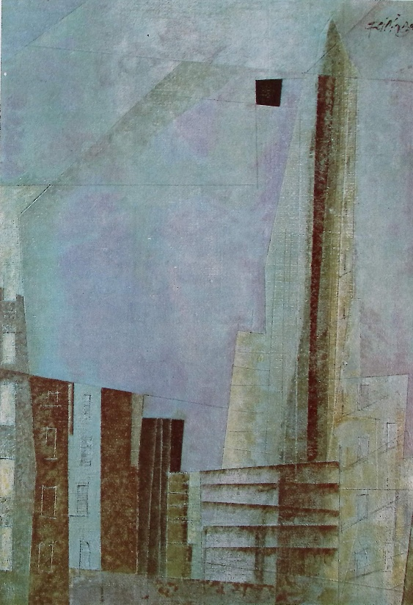  Figure 10.  Hans Hess Feininger, Phönix, 1955, from Lyonel Feininger. Stuttgart – Berlin – New York: Verlag W. Kohlhammer, 1991,161. | 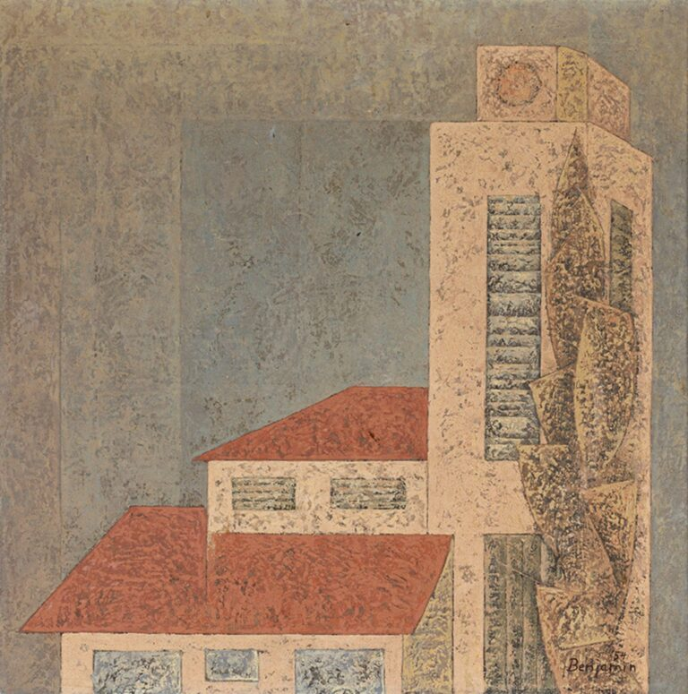  Figure 11.  Untitled, 1954, Catalog 614.
No doubt, at that time, Gris and Feininger represented for Benjamin “the outermost reaches of the breadth of expressive content he sought to achieve in his own work.” Yet by 1951 his Cubist-inspired figurative phase had already served as a springboard from which to move beyond that stage and confront two distinct modes of abstraction: works composed of varied, non-geometric forms, and works constructed from basic geometric forms.
The first subcategory is illustrated by a number of works executed between 1951 and 1952. Among the most representative are Untitled (1951) and Untitled Composition (1952), where a network of interlocking forms is delineated by black contours of varying thickness (Figs. 12-13). They do not appear to have been exhibited in 1954 at the Pasadena Art Museum exhibition, unless under a different title. Did Benjamin already regard them as belonging to an earlier, superseded phase of his development?
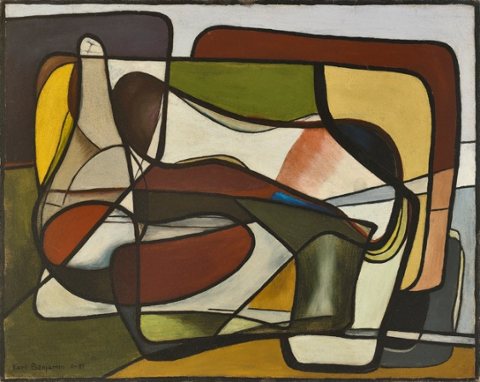  Figure 12.  Untitled, 1951, Catalog #320 | 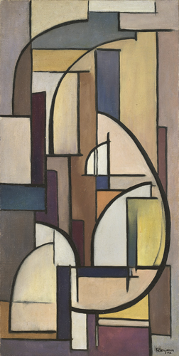  Figure 13.  Untitled, 1952, Catalog #321
Several other abstract paintings also present a dense interplay of heterogeneous forms, with the same predominantly orange and brown palette (Figs. 14-15). But Untitled (1952) contains almost no patterns suggestive of geometric forms, and those that do appear remain emphasized by broad black outlines. Ball on His Nose (1952) includes several squares or trapezoids—sometimes only partial ones—in the upper register of the painting, as well as triangles in the lower register. Yet, like the two preceding works, these paintings do not seem to have been reprised in the Pasadena exhibition. Through its title, Ball on his nose may have suggested the series of sad clowns—or the pitiful clown imagery—that brought this “genius painter” fame in the 1950s (sic) and eventually became his artistic trademark. We may be confident that adopting such a “trademark” was never among the American artist’s ambitions.
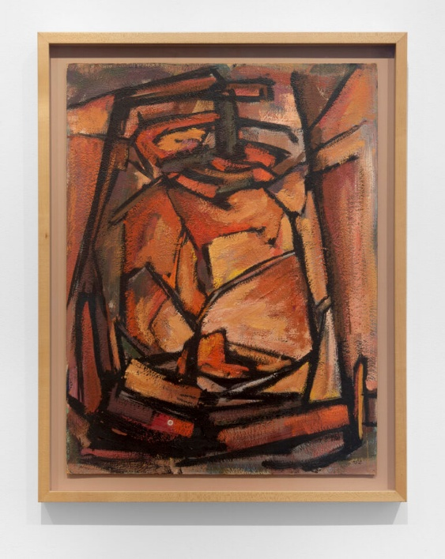  Figure 14.  Untitled, 1952, Catalog #1052 | 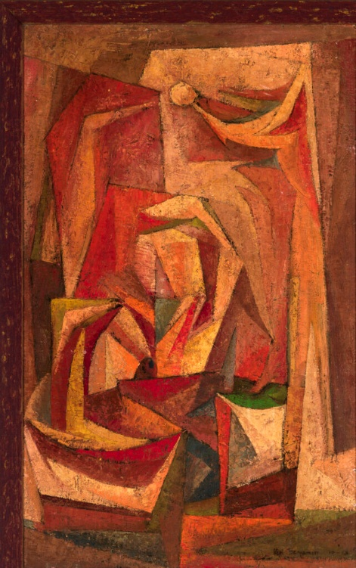  Figure 15.  Ball on his Nose, 1952, Catalog #663
If one seeks a geometric point of departure in Benjamin’s work, it may be found, as in the case of Georg Karl Pfahler, in his response to Tachism. Paradoxically, the very first work reproduced on page 1 of the Catalogue raisonné may serve as such a starting point: Cliff of Laguna (Fig. 16). The fact that the painting was not included in the Pasadena exhibition may perhaps be explained by its early date, by its lingering attachment to Tachism, or, more convincingly, by the fact that Benjamin was then exhibiting Laguna Seascape, a work that asserted a far more personal and adventurous direction of inquiry, as will become apparent below.
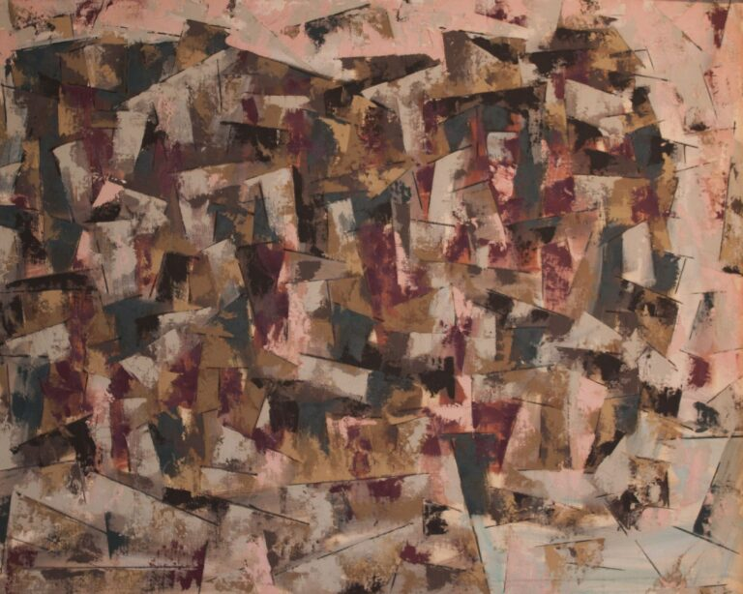
Figure 16.
Cliff of Laguna, c. 1950, Catalog #560
Cliff of Laguna is composed of a multitude of small, incomplete quadrilaterals, seemingly suspended from a line forming the upper edge of the composition. The dominant colors are dark brown and light white, alternating with black and beige, the latter occasionally taking on a pinkish hue, particularly along the upper edge of the canvas. The overall effect is remarkable, conveying an impression of harmonious unity and dazzling diversity.
At the same time—far removed from the fashionable production of Buffet—Pfahler was pursuing his own path away to overcome what he himself described as the “dead end” of Tachism, through recourse to an art of a “formless form” (formlose Gestaltung). He recounted, concerning his own that “formative works”: “I was of the opinion that after Tachism, one could really only create something very simple… The impasse had been reached among the Tachists, who had closed off the painting: all that remained was the surface. This means: the painting as a field, without a hierarchy of forms, without any relationship between the forms and the edge of the painting [‘zum Bildrand’]. But, at this time, there is no question of “hard edge” in his statements…
Chapter 4. Broken lines, “flat uniform colors”, seascapes, landscapes (1953-1954)
Other works of geometric abstraction dating from 1953 may be divided into two categories, depending on whether the geometric forms are incomplete because part of them appears degraded or cast in shadow, or whether they are composed of areas of uniform color.
In the first category, chromatic variation, with more or less pronounced shadowed areas, characterizes Small Abstraction and Untitled (Figs. 17-18).
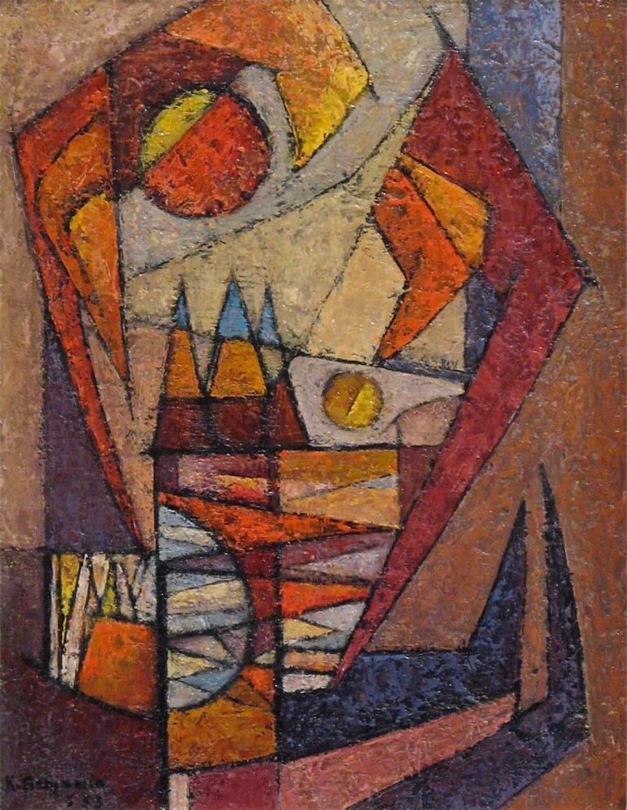  Figure 17.  Small Abstraction, 1953, Catalog #952 / PMA/L 1954, 29 | 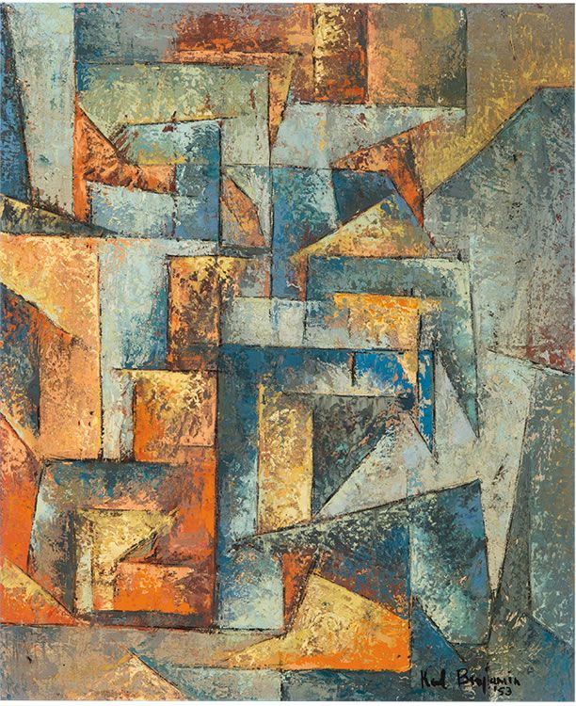  Figure 18.  Untitled, 1953, Catalog #980
The Pasadena list indicates that Small Abstraction was “lent by Mr. & Mrs. Phil Gersh”. The Catalogue raisonné specifies that the work comes from the collection of Phil Gresch and Beatrice Aberle. Phil Gersh was an American talent and literary agent. His spouse is said to have plaid a significant role in the founding of the Museum of Contemporary Art in Los Angeles. In the 1950s, both, living in Beverley Hills, were in Los Angeles among the first collectors of modern and contemporary art, to which they gave painted work by artists such as Jackson Pollock. For Benjamin, the acquisition of his Small Abstraction, prior to the summer of 1954, constituted a major form of promotional support, which extended the Californian abstraction to the East-Coast. We understand that the painting was also displayed at the 6th Annual San Gabriel Valley Artists Exhibition of the Pasadena Art Museum in 1955.
Whereas Brown, Pink and Yellow show forms whose surfaces are still modulated by gradual shifts into another color or by shadow effects, Architectural Theme, by contrast, presents surfaces characterized by what Langsner termed “uniform flat colors,” a feature he regarded as one of the defining criteria of Hard-Edge painting. The general similarity of the color schemes is deceptive insofar as it suggests a much closer relationship than actually exists (Figs. 19-20).
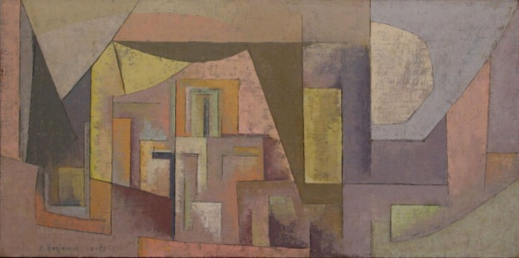  Figure 19.  Brown, Pink and Yellow, 1953, Catalog #230 / PMA/L 1954, 6 | 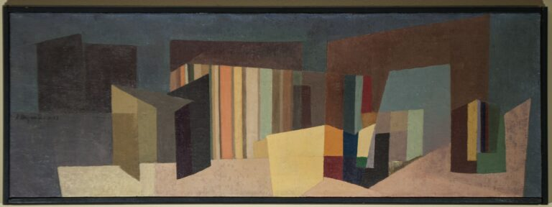  Figure 20.  Architectural Theme, 1953, Catalog #600
Although the geometry of the forms also appears analogous, the vertical bands that traverse Architectural Theme along the central axis and continue in a second series toward the right-hand edge already anticipate later works from Benjamin’s mature period. The multiplication of a single motif would become one of the determining elements in any taxonomy of Benjamin’s art. Architectural Theme, which does not appear to have been exhibited under that title at the Pasadena exhibition—unless it corresponds to a work such as Construction (no. 26)—was in any case sufficiently striking to attract the attention of Phil Gersch and Beatrice Aberle, who purchased it directly from the artist.
The tendency toward greater uniformity in the color of forms reaches its fullest expression in a number of landscape paintings from 1954. This tendency is most clearly visible in two works in which blue and brown areas are set in strong opposition, all the more striking because the contrast corresponds to the division created by the horizon line (Figs. 21–22). Another feature links Laguna Seascape II and Landscape: both paintings are structured around more or less broken lines that spring from the shoreline on the right and rebound toward the left edge of the canvas. Laguna Seascape II presents a ensemble of angular, mineral-like forms defined by a zigzag line.
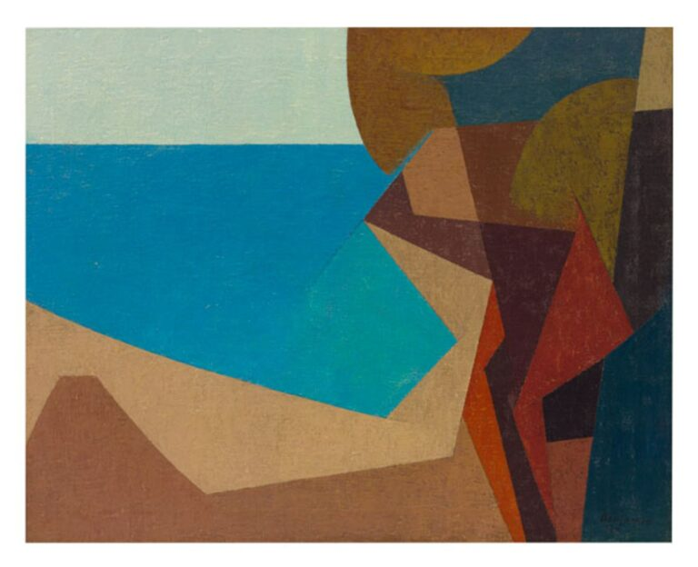  Figure 21.  Laguna Seascape II, 1954, Catalog #1027 / PMA/L 1954, 10 | 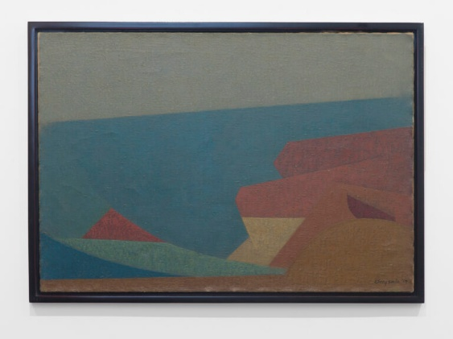  Figure 22.  Seascape, 1954, oil on canvas, Catalog #195
Spectacular, Laguna Seascape II must have made a strong impression. It was reproduced in an article of the Pomona Progress Bulletin in October 1954 entitled “Young artist to exhibit paintings”, on the occasion of Benjamin’s exhibition at the Pomona Public Library. The exhibition was held “under auspices of Pomona Valley Art Association, according to announcement by exhibitions chairman Arthur J. Tracy”. The latter is photographed with Benjamin, holding the painting, clearly identified as Laguna Seascape (Fig. 23).
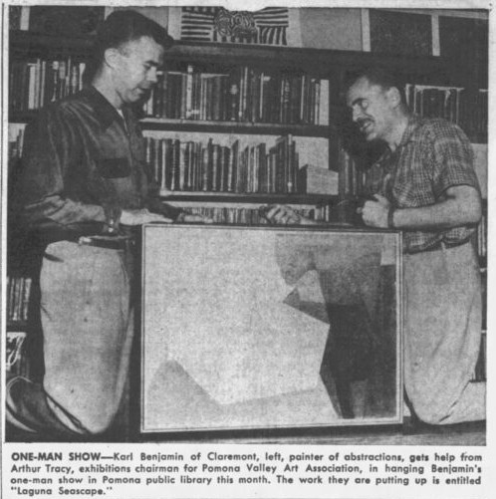
Figure 23.
From “Young artist to exhibit paintings” in Pomona Progress Bulletin, October 1954.
The work of this “young Claremont artist,” together with the exhibition devoted to him, marks the first major milestone in his career. “Benjamin, who began painting only 3 ½ years ago, has gained swift recognition for the direct and fresh quality of his abstractions. Until recently associated with the Falk-Rahoff Gallery in Los Angeles, he also has exhibited with the Los Angeles Art Association, and his paintings have appeared in shows at Long Beach City College, University of Redlands, and in competitive exhibitions thruout Southern California”. The article also highlights “the art work accomplished by children in classes under his direction,” in “his fifth grade class at El Rancho elementary school, Chino”. Their “crayon art” is shown “in the children’s room at the library concurrently with his own works”.
An aspect of those works, in the fall of 1954, concerns their patterns. “A favorite device of the artist is to ‘abstract from’ flower themes, conveying their essence in motifs rearranged to feed the needs of the picture surface”. As far as can be determined, the titles of works produced before 1955 make no reference to this type of subject. Identifying earlier instances would constitute a worthwhile line of research in its own right. “Muted, subtle texture and a simple and direct charm are characteristic”.
Of course, the article notices that Benjamin “uses land and seascapes as motif in his abstractions and sometimes a local theme appears, such as his ‘Claremont Water Tower’”. This painting, reproduced in the Catalogue raisonné as Untitled (Claremont white water tower) (1953), helped establish its reputation, as it was shown at the 5th Annual San Gabriel Valley Artists Exhibition in 1953, at the Pasadena Art Institute, but with a stronger focus at the solo exhibition at the Karl Benjamin: Paintings in the same Pasadena Art Institute, in 1954. It was also announced that “Benjamin is scheduled for another one-man show at Carr Gallery in Pasadena next spring”. Jules Langsner in fact published an article entitled “Art News from Los Angeles” in the magazine Art News in 1956, on the occasion of the exhibition Karl Benjamin held at the Jack Carr Gallery in South Pasadena from 4 to 31 May 1956. He discussed Benjamin’s “tidy abstractions,” describing them as “less resolutely anonymous” than those of John McLaughlin. A “sliderule school” for both show “the same adherence to sharp, clean edges, forms closer to conceptual than observable space, and a similar concern with interlocking advance and recession of form and color”. The concept of Hard-Edge painting was already taking shape here, anticipating the more explicit formulation that Langsner would later develop in the celebrated exhibition catalogue of Four Abstract Classicists, two years, where the oxymoric expression “interlocking advance and recession” is explained.
“Abstract Classicists painting is hard-edged painting. Forms are finite, flat, rimmed by a hard, clean edge. These forms are not intended to evoke in the spectator any recollections of specific shapes he may have encountered in some other connection. They are autonomous shapes, sufficient unto themselves as shapes. These clean-edged forms are presented in uniform flat colors running border to border. Ordinarily color serves as a descriptive or :cerebral. But in these paintings color is not an independent force. Color and shape are one and the same entity. Form gains its existence through color and color its being through form. Color and form here are indivisible. To deprive one of the other is to destroy both. To clarify matters, eliminate semantic confusion, it is helpful to unite the two elements in a single word : colorform”.
Two other Landscapes must be added to the previous ones, but they are not only linked to them by their titles. Landscape (1954) is likewise organized around a line that unfolds horizontally in angular arabesques, marked by sudden changes of direction (Fig. 24). It was evidently the painting exhibited at Pasadena under the title Green Landscape with Sun. In Jagged Landscape with Sun (Fig. 25), the division of the painted space is established by a central line that is itself “jagged,” much like the one structuring Landscape. The forms arranged within the two registers thus defined, possess the massive character of rocks or “menhirs,” bringing the painting closer to other works of 1954.
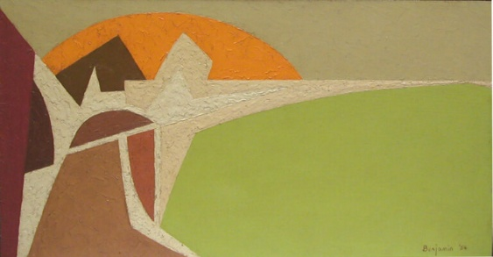  Figure 24.  Landscape, 1954, Catalog #141 / Green Landscape with Sun, PMA/L 1954, 12 | 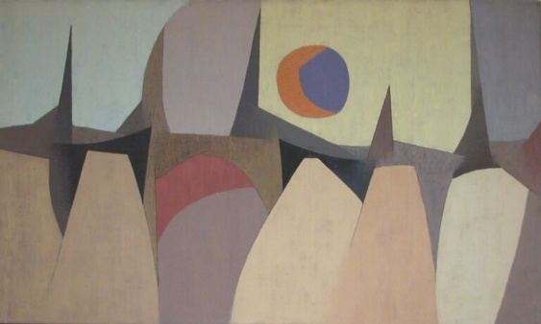  Figure 25.  Jagged Landscape with Sun, 1954, Catalog #33 / PMA/L 1954, 24
Chapter 5. Massive forms
The massive forms suggestive of large stones in Jagged Landscape with Sun may be found the same year in Untitled (Yellow Sun, Pink Sky) (Fig. 26). The painting is very close to Night Seascape (Fig. 27), which is constructed on two circle lines – a character that will be discussed.

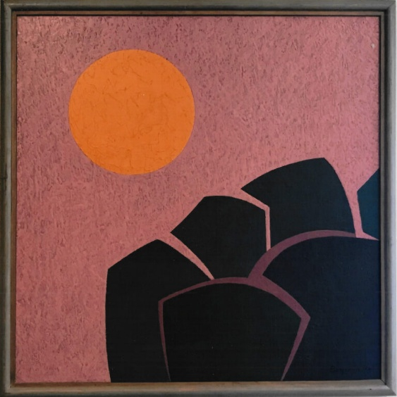  Figure 26.  Untitled (Yellow Sun, Pink Sky), 1954, Catalog #1031 | 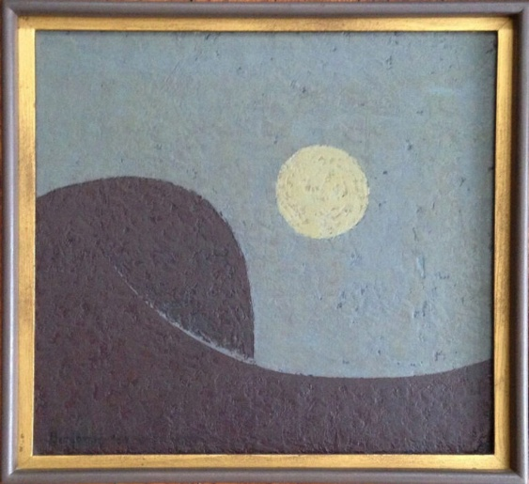  Figure 27.  Night Seascape, 1954, Catalog #619
A first untitled work of 1954 also shows massive and compact forms (Fig. 26) while another one shows more concatenated forms (Fig. 27), but in the same color range.
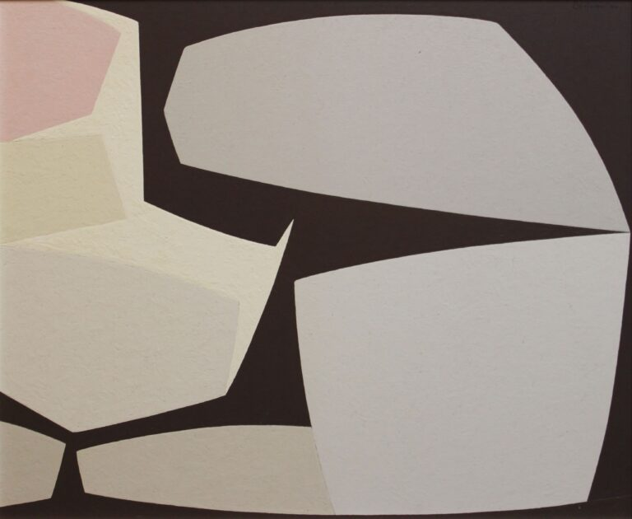  Figure 28.  Untitled, 1954, Catalog #229 | 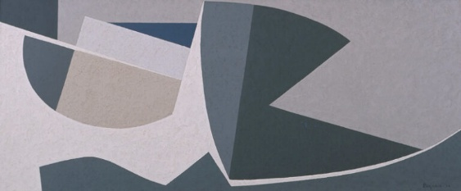  Figure 29.  Untitled, 1954, Catalog #1
Both paintings share a distinctive motif defined by a vertical zigzag line: a pointed form, black against a grey background and directed to the right in the Untitled on board, and a corresponding form, grey against a black background and pointing in the opposite direction in the Untitled on masonit. It is therefore fitting that both paintings were included in the exhibition Karl Benjamin: Paintings from 1950–1965, held at Louis Stern Fine Arts from January 10 to April 10, 2004, and again in Evolution in Abstraction: Antecedents and Descendants, presented at Wigmore Fine Art, New York, from April 15 to May 31, 2005, where both were reproduced in the accompanying catalogue. A color reproduction of the Untitled (Fig. 29) also appeared in the catalogue of the exhibition Karl Benjamin and the Evolution of Abstraction, 1950–1980, organized by Louis Stern Fine Arts in 2011, together with S. Muchnic's essay (plate 2, p. 13). Both works remained in the artist's estate and were never sold. Did Benjamin retain them as reminders of his pictorial investigations, or did they represent, in his eyes, a stage of development that he had already surpassed?
The exhibitions of 2004, 2005, and 2011 brought Benjamin's work an exceptional degree of visibility, extending a recognition that had long been established in California. Do the exhibitions held at Pasadena, Pomona, and Los Angeles as early as the mid-1950s invite comparison with the "formative years" of Georg Karl Pfahler during the 1960s? It would be unwarranted to relate the arrangement of these massive forms to the rudimentary arrow-like motif found, for example, in the 1962 lithograph Blue/Schwarz, reproduced in the Rottloff edition of G. K. Pfahler’s Werkverzeichnis der Druckgraphik (Karlsruhe: Edition Rottloff, 1975). The distance separating it from Benjamin's comparable compositions is simply too great.
Chapter 6. Curving the line: flying with arrows and swallows
If the chronology is respected, one must recognize a transformation affecting the line, already perceptible in 1953 and becoming more pronounced in 1954. The curved line assumes increasing importance as a referential element within the composition—for example in the representation of the sun—but also as a structural device when it is doubled. It generates a variety of forms: arrowheads, ox horns, scythe blades, and mainly swallows.
The swallow motif is multiplied in Black Tree and Sun (1953), where it sometimes takes on the appearance of a bird in flight (Fig. 30). This very large work (48 × 24 in. or c. 122 x 61 cm.) was included in the Pasadena exhibition of 1954 and it was reviewed in an article entitled “A First Show”, signed “A.M.”, published in the Los Angeles Times of 3 October 1954.
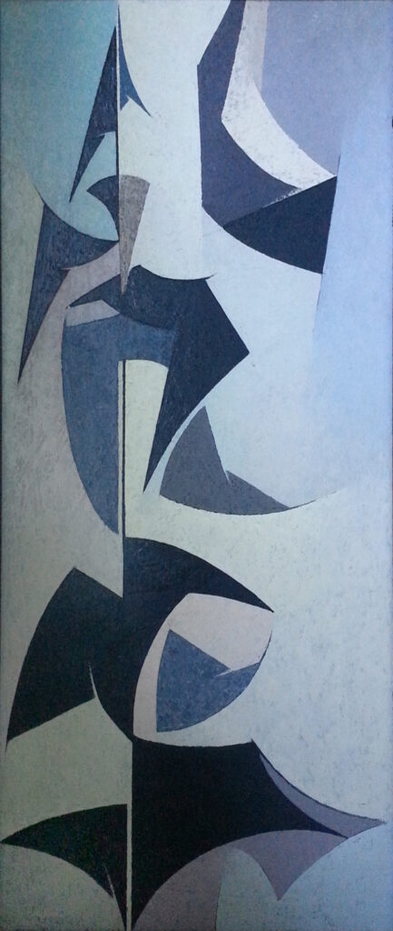
Figure 30.
Black Tree & Sun, 1953, Catalog #1034 / PMA/L 1954, 28
Another work of 1953, Yellow Landscape, is remarkable. It has been mentioned in Claudine Humblet’s The New American Abstraction 1950-1970 (2007, I, 472), and the quoted in periodicals (The Santa Barbara Independent, 2011; ArtNews, 2012). Yellow Landscape, with its vivid forms rising within a luminous space, illustrates the recurring motifs of sickle blades or bull’s horns (Fig. 31).
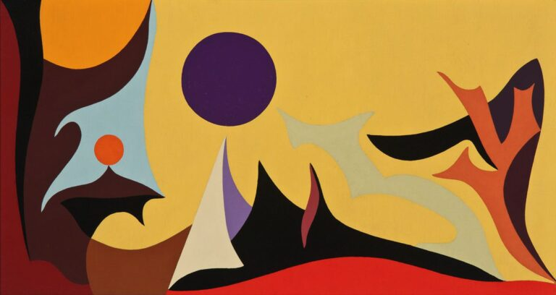
Figure 31.
Yellow Landscape, 1953, Catalog #948
The same motifs echo one another and fade, as if overwhelmed by an excess of light, beneath a kind of arch, in #8 (1953), while the scythe blade surmounts a long undulating form in Abstract Seascape (1954), where luminosity and vivid colors once again predominate (Figs. 32-33).
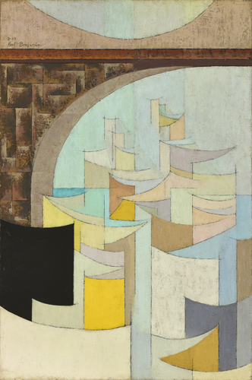  Figure 32.  #8, 1953, oil on canvas, Catalog #322 | 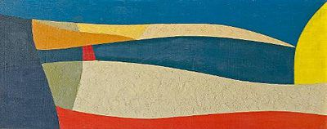  Figure 33.  Abstract Seascape, 1954, Catalog #990
The preceding works are devoted almost entirely to the celebration of the curved line and the forms it generates. Even the square itself undergoes deformation in the light-colored shape occupying the lower right-hand corner of #8. It may therefore be said that two paintings executed in 1954 represent a considerable advance through the synthesis they achieve between rounded forms and quadrangular or triangular ones. At the end of the Catalogue raisonné for 1954, Untitled with Moon and Yen Hen show may be associates, despite several differences (Fig. 34-35)
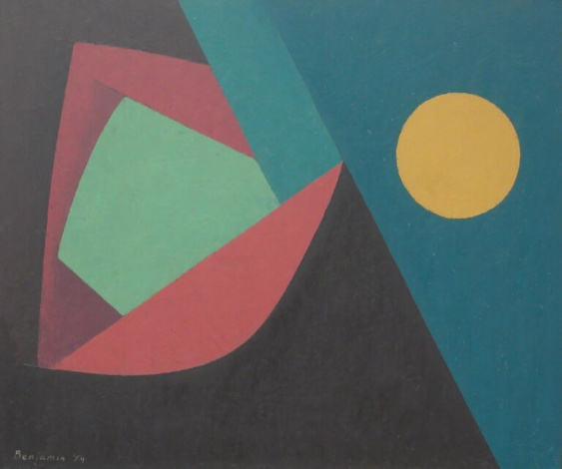  Figure 34.  Untitled with Moon, 1954, Catalog #182 | 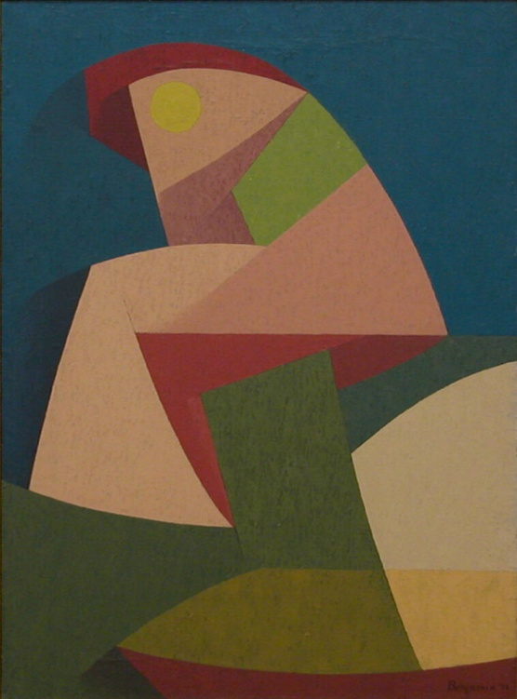  Figure 35.  Yen Hen, 1954, Catalog #245
In Untitled with Moon, an oblique transverse line divides the painting into two balanced areas peacefully illuminated by the moon. In Yen Hen, a tension rises, with increasing intensity, from red to red and the painting remarkably seeks to create the impression of an object seen in perspective, as some sides appear lighter or darker according to their apparent distance. However, despite the contrasts of form and color, the two paintings give rise to a striking sense of unity. The use of uniformly colored geometric forms distributed across uninterrupted color fields stretching from one edge of the canvas to the other anticipates the style of Benjamin’s mature production.
Chapter 7. Vertical axis, hard angles
The orientation in which an abstract work is hung on the wall and presented to viewers obviously influences the way it is perceived. This relationship has been the subject of critical discussion and scholarly investigation ((Liu, Dong, Zhang and Jiang 2015). George Mather had previously submitted to eighteen “naïve observers” fourty modern artworks “some of which are entirely abstract” (Mather 2011). “Each trial presented all four cardinal orientations on a computer screen, and the participant was asked to select the orientation that was most attractive or meaningful”. The correct orientation was selected by nearly half of the participants (48%), that is to say “above the 25% chance level, but well below perfect performance”.
It is equally important to bear in mind that Kazimir Malevich, for example, accepted that his Suprematist paintings could be exhibited in different orientations, with his approval. Rainer Crone and David Moos's Kazimir Malevich: The Climax of Disclosure reproduces photographs of several of the artist's paintings, including Supremus No. 50, shown in different orientations at the 1927 Hotel Polonia exhibition in Warsaw and at the Grosse Berliner Kunstausstellung in Berlin. Since these photographs were supplied by Malevich himself, it has generally been assumed that the orientation of the paintings was of little importance to him (Crone & Moos 1991, 203–204).

Such considerations, however, are not required to justify the manipulation proposed here. A 45-degree counterclockwise rotation of the earlier work Landscape (1954) (Fig. 22) reveals the structural similarity organized on either side of a vertical axis formed by a line composed of abrupt changes of direction (Fig. 36). To the left and right extend grey and green areas, one of which connects the upper and lower edges of the canvas. The same sinuous line, outlining a series of triangles, structures the painting Untitled (1954) by setting a red area against a range of colors extending from yellow to brown (Fig. 36). Untitled (1954) marks a twofold advance over Landscape (1954): the red triangular forms are echoed on the right by a similar yellow form, while the red area on the left likewise finds its counterpart in a red, rhinoceros-like Landscape (1954) on the right, repeated in brown. In both respects, the painting achieves a greater degree of unity.

Abstract Artists decide the orientation at which an abstract painting should be hung based
on their ideas, but the correct orientation is not obvious to other viewers. Some studies have
found that abstract paintings at the correct orientations generally get higher aesthetic rat-
ings from viewers. This e ncourages us to deal with the problem of orientation judgment for
abstract paintings through machine learning. First, we design a group of methods to extract
features from paintings based on the theories in abstract art. Then a machine leaning frame-
work is proposed using Naive Bayes classifier and BP neural network classifier for training
and orientation testing. Experiments show that it can classify abstract paintings into up and
non-up ones with performance comparable to human. This is the first work of orientation
judgment for abstract paintings through computer simulation, and the results demonstrate
the validity of abstract art theories used for feature definition. This work provides a new
scheme for exploring the relationship between aesthetic quality of abstract paintings and
their computational visual features.
Keywords Abstract paintings · Image classification · Feature extractio
Abstract Artists decide the orientation at which an abstract painting should be hung based
on their ideas, but the correct orientation is not obvious to other viewers. Some studies have
found that abstract paintings at the correct orientations generally get higher aesthetic rat-
ings from viewers. This e ncourages us to deal with the problem of orientation judgment for
abstract paintings through machine learning. First, we design a group of methods to extract
features from paintings based on the theories in abstract art. Then a machine leaning frame-
work is proposed using Naive Bayes classifier and BP neural network classifier for training
and orientation testing. Experiments show that it can classify abstract paintings into up and
non-up ones with performance comparable to human. This is the first work of orientation
judgment for abstract paintings through computer simulation, and the results demonstrate
the validity of abstract art theories used for feature definition. This work provides a new
scheme for exploring the relationship between aesthetic quality of abstract paintings and
their computational visual features.
Keywords Abstract paintings · Image classification · Feature extractioUntitled Geometric Abstract (Fig. 22), and Untitled (Fig. 23).
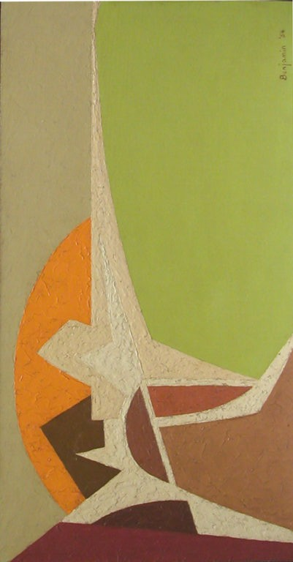  Figure 36.  Landscape, 1954, Catalog #141, previous Fig. 21, here Fig. with rotation left 45 degrees | 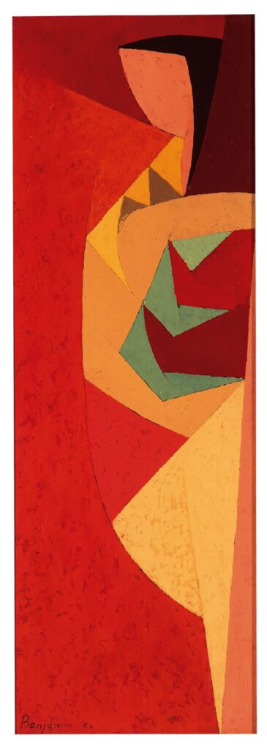  Figure 37.  Untitled, 1954, Catalog #1037
The same chromatic unity characterizes Untitled Geometric Abstract (1954), where red, together with various shades of cream and brown, predominates in a continuous arrangement that now extends to the upper and lower edges of the canvas (Fig. 38). Yet another aspect of the work anticipates and foreshadows the construction of the painting that serves in this study as its “focal point”—or the work toward which the preceding paintings progressively lead—namely I. E. Green, Ochre, Umber, reproduced in the catalogue Four Abstract Classicists. West Coast Hard-Edge (Fig. 39). In both works, an irregular zigzag line distributes differently colored areas on either side. In the painting reproduced in 1959, these lines and areas are elongated and repeated vertically to form continuous color fields, whereas in the Untitled geometric figures still develop as separate elements.
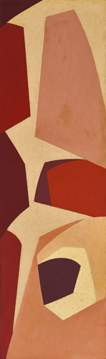  Fig. 38.  Untitled Geometric Abstract, 1954, Catalog #325 | 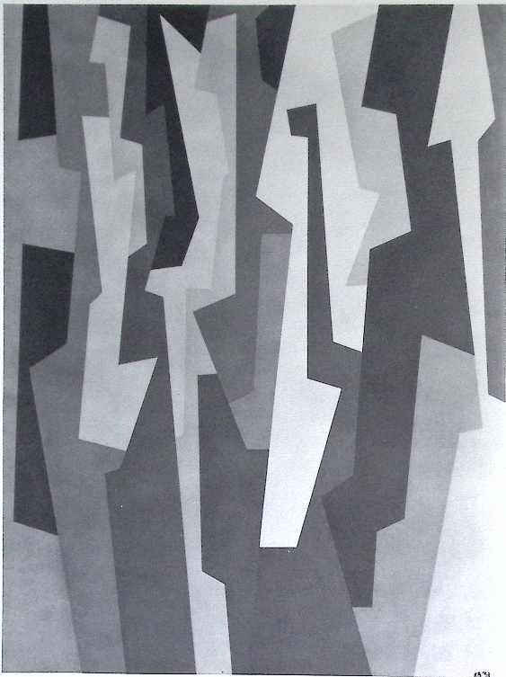  Figure 39.  I.E. Green, Ochre, Umber, from Four Abstract Classicists, repr. 1993.

Another Untitled of 1954 (Fig. 40) share some colors with the other one, but in contrast with more various ones and it shows a less structured vertical axis and reduced with minor changes of direction and more intricate forms: it could suggest a previous state of the research.
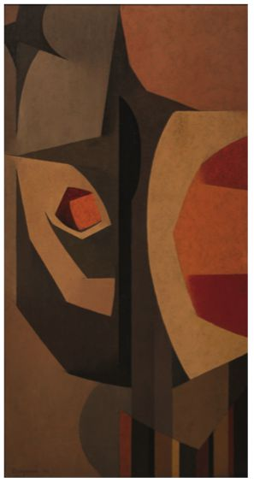
Figure 40.
Untitled, 1954, Catalog # 1019
Chapter 8. Architectural symbolism: a way to modern art?
As in literature (Droixhe 2022, Droixhe 2025), the avant-garde and abstract art privileged references to the building as a symbol of modernity. The work of the American artist Georgia O'Keeffe (1887–1986) is particularly representative in this respect. Among the most notable examples are Radiator Building—Night, New York (1927), Shelton Hotel, New York, No. 1 (1926), New York with Moon (1925), and the strikingly Constructivist City Night (1926) and Manhattan (1932), among others. A work such as Building by the Russian-American artist Ilya Bolotowsky (1907–1981) already marks, in the early 1930s, the transition to geometric abstraction under the influence of Piet Mondrian.
The list of works exhibited by Benjamin at the Pasadena Art Institute in 1954 includes a painting entitled Chino Buildings (no. 8), as well as another titled Construction (no. 26), whose title may likewise refer to the architectural motif. Did this motif provide a pathway towards a distinctive form of modern art?
A 1954 work, Night Building, Yellow Moon, could be said that it early achieved some of the Hard-Edge, at the end of the period considered until now. It shares a common title with Cube buildings. It is not the only link between them (Figs. 41-42). Apparent differences are overcome by the fact that they enclose they enclose elementary geometric forms within a black area occupying the lower right-hand corner from edge to edge. Cube Buildings, that also contains black lines and black blocks whose forms are less clearly defined than rectangles, closes in same sense the series of indeterminate forms. There is good reason why this work is the earliest of those chosen to illustrate S. Muchnic’s article.
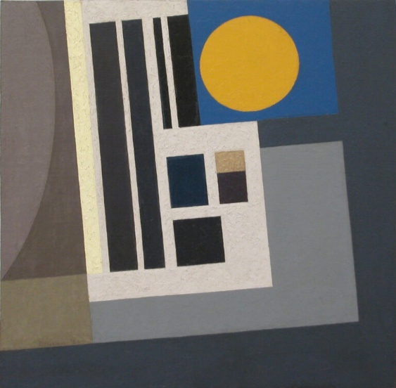  Figure 41.  Night Building, Yellow Moon, 1954, Catalog #240 | 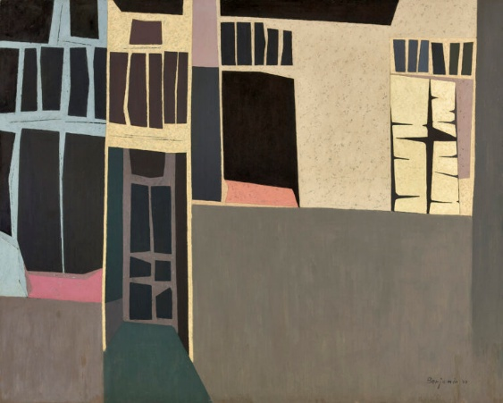  Figure 42.  Cube Buildings, 1954, Catalog #313
In 1955, two works linked by their titles may be regarded as closely related in terms of composition: Buildings / New York and City at Night (Figs. 43-44). In both paintings, a group of forms delineated by thick contours is organized in such a way that their interconnections and overlapping relationships generate a unified and visually dominant entity. Between the two buildings, a third and lower structure is anchored on a transverse line and shows similar quadrangular forms. But at the same time, the discontinuity created by the heavy outlines separating the forms prevents the viewer’s gaze from traversing the pictorial field seamlessly from edge to edge, as would later become possible in Benjamin’s mature Hard-Edge compositions.
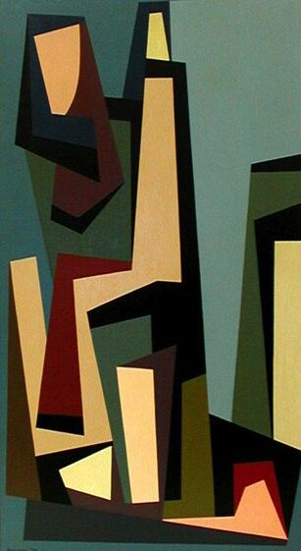  Figure 43.  Buildings / New York, 1955, Catalog #635 | 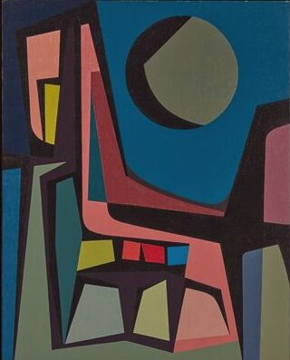  Figure 44.  City at Night, 1955, Catalog #72.
In 1954, an Untitled figurative work showed a high-construction and a 1955 one, Windows with Silver, could be seen as extending the thematic concerns of the preceding paintings (Fig. 45-46). Yet the line of inquiry initiated in Untitled would lead to other forms of abstract painting, while City at Night, with its retrospective figurative character, appears to bring this theme to a close.

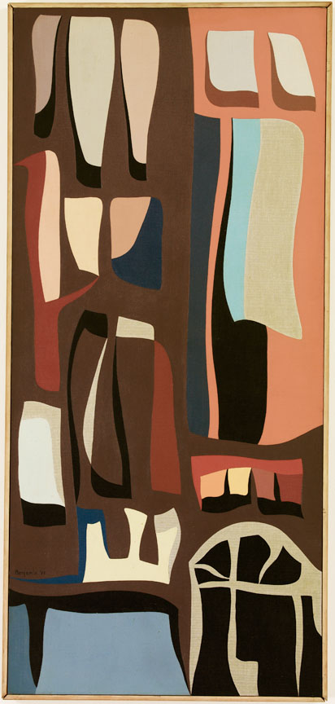  Figure 45.  Windows with Silver, 1955, Catalog #193 | Figure 46.  Untitled, 1954, Catalog #614
Chapter 9. Curving the line and “growing forms”
In 1955, an important change occurred in Benjamin’s art: straight-lines gave way to curves. The last will produce various forms suggestive of arrows, bull’s horns, and mainly swallows. It was first illustrated in a work emblematically subtitled Growing Forms (Fig. 47).
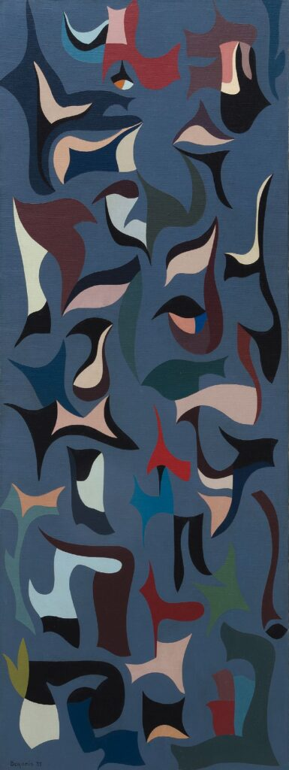  Figure 47.  Untitled (Growing Forms), 1955, Catalog #286 | 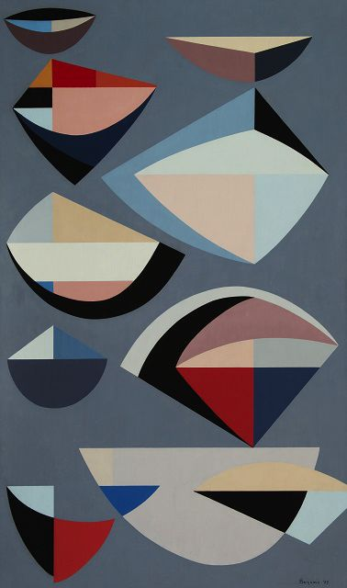  Figure 48.  Abstraction, 1955, Catalog #673
Untitled (Growing Forms), which bears a certain affinity to the works of Joan Miró mentioned in connection with Benjamin’s teaching at Bloomington, displays motifs of double pointed spindles in pink and black, the dominating colors which gives the work its unity. Some of those basic spindle-shaped form take the form of swallows, as in the upper left corner, or of a square bracket, as in the only white shape. Other forms are organic. The distribution of these small motifs across a uniform background places the work within the category of compositions based on dissemination. The formal continuity linking the edges of the composition, which would later become an important feature of Benjamin’s work, is still far from being achieved.

In an article published in the Los Angeles Times on 13 November 1999 entitled “Art Reviews”, concerning Benjamin’s exhibition at the Ruth Bachofner Gallery (Santa Monica), David Pagel reassessed the career of the artist who had by then become "the veteran Los Angeles abstractionist”. Indeed, his “idiosyncratic canvases have been marching to the beat of their own drummer since the early 1950s”. “At their best, these nifty, off-balanced images change their pace, rhythm and tempo without missing a beat”. Then, Pagel details what was shown in the rear gallery, that is to say “eight modestly scaled paintings made between 1954 and 1958”. They “look as if they belong to six different bodies of work – each as fully resolved as any other” (this should be compared with our eight “bodies of work”). At that time, Pagel skillfully distinguished three common features, one of which is characteristic of Hard-Edge painting. “Although all include the crisp contours, weird tertiary colors and meticulously finished surfaces for which the 73-year-old artist is known, their similarities end there”.
“The earliest one is titled cityscape that negotiates an uneasy compromise between Piet Mondrian’s mature works and John McLaughlin’s early still lifes. Another tightly compressed painting, measuring only 4 ½ inches wide, is a thin slice of an image in which symbolism reigns. In contrast, “Growing Forms” conveys the sensation of underwater weightlessness, as it is were made of musical notes that have been melted into protoplasmic squiggles”. We recognize into these “protoplasmic squiggles” the “organic forms,“ mentioned above.
Two works from 1955 include the idea of abstraction in their titles and display clear affinities with the preceding painting. The one simply entitled Abstraction comprises nine distinct forms, combining geometric, circular, quadrangular, and triangular shapes (Fig. 47). Set against a grey background in a thoroughly dispersed composition, the artist appears to be exploring which of these forms might emerge as the most characteristic or archetypal. The second form from the upper left combines several colors in an arrangement of curved and straight lines; a similar combination structures the third form from the upper right. The unity of the painting derives in particular from the remaining large forms and their relative chromatic homogeneity. Two of them combine white, grey, and cream in characteristic configurations. Like the preceding work, Abstraction (1955) may also be regarded as one of Benjamin's finest achievements.
Can the same be said of Untitled (Lips)? Its figurative reference may cast a shadow over a painting that does not appear to have been exhibited (Fig. 49). The arrow pattern is still present, notably in the upper left- and upper right-hand corners, as is the pair of adjoining almond-shaped forms. In the lower part of the painting, these forms take on the appearance of lips, sometimes in an inverted configuration.
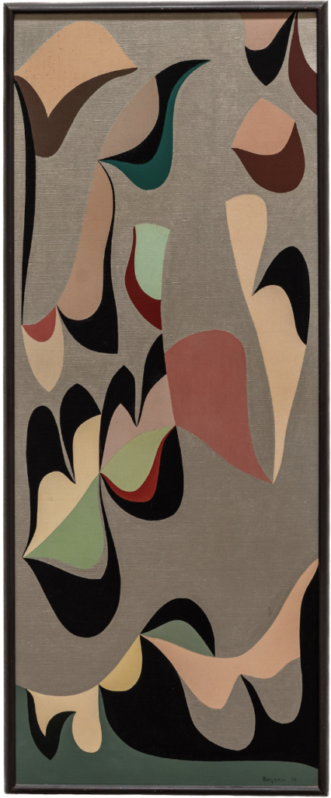
Figure 49.
Untitled (Lips), 1955, Catalog #1045
In comparison with Untitled (Lips), Abstract Landscape / Untitled (1955) shows a relative continuity in the four vertically oriented arrowheads—variants of the double-spindled form or the swallow motif—arranged along the horizontal axis (Fig. 50). The shared distribution of various shades of brown and cream does not yet bring about the chromatic simplification that would generally characterize the geometric abstraction of the Four Abstract Classicists or, later, the work of Pfahler.
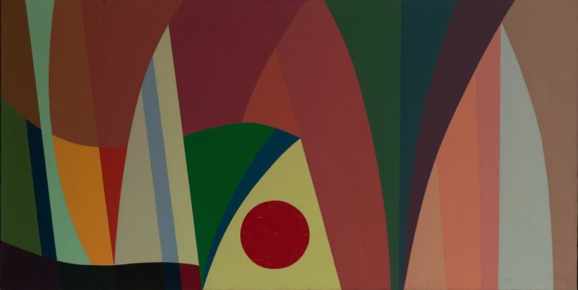
Figure 50.
Abstract Landscape / Untitled, 1955, Catalog #606
An amazing article entitled Teacher to Describe Nursery School Art was published in The Progress-Bulletin of Pomona, California, in the issue of Saturday Evening, January 8, 1955. It shows Benjamin painting exactly the Abstract Landscape with his daughter Beth also painting at an easel (Figs. 51). It announces that “Karl Stanley Benjamin, local artist, will speak on ‘Art as It Relates to Nursery School Children’ at a parents meeting of the Claremont Community Church nursery school next Tuesday at 8 p.m.”. The meeting was held in the Louise Roberts Room of the Guildhall. The speaker will answer to questions.
The article specified that Benjamin attended Northwestern University, Redlands University and the Claremont Graduate School. For the post three years, he “taught fifth grade at El Rancho School in Chino,” in the Southern California region, with Los Angeles to its west, and he taught in the elementary school in Bloomington for one year. His artistic career already showed considerable promise. He “held one-man shows at Redlands and Pasadena Art Museum and has been in group shows in Long Beach and the Los Angeles Art Association during the past year”. He had already won “two honorable mention at the Pasadena Museum and once at Chaffey Invitational Exhibit last year”. “He will have a show at the Carr Gallery in Pasadena in April”.
Thus, as the article underlines, he was already exhibiting alongside other Southern California artists. It is therefore reasonable to assume that, at this early date—before 1955—he had already become acquainted with at least some of those who would later form the group known as the “Four Abstract Classicists”.
The influence of a form of teaching that required such a high degree of personal commitment is no less remarkable. “There is always an easel set up in the Benjamin home for the benefit of his pre-school daughters and the youngsters in the neighborhood”. “A number of examples of work done by children in his classes are in the Los Angeles County Museum, and slides of these examples are used in courses at Claremont College”.
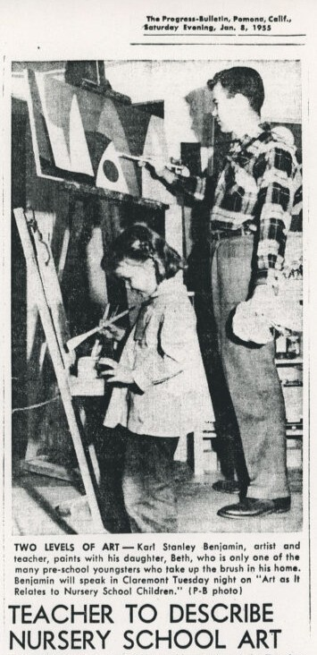
Figure 51.
Announcement in The Progress-Bulletin, Pomona, California, January 8, 1955, from Catalogue raisonné, Louis Stern Fine Art / Karl Benjamin.

Chapter 10. The 1955-1956 continuity
It would be easy to demonstrate that several 1955 paintings show forms that will be repeated in 1956. For instance, Elliptical Planes (1956) recalls by its very title the dominant form used in Critic (1955) (Figs. 52-53).
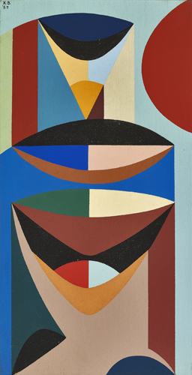  Figure 52.  Critic, 1955, oil on canvas, Catalog #327 | 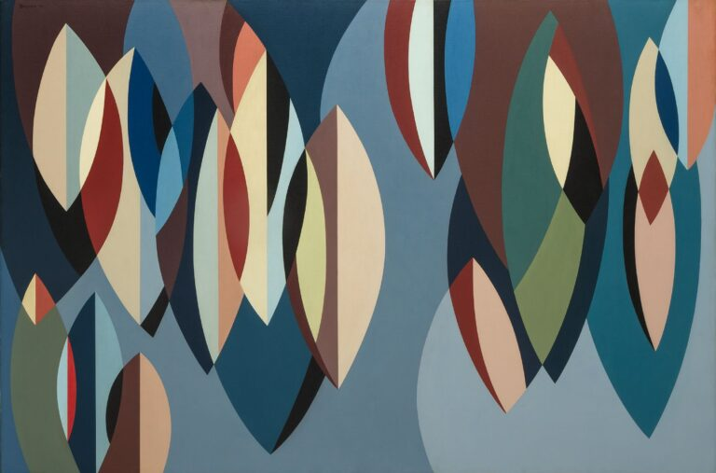  Figure 53.  Elliptical Planes, 1956, oil on canvas, Catalog #228
Similarly, Green, White, Black, Pink of 1956 recalls, through the white fork-shaped motif occupying the lower right square, the motif found on the left-hand side of the earlier Abstraction of 1955, now in the collection of the Santa Barbara Museum of Art thanks to a gift from the artist (Figs. 54–55).
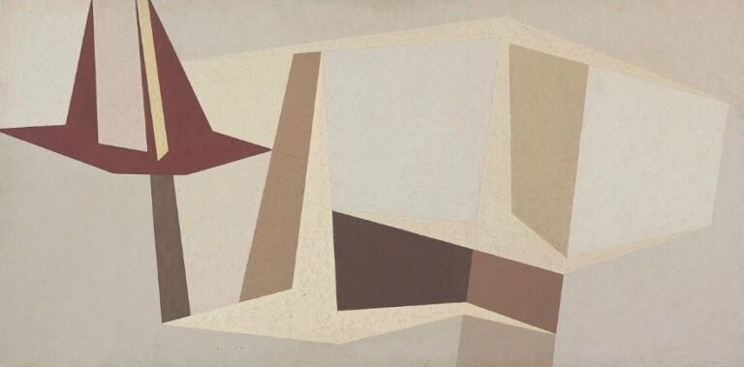  Figure 54.  Abstraction, 1955, Catalog #626 | 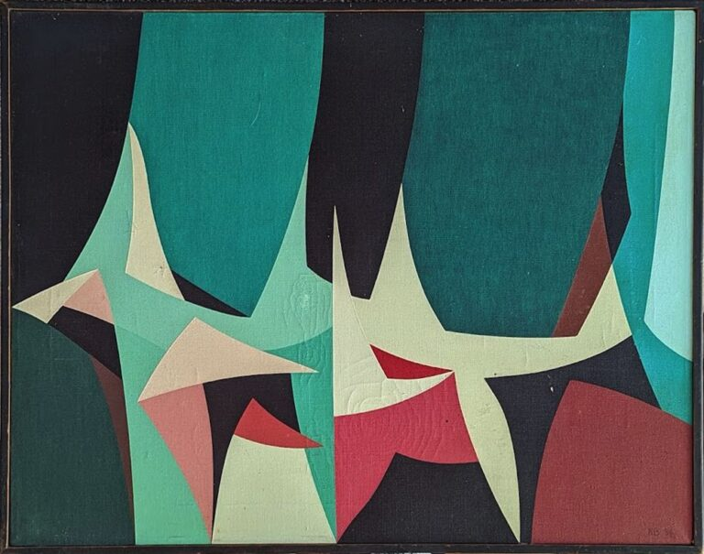  Figure 55.  Green, White, Black, Pink, 1956, Catalog #1042
To explore the variations of the swallow motif in the 1956 might become boring. Night Sky and Plant Forms deserve attention (Figs. 56–57). The curious orientation of Night Sky, signed lower right, with a moon over which material elements appear, with the swallow-like motifs, suggests that Benjamin intentionally incorporated one of the recurring forms of his personal vocabulary.

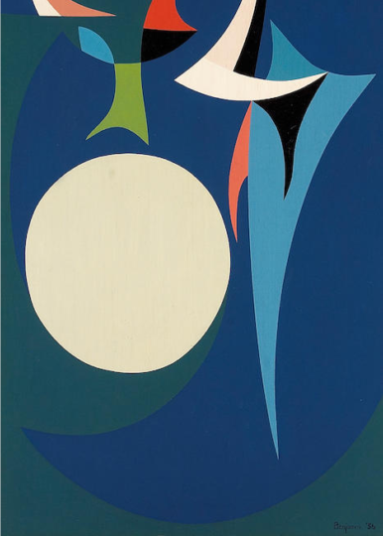  Figure 56.  Night Sky, 1956, Catalog #991 | 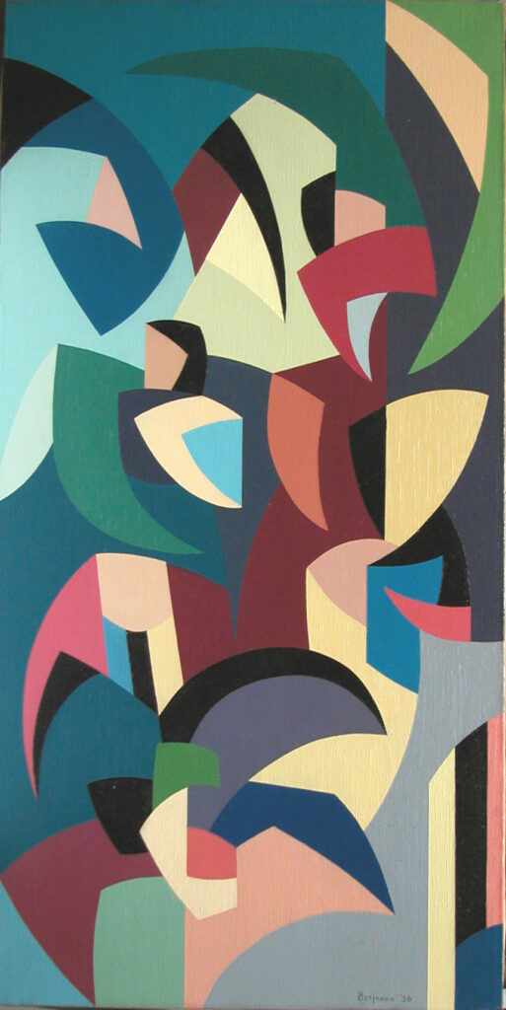  Figure 57.  Plant Forms, 1956, Catalog #139
Plant Forms (1956, Fig. 57) which multiplies the same motif in a wide range of forms and orientations, is reminiscent of the entirely open-ended exploration undertaken the previous year in Abstraction (1955).
Pursuing the same research, The New One and Untitled (Three Figures) form an evident group through their shared palette, dominated by white, pink, and beige tones, which contrasts with that of White Figure – Blue and Red, painted in the same year (Figs. 58-59). Untitled (Three Figures) synthesizes the combination of the swallow motif and the elliptical form.
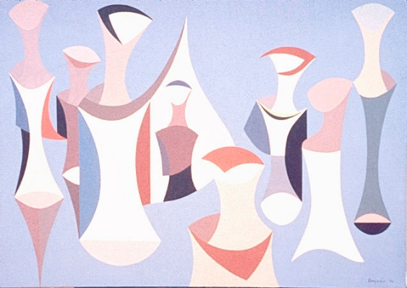  Figure 58.  The New One, 1956, Catalog #969 | 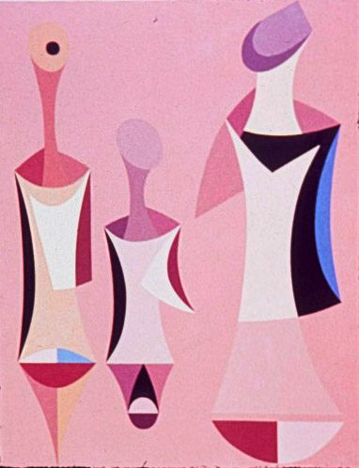  Figure 59.  Untitled (Three Figures), 1956, Catalog #1030

These closely related works had a different destiny. The New One is haused in the Buck Collection of the UC Irvine Jack and Shanaz Langston Institute and Museum (California), where it was shown at the exhibition UCI Institute and Museum for California Art, September 29, 2018 - January 5, 2019 (see also Appel 2018). Untitled (Three Figures) is in a private collection.
Does Sailboat bring the 1956 series to a close (Fig. 60)? The work recapitulates, across four continuous registers, the swallow motif transposed into a sailboat’s sails, the bracket-like form first introduced in Untitled (Growing Forms), and the delicate colors of the Figures. The figurative referent unfolds in an almost narrative manner, from one season to the next, under bright sunshine or clear skies. It is therefore fitting that the painting should serve as the opening illustration in S. Muchnick’s Fill Up the Space and Don’t Mess Around.
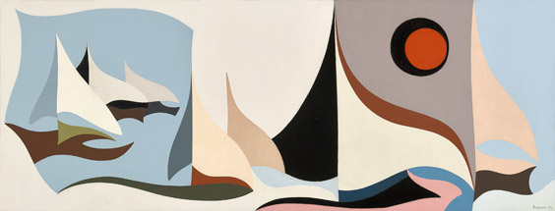
Figure 60.
Sailboat, 1956, Catalog #278

However, to conclude this chapter, two works dated precisely 1955–1956 perhaps marks more clearly the beginning of a crucial phase in Benjamin's artistic development: Dark and Light (Figs. 61-62).
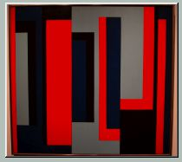  Figure 61.  Dark, 1955-1956, Catalog #1015 | 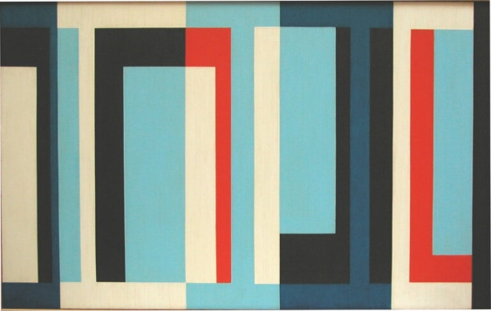  Figure 62.  Light, 1955-1956, Catalog #142
These works differ in format, measuring 24 × 26 inches and 20 × 32 inches respectively. Dark was acquired from the artist at an unknown date and subsequently sold to Marc Selwyn Fine Arts, Beverly Hills, California. As pure geometric abstractions, both paintings convey a strong sense of unity, homogeneity, and internal continuity extending from one edge of the canvas to the other. This effect results from the combination of two factors: first, the succession of rectangular and L-shaped forms sharing the same color; second, the inclusion of identical forms within larger rectangular structures. In Light, for example, one observes the inclusion of a light blue-and-white rectangle within a larger black-and-red rectangle, as well as the incorporation of the red and light-blue forms into a white rectangle on the right-hand
Chapter 10. Skipping from plane to plane (1957)
The word plane appears in titles as soon as 1955. Blue, Black & Pink Planes and Small Planes opened the way (Figs. 63-64). Quadrilateral forms are distributed across the pictorial field in a dispersed and disseminative manner. If colors – as the title indicates - are homogeneous in Blue, Black & Pink Planes, they are much more varied in Small Planes.
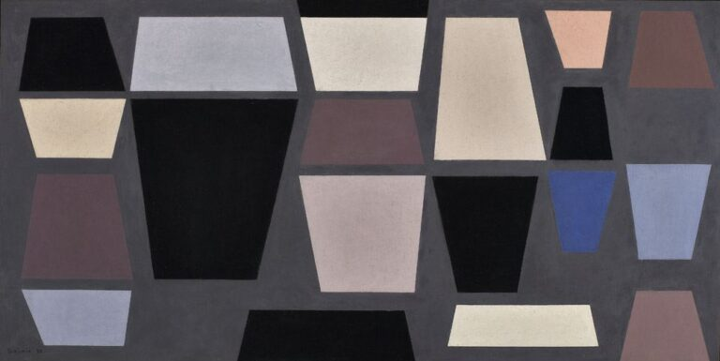  Fig. 63.  Blue, Black & Pink Planes, 1955, Catalog #561 | 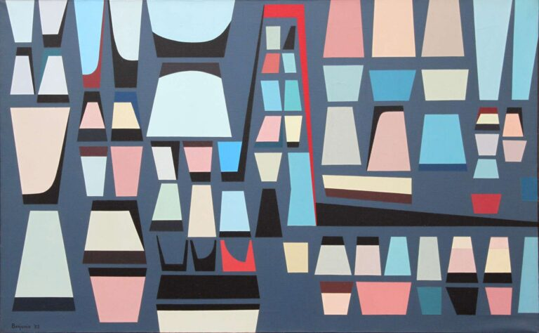  Figure 64.  Small Planes, 1955, Catalog #526

The half-dozen works of 1957 which were entitled Planes or which shared the same style may have appeared to capitalize on the favourable reception that Small Planes (1955) received from Jules Langsner in connection with Benjamin's 1956 exhibition at the Jack Carr Gallery in South Pasadena. But did this accumulated critical capital—or this emerging critical consensus—constitute, or even guarantee, a major avenue to recognition through which a young abstract painter could assert his artistic identity? And which change or what advance do this half-dozen works of 1957?
If chronology may constitute an element of classification, we could observe that Planes (Fig. 65), Planes, Grey & Pink (Fig. 66), Interlocking Horizontal Movements – Blue, Black, Pink (Fig. 67) and Grey Planes (Fig. 68) were shown at the exhibition Karl Benjamin organized at the Occidental College of Los Angeles from April 7 to May 4 1958. These works are assumed to precede other works with a similar name..
A comparative examination of the structure and color of these works should also inform their chronological classification, which is reproduced here in its entirety.
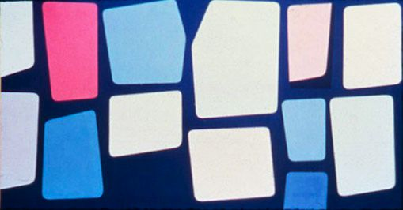  Figure 65.  Planes, 1957, Catalog #777 | 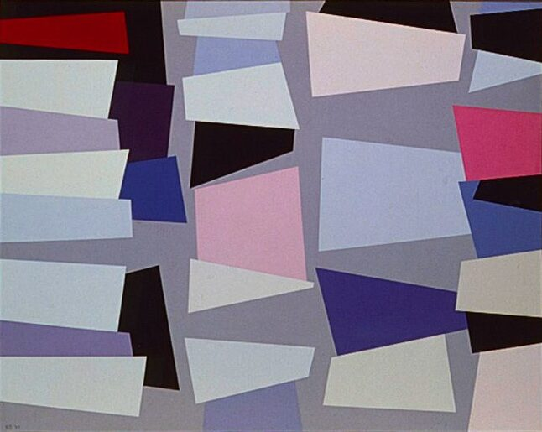  Figure 66.  Planes, Grey & Pink, 1957, Catalog #778
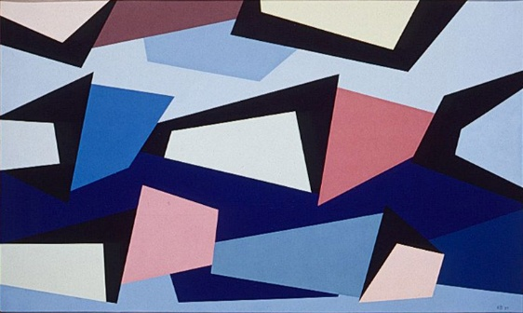  Figure 67.  Interlocking Horizontal Movements – Blue, Black, Pink, 1957, Catalog #939 | 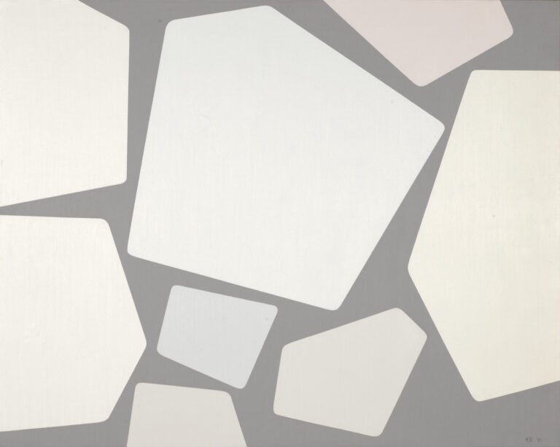  Figure 68.  Grey Planes, 1957, Catalog #143

These paintings are composed primarily of monochromatic quadrilateral forms arranged in a dispersed configuration. Grey Planes alone displays the distinctive combination of uncoloured pentagonal forms. David Pagel singles out this work - among those exhibited in 1959 at the Ruth Bachofner Gallery - for its more far-reaching avant-gardism. « The oddball among this odd constellation is ‘Grey Planes.’ Recalling faux stonework, this image forges an essential link between Benjamin’s art and the simplified shapes of Modernist design, whose streamlined stylishness embraces a similar sort of optimistic efficiency”.
Other works entitles Planes and which show a similar style were shown, after the exhibition at the Occidental College of Los Angeles in Spring 1958 at the exhibition Paintings by Karl Benjamin: Abstract Classicism held at the Long Beach Museum of Arts from December 7 1958 to January 4 1959. The catalogue of this exhibition, reproduced in Benjamin’s Catalogue raisonné, provides a list of the exhibited works together with their prices. It also reproduces Long Beach—albeit in reversed orientation—yet, curiously, omits the painting from the checklist. Since its provenance has not been traced, one may speculate that the painting was donated to the museum in appreciation of the exhibition (Fig. 69).
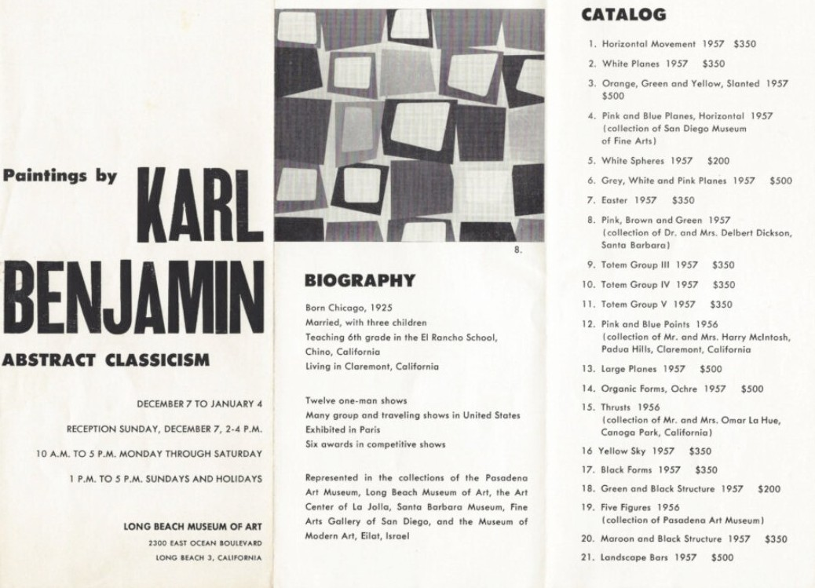
Figure 69.

We must consider these paintings with the previous ones to first compare their structure: Large Planes (Fig. 70), Long Beach (Fig. 71), Small Planes (Fig. 72) and Untitled (Fig. 73).
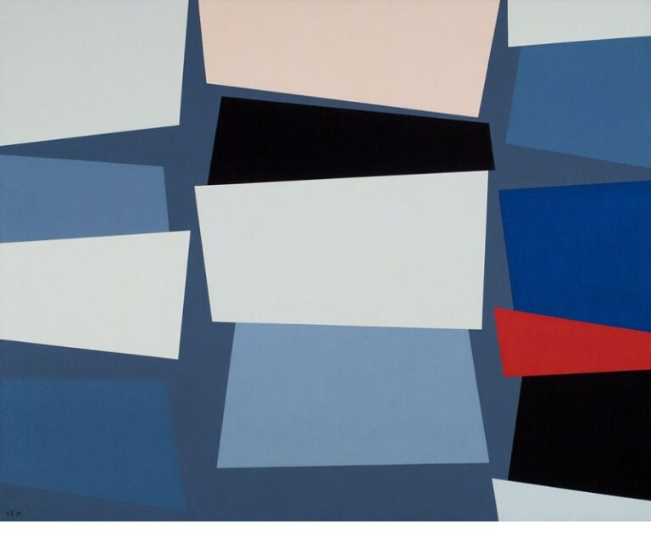Figure 70.  Large Planes, 1957, Catalog #650 | 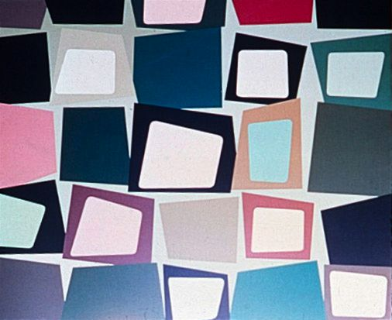  Figure 71.  Long Beach, 1957, Catalog #776
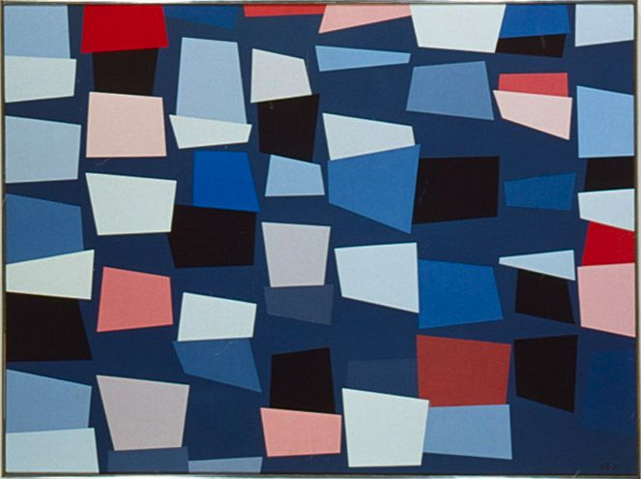  Figure 72.  Small Planes – Blue, Pink, White, 1957, Catalog #706 | 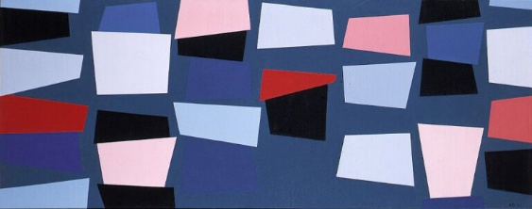  Figure 73.  Untitled, 1957, Catalog #620

The arrangement of the forms into the Planes series suggests that these forms are organized according to a dominant axis of orientation. This axis is vertical in Planes (Fig. 65), Planes, Grey & Pink (Fig. 66) - in the first series –and in Small Planes – Blue, Pink, White (Fig. 72). This vertical orientation is not associated with any particular chromatic range. Other works combine vertical and horizontal axes, such as Large Planes (Fig. 70) and Long Beach (Fig. 71-, the latter being distinguished by the inclusion of a quadrilateral within another form.
The catalogue of the Long Beach Museum of Art exhibition records two works whose titles include the word Horizontal. No. 4, Pink and Blue Planes, is said belonging to the “collection of the San Diego Museum of Fine Arts”, where is now the painting Untitled (Fig. 73). This work was acquired from the artist by William Paxton Cary, a native of San Diego, who served as Presiding Justice of California's Fourth District Court of Appeal. Untitled has clearly become one of the cornerstones of the San Diego Museum of Art's collection, as evidenced by the large number of group exhibitions in which it has been included between 2010 and 2025. These exhibitions have explored themes ranging from abstraction, modern art, Minimalism, and twentieth-century American art to music itself.
Thus, no. 1 of the catalogue of the Long Beach Museum of Art exhibition corresponds to Interlocking Horizontal Movements – Blue, Black, Pink of the Catalogue raisonné. This work is now in the Buck Collection at the UCI Jack and Shanaz Langston Institute and Museum of California Art at Irvine (Fig. 67). In this case, the title refers to the movement created by forms that nevertheless remain discontinuous, separated by black intervals. As the title itself indicates, these intervals are treated as forms equivalent to the blue and pink elements that constitute the sequence and stand out against what is, in effect, the background of the composition.
Although Untitled is closely related to Small Planes – Blue, Pink, White, their respective dimensions (20 × 50⅛ in. and 36 × 48 in.) do not make it possible to determine whether either work should be regarded as a reduced version or preliminary stage of the other. The tropology of the forms is so similar that distinguishing their variations would be a painstaking task. Computer-assisted analysis might well facilitate such a comparison. One can merely observe that a red triangle appears only in Untitled, whereas two blue triangles are unique to Small Planes – Blue, Pink, White. A rather meagre observation! Perhaps computational analysis would reveal much more.
Anyway, a common feature runs through most of the Planes paintings and directly foreshadows one of the defining characteristics of Hard-Edge painting: the forms now tend to create a continuous configuration extending from the upper edge of the canvas to the lower edge, or vice versa.
Chapter 11.
What connection can be established between Black Pillars (Fig. 74) and Yellow Sky (Fig. 77), both dated 1957, when their titles appear to bear no obvious relationship to one another?
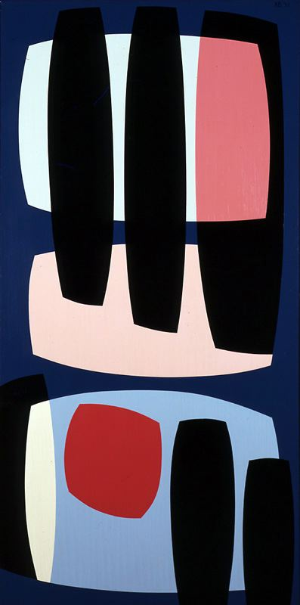  Figure 74.  Black Pillars, 1957, Catalog #8 | 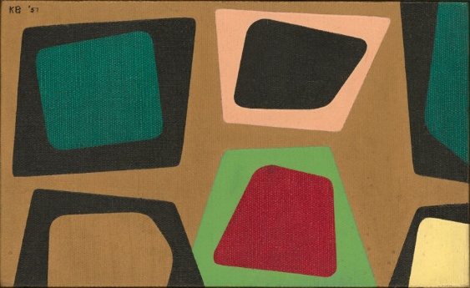  Figure 75.  Green and Gold, 1957, Catalog #656
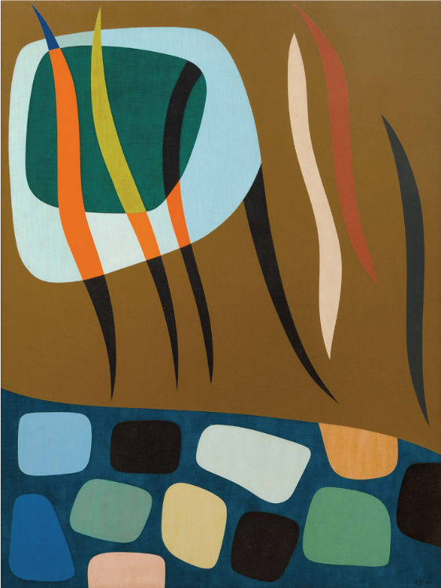  Figure 76.  Organic Forms, 1957, Catalog #721 | 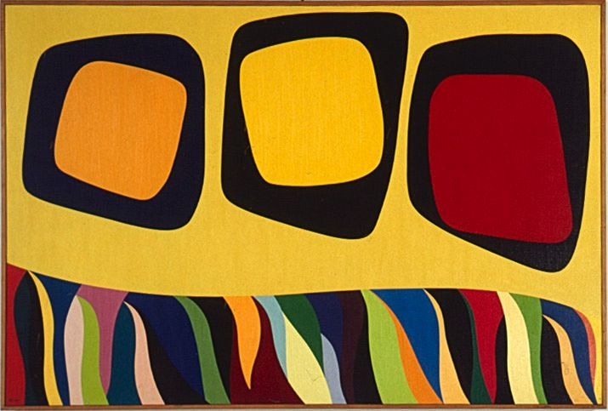  Figure 77.  Yellow Sky, 1977, Catalog #722

Black Pillars consists of three loosely defined quadrilateral forms, one of which itself contains, in addition to the massive black pillars, an irregular quadrilateral. Green and Gold (Fig. 75) likewise features quadrilateral forms enclosing a square, a trapezoid, and an irregular shape within larger quadrilaterals.
In Organic Forms (Fig. 56), the indeterminate shapes are confined to a lower zone, separated from an upper zone containing a pair of indeterminate forms and elongated flame-like figures. In Yellow Sky (Fig. 77), the paired indeterminate forms occupy the upper zone, while the flame-like figures are relegated to the lower one. The two works thus present a composition and its exact inversion.
The latter painting, which was notably included in the exhibition Paintings by Karl Benjamin: Abstract Classicism (7 December 1958–4 January 1959), therefore also marks the transition between 1958 and the year that represents the culmination of the present study.
Néanmoins, une série structurellement évolutive nous rapproche encore davantage de ce qui présentera Benjamin dans le catalogue Four Abstract Classicists – West Coast Hard Edge d’où on est parti. L’artiste cherche visiblement et de manière quasi abrupte un nouveau style en 1957. Chino Hills et Easter en témoignent (Figs. 78-79).
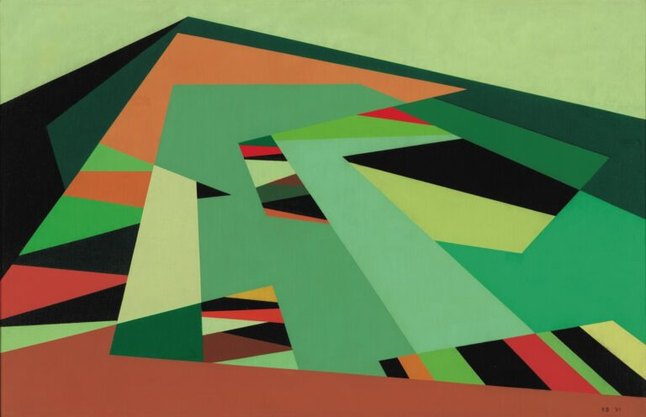  Figure 78.  Chino Hills, 1957, Catalog #7 | 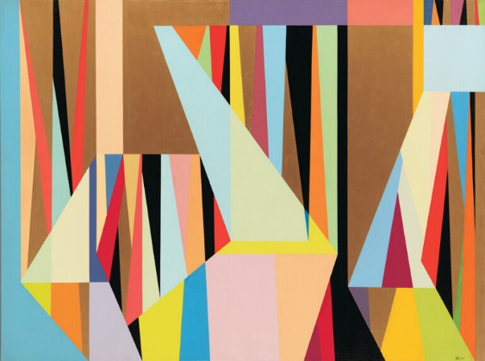  Figure 79.  Easter, 1957, Catalog #553
Although the triangular arrowhead-shaped forms remain highly prominent in Chino Hills, they are now integrated into a new formal system: parallel bands that create an effect of perspective. Four colors and their tonal variations—green, brown, cream, and black—animate the composition, producing a particularly vibrant and harmonious effect. It is easy to understand why the painting appealed to Hollis and Janet Allen, who acquired it directly from Benjamin in 1959.
At the time, Hollis P. Allen was ideally placed to appreciate Benjamin's work. Born in Pasadena in 1895, he began his education there before continuing as an undergraduate at Pomona College. In 1920, he joined the faculty of Pomona High School, and later earned both an M.A. in Education and an Ed.D. from Stanford. He was also an exceptionally discerning collector, capable of introducing Benjamin to broader artistic and educational ideals. This "Renaissance man" was himself a gifted artist “in furniture-making and photography”, as “a practical scientist in growing plants and inventing ingenious gadgets,” as “a seeker of truth in government and education”? etc. We do not, of course, know the nature of the relationship between the two men. Yet the opportunity to engage with someone who reflected on the representation of reality through photography, and to find in a botanist an interlocutor while professing to draw inspiration from plants for his painting, could hardly have failed to stimulate the artist's thinking.
Deux autres oeuvres déconstruisent de virtuelles bandes parallèles. Red, Yellow, Green (Fig. 79) y ajoute un morcellement de couleurs et rappelle un peu la configuration des Planes. Par contre, Untitled (Mondrian) ajoute à la multiplication des carrés de couleur, telle que la pratique Ellsworth Kelly de manière mécanique, des étirements de bas en haut qui dessinent des ensembles de fines bande parallèles rendant l’œuvre beaucoup dynamique. La référence à Mondrian indique la volonté d’atteindre un niveau supérieur d’abstraction géométrique.
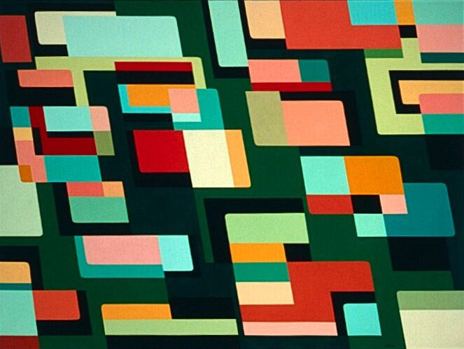  Figure 80.  Red, Yellow, Green, 1957, Catalog #705 | 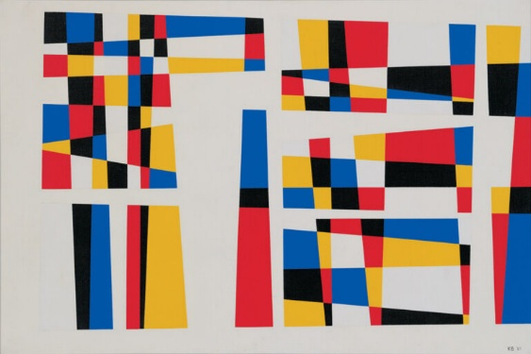  Figure 81.  Untitled (Mondrian), 1957, Catalog #2

It is, however, another group of works that, through the metamorphosis of a formal model Benjamin had been developing for many years, leads directly to the Abstract Classicism of 1959. As noted as early as Chapter 7 “Vertical Axis, Hard Angles” for 1954—if not even earlier— we highlight the “irregular zigzag line” running vertically through the canvas which plays a crucial role by “distributing areas of color differently to the left and right.” (Figs. 36-39). This vertical axis reappears in 1957 in Green Moon with Windows (Fig. 81) and Totem Group I (Fig. 82).
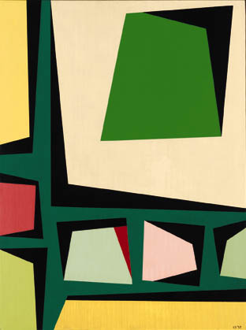  Figure 82.  Green Moon with Windows, 1957, Catalog #15 | 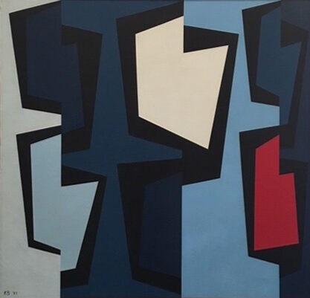  Figure 83.  Totem Group I, 1957, Catalog #1010

This structural principle is systematically developed throughout the Totem Group series, clearly anticipating the iconic painting reproduced in the West Coast Hard-Edge catalogue (Figs. 83–86).
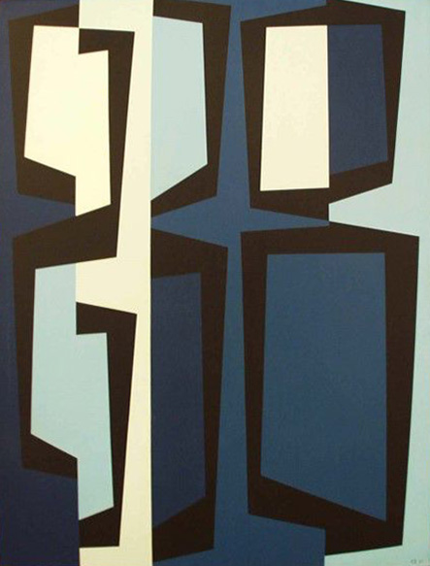  Figure 84.  Totem Group II, 1957, Catalog #664 | 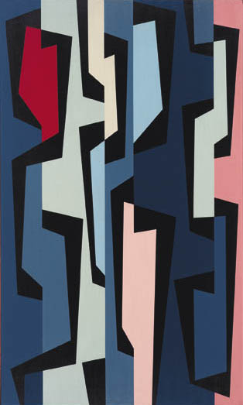  Figure 85.  Totem Group III, 1957, Catalog #17
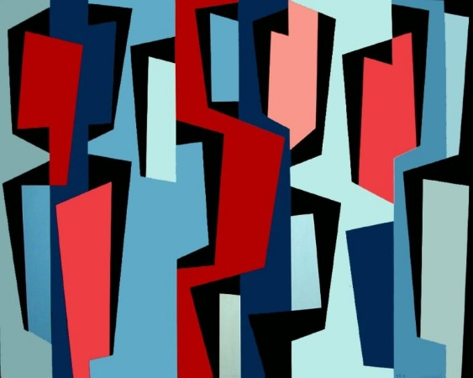  Figure 86.  Totem Group IV, 1957, Catalog #61 | 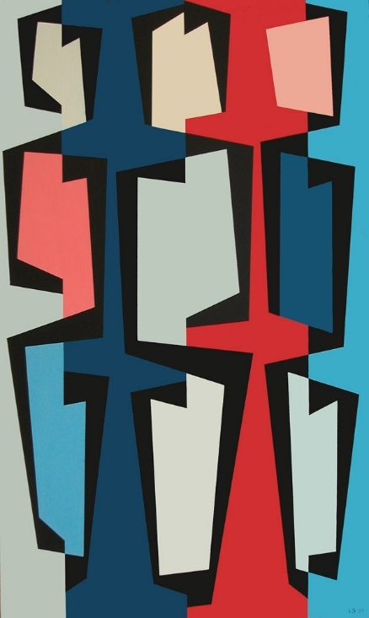  Figure 87.  Totem Group V, 1957, Catalog #63

Easter (1957), Red, Yellow Green (1957), Totem Group III (1957), Totem Group IV (1957) and Totem Groupe V (1957) were offered at the Long Beach, California, Long Beach Museum of Art, Paintings by Karl Benjamin: Abstract Classicism, December 7, 1958 – January 4, 1959. It is easy to understand why the Ruth Bachofner Gallery in Santa Monica acquired Totem Group II as soon as it was exhibited in the Karl Benjamin exhibition at Occidental College in Los Angeles in the spring of 1958, where it was shown alongside Totem Groups III, IV, and V. Seen together, these works revealed the coherent achievement of an original artist who was now establishing himself among the leading figures of post-war American abstraction. Benjamin's reputation was also spreading beyond California. Totem Group I was acquired by Edwin August Albert Grobe (1894–1963), a Texas collector. It is hardly surprising that Louis Stern Fine Arts should also have acquired Totem Group IV, now in the collection of the San José Museum of Art, as well as Totem Group V.
Conclusion. “Four Abstract Classicicists”: interpictoriality
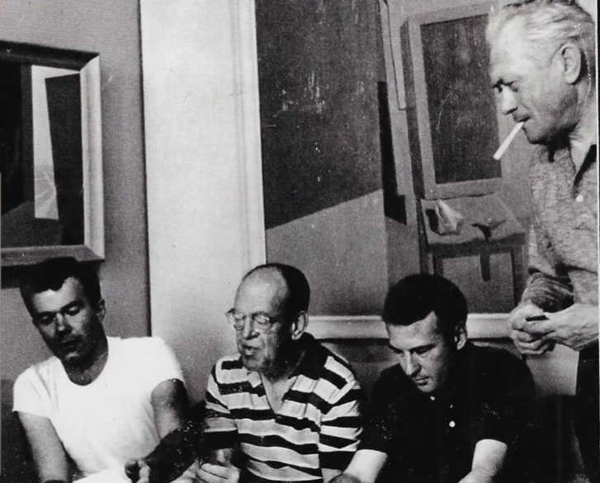
Figure 88.
From left to right : Karl Benjamin, John McLaughlin, Frederick Hammersley,Lorser Feitelson. Courtesy Louis Stern Fina Arts.
Michael Duncan, dealing with “Lorser Feitelson’s hard edge abstraction”, writes what follows (Duncan 2003, 17). “’Four Abstract Classicists’ – which traveled to London and Belfast- served as an introduction to four artists whose achievements – now– forty-six years later– need to be examine in depth. The varied approaches of these painters demonstrate the broad scope of ideas that can be evoked from the juxtapositions of simple shapes and lines”.
Duncan first mentions “McLaughlin’s austere approach to form and color”, which “resulted in bare-boned, Zen-like philosophical inquiries into dualities such as darkness and light, enclosure and exposure, symmetry and asymmetry, and elevation and decline”. Feitelson was “one of the most underrated figures of his era”, while “his career tracks a kind of mini-art historical survey, moving from Cubism to Post-Surrealism to biomorphic abstraction to hard-edged geometric abstraction to minimal line paintings”. Duncan appears to present the latter two “Abstract Classicists” as aesthetic opposites. “Hammersley’s quirky arrangements of shapes use visual puns and stark color contrasts to play formal games, while Benjamin employs intricate, interlocking arrangements of shapes and colors to flirt with patterning and visual illusion”.
The relationships among the works of these four artists are both suggested and obscured by the terms Duncan employs to characterize their art. Describing Hammersley's “formal games” as producing “eccentric arrangements” is clearly insufficient to distinguish his work from Benjamin's “interlocking arrangements of shapes,” even if Duncan is right to emphasize the distinctive role played in Benjamin's work by recurring “patterns,” whose emergence and development through successive stages of his artistic development we have attempted to trace.
Identifying the formal relationships among the “Four Abstract Classicists” would constitute a study in its own right, one that lies beyond the scope of the present investigation. Such an undertaking would require a detailed examination of Jules Langsner's seminal essay, conveniently reprinted in Birth of the Cool: California Art, Design, and Culture at Midcentury (2007), which reconstructs the remarkable cultural context in which West Coast Hard-Edge painting emerged. Here, it will suffice to point out a few instances of interpictoriality highlighted by the preceding analysis, while briefly introducing the other artists who made up the West Coast Hard-Edge movement.
Duncan first mentions John McLaughlin among them. For Peter Plagens, in the excellent volume Sushine Muse. Contemporary Art on the West Coast (1974), McLaughlin was “the mainstay of the exhibition, in 1959 – even if “Feitelson remained the senior statesman for all modernism”, in Southern California at this time (Plagens, 1973, 117). Both came from East Coast and, moreover, were exactly the same age (even if, on the famous photo of the group, Mc Laughlin seems older than Feltelson).
Feitelson deserved priority. Born in 1898 in Savannah, he was the son of a Georgian art teacher and he had the opportunity to visit the celebrated Armory Show, that is to say the International Exhibition of Modern Art which took place in New York between February and March 1913—the first of its kind in the United States. The exhibition, which travelled to Chicago and Boston, was seen by approximately 250,000 visitors. Thus, when Feitelson settled in Los Angeles in 1927, he naturally emerged as one of the pioneers of the avant-garde, together with his student—and later his wife—Helen Lundeberg, herself an accomplished artist. As Plagens also writes, “prewar Southern California produced little important art, and the main gain was the hard-won beginning of modern art's cultural acceptance.” Helen Lundeberg, born in Chicago in 1908, soon became a Californian, as she moved with her family to Pasadena, where she studied at Pasadena City College.
When Feitelson first came to Los Angeles, Henry T. Hophins recalls, “he taught privately to make ends meet and among his students were such luminaries as Edward G. Robinson, Mrs. Adolph Menjou and Producer David Loew”. “He later taught at Chouinard Art Institute, The Stickney Memorial School in Pasadena and finally at Art Center School of Design where he became a permanent fixture: instilling a love of art in the hearts of thousands of students” (Hopkins 2013, 13). The personal successive changes in artistic direction noted by Duncan must have puzzled or unsettled his students. Before the Second World War, Feitelson was deeply rooted in Surrealism, as shown by paintings such as Genesis #2 (1934), Flight over New York at Twilight (1936), and Post-Surreal Configuration, Eternal Recurrence (1939–40). The war, however, must have profoundly altered his relationship to the world, since as early as 1944 he turned towards abstraction, as evidenced by Tree Form (1944), reproduced in the catalogue of the exhibition Lorser Feitelson and the Invention of Hard Edge Painting, 1945–1965, organized by Louis Stern Fine Arts in 2003. In 1945, he began his series of Magical Forms. Plagens summarizes the artistic evolution of the couple Feitelson-Lundeberg in these terms. After they “precipitated a group of Postsurrealists (Surrealism plus geometric stylization)”, Feitelson “later moved on to a pure geometric abstraction—the Magical Space Forms of the forties,” and became “the leading spokesman for the Functionists West,” “an alignment of abstract painters”, while Lundeberg remained more closely associated with a Surrealist sensibility.
One of its earliest examples of Feitelson’s turning towards abstraction already anticipates features that would later become characteristic of Benjamin's work (Fig. 89). It combines irregular forms, such as the red shape in the upper left corner and the mauve quadrilateral, with arrowhead forms, including the green point at the center of the canvas and the black point cut into the large “red shield-shaped form” on the right.
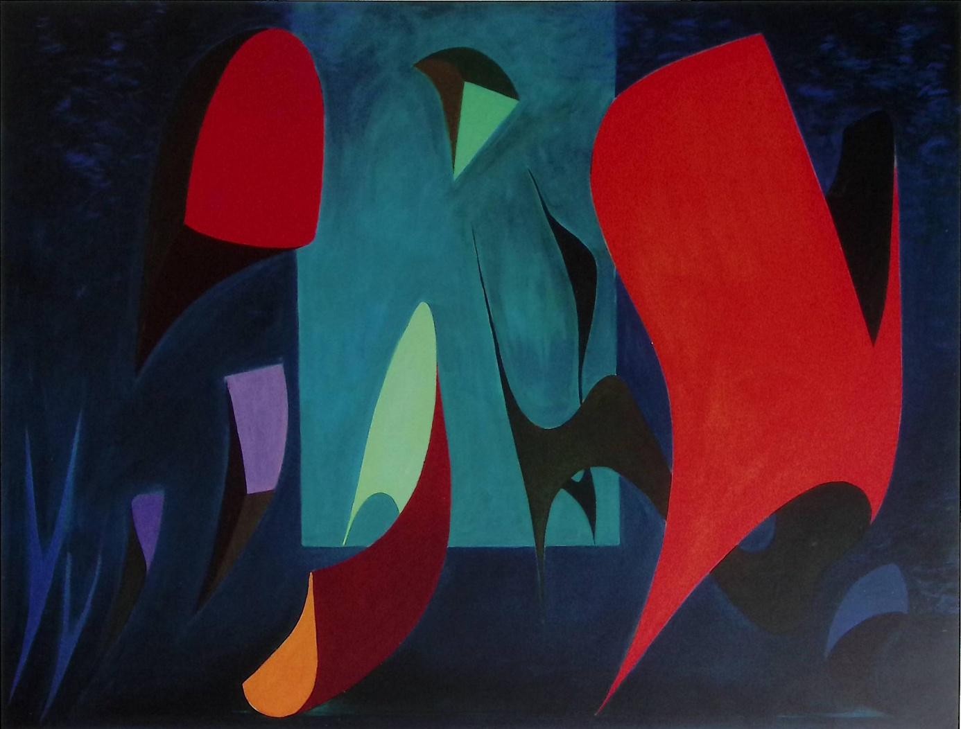
Figure 89.
Lorser Feitelson, Magical Forms 1, 1945, from Feitelson 2003, 26-27.
Courtesy Louis Stern Fine Arts.
“Mainstay” of the 1959 “West Coast Hard-Edge” exhibition, John Mc Laughlin, also born in 1898, owed to his parents an artistic interest in Asian art which led him and his wife, Florence Emerson, to settle in Japan in 1935 and to open, shortly thereafter in Boston, a gallery in Asian art, The Tokaido. McLaughlin was already painting at that time, despite having received no formal artistic training. It was only in 1946 that he settled in California to devote himself to painting full-time, thereby becoming another important point of reference for Benjamin.
Plagens thinks that McLaughlin– “an unobtrusively powerful painter” – produced a work that is “difficult to specify”. This body of work grew out of the assimilation and eventual rejection of a diverse range of experimental approaches, as Susan C. Larsen has shown. « During the late 1940s when McLaughlin settled in California, his work was quietly competent and informed, but owed a heavy debt to biomorphic Cubism, Constructivism, and Neoplasticism, styles which had long been explored in New York painting of the late 1930s”. But a radical change occurred during the 1950s—one that Benjamin must have witnessed—when “McLaughlin began to restrict himself to clearly defined rectangles, circles, and squares, coming to a severe, hard-edge format with a highly personal syntax by 1959” (Larsen 1977, 71).
In fact, the exhibition of Benjamin's earliest works at his 1956 Karl Benjamin exhibition at the Jack Carr Gallery in South Pasadena prompted an article by Jules Langsner in the Los Angeles Art News, in which Benjamin's "tidy abstractions" were compared with those of McLaughlin, although the latter and his work were considered "less anonymous." Langsner nevertheless recognized in both artists what he described as "the same adherence to sharp, clean edges, forms closer to conceptual than observable space, and a similar concern with the interlocking advance and recession of form and color." Many years later, reviewing Benjamin's early paintings exhibited at the Ruth Bachofner Gallery, David Pagel again identified the shared characteristics that link Benjamin to McLaughlin's brand of hard-edge painting: "crisp contours, weird tertiary colors and meticulously finished surfaces."
Whereas Duncan saw in McLaughlin's work a search—if not for harmony, at least for a satisfactory resolution—of "dualities such as darkness and light, enclosure and exposure, symmetry and asymmetry, and elevation and decline," Susan Larsen instead emphasizes the sense of movement and disequilibrium generated by these dualities, which become elements of tension and conflict. Eastern culture and philosophy provide a measure of serenity through a meditative attraction to emptiness, elevated to the status of a central, intermediary element between two parallel bars.
Much has been written about the relationship between McLaughlin's work and the Japanese concept of ma—the "void," or interval, that gives meaning to what it separates (Duncan 2016). As the eye moves across the canvas, it establishes a spatial and temporal tension between the forms while simultaneously expanding the intervals that separate them, whereas the geometric abstraction derived from Mondrian—for example, that of Ellsworth Kelly or Josef Albers—tends to contain and enclose the viewer within the boundaries of the composition. In McLaughlin's paintings, by contrast, the viewer becomes a dreamer, a solitary wanderer. It is precisely this distinctive quality that McLaughlin had in mind when he observed, about Oriental paintings: "It could get into the pictures and they made me wonder who I was. Western painters on the other hand, tried to tell me wonder who I was” (Plagens 1974, 118).
Kelly's work draws the viewer into a labyrinth of small cells where attention and visual pleasure gradually wear themselves out. Albers, by contrast, mechanically confines the viewer within a repetitive succession of square prisons from which there is no escape. If Albers is the artist of the concentrationary universe, Kelly is the ogre of the maze—a maze in which children are cheerfully imprisoned, as his regrettable Up, Down & Other Opposites (2025) makes all too clear.
McLaughlin's paintings, by contrast, are, as Larsen shows, "engaginely awkward, seemingly incapable of the noble harmonies of Neo-Plasticism." "McLaughlin’s clearly articulated forms, plain edges, and straightforward, even pedestrian, surfaces can create impenetrable wall. He does not charm us with ibrating, broken passages of paint or tighten the skin of his canvas so that it is shining, taut, with razor-sharp edges”. This "primitive modern abstractionist," "profoundly anti-classical," strives instead to generate "disequilibrium and virtually subliminal, visual and psychological motion out of stasis and symmetry,” drawing us "into the trap of a visual experience that exhausts perception and undermines our ability to arrive at a stable and harmonious resolution." He is the Dostoevsky of formal abstraction.
It may also be assumed that one of Benjamin's paintings of 1955 was influenced by McLaughlin and by what Peter Plagens describes as his "bare-boned" style, exemplifying an "austere approach to form and color." The painting entitled Horizon reduces the composition, in a remarkably economical manner, to a single blue bar (Fig. 90). We were unable to consult the following two letters preserved in the John McLaughlin Papers at the Archives of American Art, Smithsonian Institution: “Letter to McLaughlin from Karl Benjamin, 29 August 1957 (one typed page), containing an invitation to participate in the Four Abstract Classicists exhibition”; and “Draft of letter to Karl Benjamin from McLaughlin, 31 August 1957 (one handwritten page). Verso: Chinese characters for Zen and doodles”.
Yet the same process of reduction also characterizes the work of the fourth of the "Abstract Classicists," Frederick Hammersley. An iconic painting such as Hammersley’s Sugar Free (1966), compared with Benjamin’s Horizon (1955), clearly could not have influenced the latter during his formative years. Nevertheless, it is difficult not to look for qualities that correspond to Benjamin's own concerns in the magnificent volume Frederick Hammersley: Art Santa Fe Presents, published by the Museum of New Mexico Press in 2009?
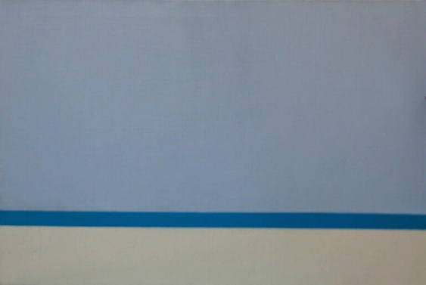  Figure 90.  John McLaughlin, Horizon, 1955, Catalog #242 | 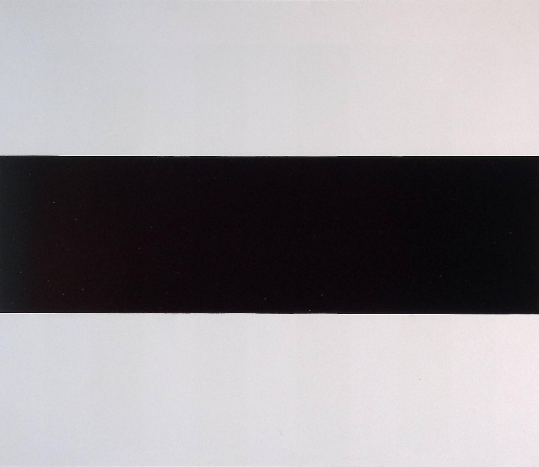  Figure 91  Frederick Hammersley, Sugar Free, #7, 1966, in: Hammersley 2009, 89.
Frederick Hammersley is also « a Westerner by birth”, born in 1919, much older than Benjamin born in 1925 (Van Deren 1977, 64). But as soon as 1946-1949, he “studied one year at Chouinard Art School”, in Los Angeles, “and two years at Jepson Art School”, recently founded by the artist Herbert Jepson, who had taught at the Chouinard Art School. As a result, from 1945 to 1954 the Jepson Art School became a center for experimental art and aesthetic inquiry. The school was located in the Westlake district of central Los Angeles, a neighborhood with a substantial Jewish and Latino population.
Van Deren helpfully recalls his beginnings. “While at Jepson he did some teaching with Rico Lebrun”, an Italian artist specializing in animal subjects (which led to his being recruited by Walt Disney). “The experience of talking to students caused him to think of various ways to break out of the somewhat academic training he himself had undergone”. The connection with Benjamin's attempt to reinvent the artistic education of his very young pupils—and with the insights he himself gained in the process—is remarkable. “One path was suggested to Hammersley by a design experiment he had undertaken in which he used a structure of 16 squares within a square working with a color series. This problem was absorbing enough to engage his attention for a year and a half using variations of black and white squares printed as lithographs. One of the last still life composition he did while at Jepson was in four colors-red, yellow, black and white. From this an abstraction was drawn, then 14 colors variations were tried using the same four colors”.
We shall leave for another occasion a discussion of how Hammersley moved beyond what might otherwise have led to the tedious and monotonous proliferation of Kelly-like compositions. It will suffice to recall that, like Feitelson and McLaughlin, Hammersley was also deeply committed to teaching. He later “taught at Pomona College for nine years before joining the faculty of the University of New Mexico on 1968”. He remained in Alburquerque, devoting after 1971 “all of his time and energies to painting,” and died in 2009, aged ninety.
Does one find the same commitment to the "uniform flat colors," as Langsner described them, in the work of Benjamin and Hammersley? As we have seen, Benjamin was already striving for such uniformity in 1953 in Brown, Pink and Yellow and Architectural Theme (Figs. 19–20). By 1955 he had fully achieved it, for example in an Untitled painting that shares with Hammersley's Face (1955) clearly defined, though distinct, geometric forms arranged in more or less interlocking configurations within a characteristically Hard-Edge composition (Figs. 92–93).
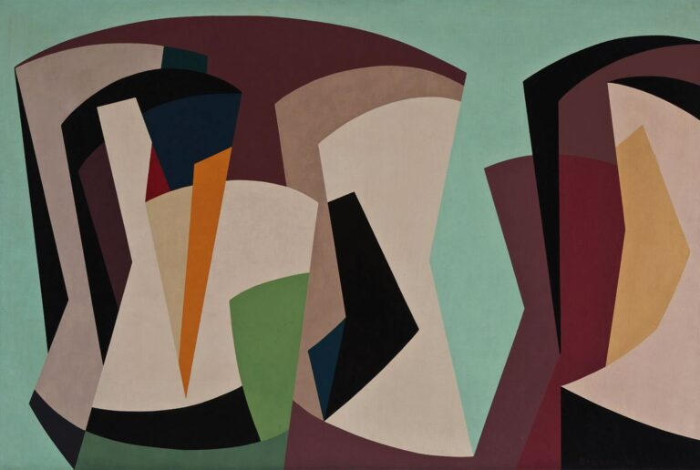  Figure 92.  Karl Benjamin, Untitled, 1955, Catalog #597 | 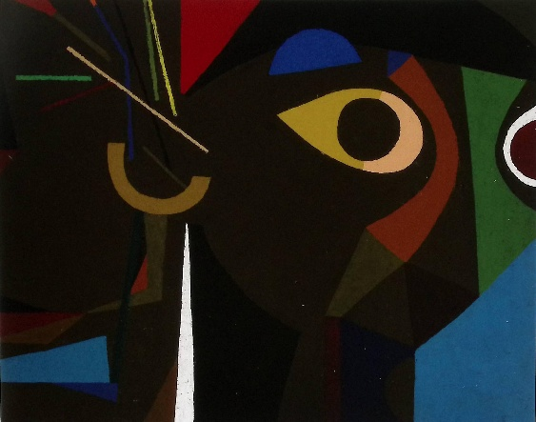  Figure 93.  Frederick Hammersley, Face, 1955, in : Hammersley 2009, 31.
A computational analysis might well identify the formal correspondences between Hammersley's remarkable 1948 series of pre-Hard-Edge geometric abstractions—each identified solely by its colors (Hammersley 2003, pp. 13–17)—and Benjamin's 1956 paintings, such as Green, White, Black, Pink (Figs. 94–95).
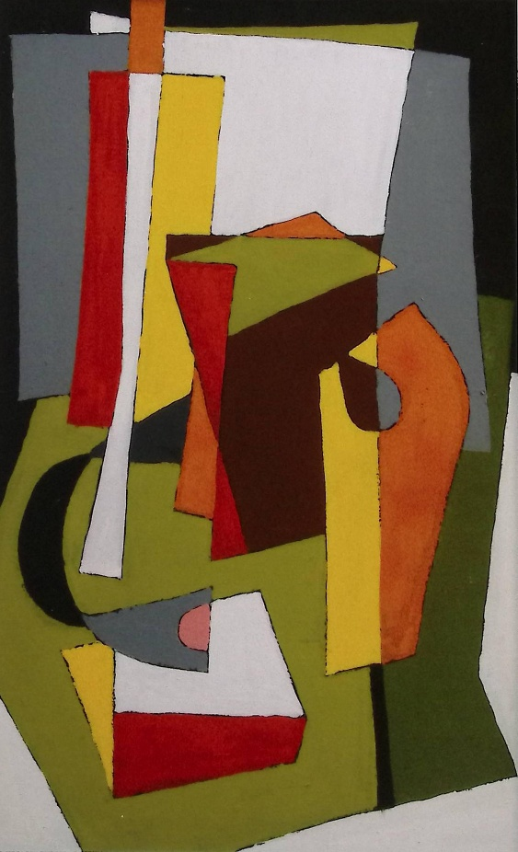  Figure 94.  Frederick Hammersley, First Trial, Red, Yellow, Black & White, 1948, in: Hammersley 2009, 14. | Figure 95.  Karl Benjamin, Green, White, Black, Pink, 1956, Catalog #1042.
What is beyond doubt is that Hammersley’s Notebooks, 1960–1987 themselves perfectly to comparison with Karl Georg Pfahler's notebooks of Präkonzeptionen (Pfahler 1975, 1984).
Bibliography
Appel 2018 | Appel, Kevin, et al. First Glimpse: Introducing the Buck Collection at the UCI Institute and Museum for California Art. Irvine: UCI Institute and Museum of California Art, 2018.
Crone & Moos 1991 | Crone, Rainer and Moos, David, Kazimir Malevich: The Climax of Disclosure, Munich: Prestel-Verlag, 1991.
Droixhe 2022 | Droixhe, Daniel, “Gustave Charlier, Georges Duhamel, André Maurois, Jules Romains et l’Amérique (1920-1940) », Bulletin de l’Académie Royale de Langue et de Littérature Françaises, 2022. https ://hdl.handle.net/2268/293761
Droixhe 2025 | Droixhe, Daniel, “All aboard ! En train aux U.S.A. avec Georges Duhamel, Luc Durtain et des écrivains contemporains (1928-1939) », Les Cahiers de l’Abbaye de Créteil, 43, 2025, 80-102. https ://hdl.handle.net/2268/329335
Duncan 2003 | Ducan, Michael, « Lorser Feitelson’s hard edge abstraction”, in: Feitelson 2003, 17-23.
Duncan 2016 | Duncan, Michael in : Larsen & Selz 1996.
Feitelson 2003 | Lorser Feitelson and the Invention of Hard Edge Painting 1945-1965. May 15 – July 12, 2003, West Hollywood: Louis Stern Fine Arts, 2013.
Hopkins 2013 | Hopkins Henry T., “Lorser Feitelson: an appreciation”, in: Feitelson 2003, 13-14.
Humblet 2007 | Humblet, Claudine, The New American Abstraction 1950-1970, Milan: Skira, 2007.
Kelly 1992 | Ellsworth Kelly. Die Jahre in Frankreich 1948-1954. Westfälische Landesmuseum für Künst unad Kulturgeschichte Münster, Landschaftsverband Westfalen-Lippe 14. Juni – 23. August 1992, München: Prestel, 1992.
Larsen 1977 | Larsen, Susan C., “John McLaughlin”, Los Angeles Hard-Edge: The Fifties and the Seventies, in: Stephanie Barron (ed.), California: 5 Footnotes to Modern Art History, foreword by Maurice Tuchman, Los Angeles: Contemporary Art Galleries, Lytton Halls, Frances and Armand Hammer Wing, Los Angeles County Museum of Art, 1977, 70-73.
Larsen & Felz 1996 | Larsen, Susan & Selz, Peter (eds.), John McLaughlin: Western Modernism, Eastern Thought, Laguna Beach : Laguna Art Museum, 1996.
Liu, Dong, Xiaopeng, Zhang 2016 | Orientation judgment for abstract paintings, Multimed Tools Appl, New York: Springer Science+Business Media, 2016.
Mather 2012 | Mather, George, “Aesthetic judgment of orientation in modern art”, i-Perception, 3, 2012, 18-24
McCallum 1977 | McCallum, Donald F., “The John McLaughlin papers in the Archives of American Art”, Los Angeles Hard-Edge: The Fifties and the Seventies, in: Stephanie Barron (ed.), California: 5 Footnotes to Modern Art History, foreword by Maurice Tuchman, Los Angeles: Contemporary Art Galleries, Lytton Halls, Frances and Armand Hammer Wing, Los Angeles County Museum of Art, 1977, 82-93.
Pfahler 1975 | G. K. Pfahler. Werkverzeichnis der Druckgrafik 1960-75, Karlsruhe: Edition Rottloff, 1975.
Pfahler 1984 | G. K. Pfahler. Präkonzeptionen, ed. Jo Enzweller and Sigurd Rompza, Berlin: Frölich & Kaufmann / Saarbrücken: Galerie St. Johann, 1984.
Plagens 1974 | Plagens, Peter, Sunshine Muse. Contemporary Art on the West Coast, New York: Praeger Publishers, 1974.
Schipper 1977 | Schipper, Merle, “Karl Benjamin”, Los Angeles Hard-Edge: The Fifties and the Seventies, in: Stephanie Barron (ed.), California: 5 Footnotes to Modern Art History, foreword by Maurice Tuchman, Los Angeles: Contemporary Art Galleries, Lytton Halls, Frances and Armand Hammer Wing, Los Angeles County Museum of Art, 1977, 52-57.

.
.

info@louissternfinearts.com
Los Angeles : Louis Stern Fine Arts, 2011.
Uploaded on April 2, 2025: https://archive.org/details/louis-stern-fine-arts-karl-benjamin-dance-the-line_202504

