Contribution to the study of the role of the E3 Ubiquitin Ligase TRIM28 (KAP1) in the Innate Immune Response Against RNA Viruses

Ruihua XIN

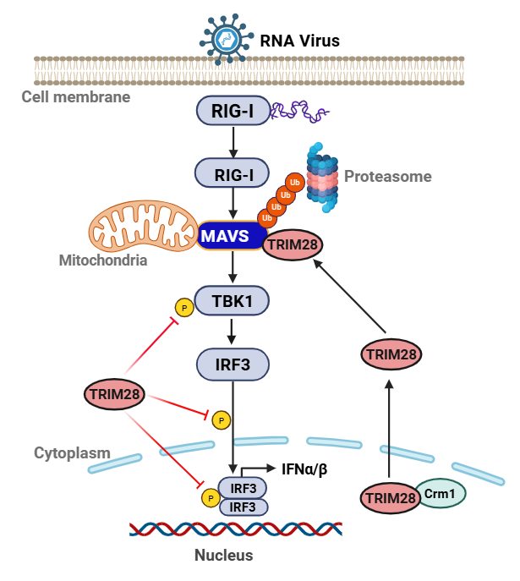
Promoteurs: Mutien Garigliany & Magali Deleu
Co-Promoteur: Jianxi Li

2026

COMMUNAUTÉ FRANÇAISE DE BELGIQUE
UNIVERSITÉ DE LIÈGE – GEMBLOUX AGRO-BIO TECH

Contribution to the study of the role of the E3 Ubiquitin Ligase TRIM28 (KAP1) in the Innate Immune Response Against RNA Viruses

Ruihua Xin

Dissertation originale présentée (ou essai présenté) en vue de l' obtention du grade de doctorat en sciences agronomiques et ingénierie biologique

Promoteurs: Mutien Garigliany & Magali Deleu
Co-Promoteur: Jianxi Li
Année civile 2026

© Ruihua Xin,April 3, 2026
Toute reproduction du présent document, par quelque procédé que ce soit, ne peutêtre réalisée qu'avec l'autorisation de l'auteur et de l'autorité académique de l' Université de Liège - Faculté Gembloux Agro-Bio Tech. Le présent document n'engage que son auteur

Abstract
Tripartite motif-containing protein 28 (TRIM28), also known as Krüppel-associated box (KRAB)-associated protein 1 (KAP1), is a multifunctional regulator that integrates epigenetic silencing with post-translational modifications (PTMs), including SUMOylation and ubiquitination. Initially identified as a transcriptional corepressor that maintains heterochromatin through SETDB1- and HP1-associated complexes, TRIM28/KAP1 has more recently been implicated in viral infection and host innate immunity. Accumulating evidence indicates that TRIM28/KAP1 exerts context-dependent effects during viral infection, functioning either as a restriction factor or as a facilitator of viral replication depending on the cellular and viral context. The RIG-I-like receptor (RLR) signaling pathway, a central axis of antiviral innate immunity against RNA viruses, relies on mitochondrial antiviral signaling protein (MAVS) to transmit signals leading to interferon production and is tightly regulated by ubiquitination. However, the specific target of TRIM28 within the RLR signaling pathway and its functional relevance during RNA virus infection in vivo remain unclear. Therefore, this thesis aims to elucidate the role of TRIM28 in RNA virus-induced antiviral innate immunity, with a focus on its regulation of the RIG-I–MAVS axis.
In the first part of this study, we characterized the functional role of TRIM28 in RNA virus-induced antiviral responses. TRIM28 expression was dynamically upregulated following RNA virus infection. Functional analyses showed that TRIM28 acts as a negative regulator of antiviral immunity: its overexpression suppressed type I interferon production and interferon-stimulated gene expression, whereas its knockdown enhanced these responses. Consistent with this role, TRIM28 promoted the replication of RNA viruses, including vesicular stomatitis virus (VSV) and enterovirus 71 (EV-71). In vivo, lung-specific knockdown of TRIM28 further demonstrated that TRIM28 deficiency enhanced antiviral responses, reduced viral burden, and alleviated virus-induced pulmonary pathology, supporting its role in promoting viral pathogenicity.
At the mechanistic level, we investigated how TRIM28 modulates antiviral signaling pathways. TRIM28 suppressed TBK1 and IRF3 activation, leading to reduced IRF3 nuclear translocation and attenuation of downstream interferon responses. Further analyses identified MAVS as the key signaling node targeted by TRIM28, and TRIM28 specifically interacted with MAVS. RNA virus infection induced CRM1-dependent nuclear export of TRIM28, allowing its accumulation in the cytoplasm and facilitating its interaction with MAVS. TRIM28 then promoted RBCC domain-dependent K48-linked polyubiquitination of MAVS, leading to its proteasomal degradation and suppression of downstream TBK1-IRF3 signaling. Mutational analyses further identified Lys136 and Lys461 of MAVS as critical sites required for TRIM28-mediated ubiquitination.
In summary, this study identifies TRIM28 as a negative regulator of type I interferon responses during RNA virus infection. Mechanistically, TRIM28 undergoes CRM1-dependent nuclear export and targets MAVS for RBCC domain-dependent K48-linked ubiquitination and degradation, thereby attenuating downstream antiviral signaling. Lys136 and Lys461 on MAVS are further identified as key sites required for this regulation. These findings establish MAVS as a direct substrate of TRIM28 and provide new insight into how ubiquitin-dependent mechanisms fine-tune antiviral innate immunity.

Keywords: TRIM28/KAP1, innate immunity, RNA virus infection, MAVS, ubiquitination, RIG-I signaling, nucleocytoplasmic trafficking, virus-host interaction
.

Résumé
La « protéine contenant un motif tripartite 28 » (TRIM28), également connue sous le nom de « protéine associée au domaine Krüppel-associated box (KRAB) 1 » (KAP1), est un régulateur multifonctionnel qui est impliqué dans le silencing épigénétique et diverses modifications post-traductionnelles, notamment la SUMOylation et l’ubiquitination. Initialement identifiée comme un corépresseur transcriptionnel impliqué dans le maintien de l’hétérochromatine via des complexes associés à SETDB1 et HP1, TRIM28/KAP1 a récemment été impliquée dans la réonse à l’infection virale et l’immunité innée de l’hôte. Des données croissantes indiquent que TRIM28/KAP1 exerce des effets dépendants du contexte au cours de l’infection virale, agissant soit comme facteur restrictif, soit comme facilitateur de la réplication virale selon le contexte cellulaire et viral. La voie de signalisation des récepteurs de type RIG-I (RLR), axe central de l’immunité innée antivirale contre les virus à ARN, repose sur la protéine adaptatrice mitochondriale MAVS pour transmettre les signaux conduisant à la production d’interférons et est étroitement régulée par l’ubiquitination. Cependant, la cible spécifique de TRIM28 au sein de cette voie ainsi que la pertinence fonctionnelle de cette régulation lors d’une infection virale in vivo restent mal définies. Cette thèse vise donc à élucider le rôle de TRIM28 dans l’immunité innée antivirale induite par les virus à ARN, en mettant l’accent sur la régulation de l’axe RIG-I–MAVS.
Dans la première partie de cette étude, nous avons caractérisé le rôle fonctionnel de TRIM28 dans les réponses antivirales induites par les virus à ARN. L’expression de TRIM28 est dynamiquement augmentée après infection virale. Des analyses fonctionnelles ont montré que TRIM28 agit comme un régulateur négatif de l’immunité antivirale : sa surexpression inhibe la production d’interféron de type I et l’expression des gènes stimulés par l’interféron, tandis que son inhibition renforce ces réponses. De manière cohérente, TRIM28 favorise la réplication de virus à ARN, notamment le virus de la stomatite vésiculaire (VSV) et l’entérovirus 71 (EV-71). In vivo, l’invalidation spécifique de TRIM28 dans le poumon a montré que la diminution de son expression renforce les réponses antivirales, réduit la charge virale et atténue les lésions pulmonaires induites par l’infection, soutenant ainsi son rôle dans la promotion de la pathogénicité virale.
Au niveau mécanistique, nous avons étudié comment TRIM28 module les voies de signalisation antivirales. TRIM28 inhibe l’activation de TBK1 et IRF3, entraînant une réduction de la translocation nucléaire de IRF3 et une atténuation des réponses en aval. Des analyses complémentaires ont identifié MAVS comme la principale cible de TRIM28, avec laquelle il interagit spécifiquement. L’infection virale induit une exportation nucléaire dépendante de CRM1 de TRIM28, permettant son accumulation dans le cytoplasme et facilitant son interaction avec MAVS. TRIM28 favorise ensuite une polyubiquitination de type K48 de MAVS dépendante de son domaine RBCC, conduisant à sa dégradation protéasomale et à l’inhibition de la signalisation en aval. Des analyses par mutations ciblées ont identifié les résidus Lys136 et Lys461 de MAVS comme des sites critiques requis pour cette régulation.
En résumé, cette étude identifie TRIM28 comme un régulateur négatif des réponses interféron de type I lors de l’infection par des virus à ARN. Sur le plan mécanistique, TRIM28 subit une exportation nucléaire dépendante de CRM1 et cible MAVS par une ubiquitination de type K48 dépendante du domaine RBCC, conduisant à sa dégradation et à l’atténuation de la signalisation antivirale. Les résidus Lys136 et Lys461 de MAVS sont identifiés comme des sites clés impliqués dans ce processus. Ces résultats établissent MAVS comme une cible directe de TRIM28 et apportent de nouvelles perspectives sur la manière dont les mécanismes dépendants de l’ubiquitine modulent finement l’immunité innée antivirale.

Mots-clés: TRIM28/KAP1, immunité innée, infection par les virus à ARN, MAVS, ubiquitination, signalisation RIG-I, trafic nucléocytoplasmique, interaction virus–hôte.

Acknolwedgements
As this thesis approaches its completion, I would like to express my sincere gratitude to all those who have supported, guided, and encouraged me throughout my doctoral journey.
First and foremost, I would like to extend my heartfelt appreciation to the Lanzhou Institute of Husbandry and Pharmaceutical Sciences and the Veterinary Research Institute, Chinese Academy of Agricultural Sciences, for providing an excellent research platform that has enabled me to grow and develop in a stimulating academic environment. I am also deeply grateful to the Faculty of Veterinary Medicine at the University of Liège and Gembloux Agro-Bio Tech for offering me the valuable opportunity of joint doctoral training, which allowed my research to be carried out within an international academic setting. The successful completion of this work would not have been possible without the strong support of these institutions.
I would like to express my deepest gratitude to my supervisor, Prof. Li Jianxi, for his guidance and continuous support throughout my doctoral studies. I am especially and sincerely grateful to Prof. Garigliany Mutien-Marie from the Faculty of Veterinary Medicine, University of Liège, for his tremendous effort and patience in guiding my experimental work, shaping my research ideas, and improving my manuscript writing. His rigorous scientific attitude, clear logical thinking, and passion for research have not only greatly enhanced my scientific abilities but also helped me build confidence and develop independent thinking skills.
I would also like to sincerely thank the members of my doctoral committee, including Dr. Magali Deleu, Prof. Linden Annick and Prof. Desmecht Daniel, for their valuable suggestions and insightful guidance, which have significantly contributed to the improvement of this thesis. My gratitude also goes to Anne and Guillaume Nathalie from the Faculty of Veterinary Medicine, University of Liège, for their assistance in my daily research work.
Furthermore, I would like to thank Prof. Zhu Zixiang and Director Zheng Haixue from the Veterinary Research Institute for their guidance and support during my proposal stage. It was under their influence that I was introduced to the field of virology and immunology, where I gained extensive knowledge and skills. I am also grateful to Director Sun Yan for providing me with the opportunity to study at the Veterinary Research Institute, which enabled me to engage in this research topic. In addition, I would like to thank Dr. Zhang Wei, Dr. Li Shasha, and Dr. Yang Jinping for their generous help with experimental materials and methodologies.
During my research and study, I have also benefited greatly from the support and companionship of my classmates and friends. I would like to thank Ren Mei, Li Zixin, and others for their help and encouragement, which made my academic journey smoother and more fulfilling.
Finally, I would like to express my deepest gratitude to my family. I am profoundly grateful to my parents for their unconditional love, support, and understanding over the years. I sincerely thank my husband Wei Li for his patience, encouragement, and unwavering support during my in-service doctoral studies. I am also thankful to my son, Alvin, whose presence has brought me strength and warmth. Without my family’s companionship and support, it would have been extremely difficult for me to complete this journey.
Last but not least, I would like to thank everyone who has contributed to and supported me along the way.

Table of contents

Abstract 5

Résumé 7

Acknolwedgements 9

Table of contents 11

List of figures 15

List of tables 16

List of acronyms 17
Chapter 1 21
Introduction 21

1. KAP1 Protein Structure and Functional Modules 24
1.1 RBCC Structural Domains: Mediators of Protein Interactions and Post-Translational Modifications 25
1.2 PHD-Bromodomain: Mediators of Histone Methylation and Deacetylation 26
1.3 HP1-Binding Domain: Recruitment of Heterochromatin Protein 1 (HP1) 27

2. Core Physiological Functions of KAP1 27
2.1 Maintaining a Heterochromatin Environment and Mediating Gene Silencing 27
2.2 Involvement in DNA Damage Repair 30
2.3 SUMOylation and Ubiquitination in KAP1-Mediated Regulation 31
2.4 Embryonic Development and Cell Fate Determination 32

3. KAP1 in Viral Infections: Mechanisms and Paradoxes 33
3.1 Epigenetic Silencing of Viral Genomes 34
3.1.1 KAP1-SETDB1-Mediated Silencing of ERVs and Exogenous Retroviruses 34
3.1.2 Herpesvirus Latency Maintenance and KAP1 Phosphorylation Switch 38
3.1.3 Transcriptional Repression by KAP1 in Emerging Viral Infections 42
3.2 Effects of KAP1 Ubiquitination/SUMOylation on Viral Proteins and Antiviral Innate Immune Regulation 43
3.2.1 Regulation of Viral and Host Proteins via PTMs 43
3.2.2 Effects on Host Antiviral Innate Immune Signaling 44
3.2.3 KAP1 in Virus-Induced Immune Regulation 46
3.3 Additional Regulatory Roles of KAP1 in Viral Infection 47

4. Discussion 50
Chapter 2 53
Objectives 53
Chapter 3 57
TRIM28 negatively regulates antiviral innate immunity 57

1. Foreword 59

2. Summary 60

3. Introduction 61

4. Materials and Methods 61
4.1 Cells and virus 61
4.2 RNA-sequencing analysis 62
4.3 Reagents and Plasmids 62
4.4 Gene knockdown in HEK293T cells 62
4.5 Reverse transcription quantitative PCR (RT-qPCR) 63
4.6 Immunoblotting Assay 64
4.7 Antibodies 64
4.8 Animal experiments 64
4.9 Virus titer determination 65
4.10 Statistical Analysis 65

5. Results 66
5.1 TRIM28 is upregulated in response to viral infection in THP-1 66
5.2 TRIM28 overexpression suppresses antiviral and pro-inflammatory responses 68
5.3 TRIM28 knockdown enhances antiviral and pro-inflammatory responses 69
5.4 TRIM28 promotes EV-71 replication 71
5.5 TRIM28 promotes VSV replication 71
5.6 TRIM28 knockdown enhances antiviral immunity and restricts viral replication in vivo 73
5.6.1 TRIM28 knockdown enhances systemic IFN responses and improves disease outcome 73
5.6.2 TRIM28 knockdown augments tissue antiviral responses 74
5.6.3 TRIM28 knockdown reduces viral burden and lung pathology 75

6. Discussion 76
Chapter 4 79
Mechanistic insights into TRIM28-mediated regulation of MAVS and antiviral signaling 79

1. Foreword 81

2. Summary 82

3. Introduction 83

4. Materials and Methods 83
4.1 Cells and virus 83
4.2 Gene knockdown in HEK293T cells 84
4.3 CRISPR-Cas9-mediated genome editing 84
4.4 Antibodies 84
4.5 Reagents 84
4.6 Plasmids 85
4.7 TRIM28 truncation 85
4.8 Co-immunoprecipitation (Co-IP) 85
4.9 Reverse transcription quantitative PCR (RT-qPCR) 86
4.10 Immunofluorescence and confocal microscopy 86
4.11 Co-IP and immunoblotting 86
4.12 Ubiquitination assay 87
4.13 Statistical Analysis 87

5. Results 87
5.1 TRIM28 modulates TBK1 and IRF3 phosphorylation upon SeV infection 87
5.2 TRIM28 regulates TBK1 and IRF3 activation during VSV infection 88
5.3 TRIM28 regulates IRF3 nuclear translocation during VSV infection 89
5.4 TRIM28 broadly suppresses RIG-I-mediated antiviral and inflammatory responses 90
5.5 TRIM28 targets MAVS as a key regulatory node in the RIG-I signaling pathway 92
5.6 TRIM28 specifically interacts with MAVS in the RIG-I signaling pathway 92
5.7 Viral infection induces nuclear export and cytoplasmic redistribution of TRIM28 94
5.8 CRM1-dependent nuclear export enables TRIM28 access to MAVS and its inhibitory function 96
5.9 TRIM28 specifically promotes K48-linked polyubiquitination of MAVS 97
5.10 The N-terminal RBCC domain of TRIM28 is required for MAVS ubiquitination and functional suppression of IFN signaling 99
5.11 MAVS K136 and K461 contribute to TRIM28-mediated ubiquitination and signaling repression 100
5.12 Structural modeling and docking analysis support the interaction between TRIM28 and MAVS 101

6. Discussion 104
Chapter 5 108
Discussion and conclusion 108

1. Multifaceted roles of TRIM28 in viral infection 110

2. Ubiquitin-dependent regulation of the RIG-I signaling pathway 111

3. TRIM family in RIG-I signaling 112

4. TRIM28 in the RIG-I signaling pathway: unresolved questions and functional implications 113

5. TRIM28 targets MAVS to regulate the RIG-I signaling pathway 115

6. Dual roles of TRIM28 in antiviral immunity 117

7. Conclusion 117
Chapter 6 119
Publications 119
Chapter 7 122
Bibliography 122

List of figures
Figure 1 . Protein structure of the TIF1 protein family 27
Figure 2 . Structure of KAP1 28
Figure 3 . The role of KAP1 in gene silencing and transcriptional repression 31
Figure 4 . Modular framework illustrating the diverse mechanisms by which KAP1 regulates viral infection and host responses 54
Figure 5 . Experimental workflow for in vivo TRIM28 knockdown and VSV infection 67
Figure 6 . TRIM28 is upregulated in response to viral infection in THP-1 69
Figure 7 . TRIM28 overexpression attenuates antiviral and proinflammatory gene expression 71
Figure 8 . TRIM28 knockdown enhances antiviral and proinflammatory gene expression during RNA virus infection 72
Figure 9 . TRIM28 promotes the replication of EV-71 73
Figure 10 . TRIM28 promotes the replication of VSV 74
Figure 11 . TRIM28 knockdown enhances systemic IFN responses and alleviates disease severity in vivo 76
Figure 12 . TRIM28 knockdown enhances tissue antiviral responses in vivo 76
Figure 13 . TRIM28 knockdown reduces viral burden and lung pathology in vivo 78
Figure 14 . TRIM28 modulates TBK1 and IRF3 phosphorylation upon SeV infection 90
Figure 15 . TRIM28 regulates TBK1 and IRF3 phosphorylation during VSV infection 91
Figure 16 . TRIM28 regulates IRF3 nuclear translocation during VSV infection 92
Figure 17 . TRIM28 suppresses RIG-I-mediated antiviral and inflammatory responses 93
Figure 18 . TRIM28 targets MAVS in the RIG-I signaling pathway 94
Figure 19 . TRIM28 specifically interacts with MAVS 95
Figure 20 . Viral infection induces nuclear export of TRIM28 97
Figure 21 . CRM1-dependent nuclear export facilitates TRIM28-mediated regulation of MAVS signaling 99
Figure 22 . TRIM28 promotes K48-linked ubiquitination of MAVS 100
Figure 23 . The RBCC domain of TRIM28 is required for MAVS ubiquitination and inhibition of IFN signaling 102
Figure 24 . MAVS K136 and K461 is essential for TRIM28-mediate ubiquitination and suppression of antiviral responses 103
Figure 25 . Structural modeling and docking analysis of the TRIM28-MAVS interaction 105
Figure 26 . Proposed model of TRIM28-mediated regulation of the RIG-I-MAVS antiviral signaling pathway 128

List of tables
Table 1 Mouse models illustrating the physiological functions of KAP1 32
Table 2 Roles of KAP1 in Regulating Host Antiviral Innate Immunity 45
Table 3 Functional Roles of KAP1 in Viral Infection 48
Table 4 Primer sequences 63
Table 5 Primer sequences 86

List of acronyms
AIDS | acquired immunodeficiency syndrome
ASFV | african swine fever virus
ACE2 | angiotensin-converting enzyme 2
ATM | ataxia Telangiectasia Mutated
ASD | autism spectrum disorders
BrD | bromodomain
CNS | central nervous system
CAF-1 | chromatin assembly factor 1
CD | chromodomain
CRM1 | chromosome region maintenance 1
CITP | chronic immune thrombocytopenia
CC | coiled-coil
CSD | C-terminal chromoshadow domain
CTD | C-terminal domain
DCs | dendritic cells
DDR | DNA damage response
DNMT3A | DNA methyltransferase 3α
DNMTs | DNA methyltransferases
DNA-PK | DNA-dependent protein kinase
DSB | double-strand break
EC | embryonic carcinoma
ESCs | embryonic stem cells
EREs | endogenous retroelements
ERVs | endogenous retroviruses
EV-71 | enterovirus 71
EBNA1 | epstein-barr nuclear antigen 1
EBV | epstein-barr virus
EAE | experimental autoimmune encephalomyelitis
GPD2 | glycerol-3-phosphate dehydrogenase 2
HSCs | hematopoietic stem cells
HBV | hepatitis B virus
HCV | hepatitis C virus
HSV-1 | herpes simplex virus type 1
HP1 | heterochromatin protein 1
HPAIV | highly pathogenic avian influenza virus
H3K9me3 | histone H3 lysine 9
KMTs | histone lysine methyltransferases
HR | homologous recombination
HP1BD | HP1-binding domain
Kasumi-3 | human acute myeloid leukemia cell line
HAdVs | human adenoviruses
HASMC | human aortic smooth muscle cells
HCMV | human cytomegalovirus
HERVs | human endogenous retroviruses
HIV | human immunodeficiency virus
HPV | human papillomavirus
HPAEpiC | human pulmonary alveolar epithelial cells
HUSH | human silencing hub
HIF-1α | hypoxia-inducible factor-1α
IFNGR2 | IFN-γ receptor 2
ICR | imprinting control region
IM | infectious mononucleosis
IAV | influenza A virus
ILK | integrin-linked kinase
IRF3 | Interferon regulatory factor 3
IRF7 | Interferon regulatory factor 7
IFN-γ | interferon-gamma
IFNs | interferons
ISGs | interferon-stimulated genes
IAP | intracisternal A-particle
KAP1 | KRAB-associated protein 1
KZNF | KAP1-KRAB-ZFP
KS | Kaposi’s sarcoma
KRAB-ZFPs | KRAB domain-containing zinc finger proteins
KRIP1 | KRAB-A interacting protein 1
KRAB | lrüppel-associated box
LANA | latency-associated nuclear antigen
LRAs | latency-reversing agents
LLPS | liquid-liquid phase separation
LTR | long terminal repeat
MIEP | major immediate-early promoter
MCPyV | merkel cell polyomavirus
MAVS | mitochondrial antiviral signaling protein
MMLV | moloney murine leukemia virus
MRN | MRE11-RAD50-NBS1
MS | multiple sclerosis
MIS-C | multisystem inflammatory syndrome in children
NPCs | neural progenitor cells
NHEJ | non-homologous end joining
NHDFs | normal human dermal fibroblasts
NES | nuclear export signals
NRF2 | nuclear factor erythroid 2-related factor 2
NR | nuclear receptor
PAMPs | pathogen-associated molecular patterns
PRRs | pattern recognition receptors
PEDV-N | PEDV nucleocapsid
PADI4 | peptidylarginine deiminase 4
PBMCs | peripheral blood mononuclear cells
PI3K | phosphoinositide 3-kinase
PKB/Akt | PI3K-stimulates protein kinase B
PHD | plant homeodomain
PRCs | polycomb repressive complexes
PRRSV | porcine reproductive and respiratory syndrome virus
P-TEFb | positive transcription elongation factor b
PTMs | post-translational modifications
PEL | primary effusion lymphoma
PBS | primer binding site
PCNA | proliferating cell nuclear antigen
PP1 | Protein phosphatase 1
PFV | prototype foamy virus
Treg | regulatory T
RTA | replication and transcription activator
RBS | repressor binding site
RSV | respiratory syncytial virus
Rb | retinoblastoma
RIG-I | retinoic acid-inducible gene I
RVs | retroviruses
RLR | RIG-I-like receptor
RBCC | RING, B-box, coiled-coil
RNAPⅡ | RNA polymerase Ⅱ
SeV | sendai virus
Ser824 | serine residue 824
SERBP1 | SERPINE1 mRNA-binding protein 1
SARS-CoV-2 | severe acute respiratory syndrome coronavirus 2
SEF | sheep embryonic fibroblasts
SIM3 | SUMO-interacting motif 3
SIMs | SUMO-interacting motifs
TBK1 | TANK-Binding Kinase 1
TXNIP | thioredoxin-interacting protein
TSS | transcription start site
TIF1 | transcriptional intermediary factor 1
TRIM | tripartite motif-containing
TRIM28 | tripartite motif-containing protein 28
TNF-α | tumor necrosis factor alpha
IFN-I | type I interferon
UV | ultraviolet
VSV | vesicular stomatitis virus
vPK | viral protein kinase
ZNF | zinc finger

Nomenclature note.
The protein studied in this thesis is referred to in the literature by several names, including Krüppel-associated box (KRAB)-associated protein 1 (KAP1), tripartite motif-containing protein 28 (TRIM28), and transcriptional intermediary factor 1 (TIF1)β. These names reflect different historical and functional aspects of the same protein. The term KAP1 was originally associated with its function as a KRAB-associated transcriptional corepressor involved in heterochromatin formation and epigenetic silencing, whereas TRIM28 emphasizes its membership in the tripartite motif-containing (TRIM) protein family and its conserved RING, B-box, coiled-coil (RBCC) domain, which is related to its E3 ubiquitin ligase activity. TIF1β reflects its classification within the transcription intermediary factor 1 family.
In the review-based introductory chapter, the term KAP1 is retained because the corresponding published review article primarily discusses the protein in the context of transcriptional repression, heterochromatin regulation, viral silencing, and immune regulation. In the experimental chapters, the term TRIM28 is used because these chapters focus mainly on its TRIM/RBCC-associated E3 ubiquitin ligase function, particularly its role in mitochondrial antiviral signaling protein (MAVS) ubiquitination and retinoic acid-inducible gene I (RIG-I)-mediated antiviral signaling. Throughout this thesis, KAP1 and TRIM28 refer to the same protein.

Introduction

This chapter has been adapted from the article:
Ruihua Xin, Mutien-Marie Garigliany, Jianxi Li. KAP1 in antiviral immunity: dual roles in viral silencing and immune regulation. Frontiers in Cellular and Infection Microbiology, 2025 Oct 2: 15: 1618103. doi: 10.3389/fcimb.2025.1618103
.

KRAB-associated protein 1 (KAP1) is a transcriptional cofactor first identified and cloned by Friedman’s team in 1996 using affinity chromatography, and named for its ability to bind KRAB domain-containing zinc finger proteins (KRAB-ZFPs)[1]. The same year, another group independently identified the protein and named it KRAB-A interacting protein 1 (KRIP1)[2]. Subsequent studies have shown that KAP1 can also interact with proteins lacking the KRAB domain, such as MDM2 and c-Myc, thereby modulating the transcription of their target genes[3, 4]. The N-terminal RBCC (RING-B box-coiled coil) domain of KAP1 contains a zinc finger, two B-boxes, and a coiled-coil region, forming the characteristic tripartite motif (TRIM) structure. KAP1 belongs to the transcription intermediary factor 1 (TIF1) subfamily of TRIM proteins, together with TRIM24 (TIF1α), TRIM33 (TIF1γ), and TRIM66 (TIF1δ)[5]. These TIF1 family members are paralogs that share conserved TRIM architectures but exhibit distinct biological functions[6]. Accordingly, KAP1 is also referred to as tripartite motif-containing protein 28 (TRIM28) or TIF1β[7]. TRIM28 orthologs have been identified in multiple mammalian species, and key functional domains of TRIM28, including the coiled-coil and plant homeodomain (PHD)-bromodomain regions, are conserved across mammalian species[8].
Accumulating evidence suggests that members of the TIF1 family contribute to genome stability through chromatin-based regulation of transcription and DNA damage response[9, 10]. KAP1 is predominantly localized in the nucleus and possesses evolutionarily conserved structural domains[6, 11]. The RBCC domain is crucial for multimerization and interaction with KRAB domains, facilitating protein-protein interactions, while the C-terminal PHD and bromodomain (BrD) are primarily involved in chromatin modification and transcriptional regulation[12, 13]. Due to its modular domain architecture, KAP1 plays multiple physiological roles[7], with most studies focusing on its transcriptional regulatory functions. For instance, KAP1 acts as a transcriptional co-repressor by recruiting histone methyltransferases to KRAB-ZFP target sites, thereby promoting heterochromatin formation and gene silencing[2, 7, 14]. It also mediates chromatin remodeling in response to DNA damage, contributing to genomic stability and DNA repair. Beyond transcriptional regulation, KAP1 also functions as a SUMO/E3 ubiquitin ligase and a signaling scaffold, participating in diverse signaling pathways[7, 15]. KAP1 is subject to various post-translational modifications (PTMs), including serine phosphorylation, SUMOylation, and acetylation. These modifications regulate its function and protein abundance, allowing KAP1 to coordinate diverse cellular processes such as DNA repair, cytokine production, and stem cell maintenance. Notably, KAP1 knockout results in embryonic lethality, highlighting its essential role in development[16]. Conditional KAP1 deficiency leads to impaired erythropoiesis, abnormal T and B lymphocyte differentiation, and defective spermatogenesis, further underscoring its physiological significance[7].
In disease contexts, KAP1 is closely associated with tumor development and progression. Elevated KAP1 expression is correlated with poor prognosis in cervical, gastric, ovarian, and hepatocellular carcinomas, and it has been proposed as a biomarker to distinguish glioblastoma from lower-grade gliomas[17]. Conversely, in early-stage lung cancer, high KAP1 expression is associated with improved overall survival[18, 19], suggesting potential anti-proliferative roles. Given these findings, the complex relationship between KAP1 and cancer has been extensively reviewed elsewhere[19] and will not be discussed in detail here.
KAP1 also plays multifaceted roles in viral infection[20]. Early studies focused on its function in silencing endogenous retroviruses (ERVs) through heterochromatin formation to maintain genomic stability[21–24]. KAP1 has since been implicated in the regulation of ERVs such as human immunodeficiency virus (HIV)[20, 25], though whether it promotes latency or activation of HIV-1 remains controversial. In addition to retroviruses (RVs), KAP1 exerts dual regulatory roles on herpesviruses, including Epstein-Barr virus (EBV)[26] and Kaposi’s sarcoma-associated herpesvirus (KSHV)[27]. KAP1 maintains herpesvirus latency by silencing viral genes; however, host kinases and inflammasomes hijacked by the virus can induce phosphorylation of KAP1 at serine residue 824 (Ser824), disrupting latency and facilitating viral reactivation and replication[28–30].
Recent studies have linked KAP1 to disease severity in Severe Acute Respiratory Syndrome Coronavirus 2 (SARS-CoV-2) infection and host immune modulation[31]. Moreover, KAP1 has been shown to influence the replication and immune evasion of several DNA and RNA viruses, including influenza A virus (IAV), African swine fever virus (ASFV), and human papillomavirus (HPV). These effects are mediated through the impact of KAP1 on viral replication, degradation of viral proteins, autophagy, immune escape, and coagulation regulation[32–34]. Importantly, beyond its classical role as an epigenetic regulator involved in transcriptional silencing of viral genomes and endogenous retroelements, KAP1 has emerged as a regulator of antiviral innate immune responses through its SUMOylation and ubiquitin ligase activities. Previous studies have demonstrated that KAP1 can modulate key signaling molecules, including RIG-I, MAVS, and TANK-Binding Kinase 1 (TBK1), thereby influencing RIG-I-like receptor (RLR)-mediated antiviral signaling[35, 36]. Therefore, investigating the role of TRIM28/KAP1 during RNA virus infection may provide further insights into its functions beyond classical epigenetic regulation and reveal additional mechanisms underlying host antiviral defense.
In this review, we summarize the current knowledge regarding KAP1’s structural features and core cellular functions, with a particular focus on its roles in viral infection and antiviral innate immunity.

KAP1 Protein Structure and Functional Modules
All members of the TIF1 family share a conserved modular architecture[37]: the N-terminal RBCC domain comprises a RING finger, two B-box zinc finger motifs, and a coiled-coil region. The central region, known as the TIF1 signature sequence (TSS), is the least conserved and is enriched in proline, glycine, and serine residues. The C-terminal region includes a conserved PHD followed by a bromodomain[1, 38]. KAP1, along with TIF1α and TIF1δ, possesses a central heterochromatin protein 1 (HP1) binding domain (Figure 1). Unlike other TIF1 family members, however, KAP1 lacks a nuclear receptor (NR) box[39]. Structurally, KAP1 is highly modular, with discrete domains that facilitate oligomerization and SUMOylation, enable recruitment to target genes by transcription factors, serve as scaffolds for chromatin-modifying enzymes, and mediate interaction with HP1[38]. Each domain of KAP1 contributes distinctly to its roles in transcriptional repression and post-translational modifications (Figure 2).
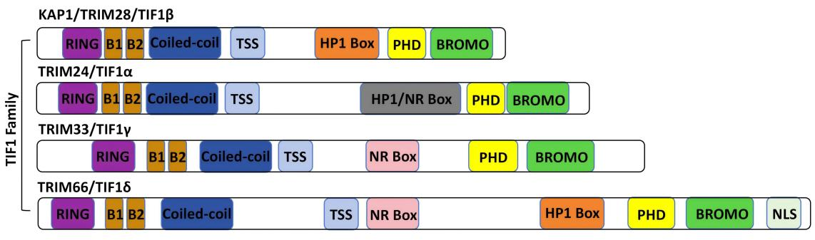
Figure 1. Protein structure of the TIF1 protein family
The TIF1 family includes TRIM24 (TIF1α), TRIM28 (TIF1β/KAP1), TRIM33 (TIF1γ), and TRIM66 (TIF1δ). All members share a characteristic N-terminal RBCC motif-comprising a RING finger, B-boxes, and a coiled-coil domain-and a C-terminal PHD and bromodomain. Variations in the central region distinguish each family member.

1.1 RBCC Structural Domains: Mediators of Protein Interactions and Post-Translational Modifications
The RBCC region (tripartite motif, TRIM) of KAP1 is composed of a RING zinc finger, two B-box motifs, and a coiled-coil (CC) domain, arranged sequentially from the N– to the C-terminus [1, 38, 40]. This region mediates protein-protein interactions and drives KAP1’s dimerization and oligomerization. The RING domain adopts a C3HC4-type zinc finger fold and coordinates two zinc ions to form a hydrophobic core, with conserved linkers contributing to substrate specificity[41]. It also functions as an E3 ubiquitin ligase by recruiting E2 conjugating enzymes to mediate substrate ubiquitination [42]. The B-box motifs form compact globular structures conserved across TRIM proteins. [39]. The CC domain consists of amphipathic α-helices that mediate homo–and hetero-oligomerization with TRIM proteins [24, 43].
This structural module also enables direct interaction with KRAB-ZFPs, the largest family of transcriptional repressors in mammals [44]. The KRAB domain recruits KAP1 to DNA-binding loci to mediate silencing [24, 44]. Among TIF1 family proteins, only KAP1 binds directly and specifically to the KRAB repression module [45]. Early work proposed a 3:1 KAP1:KRAB stoichiometry [39, 46], whereas recent studies demonstrate a 1:2 KRAB-ZFP: KAP1 binding ratio. KAP1’s RBCC forms antiparallel dimers that can assemble into higher-order oligomers, though these are not required for repression [43, 47]. AlphaFold2 shows L301 inserts into a KRAB hydrophobic pocket, with CC helices forming the interaction site. Structural variations here may tune silencing efficacy [22].
In addition to mediating protein interactions, KAP1’s RBCC and adjacent regions undergo extensive post-translational modifications. Key lysines in the C-terminal region are SUMOylated, primarily by PIAS family ligases that recognize ψKxE motifs [48, 49]. Lysine 554 (K554), near the HP1-binding domain (residues 535-580), is the primary SUMO1 site and promotes HP1 interaction and heterochromatin formation [50]. K779 (SUMO2/3) is linked to DNA repair [51], while K804 SUMOylation may affect histone H3 lysine 9 (H3K9me3) binding [50]. These modifications recruit SIM–containing partners like SETDB1, promoting H3K9 trimethylation and transcriptional silencing [52]. KAP1’s RING domain also mediates E3 ubiquitin ligase activity, requiring Cys15, Cys18, His30, and Cys33 for zinc coordination and E2 enzyme recruitment [2]. Trp22 and Phe25 contribute to a hydrophobic pocket essential for ubiquitin transfer [53]. B-box (residues 96-140) and CC (residues 141-350) domains enhance dimerization and substrate recognition, including of p53 and MDM2 [39].
SUMOylation and ubiquitination are spatially and functionally interlinked. SUMOylation may mask the RING domain and inhibit ubiquitin ligase activity [7]. Upon DNA damage, SUMOylated KAP1 can promote ubiquitination of repair factors, targeting them for degradation [54, 55]. These PTMs dynamically regulate KAP1’s transcriptional repression and DNA repair roles via conformational modulation and signaling crosstalk [7].
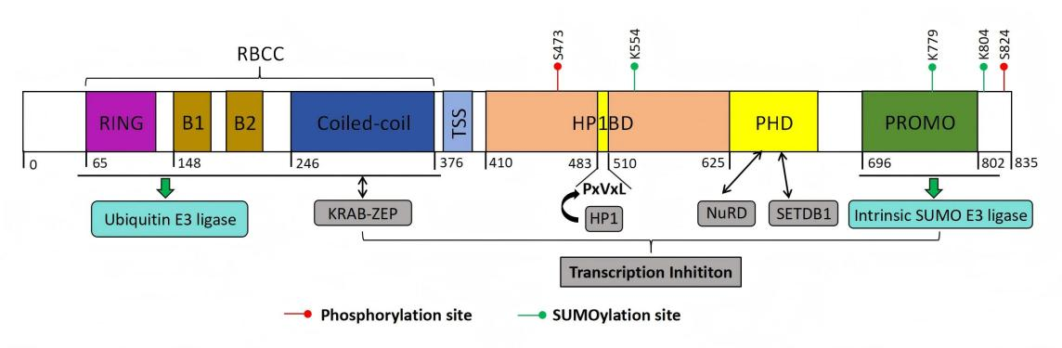
Figure 2. Structure of KAP1
KAP1 is composed of an N-terminal RING domain, two B-boxes (B1 and B2), a CC domain, a central hydrophobic PxVxL pentapeptide motif, and a C-terminal PHD followed by a bromodomain. The RBCC region functions both as a ubiquitin E3 ligase and as a binding interface for KRAB-ZFPs. The PHD domain facilitates the recruitment of the NuRD complex and the histone methyltransferase SETDB1, while the central PxVxL motif mediates interaction with HP1. KAP1’s transcriptional repression activity is tightly associated with its ability to recruit SETDB1, NuRD, and HP1, and is further modulated by SUMOylation. Notably, the PHD domain itself possesses E3 SUMO ligase activity. Post-translational modifications of KAP1, including SUMOylation and ubiquitination at distinct sites, exert differential effects on its function and regulatory capacity.

1.2 PHD-Bromodomain: Mediators of Histone Methylation and Deacetylation
The C-terminal region of KAP1 contains two highly conserved domains: a PHD zinc finger and a bromodomain. The PHD is a compact domain of approximately 60 amino acids, while the bromodomain comprises over 100 amino acids that fold into a helical bundle. Tandemly arranged, the PHD-Bromo module recognizes histone tails, recruits histone modifiers, and initiates SUMOylation, thereby promoting gene silencing [41, 56]. Proteins interacting with the PHD-Bromo module fall into two main categories. The first includes histone methyltransferases like SETDB1, which catalyzes H3K9me2/3—a heterochromatic mark that recruits downstream effectors [12, 13]. The second group includes HDAC complexes (e.g., Mi2α, HDAC1), which assemble into larger repressive structures like NCOR2 and the NuRD complex. They remove histone acetyl groups, promoting chromatin compaction and repression [57]. Thus, the PHD-Bromo domain acts as a scaffold for histone modifiers, facilitating methylation and heterochromatin formation essential for gene silencing [58].

1.3 HP1-Binding Domain: Recruitment of HP1
The interaction between HP1 and members of the TIF1 protein family was first identified through yeast two-hybrid screening[38]. HP1 is a highly conserved non-histone protein that plays a key role in heterochromatin formation [59, 60]. HP1 consists of an N-terminal chromodomain (CD) and a C-terminal chromoshadow domain (CSD), both essential for recognizing histone marks and mediating chromatin compaction [60]. KAP1 contains a central HP1-binding domain (HP1BD), defined by a conserved PxVxL motif, although it is the least conserved domain within KAP1 [61]. Following deposition of H3K9me3, KAP1 rapidly binds HP1 with high affinity. This occurs through interaction between KAP1’s PxVxL motif and the HP1 CSD, facilitating heterochromatin assembly [62, 63]. The KAP1-HP1 interaction is essential for transcriptional silencing. Disrupting this interaction, such as by altering histone or DNA methylation, can lead to in vivo reactivation of imprinted genes [64]. Moreover, HP1 has been shown to associate with the histone lysine methyltransferase SUV39H1 and to form a multiprotein complex with KAP1. This complex acts as both a “writer” and “reader” of H3K9me2/3, reinforcing and maintaining heterochromatin stability [65].

Core Physiological Functions of KAP1

2.1 Maintaining a Heterochromatin Environment and Mediating Gene Silencing
Heterochromatin is a condensed chromatin state that represses transcription in vivo. It is organized around nucleosomes composed of histone octamers (H3, H4, H2A, H2B) wrapped by DNA [57]. Heterochromatin can be categorized into two types: constitutive and facultative. Constitutive heterochromatin contains abundant non-histone proteins like HP1 and KAP1, which help maintain genome stability in eukaryotic cells [13]. Key PTMs include H3K9me3, H3K64me3, and H4K20me3—hallmarks of constitutive heterochromatin [65, 66]. Among known histone lysine methyltransferases (KMTs), SETDB1 plays a dominant role in catalyzing H3K9 methylation [58, 67, 68]. Chromatin remodelers like CHD3 and HDAC1 also interact with KAP1 to facilitate nucleosome remodeling [69].
In canonical gene silencing, KRAB-ZFPs and other DNA-binding proteins recruit KAP1 to specific genomic loci [22, 44, 45]. KAP1 then recruits the NuRD-HDAC complex and SETDB1 to deposit H3K9me3, establishing heterochromatin and repressing transcription [45]. Simultaneously, the PHD-bromodomain module of KAP1 recruits the SUMO E2 enzyme UBC9, facilitating auto-SUMOylation of KAP1. This modification enhances SETDB1 recruitment and stabilizes chromatin repression [26].
KAP1 also regulates transcriptional elongation to reinforce gene silencing [70]. After transcription is initiated, RNA polymerase Ⅱ (RNAPⅡ) typically pauses just downstream of the TSS. Productive elongation requires activation of positive transcription elongation factor b (P-TEFb), composed of CDK9 and cyclin T [71]. P-TEFb phosphorylates the C-terminal domain (CTD) of Pol II and the negative elongation factors such as NELF and DSIF to facilitate elongation. Under resting conditions, P-TEFb is sequestered in the 7SK small nuclear ribonucleoprotein (7SK snRNP) complex, which includes 7SK RNA, HEXIM1/2, and LARP7[72], thereby maintaining Pol II in a paused state[70, 73].
Importantly, KAP1 was found to recruit the 7SK snRNP complex, containing inactive P-TEFb, to paused promoters, including the HIV-1 long terminal repeat (LTR). While this recruitment enforces pausing under basal conditions, it also primes these promoters for rapid reactivation, since upon stimulation P-TEFb can be released and activated, relieving Pol II pausing and favoring HIV-1 transcription [70]. KAP1 promotes SUMOylation of CDK9 at lysine residues (e.g., K44, K56, K68), which destabilizes the P-TEFb complex [74]. KAP1 also enhances the association of P-TEFb with 7SK snRNP via HEXIM1, reinforcing transcriptional pausing under basal conditions [75]. Phosphorylation of KAP1 at Ser824 disrupts its interaction with SETDB1 and HP1, leading to the release of P-TEFb from the 7SK snRNP complex. This promotes the transition of Pol II into productive elongation, enabling rapid transcription of target genes [71, 75]. Additionally, Bacon et al. [76] reported that the PHD domain of KAP1 binds hypoacetylated histone H4, potentially influencing Pol II recruitment or termination [77].
Recent studies have uncovered additional mechanisms by which KAP1 regulates gene expression. Citrullination of KAP1, catalyzed by peptidylarginine deiminase 4 (PADI4), enhances its interaction with the chromatin remodeler Smarcad1, loosens chromatin compaction, and promotes the transcription of pluripotency genes such as Nanog and Klf4. This is achieved through increased H3K27ac and H3K4me3, along with decreased H3K9me3 at regulatory regions, thereby weakening KAP1 repressive function. Thus, KAP1 citrullination serves as a critical epigenetic mechanism for activating pluripotency genes in embryonic stem cells (ESCs) [78]. KAP1 also facilitates transcriptional repression by Kaiso (ZBTB33), a zinc finger and BTB domain-containing repressor, through its PHD-bromodomain, which interacts with both the BTB/POZ and zinc finger regions of Kaiso and promotes its SUMOylation [79]. Furthermore, KAP1 maintains H3K9me3 levels and the heterochromatic environment through continuous SETDB1 recruitment, forming a complex with chromatin assembly factor 1 (CAF-1) and HP1[62]. Although phosphorylation at KAP1 Ser473 has been implicated in maintaining global H3K9me3[80, 81], the precise role of this modification remains unclear.
In summary, KAP1 is targeted to specific genomic loci, such as transposable elements or imprinted genes, through its interaction with KRAB-ZFPs. It then recruits SETDB1 to deposit H3K9me3, together with HDACs and HP1, thereby establishing and maintaining heterochromatin and enforcing gene silencing. In parallel, KAP1 suppresses transcriptional elongation by promoting SUMOylation of CDK9 and enhancing the sequestration of P-TEFb in the 7SK snRNP complex, thereby maintaining RNAPⅡ in a paused state[24, 63, 82]. Auto-SUMOylation of KAP1 is essential for maintaining repression, whereas Ser824 phosphorylation reverses this state by displacing CHD3 and promoting chromatin relaxation (Figure 3) [69]. This dynamic regulation enables KAP1 to coordinate chromatin remodeling and transcriptional control in response to endogenous cues and external stimuli, including pathogen invasion.
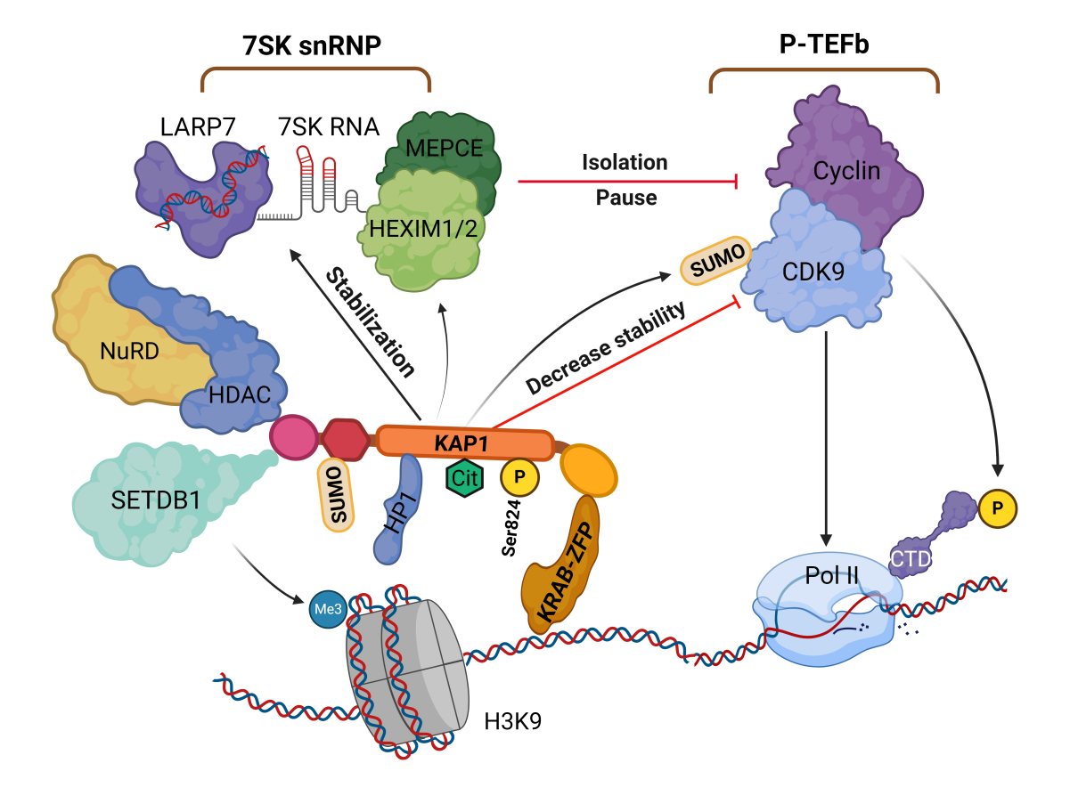
Figure 3. The role of KAP1 in gene silencing and transcriptional repression
KAP1 is recruited by KRAB-ZFPs to specific DNA loci, where it initiates heterochromatin formation via SETDB1 and the NuRD-HDAC complex, depositing H3K9me3 and promoting histone deacetylation. HP1 binds H3K9me3 and stabilizes the complex. KAP1 undergoes SUMOylation, enhancing its repressive activity, and further SUMOylates CDK9 to inhibit P-TEFb assembly and stabilize the 7SK snRNP complex, pausing RNAPⅡ at promoters. Citrullination and Ser824 dynamically modulate KAP1’s function and chromatin interactions. Created with BioRender.com
Abbreviations: H3K9, histone H3 lysine 9; HP1, heterochromatin protein 1; KAP1, KRAB-associated protein 1; NuRD-HDAC, nucleosome remodeling and deacetylase complex; P-TEFb, positive transcription elongation factor b; Pol II, RNAPⅡ; SETDB1, SET domain bifurcated histone methyltransferase 1; snRNP, small nuclear ribonucleoprotein; KRAB-ZFP, KRAB zinc finger protein.

2.2 Involvement in DNA Damage Repair
DNA damage arises from both exogenous sources–such as ultraviolet (UV) and ionizing radiation–and endogenous events, including replication stress and enzymatic errors[83]. To maintain genomic stability, cells have evolved a highly coordinated DNA damage response (DDR) system[84] that rapidly detects lesions, initiates repair pathways, and temporarily halts cell cycle progression to prevent propagation of mutations[85]. DDR encompasses multiple repair mechanisms, including direct repair, base excision repair, nucleotide excision repair, mismatch repair, and double-strand break (DSB) repair[86]. Among these, DSBs are particularly harmful and are recognized by two sensor complexes: the MRE11-RAD50-NBS1 (MRN) complex and the Ku70/Ku80 heterodimer, which activate homologous recombination (HR) and non-homologous end joining (NHEJ), respectively[87, 88].
Phosphorylation of KAP1 is among the earliest DDR events and is primarily linked to DSBs repair within heterochromatin [89]. In microlaser-irradiated U2OS human osteosarcoma cells, KAP1 rapidly localizes to damage sites, where it is recognized by the MRN complex and recruits Ataxia Telangiectasia Mutated (ATM) kinase. ATM phosphorylates KAP1 at Ser824 [90], leading to chromatin relaxation–a prerequisite for DSBs repair. Phosphorylated KAP1 has been shown to co-localize with key DNA repair factors, including γH2AX, 53BP1, and TopBP1, underscoring its involvement in HR-mediated repair[91].
KAP1 deacetylation enhances its interaction with 53BP1 and facilitates ATM-independent NHEJ [92]. DNA damage also triggers Ser473 phosphorylation of KAP1, promoting formation of a KAP1–proliferating cell nuclear antigen (PCNA)–Suv39h1 complex. Unlike Ser824, which localizes to damage foci, Ser473 phosphorylation is diffusely nuclear and mediated by Chk1/Chk2 [93]. It helps maintain global H3K9me3 levels and contributes to H4K20me3 and H3K64me3 deposition [93, 94]. Thus, under normal physiological conditions, Ser473 phosphorylation promotes heterochromatin stability and replication fidelity[94]. Upon DSBs, KAP1 undergoes Ser824 phosphorylation or deacetylation via ATM-dependent signaling to enable DNA repair [94].
KAP1-mediated DDR is further modulated by regulatory proteins. RNF4 recruitment to KAP1 modulates the 53BP1–BRCA1 balance at DSBs and influences pathway choice in a cell cycle–dependent manner [95]. While Ser824 phosphorylation is essential for DSBs repair in heterochromatin, PP4C impairs this process by dephosphorylating Ser824. PP4C thus serves as a negative regulator of the DDR [96].
KAP1 also integrates external stimuli into DDR responses. Viral mimics such as poly I:C or direct infection can induce Ser473 phosphorylation. This promotes KAP1–CTIF interaction, which inhibits stress granule formation and restricts viral replication [32]

2.3 SUMOylation and Ubiquitination in KAP1-Mediated Regulation
KAP1 acts as both a SUMO and E3 ubiquitin ligase, with these PTMs critically contributing to genomic stability, transcriptional regulation, and cell fate decisions. By coordinating protein interactions, chromatin remodeling, and intracellular signaling, KAP1 serves as a central regulatory hub [7]. SUMOylation enables KAP1 to recruit effector proteins containing SUMO-interacting motifs (SIMs), including HP1α/β/γ and SETDB1. This modification strengthens KAP1–HP1 binding and promotes HP1 aggregation at heterochromatin domains (e.g., mitophagy sites and telomeres), reinforcing chromatin compaction [97]. KAP1 also functions as a scaffold, directing SETDB1 to specific genomic loci to catalyze H3K9me3 and silence retrotransposons (e.g., LINE-1) and imprinted genes. Thus, KAP1 SUMOylation is essential for chromatin compaction and repression of endogenous retroelements [98]. However, KAP1’s repressive activity is attenuated upon DNA DSB induction. ATM-mediated phosphorylation at Ser824 disrupts KAP1 SUMOylation and weakens its gene-silencing capacity [50]. Protein phosphatase 1 (PP1), especially the α and β isoforms, reverses this effect by dephosphorylating Ser824 and promoting KAP1 SUMOylation, thereby restoring its repressive function [99]. In summary, KAP1 auto-SUMOylation promotes heterochromatin formation but is dynamically reversed during DNA damage repair [99].
In addition to self-modification, KAP1 acts as a SUMO ligase for other substrates. For instance, it SUMOylates PCNA via a PIP motif in its bromodomain, thereby preventing transcription-associated DNA breaks [100]. It also SUMOylates MORC2 at lysine 767 (K767), modulating its role in the DNA damage response; this modification is reversible by the deSUMOylase SENP1 [101].
Meanwhile, the N-terminal RING domain of KAP1 functions as an E3 ubiquitin ligase, influencing transcription factor stability and chromatin dynamics [5, 102, 103]. For example, it promotes K48-linked polyubiquitination of p53, leading to its proteasomal degradation and attenuation of p53-mediated cell cycle arrest or apoptosis [104, 105]. KAP1 is also subject to self-ubiquitination, forming part of a negative feedback loop [106]. In addition, it can catalyze K63-linked polyubiquitination, which modulates the localization and stability of itself or associated proteins[107, 108]. Under stress, such auto-ubiquitination can drive liquid-liquid phase separation (LLPS), facilitating the formation of transcriptional repressor condensates [31]. Moreover, KAP1 ubiquitinates DNA methyltransferase 3α (DNMT3A), affecting its enzymatic function and chromatin recruitment, and thereby modulating DNA methylation patterns [109].
SUMOylation at the C-terminus of KAP1 may trigger a conformational shift that occludes its N-terminal RING domain, thereby inhibiting ubiquitin ligase activity. This structural change may temporally uncouple transcriptional repression from protein degradation. Following DNA damage, SUMOylated KAP1 facilitates RNF4 recruitment, which catalyzes K63-linked ubiquitination of repair proteins, forming SUMO-ubiquitin hybrid chains that coordinate chromatin remodeling and DNA repair[55]. Under severe genotoxic stress, KAP1 promotes polyubiquitination and degradation of SIRT1, a class III histone deacetylase, thereby modulating its anti-apoptotic role in the DNA damage response [110].
In summary, KAP1 orchestrates chromatin silencing and DNA repair complex assembly via SUMOylation, while simultaneously regulating degradation of key factors and enzymatic activity through ubiquitination. These dual PTMs act as an integrated platform for chromatin dynamics and protein homeostasis, operating through site competition, signal amplification, and cooperative regulation.

2.4 Embryonic Development and Cell Fate Determination
Loss of maternal KAP1 results in early embryonic lethality, predominantly in male embryos[7, 16, 21, 111], due to its essential role in maintaining epigenetic stability during the oocyte-to-embryo transition in mice[112]. Studies employing conditional knockout models in both mice and cultured cells have demonstrated that KAP1 is critical for multiple developmental processes, including spermatogenesis, erythropoiesis, and the differentiation of T and B lymphocytes (Table 1). Beyond developmental regulation, KAP1 also contributes to immune homeostasis. It has been identified as a component of FOXP3–containing protein complexes and is known to enhance the suppressive function of regulatory T (Treg) cells. KAP1 is also implicated in immunoglobulin class-switch recombination, further linking it to immune regulation[113]. In the central nervous system, Jakobsson et al. demonstrated that deletion of KAP1 in the mouse forebrain leads to pronounced behavioral changes, including increased anxiety-like behavior, heightened exploratory activity, and impaired spatial learning and memory in response to stress[114]. Notably, KAP1 deletion also disrupts olfactory neurogenesis[115]. Transcriptomic analyses revealed that several dysregulated genes in the hippocampus are imprinted genes, suggesting that KAP1 may play a role in the maintenance of genomic imprinting[114]. This hypothesis is supported by studies showing that KAP1 contributes to DNA methylation during early embryogenesis. It achieves this by recruiting DNA methyltransferases (DNMTs) to the imprinting control region (ICR), thereby reinforcing stable silencing of imprinted loci during key developmental windows[116].
Table 1 Mouse models illustrating the physiological functions of KAP1
Animal model | Phenotype | Reference
KAP1 knockout mice | Embryonic lethal prior to gastrulation | [16, 111]
Hemato-specific KAP1 knockout mice | Impaired erythropoiesis | [7, 117, 118]
Chronic myeloid leukemia KAP1 knockout mice | Inhibits the progression of myeloid leukemia | [119]
T-cell-specific KAP1 knockout mice | Defective T-cell differentiation | [120, 121]
B-cell-specific KAP1 knockout mice | Defective B-cell differentiation | [122]
Tamoxifen-inducible-germ cell-lineage-specific KAP1 depletion mice | Impaired spermatogenesis | [123]
Liver-specific KAP1 knockout mice | Male-predominant steatosis and hepatic adenoma | [124]
KAP1 knockout in mice forebrain | Anxiety-like-behavior and cognitive impairments | [114]
KAP1 knockout mice in progeria models | Suppresses the induction of a senescence-associated secretory phenotype | [125]
Cell model | Phenotype | Reference
KAP1 knockdown in human aortic smooth muscle cells (HASMC) | Suppression of phenotypic transition dysregulation in vascular smooth muscle cells | [126]
KAP1 knockdown in porcine oocytes | Transcriptional activity of fertilized egg genes is blocked. | [127]
KAP1 knockdown in sheep embryonic fibroblasts (SEF) | Disrupts gene expression of imprinted genes Igf2 and H19, which in turn affects epigenetic inheritance | [128]

KAP1 in Viral Infections: Mechanisms and Paradoxes
KAP1 is a well-established transcriptional repressor critical for silencing integrated retroviral genomes and maintaining herpesviral latency through heterochromatin formation[6, 20]. By recruiting epigenetic modifiers such as SETDB1, HP1, and histone deacetylases, KAP1 establishes transcriptionally repressive chromatin that inhibits viral gene expression[7]. Its role in controlling ERVs, HIV-1, Moloney Murine Leukemia Virus (MMLV), Prototype Foamy Virus (PFV), and herpesviruses such as EBV, KSHV, Human cytomegalovirus (HCMV), and Herpes simplex virus type 1 (HSV-1) is well documented and represents its primary antiviral function. Notably, reactivation from latency is often linked to post-translational modifications of KAP1, particularly Ser824 phosphorylation, which disrupts its repressive activity. In recent years, KAP1 has also been implicated in the regulation of other viruses, including SARS-CoV-2, Respiratory Syncytial Virus (RSV), IAV, HPV, Hepatitis C Virus (HCV), Merkel Cell Polyomavirus (MCPyV), and adenoviruses. Although these findings remain comparatively limited, they suggest broader roles for KAP1 in modulating viral replication and innate immune responses through transcriptional control mechanisms. This expanding scope does not diminish established function of KAP1 in retroviral and herpesviral silencing but rather highlights its emerging potential as a more universal regulator of host-virus interactions[129].

3.1 Epigenetic Silencing of Viral Genomes

3.1.1 KAP1-SETDB1-Mediated Silencing of ERVs and Exogenous Retroviruses
RVs belong to the Retroviridae family, a group of single-stranded, positive-sense, non-segmented RNA viruses that exclusively infect vertebrates[130]. RV replication involves reverse transcription of the viral RNA genome into double-stranded DNA, followed by integration of the resulting DNA into the host genome to form a provirus[131]. While most RVs infect somatic cells, on rare occasions they infect germline cells[132]. In such cases, the integrated provirus becomes a heritable component of the host genome and is transmitted vertically across generations, forming what are known as ERVs. ERVs, classified as LTR retrotransposons, constitute approximately 9% of the human genome[133] and are increasingly recognized for their roles in both human health and disease. The involvement of KAP1 in maintaining the transcriptional silencing and latency of both RVs and ERVs was identified early on[20, 58]. Beyond ERVs, KAP1-mediated epigenetic silencing has also been observed in response to exogenous retroviruses, including HIV-1, MMLV, and PFV.
ERVs
Under normal physiological conditions, ERVs are silenced through multiple epigenetic mechanisms, including heterochromatin formation, DNA methylation, and RNA transcript modifications[134, 135]. Among these, one of the most well-characterized silencing pathways involves KAP1-mediated heterochromatinization. In pluripotent ESCs, KAP1 is recruited to ERVs via KRAB-ZFPs, where it cooperatively recruits SETDB1 and HP1 to establish a repressive chromatin environment. Similarly, in neural progenitor cells (NPCs), KAP1 mediates dynamic histone modifications to regulate ERVs transcriptional silencing[136–138]. KAP1 has also been shown to repress ERVs and zinc finger (ZNF) genes in differentiated human cell types such as HeLa, 293T, and peripheral blood mononuclear cells (PBMCs). This repression is closely linked to specific KAP1 binding sites and H3K9me3 enrichment, indicating that the KAP1-KRAB-ZFP (KZNF) complex contributes to genomic stability even in adult somatic cells[139]. In addition to ERVs, KAP1 also regulates other human-specific endogenous retroelements (EREs) in ESCs. Its transcriptional repression function appears to be tightly coupled with KAP1-induced DNA methylation, although KAP1-mediated chromatin remodeling is essential for transcriptional regulation of EREs regardless of their DNA methylation status[140].
Moreover, KAP1 cooperates with the human silencing hub (HUSH) complex to repress evolutionarily young LINE-1 elements and newly acquired genes rewired through retrotransposon-derived non-coding sequences [141]. Mechanistic studies have mapped KAP1-mediated transcriptional repression to a 190 bp sequence encoding the intracisternal A-particle (IAP) signal peptide in murine ESCs and NPC models. Within this sequence, a 47 bp enhancer in the U3 region of the LTR has been identified as a key element for retrotransposon activity. Knockdown of KAP1 leads to derepression of IAPs, resulting in the loss of regulatory elements required for autonomous retrotransposition[142].
Mounting evidence links aberrant expression of human endogenous retroviruses (HERVs) to autoimmune[143] and neurological disorders[144]. KAP1 and SETDB1, as central epigenetic repressors of HERV sequences, play important roles in immune regulation, neuronal differentiation, and synaptic function[136, 145]. For example, multiple sclerosis (MS) is a chronic inflammatory demyelinating disease of the central nervous system (CNS)[146]. Interestingly, pregnancy has been shown to attenuate disease severity and reduce relapse frequency[147]. Clinical studies have found significantly lower levels of HERV mRNA in the chorionic villi and basal plate tissues of pregnant women compared to non-pregnant individuals. However, concurrent impairment in KAP1 and SETDB1 expression suggests that dynamic regulation of these proteins may influence HERV activation and MS pathogenesis. Notably, the relationship between KAP1 expression and pregnancy-related hormonal changes remains to be elucidated[148].
In an experimental autoimmune encephalomyelitis (EAE) mouse model, knockdown of KAP1 led to increased dendritic cell (DC) counts in the spleen and enhanced T-cell-driven inflammatory responses, thereby exacerbating disease severity. Genome-wide analyses revealed that ERV elements in KAP1-deficient dendritic cells (DCs) suppressed the expression of adjacent inflammatory genes. Therefore, KAP1-mediated ERVs silencing is essential for maintaining proper immunoregulatory gene expression in DCs[149].
Chronic immune thrombocytopenia (CITP), an autoimmune disorder, has also been linked to dysregulated HERV activity[150]. Studies in pediatric patients have shown that blood mRNA levels of KAP1 and SETDB1 are significantly elevated in CITP patients and positively correlated with expression of HERV-H and HERV-K, suggesting that KAP1 may contribute to the immunopathogenesis of CITP[151]. Similarly, in children with autism spectrum disorders (ASD), elevated expression of HERV-H and HERV-K envelope genes was observed, along with increased KAP1 and SETDB1 mRNA levels compared to healthy controls. These findings imply that KAP1/SETDB1 may respond to environmental stimuli and reshape chromatin epigenetics, thereby participating in the etiology of ASD[144].
HIV-1
HIV-1 is the causative agent of acquired immunodeficiency syndrome (AIDS). It attacks the immune system by depleting CD4⁺T lymphocytes, leading to immunodeficiency and increased susceptibility to opportunistic infections and malignancies [152]. A major obstacle to HIV-1 eradication is the persistence of transcriptionally silent proviruses, referred to as latent HIV-1, within long-lived host reservoirs. To address this challenge, the “shock-and-kill” strategy has been widely explored, which involves reactivating latent proviruses (“shock”) followed by immune- or drug-mediated clearance of the reactivated cells (“kill”)[153]. Therefore, the development of effective latency-reversing agents (LRAs) remains a key objective in HIV-1 therapy.
The role of KAP1 in HIV-1 infection remains controversial, particularly with regard to whether it promotes viral transcription or enforces latency. Early studies suggested that KAP1 restricts HIV-1 by interacting with viral integrase and preventing proviral integration into host chromatin[154]. KAP1 has also been implicated in the regulation of HIV-1 transcription[70], where it recruits inactive P-TEFb to the HIV-1 LTR to enforce transcriptional pausing under basal conditions but at the same time primes the promoter for rapid activation upon stimulation. In CD4⁺T cells, KAP1 has been associated with both transcriptional activation and repression, contributing to the ongoing debate[155, 156].
Current evidence suggests that KAP1 plays a central role in promoting HIV-1 latency through transcriptional repression mechanisms. Ma and colleagues reported that KAP1 mediates SUMOylation of the CDK9 subunit of P-TEFb at lysine residues K44, K56, and K68. This modification reduces CDK9 kinase activity and impairs P-TEFb assembly by disrupting its interaction with Cyclin T, thereby repressing transcriptional elongation and promoting HIV-1 latency[74]. These findings highlight the dual role of KAP1 as both a SUMO ligase and a chromatin-based transcriptional corepressor[157].
KAP1 has also been shown to interact with the viral transactivator Tat, facilitating its degradation, and with CTIP2, a key epigenetic silencing factor. In microglial cells, Tat and CTIP2 compete for binding to KAP1, suggesting that KAP1 contributes to the establishment and maintenance of latency through cell type-specific molecular interactions [157].
A genome-wide CRISPR knockdown screen identified ZNF304, a KRAB-domain-containing zinc finger protein, as a host factor that promotes HIV-1 latency. ZNF304 recruits KAP1 to the viral promoter, where they together facilitate the assembly of heterochromatin-associated KMTs and polycomb repressive complexes (PRCs), enforcing transcriptional silencing. Loss of ZNF304 leads to a marked reduction in repressive histone modifications at the HIV-1 promoter–including H3K9me3, H3K27me3, and H2AK119ub–as well as diminished KAP1 recruitment, resulting in increased HIV-1 gene expression. These findings underscore the cooperative role of ZNF304 and KAP1 in sustaining viral latency[158].
Contrastingly, recent studies have revealed a potential transcriptional activator role for KAP1 under certain conditions. Acute depletion of KAP1 using a chemical genetics approach partially reduced HIV-1 promoter activity in response to activation stimuli. This phenotype was rescued by reintroducing exogenous KAP1, implicating KAP1 as a targeted transcriptional co-activator. Structural mapping further identified the RING finger domain and an intrinsically disordered region of KAP1 as essential for this activating function[155, 159]. Moreover, exposure to cocaine has been shown to promote phosphorylation of KAP1 at Ser824 via DNA-dependent protein kinase (DNA-PK), converting KAP1 from a repressor to an activator of HIV-1 transcription. This observation may help explain the link between substance abuse and poor viral control in HIV-infected individuals[160].
In summary, the role of KAP1 in HIV-1 infection is multifaceted and context-dependent. While it is clearly involved in establishing and maintaining latency through SUMOylation and transcriptional repression, under certain conditions KAP1 can also facilitate viral gene activation. The precise mechanisms and regulatory switches governing these opposing roles remain incompletely understood and warrant further investigation.
MMLV
MMLV is a retrovirus known for its ability to infect mice and other vertebrates, where it can contribute to oncogenesis. Although MMLV cannot replicate in embryonic carcinoma (EC) cells or ESCs[161], it can successfully integrate into the host genome as proviral DNA, which is subsequently transcriptionally silenced[162].
The key regulatory element responsible for this silencing is the proline primer binding site (PBS) of MMLV[163], which is complementary to host proline tRNA. This complementarity facilitates the initiation of negative-strand DNA synthesis and is thought to contribute to transcriptional repression. Further studies revealed that KAP1 is recruited to the repressor binding site (RBS) of MMLV, where it coordinates with HP1, SETDB1, and the NuRD complex to establish transcriptional silencing of the integrated provirus[164]. A central player in this process is ZFP809, a zinc finger protein that facilitates the recruitment of KAP1 and its associated silencing machinery to the MMLV proviral DNA. The interaction between KAP1 and ZFP809 is critical for chromatin and DNA modifications that enforce the silent state, and KAP1 also helps stabilize ZFP809 protein levels, further supporting sustained repression[165]. Notably, this mechanism appears to be specific to ESCs, and the role of KAP1 in regulating ZFP809 may differ in differentiated cells[166]. Subsequent studies identified another DNA-binding factor-YY1-as a sequence-specific mediator that links KAP1 to the MMLV provirus. KAP1 interacts with the acidic domain 1 and the zinc finger domain of YY1 through its RBCC region[167]. In ESCs, SUMOylation of KAP1 at lysine residue K779 was found to be essential for its gene-silencing activity against MMLV, reinforcing the importance of post-translational modification in KAP1 function[167].
Recent findings have further expanded the understanding of MMLV repression by implicating the chromatin remodeler Smarcad1. This protein interacts with KAP1 and facilitates the deposition of the histone variant H3.3 at proviral integration sites. H3.3 incorporation is thought to modulate chromatin dynamics, contributing to stable repression of MMLV transcription[168]. Depletion of either Smarcad1 or KAP1 leads to derepression of MMLV, indicating that the two proteins function cooperatively[169]. However, the precise mechanisms by which KAP1 and Smarcad1 coordinate the regulation of proviral gene expression and genome integrity remain to be fully elucidated.
PFV
PFV is a complex retrovirus that, despite its strong cytopathic effects in cultured cells, does not cause overt pathology in its natural host. Instead, PFV establishes a lifelong latent infection[170]. Similar to other retroviruses, PFV latency is regulated epigenetically. KAP1 contributes to this process by maintaining trimethylation of H3K9me3 at the LTR promoter of the viral genome. This epigenetic mark facilitates the recruitment of HP1, forming a repressive chromatin environment that supports the maintenance of PFV latency[25].

3.1.2 Herpesvirus Latency Maintenance and KAP1 Phosphorylation Switch
Herpesviruses are nearly ubiquitous in the human population and are classified into three major subfamilies-α, β, and γ-based on their biological properties and host cell tropism. A hallmark of all herpesviruses is their ability to establish latency within specific cell types[171], remaining transcriptionally silent or quiescent for extended periods[28]. Periodic reactivation into the lytic (productive) cycle enables viral replication and transmission. While α- and β-herpesviruses primarily cause disease during the lytic phase, γ-herpesviruses are associated with oncogenic potential, particularly in latently infected cells[172]. Transcriptional silencing during latency is essential for long-term viral persistence. Analogous to its role in retroviral repression, KAP1 contributes to the maintenance of herpesvirus latency by promoting constitutive heterochromatin formation on the viral genome. Through its interaction with epigenetic modifiers, KAP1 enforces silencing of lytic genes, thus stabilizing the latent state[27, 29, 173]. SUMOylation of KAP1 is a prerequisite for its gene-silencing function. However, upon entry into the lytic cycle, this repressive modification is dynamically replaced by phosphorylation, typically at Ser824. Although the specific kinases involved vary among different herpesviruses, both host and viral kinases are capable of inducing this phosphorylation. The phosphorylation of KAP1 at Ser824 acts as a molecular “switch” that disrupts its repressor function, thereby enabling reactivation of viral gene expression and progression to productive infection.
This phosphorylation-dependent regulatory mechanism positions KAP1 as a potential therapeutic target, and pharmacological induction of KAP1 Ser824 phosphorylation could potentially be explored to reactivate latent herpesviruses [28].
EBV
EBV, a member of the Lymphocryptovirus genus within the Herpesviridae family, is the etiological agent of infectious mononucleosis (IM) and has been strongly implicated in the development of nasopharyngeal carcinoma, various pediatric lymphomas, and autoimmune diseases[174]. EBV infects more than 95% of adults worldwide and establishes lifelong latency in host cells[175].
The maintenance of EBV latency involves multiple layers of transcriptional repression in which KAP1 plays a central role. KRAB-ZFPs suppress expression of EBV lytic genes by recruiting KAP1, thereby contributing to the silencing of the viral genome[27]. In addition, the EBV latency protein Epstein-Barr nuclear antigen 1 (EBNA1) can recruit KAP1 via its SUMO-interacting motif 3 (SIM3), further supporting viral latency[176]. EBV replication is governed by a tripartite helicase-primase complex composed of the deconjugating enzyme BBLF4, the primase BSLF1, and replication factors BBLF2/3[177]. Yeast two-hybrid screening and co-immunoprecipitation assays using BBLF2/3 as bait identified an interaction between the DNA-binding zinc finger protein ZBRK1, its co-repressor KAP1, and BBLF2/3. ZBRK1 was shown to bind to the oriLyt enhancer–EBV’s lytic origin of replication-indicating that the ZBRK1-KAP1 complex serves as a key regulator of EBV replication control at this site[26].
KAP1 also binds to the oriLyt and immediate early gene promoters in a CTAR3-dependent manner. CTAR3 is a signaling domain within EBV's latent membrane protein, and it facilitates SUMOylation of KAP1, reinforcing its transcriptional repressor function and contributing to maintenance of EBV latency[178]. Furthermore, the interferon-inducible protein IFI16 is required for latency and directly interacts with KAP1 to reinforce repression of viral gene expression[179, 180]. A critical regulatory switch in EBV latency is the promoter of BZLF1 (BamHI Z left fragment 1), a master transcriptional activator often referred to as the “lytic switch”. Its activation initiates the transition from latency to productive replication[29]. SUMO proteomic analyses revealed that the TRIM24/KAP1/TRIM33 complex suppresses BZLF1 expression during latent infection, suggesting that this multi-protein repressor complex may serve as a cellular defense mechanism against EBV lytic reactivation[181].
To overcome latency, EBV encodes several factors that modulate host signaling[182]. The viral transactivator BZLF1 is essential for reactivation and is implicated in EBV-associated tumorigenesis[183]. BZLF1 expression is maintained by the viral protein kinase (vPK), which activates host phosphoinositide 3-kinase (PI3K) signaling and induces phosphorylation of KAP1 at Ser824[26]. This modification disables KAP1’s repressive activity, facilitating BZLF1-driven amplification of the lytic cascade and promoting viral replication. In this context, KAP1’s latency-maintaining function is hijacked by viral signaling to enable reactivation[29, 180].
Other stressors can similarly subvert KAP1 function. Chloroquine, a known agonist of ATM kinase and antimalarial drug, has been shown to induce EBV reactivation in patients coinfected with Plasmodium falciparum, likely via ATM-mediated phosphorylation of KAP1 at Ser824[184]. In addition, EBV activates thioredoxin-interacting protein (TXNIP), a regulator of the NLRP3 inflammasome. TXNIP-induced activation of caspase-1 leads to degradation of KAP1 in certain cell populations, disrupting transcriptional silencing and triggering EBV reactivation[30]. Together, these findings demonstrate that KAP1 is a key regulator of EBV latency and that its functional inactivation through phosphorylation or degradation represents a convergent mechanism exploited by EBV to initiate lytic replication.
KSHV
KSHV is implicated in the pathogenesis of several malignancies, including Kaposi’s sarcoma (KS), primary effusion lymphoma (PEL), and multicentric Castleman’s disease. Like other herpesviruses, KSHV alternates between latent and lytic replication phases[185]. Understanding the molecular mechanisms that regulate the transition from latency to lytic reactivation is critical for controlling viral dissemination and developing targeted antiviral strategies[186, 187].
A key latency-associated protein encoded by KSHV is the latency-associated nuclear antigen (LANA), which possesses a SUMO-2–interacting motif that enables it to engage KAP1 through SUMOylation. This interaction promotes chromatin remodeling and contributes to the silencing of lytic genes during early stages of primary infection[188]. Additionally, nuclear factor erythroid 2-related factor 2 (NRF2) has been shown to facilitate the interaction between LANA and KAP1, reinforcing transcriptional repression of lytic genes[189].
The cellular transcription factor STAT3 also plays a role in maintaining KSHV latency. Suppression of STAT3 leads to downregulation of KAP1 and consequently activates the viral replication and transcription activator (RTA), highlighting a STAT3-KAP1 axis that regulates the responsiveness of latently infected cells to lytic stimuli[190]. Cai and colleagues reported that KSHV induces the accumulation of hypoxia-inducible factor-1α (HIF-1α) during latency. Under hypoxic stress, HIF-1α facilitates reactivation of the KSHV lytic cycle by disrupting the repressive complex formed between KAP1 and Sin3A at the SIM motif of LANA. This dissociation reduces KAP1 SUMOylation, enabling transcriptional activation of lytic genes. Furthermore, the RTA promoter contains overlapping binding sites for RBP-Jκ and HIF-1α (known as RBS and HRE, respectively). Inhibition of KAP1 enhances the binding of RBP-Jκ-HIF-1α complexes at this promoter region, suggesting that KAP1 occupancy at the RTA promoter is essential for suppressing lytic reactivation under normoxic conditions[191].
As with other herpesviruses, phosphorylation of KAP1 at Ser824 by viral protein kinases induces chromatin remodeling and activates lytic gene transcription, thereby promoting the switch from latency to replication[192]. The viral protein kaposin B contributes to the chronic inflammatory environment characteristic of KS by activating the host kinase MK2 (MAPKAPK2), which in turn phosphorylates KAP1 and facilitates lytic reactivation[193]. In addition to modulating KAP1 phosphorylation, KSHV has evolved strategies to counteract KAP1-mediated proteasomal degradation of key host transcriptional regulators. For instance, TFIIB, a core component of the RNAPⅡ transcriptional machinery, is typically cleaved by caspase-3 and further degraded via KAP1-mediated ubiquitination in response to cellular stress. However, KSHV impairs this degradation process, thereby preserving TFIIB and supporting viral gene expression[193].
Together, these findings demonstrate that KSHV not only hijacks the phosphorylation switch of KAP1 to escape latency but also manipulates multiple host signaling pathways to overcome KAP1-mediated transcriptional repression, enabling efficient viral replication and immune evasion.
HCMV
HCMV infection is a widespread β-herpesvirus that establishes lifelong latency, primarily within hematopoietic stem cells (HSCs)[194]. In immunocompetent individuals, viral latency is typically well controlled; however, reactivation in immunocompromised patients, such as organ transplant recipients, can result in life-threatening disease[195].
In human myeloid leukemia cells (Kasumi-3), HCMV gene expression initially becomes transiently activated before being repressed, reflecting a myeloid lineage-specific host defense mechanism that enforces viral transcriptional silencing[196]. Tumor necrosis factor alpha (TNF-α) has been shown to trigger HCMV reactivation, and this process is tightly linked to the gene-silencing function of KAP1[197]. The RNA-binding protein SERPINE1 mRNA-binding protein 1 (SERBP1) functions as a scaffold that facilitates the recruitment of KAP1 to the viral genome, promoting transcriptional repression of the major immediate-early promoter (MIEP)[198]. Genetic depletion of KAP1 in CD34⁺ cord blood-derived progenitor cells leads to enhanced expression of early and late HCMV genes, confirming that KAP1 is essential for the maintenance of viral latency[199]. Upon differentiation of DCs, which triggers HCMV reactivation, KAP1 remains associated with the viral genome; however, SETDB1 and H3K9me3 occupancy at viral promoters is diminished, thereby allowing escape from the latent state[199]. Additionally, phosphorylation of KAP1 at Ser824-induced by mTOR signaling or exposure to chloroquine-has been shown to disrupt its repressive function, further supporting the notion that Ser824 phosphorylation serves as a molecular switch enabling HCMV reactivation[200].
HSV-1
Among α-herpesviruses, HSV-1 is one of the most prevalent human pathogens, establishing lifelong latency primarily in sensory neurons [201]. Reactivation from latency leads to recurrent mucocutaneous lesions and, in severe cases, life-threatening encephalitis [202]. During the early stages of HSV-1 infection, the host mounts an epigenetic defense response characterized by the deposition of repressive histone marks, particularly H3K9me3, on the viral genome, leading to suppression of lytic gene transcription[203]. As viral reactivation proceeds, the integrin-linked kinase (ILK)-activated downstream of PI3K-stimulates protein kinase B (PKB/Akt) and facilitates productive viral infection. ILK opposes the activity of histone methyltransferase SUV39H1 and KAP1, both of which contribute to silencing of HSV-1 lytic genes. Knockdown of ILK results in reduced phosphorylation of KAP1 at Ser473 and Ser824, indicating that ILK enhances KAP1 phosphorylation to overcome transcriptional repression of lytic genes[203]. These findings suggest that the ILK-KAP1 axis represents a critical regulatory node for HSV-1 reactivation and may serve as a potential therapeutic target.

3.1.3 Transcriptional Repression by KAP1 in Emerging Viral Infections
Beyond its well-characterized roles in retroviruses and herpesviruses, KAP1 has recently garnered attention for its potential involvement in other viral infections. In several emerging systems, KAP1 is proposed to act as a transcriptional repressor through epigenetic mechanisms, suggesting a broader regulatory scope that remains to be fully elucidated.
HPV
HPV is small double-stranded DNA virus of the Papillomaviridae family that infects epithelial cells. While most HPV infections are transient and asymptomatic, persistent infection with high-risk types such as HPV-16 and HPV-18 is strongly associated with the development of cervical cancer and other anogenital and oropharyngeal malignancies [204, 205]. KAP1 functions as a co-repressor of E2F, a key transcription factor involved in HPV gene regulation. By promoting chromatin remodeling and transcriptional silencing, KAP1 influences the expression of viral oncogenes E6 and E7, which are critical for HPV-mediated oncogenesis. These oncogenes inactivate tumor suppressor proteins p53 and retinoblastoma (Rb), leading to dysregulated cell cycle progression and enhanced cellular proliferation. Through its epigenetic regulatory activity, KAP1 may thus contribute to viral persistence and the progression of HPV-associated malignancies[206].
HCV
HCV is an enveloped, positive-stranded RNA virus of the Flaviviridae family that infects hepatocytes. Globally, chronic HCV infection affects more than 50 million people and is a leading cause of liver fibrosis, cirrhosis, and hepatocellular carcinoma [207]. Several TRIM family proteins have been shown to restrict HCV by regulating viral transcription, replication, and assembly. As a key member of the TRIM family, KAP1 plays a regulatory role during HCV infection by modulating host genomic elements[208]. Upon HCV infection, KAP1 appears to reduce its transcriptional repression activity toward human HERVs, particularly HERV-H-pol and HERV-K-pol, leading to their aberrant upregulation. This derepression may influence viral replication dynamics and promote the aggregation of viral particles[209]. These findings suggest that KAP1 acts as a host epigenetic regulator whose functional alteration during HCV infection may contribute to viral persistence, making it a potential therapeutic target for HCV intervention[210].
MCPyV
MCPyV is a small double-stranded DNA virus of the Polyomaviridae family and the only polyomavirus conclusively linked to human cancer. MCPyV is clonally integrated in the majority of Merkel cell carcinoma cases, an aggressive neuroendocrine skin cancer with high morbidity and mortality [211]. KAP1 plays a critical regulatory role in MCPyV infection. Upon expression of MCPyV large and small tumor antigens (LT-Ag and ST-Ag) in normal human dermal fibroblasts (NHDFs), KAP1 undergoes phosphorylation at Ser824–a modification associated with the loss of its transcriptional repression activity. This phosphorylation event correlates with a marked increase in viral replication, indicating that KAP1 normally acts as a restriction factor during MCPyV infection. Its functional inactivation through phosphorylation enables viral gene expression and propagation, highlighting KAP1 as a key host factor modulated by MCPyV to facilitate productive infection[212].
Human Adenoviruses (HAdVs)
HAdVs are non-enveloped, double-stranded DNA viruses of the Adenoviridae family that cause a broad spectrum of diseases, ranging from respiratory and ocular infections to gastroenteritis. While typically self-limiting in immunocompetent hosts, HAdV infections can lead to severe or disseminated disease in immunocompromised individuals [213, 214]. In human adenovirus (HAdV) infections, KAP1 undergoes de-SUMOylation to relieve epigenetic repression and promote viral gene expression. This process is also linked to enhanced SUMOylation of the viral protein E1B-55K, facilitating viral replication[15].

3.2 Effects of KAP1 Ubiquitination/SUMOylation on Viral Proteins and Antiviral Innate Immune Regulation

3.2.1 Regulation of Viral and Host Proteins via PTMs
KAP1 not only helps maintain heterochromatin at the PFV promoter by regulating H3K9me3, but also directly targets viral proteins for degradation. Its RBCC domain binds to the PFV transactivator Tas and promotes its ubiquitin-mediated degradation, thereby contributing to the establishment of viral latency. This dual mechanism highlights KAP1’s role as both an epigenetic repressor and a post-translational regulator during PFV infection[25].
In hepatitis B virus (HBV), the multifunctional regulatory protein HBx modulates viral replication and host responses. KAP1, recruited by glycerol-3-phosphate dehydrogenase 2 (GPD2), facilitates HBx degradation via ubiquitination, thereby limiting HBV replication and potentially slowing liver disease progression[215].
SARS-CoV-2, the causative agent of COVID-19, is a positive-sense, single-stranded RNA virus of the Betacoronavirus genus. Since its emergence in late 2019, it has caused a global pandemic with significant morbidity and mortality[216–218]. During SARS-CoV-2 infection, KAP1 exerts antiviral effects at both the transcriptional and protein levels. Specifically, KAP1 catalyzes SUMOylation of the viral nucleocapsid protein (SARS2-NP) at lysine 65, promoting its homo-oligomerization, RNA binding, and LLPS-processes that impair the host innate immune response. Blocking this SUMOylation or LLPS formation may restore antiviral immunity and inhibit viral replication, offering a potential therapeutic strategy against COVID-19[219].
Porcine reproductive and respiratory syndrome virus (PRRSV) is a positive-stranded RNA virus of the Arteriviridae family and one of the most economically devastating pathogens in the swine industry. PRRSV infection causes reproductive failure in sows and respiratory disease in piglets, resulting in major global losses in pig production [220]. KAP1 also plays a proviral role in PRRSV infection by enhancing viral replication through regulation of K63-linked ubiquitination of the envelope glycoprotein GP4. Knockdown of KAP1 significantly suppresses PRRSV replication, identifying it as a critical host factor in the viral life cycle[221].
Interestingly, KAP1 exhibits cell-type-specific regulatory effects on the zinc finger protein ZFP809. In ESCs, KAP1 stabilizes ZFP809 and facilitates transcriptional repression of retroelements. However, in differentiated cells, KAP1 promotes ubiquitin-mediated degradation of ZFP809 via a C-terminal sequence containing lysine 391[166]. This functional switch-from transcriptional silencing in ESCs to ubiquitination-mediated degradation in somatic cells-may explain why MMLV replication is restricted in ESCs but not in differentiated cells[166].

3.2.2 Effects on Host Antiviral Innate Immune Signaling
When host cells encounter viral pathogens, pattern recognition receptors (PRRs) such as RIG-I detect viral RNA and initiate signaling cascades[222] involving MAVS, TBK1, and downstream transcription factors Interferon regulatory factor 3 (IRF3) and Interferon regulatory factor 3 (IRF3). These pathways culminate in the induction of type I interferons (IFNs), which are essential for establishing an antiviral state[223]. Post-translational modifications, particularly ubiquitination and SUMOylation, play a crucial role in modulating these pathways, often through cross-regulatory mechanisms. While these modifications enhance innate signaling, some viruses exploit the same systems to suppress immune responses[224, 225].
In this context, KAP1 directly interacts with TBK1, catalyzing K63-linked ubiquitination to amplify TBK1 activity and promote downstream type I IFN production. These findings identify TBK1 as a direct substrate of KAP1 and suggest that KAP1 can act as a positive regulator of antiviral responses through ubiquitin signaling[107].
Conversely, KAP1 has been shown to negatively regulate MAVS-mediated immune activation. Overexpression of KAP1 suppresses, while its knockdown enhances, MAVS-induced production of type I IFNs and proinflammatory cytokines[226]. Mechanistically, KAP1 mediates K48-linked polyubiquitination of MAVS, targeting it for proteasomal degradation. This process depends on cysteine residues C65 and C68 within the RING domain of KAP1 and lysines K7, K10, K371, K420, and K500 of MAVS[36].
Further downstream, KAP1 also modulates IRF7, a master regulator of type I IFN responses. Through its RING domain, KAP1 catalyzes the SUMOylation of IRF7, reducing its transcriptional activity and suppressing IFNB1 expression. The RNA-binding protein RBM45 has been implicated in facilitating the recruitment of KAP1 to IRF7, suggesting a broader regulatory network in play. KAP1 thus serves as a negative regulator of IRF7-dependent transcriptional responses[227].
Upstream of these events, KAP1 is a key modulator within this landscape. UBR5, an E3 ubiquitin ligase, has been identified as a positive regulator of RLR signaling. It promotes K63-linked ubiquitination of KAP1, which inhibits its intramolecular SUMOylation and relieves KAP1-mediated transcriptional repression on RLR genes. Thus, UBR5-mediated ubiquitination of KAP1 enhances RIG-I signaling by disinhibiting antiviral gene expression[228].
In addition to the RLR pathway, KAP1 has been shown to suppress NF-κB signaling by SUMOylating TRAF6, which interferes with its auto-ubiquitination and activation during innate immune responses[229]. This indicates that KAP1 not only regulates antiviral signaling but also plays a role in modulating inflammation.
Finally, a complex and reciprocal interaction between KAP1 and the interferon-stimulated gene XAF1 further illustrates the regulatory versatility of KAP1. Upon RNA virus infection, MAVS recruits TBK1 and XAF1. TBK1 phosphorylates XAF1 at Ser252, enabling its nuclear translocation, where it partners with IRF1 to guide KAP1 to antiviral gene loci[230]. XAF1 targets the PHD domain of KAP1 for de-SUMOylation, enhancing chromatin accessibility and driving robust expression of antiviral genes[230]. Interestingly, KAP1, in turn, promotes the K48-linked polyubiquitination and degradation of XAF1 in an apparent feedback mechanism to restore its own repressive function-though the precise relevance of this counter-regulation in antiviral contexts remains to be fully elucidated[105] (Table 2).
Table 2 Roles of KAP1 in Regulating Host Antiviral Innate Immunity
Target Protein | KAP1-Associated Function | Regulatory Outcome
TBK1 | KAP1 promotes K63-linked ubiquitination of TBK1, enhancing its protein expression and antiviral activity. | Promotes host innate immune signaling
MAVS | KAP1 induces K48-linked ubiquitination of MAVS, leading to its proteasomal degradation and weakened signaling. | Suppresses host antiviral signaling
IRF7 | KAP1 promotes SUMOylation and degradation of IRF7, reducing expression of antiviral genes. | Suppresses host antiviral gene expression
UBR5 | UBR5 modifies KAP1 via K63-linked ubiquitination, preventing its SUMOylation and relieving transcriptional repression on RLRs. | Promotes host innate immune activation
TRAF6 | KAP1 mediates SUMOylation of TRAF6 and inhibits its ubiquitination-mediated NF-κB activation. | Suppresses host inflammatory responses
XAF1 | XAF1 induces de-SUMOylation of KAP1, promoting expression of antiviral genes. | Promotes host antiviral gene expression

3.2.3 KAP1 in Virus-Induced Immune Regulation
Although mechanistic insights remain limited, accumulating evidence suggests that KAP1 may participate in shaping host immune responses during infection with various RNA viruses. These roles include modulating interferon signaling, inflammatory responses, and cellular processes such as mitophagy, thereby contributing to immune defense or facilitating immune evasion depending on the viral context.
SARS-CoV-2
A 2022 clinical study involving 188 mildly and 142 severely infected patients reported a significant reduction in KAP1 mRNA expression in both groups, with a more marked decrease in severe cases, suggesting that KAP1 downregulation may be associated with disease severity[231–233]. Additional pediatric data showed higher expression of interferon-stimulated genes (ISGs) in children with mild symptoms, whereas those with severe disease or multisystem inflammatory syndrome in children (MIS-C) exhibited reduced interferon levels. The expression trends of KAP1, SETDB1, and HERV-related transcripts followed similar patterns, implicating KAP1 in SARS-CoV-2-associated innate immunity and transcriptional regulation[234, 235]. Furthermore, a genome-wide CRISPR-Cas9 screen identified KAP1, along with TRIM33 and EHMT1/2, as proviral host factors that may facilitate SARS-CoV-2 transcription and viral particle formation[236].
RSV
RSV is an enveloped, negative-stranded RNA virus of the Pneumoviridae family and a leading cause of acute lower respiratory tract infections in infants and young children. Globally, RSV is responsible for substantial pediatric morbidity and mortality, particularly in severe bronchiolitis cases [237]. In pediatric patients with severe RSV-induced bronchiolitis, expression levels of KAP1 and SETDB1 were positively correlated with type I interferon production, suggesting a protective role for this complex in antiviral immune responses. While direct mechanistic evidence remains limited, these correlations imply that KAP1 may contribute to innate immune activation during RSV infection[227, 238].
IAV
IAV is an enveloped, negative-stranded RNA virus of the Orthomyxoviridae family that causes seasonal epidemics and occasional pandemics in humans. Beyond acute respiratory illness, severe IAV infection can trigger excessive inflammation and cytokine storm, contributing to high morbidity and mortality worldwide [239, 240]. In IAV-infected cells, KAP1 undergoes de-SUMOylation, disrupting its interaction with SETDB1 and reducing H3K9me3 deposition at transposable element (TE) loci[32, 241]. This derepression of ERVs elements leads to the release of ERV-derived RNAs, which are sensed as host-encoded pathogen-associated molecular patterns (PAMPs), thereby enhancing interferon-mediated antiviral signaling through the RIG-I/MAVS/TBK1/JAK1 axis. The Schmidt group proposed that KAP1 acts as a regulatory switch: its SUMOylation status governs ERV repression and subsequent immune activation[242]. Additionally, Krischuns et al. reported that infection with highly pathogenic avian influenza virus (HPAIV), including subtypes H1N1, H7N7, H7N9, and H5N1, induced phosphorylation of KAP1 at Ser473. This modification altered KAP1 interaction with HP1 and activated the PKR/MAPK/MSK1 signaling cascade, contributing to elevated levels of IFN-β, IL-6, and IL-8 and amplifying the inflammatory response[243].
Porcine Epidemic Diarrhea Virus (PEDV)
PEDV is an enveloped, positive-stranded RNA virus of the Coronaviridae family, Alphacoronavirus genus, that causes acute enteric disease in swine. PEDV infection leads to severe diarrhea, vomiting, and dehydration, with particularly high mortality in neonatal piglets, making it a major pathogen of economic concern in the swine industry [244, 245]. In PEDV infection, KAP1 appears to be hijacked by the virus to facilitate immune evasion. PEDV, a member of the Alphacoronavirus genus, suppresses host antiviral responses by inhibiting IRF7 phosphorylation[]. In addition, the PEDV nucleocapsid (PEDV-N) protein promotes the upregulation of host KAP1, which in turn induces mitophagy and suppresses the JAK-STAT1 signaling pathway, ultimately enhancing viral replication. Thus, PEDV exploits KAP1-mediated pathways to attenuate host immunity and promote viral proliferation[246].

3.3 Additional Regulatory Roles of KAP1 in Viral Infection
Beyond its transcriptional silencing activity, KAP1 also regulates viral replication through mechanisms involving virus-host interaction dynamics[235]. For example, SARS-CoV-2 enters host cells via the angiotensin-converting enzyme 2 (ACE2) receptor[247], whose expression level directly influences host susceptibility and disease severity. KAP1 is co-expressed with ACE2 in type II alveolar epithelial cells[247, 248]. Knockdown of KAP1 leads to ACE2 upregulation, thereby enhancing SARS-CoV-2 entry into both A549 lung carcinoma cells and primary human alveolar epithelial cells (HPAEpiC)—an effect partially reversed by granzyme B inhibition[249]. Additionally, KAP1 depletion increases interferon-gamma (IFN-γ) receptor 2 (IFNGR2) expression and promotes IFN-γ secretion, further elevating ACE2 levels. These findings suggest that KAP1 may restrict viral entry by suppressing ACE2 expression, thereby contributing to host antiviral defense[249]. Similarly, ASFV manipulates host coagulation pathways via KAP1. ASFV infection is associated with disseminated intravascular coagulation, leading to platelet depletion and severe hemorrhage. The viral protein p72 suppresses the expression of coagulation factor F10 both in vivo and in vitro. KAP1 enhances this suppressive effect of p72 on F10, thereby exacerbating disruption of the coagulation cascade and contributing to ASFV-induced pathological damage[33].
To provide a virus-centric overview of KAP1’s diverse antiviral roles described above, we summarize the major viral systems and their corresponding regulatory mechanisms in Table 3.

Table 3 Functional Roles of KAP1 in Viral Infection
Virus | KAP1 Mechanism | KAP1 Function | Regulatory Outcome
ERVs | Transcriptional repression | KAP1 recruits SETDB1 and HP1 to silence ERVs. | Suppresses viral transcription and replication
HIV-1 | Transcriptional repression | KAP1 promotes CDK9 SUMOylation, blocks P-TEFb assembly, and cooperates with CTIP2 to degrade Tat. | Suppresses viral transcription and replication
HIV-1 | Relief of transcriptional repression | KAP1 is phosphorylated at Ser824 by DNA-PK through its multi-domain structure. | Enhances viral replication
MMLV | Transcriptional repression | KAP1 interacts with ZFP809 to repress pre-viral transcription, involving YY1, histone H3.3, and K799 in ESCs. | Suppresses viral gene expression
MMLV | SUMOylation/Ubiquitination | KAP1 degrades ZFP809 in differentiated cells, lifting transcriptional repression. | Promotes viral gene expression
PFV | Transcriptional repression | KAP1 induces histone methylation at the LTR promoter and mediates Tas degradation. | Suppresses viral replication
PFV | SUMOylation/Ubiquitination | KAP1 mediates Tas ubiquitination and promotes proteasomal degradation. | Suppresses viral protein function
EBV | Transcriptional repression | KAP1 is SUMOylated by CTAR3, cooperates with IFI16 to silence EBV, inhibits BZLF1, and regulates BBLF2/3 | Suppresses viral transcription and replication
EBV | Relief of transcriptional repression | KAP1 is phosphorylated at Ser824 by BZLF1, chloroquine, and TXNIP, relieving transcriptional repression. | Enhances viral replication
KSHV | Transcriptional repression | KAP1 is SUMOylated by LANA with NRF2 involvement. | Suppresses viral transcription and replication
KSHV | Relief of transcriptional repression | KAP1 is regulated by STAT3, de-SUMOylated by HIF-1α, phosphorylated by Kaposin B, and its ubiquitination-mediated degradation of TFIIB is disrupted by KSHV | Promotes viral transcription
HCMV | Transcriptional repression | KAP1 recruits SERBP1 to silence the early promoter MIEP. | Suppresses viral gene expression
HCMV | Relief of transcriptional repression | KAP1 is phosphorylated at Ser824 by mTOR and chloroquine. | Enhances viral replication
HSV-1 | Relief of transcriptional repression | KAP1 is phosphorylated at Ser824 by ILK, eliminating its repressive function. | Enhances viral replication
SARS-CoV-2 | SUMOylation/Ubiquitination | KAP1 catalyzes SUMOylation of SARS2-NP to suppress innate immune signaling. | Promotes viral immune evasion
SARS-CoV-2 | Innate immune modulation | KAP1 modulates IFN/HERV pathways and acts as a previral factor. | Promotes immune evasion and pathogenesis
SARS-CoV-2 | Host receptor regulation | KAP1 inhibits ACE2 protein expression. | Restricts viral entry
MCPyV | Relief of transcriptional repression | KAP1 phosphorylation eliminates its transcriptional repression activity. | Enhances viral transcription
HBV | SUMOylation/Ubiquitination | KAP1 ubiquitinates and degrades HBx. | Suppresses viral replication
PRRSV | SUMOylation/Ubiquitination | KAP1 promotes K63-linked ubiquitination of GP4, enhancing viral protein expression. | Enhances viral replication or particle production
IAV | Innate immune modulation | KAP1 de-SUMOylation derepresses ERVs, triggering innate immunity. | Activates host antiviral response
HPAIV | Relief of transcriptional repression | KAP1 is phosphorylated at Ser473, activating MAPK signaling and pro-inflammatory gene expression. | Activates host innate immune response
RSV | Innate immune modulation | KAP1 expression correlates with IFN-mediated antiviral response. | Activates host innate immune signaling
PEDV | Viral immune evasion | KAP1 is hijacked by PEDVN to inhibit the JAK-STAT1 pathway. | Facilitates viral immune escape
ASFV | Virus-induced pathology | KAP1 inhibits ASFV-induced coagulation cascades, aggravating tissue damage. | Contributes to virus-induced pathology
HPV | Transcriptional repression | KAP1 acts as a co-repressor of E2F and represses E6/E7 expression through chromatin remodeling | KAP1 may facilitate HPV persistence and oncogenesis
HCV | Relief of transcriptional repression | KAP1 suppresses HERVs but is functionally impaired during HCV infection | Facilitates HCV replication and viral particle aggregation
HAdVs | Relief of transcriptional repression | KAP1 is de-SUMOylated after infection but enhances SUMOylation of E1B-55K | Enhances viral replication

Discussion
KAP1 is a multifaceted regulatory protein composed of distinct structural and functional domains, with its physiological roles widely studied in cellular and animal models. Central to its function is KRAB-ZFP-mediated gene silencing and the dynamic regulation of heterochromatin and euchromatin. SUMOylation enhances its transcriptional repression activity and plays a key role in maintaining genomic integrity[7, 14, 44]. Recent discoveries of novel KAP1-interacting transcription factors have further clarified its role in chromatin remodeling and transcriptional control[76, 78]. In immune-related diseases such as MS, KAP1 repression is subject to fine-tuned regulation, underscoring its immunomodulatory potential[144, 148, 250]. Functional loss of KAP1 leads to broad phenotypic consequences, including impaired embryonic development and defective stem cell differentiation[16, 111].
KAP1 has emerged as a central regulator of viral gene silencing, particularly in the context of ERVs. Through the recruitment of SETDB1 and HP1, KAP1 facilitates the establishment of heterochromatin at ERV loci, thereby repressing their transcription. SUMOylation of KAP1 further promotes its localization to ERV regions and stabilizes its interaction with SETDB1. Additional layers of suppression involve DNA methylation and RNA-mediated targeting of transposable elements, reinforcing KAP1-dependent ERV silencing[137, 251, 252].
In contrast, the role of KAP1 in HIV-1 regulation remains mechanistically complex and context-dependent. Accumulating evidence indicates that KAP1 functions as both a transcriptional repressor and activator, likely modulated by PTMs in response to viral or host-derived signals. During latency, KAP1 reinforces transcriptional silencing through SUMOylation and ubiquitination of P-TEFb and Tat, with ZNF304 facilitating its recruitment to the HIV-1 promoter. Conversely, phosphorylation at Ser824 by DNA-PK converts KAP1 into a transcriptional activator, promoting viral reactivation[156, 157]. These findings highlight KAP1 as a tunable molecular switch, whose activity may be selectively manipulated by targeting specific PTM sites or upstream kinases. Modulating this switch could inform future "shock-and-kill" strategies for HIV-1 eradication. By contrast, in other retroviruses such as MMLV and PFV, KAP1 appears to operate in a more canonical repressive manner, although further investigation is warranted[160, 167, 169].
Herpesviruses, in particular, seem to have evolved precise mechanisms to counteract KAP1-mediated silencing. KAP1 initially represses herpesviral lytic genes via heterochromatinization, but during lytic reactivation, the virus hijacks cellular and viral kinases to phosphorylate KAP1 at Ser824, thereby reversing its repressor function. This dynamic suggests that herpesviruses efficiently exploit the KAP1 “switch”. Whether Ser824 phosphorylation can serve as a biomarker for predicting reactivation risk or as a therapeutic target remains to be determined in vivo [28].
Beyond retroviruses and herpesviruses, recent studies have uncovered novel KAP1 functions in other viral systems. For instance, during SARS-CoV-2 infection, KAP1 expression levels correlate positively with disease severity and interferon (IFN) production[233–235]. Similar associations have been observed in IAV infection, particularly with HPAIV strains[243, 253]. These observations suggest that viral infection may trigger de-repression of KAP1-regulated endogenous retroviral (ERV) elements, leading to the accumulation of self-derived ERV RNAs that are sensed by the innate immune system. The resulting activation of IFN responses may amplify inflammatory signaling and contribute to severe immunopathology, including the so-called “cytokine storm”[243].
Phosphorylation at distinct sites further exemplifies how KAP1 integrates diverse cellular signals. Ser824 phosphorylation is predominantly induced by ATM kinase in response to DNA double-strand breaks, facilitating chromatin relaxation and DNA repair [204]. By contrast, Ser473 phosphorylation is triggered by virus-activated cascades such as PKR-MAPK-MSK1, disrupting KAP1-HP1 interactions and enhancing inflammatory gene expression [243]. These modifications illustrate how KAP1 functions as a molecular switch, balancing genome stability and antiviral defense.
Apart from its inhibitory role in transcriptional regulation, KAP1 also functions as a SUMO and E3 ubiquitin ligase through its RBCC domain, regulating not only viral proteins but also the PTMs of key components in the host antiviral signaling pathways. Interestingly, KAP1 mediates the ubiquitination and SUMOylation of MAVS and IRF7, targeting them for degradation and thereby disrupting innate immune signaling and facilitating viral replication[227]. In contrast, KAP1 enhances the stability of RLRs and TBK1, promoting IFN-mediated antiviral responses[107, 228]. The differential regulation of these signaling proteins by KAP1 may reflect virus-specific strategies or differences in experimental systems, warranting further investigation.
Given KAP1’s broad physiological roles, a single virus may elicit divergent—and at times opposing-regulatory outcomes. For example, KAP1 promotes the ubiquitination and degradation of the HBx protein, while simultaneously suppressing the HBV-induced antiviral immune response-two effects that together facilitate viral replication[215, 229]. In the case of SARS-CoV-2, KAP1 not only represses viral transcription but also SUMOylates the nucleocapsid protein (SARS2-NP) and regulates ACE2 receptor expression, thereby influencing viral replication through multiple pathways[31, 234, 249]. Experimental heterogeneity may further contribute to conflicting observations. KAP1 represses MMLV in embryonic stem cells but enhances chromatin relaxation and viral proliferation in differentiated cells—a mechanistic paradox yet to be resolved[166–168]. Likewise, studies on HIV-1 have yielded inconsistent findings depending on the knockdown approach. These discrepancies emphasize the importance of context-specific and in vivo investigations to fully elucidate KAP1’s regulatory versatility in viral infection.
To integrate the diverse regulatory roles described above, we categorized KAP1’s functions across viral systems into five mechanistic modules (Figure 4). This framework underscores its multifaceted involvement in viral silencing, immune modulation, and host-pathogen interactions.
In summary, KAP1 serves as a versatile master regulator that orchestrates diverse cellular and viral processes. Its ability to integrate chromatin remodeling, transcriptional repression, post-translational modifications, and immune regulation highlights its central role in host-virus dynamics. Moving forward, future research should adopt standardized experimental systems and incorporate in vivo models to delineate the molecular logic by which KAP1 toggles between antiviral defense and viral facilitation. Elucidating these mechanisms will be essential for understanding how KAP1 maintains genomic and immune homeostasis and for developing targeted strategies to modulate its activity in disease contexts.
Figure 4. Modular framework illustrating the diverse mechanisms by which KAP1 regulates viral infection and host responses
Five functional modules summarize KAP1’s roles in epigenetic silencing, latency-lytic control, post-translational modification of viral and host proteins, modulation of innate immunity, and regulation of viral entry and pathogenicity. Representative viruses involved in each module are indicated.

Objectives

This study aims to investigate the role of TRIM28 during RNA virus infection, as well as its involvement in regulating the antiviral RIG-I–mediated innate immune signaling pathway, and to elucidate its potential molecular mechanisms.
The first part of this study (Chapter 3) is devoted to the functional characterization of TRIM28 in antiviral innate immunity. Specifically, this section aims to determine whether TRIM28 responds to RNA virus infection and to evaluate its impact on host antiviral defense. To this end, we examined the expression dynamics of TRIM28 vesicular stomatitis virus (VSV) following viral infection and assessed its effects on key antiviral parameters, including type I interferon production, interferon-stimulated gene (ISG) expression, and pro-inflammatory responses. In addition, we further investigated whether modulation of TRIM28 expression affects the replication of RNA viruses, including and enterovirus 71 (EV-71), using overexpression and knockdown approaches. To further explore the physiological significance of these observations, in vivo experiments were conducted using a lung-specific TRIM28 knockdown mouse model. These studies aim to clarify the functional role of TRIM28 in the regulation of host antiviral responses.
The second part of this study (Chapter 4) focuses on elucidating the molecular mechanisms by which TRIM28 regulates antiviral signaling. Specifically, this section aims to investigate whether TRIM28 modulates the RIG-I–MAVS signaling pathway (a central pathway for RNA virus recognition and type I interferon induction), and to identify the relevant molecular targets. To this end, we examined the potential interactions between TRIM28 and key signaling molecules in this pathway and explored the role of TRIM28 in regulating these molecules. Furthermore, we attempted to determine whether TRIM28 exerts its regulatory effects on target proteins through ubiquitination, and to identify the structural domains and specific residues required for this process. This study also focuses on the potential role of nucleocytoplasmic transport in TRIM28-mediated regulation of antiviral signaling.
Part of the mechanistic findings described in this chapter has been published in our recent research article in Frontiers in Immunology. In addition, our previous publication in Frontiers in Cellular and Infection Microbiology provides a comprehensive review of the functions of TRIM28 in viral infection and innate immunity, which provides a theoretical framework for the present study.
Overall, this study aims to analyze the role of TRIM28 as a regulator of antiviral innate immunity, integrating functional and mechanistic perspectives to clarify how TRIM28 influences RIG-I–mediated signaling and host antiviral defense during RNA virus infection.

TRIM28 negatively regulates antiviral innate immunity

This chapter has been adapted from the article (Results 1-3):
Ruihua Xin, Wenshu Zou, Zhengying Qiu, Lina Huang, Xiaohan Jing, Qilin Huang, Zixiang Zhu, Jianxi Li, Mutien-Marie Garigliany. CRM1-dependent nuclear export of TRIM28 promotes MAVS K48-linked ubiquitination and suppresses RIG-I-mediated antiviral response. Frontiers in Immunology, 2026. 24 March 2026Do1 10.3389/fimmu.2026.1744833.

Foreword
RNA viruses pose a major threat to global health due to their high mutation rates and rapid adaptability, which enable them to effectively evade host immune responses. The innate immune system, particularly the type I interferon (IFN) signaling pathway, plays a central role in restricting viral replication and disease progression. Among the key regulators of antiviral immunity, the tripartite motif (TRIM) protein family has emerged as an important group of modulators involved in both antiviral defense and viral pathogenesis.
TRIM28 (also known as KAP1) is a multifunctional protein that was originally characterized as a transcriptional co-repressor involved in chromatin remodeling and epigenetic regulation. Recent studies have shown that TRIM28 also participates in virus–host interactions and may influence viral replication and immune responses. However, its role in antiviral innate immunity, particularly during RNA virus infection, remains incompletely understood. Therefore, in this chapter, by integrating in vitro and in vivo cellular and animal models, we explored the role of TRIM28 during RNA virus infection in terms of interferon production, viral replication, and pathological changes in vivo. The objective is to clarify the role of TRIM28 in host antiviral immunity and to provide a foundation for subsequent mechanistic studies.

Summary
RNA viruses rely on efficient evasion of host innate immunity to establish infection, whereas antiviral responses are largely dependent on type I interferon (IFN) signaling and downstream ISGs. Identifying host factors that modulate these responses is essential for understanding virus-host interactions.
In this chapter, we demonstrate that TRIM28 is dynamically upregulated in response to RNA virus infection, indicating its involvement in antiviral immune regulation. Functional analyses revealed that TRIM28 acts as a negative regulator of antiviral responses. Overexpression of TRIM28 suppressed the production of IFN-β, reduced ISG expression, and attenuated pro-inflammatory cytokine responses, whereas TRIM28 knockdown enhanced these antiviral and inflammatory responses.
Consistently, modulation of TRIM28 expression influenced viral replication. TRIM28 overexpression promoted the replication of RNA viruses such as EV-71 and VSV, while its knockdown reduced viral RNA levels, protein expression, and viral titers. These findings indicate that TRIM28 facilitates viral replication by dampening host antiviral immunity.
Importantly, in vivo studies further confirmed the physiological relevance of TRIM28 in antiviral responses. TRIM28 knockdown in mice enhanced systemic and tissue-specific IFN responses, reduced viral burden, and alleviated virus-induced pathological damage, demonstrating that TRIM28 contributes to viral pathogenicity by suppressing host immune defense.
Together, these results establish TRIM28 as a negative regulator of antiviral innate immunity that promotes RNA virus replication. This functional characterization provides a foundation for subsequent mechanistic studies on TRIM28-mediated regulation of antiviral signaling.

Introduction
RNA viruses pose a significant threat to global public health due to their high mutation rates and adaptability, enabling rapid evasion of host immune defenses. The innate immune system, particularly the type I interferon (IFN) signaling pathway[254], serves as a critical first line of defense against viral infection by limiting viral replication and spread. Understanding how host factors regulate these antiviral responses is essential for elucidating virus–host interactions and developing novel antiviral strategies.
The tripartite motif (TRIM) protein family has emerged as an important group of regulators in antiviral innate immunity[20]. Among them, TRIM28 (also known as KAP1) is a multifunctional protein originally characterized as a transcriptional co-repressor involved in chromatin remodeling and epigenetic regulation[1]. In addition to its classical nuclear functions, accumulating evidence suggests that TRIM28 participates in virus-host interactions and regulates viral replication[255]. However, its functional role in regulating antiviral immune responses, particularly during RNA virus infection, remains incompletely understood.
Previous studies have indicated that TRIM28 may influence innate immune signaling pathways, including those mediated by pattern recognition receptors such as RIG-I[256]. Given that RIG-I signaling plays a central role in detecting viral RNA and initiating type I IFN responses, we hypothesized that TRIM28 may regulate antiviral signaling and thereby influence viral replication.
In this chapter, we focus on the functional characterization of TRIM28 in antiviral innate immunity. We first examine the expression dynamics of TRIM28 following RNA virus infection and assess its impact on type I IFN production, interferon-stimulated gene (ISG) expression, and inflammatory responses using gain- and loss-of-function approaches. Furthermore, we investigate the role of TRIM28 in regulating RNA virus replication in vitro and validate its physiological relevance in vivo using a TRIM28 knockdown mouse model. These studies define the role of TRIM28 in host antiviral defense and provide a basis for subsequent mechanistic investigations.

Materials and Methods

4.1 Cells and virus
Human embryonic kidney 293T (HEK293T) cells were kindly provided by Dr. Wei Zhang (Lanzhou Veterinary Research Institute, Chinese Academy of Agricultural Sciences, CAAS) and maintained in Dulbecco’s modified Eagle’s medium (DMEM; Gibco) supplemented with 10% fetal bovine serum (FBS; Gibco, USA), 100 U/mL penicillin, and 100 μg/mL streptomycin (Gibco). THP-1 human monocytic cells (ATCC TIB-202) were maintained in RPMI-1640 medium (Gibco) supplemented with 10% FBS, 100 U/mL penicillin, and 100 μg/mL streptomycin at 37℃ with 5% CO₂. sendai virus (SeV), VSV-GFP, and EV-71 were also kindly provided by Dr. Wei Zhang (Lanzhou Veterinary Research Institute, CAAS).

4.2 RNA-sequencing analysis
Total RNA was extracted from THP-1 cells with or without VSV infection using TRIzol reagent (Invitrogen). Poly(A)+ mRNA was enriched using Oligo(dT) beads and fragmented into ~200–300 bp fragments. Strand-specific cDNA libraries were constructed, PCR-amplified to generate inserts of ~300–400 bp, and sequenced on an Illumina platform to obtain 150 bp paired-end reads. After removing adaptor sequences and low-quality reads, clean reads were aligned to the human reference genome (GRCh38, Ensembl release 104.38) using HISAT2 with default parameters. Gene-level read counts were obtained using HTSeq, and differential expression analysis was performed using DESeq2. Genes with adjusted P<0.05 and |log2(fold change)|≥1.5 were considered differentially expressed. The RNA-seq data generated have been deposited in the NCBI Sequence Read Archive (SRA) under the BioProject accession number PRJNA1356945.

4.3 Reagents and Plasmids
Polyinosinic-polycytidylic acid (poly I:C) was obtained from InvivoGen. The reverse transcription kit (PrimeScript RT reagent kit, RR037A) and qPCR master mix (TB Green Premix Ex Taq II) were from Takara (Japan). The H&E staining kit (C0105M) and anti-fade mounting medium (E675011) were from Beyotime Biotechnology (China). Lipofectamine RNAiMAX (13778075), Lipofectamine 2000 (L3000015), TRIzol reagent (15596026), Pierce™ ECL Western Blotting Substrate (32106), and culture media DMEM (high glucose) and RPMI-1640 were all obtained from Thermo Fisher Scientific (USA). Human (Cat# 414101) and mouse (Cat# 424001) IFN-β ELISA kits were also from Thermo Fisher Scientific / Invitrogen. Fetal bovine serum (FBS, 10270), penicillin-streptomycin (15140-122), and GlutaMAX Supplement (35050-061) were obtained from Gibco (Thermo Fisher Scientific, USA). EndoFree Plasmid Maxi Kit and RNase A were purchased from Sangon Biotech (Shanghai, China). Non-fat dry milk (Cat# D8340) used for membrane blocking was obtained from Solarbio (Beijing, China). The SDS-PAGE gel preparation kit (125 gels) was from Epizyme (China). pcDNA3.1-Myc-TRIM28 was purchased from the Public Protein/Plasmid Library (PPL, Biogot Technology, Nanjing, China) and were propagated in Escherichia coli DH5α competent cells (TransGen Biotech, China) and purified using the EndoFree Plasmid Maxi Kit (Sangon Biotech, China). Plasmid sequences were verified by Sanger sequencing prior to transfection.

4.4 Gene knockdown in HEK293T cells
Cells were transfected with a small interfering RNA (siRNA) targeting human TRIM28 (sense: 5’-AGGCAGAGAAAGCAGCCATT-3’; antisense: 5’-TGGCCTCTGTTCTGTGCCTTT-3’) using Lipofectamine RNAiMAX according to the manufacturer’s instructions. A commercially available non-targeting siRNA was used as a negative control.

4.5 Reverse transcription quantitative PCR (RT-qPCR)
Total RNA was extracted using TRIzol reagent according to the manufacturer’s instructions. RNA concentration and purity were assessed with a micro-volume spectrophotometer. cDNA was synthesized using the PrimeScript™ RT Reagent Kit. Quantitative PCR was performed using TB Green® Premix Ex Taq™ II on an Applied Biosystems real-time PCR system. Each 20 μL reaction contained qPCR master mix, gene-specific forward and reverse primers, cDNA template, and nuclease-free water. Gene expression levels were normalized to Actb and calculated using the 2^–ΔΔCt method. Primer sequences are listed in Table 4.
Table 4 Primer sequences
Genes | Forward (5’ − 3’ ) | Reversed (5’ − 3’ )
Human TRIM28 | TTTCATGCGTGATAGTGGCAG | GCCTCTACACAGGTCTCACAC
Human TRIM62 | CGAGCAGCATCAGGTCACC | CCAGTTGTCGCTTGAGCAG
Human TRIM49D1 | GGATGTGACCGTCAAAATCCG | CACCCAAGACTAAAGAGTCCCT
Human TRIM58 | TACCAGGTAAAGCTCCAGATGG | GAAAGCCACGATGCTTCTCAA
Human TRIM22 | CTGTCCTGTGTGTCAGACCAG | TGTGGGCTCATCTTGACCTCT
Human TRIM67 | CGTGTCCCGAGCATGAAATG | CCTGAGATAGTTGTGCCTTGTG
Human TRIM31 | AACCTGTCACCATCGACTGTG | TGATTGCGTTCTTCCTTACGG
Human TRIM56 | GCCTGCATACCTACTGCCAAG | GCAGCCCATTGACGAAGAAGT
Human TRIM24 | TGTGAAGGACACTACTGAGGTT | GCTCTGATACACGTCTTGCAG
Human TRIM68 | GCCTGCATACCTACTGCCAAG | GCAGCCCATTGACGAAGAAGT
Human TRIM34 | GACGCTGGATAAGTTTGCAGA | CCACCCATACGCACCATTTC
Human INF-β | GACATCCCTGAGGAGATTAAG | ATGTTCTGGAGCATCTCATAG
Human ISG15 | TGGACAAATGCGACGAACC | CCCGCTCACTTGCTGCTT
Human ISG54 | ACGGTATGCTTGGAACGATTG | AACCCAGAGTGTGGCTGATG
Human ISG56 | TAGCCAACATGTCCTCACAGAC | TCTTCTACCACTGGTTTCATGC
Human IL-1β | GGGATGATGACGACCTGCTA | GCTGTTGCTTGTCTCTCCTC
Human GAPDH | CGGGAAGCTTGTGATCAATGG | GGCAGTGATGGCATGGACTG
EV-71 | ACGGTATGCTTGGAACGATTG | AACCCAGAGTGTGGCTGATG
Mouse IFN-α | TCAACTCTCCTCACGGTCCT | TCTGCCCTGATGATCTCCCA
Mouse IFN-β | TAGCCAACATGTCCTCACAGAC | TCTTCTACCACTGGTTTCATGC
Mouse ISG15 | GGGATGATGACGACCTGCTA | GCTGTTGCTTGTCTCTCCTC
Mouse ISG54 | TGACCCAACCACAAATGC | AGGAACTCCTTAAAGCTGCG
Mouse ISG56 | AGAGGGAGAGAAGCAACTACA | GGGTCAGTATGTGAGAGGAAGA
β-actin | TGCTATGTTGCCCTAGACTTCG | GTTGGCATAGAGGTCTTTACGG

4.6 Immunoblotting Assay
Total cellular proteins were extracted by lysing cells in sodium dodecyl sulfate (SDS) loading buffer. Protein samples were denatured by boiling and then resolved by SDS–polyacrylamide gel electrophoresis (SDS-PAGE), followed by transfer onto nitrocellulose (NC) membranes. The membranes were blocked with 5% non-fat milk for 1 h at room temperature and subsequently incubated with primary antibodies overnight at 4 ℃. After washing six times with Tris-buffered saline containing 0.05% Tween-20 (TBST), the membranes were incubated with horseradish peroxidase (HRP)-conjugated secondary antibodies for 1 h. Following additional TBST washes, protein signals were detected using enhanced chemiluminescence (ECL) reagents (Thermo Fisher Scientific, Rockford, IL, USA).

4.7 Antibodies
Primary antibodies against TRIM28 (KAP1, #15202-1-AP), GAPDH (#60004-1-Ig), β-actin (#66009-1-Ig) were purchased from Proteintech (Wuhan, China). c-Myc (#2276S) was obtained from Cell Signaling Technology (CST, USA). The anti-GFP antibody (#334077) was purchased from Abmart (Shanghai, China), the VSV-G antibody (F-6) was purchased from Santa Cruz Biotechnology. EV-71 3C and 3D antibodies provided by Dr. Shasha Li. Unless otherwise specified, all primary antibodies were used at 1: 1000 dilution for Western blotting (WB) and 1:100 for Immunofluorescence (IF) staining.

4.8 Animal experiments
Male C57BL/6 mice (8 weeks old, SPF grade) were housed in a specific pathogen-free (SPF) facility under controlled conditions (22 ± 2 ℃, 40-60% relative humidity, 12-hour light/dark cycle) with ad libitum access to food and water. To achieve lung-specific knockdown of TRIM28, mice were administered recombinant adeno-associated virus serotype 6 carrying TRIM28-targeting shRNA (rAAV6-ZsGreen-shTRIM28) via intratracheal instillation. The effective shRNA (shRNA2) was cloned into the pAAV-U6-shRNA-CMV-ZsGreen vector. The AAV vector construction, packaging, and purification were performed by Xibeihongcheng Biotechnology Co., Ltd. (Beijing, China). Knockdown efficiency was confirmed by Western blot analysis. Experimental groups included WT and TRIM28 knockdown (KD) mice, each treated with either PBS or VSV to assess infection-induced responses. Two weeks after AAV administration, mice were intraperitoneally injected with VSV (2×10⁷ PFU/mouse) once daily for three consecutive days. Clinical observations—including general appearance, activity level, food intake, body weight, and survival were recorded daily. At designated time points, lung and serum samples were collected for downstream molecular and histological analyses. All animal experiments were approved by the Animal Ethics Committee of the Lanzhou Institute of Husbandry and Pharmaceutical Sciences, Chinese Academy of Agricultural Sciences (Approval No. 2024-059), and conducted in accordance with institutional and local regulations.
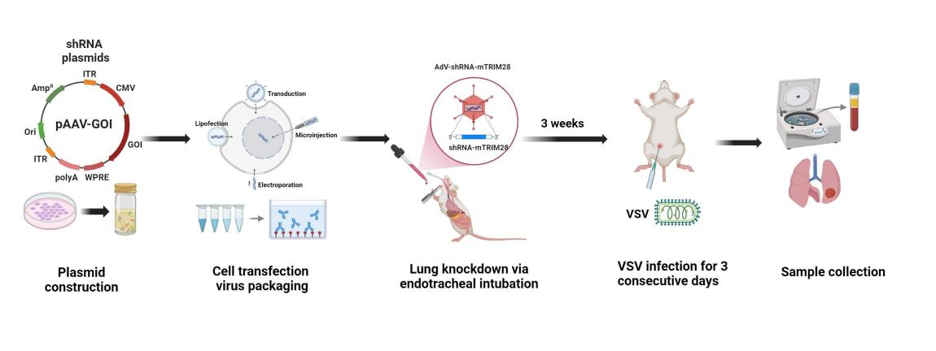
Figure 5. Experimental workflow for in vivo TRIM28 knockdown and VSV infection
Recombinant AAV6 vectors carrying TRIM28-targeting shRNA (rAAV6-shTRIM28) were constructed and packaged, followed by intratracheal instillation to achieve lung-specific TRIM28 knockdown. After a recovery period, mice were intraperitoneally infected with VSV for three consecutive days. Subsequently, lung tissues and serum samples were collected for analysis of antiviral responses, viral replication, and pathological changes.

4.9 Virus titer determination
Viral titers were determined by plaque assay as previously described[257], with slight modifications. Briefly, HEK293T cells were seeded in 6-well plates and allowed to reach approximately 90% confluency. Serial 10-fold dilutions of recovered VSV samples were prepared in DMEM and added to the cells, followed by incubation at 37 ℃ for 1 hour with gentle rocking every 15 minutes to facilitate viral adsorption. After infection, the inoculum was removed, and cells were overlaid with 1% low-melting-point agarose dissolved in DMEM supplemented with 2% FBS. Plates were incubated at 37 ℃ in 5% CO2 for 48 hours. After incubation, a second overlay containing 0.1% crystal violet in DMEM was added to stain the monolayer and visualize plaques. Plaques were counted manually, and viral titers were calculated as plaque-forming units per milliliter (PFU/mL).

4.10 Statistical Analysis
Data are presented as mean ± SD from at least three independent experiments, unless otherwise stated. Statistical analysis was performed using GraphPad Prism 8. Comparisons between groups were assessed using two-tailed unpaired Student’s t-test or one-way ANOVA, as appropriate. Statistical significance was defined as P < 0.05 (*), P < 0.01 (**), P < 0.001 (***).

Results

5.1 TRIM28 is upregulated in response to viral infection in THP-1
Transcriptome profiling of SeV-infected THP-1 cells revealed a broad remodeling of the TRIM family. Hierarchical clustering of RNA-seq data from three independent biological replicates showed that TRIM28 was among the most prominently upregulated members following SeV infection (Figure 6A), whereas several other TRIM genes displayed modest changes or downregulation, indicating a selective transcriptional response. These results were further validated by RT-qPCR analysis of representative TRIM genes(Figure 6B-C). Consistent with the RNA-seq data, TRIM28 expression was significantly increased at the mRNA level after SeV infection, while some TRIM members were downregulated . We next examined the temporal dynamics of TRIM28 expression. Both RT-qPCR and immunoblot analyses showed a clear time-dependent increase in TRIM28 mRNA and protein levels following SeV infection (Figure 6D-E), suggesting coordinated transcriptional and translational regulation. To determine whether this induction is virus-specific, THP-1 cells were infected with VSV. Similarly, VSV infection also induced a time-dependent upregulation of TRIM28 at both the mRNA and protein levels (Figure 6F-G), indicating that TRIM28 induction represents a conserved response to RNA virus infection. Collectively, these findings demonstrate that TRIM28 is dynamically upregulated upon viral infection in THP-1 cells, suggesting a potential role in antiviral innate immune regulation.
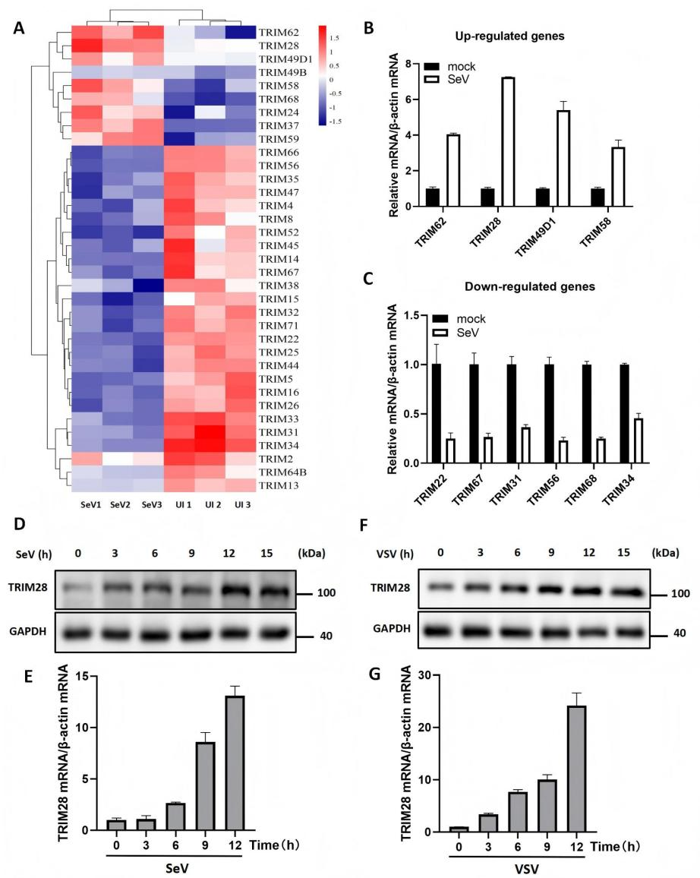
Figure 6. TRIM28 is upregulated in response to viral infection in THP-1
(A) Heatmap showing the differentially expressed TRIM family genes in THP-1 following the infection with SeV for 12 h, based on RNA sequencing data from three independent biological replicates (SeV1, SeV2, SeV3) and corresponding uninfected controls (UI1, UI2, UI3). (B-C) RT-qPCR validation of representative upregulated and downregulated TRIM genes after SeV infection. (D-E) Western blot and RT-qPCR analysis showing time-dependent upregulation of TRIM28 protein (D) and mRNA (E) following SeV infection. (F-G) Western blot and RT-qPCR analysis showing TRIM28 protein (F) and mRNA (G) expression kinetics in THP-1 after VSV infection.

5.2 TRIM28 overexpression suppresses antiviral and pro-inflammatory responses
To assess the effect of TRIM28 on antiviral responses, HEK293T cells were transfected with a Myc-tagged TRIM28 expression plasmid, and ectopic expression was confirmed by immunoblotting (Figure 7A). Following SeV infection, ELISA analysis showed that IFN-β secretion was reduced in TRIM28-overexpressing cells compared with vector control cells (Figure 7B). We next examined the effect of TRIM28 on the transcription of antiviral and inflammatory genes. Upon SeV stimulation, RT-qPCR analysis revealed that increasing levels of TRIM28 led to a gradual decrease in the mRNA expression of IFN-β, ISG15, ISG54, ISG56, and IL-1β (Figure 7C). In addition, time-course analysis showed that TRIM28 overexpression was associated with lower transcript levels of IFN-β and the indicated ISGs, as well as IL-1β, at multiple time points following SeV infection (Figure 7D). To further evaluate whether this effect extends to RNA mimic-induced responses, cells were stimulated with poly(I: C). Similar to SeV infection, increasing TRIM28 expression corresponded to reduced mRNA levels of IFN-β, ISG15, ISG54, ISG56, and IL-1β (Figure 7E).
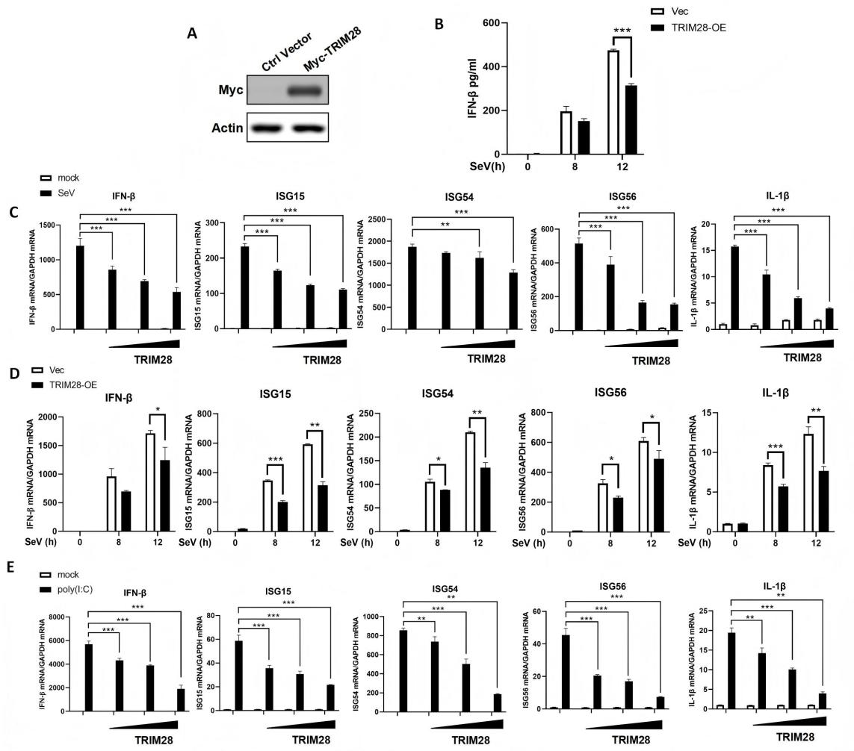
Figure 7. TRIM28 overexpression attenuates antiviral and proinflammatory gene expression
(A) Western blot showing ectopic expression of Myc-tagged TRIM28 in HEK293T cells transfected with empty vector (Vec) or TRIM28-expressing plasmid. (B) ELISA analysis of IFN-β secretion in TRIM28-overexpressing (TRIM28-OE) and Vec cells following SeV infection at the indicated time points. (C) RT-qPCR analysis showing the mRNA levels of IFN-β, ISG15, ISG54, ISG56, and IL-1β in HEK293T cells transfected with increasing amounts of TRIM28 plasmid after SeV infection. (D) Time-course analysis of IFN-β, ISG15, ISG54, ISG56, and IL-1β mRNA expression in TRIM28-OE and Vec cells following SeV infection, determined by RT-qPCR. (E) RT-qPCR analysis showing the mRNA levels of IFN-β, ISG15, ISG54, ISG56, and IL-1β in HEK293T cells transfected with increasing amounts of TRIM28 plasmid after poly (I: C) stimulation. Data are presented as mean±SD. Statistical significance was determined using two-tailed unpaired Student’s t-test; *P<0.05, **P<0.01, ***P<0.001.

5.3 TRIM28 knockdown enhances antiviral and pro-inflammatory responses
To further examine the role of TRIM28, loss-of-function experiments were performed in HEK293T cells using siRNA-mediated knockdown. Immunoblot analysis confirmed that TRIM28 protein levels were efficiently reduced by two independent siRNAs compared with the non-targeting control (Figure 8A). Following SeV infection, ELISA analysis showed that IFN-β secretion was increased in TRIM28-knockdown cells relative to control cells (Figure 8B). We next assessed the transcriptional responses of antiviral genes. Time-course RT-qPCR analysis revealed that TRIM28 knockdown led to elevated mRNA levels of IFN-β and the interferon-stimulated genes ISG15, ISG54, and ISG56 at multiple time points after SeV infection (Figure 8C). Similarly, the expression of pro-inflammatory cytokines was also affected. TRIM28-silenced cells exhibited increased IL-1β, IL-6 and TNF-α mRNA levels over time following SeV stimulation (Figure 8D). To determine whether this effect is conserved across different RNA viruses, HEK293T cells were infected with VSV. Consistent with the results observed in SeV infection, TRIM28 knockdown was associated with higher expression levels of IFN-β, ISGs, and Pro-inflammatory factors following VSV stimulation (Figure 8E).
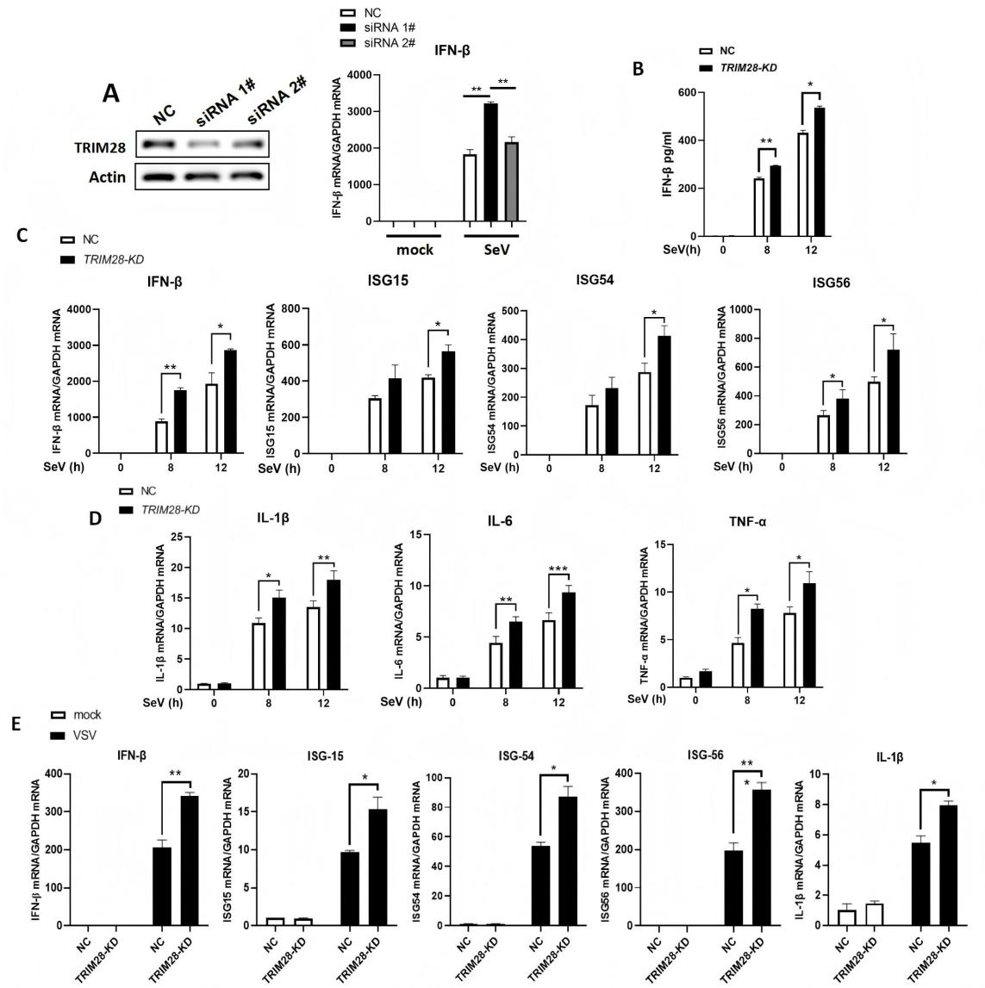
Figure 8. TRIM28 knockdown enhances antiviral and proinflammatory gene expression during RNA virus infection
(A, Left) Western blot showing knockdown efficiency of TRIM28 in HEK293T cells transfected with two independent siRNAs (siRNA 1# and siRNA 2#) or non-targeting control siRNA (NC). (A, Right) RT-qPCR analysis showing that TRIM28 knockdown enhances SeV-induced IFN-β mRNA expression, with siRNA 1# displaying a stronger effect. (B) ELISA quantification of IFN-β secretion in SeV-infected HEK293T cells transfected with siRNA 1# or NC. (C) Time-course analysis of IFN-β, ISG15, ISG54, ISG56, and IL-1β mRNA expression in TRIM28-knockdown (TRIM28-KD) and NC cells after SeV infection. (D) Time-course RT-qPCR analysis of IL-1β, IL-6 and TNF-α mRNA expression in TRIM28-KD and NC cells following SeV infection. (E) RT-qPCR analysis of IFN-β, ISG15, ISG54, ISG56, and IL-1β mRNA levels in TRIM28-KD and NC cells after VSV infection. Data are presented as mean±SD. Statistical significance was determined using two-tailed unpaired Student’s t-test; *P<0.05, **P<0.01, ***P<0.001.

5.4 TRIM28 promotes EV-71 replication
To evaluate the effect of TRIM28 on RNA virus replication, we examined its role in enterovirus EV-71 infection. RT-qPCR analysis showed that overexpression of TRIM28 increased EV-71 RNA levels at 12 and 24 h post-infection compared with vector control cells (Figure 9A). In contrast, siRNA-mediated knockdown of TRIM28 reduced viral RNA abundance (Figure 9B), indicating that TRIM28 positively regulates viral replication. We next assessed viral protein expression. Immunoblot analysis demonstrated that TRIM28 overexpression was associated with elevated levels of EV-71 3C and 3D proteins during infection (Figure 9C). Conversely, TRIM28 knockdown decreased the expression of these viral proteins at corresponding time points (Figure 9D). Together, these results indicate that TRIM28 facilitates EV-71 replication, as reflected by coordinated increases in both viral RNA and protein levels in infected cells.
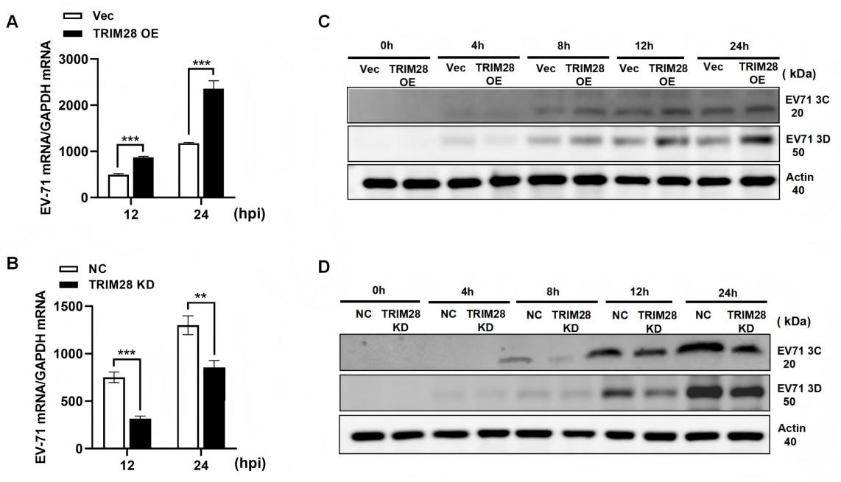
Figure 9. TRIM28 promotes the replication of EV-71
(A-B) RT-qPCR analysis of EV-71 RNA levels in cells transfected with Vec or TRIM28-overexpressing plasmid (A), and in cells transfected with NC or TRIM28-targeting siRNA (B), following EV-71 infection for the indicated times. (C-D) Western blot analysis of EV-71 3C and 3D protein expression in TRIM28-overexpressing (C) or TRIM28-knockdown (D) cells at the indicated time points post-infection. Data are presented as mean±SD. Statistical significance was determined using two-tailed unpaired Student’s t-test; **P<0.01, ***P<0.001.

5.5 TRIM28 promotes VSV replication
We next examined whether TRIM28 exerts a similar effect on VSV replication. Fluorescence microscopy revealed that TRIM28 overexpression markedly increased GFP signal intensity compared with control cells, indicating enhanced viral replication (Figure 10A). Consistently, immunoblot analysis showed elevated levels of VSV-GFP protein in TRIM28-overexpressing cells (Figure 10B), accompanied by a significant increase in viral titers as determined by plaque assay (Figure 10C). In contrast, TRIM28 knockdown markedly reduced GFP fluorescence intensity (Figure 10D), suggesting impaired viral replication. This reduction was further confirmed by decreased VSV-GFP protein levels detected by Western blot (Figure 10E) and lower viral titers (Figure 10F). Taken together, these results demonstrate that TRIM28 positively regulates VSV replication, as reflected by consistent changes in viral fluorescence, protein expression, and viral production.
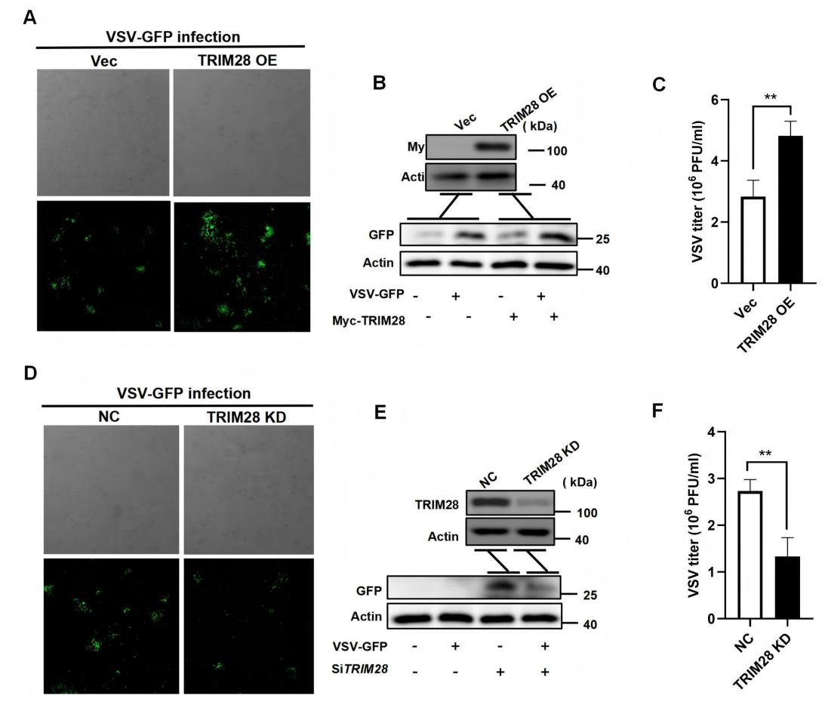
Figure 10. TRIM28 promotes the replication of VSV
(A and D) Fluorescence microscopy images showing VSV-GFP signal in TRIM28-overexpressing (E) or TRIM28-knockdown (H) HEK293T cells 12 hours after infection. (B and E) Western blot analysis of TRIM28 and VSV-GFP protein expression in TRIM28-overexpressing (F) or TRIM28-knockdown (I) cells following VSV-GFP infection. (C and F) Viral titration assays measuring VSV titers (PFU/mL) in control and TRIM28-overexpressing (C) or TRIM28-knockdown (F) cells. Data are presented as mean±SD. Statistical significance was determined using two-tailed unpaired Student’s t-test; **P<0.01.

5.6 TRIM28 knockdown enhances antiviral immunity and restricts viral replication in vivo

5.6.1 TRIM28 knockdown enhances systemic IFN responses and improves disease outcome
To evaluate the role of TRIM28 in antiviral responses in vivo, a TRIM28 knockdown model was established using AAV-mediated shRNA delivery. Immunoblot analysis confirmed efficient reduction of TRIM28 protein levels in lung tissues. Decreased TRIM28 expression was also detected in the spleen, liver, and colon (Figure 11A-D). Following intraperitoneal VSV infection, body weight changes were monitored over time. Compared with WT controls, TRIM28-knockdown mice exhibited less body weight loss, particularly at later time points post-infection (Figure 11E). Next, we assessed the systemic antiviral response by detecting interferon in serum. ELISA analysis showed that VSV infection induced the production of IFN-α and IFN-β in serum, and that the levels of IFN-α and IFN-β in TRIM28 knockdown mice were higher than those in the wild-type control group (Figure 11F).
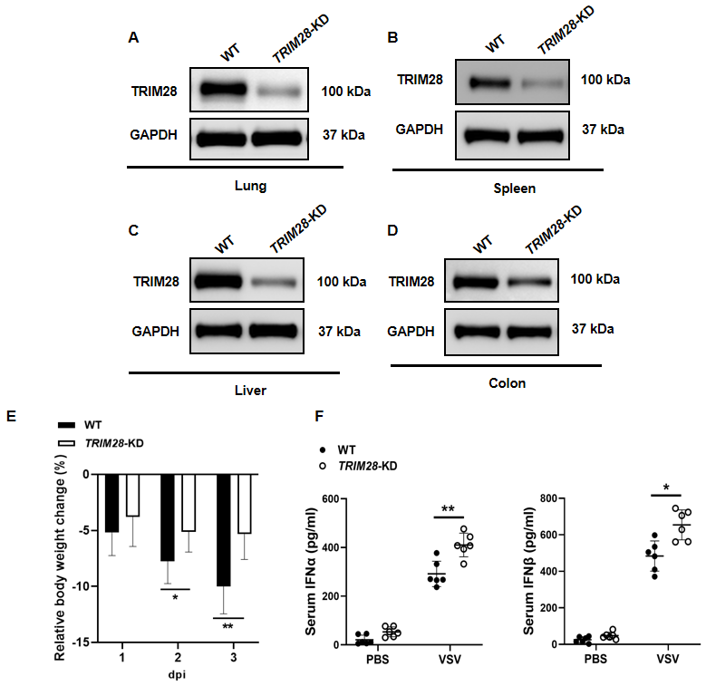
Figure 11. TRIM28 knockdown enhances systemic IFN responses and alleviates disease severity in vivo
(A-D) Western blot analysis showing TRIM28 protein levels in lung (A), spleen (B), liver (C), and colon (D) tissues from WT and TRIM28-knockdown mice. (E) Body weight changes in WT and TRIM28-knockdown mice following intraperitoneal VSV infection. (F) ELISA analysis of serum IFN-α and IFN-β levels in WT and TRIM28-knockdown mice after VSV infection. Data are presented as mean±SD. Statistical significance was determined using two-tailed unpaired Student’s t-test; *P<0.05, **P<0.01.

5.6.2 TRIM28 knockdown augments tissue antiviral responses
To further assess antiviral responses at the tissue level, we examined the expression of type I IFNs and ISGs in the lung and spleen following VSV infection. In the lung, RT-qPCR analysis showed that VSV infection induced the expression of Ifna4 and Ifnb1, which were further increased in TRIM28-knockdown mice compared with WT controls (Figure 12A-B). This enhancement was accompanied by a marked elevation in ISG expression, as the mRNA levels of ISG15, ISG54, and ISG56 were consistently higher in TRIM28-deficient mice (Figure 12C). We next analyzed antiviral responses in the spleen. Similar to the lung, TRIM28 knockdown resulted in increased expression of Ifna4 and Ifnb1 following VSV challenge (Figure 12D-E). In addition, the expression of ISG15, ISG54, and ISG56 was also elevated in the spleens of TRIM28-knockdown mice compared with WT controls (Figure 12F), indicating a consistent enhancement of antiviral gene expression across tissues.
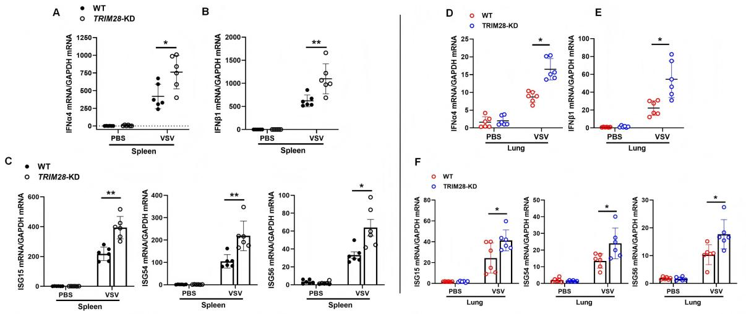
Figure 12. TRIM28 knockdown enhances tissue antiviral responses in vivo
(A) RT-qPCR analysis of Ifna4 and Ifnb1 mRNA levels in the lungs of WT and TRIM28-knockdown mice following VSV infection. (C) RT-qPCR analysis of ISG15, ISG54, and ISG56 mRNA levels in the lungs of WT and TRIM28-knockdown mice after VSV infection. (B) RT-qPCR analysis of Ifna4 and Ifnb1 mRNA levels in the spleens of WT and TRIM28-knockdown mice following VSV infection. (D) RT-qPCR analysis of ISG15, ISG54, and ISG56 mRNA levels in the spleens of WT and TRIM28-knockdown mice after VSV infection. Data are presented as mean±SD. Statistical significance was determined using two-tailed unpaired Student’s t-test; *P<0.05, **P<0.01.

5.6.3 TRIM28 knockdown reduces viral burden and lung pathology
To determine the impact of TRIM28 knockdown on viral replication in vivo, viral load in lung tissues was first assessed. RT-qPCR analysis showed that VSV RNA levels were lower in TRIM28-knockdown mice compared with WT controls following infection (Figure 13A). Consistently, immunoblot analysis revealed reduced expression of VSV-G protein in the lungs of TRIM28-deficient mice (Figure 13B), supporting reduced viral replication in TRIM28-deficient mice. We next examined lung pathology. Histological analysis showed that VSV infection induced marked inflammatory infiltration and disruption of alveolar architecture in WT mice. In contrast, TRIM28-knockdown mice exhibited relatively preserved lung structure with reduced inflammatory changes (Figure 13C). To further evaluate viral infection at the tissue level, immunofluorescence analysis of VSV-GFP signal was performed. Compared with WT mice, TRIM28-knockdown mice displayed reduced GFP fluorescence intensity in lung tissues following infection (Figure 13D).
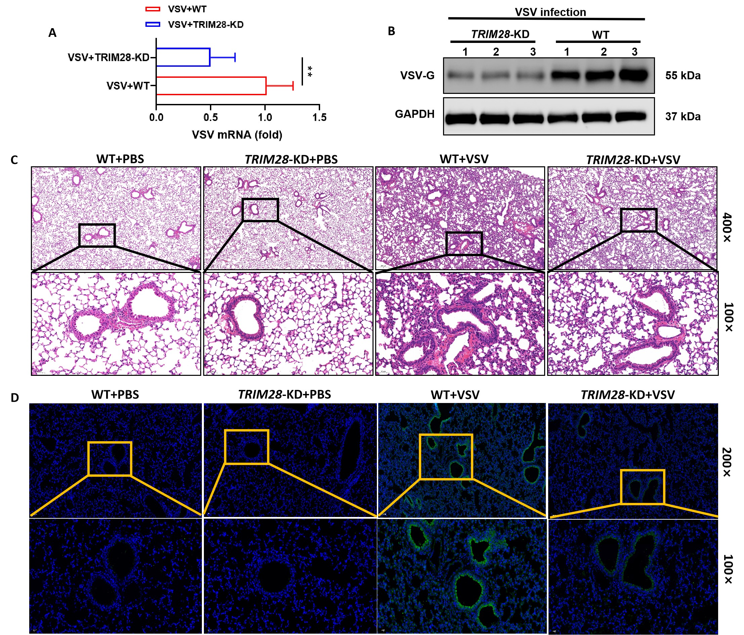
Figure 13. TRIM28 knockdown reduces viral burden and lung pathology in vivo
(A) RT-qPCR analysis of VSV RNA levels in the lungs of WT and TRIM28-knockdown mice following infection. (B) Western blot analysis of VSV-G protein expression in lung tissues from WT and TRIM28-knockdown mice. (C) Hematoxylin and eosin (H&E) staining of lung sections from WT and TRIM28-knockdown mice with or without VSV infection. Representative images are shown. (D) Immunofluorescence analysis of VSV-GFP signal in lung tissues from WT and TRIM28-knockdown mice. Representative images are shown. Data are presented as mean±SD. Statistical significance was determined using two-tailed unpaired Student’s t-test; **P<0.01.

Discussion
Type I interferon (IFN) responses represent a central defense mechanism against RNA virus infection, and their magnitude and duration are tightly controlled by multiple layers of negative regulatory factors[258]. While robust IFN activation is essential for viral clearance, excessive or prolonged responses can lead to tissue damage and inflammatory pathology[259]. Therefore, host cells often induce negative regulators to restrain the amplitude of innate immune responses. However, such regulatory mechanisms may also be exploited by viruses to attenuate host antiviral defenses[260].
TRIM28 has been widely characterized as a transcriptional co-repressor involved in chromatin remodeling and epigenetic regulation[255], yet its role in antiviral innate immunity remains incompletely understood. In the present study, we show that TRIM28 overexpression suppresses virus-induced type I IFN responses, whereas TRIM28 knockdown enhances IFN production and restricts RNA virus replication both in vitro and in vivo. These findings support a model in which TRIM28 dampens antiviral innate immune responses, thereby reducing host antiviral capacity and creating a more permissive environment for viral replication. Notably, this regulatory effect was consistently observed across multiple RNA viruses, suggesting that TRIM28 functions as a broad negative regulator of antiviral immunity.
Members of the TRIM protein family are broadly implicated in antiviral innate immunity[261], yet individual proteins exhibit considerable functional diversity during viral infection[255]. Transcriptomic analysis revealed that TRIM family members were differentially expressed following SeV infection in THP-1 cells, among which TRIM28 was one of the most strongly upregulated genes. This observation was further validated at both the mRNA and protein levels by RT-qPCR and immunoblotting. A similar induction pattern was also observed in VSV-infected cells, indicating that TRIM28 exhibits a consistent response to RNA virus infection. Previous studies have shown that many TRIM proteins act as antiviral restriction factors; for example, TRIM24 and TRIM33 have been reported to suppress viral replication[251], whereas the role of TRIM66 remains unclear. In contrast, TRIM28 appears to have a more complex role[262]. In addition to its well-established function in silencing endogenous retroelements[9], its involvement in antiviral signaling remains controversial, with studies reporting both inhibitory and promoting effects[255]. Collectively, these findings suggest that TRIM28 may not function as a classical restriction factor, but rather modulates antiviral responses indirectly through host signaling pathways. Furthermore, its context-dependent effects may be influenced by factors such as cell type, virus species, and infection stage[15], highlighting the complexity of its regulatory role.
Innate immune responses triggered by RNA viruses extend beyond interferon production and involve a coordinated transcriptional program comprising IFNs, ISGs, and inflammatory cytokines[263]. Functional analyses showed that TRIM28 overexpression markedly reduced IFN-β secretion and suppressed the transcription of IFN-β, ISG15, ISG54, ISG56, and pro-inflammatory cytokines such as IL-1β. These inhibitory effects were observed under both SeV infection and poly(I: C) stimulation, suggesting that TRIM28 interferes with RNA sensing–related signaling pathways. Conversely, siRNA-mediated knockdown of TRIM28 enhanced IFN production at multiple time points following viral infection, accompanied by increased expression of ISGs and inflammatory mediators. Importantly, modulation of TRIM28 expression directly translated into changes in viral replication efficiency. In EV-71 infection, TRIM28 overexpression promoted viral RNA accumulation and protein expression, whereas its knockdown produced the opposite effect. A similar pattern was observed in VSV infection, where TRIM28 enhanced viral replication, as reflected by increased GFP signal intensity, viral protein levels, and viral titers, while its depletion led to reduced viral replication. The consistency of these findings across different RNA viruses indicates that TRIM28 regulates a common host antiviral pathway rather than acting in a virus-specific manner.
Further analysis indicates that TRIM28 does not merely affect individual antiviral genes but exerts coordinated regulation over the broader antiviral signaling network[255]. Its simultaneous suppression of IFN production, ISG expression, and inflammatory cytokine transcription suggests that TRIM28 may function at a key regulatory node within the antiviral signaling cascade, thereby modulating the overall immune response at an upstream level[263]. In addition, the observation that similar effects occur upon poly(I:C) stimulation further supports the notion that TRIM28 targets RNA sensing pathways rather than virus-specific components. This broad regulatory capacity likely underlies its consistent impact on the replication of multiple RNA viruses.
The formation of effective antiviral responses in vivo depends not only on cell-intrinsic signaling events but also on coordinated immune regulation across multiple tissues and cell types[264]. Using an AAV-mediated knockdown mouse model, we further demonstrated the physiological relevance of TRIM28 in antiviral immunity. TRIM28 deficiency resulted in enhanced systemic IFN responses, as evidenced by increased serum levels of IFN-α and IFN-β following VSV infection. At the tissue level, TRIM28 knockdown led to elevated expression of type I IFNs and ISGs in both lung and spleen, indicating activation of antiviral responses across multiple organs. Consistent with these enhanced immune responses, TRIM28-deficient mice exhibited reduced viral burden, decreased viral protein expression, and alleviated lung pathology. These findings demonstrate that TRIM28-mediated immune suppression has direct functional consequences in vivo and significantly influences viral replication and disease progression.
Collectively, the in vivo data further support the role of TRIM28 as a regulator of antiviral immunity. Compared with in vitro systems, the in vivo environment involves complex interactions among multiple immune cell populations, suggesting that the enhanced IFN responses and reduced viral load observed in TRIM28-deficient mice reflect its broader role in systemic immune regulation. Moreover, the attenuation of lung pathology indicates that TRIM28 may also contribute to disease progression by modulating inflammatory responses. In summary, this study demonstrates that TRIM28 is induced upon RNA virus infection and functions as a negative regulator of antiviral innate immunity. By suppressing type I IFN responses and downstream ISG expression, TRIM28 promotes viral replication and enhances viral pathogenicity. These findings provide a functional framework for understanding the role of TRIM28 in virus–host interactions and lay the foundation for future studies investigating its underlying molecular mechanisms

Mechanistic insights into TRIM28-mediated regulation of MAVS and antiviral signaling

This chapter has been adapted from the article (Results 4-8):
Ruihua Xin, Wenshu Zou, Zhengying Qiu, Lina Huang, Xiaohan Jing, Qilin Huang, Zixiang Zhu, Jianxi Li, Mutien-Marie Garigliany. CRM1-dependent nuclear export of TRIM28 promotes MAVS K48-linked ubiquitination and suppresses RIG-I-mediated antiviral response. Frontiers in Immunology, 2026. 24 March 2026Do1 10.3389/fimmu.2026.1744833.

Foreword
The RIG-I-mediated signaling pathway plays a central role in antiviral innate immunity, as it senses RNA viruses and induces the production of IFNs. This pathway is tightly regulated to ensure effective antiviral responses while preventing excessive immune activation. Activation of the RIG-I–MAVS pathway triggers multiple downstream signaling cascades, including the TBK1-IRF3 axis that promotes type I interferon production, the IKK–NF-κB pathway that regulates inflammatory responses, and the IFN–JAK/STAT–ISRE axis responsible for the induction of ISGs. Therefore, regulation of this pathway can influence multiple layers of antiviral and inflammatory transcriptional programs. Among the various key regulatory mechanisms, ubiquitination has emerged as a critical determinant of signaling outcomes. Different types of ubiquitin linkages exert opposing effects: K63-linked ubiquitination promotes signal activation, whereas K48-linked ubiquitination facilitates protein degradation and signal termination. Although multiple TRIM family proteins have been identified as E3 ubiquitin ligases that regulate the RIG-I–MAVS axis, the precise mechanisms by which ubiquitination fine-tunes antiviral signaling remain incompletely understood. In the previous chapter, we demonstrated that TRIM28 negatively regulates antiviral innate immunity; however, its role as an E3 ubiquitin ligase in modulating the RIG-I signaling pathway warrants further investigation. In this chapter, we further explore the molecular mechanisms underlying this function of TRIM28, with a focus on its regulation of the RIG-I signaling pathway and the contribution of ubiquitination-dependent mechanisms.

Summary
This chapter elucidates the molecular mechanism by which TRIM28 regulates the RIG-I signaling pathway during RNA virus infection. We first demonstrate that TRIM28 suppresses activation of the RIG-I pathway by inhibiting the phosphorylation of the key signaling proteins TBK1 and IRF3, and by restricting the nuclear translocation of IRF3. Further analyses reveal that MAVS serves as a critical signaling node targeted by TRIM28. Specifically, TRIM28 directly interacts with MAVS and, upon viral infection, translocates from the nucleus to the cytoplasm to enable this interaction. This process depends on chromosome region maintenance 1 (CRM1)-mediated nuclear export, highlighting the importance of nucleocytoplasmic trafficking in TRIM28 function. In addition, TRIM28 promotes K48-linked ubiquitination of MAVS in an RBCC domain–dependent manner, thereby suppressing downstream antiviral signaling. Moreover, Lys136 and Lys461 on MAVS are identified as functionally relevant sites involved in TRIM28-mediated ubiquitination and signal inhibition.
Collectively, these findings establish a mechanistic framework in which virus-induced relocalization of TRIM28 enables its interaction with MAVS, leading to ubiquitin-dependent regulation of antiviral signaling. This work provides new insight into how TRIM28 integrates subcellular localization and post-translational modification to fine-tune innate immune responses during RNA virus infection.

Introduction
Activation of the RIG-I signaling pathway is a central event in host defense against RNA virus infection. Upon recognition of viral RNA, RIG-I engages the adaptor protein MAVS, which subsequently activates downstream kinases such as TBK1 and transcription factors including IRF3, ultimately leading to type I interferon production. The magnitude and duration of this signaling cascade are tightly controlled by multiple regulatory mechanisms, among which ubiquitination plays a critical role[265].
Previous studies have demonstrated that TRIM28 can modulate antiviral responses and influence viral replication[255]. In the preceding chapter, we established that TRIM28 acts as a negative regulator of type I interferon responses and promotes RNA virus replication both in vitro and in vivo. However, the molecular mechanisms underlying these effects remain unclear. In particular, it is not known at which level of the RIG-I signaling cascade TRIM28 exerts its regulatory function, nor how it mechanistically suppresses antiviral signaling.
Given that TRIM28 contains an N-terminal RBCC domain with E3 ubiquitin ligase activity and has been implicated in post-translational regulation of protein function[20], we hypothesized that TRIM28 may modulate antiviral signaling through ubiquitin-dependent mechanisms. In addition, considering its predominant nuclear localization under basal conditions, it is also important to determine whether viral infection induces subcellular redistribution of TRIM28, enabling it to access cytoplasmic signaling components.
In this chapter, we aim to elucidate the molecular mechanism by which TRIM28 regulates antiviral innate immunity. We first examine its impact on key signaling events downstream of RIG-I activation, including TBK1 and IRF3 phosphorylation and IRF3 nuclear translocation. We then identify MAVS as a critical regulatory target of TRIM28 and investigate the interaction between these proteins. Furthermore, we explore the role of virus-induced nucleocytoplasmic trafficking in facilitating this interaction and assess the contribution of TRIM28-mediated ubiquitination to the regulation of MAVS function. Finally, we define the structural requirements of TRIM28 and identify key ubiquitination sites on MAVS that are required for this regulatory process.

Materials and Methods

4.1 Cells and virus
Human embryonic kidney 293T (HEK293T) cells were kindly provided by Dr. Wei Zhang (Lanzhou Veterinary Research Institute, Chinese Academy of Agricultural Sciences, CAAS) and maintained in Dulbecco’s modified Eagle’s medium (DMEM; Gibco) supplemented with 10% fetal bovine serum (FBS; Gibco, USA), 100 U/mL penicillin, and 100 μg/mL streptomycin (Gibco). THP-1 human monocytic cells (ATCC TIB-202) were maintained in RPMI-1640 medium (Gibco) supplemented with 10% FBS, 100 U/mL penicillin, and 100 μg/mL streptomycin at 37℃ with 5% CO₂. SeV and VSV-GFP were also kindly provided by Dr. Wei Zhang (Lanzhou Veterinary Research Institute, CAAS).

4.2 Gene knockdown in HEK293T cells
Cells were transfected with a small interfering RNA (siRNA) targeting human TRIM28 (sense: 5′-AGGCAGAGAAAGCAGCCATT-3′; antisense: 5′-TGGCCTCTGTTCTGTGCCTTT-3′) using Lipofectamine RNAiMAX according to the manufacturer’s instructions. A commercially available non-targeting siRNA was used as a negative control.

4.3 CRISPR-Cas9-mediated genome editing
TRIM28-knockout (KO) HEK293T cells were generated using CRISPR/Cas9-mediated gene editing. Single-guide RNAs (sgRNAs) targeting the human TRIM28 gene were cloned into a lentiviral vector (pLVX-U6-CMV-Cas9-P2A-Puro), and lentivirus packaging and transduction were carried out in HEK293T cells. After puromycin selection (5 μg/mL for 4 days), single-cell clones were isolated and screened by Western blot to confirm TRIM28 deletion. The KO cells were cultured under the same conditions as wild-type HEK293T cells. All gene editing procedures and lentiviral production were performed by Xibaihongcheng Biotechnology Co., Ltd. (Beijing, China).

4.4 Antibodies
Primary antibodies against TRIM28 (KAP1, #15202-1-AP), GAPDH (#60004-1-Ig), β-actin (#66009-1-Ig), CRM1 (#66763-1-Ig), HSP60 (#15282-1-AP), Lamin B (#12987-1-AP), His-tag (#66005-1-Ig) were purchased from Proteintech (Wuhan, China). Ubiquitin (#3933S), K48-linked ubiquitin (#12805S), MAVS (#24930S), TBK1 (#38066S), phospho-TBK1 (#5483S), IRF3 (#4302S), phospho-IRF3 (#4947S), HA (#3724S), and c-Myc (#2276S) were obtained from Cell Signaling Technology (CST, USA). The anti-GFP antibody (#334077) was purchased from Abmart (Shanghai, China), and the anti-Flag antibody (A8592) from Sigma-Aldrich (USA). Mouse IgG isotype control (#A7028) was obtained from Beyotime Biotechnology (China). Fluorescent secondary antibodies, including goat anti-rabbit IgG (H+L) Alexa Fluor™ 488 (#A-11008) and goat anti-mouse IgG (H+L) Cyanine3 (#A10521), were purchased from Invitrogen (Thermo Fisher Scientific, USA). Unless otherwise specified, all primary antibodies were used at 1:1000 dilution for Western blotting (WB) and 1:100 for Immunofluorescence (IF) staining. For phosphorylation analyses, phospho-specific antibodies against TBK1 and IRF3 (p-TBK1 and p-IRF3) were used for immunoblotting.

4.5 Reagents
Polyinosinic-polycytidylic acid (poly I:C) was obtained from InvivoGen. Selinexor (KPT-330, HY-17536) was purchased from MedChemExpress (MCE, China). Proteasome inhibitor MG132 (HY-13259), protein A/G magnetic beads (41105507), and DAPI dihydrochloride (268298) were purchased from Merck. The reverse transcription kit (PrimeScript RT reagent kit, RR037A) and qPCR master mix (TB Green Premix Ex Taq II) were from Takara (Japan). The HE staining kit (C0105M) and anti-fade mounting medium (E675011) were from Beyotime Biotechnology (China). Lipofectamine RNAiMAX (13778075), Lipofectamine 2000 (L3000015), TRIzol reagent (15596026), Pierce™ ECL Western Blotting Substrate (32106), and culture media DMEM (high glucose) and RPMI-1640 were all obtained from Thermo Fisher Scientific (USA). Human (Cat# 414101) and mouse (Cat# 424001) IFN-β ELISA kits were also from Thermo Fisher Scientific / Invitrogen. The Dual-Luciferase® Reporter Assay System (E1960) was from Promega (USA). Fetal bovine serum (FBS, 10270), penicillin-streptomycin (15140-122), and GlutaMAX Supplement (35050-061) were obtained from Gibco (Thermo Fisher Scientific, USA). EndoFree Plasmid Maxi Kit and RNase A were purchased from Sangon Biotech (Shanghai, China). Non-fat dry milk (Cat# D8340) used for membrane blocking was obtained from Solarbio (Beijing, China). The SDS-PAGE gel preparation kit (125 gels) was from Epizyme (China).

4.6 Plasmids
HA-tagged expression plasmids for RIG-I, MDA5, TBK1, IRF3, IRF7, MAVS, as well as the luciferase reporter plasmids pGL4.32-NF-κB-luc, pGL4.32-IFN-β-luc, and pRL-TK were generously provided by Dr Shasha Li (Lanzhou Veterinary Research Institute, CAAS). Ubiquitin expression constructs, including His-tagged pcDNA3.1(+)-Ubiquitin (K6, K11, K27, K29, K33, K48, K63) and MAVS point mutants (K461R and K136R), along with TRIM28 expression vectors (pcDNA3.1-Myc-TRIM28), were purchased from the Public Protein/Plasmid Library (PPL, Biogot Technology, Nanjing, China). All plasmids were propagated in Escherichia coli DH5α competent cells (TransGen Biotech, China) and purified using the EndoFree Plasmid Maxi Kit (Sangon Biotech, China). Plasmid sequences were verified by Sanger sequencing prior to transfection.

4.7 TRIM28 truncation
Lentiviral vectors encoding N-terminal or C-terminal truncation mutants of TRIM28 were constructed and packaged by Xibaihongcheng Biotechnology Co., Ltd. (Beijing, China). HEK293T cells were transduced with lentiviruses according to the supplier's instructions. Briefly, cells were seeded at an appropriate density and incubated with lentiviral particles in the presence of 8 μg/mL polybrene. After 24 h, the culture medium was replaced, and puromycin (2 μg/mL) was added for the selection of successfully transduced cells. Stable cell populations were maintained under puromycin selection, and expression of TRIM28 truncation constructs was confirmed by Western blotting.

4.8 Co-immunoprecipitation (Co-IP)
Cells were lysed in IP lysis buffer (containing protease and phosphatase inhibitors) on ice for 30 minutes and centrifuged to remove debris. The supernatants were incubated with specific primary antibodies overnight at 4 ℃ with gentle rotation. The following day, Protein A/G magnetic beads (HY-K0202, MedChemExpress) were added to the mixtures and incubated for 2–4 hours at 4 ℃. Beads were then washed extensively with lysis buffer to remove nonspecific proteins. The immunoprecipitated complexes were eluted by boiling in SDS loading buffer and analyzed by SDS-PAGE and Western blotting.

4.9 Reverse transcription quantitative PCR (RT-qPCR)
Total RNA was extracted using TRIzol reagent according to the manufacturer’s instructions. RNA concentration and purity were assessed with a micro-volume spectrophotometer. cDNA was synthesized using the PrimeScript™ RT Reagent Kit. Quantitative PCR was performed using TB Green® Premix Ex Taq™ II on an Applied Biosystems real-time PCR system. Each 20 μL reaction contained qPCR master mix, gene-specific forward and reverse primers, cDNA template, and nuclease-free water. Gene expression levels were normalized to Actb and calculated using the 2^–ΔΔCt method. Primer sequences are listed in Table 5.
Table 5 Primer sequences
Genes | Forward (5’ – 3’ ) | Reversed (5’ – 3’ )
Human INF-β | GACATCCCTGAGGAGATTAAG | ATGTTCTGGAGCATCTCATAG
Human ISG15 | TGGACAAATGCGACGAACC | CCCGCTCACTTGCTGCTT
Human ISG54 | ACGGTATGCTTGGAACGATTG | AACCCAGAGTGTGGCTGATG
Human IL-1β | GGGATGATGACGACCTGCTA | GCTGTTGCTTGTCTCTCCTC
Human IL-6 | TGACCCAACCACAAATGC | AGGAACTCCTTAAAGCTGCG
Human TNF-α | AGAGGGAGAGAAGCAACTACA | GGGTCAGTATGTGAGAGGAAGA
Human GAPDH | CGGGAAGCTTGTGATCAATGG | GGCAGTGATGGCATGGACTG

4.10 Immunofluorescence and confocal microscopy
Cells were seeded on sterile coverslips in 24-well plates and cultured overnight. After the designated treatment or transfection, cells were washed with PBS and fixed with 4% cold paraformaldehyde for 10 min. Following three PBS washes, cells were permeabilized with 0.2% Triton X-100 for 5 min. Non-specific binding was blocked by incubating cells with 2% BSA in PBS containing 0.5% Tween-20 for 1 h at room temperature. Cells were then incubated with primary antibodies overnight at 4 ℃, followed by fluorophore-conjugated secondary antibodies for 2 h at room temperature in the dark. Nuclei were stained with DAPI (Sangon Biotech, China). Coverslips were mounted with Anti-Fade Mounting Medium (Beyotime) and imaged using a confocal microscope (Leica). Acquired images were processed using Fiji (ImageJ) software.

4.11 Co-IP and immunoblotting
Cells were lysed in RIPA buffer supplemented with protease and phosphatase inhibitors. For co-immunoprecipitation, whole-cell lysates were incubated with primary antibodies against the target proteins, followed by the addition of Protein A/G magnetic beads to pull down the immune complexes. Immunoprecipitates or whole-cell lysates were resolved by SDS-PAGE and transferred onto nitrocellulose membranes (Millipore). Membranes were probed with specific primary and HRP-conjugated secondary antibodies. Signal detection was performed using the Immobilon Western Chemiluminescent HRP Substrate (Millipore) and visualized with a Tanon imaging system. In some experiments, mitochondrial proteins were extracted using a mitochondrial isolation kit (C3601, Beyotime), and nuclear/cytoplasmic proteins were separated using a nuclear and cytoplasmic protein extraction kit (P0028, Beyotime), according to the manufacturer’s instructions, for immunoblotting analysis.

4.12 Ubiquitination assay
HEK293T cells were transfected with plasmids encoding HA-tagged MAVS, Myc-tagged TRIM28, and His-tagged ubiquitin (wild-type or mutants). Cells were lysed in RIPA buffer (50 mM Tris-HCl, pH 7.4, 150 mM NaCl, 1% NP-40, 0.5% sodium deoxycholate, 1 mM EDTA) supplemented with protease inhibitors and 20 mM N-ethylmaleimide (Sigma-Aldrich). After adding SDS to a final concentration of 1%, lysates were boiled at 100 ℃ for 5 min and then diluted to 0.1% SDS. The samples were precleared with Protein A/G magnetic beads and incubated with anti-HA antibody overnight at 4 ℃. Immunocomplexes were captured with Protein A/G magnetic beads, washed, eluted by boiling in SDS loading buffer, and analyzed by Western blotting using anti-His and other specific antibodies.

4.13 Statistical Analysis
Data are presented as mean ± SD from at least three independent experiments, unless otherwise stated. Statistical analysis was performed using GraphPad Prism 8. Comparisons between groups were assessed using two-tailed unpaired Student’s t-test or one-way ANOVA, as appropriate. Statistical significance was defined as P < 0.05 (*), P < 0.01 (**), P < 0.001 (***).

Results

5.1 TRIM28 modulates TBK1 and IRF3 phosphorylation upon SeV infection
To examine whether TRIM28 regulates RIG-I signaling, we analyzed the phosphorylation status of TBK1 and IRF3 in response to SeV infection. In HEK293T cells, overexpression of TRIM28 led to a reduction in SeV-induced phosphorylation of TBK1 and IRF3 across the indicated time points (Figure 14A). This effect was observed in a time-dependent manner following viral stimulation. In contrast, the total protein levels of TBK1 and IRF3 remained largely unchanged, suggesting that TRIM28 primarily affects their activation rather than overall protein abundance. Conversely, siRNA-mediated knockdown of TRIM28 resulted in enhanced phosphorylation of TBK1 and IRF3 compared with control cells upon SeV infection (Figure 14B). Increased levels of IFN-β protein were also detected under TRIM28-deficient conditions, consistent with the elevated activation of downstream signaling components.
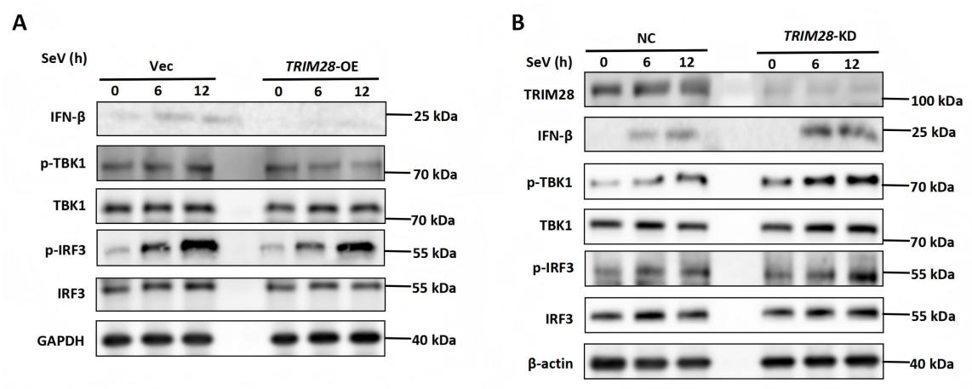
Figure 14. TRIM28 modulates TBK1 and IRF3 phosphorylation upon SeV infection
(A) Western blot analysis showing IFN-β expression and the phosphorylation levels of TBK1 and IRF3 in HEK293T cells transfected with empty vector (Vec) or TRIM28-expressing plasmid (TRIM28-OE) following SeV infection for the indicated time points. Total TBK1 and IRF3 levels are shown as controls. (B) Western blot analysis showing TRIM28 expression, IFN-β levels, and the phosphorylation status of TBK1 and IRF3 in HEK293T cells transfected with control siRNA (NC) or TRIM28-specific siRNA (TRIM28-KD) after SeV infection. β-actin was used as a loading control.

5.2 TRIM28 regulates TBK1 and IRF3 activation during VSV infection
To further determine whether TRIM28 exerts a similar regulatory effect during infection with other RNA viruses, we examined TBK1 and IRF3 activation following VSV infection. In HEK293T cells, overexpression of TRIM28 was associated with reduced phosphorylation of TBK1 following VSV stimulation (Figure 15A). A decrease in IRF3 phosphorylation was also observed, although the extent of this reduction was less pronounced compared with TBK1 (Figure 15A). This decrease was observed consistently over the course of infection, while total TBK1 and IRF3 protein levels remained largely unchanged, indicating that TRIM28 primarily affects the activation state of these signaling molecules. In contrast, siRNA-mediated knockdown of TRIM28 led to enhanced phosphorylation of TBK1 and IRF3 compared with control cells following VSV infection (Figure 15B). The increase in phosphorylation was evident at multiple time points, suggesting a sustained enhancement of signaling activation in the absence of TRIM28.

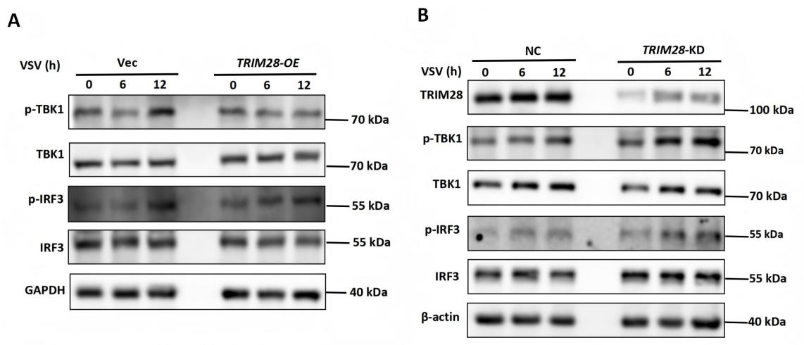
Figure 15. TRIM28 regulates TBK1 and IRF3 phosphorylation during VSV infection
(A) Western blot analysis showing the phosphorylation levels of TBK1 and IRF3 in HEK293T cells transfected with empty vector (Vec) or TRIM28-expressing plasmid (TRIM28-OE) following VSV infection for the indicated time points. Total TBK1 and IRF3 levels are shown as controls. GAPDH was used as a loading control. (B) Western blot analysis showing TRIM28 expression and the phosphorylation status of TBK1 and IRF3 in HEK293T cells transfected with control siRNA (NC) or TRIM28-specific siRNA (TRIM28-KD) after VSV infection. β-actin was used as a loading control.

5.3 TRIM28 regulates IRF3 nuclear translocation during VSV infection
To further assess the impact of TRIM28 on IRF3 activation, we examined IRF3 nuclear translocation following VSV infection using subcellular fractionation. In control cells, VSV infection induced a time-dependent increase in IRF3 levels within the nuclear fraction, accompanied by a corresponding decrease in the cytoplasmic fraction. In contrast, TRIM28 knockdown resulted in a further increase in nuclear IRF3 levels compared with control cells at the same time points (Figure 16). Correspondingly, cytoplasmic IRF3 levels were reduced in TRIM28-deficient cells, consistent with enhanced IRF3 translocation from the cytoplasm to the nucleus. This effect was more pronounced at later time points following infection. The purity of nuclear and cytoplasmic fractions was confirmed using Lamin B and GAPDH as markers, respectively.
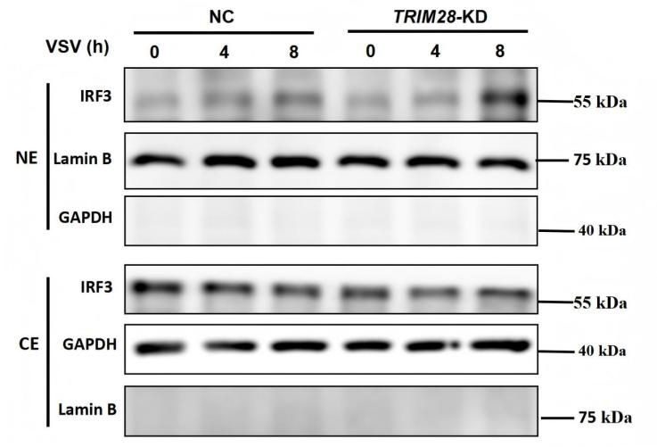
Figure 16. TRIM28 regulates IRF3 nuclear translocation during VSV infection
Western blot analysis of IRF3 distribution in nuclear (NE) and cytoplasmic (CE) fractions of HEK293T cells transfected with control siRNA (NC) or TRIM28-specific siRNA (TRIM28-KD) following VSV infection for the indicated time points. Lamin B and GAPDH were used as markers for nuclear and cytoplasmic fractions, respectively.

5.4 TRIM28 broadly suppresses RIG-I-mediated antiviral and inflammatory responses
To further evaluate the effect of TRIM28 on RIG-I-mediated innate immune signaling, dual-luciferase reporter assays were performed. HEK293T cells were transfected with TRIM28 expression plasmids or control vector and then stimulated with SeV. TRIM28 overexpression reduced IFN-β promoter activity. Similar effects were observed for NF-κB and ISRE reporter activities (Figure 17A). Immunoblotting confirmed the expression of exogenous TRIM28 in the transfected cells. We next examined the transcription of representative antiviral genes under the same conditions. RT-qPCR analysis showed that TRIM28 overexpression decreased the mRNA levels of IFNB1, ISG15, and ISG54 following SeV infection (Figure 17B). We then assessed the effect of TRIM28 on inflammatory gene expression. RT-qPCR analysis showed that the mRNA levels of TNF-α, IL-1β, and IL-6 were reduced in TRIM28-overexpressing cells (Figure 17C). Together, these results show that TRIM28 suppresses both antiviral and inflammatory gene expression downstream of RIG-I signaling.
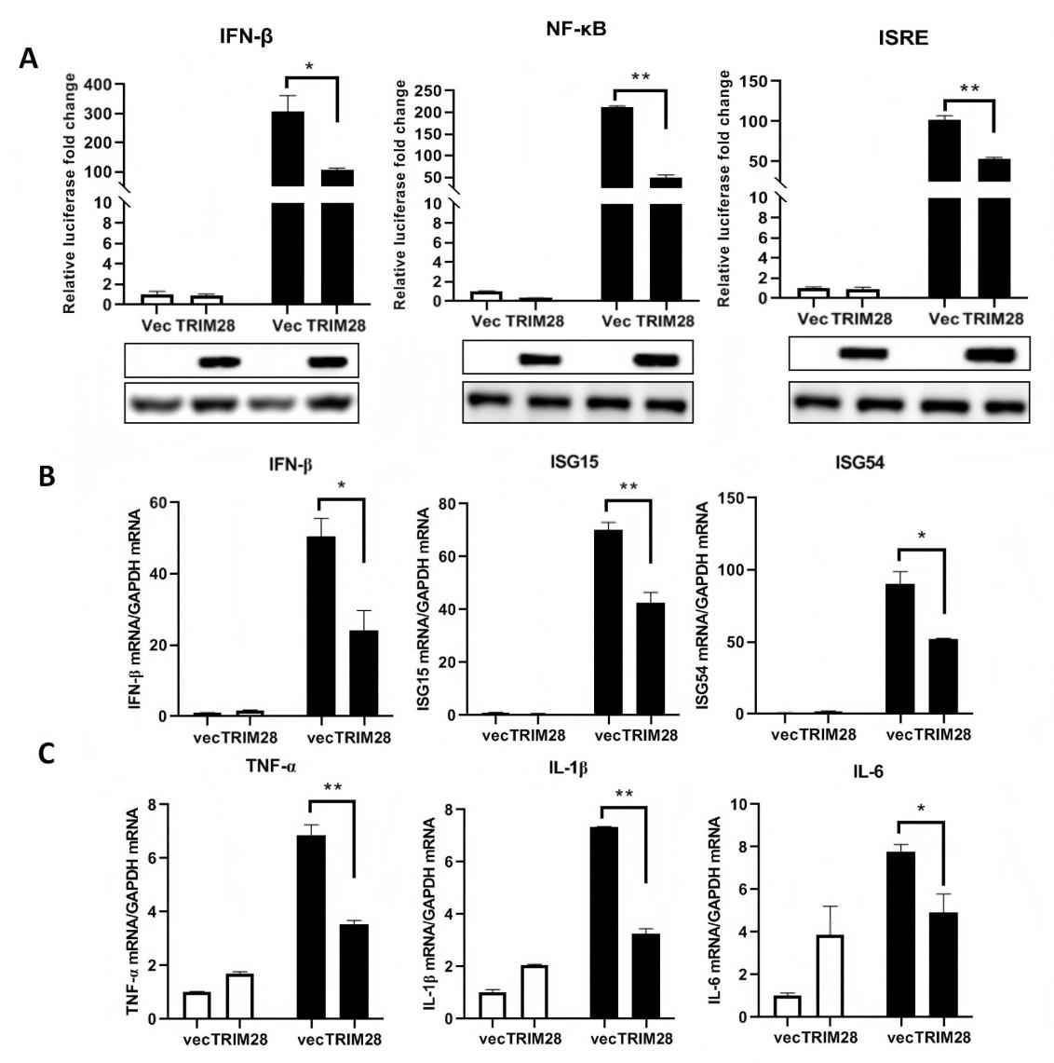
Figure 17. TRIM28 suppresses RIG-I-mediated antiviral and inflammatory responses
(A) HEK293T cells were transfected with TRIM28 expression plasmids or empty vector and stimulated with Sendai virus (SeV). IFN-β, NF-κB, and ISRE reporter activities were analyzed by dual-luciferase assays and normalized to Renilla luciferase. Immunoblotting was performed to confirm TRIM28 expression. (B) HEK293T cells were transfected with TRIM28 or control vector and infected with SeV. The mRNA levels of IFNB1, ISG15, and ISG54 were measured by RT-qPCR and normalized to GAPDH. (C) Cells were treated as in (B), and the mRNA levels of TNF-α, IL-1β, and IL-6 were analyzed by RT-qPCR. Data are presented as mean±SD. Statistical significance was determined using two-tailed unpaired Student’s t-test; *P<0.05, **P<0.01.

5.5 TRIM28 targets MAVS as a key regulatory node in the RIG-I signaling pathway
Given that TRIM28 broadly suppresses antiviral and inflammatory responses downstream of RIG-I signaling, we next sought to identify the specific signaling node targeted by TRIM28 within this pathway. To this end, we performed pathway mapping analysis using constitutively active components of the RIG-I signaling cascade. Overexpression of TRIM28 inhibited IFN-β promoter activation induced by RIG-I and MAVS, whereas activation driven by downstream signaling molecules, including TBK1, IRF3, and IRF7, was largely unaffected (Figure 18A). This pattern indicates that TRIM28 acts at the level of MAVS or upstream of it, but not at the level of downstream kinases or transcription factors. To further examine this, we assessed the effect of TRIM28 deficiency on RIG-I signaling. In contrast to overexpression, TRIM28 knockout enhanced IFN-β promoter activation in response to RIG-I and MAVS stimulation, while having minimal impact on TBK1-, IRF3-, or IRF7-mediated signaling (Figure 18B). The consistent effects observed in both gain- and loss-of-function conditions support a role for TRIM28 at the level of MAVS.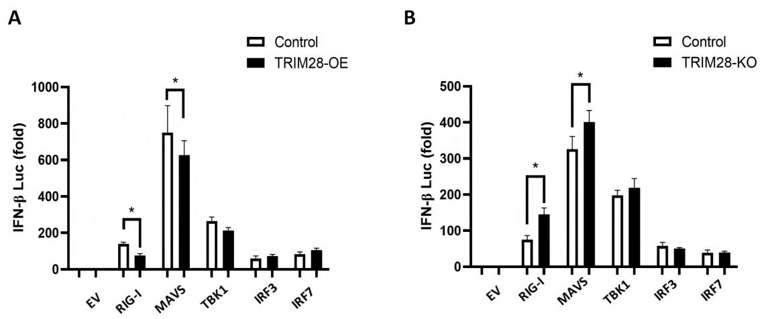
Figure 18. TRIM28 targets MAVS in the RIG-I signaling pathway
(A) HEK293T cells were co-transfected with the IFN-β luciferase reporter and expression constructs for RIG-I, MAVS, TBK1, IRF3, or IRF7, with or without TRIM28 overexpression. Luciferase activity was measured and normalized to Renilla luciferase. (B) HEK293T control or TRIM28 knockout cells were transfected with the IFN-β luciferase reporter together with expression constructs for RIG-I, MAVS, TBK1, IRF3, or IRF7. Luciferase activity was measured and normalized to Renilla luciferase. Data are presented as mean±SD. Statistical significance was determined using two-tailed unpaired Student’s t-test; *P<0.05.

5.6 TRIM28 specifically interacts with MAVS in the RIG-I signaling pathway
Having identified MAVS as the key regulatory node targeted by TRIM28 in the RIG-I signaling pathway, we next investigated whether TRIM28 physically associates with MAVS or other signaling components. To this end, co-immunoprecipitation (Co-IP) assays were performed in HEK293T cells co-expressing Myc-tagged TRIM28 and a panel of HA-tagged RIG-I pathway components. TRIM28 did not interact with RIG-I, MDA5, TBK1, IRF3, or IRF7 (Figure 14A), indicating that it does not broadly associate with upstream sensors or downstream signaling molecules. In contrast, TRIM28 showed a clear interaction with MAVS (Figure 19A), suggesting that MAVS is a binding partner of TRIM28 within this pathway. To further validate this interaction, reciprocal Co-IP assays were performed. Consistently, Myc-TRIM28 pulled down HA-MAVS, and HA-MAVS reciprocally co-precipitated with Myc-TRIM28 (Figure 19B), supporting the interaction between TRIM28 and MAVS. Importantly, to assess whether this interaction occurs under physiological conditions, endogenous Co-IP assays were conducted in VSV-infected cells. Endogenous TRIM28 was found to associate with MAVS, and this interaction was increased over the course of viral infection (Figure 19C), indicating that TRIM28–MAVS complex formation is dynamically regulated in response to viral challenge. Collectively, these results identify MAVS as a specific interaction partner of TRIM28 within the RIG-I signaling pathway and suggest that TRIM28 regulates antiviral signaling through MAVS. However, given their distinct subcellular localizations, how TRIM28 gains access to MAVS during viral infection remained unclear.
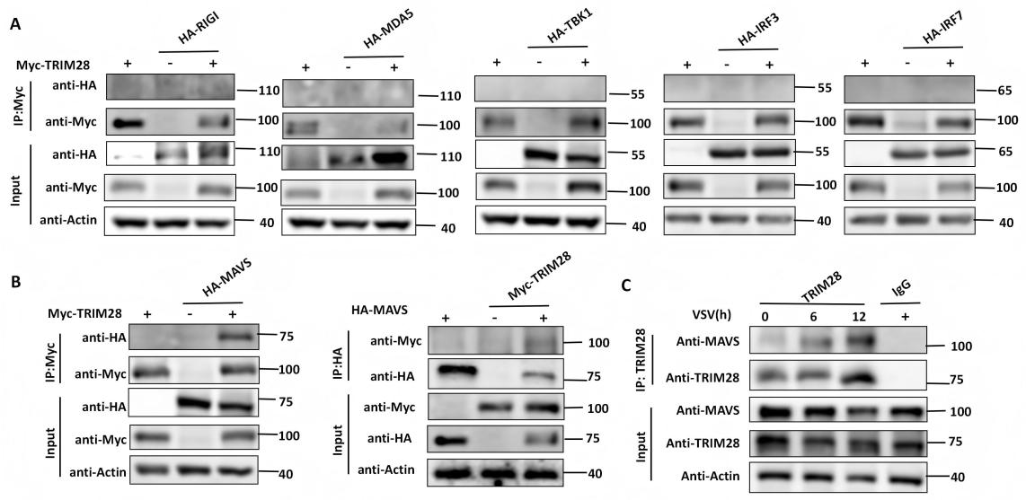
Figure 19. TRIM28 specifically interacts with MAVS
(A) HEK293T cells were co-transfected with Myc-tagged TRIM28 and HA-tagged RIG-I pathway components (RIG-I, MDA5, TBK1, IRF3, or IRF7). Cell lysates were subjected to immunoprecipitation with anti-Myc antibodies, followed by immunoblotting with anti-HA and anti-Myc antibodies. (B) Reciprocal co-immunoprecipitation assays were performed in HEK293T cells co-expressing Myc-TRIM28 and HA-MAVS. Cell lysates were immunoprecipitated with anti-Myc or anti-HA antibodies, followed by immunoblotting. (C) Endogenous co-immunoprecipitation assays were performed in VSV-infected cells at the indicated time points. Cell lysates were immunoprecipitated with anti-TRIM28 or anti-MAVS antibodies, followed by immunoblotting to detect endogenous interactions. Input samples are shown to verify protein expression. Data are representative of at least three independent experiments.

5.7 Viral infection induces nuclear export and cytoplasmic redistribution of TRIM28
Together with our previous observation that RNA virus infection induces TRIM28 expression and that TRIM28 negatively regulates antiviral innate immune responses, we next investigated how TRIM28 gains access to MAVS during viral infection. Although TRIM28 interacts with MAVS, TRIM28 is predominantly localized in the nucleus under basal conditions, whereas MAVS is mainly located on the outer mitochondrial membrane. Therefore, we examined whether viral infection induces changes in TRIM28 subcellular localization. Confocal microscopy showed that TRIM28 was mainly confined to the nucleus in unstimulated cells, as indicated by its co-localization with DAPI staining and minimal overlap with mitochondrial markers (Figure 20A). This distribution is consistent with its known role as a transcriptional co-regulator.
Upon VSV infection, however, TRIM28 redistributed from the nucleus to the cytoplasm (Figure 20B). A portion of TRIM28 was detected outside the nuclear compartment, showing a more diffuse and punctate cytoplasmic pattern, suggesting relocalization rather than passive diffusion. To further assess this redistribution, fluorescence intensity was analyzed to determine the relative proportion of TRIM28 in nuclear versus cytoplasmic compartments. As shown in Figure 20C, VSV infection resulted in decreased nuclear TRIM28 and a corresponding increase in cytoplasmic TRIM28, indicating a shift in subcellular localization. To further validate these observations, nuclear and cytoplasmic fractionation assays were performed. Consistent with the imaging results, TRIM28 levels were reduced in the nuclear fraction and increased in the cytoplasmic fraction following VSV infection (Figure 20D). Lamin B and actin were used as markers for nuclear and cytoplasmic fractions, respectively, confirming the quality of the fractionation. Collectively, these results show that RNA virus infection induces nuclear export and cytoplasmic redistribution of TRIM28, providing a basis for its interaction with cytosolic signaling components such as MAVS.
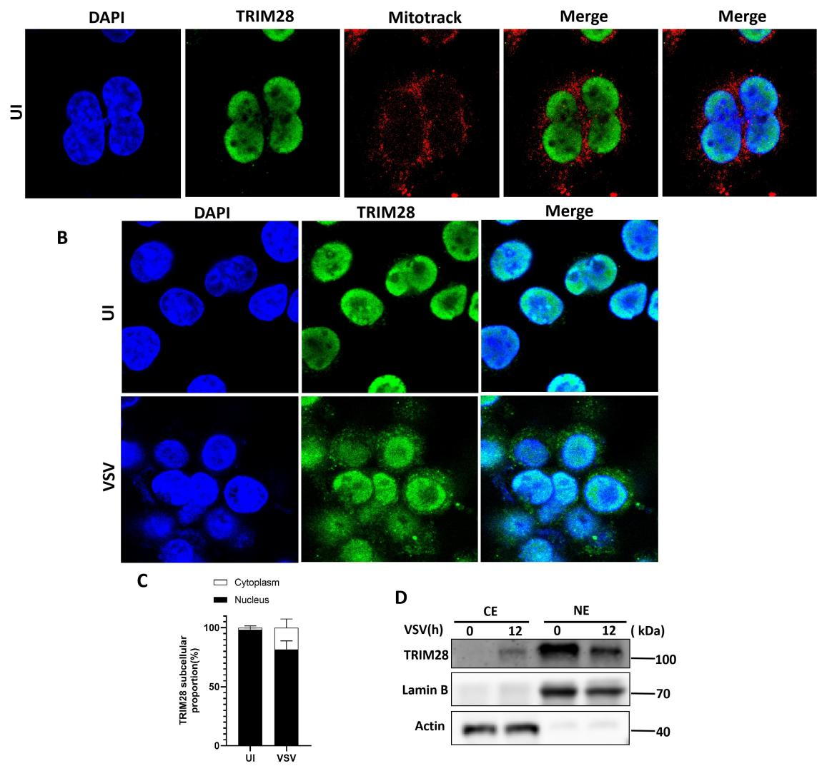
Figure 20. Viral infection induces nuclear export of TRIM28
- Confocal microscopy analysis of TRIM28 localization in unstimulated (UI) cells. Cells were stained with DAPI (blue), anti-TRIM28 antibody (green), and MitoTracker (red). Merged images show the subcellular distribution of TRIM28 relative to the nucleus and mitochondria. (B) Confocal microscopy showing TRIM28 localization in unstimulated (UI) and VSV-infected cells. TRIM28 redistributes from the nucleus to the cytoplasm upon viral infection. (C) Quantification of TRIM28 subcellular distribution based on fluorescence intensity. The relative proportion of TRIM28 in nuclear and cytoplasmic compartments was calculated. (D) Nuclear and cytoplasmic fractionation analysis of TRIM28 in cells infected with VSV for the indicated time points. Lamin B and actin were used as nuclear and cytoplasmic markers, respectively. Data are representative of at least three independent experiments.

5.8 CRM1-dependent nuclear export enables TRIM28 access to MAVS and its inhibitory function
Given that viral infection induces cytoplasmic redistribution of TRIM28, we next investigated whether this relocalization facilitates its interaction with MAVS. Confocal microscopy analysis revealed that, under basal conditions, TRIM28 and MAVS exhibited distinct subcellular distributions, with TRIM28 predominantly localized in the nucleus and MAVS confined to cytoplasmic mitochondrial structures. Upon VSV infection, however, TRIM28 was redistributed to the cytoplasm, where it partially co-localized with MAVS (Figure 21A), indicating that viral infection promotes spatial proximity between TRIM28 and MAVS. To explore the mechanism underlying TRIM28 nuclear export, we focused on CRM1, a key nuclear export receptor responsible for mediating the transport of proteins from the nucleus to the cytoplasm. Co-immunoprecipitation assays demonstrated that TRIM28 interacts with CRM1, and this interaction was enhanced upon VSV infection (Figure 21B), suggesting that CRM1 may mediate virus-induced TRIM28 translocation. To directly assess the role of CRM1 in this process, cells were treated with the specific CRM1 inhibitor KPT-330. Nuclear–cytoplasmic fractionation analysis showed that inhibition of CRM1 markedly impaired VSV-induced redistribution of TRIM28, resulting in increased retention of TRIM28 in the nuclear fraction and a concomitant reduction in the cytoplasmic fraction (Figure 21C). These findings indicate that TRIM28 nuclear export is largely dependent on CRM1 activity.
We next examined the functional consequence of blocking TRIM28 nuclear export. As expected, VSV infection induced IFN-β mRNA expression, which was significantly lower in wild-type cells compared to TRIM28-deficient cells. Notably, treatment with KPT-330 substantially reduced this difference, partially restoring IFN-β expression in wild-type cells (Figure 21D). This suggests that inhibition of CRM1-mediated nuclear export compromises the ability of TRIM28 to suppress antiviral signaling. Taken together, these results demonstrate that RNA virus infection triggers CRM1-dependent nuclear export of TRIM28, enabling its translocation to the cytoplasm where it can access MAVS and exert its inhibitory function on RIG-I–mediated antiviral responses.
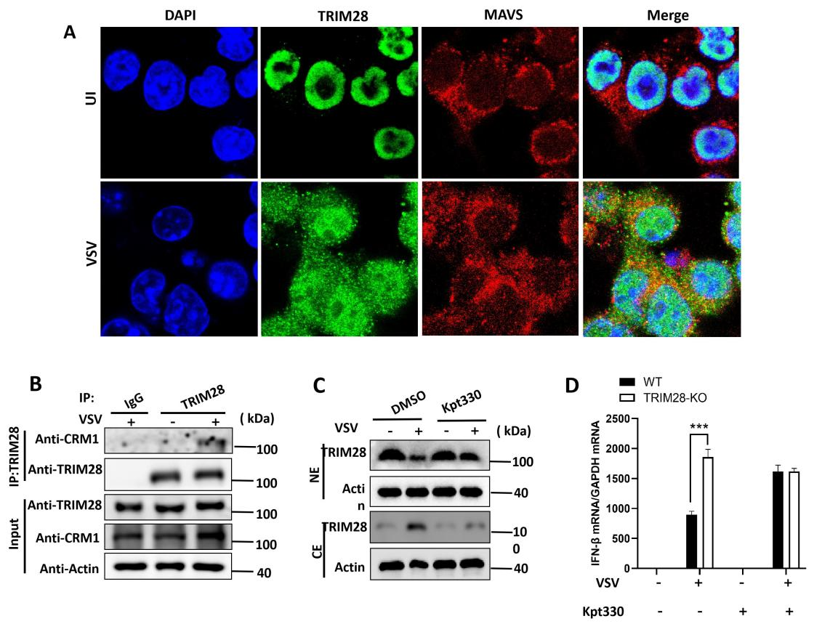
Figure 21. CRM1-dependent nuclear export facilitates TRIM28-mediated regulation of MAVS signaling
(A) Confocal microscopy analysis of TRIM28 and MAVS localization in unstimulated (UI) and VSV-infected cells. Cells were stained with DAPI (blue), TRIM28 (green), and MAVS (red). Merged images show partial co-localization of TRIM28 and MAVS upon viral infection. (B) Co-immunoprecipitation analysis of TRIM28 and CRM1 interaction in cells with or without VSV infection. Cell lysates were immunoprecipitated with anti-TRIM28 antibodies, followed by immunoblotting with anti-CRM1 antibodies. (C) Nuclear and cytoplasmic fractionation analysis of TRIM28 in cells treated with DMSO or the CRM1 inhibitor KPT-330 and infected with VSV. TRIM28 distribution in nuclear (NE) and cytoplasmic (CE) fractions was analyzed by immunoblotting. Actin was used as a loading control. (D) RT-qPCR analysis of IFN-β mRNA levels in wild-type and TRIM28 knockout cells treated with or without KPT-330 and infected with VSV. Gene expression was normalized to GAPDH. Data are presented as mean±SD. Statistical significance was determined using two-tailed unpaired Student’s t-test; ***P<0.001.

5.9 TRIM28 specifically promotes K48-linked polyubiquitination of MAVS
Given that TRIM28 contains a canonical N-terminal RBCC domain with E3 ubiquitin ligase activity, and that it directly interacts with MAVS, we next investigated whether TRIM28 regulates MAVS through ubiquitination. To determine the ubiquitin linkage specificity, HEK293T cells were co-transfected with HA-MAVS, Myc-TRIM28, and a series of ubiquitin mutants in which only a single lysine residue was retained to permit defined polyubiquitin chain formation. Co-immunoprecipitation followed by immunoblotting revealed that TRIM28 markedly enhanced MAVS ubiquitination in the presence of wild-type ubiquitin, and this effect was largely retained with the K48-only ubiquitin mutant (Figure 22A). In contrast, K63-linked ubiquitination of MAVS was only minimally affected, suggesting that TRIM28 preferentially promotes K48-linked polyubiquitin chain formation. To further exclude the involvement of other ubiquitin linkages, we systematically examined additional lysine-specific mutants (K6, K11, K27, K29, and K33). TRIM28 exhibited negligible effects on MAVS ubiquitination under these conditions (Figure 22B), confirming that its activity is highly selective for K48-linked ubiquitination. Given that K48-linked polyubiquitination is a well-established signal for proteasomal degradation, these findings strongly suggest that TRIM28 negatively regulates MAVS by promoting its K48-dependent ubiquitination, thereby potentially targeting MAVS for degradation and attenuating downstream antiviral signaling.
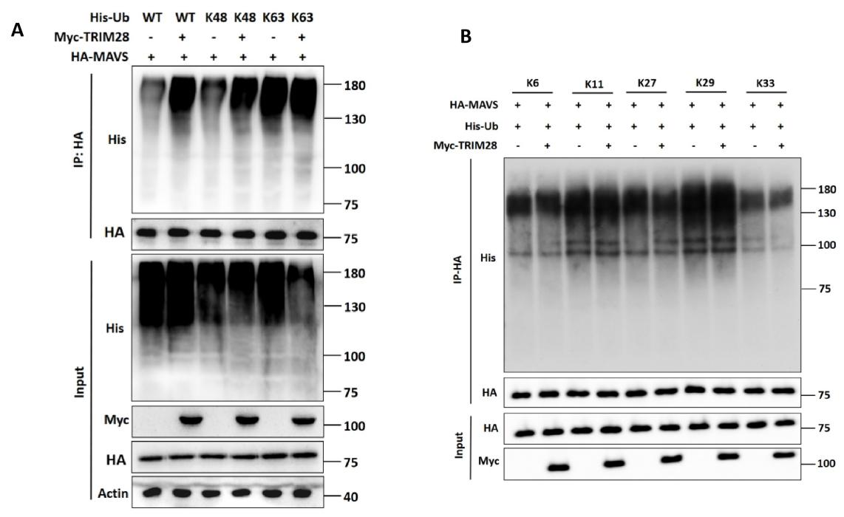
Figure 22. TRIM28 promotes K48-linked ubiquitination of MAVS
(A) HEK293T cells were co-transfected with HA-MAVS, Myc-TRIM28, and His-tagged ubiquitin (WT, K48-only, or K63-only). MAVS was immunoprecipitated using anti-HA antibodies, and ubiquitination levels were detected by immunoblotting with anti-His antibodies. Input controls are shown to verify protein expression. (B) HEK293T cells were co-transfected with HA-MAVS, Myc-TRIM28, and His-tagged ubiquitin mutants allowing only a single lysine linkage (K6, K11, K27, K29, or K33). MAVS ubiquitination was analyzed as in (A). Data are representative of at least three independent experiments.

5.10 The N-terminal RBCC domain of TRIM28 is required for MAVS ubiquitination and functional suppression of IFN signaling
To define the structural basis underlying TRIM28-mediated ubiquitination of MAVS, we generated TRIM28 truncation mutants lacking either the N-terminal RBCC domain (ΔN) or the C-terminal PHD-BROMO domain (ΔC) (Figure 23A). We first assessed the functional impact of these mutants on antiviral signaling. Dual-luciferase reporter assays showed that full-length TRIM28 robustly suppressed SeV-induced IFN-β promoter activation, whereas deletion of the N-terminal RBCC domain (ΔN) markedly impaired this inhibitory effect (Figure 23B). In contrast, the ΔC mutant largely retained its ability to suppress IFN-β reporter activity. Consistent with these findings, RT-qPCR analysis demonstrated that ΔN failed to effectively inhibit IFNB1 mRNA expression, whereas ΔC exhibited only a modest reduction in inhibitory capacity (Figure 23B). We next examined whether the RBCC domain is required for MAVS ubiquitination. Co-immunoprecipitation assays revealed that full-length TRIM28 efficiently promoted MAVS ubiquitination, whereas the ΔN mutant failed to do so (Figure 23C). These results indicate that the N-terminal RBCC domain is indispensable for TRIM28-mediated ubiquitination of MAVS. Taken together, these findings demonstrate that TRIM28 functions as an E3 ubiquitin ligase targeting MAVS, and that its N-terminal RBCC domain is essential for both MAVS ubiquitination and the suppression of downstream IFN-β signaling.
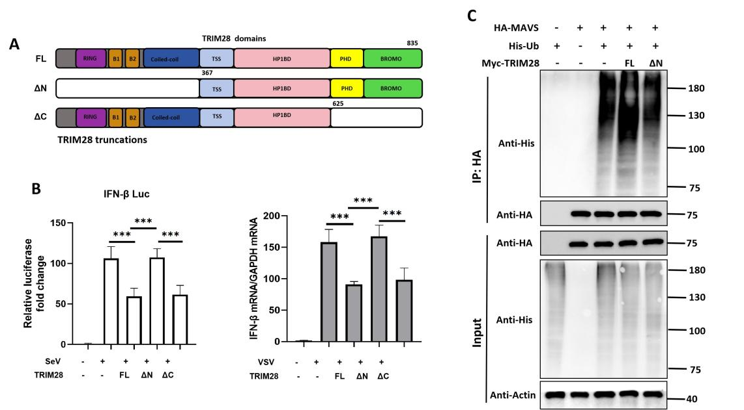
Figure 23. The RBCC domain of TRIM28 is required for MAVS ubiquitination and inhibition of IFN signaling
(A) Schematic representation of full-length (FL) TRIM28 and truncation mutants lacking the N-terminal RBCC domain (ΔN) or the C-terminal PHD-BROMO domain (ΔC). (B) HEK293T cells were transfected with IFN-β luciferase reporter constructs together with TRIM28 full-length or truncation mutants, followed by SeV infection. IFN-β promoter activity was measured by luciferase assay (left), and IFNB1 mRNA levels were quantified by RT-qPCR (right). (C) HEK293T cells were co-transfected with HA-MAVS, His-tagged ubiquitin, and either full-length or truncated TRIM28 constructs. MAVS ubiquitination was analyzed by co-immunoprecipitation and immunoblotting. Data are presented as mean±SD. Statistical significance was determined using two-tailed unpaired Student' s t-test; *P<0.05, **P<0.01, ***P<0.001.

5.11 MAVS K136 and K461 contribute to TRIM28-mediated ubiquitination and signaling repression
To identify potential ubiquitination sites on MAVS involved in TRIM28-mediated modification, we first conducted in silico prediction using the GPS-Uber algorithm. This analysis yielded several lysine residues with high prediction scores. Among them, K136 and K461 emerged as top-ranking candidates that had not been previously characterized. Based on their predicted scores and unexplored status, we selected these two sites for further validation. We next generated MAVS point mutants (K136R and K461R) to evaluate their roles in TRIM28-mediated regulation of antiviral signaling. Mutation of either residue (K136R or K461R) markedly attenuated TRIM28-mediated inhibition of IFN-β and NF-κB promoter activation (Figure 24A-B), indicating that these residues are functionally important for TRIM28-dependent repression. To determine whether these sites are involved in TRIM28-mediated ubiquitination, we conducted ubiquitination assays using a transient overexpression system. HEK293T cells were co-transfected with plasmids expressing TRIM28, wild-type or mutant MAVS, and His-tagged ubiquitin. The results showed that both K136R and K461R mutations significantly diminished K48-linked ubiquitination of MAVS compared to the wild-type control (Figure 24C-D). Collectively, these findings indicate that K136 and K461 contribute to TRIM28-mediated K48-linked ubiquitination of MAVS, which is important for TRIM28-mediated restraint antiviral signaling.

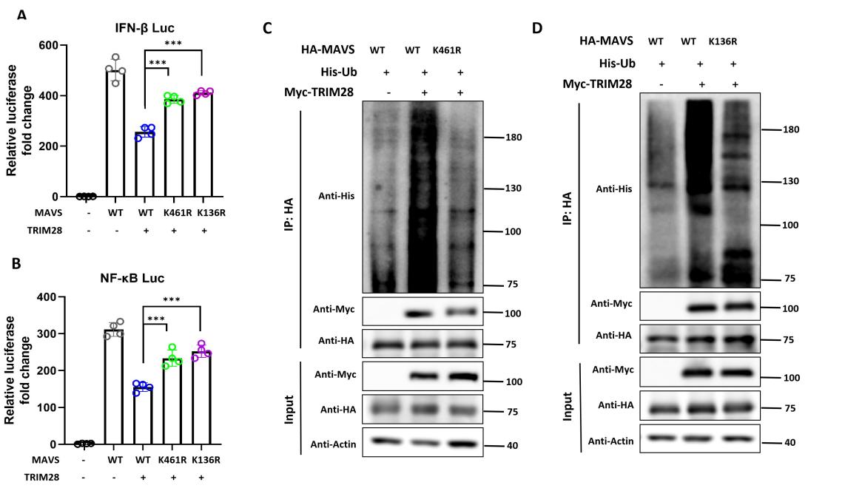
Figure 24. MAVS K136 and K461 is essential for TRIM28-mediate ubiquitination and suppression of antiviral responses
(A-B) HEK293T cells were co-transfected with wild-type or mutant MAVS (K136R or K461R), along with TRIM28, and subjected to dual-luciferase reporter assays to assess IFN-β (A) and NF-κB (B) promoter activity. TRIM28 significantly suppressed promoter activation induced by WT MAVS, but its inhibitory effect was attenuated in K136R- and K461R-expressing cells. (C-D) Ubiquitination assays were performed in HEK293T cells transfected with HA-tagged MAVS (WT or mutants), His-tagged ubiquitin, and Myc-tagged TRIM28. Cells were harvested for His pull-down, followed by immunoblotting with anti-His to detect ubiquitinated MAVS. Both K461R (C) and K136R (D) mutations markedly reduced TRIM28-mediated ubiquitination. *P<0.05, **P<0.01.

5.12 Structural modeling and docking analysis support the interaction between TRIM28 and MAVS
To further gain structural insight into the interaction between TRIM28 and MAVS, we performed in silico structural modeling and protein–protein docking analysis. The three-dimensional structure of MAVS was first predicted using a Boltz-2–based modeling approach. Evaluation of the predicted structure using a Ramachandran plot showed that the vast majority of residues were located within favored or allowed regions, indicating good stereochemical quality and structural reliability (Figure 25A). These results suggest that the predicted MAVS model is suitable for subsequent docking analysis. The overall structures of MAVS and TRIM28 used for docking are shown in Figure 25B.
We next performed protein-protein docking to explore the potential interaction interface between TRIM28 and MAVS. Among the top-ranked docking models, two representative models (model 1 and model 2) were selected for further analysis based on their favorable docking scores and structural plausibility. In model 1, MAVS was predicted to form multiple hydrogen bond interactions with TRIM28. Specifically, residues Lys362, Arg14, Glu463, and Ser94 of MAVS were involved in hydrogen bonding with Glu388, Arg27, Glu318, and Arg31 of TRIM28, respectively. In addition, a hydrophobic interaction was identified between MAVS Lys461 and TRIM28 residue Gln325 (Figure 25C), suggesting that this region contributes to the stabilization of the protein–protein interface. In model 2, a similar interaction pattern was observed. MAVS residues Lys136, Lys362, Cys133, and Asp105 were predicted to form hydrogen bonds with TRIM28 residues Lys340, Glu329, Arg347, and Lys366. Notably, MAVS Lys136 was also involved in hydrophobic interactions with TRIM28 residues Gln339 and Glu343 (Figure 25D), indicating that this residue may play a critical role in mediating TRIM28 binding. Importantly, the residues Lys136 and Lys461 of MAVS, which were experimentally identified as key ubiquitination sites, were located within or adjacent to the predicted TRIM28 interaction interface. This spatial consistency supports a model in which TRIM28 directly engages MAVS at ubiquitination-relevant residues, thereby facilitating its modification and subsequent functional regulation. Collectively, these structural and docking analyses provide complementary evidence supporting the direct interaction between TRIM28 and MAVS and further reinforce the mechanistic link between TRIM28 binding and MAVS ubiquitination observed in our experimental studies.
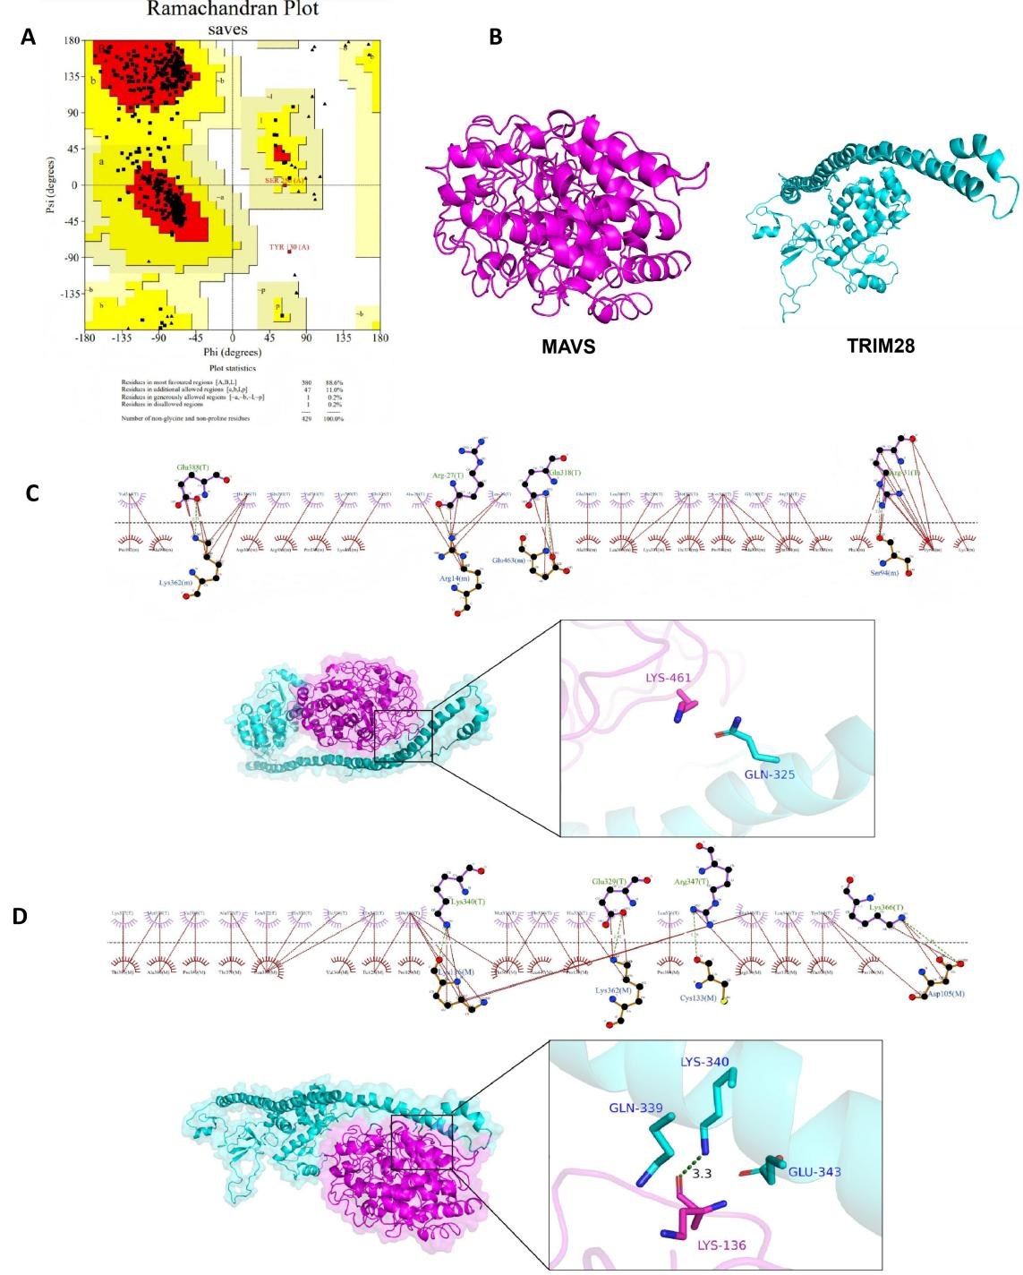
Figure 25. Structural modeling and docking analysis of the TRIM28-MAVS interaction
(A) Ramachandran plot of the predicted MAVS structure generated using the Boltz-2–based modeling approach. The majority of residues are located within favored and allowed regions, indicating good stereochemical quality and reliability of the predicted model. (B) Predicted three-dimensional structures of MAVS and TRIM28 used for docking analysis. MAVS is shown in magenta and TRIM28 in cyan. (C) Predicted interaction interface between TRIM28 and MAVS in docking model 1. Upper panel shows detailed interaction networks, including hydrogen bonds and hydrophobic contacts. Lower panel shows the overall docking conformation with a zoomed-in view highlighting the interaction between MAVS Lys461 and TRIM28 residue Gln325. (D) Predicted interaction interface in docking model 2. Upper panel illustrates hydrogen bond interactions between MAVS residues and TRIM28 residues. Lower panel shows the docking conformation with a magnified view highlighting interactions involving MAVS Lys136 and TRIM28 residues.

4 Discussion
TRIM28 has been reported to exert multifaceted roles in viral infection and host innate immunity[255]. Based on the findings presented in Chapter 3, TRIM28 overexpression suppresses virus-induced type I interferon (IFN) responses, whereas TRIM28 knockdown enhances IFN production and inhibits viral replication both in vitro and in vivo, indicating that TRIM28 functions as a negative regulator of RIG-I–mediated antiviral signaling. In the present chapter, mechanistic analyses further reveal that TRIM28 undergoes cytoplasmic translocation upon viral infection, where it interacts with MAVS and promotes its K48-linked ubiquitination, thereby attenuating the activation of downstream TBK1 and IRF3/7. Collectively, these findings support a model in which TRIM28 dampens MAVS-dependent signaling and acts as a negative regulator of antiviral innate immunity.
The RLR signaling pathway serves as a primary sensor of cytoplasmic viral RNA, particularly from RNA viruses, and plays a central role in initiating antiviral innate immune responses[266]. Upon recognition of viral RNA, RIG-I undergoes conformational activation and interacts with the mitochondrial adaptor protein MAVS, leading to the recruitment and activation of downstream kinases such as TBK1 and IKKε[267]. These kinases subsequently phosphorylate IRF3, promoting its dimerization and nuclear translocation, where it drives the transcription of type I interferons and ISGs. Disruption at any step of this signaling cascade can profoundly affect antiviral responses. In this study, we observed that TRIM28 negatively regulates the phosphorylation of TBK1 and IRF3 during both Sendai virus (SeV) and VSV infection. Overexpression of TRIM28 consistently attenuated TBK1 and IRF3 activation, whereas TRIM28 deficiency enhanced their phosphorylation and promoted downstream signaling. In addition, TRIM28 knockdown facilitated IRF3 nuclear translocation, further supporting its inhibitory role at the level of signal propagation. These findings indicate that TRIM28 not only functions at the transcriptional level but also directly modulates upstream signaling events controlling IRF3 activation. Given that TBK1 and IRF3 serve as key convergence points in antiviral signaling, this regulatory mode suggests that TRIM28 may exert broad inhibitory effects by targeting phosphorylation-dependent checkpoints within innate immune pathways[107].
MAVS acts as a central adaptor in the RIG-I signaling cascade and is localized on the outer mitochondrial membrane, where it integrates upstream RNA sensing signals and transduces them to downstream kinases[268]. Owing to its pivotal position, MAVS functions as a key signaling hub in antiviral innate immunity[269]. Through luciferase reporter assays, we found that TRIM28 selectively suppresses IFN-β activation driven by RIG-I and MAVS, while having minimal effects on signaling induced by downstream components such as TBK1, IRF3, or IRF7. This pattern was consistently observed in both TRIM28 overexpression and knockout systems, indicating that TRIM28 acts at or near the MAVS signaling node. These results identify MAVS as the primary regulatory target of TRIM28 within the RIG-I pathway. Given the central role of MAVS in amplifying antiviral signaling, even modest modulation at this level can result in pronounced downstream effects, thereby providing a mechanistic explanation for the broad suppression of IFN, ISG, and inflammatory gene expression observed in the phenotypic analyses[270].
Protein–protein interactions are fundamental to signal transduction and are particularly important for E3 ubiquitin ligases in recognizing and regulating their substrates[271]. To determine whether TRIM28 directly associates with components of the RIG-I pathway, we performed co-immunoprecipitation assays. Consistent with the pathway mapping results, TRIM28 specifically interacted with MAVS, but not with other signaling components such as RIG-I, MDA5, TBK1, or IRF3. This interaction was confirmed by both overexpression and endogenous Co-IP assays and was further enhanced upon viral infection. The specificity of this interaction indicates that TRIM28 selectively targets MAVS within the RIG-I pathway. Moreover, the infection-dependent enhancement of this interaction suggests that TRIM28-mediated regulation is dynamically engaged during antiviral responses, rather than constitutively active under basal conditions.
Subcellular localization is a critical determinant of signaling specificity, particularly for pathways such as RIG-I–MAVS that are spatially organized across different cellular compartments[272]. Under basal conditions, TRIM28 is predominantly localized in the nucleus, whereas MAVS is anchored to the mitochondrial outer membrane. Our data demonstrate that viral infection induces a marked redistribution of TRIM28 from the nucleus to the cytoplasm, as confirmed by both confocal microscopy and biochemical fractionation. This relocalization provides a spatial basis for the interaction between TRIM28 and MAVS, enabling TRIM28 to access cytoplasmic signaling complexes and directly regulate MAVS-dependent signaling. Nuclear export of regulatory proteins is commonly mediated by CRM1-dependent transport, which coordinates communication between nuclear and cytoplasmic signaling pathways[273]. In this study, we found that TRIM28 interacts with CRM1 and that inhibition of CRM1 activity significantly impairs TRIM28 cytoplasmic redistribution. Importantly, blocking nuclear export also attenuated the ability of TRIM28 to suppress IFN-β expression. These findings indicate that CRM1-dependent nuclear export is required for TRIM28-mediated regulation of antiviral signaling, suggesting that nucleocytoplasmic trafficking functions as a regulatory switch controlling TRIM28 activity during viral infection[274].
Post-translational modifications play a central role in regulating innate immune signaling, among which ubiquitination represents a key mechanism controlling MAVS activity[275]. Different ubiquitin linkages confer distinct functional outcomes: K63-linked ubiquitination is generally associated with signal activation, whereas K48-linked ubiquitination typically targets proteins for proteasomal degradation[276]. In the context of MAVS, these modifications critically influence its stability and signaling capacity[277]. Our results show that TRIM28 specifically promotes K48-linked polyubiquitination of MAVS, with minimal effects on other ubiquitin linkage types. This suggests that TRIM28 negatively regulates MAVS by facilitating its degradation. This mechanism is consistent with the observed suppression of downstream signaling and provides a direct molecular explanation for how TRIM28 attenuates antiviral responses at the protein level. Notably, another member of the TIF1 family, TRIM24, has been reported to promote antiviral responses by mediating K63-linked ubiquitination of TRAF3, thereby activating RIG-I signaling[278].
The E3 ubiquitin ligase activity of TRIM proteins is typically mediated by the N-terminal RBCC domain, which is essential for substrate recognition and ubiquitin transfer[279]. Using truncation mutants, we demonstrated that deletion of the RBCC domain abolishes TRIM28-mediated MAVS ubiquitination and significantly impairs its ability to suppress IFN signaling, whereas deletion of the C-terminal region has a relatively minor effect. These findings confirm that TRIM28 functions as an E3 ubiquitin ligase targeting MAVS and highlight the RBCC domain as the structural basis for its regulatory activity. Furthermore, identification of specific ubiquitination sites is critical for understanding substrate regulation and signaling specificity. In this study, we identified Lys136 and Lys461 of MAVS as key residues required for TRIM28-mediated ubiquitination. Mutation of either site significantly reduced K48-linked ubiquitination and attenuated TRIM28-dependent suppression of IFN signaling. Notably, these residues may not only serve as ubiquitin acceptor sites but may also contribute to conformational regulation or signalosome assembly of MAVS. [280]; thus, modification at specific sites may influence protein stability and protein–protein interactions, thereby modulating its signaling output. These findings refine the molecular mechanism by linking TRIM28 enzymatic activity to defined substrate residues.
Therefore, this study systematically elucidates the molecular mechanism by which TRIM28 regulates antiviral innate immunity at multiple levels, including signaling pathway positioning, protein–protein interaction, subcellular localization, and post-translational modification. Our results demonstrate that TRIM28 undergoes infection-induced nuclear export and accumulates in the cytoplasm, where it specifically recognizes MAVS and, through its RBCC domain-dependent E3 ligase activity, promotes K48-linked ubiquitination and degradation of MAVS. This process ultimately suppresses activation of the TBK1–IRF3 signaling axis and negatively regulates type I IFN responses. This mechanism not only identifies TRIM28 as a key regulatory node within the RIG-I pathway but also expands current understanding of MAVS regulation at the level of ubiquitination[274]. Given that MAVS activity is tightly controlled by multiple ubiquitin modifications, TRIM28-mediated K48-linked ubiquitination provides new insight into the balance between activation and termination of antiviral signaling. In addition, our findings suggest that the function of TRIM28 extends beyond its classical role as a nuclear transcriptional co-repressor and involves dynamic relocalization and cytoplasmic activity during viral infection[274], which may underlie its diverse regulatory roles in different biological contexts.
In summary, this study establishes a mechanistic model in which TRIM28 regulates antiviral signaling through a “nuclear export–MAVS targeting–ubiquitin-mediated degradation” axis, providing a conceptual framework for understanding virus–host interactions and the regulation of innate immune responses.

Discussion and conclusion

Implications of the multiple roles of TRIM28 in viral infection for the present study
TRIM28 was initially characterized as a transcriptional corepressor mainly localized in the nucleus, and its classical functions are closely associated with chromatin remodeling and epigenetic silencing[6]. By forming complexes with KRAB-ZFPs, TRIM28 recruits chromatin-modifying factors such as SETDB1, HP1, and NuRD, thereby establishing an H3K9me3-enriched heterochromatin environment and repressing transcriptional activity at specific genomic loci[7]. In virology, one of the earliest reasons why TRIM28 attracted attention was its key role in the silencing of ERVs. ERVs are viral sequences derived from ancient retroviral infections that became integrated into the host genome and now constitute part of the host genomic landscape. By maintaining the transcriptional silencing of ERVs, TRIM28 plays an important role in preserving genome stability and contributing to host defense[20].
Beyond its classical role in transcriptional regulation, increasing evidence indicates that TRIM28 is also involved in virus–host interactions during infection by various exogenous viruses[255]. Compared with its well-defined function in ERV silencing, the role of TRIM28 in exogenous viral infection appears to be more complex. Previous studies have shown that TRIM28 can regulate retroviral transcription through its classical heterochromatin-mediated silencing mechanism[16, 17], including in HIV-1[18, 20] and murine leukemia virus (MLV)[21, 22]. However, its function during exogenous retroviral infection remains somewhat controversial. On the one hand, TRIM28 can suppress viral transcription by promoting heterochromatin formation and maintaining viral latency; on the other hand, some studies suggest that TRIM28 may participate in viral persistence or immune evasion. In RNA virus infection, TRIM28 also shows diverse roles. For example, TRIM28 can enhance SARS-CoV-2 virion assembly and immune evasion by promoting SUMOylation of the nucleocapsid protein[31], support porcine epidemic diarrhea virus (PEDV) replication in a RING domain-dependent manner[246], and promote PRRSV replication by preventing ubiquitination of the GP4 glycoprotein[221]. These findings indicate that the function of TRIM28 in viral infection is highly context-dependent and is influenced by multiple factors, including virus type, infection stage, and the host cellular environment. Therefore, TRIM28 cannot be simply classified as a classical antiviral restriction factor, but is more likely to act as a regulatory molecule that modulates virus–host interactions and the outcome of antiviral responses.
This background suggests that, in the context of RNA virus infection, the role of TRIM28 should not be considered only in terms of its effects on individual viral proteins or specific steps of viral replication. It is also necessary to consider whether TRIM28 participates in the regulation of host antiviral signaling networks. For acute RNA virus infection, viral RNA recognition mediated by RLRs and the downstream MAVS-dependent type I interferon response are central mechanisms that determine the strength of early antiviral defense and the outcome of infection[281]. Meanwhile, activation and termination of the RIG-I-MAVS pathway are highly dependent on ubiquitination[282], and TRIM family members represent an important group of E3 ubiquitin ligases involved in this process[283, 284]. Previous studies have shown that TRIM proteins such as TRIM25[285], TRIM4[286], and TRIM31[287, 288] can affect antiviral signaling output by regulating the ubiquitination status of RIG-I or MAVS. Since TRIM28 also belongs to the TRIM family and contains a conserved RBCC structural module and RING-associated E3 ligase activity[289], while also showing context-dependent regulatory effects in multiple RNA virus infections, it is reasonable to hypothesize that TRIM28 may also participate in the regulation of RIG-I-MAVS-mediated innate immune responses.
Based on these considerations, this study first examined whether TRIM28 affects RNA virus-induced type I interferon responses, and further analyzed whether its effect is related to the RIG-I-MAVS signaling axis. By placing TRIM28 in the context of RNA virus infection and RLR-mediated innate immune regulation, this study aims to provide new mechanistic clues for understanding the complex functions of TRIM28 in viral infection.

Ubiquitination regulation in the RIG-I pathway and TRIM family-mediated innate immune modulation
After RNA virus infection, the host mainly relies on the RLR-mediated innate immune pathway to recognize viral RNA and rapidly induce type I interferon production. As one of the core innate immune defense mechanisms during RNA virus infection, the activation strength and duration of the RIG-I signaling pathway directly determine the efficiency of the host antiviral response and the outcome of infection[281]. After recognizing viral RNA, RIG-I undergoes conformational activation, exposing its N-terminal CARD domains, which are essential for downstream signal transduction. Activated RIG-I then interacts with the mitochondrial adaptor protein MAVS to form a signaling platform and recruit kinases such as TBK1 and IKKε. These kinases further phosphorylate IRF3, promoting its dimerization and nuclear translocation, and ultimately driving the transcription of type I interferons and ISGs[290].
Notably, RIG-I-mediated innate immune signaling does not depend only on changes in the expression of key proteins, but is highly dependent on post-translational regulation, especially ubiquitination[291, 292]. In addition, the function of ubiquitination largely depends on the type of ubiquitin chain. In general, K63-linked ubiquitination often acts as a non-degradative signaling modification and participates in protein interactions, signaling complex assembly, and downstream signal amplification; by contrast, K48-linked ubiquitination is usually associated with proteasome-dependent degradation and participates in limiting sustained signal activation and promoting signal termination[293, 294]. Therefore, different types of ubiquitin chain modifications not only determine the formation of the RIG-I-MAVS signaling complex, but also directly affect the activation strength, duration, and termination of antiviral signaling[295]. On this basis, multiple TRIM family members have been shown to function as E3 ubiquitin ligases and participate in the ubiquitination regulation of key protein targets in the RLR pathway[296]. Because different TRIM proteins act on different signaling nodes and mediate different types of ubiquitin chains, their effects on the RLR pathway are not completely consistent[297]. Therefore, TRIM proteins are not only antiviral effector molecules, but may also participate in limiting excessive immune activation and maintaining innate immune homeostasis. This bidirectional regulatory feature helps establish antiviral defense rapidly while avoiding excessive or persistent inflammatory responses.
During RIG-I activation, several TRIM family members participate in its ubiquitination regulation. TRIM25 is one of the more extensively studied E3 ubiquitin ligases in RIG-I signal transduction. Its SPRY domain can interact with RIG-I and promote K63-linked polyubiquitination at Lys172 in the CARD domain of RIG-I, thereby promoting CARD oligomerization and enhancing the interaction between RIG-I and MAVS[285]. TRIM4 has also been reported to participate in the formation of K63-linked polyubiquitin chains on RIG-I and to promote downstream antiviral signaling[298]. In addition to classical anchored K63-linked ubiquitination, TRIM6 can synthesize unanchored K48-linked polyubiquitin chains, promote IKKε activation and STAT1 phosphorylation, and mediate type I interferon (IFN-I) production and ISG expression by enhancing the association between DHX16 and RIG-I[299]. This suggests that TRIM protein-mediated ubiquitination regulation is not limited to the traditional “ubiquitination-degradation” model, but can participate in RLR signal amplification through different forms of ubiquitin chains. Conversely, some TRIM family members can negatively regulate antiviral signaling by promoting degradation of key RLR receptors. For example, TRIM40 can be recruited by Riok3 to promote K27- and K48-linked polyubiquitination of RIG-I and MDA5, inducing their degradation and weakening RLR signaling[300]. TRIM13[301] and TRIM40[300, 302] have also been reported to regulate MDA5 activity through ubiquitin-dependent mechanisms. These findings indicate that TRIM proteins exert bidirectional regulation on upstream viral RNA sensors such as RIG-I and MDA5, either promoting signal initiation or limiting sustained signal activation.
Downstream of RIG-I, MAVS is also an important target of TRIM family-mediated ubiquitination regulation. As the core signaling adaptor in the RLR pathway, the aggregation status and stability of MAVS directly affect downstream TBK1-IRF3 signaling activation and type I interferon production. TRIM31 has been identified as an important E3 ligase that mediates K63-linked ubiquitination of MAVS, promoting MAVS oligomer formation and thereby enhancing antiviral signal transduction[287, 288]. Notably, in addition to participating in RIG-I activation, TRIM25 can also regulate MAVS ubiquitination[272, 303]. Studies have shown that TRIM25 can promote ubiquitination of MAVS at Lys7 and Lys10, which is associated with MAVS turnover and downstream IRF3 phosphorylation[303]. These results suggest that TRIM family members can act not only on RIG-I itself, but also influence RLR signaling output by regulating the ubiquitination status of MAVS.
In addition to RIG-I and MAVS, TRIM family members can also act on downstream transduction molecules that connect MAVS to TBK1-IRF3 activation in the RLR pathway. For example, TRIM24 can directly target TRAF3, mediate K63-linked ubiquitination at K429/K436, and promote the association between MAVS and TBK1, thereby activating downstream antiviral signaling[278]. It is worth noting that TRIM24, TRIM28, and TRIM33 all belong to the TIF1 subfamily of the TRIM family. Members of this subfamily have traditionally been considered to participate mainly in transcriptional regulation and chromatin remodeling, but increasing evidence indicates that their functions are not limited to nuclear epigenetic regulation[5]. For example, TRIM24 can regulate TRAF3-dependent antiviral signaling through ubiquitination[278]; TRIM33 has been reported to participate in Ifnb1 transcriptional shutdown and cytosolic RNA-induced innate immune regulation, and can affect viral replication in different infection contexts[304]. These findings suggest that TIF1 subfamily members may participate in antiviral innate immune networks through ubiquitin-dependent mechanisms, transcriptional regulation, or other mechanisms. Therefore, whether TRIM28, as a member of the same subfamily, also participates in RNA virus-induced RIG-I-MAVS signaling regulation remains a question worthy of further investigation.
Overall, RIG-I-mediated innate immune signaling is highly dependent on ubiquitination regulation, and different types of ubiquitin chain modifications jointly determine signal activation, amplification, and termination. Previous studies have shown that multiple TRIM family E3 ubiquitin ligases can regulate key nodes of the RLR pathway through different ubiquitination mechanisms, including RIG-I/MDA5, MAVS, and TRAF3. This suggests that TRIM family-mediated ubiquitination is an important regulatory layer controlling RIG-I-MAVS signaling output. Considering the TRIM family identity of TRIM28, its TIF1 subfamily background, and its complex roles in viral infection, these studies provide an important background for understanding the regulatory effect of TRIM28 on RNA virus-induced type I interferon responses in the present study, and provide a basis for further analyzing its role in the RIG-I-MAVS signaling axis.

Bidirectional regulation of RIG-I-mediated antiviral innate immunity by TRIM28
Although TRIM28 has long been considered to function mainly in nuclear transcriptional repression and epigenetic regulation, recent studies have shown that it can also participate in RNA virus-induced innate immune signaling[20]. However, unlike TRIM family members such as TRIM25 and TRIM31, whose functions in the RIG-I pathway are relatively well defined, the role of TRIM28 in antiviral innate immunity does not appear to be unidirectional. Current evidence suggests that TRIM28 can either enhance type I interferon responses or suppress RIG-I-MAVS-mediated antiviral signaling[255]. Therefore, TRIM28 is more likely to act as a context-dependent immune regulator, with its functional output potentially influenced by its target proteins, types of post-translational modification, virus type, and cellular environment.
Current studies on the negative regulation of the RIG-I pathway by TRIM28 mainly focus on MAVS and its downstream signaling axis. MAVS is the core adaptor protein that transmits signals from RIG-I/MDA5-mediated viral RNA recognition to downstream TBK1-IRF3/7 activation, and its stability directly affects the production of type I interferons and inflammatory cytokines[305]. Chen et al. found that TRIM28 overexpression inhibited SeV-, N-RIG-I-, and MAVS-induced NF-κB and IFN-β reporter activity, whereas TRIM28 knockdown enhanced these responses. Further mechanistic analysis showed that TRIM28 mainly reduced MAVS protein levels, while having relatively limited effects on other signaling molecules such as RIG-I, TRAF6, and TBK1. This study further demonstrated that TRIM28 promotes K48-linked polyubiquitination of MAVS and induces its proteasomal degradation, thereby suppressing RLR-mediated innate immune signaling. In addition, the RING domain of TRIM28, especially C65 and C68, is critical for MAVS degradation and IFN suppression; K7, K10, K371, K420, and K500 of MAVS were identified as important ubiquitination sites mediated by TRIM28[36].
In addition to MAVS, TRIM28 can also negatively regulate IFN responses at the downstream level of IRF7[306]. Liang et al. showed that TRIM28 interacts with IRF7 and the SUMO E2 enzyme and promotes IRF7 SUMOylation. Compared with the classical SUMO E3 ligase PIAS1, TRIM28 shows stronger specificity for IRF7, while having a relatively limited effect on its closely related factor IRF3. Since SUMOylation of transcription factors is often associated with transcriptional repression, TRIM28-mediated IRF7 SUMOylation reduces IRF7 transcriptional activity and suppresses IFN-β expression. TRIM28 overexpression inhibits IRF7-dependent transcription, whereas TRIM28 knockdown enhances IFN production and antiviral responses[227]. These findings suggest that TRIM28 can not only regulate key adaptor proteins such as MAVS through ubiquitination, but also directly limit IFN transcription factor activity through SUMOylation, thereby negatively regulating RIG-I-mediated innate immune responses at multiple levels of the MAVS-IRF7 axis.
Consistent with these findings, the present study also found that TRIM28 mainly acts as a negative regulator of RIG-I-mediated type I interferon responses. Our results showed that TRIM28 deficiency enhanced IFN production and ISG expression and significantly inhibited RNA virus replication, whereas TRIM28 overexpression produced the opposite effects. Further mechanistic analysis indicated that TRIM28 mainly acts at the MAVS signaling node and suppresses antiviral signaling through a ubiquitination-dependent mechanism. More importantly, this study further validated these findings using a lung-specific TRIM28 knockdown mouse model and found that TRIM28 deficiency not only enhanced antiviral responses in vivo, but also reduced virus-induced lung tissue injury[255]. These results further support the role of TRIM28 as a negative regulator of MAVS and suggest that this regulation has important physiological relevance during RNA virus infection.
However, in contrast to these negative regulatory findings, other studies suggest that TRIM28 can enhance RIG-I-mediated innate immune responses under specific conditions. Among these, studies related to TBK1 are particularly representative. TBK1 is a key kinase that links MAVS to IRF3/IRF7 activation and is also a shared signaling node for RNA and DNA nucleic acid sensing pathways[307–309]. Previous studies have found that TRIM28 deficiency weakens RNA- and DNA stimulus-induced IFN-I responses and reduces TBK1 and IRF3 phosphorylation. Further mechanistic analysis showed that TRIM28 interacts with TBK1, promotes K63-linked ubiquitination of TBK1, and enhances the formation of the TBK1-IRF3 complex, thereby promoting IFN-I activation and antiviral responses[107]. This study identified TBK1 as a direct substrate of TRIM28 and supports the idea that TRIM28 can act as a positive regulator of antiviral innate immunity in specific infection contexts.
In addition to directly regulating cytoplasmic signaling proteins, TRIM28 can also affect the expression of RLR-related antiviral genes through nuclear epigenetic mechanisms. Studies on XAF1 provide important evidence for this point[105]. Kuang et al. found that[230] after RNA virus infection, MAVS recruits XAF1 and TBK1, and TBK1 further phosphorylates XAF1 and promotes its nuclear entry. Once in the nucleus, XAF1 interacts with TRIM28 under the guidance of IRF1 and promotes TRIM28 deSUMOylation through its PHD domain, thereby relieving TRIM28-mediated chromatin repression at antiviral gene loci, increasing chromatin accessibility, and promoting antiviral gene expression. XAF1-deficient mice are more susceptible to RNA viruses, suggesting that TRIM28-related nuclear epigenetic regulation can also affect antiviral immune outcomes during RNA virus infection.
Therefore, the apparent “contradiction” in current studies on TRIM28 in the RIG-I pathway does not necessarily indicate conflicting conclusions, but may instead reflect functional differences at different signaling levels. TBK1 is located downstream of MAVS and is a key kinase shared by RNA and DNA nucleic acid sensing pathways[310]. Its K63-linked ubiquitination is mainly associated with signal amplification; therefore, TRIM28-mediated K63-linked ubiquitination of TBK1 can enhance IFN-I responses. In contrast, MAVS is a core adaptor protein in the RNA virus-induced RLR pathway[311], and its K48-linked ubiquitination usually leads to protein degradation and limits signal duration. Thus, TRIM28-mediated K48-linked ubiquitination of MAVS results in negative regulation. In addition, IRF7 SUMOylation and TRIM28-mediated chromatin repression further indicate that TRIM28 can also regulate IFN responses at the levels of transcription factor activity and nuclear epigenetic control[227]. In other words, the direction of TRIM28 function in the RIG-I pathway may depend on whether the targeted signaling node is involved in signal amplification, signal termination, or nuclear transcriptional regulation.
These differences may also be closely related to the experimental systems used. Existing TBK1 studies were mainly based on MEF, U937, and HEK293T cell models and examined both RNA and DNA nucleic acid sensing pathways; therefore, their results emphasize the broad IFN-promoting role of TRIM28 at the shared downstream node TBK1[107]. In contrast, MAVS-related studies mainly focused on SeV-induced RLR signaling and RNA virus infection contexts, and therefore emphasized the negative regulation of MAVS stability by TRIM28[36]. In addition, most current studies still rely mainly on overexpression or knockdown systems in vitro and lack validation in an in vivo infection context. Using lung-specific TRIM28 knockdown mice, the present study further found that TRIM28 deficiency enhanced type I interferon responses in vivo, reduced viral replication, and alleviated virus-induced lung tissue injury. This result is consistent with previous studies showing that TRIM28 promotes MAVS degradation and suppresses RLR signaling, and also indicates that the TRIM28-MAVS axis may participate in the regulation of antiviral responses during RNA virus infection in vivo.

Cytoplasmic relocalization of TRIM28 and spatially dependent functional switching
After confirming that TRIM28 suppresses RIG-I-MAVS-mediated type I interferon responses and mainly acts at the MAVS signaling node, a new question emerged: how does TRIM28, a classical nuclear transcriptional corepressor, directly affect MAVS, a cytoplasmic adaptor protein mainly localized on the outer mitochondrial membrane? Traditionally, TRIM28 is considered to be primarily localized in the nucleus, where it participates in gene silencing and heterochromatin formation by recruiting chromatin regulatory complexes such as SETDB1, NuRD, and HP1[138]. However, RIG-I-MAVS-mediated antiviral innate immune signaling mainly occurs in the cytoplasm, particularly at the outer mitochondrial membrane[266]. Therefore, if TRIM28 directly participates in the regulation of MAVS and its downstream signaling, it would need to undergo spatial redistribution from the nucleus to the cytoplasm. Based on this reasoning, this study further analyzed changes in the subcellular localization of TRIM28 after RNA virus infection.
In this study, both confocal microscopy and nuclear-cytoplasmic fractionation showed that, after RNA virus infection, a fraction of TRIM28 relocalized from the nucleus to the cytoplasm and partially colocalized with MAVS, which is located at the outer mitochondrial membrane. This result indicates that TRIM28 does not maintain a static nuclear distribution during viral infection, but may undergo dynamic subcellular redistribution, thereby gaining the opportunity to directly participate in the regulation of cytoplasmic innate immune signaling. Further analysis showed that the interaction between TRIM28 and CRM1 was markedly enhanced after viral infection. CRM1 is a classical nuclear export receptor that usually mediates protein transport from the nucleus to the cytoplasm by recognizing leucine-rich nuclear export sequences (NES)[312]. Although TRIM28 has not been formally annotated as containing a classical NES, sequence analysis suggested the presence of a potential NES-like motif. This suggests that TRIM28 itself may have potential nucleocytoplasmic shuttling capacity. Furthermore, our results showed that the CRM1 inhibitor KPT-330 significantly reduced the cytoplasmic accumulation of TRIM28 and weakened its inhibitory effect on IFN-β expression. These results suggest that CRM1-dependent nuclear export is required for TRIM28 to exert its cytoplasmic immune regulatory function. Notably, CRM1-dependent nuclear export of TRIM28 has also been reported in PRRSV and other viral infection models[313], further supporting the idea that viral infection can induce TRIM28 nucleocytoplasmic transport and involve it in infection-related regulation.
Compared with its traditional nuclear functions, the results of this study suggest that TRIM28 may acquire cytoplasm-related immune regulatory functions during RNA virus infection. Under resting conditions, TRIM28 more commonly acts as an epigenetic regulator, maintaining chromatin compaction and transcriptional repression through SUMOylation-dependent mechanisms. During RNA virus infection, however, TRIM28 redistributed to the cytoplasm may participate in ubiquitin-dependent innate immune regulation and directly act on key signaling nodes such as MAVS. This means that viral infection may drive TRIM28 to shift from nuclear chromatin-related regulation toward cytoplasmic antiviral signaling regulation. Previous studies have shown that TRIM28 can affect the expression of RLR-related genes such as DDX58 and IFIH1[243, 314] through epigenetic mechanisms, and can also regulate signaling molecules such as TBK1, MAVS, and IRF7 in the cytoplasm[36, 107, 227]. Therefore, the functional differences observed for TRIM28 in different studies may not necessarily represent conflicting conclusions, but may instead reflect functional specialization in different subcellular compartments.
This spatially dependent functional switching may also help explain the bidirectional regulation of innate immunity by TRIM28. When TRIM28 is mainly localized in the nucleus, its function tends to involve the regulation of antiviral gene transcription and chromatin accessibility. When viral infection induces its relocalization to the cytoplasm, TRIM28 may directly regulate the stability of RIG-I-MAVS signaling complexes through ubiquitination, thereby affecting the strength of the type I interferon response. Therefore, the functional direction of TRIM28 in antiviral innate immunity may depend not only on its target proteins and ubiquitin chain types, but also on its subcellular localization and infection context.
On this basis, further clarification of how TRIM28 regulates MAVS ubiquitination in the cytoplasm, especially whether it affects the type of MAVS ubiquitination and protein stability, is important for understanding how TRIM28 limits RIG-I-mediated antiviral innate immune responses.

TRIM28-mediated K48-linked ubiquitination of MAVS and its biological significance
In the previous section, the results of this study suggested that RNA virus infection can induce the relocalization of a fraction of TRIM28 from the nucleus to the cytoplasm, thereby providing the spatial conditions for TRIM28 to access the MAVS signaling platform. On this basis, the next question to address is how TRIM28 affects MAVS stability and downstream antiviral signaling after entering the cytoplasm.
In RLR-mediated innate immunity, MAVS is the core signaling hub that connects viral RNA recognition to downstream TBK1-IRF3/7 activation, and its activity and stability are highly dependent on ubiquitination[269, 311]. Different types of ubiquitin chain modifications can confer distinct functional outcomes on MAVS. K63-linked ubiquitination usually promotes MAVS aggregation and signaling complex assembly, thereby enhancing antiviral signal amplification; by contrast, K48-linked ubiquitination mainly mediates proteasomal degradation of MAVS, thereby limiting sustained signal activation[315, 316]. Therefore, ubiquitin chain type not only determines whether MAVS is activated, but also directly affects the strength and duration of the antiviral response. In addition, increasing evidence indicates that non-canonical ubiquitin chains such as K27, K29, and even K11 also participate in innate immune regulation and can modulate antiviral responses by affecting protein interactions, autophagic degradation, or signaling platform stability[317].
The results of this study showed that TRIM28 mainly promotes K48-linked polyubiquitination of MAVS, while having a relatively limited effect on K63-linked ubiquitination. This suggests that the major role of TRIM28 in the RIG-I-MAVS pathway is not to enhance signal transduction, but rather to promote MAVS destabilization and limit sustained activation of antiviral signaling. Further experiments showed that TRIM28 overexpression reduced MAVS protein stability, whereas treatment with a proteasome inhibitor partially restored MAVS expression, indicating that TRIM28 mainly regulates MAVS degradation through a proteasome-dependent pathway. This result is consistent with the phenotype in which TRIM28 suppresses IFN-I production and promotes RNA virus replication, suggesting that TRIM28 may weaken host antiviral innate immunity by reducing MAVS stability.
Notably, different TRIM family members regulate MAVS in distinct ways[296]. Previous studies have shown that TRIM31 enhances MAVS aggregation and antiviral signal amplification by promoting K63-linked ubiquitination of MAVS[287], whereas TRIM44 stabilizes MAVS protein by antagonizing K48-linked ubiquitination, thereby maintaining IFN responses[318]. In contrast, TRIM29 has been reported to promote MAVS degradation and inhibit innate immune activation[319, 320]. At the MAVS signaling node, the results of this study suggest that TRIM28 is more similar to negatively regulating TRIM members. Its main role is not to promote MAVS signaling complex formation, but to promote MAVS destabilization through K48-linked ubiquitination, thereby limiting sustained activation of the RIG-I pathway. This further indicates that although TRIM family members generally possess E3 ubiquitin ligase activity, their functional output in innate immunity is highly dependent on their target proteins and the ubiquitin chain types they mediate.
From the perspective of innate immune regulation, K48-linked ubiquitination of MAVS does not simply represent protein degradation, but may also serve as a negative feedback mechanism used by the host to terminate excessive antiviral responses. MAVS has prion-like aggregation properties, and once activated, it can continuously amplify TBK1-IRF3 signaling and induce large amounts of type I interferons[315]. Although this process is essential for rapidly establishing an antiviral state, sustained activation may also cause inflammatory injury and immunopathology[321]. Therefore, the host needs to terminate MAVS signaling in a timely manner through ubiquitination-dependent degradation to maintain innate immune homeostasis. From this perspective, TRIM28-mediated K48-linked ubiquitination of MAVS may represent a negative regulatory mechanism that limits the strength and duration of antiviral responses.
In the context of RNA virus infection, this negative regulation of MAVS stability directly affects antiviral responses. In this study, TRIM28 deficiency enhanced type I interferon production, reduced viral replication, and alleviated lung pathology; conversely, TRIM28 overexpression suppressed IFN-I responses and promoted viral replication. Moreover, TRIM28 mainly weakened RIG-I-mediated antiviral innate immune responses by promoting K48-linked ubiquitination of MAVS and reducing MAVS stability. However, identifying K48-linked ubiquitination alone is not sufficient to fully explain how TRIM28 regulates MAVS. Therefore, further analysis of the specific sites involved in TRIM28-mediated MAVS ubiquitination will help clarify how TRIM28 affects MAVS stability and downstream signaling output.

Site specificity and structural basis of MAVS ubiquitination
After confirming that TRIM28 mainly promotes K48-linked ubiquitination of MAVS, the next question was to determine which lysine residues may be involved in this modification. Since MAVS contains multiple potential ubiquitination sites, this study further analyzed the sites involved in TRIM28-mediated MAVS ubiquitination by combining site prediction, mutational validation, and structural analysis.
Previous studies have reported that TRIM28 can promote K48-linked ubiquitination of several lysine residues in MAVS, including K7, K10, K371, K420, and K500, and further induce proteasomal degradation of MAVS[36]. However, whether TRIM28 can recognize other functionally relevant sites, and whether different sites have different structural and functional implications, remains to be further analyzed. Therefore, based on previous studies, this study further explored the sites involved in TRIM28-mediated MAVS ubiquitination.
Based on prediction using GPS-Uber and other tools, this study further screened several MAVS candidate sites with relatively high RING/PHD-related scores. Among them, K136 and K461 not only showed high prediction scores, but also displayed clear functional relevance in subsequent experimental validation. The results showed that K136R or K461R mutation reduced TRIM28-mediated K48-linked ubiquitination of MAVS to different degrees and partially restored IFN signaling activity, suggesting that these two sites may participate in the negative regulation of MAVS by TRIM28.
Further structural modeling and protein docking analysis provided spatial support for these results. This study first predicted the three-dimensional structure of MAVS using the Boltz-2 model and evaluated its structural reliability using a Ramachandran plot. The results showed that most residues were located in favored or allowed regions, suggesting that the model had good stereochemical rationality. On this basis, TRIM28-MAVS protein docking analysis was further performed. The results showed that both K136 and K461 were located near the predicted TRIM28-MAVS interaction interface. In model 1, MAVS K461 formed a hydrophobic interaction with TRIM28 Gln325; in model 2, MAVS K136 was close to TRIM28 Gln339 and Glu343 and may contribute to local interface stability. In addition, multiple hydrogen-bond interactions were involved in the formation of the TRIM28-MAVS complex. These results suggest that the regions containing K136 and K461 may have favorable interface exposure, which could facilitate TRIM28 recognition and subsequent ubiquitin transfer.
Notably, K461 has previously been reported to participate in TRIM31-mediated K63-linked ubiquitination of MAVS and is associated with antiviral signal activation[287]. In this study, however, K461 was involved in TRIM28-mediated K48-linked ubiquitination of MAVS and signal suppression. This suggests that the same lysine residue may correspond to different functional outcomes depending on the E3 ligase and ubiquitin chain type involved. In other words, MAVS ubiquitination is not determined only by whether ubiquitination occurs, but is also closely related to the E3 ligase mediating the modification, the ubiquitin chain type, and the specific modified site. Therefore, K461 may be an important site through which MAVS integrates different ubiquitination-regulatory signals.
In addition, K136 and K461 are located in different structural regions of MAVS, suggesting that ubiquitination at different sites may have different structural and functional consequences. In addition to affecting protein stability, these modifications may further regulate MAVS aggregation, mitochondrial signaling platform stability, and downstream signaling complex assembly[322]. Considering the prion-like aggregation property of MAVS, its spatial conformation is closely related to sustained signal amplification. Therefore, site-specific ubiquitination may participate in the balance between MAVS signal activation and termination.
Overall, the results of this study suggest that TRIM28-mediated regulation of MAVS has not only ubiquitin chain-type specificity, but also a certain degree of site selectivity. The identification of K136 and K461 provides new mechanistic clues for understanding how TRIM28 regulates MAVS stability and RIG-I-mediated antiviral signaling. However, the current structural analysis is mainly based on predictive modeling and molecular docking. Its dynamic conformational changes and actual interaction mode still need to be further validated by structural biology and site-level interaction experiments.

Strengths, limitations, and remaining questions of this study
This study combined RNA virus infection models, mechanistic analyses, and lung-specific TRIM28 knockdown mice to systematically analyze the regulatory role of TRIM28 in RIG-I-MAVS innate immune signaling at both in vitro and in vivo levels. Compared with previous studies that were mostly limited to overexpression or knockdown cell models, this study further validated the effects of the TRIM28-MAVS axis on type I interferon production, viral replication, and lung pathology in an in vivo infection context, thereby strengthening the physiological relevance of TRIM28 in the regulation of RNA virus infection.
In addition, this study not only clarified the negative regulatory effect of TRIM28 on MAVS stability at the functional level, but also further analyzed the molecular basis of TRIM28-mediated MAVS ubiquitination by combining ubiquitin chain-type analysis, site-directed mutation, and molecular docking. In particular, the MAVS ubiquitination-related sites K136 and K461 identified in this study were both located near the predicted interaction interface, providing structural clues for explaining how TRIM28 recognizes and regulates MAVS. However, these results are still mainly based on mutational validation and predictive models, and more direct structural and interaction evidence will be needed for confirmation.
Nevertheless, several issues remain to be further addressed. First, this study mainly focused on RNA virus infection models including VSV, SeV, and EV-71. Because different RNA viruses differ substantially in their replication strategies, host recognition patterns, and immune evasion mechanisms, whether the TRIM28-MAVS regulatory axis has broader applicability across different RNA viruses, and whether its function shifts under different viral infection contexts, remain to be further studied. In addition, during infection with different RNA viruses or even DNA viruses, whether TRIM28 may act at different levels, such as TBK1, MAVS, or nuclear transcriptional regulation, also requires further analysis.
Second, because TRIM28 plays important roles in embryonic development, chromatin homeostasis, and cell fate regulation, systemic knockout may lead to severe developmental abnormalities or even embryonic lethality[323]. Therefore, this study used a lung-specific TRIM28 knockdown strategy in vivo to avoid, as much as possible, the developmental and systemic effects caused by global TRIM28 deficiency, while preserving physiological relevance in the context of pulmonary RNA virus infection. Although this model can reasonably reflect the regulatory role of TRIM28 in innate immune responses in lung tissue, it cannot fully determine whether TRIM28 functions similarly across different tissues and immune cell types. At the same time, the in vitro experiments in this study used TRIM28 knockdown or knockout cell models according to different experimental purposes. Different genetic intervention strategies may differ in residual protein expression, compensatory effects, and cell adaptive changes. Therefore, future studies will still need conditional knockout models, cell type-specific knockout models, and more unified in vivo and in vitro validation systems to further analyze the effects of TRIM28 on local and systemic antiviral immune responses.
In addition, this study clarified the importance of the RBCC domain in TRIM28-mediated MAVS ubiquitination and IFN suppression through truncation mutant analysis, and molecular docking analysis initially suggested a potential interaction interface between TRIM28 and MAVS. However, direct structural biological evidence for the precise binding mode and dynamic interaction process between these two proteins is still lacking. In the future, higher-resolution structural analysis, site-level interaction assays, and protein dynamics detection may help further clarify the structural basis of MAVS recognition by TRIM28 and its substrate selection mechanism.
Finally, TRIM28 has multiple functions, including SUMOylation regulation, chromatin-related regulation, and E3 ubiquitin ligase activity. Therefore, its regulatory mode during RNA virus infection may not be limited to the MAVS ubiquitination pathway revealed in this study. For example, whether the nuclear SUMOylation status of TRIM28 affects its cytoplasmic relocalization, whether crosstalk exists between different post-translational modifications, and how viral infection drives TRIM28 to switch between nuclear transcriptional repression and cytoplasmic innate immune regulation remain insufficiently studied. Further analysis of these issues will help clarify the relationships among different functional modules of TRIM28 during RNA virus infection.

Potential implications of TRIM28 for host susceptibility and antiviral strategies
The results of this study suggest that TRIM28 not only participates in innate immune regulation during RNA virus infection, but may also affect the strength of the host response to viral infection. The strength and duration of type I interferon responses are important determinants of the outcome of RNA virus infection[324], and the RIG-I-MAVS pathway is a core innate immune axis that induces IFN-I production[325]. Therefore, key factors that regulate MAVS stability and signaling output may participate in shaping early host antiviral responses. This study found that TRIM28 limits IFN-I responses by promoting K48-linked ubiquitination of MAVS, and promotes viral replication and lung pathology in vivo. These findings suggest that differences in TRIM28 expression levels, post-translational modification status, or functional activity may affect the ability of the host to establish early antiviral innate immune responses and may contribute to different infection outcomes.
Notably, TRIM28 is highly conserved in vertebrates and is broadly involved in key biological processes such as chromatin regulation, transcriptional repression, and maintenance of innate immune homeostasis[326]. RNA viruses often show strong host adaptability, while the innate immune system is an important barrier that limits viral amplification and spread[327]. Therefore, whether differences exist among hosts in TRIM28 expression levels, regulatory status, or its ability to interact with MAVS is a question worthy of further attention. In particular, in the context of the continued emergence of SARS-CoV-2, influenza viruses, and other emerging zoonotic RNA viruses[328, 329], how host innate immune regulators affect viral adaptation and infection outcomes remains an important direction in virology research[330]. Previous studies have found that changes in TRIM28 expression levels in COVID-19 patients are associated with disease severity, which also suggests that TRIM28-related regulatory networks may participate in differences in host responses during RNA virus infection[234]. However, whether TRIM28 truly participates in determining viral host range or cross-species transmission still needs to be further validated in cells and animal models from different host species.
In addition, the results of this study suggest that the TRIM28-MAVS axis may serve as a potential entry point for modulating RIG-I-MAVS signaling. In recent years, targeting host innate immune pathways to enhance antiviral responses has received increasing attention. However, because MAVS is located on the outer mitochondrial membrane and has complex aggregation properties, directly targeting MAVS itself may be difficult. In comparison, modulating TRIM28-mediated changes in MAVS stability may provide another approach to influence RIG-I signaling output. For example, inhibiting TRIM28-mediated K48-linked ubiquitination of MAVS, blocking TRIM28 relocalization to the cytoplasm, or interfering with the TRIM28-MAVS interaction could theoretically enhance IFN-I responses and improve host antiviral capacity. However, it should be emphasized that TRIM28 is also involved in multiple fundamental processes, including chromatin regulation, development, and cellular homeostasis. Therefore, any intervention strategy targeting TRIM28 would need to carefully consider tissue specificity, the timing of intervention, and potential safety issues.
In addition to serving as a potential intervention node, TRIM28 may also provide a reference for understanding differences in host antiviral responses. Because the strength of innate immune responses varies substantially among individuals, TRIM28 expression levels, post-translational modification status, and subcellular localization changes may contribute to heterogeneity in antiviral capacity and disease outcomes among different hosts. In the future, systematic analysis combining clinical samples, infection stage, viral load, IFN-I response levels, and TRIM28-related molecular status may help determine whether TRIM28 can serve as a candidate indicator reflecting host antiviral status or disease progression, and may provide further support for host-directed antiviral strategies.

Conclusion
In summary, this study identifies TRIM28 as a negative regulator of type I IFN responses during RNA virus infection. Upon infection, TRIM28 undergoes predominantly CRM1-dependent nuclear export and relocalizes to the cytoplasm, where it interacts with the mitochondrial adaptor MAVS. TRIM28 promotes K48-linked ubiquitination of MAVS in an N-terminal RBCC region-dependent manner, facilitating MAVS degradation and reducing activation of TBK1 and IRF3, thereby dampening antiviral signaling. Furthermore, we identify Lys136 and Lys461 on MAVS as functionally relevant ubiquitination sites that contribute to TRIM28-mediated suppression of IFN-β and NF-κB activation. These findings refine the current understanding of TRIM28 function in innate immune regulation by identifying MAVS as a direct ubiquitination substrate of TRIM28. Future studies exploring how TRIM28 activity is regulated across different infection contexts may help delineate its broader roles in antiviral and inflammatory responses (Figure 26).
Figure 26. Proposed model of TRIM28-mediated regulation of the RIG-I-MAVS antiviral signaling pathway
In resting cells, TRIM28 is mainly nuclear. Upon RNA virus infection, it undergoes CRM1-dependent export from the nucleus to the cytoplasm, where it binds to MAVS and promotes K48-linked ubiquitination, leading to MAVS proteasomal degradation. This attenuates TBK1 activation and IRF3 phosphorylation, suppressing IFN-α/β production. TRIM28 also directly inhibits TBK1 and IRF3 activity. Its N-terminal RBCC domain is required for E3 ligase function. Mutation of MAVS at K136 or K461 impairs TRIM28-mediated ubiquitination and restores host antiviral signaling, underscoring the role of TRIM28 as a negative regulator of RIG-I-MAVS-mediated innate immunity.

Publications

Publications in scientific journals as first (co)-author
- Ruihua Xin, Wenshu Zou, Zhengying Qiu, Lina Huang, Xiaohan Jing, Qilin Huang, Zixiang Zhu, Jianxi Li, Mutien-Marie Garigliany. CRM1-dependent nuclear export of TRIM28 promotes MAVS K48-linked ubiquitination and suppresses RIG-I-mediated antiviral response. Frontiers in Immunology, 2026. 24 March 2026Do1 10.3389/fimmu.2026.1744833.
- Ruihua Xin, Mutien-Marie Garigliany, Jianxi Li. KAP1 in antiviral immunity: dual roles in viral silencing and immune regulation. Frontiers in Cellular and Infection Microbiology, 2025 Oct 2: 15: 1618103. doi: 10.3389/fcimb.2025.1618103.
- Ruihua Xin, Guibo Wang, Zhengying Qiu, Qian Ma, Saad Ahmad, Feng Yang, Hui Wang, Jiongjie He, Xiaohan Jing, Yan Sun. Screening of essential oils with acaricidal activity against Haemaphysalis longicornis (Acari: Ixodidae) and analysis of active components. Veterinary Parasitology. 2022 Jul:307-308:109712. doi: 10.1016/j.vetpar. 2022.109712.
- Hao Cao, Zhengying Qiu, Xin He, Qiyu Bai, Shaoguang Ge, Xiongwei Shi, Yujia Liu, Ruihua Xin. Dietary fenugreek leaf powder improves growth performance, immune function, antioxidant status, and intestinal health in yellow-feathered broilers. Poultry Science. 2026 Mar; 105(3): 106325. doi: 10.1016/j.psj.2025.106325.
- Qilin Huang, Lina Huang, Guanyu Zhao, Chen Liu, Xiangyi Pan, Zhaorong Li, Xiaohan Jing, Zhengying Qiu, Ruihua Xin. Naringin attenuates Actinobacillus pleuropneumoniae-induced acute lung injury via MAPK/NF-κB and Keap1/Nrf2/HO-1 pathway. BMC Veterinary Research. 2024 May 17; 20(1): 204. doi: 10.1186/s12917-024-04055-2.
- Ruihua Xin. The effect of Shegan Dilong granule on the prevention of infectious bronchitis of chicken. The 70th Annual Meeting of the European Federation of Animal Science (EAAP 2019) Ghent, Belgium. Poster presentation.
- Ruihua Xin. Study on the therapeutic effect and mechanism of naringin on lung injury induced by Actinobacillus pleuropneumoniae in mice. Annual Meeting of the China Animal Husbandry and Veterinary Association, Xinjiang China, 2023. Oral presentation.
- Kristi Leka, Alexis Hoste, Ruihua Xin, Carla Hamann, Mutien-Marie Garigliany, Allison Ledoux. Exploring the potential of traditional Chinese medicines for antiviral therapy. 71st International Congress and Annual Meeting of the Society for Medicinal Plant and Natural Product Research (GA), 2023. Poster presentation.

Bibliography

1. Friedman JR, Fredericks WJ, Jensen DE, et al (1996) KAP-1, a novel corepressor for the highly conserved KRAB repression domain. Genes Dev 10:2067–2078. https://doi.org/10.1101/gad.10.16.2067
2. Kim S-S, Chen Y-M, O’Leary E, et al (1996) A novel member of the RING finger family, KRIP-1, associates with the KRAB-A transcriptional repressor domain of zinc finger proteins. Proc Natl Acad Sci USA 93:15299–15304. https://doi.org/10.1073/pnas.93.26.15299
3. Wang C, Ivanov A, Chen L, et al (2005) MDM2 interaction with nuclear corepressor KAP1 contributes to p53 inactivation. EMBO J 24:3279–3290. https://doi.org/10.1038/sj.emboj.7600791
4. Kimura Y, Nagao A, Fujioka Y, et al (2007) MM-1 facilitates degradation of c-Myc by recruiting proteasome and a novel ubiquitin E3 ligase. Int J Oncol 31:829–836
5. Zhu Q, Xiao Y (2024) The Immune Modulatory Role of TIF1 Proteins. In: Hu H, Fu X (eds) Ubiquitination in Immune System and Immune Response. Springer Nature Singapore, Singapore, pp 89–99
6. Iyengar S, Farnham PJ (2011) KAP1 Protein: An Enigmatic Master Regulator of the Genome. Journal of Biological Chemistry 286:26267–26276. https://doi.org/10.1074/jbc.R111.252569
7. Cheng C-T (2014) KAPtain in charge of multiple missions: Emerging roles of KAP1. WJBC 5:308. https://doi.org/10.4331/wjbc.v5.i3.308
8. Lieber G, Kwaschik F, Lork M, et al (2025) TRIM28 is a target for paramyxovirus V proteins. PLoS Pathog 21:e1013487. https://doi.org/10.1371/journal.ppat.1013487
9. McAvera RM, Crawford LJ (2020) TIF1 Proteins in Genome Stability and Cancer. Cancers 12:2094. https://doi.org/10.3390/cancers12082094
10. Kotobuki Y, Tonomura K, Fujimoto M (2021) Transcriptional intermediary factor 1 (TIF1) and anti-TIF1γ antibody-positive dermatomyositis. Immunological Medicine 44:23–29. https://doi.org/10.1080/25785826.2020.1791402
11. Rosspopoff O, Trono D (2023) Take a walk on the KRAB side. Trends in Genetics 39:844–857. https://doi.org/10.1016/j.tig.2023.08.003
12. Padeken J, Methot SP, Gasser SM (2022) Establishment of H3K9-methylated heterochromatin and its functions in tissue differentiation and maintenance. Nat Rev Mol Cell Biol 23:623–640. https://doi.org/10.1038/s41580-022-00483-w
13. Grewal SIS (2023) The molecular basis of heterochromatin assembly and epigenetic inheritance. Molecular Cell 83:1767–1785. https://doi.org/10.1016/j.molcel.2023.04.020
14. Santoni De Sio FR (2014) Kruppel-associated box (KRAB) proteins in the adaptive immune system. Nucleus 5:138–148. https://doi.org/10.4161/nucl.28738
15. Bürck C, Mund A, Berscheminski J, et al (2016) KAP1 Is a Host Restriction Factor That Promotes Human Adenovirus E1B-55K SUMO Modification. J Virol 90:930–946. https://doi.org/10.1128/JVI.01836-15
16. Cammas F, Mark M, Dollé P, et al (2000) Mice lacking the transcriptional corepressor TIF1β are defective in early postimplantation development. Development 127:2955–2963. https://doi.org/10.1242/dev.127.13.2955
17. Jovčevska I, Zupanec N, Urlep Ž, et al (2017) Differentially expressed proteins in glioblastoma multiforme identified with a nanobody-based anti-proteome approach and confirmed by OncoFinder as possible tumor-class predictive biomarker candidates. Oncotarget 8:44141–44158. https://doi.org/10.18632/oncotarget.17390
18. Park H-H, Kim H-R, Park S-Y, et al (2021) RIPK3 activation induces TRIM28 derepression in cancer cells and enhances the anti-tumor microenvironment. Mol Cancer 20:107. https://doi.org/10.1186/s12943-021-01399-3
19. Czerwińska P, Mazurek S, Wiznerowicz M (2017) The complexity of TRIM28 contribution to cancer. J Biomed Sci 24:63. https://doi.org/10.1186/s12929-017-0374-4
20. Randolph K, Hyder U, D’Orso I (2022) KAP1/TRIM28: Transcriptional Activator and/or Repressor of Viral and Cellular Programs? Front Cell Infect Microbiol 12:834636. https://doi.org/10.3389/fcimb.2022.834636
21. Asimi V, Sampath Kumar A, Niskanen H, et al (2022) Hijacking of transcriptional condensates by endogenous retroviruses. Nat Genet 54:1238–1247. https://doi.org/10.1038/s41588-022-01132-w
22. Taka JRH, Sun Y, Goldstone DC (2022) Mapping the interaction between Trim28 and the KRAB domain at the center of Trim28 silencing of endogenous retroviruses. Protein Science 31:e4436. https://doi.org/10.1002/pro.4436
23. Geis FK, Goff SP (2020) Silencing and Transcriptional Regulation of Endogenous Retroviruses: An Overview. Viruses 12:884. https://doi.org/10.3390/v12080884
24. Sun Y, Keown JR, Black MM, et al (2019) A Dissection of Oligomerization by the TRIM28 Tripartite Motif and the Interaction with Members of the Krab-ZFP Family. Journal of Molecular Biology 431:2511–2527. https://doi.org/10.1016/j.jmb.2019.05.002
25. Yuan P, Yan J, Wang S, et al (2021) Trim28 acts as restriction factor of prototype foamy virus replication by modulating H3K9me3 marks and destabilizing the viral transactivator Tas. Retrovirology 18:38. https://doi.org/10.1186/s12977-021-00584-y
26. Xu H, Akinyemi IA, Haley J, et al (2023) ATM, KAP1 and the Epstein–Barr virus polymerase processivity factor direct traffic at the intersection of transcription and replication. Nucleic Acids Research 51:11104–11122. https://doi.org/10.1093/nar/gkad823
27. Li X, Burton EM, Koganti S, et al (2018) KRAB-ZFP Repressors Enforce Quiescence of Oncogenic Human Herpesviruses. J Virol 92:e00298-18. https://doi.org/10.1128/JVI.00298-18
28. Bhaduri-McIntosh S, Rousseau BA (2024) KAP1/TRIM28 – antiviral and proviral protagonist of herpesvirus biology. Trends in Microbiology 32:1179–1189. https://doi.org/10.1016/j.tim.2024.05.007
29. Li X, Kozlov SV, El-Guindy A, Bhaduri-McIntosh S (2019) Retrograde Regulation by the Viral Protein Kinase Epigenetically Sustains the Epstein-Barr Virus Latency-to-Lytic Switch To Augment Virus Production. J Virol 93:e00572-19. https://doi.org/10.1128/JVI.00572-19
30. Burton EM, Goldbach-Mansky R, Bhaduri-McIntosh S (2020) A promiscuous inflammasome sparks replication of a common tumor virus. Proc Natl Acad Sci USA 117:1722–1730. https://doi.org/10.1073/pnas.1919133117
31. Ren J, Wang S, Zong Z, et al (2024) TRIM28-mediated nucleocapsid protein SUMOylation enhances SARS-CoV-2 virulence. Nat Commun 15:244. https://doi.org/10.1038/s41467-023-44502-6
32. Chang J, Hwang HJ, Kim B, et al (2021) TRIM28 functions as a negative regulator of aggresome formation. Autophagy 17:4231–4248. https://doi.org/10.1080/15548627.2021.1909835
33. Zhu X, Li F, Fan B, et al (2024) TRIM28 regulates the coagulation cascade inhibited by p72 of African swine fever virus. Vet Res 55:149. https://doi.org/10.1186/s13567-024-01407-6
34. Köcher S, Zech HB, Krug L, et al (2022) A Lack of Effectiveness in the ATM-Orchestrated DNA Damage Response Contributes to the DNA Repair Defect of HPV-Positive Head and Neck Cancer Cells. Front Oncol 12:765968. https://doi.org/10.3389/fonc.2022.765968
35. Li Q, Qin Y, Wang W, et al (2021) KAP1-Mediated Epigenetic Suppression in Anti-RNA Viral Responses by Direct Targeting RIG-I and MDA5. The Journal of Immunology 207:1903–1910. https://doi.org/10.4049/jimmunol.2100342
36. Chen Y-Y, Ran X-H, Ni R-Z, Mu D (2023) TRIM28 negatively regulates the RLR signaling pathway by targeting MAVS for degradation via K48-linked polyubiquitination. Journal of Biological Chemistry 299:104660. https://doi.org/10.1016/j.jbc.2023.104660
37. Khetchoumian K, Teletin M, Mark M, et al (2004) TIF1δ, a Novel HP1-interacting Member of the Transcriptional Intermediary Factor 1 (TIF1) Family Expressed by Elongating Spermatids. Journal of Biological Chemistry 279:48329–48341. https://doi.org/10.1074/jbc.M404779200
38. Venturini L, You J, Stadler M, et al (1999) TIF1γ, a novel member of the transcriptional intermediary factor 1 family. Oncogene 18:1209–1217. https://doi.org/10.1038/sj.onc.1202655
39. Peng H, Begg GE, Schultz DC, et al (2000) Reconstitution of the KRAB-KAP-1 repressor complex: a model system for defining the molecular anatomy of RING-B box-coiled-coil domain-mediated protein-protein interactions. Journal of Molecular Biology 295:1139–1162. https://doi.org/10.1006/jmbi.1999.3402
40. Meroni G, Diez‐Roux G (2005) TRIM/RBCC, a novel class of ‘single protein RING finger’ E3 ubiquitin ligases. BioEssays 27:1147–1157. https://doi.org/10.1002/bies.20304
41. Zeng L, Yap KL, Ivanov AV, et al (2008) Structural insights into human KAP1 PHD finger–bromodomain and its role in gene silencing. Nat Struct Mol Biol 15:626–633. https://doi.org/10.1038/nsmb.1416
42. Metzger MB, Pruneda JN, Klevit RE, Weissman AM (2014) RING-type E3 ligases: Master manipulators of E2 ubiquitin-conjugating enzymes and ubiquitination. Biochimica et Biophysica Acta (BBA) - Molecular Cell Research 1843:47–60. https://doi.org/10.1016/j.bbamcr.2013.05.026
43. Stoll GA, Oda S, Chong Z-S, et al (2019) Structure of KAP1 tripartite motif identifies molecular interfaces required for retroelement silencing. Proc Natl Acad Sci USA 116:15042–15051. https://doi.org/10.1073/pnas.1901318116
44. Ecco G, Imbeault M, Trono D (2017) KRAB zinc finger proteins. Development 144:2719–2729. https://doi.org/10.1242/dev.132605
45. Stoll GA, Pandiloski N, Douse CH, Modis Y (2022) Structure and functional mapping of the KRAB‐KAP1 repressor complex. The EMBO Journal 41:e111179. https://doi.org/10.15252/embj.2022111179
46. Peng H, Gibson LC, Capili AD, et al (2007) The Structurally Disordered KRAB Repression Domain Is Incorporated into a Protease Resistant Core upon Binding to KAP-1-RBCC Domain. Journal of Molecular Biology 370:269–289. https://doi.org/10.1016/j.jmb.2007.03.047
47. Fonti G, Marcaida MJ, Bryan LC, et al (2019) KAP1 is an antiparallel dimer with a functional asymmetry. Life Sci Alliance 2:e201900349. https://doi.org/10.26508/lsa.201900349
48. Zhao X (2018) SUMO-Mediated Regulation of Nuclear Functions and Signaling Processes. Molecular Cell 71:409–418. https://doi.org/10.1016/j.molcel.2018.07.027
49. Gareau JR, Lima CD (2010) The SUMO pathway: emerging mechanisms that shape specificity, conjugation and recognition. Nat Rev Mol Cell Biol 11:861–871. https://doi.org/10.1038/nrm3011
50. Lee Y-K, Thomas SN, Yang AJ, Ann DK (2007) Doxorubicin Down-regulates Krüppel-associated Box Domain-associated Protein 1 Sumoylation That Relieves Its Transcription Repression on p21WAF1/CIP1 in Breast Cancer MCF-7 Cells. Journal of Biological Chemistry 282:1595–1606. https://doi.org/10.1074/jbc.M606306200
51. Zheng L, Pan H, Li S, et al (2000) Sequence-Specific Transcriptional Corepressor Function for BRCA1 through a Novel Zinc Finger Protein, ZBRK1. Molecular Cell 6:757–768. https://doi.org/10.1016/S1097-2765(00)00075-7
52. Liu X, Gan J, Du S, et al (2021) Proteomic Profiling Identifies Kaposi’s Sarcoma-Associated Herpesvirus (KSHV)-Encoded LANA^{SIM} -Associated Proteins in Hypoxia. mSystems 6:e01109-21. https://doi.org/10.1128/mSystems.01109-21
53. Nyenhuis DA, Watanabe SM, Tjandra N, Carter CA (2025) Tsg101 mimicry of canonical E2 enzymes underlies its role in ubiquitin signaling. Proc Natl Acad Sci USA 122:e2419542121. https://doi.org/10.1073/pnas.2419542121
54. Shah PA, Boutros-Suleiman S, Emanuelli A, et al (2022) The Emerging Role of E3 Ubiquitin Ligase SMURF2 in the Regulation of Transcriptional Co-Repressor KAP1 in Untransformed and Cancer Cells and Tissues. Cancers 14:1607. https://doi.org/10.3390/cancers14071607
55. Kuo C-Y, Li X, Kong X-Q, et al (2014) An Arginine-rich Motif of Ring Finger Protein 4 (RNF4) Oversees the Recruitment and Degradation of the Phosphorylated and SUMOylated Krüppel-associated Box Domain-associated Protein 1 (KAP1)/TRIM28 Protein during Genotoxic Stress. Journal of Biological Chemistry 289:20757–20772. https://doi.org/10.1074/jbc.M114.555672
56. Peng J, Wysocka J (2008) It takes a PHD to SUMO. Trends in Biochemical Sciences 33:191–194. https://doi.org/10.1016/j.tibs.2008.02.003
57. Sahu RK, Dhakshnamoorthy J, Jain S, et al (2024) Nucleosome remodeler exclusion by histone deacetylation enforces heterochromatic silencing and epigenetic inheritance. Molecular Cell 84:3175-3191.e8. https://doi.org/10.1016/j.molcel.2024.07.006
58. Fukuda K, Shinkai Y (2020) SETDB1-Mediated Silencing of Retroelements. Viruses 12:596. https://doi.org/10.3390/v12060596
59. Schoelz JM, Riddle NC (2022) Functions of HP1 proteins in transcriptional regulation. Epigenetics & Chromatin 15:14. https://doi.org/10.1186/s13072-022-00453-8
60. Sales-Gil R, Vagnarelli P (2020) How HP1 Post-Translational Modifications Regulate Heterochromatin Formation and Maintenance. Cells 9:1460. https://doi.org/10.3390/cells9061460
61. Thiru A, Nietlispach D, Mott HR, et al (2004) Structural basis of HP1/PXVXL motif peptide interactions and HP1 localisation to heterochromatin. EMBO J 23:489–499. https://doi.org/10.1038/sj.emboj.7600088
62. Lechner MS, Begg GE, Speicher DW, Rauscher FJ (2000) Molecular Determinants for Targeting Heterochromatin Protein 1-Mediated Gene Silencing: Direct Chromoshadow Domain–KAP-1 Corepressor Interaction Is Essential. Molecular and Cellular Biology 20:6449–6465. https://doi.org/10.1128/MCB.20.17.6449-6465.2000
63. Sripathy SP, Stevens J, Schultz DC (2006) The KAP1 Corepressor Functions To Coordinate the Assembly of De Novo HP1-Demarcated Microenvironments of Heterochromatin Required for KRAB Zinc Finger Protein-Mediated Transcriptional Repression. Molecular and Cellular Biology 26:8623–8638. https://doi.org/10.1128/MCB.00487-06
64. Iyengar S, Ivanov AV, Jin VX, et al (2011) Functional Analysis of KAP1 Genomic Recruitment. Molecular and Cellular Biology 31:1833–1847. https://doi.org/10.1128/MCB.01331-10
65. Wang L, Gao Y, Zheng X, et al (2019) Histone Modifications Regulate Chromatin Compartmentalization by Contributing to a Phase Separation Mechanism. Molecular Cell 76:646-659.e6. https://doi.org/10.1016/j.molcel.2019.08.019
66. Ballmer D, Tardat M, Ortiz R, et al (2023) HP1 proteins regulate nucleolar structure and function by secluding pericentromeric constitutive heterochromatin. Nucleic Acids Research 51:117–143. https://doi.org/10.1093/nar/gkac1159
67. Rapone R, Del Maestro L, Bouyioukos C, et al (2023) The cytoplasmic fraction of the histone lysine methyltransferase Setdb1 is essential for embryonic stem cells. iScience 26:107386. https://doi.org/10.1016/j.isci.2023.107386
68. Lin J, Guo D, Liu H, et al (2021) The SETDB1–TRIM28 Complex Suppresses Antitumor Immunity. Cancer Immunology Research 9:1413–1424. https://doi.org/10.1158/2326-6066.CIR-21-0754
69. Goodarzi AA, Kurka T, Jeggo PA (2011) KAP-1 phosphorylation regulates CHD3 nucleosome remodeling during the DNA double-strand break response. Nat Struct Mol Biol 18:831–839. https://doi.org/10.1038/nsmb.2077
70. McNamara RP, Reeder JE, McMillan EA, et al (2016) KAP1 Recruitment of the 7SK snRNP Complex to Promoters Enables Transcription Elongation by RNA Polymerase II. Molecular Cell 61:39–53. https://doi.org/10.1016/j.molcel.2015.11.004
71. Yang F, Tanasa B, Micheletti R, et al (2021) Shape of promoter antisense RNAs regulates ligand-induced transcription activation. Nature 595:444–449. https://doi.org/10.1038/s41586-021-03589-x
72. Schneeberger PE, Bierhals T, Neu A, et al (2019) de novo MEPCE nonsense variant associated with a neurodevelopmental disorder causes disintegration of 7SK snRNP and enhanced RNA polymerase II activation. Sci Rep 9:12516. https://doi.org/10.1038/s41598-019-49032-0
73. D’Orso I (2016) 7SKiing on chromatin: Move globally, act locally. RNA Biology 13:545–553. https://doi.org/10.1080/15476286.2016.1181254
74. Ma X, Yang T, Luo Y, et al (2019) TRIM28 promotes HIV-1 latency by SUMOylating CDK9 and inhibiting P-TEFb. eLife 8:e42426. https://doi.org/10.7554/eLife.42426
75. McNamara RP, Guzman C, Reeder JE, D’Orso I (2016) Genome-wide analysis of KAP1, the 7SK snRNP complex, and RNA polymerase II. Genomics Data 7:250–255. https://doi.org/10.1016/j.gdata.2016.01.019
76. Bacon CW, Challa A, Hyder U, et al (2020) KAP1 Is a Chromatin Reader that Couples Steps of RNA Polymerase II Transcription to Sustain Oncogenic Programs. Molecular Cell 78:1133-1151.e14. https://doi.org/10.1016/j.molcel.2020.04.024
77. Bunch H, Calderwood SK (2015) TRIM28 as a novel transcriptional elongation factor. BMC Mol Biol 16:14. https://doi.org/10.1186/s12867-015-0040-x
78. Zhang Y, Wan X, Qiu L, et al (2023) Trim28 citrullination maintains mouse embryonic stem cell pluripotency via regulating Nanog and Klf4 transcription. Sci China Life Sci 66:545–562. https://doi.org/10.1007/s11427-022-2167-3
79. Lobanova Y, Filonova G, Kaplun D, et al (2023) TRIM28 regulates transcriptional activity of methyl-DNA binding protein Kaiso by SUMOylation. Biochimie 206:73–80. https://doi.org/10.1016/j.biochi.2022.10.006
80. Bolderson E, Savage KI, Mahen R, et al (2012) Krüppel-associated Box (KRAB)-associated Co-repressor (KAP-1) Ser-473 Phosphorylation Regulates Heterochromatin Protein 1β (HP1-β) Mobilization and DNA Repair in Heterochromatin. Journal of Biological Chemistry 287:28122–28131. https://doi.org/10.1074/jbc.M112.368381
81. Chang C-W, Chou H-Y, Lin Y-S, et al (2008) Phosphorylation at Ser473 regulates heterochromatin protein 1 binding and corepressor function of TIF1beta/KAP1. BMC Mol Biol 9:61. https://doi.org/10.1186/1471-2199-9-61
82. Schultz DC, Ayyanathan K, Negorev D, et al (2002) SETDB1: a novel KAP-1-associated histone H3, lysine 9-specific methyltransferase that contributes to HP1-mediated silencing of euchromatic genes by KRAB zinc-finger proteins. Genes Dev 16:919–932. https://doi.org/10.1101/gad.973302
83. Carusillo A, Mussolino C (2020) DNA Damage: From Threat to Treatment. Cells 9:1665. https://doi.org/10.3390/cells9071665
84. Oksenych V, Kainov DE (2021) DNA Damage Response. Biomolecules 11:123. https://doi.org/10.3390/biom11010123
85. Huang R-X, Zhou P-K (2020) DNA damage response signaling pathways and targets for radiotherapy sensitization in cancer. Sig Transduct Target Ther 5:60. https://doi.org/10.1038/s41392-020-0150-x
86. Da Costa IC, Schmidt CK (2020) Ubiquitin-like proteins in the DNA damage response: the next generation. Essays in Biochemistry 64:737–752. https://doi.org/10.1042/EBC20190095
87. Tan J, Sun X, Zhao H, et al (2023) Double‐strand DNA break repair: molecular mechanisms and therapeutic targets. MedComm 4:e388. https://doi.org/10.1002/mco2.388
88. Liu H-L, Nan H, Zhao W-W, et al (2024) Phase separation in DNA double-strand break response. Nucleus 15:2296243. https://doi.org/10.1080/19491034.2023.2296243
89. Ziegler V, Deußen M, Schumacher L, et al (2020) Anticancer drug and ionizing radiation-induced DNA damage differently influences transcription activity and DDR-related stress responses of an endothelial monolayer. Biochimica et Biophysica Acta (BBA) - Molecular Cell Research 1867:118678. https://doi.org/10.1016/j.bbamcr.2020.118678
90. Bhatia N, Xiao TZ, Rosenthal KA, et al (2013) MAGE-C2 Promotes Growth and Tumorigenicity of Melanoma Cells, Phosphorylation of KAP1, and DNA Damage Repair. Journal of Investigative Dermatology 133:759–767. https://doi.org/10.1038/jid.2012.355
91. White DE, Negorev D, Peng H, et al (2006) KAP1, a Novel Substrate for PIKK Family Members, Colocalizes with Numerous Damage Response Factors at DNA Lesions. Cancer Research 66:11594–11599. https://doi.org/10.1158/0008-5472.CAN-06-4138
92. Lin Y-H, Yuan J, Pei H, et al (2015) KAP1 Deacetylation by SIRT1 Promotes Non-Homologous End-Joining Repair. PLoS ONE 10:e0123935. https://doi.org/10.1371/journal.pone.0123935
93. Hu C, Zhang S, Gao X, et al (2012) Roles of Kruppel-associated Box (KRAB)-associated Co-repressor KAP1 Ser-473 Phosphorylation in DNA Damage Response. Journal of Biological Chemistry 287:18937–18952. https://doi.org/10.1074/jbc.M111.313262
94. White D, Rafalska-Metcalf IU, Ivanov AV, et al (2012) The ATM Substrate KAP1 Controls DNA Repair in Heterochromatin: Regulation by HP1 Proteins and Serine 473/824 Phosphorylation. Molecular Cancer Research 10:401–414. https://doi.org/10.1158/1541-7786.MCR-11-0134
95. Kuo C-Y, Li X, Stark JM, et al (2016) RNF4 regulates DNA double-strand break repair in a cell cycle-dependent manner. Cell Cycle 15:787–798. https://doi.org/10.1080/15384101.2016.1138184
96. Lee D-H, Goodarzi AA, Adelmant GO, et al (2012) Phosphoproteomic analysis reveals that PP4 dephosphorylates KAP-1 impacting the DNA damage response: PP4 regulates KAP-1 function in DDR. The EMBO Journal 31:2403–2415. https://doi.org/10.1038/emboj.2012.86
97. Gan J, Wang C, Jin Y, et al (2015) Proteomic profiling identifies the SIM‐associated complex of KSHV‐encoded LANA. Proteomics 15:2023–2037. https://doi.org/10.1002/pmic.201400624
98. Ivanov AV, Peng H, Yurchenko V, et al (2007) PHD Domain-Mediated E3 Ligase Activity Directs Intramolecular Sumoylation of an Adjacent Bromodomain Required for Gene Silencing. Molecular Cell 28:823–837. https://doi.org/10.1016/j.molcel.2007.11.012
99. Li X, Lin HH, Chen H, et al (2010) SUMOylation of the Transcriptional Co-Repressor KAP1 Is Regulated by the Serine and Threonine Phosphatase PP1. Sci Signal 3:. https://doi.org/10.1126/scisignal.2000781
100. Li M, Xu X, Chang C-W, Liu Y (2020) TRIM28 functions as the SUMO E3 ligase for PCNA in prevention of transcription induced DNA breaks. Proc Natl Acad Sci USA 117:23588–23596. https://doi.org/10.1073/pnas.2004122117
101. Zhang F-L, Yang S-Y, Liao L, et al (2023) Dynamic SUMOylation of MORC2 orchestrates chromatin remodelling and DNA repair in response to DNA damage and drives chemoresistance in breast cancer. Theranostics 13:973–990. https://doi.org/10.7150/thno.79688
102. Qin Y, Li Q, Liang W, et al (2021) TRIM28 SUMOylates and stabilizes NLRP3 to facilitate inflammasome activation. Nat Commun 12:4794. https://doi.org/10.1038/s41467-021-25033-4
103. Xue C, Meng H, Niu W, et al (2024) TRIM28 promotes tumor growth and metastasis in breast cancer by targeting the BRD7 protein for ubiquitination and degradation. Cell Oncol 47:1973–1993. https://doi.org/10.1007/s13402-024-00981-3
104. Liu Y, Cao B, Hu L, et al (2022) The Dual Roles of MAGE-C2 in p53 Ubiquitination and Cell Proliferation Through E3 Ligases MDM2 and TRIM28. Front Cell Dev Biol 10:922675. https://doi.org/10.3389/fcell.2022.922675
105. Jang S-H, Choi H-W, Ahn J, et al (2024) XAF1 antagonizes TRIM28 activity through the assembly of a ZNF313-mediated destruction complex to suppress tumor malignancy. Mol Biomed 5:58. https://doi.org/10.1186/s43556-024-00224-9
106. Wang Y, Singh AR, Zhao Y, et al (2020) TRIM28 regulates sprouting angiogenesis through VEGFR‐DLL4‐Notch signaling circuit. The FASEB Journal 34:14710–14724. https://doi.org/10.1096/fj.202000186RRR
107. Hua F, Nass T, Parvatiyar K (2024) TRIM28 facilitates type I interferon activation by targeting TBK1. Front Immunol 15:1279920. https://doi.org/10.3389/fimmu.2024.1279920
108. Liu W, Zhu Y, Ye W, et al (2025) Redox regulation of TRIM28 facilitates neuronal ferroptosis by promoting SUMOylation and inhibiting OPTN-selective autophagic degradation of ACSL4. Cell Death Differ. https://doi.org/10.1038/s41418-025-01452-4
109. Li J, Cheng H, Zhao Y, et al (2024) ZNF331 Represses the Proliferation of Head and Neck Squamous Cell Carcinoma via Co‐Repressor TRIM28. Oral Diseases odi.15209. https://doi.org/10.1111/odi.15209
110. Ouyang C, Lu G, He W, et al (2022) Post-translational Modification in Control of SIRT1 Stability during DNA Damage Response. Int J Biol Sci 18:2655–2669. https://doi.org/10.7150/ijbs.68587
111. Sampath Kumar A, Seah MKY, Ling KY, et al (2017) Loss of maternal Trim28 causes male-predominant early embryonic lethality. Genes Dev 31:12–17. https://doi.org/10.1101/gad.291195.116
112. Messerschmidt DM, De Vries W, Ito M, et al (2012) Trim28 Is Required for Epigenetic Stability During Mouse Oocyte to Embryo Transition. Science 335:1499–1502. https://doi.org/10.1126/science.1216154
113. Tanaka S, Pfleger C, Lai J-F, et al (2018) KAP1 Regulates Regulatory T Cell Function and Proliferation in Both Foxp3-Dependent and -Independent Manners. Cell Reports 23:796–807. https://doi.org/10.1016/j.celrep.2018.03.099
114. Jakobsson J, Cordero MI, Bisaz R, et al (2008) KAP1-Mediated Epigenetic Repression in the Forebrain Modulates Behavioral Vulnerability to Stress. Neuron 60:818–831. https://doi.org/10.1016/j.neuron.2008.09.036
115. Pavlaki I, Alammari F, Sun B, et al (2018) The long non‐coding RNA Paupar promotes KAP 1‐dependent chromatin changes and regulates olfactory bulb neurogenesis. The EMBO Journal 37:e98219. https://doi.org/10.15252/embj.201798219
116. Haggerty C, Kretzmer H, Riemenschneider C, et al (2021) Dnmt1 has de novo activity targeted to transposable elements. Nat Struct Mol Biol 28:594–603. https://doi.org/10.1038/s41594-021-00603-8
117. Barde I, Rauwel B, Marin-Florez RM, et al (2013) A KRAB/KAP1-miRNA Cascade Regulates Erythropoiesis Through Stage-Specific Control of Mitophagy. Science 340:350–353. https://doi.org/10.1126/science.1232398
118. Hosoya T, Clifford M, Losson R, et al (2013) TRIM28 is essential for erythroblast differentiation in the mouse. Blood 122:3798–3807. https://doi.org/10.1182/blood-2013-04-496166
119. Morii M, Kubota S, Iimori M, et al (2024) TIF1β activates leukemic transcriptional program in HSCs and promotes BCR::ABL1-induced myeloid leukemia. Leukemia 38:1275–1286. https://doi.org/10.1038/s41375-024-02276-w
120. Sio FRS, Barde I, Offner S, et al (2012) KAP1 regulates gene networks controlling T‐cell development and responsiveness. FASEB j 26:4561–4575. https://doi.org/10.1096/fj.12-206177
121. Chikuma S, Suita N, Okazaki I-M, et al (2012) TRIM28 prevents autoinflammatory T cell development in vivo. Nat Immunol 13:596–603. https://doi.org/10.1038/ni.2293
122. Santoni De Sio FR, Massacand J, Barde I, et al (2012) KAP1 regulates gene networks controlling mouse B-lymphoid cell differentiation and function. Blood 119:4675–4685. https://doi.org/10.1182/blood-2011-12-401117
123. Weber P, Cammas F, Gerard C, et al (2002) Germ cell expression of the transcriptional co-repressor TIF1β is required for the maintenance of spermatogenesis in the mouse. Development 129:2329–2337. https://doi.org/10.1242/dev.129.10.2329
124. Bojkowska K, Aloisio F, Cassano M, et al (2012) Liver-specific ablation of Krüppel-associated box–associated protein 1 in mice leads to male-predominant hepatosteatosis and development of liver adenoma. Hepatology 56:1279–1290. https://doi.org/10.1002/hep.25767
125. Santos J, Gil J (2014) TRIM28/KAP1 regulates senescence. Immunology Letters 162:281–289. https://doi.org/10.1016/j.imlet.2014.08.011
126. Liu H, Chen H, Deng X, et al (2019) Knockdown of TRIM28 inhibits PDGF-BB-induced vascular smooth muscle cell proliferation and migration. Chemico-Biological Interactions 311:108772. https://doi.org/10.1016/j.cbi.2019.108772
127. Zhai Y, Zhang M, An X, et al (2021) TRIM28 maintains genome imprints and regulates development of porcine SCNT embryos. Reproduction 161:411–424. https://doi.org/10.1530/REP-20-0602
128. Luo J, Zhang Y, Guo Y, et al (2017) TRIM28 regulates Igf2-H19 and Dlk1-Gtl2 imprinting by distinct mechanisms during sheep fibroblast proliferation. Gene 637:152–160. https://doi.org/10.1016/j.gene.2017.09.048
129. Lork M, Lieber G, Hale BG (2021) Proteomic Approaches to Dissect Host SUMOylation during Innate Antiviral Immune Responses. Viruses 13:528. https://doi.org/10.3390/v13030528
130. Krebs A-S, Mendonça LM, Zhang P (2021) Structural Analysis of Retrovirus Assembly and Maturation. Viruses 14:54. https://doi.org/10.3390/v14010054
131. Miyazato P, Matsuo M, Katsuya H, Satou Y (2016) Transcriptional and Epigenetic Regulatory Mechanisms Affecting HTLV-1 Provirus. Viruses 8:171. https://doi.org/10.3390/v8060171
132. Greenwood AD, Ishida Y, O’Brien SP, et al (2018) Transmission, Evolution, and Endogenization: Lessons Learned from Recent Retroviral Invasions. Microbiol Mol Biol Rev 82:e00044-17. https://doi.org/10.1128/MMBR.00044-17
133. Hughes SH (2015) Reverse Transcription of Retroviruses and LTR Retrotransposons. Microbiol Spectr 3:3.2.18. https://doi.org/10.1128/microbiolspec.MDNA3-0027-2014
134. Chelmicki T, Roger E, Teissandier A, et al (2021) m6A RNA methylation regulates the fate of endogenous retroviruses. Nature 591:312–316. https://doi.org/10.1038/s41586-020-03135-1
135. Liu J, Gao M, He J, et al (2021) The RNA m6A reader YTHDC1 silences retrotransposons and guards ES cell identity. Nature 591:322–326. https://doi.org/10.1038/s41586-021-03313-9
136. Fasching L, Kapopoulou A, Sachdeva R, et al (2015) TRIM28 Represses Transcription of Endogenous Retroviruses in Neural Progenitor Cells. Cell Reports 10:20–28. https://doi.org/10.1016/j.celrep.2014.12.004
137. Brattås PL, Jönsson ME, Fasching L, et al (2017) TRIM28 Controls a Gene Regulatory Network Based on Endogenous Retroviruses in Human Neural Progenitor Cells. Cell Reports 18:1–11. https://doi.org/10.1016/j.celrep.2016.12.010
138. Rowe HM, Jakobsson J, Mesnard D, et al (2010) KAP1 controls endogenous retroviruses in embryonic stem cells. Nature 463:237–240. https://doi.org/10.1038/nature08674
139. Tie CH, Fernandes L, Conde L, et al (2018) KAP 1 regulates endogenous retroviruses in adult human cells and contributes to innate immune control. EMBO Reports 19:e45000. https://doi.org/10.15252/embr.201745000
140. Turelli P, Castro-Diaz N, Marzetta F, et al (2014) Interplay of TRIM28 and DNA methylation in controlling human endogenous retroelements. Genome Res 24:1260–1270. https://doi.org/10.1101/gr.172833.114
141. Robbez-Masson L, Tie CHC, Conde L, et al (2018) The HUSH complex cooperates with TRIM28 to repress young retrotransposons and new genes. Genome Res 28:836–845. https://doi.org/10.1101/gr.228171.117
142. Enriquez-Gasca R, Gould PA, Tunbak H, et al (2023) Co-option of endogenous retroviruses through genetic escape from TRIM28 repression. Cell Reports 42:112625. https://doi.org/10.1016/j.celrep.2023.112625
143. Tovo P-A, Rabbone I, Tinti D, et al (2020) Enhanced expression of human endogenous retroviruses in new-onset type 1 diabetes: Potential pathogenetic and therapeutic implications. Autoimmunity 53:283–288. https://doi.org/10.1080/08916934.2020.1777281
144. Tovo P-A, Davico C, Marcotulli D, et al (2022) Enhanced Expression of Human Endogenous Retroviruses, TRIM28 and SETDB1 in Autism Spectrum Disorder. IJMS 23:5964. https://doi.org/10.3390/ijms23115964
145. Kawabe H, Stegmüller J (2021) The role of E3 ubiquitin ligases in synapse function in the healthy and diseased brain. Molecular and Cellular Neuroscience 112:103602. https://doi.org/10.1016/j.mcn.2021.103602
146. Dobson R, Giovannoni G (2019) Multiple sclerosis – a review. Euro J of Neurology 26:27–40. https://doi.org/10.1111/ene.13819
147. Bove R, Sutton P, Nicholas J (2024) Women’s Health and Pregnancy in Multiple Sclerosis. Neurologic Clinics 42:275–293. https://doi.org/10.1016/j.ncl.2023.07.004
148. Tovo P-A, Marozio L, Abbona G, et al (2023) Pregnancy Is Associated with Impaired Transcription of Human Endogenous Retroviruses and of TRIM28 and SETDB1, Particularly in Mothers Affected by Multiple Sclerosis. Viruses 15:710. https://doi.org/10.3390/v15030710
149. Chikuma S, Yamanaka S, Nakagawa S, et al (2021) TRIM28 Expression on Dendritic Cells Prevents Excessive T Cell Priming by Silencing Endogenous Retrovirus. The Journal of Immunology 206:1528–1539. https://doi.org/10.4049/jimmunol.2001003
150. Volkmann ER, Andréasson K, Smith V (2023) Systemic sclerosis. The Lancet 401:304–318. https://doi.org/10.1016/S0140-6736(22)01692-0
151. Tovo P-A, Galliano I, Parodi E, et al (2023) Children with Chronic Immune Thrombocytopenia Exhibit High Expression of Human Endogenous Retroviruses TRIM28 and SETDB1. Genes 14:1569. https://doi.org/10.3390/genes14081569
152. Swinkels HM, Nguyen AD, Gulick PG (2025) HIV and AIDS. In: StatPearls. StatPearls Publishing, Treasure Island (FL)
153. Chou TC, Maggirwar NS, Marsden MD (2024) HIV Persistence, Latency, and Cure Approaches: Where Are We Now? Viruses 16:1163. https://doi.org/10.3390/v16071163
154. Allouch A, Di Primio C, Alpi E, et al (2011) The TRIM Family Protein KAP1 Inhibits HIV-1 Integration. Cell Host & Microbe 9:484–495. https://doi.org/10.1016/j.chom.2011.05.004
155. Morton EL, Forst CV, Zheng Y, et al (2019) Transcriptional Circuit Fragility Influences HIV Proviral Fate. Cell Reports 27:154-171.e9. https://doi.org/10.1016/j.celrep.2019.03.007
156. Taura M, Song E, Ho Y-C, Iwasaki A (2019) Apobec3A maintains HIV-1 latency through recruitment of epigenetic silencing machinery to the long terminal repeat. Proc Natl Acad Sci USA 116:2282–2289. https://doi.org/10.1073/pnas.1819386116
157. Ait-Ammar A, Bellefroid M, Daouad F, et al (2021) Inhibition of HIV-1 gene transcription by KAP1 in myeloid lineage. Sci Rep 11:2692. https://doi.org/10.1038/s41598-021-82164-w
158. Krasnopolsky S, Kuzmina A, Taube R (2020) Genome-wide CRISPR knockout screen identifies ZNF304 as a silencer of HIV transcription that promotes viral latency. PLoS Pathog 16:e1008834. https://doi.org/10.1371/journal.ppat.1008834
159. Randolph K, Hyder U, Challa A, et al (2024) Functional Analysis of KAP1/TRIM28 Requirements for HIV-1 Transcription Activation. Viruses 16:116. https://doi.org/10.3390/v16010116
160. Sharma AL, Tyagi P, Khumallambam M, Tyagi M (2024) Cocaine-Induced DNA-Dependent Protein Kinase Relieves RNAP II Pausing by Promoting TRIM28 Phosphorylation and RNAP II Hyperphosphorylation to Enhance HIV Transcription. Cells 13:1950. https://doi.org/10.3390/cells13231950
161. Linney E, Davis B, Overhauser J, et al (1984) Non-function of a Moloney murine leukaemia virus regulatory sequence in F9 embryonal carcinoma cells. Nature 308:470–472. https://doi.org/10.1038/308470a0
162. Wang GZ, Wolf D, Goff SP (2014) EBP1, a Novel Host Factor Involved in Primer Binding Site-Dependent Restriction of Moloney Murine Leukemia Virus in Embryonic Cells. J Virol 88:1825–1829. https://doi.org/10.1128/JVI.02578-13
163. Yamauchi M, Freitag B, Khan C, et al (1995) Stem cell factor binding to retrovirus primer binding site silencers. J Virol 69:1142–1149. https://doi.org/10.1128/jvi.69.2.1142-1149.1995
164. Wolf D, Cammas F, Losson R, Goff SP (2008) Primer Binding Site-Dependent Restriction of Murine Leukemia Virus Requires HP1 Binding by TRIM28. J Virol 82:4675–4679. https://doi.org/10.1128/JVI.02445-07
165. Wolf D, Goff SP (2007) TRIM28 Mediates Primer Binding Site-Targeted Silencing of Murine Leukemia Virus in Embryonic Cells. Cell 131:46–57. https://doi.org/10.1016/j.cell.2007.07.026
166. Wang C, Goff SP (2017) Differential control of retrovirus silencing in embryonic cells by proteasomal regulation of the ZFP809 retroviral repressor. Proc Natl Acad Sci USA 114:. https://doi.org/10.1073/pnas.1620879114
167. Lee A, CingÖz O, Sabo Y, Goff SP (2018) Characterization of interaction between Trim28 and YY1 in silencing proviral DNA of Moloney murine leukemia virus. Virology 516:165–175. https://doi.org/10.1016/j.virol.2018.01.012
168. Elsässer SJ, Noh K-M, Diaz N, et al (2015) Histone H3.3 is required for endogenous retroviral element silencing in embryonic stem cells. Nature 522:240–244. https://doi.org/10.1038/nature14345
169. Bren I, Tal A, Strauss C, Schlesinger S (2024) The role of Smarcad1 in retroviral repression in mouse embryonic stem cells. Mobile DNA 15:4. https://doi.org/10.1186/s13100-024-00314-z
170. Wei J, Sun Y, Wang T, et al (2022) The Regulation of Prototype Foamy Virus 5′Long Terminal Repeats and Internal Promoter by Endogenous Transcription Factors. Intervirology 65:17–28. https://doi.org/10.1159/000517539
171. Kanda T (2018) EBV-Encoded Latent Genes. In: Kawaguchi Y, Mori Y, Kimura H (eds) Human Herpesviruses. Springer Singapore, Singapore, pp 377–394
172. Cohen JI (2020) Herpesvirus latency. Journal of Clinical Investigation 130:3361–3369. https://doi.org/10.1172/JCI136225
173. Burton EM, Akinyemi IA, Frey TR, et al (2021) A heterochromatin inducing protein differentially recognizes self versus foreign genomes. PLoS Pathog 17:e1009447. https://doi.org/10.1371/journal.ppat.1009447
174. Damania B, Kenney SC, Raab-Traub N (2022) Epstein-Barr virus: Biology and clinical disease. Cell 185:3652–3670. https://doi.org/10.1016/j.cell.2022.08.026
175. Soldan SS, Lieberman PM (2023) Epstein–Barr virus and multiple sclerosis. Nat Rev Microbiol 21:51–64. https://doi.org/10.1038/s41579-022-00770-5
176. Wang Y, Du S, Zhu C, et al (2020) STUB1 is targeted by the SUMO-interacting motif of EBNA1 to maintain Epstein-Barr Virus latency. PLoS Pathog 16:e1008447. https://doi.org/10.1371/journal.ppat.1008447
177. Thierry E, Brennich M, Round A, et al (2015) Production and characterisation of Epstein–Barr virus helicase–primase complex and its accessory protein BBLF2/3. Virus Genes 51:171–181. https://doi.org/10.1007/s11262-015-1233-6
178. Bentz GL, Moss CR, Whitehurst CB, et al (2015) LMP1-Induced Sumoylation Influences the Maintenance of Epstein-Barr Virus Latency through KAP1. J Virol 89:7465–7477. https://doi.org/10.1128/JVI.00711-15
179. Pisano G, Roy A, Ahmed Ansari M, et al (2017) Interferon-γ-inducible protein 16 (IFI16) is required for the maintenance of Epstein-Barr virus latency. Virol J 14:221. https://doi.org/10.1186/s12985-017-0891-5
180. Xu H, Li X, Rousseau BA, et al (2022) IFI16 Partners with KAP1 to Maintain Epstein-Barr Virus Latency. J Virol 96:e01028-22. https://doi.org/10.1128/jvi.01028-22
181. De La Cruz-Herrera CF, Tatham MH, Siddiqi UZ, et al (2023) Changes in SUMO-modified proteins in Epstein-Barr virus infection identifies reciprocal regulation of TRIM24/28/33 complexes and the lytic switch BZLF1. PLoS Pathog 19:e1011477. https://doi.org/10.1371/journal.ppat.1011477
182. Leonardi L, Rivalta B, Leone F, et al (2022) Host Defenses to Viruses: Lessons from Inborn Errors of Immunity. Medicina 58:248. https://doi.org/10.3390/medicina58020248
183. Germini D, Sall FB, Shmakova A, et al (2020) Oncogenic Properties of the EBV ZEBRA Protein. Cancers (Basel) 12:1479. https://doi.org/10.3390/cancers12061479
184. Li X, Burton EM, Bhaduri-McIntosh S (2017) Chloroquine triggers Epstein-Barr virus replication through phosphorylation of KAP1/TRIM28 in Burkitt lymphoma cells. PLoS Pathog 13:e1006249. https://doi.org/10.1371/journal.ppat.1006249
185. Broussard G, Damania B (2020) Regulation of KSHV Latency and Lytic Reactivation. Viruses 12:1034. https://doi.org/10.3390/v12091034
186. Chang P-C, Fitzgerald LD, Van Geelen A, et al (2009) Kruppel-Associated Box Domain-Associated Protein-1 as a Latency Regulator for Kaposi’s Sarcoma-Associated Herpesvirus and Its Modulation by the Viral Protein Kinase. Cancer Research 69:5681–5689. https://doi.org/10.1158/0008-5472.CAN-08-4570
187. Yan Q, Zhou J, Gu Y, et al (2024) Lactylation of NAT10 promotes N4‐acetylcytidine modification on tRNASer-CGA-1-1 to boost oncogenic DNA virus KSHV reactivation. Cell Death Differ 31:1362–1374. https://doi.org/10.1038/s41418-024-01327-0
188. Sun R, Liang D, Gao Y, Lan K (2014) Kaposi’s Sarcoma-Associated Herpesvirus-Encoded LANA Interacts with Host KAP1 To Facilitate Establishment of Viral Latency. J Virol 88:7331–7344. https://doi.org/10.1128/JVI.00596-14
189. Gjyshi O, Roy A, Dutta S, et al (2015) Activated Nrf2 Interacts with Kaposi’s Sarcoma-Associated Herpesvirus Latency Protein LANA-1 and Host Protein KAP1 To Mediate Global Lytic Gene Repression. J Virol 89:7874–7892. https://doi.org/10.1128/JVI.00895-15
190. King CA, Li X, Barbachano-Guerrero A, Bhaduri-McIntosh S (2015) STAT3 Regulates Lytic Activation of Kaposi’s Sarcoma-Associated Herpesvirus. J Virol 89:11347–11355. https://doi.org/10.1128/JVI.02008-15
191. Zhang L, Zhu C, Guo Y, et al (2014) Inhibition of KAP1 Enhances Hypoxia-Induced Kaposi’s Sarcoma-Associated Herpesvirus Reactivation through RBP-Jκ. J Virol 88:6873–6884. https://doi.org/10.1128/JVI.00283-14
192. Ali SR, Jordan M, Nagarajan P, Amit M (2022) Nerve Density and Neuronal Biomarkers in Cancer. Cancers 14:4817. https://doi.org/10.3390/cancers14194817
193. King CA (2013) Kaposi’s Sarcoma-Associated Herpesvirus Kaposin B Induces Unique Monophosphorylation of STAT3 at Serine 727 and MK2-Mediated Inactivation of the STAT3 Transcriptional Repressor TRIM28. J Virol 87:8779–8791. https://doi.org/10.1128/JVI.02976-12
194. Griffiths P, Reeves M (2021) Pathogenesis of human cytomegalovirus in the immunocompromised host. Nat Rev Microbiol 19:759–773. https://doi.org/10.1038/s41579-021-00582-z
195. Gugliesi F, Pasquero S, Griffante G, et al (2021) Human Cytomegalovirus and Autoimmune Diseases: Where Are We? Viruses 13:260. https://doi.org/10.3390/v13020260
196. Rozman B, Nachshon A, Levi Samia R, et al (2022) Temporal dynamics of HCMV gene expression in lytic and latent infections. Cell Reports 39:110653. https://doi.org/10.1016/j.celrep.2022.110653
197. Forte E, Swaminathan S, Schroeder MW, et al (2018) Tumor Necrosis Factor Alpha Induces Reactivation of Human Cytomegalovirus Independently of Myeloid Cell Differentiation following Posttranscriptional Establishment of Latency. mBio 9:e01560-18. https://doi.org/10.1128/mBio.01560-18
198. Reichel A, Stilp A-C, Scherer M, et al (2018) Chromatin-Remodeling Factor SPOC1 Acts as a Cellular Restriction Factor against Human Cytomegalovirus by Repressing the Major Immediate Early Promoter. J Virol 92:e00342-18. https://doi.org/10.1128/JVI.00342-18
199. Poole E, Sinclair J (2022) Latency-associated upregulation of SERBP1 is important for the recruitment of transcriptional repressors to the viral major immediate early promoter of human cytomegalovirus during latent carriage. Front Microbiol 13:999290. https://doi.org/10.3389/fmicb.2022.999290
200. Rauwel B, Jang SM, Cassano M, et al (2015) Release of human cytomegalovirus from latency by a KAP1/TRIM28 phosphorylation switch. eLife 4:e06068. https://doi.org/10.7554/eLife.06068
201. Harrison KS, Jones C (2022) Regulation of herpes simplex virus type 1 latency-reactivation cycle and ocular disease by cellular signaling pathways. Exp Eye Res 218:109017. https://doi.org/10.1016/j.exer.2022.109017
202. Ak AK, Bhutta BS, Mendez MD (2025) Herpes Simplex Encephalitis. In: StatPearls. StatPearls Publishing, Treasure Island (FL)
203. Tsai M-S, Chen S-H, Chang C-P, et al (2022) Integrin-Linked Kinase Reduces H3K9 Trimethylation to Enhance Herpes Simplex Virus 1 Replication. Front Cell Infect Microbiol 12:814307. https://doi.org/10.3389/fcimb.2022.814307
204. Liu S, Cai X, Wu J, et al (2015) Phosphorylation of innate immune adaptor proteins MAVS, STING, and TRIF induces IRF3 activation. Science 347:aaa2630. https://doi.org/10.1126/science.aaa2630
205. Schichl K, Doorbar J (2025) Regulation and Deregulation of Viral Gene Expression During High-Risk HPV Infection. Viruses 17:937. https://doi.org/10.3390/v17070937
206. Gao X, Li Q, Chen G, et al (2020) MAGEA3 promotes proliferation and suppresses apoptosis in cervical cancer cells by inhibiting the KAP1/p53 signaling pathway. Am J Transl Res 12:3596–3612
207. Spearman CW, Dusheiko GM, Hellard M, Sonderup M (2019) Hepatitis C. Lancet 394:1451–1466. https://doi.org/10.1016/S0140-6736(19)32320-7
208. Cao X, Chen Y, Chen Y, Jiang M (2024) The Role of Tripartite Motif Family Proteins in Chronic Liver Diseases: Molecular Mechanisms and Therapeutic Potential. Biomolecules 14:1038. https://doi.org/10.3390/biom14081038
209. Weber M, Padmanabhan Nair V, Bauer T, et al (2021) Increased HERV-K(HML-2) Transcript Levels Correlate with Clinical Parameters of Liver Damage in Hepatitis C Patients. Cells 10:774. https://doi.org/10.3390/cells10040774
210. Tovo P-A, Garazzino S, Daprà V, et al (2020) Chronic HCV Infection Is Associated with Overexpression of Human Endogenous Retroviruses that Persists after Drug-Induced Viral Clearance. IJMS 21:3980. https://doi.org/10.3390/ijms21113980
211. Harms PW, Harms KL, Moore PS, et al (2018) The biology and treatment of Merkel cell carcinoma: current understanding and research priorities. Nat Rev Clin Oncol 15:763–776. https://doi.org/10.1038/s41571-018-0103-2
212. Siebels S, Czech-Sioli M, Spohn M, et al (2020) Merkel Cell Polyomavirus DNA Replication Induces Senescence in Human Dermal Fibroblasts in a Kap1/Trim28-Dependent Manner. mBio 11:e00142-20. https://doi.org/10.1128/mBio.00142-20
213. Lion T (2014) Adenovirus infections in immunocompetent and immunocompromised patients. Clin Microbiol Rev 27:441–462. https://doi.org/10.1128/CMR.00116-13
214. Kajon AE (2024) Adenovirus infections: new insights for the clinical laboratory. J Clin Microbiol 62:e0083622. https://doi.org/10.1128/jcm.00836-22
215. Liu C, Zhao K, Chen Y, et al (2023) Mitochondrial Glycerol-3-Phosphate Dehydrogenase Restricts HBV Replication via the TRIM28-Mediated Degradation of HBx. J Virol 97:e00580-23. https://doi.org/10.1128/jvi.00580-23
216. Steiner S, Kratzel A, Barut GT, et al (2024) SARS-CoV-2 biology and host interactions. Nat Rev Microbiol 22:206–225. https://doi.org/10.1038/s41579-023-01003-z
217. V’kovski P, Kratzel A, Steiner S, et al (2021) Coronavirus biology and replication: implications for SARS-CoV-2. Nat Rev Microbiol 19:155–170. https://doi.org/10.1038/s41579-020-00468-6
218. Garigliany M, Van Laere A-S, Clercx C, et al (2020) SARS-CoV-2 Natural Transmission from Human to Cat, Belgium, March 2020. Emerg Infect Dis 26:3069–3071. https://doi.org/10.3201/eid2612.202223
219. Zhang H, Zheng H, Zhu J, et al (2021) Ubiquitin-Modified Proteome of SARS-CoV-2-Infected Host Cells Reveals Insights into Virus–Host Interaction and Pathogenesis. J Proteome Res 20:2224–2239. https://doi.org/10.1021/acs.jproteome.0c00758
220. Gao F, Wen G (2025) Strategies and scheming: the war between PRRSV and host cells. Virol J 22:191. https://doi.org/10.1186/s12985-025-02685-y
221. Cui Z, Zhou L, Zhao S, et al (2023) The Host E3-Ubiquitin Ligase TRIM28 Impedes Viral Protein GP4 Ubiquitination and Promotes PRRSV Replication. IJMS 24:10965. https://doi.org/10.3390/ijms241310965
222. Xu S, Jin T, Weng J (2022) Endothelial Cells as a Key Cell Type for Innate Immunity: A Focused Review on RIG-I Signaling Pathway. Front Immunol 13:951614. https://doi.org/10.3389/fimmu.2022.951614
223. Li H, Chen M, Zheng T, et al (2024) IFITM1 and IFITM2 inhibit the replication of senecavirus A by positive feedback with RIG-I signaling pathway. Veterinary Microbiology 292:110050. https://doi.org/10.1016/j.vetmic.2024.110050
224. Yoneyama M, Kato H, Fujita T (2024) Physiological functions of RIG-I-like receptors. Immunity 57:731–751. https://doi.org/10.1016/j.immuni.2024.03.003
225. Xiao X, Fu Y, You W, et al (2024) Inhibition of the RLR signaling pathway by SARS-CoV-2 ORF7b is mediated by MAVS and abrogated by ORF7b-homologous interfering peptide. J Virol 98:e01573-23. https://doi.org/10.1128/jvi.01573-23
226. Liu F, Zhuang W, Song B, et al (2023) MAVS-loaded unanchored Lys63-linked polyubiquitin chains activate the RIG-I-MAVS signaling cascade. Cell Mol Immunol 20:1186–1202. https://doi.org/10.1038/s41423-023-01065-2
227. Liang Q, Deng H, Li X, et al (2011) Tripartite Motif-Containing Protein 28 Is a Small Ubiquitin-Related Modifier E3 Ligase and Negative Regulator of IFN Regulatory Factor 7. The Journal of Immunology 187:4754–4763. https://doi.org/10.4049/jimmunol.1101704
228. Yang D, Geng T, Harrison AG, et al (2024) UBR5 promotes antiviral immunity by disengaging the transcriptional brake on RIG-I like receptors. Nat Commun 15:780. https://doi.org/10.1038/s41467-024-45141-1
229. Yang Y, Wang T, Fu Y, et al (2025) TRIM28 functions as SUMO ligase to SUMOylate TRAF6 and regulate NF-κB activation in HBV-replicating cells. Hepatol Int. https://doi.org/10.1007/s12072-025-10779-6
230. Kuang M, Zhao Y, Yu H, et al (2023) XAF1 promotes anti-RNA virus immune responses by regulating chromatin accessibility. Sci Adv 9:eadg5211. https://doi.org/10.1126/sciadv.adg5211
231. Lu R, Zhao X, Li J, et al (2020) Genomic characterisation and epidemiology of 2019 novel coronavirus: implications for virus origins and receptor binding. The Lancet 395:565–574. https://doi.org/10.1016/S0140-6736(20)30251-8
232. Acharya A, Ambikan AT, Thurman M, et al (2023) Proteomic landscape of astrocytes and pericytes infected with HIV/SARS-CoV-2 mono/co-infection, impacting on neurological complications
233. Tavakoli R, Rahimi P, Hamidi-Fard M, et al (2022) Comparing the expression levels of tripartite motif containing 28 in mild and severe COVID-19 infection. Virol J 19:156. https://doi.org/10.1186/s12985-022-01885-0
234. Tovo P-A, Garazzino S, Daprà V, et al (2021) COVID-19 in Children: Expressions of Type I/II/III Interferons, TRIM28, SETDB1, and Endogenous Retroviruses in Mild and Severe Cases. IJMS 22:7481. https://doi.org/10.3390/ijms22147481
235. Pellegrina D, Bahcheli AT, Krassowski M, Reimand J (2022) Human phospho‐signaling networks of SARS‐CoV‐2 infection are rewired by population genetic variants. Molecular Systems Biology 18:e10823. https://doi.org/10.15252/msb.202110823
236. Sakai M, Masuda Y, Tarumoto Y, et al (2024) Genome-scale CRISPR-Cas9 screen identifies host factors as potential therapeutic targets for SARS-CoV-2 infection. iScience 27:110475. https://doi.org/10.1016/j.isci.2024.110475
237. Wang X, Li Y, Shi T, et al (2024) Global disease burden of and risk factors for acute lower respiratory infections caused by respiratory syncytial virus in preterm infants and young children in 2019: a systematic review and meta-analysis of aggregated and individual participant data. Lancet 403:1241–1253. https://doi.org/10.1016/S0140-6736(24)00138-7
238. Tovo P-A, Garazzino S, Savino F, et al (2023) Expressions of Type I and III Interferons, Endogenous Retroviruses, TRIM28, and SETDB1 in Children with Respiratory Syncytial Virus Bronchiolitis. CIMB 45:1197–1217. https://doi.org/10.3390/cimb45020079
239. Wildenbeest JG, Lowe DM, Standing JF, Butler CC (2024) Respiratory syncytial virus infections in adults: a narrative review. Lancet Respir Med 12:822–836. https://doi.org/10.1016/S2213-2600(24)00255-8
240. Zhao Y, Gao Y, Guyatt G, et al (2024) Antivirals for post-exposure prophylaxis of influenza: a systematic review and network meta-analysis. Lancet 404:764–772. https://doi.org/10.1016/S0140-6736(24)01357-6
241. Feng H, Yi R, Wu S, et al (2022) KAP1 Positively Modulates Influenza A Virus Replication by Interacting with PB2 and NS1 Proteins in Human Lung Epithelial Cells. Viruses 14:689. https://doi.org/10.3390/v14040689
242. Schmidt N, Domingues P, Golebiowski F, et al (2019) An influenza virus-triggered SUMO switch orchestrates co-opted endogenous retroviruses to stimulate host antiviral immunity. Proc Natl Acad Sci USA 116:17399–17408. https://doi.org/10.1073/pnas.1907031116
243. Krischuns T, Günl F, Henschel L, et al (2018) Phosphorylation of TRIM28 Enhances the Expression of IFN-β and Proinflammatory Cytokines During HPAIV Infection of Human Lung Epithelial Cells. Front Immunol 9:2229. https://doi.org/10.3389/fimmu.2018.02229
244. Crawford K, Lager KM, Kulshreshtha V, et al (2016) Status of vaccines for porcine epidemic diarrhea virus in the United States and Canada. Virus Res 226:108–116. https://doi.org/10.1016/j.virusres.2016.08.005
245. Jung K, Saif LJ, Wang Q (2020) Porcine epidemic diarrhea virus (PEDV): An update on etiology, transmission, pathogenesis, and prevention and control. Virus Res 286:198045. https://doi.org/10.1016/j.virusres.2020.198045
246. Li X, Yan Z, Ma J, et al (2024) TRIM28 promotes porcine epidemic diarrhea virus replication by mitophagy-mediated inhibition of the JAK-STAT1 pathway. International Journal of Biological Macromolecules 254:127722. https://doi.org/10.1016/j.ijbiomac.2023.127722
247. Jackson CB, Farzan M, Chen B, Choe H (2022) Mechanisms of SARS-CoV-2 entry into cells. Nat Rev Mol Cell Biol 23:3–20. https://doi.org/10.1038/s41580-021-00418-x
248. Ashraf UM, Abokor AA, Edwards JM, et al (2021) SARS-CoV-2, ACE2 expression, and systemic organ invasion. Physiological Genomics 53:51–60. https://doi.org/10.1152/physiolgenomics.00087.2020
249. Wang Y, Fan Y, Huang Y, et al (2021) TRIM28 regulates SARS-CoV-2 cell entry by targeting ACE2. Cellular Signalling 85:110064. https://doi.org/10.1016/j.cellsig.2021.110064
250. Vianelli N, Auteri G, Buccisano F, et al (2022) Refractory primary immune thrombocytopenia (ITP): current clinical challenges and therapeutic perspectives. Ann Hematol 101:963–978. https://doi.org/10.1007/s00277-022-04786-y
251. Margalit L, Strauss C, Tal A, Schlesinger S (2020) Trim24 and Trim33 Play a Role in Epigenetic Silencing of Retroviruses in Embryonic Stem Cells. Viruses 12:1015. https://doi.org/10.3390/v12091015
252. Yang BX, EL Farran CA, Guo HC, et al (2015) Systematic Identification of Factors for Provirus Silencing in Embryonic Stem Cells. Cell 163:230–245. https://doi.org/10.1016/j.cell.2015.08.037
253. Hale BG (2022) Antiviral immunity triggered by infection-induced host transposable elements. Current Opinion in Virology 52:211–216. https://doi.org/10.1016/j.coviro.2021.12.006
254. Lei J, Hilgenfeld R (2017) RNA ‐virus proteases counteracting host innate immunity. FEBS Letters 591:3190–3210. https://doi.org/10.1002/1873-3468.12827
255. Xin R, Garigliany M-M, Li J (2025) KAP1 in antiviral immunity: dual roles in viral silencing and immune regulation. Front Cell Infect Microbiol 15:1618103. https://doi.org/10.3389/fcimb.2025.1618103
256. Hale BG (2022) Antiviral immunity triggered by infection-induced host transposable elements. Current Opinion in Virology 52:211–216. https://doi.org/10.1016/j.coviro.2021.12.006
257. Zhu W, Li J, Zhang R, et al (2019) TRAF 3 IP 3 mediates the recruitment of TRAF 3 to MAVS for antiviral innate immunity. The EMBO Journal 38:e102075. https://doi.org/10.15252/embj.2019102075
258. Pestka S, Krause CD, Walter MR (2004) Interferons, interferon‐like cytokines, and their receptors. Immunological Reviews 202:8–32. https://doi.org/10.1111/j.0105-2896.2004.00204.x
259. Lazear HM, Schoggins JW, Diamond MS (2019) Shared and Distinct Functions of Type I and Type III Interferons. Immunity 50:907–923. https://doi.org/10.1016/j.immuni.2019.03.025
260. Fanunza E, Frau A, Corona A, Tramontano E (2019) Insights into Ebola Virus VP35 and VP24 Interferon Inhibitory Functions and their Initial Exploitation as Drug Targets. IDDT 19:362–374. https://doi.org/10.2174/1871526519666181123145540
261. Khan R, Khan A, Ali A, Idrees M (2019) The interplay between viruses and TRIM family proteins. Reviews in Medical Virology 29:e2028. https://doi.org/10.1002/rmv.2028
262. Shen S, Chen F, Zhang Y, et al (2025) TRIM66-HP1γ remodels the chromatin through phase separation. swwlxb 11:18. https://doi.org/10.52601/bpr.2024.240038
263. Schneider WM, Chevillotte MD, Rice CM (2014) Interferon-Stimulated Genes: A Complex Web of Host Defenses. Annu Rev Immunol 32:513–545. https://doi.org/10.1146/annurev-immunol-032713-120231
264. Pereira TA, Espósito BP (2024) Can iron chelators ameliorate viral infections? Biometals 37:289–304. https://doi.org/10.1007/s10534-023-00558-x
265. Thoresen D, Wang W, Galls D, et al (2021) The molecular mechanism of RIG‐I activation and signaling. Immunological Reviews 304:154–168. https://doi.org/10.1111/imr.13022
266. Onomoto K, Onoguchi K, Yoneyama M (2021) Regulation of RIG-I-like receptor-mediated signaling: interaction between host and viral factors. Cell Mol Immunol 18:539–555. https://doi.org/10.1038/s41423-020-00602-7
267. Van Huizen M, Gack MU (2025) The RIG-I-like receptor family of immune proteins. Molecular Cell 85:3793–3806. https://doi.org/10.1016/j.molcel.2025.09.008
268. Gokhale NS, Sam RK, Somfleth K, et al (2024) Cellular RNA interacts with MAVS to promote antiviral signaling. Science 386:eadl0429. https://doi.org/10.1126/science.adl0429
269. Ren Z, Ding T, Zuo Z, et al (2020) Regulation of MAVS Expression and Signaling Function in the Antiviral Innate Immune Response. Front Immunol 11:1030. https://doi.org/10.3389/fimmu.2020.01030
270. Liu J, Luo S, Wang G, et al (2025) PHB1 and PHB2 positively regulate IFN-β production by targeting MAVS in ducks. Poultry Science 104:105434. https://doi.org/10.1016/j.psj.2025.105434
271. Akbarzadeh S, Coşkun Ö, Günçer B (2024) Studying protein–protein interactions: Latest and most popular approaches. Journal of Structural Biology 216:108118. https://doi.org/10.1016/j.jsb.2024.108118
272. Sigaeva A, Hutchings C, Cesnik A, et al (2026) Subcellular localization as a driver of protein function. Nat Rev Mol Cell Biol. https://doi.org/10.1038/s41580-026-00947-3
273. Kehlenbach RH, Chook YM (2025) The nuclear export receptor CRM1/XPO1 and its diverse cargoes. Trends in Biochemical Sciences 50:1131–1144. https://doi.org/10.1016/j.tibs.2025.09.003
274. Xin R, Zou W, Qiu Z, et al (2026) CRM1-dependent nuclear export of TRIM28 promotes MAVS K48-linked ubiquitination and suppresses RIG-I-mediated antiviral response. Front Immunol 17:1744833. https://doi.org/10.3389/fimmu.2026.1744833
275. Liu J, Qian C, Cao X (2016) Post-Translational Modification Control of Innate Immunity. Immunity 45:15–30. https://doi.org/10.1016/j.immuni.2016.06.020
276. Waltho A, Popp O, Lenz C, et al (2024) K48- and K63-linked ubiquitin chain interactome reveals branch- and length-specific ubiquitin interactors. Life Sci Alliance 7:e202402740. https://doi.org/10.26508/lsa.202402740
277. Ren Z, Ding T, Zuo Z, et al (2020) Regulation of MAVS Expression and Signaling Function in the Antiviral Innate Immune Response. Front Immunol 11:1030. https://doi.org/10.3389/fimmu.2020.01030
278. Zhu Q, Yu T, Gan S, et al (2020) TRIM24 facilitates antiviral immunity through mediating K63-linked TRAF3 ubiquitination. Journal of Experimental Medicine 217:e20192083. https://doi.org/10.1084/jem.20192083
279. Li Y, Wu H, Wu W, et al (2014) Structural insights into the TRIM family of ubiquitin E3 ligases. Cell Res 24:762–765. https://doi.org/10.1038/cr.2014.46
280. Wu B, Hur S (2015) How RIG-I like receptors activate MAVS. Current Opinion in Virology 12:91–98. https://doi.org/10.1016/j.coviro.2015.04.004
281. Rehwinkel J, Gack MU (2020) RIG-I-like receptors: their regulation and roles in RNA sensing. Nat Rev Immunol 20:537–551. https://doi.org/10.1038/s41577-020-0288-3
282. Huang S, Cheng A, Wang M, et al (2022) Viruses utilize ubiquitination systems to escape TLR/RLR-mediated innate immunity. Front Immunol 13:1065211. https://doi.org/10.3389/fimmu.2022.1065211
283. Munir M (2010) TRIM Proteins: Another Class of Viral Victims. Sci Signal 3:. https://doi.org/10.1126/scisignal.3118jc2
284. Sayyad Z, Acharya D, Gack MU (2024) TRIM Proteins: Key Regulators of Immunity to Herpesvirus Infection. Viruses 16:1738. https://doi.org/10.3390/v16111738
285. Wu S-F, Xia L, Shi X-D, et al (2020) RIG-I regulates myeloid differentiation by promoting TRIM25-mediated ISGylation. Proc Natl Acad Sci USA 117:14395–14404. https://doi.org/10.1073/pnas.1918596117
286. Yan J, Li Q, Mao A-P, et al (2014) TRIM4 modulates type I interferon induction and cellular antiviral response by targeting RIG-I for K63-linked ubiquitination. Journal of Molecular Cell Biology 6:154–163. https://doi.org/10.1093/jmcb/mju005
287. Liu B, Zhang M, Chu H, et al (2017) The ubiquitin E3 ligase TRIM31 promotes aggregation and activation of the signaling adaptor MAVS through Lys63-linked polyubiquitination. Nat Immunol 18:214–224. https://doi.org/10.1038/ni.3641
288. Huang J, Xu S, Liu J, et al (2025) The viral proteins of influenza A virus competitively bind to TRIM31 with MAVS to fine-tune the antiviral innate immunity. J Virol 99:e01893-25. https://doi.org/10.1128/jvi.01893-25
289. Peng H, Feldman I, Rauscher FJ (2002) Hetero-oligomerization Among the TIF Family of RBCC/TRIM Domain-containing Nuclear Cofactors: A Potential Mechanism for Regulating the Switch Between Coactivation and Corepression. Journal of Molecular Biology 320:629–644. https://doi.org/10.1016/S0022-2836(02)00477-1
290. Onomoto K, Onoguchi K, Yoneyama M (2021) Regulation of RIG-I-like receptor-mediated signaling: interaction between host and viral factors. Cell Mol Immunol 18:539–555. https://doi.org/10.1038/s41423-020-00602-7
291. Chiang C, Liu G, Gack MU (2021) Viral Evasion of RIG-I-Like Receptor-Mediated Immunity through Dysregulation of Ubiquitination and ISGylation. Viruses 13:182. https://doi.org/10.3390/v13020182
292. Chen K-R, Yang C-Y, Shu S-G, et al (2024) Endosomes serve as signaling platforms for RIG-I ubiquitination and activation. Sci Adv 10:eadq0660. https://doi.org/10.1126/sciadv.adq0660
293. Waltho A, Popp O, Lenz C, et al (2024) K48- and K63-linked ubiquitin chain interactome reveals branch- and length-specific ubiquitin interactors. Life Sci Alliance 7:e202402740. https://doi.org/10.26508/lsa.202402740
294. Swatek KN, Komander D (2016) Ubiquitin modifications. Cell Res 26:399–422. https://doi.org/10.1038/cr.2016.39
295. Oshiumi H, Matsumoto M, Seya T (2012) Ubiquitin-mediated modulation of the cytoplasmic viral RNA sensor RIG-I. Journal of Biochemistry 151:5–11. https://doi.org/10.1093/jb/mvr111
296. Wang H-T, Hur S (2021) Substrate recognition by TRIM and TRIM-like proteins in innate immunity. Seminars in Cell & Developmental Biology 111:76–85. https://doi.org/10.1016/j.semcdb.2020.09.013
297. Munir M (2010) TRIM Proteins: Another Class of Viral Victims. Sci Signal 3:. https://doi.org/10.1126/scisignal.3118jc2
298. Yan J, Li Q, Mao A-P, et al (2014) TRIM4 modulates type I interferon induction and cellular antiviral response by targeting RIG-I for K63-linked ubiquitination. Journal of Molecular Cell Biology 6:154–163. https://doi.org/10.1093/jmcb/mju005
299. Hage A, Bharaj P, Van Tol S, et al (2022) The RNA helicase DHX16 recognizes specific viral RNA to trigger RIG-I-dependent innate antiviral immunity. Cell Reports 38:110434. https://doi.org/10.1016/j.celrep.2022.110434
300. Shen Y, Tang K, Chen D, et al (2021) Riok3 inhibits the antiviral immune response by facilitating TRIM40-mediated RIG-I and MDA5 degradation. Cell Reports 35:109272. https://doi.org/10.1016/j.celrep.2021.109272
301. Narayan K, Waggoner L, Pham ST, et al (2014) TRIM13 Is a Negative Regulator of MDA5-Mediated Type I Interferon Production. J Virol 88:10748–10757. https://doi.org/10.1128/JVI.02593-13
302. Zhao C, Jia M, Song H, et al (2017) The E3 Ubiquitin Ligase TRIM40 Attenuates Antiviral Immune Responses by Targeting MDA5 and RIG-I. Cell Reports 21:1613–1623. https://doi.org/10.1016/j.celrep.2017.10.020
303. Castanier C, Zemirli N, Portier A, et al (2012) MAVS ubiquitination by the E3 ligase TRIM25 and degradation by the proteasome is involved in type I interferon production after activation of the antiviral RIG-I-like receptors. BMC Biol 10:44. https://doi.org/10.1186/1741-7007-10-44
304. Ferri F, Parcelier A, Petit V, et al (2015) TRIM33 switches off Ifnb1 gene transcription during the late phase of macrophage activation. Nat Commun 6:8900. https://doi.org/10.1038/ncomms9900
305. He Q, Huang Y, Nie L, et al (2023) MAVS integrates glucose metabolism and RIG-I-like receptor signaling. Nat Commun 14:5343. https://doi.org/10.1038/s41467-023-41028-9
306. Lv Y, Sun S, Zhang J, et al (2024) Loss of RBM45 inhibits breast cancer progression by reducing the SUMOylation of IRF7 to promote IFNB1 transcription. Cancer Letters 596:216988. https://doi.org/10.1016/j.canlet.2024.216988
307. Liu H, Sheng Q, Dan J, Xie X (2024) Crosstalk and Prospects of TBK1 in Inflammation. Immunological Investigations 53:1205–1233. https://doi.org/10.1080/08820139.2024.2392587
308. Xiang S, Song S, Tang H, et al (2021) TANK-binding kinase 1 (TBK1): An emerging therapeutic target for drug discovery. Drug Discovery Today 26:2445–2455. https://doi.org/10.1016/j.drudis.2021.05.016
309. Ma Y, Wang X, Luo W, et al (2021) Roles of Emerging RNA-Binding Activity of cGAS in Innate Antiviral Response. Front Immunol 12:741599. https://doi.org/10.3389/fimmu.2021.741599
310. Zhao C, Zhao W (2019) TANK-binding kinase 1 as a novel therapeutic target for viral diseases. Expert Opinion on Therapeutic Targets 23:437–446. https://doi.org/10.1080/14728222.2019.1601702
311. Dong H, Shen J (2024) MAVS Ubiquitylation: Function, Mechanism, and Beyond. Front Biosci (Landmark Ed) 29:72. https://doi.org/10.31083/j.fbl2902072
312. Mathew C, Ghildyal R (2017) CRM1 Inhibitors for Antiviral Therapy. Front Microbiol 8:1171. https://doi.org/10.3389/fmicb.2017.01171
313. Chen M, Zhao Y, An H, et al (2025) Cytoplasmic translocation of tripartite motif-containing 28 is critical for PRRSV-induced autophagy through promoting Vps34-Beclin1 complex formation. J Virol 99:e01133-25. https://doi.org/10.1128/jvi.01133-25
314. Lee AK, Pan D, Bao X, et al (2020) Endogenous Retrovirus Activation as a Key Mechanism of Anti-Tumor Immune Response in Radiotherapy. Radiation Research 193:305. https://doi.org/10.1667/RADE-20-00013
315. Hou F, Sun L, Zheng H, et al (2011) MAVS Forms Functional Prion-like Aggregates to Activate and Propagate Antiviral Innate Immune Response. Cell 146:448–461. https://doi.org/10.1016/j.cell.2011.06.041
316. Zhang Z-D, Xiong T-C, Yao S-Q, et al (2020) RNF115 plays dual roles in innate antiviral responses by catalyzing distinct ubiquitination of MAVS and MITA. Nat Commun 11:5536. https://doi.org/10.1038/s41467-020-19318-3
317. Tracz M, Bialek W (2021) Beyond K48 and K63: non-canonical protein ubiquitination. Cell Mol Biol Lett 26:1. https://doi.org/10.1186/s11658-020-00245-6
318. Yang B, Wang J, Wang Y, et al (2013) Novel Function of Trim44 Promotes an Antiviral Response by Stabilizing VISA. The Journal of Immunology 190:3613–3619. https://doi.org/10.4049/jimmunol.1202507
319. Li W, Song Y, Du Y, et al (2023) Duck TRIM29 negatively regulates type I IFN production by targeting MAVS. Front Immunol 13:1016214. https://doi.org/10.3389/fimmu.2022.1016214
320. Xing J, Zhang A, Minze LJ, et al (2018) TRIM29 Negatively Regulates the Type I IFN Production in Response to RNA Virus. The Journal of Immunology 201:183–192. https://doi.org/10.4049/jimmunol.1701569
321. Sandhir R, Halder A, Sunkaria A (2017) Mitochondria as a centrally positioned hub in the innate immune response. Biochimica et Biophysica Acta (BBA) - Molecular Basis of Disease 1863:1090–1097. https://doi.org/10.1016/j.bbadis.2016.10.020
322. Paz S, Vilasco M, Werden SJ, et al (2011) A functional C-terminal TRAF3-binding site in MAVS participates in positive and negative regulation of the IFN antiviral response. Cell Res 21:895–910. https://doi.org/10.1038/cr.2011.2
323. Mazurek S, Oleksiewicz U, Czerwińska P, et al (2021) Disruption of RING and PHD Domains of TRIM28 Evokes Differentiation in Human iPSCs. Cells 10:1933. https://doi.org/10.3390/cells10081933
324. Diebold SS, Kaisho T, Hemmi H, et al (2004) Innate Antiviral Responses by Means of TLR7-Mediated Recognition of Single-Stranded RNA. Science 303:1529–1531. https://doi.org/10.1126/science.1093616
325. Cuevas RA, Ghosh A, Wallerath C, et al (2016) MOV10 Provides Antiviral Activity against RNA Viruses by Enhancing RIG-I–MAVS-Independent IFN Induction. The Journal of Immunology 196:3877–3886. https://doi.org/10.4049/jimmunol.1501359
326. Imbeault M, Helleboid P-Y, Trono D (2017) KRAB zinc-finger proteins contribute to the evolution of gene regulatory networks. Nature 543:550–554. https://doi.org/10.1038/nature21683
327. Thompson MR, Kaminski JJ, Kurt-Jones EA, Fitzgerald KA (2011) Pattern Recognition Receptors and the Innate Immune Response to Viral Infection. Viruses 3:920–940. https://doi.org/10.3390/v3060920
328. Garcia-Blanco MA, Ooi EE, Sessions OM (2022) RNA Viruses, Pandemics and Anticipatory Preparedness. Viruses 14:2176. https://doi.org/10.3390/v14102176
329. Sharma A, Ahmad Farouk I, Lal SK (2021) COVID-19: A Review on the Novel Coronavirus Disease Evolution, Transmission, Detection, Control and Prevention. Viruses 13:202. https://doi.org/10.3390/v13020202
330. Gordon DE, Jang GM, Bouhaddou M, et al (2020) A SARS-CoV-2 protein interaction map reveals targets for drug repurposing. Nature 583:459–468. https://doi.org/10.1038/s41586-020-2286-9

