Supporting Information

In situ generation of highly active sites by chemical vapor deposition of C₂H₄ over the LaMn_{0.7}Co_{0.3}O₃ perovskite for the oxygen reduction reaction
Jhony Xavier Flores-Lasluisa¹, Bryan Carré¹, Joachim Caucheteux¹, Alexandre F. Léonard², Nathalie Job¹

¹Department of Chemical Engineering - NCE (Nanomaterials, Catalysis, Electrochemistry), University of Liège, B6a, Allée du six août 11, B-4000 Liège, Belgium
²Department of Chemical Engineering - CARPOR, University of Liège, B6a, Allée du six août 13, B-4000 Liège, Belgium

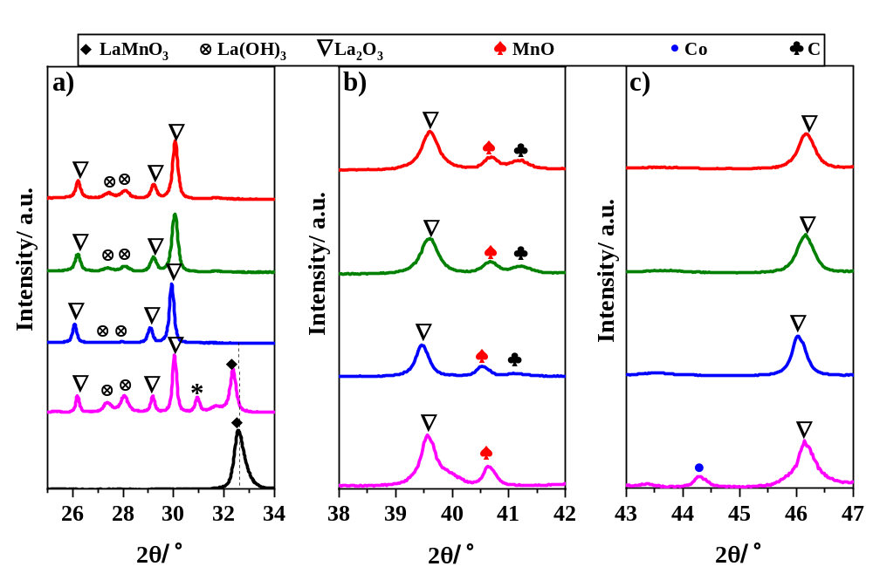
Figure S.1. XRD patterns of the samples with different CVD times. (a) zoom in the region 25-34º (b) zoom in the region 38-42º, and (c) zoom in the region 43-47º. (black line ▬) P; (magenta line ▬) CVD_0; (blue line ▬) CVD_10; (olive line ▬) CVD_20; (red line ▬) CVD_30. The asterisk (*) is related to the LaCoO₃ structure.

The crystallite sizes were estimated by applying the Scherrer equation [1]:
$D_{c}=\frac{kλ}{βcos⁡(θ)}$ (Eq. S.1)
where D_{c} is the crystallite size (nm); k is the constant related to the shape of the grain whose value is 0.89; λ is the wavelength of the radiation source used, which is 0.15406 nm; ꞵ corresponds to the full width at half maximum (FWHM) (radians), and θ is the Bragg angle.

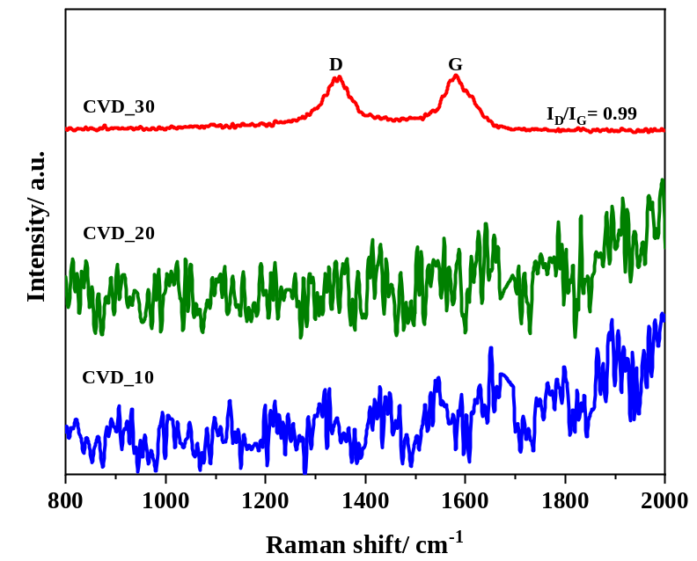
Figure S.2. Raman spectra of the CVD-based composites. (▬) CVD_10; (▬) CVD_20; (▬) CVD_30.

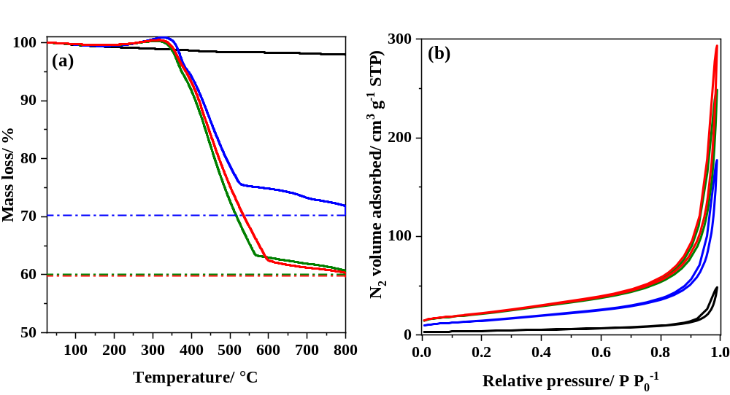
Figure S.3. (a) Thermogravimetric analysis (TGA) curves of the samples and (b) N₂ adsorption-desorption isotherms at -196 °C for the samples. (▬) P; (▬) CVD_10; (▬) CVD_20; (▬) CVD_30.

Table S.1. Surface composition of the samples determined by XPS.
Sample | C | O | La | Mn | Co
Sample | wt.% | wt.% | wt.% | wt.% | wt.%
P | 17.69 | 21.55 | 50.45 | 7.74 | 2.58
CVD_0 | 17.98 | 25.37 | 50.62 | 4.37 | 1.67
CVD_10 | 58.04 | 17.06 | 22.26 | 2.06 | 0.58
CVD_20 | 74.37 | 8.77 | 14.88 | 1.25 | 0.73
CVD_30 | 70.49 | 11.69 | 15.81 | 1.49 | 0.52

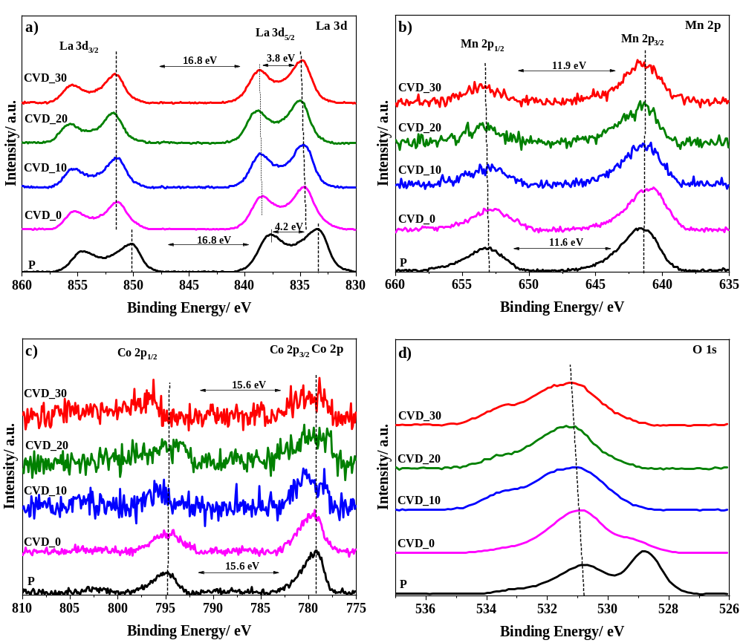
Figure S.4. XPS spectra obtained from (a) La 3d; (b) Mn 2p; (c) Co 2p; and (d) O 1s for the pristine perovskite and the composited formed at different times of CVD.
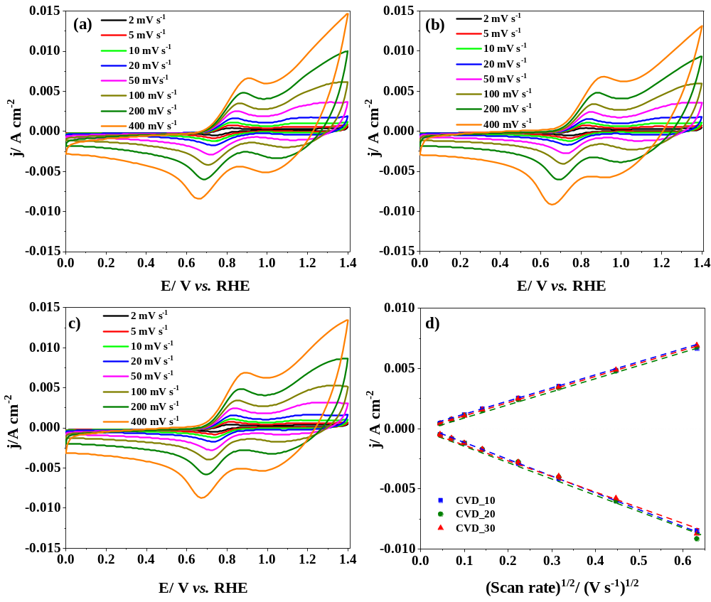
Figure S.5. Cyclic voltammetry experiments performed at different scan rates for the composites in 10 mM K₃Fe(CN)₆/K₄Fe(CN)₆ in pH 7.0 PBS solution saturated with N₂: (a) CVD_10; (b) CVD_20; (c) CVD_30; and (d) Randles-Sevcik plot obtained from the cyclic voltammetry for samples in the same conditions. (■) CVD_10; (●) CVD_20; (▲) CVD_30.

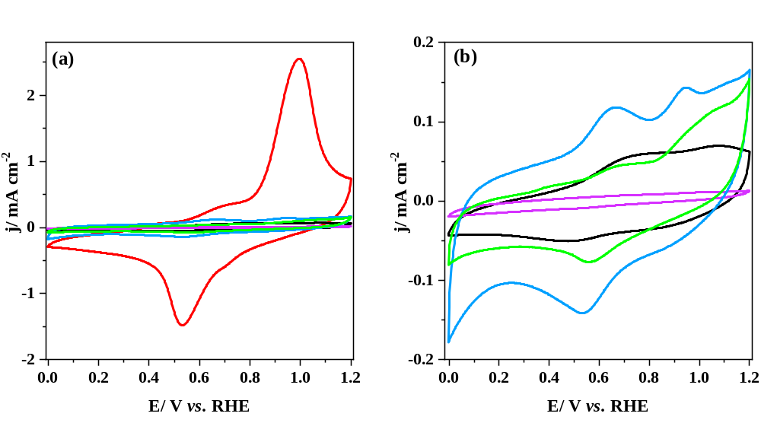
Figure S.6. (a) Cyclic voltammetry of the pure metal oxides, the composites formed with Vulcan and the CVD_30 sample in 0.1 M KOH under N₂ atmosphere and (b) CVs at smaller current density scale to observe only the metal oxides and the composites. Scan rate: 10 mV s⁻¹. (▬) P; (▬) P+Vul; (▬) CVD_0; (▬) CVD_0+Vul; (▬) CVD_30.

Table S.2. E_{onset}, number of electrons involved in the ORR, limiting current density, and tafel slope obtained from the LSV data of the CVD_30 sample and metal oxides mixed physically with and without Vulcan.
Sample | E_{onset}ª | E_{1/2}^{b} | n_{e-}^{c} | j_{lim}^{d} | Tafel slope^{e}
Sample | V vs. RHE | V vs. RHE | - | mA cm⁻¹ | mV dec⁻¹
P | 0.74 | 0.57 | 3.98 | -2.36 | 150
P+Vul | 0.81 | 0.69 | 3.83 | -4.98 | 74
CVD_0 | 0.65 | 0.56 | 3.20 | -1.00 | 109
CVD_0+Vul | 0.81 | 0.70 | 3.65 | -3.51 | 79
CVD_30 | 0.90 | 0.83 | 3.95 | -3.60 | 54
ª E_{onset}: onset potential at -0.1 mA cm².
^{b} E_{1/2}: half-way potential.
^{c} n_{e}⁻: the number of electrons at 0.7 V vs. RHE.
^{d} j_{lim}: the current limiting density at 0.4 V vs. RHE.
^{e} Tafel slope.

References
1. Waseda Y, Matsubara E, Shinoda K (2011) X-Ray Diffraction Crystallography. Springer Berlin Heidelberg, Berlin, Heidelberg

