SUPPORTING INFORMATION

Multi-objective optimization of the hydrothermal liquefaction of microalgae for cost-effective advanced biofuel production

Sergio Martinez-Villarreal^{a*}, Benoît Dochyª, Isabelle Van De Vrekenª, Konstantina Vasilakou^{b}, Philippe Nimmegeers^{b,c,d}, Aurore Richelª.

ªUniversity of Liège – Gembloux Agro-Bio Tech, Laboratory of Biomass and Green Technologies, Passage des Déportés, 2, B-5030 Gembloux, Belgium.
^{b}Department of Engineering Management, University of Antwerp, Prinsstraat 13, 2000 Antwerpen, Belgium.
^{c}NANOlight Centre of Excellence, Prinsstraat 13, 2000 Antwerpen, Belgium
^{d}Flanders Make @UAntwerp, Prinsstraat 13, 2000 Antwerpen, Belgium

*Corresponding author: Tel.: +32 81 62 26 52; Fax: +32 81 62 22 31
*E-mail: sa.martinez@uliege.be

Supporting information for the TEA
In addition to the information supplied in the main article, the Table S1 presents the market prices for raw materials and utilities employed in the calculations of the OPEX for the TEA.
Table S1. Market prices for raw materials and utilities for the TEA.
Economic parameters | Value | Unit | Quote year | Reference
Naphtha selling price | 789 | $/ton | 2022 | [1]
Purchase price of CO₂ | 80 | €/ton | 2020 | [2]
Purchase price of ammonia | 312 | €/ton | 2020 | [3]
Purchase price of DAP | 700 | €/ton | 2022 | [4]
Purchase price of H₂ | 10 | €/kg | 2015 | [5]
Cost of process water | 3.39 | €/m³ | 2015 | [5]
Cost of makeup water (from groundwater) | 0 | €/kg |  | [6]
Cost of natural gas | 0.1056 | €/kWh | 2022 | [7]
Cost of electricity | 0.4464 | €/kWh | 2022 | [8]
Cost of off-gas disposal | 0 | €/m³ | 2022 | Assumption
Cost of wastewater treatment | 2.43 | €/m³ | 2015 | [5]
Cost of solid waste disposal | 33.43 | €/ton | 2015 | [5]
Land cost | 10 603 | €/acre | 2015 | [5]

Supporting information about the quality of the bio-oil

Higher heating values (HHV) of the bio-oil samples
The HHV of the bio-oil samples is illustrated by Figure S1. It ranged from 31 – 38 MJ/kg, representing an improvement of approximately 44–76% compared to the initial C. vulgaris. As expected from Boie’s equation, an almost linear relationship was observed between the HHV and the O/C ratio, the former being higher at lower O/C values.
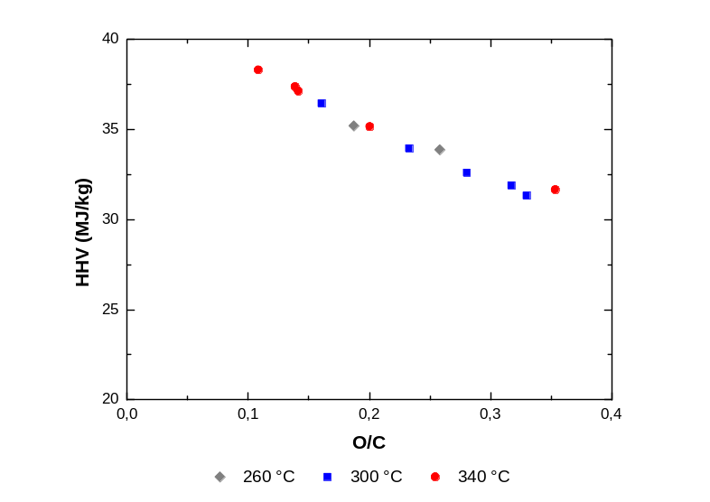
Figure S1. Higher heating value of the bio-oil samples from the preliminary screening as function of the O/C.

Nitrogen distribution during HTL
To better understand the distribution of nitrogen from the microalgae to the various products of the HTL, a nitrogen balance was evaluated. Although the gas phase was not analyzed, prior studies, particularly those involving Chlorella strains [9,10], suggest that nitrogen is unlikely to be present in this phase. Therefore, the nitrogen balance was confined to the bio-oil, biochar, and aqueous phase. Except for one condition (340 °C, 0 min – 89.26%), the mass balance across the experiments closed within a range of 99.62 – 106.09%, indicating, within a reasonable margin of experimental error, that the nitrogen in C. Vulgaris was distributed exclusively among these three products. Furthermore, as depicted by Figure S2, the majority of nitrogen (approximately 75–80%) was found in the aqueous phase, with the bio-oil accounting for 20–23%, agreeing with the prevailing scientific consensus [11–13]. Exploiting this balance to further direct nitrogen toward the aqueous phase, without significantly impacting the bio-oil yield, would not only improve bio-oil composition prior to upgrading but would also facilitate nutrient recovery, thereby promoting the sustainability of microalgae cultivation [14–17].

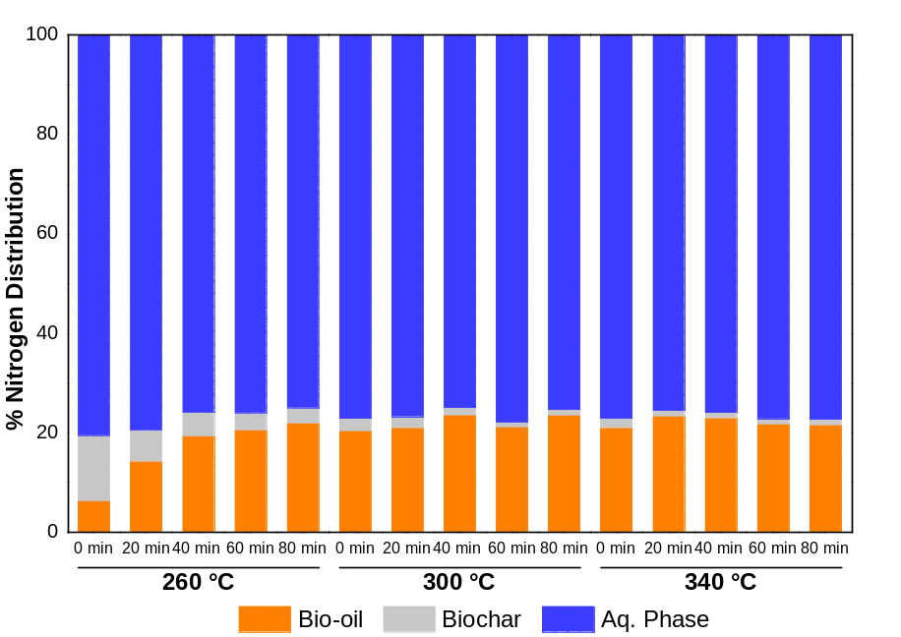
Figure S2. Nitrogen distribution towards the different products of HTL.

Fatty acids profile in the bio-oil
Tables S2 to S4 show the average mass fractions (wt%) of the different fatty acids (FA) identified by GC-MS and quantified by GC-FID (accompanied by the standard deviations), for the conditions evaluated in this study.

Table S2. Identified fatty acids in the bio-oil samples treated at 260 °C for different reaction times.
Fatty acid | Mass fractions (wt%)
Fatty acid | 0 min | 20 min | 40 min | 60 min | 80 min
Hexadecadienoic acid, TMS derivative | 1.0196 ± 0.0585 | 2.7605 ± 0.1648 | 2.6453 ± 0.0991 | 2.1485 ± 0.0130 | 1.9820 ± 0.1257
Palmitelaidic acid, TMS | 0.3470 ± 0.0176 | 0.8815 ± 0.0377 | 0.8514 ± 0.0200 | 0.7183 ± 0.0153 | 0.6687 ± 0.0376
Palmitic Acid, TMS derivative | 3.3468 ± 0.0014 | 7.2051 ± 0.4345 | 7.1316 ± 0.0985 | 6.2390 ± 0.0392 | 5.6047 ± 0.3714
Heptadecanoic acid, TMS derivative | 0.1140 ± 0.0081 | 0.2707 ± 0.0263 | 0.2817 ± 0.0074 | 0.2601 ± 0.0000 | 0.2521 ± 0.0138
10-Heptadecenoic acid, (Z)-, TMS derivative | 0.0156 ± 0.0220 | 0.1132 ± 0.0127 | 0.1199 ± 0.0035 | 0.1030 ± 0.0044 | 0.0946 ± 0.0026
9,12-Octadecadienoic acid (Z,Z)-, TMS derivative | 4.7889 ± 0.1348 | 10.2335 ± 0.3692 | 9.1260 ± 0.1719 | 7.2810 ± 0.0509 | 6.4186 ± 0.5646
9-Octadecenoic acid, (E)-, TMS | 4.1361 ± 0.0678 | 10.7156 ± 0.2232 | 10.8833 ± 0.0312 | 9.1337 ± 0.0605 | 8.1826 ± 0.5509
Oleic Acid, (Z)-, TMS | 0.3006 ± 0.0087 | 0.8014 ± 0.0155 | 1.0629 ± 0.0011 | 1.1363 ± 0.0046 | 1.2212 ± 0.0470
.alpha.-Linolenic acid, TMS derivative | n.d. | 0.0710 ± 0.1003 | 0.2504 ± 0.0005 | 0.2842 ± 0.0262 | 0.2875 ± 0.0300
9(E),11(E)-Conjugated linoleic acid, TMS derivative | n.d. | 0.1220 ± 0.0059 | 0.1495 ± 0.0030 | 0.1647 ± 0.0021 | 0.1834 ± 0.0076
Stearic acid, TMS derivative | 0.5940 ± 0.0255 | 1.5044 ± 0.0645 | 1.6146 ± 0.0029 | 1.4414 ± 0.0287 | 1.2877 ± 0.0441
Arachidic acid, TMS derivative | n.d. | 0.1103 ± 0.0013 | 0.1529 ± 0.0051 | 0.1972 ± 0.0001 | 0.2375 ± 0.0152
n.d. stands for not detected.

Table S3. Identified fatty acids in the bio-oil samples treated at 300 °C for different reaction times.
Fatty acid | Mass fractions (wt%)
Fatty acid | 0 min | 20 min | 40 min | 60 min | 80 min
Hexadecadienoic acid, TMS derivative | 2.2225 ± 0.2522 | 1.9107 ± 0.0488 | 1.6154 ± 0.0511 | 1.4281 ± 0.0134 | 1.2458 ± 0.2616
Palmitelaidic acid, TMS | 0.7772 ± 0.0179 | 0.6873 ± 0.0081 | 0.6569 ± 0.0209 | 0.7723 ± 0.2313 | 0.5716 ± 0.0855
Palmitic Acid, TMS derivative | 7.6262 ± 0.7877 | 6.6174 ± 0.2097 | 6.4856 ± 0.5043 | 6.1136 ± 0.0731 | 6.3778 ± 0.3367
Heptadecanoic acid, TMS derivative | 0.2775 ± 0.0283 | 0.2909 ± 0.0110 | 0.3200 ± 0.0072 | 0.3154 ± 0.0115 | 0.2876 ± 0.0651
10-Heptadecenoic acid, (Z)-, TMS derivative | 0.0571 ± 0.0807 | 0.0913 ± 0.0156 | 0.0765 ± 0.0042 | 0.0316 ± 0.0447 | 0.0323 ± 0.0457
9,12-Octadecadienoic acid (Z,Z)-, TMS derivative | 8.3342 ± 0.3712 | 6.3268 ± 0.1893 | 6.0847 ± 1.6888 | 5.1073 ± 2.2354 | 2.9928 ± 0.3760
9-Octadecenoic acid, (E)-, TMS | 10.5515 ± 1.2194 | 8.7388 ± 0.4741 | 4.0207 ± 5.6861 | 3.4294 ± 4.8499 | 5.1655 ± 2.4397
Oleic Acid, (Z)-, TMS | 1.2569 ± 0.1713 | 1.7317 ± 0.1406 | 4.9842 ± 3.2887 | 4.9560 ± 2.5601 | 5.3289 ± 1.8891
.alpha.-Linolenic acid, TMS derivative | 0.3833 ± 0.0331 | 0.4154 ± 0.0150 | n.d. | n.d. | n.d.
9(E),11(E)-Conjugated linoleic acid, trimethylsilyl ester | 0.1682 ± 0.0059 | 0.2524 ± 0.0053 | 0.1696 ± 0.2398 | 0.3111 ± 0.0556 | 0.3158 ± 0.0514
Stearic acid, TMS derivative | 1.8123 ± 0.3463 | 1.5716 ± 0.0583 | 1.5080 ± 0.0841 | 1.5514 ± 0.0079 | 1.8997 ± 0.3357
Arachidic acid, TMS derivative | 0.2670 ± 0.0113 | 0.4615 ± 0.0009 | 0.6173 ± 0.0102 | 0.6537 ± 0.0334 | 0.6991 ± 0.0286
n.d. stands for not detected.

Table S4. Identified fatty acids in the bio-oil samples treated at 340 °C for different reaction times.
Fatty acid | Mass fractions (wt%)
Fatty acid | 0 min | 20 min | 40 min | 60 min | 80 min
Undecanoic acid, TMS derivative | n.d. | n.d. | n.d. | 0.0200 ± 0.0041 | 0.0258 ± 0.0007
10-Undecenoic acid, TMS derivative | n.d. | n.d. | 0.0229 ± 0.0324 | 0.0996 ± 0.0120 | 0.1147 ± 0.0043
Hexadecadienoic acid, TMS derivative | 1.7597 ± 0.0339 | 1.5260 ± 0.0628 | 1.3489 ± 0.0800 | 1.2543 ± 0.0730 | 1.1793 ± 0.2603
Palmitelaidic acid, TMS | 0.7365 ± 0.0253 | 0.7677 ± 0.0220 | 0.6999 ± 0.0335 | 0.5790 ± 0.0000 | 0.4907 ± 0.0730
Palmitic Acid, TMS derivative | 6.7028 ± 0.3183 | 6.5495 ± 0.1946 | 6.6334 ± 0.0807 | 6.6088 ± 0.0390 | 6.6418 ± 0.2807
Heptadecanoic acid, TMS derivative 1 | 0.3166 ± 0.0136 | 0.3792 ± 0.0005 | 0.4062 ± 0.0041 | 0.3821 ± 0.0124 | 0.3650 ± 0.0414
10-Heptadecenoic acid, (Z)-, TMS derivative | 0.0522 ± 0.0738 | n.d. | n.d. | n.d. | n.d.
9,12-Octadecadienoic acid (Z,Z)-, TMS derivative | 6.5067 ± 1.6837 | 3.3904 ± 0.0277 | 2.2577 ± 0.0675 | 1.8362 ± 0.0051 | 1.7903 ± 0.3499
9-Octadecenoic acid, (E)-, TMS | 8.4076 ± 0.5788 | 9.7610 ± 3.2415 | 11.6335 ± 0.1091 | 10.8533 ± 0.0555 | 10.5699 ± 0.4890
Oleic Acid, (Z)-, TMS | 1.5264 ± 2.1586 | 1.9535 ± 2.7626 | n.d. | n.d. | n.d.
9(E),11(E)-Conjugated linoleic acid, trimethylsilyl ester | 0.3434 ± 0.0349 | 0.5495 ± 0.0293 | 0.5650 ± 0.0132 | 0.4674 ± 0.0052 | 0.4165 ± 0.0571
Stearic acid, TMS derivative | 1.6261 ± 0.0802 | 1.6831 ± 0.0072 | 1.8801 ± 0.0309 | 2.1005 ± 0.0780 | 2.1706 ± 0.0459
Arachidic acid, TMS derivative | 0.4770 ± 0.0023 | 0.5074 ± 0.0221 | 0.4913 ± 0.0273 | 0.4849 ± 0.0170 | 0.4678 ± 0.0550
n.d. stands for not detected.
To evaluate the influence of HTL conditions on the bio-oil FA profile, the selectivity of these FA as a function of temperature and time was determined, as depicted by Figure S3. At 260 °C, reaction time had a minimal impact on selectivity, with an average of approximately 31% and 67% for C₁₆ and C₁₈ FA, respectively. However, at 300 °C and 340 °C, a slight decrease in C₁₈ FA selectivity was observed with increasing temperature and reaction time, in advantage of a marginal increase in C₁₆ FA selectivity. The average selectivity for C₁₆ FA at these temperatures was approximately 33%, while C₁₈ FA selectivity declined marginally from 64% at 300 °C to 63% at 340 °C. Furthermore, undecanoic acid (C₁₁ FA) was identified exclusively at 340 °C, likely resulting from the cracking of C₁₈ FA.
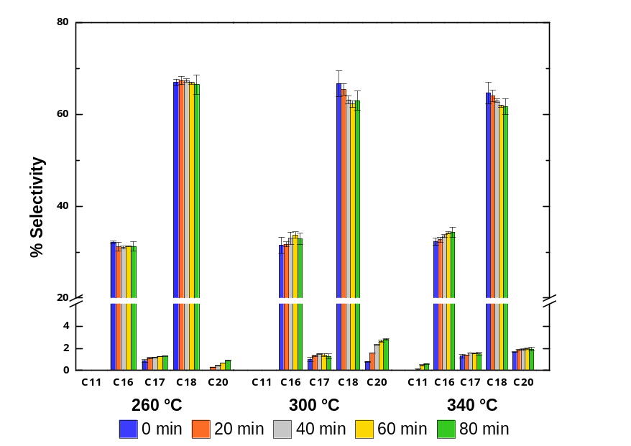
Figure S3. Influence of temperature and reaction time on the selectivity of FA for the HTL of C. Vulgaris.

Degree of unsaturation of the fatty acids in the bio-oil
The tested conditions also influenced significantly the degree of unsaturation in the bio-oil. As illustrated in Figure S4, the proportion of polyunsaturated fatty acids (PUFA) in the bio-oil decreased with increasing temperature and reaction time, with this decline being more pronounced at higher temperatures. This effect is particularly evident in the case of linolenic acid (C_{18:3} FA), which was not detected via gas chromatography at 340 °C or in reactions conducted at 300 °C for durations exceeding 40 min. Concurrently, an increase in weight percentage of stearic and oleic acids was observed. These findings suggest that high-severity HTL conditions could be advantageous for biofuel production.
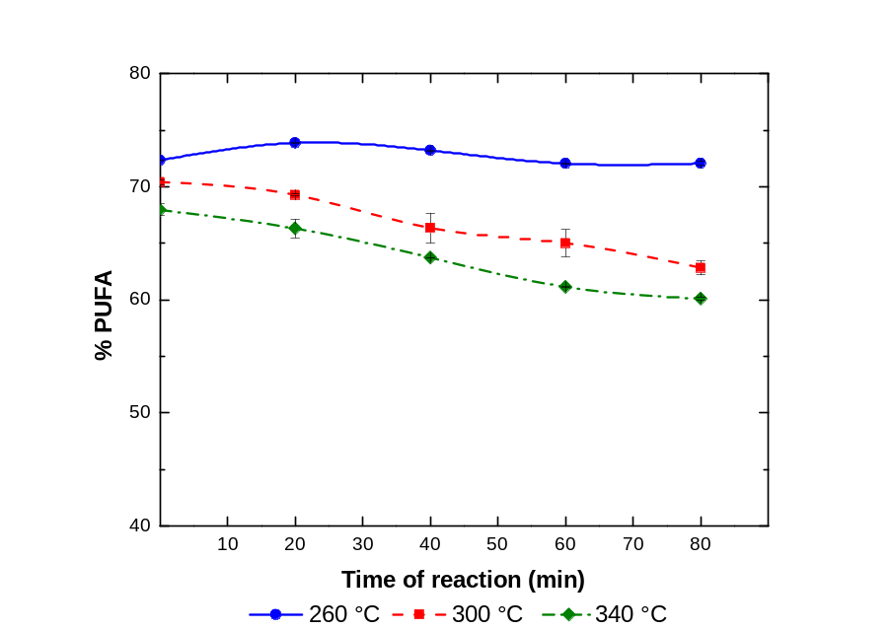
Figure S4. Effect of temperature and time on the proportion of PUFA in the bio-oil for the HTL of C. Vulgaris.

Influence of reaction conditions on the content of nitrogenated compounds
Although the content of nitrogenated molecules exhibited only slight variations across different reaction conditions, the observed changes are illustrated in Figure S5. In general, higher temperatures tended to reduce the total content of nitrogenated compounds, while the influence of reaction time was temperature dependent. At 260 °C, the content of nitrogenated molecules increased with prolonged reaction times, a trend observed for both amides and pyrrolidine derivatives. However, this behavior was not consistent at the other tested temperatures. At 300 °C, the nitrogenated compound content peaked at 20 min of reaction time before declining and apparently stabilizing at 80 min. A similar trend was observed at 340 °C, with the key difference being a marked reduction in pyrrolidine derivative content.

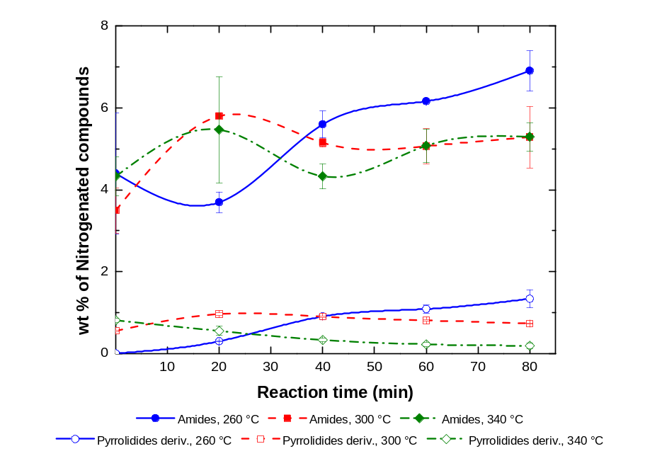
Figure S5. Influence of temperature and reaction time on the content of nitrogenated compounds in the bio-oil for the HTL of C. Vulgaris.

Influence of temperature and reaction time on minority compounds in the bio-oil
Small proportions of monoglycerides (MAG), ethyl esters, and other secondary derivatives such as phytol, neophytadiene, ergosterol, tocopherol, and various products derived from secondary metabolites, fatty acids, or sterols were identified under different reaction conditions (See Figure S6). The detection of MAG was exclusive to reactions performed at 260 °C, for reaction times between 0 and 40 min, or at 300 °C for 5 min (trace amounts)—reaching a maximum concentration of 7.4 wt% of the bio-oil. Although only the lighter fraction of the bio-oil can be analyzed using conventional gas chromatography techniques [18], such as those employed in this study, it is anticipated that the heavier fraction would contain tri- and/or di-glycerides that were not fully hydrolyzed [19]. Thus, the detection of MAG may suggest the presence of these additional lipid species in the bio-oil.
As demonstrated during the optimization of the bio-oil yield, not only there is a portion of biochar that could be further converted to enhance yield at 260 °C, but the ensemble of lipids present in the bio-oil has also not been fully degraded into free fatty acids, which is intended for subsequent hydrotreating processes. Therefore, these findings suggest that these reaction conditions are suboptimal for producing a bio-oil intended as a biofuel precursor.
In addition to MAG, some ethyl-esters of fatty acids were also detected along the different treatments. On average, they accounted for 0.05 – 0.50 wt% of the bio-oil. This modest proportion appeared to be influenced by the reaction severity, exhibiting greater fluctuations with time at lower temperatures, while demonstrating greater stability at higher temperatures.
These findings align with simulations conducted by Voll and co-workers [20], who reported that the yield of ethyl oleate, used as a model compound, increased with a rise in temperature from 250 °C to 310 °C. Further temperature increases up to 350 °C, however, did not significantly affect the production of ethyl oleate. Additionally, the influence of reaction time was less pronounced at higher temperatures, with the maximum yield achieved at 10 min. In contrast, a more proportional effect of reaction time was observed at lower temperatures, where extended periods were required to achieve complete conversion of oleic acid [20].
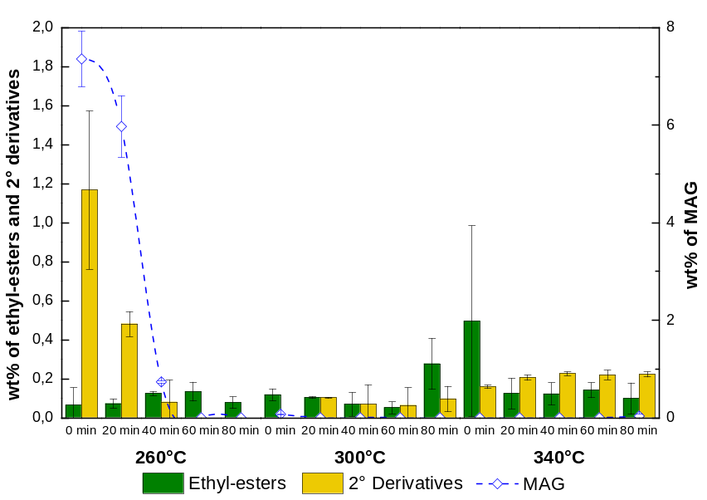
Figure S6. Influence of temperature and reaction time on minority compounds in the bio-oil.

Among the secondary derivatives, although these compounds are present in higher estimated proportions under mild reaction conditions, their composition changed with increasing reaction severity. At 260 °C, the predominant compounds identified included phytol, neophytadiene (and its derivatives), tocopherols, and ergosterol, primarily resulting from the degradation of secondary metabolites such as chlorophyll, terpenes, and sterols [21,22]. Nevertheless, these compounds are no longer detected at higher temperatures and are not part of the secondary derivatives quantified under severe conditions evidenced in Figure S6. In fact, this shift in composition has been previously reported [23]. Under more severe conditions, the secondary derivatives primarily consist of compounds such as tetracosanol, derived from lignoceric acid.

Supporting information for the multi-objective optimization

Structure of the Central Composite Design
A Central Composite Design (CCD) was selected to provide the data needed for the optimization methodology. The aim was to fit the experimental data to a mathematical model capable of predicting the different response variable as a function of temperature and reaction time, within an acceptable experimental error. This design reduced the number of required experiments by selecting some of the previously tested conditions, such as the central point and factorial portion (see Figure S7), thereby requiring only a few additional experiments. The chosen central point was 300 °C and 40 min. The distance of the axial points from the center and the total number of central point repetitions were calculated to ensure the rotatability and stability of the models, resulting in models with uniform and stable variance at any point equidistant from the central point [24].
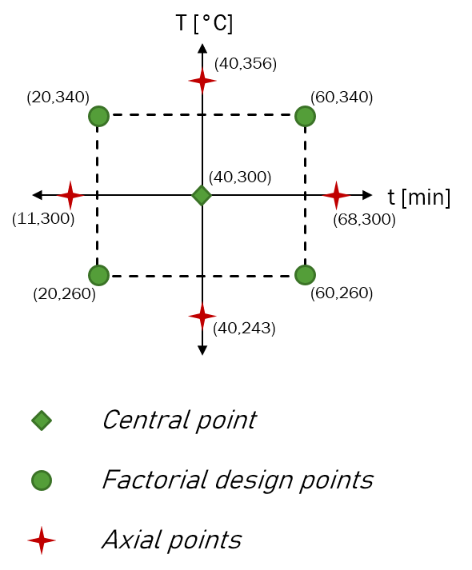
Figure S7. Representation of the experimental points selected for the Central composite design (CCD).

Regression coefficients for the second-order models
The models obtained for the different scenarios are presented in Table S5. The equations for yield and O/C were used for both scenarios, while specific expressions were fitted for MFSP depending on the data simulated for low and high productivity.
Table S5. Regression coefficients (for coded variables) and models metrics for the response variables.
 | b₀ | b₁ | b₂ | b₁₂ | b₁₁ | b₂₂ | R² | RSE
Y_{BO} | 0.3514 | 0.0216 | 0.0125 | -0.0131 | -0.0248 | -0.0046 | 90.66% | 0.0106
O/C | 0.1807 | -0.0434 | -0.0120 | 0.0148 | -0.0348 | -0.0096 | 78.00% | 0.0285
MFSP_{LP} | 13.2350 | 0.5666 | 0.2242 | 0.1592 | 0.5056 | 0.0994 | 81.26% | 0.3519
MFSP_{HP} | 4.1750 | 0.5263 | 0.3283 | 0.0275 | 0.2350 | 0.0025 | 99.10% | 0.0631
Y_{BO}: Bio-oil yield. LP: Low productivity scenario. HP: High productivity scenario.

Structure of the desirability functions
The structure of the individual desirability functions can be represented by eq 1 and eq 2, depending if maximization or minimization was desired, respectively [24,25]. In those equations, $\hat{y}$ represents the variables estimates, T the target value for optimization, and L and U stand for the lower and upper limits for acceptable values. The constant r represents the weights of the functions and was specified to indicate how desirable it was for the estimate value to increase or decrease away from its minimum or maximum acceptable value [25].
$$d=\begin{matrix}\left\{\begin{matrix}0 & \hat{y}<L \\ {\left(\frac{\hat{y}-L}{T-L}\right)}^{r} & L≤\hat{y}≤T \\ 1 & \hat{y}>T\end{matrix}\right. & (1)\end{matrix}$$
$$d=\begin{matrix}\left\{\begin{matrix}1 & \hat{y}<T \\ {\left(\frac{U-\hat{y}}{U-T}\right)}^{r} & T≤\hat{y}≤U \\ 0 & \hat{y}>U\end{matrix}\right. & (2)\end{matrix}$$

Results of the sensitivity test on desirability functions weights
Table S6. Results of the sensitivity test on desirability functions weights, sorted by descending overall desirability (best 40 points) for the low productivity case.
r₁ | r₂ | r₃ | Overall  desirability | Yield  [g/g] | O/C  [mol/mol] | MFSP  [€/L] | Temperature  [°C] | Time  [min]
0.3 | 0.3 | 0.3 | 0.8803 | 0.3483 | 0.1856 | 13.17 | 294.34 | 40.71
0.5 | 0.3 | 0.3 | 0.8628 | 0.3507 | 0.1828 | 13.21 | 295.76 | 42.83
0.3 | 0.3 | 0.5 | 0.8604 | 0.3446 | 0.1892 | 13.12 | 292.93 | 37.17
0.3 | 0.5 | 0.3 | 0.8512 | 0.3493 | 0.1846 | 13.19 | 294.34 | 42.12
0.5 | 0.3 | 0.5 | 0.8366 | 0.3478 | 0.1862 | 13.16 | 294.34 | 40.00
0.5 | 0.5 | 0.3 | 0.8356 | 0.3511 | 0.1822 | 13.22 | 295.76 | 43.54
1 | 0.3 | 0.3 | 0.8325 | 0.3536 | 0.1785 | 13.28 | 297.17 | 46.36
0.3 | 0.5 | 0.5 | 0.8302 | 0.3452 | 0.1887 | 13.13 | 292.93 | 37.88
0.3 | 0.3 | 1 | 0.8291 | 0.3397 | 0.1930 | 13.08 | 290.10 | 34.34
0.5 | 0.5 | 0.5 | 0.8086 | 0.3483 | 0.1856 | 13.17 | 294.34 | 40.71
1 | 0.5 | 0.3 | 0.8081 | 0.3539 | 0.1778 | 13.29 | 297.17 | 47.07
0.3 | 0.5 | 1 | 0.7980 | 0.3403 | 0.1926 | 13.09 | 290.10 | 35.05
1 | 0.3 | 0.5 | 0.7960 | 0.3511 | 0.1822 | 13.22 | 295.76 | 43.54
0.5 | 0.3 | 1 | 0.7954 | 0.3428 | 0.1907 | 13.11 | 291.51 | 36.46
0.3 | 1 | 0.3 | 0.7855 | 0.3480 | 0.1764 | 13.23 | 305.66 | 30.81
0.5 | 1 | 0.3 | 0.7732 | 0.3526 | 0.1786 | 13.26 | 292.93 | 49.19
1 | 0.5 | 0.5 | 0.7711 | 0.3516 | 0.1816 | 13.23 | 295.76 | 44.24
0.5 | 0.5 | 1 | 0.7667 | 0.3434 | 0.1903 | 13.11 | 291.51 | 37.17
3 | 0.3 | 0.3 | 0.7654 | 0.3562 | 0.1729 | 13.36 | 298.59 | 50.61
0.3 | 0.3 | 3 | 0.7639 | 0.3326 | 0.1969 | 13.04 | 287.27 | 30.10
0.3 | 1 | 0.5 | 0.7609 | 0.3467 | 0.1859 | 13.16 | 297.17 | 35.76
1 | 1 | 0.3 | 0.7513 | 0.3546 | 0.1764 | 13.31 | 297.17 | 48.49
3 | 0.5 | 0.3 | 0.7453 | 0.3565 | 0.1721 | 13.37 | 298.59 | 51.31
0.5 | 1 | 0.5 | 0.7436 | 0.3493 | 0.1844 | 13.19 | 295.76 | 40.71
1 | 0.3 | 1 | 0.7370 | 0.3473 | 0.1868 | 13.16 | 292.93 | 40.71
0.3 | 0.5 | 3 | 0.7334 | 0.3334 | 0.1966 | 13.05 | 287.27 | 30.81
0.3 | 1 | 1 | 0.7264 | 0.3416 | 0.1910 | 13.10 | 292.93 | 33.64
5 | 0.3 | 0.3 | 0.7236 | 0.3570 | 0.1709 | 13.39 | 300.00 | 51.31
0.3 | 0.3 | 5 | 0.7221 | 0.3303 | 0.1981 | 13.04 | 285.86 | 29.39
0.5 | 0.3 | 3 | 0.7133 | 0.3356 | 0.1953 | 13.06 | 288.69 | 31.51
1 | 1 | 0.5 | 0.7131 | 0.3524 | 0.1803 | 13.25 | 295.76 | 45.66
1 | 0.5 | 1 | 0.7120 | 0.3478 | 0.1862 | 13.16 | 294.34 | 40.00
3 | 0.3 | 0.5 | 0.7090 | 0.3553 | 0.1752 | 13.33 | 298.59 | 48.49
5 | 0.5 | 0.3 | 0.7055 | 0.3572 | 0.1700 | 13.41 | 300.00 | 52.02
0.5 | 1 | 1 | 0.7002 | 0.3446 | 0.1892 | 13.12 | 292.93 | 37.17
3 | 1 | 0.3 | 0.6978 | 0.3565 | 0.1721 | 13.37 | 298.59 | 51.31
0.3 | 0.5 | 5 | 0.6927 | 0.3303 | 0.1981 | 13.04 | 285.86 | 29.39
3 | 0.5 | 0.5 | 0.6894 | 0.3553 | 0.1752 | 13.33 | 298.59 | 48.49
0.5 | 0.5 | 3 | 0.6855 | 0.3356 | 0.1953 | 13.06 | 288.69 | 31.51
0.3 | 3 | 0.3 | 0.6658 | 0.3376 | 0.1415 | 13.38 | 318.39 | 11.72
r₁, r₂ and r₃ stand for the weights of the bio-oil yield, O/C and MFSP desirability functions, respectively.
Table S7. Results of the sensitivity test on desirability functions weights, sorted by ascending MFSP (best 40 points) for the low productivity case.
r₁ | r₂ | r₃ | Overall  desirability | Yield  [g/g] | O/C  [mol/mol] | MFSP  [€/L] | Temperature  [°C] | Time  [min]
0.3 | 0.3 | 5 | 0.7221 | 0.3303 | 0.1981 | 13.04 | 285.86 | 29.39
0.3 | 0.5 | 5 | 0.6927 | 0.3303 | 0.1981 | 13.04 | 285.86 | 29.39
0.3 | 1 | 5 | 0.6245 | 0.3311 | 0.1974 | 13.04 | 287.27 | 28.69
0.3 | 3 | 5 | 0.4149 | 0.3319 | 0.1965 | 13.04 | 288.69 | 27.98
0.3 | 0.3 | 3 | 0.7639 | 0.3326 | 0.1969 | 13.04 | 287.27 | 30.10
0.5 | 0.3 | 5 | 0.6649 | 0.3326 | 0.1969 | 13.04 | 287.27 | 30.10
0.5 | 0.5 | 5 | 0.6383 | 0.3326 | 0.1969 | 13.04 | 287.27 | 30.10
0.3 | 0.5 | 3 | 0.7334 | 0.3334 | 0.1966 | 13.05 | 287.27 | 30.81
0.3 | 1 | 3 | 0.6626 | 0.3334 | 0.1966 | 13.05 | 287.27 | 30.81
0.5 | 1 | 5 | 0.5766 | 0.3334 | 0.1966 | 13.05 | 287.27 | 30.81
0.5 | 3 | 5 | 0.3855 | 0.3341 | 0.1959 | 13.05 | 288.69 | 30.10
0.3 | 5 | 5 | 0.2787 | 0.3326 | 0.1943 | 13.05 | 291.51 | 25.86
0.5 | 0.3 | 3 | 0.7133 | 0.3356 | 0.1953 | 13.06 | 288.69 | 31.51
0.5 | 0.5 | 3 | 0.6855 | 0.3356 | 0.1953 | 13.06 | 288.69 | 31.51
0.5 | 1 | 3 | 0.6209 | 0.3363 | 0.1950 | 13.06 | 288.69 | 32.22
0.3 | 3 | 3 | 0.4457 | 0.3356 | 0.1938 | 13.06 | 291.51 | 28.69
0.5 | 5 | 5 | 0.2601 | 0.3356 | 0.1938 | 13.06 | 291.51 | 28.69
1 | 0.3 | 5 | 0.5634 | 0.3370 | 0.1947 | 13.06 | 288.69 | 32.93
1 | 0.5 | 5 | 0.5417 | 0.3370 | 0.1947 | 13.06 | 288.69 | 32.93
1 | 1 | 5 | 0.4909 | 0.3370 | 0.1947 | 13.06 | 288.69 | 32.93
1 | 3 | 5 | 0.3322 | 0.3384 | 0.1937 | 13.07 | 290.10 | 32.93
0.5 | 3 | 3 | 0.4206 | 0.3384 | 0.1930 | 13.07 | 291.51 | 31.51
1 | 5 | 5 | 0.2263 | 0.3390 | 0.1928 | 13.08 | 291.51 | 32.22
0.3 | 0.3 | 1 | 0.8291 | 0.3397 | 0.1930 | 13.08 | 290.10 | 34.34
1 | 0.3 | 3 | 0.6243 | 0.3397 | 0.1930 | 13.08 | 290.10 | 34.34
0.3 | 0.5 | 1 | 0.7980 | 0.3403 | 0.1926 | 13.09 | 290.10 | 35.05
1 | 0.5 | 3 | 0.6009 | 0.3403 | 0.1926 | 13.09 | 290.10 | 35.05
1 | 1 | 3 | 0.5464 | 0.3403 | 0.1926 | 13.09 | 290.10 | 35.05
0.3 | 1 | 1 | 0.7264 | 0.3416 | 0.1910 | 13.10 | 292.93 | 33.64
1 | 3 | 3 | 0.3756 | 0.3422 | 0.1907 | 13.10 | 292.93 | 34.34
0.5 | 0.3 | 1 | 0.7954 | 0.3428 | 0.1907 | 13.11 | 291.51 | 36.46
0.5 | 0.5 | 1 | 0.7667 | 0.3434 | 0.1903 | 13.11 | 291.51 | 37.17
3 | 0.3 | 5 | 0.3625 | 0.3434 | 0.1903 | 13.11 | 291.51 | 37.17
3 | 0.5 | 5 | 0.3495 | 0.3434 | 0.1903 | 13.11 | 291.51 | 37.17
0.5 | 5 | 3 | 0.2937 | 0.3367 | 0.1838 | 13.11 | 300.00 | 22.32
3 | 1 | 5 | 0.3191 | 0.3440 | 0.1899 | 13.12 | 291.51 | 37.88
1 | 5 | 3 | 0.2616 | 0.3426 | 0.1876 | 13.12 | 297.17 | 30.81
0.3 | 5 | 3 | 0.3132 | 0.3333 | 0.1802 | 13.12 | 301.41 | 18.08
0.3 | 0.3 | 0.5 | 0.8604 | 0.3446 | 0.1892 | 13.12 | 292.93 | 37.17
0.5 | 1 | 1 | 0.7002 | 0.3446 | 0.1892 | 13.12 | 292.93 | 37.17
r₁, r₂ and r₃ stand for the weights of the bio-oil yield, O/C and MFSP desirability functions, respectively.

Table S8. Results of the sensitivity test on desirability functions weights, sorted by descending overall desirability (best 40 points) for the high productivity case.
r₁ | r₂ | r₃ | Overall  desirability | Yield  [g/g] | O/C  [mol/mol] | MFSP  [€/L] | Temperature  [°C] | Time  [min]
0.3 | 0.3 | 0.3 | 0.8843 | 0.3482 | 0.1516 | 4.20 | 318.39 | 24.44
0.3 | 0.5 | 0.3 | 0.8768 | 0.3421 | 0.1141 | 4.24 | 329.70 | 13.84
0.3 | 1 | 0.3 | 0.8765 | 0.3421 | 0.1100 | 4.27 | 331.11 | 13.84
0.3 | 3 | 0.3 | 0.8764 | 0.3421 | 0.1100 | 4.27 | 331.11 | 13.84
0.3 | 5 | 0.3 | 0.8763 | 0.3421 | 0.1100 | 4.27 | 331.11 | 13.84
0.5 | 0.3 | 0.3 | 0.8725 | 0.3563 | 0.1708 | 4.34 | 305.66 | 44.95
1 | 0.3 | 0.3 | 0.8648 | 0.3587 | 0.1649 | 4.45 | 302.83 | 54.14
3 | 0.3 | 0.3 | 0.8578 | 0.3598 | 0.1562 | 4.55 | 302.83 | 60.51
5 | 0.3 | 0.3 | 0.8568 | 0.3600 | 0.1549 | 4.58 | 304.24 | 60.51
0.5 | 0.5 | 0.3 | 0.8539 | 0.3512 | 0.1471 | 4.33 | 321.21 | 28.69
0.3 | 0.3 | 0.5 | 0.8524 | 0.3441 | 0.1553 | 4.08 | 315.56 | 20.20
1 | 0.5 | 0.3 | 0.8464 | 0.3593 | 0.1594 | 4.50 | 300.00 | 59.80
0.5 | 1 | 0.3 | 0.8452 | 0.3444 | 0.1100 | 4.36 | 332.53 | 17.37
0.5 | 3 | 0.3 | 0.8452 | 0.3444 | 0.1100 | 4.36 | 332.53 | 17.37
0.5 | 5 | 0.3 | 0.8452 | 0.3444 | 0.1100 | 4.36 | 332.53 | 17.37
0.3 | 0.5 | 0.5 | 0.8425 | 0.3398 | 0.1234 | 4.12 | 325.46 | 11.72
3 | 0.5 | 0.3 | 0.8423 | 0.3599 | 0.1551 | 4.57 | 302.83 | 61.21
5 | 0.5 | 0.3 | 0.8418 | 0.3600 | 0.1539 | 4.58 | 302.83 | 61.92
0.3 | 1 | 0.5 | 0.8387 | 0.3405 | 0.1115 | 4.21 | 329.70 | 11.72
0.3 | 3 | 0.5 | 0.8358 | 0.3405 | 0.1073 | 4.24 | 331.11 | 11.72
0.3 | 5 | 0.5 | 0.8358 | 0.3405 | 0.1073 | 4.24 | 331.11 | 11.72
0.5 | 0.3 | 0.5 | 0.8325 | 0.3513 | 0.1718 | 4.19 | 308.49 | 33.64
0.5 | 0.5 | 0.5 | 0.8147 | 0.3482 | 0.1516 | 4.20 | 318.39 | 24.44
1 | 1 | 0.3 | 0.8139 | 0.3589 | 0.1470 | 4.57 | 294.34 | 68.29
1 | 0.3 | 0.5 | 0.8136 | 0.3569 | 0.1711 | 4.35 | 302.83 | 48.49
3 | 1 | 0.3 | 0.8081 | 0.3599 | 0.1473 | 4.62 | 300.00 | 66.87
5 | 1 | 0.3 | 0.8081 | 0.3600 | 0.1490 | 4.62 | 301.41 | 65.46
0.5 | 1 | 0.5 | 0.8029 | 0.3421 | 0.1100 | 4.27 | 331.11 | 13.84
0.5 | 3 | 0.5 | 0.8027 | 0.3421 | 0.1100 | 4.27 | 331.11 | 13.84
0.5 | 5 | 0.5 | 0.8026 | 0.3421 | 0.1100 | 4.27 | 331.11 | 13.84
0.3 | 0.3 | 1 | 0.7973 | 0.3375 | 0.1606 | 3.93 | 311.31 | 15.25
3 | 0.3 | 0.5 | 0.7942 | 0.3593 | 0.1613 | 4.50 | 302.83 | 56.97
1 | 0.5 | 0.5 | 0.7931 | 0.3574 | 0.1697 | 4.38 | 302.83 | 49.90
5 | 0.3 | 0.5 | 0.7891 | 0.3598 | 0.1572 | 4.54 | 302.83 | 59.80
1 | 3 | 0.3 | 0.7858 | 0.3466 | 0.1101 | 4.47 | 333.94 | 21.61
1 | 5 | 0.3 | 0.7855 | 0.3466 | 0.1101 | 4.47 | 333.94 | 21.61
0.3 | 0.5 | 1 | 0.7840 | 0.3369 | 0.1449 | 3.96 | 316.97 | 11.72
3 | 0.5 | 0.5 | 0.7782 | 0.3596 | 0.1593 | 4.52 | 302.83 | 58.39
5 | 0.5 | 0.5 | 0.7744 | 0.3598 | 0.1562 | 4.55 | 302.83 | 60.51
0.5 | 0.3 | 1 | 0.7641 | 0.3443 | 0.1736 | 4.03 | 307.07 | 25.15
r₁, r₂ and r₃ stand for the weights of the bio-oil yield, O/C and MFSP desirability functions, respectively.

Table S9. Results of the sensitivity test on desirability functions weights, sorted by ascending MFSP (best 40 points) for the high productivity case.
r₁ | r₂ | r₃ | Overall  desirability | Yield  [g/g] | O/C  [mol/mol] | MFSP  [€/L] | Temperature  [°C] | Time  [min]
0.3 | 0.3 | 5 | 0.5960 | 0.3258 | 0.1761 | 3.73 | 301.41 | 11.72
0.3 | 0.5 | 5 | 0.5793 | 0.3258 | 0.1761 | 3.73 | 301.41 | 11.72
0.3 | 1 | 5 | 0.5410 | 0.3271 | 0.1737 | 3.75 | 302.83 | 11.72
0.3 | 0.3 | 3 | 0.6746 | 0.3284 | 0.1712 | 3.77 | 304.24 | 11.72
0.5 | 0.5 | 5 | 0.5189 | 0.3284 | 0.1712 | 3.77 | 304.24 | 11.72
0.5 | 0.3 | 5 | 0.5328 | 0.3288 | 0.1748 | 3.77 | 302.83 | 13.13
0.3 | 0.5 | 3 | 0.6579 | 0.3296 | 0.1687 | 3.79 | 305.66 | 11.72
0.5 | 1 | 5 | 0.4876 | 0.3296 | 0.1687 | 3.79 | 305.66 | 11.72
0.3 | 1 | 3 | 0.6195 | 0.3307 | 0.1660 | 3.81 | 307.07 | 11.72
0.3 | 3 | 5 | 0.4212 | 0.3318 | 0.1632 | 3.83 | 308.49 | 11.72
0.5 | 0.5 | 3 | 0.6029 | 0.3323 | 0.1672 | 3.83 | 307.07 | 13.13
0.5 | 0.3 | 3 | 0.6183 | 0.3333 | 0.1744 | 3.84 | 304.24 | 15.96
0.5 | 1 | 3 | 0.5718 | 0.3328 | 0.1604 | 3.85 | 309.90 | 11.72
1 | 0.3 | 5 | 0.4354 | 0.3345 | 0.1779 | 3.85 | 302.83 | 18.08
1 | 0.5 | 5 | 0.4231 | 0.3349 | 0.1752 | 3.86 | 304.24 | 17.37
1 | 1 | 5 | 0.3969 | 0.3342 | 0.1651 | 3.86 | 308.49 | 13.84
0.5 | 3 | 5 | 0.3903 | 0.3338 | 0.1575 | 3.87 | 311.31 | 11.72
0.3 | 0.3 | 1 | 0.7973 | 0.3375 | 0.1606 | 3.93 | 311.31 | 15.25
1 | 3 | 5 | 0.3313 | 0.3362 | 0.1482 | 3.94 | 315.56 | 11.72
1 | 0.3 | 3 | 0.5349 | 0.3403 | 0.1800 | 3.95 | 302.83 | 23.74
1 | 0.5 | 3 | 0.5196 | 0.3402 | 0.1749 | 3.95 | 305.66 | 21.61
1 | 1 | 3 | 0.4886 | 0.3389 | 0.1617 | 3.95 | 311.31 | 16.66
0.3 | 0.5 | 1 | 0.7840 | 0.3369 | 0.1449 | 3.96 | 316.97 | 11.72
0.3 | 5 | 5 | 0.3527 | 0.3369 | 0.1449 | 3.96 | 316.97 | 11.72
0.3 | 3 | 3 | 0.5176 | 0.3376 | 0.1415 | 3.99 | 318.39 | 11.72
0.5 | 5 | 5 | 0.3337 | 0.3376 | 0.1415 | 3.99 | 318.39 | 11.72
0.5 | 3 | 3 | 0.4908 | 0.3381 | 0.1381 | 4.01 | 319.80 | 11.72
0.5 | 0.3 | 1 | 0.7641 | 0.3443 | 0.1736 | 4.03 | 307.07 | 25.15
0.5 | 0.5 | 1 | 0.7467 | 0.3423 | 0.1574 | 4.03 | 314.14 | 18.79
1 | 5 | 5 | 0.2927 | 0.3387 | 0.1345 | 4.04 | 321.21 | 11.72
3 | 0.3 | 5 | 0.2891 | 0.3467 | 0.1821 | 4.07 | 301.41 | 32.22
0.3 | 1 | 1 | 0.7628 | 0.3391 | 0.1309 | 4.07 | 322.63 | 11.72
1 | 3 | 3 | 0.4330 | 0.3391 | 0.1309 | 4.07 | 322.63 | 11.72
3 | 1 | 5 | 0.2596 | 0.3467 | 0.1785 | 4.07 | 304.24 | 30.10
3 | 0.5 | 5 | 0.2801 | 0.3470 | 0.1804 | 4.07 | 302.83 | 31.51
0.3 | 0.3 | 0.5 | 0.8524 | 0.3441 | 0.1553 | 4.08 | 315.56 | 20.20
3 | 3 | 5 | 0.2024 | 0.3441 | 0.1553 | 4.08 | 315.56 | 20.20
0.5 | 1 | 1 | 0.7268 | 0.3395 | 0.1272 | 4.09 | 324.04 | 11.72
0.3 | 0.5 | 0.5 | 0.8425 | 0.3398 | 0.1234 | 4.12 | 325.46 | 11.72
3 | 5 | 5 | 0.1802 | 0.3398 | 0.1234 | 4.12 | 325.46 | 11.72
r₁, r₂ and r₃ stand for the weights of the bio-oil yield, O/C and MFSP desirability functions, respectively.

Supporting information for the sensitivity and uncertainty analyses
Table S10. Selected variables for the sensitivity and uncertainty analyses, with variation ranges employed for the uniform distribution of inputs in the uncertainty analysis.
Variable | Low Productivity Case |  | High Productivity Case
Variable | Base case | Ranges | Base case | Ranges
Income tax rate [%] | 25 | 20 – 30 | 25 | 20 – 30
Start-up time [years] | 0.5 | 0.3 – 1 | 0.5 | 0.3 – 1
Working capital [€] | €3,750,202 | 2.63 – 4.88 M€ | €7,910,828 | 5.54 – 10.28 M€
Equity [%] | 20 | 10 – 40 | 20 | 10 – 40
Land cost [€/acre] | 10,603 | 5 – 20 M€ | 10,603 | 5 – 20 M€
Discount rate [%] | 15 | 10 – 25 | 15 | 10 – 25
Total variable OPEX [€] | €2,030,703 | 1.42 – 2.84 M€ | €9,667,654 | 6.77 – 13.53 M€
Total Fixed OPEX [€] | €3,817,123 | 2.67 – 4.96 M€ | €7,274,709 | 5.09 – 9.46 M€
Annual operating wage [€/year] | 44,004 | 30 – 60 M€ | 44,004 | 30 – 60 M€
FCI [€] | €75,004,042 | 52.5 – 97.5 M€ | €158,216,550 | 110.75 – 205.68 M€
Fuel Production rate [MMGGE/year] | 0.30 | 0.225 – 0.375 | 2.43 | 1.82 – 3.04
Hydrogen demand (HT) [kg/h] | 7.1 | 5.33 – 8.88 | 56.91 | 42.68 – 71.14
Hydrogen demand (HC) [kg/h] | 0.29 | 0.22 – 0.36 | 2.29 | 1.72 – 2.86
Flowrate of wastewater [kg/h] | 18,356.32 | 13,767.24 – 22,945.4 | 147,486.08 | 110,614.56 – 184,357.6
Ammonia demand [kg/h] | 6 | 4.5 – 7.5 | 6 | 4.5 – 7.5
DAP demand [kg/h] | 1 | 0.75 – 1.25 | 1 | 0.75 – 1.25
Purchase Price of ammonia [€/ton] | 312 | 200 – 600 | 312 | 200 – 600
Cost of electricity [€/kWh] | 0.4464 | 0.1 – 0.6 | 0.4464 | 0.1 – 0.6
Purchase price of hydrogen [€/kg] | 10 | 3 – 15 | 10 | 3 – 15
Purchase price of natural gas [€/kWh] | 0.1056 | 0.03 – 0.20 | 0.1056 | 0.03 – 0.20
Reactor size [ft] | 1,435 | 238 – 3,815 | 4,500 | 1,900 – 31,000

References
[1] STATISTA, Price of naphtha worldwide from 2017 to 2023, Statista Research Department (2025). https://www.statista.com/statistics/1171139/price-naphtha-forecast-globally/ (accessed January 9, 2025).
[2] S. Van Schoubroeck, G. Thomassen, S. Van Passel, R. Malina, J. Springael, S. Lizin, R.A. Venditti, Y. Yao, M. Van Dael, An integrated techno-sustainability assessment (TSA) framework for emerging technologies, Green Chemistry 23 (2021) 1700–1715. https://doi.org/10.1039/d1gc00036e.
[3] European Commision, Ensuring availability and affordability of fertilisers, Agriculture and Rural Development (2023). https://agriculture.ec.europa.eu/common-agricultural-policy/agri-food-supply-chain/ensuring-availability-and-affordability-fertilisers_en#fertiliser-prices-worldwide-and-in-the-eu (accessed January 10, 2025).
[4] IndexMundi, DAP fertilizer Monthly Price, (2024). https://www.indexmundi.com/commodities/?commodity=dap-fertilizer&months=12&currency=eur (accessed January 10, 2025).
[5] G. Thomassen, M. Van Dael, F. You, S. Van Passel, A multi-objective optimization-extended techno-economic assessment: Exploring the optimal microalgal-based value chain, Green Chemistry 21 (2019) 5945–5959. https://doi.org/10.1039/c9gc03071a.
[6] R. Davis, J. Markham, C. Kinchin, N. Grundl, E.C.D. Tan, D. Humbird, Process Design and Economics for the Production of Algal Biomass: Algal Biomass Production in Open Pond Systems and Processing Through Dewatering for Downstream Conversion, 2016. www.nrel.gov/publications.
[7] EUROSTAT, Gas prices for non-household consumers - bi-annual data (from 2007 onwards), Eurostat Data Browser (2025). https://doi.org/https://doi.org/10.2908/NRG_PC_203.
[8] EUROSTAT, Electricity prices for non-household consumers - bi-annual data (from 2007 onwards), Eurostat Data Browser (2025). https://ec.europa.eu/eurostat/databrowser/view/NRG_PC_205/default/table?lang=en&category=nr g.nrg_price.nrg_pc (accessed January 10, 2025).
[9] D. López Barreiro, C. Zamalloa, N. Boon, W. Vyverman, F. Ronsse, W. Brilman, W. Prins, Influence of strain-specific parameters on hydrothermal liquefaction of microalgae, Bioresour. Technol. 146 (2013) 463–471. https://doi.org/10.1016/j.biortech.2013.07.123.
[10] S. Jones, R. Davis, Y. Zhu, C. Kinchin, D. Anderson, R. Hallen, E.A. Schmidt, K. Albrecht, T. Hart, M. Butcher, C. Drennan, L. Snowden-Swan, Process Design and Economics for the Conversion of Algal Biomass to Hydrocarbons: Whole Algae Hydrothermal Liquefaction and Upgrading, 2014. http://www.osti.gov/bridge.
[11] L. Matricon, A. Roubaud, G. Haarlemmer, C. Geantet, The challenge of nitrogen compounds in hydrothermal liquefaction of algae, Journal of Supercritical Fluids 196 (2023). https://doi.org/10.1016/j.supflu.2023.105867.
[12] G. Yu, Y. Zhang, L. Schideman, T. Funk, Z. Wang, Distributions of carbon and nitrogen in the products from hydrothermal liquefaction of low-lipid microalgae, Energy Environ. Sci. 4 (2011) 4587–4595. https://doi.org/10.1039/c1ee01541a.
[13] L. Leng, W. Zhang, H. Peng, H. Li, S. Jiang, H. Huang, Nitrogen in bio-oil produced from hydrothermal liquefaction of biomass: A review, Chemical Engineering Journal 401 (2020). https://doi.org/10.1016/j.cej.2020.126030.
[14] J. Chen, J. Zhang, W. Pan, G. An, Y. Deng, Y. Li, Y. Hu, Y. Xiao, T. Liu, S. Leng, J. Chen, J. Li, H. Peng, L. Leng, W. Zhou, A novel strategy to simultaneously enhance bio-oil yield and nutrient recovery in sequential hydrothermal liquefaction of high protein microalgae, Energy Convers. Manag. 255 (2022). https://doi.org/10.1016/j.enconman.2022.115330.
[15] L. Leng, L. Yang, J. Chen, Y. Hu, H. Li, H. Li, S. Jiang, H. Peng, X. Yuan, H. Huang, Valorization of the aqueous phase produced from wet and dry thermochemical processing biomass: A review, J. Clean. Prod. 294 (2021). https://doi.org/10.1016/j.jclepro.2021.126238.
[16] J. Watson, T. Wang, B. Si, W.T. Chen, A. Aierzhati, Y. Zhang, Valorization of hydrothermal liquefaction aqueous phase: pathways towards commercial viability, Prog. Energy Combust. Sci. 77 (2020). https://doi.org/10.1016/j.pecs.2019.100819.
[17] T.A.H. Nguyen, T.H. Bui, W.S. Guo, H.H. Ngo, Valorization of the aqueous phase from hydrothermal carbonization of different feedstocks: Challenges and perspectives, Chemical Engineering Journal 472 (2023). https://doi.org/10.1016/j.cej.2023.144802.
[18] B. da Costa Magalhães, R. Checa, C. Lorentz, P. Afanasiev, D. Laurenti, C. Geantet, Catalytic hydroconversion of HTL micro-algal bio-oil into biofuel over NiWS/Al2O3, Algal Res. 71 (2023). https://doi.org/10.1016/j.algal.2023.103012.
[19] N. Sudasinghe, H. Reddy, N. Csakan, S. Deng, P. Lammers, T. Schaub, Temperature-Dependent Lipid Conversion and Nonlipid Composition of Microalgal Hydrothermal Liquefaction Oils Monitored by Fourier Transform Ion Cyclotron Resonance Mass Spectrometry, Bioenergy Res. 8 (2015) 1962–1972. https://doi.org/10.1007/s12155-015-9635-9.
[20] F.A.P. Voll, C. da Silva, C.C.R.S. Rossi, R. Guirardello, F. de Castilhos, J.V. Oliveira, L. Cardozo-Filho, Thermodynamic analysis of fatty acid esterification for fatty acid alkyl esters production, Biomass Bioenergy 35 (2011) 781–788. https://doi.org/10.1016/j.biombioe.2010.10.035.
[21] J.A.V. Costa, A.P.A. Cassuriaga, L. Moraes, M.G. Morais, Biosynthesis and potential applications of terpenes produced from microalgae, Bioresour. Technol. Rep. 19 (2022). https://doi.org/10.1016/j.biteb.2022.101166.
[22] A. Randhir, D.W. Laird, G. Maker, R. Trengove, N.R. Moheimani, Microalgae: A potential sustainable commercial source of sterols, Algal Res. 46 (2020). https://doi.org/10.1016/j.algal.2019.101772.
[23] R. Obeid, N. Smith, D.M. Lewis, T. Hall, P. van Eyk, A kinetic model for the hydrothermal liquefaction of microalgae, sewage sludge and pine wood with product characterisation of renewable crude, Chemical Engineering Journal 428 (2021) 131228. https://doi.org/10.1016/j.cej.2021.131228.
[24] D.C. Montgomery, Design and Analysis of Experiments Ninth Edition, 8th Edition, John Wiley and sons, Inc., 2017. www.wiley.com/go/permissions.%0Ahttps://lccn.loc.gov/2017002355.
[25] G. Derringer, R. Suich, Simultaneous Optimization of Several Response Variables, Journal of Quality Technology 12 (1980) 214–219. https://doi.org/10.1080/00224065.1980.11980968.

