Open-Book pattern in Pfahler’s hard-edge. The history of an abstract-geometric motif in exhibition catalogues.
Daniel Droixhe (Université Libre de Bruxelles – Université de Liège) & Alice Piette (Société wallonne d’étude du dix-huitième siècle)
In the introduction to Pfahler’s exhibition held at Galerie Arc in Hamburg in 1990–1991, Tayfin Belgin outlines the key stages in the artist’s development. Sharing with other artists, after the Second World War, the search for a “new image,” he was profoundly influenced by Willi Baumeister and his 1947 work The Unknown in Art. However, as Pfahler himself points out, the call for abstract art did not result in any major exhibitions until the mid-1950s. “documenta I” in Kassel in 1955 did not yet truly mark the birth of an abstract artistic movement in the German-speaking world.
Between 1955 and 1958, Pfahler situated his experimentation within the context of research into Informel (“die ‘formlose’ Gestaltung”). He then discovered a “form of its own”, the Formative, the principle of which he defined as follows. “I was of the opinion that after Tachism, one could in reality only create something very simple”. “The limit had been reached by the Tachists, who had closed off the painting: all that remained was the surface. This means: the painting as a field, without a hierarchy of forms, without any relationship between the forms and the edge of the painting” (“Das Bild als Feld, ohne Formenhierarchie, ohne Formenbezug zum Bildrand”). In short: “The painting as a sign—thus, we could go no further”.
T. Belgin defines Pfahler’s “formative” works as “colored forms organized on a macrostructural scale with an internal modelling”, “based geometrically”. “Following a series of gouaches conceived in a formative manner, the artist developed his famous ‘preconceptions’”. Stephan von Wiese explains what is meant by this term in the 1984 book G.K. Pfahler. Präkonzeptionen by Jo Enzweller and Sigurd Rompza. These “preconceptions” constitute “an autonomous pictorial body of coloured conceptual sketches produced in 1959 and 1965”: an iconographic collection of a quasi-historical or archaeological nature, yet of great importance “from the perspective of the aesthetic foundations of Pfahler’s work”.
Indeed, the document allows us to trace “the formal genesis inherent in the work, with all its contradictory consequences”. We see how, in the 1960s, the sketches became “increasingly succinct”, through a “process of selection, reduction and pictorial strategy”. Unlike Frank Stella, where the project is first realised “in the mind”, the “preconception”, von Wiese emphasises, stems from a “pictorial stream of thought” that settles “unfiltered and in a sensitive manner”, without concealing the “side paths” that the hand traces, so to speak, instinctively, and which will sometimes be abandoned. Thus “the relationship between image and background, colour and space, symmetry and asymmetry, form and the image’s boundary, image and object” is defined with increasing precision. But these relationships, which give rise to “individual forms” within structural ensembles, retain a dynamic that sustains an “open conflict”, avoiding an overly rigorous structuring in favour of a free and adventurous “absence of system”.
#1. The Espan series and Tayfin’s analysis of Kleiner Espan no. 26
Tayfin Belgin writes that a new phase in Pfahler’s exploration began “after the gouaches and the ‘formative’”. From 1964 onwards, his output appeared in “series” that “consistently developed the path of geometric abstraction”. We shall not examine here how “individual forms” organised into constructions that form part of what might be termed “hard-edge” come to the fore. Belgin then discusses the “Espan” series, whose name derives from a trip to Spain.
This was begun in 1975, with an interruption in 1982 and a resumption in 1989. The painting of Velásquez, Ribera and Zurbarán, marked by Catholic culture, is said to have played a role in the “choice of ‘heavy’ colours” and an “intensive use of black”. Belgin offers, by way of example, an analysis of Kleiner Espan no. 26, an acrylic on canvas from 1986. The work is reproduced here from the “Pfahler Archive” (Fig. 1), where the blue differ slightly from the reproduction in my copy of the Galerie Arc catalogue, in which the blue tends towards mauve.
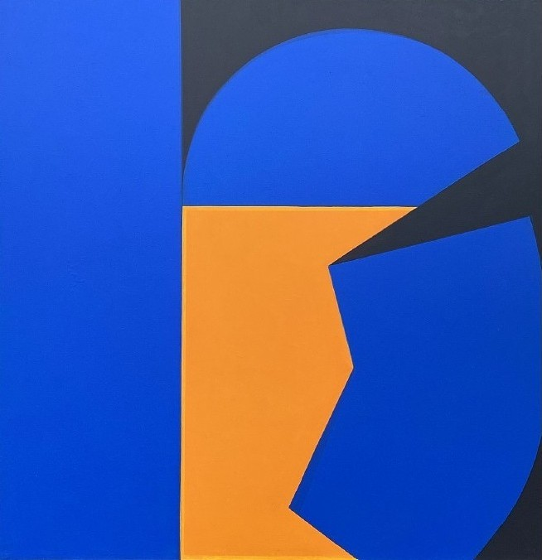
Figure 1.
Karl G. Pfahler, Espan 48, 1981, Acryl auf Leinwand, 200x200cm, in G.K. Pfahler. XVI. Bienal de São Paulo. 16 outubro – 20. Dezembro 1981. República Federal da Alemanha. Katalog, Mercedes-Benz do Brazil, s. By courtesy Florian Pfahler
Belgin’s analysis is worth reproducing in full. “Three colours dominate: orange, blue and the non-colour black. The painting is bordered on the left by a thin yellow line and on the right by a white line (canvas). The painting develops its internal movement from left to right. The compact vertical blue surface occupies about a third of the width, before forming an arc that enhances the interplay of contrast with the orange. The black in the upper section forms a sort of arch through which the eye perceives the blue intensely. However, the central action begins in the area where the black, starting from the right-hand edge, moves along the blue hexagon towards the orange centre. The optical shift then becomes the theme: if the gaze focuses on the orange zigzag shape, the blue and black function as a background. But whilst contemplating the orange, the eye involuntarily drifts towards the black-and-blue area on the right. This then becomes dominant, although the risk of drifting back towards the orange on the left remains. The trigger for all these moments of perception is the black triangle situated above the irregular blue shape. If one masks it, the painting loses its power.”
The structure of Kleiner Espan No. 26 is found exactly in two other paintings: Espan Midi no. 16 from 1989, where the ‘zig-zag form’ is yellow (Fig. 2) and the 1992 New Year’s Greeting Card (Fig. 3).
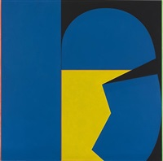
Figure 2.
Espan Midi no. 16, 1989
?
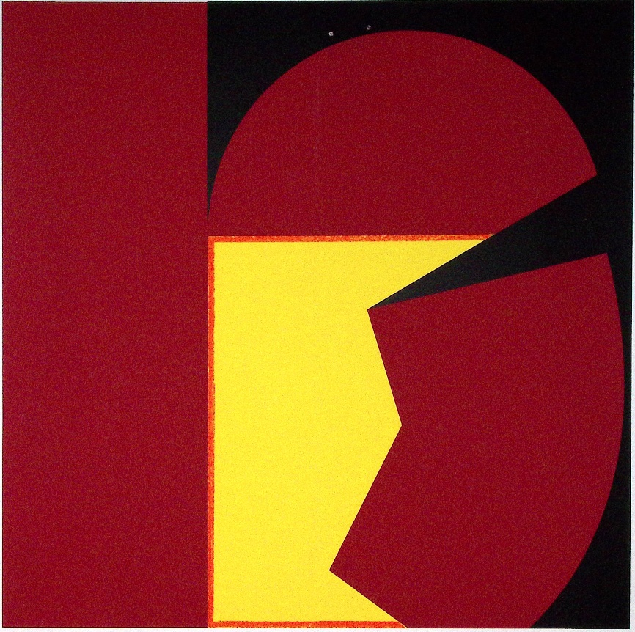
Figure 3.
- New Year’s Greeting Card. D. Droixhe & A. Piette collection.
#2. The pattern of the “open book” in Espan 48 and Espan 49 (1981)
What Elgin calls the “orange centre” (“die orangene Mitte”) and the “orange zigzag form” or “orange zigzag shape” may be considered as the counterform of the matrix pattern or motif referred to here as the “open book with a broken spine”. The cut-out square, coloured either orange or yellow, functions as the negative form—or reverse form—of the blue-and-black configuration composed of the blue shape described by Belgin as “hexagonal” and a black triangular form surmounting it. This triangle, which partly overlaps the “arc that benefits the contrast play of the orange,” also constitutes an essential element of the “open-book” pattern, one side of which assumes, in the lower right-hand corner, the rounded contour characteristic of Pfahler’s geometric works.
The pattern of the “open book with a broken spine” appears on its own in another New Year’s card (Fig. 4).
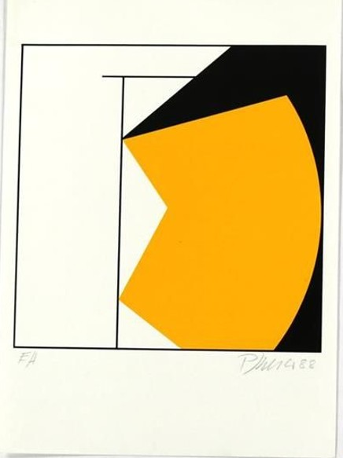
Figure 4.
1988 New Year’s Greeting Card. D. Droixhe & A. Piette collection.
The angles in the first three works appear identical and may be estimated at approximately 159 degrees. The angle appears slightly more open than in the 1988 New Year’s card, as the protractor yields a measurement of 155° in the latter, while it could seem more open… More significant, perhaps, is the way the pattern of the “open book with a broken spine”, from a structural point of view, is integrated within a framework of vertical and horizontal lines that define three triangles—two right-angled scalene triangles and one scalene triangle with unequal sides and angles—as well as an upper horizontal trapezoid and a vertical rectangle.
This structural framework perhaps finds its fullest realization in one of the works presented by Pfahler at the XVI São Paulo Biennial, held between October and December 1981. The exhibition is introduced by Adriani Götz, director of the Kunsthalle in Tübingen from 1971 to 2005. The latter recalls the principal stages of Pfahler’s artistic development, which tended toward “a restriction to ever simpler formal organisms, which ultimately serve only to allow the expressive values of colour to come fully into their own”. From these values arise “strictly geometric formations” that “alternate, usually in square formats, with almost baroque ‘cloud pictures’, as well as vivid colours with generous black-and-white accentuations”.
Götz does not specify to what extent the “geometric formations” exhibited in São Paulo differ from those of the 1960s and 1970s, nor what distinctive characteristics they may possess. Rather, he concentrates on Pfahler’s aim to create a pictorial form “capable in itself of determining an entire spatial environment”. “Pfahler’s wish to situate his art in the public sphere—that is, to make it visible in areas accessible to everyone—ultimately led from large-scale picture-objects, in which the properties of colour were tested in various ways, to colour-space objects that make it possible to relate the picture concretely to the given space”. Three-dimensional arrangements would generate “colour-space objects” extending “the colour relations of the picture into architectural interior and exterior spaces and transform them”. Unlike Baroque ceiling painting, “which brought architecture, sculptural elements and painting into a close formal and thematic relationship”, Pfahler’s projects made architecture itself “newly perceptible” to the viewer through these colour-space objects.
Thus, our task now is to characterize and classify these large acrylic-on-canvas works, measuring 200 × 200 cm and forming square formats, which were exhibited at São Paulo. As it has been said, one painting corresponds to the structural framework defined earlier: the Espan 48 of 1981 (Fig. 5).
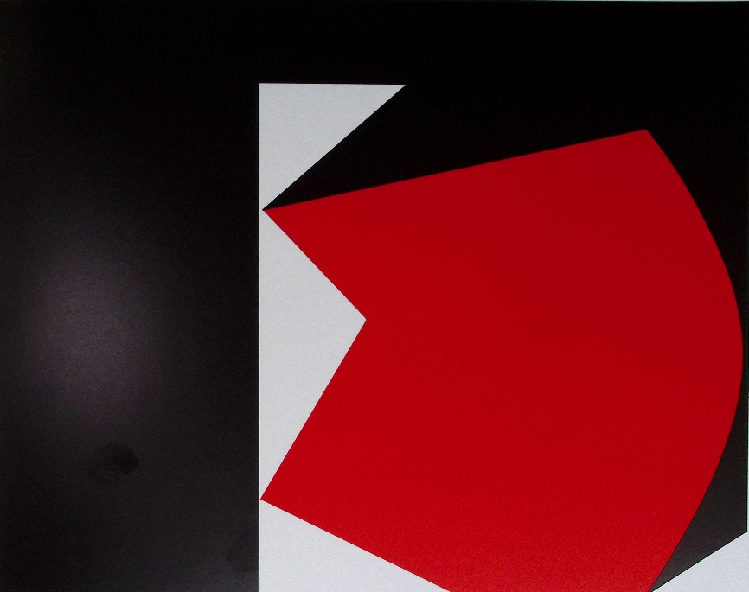
Fig. 5.
G. K. Pfahler, Espan 48, 1981, Acryl auf Leinwand, 200x200cm, in G.K. Pfahler. XVI. Bienal de São Paulo. 16 outubro – 20. Dezembro 1981. República Federal da Alemanha. Katalog, Mercedes-Benz do Brazil, s. p.
The upper horizontal trapezoid and the vertical rectangle previously defined by lines are integrated into a black area that defines the motif of the “open book with a broken spine,” whose spine stands out against the white triangles. One characteristic that distinguishes this work from the preceding ones is that the black square, which now occupies the entire canvas, displays three uncut corners, whereas the lower right-hand corner is truncated to form a triangle of the same color as the vertical triangles.
The structural framework illustrated by fig. 5 is modified in the Espan 49 1981 (Fig. 6).
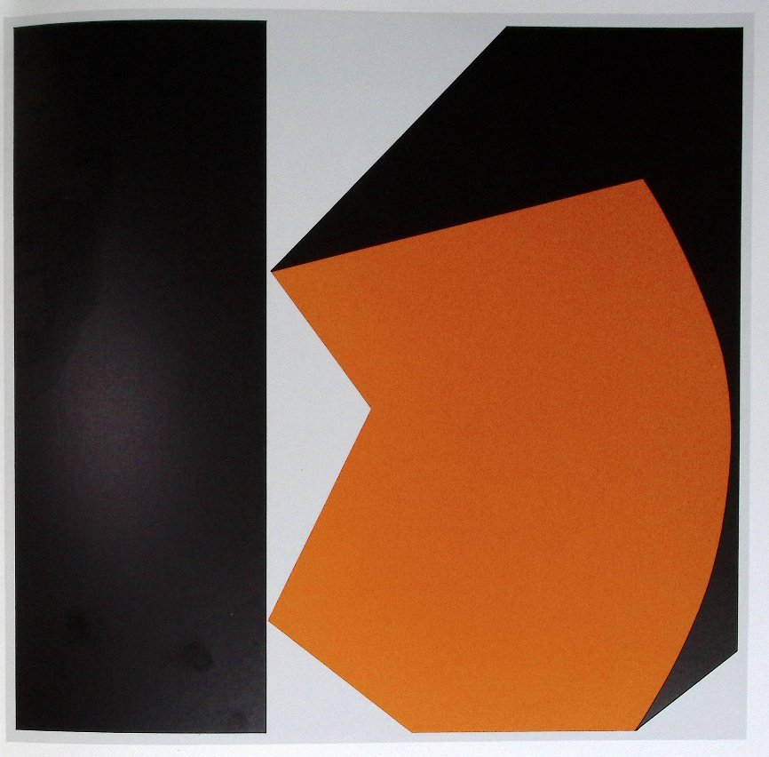
Figure 6.
G. K. Pfahler, Espan 49, 1981, Acryl auf Leinwand, 200x200cm, in G.K. Pfahler. XVI. Bienal de São Paulo. 16 outubro – 20. Dezembro 1981. República Federal da Alemanha. Katalog, Mercedes-Benz do Brazil, s. p.
The vertical rectangle is retained, in black, whereas the upper rectangle is eliminated, leaving only a right-angled triangle of the same colour as the smaller triangle in the preceding work. This painting is also characterized by the truncated lower right-hand corner.
#3. The temptation of imbalance: from Espan 50 to Espan 69 (1989)
According to the number, the next work to be examined is Espan 50 of 1981 (Fig. 7).
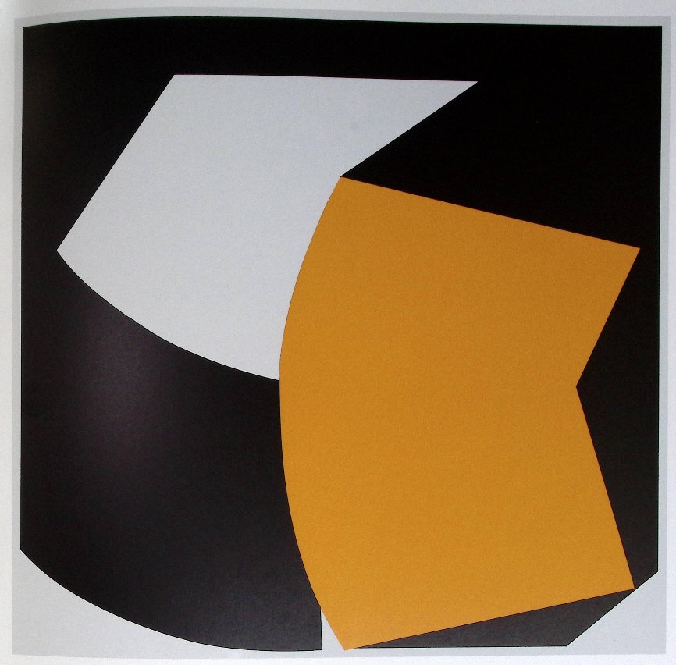
Figure 7.
G. K. Pfahler, Espan 50, 1981, Acryl auf Leinwand, 200x200cm, in G.K. Pfahler. XVI. Bienal de São Paulo. 16 outubro – 20. Dezembro 1981. República Federal da Alemanha. Katalog, Mercedes-Benz do Brazil, s. p.
The form that was hexagonal in Espan 49 here appears as a complete shape, without the truncation in its lower section, and thus becomes a pentagon. Its color lies somewhere between orange and yellow. In contrast to the preceding work, it is oriented in the opposite direction, with its two points facing the right-hand side of the canvas, which they do not touch. It should be noted that the two sides forming the angle of the pentagon also differ in size in the catalogue reproduction: approximately 5.3 and 7.3 cm here, compared with 5.3 and 7 cm in the previous work. The angle is therefore more open in Espan 50—about 40 degrees rather than 60° in Espan 49.
The principal difference, however, is structural. The motif of the open book, which once again includes a rounded spine, is now set against an indistinct light-colored quadrilateral form inserted into a hybrid black shape. Three sides of this black form describe a square, while the fourth is rounded so as to correspond to the lower contour of the indistinct light form.
Did this composition appear less balanced? On the one hand, the visual movement—the action—generated by the triangular opening of the book and the zigzags of the broken spine is cancelled out by the reversal of the form and by the large curve of the opposing line. The dynamic action is further diminished in the indeterminate zone of the upper register and by the kind of redundancy represented by the lower section. This type of composition is not generative in Pfahler’s work.
It may be assumed that Espan 51 represents a first attempt to renew the motif of the open book with broken spine, in which the original formula reappears within the composition (Fig. 8).

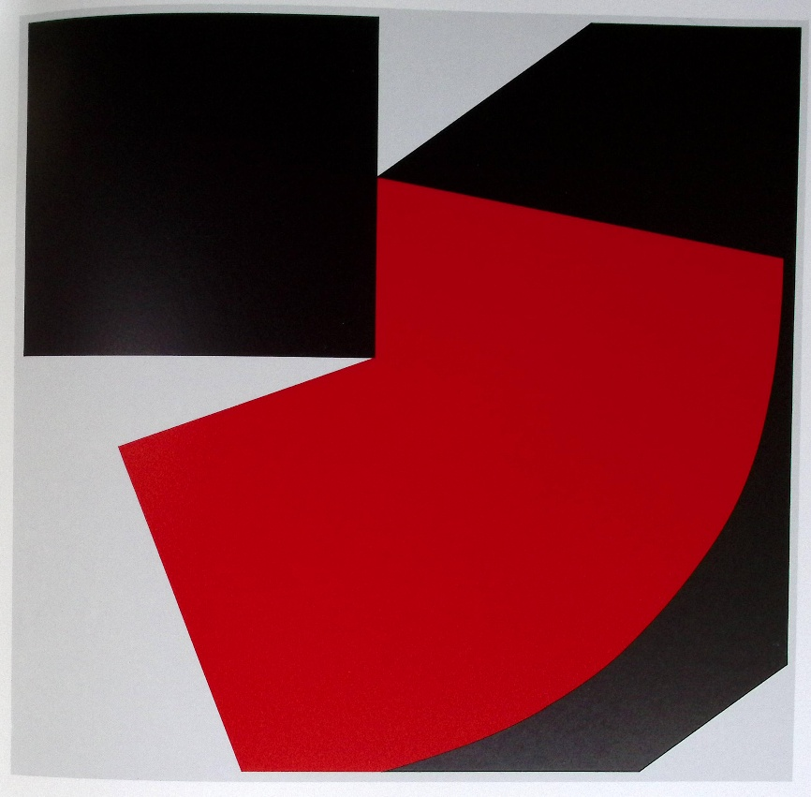
Figure 8.
G. K. Pfahler, Espan 51, 1981, Acryl auf Leinwand, 200x200cm, in G.K. Pfahler. XVI. Bienal de São Paulo. 16 outubro – 20. Dezembro 1981. República Federal da Alemanha. Katalog, Mercedes-Benz do Brazil, s. p.
A black square now replaces the vertical rectangle of Espan 49. The 60-degree angle of Espan 49 and the 40-degree angle of Espan 50 now give way to a 70-degree angle, one side of which adjoins the right-hand side of the square, while the other forms a very acute angle that echoes the light-colored triangle touching the upper edge of the canvas. The lower edge of this light grey triangle likewise echoes the “broken corner” in the lower right-hand corner, so that the same grey color extends across three lateral zones, in opposition to two black areas that also occupy three spaces around a central form of brilliant red. The grey zones thus bring into relief two colors engaged in dialogue: black and red.
The balance of forms is perfectly coordinated with a distribution of colours reduced to their essentials, in a kind of bichromatism that also plays upon the gradations of grey and black. The work achieves a remarkable culmination.
Did the composition prove so satisfying that Pfahler experimented with a variation in which the angle of the book’s spine opens even further in order to adjoin a regular oblique trapezoid whose base, parallel to the upper edge of the canvas, forms something close to a median line (fig. 9)?
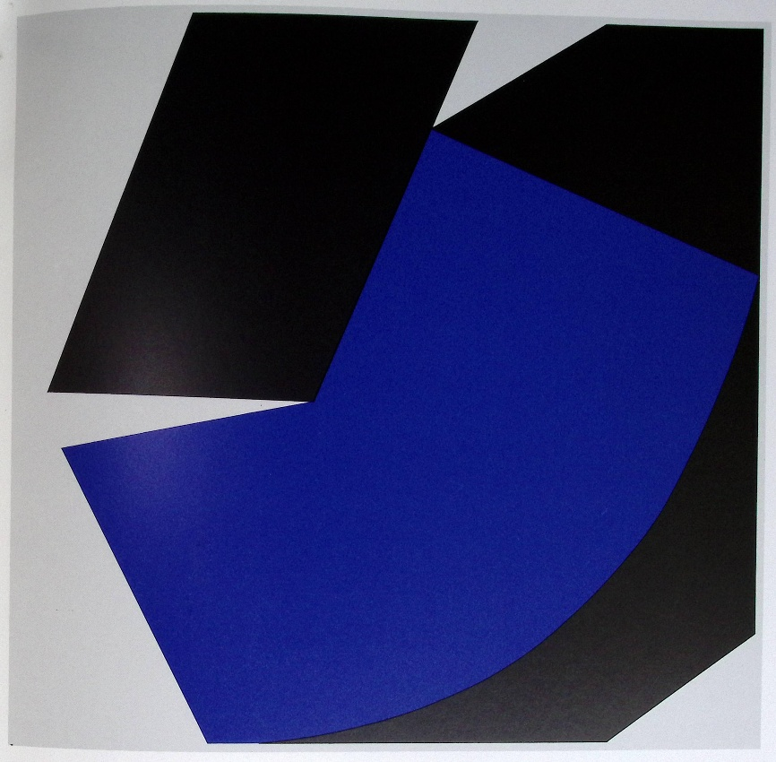
Figure 9.
G. K. Pfahler, Espan no. 69, 1989, Acryl auf Leinwand, 200x200cm, in Georg Karl Pfahler. Galerie Neuendorf, Frankfurt/Main 26. September – 30 November 1992, Monika Reitz (ed.), Stuttgart: Printed by müller prints, 61.
The sense of instability affecting the blue pentagon, poised upon its curve, finds a counterpart in the oblique character of the trapezoid, which together with it creates an angular rupture that is itself suggestive of fragility beneath the appearance of a regular form. This time, the feeling of calm and security ordinarily inspired by geometry is disturbed by an anxiety of imbalance. The image becomes charged with tension. One has the impression that it is apprehensive of its own possible destruction.
#4. The quest for background symmetry (1981-1989)
It sometimes happens that a large-format work proves sufficiently satisfying to generate, years later, a series of screen prints in different colours. This appears to be the case with a type of composition in which the open book with a broken spine occupies the right-hand portion of the pictorial space, in chromatic opposition to a black zone on the left. The composition was first executed for exhibition at the Neuendorf Gallery of Francfort in 1992. Let us underline that this exhibition retraces Pfahler’s artistic development, from the Tachist paintings of 1955–56 through the Formative period and beyond. The catalogue is accompanied by a number of rare photographs documenting Pfahler’s relationships with his wife, his son Florian and other artists, some of whom played an important role in the history of Abstraction and Hard-Edge painting, such as Günther C. Kirchberger, who founded Gruppe 11 together with Pfahler, as well as Nicholas Krushenick, Thomas Lenk, and others.
The work in question here is the Espan IV R/52 (Fig. 10).
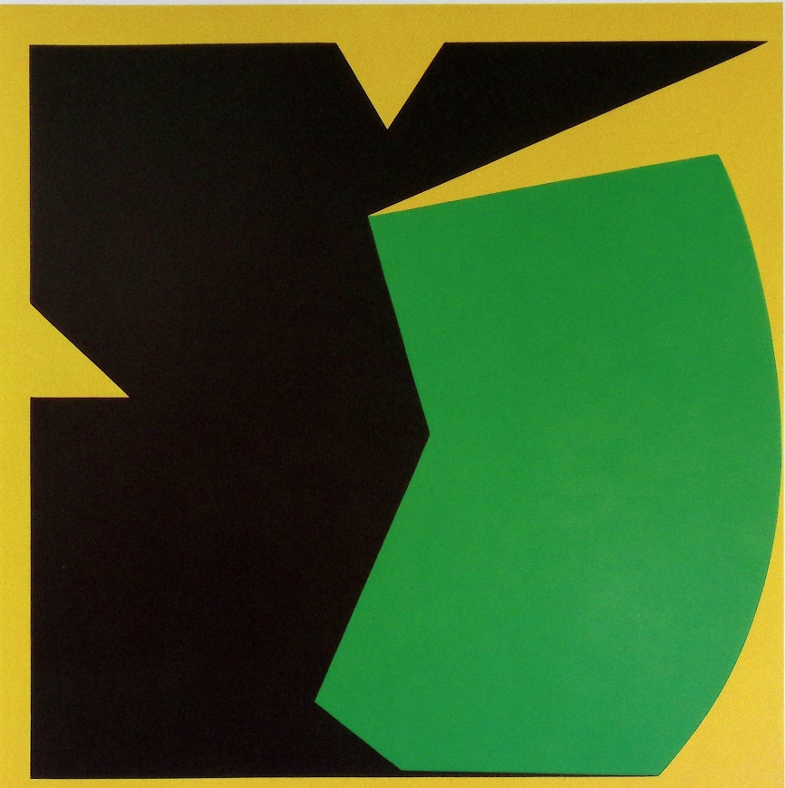
Figure 10.
G. K. Pfahler, Espan IV R/52, 1981, 200x200 cm, in Georg Karl Pfahler. Galerie Neuendorf, Frankfurt/Main 26. September – 30 November 1992, Monika Reitz (ed.), Stuttgart: Printed by müller prints, 58.
This work was shown again under the title Espan no. 69 at the exhibition realized in Pécs, in Hungary, in 1991 (Georg Karl Pfahler. Austellung: Bilder, Grafik Pécs, 1. September bis 6. Oktober 1991 / Kiállitás: Képek, Grafikák, Pécs, 1991. Sezptember 1-Tól Október 6-1G, Stadt Fellbach, 1991, 59).
The overall field reveals a division into three black squares, indicated or suggested by incisions or chipped corners that rhythmically articulate the succession of the squares and create an impression of balance. This balance is, however, disrupted by the zigzag line that forms, on the one hand, the angular point to which the upper right-hand square is reduced and, on the other, the point of the open-book motif. The green form in a sense combines and synthesizes the opposing movements of regularity and contraction that animate the composition.
The large painting of 1981 was subsequently reproduced as screen prints in different colors in 1989 (Fig. 11-12).
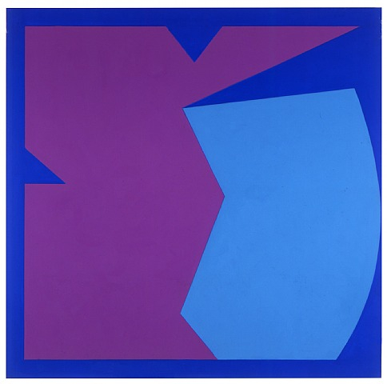  Figure 11.  Espan no.. 69 A (1989)  200 x 200 cm.  ?  https://www.georgkarlpfahler.com/paintings/1980-1989?view=slider#9 | 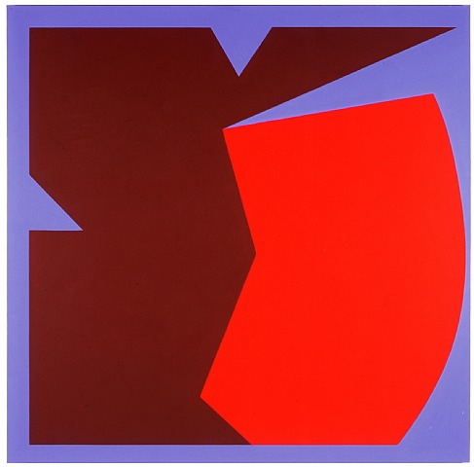  Figure 12.  Espan no. 69 III (1992)  200 x 200 cm.  ?  https://www.georgkarlpfahler.com/paintings/1990-2002?view=slider#4
#5. Form the “open-book with broken spine” to the “open-book with square cover”
Just as the 1988 New Year’s Greeting Card (Fig. 4), through its schematic simplicity, inaugurated the “open book with a broken spine” type, Espan no. 60 III of 1984 may be regarded as exemplifying the model of the “open book with a square cover” (Fig. 13).
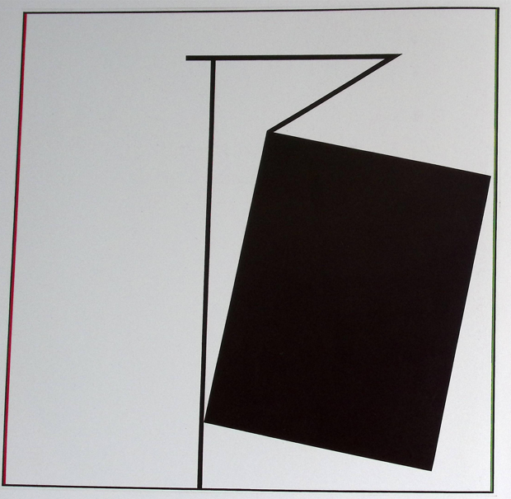
Figure 13.
G. K. Pfahler, Espan no. 60 III, 200x200, in Georg Karl Pfahler. Galerie Neuendorf, Frankfurt/Main 26. September – 30 November 1992, Monika Reitz (ed.), Stuttgart: Printed by müller prints, 58.
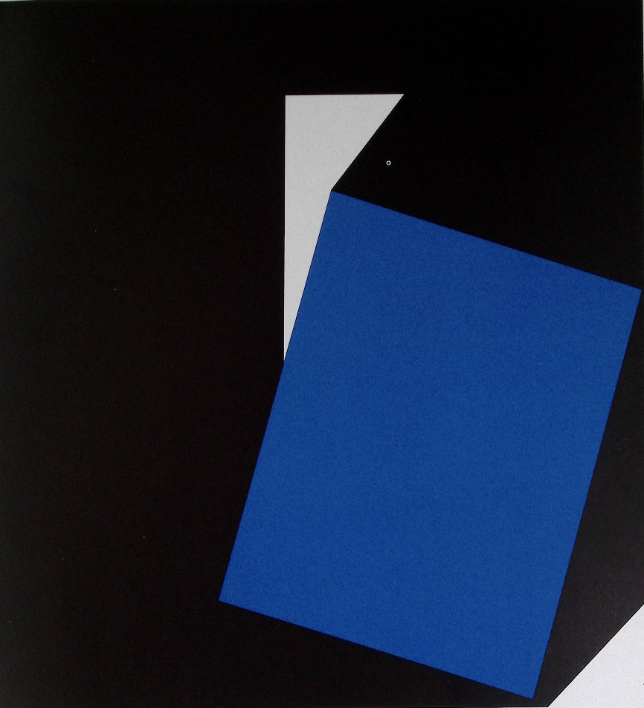
Figure 14.
G. K. Pfahler, Espan 44, 1980, Acryl auf Leinwand, 200x200 cm., in G.K. Pfahler. XVI. Bienal de São Paulo. 16 outubro – 20. Dezembro 1981. República Federal da Alemanha. Katalog, Mercedes-Benz do Brazil.
A slightly different composition was used for the cover of the São Paulo exhibition catalogue (Fig. 15).
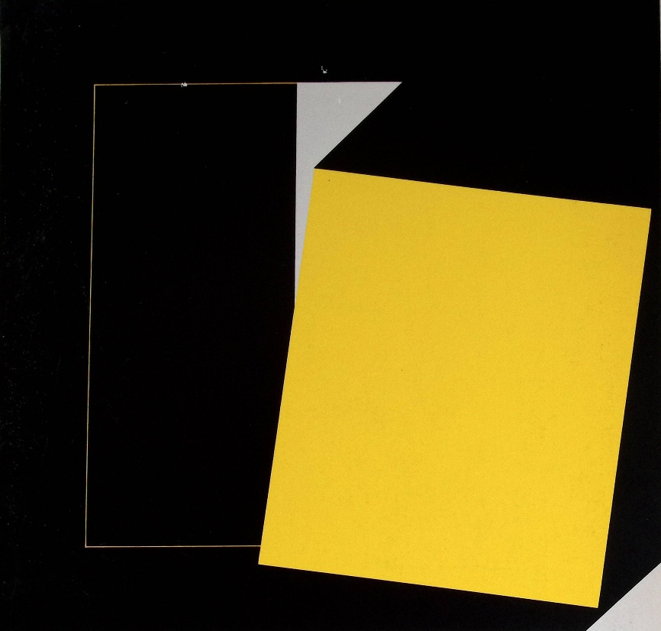
Figure 15.
G. K. Pfahler, Espan 44, 1980, Acryl auf Leinwand, 200x200 cm., cover, in G.K. Pfahler. XVI. Bienal de São Paulo. 16 outubro – 20. Dezembro 1981. República Federal da Alemanha. Katalog, Mercedes-Benz do Brazil.
The black area is subtly subdivided by the horizontal line formed by the light-colored triangle and by other lines suggesting a central square that echoes the outline of the canvas itself. The composition tends to tighten or contract inward.
As in Espan No. 60 III, the lower right-hand corner is occupied by a light-colored triangle. Unlike Espan No. 60 III, however, the break affecting the large black square that fills the canvas finds a counterpart here in the light upper triangle formed by the open-book motif. A kind of symmetry is thus established. The broken corner functions as a kind of artist’s signature.
A question now arises: which of the two following works was conceived first? Both feature open-book patterns in which one cover, or page, is formed by a red shape that appears rectangular—or even square—at first glance, although it is in fact a trapezoid. These forms differ in the angle of opening of the book: the image without the median band displays an angle of approximately 130 degrees, whereas the other opens at an angle of slightly less than 120 degrees. More noticeably, the red form descends much lower in the image without the median band. By contrast, the very thin red lines that delineate a central square, as in the yellow screen print, are almost imperceptible. In both cases, the “broken corner” functions as a signature motif.
The titles of the works provide the answer to this question. The 190×190 cm painting featuring a light-colored median band, reproduced on the cover of the catalogue of the exhibition organized by the Art Society of Zug is entitled Espan 40 and dates from 1979 (Fig. 16). The other work, measuring 200×200 cm and exhibited in Pécs, Hungary, bears the title Espan no. 42 H and dates from 1981 (Fig. 17).
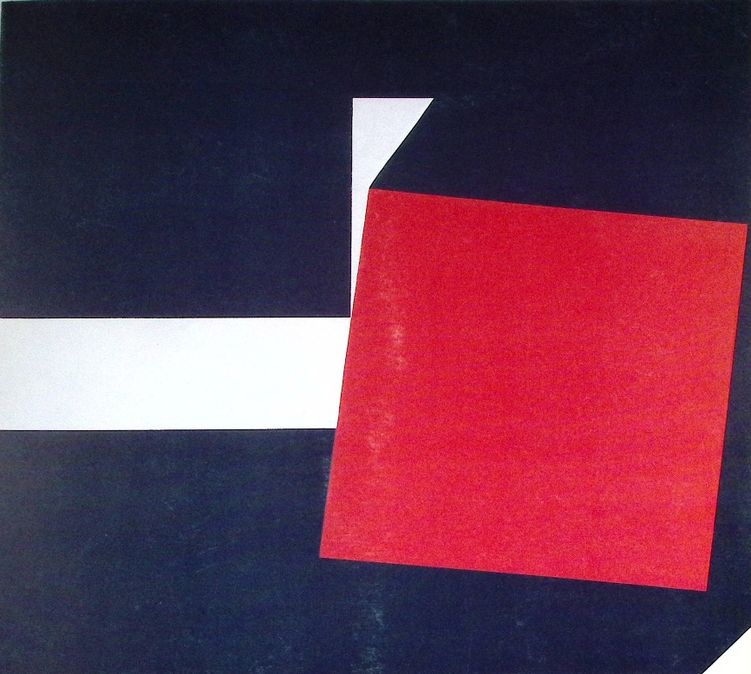
Figure 16.
G. K. Pfahler, Espan 40, 1979, 190x190 cm., cover, in Georg Karl Pfahler. Präkonzeptionen, Bilder, Farbräume, Zug: Kunsthaus Zug, 27. May 1979-28 June 1979.
The same composition has been reproduced in screen print, edition of 30, measuring 69×69 cm. The present example is numbered 11/30 and signed in pencil.
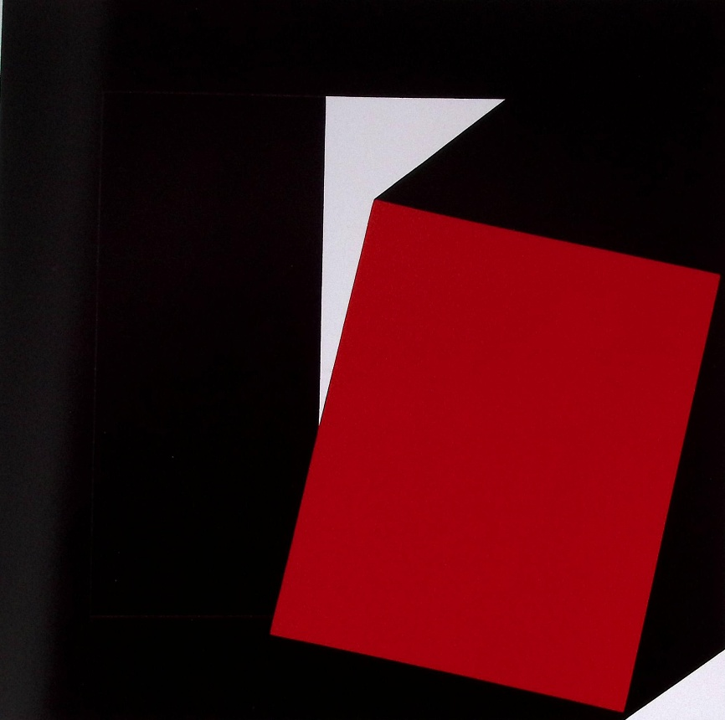
Figure 17.
G. K. Pfahler, Espan 42 II, 1981, Acryl auf Leinwand, 200x200 cm., in Georg Karl Pfahler. Austellung: Bilder, Grafik Pécs, 1. September bis 6. Oktober 1991 / Kiállitás: Képek, Grafikák, Pécs, 1991. Sezptember 1-Tól Október 6-1G, Pécs, Stadt Fellbach, 1991, 41.
#6. Back to the origins: Pfahler’s path to the Espan series.
Another question is: what path did Pfahler follow in arriving at the first work to bear the title Espan? This work is Espan no. 22 of 1975 (Fig. a).
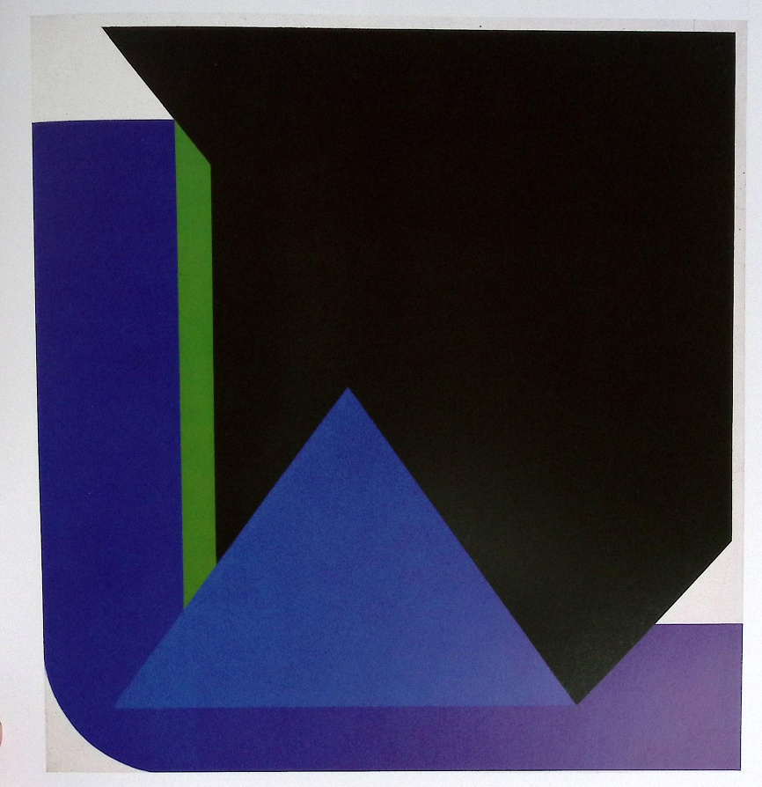
Figure a.
G. K. Pfahler, Espan No 22, 1975, 200x200 cm, in Georg Karl Pfahler. Galerie Neuendorf, Frankfurt/Main 26. September – 30 November 1992, Monika Reitz (ed.), Stuttgart: Printed by müller prints, 53.
Espan No. 22 belongs to a sequence of works characterized by three essential features: an upward-pointing triangle, one side of which follows a transverse axis running downward from left to right, while its lower section is inserted into the curved form occupying the left-hand edge and the lower edge of the composition. This structure already organizes the screen print produced by the Domberger workshop in Bonlanden (Baden-Württemberg) in 1969, listed as no. 88 in G. K. Pfahler. Werkverzeichnis der Druckgrafik 1960–1975 (Fig. b).

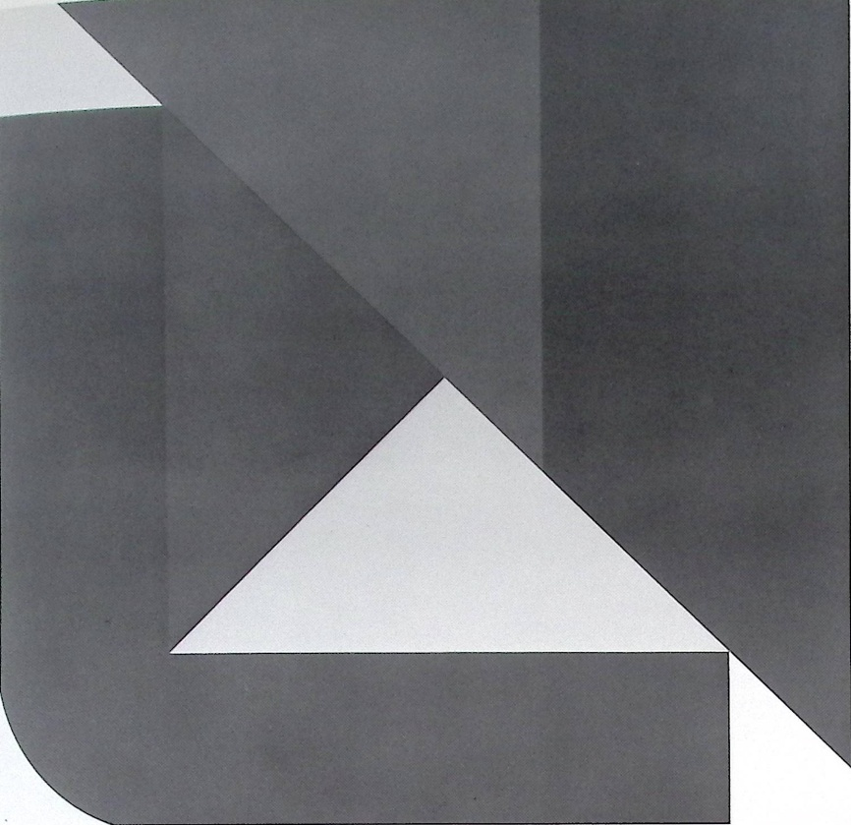
Figure b.
G. K. Pfahler, Screen print, 1969, carmine/violet/blue/yellow, 70x70 cm, Bonladen: Domberger, in G. K. Pfahler, Werkverzeichnis der Druckgrafik 1960-75 [Catalogue raisonné of prints 1960-75), Karlsruhe: Edition Rottloff, 1975, no. 88.
In 1970, however, in a group of screen prints published by Wettig and printed by Löw in Stuttgart, the triangle sometimes takes the form of a right-angled triangle, with the right angle pointing toward the lower left-hand corner, as in works nos. 95, 97, and 98. It is also the case with the screen print edited by Müller in Stuttgart in 1970 which has the no. 100. In another screen print published by Galerie Müller and included in the portfolio 30 Deutsche Künstler, reproduced as no. 109 in the Rottloff volume, the transverse axis is running downward from right to left and the triangle is extended by a second triangle, so that the future rupture of the “broken spine” motif already begins to emerge (Fig. c).
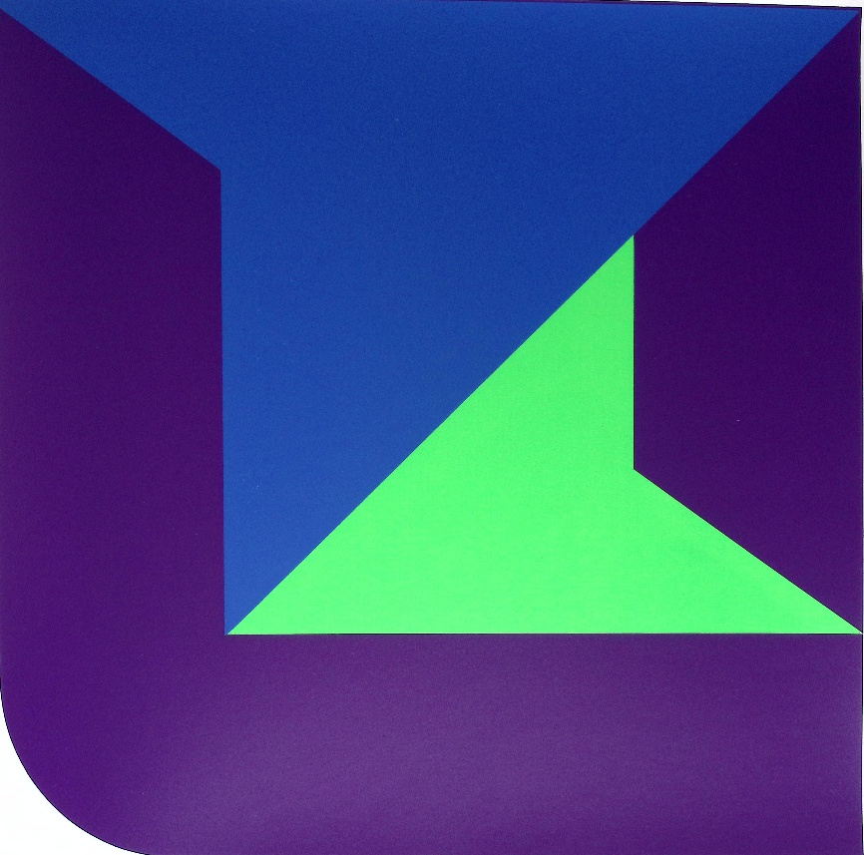
Figure c.
G. K. Pfahler, Screen print, 1970, 60x60 cm, from portfolio 30 Deutsche Künstler, Stuttgart: Galerie Müller, Druck: Stuttgart: Löw, in G. K. Pfahler, Werkverzeichnis der Druckgrafik 1960-75 [Catalogue raisonné of prints 1960-75), Karlsruhe: Edition Rottloff, 1975, no. 100.
The structural scheme is renewed in the KPp16 portfolio published by Domberger Editions, which comprises nine screen prints. The second, unnumbered in the Rottloff catalogue, consists of a square configuration whose corners are all rounded (Fig. d). The triangle rests on its side bearing the right angle. The renewal also appears to affect the color scheme, which is now based on brown, orange, and red.
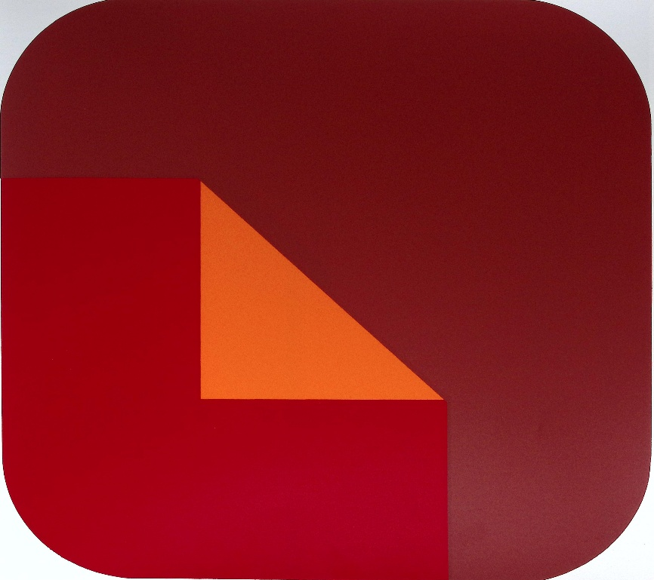
Figure d.
G. K. Pfahler, Screen print, 1970, 65x65 cm, from KPp 16 Portfolio, Bonladen: Edition: Domberger, Druck: Domberger, [no. 2], in; G. K. Pfahler, Werkverzeichnis der Druckgrafik 1960-75 [Catalogue raisonné of prints 1960-75), Karlsruhe: Edition Rottloff, 1975, no.
#7. Stabilization: the two-triangle motif in the constructions in 1971-1972
Pfahler’s composition takes the iconic construction which is familiar in the screen prints of the Ost–West–Transit portfolio of 1971: a triangle supporting a transverse line and resting upon a curved band. However, a first criterion now makes it possible to distinguish between two types of construction. On the one hand, the diagonal line leaves the upper left-hand corner and the lower right-hand corner occupied by the dominant color of the painting's right-hand section (Fig. e).
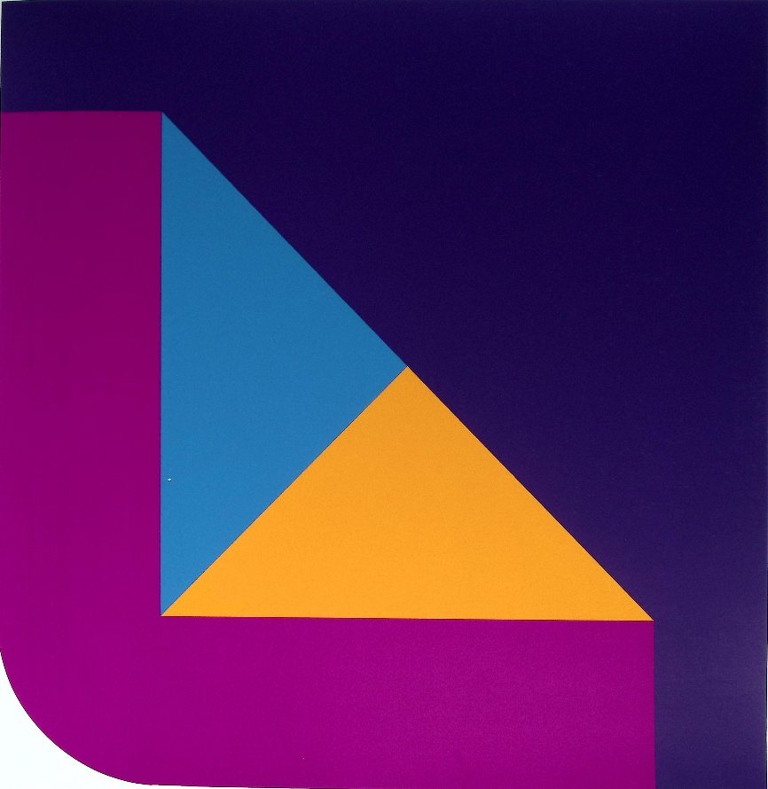
Figure e.
G. K. Pfahler, Screen print, 1971, from Ost – West – Transit Portfolio, Detroit: London Art, Druck: Stuttgart: Haas, no. 3, in G. K. Pfahler, Werkverzeichnis der Druckgrafik 1960-75 [Catalogue raisonné of prints 1960-75], Karlsruhe: Edition Rottloff, 1975, no. 123.

In the second, the diagonal changes direction or is extended, giving rise to white quadrangular or triangular forms (Fig. f).
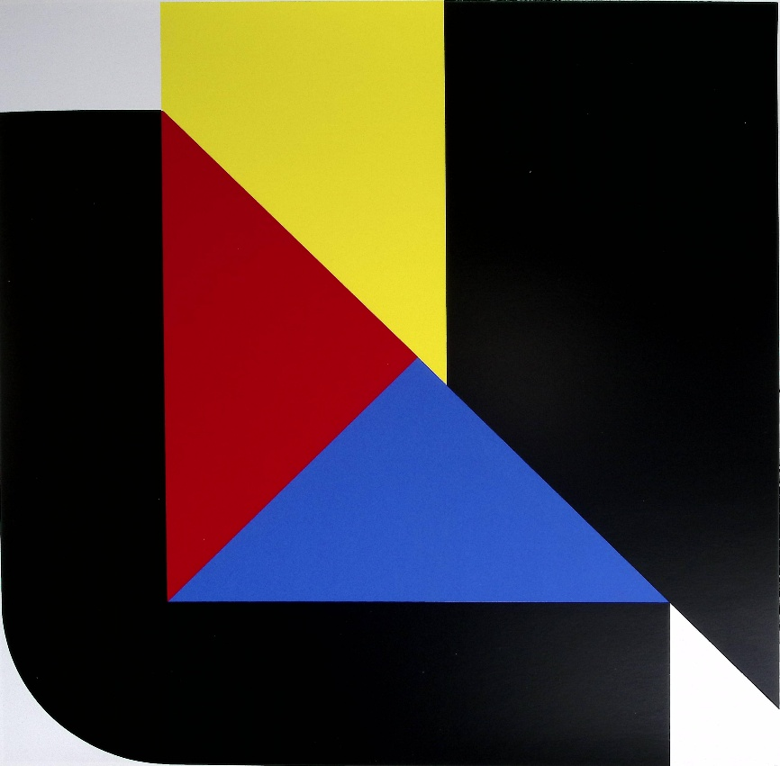
Figure f.
G. K. Pfahler, Screen print, 1971, from 8 Kunstler Folio, Galerie Müller: Stuttgart, Druck:
Ost – West – Transit Portfolio, Detroit: London Art, Druck: Stuttgart: Haas, in G. K. Pfahler, Werkverzeichnis der Druckgrafik 1960-75 [Catalogue raisonné of prints 1960-75], Karlsruhe: Edition Rottloff, 1975, no. 135.

Un autre critère peut intervvenir : dans les œuvres ci-dessus, la ligne transversale n’atteint pas le bord supérieur de la toile, alors qu’elle le fait dans la sérigraphie ci-dessous (Fig. g).

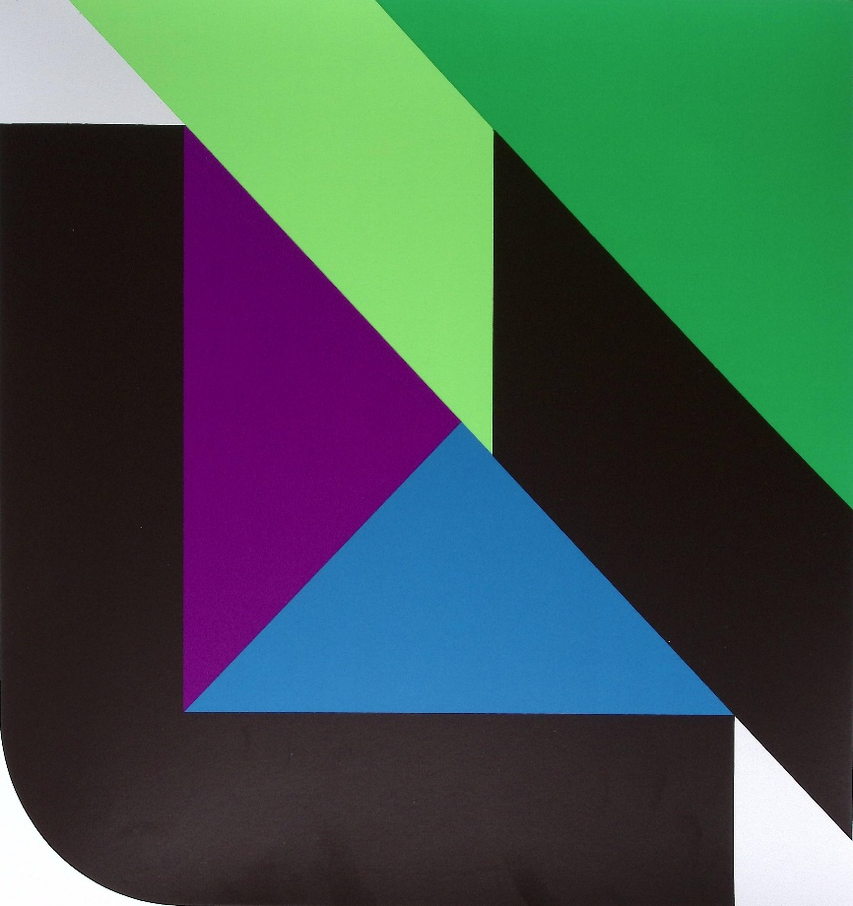
Figure g.
G. K. Pfahler, Screen print, 1972, from Portfolio 7 Siebdrucke, Stuttgart: Edition Domberger, no. 6, in G. K. Pfahler, Werkverzeichnis der Druckgrafik 1960-75 [Catalogue raisonné of prints 1960-75], Karlsruhe: Edition Rottloff, 1975, no no.
# 8. Toward the Spanish black (1971-1974)
As the principal elements of the construction of Espan no. 22 of 1975 were already in place by 1972, does the evolution of the colors assigned to the curved form occupying the lower left-hand corner confirm a similar progress? It has been suggested that the increasing emphasis placed by Pfahler on the color—or non-color—black resulted from the influence of Spanish painting. Black appears very irregularly in the works of 1971–1972; one time in the works belonging to the 1971 Ost – West –Transit portfolio published by London Arts, Detroit (nos. 121–129) and in the seven screen prints that followed (nos. 130–136); two times in the Portfolio 7 Siebdrucke 1972 published by Domberger.
The Kalender 1973 published by Rottloff Editions, which comprises twelve screen prints from 1972, even represents, in a certain sense, a regression in relation to the Espan series, since it contains no corner form rendered in black (nos. 158–169).
Among the last works reproduced in Rottloff’s Catalogue raisonné, two screen prints show a further extension of black within the corner form: no. 177 edited by the Art Circle of Lucerne in 1973 (Fig. h) and no. 188 of 1974 (Fig. i).
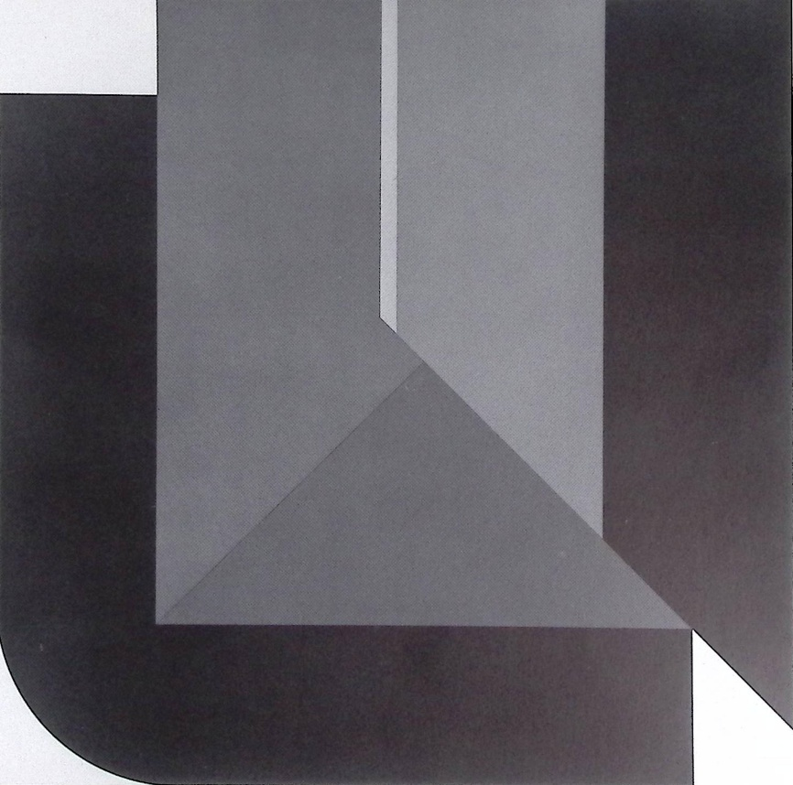
Figure h.
G. K. Pfahler, Siebdruck 1973, Kunstkreis Luzern, Druck: Stuttgart: Haas, in K. Pfahler, Werkverzeichnis der Druckgrafik 1960-75 [Catalogue raisonné of prints 1960-75], Karlsruhe: Edition Rottloff, 1975, no 177.
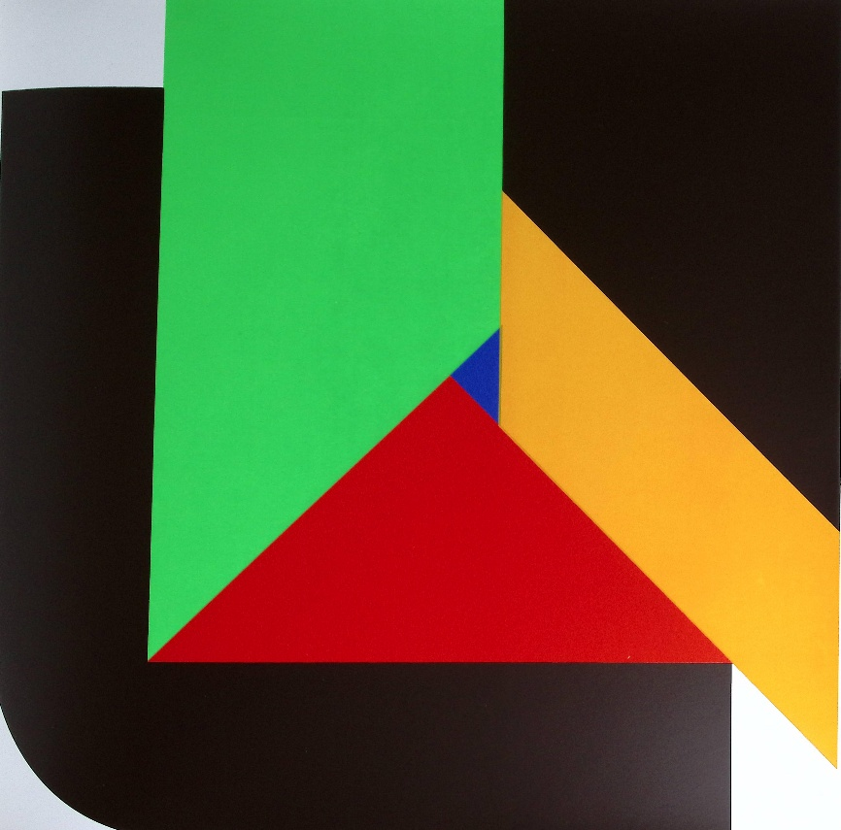
Figure i.
G. K. Pfahler, Siebdruck 1974, Karlsruhe: Edition Rottloff, Druck: Rottloff, in K. Pfahler, Werkverzeichnis der Druckgrafik 1960-75 [Catalogue raisonné of prints 1960-75], Karlsruhe: Edition Rottloff, 1975, no. 188.
We are now, structurally and chromatically, very close to Espan no. 22 of the following year.
Conclusion
The "open book" motif in Pfahler's work is the result of a long process of development, generally traced back to the serigraph dated 1969, listed as no. 88 (Fig. b) in Rottloff's Catalogue Raisonné of Prints 1960–1975. By this stage, the motif had already evolved considerably from the works of 1965, which mark the emergence of Pfahler's characteristic style. The evolution of Pfahler's work is punctuated, in what will hereafter simply be referred to as the Catalogue raisonné, by introductory texts opening the various sections of the volume, due to Juliane Roh, Gerd Winkler, Dieter Honisch and Hans Jürgen Müller.
Juliane Roh has described in the Catalogue raisonné the first historical context of the artist’s graphic cursus. “Georg Karl Pfahler, alongside Günther Fruhtrunk, who lived in Paris, was among the first artists in Germany to strive for a new articulation of color as form. Whereas Rupprecht Geiger was concerned with light in relation to color, and Gaul with the signaling power of color, Pfahler sought constellations of forms that would do justice to the spatial value of color, while making every effort to avoid the play of spatial illusion.” Rupprecht Geiger (Munich 1908-2009) produced beautiful works characterized by geometrical abstraction that indeed explore chromatic variation as a function of light, their forms lacking sharply defined contours and instead dissolving into fragmented edge (Fig. j).
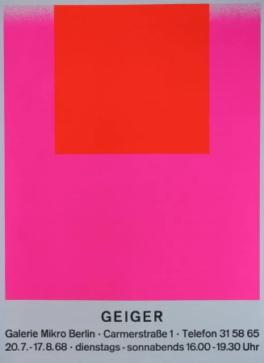
Figure j.
Poster of exhibition Rupprecht Geiger 1967-68, Galerie Wilbrand, Cologne.
Daniel Droixhe & Alice Piette Collection.
Winfried or Winfred Gaul (Düsseldorf, 1928–2003) was far more than an artist concerned with the "signaling power of color." Like Pfahler, he may equally be regarded as pursuing "constellations of forms attuned to the spatial values of color." His investigations underwent such abrupt transformations, prompted by his sustained reflection on the relationship between art and reality, that his work often met with incomprehension from critics accustomed to the unity—or even the repetition—of a linear artistic development. For this reason, this pioneer of Informal Art and Color Field painting remains seriously underestimated, and forgotten, in the history of Hard-Edge painting.
It is difficult to understand—though at the same time revealing of a certain French conception of modern art—that neither Pfahler nor Fruhtrunk (Munich, 1923-1982) is included in Violette Garnier's L'Art en Allemagne 1945–1995. Yet this volume contains entries devoted to Geiger and Gaul, as well as to Willi Baumeister, Heinz Mack, Raimund Girke, and others. Further entries celebrate artists such as Blinky Palermo, Sigmar Polke, and Gerhard Richter, whose artistic careers developed during the 1960s, just as Pfahler's did. Nor did Hermann Glöckner (Dresden-Cotta, 1889–1987) escape a measure of neglect, despite the fact that his Constructivism had been condemned by the Nazis and subsequently fell into disfavour with the authorities of the GDR. Only rehabilitated in the late 1960s, he left behind a body of work whose austere geometric language of the 1930s unquestionably lay beyond the aesthetic horizon of Garnier's study. One need only consider his remarkable Farbfelder auf Weiss (Colourfields on White) and Weiss und Silber mit schwarzen Keil oben (White and Silver with a Black Wedge at the Top), both dating from 1932.
For the sake of chronology, mention should first be made of Pfahler's early appearance in a particular type of media platform. The gallerist and publisher Hans-Jürgen Müller (Limenau, 1936–2009) recounts in Rottloff's Catalogue raisonné that, towards the end of the 1950s, he set out "to make high-quality modern prints available at an affordable price, enabling collectors to discover, month after month, a different artist or motif." "The first calendar, published in 1959, cost 120 DM and featured, among others, Sonderborg, Piene, Brüning, Pfahler, and Schumacher. Subsequent editions included artists such as Vasarely, Denny, Fontana, and Quinte, for only 30 DM. All the prints were signed, and the editions never exceeded eighty impressions." The series came to an end when the calendar format—widely imitated, even down to its dimensions—gave way to a different means of promoting Pfahler's work. The new concept consisted in offering different chromatic combinations of a number of motifs, thereby exploiting the tropological potential inherent in "the distinctive nature of Pfahler's printed oeuvre."
This "distinctive nature" was therefore already evident, if not yet widely recognized, when Pfahler burst onto the national art scene. Juliane Roh first states: “Unlike his American Hard-Edge counterparts, he did not approach the problem through the right angle. Until 1965, his work was dominated by curved forms that moved diagonally across the picture plane, yet were either enclosed within a rectangular frame or counterbalanced by a triangle advancing from one corner. This produced a tension between frame and pictorial content, to the point where their respective roles could even be reversed. The frame moved toward the center, while the more dynamic color forms shifted outward. Through color, Pfahler explored a complex equilibrium between static and dynamic forms.”
Whom did Roh have in mind when she compared Pfahler to his "American Hard-Edge counterparts"? It is likely that she was thinking primarily of artists such as Josef Albers, the German-born painter whose American career is well known (Bottrop, 1888–1976), or Ellsworth Kelly (Newburgh, New York, 1923–2015). In his 1960 essay " (“Meaning and Permanence of Constructive Painting)," Michel Seuphor—that is, Ferdinand Louis Berckelaers (Antwerp, 1901–1999), arguably one of the foremost authorities on abstract art, having witnessed and accompanied its development—also identified Albers and Kelly as the leading American exponents of Constructive Abstraction. According to Seuphor, Albers belonged among those who had taken up the mantle of figures such as Malevich, Mondrian, and van Doesburg, alongside Magnelli, Arp, and Sonia Delaunay. Seuphor’s pen, characteristically dipped in acid, readily castigated "the enormous flock of Panurge's sheep wallowing in the same mire"—that is, those caught up in the fashionable rush towards abstraction. Kelly, for his part, belonged to the "younger generation," together with "Baertling, Thépot, Agam, Nemours, Fruhtrunk, [and] Tomasello." It is noteworthy that Seuphor singles out Fruhtrunk as the foremost German representative of Constructive Abstraction, reproducing a version of his Drei Kreise und ihre Negatives, shown at the Galerie Denise René in Paris, while omitting any reference to Pfahler (Figs.k-l).
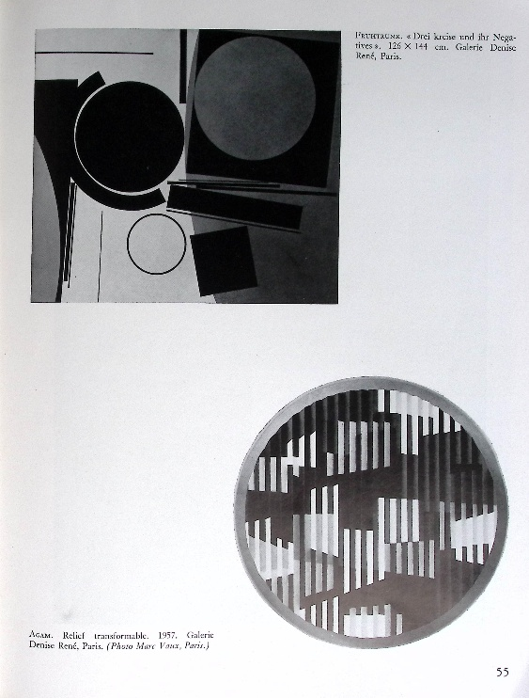  Figure k.  Michel Seuphor, « Sens et permanence de la peinture construite”, Quadrum 8, 1960, 54-55, with Günther Fruhtrunk, Drei Kreise und ihr Negatives, 126 x 144 cm. Galerie Denise René, Paris. | 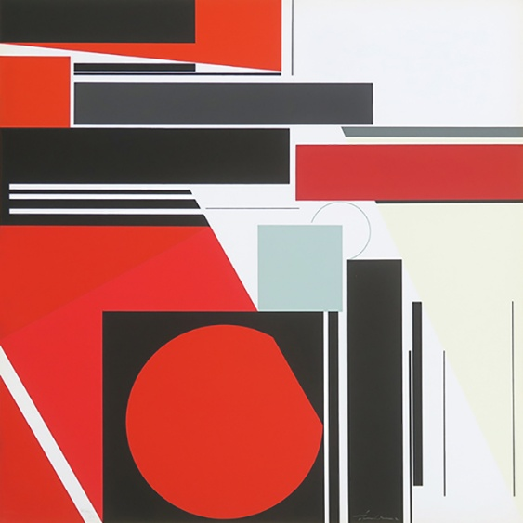  Figure l.  Günther Fruhtrunk, Drei Kreise und ihre Negatives, screen print, from portfolio “Günter Fruhtrunk: 6 sérigraphies imprimées chez Marquet”, Galerie Lahumière (Paris). Image courtesy of Galerie Lahumière.
An "approach to Hard-Edge through the right angle," to borrow Roh's phrase, applies far more readily to Albers's Homage to the Square or to Kelly's works of the 1950s, such as Neuilly or Pink Rectangle, than to the paintings of the "Four Abstract Classicists" as they appeared in 1959–1960 in the catalogues of the celebrated West Coast Hard-Edge exhibition (Figs. m-n). More generally, the work of these “four classicists” - Karl Benjamin, Lorser Feitelson, Frederick Hammersley, and John McLaughlin - has often been overshadowed by the New York avant-garde. See the “constant misrepresentation” of “the West Coast America in art criticism” denounced by Lawrence Allowey in the British and Irish version of the catalogue.
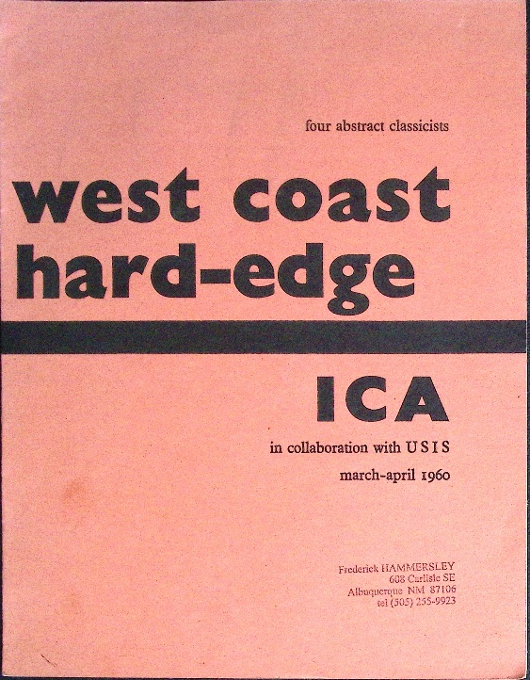  Figure m.  Four Abstract Classicists. WestCoast Hard-Edge. ICA in collaboration with USIS, march-april 1960, London: Graphic Press Ltd. Copy sent to Frederick Hammersley. D. Droixhe & A. Piette collection. | 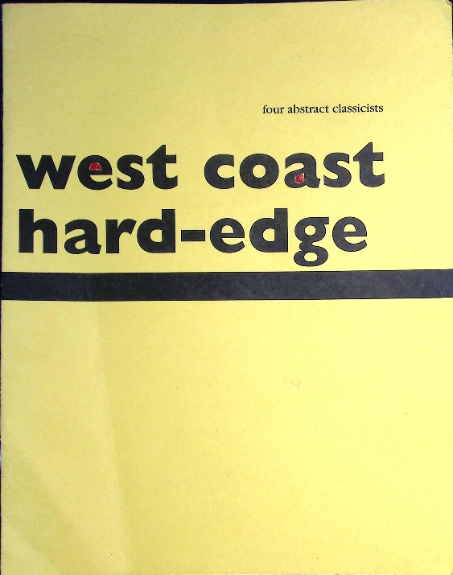  Figure n.  Four Abstract Classicists, West Coast Hqrd-Edge, San Francisco: Modernism, March 4 – April 24, 1993. D. Droixhe & A.Piette collection.
In any case, suggestive geometry of right angles structures may be identified in the works by Benjamin and Feitelson reproduced in these catalogues (Figure o-p).
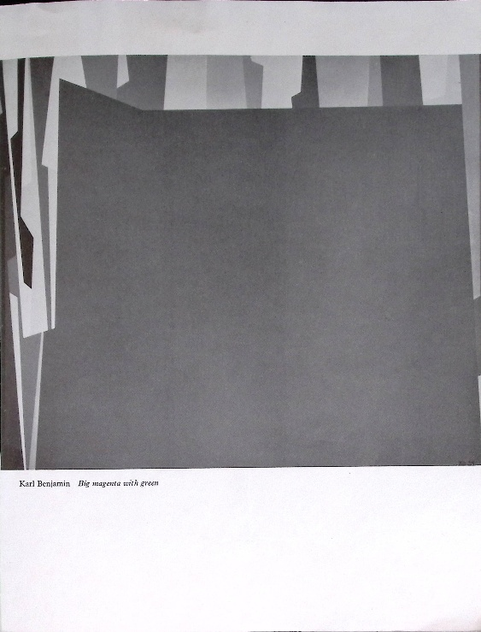  Figure o.  Karl Benjamin, Big magenta with green, in  Four Abstract Classicists. West Coast Hard-Edge. ICA, 1960. Benjamin’s work reproduced in Four Abstract Classicists, West Coast Hard-Edge, 1993 is I. F. Green, Ochre, Umber. | 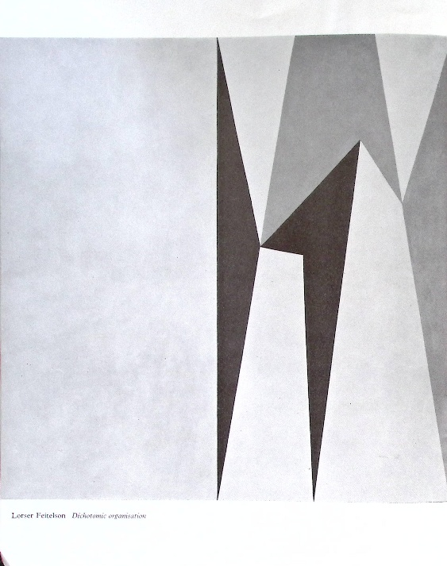  Figure p.  Lorser Feitelson, Dichotomic organisation, in Four Abstract Classicists. WestCoast Hard-Edge. ICA, 1960. Feitelson’s work reproduced in Four Abstract Classicists, West Coast Hqrd-Edge, 1993 has the same title but different colors.
Works by Hammersley and McLaughlin display an altogether different mode of construction, based on bars and circles (Figs. r–s). Considered in light of the artists' own statements and subjected to closer examination, these works also reveal markedly different cultural and philosophical foundations, perhaps characteristic of a distinctly Californian sensibility. It is welknown that Jules Langsner coined the very term "hard-edge" for the West Coast Hard-Edge catalogue. Establishing when the term was first applied to Pfahler constitutes a further line of inquiry.
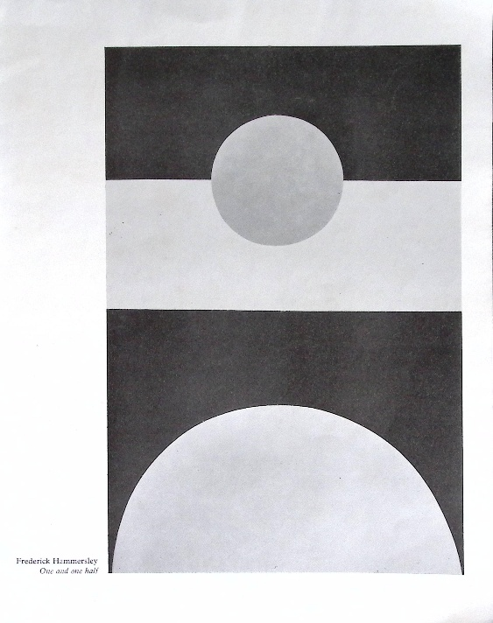  Figure r.  Frederick Hammersley, One and one half, in  Four Abstract Classicists. WestCoast Hard-Edge. ICA, 1960, Hammersley’s work reproduced in Four Abstract Classicists, West Coast Hard-Edge, 1993 is Like Unlike. | 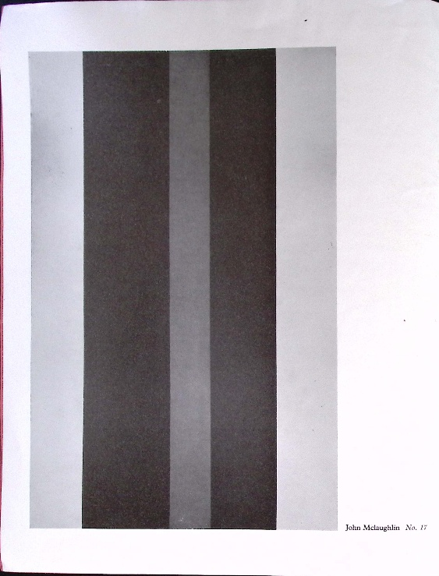  Figure s.  John McLaughlin, No. 17, in  Four Abstract Classicists. WestCoast Hard-Edge. ICA, 1960, Mc’sLaughlin work reproduced in Four Abstract Classicists, West Coast Hard-Edge, 1993 is D-1957.
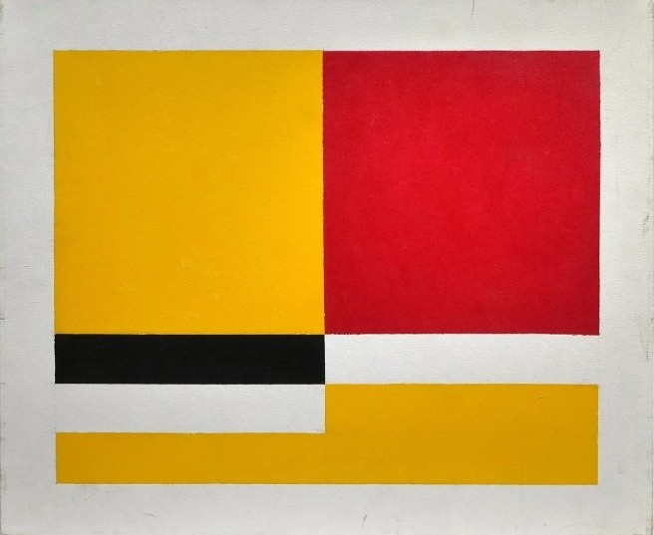
Figure t.
After John McLaughlin, Untitled, oil on canvas, 19,5 x 24 in. Provenance: Edmund & Leslie Glass, Manhattan, NY & Redding, CT. With ms: “Ameringer [unreadable: McEnery / Yohe?] Gallery – John McLaughlin 5-1958”. The Ameringer Gallery exposed David Hockney and Frank Stella, but also some of the “Four Abstract Classicists” such as Frederick Hammersley and John McLaughlin, whose exhibition was reviewed by Grace Glueck in The New York Times of September 23, 2005. D. Droixhe & A. Piette collection.
If we return to Pfahler's development at the point where Juliane Roh left off—that is, in 1965—we already encounter a decisive turning point in one of the first works reproduced in the Catalogue raisonné for that year: Nos. 24–25. The serigraph published that year by the Kunstverein Stuttgart (No. 24) does indeed display the rectangular frame with rounded corners enclosing two squares, the smaller of which contains coloured bands terminating in downward-pointing tips (Fig. t). This composition still seems to retain something of Albers's Homage to the Square.

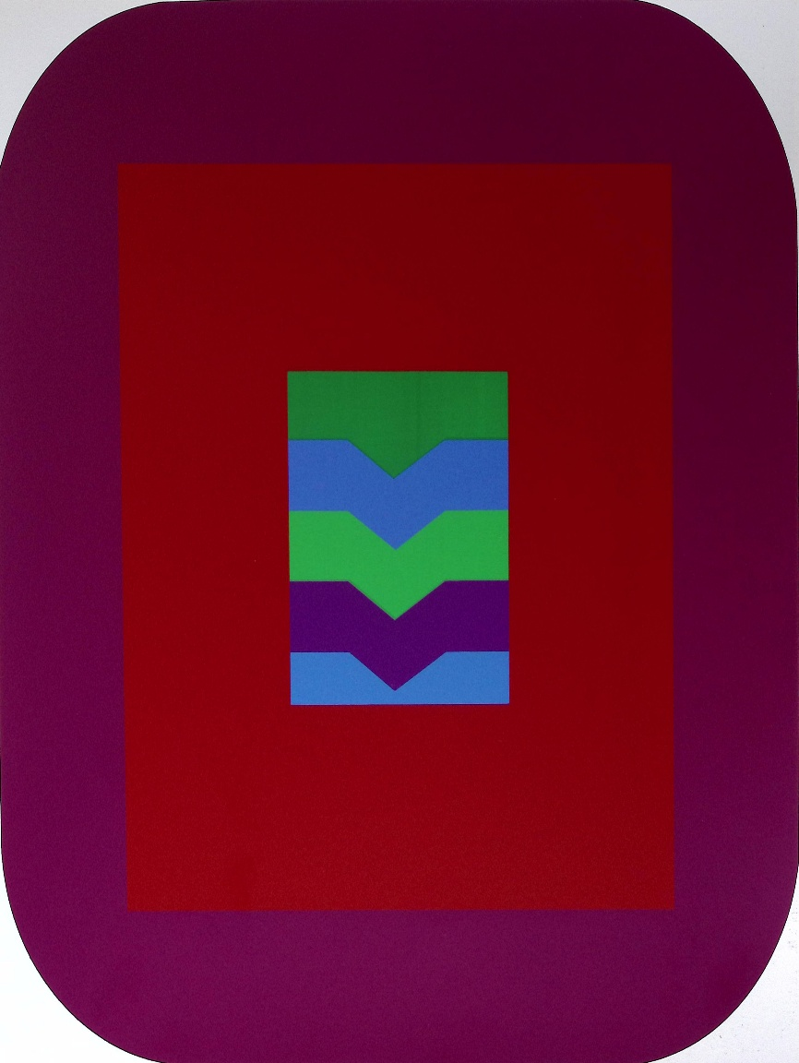
Figure t.
G. K. Pfahler, Siebdruck 1965, 60x52,5 cm, Kunstverein Stuttgart. Fruck : Löw, in K. Pfahler, Werkverzeichnis der Druckgrafik 1960-75 [Catalogue raisonné of prints 1960-75], Karlsruhe: Edition Rottloff, 1975, no. 24. D. Droixhe & A. Piette collection.
Another serigraph of 1965 (No. 26) presents an asymmetrical intersection of rounded forms, a solution that Pfahler would subsequently abandon.
The serigraphs produced in 1966 in Stuttgart by Löw for the Edition Kaufhof and the Edition Rottloff in Karlsruhe continue to employ the inclusion of squares within a quadrangular frame (Nos. 28–29). At the same time, however, Edition Rottloff and Galerie Müller in Stuttgart were already publishing compositions of rounded forms, one of which Pfahler would retain as a triptych (Nos. 31–33). A variant of this triptych composition is also known (fig. u). Roh writes that these rounded forms dominate Pfahler’s production until 1965, as he immediately contrasts with “his American Hard-Edge counterparts”, and, rather than privileging the right angle,” favored "curved forms that move diagonally across the picture plane”. Curved forms likewise descend from the upper right corner or follow the central axis to reach the lower edge in the works of 1966 (Nos. 30–33), including the one reproduced below (Fig. v).
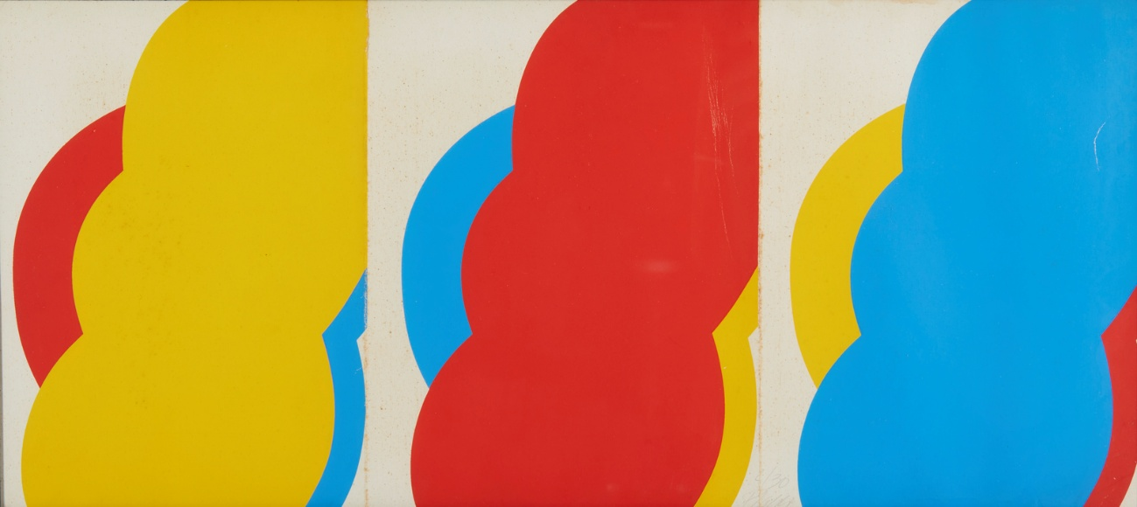
Figure u.
Karl Georg Pfahler, Without Title, screen print, pencil signature and edition number, cop. 2/30, Provenance: Treviso, Private Collection; Oupeye, Daniel Droixhe & Alice Piette Collection. Colors different from Siebdruck 1966, 25 signierte und numerierte Exemplare, Edition Rottloff, Karlsruhe, Druck: Rottloff.
One may suppose that Gerd Winkler had the work reproduced above, or a comparable work from 1966, in mind when he wrote in Rottloff's Catalogue raisonné that one of these compositions "presents, on the open side of the composition"—the side originating on the right and developing towards the left—"three rounded forms." "The symbolic significance of the number three opens up countless possibilities: the triad of father, mother, and child; the three openings of the human body; the three wishes of the fairy tale."
The serigraph published in 1966 by the Kestnergesellschaft Hannover (Fig. v) marks a turning point, as it brings together the structural elements that Pfahler would subsequently develop in an extraordinary variety of compositions. These proved so successful that they became the defining features of his oeuvre and, ultimately, iconic images of his artistic production.
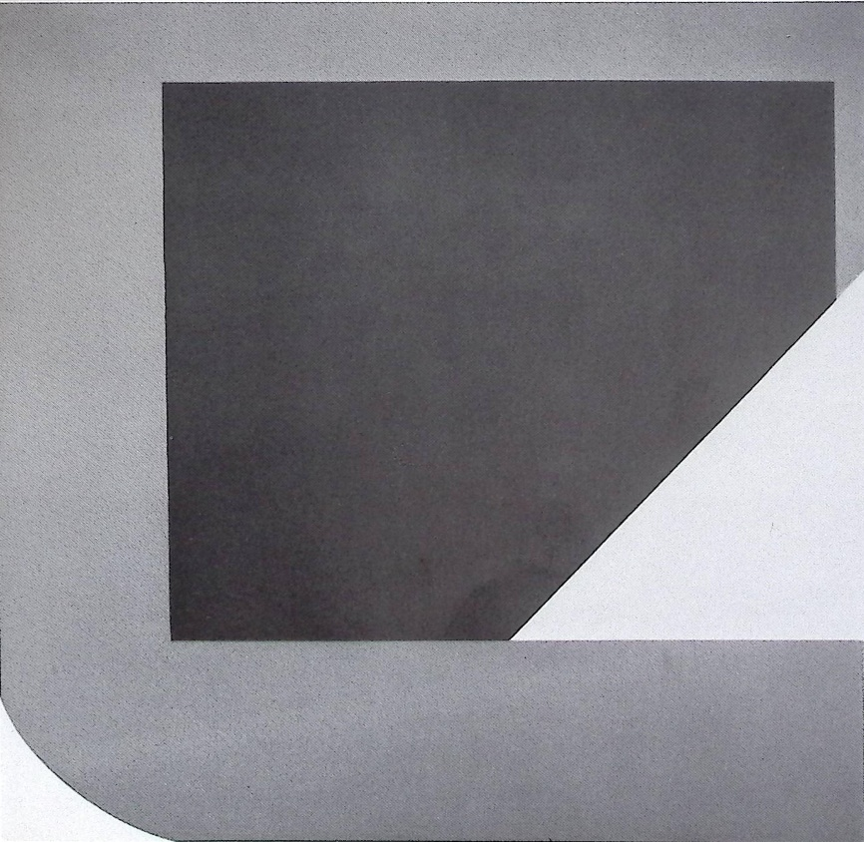
Figure v.
Pfahler, Siebdruck 1966, Kestnergesellschaft Hannover, Druck: Löw, Stuttgart, in : Rottloff Catalogue Raisonné, No. 34.
The 1969 serigraph, No. 88 in Rottloff's Catalogue Raisonné, which is supposed to constitute the starting point of the “open book pattern”, was published by the Domberger workshop, famous for screen-printing. Its website proudly recalls: “Luitpold Domberger pioneered and developed screen printing as an artistic medium, his son Michael developed it further and promoted the original prints produced through this printing technique. The Domberger have encountered and worked with a large number of modern artists, from Baumeister and the exponents of abstract painting to constructivists and pop artists as well as more recent contemporary artists”. The Domberger’s illustrated calenders play a significant role in the history of modern art since 1967.
These calenders, like those made by Müller in Stuttgart, also deserve a place in the sociological history of Hard-Edge painting. However, we could be surprised that Pfahler—who was featured by the Kunstverein Stuttgart and the Kunstverein Münster in 1965, and the following year by Rottloff in Karlsruhe, Edition Kaufhof, Galerie Müller in Stuttgart, and the Kestnergesellschaft in Hanover—was not included in Domberger's 1967 calendar. That calendar contained works of geometric abstraction in the hard-edge idiom, such as those by Günther Fruhtrunk and Fritz Ruoff (Nürtingen, 1906–1986). Preference was given to internationally fashionable figures such as Vasarely and Albers, with their familiar or ordinary quadrilateral compositions. Did Pfahler deliberately seek to establish a distinctive artistic identity, rather than being associated with abstract painters whose concerns differed markedly from his own?
When reconstructing the path that led Pfahler from his encounter with Domberger in 1969 to Espan No. 22 of 1975, the chronology jumps directly from 1969 to 1970. It is therefore necessary to take into account the evolution that Juliane Roh identifies during the intervening period. According to her, in 1967 Pfahler embraced the tendency "to allow the viewer to enter the picture rather than merely stand before it." But what exactly does this mean? He is said to have abandoned "the complex internal tensions between static and dynamic color forms in favor of concentrating on the relationship between pictorial space and real space." His approach would thus have become essentially environmental. From the more limited standpoint of the painting's internal organization—as a structure of forms and an arrangement of colors—a change is indeed immediately perceptible: "color forms now had to become more concentrated, simplified, and conceived in relation to one another from one work to the next."
Roh is therefore justified in writing that Pfahler "thus arrived at an optimal pictorial structure," in which "nearly all compositions since 1967 are based on an energetic dialectic between the left and right sides of the picture." She continues: "A half-frame, rounded at the lower corner, compels the viewer to read the composition from left to right." Yet this is precisely the configuration already found in the 1966 serigraph published by the Kestnergesellschaft, reproduced above (Fig. v). To the right opens "a large square plane," whose "visual weight establishes equilibrium within the composition."
We have seen that, for Gerd Winkler, “three rounded forms” in an abstract painting may involve a “symbolic significance”. Confronted with a simple geometric figure, we could be tempted to recognize a real object. The relative validity of such identification had already been debated by Pablo Picasso and the first Belgian master of geometric abstraction, Victor Servranckx, during the 1920s, if Servranckx's own account is to be believed (Diegem, 1897–1965). To detach oneself from the concrete object "in order to regard it as the representative of a more general category," Winkler writes, is not merely to rise to the level of abstraction; it is also to allow the mysterious dimension of reality to emerge, as suggested by the existential philosophy of Karl Jaspers. To this, Winkler adds the reflection of Ernst Fischer, the "Marxist endowed with a profound understanding of art," whose intellectual and political outlook was so close to that of Élie Faure: "Within the abstract work of art there are rhythm and the fabric of lived reality."
Dieter Honisch, perhaps the finest interpreter of Pfahler's work, rejects any abstract representation of reality that would elevate the level of suggestion to that of symbolism—or even mystery. This is especially true of colour. « Georg Karl Pfahler ‘constructs’ his paintings out of color. For him, colors are primary realities; they are not derived from nature, emotion, or symbolic associations. Nor do they serve a representational function by producing, as complementary values, effects of light, simultaneous contrasts suggesting movement, or signals conveying messages”. This definitely distinguishes Pfahler from Geiger, for example. Pfahler’s colors “remain identical with themselves”. These are “the qualities that endow the colored fields with their original, almost naïve freshness and their simple beauty.”
“Yet Pfahler’s paintings do not merely present beautiful colors. Something takes place with and between these colors, and it is precisely from this interaction that the idea of the painting emerges”. If the painting does not symbolize anything, it nevertheless arouses an “idea”. “Thus, for example, an angular acid green penetrates a warm violet from a rich, deep blue. As a result, the harmonious coexistence of blue and violet is perceptibly disturbed. The violet seems to retreat upwards, while at the same time optically consolidating the blue. Along the dividing boundary, both colors acquire greater luminosity; their hue becomes more intense than in the lower or left-hand part of the picture and appears to lose some of its energy around the green, with the result that the angular outline of the green assumes a positive presence, sharp as though cut with a knife.”
This analysis is at least acute, and would deserve to be illustrated. Among the works recorded after Honisch’s commentary, there is a painting, No. 55 from the Domberger KP Portfolio of 1968, that has the colors “blue/violet/green”, but the reproduction is in black and white. The Siebdruck 1970 from the portfolio “30 Deutsche Künstler” published by the Galerie Müller in Stuttgart (No. 109), provides a useful point of comparison (Fig. w).
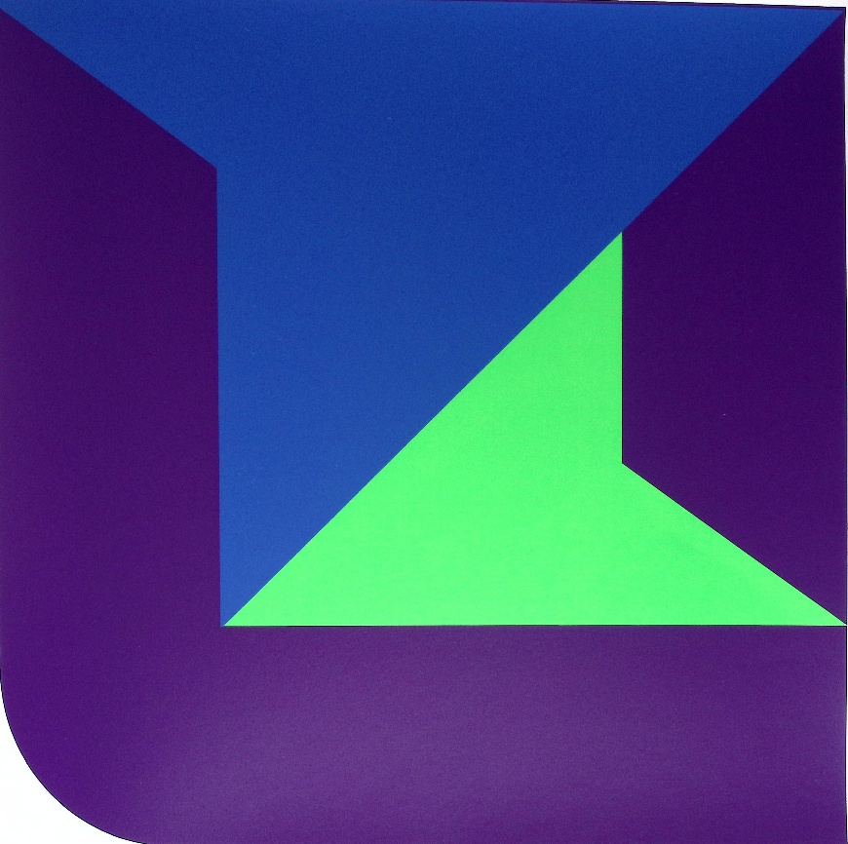
Figure w.
Karl Georg Pfahler, Siebdruck 1970, from portfolio “30 Deutsche Künstler”, Galerie Müller, Stuttgart; in Rottloff Catalogue raisonné, No. 109.
Honisch adds: “The right-hand corner of the sheet reveals once again that the colors do not lie side by side on a single plane, but are arranged in depth: blue lies upon green, green upon violet, violet upon blue,” etc. “This superimposition of colors corresponds to the succession of the optical process just described. Consequently, the pictorial form is not simultaneous but successive; it is not planar but spatial. What is remarkable is that, within this stratification, the colors assume a different status from that which they possess optically. The apparent contingency of the fragment and of the delimitation of color is thereby elevated to the rank of definitive formal value.” In other words, “Pfahler's paintings do not merely present beautiful colors. Something takes place with and between these colors, and it is precisely from this interaction that the idea of the painting emerges.”
The same interaction moves geometric forms as they “never acquire an autonomous value as circles, squares, angles, or stripes”. This is completely different from so many constructivists using geometry. “Rather, these forms appear as fragments, as portions of such structural elements that serve the construction of the painting while retaining a concealed inclination towards symmetry”. This inclination radically opposes Pfahler to one of the American “Four Abstract Classicists”: John McLaughlin (Sharon, Massachusetts, 1898-Dana Point, 1976). Michael Duncan writes that “McLaughlin’s austere approach to form and color resulted in bare-boned, Zen-like philosophical inquiries into dualities such as darkness and light, enclosure and exposure, symmetry and asymmetry, and elevation and decline”. But those dualities, Susan Larsen writes, became elements of tension and conflict so that McLaughlin’s paintings show a sense of disequilibrium, instead of harmony. However, when the artist or the spectator looks at a work reduced to two parallel bars, he feels a meditative attraction to emptiness that provides calm and serenity, as it is taught by Eastern culture and philosophy of the ma – the “void”.
“Pfahler”, Honisch adds, “works with relatively few elements: the rectangle with rounded corner, the rectangular frame, and angular bands arranged either in parallel or in mirror symmetry”. It is striking that Honisch, too, speaks of “formal austerity”, much as American critics did in relation to McLaughlin. It is sufficient to “continually direct the eye back to color, which is the true subject of the work”. “At the same time, it prevents color from being misconstrued as merely the coloring of beautiful forms. We recognize the fragmentary formal element in Pfahler for what it is intended to be: a simple and precise delimitation of color.”
Hans-Jürgen Müller explained how, during the 1960s, he came to conceive the idea of multiplying Pfahler's "color-form." The artist, he writes, "had devised a series of six motifs, each printed in two different chromatic combinations." Color thus became the vehicle through which form was varied, opening up a process that was, in principle, without limit. "The compositions ranged from relatively closed, symmetrical structures in light tonalities to extremely dynamic forms, bursting open pictorial space through dramatic chromatic constellations." The idea grew out of the practical production of calendars. As Müller points out, each series—"limited only by the purpose of the set as a whole"—was "restricted to the number twelve."
Removing this material constraint did more than simply maximize the combinatorial potential of the series. "When we arranged the different motifs according to the order in which they had been created, in keeping with the 6 × 2 concept, a kind of thirteenth sheet emerged, as the sum of all the individual prints. We then intervened freely in this creative process: we played with the arrangement, removed certain prints, recomposed the ensemble in different ways, and were astonished to discover yet more images—a thirteenth, a fourteenth, a fifteenth, a sixteenth…"
Beyond the various possible configurations there thus emerged the prospect of a kind of potential synthesis—an arch-image or meta-image that provided the key to an ensemble structured as a cluster. A comparable type of virtual, synthetic image has been developed in computer science within a different field of image-identification research, namely the study of typographic ornamentation. This research was carried out in collaboration with the LISA Department of Image Analysis of the Université Libre de Bruxelles (O. Debeir, S. Rahmoune).Artificial intelligence should not only offer artists the kind of "astonishing" extension of creative possibilities developed by Pfahler and his publisher-printer; it should also provide art historians with a valuable tool for the classificatory and critical analysis of abstract works of art.

For reasons of consistency and convenience, the original title Span No. 26 will be translated as Span No. 26.
Yet the experimental construction of such an archi-fleuron, or arch-typographic ornament, continues to meet resistance from an increasingly obsolete strain of bibliography from Mr. Joran Proot concerning our participation to the Conference Methods for Micro- and Mesotypography (Conference Sept. 24-26, 2025, Herzog August Bibliothek Wolfenbüttel).
Tayfin Belgin, Georg Karl Pfahler: Farbraum – Linienraum, in Georg Karl Pfahler, 4 December 1990 – 19 January 1991. Arc Galerie. Lilienstrasse 11 / 2nd Floor D-2000 Hamburg 1. I thank for help, support and positive answer to my questions, Michelle Champetier (Galerie Michelle Champetier, Cannes), Muriel Collart (Université Libre de Bruxelles), Diane Lahumière (Galerie Lahumière, Paris), Ursula Sturm (Meckenheim),
Stephan von Wiese, Zwische Bild und Objekt, in G. K. Pfahler. Präkonzeptionen, ed. Jo Enzweller and Sigurd Rompza, Berlin: Frölich & Kaufmann / Saarbrücken: Galerie St. Johann, 1984, p. 3.
G. K. Pfahler. Werkverzeichnis der Druckgrafik 1960-78, Edition Rottloff: Karlruhe, 1975. These essays are neither numbered nor, in keeping with the graphic and aesthetic design of the publication, provided with page numbers. My translation.
Violette Garnier, L'Art en Allemagne 1945–1995, Paris: Nouvelles Éditions françaises, 1997.
Glöckner. Hermann Glöckner zum 100. Geburtstag. Gemälde, Zeichnungen, Tafeln, Collagen, Abdrucke, Faltungen und plastiche Arbeiten, Staatliche Kunstsammlungen Dresden, Kupperstich-Kabinett / Ausstellung im Albertinum, 21. Januar-29.März 1989 / Staatliche Galerie Mortizburg Halle, 28. Mai-9. Juli 1989, Nos 10-11.
Michel Seuphor, « Sens et permanence de la peinture construite”, Quadrum 8, 1960, p. 37-58, here p. 54-55.
Lawrence Alloway, “Preface”, in West Coast Hard-Edge. ICA, March-Aprril 1960.
Daniel Droixhe, Karl Benjamin’s formative years. The main steps to Hard-Edge (1950-1959), to appear.
Ameringer / McEnery / Yohe Gallery, founded in 1999, headed by Miles McEnery, was located in the Chelsea neighbourhood of New York City. I changed its name in 2018. See John Chiaverina, “New York’s Miles McEnery Gallery to Open Second Space in Chelsea”, ARTnews July 26, 2018.
Daniel Droixhe, Archives d'avant-garde. Parcours d'artistes belges dans la presse des années 1920. Bruxelles: Académie royale de Belgique, 2026 https://hdl.handle.net/2268/345518

