Dynamic and Image Variation Archive (DIVA-Face):

A novel controlled facial stimuli set

Wenrui Li*¹, Raphaël Legrand*^{1,2}, William Daro¹, and Christel Devue¹
¹ Psychology and Neuroscience of Cognition Research Unit, University of Liège, Belgium
² GIGA-CRC Human Imaging, University of Liège
* Contributed equally to the work

Author Note
Wenrui Li https://orcid.org/0009-0008-3900-5200
Raphaël Legrand https://orcid.org/0009-0004-3979-508X
Christel Devue https://orcid.org/0000-0001-7349-226X
Correspondence should be addressed to Christel Devue (cdevue@uliege.be), University of Liège, Psychology and Neuroscience of Cognition Research Unit, Place de Orateurs, 2 (B32), 4000 Liège, Belgium. Tel: +32 4 3669282
Additional illustrations of the material, validation data and access request documents are available from https://doi.org/10.58119/ULG/EFLCIJ.
The pre-registration of hypotheses and analyses plan are visible at https://doi.org/10.17605/OSF.IO/V3ZAX. Aggregated data are available at https://osf.io/wezxs/?view_only=ba18fa36bfd3492f83e018e6dc4d5407. We posted a draft of our manuscript on the preprint server of the OSF under the following link https://osf.io/preprints/psyarxiv/nbm5h_v1 on the 13th of July, 2026.
Word count: 5,245 (excluding title, references, author affiliations, declarations, figure captions, and abstract).

Abstract
Understanding how humans learn, recognize or otherwise process unfamiliar faces requires stimulus materials that balance experimental control with ecological validity. Although face learning research has highlighted the importance of within-person variability, most existing studies rely on static ambient images or do not systematically disentangle appearance-based variability from other display-related factors. Here, we introduce the Dynamic and Image Variation Archive (DIVA-Face), a video-based face database designed to fill this gap. The database comprises 8,064 video clips and 2,016 still images of eight actresses recorded under tightly controlled conditions. Each identity is presented across orthogonally manipulated appearance dimensions, including hairstyle (via six distinct wigs—hair down or up—and one balaclava), makeup (lipstick present or absent), and accessory (glasses present or absent), giving 28 distinct combinations. Each appearance combination was captured under three lighting directions, while performing twelve dynamic facial actions for videos, or posing with three head orientations for photographs. All recordings were made against a uniform green-screen background, allowing flexible manipulation of contextual information for future applications. To validate the usability of the database, we conducted a preregistered proof-of-concept experiment using an incidental face learning paradigm with a subset of the stimuli. Results show reliable effects of appearance manipulations on recognition performance, even under online testing conditions. These findings confirm that the database supports controlled behavioral investigations of unfamiliar face learning. The database is also suited for behavioral, social-cognitive, and computational investigations beyond face learning, and is openly available to promote reproducibility and cross-disciplinary integration.

Keywords: face learning, face processing, facial appearance, experimental material, dynamic stimuli.

Dynamic and Image Variation Archive (DIVA-Face): A novel controlled facial stimuli set
Face processing in general, and face recognition in particular, play a crucial role in effective social interactions (Avery et al., 2016; Engfors et al., 2024). Humans are remarkably proficient at recognizing familiar faces. Once a face has been learned, recognition may remain robust across time, changes in appearance, and viewing conditions—even after years (Bahrick et al., 1975; Ritchie et al., 2015; but see Devue, Wride, & Grimshaw, 2019). In contrast, the recognition of unfamiliar faces is relatively fragile: performance is highly sensitive to changes in appearance, viewpoint, and context, and even multiple encounters often fail to produce stable identity representations (Baker et al., 2017; Bruce et al., 1999; Liu et al., 2015; Young & Burton, 2017). This asymmetry between familiar and unfamiliar face recognition performance highlights the central role of face learning in enabling reliable person identification.
A dominant theoretical view holds that face learning involves building a stable identity representation by integrating information across multiple encounters (Bruce & Young, 1986; Burton, 2013). From this perspective, learning reflects the integration—or averaging—of variable instances of the same individual, thereby enabling observers to extract identity-diagnostic information while discounting incidental, image-specific features. Consistent with this account, a large body of laboratory research shows that exposure to highly variable images—differing in hairstyle, accessories, expression, viewpoint, quality, background or camera lens—can improve subsequent recognition performance relative to exposure to less variable images (Baker et al., 2017; Kho et al., 2025; Liu et al., 2015; Murphy et al., 2015; Ritchie & Burton, 2017). However, this advantage is not uniform: effects can be modest or absent under certain conditions or populations (e.g. Baker et al., 2017; Ritchie & Burton, 2017), and other findings suggest that stability in appearance may also support early stages of learning (Devue & de Sena, 2023). Taken together, these findings suggest that variability is not uniformly beneficial, highlighting the need to isolate specific sources of variation and examine how they interact with learning context. In this regard, Devue and de Sena (2023) proposed a cost-efficient account of face learning in which familiarity emerges through the parsimonious extraction of diagnostic facial features following a coarse-to-fine encoding process. This process would be modulated by idiosyncratic facial characteristics such as a person’s tendency to change their facial appearance across encounters. This framework therefore explicitly motivates the development of controlled materials to isolate different types of variation, including facial appearance, in order to determine which ones matter, when, and why.
Addressing this challenge, while bridging the gap between laboratory findings and real-world face learning, requires facial stimuli that combine ecological validity with tight experimental control. To this end, we developed the Dynamic and Image Variation Archive (DIVA-Face), a stimulus database that systematically manipulates appearance variability while controlling display conditions. Importantly, the database includes dynamic information through short video clips that more closely approximate everyday encounters than static images. These clips capture natural head and facial movements as well as hand gestures, providing rich temporal and motion cues. Such dynamic information has been shown to facilitate identity learning and recognition, thereby enhancing the ecological validity and the practical applicability of the database in experimental and applied contexts (e.g., Knight & Johnston, 1997; Lander & Davies, 2007; O’Toole et al., 2002).
Concretely, the DIVA-Face consists of 8,064 videos and 2,016 still images of eight actresses captured under systematically controlled appearance and viewing conditions. Each identity was recorded while wearing a balaclava covering the hair and ears and paired with six different wigs. From these elements, a standardized set of 28 appearances was created, incorporating no additional features, lipstick, glasses, both lipstick and glasses, or a low ponytail secured with a hair tie. Each appearance was recorded while the actress performed twelve distinct actions under three different lighting directions (frontal, leftward, and rightward). Three photographs were also taken from different angles (frontal, ¾ left, and ¾ right) for every combination of appearance and lighting.
The selection and grouping of wigs and actresses were based on two pretests designed to ensure balanced visual characteristics and minimize confounds. In the wig pretest, participants rated the distinctiveness and pairwise similarity of 26 wigs. Based on these ratings, four groups of six wigs were created to balance average similarity (i.e. three relatively similar and three more distinct hairstyles per group), average distinctiveness (i.e. including two wigs with higher distinctiveness ratings per group), while maintaining a balanced range of hair lengths and styles within each group. In the actress pretest, independent judges rated the similarity and distinctiveness of twelve actresses’ facial features. Four actresses with extreme scores were excluded, and the remaining eight were paired into four groups matched on both dimensions. Each wig set was then assigned to a pair of actresses, who were both filmed and photographed under the conditions described above. Within each pair, the actresses can serve as each other’s target and foil, enabling controlled comparisons both within and across groups. Overall, the database allows researchers to manipulate multiple sources of appearance variability—including hairstyle, makeup, accessories, lighting, and movement—while maintaining internal consistency across identities and conditions.
To validate the usability and experimental flexibility of the database, we conducted a study using a subset of the stimuli in an incidental face learning paradigm. The aim was to test whether controlled appearance variability in these video-based stimuli would yield the expected patterns of face recognition performance under standardized conditions. The study design and analysis plan were preregistered on the Open Science Framework (https://osf.io/wezxs/). The results provide empirical evidence that the database supports controlled manipulations of facial appearance and enables rigorous behavioral investigations of face learning and recognition.

Database development
Elements of the database were selected and acquired in three stages before the final standardization of obtained videos and images. First, a pretest was conducted to select 24 wigs amongst a set of 26 and group them into four groups of six. Second, a pretest was conducted to select eight women amongst twelve, and form four pairs of actresses. Third, a set of wigs was assigned to each pair of actresses, ensuring that each pair was associated with a distinct and idiosyncratic range of variations in hairstyle. Each actress was then filmed and photographed under every presentation condition.

Table 1
Mean pairwise similarity and distinctiveness ratings for wig groups and actress pairs.
Category | Group | Pairwise similarity | Distinctiveness
Wig groups | 1 | 4.64 ± 1.78 | 4.04 ± 0.78
Wig groups | 2 | 4.19 ± 1.86 | 3.63 ± 1.07
Wig groups | 3 | 4.47 ± 1.58 | 3.88 ± 0.60
Wig groups | 4 | 4.18 ± 1.21 | 3.84 ± 0.39
Actress pairs | 1 | 4.27 | 3.02
Actress pairs | 2 | 5.66 | 4.32
Actress pairs | 3 | 4.16 | 3.43
Actress pairs | 4 | 4.86 | 4.32
Notes. Ratings were collected on 7-point Likert scales (1 = Very similar, 7 = Very different; 1 = Not at all distinctive, 7 = Very distinctive). Similarity values for each wig group represent the mean of the pairwise similarity ratings for all 15 possible pairs of the six wigs within that group, allowing standard deviations to be reported as a meaningful index of dispersion. Similarity values for each actress pair represent the average of each of the two actress’s mean pairwise similarity with the seven other actresses in the database. Distinctiveness values represent the mean of the individual distinctiveness scores for the items within each group or pair. Raw ratings are visible at https://doi.org/10.58119/ULG/EFLCIJ.
1. Wig selection. Twenty-six synthetic wigs spanning a natural range of colors and hairstyle were purchased online. All wigs were photographed on the same actress—who was not included in the subsequent steps—with a neutral expression, from three viewing angles (left-facing, frontal, and right-facing), against a neutral background. All images were cropped and resized to 338 x 450 pixels.
Twenty-four independent judges recruited via the Prolific platform rated the pairwise similarity of all possible wig pairs (1 = Very similar, 7 = Very different) and the distinctiveness of each wig (1 = Not at all distinctive =, 7 = Very distinctive) using seven-point Likert scales. One judge was excluded for failing two of the four attention checks interspersed throughout the trials. For similarity ratings, pairs of wigs were displayed on two rows, each represented by three images with a different viewing angle. For distinctiveness ratings, a single wig was presented at a time, using the same three images.
Ratings were averaged at the item-level (i.e. wig pair or individual wig). Based on these ratings, two wigs were excluded and four groups of six wigs were constructed under several constraints. Each group included three wigs that were similar in color, length, and hairstyle (see Figure 1A, left), and three wigs that differed markedly in these characteristics, including one among the most distinctive, while ensuring that similar wigs within a group remained clearly distinguishable from their counterparts in other groups. In addition, each group contained at least four wigs long enough to be tied up and one that was too short to be tied up. Finally, wigs were grouped to achieve the best possible balance across groups in terms of mean within-group pairwise similarity and mean distinctiveness (see Table 1).
2. Actress selection. Twelve Caucasian women between eighteen and thirty years old were recruited as candidates for the database. Each provided frontal, left-facing, and right-facing facial pictures with a neutral expression, which were evaluated by thirty independent judges recruited via Prolific. Each judge rated the pairwise similarity and individual distinctiveness of the twelve faces with the same Likert scales as above. Each model was presented by means of its three images (resized at 235x280 pixels), which were cropped and in which a gray field replaced external features (similar to what remains visible on Figure 1B). Eight judges were excluded for failing two or more of the six attention checks interspersed throughout the ratings.
Similar to the procedure used for wig selection and grouping, we selected four pairs of faces with equivalent average pairwise similarity and distinctiveness ratings, based on Z-scores. Two pairs of faces (Pairs 2 and 4) were considered “easily distinguishable” because of their higher average distinctiveness, while the remaining two pairs were relatively more difficult to distinguish due to slightly lower distinctiveness and higher pairwise similarity (see Table 1).
3. Image and video acquisition. All actresses were filmed and photographed using a Panasonic Lumix DC-FZ81 digital camera in a standardized studio setup installed in a small, windowless room (see Figure 1C). A chair was placed in front of a green screen, about one meter from the camera, which was adjusted to each actress's eye level. Two studio lights with reflective umbrellas were positioned on either side of the chair, and a central light was mounted above the camera. Overhead fluorescent lights remained on to maintain consistent ambient illumination throughout the recording sessions. Red “x” markings, adjusted to each actress’s eye level, were placed on the equipment to guide ¾ head orientation and corresponding straight gaze direction.
Each wig group was assigned to one actress pair such that actresses with higher facial distinctiveness were paired with less distinctive wig groups, and vice versa. This assignment helped balance the overall distinctiveness of the appearance conditions across actresses.
Each actress was captured in 28 different appearance conditions, wearing the same light grey hoodie. Each condition consisted of standardized combinations of four accessories, the last three being present or absent: wigs (or balaclava that concealed hair), lipstick, glasses and/or hair tie (see Figure 1C). The same black framed glasses and the same red lipstick were used for all actresses, to create visual variations in appearance while keeping these features non distinctive or diagnostic of identity. To optimize appearance variability while keeping the number of recording conditions manageable (i.e. video and image acquisition took a total of approximately 8 hours per actress), hairstyle and makeup were combined according to the following predefined pairing strategy. For each actress, four of the six wigs were assigned to hairstyle manipulations (i.e. four wigs with longer hair, and excluding the most distinctive one). These four wigs formed two pairs that were visually similar once tied up. Therefore, to maximize visual variations, within one pair, one wig was recorded with hair down and lipstick, whereas the other was recorded with hair tied up and lipstick. Within the second pair, one wig was recorded with hair down and no lipstick, whereas the other was recorded with hair tied up and no lipstick. The remaining two wigs were always recorded with hair down and were not used in the hairstyle manipulation.
For each appearance condition, actresses were captured under three different lighting conditions to vary facial shadow distribution: frontal (all lights on), left (lights three, four, and five off), and right (lights one, two, and three off). In each combination of appearance and lighting, three pictures were first taken, showing the actress with a neutral expression, with the head and gaze oriented ¾ leftwards, frontally, or ¾ rightwards. Following the photographs, actresses were filmed performing the following twelve standardized gestures, selected to cover a broad range of natural head, facial, and upper-body movements: head rotations (x or y axis), head tilt, self-directed hand actions (hair arranging, nose or chin scratching, tear wiping), sentence utterance (frontal or ¾ view), waving and greeting (frontal or ¾ view), and facial expression (open mouth smiling). During filming, the experimenter verbally announced each gesture while a metronome provided a constant temporal rhythm to guide its execution within approximately a count of four. All recordings were subsequently edited to a standardized duration of 4 s per action (see below).

Figure 1
Procedure used for the database creation and sample of resulting stimuli.
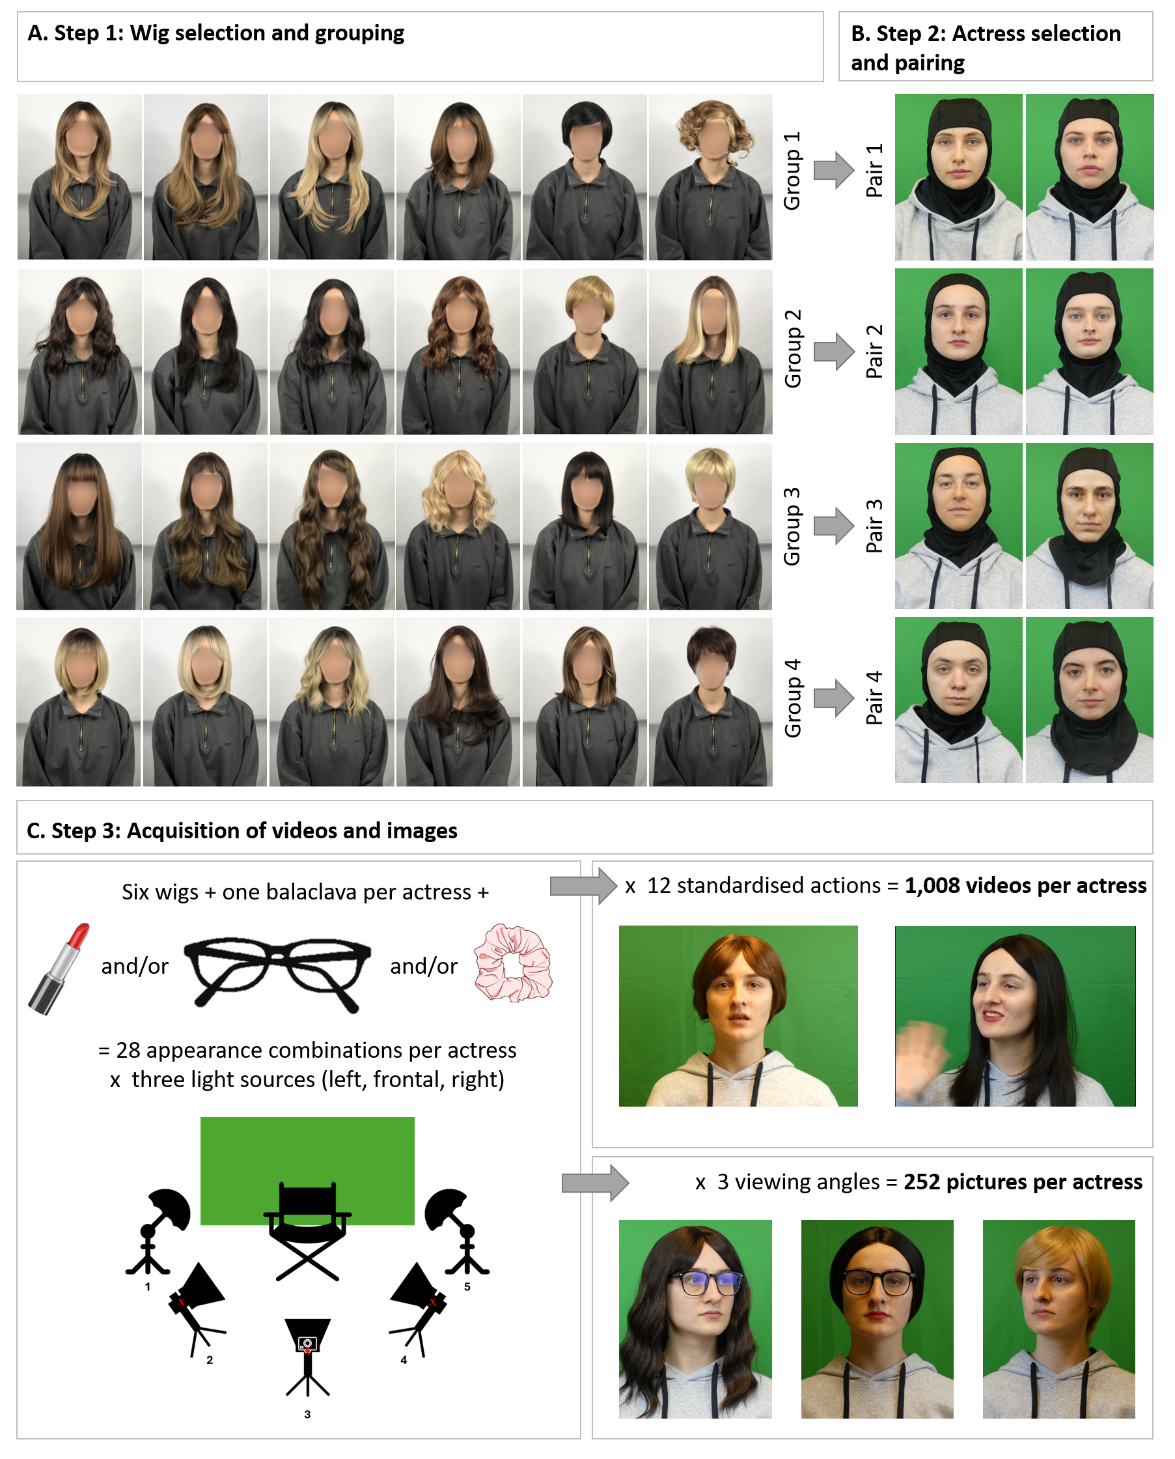
Notes. A. The set of 24 wigs is split into four distinct groups. Each group includes three highly similar wigs (left) and three that differ from those in color, length and/or style, and which include one of the most distinctive wigs and one shorter wig (right). The model’s face was blurred to protect her privacy but remained visible to independent judges during the rating phase. In the database, each wig group is assigned to a different pair of actresses. B. Eight actresses were paired into four groups based on average perceived similarity with the others and distinctiveness. Within each pair, the two actresses may serve as each other's target and foil in face-learning experiments. C. Each actress was recorded under systematically controlled appearance conditions, including six wigs (hair down or up) and one balaclava, with or without lipstick and/or glasses, under three lighting directions. Standardized videos of 12 actions and reference photographs from three viewing angles were acquired for every combination of appearance and lighting.

4. Material standardization. First, we used DaVinci Resolve Studio 18.6 (Blackmagic Design, Melbourne, Australia) to separate the 12 different gestures into 4-second clips each. Additional editing included occasionally slightly speeding up or slowing down some clips to ensure that each video was exactly 4 seconds long. We obtained a total of 8,064 clips (i.e. 8 actresses x 28 appearances x 3 lightings x 12 gestures). Then, we used CapCut 5.5.0 (ByteDance Ltd., Beijing, China) to crop all clips to a 4:3 ratio with a black background, and saved them in .mp4 format with a resolution of 960 x 540 pixels. To ensure consistent framing across all video clips while preserving hairstyle information, cropping was standardized using fixed vertical landmarks. A small, consistent amount of space was retained above the head, and the lower boundary was aligned with the upper edge of a large circular emblem printed centrally on the front of the grey hoodie worn by all actresses, thereby excluding the emblem from the final videos.
All pictures, 2,016 in number (i.e. 8 actresses x 28 appearances x 3 lightings x 3 orientations), were cropped and framed in a standardized manner, using GIMP (version 2.10.34), with a fixed 1:1.3 aspect ratio and using the same vertical landmarks as for videos. The frame was centered on the actress' nose for frontal images, and on their camera-facing pupil for side-view images. Pictures were then exported in BMP format.
After editing, each actress was represented in 1,008 video clips and 252 pictures. A sample of appearance conditions including variation in lighting, hairstyle and accessories is shown on Figure 1C.
5. Database accessibility
The DIVA-Face database is hosted on the ULiège Dataverse repository (https://doi.org/10.58119/ULG/EFLCIJ). The repository includes a detailed description of the database and its content (README documentation), metadata, wig and actress pretests’ data, and a preview of the image and video materials. These resources allow researchers to inspect the database structure and evaluate its suitability for their research purposes.
Because the database contains identifiable recordings of human actresses, the full-resolution images and videos are not available for unrestricted public download. This restriction was implemented to protect the actresses’ image and to ensure that the materials are used exclusively for non-commercial scientific research, in accordance with the informed consent provided by the actresses. Researchers wishing to access the complete database may submit a request through the Dataverse repository (Li et al., 2025). Access will be granted for non-commercial scientific research following acceptance of the database terms of use.
Empirical use of the database
We designed an incidental face learning task, to illustrate one way of using the newly constructed material. Our aim was to investigate the specific role of variability in appearance (stable vs. variable) on face learning, and how appearance may interact with exposure, which was manipulated via the number of videos seen by participants (i.e. 3, 6, 9 or 12 videos; for more details, see also Li et al., 2026/under review, in which an explicit learning procedure was used in a series of experiments using a similar methods as here). Study design and analyses plans were preregistered on the Open Science Framework prior to data collection (the preregistration and data are visible at https://osf.io/wezxs/?view_only=ba18fa36bfd3492f83e018e6dc4d5407).
Participants. Sample size estimation was conducted using an a priori power analysis in G*Power (version 3.1). Based on previous findings (Devue & de Sena, 2023; Reedy & Devue, 2019), an effect size of d = 0.25 was estimated for the simple effects of appearance within four learning groups. To test these effects in each group, while accounting for Type I error rates, a Bonferroni correction for multiple comparisons was applied, setting the significance threshold at .0125 (.05/4). To achieve a power of .8, a total of 182 participants were required; raised to 184 participants, spread equally across four learning groups (N = 46).
We recruited 187 right-handed Caucasian participants aged between 18 and 50 years old (M_{age} = 35.6 ± 8.57; 98 men, 84 women and 4 non-binary) through two online data collection platforms: Prolific (N = 110; https://www.prolific.com/) and Testable minds (N = 77; https://minds.testable.org/). Due to platforms intricacies, the final sample comprised 48 participants in Group 1 and 47 participants in Group 2 instead of the 46 planned. The proportion of participants from each platform was comparable in all groups (i.e. 27 to 29 and 19 to 20, respectively). They all had normal or corrected to normal vision, spoke English as a first language and lived in English-speaking countries (United Kingdom, Ireland or United States). We had planned to exclude subjects who failed two or more of three attention checks randomly presented during the recognition test or those with a mean response time two standard deviations below the sample’s mean. No participants had to be excluded. The study was approved by the local psychology ethics committee and participants all provided informed consent before taking part.
Material. For the current experiment, a subset of the database consisting of 96 video clips of four actresses (i.e. one from each of the four pairs of faces visible on Figure 1B) were used in the learning phase. There were 12 videos with a stable appearance and 12 with a variable appearance per actress, selected so as to provide systematic variation in lighting and facial movements, while sampling the range of appearance manipulations (e.g., wigs, glasses, and lipstick) available in the variable condition. Any visible blemishes such as pimples, moles or other non-facial features that could serve as superficial learning cues were removed with Adobe Premier Pro 2025 (Adobe Inc., San Jose, CA, USA).

Figure 2
Illustration of materials used in the learning phase and in the recognition test.
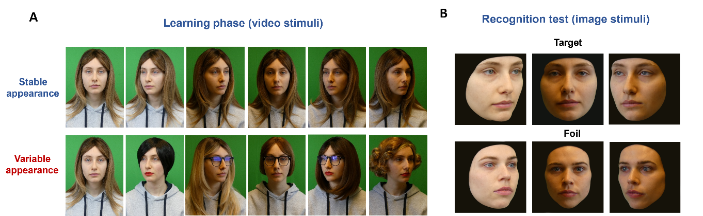
Notes. A. Examples of appearances (stable, top row, variable, bottom row) used during the learning phase (stimuli were video clips rather than static images). In the stable condition, the actress maintained the same appearance across videos (hair down, no makeup or glasses), whereas in the variable condition, appearance varied across videos through changes in wigs, hairstyles, glasses and makeup. In both conditions, lighting and gestures performed varied systematically across videos. B. Example of stimuli used in the recognition test. Test images were created from pictures of actresses wearing a balaclava, allowing the removal of peripheral information. Head orientation and lighting varied systematically across pictures of actresses in both conditions.

Test materials consisted of 72 pictures of the eight actresses (i.e. four learned targets and their counterparts). There were 9 pictures per identity (combining three lightings and three head orientations), with no glasses or lipstick, and in which they all wore the same balaclava that completely concealed their natural hair (see Figure 1B). This ensured that recognition performance primarily relied on facial identity rather than hairstyle cues. The pictures were cropped with a square frame around the opening of the balaclava, and resized at 300x300 pixels. The balaclava and background were covered with a black field (see Figure 2B). Any blemishes were also removed using Gimp (version 2.10.34).
Procedure. The experiment was programmed with PsychoPy and was accessed through the online platform Pavlovia. Before starting the experiment, participants were instructed to complete the task in a quiet environment, alone, using a computer (rather than a mobile device), and to avoid interruptions during testing. All stimuli and instructions were presented on a middle gray background to minimise eyestrain.
Incidental learning phase. Participants viewed the faces of four women, two of whom had a stable appearance and two a variable appearance (Figure 2A). In the stable condition, each video of the actress displayed her in the same constant appearance condition, with hair down, no make-up nor glasses. In the variable condition, appearance varied in each video clip based on hairstyle and combinations of the three other features (makeup, lipstick, hair tie). In both conditions, display conditions (lighting and performed gesture) varied consistently across videos. This ensured that both types of faces were seen in rich but controlled conditions, and that the two categories of faces only differed in terms of physical appearance. The assignment of stable and variable appearance was randomly determined for specific pairs of actresses at the beginning of the experiment.
Participants were pseudo-randomly assigned to one of four learning groups by signing up to one out of four versions of our experiment advertised on the testing platforms, with the constraint that participating in one version precluded participation in another and a set number of authorized participant per version. Participants in Group 1 viewed three video clips per actress (12 videos in total), those in Group 2 six clips per actress (24 in total), those in Group 3 nine clips (36 in total), and those in Group 4 saw twelve clips per actress (48 total; encompassing all twelve gestures). The exposure to individual identities was interspersed and organized via distinct learning episodes of 12 videos each. Within each learning episode, one actress was presented via a subset of three consecutive 4-second video clips, each preceded by a 500 ms fixation cross. The four actresses appeared in a random order within a given learning episode. The total number of episodes seen varied as a function of group (i.e. from one to four).
To ensure that appearance variability alone distinguished the two appearance conditions, video selection was pseudo-randomized. Within each episode, all four actresses were presented in the same viewing conditions, unique to that episode (i.e., a combination of three distinct lighting and gestures). Between episodes, participants were informed that they would see the same four faces again in a randomized order.
To enhance ecological validity, an incidental learning paradigm was employed. Participants were not informed that they would later have to recognize the faces. Instead, they were asked to rate actresses’ friendliness, boldness and intelligence after each three-video subset, using visual analog scales ranging from 0 to 100.
Recognition test. Following the learning phase, participants completed an old/new recognition task in which they indicated whether each presented face had been rated during the previous phase of the experiment or not. Participants were instructed to respond as accurately and as fast as possible by using the “1” and “2” keys on the keyboard, with key assignment counterbalanced across participants. A total of 72 trials were presented across three blocks of 24 trials. The stimuli consisted of eight identities (the four learned faces and their four paired foils), each presented three times per block in a randomized order: once under each lighting condition and once under each face orientation, with the association between lighting and orientation counterbalanced across blocks. Participants were allowed to take a short break between blocks.
Each trial began with a 1000 ms fixation cross, followed by a face image displaying only the internal facial features for 3 seconds. If no response was provided during this interval, the image was replaced by a screen reminding participants of the response keys, which remained visible until a response was made. Each block also included one attention check instructing participants to press a specific digit key.
Open Practices Statement. We provide the following information in accordance with TOP guidelines. We preregistered the study design and analyses plan prior to data collection on the Open Science Framework (https://osf.io/v3zax). The aggregated data, analysis files, and programming code for the experiment are available at https://osf.io/wezxs/?view_only=ba18fa36bfd3492f83e018e6dc4d5407. The full stimuli database is visible at https://doi.org/10.58119/ULG/EFLCIJ.

Results
Sensitivity d’ was calculated in each learning group using mean hit rates and false alarm rates computed separately for each appearance condition, with false-alarm rates calculated from the corresponding foil identities. The distribution of the d’ within each group is displayed in Figure 3. A two-way mixed analysis of variance (ANOVA) was conducted on d’ with Appearance (stable, variable) as a within-subject factor and Learning group (Group 1, 2, 3, 4) as a between-subject factor. All the assumptions for the use of the mixed ANOVA were met, except for the equality of variances. Levene’s tests revealed significant variance differences for both stable, F(3,183) = 4.237, p = .006, and variable, F(3,183) = 3.596, p = .015, conditions. However, since the differences between the variances were fairly small, the sample size high and the groups almost equilibrated, we chose to rely on the tests’ robustness. The ANOVA, and the simple effects analyses following it up, were interpreted with the Bonferroni-corrected significance criterion (α = .0125).
A significant main effect of Learning group (i.e., increased exposure) was observed, F(3,183) = 7.891, p < .001, η_{p}² = 0.115, suggesting that sensitivity to the inner features of the target faces increased with additional exposure (M_{group1} = 0.625 ± 1.16; M_{group2} = 1.443 ± 1.54; M_{group3} = 1.557 ± 1.66; M_{group4} = 1.877 ± 1.69). A linear contrast confirmed that sensitivity increased linearly across learning groups, t(183) = 4.542, p < .001, whereas quadratic and cubic trends were not significant (both ps>.10). A significant main effect of Appearance was also found, F(1, 183) = 13.942, p < .001, η_{p}² = 0.071, with an overall sensitivity advantage for Stable faces compared to variable ones (M_{stable} = 1.58 ± 1.64; M_{variable} = 1.16 ± 1.51). The interaction between Appearance and Learning group was not significant, F(3, 183) = 0.631, p = .596, η_{p}² = 0.01.
Figure 3
Violin plots of sensitivity d', split by appearance and learning group.
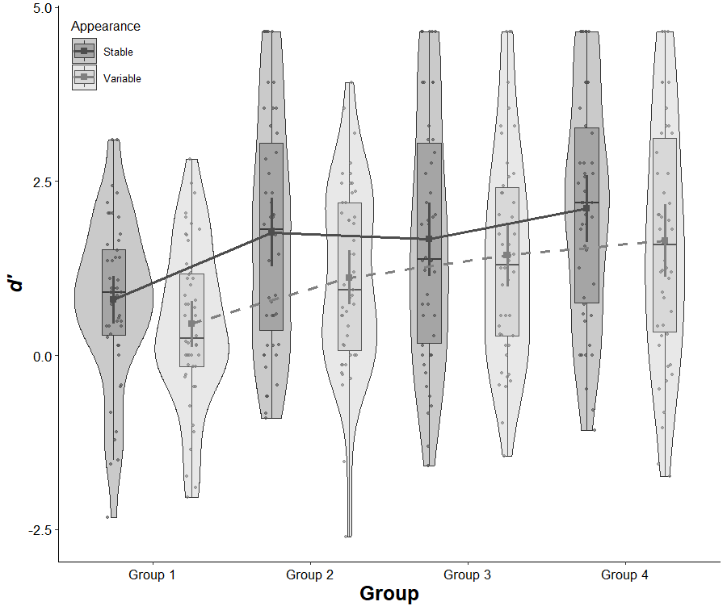
Notes. Squares indicate condition means, with 95% confidence intervals represented as error bars. Box plots display interquartile ranges (IQRs), with medians marked by dark horizontal lines. Whiskers extend to values within 1.5 times the IQR, and points beyond these limits indicate outliers. Violin shapes depict the distribution density, with individual datapoints overall as semi-transparent dots. Although learning group is a between-subject factor, means were connected by lines to aid interpretation. Outliers were retained due to the large sample size.

Simple effects of Appearance in each group were tested with Student’s t tests for paired samples. No significant differences were found in Group 1, t(47) = 1.774, p = .083, d = 0.256, 95% CI = [-0.033, 0.542], Group 3, t(45) = 0.928, p = .359, d = 0.137, 95% CI = [-0.154, 0.426] or Group 4, t(45) = 1.981, p = .054, d = 0.292, 95% CI = [-0.005, 0.586]. A significant difference was found in Group 2, t(46) = 2.837, p = .007, d = 0.414, 95% CI = [0.114, 0.710], where Stable faces (M_{stable – Group 2} = 1.767 ± 1.671) were recognized significantly better than Variable ones (M_{variable – Group 2} = 1.119 ± 1.336).
To probe these results further, and as comparing all possible pairs of independent groups would not be meaningful, we examined linear contrasts separately for stable and variable faces. Following Armstrong (2016)’s recommendations on exploratory analyses, these tests were interpreted with the classic significance criterion (α = .05). Significant linear trends were found for both Stable, t(183) = 3.718, p < .001, and Variable faces, t(183) = 4.130, p < .001, confirming that they both benefited from additional exposure.

General discussion
This paper introduces the Dynamic and Image Variation Archive (DIVA-Face) database that systematically manipulates multiple aspects of within-person variability while preserving ecological validity. By incorporating controlled variations in identity, hairstyle, lipstick, glasses, lighting, gestures and poses, the database enables researchers to isolate each of those individual factors in experimental or applied psychological, neuroscientific, or modelling studies revolving around the processing of faces, or complex stimuli categories more broadly. A key contribution of the database is its focus on facial appearance, offering 28 distinct realistic combinations of appearances per actress, and the inclusion of dynamic information. The video clips capture natural facial and head movements, temporal continuity, and motion cues that are characteristic of real-world face exposure. Such dynamic information is absent from static image sets and is known to support identity learning and recognition (Lander & Bruce, 2003; see also Dobs et al., 2018; Xiao et al., 2014), making the present database particularly well suited for bridging laboratory research and real-world face processing.
A central feature of the database is also its use of a uniform green-screen background. This not only provides a consistent background environment across all stimuli thereby maximizing experimental control, but also maximizes flexibility for future applications. Indeed, thanks to the green-screen recordings, the background can easily be substituted with customized environments, enabling investigations of contextual effects on face processing or the embedding the faces in environments that further increase ecological validity. This feature supports applications in virtual and augmented reality, human–computer interaction, and social robotics, where identity processing often occurs in dynamic and context-dependent settings.
We also provided an example of application for DIVA-Face, in the form of an incidental face learning experiment which included a controlled subset of stimuli. The primary aim of this study was to assess whether the manipulation of factors controlled in the database would elicit reliable and theoretically meaningful effects on face learning. As expected, recognition performance increased with exposure, demonstrating a robust experience-dependent improvement in unfamiliar face learning consistent with previous literature (Baker & Mondloch, 2023; Dowsett et al., 2016; Matthews & Mondloch, 2018; Matthews et al., 2024). In addition, the advantage observed for stable learning materials is consistent with a growing body of evidence suggesting that appearance variability is not universally beneficial and that stable appearance conditions can, under some circumstances, support face learning as effectively as highly variable conditions (e.g., adults in Baker et al., 2017; Devue & de Sena, 2023; Moore et al., 2024; Ritchie & Burton, 2017). Importantly, these effects emerged in an online testing environment, across different recruitment platforms, and under incidental learning conditions. The robustness of the observed learning patterns—despite heterogeneous populations, hardware and uncontrolled viewing settings—provides strong empirical support for the reliability and experimental usability of the database.
Despite its strengths, several limitations of the database should be acknowledged. The current version only includes young Caucasian females, which may limit generalization to other genders, age groups, or ethnic backgrounds. Future extensions could expand the diversity of identities represented and include additional features such as synchronized audio, a more diverse range of emotional expressions or camera perspectives.
Finally, manipulating appearance by means of wigs raises concerns about ecological validity. However, pretest results demonstrated that the wigs fell within a moderate range of distinctiveness. Importantly, the natural hair of the actress wearing wigs for the wig pretest (i.e. brown hair with blond highlights) received higher distinctiveness ratings than most wigs, indicating that wigs themselves do not necessarily create implausible or salient appearances. This concern can also be alleviated by the fact that most of us are regularly exposed to people—actors or otherwise—changing their appearance via wigs. The use of wigs allowed a systematic control over hairstyle variability within a single session of image acquisition, keeping all other facial information constant. Crucially, it also permitted to create pairs of identities with different facial features but identical peripheral features, providing materials that could for example be extremely valuable in forensic settings. This balance between experimental control and ecological realism is therefore a defining strength of the database and ensures that appearance manipulations do not introduce other uncontrolled visual artifacts. As noted above, distinctiveness and similarity ratings for individual wigs are available for researchers willing to select those that best suits their needs.

Conclusion
In conclusion, DIVA-Face provides a comprehensive, well-controlled, and ecologically valid resource for applications that involve studying face processing or more broadly, the processing of complex visual stimuli. Our face learning experiment demonstrates that the stimuli reliably elicit theoretically grounded learning effects, supporting the scientific utility of the database. By combining dynamic recordings, systematic appearance manipulations, and flexible green-screen design, this resource is uniquely positioned to advance research on person perception across behavioral, neuroscientific, and applied domains. Open access to the stimuli and metadata is intended to promote reproducibility, facilitate methodological integration, and support large-scale, cross-disciplinary investigations.

Declarations
Funding: Special Funds for Research (Wallonia-Brussels Federation) allocated to the University of Liège.
Conflicts of interest: The authors have no conflicts of interest to declare.
Ethics approval: The study was approved by the local psychology ethics committee of the University of Liège.
Consent to participate: All actresses and participants provided informed consent before taking part to this study.
Consent for publication: All actresses and participants gave informed consent for the use and publication of images for non-commercial research purposes, or for sharing anonymized data, respectively.
Availability of data and materials: At https://osf.io/wezxs/?view_only=ba18fa36bfd3492f83e018e6dc4d5407 and https://doi.org/10.58119/ULG/EFLCIJ
Code availability: At https://osf.io/wezxs/?view_only=ba18fa36bfd3492f83e018e6dc4d5407
Authors’ contributions Wenrui Li: Conceptualization, Data curation, Formal analysis, Investigation, Methodology, Project administration, Resources, Software, Visualization, Writing – original draft, Writing - Review & Editing.
Raphaël Legrand: Conceptualization, Data curation, Formal analysis, Investigation, Methodology, Project administration, Resources, Software, Visualization, Writing – original draft, Writing - Review & Editing.
William Daro: Conceptualization, Methodology, Resources, Software.
Christel Devue: Funding acquisition, Conceptualization, Data curation, Formal analysis, Investigation, Methodology, Project administration, Resources, Supervision, Validation, Visualization, Writing - Review & Editing.
Acknowledgements: The authors would like to express their sincere gratitude to the actress who participated in the wig pretest and to all actresses who took part in the actress selection pretest. We are especially grateful to the eight actresses whose participation made the DIVA-Face database possible.

References
Avery, S. N., VanDerKlok, R. M., Heckers, S., & Blackford, J. U. (2016). Impaired face recognition is associated with social inhibition. Psychiatry research, 236, 53–57. https://doi.org/10.1016/j.psychres.2015.12.035
Bahrick, H. P., Bahrick, P. O., & Wittlinger, R. P. (1975). Fifty Years of Memory for Names and Faces: A Cross-Sectional Approach. Journal of Experimental Psychology: General, 104(1), 54–75. http://doi.org/10.1037/0096-3445.104.1.54
Baker, K. A., Laurence, S., & Mondloch, C. J. (2017). How does a newly encountered face become familiar? The effect of within-person variability on adults’ and children’s perception of identity. Cognition, 161, 19–30. https://doi.org/10.1016/j.cognition.2016.12.012
Baker, K. A., & Mondloch, C. J. (2023). Unfamiliar face matching ability predicts the slope of face learning. Scientific Reports, 13(1), 5248. https://doi.org/10.1038/s41598-023-32244-w
Bruce, V., Henderson, Z., Greenwood, K., Hancock, P. J. B., Burton, A. M., & Miller, P. (1999). Verification of face identities from images captured on video. Journal of Experimental Psychology: Applied, 5(4), 339–360. http://doi.org/10.1037/1076-898X.5.4.339
Bruce, V., & Young, A. (1986). Understanding face recognition. British journal of psychology (London, England: 1953), 77 (Pt 3), 305–327. https://doi.org/10.1111/j.2044-8295.1986.tb02199.x
Burton, A. M., Kramer, R. S., Ritchie, K. L., & Jenkins, R. (2016). Identity from variation: Representations of faces derived from multiple instances. Cognitive Science, 40(1), 202–223. https://doi.org/10.1111/cogs.12231
Devue, C., & de Sena, S. (2023). The impact of stability in appearance on the development of facial representations. Cognition, 239, 105569. https://doi.org/10.1016/j.cognition.2023.105569
Devue, C., Wride, A., & Grimshaw, G. M. (2019). New insights on real-world human face recognition. Journal of Experimental Psychology: General, 148(6), 994–1007. https://doi.org/10.1037/xge0000493
Dobs, K., Bülthoff, I., & Schultz, J. (2018). Use and Usefulness of Dynamic Face Stimuli for Face Perception Studies-a Review of Behavioral Findings and Methodology. Frontiers in psychology, 9, 1355. https://doi.org/10.3389/fpsyg.2018.01355
Dowsett, A. J., Sandford, A., & Burton, A. M. (2016). Face learning with multiple images leads to fast acquisition of familiarity for specific individuals. Quarterly journal of experimental psychology (2006), 69(1), 1–10. https://doi.org/10.1080/17470218.2015.1017513
Engfors, L. M., Wilmer, J., Palermo, R., Gignac, G. E., Germine, L. T., & Jeffery, L. (2024). Face recognition's practical relevance: Social bonds, not social butterflies. Cognition, 250, 105816. https://doi.org/10.1016/j.cognition.2024.105816
Jeffery, L., & Rhodes, G. (2011). Insights into the development of face recognition mechanisms revealed by face aftereffects. British journal of psychology (London, England: 1953), 102(4), 799–815. https://doi.org/10.1111/j.2044-8295.2011.02066.x
Jenkins, R., White, D., Van Montfort, X., & Burton, A. M. (2011). Variability in photos of the same face. Cognition, 121(3), 313–323. https://doi.org/10.1016/j.cognition.2011.08.001
Kho, S. K., Keeble, D. R. T., Wong, H. K., & Estudillo, A. J. (2025). Own- and other-race face learning in high and low variability. Quarterly Journal of Experimental Psychology, 0(0). https://doi.org/10.1177/17470218251346749
Knight, B., & Johnston, A. (1997). The role of movement in face recognition. Visual Cognition, 4(3), 265–273. https://doi.org/10.1080/713756764
Kramer, R. S. S., Jenkins, R., Young, A. W., & Burton, A. M. (2016). Natural variability is essential to learning new faces. Visual Cognition, 25(4–6), 470–476. https://doi.org/10.1080/13506285.2016.1242522
Lander, K., & Bruce, V. (2003). The role of motion in learning new faces. Visual Cognition, 10(8), 897–912. https://doi.org/10.1080/13506280344000149
Lander, K., & Davies, R. (2007). Exploring the role of characteristic motion when learning new faces. Quarterly journal of experimental psychology, 60(4), 519–526. https://doi.org/10.1080/17470210601117559
Li, W., Legrand, R., & Devue, C. (2025). DIVA-Face - Dynamic and Image Variation Archive. ULiège Open Data Repository. https://doi.org/10.58119/ULG/EFLCIJ
Li, W., Legrand, R., & Devue, C. (2026, April 13). The role of variability in appearance, exposure and learning procedure in dynamic face learning (Version 3) [Preprint]. OSF Preprints. https://doi.org/10.31219/osf.io/4y9df_v3
Liu, C. H., Chen, W., & Ward, J. (2015). Effects of exposure to facial expression variation in face learning and recognition. Psychological Research, 79(6), 1042–1053. https://doi.org/10.1007/s00426-014-0627-8
Matthews, C. M., Davis, E. E., & Mondloch, C. J. (2018). Getting to know you: The development of mechanisms underlying face learning. Journal of experimental child psychology, 167, 295–313. https://doi.org/10.1016/j.jecp.2017.10.012
Matthews, C. M., & Mondloch, C. J. (2018). Finding an unfamiliar face in a line-up: Viewing multiple images of the target is beneficial on target-present trials but costly on target-absent trials. British journal of psychology (London, England : 1953), 109(4), 758–776. https://doi.org/10.1111/bjop.12301
Matthews, C. M., Ritchie, K. L., Laurence, S., & Mondloch, C. J. (2024). Multiple images captured from a single encounter do not promote face learning. Perception, 53(5-6), 299–316. https://doi.org/10.1177/03010066241234034
Mike Burton A. (2013). Why has research in face recognition progressed so slowly? The importance of variability. Quarterly journal of experimental psychology (2006), 66(8), 1467–1485. https://doi.org/10.1080/17470218.2013.800125
Moore, K. N., Nesmith, B. L., Zwemer, D. U., & Yu, C. (2024). Search efforts and face recognition: The role of expectations of encounter and within-person variability in prospective person memory. Cognitive Research: Principles and Implications, 9(1). https://doi.org/10.1186/s41235-024-00590-6
Murphy, J., Ipser, A., Gaigg, S. B., & Cook, R. (2015). Exemplar variance supports robust learning of facial identity. Journal of Experimental Psychology: Human Perception and Performance, 41(3), 577–581. https://doi.org/10.1037/xhp0000049
O'Toole, A. J., Roark, D. A., & Abdi, H. (2002). Recognizing moving faces: a psychological and neural synthesis. Trends in cognitive sciences, 6(6), 261–266. https://doi.org/10.1016/s1364-6613(02)01908-3
Phillips, P. J., Yates, A. N., Hu, Y., Hahn, C. A., Noyes, E., Jackson, K., Cavazos, J. G., Jeckeln, G., Ranjan, R., Sankaranarayanan, S., Chen, J. C., Castillo, C. D., Chellappa, R., White, D., & O'Toole, A. J. (2018). Face recognition accuracy of forensic examiners, superrecognizers, and face recognition algorithms. Proceedings of the National Academy of Sciences of the United States of America, 115(24), 6171–6176. https://doi.org/10.1073/pnas.1721355115
Reedy, M., & Devue, C. (2019). New perspective on face learning: Stability modulates resolution of facial representations in the optimal observer. https://doi.org/10.31219/osf.io/6s8c7
Ritchie, K. L., & Burton, A. M. (2017). Learning faces from variability. Quarterly Journal of Experimental Psychology, 70(5), 897–905. https://doi.org/10.1080/17470218.2015.1136656
Ritchie, K. L., Smith, F. G., Jenkins, R., Bindemann, M., White, D., & Burton, A. M. (2015). Viewers base estimates of face matching accuracy on their own familiarity: Explaining the photo-ID paradox. Cognition, 141, 161–169. http://doi.org/10.1016/j.cognition.2015.05.002
Xiao, N. G., Perrotta, S., Quinn, P. C., Wang, Z., Sun, Y. H., & Lee, K. (2014). On the facilitative effects of face motion on face recognition and its development. Frontiers in psychology, 5, 633. https://doi.org/10.3389/fpsyg.2014.00633
Young, A. W., & Burton, A. M. (2017). Recognizing Faces. Current Directions in Psychological Science, 26(3), 212–217. http://doi.org/10.1177/0963721416688114
Zhou, X., Vyas, S., Ning, J., & Moulson, M. C. (2022). Naturalistic Face Learning in Infants and Adults. Psychological science, 33(1), 135–151. https://doi.org/10.1177/09567976211030630

Photographs and ratings were also collected for the actress’ natural hair. These received ratings in the same range as the wigs in our set, suggesting that the wig are not perceptually different on those two dimensions.
The preregistration specified that d′ would be calculated using mean hit rates per appearance condition and overall false alarm rates. However, because each target pair (one stable, one variable) was associated with a specific pair of foils, false alarm rates were instead calculated separately for the corresponding foil identities. This provides a more accurate estimate of sensitivity by ensuring that d′ reflects discrimination between each target pair and its associated foils. This deviation from the preregistration does not affect the interpretation because false alarm rates did not differ across appearance conditions.

