The Effect of Variability in Appearance and Context on Face Learning

Kevin Nguy, Tom Lapadula and Christel Devue
Psychology and Neuroscience of Cognition Research Unit, University of Liège, Liège, Belgium

Author Note
Kevin Nguy  https://orcid.org/0000-0003-4745-1231
Tom Lapadula https://orcid.org/0009-0005-7723-2787
Christel Devue https://orcid.org/0000-0001-7349-226X
We have no known conflict of interest to disclose.
Correspondence should be addressed to Christel Devue, Université de Liège, Place des Orateurs 2, 4000 Liège, Belgique. Email: cdevue@uliege.be

Supplementary Materials
Face stimulus selection in Stirling/ESRC 3D Face Database:
The sixteen identities were selected in the Stirling/ESRC 3D Face Database (“pics.stir.ac.uk.”) following the description “Caucasian adult women between the ages of 18 and 50”. Each selected woman needed to appear in the database with the same designated viewpoint and lighting. Each woman was paired with another woman by visual similarity (i.e. overall head shape, age, eye and eyebrow colour). Within each pair, one of them was added to the target pool, whereas the remaining one joined the foil pool. In the target pool, pairs of women were formed based on their similarity. Each pair of targets was assigned one of four sets of six wig hairstyles that were most likely to appear natural on them.

Full factorial mixed-effects model for the proportion of fixation duration, including AOI
A linear mixed-effects model was fitted to examine whether the effects of appearance and context varied across areas of interest with a random intercept for participant. The model included all main effects, two-way interactions, and the three-way interaction. The model was fitted using restricted maximum likelihood (REML) with Satterthwaite’s approximation for degrees of freedom.
The full model revealed a significant main effect of context, with lower durations in several zones relative to the reference category, a significant main effect of AOI, indicating strong differences in fixation duration across AOIs. A small number of significant interaction terms involving AOI were found, including: Appearance × Context (p = .043), Appearance × Context × AOI hair (p = .018), Context × AOI scene (p = .001) and Appearance × AOI other (p = .008).
However, these effects were not consistent across AOIs, and higher-order interactions showed mixed patterns without a clear or stable structure. Most other interaction terms were non-significant.
The model included a random intercept for participant. The variance of the random intercept was estimated as zero, indicating a boundary (singular) fit. This suggests that the inclusion of participant-level random intercepts did not substantially improve model fit given the strong effects of AOI and the large number of observations.
Model diagnostics indicated several limitations: evidence of heteroscedasticity (p < .001), deviations from uniform residual distribution (DHARMa test, p < .001), elevated number of outliers relative to model expectations, no evidence of overdispersion (dispersion test, p = .92). Multicollinearity diagnostics indicated: moderate collinearity for appearance and context (VIF ≈ 8) and severe collinearity for AOI and interaction terms: (AOI: VIF = 64; Appearance × AOI: VIF = 160; Context × AOI: VIF = 160; Appearance × Context × AOI: VIF = 208).These values indicate substantial redundancy among higher-order interaction terms, limiting interpretability of the full factorial model.
Overall, the full model including AOI and all interactions did not provide a more interpretable or stable representation of the data compared to the reduced models. Therefore, results reported in the main text are based on models excluding higher-order interactions with AOI.

Robustness analyses using linear mixed-effects models: AUC and criterion
We performed confirmatory mixed-effects models analyses using R libraries lme4 and lmerTest to support our main results. Linear mixed models were computed to predict AUC and criterion during learning with variability in appearance and variability of context, including their interaction, as fixed effect and participant as random effect.
Experiment 1
We found that variability in appearance was a good predictor of AUC values (β = 0.048, SE = 0.018, t(249) = 2.26, p < 0.01) but not variability of context (β = -0.001, SE = 0.018, t(249) = -0.08, p = 0.94). There was no interaction between appearance and context (β = -0.008, SE = 0.026, t(249) = -0.31, p = 0.76). Similarly, we found that the criterion representing response bias was predicted by variability in appearance (β = -0.117, SE = 0.051, t(249) = -2.30, p = 0.02) but not variability of context (β = 0.005, SE = 0.051, t(249) = -0.11, p = 0.92). There was also no interaction between appearance and variability of context (β = -0.013, SE = 0.072, t(249) = -0.18, p = 0.86).
Experiment 2
There was no main effect of variability in appearance on AUC (β ≈ 0, SE = 0.021, t(249) = 0.30, p = 0.98) and nor of variability of context (β = 0.004, SE = 0.021, t(249) = 0.24, p = 0.81). The interaction was not significant either (β = -0.007, SE = 0.030, t(249) = -0.23, p = 0.82). We also found no effect of variability in appearance on response bias (β = 0.026, SE = 0.055, t(249) = 0.47, p = 0.64) nor of variability of context (β = -0.009, SE = 0.055, t(249) = -0.17, p = 0.87). There was no interaction effect (β = -0.013, SE = 0.078, t(249) = -0.17, p = 0.87). Overall, the mixed model analyses confirm the results obtained with repeated-measures ANOVA.

Robustness analyses using linear mixed-effects models: response times
We fitted a linear mixed-effects model predicting log-transformed response times, with appearance variability and context variability as fixed effects, including their interaction, and participant as a random effect. Response times for correct responses were positively skewed. Therefore, RTs were log-transformed prior to analysis to better approximate normality and stabilise variance. This transformation is standard practice in cognitive psychology and improves the validity of linear mixed-effects models applied to reaction time data.
Experiment 1
Response times for correct answers were not predicted by variability in appearance (β = -0.035, SE = 0.020, t(2672.69) = -1.72, p = 0.08) nor by variability of context (β = 0.041, SE = 0.021, t(2673.64) = -1.96, p = 0.0498), as p-value was corrected to α=0.0294 in respect to our sequential analyses plan. The interaction was not significant (β = 0.027, SE = 0.029, t(2673.64) = 0.93, p = 0.35). These findings replicate the results obtained with the repeated-measures ANOVA.
Experiment 2
We found that variability in appearance predicts response times for correct answers (β = -0.039, SE = 0.019, z = -2.03, p = 0.04) but that variability of context did not (β = -0.031, SE = 0.019, z = -1.62, p = 0.10). The interaction was not significant (β = 0.036, SE = 0.027, z = 1.36, p = 0.18). The results obtained with the repeated measures ANOVA were different from the mixed model analyses. The linear mixed-effects model on log-transformed response times revealed a significant effect that was not detected in the ANOVA on raw correct reaction times. This discrepancy likely reflects the positively skewed distribution of RTs, which violates ANOVA assumptions and reduces statistical power. Therefore, it is probable that variability in appearance influenced correct response times in such a way that answers for variable faces (M_{variable} = 1219.45ms, SD_{variable} = 656.47ms) were given faster than answers for stable faces (M_{stable} = 1256.37ms, SD_{stable} = 705.07ms) even though their accuracy was comparable. Thus, the speed-accuracy trade-off effect may have masked an advantage of variable faces over stable faces appearing.
While these findings contradict our predictions that stable hairstyles would benefit face learning by serving as anchors for face matching, they support the cost-efficient hypothesis by suggesting that the acquisition of the inner features of variable faces was faster than the ones of stable faces, hence enabling easier recognition of the identity across pictures during learning.

Exploratory analyses on confidence ratings using repeated-measures ANOVA and linear mixed-effects models:
We performed a three-way repeated measures ANOVA with variability in appearance (stable/variable), context (unique/multiple) and response type (“Old”/”New”) as within-subject factors on confidence ratings for both experiments.
Experiment 1
We found no significant difference in mean confidence scores between stable (M_{stable} = 2.26, SD_{stable} = 0.54) and variable faces (M_{variable} = 2.28, SD_{variable} = 0.57), F(1,41) < 1, p = 0.90, η²p < 0.01. We also found no difference between unique (M_{unique} = 2.30, SD_{unique} = 0.53) and multiple conditions (M_{multiple} = 2.25, SD_{multiple} = 0.57), F(1,41) < 1, p = 0.98, η²p < 0.01. However, we found a significant difference of confidence between responses with “Old” responses (M_{old} = 2.53, SD_{old} = 0.41) given more confidently than “New” responses (M_{new} = 1.96, SD_{new} = 54), F(1,41) = 61.48, p < 0.01, η²p = 0.60. This suggests that participants were very confident to know some of the target faces. The interaction between appearance and variability of context was not significant, F(1,41) < 1, p = 0.38, η²p = 0.02 and the interaction between variability of context and response type neither, F(1,41) = 1.69, p = 0.21, η²p = 0.04. However, the interaction between appearance and response revealed to be significant, F(1,41) = 16.97, p < 0.01, η²p = 0.29. Finally, we found no triple interaction between appearance, variability of context and response type, F(1,41) < 1, p = 0.95, η²p < 0.01.
As the sample was unbalanced regarding response type, we fitted a linear mixed-effects model predicting confidence from variability in appearance, variability of context, and response type, including all two- and three-way interactions to confirm the results obtained with the repeated-measures ANOVA. Random intercepts for subjects were also included. We found that variability in appearance (β = -0.120, SE = 0.070, t(526.4) = -1.71, p = 0.09) and effect of variability of context (β = 0.076, SE = 0.069, t(528.9) = 1.09, p = 0.28) did not predict confidence score; but that response type was a good predictor of confidence (β = 0.518, SE = 0.068, t(524.8) = 7.76, p < 0.001). There was no significant effect between appearance and context (β = 0.052, SE = 0.100, t(529.8) = 0.52, p = 0.61) and between context and response type (β = -0.108, SE = 0.095, t(523.6) = -1.14, p = 0.25) but a significant interaction between appearance and response type (β = 0.206, SE = 0.095, t(523.6) = 2.17, p = 0.031). The triple interaction is not significant (β ≈ 0, SE = 0.135, t(526.1) < 0.01, p ≈ 1). Post-hoc comparisons using estimated marginal means (emmeans) with Bonferroni correction showed that the mean confidence for stable appearance (M_{stable} = 2.47, SD_{stable} = 0.45) was significantly lower than for variable appearance (M_{variable} = 2.59, SD_{variable} = 0.36) when response was “Old” (mean difference = -0.11, 95% CI [-0.20, -0.02], p = 0.01), but not when response was “New” (mean difference = 0.09, 95% CI [-0.01, 0.19], p = 0.06).
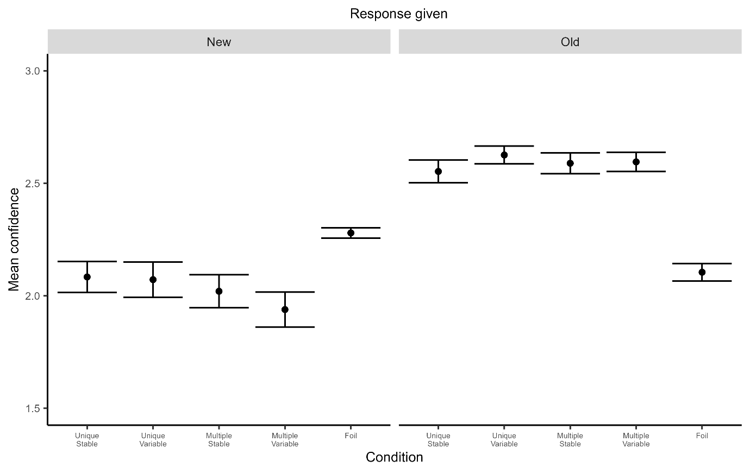
Fig.S3 Mean confidence ratings per condition and response given following a blocked learning procedure. Error bars show 95% CI and black points represent mean confidence

Experiment 2
There was no difference in mean confidence scores between stable (M_{stable} = 2.28, SD_{stable} = 0.53) and variable faces (M_{variable} = 2.23, SD_{variable} = 0.56), F(1,39) < 1, p = 0.34, η²p = 0.02 and no difference between unique (M_{unique} = 2.26, SD_{unique} = 0.54) and multiple contexts (M_{multiple} = 2.24, SD_{multiple} = 0.54), F(1,39) = 1.01, p = 0.30, η²p = 0.03. However, we found that “Old” responses (M_{old} = 2.51, SD_{old} = 0.43) were responded more confidently than “New” responses (M_{new} = 1.92, SD_{new} = 0.49), F(1,39) = 64.38, p < 0.01, η²p = 0.62. There was no interaction between variability in appearance and variability of context (F(1,39) = 1.55, p = 0.22, η²p = 0.04), nor between variability in appearance and response type (F(1,39) = 1.12, p = 0.30, η²p = 0.03), nor between variability of context and response type (F(1,39) = 1.44, p = 0.24, η²p = 0.04). The triple interaction was not significant (F(1,39) = 0.16, p = 0.69, η²p < 0.01).
We fitted the same mixed-model as in experiment 1 to confirm our results. There was no main effect of appearance (β = -0.126, SE = 0.073, t(520.99) = -1.73, p = 0.08), nor of variability of context (β = 0.035, SE = 0.074, t(521.44) = 0.48, p = 0.63) on confidence scores. However, response type was a good predictor of confidence scores (β = 0.541, SE = 0.069, t(517.97) = 7.80, p < 0.01). We found no interaction effect between appearance and variability of context (β = 0.032, SE = 0.103, t(518.43) = 0.31, p = 0.76), appearance and response type (β = 0.121, SE = 0.097, t(518.43) = 1.24, p = 0.22), variability of context and response type (β = -0.022, SE = 0.098, t(516.46) = -0.22, p = 0.83). The triple interaction was not significant either (β = -0.037, SE = 0.138, t(515.61) = -0.27, p = 0.79)
Confidence scores explain in part the accuracy results we obtained in the first experiment. Participants were more confident for variable faces than stable faces. This indicates that the representations of the inner features of the variable faces were more robust than the inner features of the stable faces.
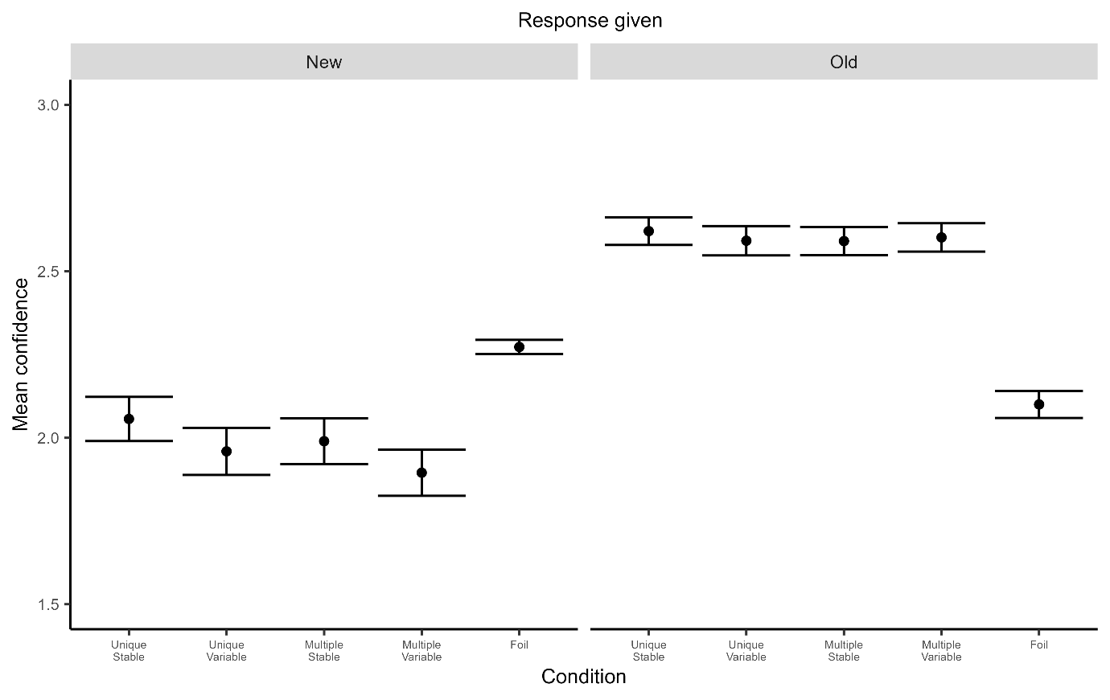
Fig.S3 Mean confidence ratings per condition and response given following a randomized learning procedure. Error bars show 95% CI and black points represent mean confidence

Exploratory analyses using linear Mixed Model to predict hit rate by face fixation duration:
A linear mixed-effects model was fitted to predict mean response accuracy, with context, appearance, and proportion of fixation duration on inner feature included as fixed effects and Participant as a random intercept. The results revealed a significant main effect of appearance (β = 0.074, SE = 0.010, t = 7.14, p < 0.001), indicating higher accuracy in the variable appearance condition. No significant effects were observed for context (β = 0.001, SE = 0.010, t = 0.10, p = 0.92) or face fixation duration (β = 0.028, SE = 0.028, t = 1.01, p = 0.314).

