Lifetime familiarity and episodic familiarity: The role of the transentorhinal cortex in aging

Anaïs SERVAIS¹, Aurélien FRICK^{1,3}, François MEYER¹, Christine BASTIN¹, and Emma DELHAYE^{1,2}

¹GIGA Research, CRC Human Imaging, University of Liège, Belgium
²CICPSI, Faculdade de Psicologia, Universidade de Lisboa, Portugal
³School of Psychology and Neuroscience, University of St Andrews, UK

©American Psychological Association, 2026. This paper is not the copy of record and may not exactly replicate the authoritative document published in the APA journal. The final article is available, upon publication, at: 10.1037/neu0001102

Corresponding author: Emma Delhaye, emma.delhaye@uliege.be, Allée du Six Août, 8–4000 Liège, Belgium
Abstract
Objectives: The transentorhinal cortex (tErC), which includes the medial portion of the perirhinal (PrC) and the anterolateral portion of the entorhinal cortices (alErC), is among the first brain regions affected by Alzheimer’s Disease (AD). Yet, its precise cognitive role remains controversial. Recent models propose that this region supports episodic familiarity and lifetime familiarity, and that it is particularly involved in tasks requiring fine conceptual discrimination between similar objects. The present study examined episodic and lifetime familiarity across three tasks to understand how the tErC supports familiarity, using materials with varying conceptual overlap and lifetime familiarity levels in both normal and pathological aging, encompassing different levels of tErC integrity.
Methods: Fifty-eight older adults (aged 55+), including healthy individuals and patients with Mild Cognitive Impairment or subjective cognitive decline, completed familiarity tasks. tErC volume was measured via high-resolution MRI and was associated with tasks performance using repeated measures ANCOVAs or stepwise linear regressions.
Results: The tErC volume was associated with familiarity performance selectively in task conditions involving high conceptual overlap between targets and lures.
Conclusion: Results indicate that tErC integrity is selectively related to familiarity-based performance when recognition requires resolving interference between conceptually similar items. We discuss how combining tasks assessing different aspects of familiarity could help identify early cognitive decline. We suggest this approach should be tested in patients with AD biomarkers.
KEYWORDS: Mild Cognitive Impairment; Familiarity; Transentorhinal Cortex; Recollection; Aging; Alzheimer’s Disease; Episodic Memory
Key points
Question: What is the role of the transentorhinal cortex in supporting familiarity, and is it linked with the disambiguation of concepts with high conceptual overlap? The transentorhinal cortex (tErC) stands among the first brain regions impacted by Alzheimer’s Disease (AD). Numerous models propose that this region supports episodic familiarity (the sense of recognizing something based on a specific prior encounter) while recent studies propose its role in lifetime familiarity (the gradual accumulation of familiarity with object concepts over the course of one's life), specifically when discriminating highly overlapping concepts is necessary. To better understand what aspects of familiarity are supported by this brain region, the present study assessed both episodic and lifetime familiarity across three tasks, manipulating conceptual overlap between object concepts.
Findings: Results suggest that tErC volume is selectively associated with familiarity-based performance when discrimination between highly overlapping concepts is required, and when familiarity signals from episodic and lifetime sources must be resolved.
Importance: Understanding the role of the tErC in cognition is key to developing new tools for early diagnosis of AD.
Next steps: Future studies will refine the familiarity tasks and test them in larger samples of patients to assess the sensitivity and specificity of these tasks in identifying preclinical AD and further explore the key role of the tErC in explaining familiarity deficits in these preclinical patients.

Introduction
The regions from the medial temporal lobe (MTL) are well known for their involvement in memory processes (Squire et al., 2007). Within the MTL, the transentorhinal cortex (tErC) stands among the first brain regions to be affected by the neuropathology of Alzheimer’s Disease (AD) (Braak & Braak, 1991; Braak, & Del Tredici, 2015). The tErC is composed of the anterolateral portion of the entorhinal cortex (alErC) and the medial portion of the perirhinal cortex (PrC), precisely Brodman area (BA) 35 (Braak & Braak, 1995; Mazloum-Farzaghi et al., 2024; Taylor & Probst, 2008). In humans, the tErC is generally distinguished from its adjacent regions, including the posteromedial entorhinal cortex (pmErC), based on its distinct functional connectivity patterns with other brain regions in functional imaging studies (Maass et al., 2015; Syversen et al., 2024) and its processing of different types of information (Ranganath & Ritchey, 2012). Notably, the tErC is presumably involved in non-spatial object-related memory, while the pmErC is associated with spatial or contextual memory (Ranganath & Ritchey, 2012). However, to date, the precise role of the tErC in cognition remains controversial. Clarifying its role could refine diagnostic tools crucial for early AD detection (Berron et al., 2021; Mazloum-Farzaghi et al., 2024).
A strong, historical line of research suggests that the tErC supports familiarity, that is, an acontextual sense of prior exposure in episodic memory (e.g., Bowles et al., 2010; Despouy et al., 2019; Eichenbaum & Lipton, 2008; Mahnke et al., 2021; Yang et al., 2023; Yonelinas, 2002). While familiarity is well preserved in healthy aging (Koen & Yonelinas, 2016), it should represent the earliest subtle episodic memory impairment in preclinical AD (Bastin et al., 2021; Wolk et al., 2013). However, studies show mixed results, with nearly equal number of studies indicating impaired versus preserved familiarity in early AD and Mild Cognitive Impairment (MCI) (Schoemaker et al., 2014).
Meanwhile, recent models of semantic memory suggest the tErC also plays a role in conceptual processing, particularly in fine representation of overlapping concepts (Bruffaerts et al., 2019; Clarke, 2020; Clarke & Tyler, 2015; Hirni et al., 2013). While episodic memory impairment is a hallmark of AD, early semantic memory deficits are also reported in MCI (Joubert et al., 2021), contrasting with the generally well-preserved semantic memory seen in healthy aging (Nyberg et al., 1996). However, the exact nature of these early semantic deficits remains a matter of debate (Flanagan et al., 2013). Most studies of semantic memory in AD have focused on naming and fluency impairments (e.g., Marra et al., 2021; Yucebas et al., 2024). Fewer (but see Frick et al., 2023) have examined fine conceptual representation that enables discrimination between similar concepts with highly overlapping conceptual features (like a cabbage and a broccoli; Clarke & Tyler, 2015). In AD, distinctive object features (e.g., a zebra's stripes) are more vulnerable to disruption than shared features (e.g., having four legs) (Flanagan et al., 2013; Garrard et al., 2005; Laisney et al., 2011), likely causing confusion between close concepts (Taylor et al., 2011; Kivisaari et al., 2013). A study comparing patients with AD and controls on a conceptual matching task showed that the sensitivity to conceptual confusability was specifically associated with left BA36 volume (i.e., the lateral part of the PrC) in patients with AD, suggesting that PrC alterations impact the ability to disambiguate conceptually similar items (Frick et al., 2023).
One model further proposed the PrC - including BA35, within the tErC - as a hub linking episodic and semantic memory (Miyashita, 2019). In the same line, studies have identified correspondences in patterns of PrC activity for episodic familiarity (the sense of recognizing something based on a specific prior encounter) and cumulative lifetime familiarity (the gradual accumulation of familiarity with object concepts over the course of one's life) (Bowles et al., 2016). Episodic familiarity is the most commonly studied in the lab where it often corresponds to familiarity judgements with reference to experimental pre-exposure or study phase. However, humans also assess the cumulative familiarity of concepts based on numerous learning experiences accumulated over a lifetime outside the laboratory, that is, based on lifetime familiarity. Lifetime familiarity judgments tend to be highly consistent across individuals and demonstrate a degree of external validity, as evidenced by moderate correlations with objective word frequency measures (Bowles at al., 2016; Cree & McRae, 2003), to a point that there is sometimes a confusion as to what lifetime familiarity designates, the degree of one’s prior exposure to a concept, or a property emerging from the materials itself.
Interestingly, fMRI studies reveal that PrC activation tracks both lifetime familiarity and episodic familiarity (Duke et al., 2017; Yang et al., 2023). Additionally, a patient with a focal lesion affecting the left PrC shows impairments in both lifetime familiarity, especially for high-overlap object concepts (Bowles et al., 2016), and episodic familiarity (Köhler & Martin, 2020). However, in patients with MCI, with presumed AD-related pathology in the PrC, a different pattern of results was revealed, with preserved lifetime, but impaired relative familiarity (Anderson et al., 2021). Yet, in that study, the overlap between concepts was not assessed.
While inconsistencies between studies as to the integrity of familiarity have been partly attributed to differences in materials and tasks (Koen & Yonelinas, 2014), we suggest that conceptual overlap may be a key factor influencing findings on the preservation or impairment of familiarity in AD. This is in the line of recent work that distinguished the representational and phenomenological dimensions of familiarity (Gardette et al., 2025). The representational dimension refers to the neural traces formed by prior exposure to a stimulus, which are distributed across hierarchically organized brain regions and which, when reactivated during later encounters, signal familiarity. The phenomenological dimension refers to the subjective conscious feeling of knowing the stimulus (Gardette et al., 2025). In that framework, the PrC is assumed to signal familiarity specifically when the memory signal stems from fine-grained object representations (Gardette et al., 2025). In addition, lifetime and episodic familiarity may interact, as shown by the influence of lifetime familiarity on associative memory tasks. Older participants are more prone to false alarms with distractors involving frequent associations, based on their prior knowledge (Delhaye, Foville, et al., 2019).
The present study assesses episodic familiarity and adequacy of lifetime familiarity across three tasks, manipulating conceptual overlap between object concepts in the third task, in 58 older participants (≥55 years) including healthy controls, patients with MCI, and individuals with subjective cognitive decline (SCD; Jessen et al., 2014). The mixed group ensures variability in tErC integrity for correlational analyses. The goal of the study is three-fold. First, we aim at better understanding the role of the tErC in familiarity processes. We hypothesize that episodic and lifetime familiarity accuracy will decline with lower tErC volumes, especially in the task requiring discrimination of highly overlapping concepts (in the third task). Given the verbal nature of our stimuli and based on prior studies showing that it is particularly the left tErC that is involved in processing conceptual similarity (for a review, see Bruffaerts et al., 2019), we expect the effects to be left-lateralized. Second, inspired by the models conceptualizing the PrC as a critical neural hub mediating interactions between episodic and semantic memory (Miyashita, 2019), we expect that alterations in the tErC lead to similar impairments in episodic and semantic memory judgements. To explore this hypothesis, we will examine associations between the tErC volumes and performance on the three tasks using regressions or ANCOVAs, depending on the task. Third, we take advantage of our mixed group to conduct an exploratory clustering analysis (available in Appendix), grouping participants based on their performance across the three familiarity tasks. This allows us to assess how the resulting clusters align with initial diagnoses-. The main goal of the clustering analysis is to determine whether the behavioural evaluation across familiarity tasks allows to identify participants with slight memory impairment.
Throughout this manuscript, the term familiarity is used in distinct senses, which we explicitly distinguish here to avoid confusion. First, we use the term lifetime familiarity to refer to normative properties of object concepts (stimulus-level), reflecting the cumulative frequency of prior encounters with those concepts across the lifespan (Bowles et al., 2016; Cree & McRae, 2003). Second, we use the terms familiarity judgments or responses to refer to participants’ trial-level or task-level reports of how familiar an item feels, either with respect to a specific experimental episode (episodic familiarity judgement during recognition tests) or in a more general sense (adequacy of lifetime familiarity judgments compared to the norms). These judgments constitute behavioral outcome measures. Although lifetime familiarity of the stimulus and subjective familiarity judgments are related, they are not assumed to be isomorphic. Rather, a central goal of the present study is to examine how stimulus-level lifetime familiarity and conceptual overlap modulate subjective familiarity judgments, and how these relationships depend on the structural integrity of the tErC

Methods
Participants
The sample size was estimated a priori using G∗Power 3.1 (Faul et al., 2007). In Delhaye et al. (2025), a linear regression of left tErC volume on discrimination scores showed an effect size of R² = .127 (corresponding to f² = 0.1454). To detect a similar effect with α=.05 and 80% power, 57 participants were required. Considering α=.05, 80% power, and the same effect size, we also verified that this sample size was sufficient for the within-subjects repeated measures ANOVA planned for the Episodic concepts familiarity task (2x2x2), using MorePower 6.0.4 (Campbell & Thompson, 2012), which recommended a minimum of 56 participants.
We recruited 71 adults aged ≥55 years, excluding 13 due to missing neuroimaging data, resulting in a final sample of 58 participants (32 females) aged 55–83 years (see Table 1). All were French-speaking. Thirty-seven (including 22 females) had no memory complaints (HC: healthy controls), 7 (including 4 females) had SCD (Jessen et al., 2014), and 14 (including 6 females) were diagnosed with MCI. Participants with memory complaints or deficits were included to increase variability in memory scores and brain atrophy for regression analyses. Patients with SCD or MCI received their diagnoses from a neurologist at the Memory Clinics of the University Hospital of Liège prior to their inclusion in the study. None met criteria for dementia or had a history of neurological disorders. Diagnosis of MCI was made based on the criteria provided by Petersen et al. (2004). Patients had an objective cognitive decline, that is not normal for their age, while not being demented, and functioning essentially normally in daily activities. As for SCD, it was diagnosed based on the criteria established by Jessen et al. (2020), in which patients experience a persistent decline in cognitive capacity, compared with a previously normal cognitive status, which is unrelated to an acute event, while displaying normal performance on standardised cognitive tests used to classify MCI. The study followed the Declaration of Helsinki (1964) guidelines and was approved by the Liège CHU Ethics Committee. All participants provided written informed consent.

Procedure
Participants completed three sessions: a brief neuropsychological assessment, three experimental tasks assessing familiarity, and an MRI scan. Sessions 1 and 2, which were more susceptible to fatigue effects, were always conducted on separate days. Participants were allowed to complete Sessions 2 and 3 on the same day, if they chose to do so. This option was offered to participants primarily to reduce their travel time and cost. In such cases, the experimental tasks were administered first, followed by structural MRI data acquisition.

Neuropsychological assessment
Participants underwent a brief neuropsychological assessment to characterize their cognitive profiles. The Montreal Cognitive Assessment (MoCA) was used to assess global cognitive functioning (Nasreddine et al., 2005). The RI-48 memory test consists of immediate and delayed recall of word lists to assess episodic memory impairments (Adam et al., 2004). The Digit Span forward and backwards (from the WAIS-IV) briefly assessed working memory (Wechsler, 2008). The Stroop test assesses cognitive inhibition and processing speed (GREFEX, 2001; Stroop, 1935) along the French-speaking version of the Hayling inhibition test, which was used to assess verbal inhibition (Belleville et al., 2006). The Trail Making Test (Amieva et al., 2009) and the semantic (animals) and phonemic (“P”) verbal fluency tests (St-Hilaire et al., 2016) were used to assess mental flexibility. The Lexis 64 denomination task screened for potential naming difficulties (De Partz, 2001). The Camel and Cactus test (Bozeat et al., 2000) assessed semantic memory through the ability to perform conceptual associations. Participants also completed the 15-item geriatric depression (GDS-15) scale (Sheikh & Yesavage, 1986), and the STAY questionnaire for anxiety state and trait (Gauthier & Bouchard, 1993) to briefly assess mood related problems. The Lawton Instrumental Activities of Daily Living Scale (IADL) was used to assess functional independence in daily activities such as managing finances, cooking, making groceries, medication, and transportation (Lawton & Brody, 1969).
Average test scores are presented in Table 1. Some tests were omitted for participants with SCD, who had undergone extensive evaluation in another study, to reduce demands in this hard-to-recruit population. As the different subgroups may represent distinct cognitive profiles, average test scores for each subgroup separately are presented in Appendix A.

Table 1.
Neuropsychological, demographic, behavioural and brain volumes data of the sample (mean and SD) to present all key sample characteristics.
 | N | Mean (SD) | Range min-max
Demographics
Age | 58 | 69.39 (6.03) | 55-83
Years of education | 58 | 14.09 (3.08) | 6-19
Neuropsychological assessment
MoCA score /30 | 55 | 26.29 (2.69) | 19-30
RI48 immediate recall score /48 | 48 | 38.29 (8.26) | 6-49
RI48 delayed recall score /48 | 47 | 24.26 (7.80) | 9-39
Camel & Cactus score /64 | 54 | 55.48 (3.08) | 45-61
WAIS-IV Digit Span Forward score | 47 | 9.36 (1.87) | 6-15
WAIS-IV Digit Span Backward score | 47 | 7.88 (1.88) | 3-11
TMT B-A (seconds) | 49 | 21.76 (30.45) | 0.25-137.0
Stroop Naming time (seconds) | 50 | 62.03 (15.21) | 39-119
Stroop Interference time (seconds) | 49 | 111.83 (43.97) | 61-335
Hayling test corrected time (seconds) | 46 | 230.33 (96.08) | 99-520
Hayling test correct responses /15 | 46 | 10 (2.63) | 3-15
Letter fluency (n words) | 52 | 22.89 (6.54) | 12-39
Category fluency (n words) | 52 | 29.75 (9.84) | 6-51
Lexis 64 naming score /64 | 48 | 58.71 (3.80) | 47-64
GDS score /15 | 47 | 2.66 (3.64) | 0-15
STAI-A state | 47 | 29.92 (9.88) | 11-56
STAI-B trait | 46 | 36.48 (10.62) | 20-64
Lawton IADL scale normalized score /8 | 50 | 7.57 (.85) | 5-8
Subregion brain volumes (mm³ post-regression for the ICV)
Left tErC | 55 | 3793.04 (727.55) | 1995.9-5569.7
Right tErC | 55 | 3355.13 (680.03) | 1124.6-4579.5
Left CA1 | 55 | 6158.02 (1202.42) | 2858.8-8551.1
Right CA1 | 55 | 6386.61 (1258.19) | 2374.8-8958.9
Left CA3 | 55 | 280.65 (61.26) | 135.7-387.6
Right CA3 | 55 | 287.36 (71.56) | 163.6-470.7
Left DG | 55 | 3654.19 (678.43) | 1829.6-4878.0
Right DG | 55 | 3846.22 (821.15) | 1057.9-5370.6
Left BA36 | 55 | 7410.15 (1378.35) | 4006.1-12634.3
Right BA36 | 55 | 6679.02 (1475.26) | 3050.1-10237.9
Left pmErC | 55 | 688.91 (215.33) | 17.6-1034.6
Right pmErC | 55 | 741.23 (184.42) | 192.7-1133.4
Behavioural performance
Episodic pseudowords familiarity task
Hit% single | 55 | 0.66 (0.11) | 0.40-1.00
Hit% three | 55 | 0.83 (0.13) | 0.40-1.00
F responses single /30 | 55 | 11.35 (6.31) | 0-27
F responses three /30 | 55 | 9.87 (7.40) | 0-29
R responses single /30 | 55 | 7.66 (5.62) | 0-19
R responses three /30 | 55 | 13.96 (9.13) | 0-30
G responses single /30 | 55 | 11.00 (7.29) | 0-30
G responses three /30 | 55 | 6.16 (6.70) | 0-30
F responses on FA single /30 | 55 | 3.78 (2.71) | 0-10
F responses on FA three /30 | 55 | 1.60 (1.71) | 0-7
Lifetime familiarity task
Z-score | 55 | 0.69 (0.27) | 0.19-1.15
Episodic concepts familiarity task
Z_diff_fam | 53 | 0.08 (0.13) | -0.29-0.42
Z_overlap | 53 | -0.04 (0.12) | -0.25-0.28
Note. MoCA: Montreal Cognitive Assessment (Nasreddine et al., 2005); RI48: episodic memory test (Adam et al., 2004); WAIS: Wechsler Adult Intelligence Scale (Wechsler, 2008); TMT: Trail Making Test (Amieva et al., 2009); Stroop (GREFEX, 2001; Stroop, 1935); Hayling inhibition test (CRIUGM, Belleville et al., 2006); the category “animals” and letter “P” fluency tests (St-Hilaire et al., 2016); GDS: geriatric depression scale (Sheikh & Yesavage, 1986): STAI questionnaire for anxiety state and trait (French translation by Gauthier & Bouchard, 1993); IADL: Instrumental Activities of Daily Living Scale (Lawton & Brody, 1969), normalized score = (sum of scores assessed/number of items assessed)*8. tErC: transentorhinal cortex; pmErC: posteromedian entorhinal cortex; CA1, CA3: hippocampal subfields; DG: dentate gyrus; BA36: Brodmann area 36. R: recollection; F: familiarity; G: guess; FA: False alarms.
Missing neuropsychological data are due to the omission of some tests for SCD participants in order to reduce demands on this hard-to-recruit population, as they had already undergone extensive cognitive evaluation in another study within a short period of time. Missing brain volumes are due to poor automatic segmentations of MTL regions, leading to exclusion of these subjects from brain-behaviour analyses.

Experimental tasks
The study included three experimental tasks (Figure 1) administered in a fixed order. The Episodic pseudowords familiarity task assessed episodic familiarity using pseudowords. The Lifetime familiarity task evaluated lifetime familiarity adequacy of word concepts. The Episodic concepts familiarity task examined both lifetime and episodic familiarity, including their potential additive effects, especially during fine conceptual discrimination.

Figure 1.
Illustration of the experimental procedures for the three tasks assessing familiarity processes.
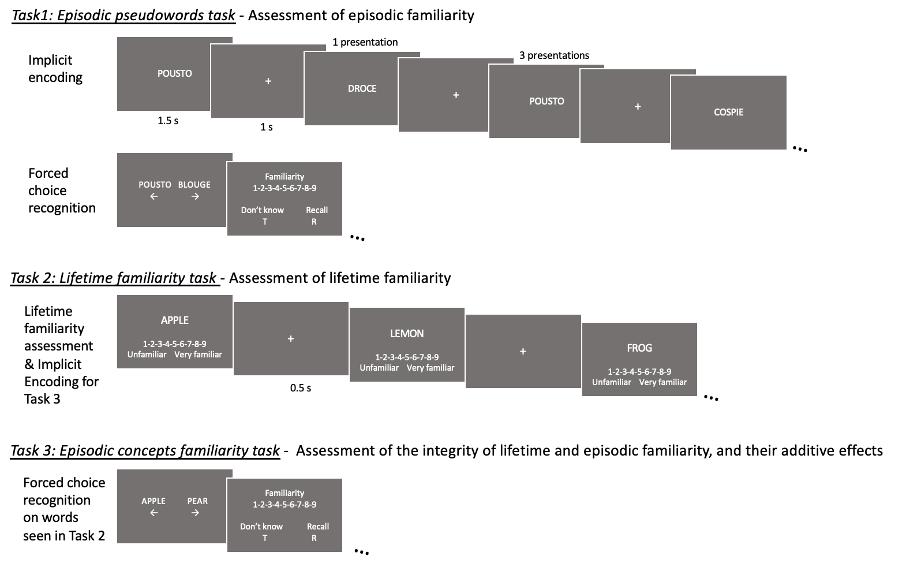
Episodic pseudowords familiarity task: Assessment of episodic familiarity
We created 120 pseudowords (60 targets and 60 lures), ensuring they were not real French words or related to famous brands or companies. Each target was paired with a lure matched for length, diphones, and digraphs.
During an incidental encoding phase, participants viewed 60 pseudowords on the screen for 1.5 seconds each, with a 1-second inter-stimulus interval. Half pseudowords were shown once, and half were shown three times (i.e., leading to a total of 120 trials), creating two levels of episodic familiarity for a later forced-choice recognition task. Participants read the pseudowords, knowing some would repeat. For pseudowords shown three times, repetitions were spaced by 20–40 random intervening stimuli. Several task versions were designed to counterbalance pseudoword status (target or lure) and presentation frequency (one or three times).
After the encoding phase, there was a 2-minute pause before participants began a forced-choice recognition task. Each pseudoword from encoding was shown alongside its associated lure, with randomized order and counterbalanced left/right presentation. Participants selected the pseudoword they had seen during encoding by pressing the corresponding arrow key (left or right). The forced-choice modality was chosen to promote familiarity-based recognition in aging (Bastin & Van der Linden, 2003). After each recognition, participants indicated their strategy: pressing “R” for recollection, “T” for guess, or rating their familiarity on a scale from 1 (“barely familiar”) to 9 (“very familiar”). Recollection was defined as remembering specific details from when the item was seen first, while familiarity was the sense of having seen the item without recalling specifics. Participants were instructed to use "guess" only for items that felt unfamiliar. Instructions were clarified with examples, and participants were asked to rephrase them to ensure understanding. The familiarity scale helped participants distinguish varying phenomenological intensities of familiarity.

Lifetime familiarity task: Assessment of lifetime familiarity
For the Lifetime familiarity task and the Episodic concepts familiarity task, we selected 160 object labels from McRae et al.'s (2005) normative database of object concepts and translated them into French. These labels formed 80 concept pairs: 80 labels were used in the Lifetime familiarity task, and were used as targets in a forced-choice recognition test in the Episodic concepts familiarity task, while their paired label (from the same category) served as lures. All items represented living things since they are more conceptually confusable (Clarke & Tayler, 2015).
During the Lifetime familiarity task, participants rated their lifetime familiarity with 80 concept labels on a 9-point scale (1 = "barely familiar," 9 = "extremely familiar"). Familiarity referred to encounters with the concept, not recognition of the word. Each stimulus was preceded by a 0.5-second fixation cross. Normative lifetime familiarity ratings for all 160 concepts were obtained from pilot studies and were used to calculate participants’ ratings adequacy. A poor adequacy of judgments on the Lifetime familiarity task is assumed to reflect an alteration of the underlying conceptual representations.

Episodic concepts familiarity task: Assessment of episodic familiarity, and the possibly additive effect of lifetime familiarity
The Lifetime familiarity task served as incidental encoding for the Episodic concepts familiarity task, a forced-choice recognition task. Participants identified which item, from each target-lure pair, was seen in the Lifetime familiarity task and indicated their recognition strategy: "R" for recollection, "T" for guessing, or an episodic familiarity rating from 1 ("barely familiar") to 9 ("very familiar").
The 80 concept pairs were divided into two subgroups (40 pairs each) based on conceptual overlap (above or below the median), measured by cosine similarity values from McRae et al. (2005).
In addition, items were categorized as either highly familiar (e.g., apple) or relatively unfamiliar (e.g., iguana) based on our pilot’s normative lifetime familiarity ratings. Each subgroup was further split into four conditions based on target and lure lifetime familiarity of the stimuli (high/low compared to median from pilot study¹, 10 pairs per condition), creating a 2x2x2 repeated-measures design: conceptual overlap (high/low) × target lifetime familiarity (high/low) × lure lifetime familiarity (high/low). Each condition was assigned an abbreviation code, such as LH_H (Target lifetime familiarity*Lure lifetime familiarity_Overlap). This example represents a low (L) target familiarity, high (H) lure familiarity, and high (H) conceptual overlap between the target and lure. Examples of pairs appear in Table 2.

Table 2.
Examples of concept pairs for each condition in the cross design 2 (target lifetime familiarity: high, low) x 2 (lure lifetime familiarity: high, low) x 2 (target-lure conceptual overlap: high, low).
Target lifetime familiarity | Lure lifetime familiarity | Conceptual overlap
Target lifetime familiarity | Lure lifetime familiarity | High | Low
High | High | Pear-Apple  Peach-Apricot  Toe-Thumb  Strawberry-Raspberry | Cherry-Plum  Kiwi-Banana  Ear-Leg  Rabbit-Goat
High | Low | Frog-Toad  Duck-Swan  Mosquito-Flea  Deer-Elk | Salmon-Dolphin  Wolf-Cheetah  Bee-Grasshopper  Spinach-Seaweed
Low | High | Crayfish-Shrimp  Buzzard-Pigeon  Heron-Eagle  Tarantula-Spider | Zebra-Cow  Camel-Pony  Rhubarb-Parsley  Skunk-Mouse
Low | Low | Walrus-Seal  Geranium-Hyacinth  Iguana-Lizard  Starling-Kingbird | Jellyfish-Seahorse  Sardine-Eel  Otter-Beaver  Poppy-Buttercup

Structural magnetic resonance imaging (MRI) acquisition
Images were acquired using a 3T Siemens Prisma scanner with a 64-channel head coil. Two anatomical images were collected: a T1-weighted MRI (240 x 256 x 224 matrix, 1 x 1 x 1 mm³ voxel size) and a T2-weighted MRI (448 x 448 x 60 matrix, 0.4 x 0.4 x 1.2 mm³ voxel size) covering the MTL in an oblique coronal orientation perpendicular to the long axis of the hippocampus. Participants were instructed to remain still during the scan to reduce motion artifacts. Image quality was visually assessed, and if poor, a second T2 (n=4) or T1 (n=1) scan was performed. The best-quality image was used for further processing.

Analyses
MRI volume segmentation
High-resolution T2-MRIs were labeled using the ASHS software and the Penn Memory Center (PMC) 3T atlas from the NITRC repository (Yushkevich et al., 2015). Hippocampal subfields (CA1, CA2, CA3, subiculum, dentate gyrus (DG)), ErC, BA35, BA36, and parahippocampal cortex (PhC) were labeled bilaterally. Automated segmentations were visually checked. Visual quality control identified three participants with poor segmentation, and their data were excluded.
The ErC was then manually divided into its anterolateral (alErC) and posteromedial (pmErC) portions, following the same methodology as in existing studies (Besson et al., 2020; Delhaye et al., 2025, based on established criteria, Olsen et al., 2017). Two raters (authors AS and ED) segmented the regions, with author AS re-segmenting 7 scans for inter-rater reliability, yielding an ICC_{1,1} of .869 (95% CI [.651, .955]). Intra-rater reliability was assessed by author AS re-segmenting 5 scans after 2 months, resulting in an ICC_{3,1} of .986 (95% CI [.946, .997]). Spatial overlap, measured using the Dice coefficient, showed excellent agreement: intra-rater values were .980 (left alErC) and .979 (right alErC), and inter-rater values were .975 (left alErC) and .965 (right alErC), which are consistent with prior studies (Besson et al., 2020; Delhaye et al., 2025; Olsen et al., 2017). alErC, pmErC and PrC volumes were normalized by dividing by the product of slice count and thickness.
All regional volumes were further adjusted for total intracranial volume (ICV) using the formula: Volume_{adjusted} = Volume_{raw} – β_{ICV}(ICV_{indiv} – ICV_{mean}) (Delhaye, Bahri et al., 2019; Yeung et al., 2017). The adjusted individual volumes of the left alErC and left BA35 were then summed to obtain the total volume of the left tErC for each participant. Similarly, the right tErC was the sum of the right alErC and right BA35.

Statistical analyses
All statistical analyses were conducted using JASP (v0.19), except for the correlation matrix, computed with SciPy Stats in Python 3. Analyses were performed on the entire sample. See our exploratory cluster analysis available in Appendix H for exploration of group differences. For the Episodic pseudowords familiarity task and the Episodic concepts familiarity task, we analyzed percentage accuracy at the condition level to remain consistent with our balanced experimental design, which we constructed based on previous studies using similar design and analyses (Delhaye, Folville, et al., 2019).

Episodic pseudowords familiarity task. This task aimed to provide a “pure” measure of episodic familiarity, without pre-experimental lifetime familiarity. Pseudowords recognition indeed has been classically shown to enhance recognition in the absence of conscious recollection (Gardiner & Java, 1990). As the tErC is assumed to track the increase in familiarity with repeated encounters of a stimulus, the accuracy for items presented three times should correlate more with its volume than accuracy for items presented once.
The percentage of correct recognition responses was calculated for each participant and condition. The hypothesis regarding the link with the volume of the MTL brain regions was tested using a repeated-measures ANCOVA with two levels (one vs. three presentations). The analysis focused on the percentage of correct responses in the two conditions, with the volumes of the left and right tErC –the main predictors– as covariates, alongside volumes of other MTL brain regions (left and right tErC, pmErC, BA36, and the hippocampal subfields CA1, CA3, and DG) and sex and age to control for aging effects and unspecific MTL volume loss. All covariates were added together. Controlling for age helps testing the hypothesis that brain volumes (not just age) are associated with cognitive performance. Similarly, given the critical role of CA1 and CA3 in memory processes (Bastin et al., 2019; Duncan et al., 2014) and the critical role of DG in pattern separation (Yassa & Stark, 2011), we added their volumes as covariates to ensure that observed associations between tErC and memory accuracy are not confounded by variance attributable to hippocampal subfield integrity. This allowed us to assess the specificity of the relationship between the task performance and the tErC volume rather than a broader relationship between the task performance and the MTL regions in general. We included all interactions between covariates and factors to model the possibility that the relationship between a covariate and the dependent variable varies across within-subject conditions—an important consideration in repeated measures designs where slope heterogeneity may be present (Yzerbyt et al., 2004).

Lifetime familiarity task. Inspired by Bowles et al. (2016), we analysed the correlation between the pattern of lifetime familiarity judgments of our participants with the normative ones from pilot studies¹. We calculated Pearson correlations for each participant’s lifetime familiarity ratings (1-9 scale) with the pilot sample's average ratings, then applied Fisher transformation to the rho-values to obtain Z-scores, correcting for the skewed distribution of rho-values for further analysis. We use the term 'adequacy' to refer to the Z-score values, as they reflect how similarly participants perform familiarity judgments compared to an independent control sample. We plotted a histogram of the correlation coefficients across participants to verify that the majority of participants exhibited positive correlations—whether strong or weak—between their judgments and those of the normative sample. Negative correlations, indicating unexpectedly high familiarity for rare concepts (and vice versa), would signal potential outliers.
The Z-scores were expected to be associated with the volume of the left tErC (Bowles et al., 2016; Yang et al., 2023). This relationship was assessed using a stepwise regression with the Z-scores as the dependent variable, the left and right tErC volumes as predictors and the following covariates: age, sex, left and right CA1, CA3, and DG hippocampal subfields and pmErC, and BA36 volumes (for similar methods, see Delhaye, Bahri, et al., 2019; or Frick et al., 2023).

Episodic concepts familiarity task. We compared percentage accuracy aggregated at the condition level using repeated-measures ANCOVA. We thus used a 2 (target-lure conceptual overlap: high, low) x 2 (target lifetime familiarity: high, low) x 2 (lure lifetime familiarity: high, low) repeated measures ANCOVA to compare memory accuracy across conditions with the same predictors (the left and right tErC) and statistical covariates (age, sex, left and right CA1, CA3, DG, pmErC, and BA36) as in the Episodic pseudowords familiarity task. We expected the ANCOVA to reveal an influence of the left tErC on performance, depending on conceptual overlap and lifetime familiarity.
For further exploration, we calculated two indices: the first measures how conceptual overlap between the target and lure influenced performance, and the second reflects the impact of the lifetime familiarity difference between the target and lure on memory accuracy. Both indices were computed using point-biserial correlations between correct responses (1 or 0) and either conceptual overlap or the lifetime familiarity difference (target familiarity minus lure familiarity). Fisher transformation was applied to the rho-values for statistical analysis. Stepwise regression was used as an exploratory approach to investigate whether the derived indices (Z_{overlap} and Z_{diff_fam}) could be predicted by the tErC volume. All predictors entered the model were constrained to those included in the primary ANCOVA analyses.

Across tasks analyses. Spearman correlations were computed between performance across the three familiarity tasks using individual correct response percentages for items presented once and three times in the Episodic pseudowords familiarity task, the Z-score from the Lifetime familiarity task, and correct response percentages for each of the eight conditions in the Episodic concepts familiarity task. Given that both episodic and lifetime familiarity likely depend on tErC integrity, we expected positive correlations and examined this relation using one-tailed correlations. P-values were corrected for multiple comparisons using False Discovery Rate (FDR) (Benjamini & Hochberg, 2000).
Transparency and Openness
The materials to reproduce the experiment and the data are freely available at OSF via the following link: https://osf.io/5mpnu/?view_only=5c3dcc11d2f84018bc7ebab9c176135d. The study was not preregistered. We shared raw behavioural data and pre-processed MRI segmentations data.

Results
Cognitive status was assessed using the MoCA, with scores available for 55 participants, ranging from 19 to 30 (M = 26.29, SD = 2.68). The score distribution (Appendix B) confirmed a wide range of cognitive abilities in the sample, aligning with our goal to include participants with potential varying MTL integrity as prior research links MoCA score to tErC volume (Olsen et al., 2017; Yeung et al., 2021). The mean volumes of MTL subregions of interest across diagnostic subgroups (HC, SCD and MCI) are presented in Appendix C to show variability.

Episodic pseudowords familiarity task: Episodic familiarity for pseudowords
Figure 2A and 2B present memory performance on the Episodic Pseudowords Familiarity task for descriptive purposes. See Appendix D for detailed statistical analyses of these behavioural results.

Figure 2.
Memory performance on the experimental tasks. A) Boxplots with the individual data of the percentages of correct responses when the item was presented one single time or three times during the encoding phase of the Episodic pseudowords familiarity task; B) Bar plots with 95% confidence intervals (CI95%) showing the percentage of items for which participants used recollection (R), familiarity (F), or guess (G) judgments, separately for items presented either once or three times during the encoding phase of the Episodic pseudowords familiarity task, independently of response accuracy; C) Histogram of the Pearson correlation values between familiarity judgements made by the participants on the Lifetime familiarity task and those from the normative pilot study. The correlations are plotted before their Fisher transformation into Z-scores; D) Point Plots representing the average percentage of correct responses with the CI95% for the different levels of target-lure conceptual overlap (high on the left and low on the right), the level of lifetime familiarity of the target and of the lure in the Episodic concepts familiarity task; E) Percentages of R, F, and G responses for the different conditions independently of response accuracy in the Episodic concepts familiarity task.
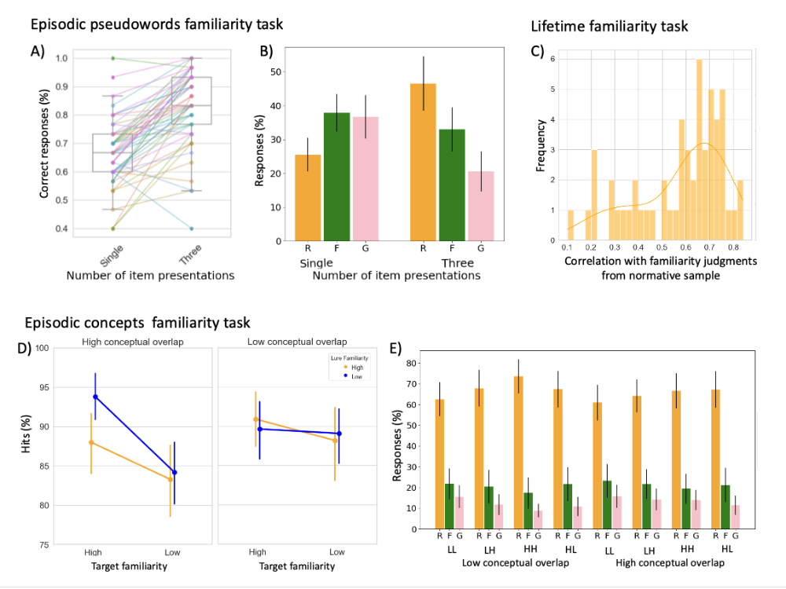
Note. L: low, H: high lifetime familiarity (presented in the order ‘Target-Lure’, e.g., LH: target with low familiarity and lure with high familiarity), R: recollection, F: familiarity; G: guess.
The repeated measures ANCOVA with age, sex, and brain region volumes (left and right tErC, CA1, CA3, DG, BA36, and pmErC) as covariates showed that memory accuracy was not significantly different between pseudowords presented three times and pseudowords presented once (F(1,40) = .93, η²_{p} = .02, p = .34). Furthermore, the ANCOVA revealed no significant interaction between brain regions and pseudoword presentation frequency (see Appendix E for detailed results table).

Lifetime familiarity task
With a sample including both patients and healthy older participants, we expected variability in correlations between individual lifetime familiarity judgments and those of the normative sample to capture associations between adequacy scores and brain volumes. This variability is shown in Figure 2C. The average Fisher’s Z-score was .69 with a standard deviation of .27 and no participant showing a negative correlation.
A stepwise linear regression analysis was used to investigate whether the left and right tErC volumes explained the variance of the Z-scores on the Lifetime familiarity task while controlling for age, sex, and other MTL subregion volumes (pmErC, BA36, CA1, CA3, and DG hippocampal subfields). The regression intercept was statistically significant (β=0.695, SE=0.037, t=18.63, p<.001), but all the covariates considered for inclusion were non-significant and were thus ultimately excluded from the model. No MTL subregion volumes significantly explained variability in the adequacy of lifetime familiarity judgments (Z-scores).

Episodic concepts familiarity task: Episodic and lifetime familiarity
Figure 2D and 2E presents memory performance on the Episodic concepts familiarity task for descriptive purposes. See Appendix F for detailed statistical analyses of these behavioural patterns.
The 2 (target-lure conceptual overlap: high, low) x 2 (target lifetime familiarity: high, low) x 2 (lure lifetime familiarity: high, low) repeated measures ANCOVA with the MTL subregion volumes (left and right tErC, CA1, CA3, DG, pmErC, and BA36), age and sex, as covariates showed that no brain volume significantly explained variance in memory accuracy (p > .05). However, significant triple interactions were found between lure familiarity, target-lure conceptual overlap, and the volumes of the left tErC (F(1,40) = 9.46, η²_{p} = 0.19, p = .004), and left BA36 (F(1,40) = 7.77, η²_{p} = .16, p = .008), indicating the volume of these regions modulate the influence of overlap and of lure familiarity on memory accuracy. Additionally, the interaction between the conceptual overlap between lure and target familiarity, the target lifetime familiarity, and left tErC volume (F(1,40) = 3.90, η²_{p} = .09, p = .05) was just significant. The significant interactions between memory performance on the Episodic concepts familiarity task and volumes of MTL subregions are represented in Figure 3. Other interactions were not significant (p > .05). Full results table is in Appendix G.

Figure 3.
Regression lines and scatter plot between memory performance on the Episodic concepts familiarity task and volumes of the MTL subregions for the significant interactions of the ANCOVA. A) Regressions illustrating the significant triple interaction between the lure lifetime familiarity, the degree of conceptual overlap between the target and the lure, and the volume of the left tErC; B) Regressions illustrating the significant triple interaction between the degree of target-lure conceptual overlap, the lure lifetime familiarity, and the volume of the left BA36. Brain volumes are in mm³ post-regression for the ICV.
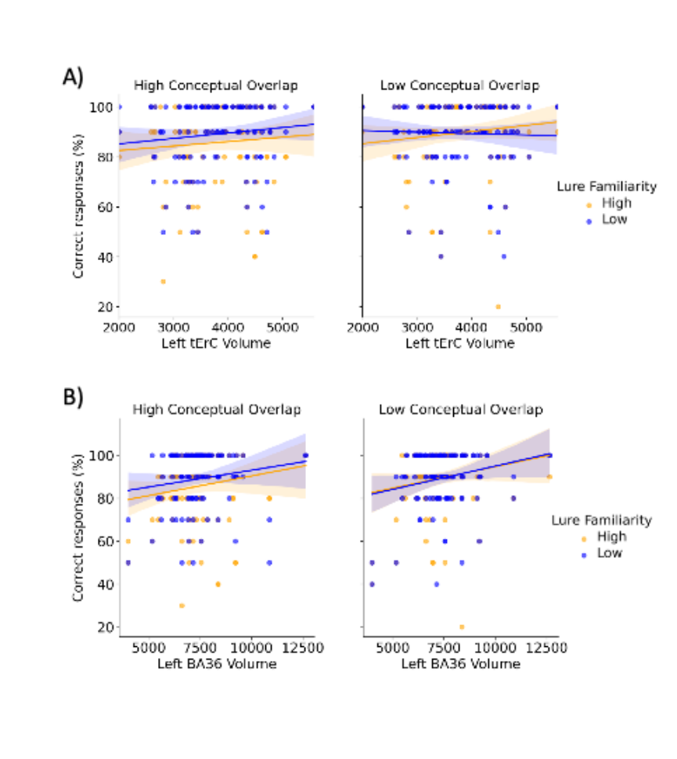
The stepwise linear regressions on Z_{diff_fam} and Z_{overlap} scores were performed on 53 participants with complete data, excluding two who achieved 100% accuracy on all the conditions from the Episodic concepts familiarity task. The stepwise linear regressions on Z_{diff_fam} with MTL subregion volumes (left and right tErC, CA1, CA3, DG, pmErC, and BA36), age and sex, selected a significant model with one predictor: right CA1 volume. The overall model (i.e., the omnibus test) was significant, F(1, 52) = 4.48, p = .039, R² = 0.081, indicating that CA1 region explains 8% of the variance in task performance. The predictor contributed significantly to the model (right CA1: β = –0.284, t = –2.12, p = .039). On the other hand, the stepwise linear regression for Z_{overlap} scores revealed no significant predictors.

Correlations between performance across tasks
Spearman correlations (ρ) between performance on the different familiarity tasks (correlation matrix in Figure 4) revealed no significant correlation between recognition accuracy for items presented once in the Episodic pseudowords familiarity task (purest measure of episodic familiarity we have) and Z-scores from the Lifetime familiarity task, ρ = .16, p = .24. The correlation between recognition accuracy for items presented three times in the Episodic pseudowords familiarity task (supposedly stronger episodic familiarity) and Z-scores from the Lifetime familiarity task was not statistically significant, ρ = .25, p = .08.
Memory accuracy for items presented once in the Episodic pseudowords familiarity task only correlated marginally with one condition of the Episodic concepts familiarity task (HL_L: ρ = .28, p = .05), but not with others. Memory accuracy for items presented three times in the Episodic pseudowords familiarity task significantly correlated with all conditions of the Episodic concepts familiarity task (HH_H: ρ = .33, p = .007; HL_H: ρ = .50, p < .001; LH_H: ρ = .47, p < .001; LL_H: ρ = .48, p < .001; HH_L: ρ = .42, p < .001; HL_L: ρ = .49, p < .001) except the ones involving both low lifetime familiarity target and low conceptual overlap (LH_L: ρ = .24, p = .09; LL_L: ρ = .25, p = .09).
Significant correlations were found between Z-scores from the Lifetime familiarity task and performance on the conditions from the Episodic concepts familiarity task that involved high lifetime familiarity targets (HH_H: ρ = .45, p = .001; HL_H: ρ = .46, p = .001; HH_L: ρ = .34, p = .02; HL_L: ρ = .36, p = .01), but not on those involving low target familiarity (LH_H: ρ = .17, p = .22; LL_H: ρ = .05, p = .73; LH_L: ρ = .24, p = .09; LL_L: ρ = .19, p = .18).

Figure 4.
Matrix of Spearman correlations between scores on the different familiarity tasks. The values correspond to the Spearman’s correlation coefficient rho (ρ). Significance of p-value is defined after FDR correction. *p<.05; **p<.01; ***p<.001

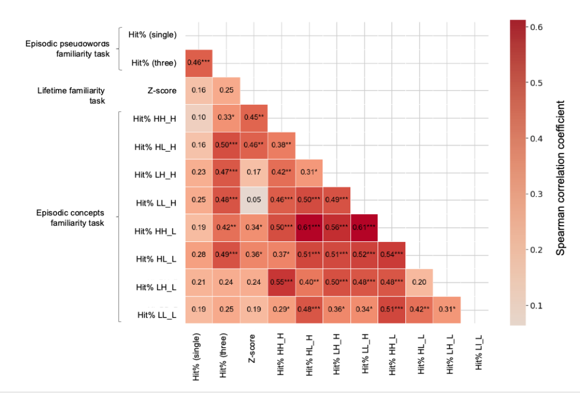
Finally, an exploratory clustering analysis is presented in Appendix H. In summary, results from this exploratory analysis suggest the present data could be clustered across three groups, distinguishing themselves in their memory accuracy in the Episodic pseudowords familiarity task, the adequacy of their lifetime familiarity judgements, their accuracy in the Episodic concepts familiarity task, especially in case of high target-lure overlap, and their use of recollection, episodic familiarity and guess judgements across the different episodic tasks. Of note, a subsequent exploratory Chi-Squared test between these clusters and initial participants’ diagnoses shows that one cluster mostly groups healthy participants, another one mainly includes patients with a diagnosis of MCI or SCD, while a last one groups healthy participants and patients in a heterogeneous fashion.

Discussion
This study aimed to better understand the role of the tErC in familiarity processes, through the study of older adults with various levels of possible tErC alterations. We designed three behavioural tasks to test the idea that the tErC contributes to both episodic and semantic memory (Miyashita, 2019) and helps differentiate overlapping concepts (Clarke & Tyler, 2015). Previous studies supported PrC's - including BA35, as part of the tErC - role in both episodic and lifetime familiarity, especially for closely related concepts (Duke et al., 2017; Bowles et al., 2016). However, one study in patients with MCI did not find lifetime familiarity impairments, questioning PrC/tErC involvement (Anderson et al., 2021), though conceptual overlap was not tested. Here, we investigated whether lower tErC volume in healthy older adults and patients with SCD or MCI relates to diminished performance in episodic and lifetime familiarity, especially in the presence of conceptual overlap, assuming that tErC integrity is particularly relevant for familiarity judgments when these rely on resolving interference between conceptually overlapping representations.

Relation with MTL subregions structural integrity
In the Episodic concepts familiarity task, our results showed that the volumes of the left tErC and left BA36 interacted significantly with the lure's lifetime familiarity and the conceptual overlap between the target and lure. Performance was lower when the lure had high lifetime familiarity and high conceptual overlap with the target. However, when the lure had low lifetime familiarity in the presence of high overlap, performance was similar to conditions with low overlap. Precisely, our results indicate that the volume of the left tErC is positively linked with the percentage of correct recognitions both in case of high conceptual overlap and in case of low conceptual overlap if the lure familiarity is high. This suggests that the tErC volume might be more strongly related to correct responses when conceptual overlap is high. When conceptual overlap is low, the modulation of the effect of lure lifetime familiarity by the tErC weakens, especially when the lure’s familiarity is also low, suggesting that tErC may be particularly engaged in resolving conceptual interference when sources of familiarity must be disambiguated. The volume of the left BA36 also appeared to be positively associated with memory performance under high conceptual overlap. This pattern is consistent with theories suggesting that the PrC involved in discriminating closely related concepts (Clarke & Tyler, 2015) and that the tErC/PrC is engaged in familiarity when fine conceptual discrimination is needed (Bastin & Delhaye, 2023; Bowles et al., 2016). More intriguingly however, the volume of the left BA36 appeared to be slightly more positively associated with memory performance when the lure had a low lifetime familiarity. To date, we are not sure how to interpret this result. Although BA35 and BA36 are rarely distinguished when studying the role of the PrC in cognition, it is not the first time that BA36 is shown to be associated with conceptual processes (see Frick et al., 2023). Consequently, the role of this often-neglected subregion needs to be further studied when investigating familiarity and conceptual discrimination processes. Note that overall performance was relatively high across conditions, which raises the possibility of ceiling effects that may limit sensitivity to detect other potential subtle differences between conditions. However, sufficient variability remained to support the analyses reported above.
Unexpectedly however, no significant modulation of memory performance in the Episodic pseudowords familiarity task or in the Lifetime familiarity task was observed in relation with these brain regions. In other words, we did not show evidence linking tErC integrity to episodic or lifetime familiarity as such, nor to increased exposure, but our results suggest that tErC integrity is selectively associated with familiarity performance under conditions that impose high conceptual discrimination demands. Although previous functional MRI studies have shown PrC involvement in both kinds of familiarity (Duke et al., 2017), brain volumes from structural MRI may be less sensitive. Variations in MTL segmentation methods (Yushkevich et al., 2015) and the need for more refined delineation of MTL subregions (Mazloum-Farzaghi et al., 2024) may also limit volumetric precision. Additionally, the inter-individual variability in PrC volumes in our sample may be smaller than that in case studies with extensive focal PrC damage (Bowles et al., 2016), which may have hindered detection of some subtle effects.
In the Episodic concepts familiarity task, the stepwise linear regression on the Z_{diff_fam} revealed a significant model involving the right CA1 volume. Participants with smaller right CA1 volumes rely more strongly on lifetime familiarity of the stimuli (target vs. lure) to perform the recognition task. Given the established role of CA1 in episodic memory formation and recall (Bartsch et al., 2011), this result, together with the high “remember” response rates, suggest that recollection is involved when lure lifetime familiarity is high.
Theoretically, the finding that tErC volume was associated with recognition performance only when the task required discrimination between overlapping concepts constrains models of familiarity by indicating that tErC integrity becomes particularly relevant when familiarity judgments must resolve competing or overlapping sources of information. This aligns with recent views proposing that different stimuli and representations may evoke familiarity through distinct neural correlates (Gardette et al., 2025), and that the subjective feeling of familiarity may be independent of its representational dimensions.
Behavioural modulations of familiarity
Interestingly, adequacy of lifetime familiarity judgments was positively associated with conditions from the Episodic concepts familiarity task that involved targets with high lifetime familiarity—that is, in cases where lifetime familiarity was likely to support recognition accuracy. In contrast, no such associations were observed for conditions involving low-familiarity targets. For the Episodic pseudowords familiarity task, adequacy of lifetime familiarity judgements was not significantly associated with recognition accuracy. Overall, the fact that Lifetime familiarity adequacy score was selectively associated with conditions where lifetime familiarity could plausibly influence accuracy, but not with those reliant on pure episodic familiarity, supports the idea that our task design differentially modulated episodic and lifetime familiarity.
However, despite efforts to focus on familiarity, the high rates of recollection responses in the Episodic pseudowords familiarity task and the Episodic concepts familiarity task suggest that the tasks did not capture familiarity in its purest form. This might contribute to the lack of relation with tErC integrity on a series of measures. Assessing recognition based solely on episodic familiarity, without recollection, remains challenging (Anderson et al., 2021; Besson et al., 2015; Gardette et al., 2025). Measuring lifetime familiarity also remains difficult, as it cannot be scored objectively. Following previous work (Bowles et al., 2016), we estimated judgements adequacy through correlations with familiarity scores from young controls. This is a limitation as the measure reflects deviations from a normative sample rather than providing a direct assessment of the construct itself.
In addition to memory accuracy however, our exploratory hierarchical clustering analysis also considered recollection, familiarity, guesses, and familiarity on false alarms. This analysis identified three subgroups: Cluster 1, with higher memory accuracy, mostly comprised healthy older participants (76%); Cluster 3, with the lowest memory accuracy, mainly included patients with SCD or MCI (83%); and Cluster 2, which had a mix of healthy participants and patients with SCD or MCI. Participants in Cluster 2 showed slightly below average memory accuracy, used less recollection and more familiarity responses, suggesting they rely on familiarity to compensate for impaired recollection, as seen in previous MCI studies (Bastin & Van der Linden, 2003; Westerberg et al., 2006). They also used familiarity on false alarms more often, echoing findings that patients with MCI with increased false recognitions are more likely to develop AD (Bastin et al., 2021). Although their lifetime familiarity adequacy was average, Cluster 2’s performance in the Episodic concepts familiarity task was more negatively affected by conceptual overlap, consistent with the hypothesis that early tErC alterations are associated with altered familiarity when discrimination between conceptually similar items is required (Bastin & Delhaye, 2023). Cluster 2 showed milder impairment compared to Cluster 3, who had the worst accuracy and used more Guess responses. Cluster 3 also showed slightly lower adequacy on their lifetime familiarity judgements.
In favour of the assumption that the three clusters might partly distinguish between clinical subgroups, MoCA scores differed between clusters, attesting to their different level of cognitive impairment. Although exploratory, these clustering results provide insights into cognitive task design for detecting preclinical cognitive decline. Recent research shows that older adults have more difficulty distinguishing semantically similar verbal memory traces (Ilyés et al., 2024), and Cluster 2’s MoCA score (24.08 ± 2.81) aligns with those of participants in that study (25.95 ± 2.01). In this line, our results distinguish Cluster 2 from Cluster 1 (more efficient), highlighting the potential of our tasks combination to identify early cognitive decline. This hypothesis should be confirmed by future group studies including patients with AD diagnosis at prodromal stage based on biomarkers (Jack et al., 2024).

Limitations and future perspectives
The present behavioural paradigms do not allow for a process-pure isolation of representational “fineness.” Forced-choice familiarity judgments may reflect multiple contributing factors, including episodic familiarity, conceptual fluency, discriminability, and response strategies (Yonelinas, 2002). Likewise, volumetric associations provide only indirect evidence regarding the nature of neural representations and cannot speak to representational coding precision per se. Accordingly, our conclusions are framed in terms of associations between transentorhinal cortex integrity and familiarity-based performance under varying degrees of conceptual overlap, rather than as direct evidence for fine-grained representational coding.
Future studies might attempt to induce higher rates of phenomenological familiarity to better isolate the role of the tErC in the representational dimension of familiarity. Although our tasks did not assess familiarity processes as purely as expected, exploratory behavioural clustering across tasks highlighted the potential of combining familiarity-related tasks to detect subtle cognitive changes linked to tErC integrity. Future studies with larger samples could further explore differences in tErC volumes between subgroups and assess the sensitivity and specificity of these tasks in identifying preclinical AD. A longitudinal follow-up after 2 years would help determine if patients with profiles similar to the ones in Cluster 2 are more likely to progress to AD, providing a better understanding of the predictive value of these tasks. Note that our study included only French-speaking participants, as it was important for the healthy controls to match the profile of patients recruited through the Memory Clinic. However, future studies may explore the generalizability to other groups (Roberts et al., 2020).
Conclusion
In conclusion, our findings highlight the complexity of the relationship between familiarity-based memory processes and the structural integrity of MTL subregions. Behaviourally, we showed that memory accuracy is influenced by both episodic and lifetime familiarity, particularly when conceptual overlap increases discrimination demands. It is therefore not surprising that the tErC volume appears to be associated to familiarity specifically when familiarity judgments require resolving ambiguity between conceptually similar items. These results identify task conditions under which tErC structure is most strongly related to familiarity-based behaviour.
Ackowledgements: The authors thank Adrien Folville for creating the material and pre-testing the experimental tasks, Renaud Coppalle for administering some of the neuropsychological assessments, and Bhavin Choksi for his feedback on the clustering analysis. This work has been presented at the Cognitive Neuroscience Society conference in 2025.
Competing interests: The authors have no conflict of interest to declare.
Declaration of generative AI technologies in the writing process: During the preparation of this work the authors used ChatGPT in order to improve the readability, concision, and language of the manuscript. After using this tool/service, the authors reviewed and edited the content as needed and take full responsibility for the content of the published article.
References
Adam, S., Van der Linden, M., Ivanoiu, A., Juillerat, A.-C., Bechet, S., & Salmon, E. (2007). Optimization of encoding specificity for the diagnosis of early AD : The RI-48 task. Journal of Clinical and Experimental Neuropsychology, 29(5), 477-487. https://doi.org/10.1080/13803390600775339
Amieva, H., Le Goff, M., Stoykova, R., Lafont, S., Ritchie, K., Tzourio, C., Fabrigoule, C., & Dartigues, J. (2009). Trail Making Test A et B (version sans correction des erreurs) : normes en population chez des sujets âgés, issues de l'étude des trois Cités. Revue de Neuropsychologie, 1, 210-220. https://doi.org/10.1684/nrp.2009.0031.
Anderson, N. D., Beana, E., Yang, H., & Köhler, S. (2021). Deficits in recent but not lifetime familiarity in amnestic mild cognitive impairment. Neuropsychologia, 151, 107735. https://doi.org/10.1016/j.neuropsychologia.2020.107735
Bartsch, T., Döhring, J., Rohr, A., Jansen, O., & Deuschl, G. (2011). CA1 neurons in the human hippocampus are critical for autobiographical memory, mental time travel, and autonoetic consciousness. PNAS, 108(42), 17562–17567. https://doi.org/10.1073/pnas.1110266108
Bastin, C., Bahri, M. A., Giacomelli, F., Miévis, F., Lemaire, C., Degueldre, C., Balteau, E., Guillaume, B., & Salmon, E. (2021). Familiarity in Mild Cognitive Impairment as a Function of Patients' Clinical Outcome 4 Years Later. Alzheimer Disease and Associated Disorders, 35(4), 321–326. https://doi.org/10.1097/WAD.0000000000000466
Bastin, C., Besson, G., Simon, J., Delhaye, E., Geurten, M., Willems, S., & Salmon, E. (2019). An integrative memory model of recollection and familiarity to understand memory deficits. Behavioral and Brain Sciences, 42, e281. https://doi.org/10.1017/S0140525X19000621
Bastin, C., & Delhaye, E. (2023). Targeting the function of the transentorhinal cortex to identify early cognitive markers of Alzheimer's disease. Cognitive, Affective & Behavioral Neuroscience, 23(4), 986–996. https://doi.org/10.3758/s13415-023-01093-5
Bastin, C., & Van der Linden, M. (2003). The contribution of recollection and familiarity to recognition memory: A study of the effects of test format and aging. Neuropsychology, 17(1), 14–24. https://doi.org/10.1037/0894-4105.17.1.14
Belleville, S., Rouleau, N., & Van der Linden, M. (2006). Use of the Hayling task to measure inhibition of prepotent responses in normal aging and Alzheimer's disease. Brain and Cognition, 62(2), 113–119. https://doi.org/10.1016/j.bandc.2006.04.006
Benjamini, Y., & Hochberg, Y. (2000). On the adaptive control of the false discovery rate in multiple testing with independent statistics. Journal of Educational and Behavioral Statistics, 25(1), 60–83. https://doi.org/10.2307/1165312
Berron, D., Vogel, J. W., Insel, P. S., Pereira, J. B., Xie, L., Wisse, L. E. M., Yushkevich, P. A., Palmqvist, S., Mattsson-Carlgren, N., Stomrud, E., Smith, R., Strandberg, O., & Hansson, O. (2021). Early stages of tau pathology and its associations with functional connectivity, atrophy and memory. Brain : A Journal of Neurology, 144(9), 2771–2783. https://doi.org/10.1093/brain/awab114
Besson, G., Ceccaldi, M., Tramoni, E., Felician, O., Didic, M., & Barbeau, E. J. (2015). Fast, but not slow, familiarity is preserved in patients with amnestic mild cognitive impairment. Cortex, 65, 36–49. https://doi.org/10.1016/j.cortex.2014.10.020
Besson, G., Simon, J., Salmon, E., & Bastin, C. (2020). Familiarity for entities as a sensitive marker of antero-lateral entorhinal atrophy in amnestic mild cognitive impairment. Cortex, 128, 61–72. https://doi.org/10.1016/j.cortex.2020.02.022
Bowles, B., Crupi, C., Pigott, S., Parrent, A., Wiebe, S., Janzen, L., & Köhler, S. (2010). Double dissociation of selective recollection and familiarity impairments following two different surgical treatments for temporal-lobe epilepsy. Neuropsychologia, 48(9), 2640–2647. https://doi.org/10.1016/j.neuropsychologia.2010.05.010
Bowles, B., Duke, D., Rosenbaum, R. S., McRae, K., & Köhler, S. (2016). Impaired assessment of cumulative lifetime familiarity for object concepts after left anterior temporal-lobe resection that includes perirhinal cortex but spares the hippocampus. Neuropsychologia, 90, 170–179. https://doi.org/10.1016/j.neuropsychologia.2016.06.035
Bozeat, S., Lambon Ralph, M. A., Patterson, K., Garrard, P., & Hodges, J. R. (2000). Non-verbal semantic impairment in semantic dementia. Neuropsychologia, 38(9), 1207–1215. doi:10.1016/S0028-3932(00)00034-8
Braak, H., & Braak, E. (1991). Neuropathological stageing of Alzheimer-related changes. Acta Neuropathologica, 82(4), 239–259. https://doi.org/10.1007/BF00308809
Braak, H., & Braak, E. (1995). Staging of Alzheimer's disease-related neurofibrillary changes. Neurobiology of Aging, 16(3), 271–284. https://doi.org/10.1016/0197-4580(95)00021-6
Braak, H., & Del Tredici, K. (2015). The preclinical phase of the pathological process underlying sporadic Alzheimer's disease. Brain : A Journal of Neurology, 138(10), 2814–2833. https://doi.org/10.1093/brain/awv236
Bruffaerts, R., De Deyne, S., Meersmans, K., Liuzzi, A. G., Storms, G., & Vandenberghe, R. (2019). Redefining the resolution of semantic knowledge in the brain : Advances made by the introduction of models of semantics in neuroimaging. Neuroscience & Biobehavioral Reviews, 103, 3‑13. https://doi.org/10.1016/j.neubiorev.2019.05.015
Campbell, J. I., & Thompson, V. A. (2012). MorePower 6.0 for ANOVA with relational confidence intervals and Bayesian analysis. Behavior Research Methods, 44(4), 1255–1265. https://doi.org/10.3758/s13428-012-0186-0
Clarke A. (2020). Dynamic activity patterns in the anterior temporal lobe represents object semantics. Cognitive Neuroscience, 11(3), 111–121. https://doi.org/10.1080/17588928.2020.1742678
Clarke, A., & Tyler, L. K. (2015). Understanding what we see: How we derive meaning from vision. Trends in Cognitive Sciences, 19(11), 677–687. https://doi.org/10.1016/j.tics.2015.08.008
Cree, G. S., & McRae, K. (2003). Analyzing the factors underlying the structure and computation of the meaning of chipmunk, cherry, chisel, cheese, and cello (and many other such concrete nouns). Journal of Experimental Psychology: General, 132(2), 163–201. https://doi.org/10.1037/0096-3445.132.2.163
Delhaye, E., Bahri, M. A., Salmon, E., & Bastin, C. (2019). Impaired perceptual integration and memory for unitized representations are associated with perirhinal cortex atrophy in Alzheimer's disease. Neurobiology of Aging, 73, 135–144. https://doi.org/10.1016/j.neurobiolaging.2018.09.021
Delhaye, E., Besson, G., Bahri, M. A., & Bastin, C. (2025). Object fine-grained discrimination as a sensitive cognitive marker of transentorhinal integrity. Communications Biology, 8(1), 800. https://doi.org/10.1038/s42003-025-08201-w
Delhaye, E., Folville, A., & Bastin, C. (2019). How to induce an age-related benefit of semantic relatedness in associative memory: It's all in the design. Psychology and Aging, 34(4), 572–586. https://doi.org/10.1037/pag0000360
Despouy, E., Curot, J., Deudon, M., Gardy, L., Denuelle, M., Sol, J. C., Lotterie, J. A., Valton, L., & Barbeau, E. J. (2020). A Fast Visual Recognition Memory System in Humans Identified Using Intracerebral ERP. Cerebral Cortex, 30(5), 2961–2971. https://doi.org/10.1093/cercor/bhz287
Duke, D., Martin, C. B., Bowles, B., McRae, K., & Köhler, S. (2017). Perirhinal cortex tracks degree of recent as well as cumulative lifetime experience with object concepts. Cortex, 89, 61‑70. https://doi.org/10.1016/j.cortex.2017.01.015
Duncan, K., Tompary, A., & Davachi, L. (2014). Associative encoding and retrieval are predicted by functional connectivity in distinct hippocampal area CA1 pathways. The Journal of neuroscience : the official journal of the Society for Neuroscience, 34(34), 11188–11198. https://doi.org/10.1523/JNEUROSCI.0521-14.2014
Eichenbaum, H., & Lipton, P. A. (2008). Towards a functional organization of the medial temporal lobe memory system: role of the parahippocampal and medial entorhinal cortical areas. Hippocampus, 18(12), 1314–1324. https://doi.org/10.1002/hipo.20500
Faul, F., Erdfelder, E., Lang, A. G., & Buchner, A. (2007). G*Power 3: a flexible statistical power analysis program for the social, behavioral, and biomedical sciences. Behavior Research Methods, 39(2), 175–191. https://doi.org/10.3758/bf03193146
Flanagan, K. J., Copland, D. A., Chenery, H. J., Byrne, G. J., & Angwin, A. J. (2013). Alzheimer’s disease is associated with distinctive semantic feature loss. Neuropsychologia, 51(10), 2016‑2025. https://doi.org/10.1016/j.neuropsychologia.2013.06.008
Frick, A., Besson, G., Salmon, E., & Delhaye, E. (2023). Perirhinal cortex is associated with fine-grained discrimination of conceptually confusable objects in Alzheimer's disease. Neurobiology of Aging, 130, 1–11. https://doi.org/10.1016/j.neurobiolaging.2023.06.003
Gardette, J., Delhaye, E., & Bastin, C. (2025). The Multiple Dimensions of Familiarity: From Representations to Phenomenology. Wiley Interdisciplinary Reviews: Cognitive science, 16, e1698. https://doi.org/10.1002/wcs.1698
Gardiner, J. M., & Java, R. I. (1990). Recollective experience in word and nonword recognition. Memory & Cognition, 18(1), 23–30. https://doi.org/10.3758/bf03202642
Garrard, P., Lambonralph, M., Patterson, K., Pratt, K., & Hodges, J. (2005). Semantic feature knowledge and picture naming in dementia of Alzheimer?s type : A new approach. Brain and Language, 93(1), 79‑94. https://doi.org/10.1016/j.bandl.2004.08.003
Gauthier, J., & Bouchard, S. (1993). Adaptation canadienne-française de la forme révisée du State–Trait Anxiety Inventory de Spielberger [A French-Canadian adaptation of the revised version of Spielberger's State–Trait Anxiety Inventory]. Canadian Journal of Behavioural Science / Revue canadienne des sciences du comportement, 25(4), 559–578. https://doi.org/10.1037/h0078881
GREFEX, Groupe de Réflexion sur l'Evaluation des Fonctions exécutives (2001). L'évaluation des fonctions exécutives en pratique clinique. Revue de Neuropsychologie, 11, 383-434.
Hirni, D. I., Kivisaari, S. L., Monsch, A. U., & Taylor, K. I. (2013). Distinct neuroanatomical bases of episodic and semantic memory performance in Alzheimer's disease. Neuropsychologia, 51(5), 930–937. https://doi.org/10.1016/j.neuropsychologia.2013.01.013
Ilyés, A., Paulik, B., & Keresztes, A. (2024). Discrimination of semantically similar verbal memory traces is affected in healthy aging. Scientific Reports, 14(1), 17971. https://doi.org/10.1038/s41598-024-68380-0
Jack, C. R., Jr, Andrews, J. S., Beach, T. G., Buracchio, T., Dunn, B., Graf, A., Hansson, O., Ho, C., Jagust, W., McDade, E., Molinuevo, J. L., Okonkwo, O. C., Pani, L., Rafii, M. S., Scheltens, P., Siemers, E., Snyder, H. M., Sperling, R., Teunissen, C. E., & Carrillo, M. C. (2024). Revised criteria for diagnosis and staging of Alzheimer's disease: Alzheimer's Association Workgroup. Alzheimer's & Dementia : The Journal of the Alzheimer's Association, 20(8), 5143–5169. https://doi.org/10.1002/alz.13859
Jessen, F., Amariglio, R. E., van Boxtel, M., Breteler, M., Ceccaldi, M., Chételat, G., Dubois, B., Dufouil, C., Ellis, K. A., van der Flier, W. M., Glodzik, L., van Harten, A. C., de Leon, M. J., McHugh, P., Mielke, M. M., Molinuevo, J. L., Mosconi, L., Osorio, R. S., Perrotin, A., Petersen, R. C., … Subjective Cognitive Decline Initiative (SCD-I) Working Group (2014). A conceptual framework for research on subjective cognitive decline in preclinical Alzheimer's disease. Alzheimer's & dementia : The Journal of the Alzheimer's Association, 10(6), 844–852. https://doi.org/10.1016/j.jalz.2014.01.001
Jessen, F., Amariglio, R. E., Buckley, R. F., van der Flier, W. M., Han, Y., Molinuevo, J. L., Rabin, L., Rentz, D. M., Rodriguez-Gomez, O., Saykin, A. J., Sikkes, S. A. M., Smart, C. M., Wolfsgruber, S., & Wagner, M. (2020). The characterisation of subjective cognitive decline. The Lancet. Neurology, 19(3), 271–278. https://doi.org/10.1016/S1474-4422(19)30368-0
Joubert, S., Gardy, L., Didic, M., Rouleau, I., & Barbeau, E. J. (2021). A Meta-Analysis of Semantic Memory in Mild Cognitive Impairment. Neuropsychology Review, 31(2), 221–232. https://doi.org/10.1007/s11065-020-09453-5
Kivisaari, S. L., Monsch, A. U., & Taylor, K. I. (2013). False positives to confusable objects predict medial temporal lobe atrophy : False Positives and Medial Temporal Lobe Atrophy. Hippocampus, 23(9), 832‑841. https://doi.org/10.1002/hipo.22137
Koen, J. D., & Yonelinas, A. P. (2014). The effects of healthy aging, amnestic mild cognitive impairment, and Alzheimer's disease on recollection and familiarity: a meta-analytic review. Neuropsychology Review, 24(3), 332–354. https://doi.org/10.1007/s11065-014-9266-5
Koen, J. D., & Yonelinas, A. P. (2016). Recollection, not familiarity, decreases in healthy ageing: Converging evidence from four estimation methods. Memory, 24(1), 75–88. https://doi.org/10.1080/09658211.2014.985590
Köhler, S., & Martin, C. B. (2020). Familiarity impairments after anterior temporal-lobe resection with hippocampal sparing : Lessons learned from case NB. Neuropsychologia, 138, 107339. https://doi.org/10.1016/j.neuropsychologia.2020.107339
Laisney, M., Giffard, B., Belliard, S., De La Sayette, V., Desgranges, B., & Eustache, F. (2011). When the zebra loses its stripes : Semantic priming in early Alzheimer’s disease and semantic dementia. Cortex, 47(1), 35–46.
Lawton, M. P., & Brody, E. M. (1969). Assessment of older people: self-maintaining and instrumental activities of daily living. The Gerontologist, 9(3), 179–186.
Maass, A., Berron, D., Libby, L. A., Ranganath, C., & Düzel, E. (2015). Functional subregions of the human entorhinal cortex. eLife, 4, e06426. https://doi.org/10.7554/eLife.06426
Mahnke, L., Atucha, E., Pina-Fernàndez, E., Kitsukawa, T., & Sauvage, M. M. (2021). Lesion of the hippocampus selectively enhances LEC's activity during recognition memory based on familiarity. Scientific Reports, 11(1), 19085. https://doi.org/10.1038/s41598-021-98509-4
Marra, C., Piccininni, C., Masone Iacobucci, G., Caprara, A., Gainotti, G., Costantini, E. M., Callea, A., Venneri, A., & Quaranta, D. (2021). Semantic Memory as an Early Cognitive Marker of Alzheimer's Disease: Role of Category and Phonological Verbal Fluency Tasks. Journal of Alzheimer's disease : JAD, 81(2), 619–627. https://doi.org/10.3233/JAD-201452
Mazloum-Farzaghi, N., Barense, M. D., Ryan, J. D., Stark, C. E. L., & Olsen, R. K. (2024). The Effect of Segmentation Method on Medial Temporal Lobe Subregion Volumes in Aging. Human Brain Mapping, 45(15), e70054. https://doi.org/10.1002/hbm.70054
McRae, K., Cree, G. S., Seidenberg, M. S., & Mcnorgan, C. (2005). Semantic feature production norms for a large set of living and nonliving things. Behavior Research Methods, 37(4), 547‑559. https://doi.org/10.3758/BF03192726
Miyashita, Y. (2019). Perirhinal circuits for memory processing. Nature Reviews Neuroscience, 20(10), 577‑592. https://doi.org/10.1038/s41583-019-0213-6
Nasreddine, Z. S., Phillips, N. A., Bédirian, V., Charbonneau, S., Whitehead, V., Collin, I., Cummings, J. L., & Chertkow, H. (2005). The Montreal Cognitive Assessment, MoCA: A Brief Screening Tool For Mild Cognitive Impairment. Journal of the American Geriatrics Society, 53, 695–699. https://doi.org/10.1111/j.1532-5415.2005.53221.x.
Nyberg, L., Bäckman, L., Erngrund, K., Olofsson, U., & Nilsson, L.-G. (1996). "Age differences in episodic memory, semantic memory, and priming: Relationships to demographic, intellectual, and biological factors." Journal of Gerontology: Psychological Sciences, 51B(4), P234–P240.
Olsen, R. K., Yeung, L. K., Noly-Gandon, A., D'Angelo, M. C., Kacollja, A., Smith, V. M., Ryan, J. D., & Barense, M. D. (2017). Human anterolateral entorhinal cortex volumes are associated with cognitive decline in aging prior to clinical diagnosis. Neurobiology of Aging, 57, 195–205. https://doi.org/10.1016/j.neurobiolaging.2017.04.025
Petersen R. C. (2004). Mild cognitive impairment as a diagnostic entity. Journal of Internal Medicine, 256(3), 183–194. https://doi.org/10.1111/j.1365-2796.2004.01388.x
Ranganath, C., & Ritchey, M. (2012). Two cortical systems for memory-guided behaviour. Nature Reviews Neuroscience, 13(10), 713–726. https://doi.org/10.1038/nrn3338
Roberts, S. O., Bareket-Shavit, C., Dollins, F. A., Goldie, P. D., & Mortenson, E. (2020). Racial Inequality in Psychological Research: Trends of the Past and Recommendations for the Future. Perspectives on Psychological Science : a journal of the Association for Psychological Science, 15(6), 1295–1309. https://doi.org/10.1177/1745691620927709
Schoemaker, D., Gauthier, S., & Pruessner, J. C. (2014). Recollection and Familiarity in Aging Individuals with Mild Cognitive Impairment and Alzheimer’s Disease : A Literature Review. Neuropsychology Review, 24(3), 313‑331. https://doi.org/10.1007/s11065-014-9265-6
Sheikh, J. I., & Yesavage, J. A. (1986). Geriatric Depression Scale (GDS): Recent evidence and development of a shorter version. Clinical Gerontologist: The Journal of Aging and Mental Health, 5(1-2), 165–173. https://doi.org/10.1300/J018v05n01_09
Squire, L. R., Wixted, J. T., & Clark, R. E. (2007). Recognition memory and the medial temporal lobe: a new perspective. Nature Reviews Neuroscience, 8(11), 872–883. https://doi.org/10.1038/nrn2154
Stroop JR. Studies of interference in serial verbal reactions. Journal of Experimental Psychology. 1935;18:643-662.
St-Hilaire, A., Hudon, C., Vallet, G. T., Bherer, L., Lussier, M., Gagnon, J. F., ... & Macoir, J. (2016). Normative data for phonemic and semantic verbal fluency test in the adult French–Quebec population and validation study in Alzheimer’s dis- ease and depression. The Clinical Neuropsychologist, 30(7), 1126-1150. doi:10.1080/13854046.2016.1195014
Syversen, I. F., Reznik, D., Witter, M. P., Kobro-Flatmoen, A., Navarro Schröder, T., & Doeller, C. F. (2024). A combined DTI-fMRI approach for optimizing the delineation of posteromedial versus anterolateral entorhinal cortex. Hippocampus, 34(11), 659–672. https://doi.org/10.1002/hipo.23639
Taylor, K. I., & Probst, A. (2008). Anatomic localization of the transentorhinal region of the perirhinal cortex. Neurobiology of Aging, 29(10), 1591–1596. https://doi.org/10.1016/j.neurobiolaging.2007.03.024
Taylor, K. I., Devereux, B. J., & Tyler, L. K. (2011). Conceptual structure : Towards an integrated neurocognitive account. Language and Cognitive Processes, 26(9), 1368‑1401. https://doi.org/10.1080/01690965.2011.568227
Wechsler D. Wechsler Adult Intelligence Scale--Fourth Edition (WAIS-IV). APA PsycTests. 2008. doi:10.1037/t15169-000
Westerberg, C. E., Paller, K. A., Weintraub, S., Mesulam, M.-M., Holdstock, J. S., Mayes, A. R., & Reber, P. J. (2006). When memory does not fail: Familiarity-based recognition in mild cognitive impairment and Alzheimer's disease. Neuropsychology, 20(2), 193–205. https://doi.org/10.1037/0894-4105.20.2.193
Wolk, D. A., Mancuso, L., Kliot, D., Arnold, S. E., & Dickerson, B. C. (2013). Familiarity-based memory as an early cognitive marker of preclinical and prodromal AD. Neuropsychologia, 51(6), 1094–1102. https://doi.org/10.1016/j.neuropsychologia.2013.02.014
Yang, H., McRae, K., & Köhler, S. (2023). Perirhinal cortex automatically tracks multiple types of familiarity regardless of task-relevance. Neuropsychologia, 187, 108600. https://doi.org/10.1016/j.neuropsychologia.2023.108600
Yassa, M. A., & Stark, C. E. (2011). Pattern separation in the hippocampus. Trends in nNurosciences, 34(10), 515–525. https://doi.org/10.1016/j.tins.2011.06.006
Yeung, L. K., Olsen, R. K., Bild-Enkin, H. E. P., D'Angelo, M. C., Kacollja, A., McQuiggan, D. A., Keshabyan, A., Ryan, J. D., & Barense, M. D. (2017). Anterolateral Entorhinal Cortex Volume Predicted by Altered Intra-Item Configural Processing. The Journal of Neuroscience : the Official Journal of the Society for Neuroscience, 37(22), 5527–5538. https://doi.org/10.1523/JNEUROSCI.3664-16.2017
Yeung, L. K., Hale, C., Rizvi, B., Igwe, K., Sloan, R. P., Honig, L. S., Small, S. A., & Brickman, A. M. (2021). Anterolateral entorhinal cortex volume is associated with memory retention in clinically unimpaired older adults. Neurobiology of Aging, 98, 134–145. https://doi.org/10.1016/j.neurobiolaging.2020.10.031
Yonelinas, A. P. (2002). The Nature of Recollection and Familiarity : A Review of 30 Years of Research. Journal of Memory and Language, 46(3), 441‑517. https://doi.org/10.1006/jmla.2002.2864
Yucebas, D., Fox-Fuller, J. T., Badillo Cabrera, A., Baena, A., Pluim McDowell, C., Aduen, P., Vila-Castelar, C., Bocanegra, Y., Tirado, V., Sanchez, J. S., Cronin-Golomb, A., Lopera, F., & Quiroz, Y. T. (2024). Associations of category fluency clustering performance with in vivo brain pathology in autosomal dominant Alzheimer's disease. Journal of the International Neuropsychological Society : JINS, 30(1), 77–83. https://doi.org/10.1017/S1355617723000243
Yushkevich, P. A., Amaral, R. S., Augustinack, J. C., Bender, A. R., Bernstein, J. D., Boccardi, M., Bocchetta, M., Burggren, A. C., Carr, V. A., Chakravarty, M. M., Chételat, G., Daugherty, A. M., Davachi, L., Ding, S. L., Ekstrom, A., Geerlings, M. I., Hassan, A., Huang, Y., Iglesias, J. E., La Joie, R., … Hippocampal Subfields Group (HSG) (2015). Quantitative comparison of 21 protocols for labeling hippocampal subfields and parahippocampal subregions in in vivo MRI: towards a harmonized segmentation protocol. NeuroImage, 111, 526–541. https://doi.org/10.1016/j.neuroimage.2015.01.004
Yushkevich, P. A., Pluta, J. B., Wang, H., Xie, L., Ding, S. L., Gertje, E. C., Mancuso, L., Kliot, D., Das, S. R., & Wolk, D. A. (2015). Automated volumetry and regional thickness analysis of hippocampal subfields and medial temporal cortical structures in mild cognitive impairment. Human Brain Mapping, 36(1), 258–287. https://doi.org/10.1002/hbm.22627
Yzerbyt, V. Y., Muller, D., & Judd, C. M. (2004). Adjusting researchers' approach to adjustment: On the use of covariates when testing interactions. Journal of Experimental Social Psychology, 40(3), 424–431. https://doi.org/10.1016/j.jesp.2003.10.001

Appendix A
Neuropsychological and demographic data of the sample for each diagnostic group separately. The data represents mean (SD; N).
 | HC | SCD | MCI
Sex females / N total  Age | 22 females /37  69.58 (5.31; 37) | 4 females /7  66.10 (10.78; 7) | 6 females /14  70.55 (4.52; 14)
Years of education | 14.91 (2.47; 32) | 9.57 (2.51; 7) | 14.75 (2.49; 8)
MoCA score /30 | 27.08 (2.06; 37) | 26.86 (1.95; 7) | 23.27 (2.97; 11)
RI48 immediate recall score /48 | 39.81 (7.76; 36) | 35.0 (0; 1) | 33.46 (8.68; 11)
RI48 delayed recall score /48 | 26.39 (6.53; 36) | 31.0 (0; 1) | 15.90 (6.69; 10)
Camel & Cactus score /64 | 55.86 (2.53; 35) | 53.0 (2.35; 5) | 55.43 (4.18; 14)
WAIS-IV Digit Span Forward score | 9.30 (2.04; 37) | 9.0 (0; 1) | 9.67 (1.12; 9)
WAIS-IV Digit Span Backward score | 7.89 (1.82; 37) | 7.0 (0; 1) | 7.44 (2.24; 9)
TMT B-A (seconds) | 22.92 (26.41; 34) | 5.53 (9.77; 5) | 25.93 (46.71; 10)
Stroop Naming time (seconds) | 59.16 (16.15; 36) | 67.20 (4.97; 5) | 70.64 (11.23; 9)
Stroop Interference time (seconds) | 100.71 (30.44; 35) | 125.20 (21.34; 5) | 147.67 (73.06; 9)
Hayling test corrected time (seconds) | 218.92 (98.48; 37) | Nan | 277.22 (72.31; 9)
Hayling test correct responses /15 | 10.41 (2.57; 37) | Nan | 8.33 (2.35; 9)
Letter fluency (n words) | 23.81 (6.53; 37) | 18.0 (6.04; 5) | 21.90 (6.15; 10)
Category fluency (n words) | 33.81 (7.93; 37) | 18.20 (4.55; 5) | 20.50 (7.12; 10)
Lexis 64 naming score /64 | 58.97 (3.41; 37) | 59.0 (0; 1) | 57.6 (5.23; 10)
GDS score /15 | 1.40 (1.82; 35) | Nan | 6.33 (5.05; 12)
STAI-A state | 29.53 (7.94; 34) | Nan | 30.92 (14.10; 13)
STAI-B trait | 35.94 (10.05; 34) | Nan | 38.0 (12.45; 12)
Lawton IADL scale score /8 | 7.79 (0.65; 36) | 8.0 | 7.00 (1.08; 13)

Appendix B
Histogram and kernel distribution of the MoCA scores in our sample.
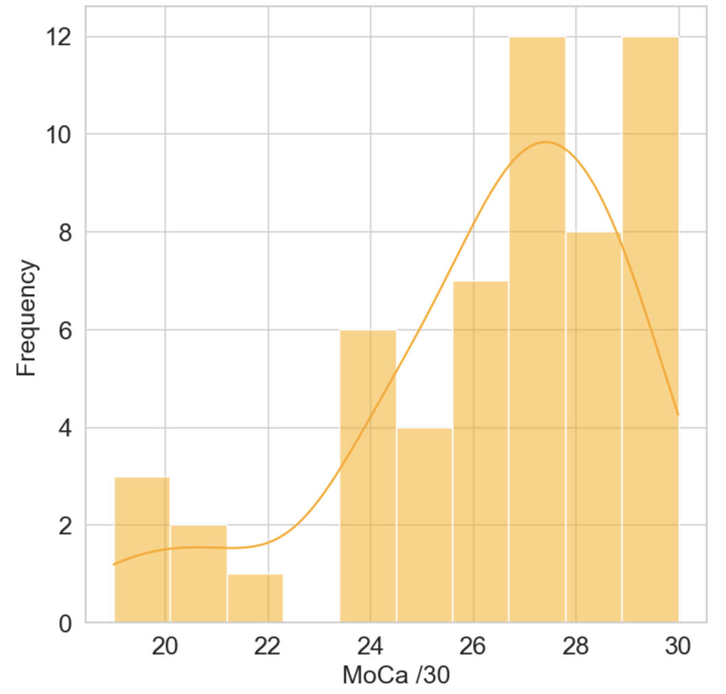

Appendix C
Table of mean (and SD) volumes of perirhinal and entorhinal cortices in groups based on their initial diagnosis.
Mean (SD) volume of MTL region (mm³ post-regression for the ICV) | HC  (N = 34) | SCD  (N = 7) | MCI  (N = 14)
right tErC | 3495.10 (549.8) | 3608.26 (657.9) | 2888.66 (796.2)
left tErC | 3938.08 (679.5) | 3980.72 (675.7) | 3346.96 (727.3)
right BA36 | 6883.0 (1292.2) | 7630.8 (1515.8) | 5707.8 (1459.1)
left BA36 | 7608.3 (1309.0) | 7879.9 (1570.0) | 6694.1 (1277.1)
right pmErC | 787.7 (149.8) | 743.3 (146.8) | 627.4 (234.1)
left pmErC | 753.5 (194.0) | 567.6 (271.2) | 592.8 (185.3)
Note. HC: healthy controls; SCD: subjective cognitive decline; MCI: Mild Cognitive Impairment; tErC: transentorhinal cortex; pmErC: posteromedian entorhinal cortex; BA36: Brodmann area 36.

Appendix D
Statistical analyses of the behavioural performance across conditions of the Episodic pseudowords familiarity task.
Analyses
This task aimed to provide a “pure” measure of episodic familiarity, without pre-experimental lifetime familiarity. Pseudowords recognition indeed has been classically shown to enhance recognition in the absence of conscious recollection (Gardiner & Java, 1990). We predicted that the percentage of correct responses (across all trials, regardless of judgment type) would be higher for pseudowords presented three times compared to those shown once.
The percentage of correct responses was calculated for each participant and condition. We used a repeated-measures ANOVA with two levels (one vs. three presentations) to compare performance across conditions.
We used the Wilcoxon signed-ranked to examine differences in the occurrences of recollection, familiarity, and guess responses. We also tested differences in familiarity responses on false alarms depending on pseudoword presentation frequency. Familiarity strength ratings were not analyzed due to uneven distribution across levels, resulting in insufficient data for meaningful statistical analysis.
Results
Repeated-measures ANOVA revealed that memory accuracy (percentage of correct responses) was significantly higher for pseudowords presented three times than once (F(1,54) = 91.66, η²_{p} = .63, p < .001) (Figure 2A).
Wilcoxon signed-rank tests revealed that presentation frequency (one or three times) significantly influenced the use of recollection (W = 26, r = -.96, p < .001), familiarity (W = 867.5, r = .36, p = .03), and guess responses (W = 1162, r = .98, p < .001) (Figure 2B). While recollection responses were used more often for items presented three times, familiarity and guess responses were more frequent for items that were presented only once. Also, familiarity responses on false alarms were significantly more frequent for pseudowords presented once than three times (W = 787, r = .92, p < .001).

Appendix E
Within and Between Subjects effects of the ANCOVA for the Episodic pseudowords familiarity task. *p<.05; **p<.01
Cases | Sum of Squares | df | Mean Square | F | p | η²p
Occurence | 0.009 | 1 | 0.009 | 0.933 | 0.340 | 0.023
Occurence ✻ left tErC | 0.016 | 1 | 0.016 | 1.666 | 0.204 | 0.04
Occurence ✻ right tErC | 0.006 | 1 | 0.006 | 0.630 | 0.432 | 0.016
Occurence ✻ left CA1 | 0.011 | 1 | 0.011 | 1.178 | 0.284 | 0.028
Occurence ✻ right CA1 | 0.014 | 1 | 0.014 | 1.464 | 0.233 | 0.035
Occurence ✻ left CA3 | 0.002 | 1 | 0.002 | 0.171 | 0.681 | 0.005
Occurence ✻ right CA3 | 9.308×10⁻⁴ | 1 | 9.308×10⁻⁴ | 0.098 | 0.756 | 0.002
Occurence ✻ left pmErC | 1.033×10⁻⁴ | 1 | 1.033×10⁻⁴ | 0.011 | 0.918 | 2.711^{e-04}
Occurence ✻ right pmErC | 8.876×10⁻⁴ | 1 | 8.876×10⁻⁴ | 0.093 | 0.762 | 0.002
Occurence ✻ left BA36 | 0.019 | 1 | 0.019 | 1.993 | 0.166 | 0.047
Occurence ✻ right BA36 | 0.013 | 1 | 0.013 | 1.410 | 0.242 | 0.033
Occurence ✻ left DG | 7.735×10⁻⁴ | 1 | 7.735×10⁻⁴ | 0.081 | 0.777 | 0.002
Occurence ✻ right DG | 0.010 | 1 | 0.010 | 1.051 | 0.311 | 0.026
Occurence ✻ Age | 0.003 | 1 | 0.003 | 0.333 | 0.567 | 0.008
Occurence ✻ Sex | 4.610×10⁻⁴ | 1 | 4.610×10⁻⁴ | 0.048 | 0.827 | 0.001
Residuals | 0.381 | 40 | 0.010

Note. The occurrence refers to the items being presented once or three times. tErC: transentorhinal cortex; pmErC: posteromedian entorhinal cortex; CA1, CA3: hippocampal subfields; DG: dentate gyrus; BA36: Brodmann area 36.
Appendix F
Statistical analyses of the behavioural performance across conditions of the Episodic concepts familiarity task.
Analyses
The percentage of correct responses was calculated for each participant and condition. We used a 2 (target-lure conceptual overlap: high, low) x 2 (target familiarity: high, low) x 2 (lure familiarity: high, low) repeated measures ANOVA to compare memory accuracy across conditions.
To investigate how the use of familiarity judgements varied between conditions, we ran a 2 (target-lure conceptual overlap: high, low) x 2 (target lifetime familiarity: high, low) x 2 (lure lifetime familiarity: high, low) repeated-measures ANOVA to compare the number of familiarity judgements on all trials across conditions. Given the high reliance on recollection and low use of familiarity and guess options (Figure 2E), we also decided to run the same analysis on the number of recollection responses to explore how it varies between conditions. Familiarity strength ratings were not explored due to uneven distribution, resulting in insufficient data for statistical analysis.
Results
The 2 (target-lure conceptual overlap: high, low) x 2 (target familiarity: high, low) x 2 (lure familiarity: high, low) repeated measures ANOVA on memory accuracy revealed a significant main effect of target familiarity, with better performance for highly familiar targets (F(1,54) = 22.87, η²_{p} = .30, p < .001), and a significant main effect of target-lure conceptual overlap, with better performance for low overlap (F(1,54) = 5.44, η²_{p} = .09, p = .02). Conceptual overlap significantly interacted with target familiarity (F(1,54) = 6.93, η²_{p} = .11, p = .01) and lure familiarity (F(1,54) = 4.80, η²_{p} = .08, p = .03), with a significant triple interaction (F(1,54) = 4.62, η²_{p} = .08, p = .04). Neither the main effect of lure familiarity (F(1,54) = 1.71, η²_{p} = .03, p = .20), nor the interaction between target and lure’s level of familiarity (F(1,54) = .73, η²_{p} = .01, p = .40) was significant. These interactions indicate that performance was particularly influenced by the lifetime familiarity of both the lure and the target under conditions of high conceptual overlap between them. When conceptual overlap was high, performance was higher when the target had high lifetime familiarity, and this effect was even more pronounced when the competing lure had low lifetime familiarity. (Figure 2D).
The 2 (target-lure conceptual overlap: high, low) x 2 (target familiarity: high, low) x 2 (lure familiarity: high, low) repeated-measures ANOVA on the number of familiarity responses revealed a significant main effect of the lure’s level of lifetime familiarity (F(1,54) = 4.46, η²_{p} = .08, p = .04). Overall, participants used familiarity responses more often when the lure had lower lifetime familiarity. All the other main effects or interactions were not significant. Regarding the same analysis performed on the number of recollection responses, the ANOVA revealed significant main effects of the target’s level of lifetime familiarity (F(1,54) = 7.46, η²_{p} = .12, p = .009), of the lure’s level of lifetime familiarity (F(1,54) = 7.21, η²_{p} = .12, p = .01), and of the level of conceptual overlap between the target and the lure (F(1,54) = 13.42, η²_{p} = .20, p < .001). Participants used recollection responses more often when the target or the lure had higher lifetime familiarity. They also used recollection responses more often when the conceptual overlap between the target and the lure was lower. There was also a significant interaction between the lure’s level of lifetime familiarity and the level of conceptual overlap between the target and the lure (F(1,54) = 4.07, η²_{p} = .07, p = .049), but all the other interactions were not significant. This interaction revealed that participants tended to use recollection responses the most when the lure had higher lifetime familiarity and the conceptual overlap was lower.

Appendix G
Within Subjects effects of the ANCOVA for the Episodic concepts familiarity task. *p<.05; **p<.01
Cases | Sum of Squares | df | Mean Square | F | p | η²p
Target | 112.500 | 1 | 112.500 | 1.254 | 0.269 | 0.030
Target ✻ Age | 12.678 | 1 | 12.678 | 0.141 | 0.709 | 0.004
Target ✻ Sex | 36.277 | 1 | 36.277 | 0.404 | 0.528 | 0.010
Target ✻ left tErC | 16.879 | 1 | 16.879 | 0.188 | 0.667 | 0.005
Target ✻ right tErC | 234.088 | 1 | 234.088 | 2.609 | 0.114 | 0.061
Target ✻ left BA36 | 4.009 | 1 | 4.009 | 0.045 | 0.834 | 0.001
Target ✻ right BA36 | 17.220 | 1 | 17.220 | 0.192 | 0.664 | 0.005
Target ✻ left pmErC | 68.639 | 1 | 68.639 | 0.765 | 0.387 | 0.019
Target ✻ right pmErC | 185.486 | 1 | 185.486 | 2.067 | 0.158 | 0.049
Target ✻ left CA1 | 40.579 | 1 | 40.579 | 0.452 | 0.505 | 0.011
Target ✻ right CA1 | 20.625 | 1 | 20.625 | 0.230 | 0.634 | 0.006
Target ✻ left CA3 | 18.681 | 1 | 18.681 | 0.208 | 0.651 | 0.005
Target ✻ right CA3 | 127.353 | 1 | 127.353 | 1.419 | 0.241 | 0.034
Target ✻ left DG | 34.825 | 1 | 34.825 | 0.388 | 0.537 | 0.010
Target ✻ right DG | 110.069 | 1 | 110.069 | 1.227 | 0.275 | 0.030
Residuals | 3588.715 | 40 | 89.718
Lure | 187.724 | 1 | 187.724 | 1.128 | 0.295 | 0.027
Lure ✻ Age | 71.031 | 1 | 71.031 | 0.427 | 0.517 | 0.011
Lure ✻ Sex | 1.154 | 1 | 1.154 | 0.007 | 0.934 | 1.733×10⁻⁴
Lure ✻ left tErC | 32.027 | 1 | 32.027 | 0.192 | 0.663 | 0.005
Lure ✻ right tErC | 459.779 | 1 | 459.779 | 2.762 | 0.104 | 0.065
Lure ✻ left BA36 | 67.638 | 1 | 67.638 | 0.406 | 0.527 | 0.010
Lure ✻ right BA36 | 246.538 | 1 | 246.538 | 1.481 | 0.231 | 0.036
Lure ✻ left pmErC | 10.254 | 1 | 10.254 | 0.062 | 0.805 | 0.002
Lure ✻ right pmErC | 7.397 | 1 | 7.397 | 0.044 | 0.834 | 0.001
Lure ✻ left CA1 | 135.196 | 1 | 135.196 | 0.812 | 0.373 | 0.020
Lure ✻ right CA1 | 538.155 | 1 | 538.155 | 3.233 | 0.080 | 0.075
Lure ✻ left CA3 | 247.104 | 1 | 247.104 | 1.484 | 0.230 | 0.036
Lure ✻ right CA3 | 37.317 | 1 | 37.317 | 0.224 | 0.638 | 0.006
Lure ✻ left DG | 120.662 | 1 | 120.662 | 0.725 | 0.400 | 0.018
Lure ✻ right DG | 108.539 | 1 | 108.539 | 0.652 | 0.424 | 0.016
Residuals | 6658.369 | 40 | 166.459
Conceptual overlap | 0.064 | 1 | 0.064 | 6.352×10⁻⁴ | 0.980 | 1.588×10⁻⁵
Conceptual overlap ✻ Age | 6.782 | 1 | 6.782 | 0.067 | 0.797 | 0.002
Conceptual overlap ✻ Sex | 7.049 | 1 | 7.049 | 0.069 | 0.793 | 0.002
Conceptual overlap ✻ left tErC | 13.668 | 1 | 13.668 | 0.135 | 0.716 | 0.003
Conceptual overlap ✻ right tErC | 256.001 | 1 | 256.001 | 2.524 | 0.120 | 0.059
Conceptual overlap ✻ left BA36 | 78.901 | 1 | 78.901 | 0.778 | 0.383 | 0.019
Conceptual overlap ✻ right BA36 | 52.072 | 1 | 52.072 | 0.513 | 0.478 | 0.013
Conceptual overlap ✻ left pmErC | 36.492 | 1 | 36.492 | 0.360 | 0.552 | 0.009
Conceptual overlap ✻ right pmErC | 90.131 | 1 | 90.131 | 0.889 | 0.352 | 0.022
Conceptual overlap ✻ left CA1 | 0.452 | 1 | 0.452 | 0.004 | 0.947 | 1.114×10⁻⁴
Conceptual overlap ✻ right CA1 | 46.115 | 1 | 46.115 | 0.455 | 0.504 | 0.011
Conceptual overlap ✻ left CA3 | 4.454 | 1 | 4.454 | 0.044 | 0.835 | 0.001
Conceptual overlap ✻ right CA3 | 37.121 | 1 | 37.121 | 0.366 | 0.549 | 0.009
Conceptual overlap ✻ left DG | 37.216 | 1 | 37.216 | 0.367 | 0.548 | 0.009
Conceptual overlap ✻ right DG | 33.645 | 1 | 33.645 | 0.332 | 0.568 | 0.008
Residuals | 4057.504 | 40 | 101.438
Target ✻ Lure | 4.570 | 1 | 4.570 | 0.064 | 0.802 | 0.002
Target ✻ Lure ✻ Age | 30.537 | 1 | 30.537 | 0.425 | 0.518 | 0.011
Target ✻ Lure ✻ Sex | 14.323 | 1 | 14.323 | 0.199 | 0.658 | 0.005
Target ✻ Lure ✻ left tErC | 63.615 | 1 | 63.615 | 0.885 | 0.352 | 0.022
Target ✻ Lure ✻ right tErC | 76.886 | 1 | 76.886 | 1.070 | 0.307 | 0.026
Target ✻ Lure ✻ left BA36 | 17.959 | 1 | 17.959 | 0.250 | 0.620 | 0.006
Target ✻ Lure ✻ right BA36 | 6.692 | 1 | 6.692 | 0.093 | 0.762 | 0.002
Target ✻ Lure ✻ left pmErC | 54.486 | 1 | 54.486 | 0.758 | 0.389 | 0.019
Target ✻ Lure ✻ right pmErC | 261.630 | 1 | 261.630 | 3.640 | 0.064 | 0.083
Target ✻ Lure ✻ left CA1 | 31.462 | 1 | 31.462 | 0.438 | 0.512 | 0.011
Target ✻ Lure ✻ right CA1 | 97.211 | 1 | 97.211 | 1.352 | 0.252 | 0.033
Target ✻ Lure ✻ left CA3 | 16.419 | 1 | 16.419 | 0.228 | 0.635 | 0.006
Target ✻ Lure ✻ right CA3 | 90.289 | 1 | 90.289 | 1.256 | 0.269 | 0.030
Target ✻ Lure ✻ left DG | 53.581 | 1 | 53.581 | 0.745 | 0.393 | 0.018
Target ✻ Lure ✻ right DG | 0.340 | 1 | 0.340 | 0.005 | 0.946 | 1.181×10⁻⁴
Residuals | 2875.104 | 40 | 71.878
Target ✻ Conceptual overlap | 115.419 | 1 | 115.419 | 1.072 | 0.307 | 0.026
Target ✻ Conceptual overlap ✻ Age | 145.176 | 1 | 145.176 | 1.348 | 0.253 | 0.033
Target ✻ Conceptual overlap ✻ Sex | 94.606 | 1 | 94.606 | 0.878 | 0.354 | 0.021
Target ✻ Conceptual overlap ✻ left tErC | 419.618 | 1 | 419.618 | 3.896 | 0.055 | 0.089
Target ✻ Conceptual overlap ✻ right tErC | 66.315 | 1 | 66.315 | 0.616 | 0.437 | 0.015
Target ✻ Conceptual overlap ✻ left BA36 | 0.006 | 1 | 0.006 | 5.607×10⁻⁵ | 0.994 | 1.402×10⁻⁶
Target ✻ Conceptual overlap ✻ right BA36 | 11.186 | 1 | 11.186 | 0.104 | 0.749 | 0.003
Target ✻ Conceptual overlap ✻ left pmErC | 55.446 | 1 | 55.446 | 0.515 | 0.477 | 0.013
Target ✻ Conceptual overlap ✻ right pmErC | 91.726 | 1 | 91.726 | 0.852 | 0.362 | 0.021
Target ✻ Conceptual overlap ✻ left CA1 | 8.508 | 1 | 8.508 | 0.079 | 0.780 | 0.002
Target ✻ Conceptual overlap ✻ right CA1 | 84.067 | 1 | 84.067 | 0.780 | 0.382 | 0.019
Target ✻ Conceptual overlap ✻ left CA3 | 5.018 | 1 | 5.018 | 0.047 | 0.830 | 0.001
Target ✻ Conceptual overlap ✻ right CA3 | 175.688 | 1 | 175.688 | 1.631 | 0.209 | 0.039
Target ✻ Conceptual overlap ✻ left DG | 73.781 | 1 | 73.781 | 0.685 | 0.413 | 0.017
Target ✻ Conceptual overlap ✻ right DG | 21.036 | 1 | 21.036 | 0.195 | 0.661 | 0.005
Residuals | 4308.452 | 40 | 107.711
Lure ✻ Conceptual overlap | 130.259 | 1 | 130.259 | 2.185 | 0.147 | 0.052
Lure ✻ Conceptual overlap ✻ Age | 70.052 | 1 | 70.052 | 1.175 | 0.285 | 0.029
Lure ✻ Conceptual overlap ✻ Sex | 2.562 | 1 | 2.562 | 0.043 | 0.837 | 0.001
Lure ✻ Conceptual overlap ✻ left tErC | 563.627 | 1 | 563.627 | 9.455 | 0.004** | 0.191
Lure ✻ Conceptual overlap ✻ right tErC | 63.204 | 1 | 63.204 | 1.060 | 0.309 | 0.026
Lure ✻ Conceptual overlap ✻ left BA36 | 463.229 | 1 | 463.229 | 7.771 | 0.008** | 0.163
Lure ✻ Conceptual overlap ✻ right BA36 | 89.071 | 1 | 89.071 | 1.494 | 0.229 | 0.036
Lure ✻ Conceptual overlap ✻ left pmErC | 87.341 | 1 | 87.341 | 1.465 | 0.233 | 0.035
Lure ✻ Conceptual overlap ✻ right pmErC | 25.618 | 1 | 25.618 | 0.430 | 0.516 | 0.011
Lure ✻ Conceptual overlap ✻ left CA1 | 3.106 | 1 | 3.106 | 0.052 | 0.821 | 0.001
Lure ✻ Conceptual overlap ✻ right CA1 | 161.831 | 1 | 161.831 | 2.715 | 0.107 | 0.064
Lure ✻ Conceptual overlap ✻ left CA3 | 131.046 | 1 | 131.046 | 2.198 | 0.146 | 0.052
Lure ✻ Conceptual overlap ✻ right CA3 | 81.468 | 1 | 81.468 | 1.367 | 0.249 | 0.033
Lure ✻ Conceptual overlap ✻ left DG | 50.909 | 1 | 50.909 | 0.854 | 0.361 | 0.021
Lure ✻ Conceptual overlap ✻ right DG | 23.922 | 1 | 23.922 | 0.401 | 0.530 | 0.010
Residuals | 2384.543 | 40 | 59.614
Target ✻ Lure ✻ Conceptual overlap | 59.024 | 1 | 59.024 | 0.782 | 0.382 | 0.019
Target ✻ Lure ✻ Conceptual overlap ✻ Age | 100.129 | 1 | 100.129 | 1.326 | 0.256 | 0.032
Target ✻ Lure ✻ Conceptual overlap ✻ Sex | 208.974 | 1 | 208.974 | 2.767 | 0.104 | 0.065
Target ✻ Lure ✻ Conceptual overlap ✻ left tErC | 6.017 | 1 | 6.017 | 0.080 | 0.779 | 0.002
Target ✻ Lure ✻ Conceptual overlap ✻ right tErC | 176.052 | 1 | 176.052 | 2.331 | 0.135 | 0.055
Target ✻ Lure ✻ Conceptual overlap ✻ left BA36 | 0.470 | 1 | 0.470 | 0.006 | 0.937 | 1.557×10⁻⁴
Target ✻ Lure ✻ Conceptual overlap ✻ right BA36 | 173.440 | 1 | 173.440 | 2.297 | 0.138 | 0.054
Target ✻ Lure ✻ Conceptual overlap ✻ left pmErC | 39.833 | 1 | 39.833 | 0.527 | 0.472 | 0.013
Target ✻ Lure ✻ Conceptual overlap ✻ right pmErC | 0.363 | 1 | 0.363 | 0.005 | 0.945 | 1.203×10⁻⁴
Target ✻ Lure ✻ Conceptual overlap ✻ left CA1 | 136.103 | 1 | 136.103 | 1.802 | 0.187 | 0.043
Target ✻ Lure ✻ Conceptual overlap ✻ right CA1 | 26.908 | 1 | 26.908 | 0.356 | 0.554 | 0.009
Target ✻ Lure ✻ Conceptual overlap ✻ left CA3 | 6.633 | 1 | 6.633 | 0.088 | 0.768 | 0.002
Target ✻ Lure ✻ Conceptual overlap ✻ right CA3 | 0.004 | 1 | 0.004 | 5.246×10⁻⁵ | 0.994 | 1.311×10⁻⁶
Target ✻ Lure ✻ Conceptual overlap ✻ left DG | 56.058 | 1 | 56.058 | 0.742 | 0.394 | 0.018
Target ✻ Lure ✻ Conceptual overlap ✻ right DG | 265.572 | 1 | 265.572 | 3.517 | 0.068 | 0.081
Residuals | 3020.645 | 40 | 75.516
Note. tErC: transentorhinal cortex; pmErC: posteromedian entorhinal cortex; CA1, CA3: hippocampal subfields; DG: dentate gyrus; BA36: Brodmann area 36.
Appendix H
Exploratory hierarchical clustering analysis grouping participants based on their performance across the three familiarity tasks.
We conducted an exploratory clustering analysis on scores from the three tasks to identify response patterns that might reveal subgroups within the sample and distinguish patients from healthy controls. The main goal of the clustering analysis is to determine whether the behavioural performance across familiarity tasks allows to identify participants with slight memory impairment. Given the heterogeneous sample and unequal group sizes (healthy controls, MCI, SCD), traditional statistical group comparisons were unsuitable. Instead, we applied hierarchical clustering in JASP with the number of clusters determined using the elbow method optimized for the lowest Bayesian Information Criterion (BIC). Given the exploratory character of the clustering analysis, we ran a linear discriminant classification analysis to provide additional certainty that the clusters are well separated and unique. Variables included aimed to capture diverse performance aspects that are assumed to be impaired in patients. We included the recognition accuracy on the Episodic pseudowords familiarity task and the Z-score from the Lifetime familiarity task to account for potential alterations of episodic and lifetime familiarity respectively. Given the propension of patients to rely more on familiarity than on recollection (Bastin & Van der Linden, 2003), and their tendency to commit false alarms based on familiarity (Bastin et al., 2021), we also included the counts of recollection, familiarity, guess responses, and familiarity-based false alarms, separately for items presented once and three times from the Episodic pseudowords familiarity task. Finally, assuming that transentorhinal atrophy affects familiarity for fine representations, we added Z_{overlap} and Z_{diff_fam} scores from the Episodic concepts familiarity task.
The exploratory hierarchical clustering model was performed on 53 participants with complete data, excluding two who achieved 100% accuracy on all the conditions from the Episodic concepts familiarity task. The elbow method suggested 3 clusters as BIC was the lowest (Figure H1). Based on the euclidean distance, the model shows an entropy of .89 and a Dunn index of .31. The model had R² = .39. Cluster 1 contained 33 participants, Cluster 2 had 14, and Cluster 3 included 6 participants. See Figure H2.A for cluster means across variables. The overall silhouette score, which aims to assess how well each point belongs to its cluster (and how distinct it is from other clusters), was just adequate (~0.25), indicating weak structure. The silhouette scores by cluster (Cluster 1 = .274; Cluster 2 = .176; Cluster 3 = .328) showed that Cluster 2 has weaker cohesion than the others. Despite the relatively high entropy and low silhouette score, a linear discriminant classification analysis reached high test accuracy of .923 using two linear discriminants, 40 data points for training and 13 data points for testing. See Figure H2.B for scatter plot of cluster separation and Figure H3 for detailed decision boundary matrix. See also Figure H4 for the distribution of silhouette scores obtained by a bootstrapping strategy consisting of randomly generating 1,000 samples from the original 53-participant dataset and repeating the hierarchical clustering procedure. The 1,000 values were used to estimate the confidence interval of the silhouette score, indicating that although the cluster separation is relatively weak, the solution demonstrates adequate stability.
- Qualitatively, participants in Cluster 1 had the highest memory accuracy in the Episodic pseudowords familiarity task and used recollection the most. Their adequacy on the Lifetime familiarity task was average. In the Episodic concepts familiarity task, their memory accuracy showed a slightly stronger positive correlation with target-lure overlap, indicating a better ability to distinguish closely related concepts.
- Cluster 2 participants showed slightly below average memory accuracy in the Episodic pseudowords familiarity task but used recollection less, relying more on familiarity judgments, including more erroneous ones for false alarms. These patterns were similar for pseudowords presented once or three times. In the Lifetime familiarity task, the adequacy of their judgements was slightly below average, and in the Episodic concepts familiarity task, their memory accuracy had a slightly stronger negative correlation with target-lure conceptual overlap compared to the other clusters.
- Cluster 3 had the lowest memory accuracy in the Episodic pseudowords familiarity task, using fewer recollection and familiarity judgments, and relying more on guessing. They showed average lifetime familiarity adequacy and their memory accuracy in the Episodic concepts familiarity task was most influenced by the familiarity difference between target and lure.
Figure H1. Results of the elbow method used to determine the number of clusters for clustering analysis, optimized for the lowest Bayesian Information Criterion (BIC).
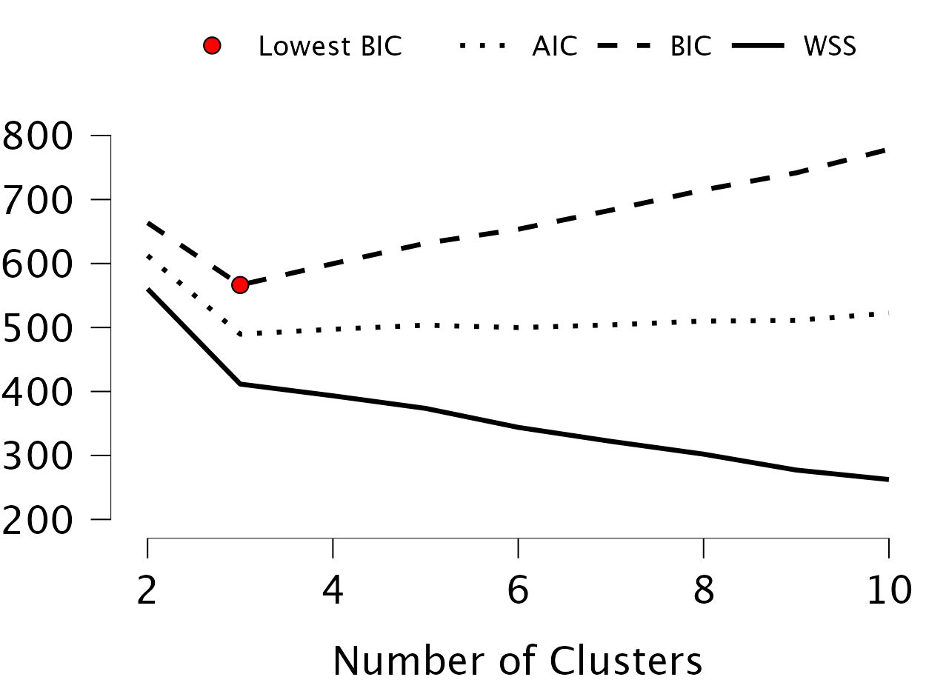

Figure H2. A) Visualization of the cluster means from each predicted cluster and for each variable (from the three experimental tasks) included in the neighborhood-based clustering analysis. B) Cluster separation from linear discriminant analysis. R: recollection; F: familiarity; G: guess; FA: False alarms. R, F and G responses are represented in terms of number of responses (n).
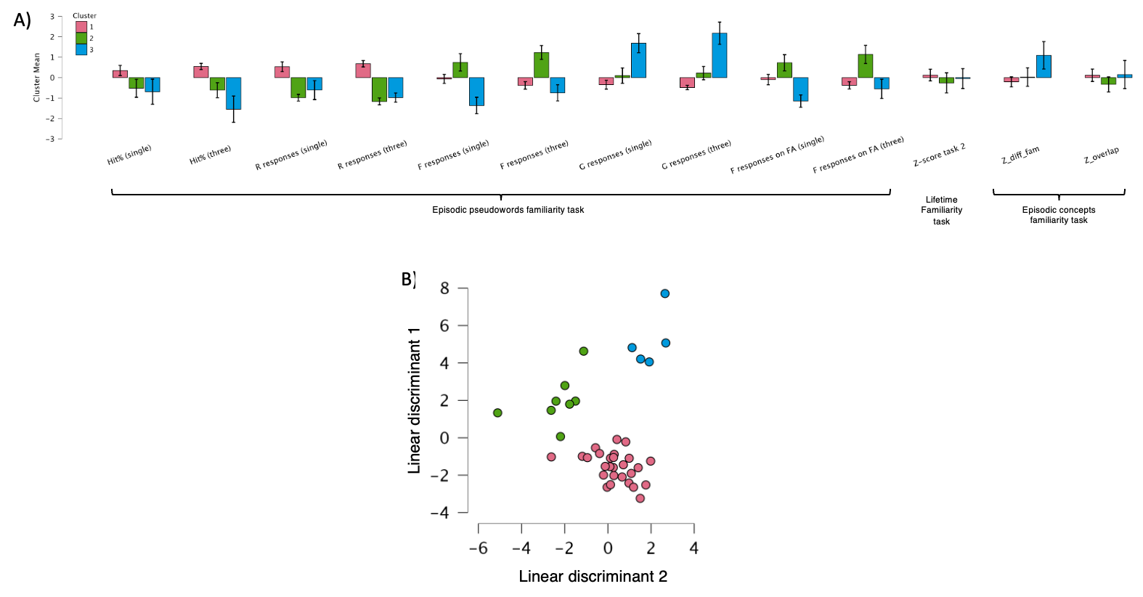
Figure H3. Decision boundary matrix of the linear discriminant analysis.
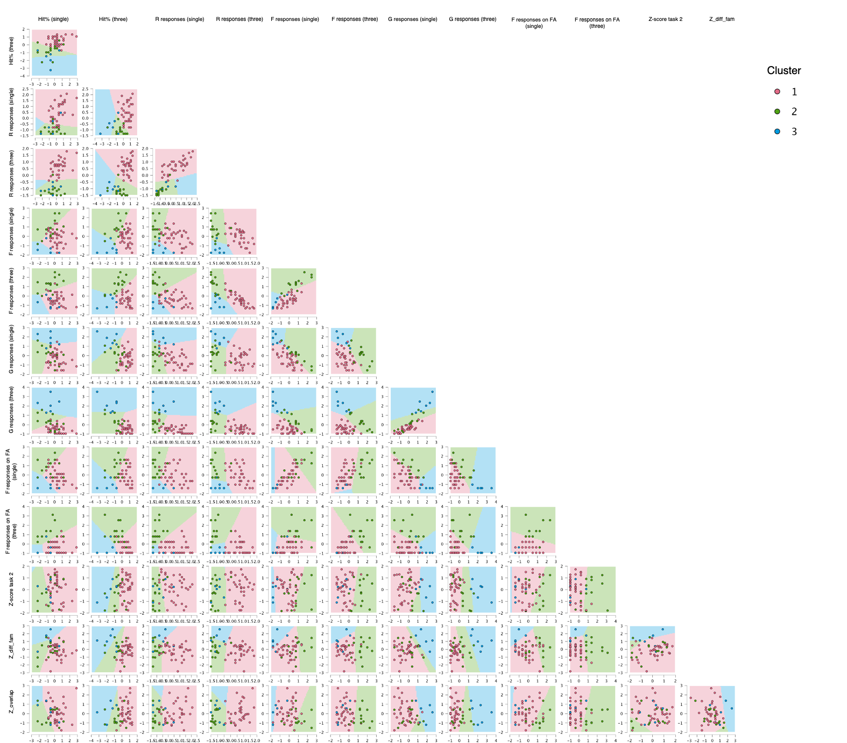

Figure H4. Histogram of the bootstrap analysis showing the distribution of silhouette scores obtained by randomly generating 1,000 samples from the original 53-participant dataset and repeating the hierarchical clustering procedure. The 1,000 values were used to estimate the confidence interval of the silhouette score, indicating that although the cluster separation is relatively weak, the solution demonstrates adequate stability.
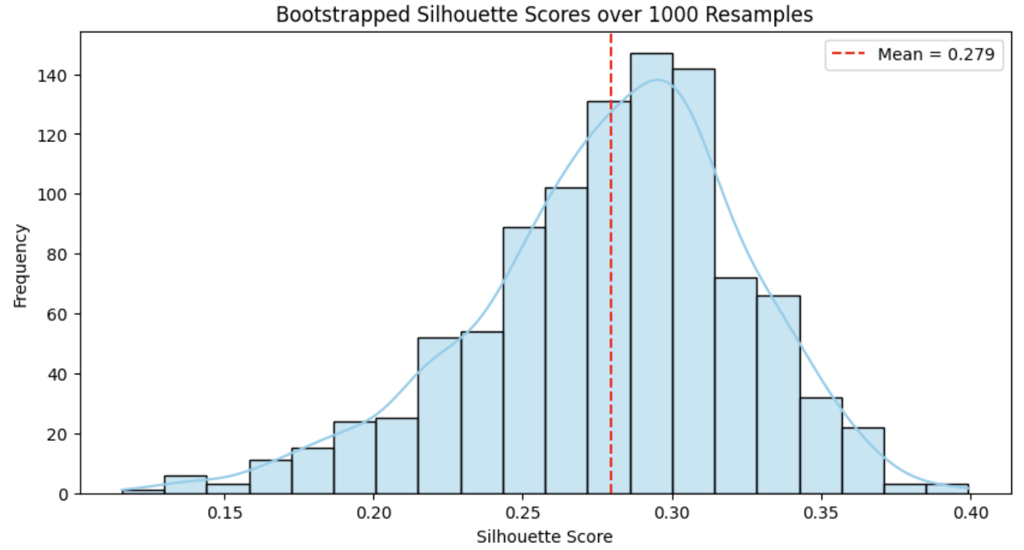
Using our heterogeneous sample of healthy controls and patients, we then conducted a Chi-Squared test on a contingency table, with clusters as columns and diagnoses/groups as rows, to assess if response patterns from the familiarity tasks aligned with MCI/SCD diagnoses. We conducted two Kruskal-Wallis ANOVAs to test for differences in MoCA scores and age across clusters.
MoCA score significantly differed between clusters (Kruskal-Wallis ANOVA: H(2) = 16.40, η² = .31 , p < .001). Post-hoc tests showed Cluster 1 had higher scores than Cluster 2 (t=4.57, p < .001) and Cluster 3 (t=3.38, p = .004). Cluster 2 and Cluster 3 did not have significantly different scores on the MoCA (t=.23, p = .97). Average scores were 27.47 for Cluster 1, 24.08 for Cluster 2, and 23.80 for Cluster 3. No significant age differences were found between clusters (Kruskal-Wallis ANOVA: H(2) = .30, η² < .001 , p = .86).
The Chi-Squared test between clusters and initial diagnoses was significant, χ²(4) = 11.67, p = .02 (contingency table in Table H1). Cluster 1 mostly consisted of healthy participants (76%), Cluster 3 mainly included patients with SCD or MCI (83%), while Cluster 2 was more heterogeneous, with 43% healthy participants and 57% patients.
Table H1. Contingency table with the pre-inclusion diagnosis as columns and the predicted clusters as rows.
 | Diagnosis
Cluster | HC | MCI | SCD | Total
1 | 25 | 4 | 4 | 33
2 | 6 | 6 | 2 | 14
3 | 1 | 4 | 1 | 6
Total | 32 | 14 | 7 | 53

HC: Healthy Controls, MCI: Mild Cognitive Impairment, SCD: subjective cognitive decline

Appendix I
Results of the sensitivity analysis for the Episodic concepts familiarity task.
We acknowledge that performance on the Episodic concepts familiarity task is high overall, which results in a clustering of data points near ceiling. To assess whether the brain–behaviour relationships shown in Figure 3 were driven by influential observations, we conducted regression diagnostics using Cook’s distance for each condition-specific accuracy measure. Using a standard threshold (Cook’s D > 4/N; N = 55), 6 participants were identified as influential in at least two conditions. We therefore performed sensitivity analyses by re-running the repeated-measures ANCOVA after excluding these participants.
The sensitivity analysis conducted after excluding influential participants (N = 49) confirmed the robustness of the primary findings. Specifically, the significant triple interaction between lure familiarity, target–lure conceptual overlap, and the volumes of the left tErC (F(1,34) = 9.17, η²_{p} = .21, p = .005) and left BA36 (F(1,34) = 8.85, η²_{p} = .21, p = .005) was preserved. In contrast, the interaction between lure familiarity, target familiarity, and left tErC volume, which was only marginally significant in the main analysis, did not survive the sensitivity analysis (F(1,34) = 1.38, η²_{p} = .04, p = .25). In addition to confirming the main effects, the sensitivity analysis revealed minor differences in secondary interaction patterns. These included a significant interaction between lure lifetime familiarity and right CA1 volume (F(1,34) = 4.24, η²_{p} = .11, p = .047), as well as higher-order interactions involving right tErC volume (F(1,34) = 4.58, η²_{p} = .12, p = .04) and right DG volume (F(1,34) = 6.33, η²_{p} = .16, p = .017). These additional effects did not alter the overall interpretation of the results.

Two pilot studies (n = 16 and n = 43 young healthy volunteers aged between 18 and 30 years old) validated the materials and normative ratings for a French-speaking population. Each participant rated their familiarity with each concept on a scale from 0 (very low familiarity) to 100 (very high familiarity). For each pilot study, we calculated the average lifetime familiarity ratings for each concept. These averages were strongly positively correlated between the two pilot studies (r = 0.918, p < 0.001). Normative ratings were calculated by taking the weighted average of the lifetime familiarity ratings from both samples (54 individual ratings per concept).
This difference is however significant when compared in a repeated-measures design on behavioural data only, thus removing all covariates to focus on the within-subjects effects: memory accuracy is then significantly higher following three than one presentation. See Appendix D.
Note that our results follow the same pattern of significance when introducing MoCA scores as covariate in the main ANCOVAs for the Episodic pseudowords familiarity task and the Episodic concepts familiarity task, and as a covariate in our linear regression for the Lifetime familiarity task. Results seem to be specific to our experimental tasks and do not only reflect the variability in level of general cognitive impairment in our sample.
Note that given the clustering of data points near ceiling (see Figure 3), we conducted regression diagnostics using Cook’s distance for each condition-specific accuracy measure. Using a standard threshold (Cook’s D > 4/N; N = 55), 6 participants were identified as influential in at least two conditions. We therefore performed sensitivity analyses by re-running the repeated-measures ANCOVA after excluding these participants. While the significant triple interaction between lure familiarity, target–lure conceptual overlap, and the volumes of the left tErC (F(1,34) = 9.17, η²p = .21, p = .005) and left BA36 (F(1,34) = 8.85, η²p = .21, p = .005) was preserved, the interaction between lure familiarity, target familiarity, and left tErC volume did not survive the sensitivity analysis (F(1,34) = 1.38, η²p = .04, p = .25). Details can be found in Appendix I.
When compared behavioural results in a repeated-measures design, removing all covariates to focus on the within-subjects effects: results show a significant main effect of target lifetime familiarity, leading to higher accuracy than targets of low lifetime familiarity, a significant main effect of target-lure conceptual overlap, with low overlap leading to higher accuracy, significant interactions between target lifetime familiarity and conceptual overlap, between lure lifetime familiarity and conceptual overlap, and a significant triple interaction between these three variables showing that when conceptual overlap was high, performance was higher when the target had high lifetime familiarity, and this effect was even more pronounced when the competing lure had low lifetime familiarity. See Appendix F for details on this analysis.

