Intensive Care Med https://doi.org/10.1007/s00134-026-08546-8

CORRESPONDENCE

Vitamin C in acute critical illness: don’t confuse pharmacotherapy and nutrition!
Anne‑Françoise Rousseau^{1,2*} , Olivier Pantet³, Christian Stoppe⁴, Angélique M. E. de Man⁵

and Mette M. Berger⁶
© 2026 Springer‑Verlag GmbH Germany, part of Springer Nature
Two important, large, randomized trials recently showed that high-dose intravenous vitamin C administered during the acute phase of critical illness is at best ineffective and may even be harmful. In the VICTORY trial, patients with major burns received vitamin C 50 mg/kg every 6 h for 96 h after admission [1]. In the VITaCCA trial, resuscitated cardiac arrest patients received 3 g/day (supplementary dose) or 10 g/day (high dose) of intravenous vitamin C for 96 h [2]. The adverse effects on organ dysfunction and/or mortality observed in both studies are consistent with the findings of the LOVIT trial, in which septic patients received vitamin C 50 mg/kg every 6 h for up to 96 h [3]. It is now increasingly clear that high dose of vitamin C should not be administered to patients suffering sepsis, cardiac arrest, or major burn injury, still pending are the results of the ongoing French LOVITARDS trial (NCT04404387).
These findings may be understood as arguing against any vitamin C administration. This interpretation would be inappropriate. Importantly, the doses evaluated in recent trials were 10 to 100-fold higher than standard repletion doses and should therefore be viewed as a separate therapeutic strategy. Rather than contradicting existing guidelines [4], these findings reinforce the cautious position of the European Society for Clinical Nutrition and Metabolism (ESPEN) guidelines discouraging the use
*Correspondence: afrousseau@chuliege.be
¹ Department of Intensive Care, University Hospital of Liège, University of Liège, Sart‑Tilman B35, 4000 Liège, Belgium
Full author information is available at the end of the article
This comment refers to the article available online at https:// doi. org/ 10. 1007/ s00134‑ 026‑ 08492‑5.

of high-dose micronutrient monotherapy, including vitamin C [5].
As investigators of the VICTORY and VITaCCA trials and contributors to nutritional guidelines, we wish to emphasize that the reported harms relate specifically to the pharmacological high-dose regimens tested and should not be extrapolated to vitamin C administration aimed at meeting nutritional requirements or correcting deficiencies, which represent three distinct clinical concepts (Fig. 1).
First, nutritional doses aim at covering daily physiological requirements (≅ 100–200 mg/day), commonly expressed as dietary reference intake and generally covered by standard medical nutrition providing 1500 kcal/ day.
Second, repletion doses are required in patients with documented or suspected deficiency, excessive losses, or markedly increased metabolic rate, as frequently occurs in critical illness, intense inflammation, chronic oxidative stress, malabsorption, major burns, chronic significant wounds or continuous renal replacement therapy. In these circumstances, doses in the range of 1–3 g/ day may be necessary, based on evidence of losses or consumption. More insight is needed into the individualized optimal repletion and is currently investigated (BIO-MICRO- Advancing micronutrient diagnostics for personalised ICU care; https:// bio- micro. eu/). In the meantime, we recommend that clinicians continue to follow ESPEN guidelines for repletion [4, 5].
Finally, pharmaconutrition refers to the administration of supraphysiological doses (high doses) aiming for modulation of biological pathways rather than correcting a deficiency. The recent trials specifically evaluated such pharmacological strategies.
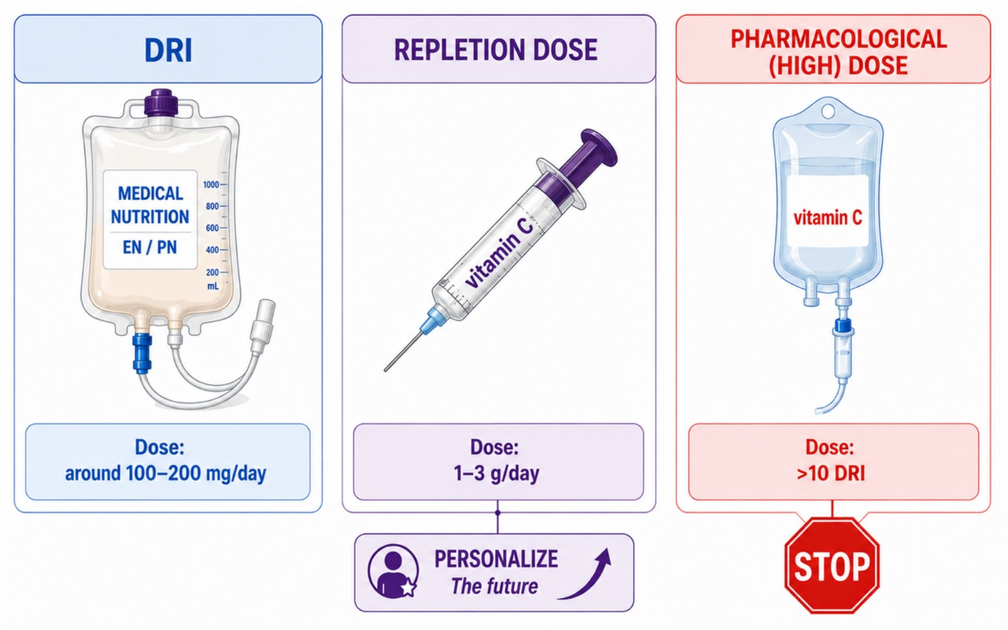
While the results from VICTORY and VITaCCA argue against pharmacological high-dose vitamin C, they should not distract from the need to identify and correct increased vitamin C requirements in selected patients. While the era of pharmacological vitamin C trials may be ending, this should not obscure the ongoing need for adequate nutritional support.
Fig.

1

Three distinct concepts of vitamin C administration in critical illness.
DRI
dietary reference intake,
EN
enteral nutrition,
PN
parenteral nutrition.
Figure created by the authors with assistance from ChatGPT (OpenAI) for graphical design and layout

Author details
¹ Department of Intensive Care, University Hospital of Liège, University of Liège, Sart‑Tilman B35, 4000 Liège, Belgium. ² Department of Anesthesia, McGill University, Montreal, QC, Canada. ³ Department of Intensive Care Medicine, Lausanne University Hospital and University of Lausanne, Lausanne, Switzerland. ⁴ University Hospital Würzburg, Department of Anesthesiology, Intensive Care, Emergency and Pain Medicine, Würzburg, Germany. ⁵ Department of Intensive Care Medicine, Amsterdam Gastroenterology, Endocrinology Metabolism (AGEM), Amsterdam Medical Data Science, (AMDS), Amsterdam UMC, Vrije Universiteit, Amsterdam, The Netherlands. ⁶ Faculty of Biology and Medicine, Lausanne University, Lausanne, Switzerland.
Funding None.
Data availability Not applicable.

Declarations Conflicts of interest
CS is the investigator of the VICTORY trial. CS reported receiving grants from
Fresenius Kabi and personal fees from Fresenius Kabi, Nestle Health Int, Baxter, Nutricia and BBRAUN outside of this work. AdM is senior author of the VITaCCA trial and project coordinator of BIO‑MICRO and reports lecture honoraria from Pascoe; MMB reports lecture honoraria from Fresenius Kabi and Nestlé Health
Int.

Ethical approval
This article does not contain any studies with human participants performed by any of the authors.

Publisher’s Note
Springer Nature remains neutral with regard to jurisdictional claims in published maps and institutional affiliations.
Received: 22 June 2026 Accepted: 28 June 2026

References
- Stoppe C, Hill A, Cancio LC et al (2026) High‑dose intravenous vitamin C and mortality and organ dysfunction in severe burn injury: the VICTORY randomized clinical trial. JAMA e2610616. https:// doi. org/ 10. 1001/ jama. 2026. 10616
- Rozemeijer S, Dubois EA, de Grooth HJ et al (2026) Early high‑dose vitamin C for out‑of‑hospital cardiac arrest: the VITaCCA randomized clinical trial. Intensive Care Med. https:// doi. org/ 10. 1007/ s00134‑ 026‑ 08492‑5 3. Lamontagne F, Masse MH, Menard J, Sprague S, Pinto R, Heyland DK, Cook DJ, Battista MC, Day AG, Guyatt GH et al (2022) Intravenous vitamin C in adults with sepsis in the Intensive Care Unit. N Engl J Med
386(25):2387–2398
- Rousseau AF, Losser MR, Ichai C, Berger MM (2013) ESPEN endorsed recommendations: nutritional therapy in major burns. Clin Nutr
32(4):497–502
- Berger MM, Shenkin A, Schweinlin A, Amrein K, Augsburger M, Biesalski HK, Bischoff SC, Casaer MP, Gundogan K, Lepp HL et al (2022) ESPEN micronutrient guideline. Clin Nutr 41(6):1357–1424

