Drivers of locus coeruleus contrast in magnetization transfer magnetic resonance imaging

Mikhail Zubkov¹, Aurora Gasparello^{1,2}, Nicholas John Simos¹, Maarten Spruyt¹, Nasrin Mortazavi¹, Laurent Lamalle¹, Fabienne Collette^{1,2}, Emilie Lommers¹, Kerrin J Pine², Evgeniya Kirilina², Puneet Talwar¹, Gilles Vandewalle¹
¹ GIGA-Institute, CRC-Human Imaging Unit, University of Liège, Liège, Belgium
² Psychology and Neuroscience of Cognition Research Unit, University of Liège, Liège, Belgium
³ Department of Neurophysics, Max Planck Institute for Human Cognitive and Brain Sciences, Leipzig, Germany

Introduction
The integrity of the noradrenergic locus coeruleus (LC) is critical for regulating sleep, arousal, attention, cognition, memory and other integral brain functions¹. Non-invasive probing into the physiological state of LC can be done through magnetic resonance imaging (MRI), particularly at ultra-high field (UHF), as it provides high-resolution capabilities facilitating the LC imaging². At UHF MRI LC is particularly prominent in the magnetization transfer (MT) based imaging techniques. The difference of the LC intensity and the surrounding tissues intensity in MT-weighted images (LC-contrast) has been found to correlate with the LC integrity and neuromelanin content, thus becoming a measurement of choice for many studies. Nevertheless, the implicit arbitrary scaling of MRI images renders the LC-contrast a non- or semi-quantitative metric, as it precludes directly relating the LC-contrast to tissue microstructure. LC-contrast has been partially linked² to other truly quantitative metrics, such as R1, R2, and R2* relaxation rates, quantitative measurements of MT, and proton density (PD). Nevertheless, the exact relation between quantitative tissue parameters and the LC-contrast has not been established.
In this work we have employed a multiparameter mapping (MPM) approach to obtain the quantitative measurements of the LC. This, in turn, allowed us to assess which tissue properties are more likely to drive the LC-contrast, and which ones are the prominent candidates for building the biophysical models linking the MRI-based measurements to the LC microstructural integrity.

Methods
The sample consists of 28 healthy volunteers (12 males) with age ranging from 21 to 73y (median of 29). Subjects underwent the scanning at 7T Terra MRI (Siemens Healthineers, Erlangen, Germany) with a 8-Tx/32-Rx RF head coil (Nova Medical, Wilmington, MA, USA).
The MPM protocol³ comprised three (T1-weighted, PD-weighted, MT-weighted) whole-brain 3D FLASH-based multi-echo sequences covering the sagittal FoV of 250×218×173 mm with isotropic resolution of 0.6 mm (TR 22.4 ms, FA PDw/MTw/T1w 7/7/22°, six equispaced echoes with TE ranging from 3 ms to 15.6 ms for PDw and T1w and 4 equispaced echoes with TE ranging from 3 ms to 10.56 ms for MTw (the latter achieved by applying a 4 ms, 130° Gaussian-shaped pulse, 3 kHz off-resonance), CAIPIRINHA acceleration in two phase encoding directions with acceleration factor R=2 in each, kT-points pulses for RF homogeneity improvement and AFI based B1 mapping for transmit field correction. The field mapping protocol was acquired at an isotropic 4 mm resolution (two TR values of 25 ms and 125 ms, TE 2.12 ms, nominal pulse flip angle of 55°, GRAPPA acceleration in one phase encoding direction with an acceleration factor R=2). Two field mappings were performed per protocol to account for different B1⁺ distributions when using the kT-points excitation pulses and the Gaussian-shaped MT-pulses.
Images used for the LC-contrast calculation and LC segmentation were acquired with a MT-weighted turbo flash (MT-TFL) sequence², where a multi-shot 3D readout was performed in a 30 mm slab with the across-slab resolution of 0.5 mm and 0.4×0.4 mm² resolution in the slab plane. The sequence parameters were TR = 544 ms, TE = 4.08, flip angle = 8°. Sampling the centre of k-space was preceded by 20 long off-resonant Gaussian sinc pulses (pulse length = 10 ms, pulse offset of 2000 Hz and nominal flip angle of 350°). The field of view was placed perpendicular to the dorsal surface of the pons and covered an area between the inferior colliculi and the caudal border of the pons.
The whole-brain images were processed through a pipeline comprising LCPCA-based denoising of the anatomical magnitude images, hMRI-toolbox⁴ (0.6.1) based quantitative parameter maps calculation, employing incomplete spoiling correction, and two-iteration weighted least squares R2* fitting. The LC-specific MT-TFL images were processed through a segmentation pipeline, which included ANTs-based co-alignment of the images to a subject-specific anatomical space and manual delineation of the LC based on voxel intensities and prior knowledge of the LC anatomy by two raters for each participant (Figure 1). The same raters also have delineated a reference region in the pontine tegmentum.
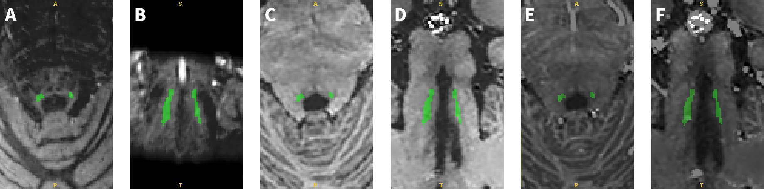
Figure 1 Example of the LC segmentation and imaging modalities. A,B – axial and coronal MT-TFL images with LC consensus masks (green). C,D – axial and coronal slices through the R1 maps for the same subject with overlaid consensus LC masks. E,F – axial and coronal slices through R2* maps for the same subject.
Next, an intersection of LC masks for all the raters was used to create individual consensus LC masks, similarly consensus masks of reference region in the pons were created for each participant. The values of R1, R2*, PD and MTsat, as well as the intensity values of the MT-TFL images were extracted from the combined left and right LC regions and the reference region, and outliers in each region and each subject were removed using generalized extreme Studentized deviate test for outliers. LC-contrast in the MT-TFL images was calculated as the difference between the median intensity in the LC region and the median intensity in the reference region, relative to the latter. Quantitative contrast was calculated as the difference between median values of the corresponding quantitative parameter in the LC and reference region. The resulting quantitative contrasts were used as predictor variables (ΔR1, ΔR2*, ΔPD and ΔMTsat) and response variables (LC-contrast) in general linear models built in MATLAB 2022b.

Results
High-resolution quantitative maps of human brain were obtained and co-aligned with MT-weighted TFL images of the LC region. The consensus LC masks varied between the subjects from 96 voxels to 537 voxels (with median consensus mask size of 276 voxels). The consensus pons reference masks varied between the subjects from 1176 voxels to 6300 voxels (with mean consensus mask size of 4050 voxels). Median values of R1, R2*, PD and MTsat, as well as the values for LC-contrast were extracted for 28 subjects from the resulting dataset.
The linear models showed borderline significant dependence of the LC-contrast on ΔR1 and ΔPD, and a trend for ΔR2* dependence (Figure 2). Notably, contrary to the previous results² the observed dependence in ΔR1 (53±25 p.u/s⁻¹, p < 0.042) and ΔPD (0.89±0.39 p.u.(LC-contrast)/p.u.(PD), p < 0.033) was for LC-contrast being positively correlated to quantitative values, and in line with the previous results – negative for the ΔR2* trend (-0.37±0.20 p.u./s⁻¹, p < 0.075). But no relation with the ΔMTSat metric was observed (p > 0.80) despite the LC-contrast being driven primarily by MT-weighting.
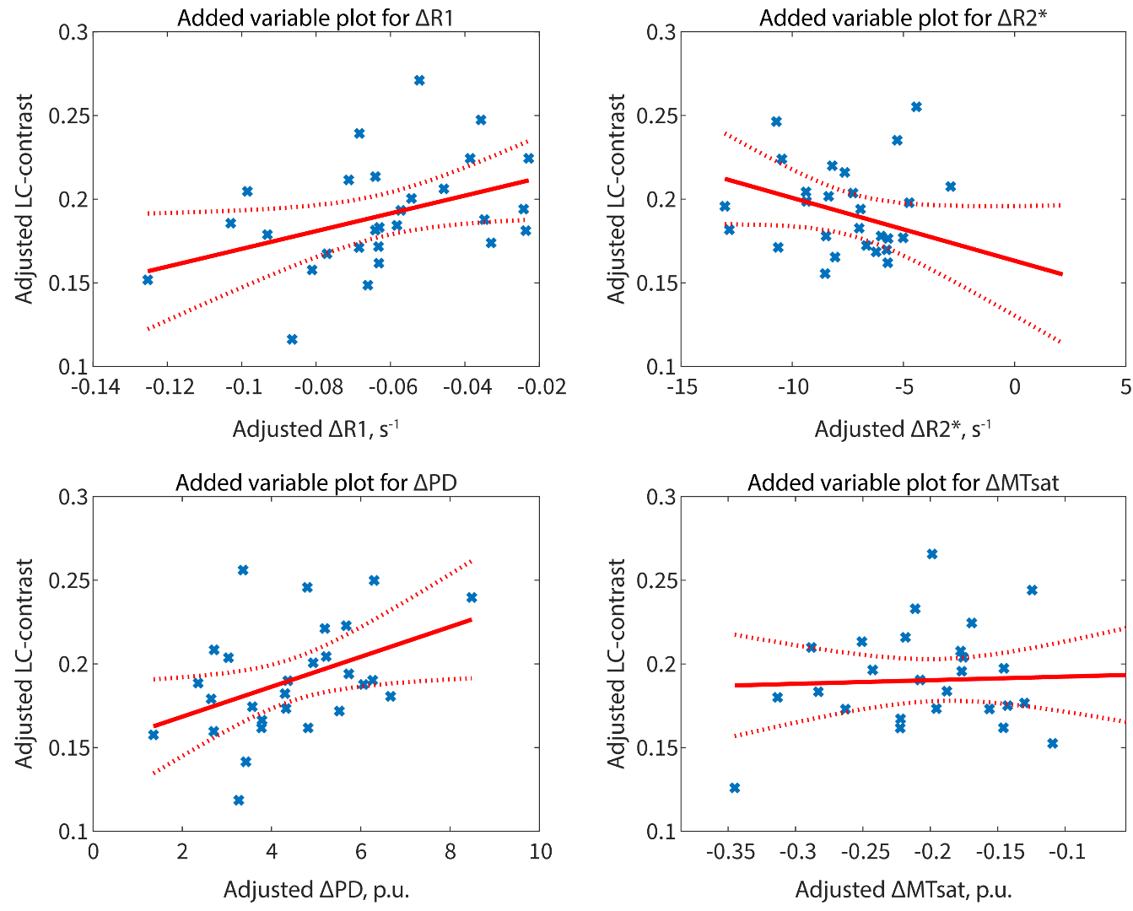
Figure 2. Added variable plots for LC-contrast against difference in quantitative values (ΔR1, ΔPD, ΔR2* and ΔMTSat) between LC and reference region in the pontine tegmentum.

Conclusion
The correlations detected between the LC-contrast and the quantitative MR parameters suggest the potential existence of multiple microstructural mechanisms affecting the LC-contrast. While neuromelanin and iron content, considered to be the primary driver for the LC-contrast, can result⁵ in the change of R1 and R2*, the change in PD is not directly rooted in the neuromelanin content. The lack of dependence on MTSat is potentially due to different MT approaches in the MPM and MT-TFL sequences, and thus MTSat and LC-contrast being related to distinctly different MT processes, while both being MT-related. This underlines the need for a comprehensive evaluation of the LC-contrast, being conventionally considered MT-driven, but as suggested by the presented results, comprising a mixture of contrast mechanisms.
The complexity of quantitative brain mapping acquisition and processing schemes, and on the contrary the apparent simplicity of MT-TFL acquisitions, leverages the LC-contrast derived from latter to be considered the primary option of LC integrity assessment. Nevertheless, it is crucial to first obtain a comprehensive description of the mechanisms causing the change in LC-contrast to better evaluate the LC integrity status based on the measured LC-contrast. This is the area where studies combining quantitative measurements in the LC with LC-contrast, theoretical evaluation of the LC-contrast origins and biophysical models will be of utter importance.

References
1. Sara SJ. The locus coeruleus and noradrenergic modulation of cognition. Nat Rev Neurosci. 2009;10(3):211-223. doi:10.1038/nrn2573
2. Priovoulos N, Jacobs HIL, Ivanov D, Uludağ K, Verhey FRJ, Poser BA. High-resolution in vivo imaging of human locus coeruleus by magnetization transfer MRI at 3T and 7T. NeuroImage. 2018;168:427-436. doi:10.1016/j.neuroimage.2017.07.045
3. Weiskopf N, Suckling J, Williams G, et al. Quantitative multi-parameter mapping of R1, PD*, MT, and R2* at 3T: a multi-center validation. Front Neurosci. 2013;7. Accessed November 30, 2023. https://www.frontiersin.org/articles/10.3389/fnins.2013.00095
4. Tabelow K, Balteau E, Ashburner J, et al. hMRI – A toolbox for quantitative MRI in neuroscience and clinical research. NeuroImage. 2019;194:191-210. doi:10.1016/j.neuroimage.2019.01.029
5. Sasaki M, Shibata E, Tohyama K, et al. Neuromelanin magnetic resonance imaging of locus ceruleus and substantia nigra in Parkinson’s disease. NeuroReport. 2006;17(11):1215. doi:10.1097/01.wnr.0000227984.84927.a7

This work was conducted at the GIGA-In Vivo Imaging platform of ULiège, Belgium. This work was supported by Fonds National de la Recherche Scientifique (FRS-FNRS, T.0242.19, T.0238.23 and J. 0222.20), the EU Joint Programme Neurodegenerative Disease Research (JPND) IRONSLEEP/HISTOPARK and SCAIFIELD projects, respectively – (FNRS references: PINT-MULTI R.8011.21/R.8002.25 & 8006.20); Action de Recherche Concertée – Fédération Wallonie-Bruxelles (ARC SLEEPDEM 17/27-09), Fondation Recherche Alzheimer (SAO-FRA 2019/0025 & 2022/0014), Fondation Léon Frédéricq, ULiège, European Regional Development Fund (Radiomed, Biomed-Hub, WALBIOIMAGING).

