Supplementary Information
The supplementary material provides details of the pTx universal pulse design, custom sequence implementation, and subsequent image processing. In addition, MR protocols without compressed sensing are provided as those do not require software or hardware extensions of the MR scanner. Finally, group statistics of the quantitative sequences, MPM and CEST, are presented.

Sequence Implementation

Field map database and Universal Pulse design
A field map database was constructed from $B_{0}$ maps, $B_{1}$ maps, and anatomical scans. The $B_{0}$ maps were acquired using a standard vendor-provided double-echo 3D GRE sequence with the following parameters: TR = 5 ms, TE1/TE2 = 0.75/1.94 ms, FA = 8$​^{∘}$, FoV = $234×228×180$ mm$​^{3}$ (AP–RL–FH), 3 mm isotropic resolution, and TA = 19 s. $B_{1}$ maps were obtained with a custom 3D-DREAM [1] implementation (available from the Siemens c2p exchange; package “dzne_b1mapping”), using 8 interferometric DREAM encodings (one channel inverted per encoding) [2] plus an additional interferometrically encoded phase reference scan. Acquisition parameters were: TR = 3 s, TE = 2.34 ms, FA$​_{prep}$ = 50$​^{∘}$, FA$​_{readout}$ = 8$​^{∘}$, FoV = $224×224×176$, 4 mm isotropic resolution, parallel imaging acceleration factor 4, and TA = 36 s. Anatomical MP-RAGE scans were used for masking. In total, 82 subjects were scanned across three different 7T sites: Bonn, Liège, and Trondheim. All pulses were calculated using custom code written in MATLAB R2021b (The Mathworks, Natick, MA, USA) and the Optimization Toolbox (Version 9.2). Universal pulses (UPs) [3] for excitation, refocusing and inversion were designed utilizing the Gradient Ascent Pulse Engineering (GRAPE) algorithm [4] under explicit voltage, RF power and slew rate constraints. To achieve water excitation with the non-selective excitation pulses employed in the MP-RAGE and the EPI sequence, a binomial UP [5] was composed of a short GRAPE pulse. For that purpose, additional constraints were enforced to ensure that the integral over all gradient axes equals zero for each repetition.

MP-RAGE und SPACE
The MP-RAGE and SPACE sequence are modified versions of the according vendor implementations (software version VE12 for Siemens 7T scanners). In contrast to the vendor sequence, our custom MPRAGE sequence uses a flexible reordering scheme which supports 2D-CAIPIRINHA and elliptical sampling [6]. Furthermore, it uses optimized UPs for nonselective water excitation and inversion. The custom SPACE sequence uses an EPG-based variable flip angle train calculation for SAR reduction [7] and UPs for spin echo excitation and refocusing [8] and for the FLAIR inversion [9]. In contrast to the vendor implementations, both sequences support external acquisition of the reference data for parallel imaging. This saves time and improves motion-robustness. Finally, our custom MPRAGE and SPACE sequences optionally support additional acceleration with compressed sensing (CS). Without CS, the vendor-provided online image reconstruction is used for all sequences. If CS is used, MPRAGE and SPACE reconstruction is still performed online but with a custom image reconstruction workflow [10] which is based on the Siemens FIRE framework for online raw data export. The workflow performs image reconstruction on dedicated external hardware and subsequent injection of the reconstructed images into the scanner’s image database. Coil sensitivity maps were computed using the $\text{caldir}$ command from the Berkeley Advanced Reconstruction Toolbox (BART) [11] and based on an external reference scan. Image reconstruction was subsequently performed with the $\text{pics}$ command from the same toolbox, employing l1-wavelet regularization (regularization weight r = 0.001, 40 iterations).
In addition to the MR protocol described in the main manuscript, we provide a protocol without CS for the MPRAGE and SPACE (FLAIR) sequences. This might be of interest, as it does not require setting up the custom online image reconstruction. Both protocol versions are available on github.

3D-EPI sequences
The custom SWI, MPM, and CEST sequences use a double-segmented 3D-EPI readout based on the skipped-CAIPI approach [12], which is well-suited for rapid high-resolution anatomical imaging. Due to high 2D phase encode segmentation, the images are free of geometrical distortions and other artifacts usually associated with EPI. As for the MPRAGE, optimized UPs for nonselective water excitation are employed in all variants of the 3D-EPI sequence. Details of the SWI sequence and protocols were recently published [13]. The implementation details for fast whole-brain MPM and CEST imaging with 3D-EPI readout, were as well previously published [14,15]. Additionally, our current 3D-EPI sequence versions utilize the novel PUSHUP approach for calibration-free homogenous whole-brain saturation of the macromolecular pool [16]. This publication describes the details of PUSHUP for CEST imaging, as well as the CEST protocol used in this study. The PUSHUP approach was also implemented into the MPM sequence to achieve homogeneous MT saturation across the whole brain PUSHUP homogenization has consequences for the CEST and MPM parameter quantification, which is described in the next section.

Image Processing and Analysis

Quantitative parameter maps
Quantitative tissue parameter maps were obtained based on previously published approaches for CEST [16], and MPM [14]. Susceptibility maps were generated from the phase maps of preprocessed high-resolution 3D-EPI data [13] using the two-pass reconstruction approach proposed in QSMxT [17] and total generalised variation (TGV) [18]. BET [19] was used to create a brain mask for the first QSM reconstruction, while ROMEO [20] was used to generate a refined brain mask that excludes unreliable susceptibility sources. MPM processing with the hMRI toolbox [21] had to be adjusted compared to Ref. [14] in order to take UP excitation and PUSHUP saturation into account, since homogenization is not perfect across the field of view. For transmit field correction, the actual UP excitation flip angle was mapped using the actual flip angle imaging (AFI) method [22,23]. Additionally, the saturation $B_{1}$ was calculated from the individual-channel $B_{1}$ maps that were measured using the 3D-DREAM sequence.

ROI analysis
All contrast pairs (vendor/custom, CP/UP) were co-registered to each other using a rigid body half-way co-registration. The actual image analysis was conducted afterwards in the (half-way) MPRAGE custom $T_{1}$-space, with anatomical scans and quantitative scans co-registered using rigid body and affine transformations, respectively. Brain segmentation for ROI analysis utilized Deep Atropos from the ANTs toolbox on MPRAGE custom scans in the half-way $T_{1}$-space.
All post-processing steps and image statistics were carried out using a custom Nipype analysis workflow adapted from [24], integrating tools from FSL, ANTs, and AFNI for a comprehensive and standardized analyses [25–27]. The workflow computes several image quality metrics such as signal-to-noise ratio (SNR) and contrast-to-noise ratio (CNR), Michelson contrast (MC), and coefficient of joint variation (CJV). The SNR was determined using Dietrich’s formula [28]: $SNR=\sqrt{\frac{π}{2}}μ_{fg}/μ_{bg}$, where $μ_{fg}$ is the mean signal intensity of the tissue region and $μ_{bg}$ is the mean of the signal intensity in the background air ROI. Tissue regions were defined using ANTs deep Atropos segmentation [27], while the background air ROI was calculated following Mortamet et al.[mortametAutomaticQualityAssessment2009]. Similarly, the WM/GM CNR was calculated as: $CNR=\left|μ_{wm}−μ_{gm}\right|/μ_{bg}$. It is known that these metrics are theoretically not fully valid in case of accelerated acquisitions with specific g-factor distribution [29]. However, we observed that they provide sufficient estimates for the comparison purposes of this study.

ROI and group statistics of MPM and CEST parameters
Table S1 shows mean and standard deviations of the quantitative CEST and MPM parameters in different brain regions for the group of healthy subjects. For all brain regions and parameters, a small standard deviation over the mean ROI values for all subjects (first value in brackets below the mean value) is observed in comparison to the mean value. This observation holds for both acquisitions, in CP mode and with UPs, showing that our custom sequences provide excellent reproducibility across the group of healthy subjects. The mean over the standard deviations of ROI values for all subjects (second value in brackets) is in most cases higher for CP mode acquisitions than for the acquisitions with UPs. This shows that UPs improve the spatial homogeneity of nearly all parameter estimates (except for $T_{2}^{*}$, which is less affected by $B_{1}$ inhomogeneity). This observation is especially evident in the cerebellum and for parameters related to PUSHUP preparation (all CEST parameters and MT$​_{sat}$ of MPM), where the spatial variation using UPs is much lower as compared to CP mode saturation and excitation. Also UP excitation reduces parameter variation, as seen from the $T_{1}$ estimates (not depending on MTw data) in all brain regions and, again, especially in the cerebellum.
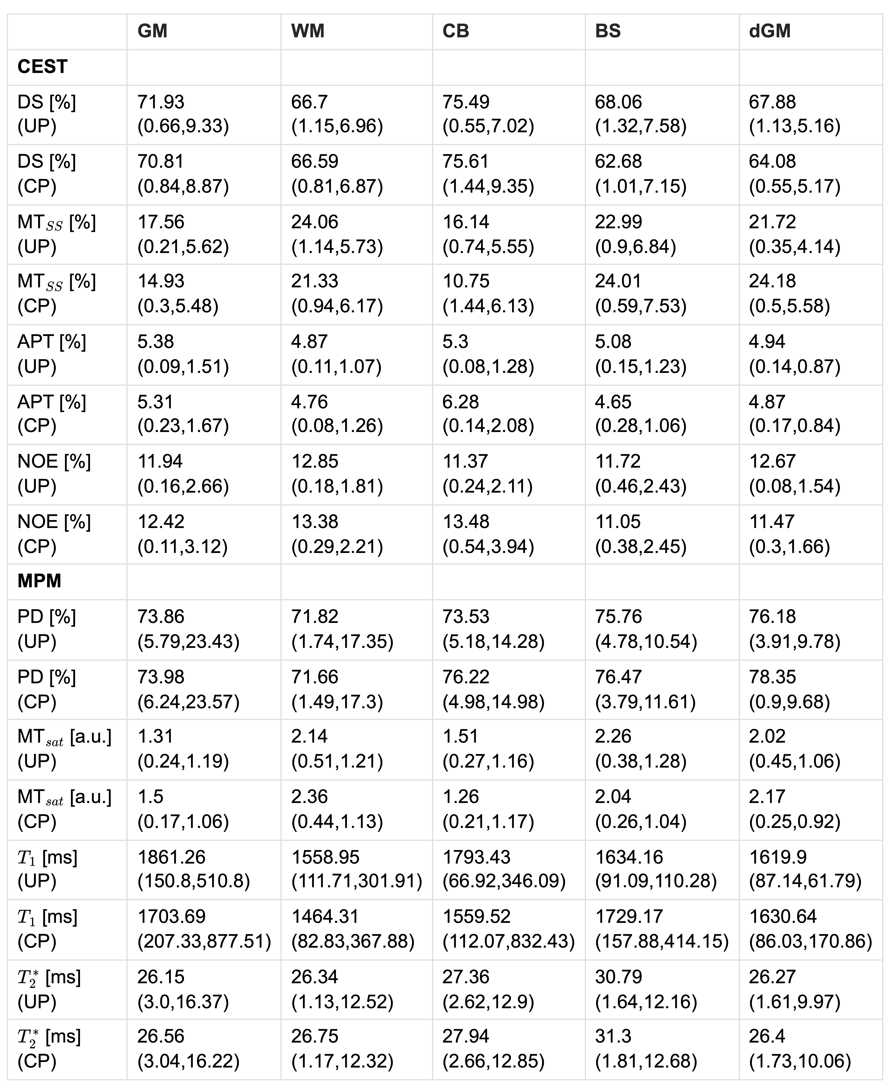
Table S1: Group mean and standard deviation of quantitative parameters (rows) in different brain regions (columns) obtained from 10 healthy subjects. Adjacent rows compare the results for the different CEST and MPM parameters with UP and CP mode acquisition, respectively. Below each mean value two standard deviations are given in brackets. The first is the standard deviation over the mean ROI values for all subjects, describing the parameter’s variation across the group. The second is the mean over the standard deviation of ROI values for all subjects, describing the parameter’s spatial variation in the specific ROI. In most cases this value is smaller for UP than for CP acquisitions, showing the improved homogeneity with UPs. This is most evident in the cerebellum (CB).
Brain structures: WM: white matter, GM: gray matter, CB: cerebellum, BS: brain stem, dGM: deep gray matter nuclei. CEST parameters: DS: Direct Saturation, MT$​_{SS}$: semi-solid Magnetization Transfer, APT: Amide Proton Transfer, rNOE: relayed Nuclear-Overhauser-Enhanced. MPM parameters: PD: Proton Density, MT$​_{sat}$: Magnetization Transfer saturation, $T_{1}$: longitudinal relaxation time, $T_{2}^{*}$: effective transverse relaxation time.

MPM and CEST repeatability
The voxel-wise quantitative MPM and CEST parameters were calculated for test and retest acquisitions of the repeatability study. Next, the quantitative maps of the retest acquisition were registered to the maps of the test acquisition, and the voxel-wise percentage coefficient of variation was calculated as $COV=100⋅σ/μ$, where $μ$ and $σ$ denote the mean and the standard deviation of the parameter of interest over the two acquisitions. Segmentation masks were used to compute the mean COV over the ROIs, and these values were finally averaged over the three subjects. Table S2 shows the group mean COV for all quantitative CEST and MPM parameters in the different brain regions (group standard deviations are given in brackets). The COVs are in good agreement with literature for CEST [30,31] and MPM [14]. The COV of MPM-$MT_{sat}$ is by a factor of 2-3 larger than for all other parameters, showing that this semi-quantitative parameter is less reliable at 7T as previously reported [14]. Overall, the COVs for CP-mode and UP acquisitions are of a similar magnitude. In most cases, the mean $±$ standard deviation intervals overlap for CP and UP. Nevertheless, the COVs for UP are mostly lower than for CP. For instance, all mean COVs for CP are higher than for UP in the cerebellum. The same holds for all MPM parameters and brain regions, except MT$​_{sat}$ and $T_{2}^{*}$ in the brainstem. For CEST, the UP-vs-CP pattern is less stringent, which may be related to a robust acquisition and fitting procedure involving two $B_{1}$ scaling factors for both CP and UP, which is not actually required for UP CEST [16]. But again, most COVs are lower for UP than for CP acquisition. 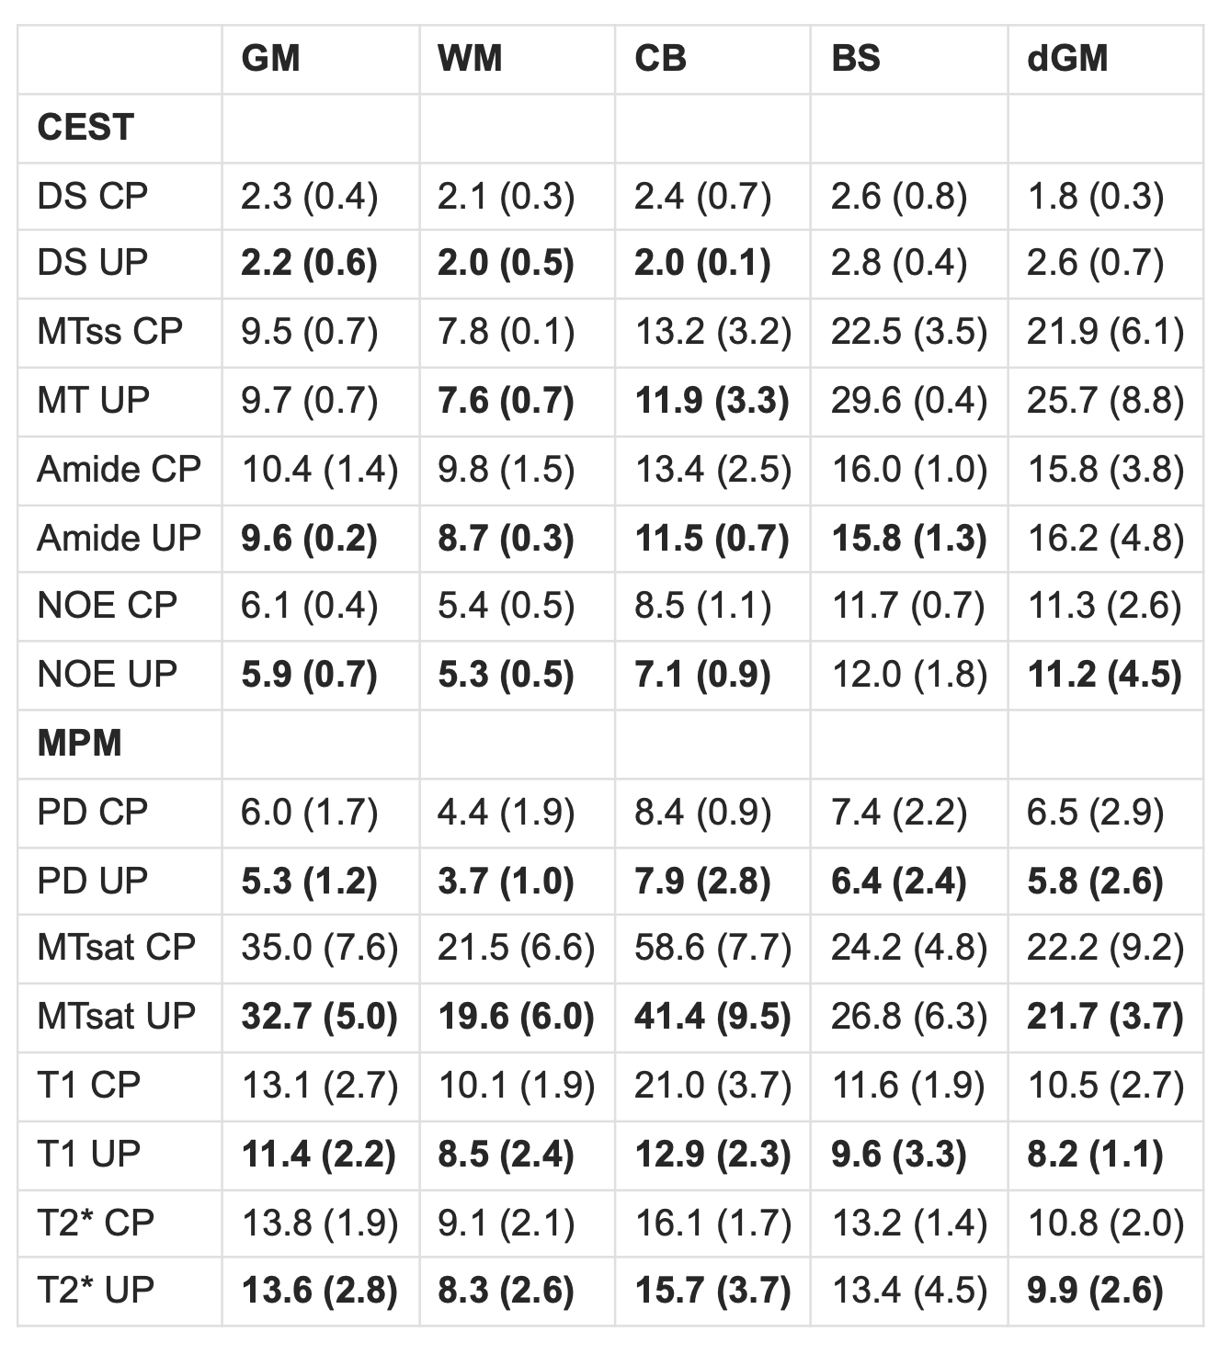
Table S2: Results of the test-retest repeatability study: the table shows the mean percentage coefficient of variation (COV) for all CEST and MPM parameters in different brain regions (columns). The group standard deviations are given in brackets. The UP values ​​are printed in bold, if the mean COV is smaller than the corresponding CP value.

References
[1] Ehses P, Brenner D, Stirnberg R, Pracht E D and Stöcker T 2019 Whole-brain B1-mapping using three-dimensional DREAM Magnetic Resonance in Medicine 82 924–34
[2] Brunner D O and Pruessmann K P 2009 B1(+) interferometry for the calibration of RF transmitter arrays. Magnetic resonance in medicine : official journal of the Society of Magnetic Resonance in Medicine / Society of Magnetic Resonance in Medicine 61 1480–8
[3] Gras V, Vignaud A, Amadon A, Le Bihan D and Boulant N 2017 Universal pulses: A new concept for calibration-free parallel transmission Magnetic Resonance in Medicine 77 635–43
[4] Van Damme L, Mauconduit F, Chambrion T, Boulant N and Gras V 2021 Universal nonselective excitation and refocusing pulses with improved robustness to off-resonance for Magnetic Resonance Imaging at 7 Tesla with parallel transmission Magnetic Resonance in Medicine 85 678–93
[5] Löwen D, Pracht E D, Stirnberg R, Liebig P and Stöcker T 2022 Interleaved binomial k _{T} -points for water-selective imaging at 7T Magnetic Resonance in Medicine 88 2564–72
[6] Brenner D, Stirnberg R, Pracht E D and Stöcker T 2014 Two-dimensional accelerated MP-RAGE imaging with flexible linear reordering. Magma (New York, N.Y.) 27 455–62
[7] Pracht E D, Feiweier T, Ehses P, Brenner D, Roebroeck A, Weber B and Stöcker T 2018 SAR and scan-time optimized 3D whole-brain double inversion recovery imaging at 7T Magnetic Resonance in Medicine 79 2620–8
[8] Gras V, Mauconduit F, Vignaud A, Amadon A, Le Bihan D, Stöcker T and Boulant N 2018 Design of universal parallel-transmit refocusing k _{T} -point pulses and application to 3D T ₂ -weighted imaging at 7T Magnetic Resonance in Medicine 80 53–65
[9] Gras V, Pracht E D, Mauconduit F, Le Bihan D, Stöcker T and Boulant N 2019 Robust nonadiabatic T2 preparation using universal parallel-transmit kT-point pulses for 3D FLAIR imaging at 7 T Magnetic Resonance in Medicine 81 3202–8
[10] Veldmann M, Ehses P, Chow K, Nielsen J-F, Zaitsev M and Stöcker T 2022 Open-source MR imaging and reconstruction workflow Magnetic Resonance in Medicine 88 2395–407
[11] Uecker M, Tamir J I, Ong F and Lustig M 2016 The BART toolbox for computational magnetic resonance imaging. 24th Annual Meeting of ISMRM (Singapore)
[12] Stirnberg R and Stöcker T 2021 Segmented K-space blipped-controlled aliasing in parallel imaging for high spatiotemporal resolution EPI Magnetic Resonance in Medicine 85 1540–51
[13] Stirnberg R, Deistung A, Reichenbach J R, Breteler M M B and Stöcker T 2024 Rapid submillimeter QSM and R2* mapping using interleaved multishot 3D-EPI at 7 and 3 Tesla Magnetic Resonance in Medicine
[14] Wang D, Ehses P, Stöcker T and Stirnberg R 2022 Reproducibility of rapid multi-parameter mapping at 3T and 7T with highly segmented and accelerated 3D-EPI Magnetic Resonance in Medicine 88 2217–32
[15] Akbey S, Ehses P, Stirnberg R, Zaiss M and Stöcker T 2019 Whole-brain snapshot CEST imaging at 7 T using 3D-EPI Magnetic Resonance in Medicine 82 1741–52
[16] Völzke Y, Akbey S, Löwen D, Pracht E D, Stirnberg R, Gras V, Boulant N, Zaiss M and Stöcker T 2025 Calibration-free whole-brain CEST imaging at 7T with parallel transmit pulse design for saturation homogeneity utilizing universal pulses (PUSHUP) Magnetic Resonance in Medicine 93 630–42
[17] Stewart A W, Robinson S D, O’Brien K, Jin J, Widhalm G, Hangel G, Walls A, Goodwin J, Eckstein K, Tourell M, Morgan C, Narayanan A, Barth M and Bollmann S 2022 QSMxT: Robust masking and artifact reduction for quantitative susceptibility mapping Magnetic Resonance in Medicine 87 1289–300
[18] Langkammer C, Bredies K, Poser B A, Barth M, Reishofer G, Fan A P, Bilgic B, Fazekas F, Mainero C and Ropele S 2015 Fast quantitative susceptibility mapping using 3D EPI and total generalized variation NeuroImage 111 622–30
[19] Smith S M 2002 Fast robust automated brain extraction Human Brain Mapping 17 143–55
[20] Dymerska B, Eckstein K, Bachrata B, Siow B, Trattnig S, Shmueli K and Robinson S D 2021 Phase unwrapping with a rapid opensource minimum spanning tree algorithm (ROMEO) Magnetic Resonance in Medicine 85 2294–308
[21] Tabelow K, Balteau E, Ashburner J, Callaghan M F, Draganski B, Helms G, Kherif F, Leutritz T, Lutti A, Phillips C, Reimer E, Ruthotto L, Seif M, Weiskopf N, Ziegler G and Mohammadi S 2019 hMRI – A toolbox for quantitative MRI in neuroscience and clinical research NeuroImage 194 191–210
[22] Yarnykh V L 2007 Actual flip-angle imaging in the pulsed steady state: A method for rapid three-dimensional mapping of the transmitted radiofrequency field. Magnetic resonance in medicine : official journal of the Society of Magnetic Resonance in Medicine / Society of Magnetic Resonance in Medicine 57 192–200
[23] Nehrke K 2009 On the steady-state properties of actual flip angle imaging (AFI). Magnetic resonance in medicine : official journal of the Society of Magnetic Resonance in Medicine / Society of Magnetic Resonance in Medicine 61 84–92
[24] Esteban O, Birman D, Schaer M, Koyejo O O, Poldrack R A and Gorgolewski K J 2017 MRIQC: Advancing the automatic prediction of image quality in MRI from unseen sites
[25] Jenkinson M, Beckmann C F, Behrens T E J, Woolrich M W and Smith S M 2012 Fsl. NeuroImage 62 782–90
[26] Cox R W and Hyde J S 1997 Software tools for analysis and visualization of fMRI data NMR in Biomedicine 10 171–8
[27] Tustison N J, Cook P A, Holbrook A J, Johnson H J, Muschelli J, Devenyi G A, Duda J T, Das S R, Cullen N C, Gillen D L, Yassa M A, Stone J R, Gee J C and Avants B B 2021 The ANTsX ecosystem for quantitative biological and medical imaging Scientific Reports 11 9068
[28] Dietrich O, Raya J G, Reeder S B, Reiser M F and Schoenberg S O 2007 Measurement of signal-to-noise ratios in MR images: Influence of multichannel coils, parallel imaging, and reconstruction filters Journal of Magnetic Resonance Imaging 26 375–85
[29] Pruessmann K P, Weiger M, Scheidegger M B and Boesiger P 1999 SENSE: Sensitivity encoding for fast MRI. Magnetic resonance in medicine : official journal of the Society of Magnetic Resonance in Medicine / Society of Magnetic Resonance in Medicine 42 952–62
[30] Cronin A E, Liebig P, Detombe S A, Duggal N and Bartha R 2024 Reproducibility of 3D chemical exchange saturation transfer (CEST) contrasts in the healthy brain at 3T Scientific Reports 14 25637
[31] Fabian M S, Rajput J R, Schüre J-R, Weinmüller S, Mennecke A, Möhle T A, Rampp S, Schmidt M, Dörfler A and Zaiss M 2024 Comprehensive 7 T CEST: A clinical MRI protocol covering multiple exchange rate regimes NMR in Biomedicine 37 e5096

