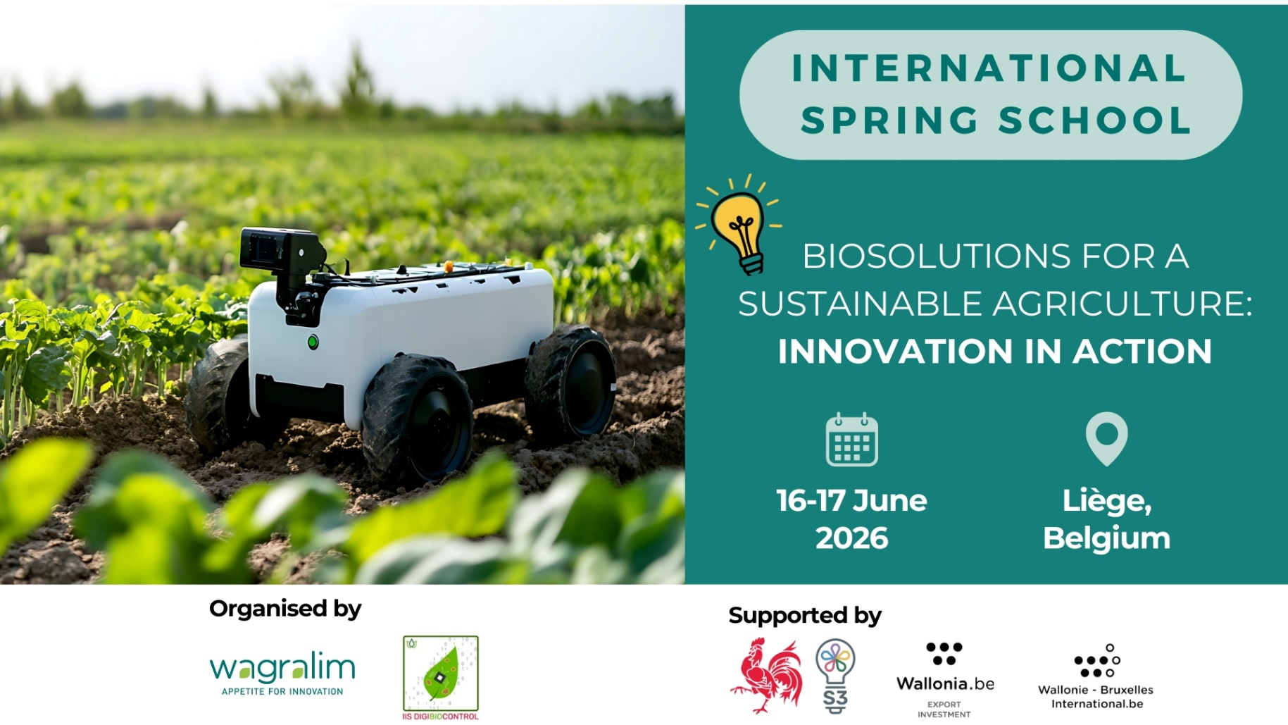

Spring School Abstract Form

Towards new alternatives for potato late blight disease management: Essential oils chemical profiles drive biological activities against P. infestans
Florian MARTINI (1), Clément BURGEON (2), Marie-Laure FAUCONNIER(3), Haïssam JIJAKLI(4)
- Laboratory of Chemistry of Natural Molecules,Gembloux Agro-Bio Tech, Liege University, Passage des Déportés 2, 5030 Gembloux, Belgium Florian Martini is a phD student working on the agent of potato late blight Phtophthora infestans and its alternative management, mainly through essential oils from in vitro to in planta . He also teaches organic chemistry to bio-enginnering students at Gembloux Agro-Bio Tech.
- Laboratory of Integrated and Urban Plant Pathology, Gembloux Agro-Bio Tech, Liege University, Passage des Déportés 2, 5030, Gembloux, Belgium Clément Burgeon is phD in biological engineering and agronomical sciences. He has been working on plant diseases since his post-doc started in 2023 and works now as a project manager at APEO.

- Laboratory of Chemistry of Natural Molecules,Gembloux Agro-Bio Tech, Liege University, Passage des Déportés 2, 5030 Gembloux, Belgium Marie-Laure Fauconnier teaches chemistry at Gembloux Agro-Bio Tech and is head of the laboratory of chemistry of natural molecules. Her research activities focus on the extraction, caracterization and valorization of plant metabolites for agronomical and food applications. She is also dean of the faculty since october 2025.
- Laboratory of Integrated and Urban Plant Pathology, Gembloux Agro-Bio Tech, Liege University, Passage des Déportés 2, 5030, Gembloux, Belgium Haïssam Jijakli is professor of phytopathology and urban agriculture at Gembloux Agro-Bio Tech. He is also one of the co-founder of APEO, a spin-off that develops essential oils-based alternative to synthetic pesticides.

ABSTRACT :

Potato (Solanum tuberosum) plays a crucial role in global food security, as the most important non-cereal crop for human consumption. Its main threat remains the oomycete Phytophthora infestans which causes late blight disease. While synthetic pesticides still count as effective disease control despite increasing appearances of resistance, it also depletes natural resources, pollutes water, and threatens human and ecosystems health. Therefore, new and more sustainable alternatives for crop protection must be urgently developed. In this context, this study explores the use of essential oils (EOs) - which are complex mixtures of volatile and hydrophobic plant secondary metabolites – as a bio-sourced alternative against Phytophthora infestans.
For this purpose, five different EOs were selected and analyzed by GC-MS. Their chemical profiles were distinguished on two groups: terpenoids - mainly found in bergamot and rosemary EO whereas oregano, cinnamon and clove contained molecules from the phenylpropanoid metabolic pathway.
To evaluate their anti-oomycete potential, EOs were emulsified in water using Tween 20 and tested in vitro against three P. infestans genotypes (EU-13-A2, EU-36-A2, and EU-37-A2). Oils rich in phenylpropanoids completely inhibited both mycelial growth (MIC on Petri dish) and spore germination (IC50 on microplates) at concentrations starting from 1 µL mL⁻¹, showing significantly higher efficacy than terpene-rich oils.
Before validating these results under more realistic conditions, the appropriate host-pathogen couple had to be selected. Through ex vivo assays on detached potato leaves a gradient of susceptibility among three potato varieties (Bintje, Fontane, and Carolus known to exhibit respectively no, low, and high resistance to late blight) was implemented. The observations supported how varietal selection and genotype diversity modulates infection severity. Then, phytotoxicity assessments did not show any visible lesions nor significant decreases in chlorophyll fluorescence under 2.5 µL of EO per mL of emulsion, although chlorosis appeared at higher doses. Finally, efficacy tests were conducted to quantify the protective effects of the most promising EOs against early symptoms of late blight. Preliminary results revealed no significant difference between EO treatments and the conventional copper sulfate solution. Further in planta experiments are still required to determine whether similar protective effects can be achieved at the whole-plant level under semi-controlled conditions.
In parallel, the impacts of major EO compounds were investigated at the cellular level in P. infestans. Rapid alterations in membrane permeability along with acute intracellular reactive oxygen species production were identified as potential modes of action, occurring within two hours after EO exposure on both spores and mycelium.
These findings, combined with appropriate formulation, bring the selected essential oils as a potential source of effective and less-toxic biofungicides.

