Characterization and timing of weathering processes of the polymetallic Cu-Fe-Zn-As Tassrirt deposit (Kerdous inlier, Anti-Atlas, Morocco)
Julien Poot ^{1,*}, Michèle Verhaert ², Basile Caterina ³, Augustin Dekoninck ^{1,4}, Théo Bouvart ¹, Mohammed Bouabdellah ^{5,6}, Lhou Maacha ⁷, Gaëtan Rochez¹, Nathalie Fagel⁸ and Johan Yans ¹
¹Department of Geology, Institute of Life-Earth-Environment (ILEE), University of Namur, Rue de Bruxelles 61, 5000 Namur, Belgium.
²Groupe Jean Nonet, Rue de la Vieille Sambre 162, 5190 Jemeppe sur Sambre, Belgique.
³ SPHERES, Department of Geography, University of Liège, 4000 Liège, Belgium.
⁴ Service de Génie Minier, Département Mines-Géologie, Faculté Polytechnique de Mons (FPMs), Université de Mons. Rue du Joncquois 53, 7000 Mons, Belgique.
⁵ Geology and Sustainable Mining Institute, Mohammed VI Polytechnic University, Benguerir 43150, Morocco.
⁶ Laboratoire des Gîtes Minéraux, Hydrogéologie & Environnement, Faculté des Sciences, Université Mohammed Premier, Oujda 60000, Morocco
⁷ Managem Group, BP 5199, Casablanca 20100, Morocco.
⁸ Department of Geology, Argiles, Géochimie et Environnements sédimentaires (AGEs), Université de Liège, Allée du six Août 14, 4000 Liege, Belgium.
*Corresponding author: julien.poot@unamur.be
Abstract
The Tassrirt deposit (Kerdous inlier, Western Anti‑Atlas, Morocco) hosts polymetallic Cu-Fe-Zn-As mineralization affected by intense weathering. This study provides mineralogical, petrographic and geochemical analyses for host rocks, primary sulfides and secondary minerals using XRD, SEM-EDS and whole-rock geochemistry. K-Ar dating on alunite is also performed to constrain the timing of weathering to refine/confirm main weathering period in the Anti-Atlas. The mineralogical and geochemical data reflect strong oxidation of sulfide‑rich protore, heterogeneous neutralization (carbonates and silicates), and significant Si‑mobility related to weathering of feldspar‑bearing host rocks. These processes generated various secondary minerals including malachite, hemimorphite, fraipontite, smithsonite, alunite, iron (oxyhydr)oxides, and locally beudantite–beaverite group minerals with various trace metals. Zn‑silicates dominate over carbonates, reflecting acidic, oxidizing conditions with limited carbonate buffering. Arsenic is mainly retained by Fe-(oxyhydr)oxides, while REE signatures remain close to the Upper Continental Crust values, with minor variations related to adsorption and accessory phosphates. K–Ar dating of alunite reveals a major supergene episode at ~18–17 Ma, which is consistent with tropical North Africa climate during the Early/Middle Miocene and the long-lasting topographic stability until onset of the modern topography since c. 14-10 Ma. Together, these results refine the paragenetic sequence and metal redistribution in Tassrirt deposit for potential exploitation and confirm the main Early Miocene weathering period in this region.
Keywords : weathering; polymetallic deposit; Anti-Atlas; K-Ar dating; supergene timing
1. Introduction
The Anti-Atlas hosts one of the most diverse and metal-rich geological provinces of North Africa. Its Precambrian inliers, aligned along the so-called Anti-Atlas Copperbelt (e.g., Bourque et al. 2016; Gouiza et al., 2017; Jabbour et al., 2025; Oummouch et al., 2017; Poot et al., 2026, 2020; Verhaert et al., 2020), expose many polymetallic mineralization, from Neoproterozoic hydrothermal systems (e.g., Bouabdellah et al., 2016; El Azmi et al., 2014) to more recent development weathering profiles. Across this belt, numerous deposits (e.g., Tizert, Tazalaght, Agoujgal, Bou Skour; Poot et al., 2026, 2020; Verhaert et al., 2020) illustrate how the different phases of uplift, erosion and meteoric fluids circulation have remobilized and recrystallized metals near the surface.
The Tassrirt deposit in the Kerdous inlier (Figure 1A) is a Cu–Zn–Fe–As mineralization affected by weathering, which has not been described compare to other mineralization systems of the region (e.g., structural evolution, see Soulaimani and Piqué, 2004). The Tassrirt mineralization displays many of the key features that characterize the Anti-Atlas weathering environment (e.g., Bouabdellah et al., 2021; Clementucci et al., 2022, 2023; Lanari et al., 2022; Leprêtre et al., 2015, 2018; Oukassou et al., 2013), especially oxidation of primary sulfides and heterogeneous neutralization patterns. These transformations generated complex assemblages of carbonates, sulfates, silicates and (oxyhydr)oxides, which record variations in pH, redox state and cations/metals activity (e.g., Bowell and Butt, 2025; Sangameshwar and Barnes, 1983; Velasco et al., 2013). In many supergene deposits, such minerals constitute effective sinks of strategic and critical elements, highlighting the role of supergene processes to concentrate or redistribute these metals
Here we provide the first description of Tassrirt Cu–Zn–Fe–As supergene mineralization and compare the system with other occurrences in the Anti-Atlas Copperbelt (e.g., Poot et al., 2026, 2020; Verhaert et al., 2020). This study primarily focuses on the mineralogical, petrographic and geochemical characterization of the primary (hypogene) and secondary mineral (supergene) assemblages in Tassrirt which document the weathering of the primary Cu–Zn–Fe–As sulfides and the role of the host rocks (carbonates vs silicates), fluid pathways, neutralization processes and the resulting supergene mineralogy. Emphasis is also placed on the temporal constraints of weathering through K-Ar dating of supergene alunite providing the first timing of supergene mineralization in Kerdous inlier.
By coupling mineralogical, petrographic and geochemical characterization with K-Ar timing, we propose an evolution of the Tassrirt weathering system within the broader Miocene tectono-climatic evolution of the Kerdous inlier. Ultimately, this integrated study highlights the main processes controlling metal mobility during weathering. This contribution forms part of a broader research program dedicated to understanding weathering processes and their metallogenic implications across the whole Anti-Atlas Copperbelt (see Poot et al., 2020, 2026; Verhaert et al., 2020).
2. Geological context
The Anti-Atlas belt, situated along the northern edge of the West African Craton (WAC), extends ENE-WSW from the Atlantic margin into the African plate over 800 km long and 200 km wide (Gasquet et al., 2008; Michard et al., 2017). The most elevated part of this belt is marked by the alignment of inliers where the Precambrian basement is exposed beneath the folded Paleozoic sedimentary formations (Michard et al., 2017). The Tassrirt massif/dome is in the Kerdous inlier (Western Anti-Atlas, Figure 1A), which is one of the widest inliers, and is interpreted as a Late Proterozoic diapiric gneiss dome rather than reactivation of an old Eburnean basement (Soulaimani and Piqué, 2004).
In Tassrirt dome, the oldest rocks observed date from the Paleoproterozoic (2.2-2.0 Ga) and mainly consist of granitoids (Tahala, Tassrirt and Anammr granitoid date at 2058 ± 11 Ma; Loughlin et al. 2002) that are globally metamorphosed (gneiss/orthogneiss) and are responsible for the formation of “domes”, including the Tassrirt one (Figure 1B) (Druguet et al., 2015; Soulaimani and Piqué, 2004). The Paleoproterozoic rocks are then subjected to retrograde metamorphism during the Pan-African orogeny and are cut by numerous faults and shear zones. The Tassrirt dome is therefore the result of these successive events (Eburnean and Pan-African orogeny) and is interpreted as a Late Proterozoic diapiric gneiss dome (Soulaimani and Piqué, 2004). Eburnean and Pan-African structures are both cut by granite intrusions (Tarçouate and Tafraoute) from Late Neoproterozoic (583–548 Ma) magmatic events (Aït Malek et al., 1998; Soulaimani and Piqué, 2004). Late Neoproterozoic conglomerates of the Ouarzazate Supergroup lie unconformably above these granites (Gasquet et al., 2008) and could also host polymetallic mineralization (mostly Cu–Zn-Fe-As) although it was not observed in our study (Gasquet et al., 2008; Soulaimani and Burkhard, 2008).
The Cambrian rocks are exposed at the western edge of the inlier, close to the Tassrirt deposit. They are affected by different tectonic events, including the Variscan compression, which is responsible for the uplift of the region (Druguet et al., 2015; Gasquet et al., 2008; Soulaimani and Piqué, 2004). The Adoudou Formation (561-524 Ma) which overlies the Ouarzazate Supergroup and the main host formation of the Tassrirt deposit. The stratigraphic succession of Adoudou Formation is subdivided into the Tabia and the Tifnout members (Maloof et al., 2005) formerly called Basal Series and Lower Limestone, respectively. The Tabia member (up to 250m thick) is composed of siliceous carbonates (Maloof et al., 2005), siltstones and fluviatile sandstones formed during transgression episodes in a syn-rift to post-rift system. The Tifnout member consists of limestones and dolostones with deeper facies (Álvaro and Subías, 2011). Above the Adoudou Formation lies the “Lie-de-Vin” series made of purplish siltstones related to a tilting in the Anti-Atlas margin (Maloof et al., 2005) but this succession does not outcrop in Tassrirt deposit. The primary mineralization at Tassrirt is difficult to observe at the outcrop scale, but it appears to occur as plurimillimiters or centimeter veins and veinlets and could be related to hydrothermal fluid, as observed in many polymetallic deposits in the Anti-Atlas in the same host rocks (e.g., Ouansimi, Tizert, Agoujgal and Tazalaght deposit; El Basbas et al., 2020, Oummouch et al., 2017; Poot et al., 2020,2026; Verhaert et al., 2020).
3. Material and methods
Samples were collected in the Tassrirt area (Figure 1B) and selected from surface outcrops, backfills, old galleries and some recent excavations (Figure 2), to get an overall view of host rocks, primary (hypogene) and secondary (supergene) mineralized samples.
Samples were crushed using stainless steel mortar with Retsch PM 100 planetary ball mills then sieved to 500 µm grain size. X-ray diffraction was carried out on powdered whole rock samples using a PANalytical X’Pert Pro diffractometer and a Phillips PW3710 (CuKα radiation, 40 kV and 30 mA) at the PC2 platform (University of Namur). Resulting data were analyzed using the International Centre for Diffraction Data (ICDD) software and the 2019 PDF-2 (Powder Diffraction Files) database. Geochemical analyses were carried out on twenty-three representative samples sieved at 125 μm grain size by Activation Laboratories Ltd. (Actlabs, Ancaster, ON, Canada). Rare earth elements were measured using fusion mass spectrometry (FUS-MS), while major elements were quantified by Inductively Coupled Plasma - Optical Emission Spectrometry (ICP-OES). Reduced iron (FeO) concentrations were determined by titration. Trace elements were mainly analyzed by FUS-MS; except for Cu, Zn, As, Sb, and Pb that are quantified in wt.% than in ppm by fusion inductively coupled plasma with sodium peroxide oxidation (FUS-Na₂O₂) and Ag by ICP-OES for concentrations above 200 ppm. All major and trace elements data were normalized to upper continental crust (UCC) composition (Taylor and McLennan, 1995).
Samples 17TAS09, 18TAS15A and 18TAS15B (alunite) were selected for K-Ar dating after bulk XRD and geochemical analyses. Polished sections were examined using a JEOL JSM-7500F scanning electron microscope (SEM) equipped with an energy dispersive electron spectrometer (EDS) to confirm the absence of K-contaminant phases, particularly muscovite inherited from host rocks. Material was extracted from central portions of some irregular veinlets to minimize contamination by other K-bearing minerals.
After this preliminary analysis, samples were crushed to obtain fragments before K-Ar analysis by Actlabs. Aliquots were weighed into aluminum container, loaded into extraction system, and degassed at ~100°C for two days. Argon is then extracted in a double vacuum furnace at 1700°C. Radiogenic argon contents were determined twice using a MI-1201 IG mass spectrometer by isotope-dilution, employing a ³⁸Ar spike introduced prior to each extraction. Extracted gases were purified into a two-step cleanup system before being introduced into the custom-built magnetic sector mass spectrometer (Reynolds type). Duplicate measurements were performed to ensure analytical reproducibility. Calibration of the ³⁸Ar spike used two internationally recognized standards : Bern 4M Muscovite (18.6 ± 0.4 Ma; alternatively, P-207 Muscovite) and 1/65 "Asia" rhyolite matrix (262.7 ± 1.0 Ma) (Verhaert, 2020). For potassium analysis, samples aliquots were weighted into graphite crucible fused with a lithium metaborate/tetraborate flux using a LECO induction furnace, and the resulting fusion bead was dissolved in acid. Standards, blanks and samples were analyzed using an ICP Spectrometer. For age calculations, internationally accepted decay constants were used as follows: ⁴⁰Kλ_{K} = 0.581 x 10⁻¹⁰y⁻¹, ⁴⁰K λ_{β}=4.962 x 10⁻¹⁰ y⁻¹, and the isotopic abundance of ⁴⁰K=0.01167 аt.% (Allègre, 2008). These K/Ar datation provide the first geochronological information to estimate the timing of weathering processes at the Tassrirt deposit. New further investigation, such as (U-Th)/He dating of goethite (Yans et al., 2021) or ⁴⁰Ar/³⁹Ar dating of alunite, may be carried out in the future.
4. Results
4.1 Host rocks
Host rocks of the Adoudou Formation have been sampled i) in the western part of the deposit and ii) outside the deposit to obtain both proximal and distal samples from the mineralization site. Most of these rocks come from the Basal Serie or the Tamjout Dolomite, which include siltstones, sandstones (Figure 3A), dolomite (Figure 3B) and Kerdous granite (Figure 3C). X-ray diffraction and petrographic results show that the whitish siltstone (18TAS34) is mostly made of quartz, muscovite and feldspars, and low proportion of kaolinite. The greyish siltstone (18TAS56) shows rather similar mineralogy with the presence of quartz, feldspars, muscovite and chlorite (Figure 3D). This sample contains 71.4 wt.% of SiO₂, 15.6 wt.% of Al₂O₃ and 4.83 wt.% K₂O (ESM1). A low proportion of iron oxides are also observed (Fe₂O₃ 1.16 wt.%). Reddish sandstone (18TAS57) contains quartz, muscovite, chlorite, calcite and hematite (Figure 3E). In the other sandstone/siltstone samples, calcite is not observed. This last observation is confirmed by geochemical analyses with 4.5 wt.% MgO and 9.9 wt.% CaO for the reddish siltstone. The dolomite sample shows some quartz in addition to dolomite. The Kerdous granite contains quartz, muscovite, chlorite, feldspars (mostly Na-plagioclases) and biotite (Figure 3F). Chlorite is partially observed as replacement of biotite.
Host rocks are all enriched in As, Sb and Ag compared to the Upper Continental Crust (UCC)(Figure 4A). The dolomite sample shows depletion for almost all elements while other host rocks have concentration like UCC. Rare Earth Elements (REE) patterns are flat (Figure 4B) and close to UCC values; except for the dolomite that shows a slight depletion in LREE.
4.2 Primary mineralization
Primary mineralization alone is difficult to observe from our subsurface sampling and is frequently associated with secondary mineralization but seems to appear as veins and veinlets within host rocks, especially in Tamjout Dolomite and the upper part of the Basal Serie (Figure 1C). Primary mineralization mainly consists of chalcopyrite (CuFeS₂) (Figures 5A,B), sphalerite (Zn,Fe)S (Figure 5A), tennantite [Cu,Zn,Fe)₁₂As₄S₁₃] (Figure 5B) and octahedral pyrite (FeS₂) (Figure 5C); the latter is abundant in the Tamjout Dolomite and sometimes partially oxidized. Chalcopyrite is also observed within pyrite (Figure 5C), while tennantite and sphalerite are generally intersecting chalcopyrite (Figure 5A,B). Zn-content can reach up to 4 wt.% in tennantite (EDX data). Rare stromeyerite (AgCuS) is also observed (Figure 5D).
Whole rock samples containing primary mineralization are enriched in Cu (160 wt.ppm - 2.06 wt.%), Zn (40 to 1170 ppm), Co (up to 594 ppm) and As (37-193 ppm) compared to UCC (Figure 4A, ESM1). Sample 18TAS91 (dolomite) also shows a slight enrichment in Pb (97ppm). REE patterns are depleted compared to UCC, some samples show an enrichment in middle REE (Figure 4B). Note that primary mineralization is already slightly oxidized and there are therefore some minor secondary minerals in these whole rock samples (Figure 5).
4.3 Secondary mineralization
4.3.1 Cu-Zn mineralization
Tassrirt secondary mineralization is mostly represented by many Cu and Zn minerals (carbonates, silicates, sulfides, sulfates, phosphates, arsenates, oxides) in Tamjout Dolomite and the upper part of the Basal Serie (Figure 1C). The main minerals are shown in Figure 6 and geochemical data in Figure 7.
Malachite [Cu₂(CO₃)(OH)₂] is the most common Cu-bearing mineral in the Tassrirt deposit and is often observed as thin crusts or/and as veins/veinlets (Figures 6A, B, C and D). Chalcocite (Cu₂S) and goethite are observed with malachite (Figure 6B). Geochemical data for this whole rock sample reveals 3.8 wt.% of Cu (18TAS46B, ESM1) and Ag (9 ppm) compared to the UCC (Figure 7A). The REE pattern is quite similar to UCC values for this latter sample (Figure 7B). Samples 18TAS46B (Figures 6B,C) and 18TAS91 (Figure 4B) display secondary sulfides, most of the time associated with malachite. Thin crusts of malachite are also observed in weathered siltstone; this malachite contains up to 2 wt.% in Fe while the associated goethite can contain up to 3 wt.% of Cu and 1 wt.% in Zn. In sample 17TAS01B (mostly malachite, Figure 6D), some residual monazite [(Ce,La,Nd)PO₄], xenotime [YPO₄] and anatase [TiO₂] are observed in the Zn-goethite matrix. Fibrous malachite (17TAS01F; Figure 6E) is associated with fraipontite [(Zn,Al)₃((Si,Al)₂O₅)(OH)₄] and Cu-Zn or Al-Si-bearing goethite as veins in weathered sandstone. Chlorite is also observed with malachite and/or goethite and can contain Zn and Cu (up to 1 wt.%). Geochemical data on pure botryoidal malachite (17TAS01M, Figure 6A) show 47.1 wt.% in Cu and 6.1 wt.% in Zn (ESM1) suggesting the presence of Zn-bearing malachite or/and a mix of malachite and rosasite [(Cu,Zn)₂(CO₃)(OH)₂]. Smithsonite (ZnCO₃) is not observed in this sample. Similar observations can be made for malachite forming thin crusts in the host siltstone showing 47.2 wt.% in Cu, 3.8 wt.% in Zn, 285 ppm in As and 3.2 ppm in Ag (ESM1 and Figure 7A). However, these two samples have different REE patterns: 17TAS01 shows a major depletion in LREE while sample 18TAS84 shows values slightly depleted to UCC (Figure 7B).
Azurite [Cu₃(CO₃)₂(OH)₂] is sometimes observed as superficial thin crust but globally less abundant than malachite. Smithsonite is only observed in the weathered siltstone 17TAS02B (Figure 6F) as veins or in the matrix associated with hemimorphite [Zn₄Si₂O₇(OH)₂·(H₂O)], Zn-bearing goethite, fluorapatite, quartz, illite, calcite and dolomite; Cu-bearing minerals are not directly associated with Zn-minerals. Veins are filled with smithsonite in the center, then hemimorphite and iron oxides (mostly goethite) on the edge. Hemimorphite and calcite are also identified in veinlets in the main smithsonite vein (Figure 6F). Calcite and dolomite can contain up to 2 wt.% Zn, and sometimes 2 wt.% Cd in calcite (EDS analyses). Some manganese oxides (coronadite-hollandite) are locally observed (Figure 6F) on the edge of quartz grains associated with illite. Geochemistry of whole-rock sample reveals a content of 12.2 wt.% in Zn with some Cu (392 wt.ppm) and As (182 wt.ppm) (ESM1, Figure 7A). The REE pattern is slightly bell-shaped and slightly depleted compared to UCC (Figure 7B).
Hemimorphite is the most common Zn-silicate observed in Tassrirt in addition to fraipontite; willemite is not observed in studied samples. Fraipontite is observed as veins (17TAS01F; Figure 6E) mostly associated with goethite and malachite. In sample 17TAS09, fraipontite is observed with alunite, illite and quartz. Geochemical data on whole rock sample (mostly alunite) shows a content of 3.7 wt.% in Zn, 0.9 wt.% in Cu, 0.3 wt.% in As and 0.1 wt.% in Pb (ESM1). This latter metal content is most likely due to the presence of beaverite-osarizawaite [Pb(Fe³⁺,Al)₂Cu(SO₄)₂(OH)₆] identified by SEM-EDS. A slight enrichment in Ag (5.2 wt.ppm), Bi (11.2 wt.ppm) and Mo (18 wt.ppm) compared to UCC can be highlighted (Figure 7A). The REE patterns (17TAS09, 01) show an enrichment in MREE and depletion in HREE compared to UCC (Figure 7B). In sample 18TAS93, fraipontite can contain up to 4 wt.% of Cu and is observed as clusters (Figure 6G) in a matrix mostly made of goethite, kaolinite and alunite/jarosite. Some monazite and anatase are also identified (Figure 6G). This sample shows high content in Fe₃O₃ (21.1 wt.%), Zn (2.1 wt.%), Cu (1.4 wt.%) and As (0.6 wt.%) (ESM1). No arsenates are observed in this sample. The As content is mostly hosted by the goethite. There is an enrichment in Ag (12.2 wt.ppm), Bi (5.2 wt.ppm), Pb (607 wt.ppm), U (34.4 wt.ppm) and Ni (210 wt.ppm) compared to UCC (Figure 7A). The REE pattern (18TAS93) is flat and depleted compared to UCC (Figure 7B).
Some olivenite [(Cu,Zn)₂(AsO₄)(OH)] is observed on the edge of tennantite (Figure 5B). In sample 18TAS79, minerals of the alunite supergroup were identified by XRD and confirmed in SEM analysis in quartz matrix: beudantite [PbFe₃(AsO₄)(SO₄)(OH)₆] and beaverite-osarizawaite. These minerals are observed as a powdery thin crust with malachite on a totally silicified sample (Figure 6H). Geochemical data show a high content in SiO₂ (71,2 wt.%), Fe₂O₃ (9.6 wt.%), Pb (7.5 wt.%), S (2.1 wt.%), As (1.1 wt.%) and Cu (0.9 wt.%) (ESM1). There is an enrichment in Sb (800 ppm), Ag (37.7 ppm), Ge (183 ppm), Ga (109 ppm) Bi (10.2 ppm) and Mo (26.ppm) compared to UCC (Figure 7A). REE are depleted compared to UCC (Figure 7B), especially for MREE. Olivenite and beudantite are the only arsenate observed in the samples despite the almost constant enrichment in As in weathered samples. Arsenic content is generally higher in samples rich in iron oxides (mostly goethite).
4.3.2 Other secondary minerals
Iron oxides are observed with Cu-Zn secondary minerals as mentioned above (e.g. 18TAS93, 17TAS01B) but can also be observed alone or with clay minerals. Sample 18TAS01B is mostly made of goethite (78.1 wt.% Fe) with some hematite, quartz and illite. These iron (oxyhydr)oxides contain 1.2 wt.% of Cu and 1.3 wt.% of Zn (ESM1). A few enrichments compared to UCC can also be highlighted like As (131 ppm), Ag (0.9 ppm), Mo (14 ppm), Bi (1.3 ppm), Pb (137 ppm) and Co (87 ppm); while other minor/trace elements and REE are close to UCC values (ESM1). Sample 18TAS07 displays small proportion of calcite instead of illite. Zn content (1.5 wt.%) is lower than Cu (0.5 wt.%); As (0.5 wt.%) and Pb (287 ppm) higher (ESM1). Other elements show similar content as sample 18TAS01B (ESM1).
Alunite is a relatively common mineral at Tassrirt deposit and is observed in different studied samples (e.g., 17TAS08, 17TAS09, 18TAS15; Figures 8A,B,C). Sample 17TAS08 mostly consists of alunite and illite with small proportions (Figure 8C) of malachite/smithsonite, beaverite-osarizawaite and monazite. This mineralogical diversity is reflected in the geochemical data (ESM1) with 38.0 wt.% SO₄, 32.9 wt.% Al₂O₃, 0.9 wt.% As, 0.6 wt.% Cu, 0.1 wt.% Zn and 576 ppm Pb (ESM1). Some late recrystallizations of light blue/green calcite-aragonite (18TAS09, Figure 8H) are observed in the deposit. These carbonates contain some Cu (0.2 wt.%), Zn (0.1 wt.%) and Pb (331 ppm) (ESM1); while other minor/trace elements and REE are depleted compared to UCC (ESM1). Same observations can be made with calcite-dolomite sample (18TAS06), except that the content in Cu (420 ppm), Zn (210 ppm) and Pb (83 ppm) is significantly lower than in calcite-aragonite samples (ESM1).
4.4 K-Ar dating on alunite
Samples 17TAS09 and 18TAS15 are both used for K-Ar dating. Sample 17TAS09 (Figure 8A) is mostly made of alunite and (Cu-)fraipontite with some muscovite/illite (in bulk sample) and quartz and show a mirror REE pattern compared to arsenates/sulfates (18TAS79, Figure 7B). Only the white, powdery portion of the sample, consisting of nearly pure alunite, was used for dating (Figure 8G). However, SEM-BSE images show that minor muscovite and quartz observed, and that alunite appeared to have different chemical composition reflected by the slight difference in grey scale (Figure 8G) but that does not appear in the EDX results (no Na or other elements detected). This white alunite yield ages of 25.1 ± 0.5 and 24.9 ± 0.4 Ma (Table 1).
Samples 18TAS15A and 18TAS15B (Figures 8B,D,E,F) are massive “porcelaneous” alunite with slight light green/blue coloration with 0.4 wt.% Cu, 492 ppm As and 400 ppm Zn. It contains minor quartz, kaolinite and small grains of goethite (Figures 8D,E,F); without muscovite/illite or Mn-oxides. The most compositionally pure zones were carefully selected for dating (Figure 8D). Geochemical analysis is provided in ESM1 and, in addition to SEM analyses, confirm the absence of Mn-oxides such as hollandite or cryptomelane (420 ppm for Ba and 50 ppm for MnO). Moreover, natroalunite is not observed in SEM analyses and chemical analyses only reveal 0.6 wt.% of Na₂O. SEM analyses also highlight the presence of kaolinite and minor goethite in sample 18TAS15 (Figures 8E,F). All samples show high reproducibility between the two aliquots. This green porcelaneous alunite samples yield ages of 18.2 ± 0.4, 18.6 ± 0.3, 16.7 ± 0.4 and 17.1 ± 0.3 Ma (Table 1).
5. Discussion
5.1 Weathering processes and paragenetic sequence
The oxidation of primary sulfides (mostly pyrite, chalcopyrite, sphalerite, tennantite) and neutralization processes are the dominant drivers of secondary mineral formation at Tassrirt. Clear delimitation of the weathering zones/profile within the Tassrirt deposit is difficult on the field, as the various supergene zones tend to merge and overlap, as observed in other polymetallic deposits in the Anti-Atlas (Poot et al., 2026). Moreover, the available weathered samples come primarily from excavations and trenches rather than outcrops. Consequently, the observed paragenetic sequence is rarely complete. Neutralization of acidic fluids is not homogeneous throughout the deposit, as the primary sulfides occur predominantly within the sandstones and siltstones of the Basal Series, which itself contains only a few carbonate levels but minor chlorite. The Tamjout Dolomite Formation, which can act as neutralizer, is only weakly mineralized and hosting mainly (oxidized) pyrite. Similar neutralization pathway is observed in the Tizert deposit within the same host rocks (Igherm inlier, Morocco) (Poot et al., 2020), while the dual (carbonates-silicates) neutralization is also observed many other supergene deposits such as Bou Skour deposit (Saghro massif, Morocco), Cap Garonne mine (France) and Luishwishi deposit (Democratic Republic of Congo) (Fontaine et al., 2020; Poot et al., 2026, 2024).
Regarding secondary mineralization, residual chalcocite is rare and typically observed within malachite veinlets (e.g., 18TAS46B, Figures 6B,C), while most copper occurs as malachite (with minor azurite), accompanied by abundant goethite/hematite (Figures 5,6). This scarcity of secondary sulfides implies a continuous oxidizing supergene regime, with limited development of reducing (micro)environments required for extensive secondary sulfides formation (Chávez, 2021), and/or an oxidation of these secondary sulfides as source of metals for the further formation of (Cu-)Zn-silicates and carbonates involving variations in weathering conditions (Chàvez, 2000).
Secondary mineralization are quite common throughout the world and are already well described (e.g., Boni and Large, 2003; Boni and Mondillo, 2015; Choulet et al., 2016; Leach et al., 2010). An important feature of secondary minerals assemblage at Tassrirt is the predominance of Zn-silicates (hemimorphite, fraipontite) over Zn-carbonates (smithsonite), willemite being absent (Figures 6E-G). Smithsonite occurs only locally as veins (17TAS02B) and is texturally associated to hemimorphite in vein margins, where Si-rich fluids precipitated silicates alongside goethite, calcite and dolomite (Figure 6F). These results show that rich-silica fluids coming from feldspars weathering in the host rocks (siltstones, sandstones and granite) and the pervasive presence of kaolinite/illite in weathered samples (Figures 6C,F,G) combined with acidic, oxidizing conditions and limited neutralization, shifted Zn from carbonate to silicate stability field. In contrast, smithsonite replaces carbonates (Figure 6F), yet at Tassrirt their role appears limited, or related to late-stage precipitation forming secondary Cu-Zn-rich calcite and aragonite (18TAS09, Figure 8D). The absence of willemite among Zn-silicates can have several implications (Brugger et al., 2003; Choulet et al., 2017): (i) hydrothermal willemite is stable under temperature >100°C, neutral to basic pH, oxidized conditions and/or in the absence of dissolved sulfides which may suggest the absence of hydrothermal event after the formation of primary sulfides, and/or more acidic pH that are correlated with the low abundance of (Cu-)Zn-carbonates; (ii) supergene willemite (~25°C) forms under high pH, high silica activity, and low pCO₂. Meteoric fluids are more than likely enriched in silica, as indicated by the abundance of other (Zn-)silicates, and the low pCO₂ is supported by the near-absence of azurite which also forms at higher pCO₂ (Poot et al., 2020; Vink, 1986) in comparison with malachite. These features suggest that high pH is not reached at Tassrirt, or locally.
Despite high As content in weathered samples, arsenates are limited to beudantite and some olivenite occurrences generally associated to beaverite-osarizawaite (Figures 5B, 6H). While Fe-(oxyhydr)oxides surfaces seems to retain the bulk of As via adsorption (Figures 7A; ESM1), as already described in other supergene environments (Decrée et al., 2010; Farmer and Lovell, 1986; Verhaert et al., 2018, 2017). The beudantite assemblages, which is part of the alunite supergroup, also show notable Ga–Ge–Ag–Bi enrichments (e.g., Ge 183 ppm; Ga 109 ppm; Ag 37.7 ppm in 18TAS79), consistent with the gallobeudantite [PbGa₃((AsO₄),(SO₄))₂(OH)₆] tendency (Tsumeb, Namibia) and highlighting this mineral group as trace-metal host during weathering (Drahota et al., 2024; Jambor et al., 1996; Velasco et al., 2013). These observations reveal metal-specific micro-domain chemistry (Pb–As–SO₄ rich) superimposed on the broader oxidizing regime and underscore potential environmental sinks for As and trace metals whose stability may hinge on future redox/pH fluctuations. The near absence of Zn in sulfates and arsenates suggests that Zn is less stable in solid form under acidic conditions than Cu, which is strongly present in these secondary mineral phases, together with Pb (Reddy et al., 1995).
REE patterns of both host rocks and secondary mineral assemblages are generally flat and close to the UCC composition. Minor deviations from this trend include MREE enrichments or LREE depletions observed in some alunite-and (oxyhydr)oxide-rich samples (Figures 4,7). The REE behaviour is governed primarily by pH, ligand availability, fluid-rock interactions and the presence of REE scavenging secondary minerals (Fulignati et al., 1999). Fractionation trends are consistent with surface adsorption processes on (oxyhydr)oxides and clay minerals (Verhaert et al., 2017), as well as with the minor proportion of accessory phosphate minerals such as monazite and xenotime that may partly influence the fractionation of REE. Although present in low abundance, such phases can have significant proportions of REE and exerting a measurable influence on whole-rock REE patterns (e.g. sample 17TAS01B; Figure 6D).
Fluid–rock interactions together with repeated dissolution–precipitation cycles and local disequilibrium, could provide an additional explanation about observed the REE patterns. Neutral waters commonly display MREE enrichments (Johannesson et al., 1996), while alkaline waters display strong HREE enrichment and associated LREE depletion due to CO₃²⁻ complexation (Johannesson and Lyons, 1994). Also, some authors reported preferential enrichment MREE in acidic waters owing to acid leaching of Fe-Mn-(oxyhydr)oxides that are MREE-enriched (Johannesson and Lyons, 1995; Johannesson and Zhou, 1999). Besides, hydrothermal alunite generally shows LREE/HREE fractionation (e.g., Bouvart et al., 2024; Dill, 2001; Fulignati et al., 1999; Parsapoor et al., 2009). Therefore, these processes suggest no hydrothermal input, but rather formed alunite in supergene environment or low temperature conditions
The flat UCC-normalized REE patterns indicate limited bulk fractionation during weathering, whereas slight variations from this trend reflect micromineral sinks (Figures 4, 7; ESM1).
Considering that the paragenetic sequence is uncomplete due to local conditions (pH, eH, available metals), and successive/distinct episodes of weathering, the proposed paragenetic sequence for the Tassrirt deposit is as follows (Figure 8): primary sulfides (chalcopyrite, sphalerite, pyrite, tennantite) à secondary sulfides (residual chalcocite) à sulfates, arsenates à silicates (fraipontite, hemimorphite, clays) à carbonates (malachite, azurite, smithsonite, rosasite) à (oxyhydr)oxides (goethite, hematite, Mn-oxides) à late carbonates (calcite, aragonite, malachite)
5.2 Origin and timing of alunite
Alunite typically forms under acidic conditions (Hemley et al., 1969) and is therefore commonly associated with environments affected by intense pyrite oxidation, particularly in or close gossans characterized by abundant Fe-(oxyhydr)oxides or even jarosite (Bladh, 1982; Nordstrom, 1982). At Tassrirt, the former presence of pyrite is evidenced by abundant pyrite pseudomorphs and large amount of Fe-(oxyhydr)oxides within the gossan. This mineralogical assemblage strongly suggests that alunite formed through supergene oxidation of pyrite. Its association with other supergene minerals such as goethite, hematite, and fraipontite, further supports an origin within the oxidized or leached zone (Verhaert, 2020), rather than inheritance from hypogene sulfide assemblages, as proposed for other regions (e.g., Alpers and Brimhall, 1988). After its formation, alunite is relatively stable under typical weathering conditions, although it may become unstable in the presence of saline fluids (Vasconcelos, 1999). Consequently, the occurrence of alunite in weathering profiles is often interpreted as marking a shift toward more arid climatic conditions (Alpers and Brimhall, 1988; Bird et al., 1990; Vasconcelos, 1999).
Textural observations provide indications about paleoclimatic regime that operated during the weathering event(s) . In samples where alunite hosts Cu–Zn veinlets (17TAS08), sulfates appear coeval with metal mobilization. In alunite–clays–Fe-(oxyhydr)oxides assemblages, the sulfates occur more as a matrix phase, detached from base-metal enrichment (Figure 8C; ESM1). Another hypothesis is that pyrite oxidation and alunite precipitation under low-pH conditions were quickly followed by Fe-(oxyhydr)oxides formation, likely because of efficient pH neutralization driven by host-rock dissolution. This interpretation is further supported by the close spatial association between alunite and Fe-(oxyhydr)oxides at Tassrirt, as well as by the absence of other sulfate minerals, especially in the absence of Cu-Zn veinlets, typically produced during pyrite oxidation. These observations imply that dissolved sulfur was rapidly and preferentially incorporated into alunite. Consequently, the supergene alunite radiometric ages are interpreted as directly dating episodes of pyrite oxidation, in agreement with previous interpretations (e.g., Sillitoe, 2019; Vasconcelos, 1999); especially during Late Oligocene/Early Miocene where North Africa was characterized by a warm climate with seasonal rainfall and increased humidity favorable to intense weathering (Beauvais and Chardon, 2013; Couvreur et al., 2021).
K–Ar dating constrains a weathering episode to ~18.6–16.7 Ma (Early Miocene) based on green porcelaneous alunite from samples 18TAS15A/B (Table 1). Despite the consistency of the ages obtained, sample 17TAS09 (~25 Ma) was excluded due to inconsistent textural and mineralogical characteristics, in particular the presence of K-bearing phases such as muscovite and/or illite (Figure 8G). The alunite ages obtained from samples 18TAS15A/B (18.6-16.7 Ma) provide the most robust current estimate for the timing of weathering at Tassrirt deposit.
These new ages align closely with the tropical humid conditions that prevailed during the Early Miocene, before progressively transitioning toward more open grassland environments by the end of the Miocene in North Africa (Griffin, 2002). Such climatic conditions ensured sustained water availability, promoting intense and prolonged chemical weathering processes, in contrast to the progressive aridification that developed from the Late Miocene to the Early Pliocene (Micheels et al., 2009). This climatic shift culminated with the emergence of the modern Sahara Desert around 7 Ma (Schuster et al., 2006). In addition, the Anti-Atlas appears to reflect the persistence of a long-lived, low-relief relict landscape developing since at least the Late Cretaceous (Malusà et al., 2007; Guimera et al., 2011; Clementucci et al., 2022, 2023), prior to the onset of regional surface uplift during the Middle to Late Miocene (~14–10 Ma) (Clementucci et al., 2022, 2023). Consequently, these new K/Ar ages fall within a period combining long-term surface stability and humid tropical climatic conditions, both of which constitute key factors favoring deep chemical weathering and regolith development. The subsequent preservation of these ages in the weathering profile was likely promoted by the onset of arid conditions, which significantly reduced erosion rates and mainly stripped only the uppermost portions of the weathering blanket, now largely eroded. Therefore, the 18.6–16.7 Ma ages most likely record the preserved roots of a weathering system that may have remained active over a much longer interval during the Cenozoic.
6. Conclusions
Weathering processes of the Cu-Fe-Zn-As Tassrirt deposit results from a complex interaction of oxidation, fluid circulation, and locally variable neutralization processes affecting primary Cu–Fe–Zn-As sulfides (chalcopyrite, pyrite, sphalerite and tennantite) mostly hosted in the Basal Serie (sandstones/siltstones) and Lower Limestone (Tamjout dolomite). The resulting mineral assemblage is dominated by hemimorphite, fraipontite, malachite, alunite and Fe-(oxyhydr)oxides. This reflects a limited carbonate buffering, silica availability (feldspars alteration), and acidic, oxidizing conditions that favored Zn-silicates over carbonates. This trend is also consistent with the abundance of Fe-(oxyhydr)oxides and the near-absence of secondary sulfides.
Trace element geochemistry also supports these interpretations. Indeed, As content is largely retained by Fe-(oxyhydr)oxides, while only minor arsenates are formed (e.g., beudantite–olivenite). These arsenates concentrate Ga, Ge and Ag, and reflect micro-scale metal redistribution. REE signatures remain close to UCC values, with slight variations linked to adsorption in Fe-(oxyhydr)oxides and the presence of accessory phosphates (monazite, xenotime).
K–Ar ages of alunite point one major weathering period starting in early Miocene (~18-17 Ma). These events are consistent with tropical North Africa climate during the Early/Middle Miocene and the long-lasting topographic stability until onset of the modern topography from c. 14-10 Ma. These conditions favor chemical weathering of sulfides over erosion, although the upper part of the weathering blanket has likely been eroded subsequently. These ages are interpreted as pyrite oxidation timing given the close association of alunite and Fe-(oxyhydr)oxides.
Overall, the results refine the paragenetic sequence of the Cu-Fe-Zn-As Tassrirt deposit and improve the understanding of metal redistribution in this polymetallic system. These findings also contribute to the regional framework of weathering across the Anti-Atlas of Morocco and confirm the Early Miocene as a major period of weathering in this region.

Author contributions
J. Poot, M. Verhaert, B. Caterina, A. Dekoninck and J. Yans managed field work. J. Poot, M. Verhaert, B. Caterina, T. Bouvart and G. Rochez conducted experiments in the laboratory. J. Poot wrote the original paper. All authors contributed to the discussion, have read and agreed to the published version of the manuscript. J. Yans supervised the study.
Acknowledgements
Michèle Verhaert thanks the Fonds de la Recherche Scientifique - FNRS for providing her with a FRIA PhD grant. Thanks are due to SRI-UNamur « Service des Relations Internationales” and EU-Project AC171 2024-2026 between University Mohammed Premier Oujda (Morocco) and University of Namur (Belgium). This work was also supported by the FNRS under grant n°40010743 (A. Dekoninck). We thank the PC2 platform of the University of Namur (UNamur) for XRD spectra. This research used the SEM from Electron Microscopy Service (Plateforme Technologique Morphologie–Imagerie, UNamur).
References
Aït Malek, H., Gasquet, D., Bertrand, J.M., Leterrier, J., 1998. Géochronologie U-Pb sur zircon de granitoïdes éburneens et panafricains dans les boutonnières protérozoïques d’Igherm, du Kerdous et du Bas Draa (Anti-Atlas occidental, Maroc). Comptes Rendus l’Académie Sci. - Ser. IIa Earth Planet. Sci. 327, 819–826. https://doi.org/10.1016/S1251-8050(99)80056-1
Allègre, J.C., 2008. Isotope Geology. Cambridge University Press.
Alpers, C.N., Brimhall, G.H., 1988. Middle Miocene climatic change in the Atacama Desert, northern Chile: Evidence from supergene mineralization at La Escondida. Bull. Geol. Soc. Am. 100, 1640–1656. https://doi.org/10.1130/0016-7606(1988)100<1640:MMCCIT>2.3.CO;2
Álvaro, J.J., Subías, I., 2011. Interplay of phosphogenesis and hydrothermalism in the latest Ediacaran rift of the High Atlas, Morocco. J. African Earth Sci. 59, 51–60. https://doi.org/https://doi.org/10.1016/j.jafrearsci.2010.08.004
Beauvais, A., Chardon, D., 2013. Modes, tempo, and spatial variability of Cenozoic cratonic denudation: The West African example. Geochemistry, Geophys. Geosystems 14, 1590–1608. https://doi.org/10.1002/GGGE.20093
Berrahma, M., Delaloye, M., 1989. Données géochronologiques nouvelles sur le massif volcanique du Siroua (Anti-Atlas, Maroc). J. African Earth Sci., 9(3–4), 651–656. https://doi.org/10.1016/0899-5362(89)90049-3
Bird, M.I., Chivas, A.R., Mcdougall, I., 1990. An isotopic study of surficial alunite in Australia 2. Potassium-argon geochronology. Chem. Geol. Isot. Geosci. Sect. 80, 133–145. https://doi.org/10.1016/0168-9622(90)90022-5
Bladh, K.W., 1982. The formation of goethite, jarosite, and alunite during the weathering of sulfide-bearing felsic rocks. Econ. Geol. 77, 176–184. https://doi.org/10.2113/gsecongeo.77.1.176
Boni, M., Large, D., 2003. Nonsulfide Zinc Mineralization in Europe: An Overview. Econ. Geol. 98, 715–729. https://doi.org/10.2113/98.4.715
Boni, M., Mondillo, N., 2015. The “Calamines” and the “Others”: The great family of supergene nonsulfide zinc ores. Ore Geol. Rev. 67, 208–233. https://doi.org/10.1016/j.oregeorev.2014.10.025.
Bouabdellah, M., Chekroun, F., Alansari, A., Margoum, D., 2016. The Granitoid-Related Tiouit Gold Deposit, Saghro Inlier, Eastern Anti-Atlas (Morocco): Neoproterozoic Mineralization by a Polyphase Late-Magmatic to Hydrothermal System. In: Bouabdellah, M., Slack, J. (eds) Mineral Deposits of North Africa. Mineral Resource Reviews. Springer, Cham. https://doi.org/10.1007/978-3-319-31733-5_16.
Bouabdellah, M., Boukirou, W., Potra, A., Melchiorre, E., Bouzahzah, H., Yans, J., Zaid, K., Idbaroud, M., Poot, J., Dekoninck, A., Levresse, G., 2021. Origin of the moroccan touissit-bou beker and jbel bou dahar supergene non-sulfide biomineralization and its relevance to microbiological activity, late miocene uplift and climate changes. Minerals 11. https://doi.org/10.3390/min11040401
Boudzoumou, F., Vandamme, D., Affaton, P., Gattacceca, J., Ouazzani, H., Badra, L., Mahjoubi, E., 2012. Evidence of a Permian remagnetization in the Neoproterozoic-Cambrian Adoudounian Formation (Anti-Atlas, Morocco). Bull. l’Institut Sci. Sect. Sci. la Terre 34, 15–28.
Bourque, H., Barbanson, L., Sizaret, S., Branquet, Y., et al., 2016. The copper hsotory in the Anti Atlas belt, from Panafrican to Variscan orogeny, a persistence of tectonic controls: an overview of Bou Azzer-El Graara inlier. 25 ème Réunion des sciences de la Terre (RST 2016), Société Géologique de France, Oct 2016, Caen, France. pp.60
Bouvart, T., Poot, J., Dekoninck, A., Schmit, F., Keutgen De Greef, M., Vander Auwera, J., Bernard, A., Yans, J., 2024. Alunite and kaolinite as geochemical markers in active acid sulfate alterations of southern Italy (Panarea, La Solfatara and Ischia). Geochemistry 84, 126204. https://doi.org/https://doi.org/10.1016/j.chemer.2024.126204
Bowell, R.J., Butt., C.R.M., (Eds.) 2025. Geology, Geochemistry and Formation of Supergene Mineral Deposits in Deeply Weathered Terrain. Springer Nature Switzerland AG. https://doi.org/10.1007/978-3-031-75733-4.
Brugger, J., McPhail, D.C., Wallace, M., Waters, J., 2003. Formation of Willemite in Hydrothermal Environments. Econ. Geol. 98, 819–835. https://doi.org/10.2113/GSECONGEO.98.4.819
Chávez, W.X., 2021. Weathering of Copper Deposits and Copper Mobility: Mineralogy, Geochemical Stratigraphy, and Exploration Implications. SEG Discov. 16–27. https://doi.org/10.5382/SEGNEWS.2021-126.FEA-01/605900/WEATHERING-OF-COPPER-DEPOSITS-AND-COPPER-MOBILITY
Chàvez, W.X., 2000. Supergene Oxidation of Copper Deposits: Zoning and Distribution of Copper Oxide Minerals. SEG Discov. 1–21. https://doi.org/10.5382/segnews.2000-41.fea
Choulet, F., Barbanson, L., Buatier, M., Richard, J., Vennemann, T., Ennaciri, A., Zouhair, M., 2017. Characterization and origin of low-T willemite (Zn2SiO4) mineralization: the case of the Bou Arhous deposit (High Atlas, Morocco). Miner. Depos. 52, 1085–1102. https://doi.org/10.1007/S00126-016-0675-7/FIGURES/12
Choulet, F., Buatier, M., Barbanson, L., Guégan, R., Ennaciri, A., 2016. Zinc-rich clays in supergene non-sulfide zinc deposits. Miner. Depos. 51, 467–490. https://doi.org/10.1007/s00126-015-0618-8
Clementucci, R., Ballato, P., Siame, L., Fox, M., Lanari, R., Sembroni, A., Faccenna, C., Yaaqoub, A., Essaifi, A., 2023. Surface Uplift and Topographic Rejuvenation of a Tectonically Inactive Range: Insights From the Anti-Atlas and the Siroua Massif (Morocco). Tectonics 42, e2022TC007383. https://doi.org/10.1029/2022TC007383
Clementucci, R., Ballato, P., Siame, L.L., Faccenna, C., Yaaqoub, A., Essaifi, A., Leanni, L., Guillou, V., 2022. Lithological control on topographic relief evolution in a slow tectonic setting (Anti-Atlas, Morocco). Earth Planet. Sci. Lett. 596, 117788. https://doi.org/10.1016/j.epsl.2022.117788
Couvreur, T.L.P., Dauby, G., Blach-Overgaard, A., Deblauwe, V., Dessein, S., Droissart, V., Hardy, O.J., Harris, D.J., Janssens, S.B., Ley, A.C., Mackinder, B.A., Sonké, B., Sosef, M.S.M., Stévart, T., Svenning, J.C., Wieringa, J.J., Faye, A., Missoup, A.D., Tolley, K.A., Nicolas, V., Ntie, S., Fluteau, F., Robin, C., Guillocheau, F., Barboni, D., Sepulchre, P., 2021. Tectonics, climate and the diversification of the tropical African terrestrial flora and fauna. Biol. Rev. 96, 16–51. https://doi.org/10.1111/BRV.12644
Decrée, S., Deloule, É., Ruffet, G., Dewaele, S., Mees, F., Marignac, C., Yans, J., de Putter, T., 2010. Geodynamic and climate controls in the formation of Mio-Pliocene world-class oxidized cobalt and manganese ores in the Katanga province, DR Congo. Miner. Depos. 45, 621–629. https://doi.org/10.1007/S00126-010-0305-8/FIGURES/3
Dill, H.G., 2001. The geology of aluminium phosphates and sulphates of the alunite group minerals: a review. Earth-Science Rev. 53, 35–93. https://doi.org/10.1016/S0012-8252(00)00035-0
Drahota, P., Chatziantoniou, A., Mihaljevič, M., Culka, A., Melfou, M., Melfos, V., Voudouris, P., 2024. A mineralogical and geochemical assessment of the As-, Cu-, In-, Pb-, Sb-, and Zn-rich mine wastes at the Pefka epithermal deposit, Greece. J. Geochemical Explor. 256, 107336. https://doi.org/10.1016/j.gexplo.2023.107336
Druguet, E., Rahimi, A., Carreras, J., Castaño, L.M., Sánchez-Sorribes, I., 2015. The Geoheritage of Kerdous Inlier (Western Anti-Atlas, Morocco): Pages of Earth History in an Outstanding Landscape BT - From Geoheritage to Geoparks: Case Studies from Africa and Beyond, in: Errami, E., Brocx, M., Semeniuk, V. (Eds.), Springer International Publishing, Cham, pp. 81–90. https://doi.org/10.1007/978-3-319-10708-0_5
El Azzouzi, M., Bellon, H., Maury, R. C., Pique, A., Cotten, J., Griffiths, J. B., et al. (1999). Evolution of the sources of Moroccan volcanism during the Neogene. In Comptes Rendus de l'Academie des Sciences. Serie 2 (pp. 95–102). Sciences de la Terre et des Planetes.
El Azzouzi, M. H., Maury, R. C., Bellon, H., Youbi, N., Cotten, J., Kharbouch, F., 2010. Petrology and K-Ar chronology of the Neogene-quaternary middle atlas basaltic province, Morocco. Bulletin de la Societe Geologique de France, 181(3), 243–257. https://doi.org/10.2113/gssgfbull.181.3.243
El Basbas, A., Aissa, M., Ouguir, H., Mahdoudi, M.L., Madi, A., Zouhair, M., 2020. Ouansimi copper mineralization (Western Anti-Atlas, Morocco): Paragenetic sequence and circulation of gangue hosted paleofluids. J. African Earth Sci. 162, 103692. https://doi.org/10.1016/j.jafrearsci.2019.103692
El Harfi, A., Lang, J., Salomon, J., Chellai, E. H., 2001. Cenozoic sedimentary dynamics of the Ouarzazate foreland basin (Central High Atlas Mountains, Morocco). Int J of Earth Sci 90(2), 393–411. https://doi.org/10.1007/s005310000115
Farmer, J.G., Lovell, M.A., 1986. Natural enrichment of arsenic in Loch Lomond sediments. Geochim. Cosmochim. Acta 50, 2059–2067. https://doi.org/10.1016/0016-7037(86)90259-0
Fontaine, L., De Putter, T., Bernard, A., Decrée, S., Cailteux, J., Wouters, J., Yans, J., 2020. Complex mineralogical-geochemical sequences and weathering events in the supergene ore of the Cu–Co Luiswishi deposit (Katanga, D.R. Congo). J. African Earth Sci. 161. https://doi.org/10.1016/j.jafrearsci.2019.103674
Fulignati, P., Gioncada, A., Sbrana, A., 1999. Rare-earth element (REE) behaviour in the alteration facies of the active magmatic–hydrothermal system of Vulcano (Aeolian Islands, Italy). J. Volcanol. Geotherm. Res. 88, 325–342. https://doi.org/10.1016/S0377-0273(98)00117-6
Gasquet, D., Ennih, N., Liégeois, J.P., Soulaimani, A., Michard, A., 2008. The pan-African belt, in: Lecture Notes in Earth Sciences (Ed.), Continental Evolution: The Geology of Morocco. Springer Verlag, pp. 33–64. https://doi.org/10.1007/978-3-540-77076-3_2/COVER/
Gasquet, D., Levresse, G., Cheilletz, A., Azizi-Samir, M.R., Mouttaqi, A., 2005. Contribution to a geodynamic reconstruction of the Anti-Atlas (Morocco) during Pan-African times with the emphasis on inversion tectonics and metallogenic activity at the Precambrian-Cambrian transition. Precambrian Res. 140, 157–182. https://doi.org/10.1016/j.precamres.2005.06.009.
Gouiza, M., Charton, R., Bertotti, G., Andriessen, P., Storms, J.E.A, 2016. Post-Variscan evolution of the Anti-Atlas belt of Morocco constrained from low-temperature geochronology. Int J Earth Sci (Geol Rundsch) 106, 593–616. https://doi.org/10.1007/s00531-016-1325-0.
Guimerà, J., Arboleya, M. L., Teixell, A., 2011. Structural control on present-day topography of a basement massif: The central and eastern anti-atlas (Morocco). Geológica Acta: An International Earth Science Journal 9(1), 55–65. https://doi.org/10.1344/105.000001643
Hemley, J.J., Hostetler, P.B., Gude, A.J., Mountjoy, W.T., 1969. Some Stability Relations of Alunite. Econ. Geol. 64, 599–612.
Hssaine, A.A., Bridgland, D., 2009. Pliocene–quaternary fluvial and Aeolian records in the Souss Basin, southwest Morocco: A geomorphological model. Global and Planetary Change, 68(4), 288–296. https://doi.org/10.1016/j.gloplacha.2009.03.002
Jabbour, M., Ilmen, S., Ikenne, M., Zoheir, B., Souhassou, M., Bouskri, I., El-Masoudy, A., Prokopyev, I., Oulhaj, M., Ait Addi, M., & Maacha, L., 2025. Genesis of the Aït Abdellah Copper Deposit, Bou Azzer-El Graara Inlier, Anti-Atlas, Morocco. Minerals 15(5), 545. https://doi.org/10.3390/min15050545
Jambor, J.L., Owens, D.R., Grice, J.D., Feinglos, M.N., 1996. Gallobeudantite, PbGa₃[(AsO₄),(SO₄)]₂(OH)₆ , a new mineral species from Tsumeb, Namibia, and associated new gallium analogues of the alunite-jarosite family. Can. Mineral. 34, 1305–1315.
Johannesson, K.H., Lyons, W.B., 1995. Rare-earth element geochemistry of Colour Lake, an acidic freshwater lake on Axel Heiberg Island, Northwest Territories, Canada. Chem. Geol. 119, 209–223. https://doi.org/10.1016/0009-2541(94)00099-T
Johannesson, K.H., Lyons, W.B., 1994. The rare earth element geochemistry of Mono Lake water and the importance of carbonate complexing. Limnol. Oceanogr. 39, 1141–1154. https://doi.org/10.4319/LO.1994.39.5.1141
Johannesson, K.H., Lyons, W.B., Yelken, M.A., Gaudette, H.E., Stetzenbach, K.J., 1996. Geochemistry of the rare-earth elements in hypersaline and dilute acidic natural terrestrial waters: Complexation behavior and middle rare-earth element enrichments. Chem. Geol. 133, 125–144. https://doi.org/10.1016/S0009-2541(96)00072-1
Johannesson, K.H., Zhou, X., 1999. Origin of middle rare earth element enrichments in acid waters of a Canadian High Arctic lake. Geochim. Cosmochim. Acta 63, 153–165. https://doi.org/10.1016/S0016-7037(98)00291-9.
Lanari, R., Fellin, M.G., Faccenna, C., Balestrieri, M.L., Pazzaglia, F.J., Youbi, N., Maden, C., 2020. Exhumation and Surface Evolution of the Western High Atlas and Surrounding Regions as Constrained by Low-Temperature Thermochronology. Tectonics 39. https://doi.org/10.1029/2019TC005562.
Lanari, R., Reitano, R., Giachetta, E., Pazzaglia, F.J., Clementucci, R., Faccenna, C., Fellin, M.G., 2022. Is the Anti-Atlas of Morocco still uplifting? J. African Earth Sci. 188, 104481. https://doi.org/10.1016/j.jafrearsci.2022.104481
Leach, D.L., Bradley, D.C., Huston, D., Pisarevsky, S.A., Taylor, R.D., Gardoll, S.J., 2010. Sediment-Hosted Lead-Zinc Deposits in Earth History. Econ. Geol. 105, 593–625. https://doi.org/10.2113/gsecongeo.105.3.593
Leprêtre, R., Missenard, Y., Saint-Bezar, B., Barbarand, J., Delpech, G., Yans, J., Dekoninck, A., Saddiqi, O., 2015. The three main steps of the Marrakech High Atlas building in Morocco: Structural evidences from the southern foreland, Imini area. J. African Earth Sci. 109, 177–194. https://doi.org/10.1016/J.JAFREARSCI.2015.05.013
Leprêtre, R., Missenard, Y., Barbarand, J., Gautheron, C., Jouvie, I., Saddiqi, O., 2018. Polyphased Inversions of an Intracontinental Rift: Case Study of the Marrakech High Atlas, Morocco. Tectonics 37, 818–841. https://doi.org/10.1002/2017TC004693
Loughlin, S.C., Hawkins, M.P., Gillespie, M., Barnes, R.P., Evans, J., Horstwood, M., Darbyshire, F., 2002. Proterozoic volcanism and crustal evolution in the Anti-Atlas mountains, southern Morocco. 19th Colloquim of African Geology, El Jadida (Morocco), March 2002.
Maloof, A.C., Schrag, D.P., Crowley, J.L., Bowring, S.A., 2005. An expanded record of Early Cambrian carbon cycling from the Anti-Atlas Margin, Morocco. Can. J. Earth Sci. 42, 2195–2216. https://doi.org/10.1139/e05-062
Malusa, M. G., Polino, R., Feroni, A. C., Ellero, A., Ottria, G., Baidder, L., Musumeci, G., 2007. Post-Variscan tectonics in eastern anti-atlas (Morocco). Terra Nova 19(6), 481–489. https://doi.org/10.1111/j.1365-3121.2007.00775.x
Michard, A., Saddiqi, O., Missenard, Y., Oukassou, M., Barbarand, J., 2017. Les grandes régions géologiques du Maroc ; diversité et soulèvement d’ensemble. Géologues-SGF 197, 4–12.
Micheels, A., Eronen, J. & Mosbrugger, V, 2009. The Late Miocene climate response to a modern Sahara desert. Global and Planetary Change 67, 193–204. https://doi.org/10.1016/j.gloplacha.2009.02.005.
Missenard, Y., Saddiqi, O., Barbarand, J., Leturmy, P., Ruiz, G., El Haimer, F. Z., & Frizon de Lamotte, D., 2008. Cenozoic denudation in the Marrakech High Atlas, Morocco: Insight from apatite fission-track thermochronology. Terra Nova, 20(3), 221–228. https://doi.org/10.1111/j.1365-3121.2008.00810.x
Nordstrom, D.K., 1982. The effect of sulfate on aluminum concentrations in natural waters: some stability relations in the system Al2O3-SO3-H2O at 298 K. Geochim. Cosmochim. Acta 46, 681–692. https://doi.org/10.1016/0016-7037(82)90168-5
Oukassou, M., Saddiqi, O., Barbarand, J., Sebti, S., Baidder, L., Michard, A., 2013. Post-Variscan exhumation of the Central Anti-Atlas (Morocco) constrained by zircon and apatite fission-track thermochronology. Terra Nov. 25, 151–159. https://doi.org/10.1111/ter.12019
Oummouch, A., Essaifi, A., Zayane, R., Maddi, O., Zouhair, M., Maacha, L., 2017. Geology and Metallogenesis of the Sediment-Hosted Cu-Ag Deposit of Tizert ( Igherm Inlier ,Anti-Atlas Copperbelt, Morocco). Geofluids 2017, 1–19. https://doi.org/10.1155/2017/7508484
Parsapoor, A., Khalili, M., Mackizadeh, M.A., 2009. The behaviour of trace and rare earth elements (REE) during hydrothermal alteration in the Rangan area (Central Iran). J. Asian Earth Sci. 34, 123–134. https://doi.org/10.1016/J.JSEAES.2008.04.005
Poot, J., Buelens, P., Dekoninck, A., Rochez, G., Yans, J., 2024. Tracing the Eh–pH evolution of Cu–Pb–As–Zn supergene mineralization using detailed petrography in the Cap Garonne mineral deposit (Provence, France). Miner. Depos. 59, 1249–1271. https://doi.org/10.1007/S00126-024-01258-3
Poot, J., Stanus, R., EL Azmi, M., Dekoninck, A., Maacha, L., Rochez, G., Bouabdellah, M., Yans, J., 2026. Weathering processes and the role of combined chlorite-dolomite as main neutralizing agents of acidic fluids in the Cu(-Pb-Zn-Ag) Bou Skour supergene deposit (Eastern Anti-Atlas, Morocco). J. African Earth Sci. 235, 105981. https://doi.org/https://doi.org/10.1016/j.jafrearsci.2025.105981
Poot, J., Verhaert, M., Dekoninck, A., Oummouch, A., Basbas, A. El, Maacha, L., Yans, J., 2020. Characterization of weathering processes of the giant copper deposit of Tizert (Igherm inlier, Anti-Atlas, Morocco). Minerals 10, 620. https://doi.org/10.3390/min10070620
Reddy, K.J., Wang, L., Gloss, S.P., 1995. Solubility and mobility of copper, zinc and lead in acidic environments. Plant Soil 171, 53–58. https://doi.org/10.1007/BF00009564.
Ruiz, G.M.H., Sebti, S., Negro, F., Saddiqi, O., Frizon De Lamotte, D., Stockli, D., Foeken, J., Stuart, F., Barbarand, J., Schaer, J.P., 2011. From central Atlantic continental rift to Neogene uplift - western Anti-Atlas (Morocco). Terra Nov. 23, 35–41. https://doi.org/10.1111/j.1365-3121.2010.00980.x.
Sangameshwar, S.R., Barnes, H.L., 1983. Supergene process in zinc-lead-silver sulfide ores in carbonates. Econ. Geol. 78, 1379–1397. https://doi.org/10.2113/gsecongeo.78.7.1379
Schuster, M., Duringer, P., Ghienne, J.-F., Vignaud, P., Mackaye, H., T., Likius, A., Brunet, M., 2006. The Age of the Sahara Desert. Science 311, 821–821. https://doi.org/10.1126/science.1120161.
Sillitoe, R.H., 2019. Supergene oxidation of epithermal gold-silver mineralization in the Deseado massif, Patagonia, Argentina: response to subduction of the Chile Ridge. Miner. Depos. 54, 381–394. https://doi.org/10.1007/s00126-018-0814-4
Soulaimani, A., Burkhard, M., 2008. The Anti-Atlas chain (Morocco): the southern margin of the Variscan belt along the edge of the West African craton, in: Ennih, N., Liégeois, J.-P. (Eds.), The Boundaries of the West African Craton. Geological Society of London, p.433-452. https://doi.org/10.1144/SP297.20
Soulaimani, A., Piqué, A., 2004. The Tasrirt structure (Kerdous inlier, Western Anti-Atlas, Morocco): a late Pan-African transtensive dome. J. African Earth Sci. 39, 247–255. https://doi.org/10.1016/J.JAFREARSCI.2004.07.043
Taylor, S.R., McLennan, S.M., 1995. The geochemical evolution of the continental crust. Rev. Geophys. 33, 241–265. https://doi.org/10.1029/95RG00262
Vasconcelos, P.M., 1999. K-Ar and 40Ar/39Ar geochronology of weathering processes. Annu. Rev. Earth Planet. Sci. 27, 183–229.
Velasco, F., Herrero, J.M., Suárez, S., Yusta, I., Alvaro, A., Tornos, F., 2013. Supergene features and evolution of gossans capping massive sulphide deposits in the Iberian Pyrite Belt. Ore Geol. Rev. 53, 181–203. https://doi.org/10.1016/j.oregeorev.2013.01.008
Verhaert, M., 2020. Characterization and (U-Th-Sm)/He dating of Moroccan supergene ore deposits: New insights to unravel the periods and potential causes of weathering processes. PhD Thesis, Université de Namur, Belgique, 334p.
Verhaert, M., Bernard, A., Dekoninck, A., Lafforgue, L., Saddiqi, O., Yans, J., 2017. Mineralogical and geochemical characterization of supergene Cu–Pb–Zn–V ores in the Oriental High Atlas, Morocco. Miner. Depos. 52, 1049–1068. https://doi.org/10.1007/s00126-017-0753-5
Verhaert, M., Bernard, A., Saddiqi, O., Dekoninck, A., Essalhi, M., Yans, J., 2018. Mineralogy and genesis of the polymetallic and polyphased low grade Fe-Mn-Cu ore of Jbel Rhals deposit (Eastern High Atlas, Morocco). Minerals 8, 39. https://doi.org/10.3390/min8020039
Verhaert, M., Madi, A., El Basbas, A., Elharkaty, M., Oummouch, A., Oumohou, L., Malfliet, A., Maacha, L., Yans, J., 2020. Genesis of as-pb–Rich supergene mineralization: The Tazalaght and Agoujgal Cu deposits (Moroccan Anti-Atlas Copperbelt). Econ. Geol. 115, 1725–1748. https://doi.org/10.5382/ECONGEO.4779
Vink, B.W., 1986. Stability relations of malachite and azurite. Mineral. Mag. 50, 41–47.

Figure captions
Figure 1. (A) General map of the Anti-Atlas and its inliers modified from (Gasquet et al., 2008). (B) Simplified geological and structural map of the area around the Tassrirt plateau in the Kerdous inlier (AVFZ = Ameln Valley Faulted Zone , TTFZ = Tassrirt-Tahala Faulted Zone; modified from (Soulaimani and Piqué, 2004). (C) Synthetic lithostratigraphic column of the mineralized area of Tassrirt based on field observations (modified from Boudzoumou et al., 2012; Gasquet et al., 2005; Oummouch et al., 2017; Poot et al., 2020).
Figure 2. Tassrirt ore field pictures: (A) General view of the deposit, (B) Backfills in Basal Serie with goethite (Gth), hematite (Hem), alunite (Alu) and clays mineralization, (C) Recent excavation in Tamjout Dolomite showing the gossan (mostly hematite and goethite) and malachite thin layers, (D) Old gallery.
Figure 3. Samples pictures (A,B,C); transmitted polarized light microphotographs (D,E,F). (A) Reddish sandstone from Basal Serie (18TAS57). (B) Tamjout Dolomite (18TAS71). (C) Kerdous granite (18TAS75). (D) Coarse quartz (Qz) grain with abundant chlorite (Chl) in greyish sandstone (18TAS56). (E) Reddish sandstone with quartz, muscovite (Ms), chlorite and some calcite (Cal) as cement. (F) Kerdous granite with quartz, feldspars (Fsp), chlorite, muscovite and biotite (chloritization).
Figure 4. Geochemical data normalized to UCC. (A) trace elements patterns for host rocks and primary mineralized rocks; (B) REE patterns of host rocks and primary mineralized rocks.
Figure 5. Primary (and secondary) mineralization in the Tassrirt ore. Reflected polarized light microphotographs (A,C); SEM microphotographs in backscattered electron mode (B,D). (A) Chalcopyrite (Ccp) cut by sphalerite (Sp) and hematite (Hem) in Tamjout Dolomite (18TAS91). (B) Some secondary minerals (olivenite (Oli), malachite (Mlc), chalcocite (Cc), goethite (Gth)) associated to tennantite (Tnt) and chalcopyrite (18TAS91). (C) Chalcopyrite, quartz and apatite (Ap) within slightly oxidized pyrite (18TAS59). (D) Reliquary stromeyerite (Smy) in weathered 17TAS01 sample (Ilt= illite, Msc = muscovite, Kln= kaolinite, Chl = chlorite).
Figure 6. Field pictures (A,B) and SEM microphotographs in backscattered electron mode (C to H). (A) Botryoidal crust of malachite (Mlc) (17TAS01M). (B) Veins of malachite and chalcocite (Cc) in weathered siltstone (18TAS46B). (C) Residual chalcocite and goethite (Gth) within malachite veins in kaolinite-illite (Kln-Ilt) matrix (18TAS46B). (D) Xenotime (Xtm) and monazite (Mnz) in Zn-bearing goethite matrix with anatase (Ant) and illite-muscovite (Ilt-Ms) (17TAS01B). (E) Weathered sandstone with fraipontite (Fpt) and fibrous malachite associated with chlorite (Chl) and (Al-Si-bearing) goethite (17TAS01F). (F) Smithsonite (Smt) vein with hemimorphite (Hmp) within and on the edge, associated to Zn-bearing goethite, coronadite-hollandite (Cor), calcite (Cal) and dolomite (Dol) (17TAS02B). (G) Cu-bearing fraipontite clusters in goethite, kaolinite and alunite/jarosite (Alu-Jrs) matrix (18TAS93). (H) Beudantite (Bdn), beaverite-osarizawaite (Bvr-Orz) and malachite as thin crust (18TAS79).
Figure 7. Geochemical data normalized to UCC. (A) trace elements patterns for secondary mineralization; (B) REE patterns for secondary mineralization.
Figure 8. (A,B,H) Sample pictures, (C,D,E,F,G) SEM microphotograph in backscattered electron mode: (A,B) Alunite samples (17TAS09 and 18TAS15) used for K-Ar dating, (C) Veins of malachite, smithsonite and fraipontite in alunite matrix (17TAS08) with occurrence of monazite, (D) Sample 18TAS15A showing the selected area with almost pure alunite, (E) Close up on the selected area of sample 18TAS15A with minor kaolinite in alunite, (F) Zoom on Figure 8E showing minor inclusions of goethite in alunite (18TAS15A), (G) Zoom on sample 17TAS09 showing potentially two generations of alunite with minor quartz (H) Late calcite-aragonite (18TAS09) with light blue/green coloration.
Figure 9. Tentative paragenetic sequence for Tassrirt mineralization.
Table caption
Table 1. Alunite K-Ar data (Verhaert, 2020).
Figure 1
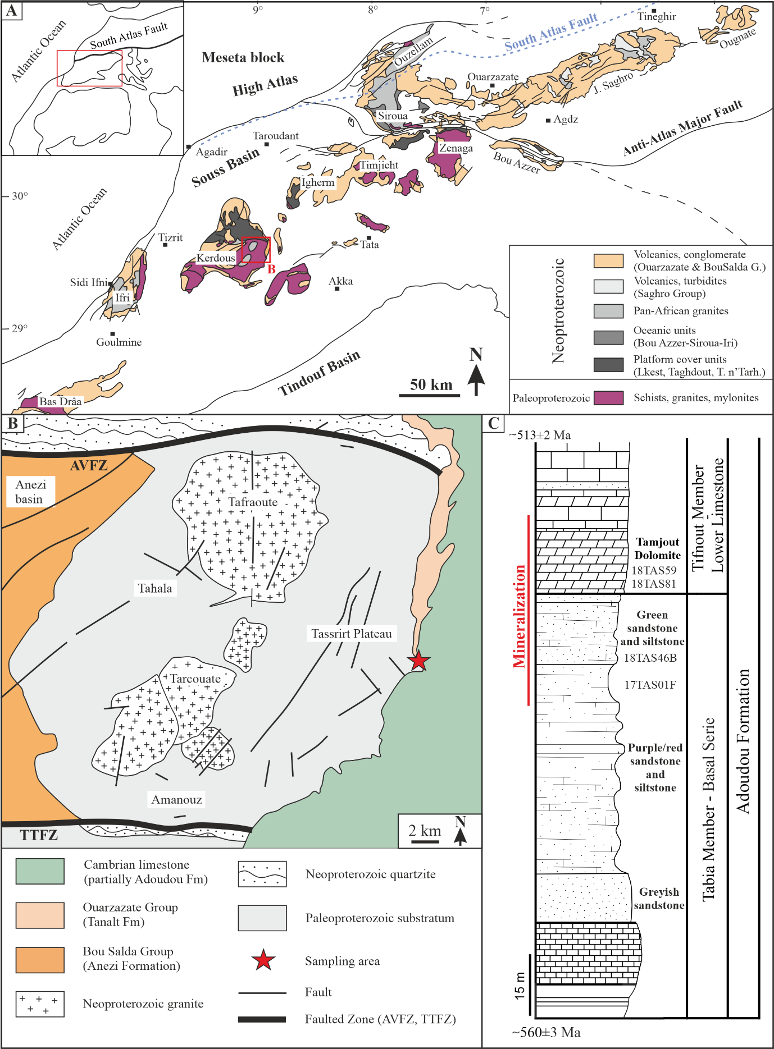
Figure 2
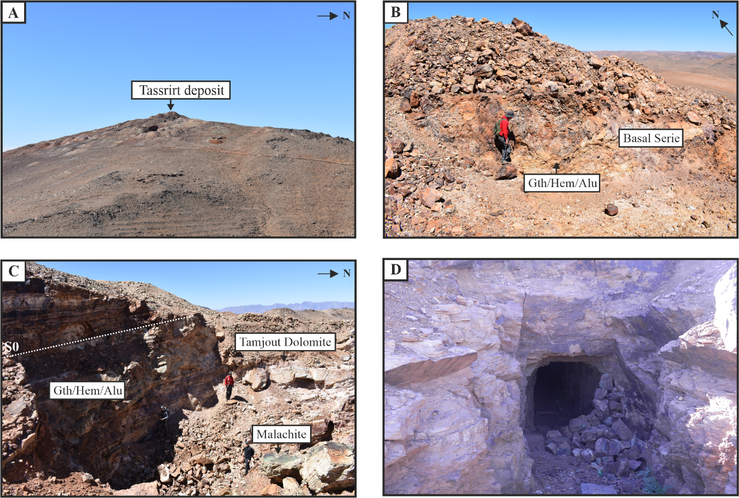

Figure 3
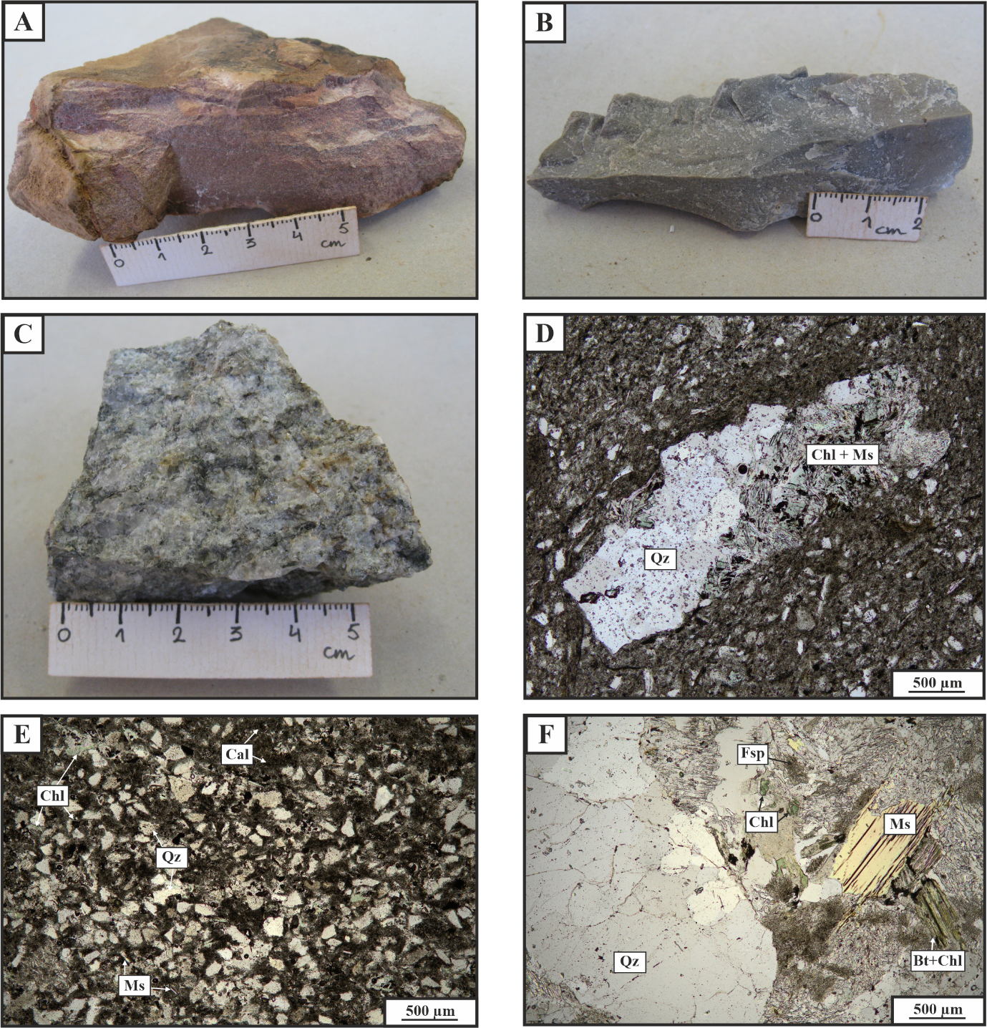

Figure 4
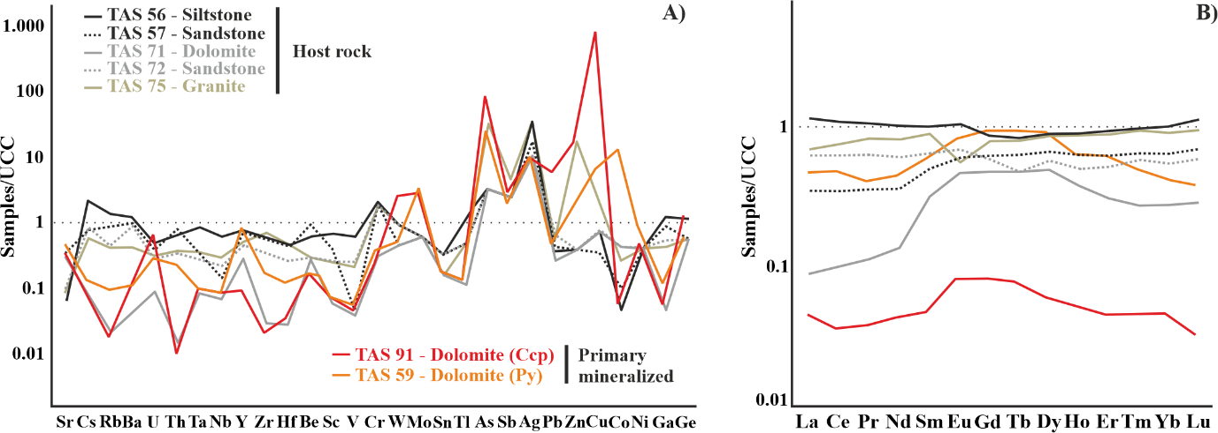

Figure 5
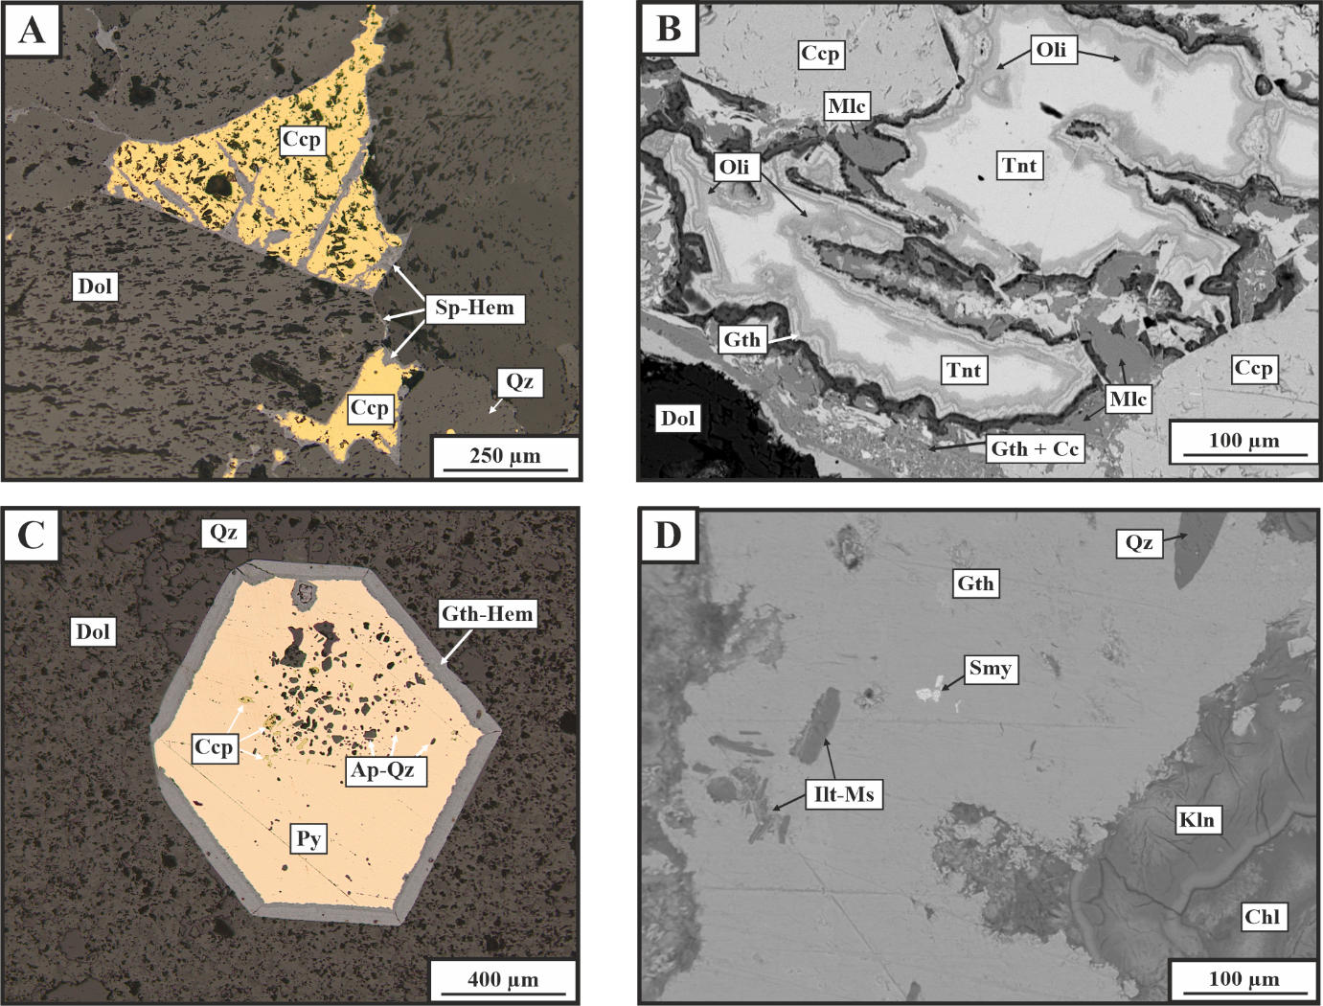
Figure 6
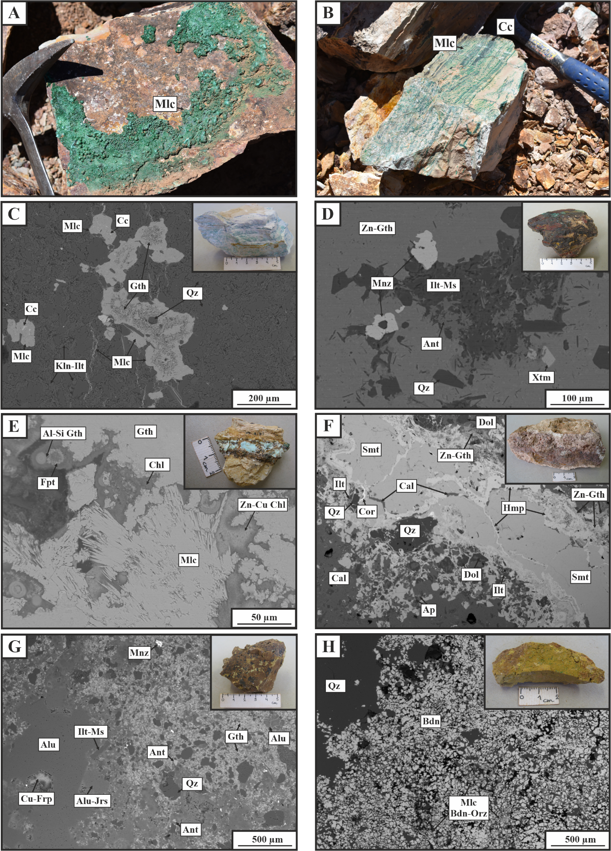

Figure 7
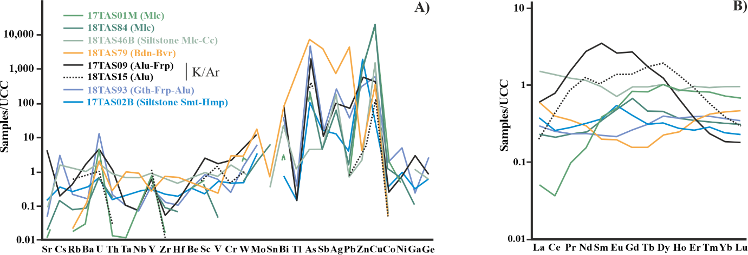

Figure 8
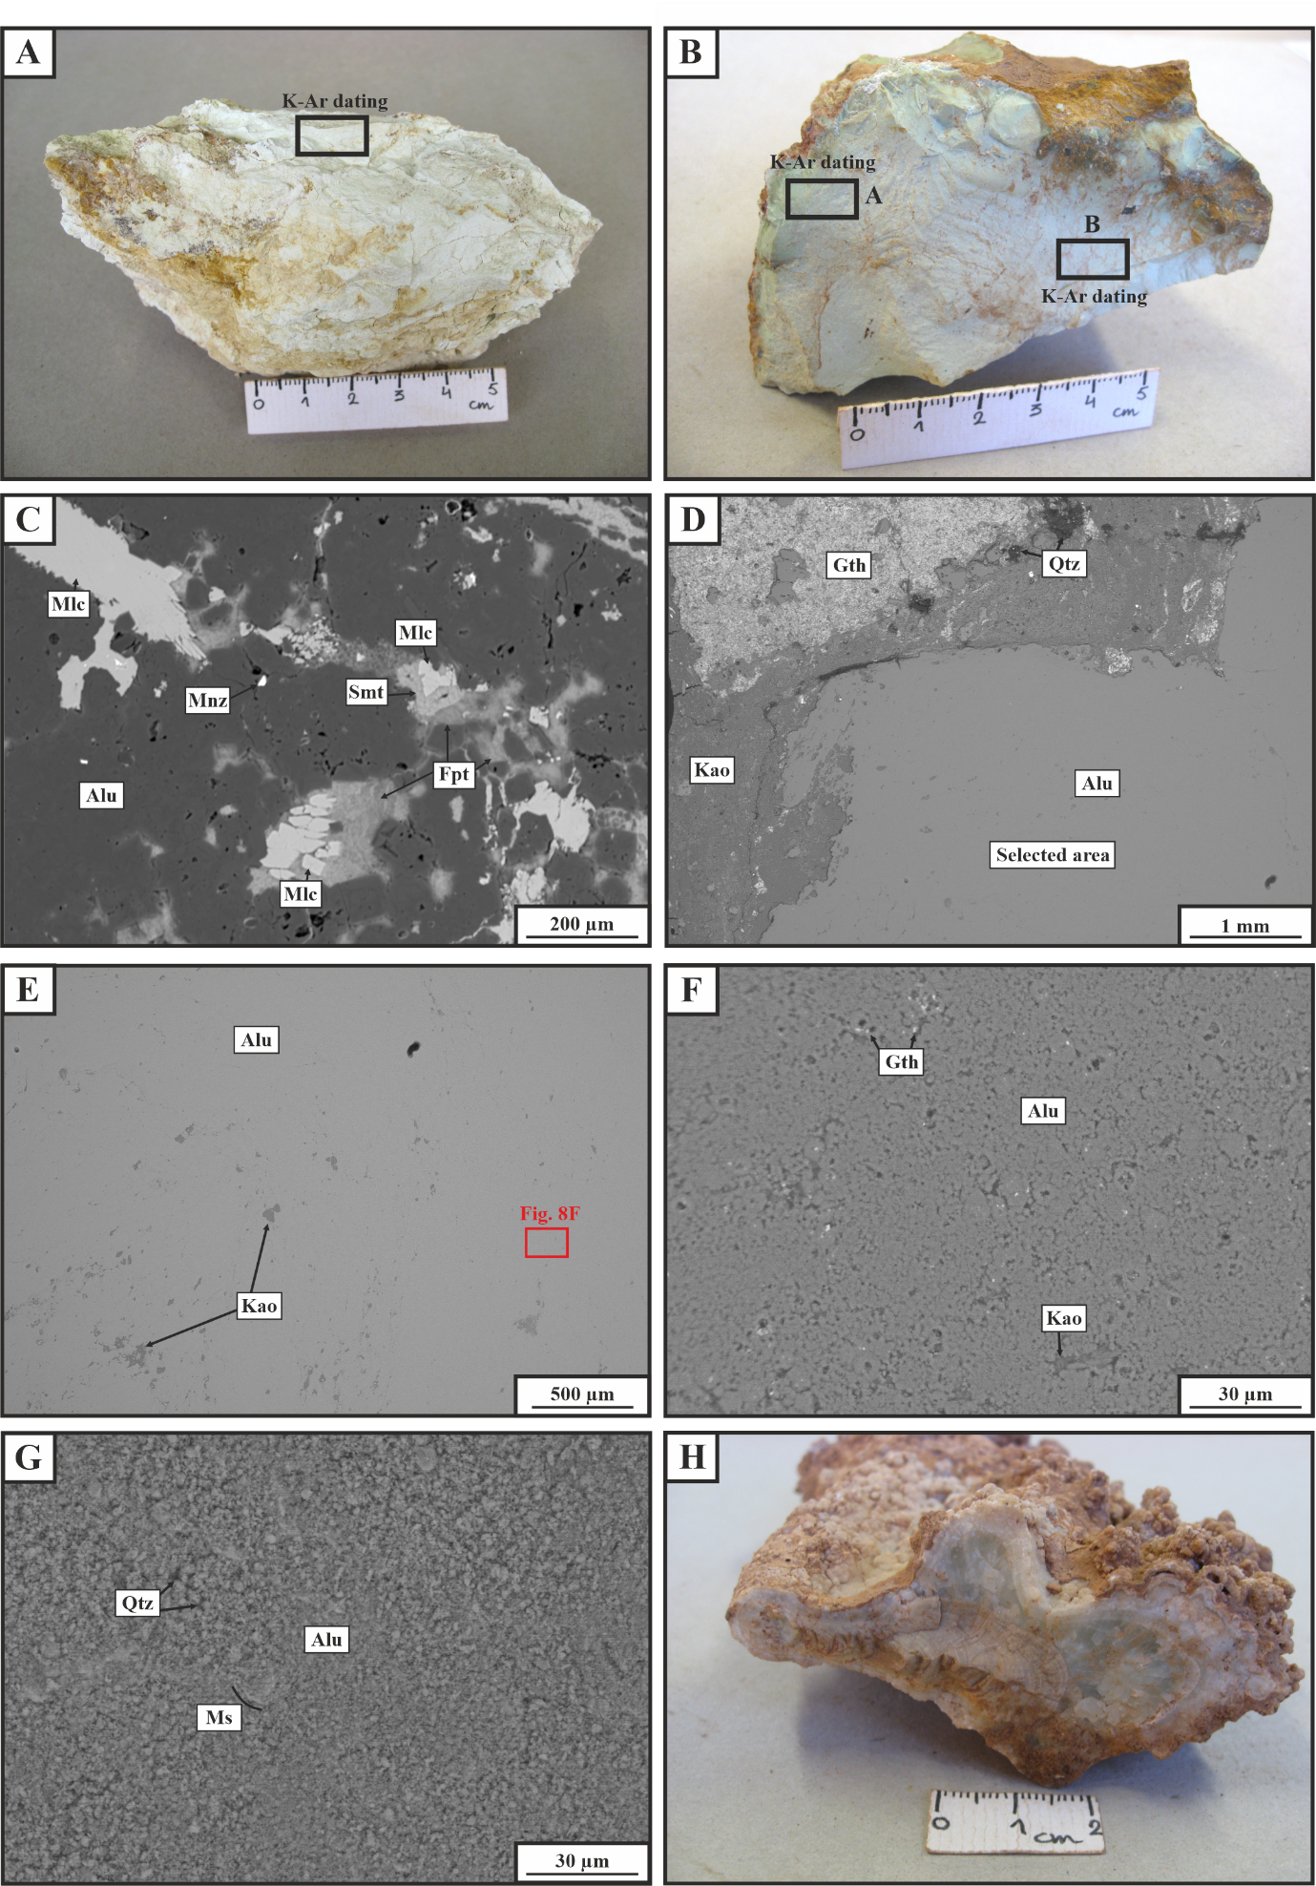

Figure 9
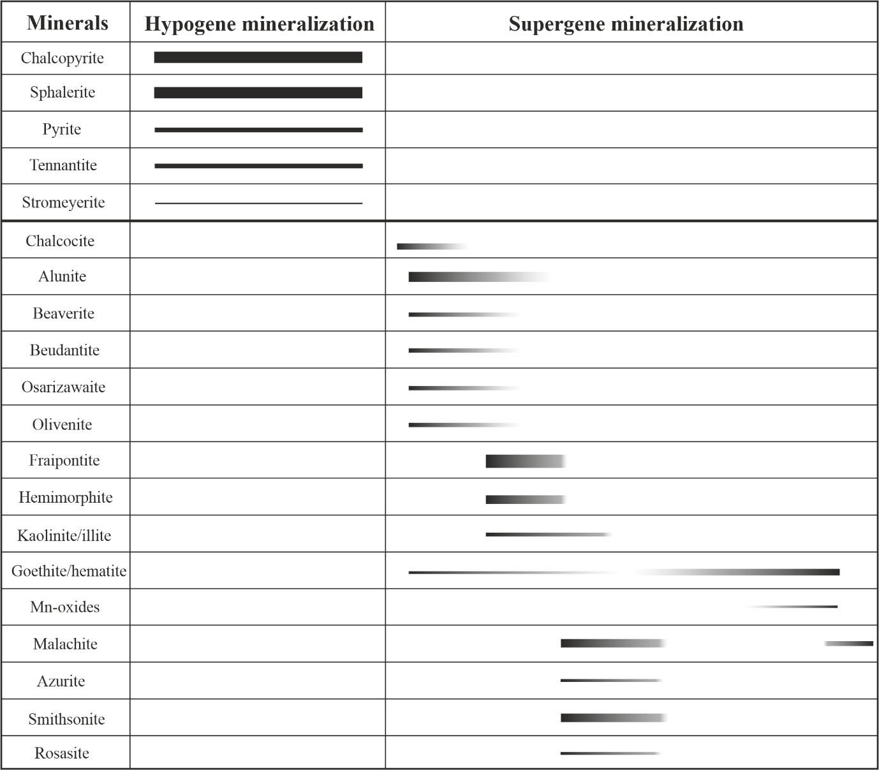

 |  | 17TAS09(1) | 17TAS09(2) | 18TAS15A(1) | 18TAS15A(2) | 18TAS15B(1) | 18TAS15B(2)
K | % | 6.58 | 6.58 | 7.29 | 7.38 | 7.15 | 7.24
± s | % | 0.07 | 0.07 | 0.08 | 0.08 | 0.07 | 0.08
⁴⁰Ar_{rad (nl/g)} | nl/g | 11.54 | 11.43 | 9.26 | 9.51 | 8.30 | 8.53
± s | % | 0.04 | 0.12 | 0.03 | 0.10 | 0.03 | 0.11
⁴⁰Ar_{air} | % | 18.5 | 22.6 | 10.9 | 15.0 | 15.8 | 15.7
Age | Ma | 25.1 | 24.9 | 18.2 | 18.6 | 16.7 | 17.1
2σ | Ma | 0.5 | 0.4 | 0.4 | 0.3 | 0.4 | 0.3
Table 1

