Assessment of the suitability of clay materials from the Sudano-Sahelian zone of Cameroon for brick production

Moongon Obam B. I ^{1, 2*}, Mache J.R^{3**}, Balo Madi A⁴, Manjia M.B¹, Fagel N²

¹: Laboratory of Civil Engineering and Mechanics, National Advanced School of Engineering of Yaoundé, University of Yaoundé 1, BP 8390, Yaoundé, Cameroon
²: Laboratory of Clays, Geochemistry and Sedimentary Environments, Department of Geology, University of Liege, Quartier Agora, 14, Allée du 6 Août, Bât. B18, Sart-Tilman- 4000, Liège, Belgium
³: Department of Mining Engineering, School of Geology and Mining Engineering, University of Ngaoundere, P.O.Box: 115 Meiganga, Cameroon.
⁴: Materials Analysis Laboratory, Local Materials Promotion Authority (MIPROMALO), BP 2393, Yaoundé, Cameroon
Corresponding authors:
E-mail:
*:irmaobam@gmail.com
**: jamache@yahoo.fr/jacques.mache@univ-ndere.cm;
https://orcid.org/0000-0003-2293-4587

Abstract
This study evaluates the suitability of six clayey materials from artisanal brickmaking sites in the soudano-sahelian zone of Cameroon for use as raw materials in fired brick production, which have not been previously tested. Their mineralogical and geochemical compositions were determined respectively by using X-ray diffraction and Fourier transform infrared spectrometry as well as by X-ray fluorescence spectrometry. The physical properties of the clays were determined through Atterberg limit test and laser particle-size distribution analysis. Thermal analyses (TGA/DSC) were conducted to survey the behavior upon heating of the clays. The main clay minerals identified in the clayey materials are kaolinite, illite, and smectite (montmorillonite) in variable proportions, along with varying amounts of quartz, K-feldspars, and plagioclases as associated minerals. All of the samples are mainly composed of SiO₂, Al₂O₃, and Fe₂O₃, with variable amounts of K₂O, Na₂O, CaO, and MgO, which are regarded as fluxing oxides. High concentrations (4.5–8.3%) of these oxides in the MPG, MPZ, and MPZL samples point out a high fluxing content, capable of achieving adequate densification at relatively low firing temperatures. In contrast, the MPB, MPD, and MPDB samples contain low proportions of fluxing oxides (≤2.5%), that may cause insufficient densification. The clays studied are characterized by a high proportion of sand fraction, with moderate proportions of silt and clay fraction, resulting in a low plasticity even for those with a high content of swelling clay minerals. All of the clayey materials undergo progressive thermal transformations with increasing temperature, beginning with dehydration at low temperatures (up to 100 °C), followed by dehydroxylation between 400 and 600 °C, decomposition of carbonates between 700 and 900 °C and finally a structural reorganization and recrystallization of newly minerals at temperatures above 900 °C. These clay materials (MPZL and MPDB) have good properties for brick production, while MPD and MPZ have acceptable properties but require extrusion. However, MPG, can be used for fired brick production but requires optimum extrusion. Furthermore, MPB, with a high plasticity index, requires the addition of a degreaser for use in the production of fired bricks.
Keywords: clayey material, characterization, suitability, fired brick

1. Introduction
The development of infrastructure in Africa is visible today, with roads and buildings appearing every day. This transformation is the result of the dynamism and expansion of the building and public works sector, which mobilizes vast financial and human resources. The building sector is therefore an important lever for socio-economic development in Africa. The building materials used in Africa vary according to the availability of local resources, economic needs, climate and cultural norms. Conventional industrial materials (concrete, steel) and local materials (stone, bamboo, straw, laterite, adobes and terracotta bricks) are commonly used. However, there is a growing trend towards the use of improved local materials, which combine traditional techniques with modern innovations to improve performance and durability. In the same vein, Cameroon, through its national development strategy (2020-2030), is promoting the exploitation of local resources in the construction sector to meet the growing demand for building materials (United Nations Development Program 2016) and improve the development of economy. Despite the fact that structures like the Local Materials Promotion Authority (MIPROMALO) produce ceramic building materials on an industrial scale, supply does not meet the existing demand, even though fired bricks are also produced by craftsmen (which are an important economic potential). However, the products of craftsmen are generally of poor quality due to the raw material which are not always appropriate for ceramic bricks production. Yet the knowledge of the particle size distribution, the mineralogical composition and the thermal behavior of these materials remains essential [1] to guarantee better quality of earthen building materials.
In Cameroon, raw clay deposits are widespread and of diverse origins (sedimentary, alluvial or residual) [2, 3]. Numerous studies have focused on the characterization of these materials for industrial purposes [4], for the decolorization of vegetable oils [5, 6], for the formulation of geopolymer cements based on kaolinitic-dominant clays [7], and for the production of fired products (porcelain, bricks, tiles, refractories and fine ceramics) [8-11]. In the Sudano-Sahelian zone of Cameroon, much work has focused on the characterization of raw clay materials and their valorization, mainly in ceramics and for the development of building materials [12-14]. Nguetnkam et al. [15] has shown that these materials are the result of the alteration of the granitic bedrock, which gives it a varied mineralogy. The mineralogy of this zone reveals that kaolinite, illite and smectites are the clay minerals preferentially associated with quartz, feldspars, oxy-hydroxides and plagioclases as accessory minerals [3, 16, 17]. The main major oxides present are silica (SiO₂), alumina (Al₂O₃), iron oxides and/or hydroxides (in ascending order in proportion). Alkali and alkaline earth are in relatively average proportion due to the initial alteration of the parent rock in a dry tropical climate [18]. In addition, these materials have a sandy-clayey texture with a predominant proportion of the sandy fraction [17].
Existing studies on clayey materials characterisation in the sudano-sahelian zone of Cameroon mainly concentrated on some limited isolated deposits. Whereas, this study focuses on the clay extraction sites of local fired brick artisans in order to address issues concerning quality for improved processing and final products for the enhancement of the local economy and consequently, local development. This will equally contribute to enrich the database on clay materials in the Sudano-Sahelian zone of Cameroon for possible industrial-scale brick production projects. Thus, the present work aims to assess the physical, geochemical, mineralogical and thermal properties of six samples collected from widely used artisanal fired brick production sites in the Sudano-Sahelian zone of Cameroon.
2. Materials and methods
2.1. Materials
The clayey materials examined in the present work were collected from six distinct artisanal brick-making sites in the Sudanian-Sahelian zone of Cameroon as located in the Far-North (Fig 1a) and in the North (Fig 1b) regions. The samples were taken at Bagara (MPB), Dablak (MPD), Guizigare (MPG), Zak-tinglin (MPZ), Doubangou (MPDB), and Zoulla (MPZL). Therefore, a single representative sample for each zone as shown in Fig 1c was collected, and the Munsell Soil Color Chart were used to determine the color of raw materials. The MPB raw material is compact and occurs as soil clods with diameters ranging from 8 to 15 cm, collected at depths between 50 and 100 cm; it dissolves poorly in water, forms a sticky paste to the touch, exhibits a dark gray color (2.5Y4/1), a sandy clay texture, and contains a few plant fibers. MPD appears as loose soil with a sandy–silty texture and a yellow color (2.5Y8/8); it is weakly plastic and contains small black ferruginous concretions. MPG occurs as compact soil clods measuring 1 to 3 cm in diameter, with pinkish rounded or flat fragments; it gradually dissolves in water, is slightly sticky adheres to the fingers, has a silty–clayey–sandy texture, contains coarse particles, and is gray in color (2.5Y5/1). MPZ is similar to MPG, with the presence of some pinkish rounded or flat fragments and millimeter-sized coarse elements, and displays a color of 2.5Y5/3. MPDB is characterized by loose and friable soil, moderately plastic, with small clods ranging from 2 to 5 cm; it has a silty texture, a color of 2.5Y8/3, and shows the presence of calcareous nodules, rust-colored stains, as well as roots and rootlets. MPZL consists of relatively coarse soil clods, is weakly plastic, lacks visible plant fibers, produces a sandy feeling when crumbled under water, has a silty texture, and displays numerous stains.

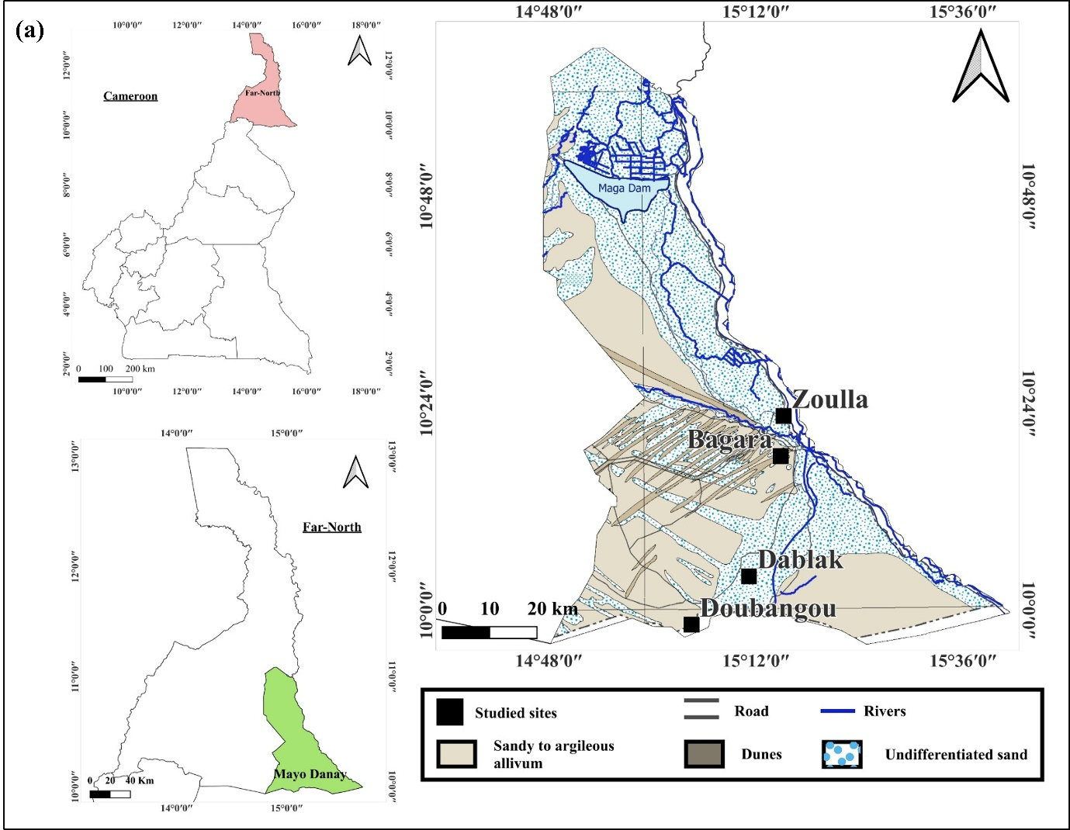
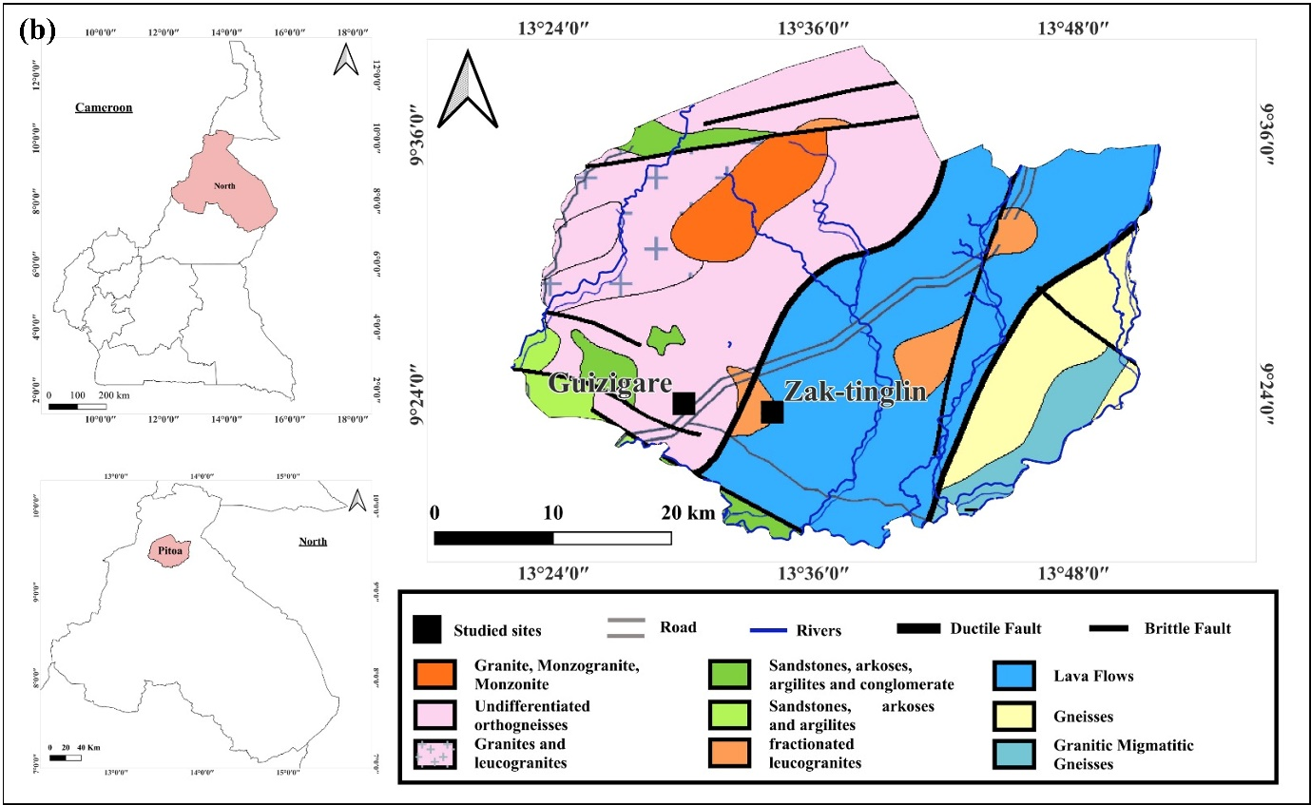
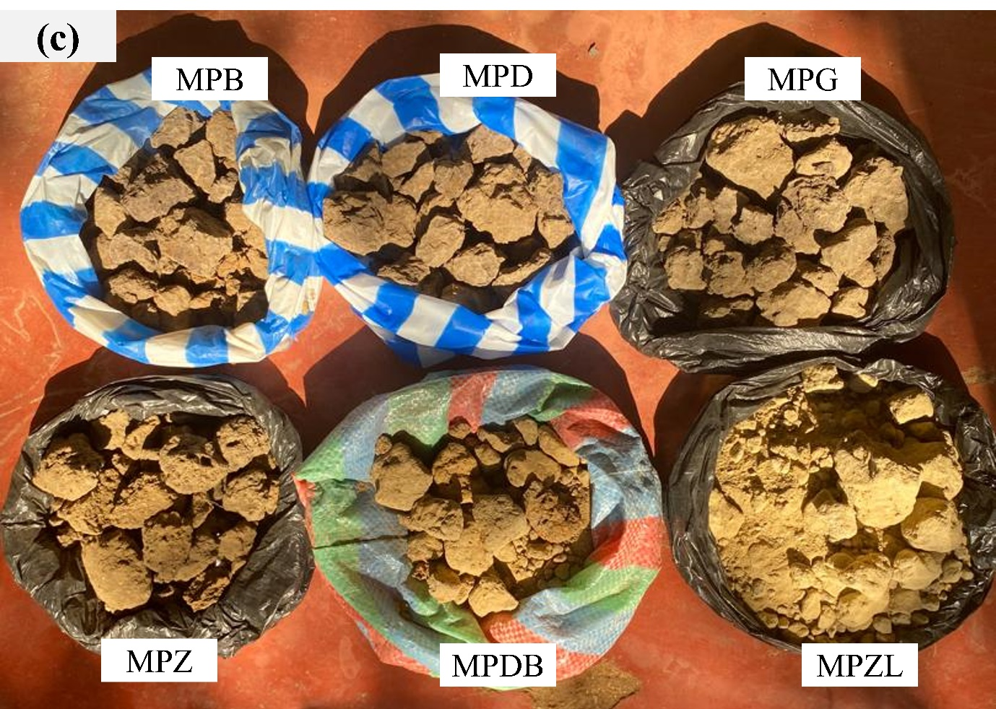

Fig.1. Map location of the sampling areas: (a)- Far-North Region; (b)- North Region, and (c)- Clayey materials samples collected
2.2. Experimental Methods
The physical tests (Particle Size Distribution, Atterberg limits, Methylene Blue index) were carried out at the Materials Analysis Laboratory of the Local Materials Promotion Authority (MIPROMALO), in Cameroon. Mineralogical (XRD, FTIR) and thermal (TGA/DSC) analyses were performed at the laboratory of Clays, Geochemistry and sedimentary Environment (AGEs), Geochemistry analysis (XRF) was performed at the laboratory of Petrology, Endogenous Geochemistry and Petrophysics, and microstructural analysis (SEM) was performed at the Laboratory of Structural Inorganic Chemistry, all at the University of Liège in Belgium.
Particle size distribution of raw samples was determined by wet sieving for fractions with grain size above 80μm according to the ASTM D6913–2017 standard [19], and sedimentometry for fractions with grain size below 80μm according to the ASTM D422-63–2007 standard [20]. Atterberg limits (liquid limit (LL) and plasticity limit (PL)) were measured according to ASTM D 4318-10 standard methodology [21]. The liquid limit was measured by Casagrande dish method and plastic limit by roller method. Plasticity index (PI) was calculated as the difference between LL and PL.
Methylene blue adsorption experiments were performed according to the NF P94–068 standard [22]. For 100 g of fine soil, the Methylene Blue Value (MBV) of the soil is given by the following equation:
MBV(g/100g) =$[VV_{cc}\left(mL\right).10\left(g\right).100(g)$]/$[1000\left(mL\right).fʹ(g)]$………………………. (1)
Where:
V_{cc} = volume of the methylene blue solution added into the soil solution, f’ = dry weight of the specimen used.
The major oxides contents were determined by X-ray fluorescence spectroscopy using a Bruker S8 Tiger 4 kW. Loss on ignition (LOI) was measured from total weight after ignition at 1000 °C for 2 h.
XRD analysis was performed on powder samples (<250µm) as well as on the clay fraction (<2µm) using a Bruker Advance D8 diffractometer (Cu Kα1 radiation (λ = 1.5406 Å, λ = 1, 5418 Å, V = 40 kV, I = 30 mA) according to the methodology proposed by Moore and Reynolds (1997) [23]. The measurements were carried out in the 2θ range from 2° to 70° (on powder samples) and from 2° to 30° (on the clay fraction) with step size of 0.02° and time per step 2s. The clay fraction (<2 µm) was separated from the bulk sample through a standard centrifugation procedure and recorded on oriented aggregates sequentially under natural conditions in air-dried (N), upon saturation with ethylene glycol (EG) for 24 h, and heating at 550° C for 4h (H), for the accurate distinction of clay minerals. The identification of mineral phases was carried out using DIFFRAC^{plus} Eva software (Bruker). Two methods were used to assess the mineral content in these clays: the peak intensity method on bulk powder samples and the area under the peak of the XRD profile for the clay fraction. The relative abundance of minerals on bulk powder was estimated from the intensity of the main peak of the mineral, multiplied by the corresponding corrective factor. Semi-quantitative estimation for the clay minerals was determined according to the method proposed by Fagel et al. (2003) [24]. The proportions of clay minerals were calculated in proportion to the total clay content of the total fraction and based on the intensities of the specific reflections measured on EG runs [25].
The Fourier Transform Infrared Spectroscopy (FTIR) was carried out on samples using a Nicolet NEXUS Spectrometer. For FTIR measurements, pellets were prepared using a mixture of the powdered sample and potassium bromide (KBr). Approximately 2 mg of the sample, previously ground to a particle size of <250 μm, was thoroughly homogenized with 148 mg of KBr. The mixture was then placed into a pellet die and subjected to high pressure using a hydraulic press to form a transparent, uniform pellet. The prepared pellets were immediately transferred to the FTIR spectrometer for analysis. The spectra were recorded within the range of 400 to 4000 cm⁻¹ with a resolution of 4 cm⁻¹.
Scanning electron microscopy (SEM) was used to determine the morphology of the clay samples. SEM images were obtained using a Philips ESEM-FG XL30 apparatus. To perform this analysis, clayey materials samples are wet-sieved < 63 μm and the passing fraction dried for 24 hours at 40 °C. The images were obtained with a secondary electron detector after gold metallization of the samples by plasma spraying (distance 5 cm, 30 mA, 0.05 atm. Argon, 50 seconds) for an acceleration voltage at 15 kV.
Simultaneous thermal analysis (STA) which allowed to measure the mass variation and the heat flow of the samples were performed on 25mg of clay raw material crushed and sieved to <250 μm. The analyses were performed at University of Liege using a Metler ®TGA apparatus in a range of 25°C to 1200 °C at a rate of 20°C per minute under nitrogen atmosphere.
3. Results
3.1. Physical and chemical properties of raw materials
Table 1: Physical properties of clayey materials
 | Parameter | MPB | MPD | MPG | MPZ | MPDB | MPZL
PSD (wt.%) | Clay (%) | 41.0 | 24.8 | 26.9 | 12.6 | 12.6 | 12.6
PSD (wt.%) | Silt (%) | 7.6 | 13.6 | 26.9 | 12.6 | 12.6 | 12.6
PSD (wt.%) | Sand (%) | 51.4 | 61.6 | 44.7 | 53.1 | 74.8 | 74.0
PSD (wt.%) | Gravel (%) | 0.0 | 0.0 | 1.5 | 21.7 | 0.0 | 0.8
Plasticity | LL (%) | 53.4 | 39.4 | 31.1 | 31.3 | 20.5 | 25.8
Plasticity | PL (%) | 35.0 | 28.2 | 17.4 | 19.7 | 16.1 | 21.4
Plasticity | PI (%) | 18.4 | 11.2 | 13.7 | 11.6 | 4.4 | 4.4
MBV (g/100g) |  | 5.1 | 4.3 | 5.5 | 2.8 | 5.2 | 3.3

The particle-size distribution of clayey material is an important factor to determine their suitability for various applications particularly for ceramic products [26]. From the particle size distribution data in Table 1, the studied samples are composed of clay fraction (<2µm) ranging from 11 to 41%wt, silt fraction (2-20µm) ranging from 7.6-24wt%, sand (20µm-2mm) ranging from 48-75wt.% and gravel (>2mm) ranging from 0.0-22wt%. Sample MPB has the highest content of clay fraction (41%) with a high content of fines (clay + silt fractions) (48.6%). The highest content of fines is observed in MPG (51%), MPZL and MPDB are rich in sand (74% and 75% respectively) with a lower content of clay (11%). The highest content of gravel (22%) is observed in MPZ. The Methylene Blue Values (MBV) ranged between 2.8 and 5.5g/100g, these values indicate that the studied materials are classified as silt-clay soil (2.5<MBV≤6). Regarding the plasticity of the clayey materials presented in Table 1, the liquid limit (LL) varies between 20% and 53%. The plasticity index (PI) varies between 4.4 and 18.4%. These plasticity index values for clayey materials classify them into two categories: low plasticity (PI≤15: MPD, MPG, MPZ, MPDB, MPZL) and high plasticity (PI>15: MPB) samples.
Table 2: Chemical composition of clayey materials.
Oxides (wt.%) | MPB | MPD | MPG | MPZ | MPDB | MPZL
SiO₂ | 60.86 | 78.91 | 61.05 | 66.42 | 75.93 | 65.25
Al₂O₃ | 17.02 | 9.56 | 15.30 | 13.18 | 10.71 | 14.65
Fe₂O₃ | 5.47 | 2.25 | 4.99 | 4.49 | 2.72 | 5.07
K₂O | 1.83 | 1.14 | 3.12 | 3.60 | 1.02 | 3.30
MgO | 0.24 | 0.13 | 1.41 | 1.09 | 0.26 | 0.35
TiO₂ | 1.07 | 0.59 | 1.04 | 0.72 | 0.71 | 0.87
P₂O₅ | 0.00 | 0.00 | 0.20 | 0.20 | 0.20 | 0.04
CaO | 0.50 | 0.30 | 2.30 | 1.82 | 0.26 | 0.56
Na₂O | 0.00 | 0.00 | 1.55 | 1.57 | 0.00 | 0.44
LOI | 11.82 | 5.83 | 7.66 | 5.92 | 7.06 | 7.09
Total | 98.81 | 98.71 | 98.62 | 99.01 | 98.87 | 97.62
SiO₂/Al₂O₃ | 3.57 | 8.25 | 3.99 | 5.03 | 7.08 | 4.45
Na₂O+K₂O | 1.83 | 1.14 | 4.67 | 5.17 | 1.02 | 3.74
CaO+MgO | 0.74 | 0.43 | 3.71 | 2.91 | 0.52 | 0.91

The chemical composition of the clayey materials presented in Table 2 is mainly dominated by silica (SiO₂: 61–79%), alumina (Al₂O₃: 11–17%), and iron oxide (Fe₂O₃: 2.3–5.5%). The proportion of fluxing agents (Na₂O + K₂O + CaO + MgO) ranges from 1.52% to 8.35%, while TiO₂ content does not exceed 1.5%. MPD and MPDB show the highest SiO₂ contents (76–79%) and the lowest contents of Al₂O₃ (9.6–11%), Fe₂O₃(2.3–2.7%), and fluxing agents (1.52–1.53%). Conversely, samples MPB and MPG exhibit the lowest SiO₂ content (61%) but the highest levels of Al₂O₃ (15–17%) and Fe₂O₃(5–5.5%). Regarding fluxing agents, MPB contains a low amount (2.54%), whereas MPG shows the highest content (8.35%). The high ratio SiO₂/Al₂O₃ (3.6-8.2) confirms the large contribution of free silica (amorphous silica or quartz) and the presence of illite [27, 28]. The content of Fe₂O₃ (2.3-5.5%) is associated to the iron mineral and could be responsible of the orange-yellow color of fired specimens [29]. The values of K₂O (1.0-3.6%) are associated to the presence of non-clay mineral as feldspars and clay mineral as illite revealed by X-ray diffraction analysis, and the values of MgO (0.24-1.41%), Na₂O (0-1.6%) and CaO (0.3-2.30%) are oxides containing Mg²⁺, Na⁺ and Ca²⁺ cations present in the interlayer space of 2:1 clay (smectites, illites) and serve to compensate for the negative charge deficit created by isomorphic substitutions in the layers. These compensating cations ensure the electroneutrality of the layers [30, 31]. According to Celik, 2010 [30] the relatively low Loss on Ignition (LOI) values, ranging from 5.8% to 7.1% observed in five clay samples are indicative of a low clay mineral content and suggest the presence of hydrated minerals such as goethite, and a high LOI value (>10 % for MPB sample) is associated with high SiO₂ and Al₂O₃ contents caused by the significant abundance of clay minerals [32]. When compared to the typical LOI value of pure kaolinitic clays (around 14%), these lower values imply the presence of impurities particularly quartz (SiO₂) which may contribute to the high abrasive behavior observed in fired products like bricks and tiles [33].
3.2. Mineralogical composition of clayey materials

Fig. 2. XRD patterns of clayey materials: Kaol: Kaolinite; Sme: Smectite; Hem: Hematite; Ill: Illite; Qtz: Quartz; Kfs: K-Feldspar; Pl: Plagioclase

Fig. 3. XRD patterns of Clay < 2μm pattern. N: air dried condition; EG: glycolated condition with ethylene glycol for 24 h; H: heated condition (500°C for 4 h). Sme: Smectite; Ill: Illite; Kaol: Kaolinite

Table 3 Mineralogical composition of clayey materials.
Minerals | Range of d spacing (Å) | Intensity factors | Semi-quantification (%)
Minerals | Range of d spacing (Å) | Intensity factors | MPB | MPD | MPG | MPZ | MPDB | MPZL
Quartz | 3.33-3.37 | 1 | 31 | 70 | 21 | 50 | 56 | 46
K-feldspar | 3.24-3.26 | 4.30 | 23 | 10 | 41 | 9 | 5 | 23
Plagioclase | 3.16-3.19 | 2.80 | 7 | 0 | 14 | 30 | 6 | 12
Total clay | 4.44 | 20 | 39 | 20 | 17 | 11 | 33 | 19
Hematite | 2.71 | 3.33 | - | - | 6 | - | - | -
Kaolinite | 7.02-7.25 | 0.70 | 9 | 5 | 2 | 1 | 24 | 12
Illite | 9.98-10.0 | 1 | 2 | 2 | 1 | 2 | 5 | 6
Smectite | 14-17 | 3 | 27 | 13 | 14 | 8 | 3 | 2
The XRD patterns of the studied clayey materials are shown in Fig. 2. The mineral phases identified are quartz (main peaks at 3.34Å,), feldspars (main peak at 3.24Å) except for MPD, kaolinite (main peak at 7.1Å), plagioclase (3.18Å) and the peak at 4.47Å associated to the contribution of clay minerals. The patterns of clay fraction (<2µm) show the presence of kaolinite (7.1Å-7.2Å), illite (9.95-10.0Å), and smectite (14.6-15.9Å) as shown in Fig. 3. The presence of smectite or smectite-illite mixed-layers was confirmed by the expansion of peak 001 (with ethylene glycol) from 14.4Å up to 17.3Å. The high valley/peak ratio (v/p ~ 1) reveals a relatively pure smectite only in MPB. The other samples (except MPZL) do not display a well-defined valley (v/p > 1). The broad and continuous reflection observed between 14 and 17Å suggest the presence of an interstratified smectite-illite minerals with low proportions of swelling layers (< 40% according to [34]). The swelling behavior is particularly limited in MPDB and MPZL, with a peak observed after EG saturation at 15.9Å and 14.5Å, respectively. The limited expansion observed after solvation (peak at 14.5 Å) suggests the presence, in low abundance, of interstratified smectite-illite minerals mixed-layers in MPZL. The expansion at 15.9 Å in MPDB indicates either smectite-illite mixed-layers and/or vermiculite.
The persistence of diffraction peaks around 7.1Å and 9.9Å after EG treatment on one hand, and the disappearance of peaks around 7.1Å, coupled with the persistence of peaks around 9.9Å, after thermal treatment on the other hand, confirms the presence of kaolinite and illite in all samples. The raw materials are composed of quartz (21-70%wt), K-feldspar (5-41%wt), plagioclase (0-30%wt), smectite (2-27%wt), kaolinite (1-24%wt) and illite (1-6%wt). Kaolinite, is the main clay mineral required for ceramic industry [4], is present in all samples in varying concentrations. The samples can therefore be classified according to their kaolinite content, as follows: MPDB (24%)>MPZL (12%)>MPB (9%)>MPD (5%)>MPG (2%)>MPZ (1%). Furthermore, feldspars, which act as fluxing agents in the manufacture of ceramic products [31], are widely represented in all the samples studied.
Fig. 4. FTIR spectra of the < 250 μm fractions of the clayey materials samples
The samples’ infrared spectra are shown in Fig. 4. The presence of kaolinite in all the studied samples is confirmed by the absorption bands appearing between 3700 cm⁻¹ and 3620 cm⁻¹, which are characteristic of the O-H stretching bands of the kaolinite [12]. The three bands observed at 3698 cm⁻¹, 3646 cm⁻¹ and 3624 cm⁻¹ without a well-defined peak at 3646cm⁻¹, reveal that the kaolinite present in the materials studied is disordered or poorly crystallized [35]. The absorption band observed at 3417-3421cm⁻¹ is attributed to the stretching vibration of the OH group of the Al-OH bond in kaolinite [36]. The absorption band at 1631 cm⁻¹ is characteristic of the stretching vibration of the O-H bond of absorbed water molecules in the samples. The absorption bands at 1066 cm⁻¹, 1035cm⁻¹, 917 cm⁻¹ are attributed to the stretching vibration of the Si-O-Si and Al-OH bonds of kaolinite. 773 cm⁻¹ and at 698cm-1 are characteristic of the Si-O bond of quartz and feldspars [37]. The absorption band at 530 cm⁻¹ corresponds to the stretching vibration of the Si-O-Al bond characteristic of aluminosilicate minerals, and the bands at 464 cm⁻¹ and 424 cm⁻¹ are attributed to Si-O-Si bond , characteristic of silicate minerals [38, 39].

Fig. 5. SEM images of the clayey materials. a: MPB; b: MPD; c: MPG; d: MPZ; e: MPDB; f: MPZL

The SEM micrographs of the studied clay materials are presented in Fig.5. Smectite particles are observed appearing as flower-like structure with folded edge petals in samples MPB, MPG and MPZ but less visible in sample MPD, sample MPD being the least magnified on the micrographs, with encrusted quarts particles. Voids between quartz particles are more observed in samples MPB, MPD, MPDB and MPZL, finely coated by kaolinite and smectite particles. Pseudo-hexagonal particles of kaolinite are observed more in sample MPZL. The SEM micrographs of the studied clay materials show a strong morphological heterogeneity, confirming the varied mineralogical composition detected by X-ray diffraction in terms of clay minerals (smectite, kaolinite) and non-clay minerals (quartz).

Fig. 6. TG/DTG curves of the clayey materials.

Fig. 7. DSC curves of the clayey materials.

The simultaneous thermal analysis (STA) presented in Fig. 6 and Fig. 7 reveals the thermal behaviour and transformation mechanisms during heating of the clayey materials studied. The curves show a first endothermic peak for all samples between 71-88°C without a significant peak on the DSC curve. This peak is associated with a mass loss between 1-3% and corresponds to the dehydration of adsorbed water [39, 40]. The second endothermic peaks observed at 247-280°C (most pronounced in MPB, MPDB and MPZL) with a gradual decrease in mass (0-1%) and slight endothermic shifts on the DSC curves are related to the oxidation of organic matter or decomposition of iron hydroxides (e.g., goethite) [41]. However, iron minerals were not detected by XRD, this indicates that the iron-bearing phases may be present in an amorphous form [28], or integrated into the clays structure. The third endothermic peaks more prominent and stronger the other endothermic peaks (less marked in MPG and MPZ) associated with mass loss between 1% and 4% are observed between ~450-600°C and are related to the dehydroxylation of kaolinite into metakaolinite [40], and other clay minerals such as smectite/illite. Between 650-800°C a continuous mass loss is still observed with no significant peaks. This event maybe related to the structural reorganization of minerals or to an entire dehydroxylation of illite and smectite. Above 850°C, the mass loss a nearly complete, however, some exothermic peaks in the DSC curve are observed in all the samples. They are related to the new crystalline phase formation such as mullite and spinel [4, 39].
4. DISCUSSION
The quality of terracotta building materials is the result of a balance between the different properties of the raw material used, such as the particle size distribution in terms of the proportion of fine fraction (clay+silt) and sand fraction, which have an influence on the plasticity of the material. Particle size distribution and plasticity are essential to define the properties of bricks during drying and firing [41]. The Belgian diagram of textural classifications of clay materials (Fig. 8a) was used to classify the samples studied by their particle size distribution. This diagram indicates that the materials are heavy sandy clay (MPB), sandy clays (MPD, MPG), clayey sand (MPZL, MPDB) and heavy sandy silt (MPZ). This is in accordance with the proportions of different fractions (clay, silt and sand) observed. A sample with a high proportion of fine fraction (<2µm) will therefore be more plastic than one with a lower proportion of fine fraction [42]. Good plasticity ensures good cohesion of the paste and facilitates its shaping while limiting the risk of cracking and/or deformation after drying or firing. Barnes (2018) [43] shows that materials with IP<10% are not appropriate for the manufacture of building-related items, and those with an IP>34% would be difficult to extrude. According to the Bain and Higley diagram of the materials studied see Fig. 8b, all the samples are suitable for the production of bricks except for MPB which is suitable for pottery. MPD, MPZ and MPG samples have better shaping properties and reduce the risk of cracking due to their plasticity indices. MPDB and MPZL, on the other hand are in the range of brick making. However, in order to improve their shaping, more plastic materials should be added to these samples in order to achieve the plasticity values recommended for the production of fired bricks. MPB would be more suitable for pottery because it has a high plasticity index (IP≥15). High plasticity index requires a large amount of water for shaping, which would lead to high volumetric shrinkage (due to the departure of the shaping water) during drying and firing and would induce the occurrence of cracks [44]. In addition, it is likely to vitrify excessively and produce weakly porous bricks but too dense and brittle. To prevent these phenomena, it would be wise to incorporate degreasers in order to reduce its plasticity, and to control temperatures and firing times. The clayey materials studied were plotted in the diagram of grain size classification see Fig. 8c. This diagram shows that MPB, MPG, MPD are proper for hollow bricks, roofing tiles and masonry bricks blocks and vertically perforated bricks respectively. MPZ are appropriate for common bricks. On the other hand, MPDB and MPZL do not correspond to any defined areas in the diagram. Their high content of in sand is responsible for this behavior. The addition of material with higher content in clay fraction may improve the processing of these samples as indicated above.
Chemical analysis of clay materials provides important information for understanding their properties. It influences the quality of bricks because each oxide plays a specific role during the mineralogical and physicochemical transformations that occur during firing. These transformations are at the origin of the different physico-mechanical properties essential for determining the suitability of the raw material for a specific use. During firing, the densification of the material is favoured by the chemical reactions occurring between the feldspars (Na₂O+K₂O or CaO+MgO) combined with quartz, and the clay minerals. Kaolinite (Al₂Si₂O₅(OH)₄) is transformed by dehydroxylation between 550°C-600°C, into metakaolinite (Al₂O₃,2SiO₂) with a metastable amorphous structure. At 950-1000°C when the feldspar grains react with the amorphous silica and kaolinite phases to form the glassy phase (around 950°C), the metakaolinite transforms into spinel and the finer quartz grains start to dissolve in the glassy phase [45]. Beyond 1100°C, the spinel transforms into primary mullite and silica which will react with the quartz particles and densify the material. A high proportion of silicon oxide (SiO₂) and low values ​​of alumina (Al₂O₃) (<15%) and fluxing agents (<5%) as observed for MPD and MPDB could thus limit the formation of the glassy phase and densification, which would give porous bricks with poor mechanical properties because the glassy phase would be insufficient to fill the pores released by the dehydration and dihydroxylation reactions. Furthermore, balanced proportions of SiO₂ (61-66.4%), Al₂O₃ (13-17%) and fluxing agents (9.11-13.5%) as observed in samples MPB, MPG, MPZ and MPZL would favor the production of fired bricks with acceptable physico-mechanical properties. This is in agreement with their positions in the ternary diagram of [46] see Fig. 8d.

Fig. 8. (a): Classification of the clayey materials according to the Belgian triangle of textures Richer de Forges et al., 2008. (b): Diagram of Bain and Highly (1978) showing sample good for brick (MPDB, MPZL), samples acceptable (MPB, MPD, MPZ,) or optimum (MPG) in extrusion brick-making. (c): Technological classification of the clay samples according to Winkler (1954): (1): common bricks; (2): vertically perforated bricks; (3): roofing tiles and masonry bricks blocks; (4): hollow bricks. (d): Ternary diagram of Fiori et al [46] : Chemical classification of clays raw materials in ceramic: (a): white stoneware; (b): red stoneware; (c): cottoforte tile; (d): majolica tile.

5.CONCLUSION
The work is focused on the physical, geochemical, mineralogical and thermal study of six (06) samples collected from large-scale artisanal fired brick production sites in the Sudano-Sahelian zone of Cameroon. Accordingly, the following conclusions are drawn:
- The raw materials studied are materials with low to medium plasticity, classifying them as clayey-sand, sandy clay, heavy sandy silt and heavy sandy clay materials.
- The raw materials are composed of non-clay minerals such as quartz (21-70%), K-feldspar (5-41%), plagioclase (0-30%) and hematite (6%)., and the clay minerals are Kaolinite (1-24%), illite (1-6%) and smectite (2-27%).
- The clay materials are rich in SiO₂ and Al₂O₃, and the values of the SiO₂/ Al₂O₃ ratio largely greater than 3 indicate a high SiO₂ content, which is in accordance with the presence of quartz associated with clay minerals (kaolinite-illite-smectite).
- The relatively high combined presence of Na₂O+K₂O (1.0–5.2%) and CaO+MgO (0.4–3.7%) in these samples will act as a flux during brick firing, lowering the vitrification temperature to densify the brick and improve its mechanical properties.
- The classification of the clay samples according to Winkler (1954) show that these raw materials can used for common bricks, vertically perforated bricks, roofing tiles, masonry bricks blocks and hollow bricks.
- The clay materials (MPZL and MPDB) have good properties for brick production, while MPD and MPZ have acceptable properties but require extrusion. However, MPG, can be used for fired brick production but requires optimum extrusion. Furthermore, MPB, with a high plasticity index, requires the addition of a degreaser for use in the production of fired bricks.

Acknowledgements: The authors which to acknowledge their gratitude to Mr Joel Otten, for the support.
Author contributions:
Moongon Obam Berthe Irma: Conceptualization, Methodology, Investigation, Resources, Formal analysis, Data curation, Writing – original draft. Mache Jacques Richard: Conceptualization, Methodology, Visualization, Data curation, Writing – review & editing. Balo Madi Achille: Methodology, Writing – review & editing. Manjia Marcelline Blanche: Methodology, Supervision, Writing – review & editing. Fagel Nathalie: Resources, Methodology, Validation, Supervision, Data curation, Writing – review & editing.
Funding
This research was funded by ARES (Académie de Recherche et d’Enseignement Supérieur)
Availability of data and materials: All data generated or analyzed during this study are included in this article. Materials are available under reasonable request.

DECLARATIONS

Ethics approval
All authors declare that this work complies with ethical guidelines set by the journal.

Consent to participate
Not applicable

Consent for publication
Not applicable

Competing interests
The authors declare no conflict of interest.

REFERENCES
[1] Sousa, S. J. G., and Holanda, J. N. F. (2005). Development of red wall tiles by the dry process using Brazilian raw materials. Ceramics International, vol. 31, no. 2, pp. 215–222, doi: 10.1016/j.ceramint.2004.05.003
[2] Ngon Ngon, G. F., Mbog, M., Etame, B., Ntamak-Nida, M. J., Logmo, E. O., Gerard, M., Yongue-Fouateu, R., Bilong, P. (2014). Geochemistry of the Paleocene-Eocene and Miocene-Pliocene clayey materials of the eastern part of the Wouri River (Douala sub-basin, Cameroon): Influence of parent rocks. Journal of African Earth Sciences, vol. 91, pp. 110–124, doi: 10.1016/j.jafrearsci.2013.12.005
[3] Ndjigui, P. D., Beauvais, A., Fadil-Djenabou, S., and Ambrosi, J. P. (2014). Origin and evolution of Ngaye River alluvial sediments, Northern Cameroon: Geochemical constraints. Journal of African Earth Sciences, vol. 100, pp. 164–178, doi: 10.1016/j.jafrearsci.2014.06.005
[4] Pialy, P., Nkoumbou, C., Villiéras, F., Razafitianamaharavo, A., Barres, O., Pelletier, M., Ollivier, G., Bihannic, I., Njopwouo, D., Yvon, J., Bonnet, J. P. (2008). Characterization for industrial applications of clays from Lembo deposit, Mount Bana (Cameroon). Clay miner., vol. 43, no. 3, pp. 415–435, doi: 10.1180/claymin.2008.043.3.07
[5] Nguetnkam, J. P., Kamga, R., Villiéras, F., Ekodeck, G. E., and Yvon, J. (2008). Assessing the bleaching capacity of some Cameroonian clays on vegetable oils. Applied Clay Science, vol. 39, no. 3–4, pp. 113–121, doi: 10.1016/j.clay.2007.05.002
[6] Mache, J. R., Signing, P., Njoya, A., Kunyukubundo, F., Mbey, J. A., Njopwouo, D., Fagel, N. (2013). Smectite clay from the Sabga deposit (Cameroon): mineralogical and physicochemical properties. Clay miner., vol. 48, no. 3, pp. 499–512, doi: 10.1180/claymin.2013.048.3.07
[7] Lemougna, P. N., Melo, U. F. C., Kamseu, E., and Tchamba, A. B. (2011). Laterite Based Stabilized Products for Sustainable Building Applications in Tropical Countries: Review and Prospects for the Case of Cameroon. Sustainability, vol. 3, no. 1, pp. 293–305, doi: 10.3390/su3010293
[8] Ngon Ngon, G. F., Yongue Fouateu, R., Lecomte Nana, G. L., Bitom, D. L., Bilong, P., and Lecomte, G. (2012). Study of physical and mechanical applications on ceramics of the lateritic and alluvial clayey mixtures of the Yaoundé region (Cameroon). Construction and Building Materials, vol. 31, pp. 294–299, doi: 10.1016/j.conbuildmat.2011.12.108
[9] Nzeukou-Nzeugang, A., Medjo Eko, R., Fagel, N., Kamgang-Kabeyene, V., Njoya, A., Balo Madi, A., Mache, J. R., Melo Chinje, U. (2013). Characterization of clay deposits of Nanga-Eboko (central Cameroon): suitability for the production of building materials. Clay miner., vol. 48, no. 4, pp. 655–662, doi: 10.1180/claymin.2013.048.4.18
[10] Bomeni, I. Y., Njoya, A., Ngapge, F., Wouatong, A. S. L., Yongue-Fouateu, R., Kamgang- Kabeyene, V., Fagel, N. (2018). Ceramic with potential application of ngwenfon alluvial clays (noun, west cameroon) in building construction: Mineralogy, physicochemical composition and thermal behaviour. Construction and Building Materials, vol. 182, pp. 493–503, doi: 10.1016/j.conbuildmat.2018.06.135
[11] Assomo, P. S., Lawou, S. K., Bouba, L., and Beyala, V. K. K. (2022). Géochimie, minéralogie et sélection altérologique des argiles alluviales de la vallée du Nyong à Akonolinga (Cameroun) en vue de leur utilisation dans la production des briques cuites. J. Cam. Acad. Sci, vol. 18, no. 2, pp. 419–436, doi: 10.4314/jcas.v18i2.3
[12] Tsozué, D., Nzeugang, A. N., Mache, J. R., Loweh, S., and Fagel, N. (2017). Mineralogical, physico-chemical and technological characterization of clays from Maroua (Far-North, Cameroon) for use in ceramic bricks production. Journal of Building Engineering, vol. 11, pp. 17–24, doi: 10.1016/j.jobe.2017.03.008
[13] Temga, J. P., Mache, J. R., Madi, A. B., Nguetnkam, J. P., and Bitom, D. L. (2019). Ceramics applications of clay in Lake Chad Basin, Central Africa. Applied Clay Science, vol. 171, pp. 118–132, doi: 10.1016/j.clay.2019.02.003
[14] Moctar, I. B., Yannick, T. L., Albertine, A. S. T., Mache, J. R., and Mominou, N. (2023). Physico-chemical, mineralogical characterization, and ceramic properties of clay materials from South Mindif (Far North, Cameroon). JMST Adv., vol. 5, no. 1, pp. 13–26, doi: 10.1007/s42791-023-00047-9
[15] Nguetnkam, J. P., Kamga, R., Villiéras, F., Ekodeck, G. E., and Yvon, J. (2007). Pedogenic formation of smectites in a vertisol developed from granitic rock from Kaélé (Cameroon, Central Africa). Clay miner., vol. 42, no. 4, pp. 487–501, doi: 10.1180/claymin.2007.042.4.07
[16] Fadil-Djenabou, S., Ndjigui, P. D., and Mbey, J. A., (2015). Mineralogical and physicochemical characterization of Ngaye alluvial clays (Northern Cameroon) and assessment of its suitability in ceramic production. Journal of Asian Ceramic Societies, vol. 3, no. 1, pp. 50–58, doi: 10.1016/j.jascer.2014.10.008
[17] Tsozué, D., Nzeugang, A. N., Kagonbé, B. P., Madi, A. B., Mache, J. R., Bitom, D. L., Fagel, N. (2022). Genesis and assessment of clay materials suitability for earthenware production in northern Cameroon. Arab J Geosci, vol. 15, no. 16, p. 1376, doi: 10.1007/s12517-022-10603-7
[18] Nguetnkam, J. P., Villiéras, F., Kamga, R., Ekodeck, G. E., and Yvon, J. (2014). Mineralogy and geochemical behaviour during weathering of greenstone belt under tropical dry conditions in the extreme North Cameroon (Central Africa). Geochemistry, vol. 74, no. 2, pp. 185–193, doi: 10.1016/j.chemer.2013.06.007
[19] D18 Committee, Test Methods for Particle-Size Distribution (Gradation) of Soils Using Sieve Analysis. doi: 10.1520/D6913_D6913M-17
[20] D18 Committee, Test Method for Particle-Size Analysis of Soils. doi: 10.1520/D0422-63R07.
[21] D18 Committee, Test Methods for Liquid Limit, Plastic Limit, and Plasticity Index of Soils, West Conshohocken, PA. doi: 10.1520/d4318-10.
[22] Association Française de Normalisation. (1998). Sols: reconnaissance et essais - Détermination de la valeur de bleu de méthylène d’un sol ou d’un matériau rocheux par l’essai à la tache (NF P94-068).
[23] Moore D. M., and Reynolds, R. C. (1997). X-ray diffraction and the identification and analysis of clay minerals. 2. ed. Oxford: Oxford University Press
[24] Fagel, N., Boski, T., Likhoshway, L., and Oberhaensli, H. (2003). Late Quaternary clay mineral record in Central Lake Baikal (Academician Ridge, Siberia). Palaeogeography, Palaeoclimatology, Palaeoecology, vol. 193, no. 1, pp. 159–179, doi: 10.1016/S0031-0182(02)00633-8
[25] Biscaye, P. E. (1965). Mineralogy and Sedimentation of Recent Deep-Sea Clay in the Atlantic Ocean and Adjacent Seas and Oceans. Geol Soc America Bull, vol. 76, no. 7, p. 803, doi: 10.1130/0016-7606(1965)76%5B803:MASORD%5D2.0.CO;2
[26] Mahmoudi, S., Srasra, E., and Zargouni, F. (2008). The use of Tunisian Barremian clay in the traditional ceramic industry: Optimization of ceramic properties. Applied Clay Science, vol. 42, no. 1–2, pp. 125–129, doi: 10.1016/j.clay.2007.12.008.
[27] Abdelmalek, B., Rekia, B., Youcef, B., Lakhdar, B., and Nathalie, F. (2017) Mineralogical characterization of Neogene clay areas from the Jijel basin for ceramic purposes (NE Algeria -Africa). Applied Clay Science, vol. 136, pp. 176–183, doi: 10.1016/j.clay.2016.11.025
[28] Milošević, M., Dabić, P., Kovač, S., Kaluđerović, L., and Logar M. (2019). Mineralogical study of clays from Dobrodo, Serbia, for use in ceramics. Clay miner., vol. 54, no. 4, pp. 369–377, doi: 10.1180/clm.2019.49
[29] Martínez-Martínez, S., Pérez-Villarejo, L., Garzón, E., and Sánchez-Soto, P. J. (2023). Influence of firing temperature on the ceramic properties of illite-chlorite-calcitic clays. Ceramics International, vol. 49, no. 14, pp. 24541–24557, doi: 10.1016/j.ceramint.2022.11.077
[30] Celik, H. (2010). Technological characterization and industrial application of two Turkish clays for the ceramic industry. Applied Clay Science, vol. 50, no. 2, pp. 245–254, doi: 10.1016/j.clay.2010.08.005
[31] Montana, G., Cau Ontiveros, M. Á., Polito, A. M., and Azzaro, E. (2011). Characterisation of clayey raw materials for ceramic manufacture in ancient Sicily. Applied Clay Science, vol. 53, no. 3, pp. 476–488, doi: 10.1016/j.clay.2010.09.005
[32] Nkalih-Mefire, A., Njoya, A., Yongue-Fouateu, R., Mache, J. R,. Tapon, N. A., Nzeukou Nzeugang, A., Melo Chinje, U., Pilate, P., Flament, P., Siniapkine, S., Ngono, A., Fagel, N. (2015). Occurrences of kaolin in Koutaba (west Cameroon): Mineralogical and physicochemical characterization for use in ceramic products. Clay miner., vol. 50, no. 5, pp. 593–606, doi: 10.1180/claymin.2015.050.5.04
[33] Kornmann, M. (2005). Matériaux de construction en terre cuite: fabrication et propriétés. Paris Genève: Éd. Septima,
[34] Rettke, R. C. (1981). Probable burial diagenetic and provenance effects on Dakota Group clay mineralogy, Denver Basin. Journal of Sedimentary Research, vol. 51, no. 2, pp. 541–551.
[35] Cases, J. M., Liétard, O., Yvon, J., and Delon, J. F. (1982). Étude des propriétés cristallochimiques, morphologiques, superficielles de kaolinites désordonnées. bulmi, vol. 105, no. 5, pp. 439–455, doi: 10.3406/bulmi.1982.7566
[36] Amigo, J. M., Bastida, J., Sanz, A., Signes, M., and Serrano, J. (1994). Crystallinity of Lower Cretaceous kaolinites of Teruel (Spain). Applied Clay Science, vol. 9, no. 1, pp. 51–69, doi: 10.1016/0169-1317(94)90014-0.
[37] Lorentz, B., Shanahan, N., Stetsko, Y. P., and Zayed, A. (2018). Characterization of Florida kaolin clays using multiple-technique approach. Applied Clay Science, vol. 161, pp. 326–333, doi: 10.1016/j.clay.2018.05.001.
[38] Van Der Marel, H. W., and Krohmer, P. (1969). O-H stretching vibrations in kaolinite, and related minerals. Contr. Mineral. and Petrol., vol. 22, no. 1, pp. 73–82, doi: 10.1007/BF00388013.
[39] Velde B., and Meunier, A. (2008). The origin of clay minerals in soils and weathered rocks. Berlin: Springer,
[40] Földvári, M. (2011). Handbook of thermogravimetric system of minerals and its use in geological practice. in Occasional papers of the Geological Institute of Hungary, no. 213. Budapest: Geological Inst. of Hungary
[41] Milošević, M., Logar, M., and Djordjević, B. (2020). Mineralogical analysis of a clay body from Zlakusa, Serbia, used in the manufacture of traditional pottery’, Clay miner., vol. 55, no. 2, pp. 142–149, doi: 10.1180/clm.2020.20.
[42] Dondi, M., and Raimondo, G. G. M. (2003). Influence of mineralogy and particle size on the technological properties of ball clays for porcelain stoneware tiles. Tile & Brick International, vol. 20, pp. 2–11,
[43] Barnes, G. E. (2018). Workability of clay mixtures. Applied Clay Science, vol. 153, pp. 107–112, doi: 10.1016/j.clay.2017.12.006.
[44] De Souza Tavares, F., De Farias Neto, S., Barbosa, E., De Lima, A., and Silva, C. E. (2014). Drying of Ceramic Hollow Bricks in an Industrial Tunnel Dryer: A Finite Volume Analysis. The International Journal of Multiphysics, vol. 8, no. 3, pp. 297–312, doi: 10.1260/1750-9548.8.3.297.
[45] Zanelli, C., Raimondo, M., Guarini, G., and Dondi, M. (2011). The vitreous phase of porcelain stoneware: Composition, evolution during sintering and physical properties. Journal of Non-Crystalline Solids, vol. 357, no. 16–17, pp. 3251–3260, doi: 10.1016/j.jnoncrysol.2011.05.020.
[46] Fiori, C., Fabbri, B., Donati, G., and Venturi, I. (1989). Mineralogical composition of the clay bodies used in the Italian tile industry. Applied Clay Science, vol. 4, no. 5–6, pp. 461–473, doi: 10.1016/0169-1317(89)90023-9.

