Climate forcings on sedimentary fluxes in Lake Santa Maria del Oro (west-central Mexico) over the last 1500 years

Nathalie Fagel^{1*}, Marttiina Rantala¹, Reza Safaierad¹, Wojciech Tylmann², Paweł Etmański², Pierre Pellenard³, Pierre Francus⁴, Sarah Metcalfe⁵, Nadine Mattielli⁶, Isabel Israde-Alcántara⁷

- AGEs, Department of Geology, University of Liège, Belgium
- Department of Geography, University of Gdańsk, Poland
- Biogéosciences UMR 6282 CNRS, Université Bourgogne Europe, France
- Centre Eau Terre Environnement, Institut national de la Recherche Scientifique, Québec City, and GEOTOP research centre, Montréal, Canada
- School of Geography, University of Nottingham, United Kingdom UK
- Laboratoire G-Time, DGES, Université Libre de Bruxelles, ULB, Belgium
7. Instituto de Investigaciones en Ciencias de la Tierra, Univ. Michoacana de San Nicolás de Hidalgo, Mexico
* Corresponding author: <Nathalie.Fagel@uliege.be>

Abstract (337 words)
This study investigates a sediment core (LSMo22-1) from crater lake Santa Maria del Oro situated in western Mexico within the Trans-Mexican Volcanic Belt. The aim is to evidence the main forcing factors influencing the sediment influx into the lake, including climate variability in the tropical North American Monsoon domain. Core LSMo22-1 is 97-cm long and covers the last ~1500 years based on ²¹⁰Pb and ¹⁴C data. The core was analyzed for inorganic geochemistry by X-ray fluorescence core scanning (XRF-CS) and bulk mineralogy by X-ray diffraction (XRD). The core is dominated by smectite (68 ± 4%), with smaller amounts of albite (5.8 ± 2% plus traces of amphibole, pyroxene, and cristobalite) and quartz (5.3 ± 2%); these minerals, also identified in surrounding soil samples, represent the detrital fraction supplied to the lake by surface runoff. In addition, the core contains variable endogenic carbonates (calcite 8±6%, aragonite 3±6%) and traces of gypsum, while amorphous components, biogenic silica (diatoms) and organic matter, account for 11% and 9% of the total sedimentary flux, respectively. XRF-CS data reveal an inverse correlation between Ti and Ca (r = -0.82). The Ti content reflects the detrital minerals released from the crater flanks by surface runoff. Detrital flux was greater during wetter periods and diminished during drier phases, with the lowest input around 1500 CE, interpreted as the driest interval of the record. Dry periods likely also result in lower lake levels resulting in higher primary productivity. The covariation of Botryococcus and calcite abundance suggests that lower lake levels during dry periods enhanced nutrient and carbonate concentrations, promoting elevated primary productivity and calcite precipitation. Variations in Ca correspond to changes in endogenic minerals and covary with whole lake productivity. Within the last 1100 years, five intervals of reduced calcite flux coincide with cooler periods, broadly linked to solar minima. In the uppermost section of core LSMo22-1 (13-0 cm, 1957-2022 CE), elevated aragonite is favored by stronger evaporation and endogenic precipitation under lower lake levels, reflecting both recent climate warming and probably possible also water abstraction.

Keywords: crater lake, tropics, mineralogy, sediment geochemistry, XRF-CS, sedimentary components; Late Holocene

- Introduction
The Trans-Mexican Volcanic Belt (TMVB, Fig. 1A) has widespread closed-system crater lakes whose sedimentary sequences are unique archives of past climate variability in the tropical North American Monsoon (NAM) domain. In summer, the NAM brings moisture from the Gulf of California/eastern Tropical Pacific and the Gulf of Mexico/Caribbean (e.g. Metcalfe et al., 2000), linked to the summer northernmost position of the Intertropical Convergence Zone (ICTZ), the establishment of a thermal depression over the southwest USA, and a thermal contrast off the Baja California coast (Barron et al., 2012). NAM summer rainfall is also modulated by the El Niño Southern Oscillation (ENSO) and the Pacific Decadal Oscillation (PDO) (Magaña et al., 2003; Engelhart and Douglas, 2006). The Pacific Coast is affected by the East Pacific Warm Pool that moves eastward during El Niño events, generating tropical storms and contributing to annual precipitation in Mexico (Engelhart and Douglas 2002; Amador et al., 2006).
Over the Holocene, climatic variability on a global scale was controlled by the increase and then decline in summer insolation over the Northern Hemisphere (Berger and Loutre, 1991), reaching modern conditions by the late Holocene (the last 4.2 kyr). Based on sedimentary archives, climate dynamics in the NAM region have exhibited significant variability over the past few millennia. In Mexico, the changes were associated with a southward migration of the ITCZ, reduced intensity in the NAM and increased ENSO strength (Metcalfe et al., 2015), leading to drier climate conditions over northern and central Mexico after 4 kyr BP and increased climatic variability (Bradbury, 2000; Ortega et al., 2010; Cuna et al., 2014; Jones et al., 2015; Metcalfe et al., 2015). With insolation control decreasing over the Holocene, other forcings, such as solar activity and ENSO, became more significant (Bond et al., 2001; Mayewski et al., 2004; Gupta et al., 2003; Versteegh, 2005).
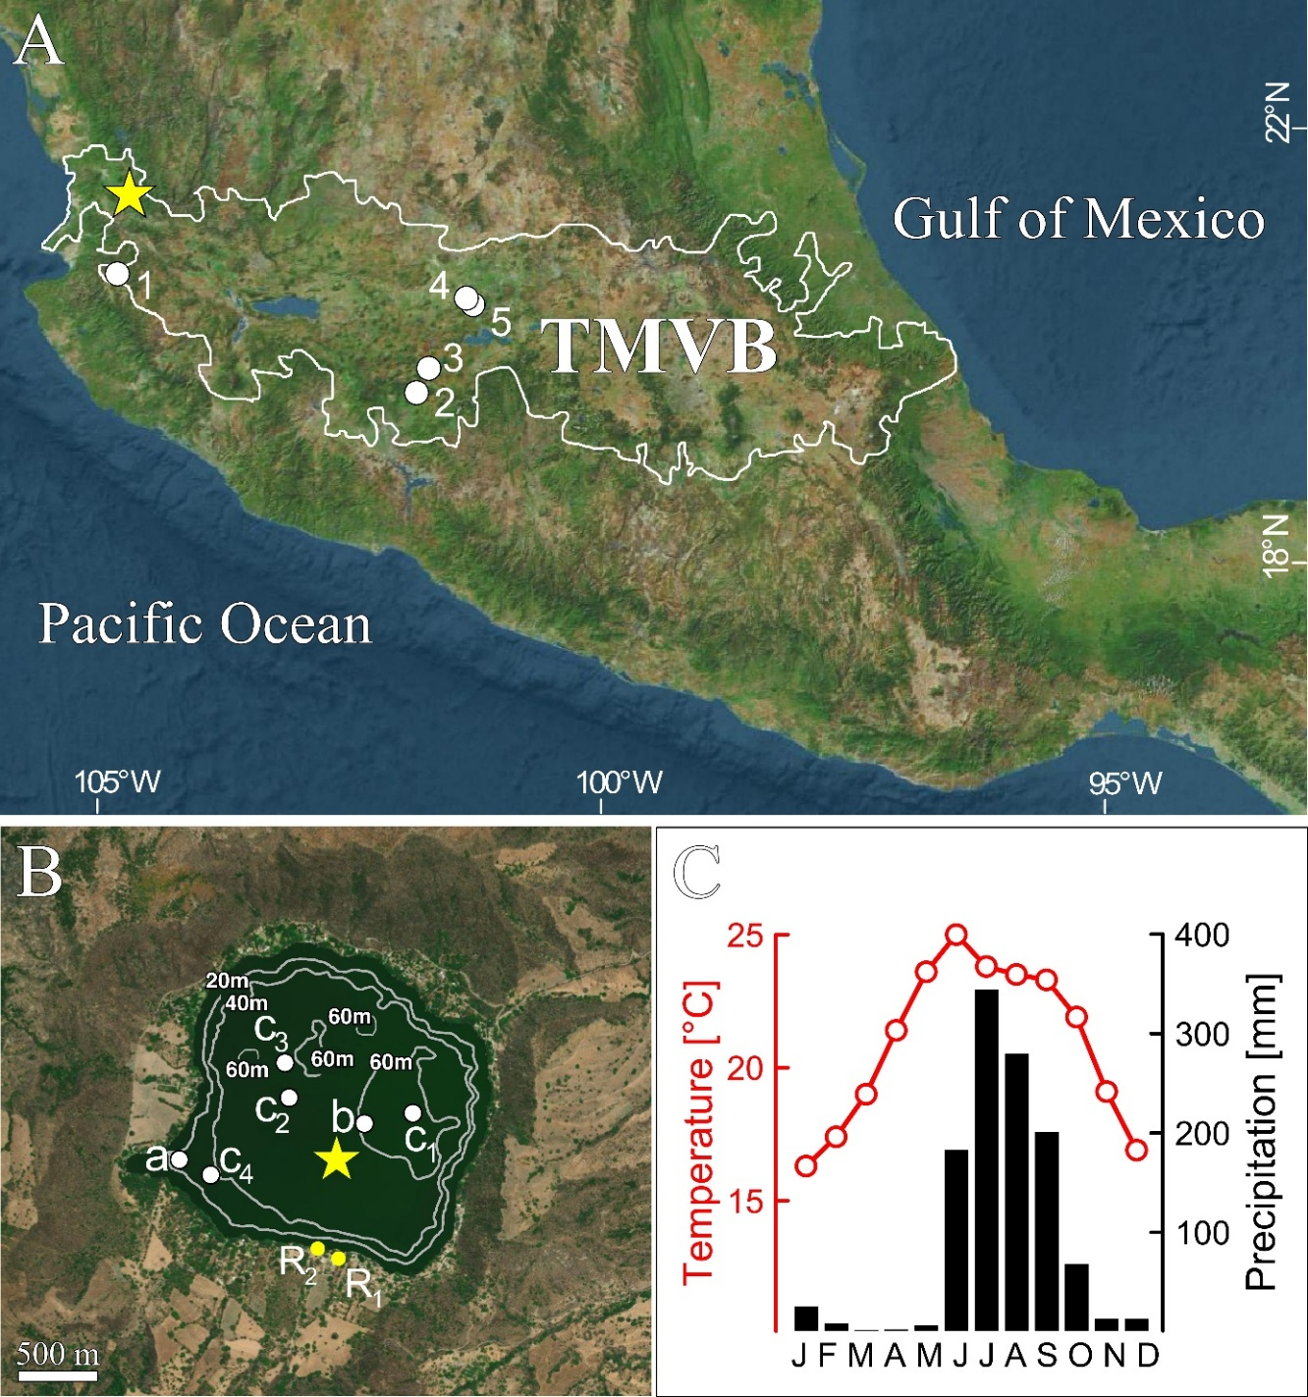
Figure 1. (A) Location of Lake Santa María del Oro (SMO) (yellow star) within the Trans-Mexican Volcanic Belt (TMVB). White numbered dots indicate the locations of sites mentioned in the text: (1) Juanacatlán, (2) Zirahuén, (3) Pátzcuaro, (4) Hoya Rincón de Parangueo, and (5) Hoya La Alberca. (B) Satellite image of Lake Santa María del Oro with bathymetric contours retrieved from Ruiz-Fernandez et al. (2022). The yellow star marks the sediment coring site for this study (LSMo22-1) while white dots indicate coring locations from previous research: (a) core SMO02V (880 cm) from the southwestern bay of SMO (Vázquez-Castro et al., 2008, Rodríguez-Ramírez et al., 2015); (b) core MOLE SMO03 (894 cm) from one of the deeper basins (Sosa-Nájera et al., 2010; Lozano-García et al., 2021) and short cores (< 1 m) SAMO14-1 (c1), SAMO14-2 (c2), SAMO14-3 (c3) and SAMO18-4 (c4) retrieved at depths between 30 and 55 m (Ruiz-Fernandez et al., 2022). Yellow dots labeled R1 and R2 indicate the locations of catchment reference sediment samples of soil and lake margin sediment, respectively. (C) Climate diagram displaying monthly mean temperature and precipitation around the lake. Data for years 1991–2020 from station 18005 (Cerro Blanco, Nayarit) retrieved from https://cucapa-clicom.cicese.mx/.
During the last 5 kyr, climatic events associated with drought were considered a major factor in human migration and the rise/demise of Mesoamerican cultures. (Stahle et al., 2012; Ortega-Guerrero et al., 2021). For instance, the abandonment of cities from Yucatán to the central Mexican highlands was attributed to a drought that occurred during the late Classic period (600-900 CE - e.g. Ortega-Guerrero et al., 2021). During the last 2 kyr, the increased influence of ENSO-like variability across the NAM domain led to contrasting precipitation patterns over Mexico (Metcalfe et al., 2015), with two climatic extremes, i.e. the Medieval Climate Anomaly (MCA, ~ 850-1300 CE) and the Little Ice Age (LIA, ~1400-1850 CE). During the early MCA (850-910 CE), the collapse of the Late-Classical Maya civilization was explained by a period of severe drought referred to as the Terminal Classical Drought (TCD, Cutis et al. 1996; Hodell et al., 1995). The TCD was recorded in marine sediment (Cariaco Basin, Haug et al., 2003), speleothems (Yucatán, Medina-Elizalde et al., 2010), and in several lake sediment records from the TMVB, such as Zirahuén (Vazquez et al., 2010), Pátzcuaro (Metcalfe et al., 2007) and Juanacatlán (Metcalfe et al., 2010) (Fig. 1A).
In sedimentary records, climatic variability over the last 2 kyr is more difficult to decipher due to increased human impact. Only a few Mexican records from laminated lake sediments (Metcalfe et al., 2010; Kienel et al., 2009; Jones et al., 2015; Park et al., 2019; Wogau et al., 2019) or cave deposits (Lachniet et. 2017) have annual to sub-decadal resolution, allowing comparison with historical data (Mendoza et al., 2005; Metcalfe 1987; Endfield and O’Hara 1999) or tree ring sequences (Stahle et al., 2011; 2016). Short varved sequences were also obtained from two maar lakes (i.e. Hoya La Alberca, Hoya Rincón de Parangueo - Kienel et al. 2009) in the Valle de Santiago in central Mexico (Fig. 1). These lacustrine varve records provide a paleo-precipitation record over the 19-20th centuries, which has been correlated with documentary droughts, ENSO events and reconstructed anomalies of sea surface temperature. In these short records, the lighter laminae were composed of endogenic minerals (calcite, aragonite, hydromagnesite) that precipitated from the saturated water column during the dry spring season, while the darker clayey and silty laminae were composed of detrital components (plagioclase, quartz, clay minerals, organic matter) delivered to the lake by surface runoff caused by summer rainfall. The study suggested a relationship between detrital laminae and local precipitation; however, no statistical relationship was established, likely due to the incompleteness of the instrumental data in Mexico (Kienel et al. 2009; Metcalfe 1987), especially following the decrease in active meteorological stations after 1980 CE (Jauregui, 1997).
More recently, the finely laminated sediments of the lava-dammed Lake Juanacatlán (Metcalfe et al., 2010; Jones et al., 2015) (Fig. 1A) have provided a high-resolution record of NAM precipitation in central Mexico over the last 6 kyr. The sediments consist of alternating organic diatomaceous and detrital clayey layers, with occasional sandy intervals. The Ti record, obtained at 200 μm resolution XRF-CS, was used as a proxy for summer rainfall, which drives increased surface runoff (Metcalfe et al., 2010). The Ti record of Lake Juanacatlán (Jones et al., 2015) displayed similar but anti-phase cycles to the Pallacacocha record from Ecuador (Moy et al., 2002), a pattern consistent with ENSO forcing. Moreover, the Juanacatlán record showed an increase in NAM-related rainfall after 3 kyr BP. This change was associated with warmer phases of the multi-millennial variability in the North Pacific Gyre (Isono et al., 2009), consistent with ENSO/PDO forcings (Haug et al., 2001). To date, the 6 kyr-long Juanacatlán record is the only study performed in Mexico which has directly investigated ENSO variability at pluri-annual timescales.
Among lakes along the TMVB, Lake Santa Maria del Oro (SMO, Fig. 1A) is strongly influenced by regional climatic variables (rather than local factors) and thus a suitable site for paleoclimatic investigations (Sigala et al., 2017). SMO was previously investigated by Sosa-Najerá et al. (2010) who analysed a core retrieved from one of the deeper (> 60m) parts of the lake (see location on Fig. 1B). The sediments displayed millimetre to centimetre-scale laminations composed of alternating clayey silts and diatom oozes. In the SMO sedimentary record, Ti concentrations measured by XRF-CS, were interpreted as a proxy for detrital input, with lower Ti values indicating reduced precipitation and surface runoff (Sosa-Najerá et al., 2010). Such an interpretation was previously proposed for the marine anoxic Cariaco Basin (Peterson et al., 2000; Rothwell and Rack 2006) and for lacustrine sedimentary records, including Mexican lakes (e.g. Metcalfe et al., 2010). Lozano-García et al. (2021) studied plant community changes in the SMO watershed based on the palynological record from the same core to decipher climate and human influences over the past 5 millennia. They identified three periods of drought with the most severe occurring during the Classical period (300-900 CE), as well as two periods of intense agricultural activity, detected by the presence of maize pollen, at 2000BC-100CE and after 1650CE.
In addition, a sediment core drilled in 12 m water depth in the southwestern bay of SMO (see Fig. 1B) was investigated by Vásquez-Castro et al. (2008) and Rodríguez-Ramirez et al. (2015). The sediment consisted of alternating sandy and silty layers with some peat layers, with detrital (quartz, plagioclase, pyroxene, magnetite, hematite), carbonate-rich (biogenic calcite from ostracod and authigenic calcite, authigenic aragonite and siderite) and amorphous fractions (organic matter, biogenic silica [diatom], volcanic glass). Vásquez-Castro et al. (2008) focused their study on the magnetic properties of the minerals encountered in the SMO sedimentary record. They identified a recurring sedimentary sequence with a lower layer enriched in inorganic carbon content and authigenic siderite characterized by a dissolution of the finest ferrimagnetic minerals (magnetite), overlain by a layer enriched in ferrimagnetic minerals. These dissolution-precipitation cycles were attributed to alternating anoxic/oxic conditions at the water-sediment interface. The results pointed to episodes of warmer and drier conditions during two intervals (600-1140 CE, 1410-1830 CE), which correspond to the Classic Maya civilization (300-900 CE, Manzanilla 2011) and the Little Ice Age (LIA , ~1400-1850 CE).
Rodríguez-Ramirez et al. (2015) developed a paleoenvironmental reconstruction based on ostracod abundance, total inorganic carbon (TIC) and Ca/Ti ratio. Elevated TIC and Ca/Ti ratios were interpreted as proxies for droughts, as carbonate precipitation increases during periods of higher evaporation and lower precipitation. An opposite trend was observed for Ti content and magnetic susceptibility, both acting as proxies for surface runoff (Sosa-Najerá et al., 2010; Vásquez-Castro et al., 2008). Two ostracod-rich intervals (600-800 CE, 1400-1550 CE) were consistent with the drier periods defined by Vásquez-Castro et al. (2008). According to Rodríguez-Ramirez et al. (2015), the driest interval observed during the late Classic period in SMO was the most severe drought in the region during the last two millennia. A second dry interval, around the onset of the LIA, was correlated with the Spörer solar minimum (Hodell et al., 2001; Haug et al., 2003).
This new study investigates the SMO sediments to better understand sediment transport and depositional patterns in relation to environmental variability over the last ~1500 years. First, a detailed mineralogical and geochemical study is conducted to identify the different sedimentary components (i.e. detrital, biogenic, authigenic). Second, these data are used to estimate the sediment fluxes to the lake bottom, minimizing the influence of dilution and providing a more accurate measure of material inputs. The discussion then focuses on the identification of the main forcing factors controlling allochthonous versus autochthonous contributions.

- Study area
SMO is a volcanic lake in the state of Nayarit in western Mexico. The lake lies at the western end of the TMVB (Ferrari et al., 2012 - Fig. 1A), close to the Pacific coast (~70 km). The lake (Fig. 1B) has a surface area of 3.7 km² and is located at an altitude of ~750 masl (Serrano 2002). The lake occupies a closed crater with an elliptical basin. Its axes range between 3 and 5 km (average diameter of 2 km - Serrano 2002) with a rim located between 500 and 175 masl (Vásquez-Castro et al., 2008). The lake bottom is flat, its depth ranges between 55 and
60 m with a maximum of 65.5 m (Serrano 2002).
The regional climate is marked by a seasonal precipitation regime with abundant rainfall from June to September (Fig. 1C). Precipitation is primarily driven by the NAM (see above). The climate of the SMO area is tropical, warm and sub-humid (García, 1973). Mean annual temperature, precipitation and evaporation average 21°C, 1240 mm and 1690 mm, respectively, based on data from station 18005 (Cerro Blanco, Nayarit) for the period 1964-2018 CE (https://cucapa-clicom.cicese.mx/).
The bedrock of SMO consists of a silicic volcanic plateau made of Oligocene and Miocene ignimbrites and rare rhyolites (Ferrari et al., 2003). Widespread alluvium outcrops along the lake margin, while volcanic breccias are limited to the southeastern margin (INEGI, 1974). The crater displays the steepest walls (up to 70° of slope - Vásquez-Castro et al., 2008) to the north and eastern lacustrine margin. The northeast crater flank presents the lowest altitude ~5 m above present lake level. An artificial channel drains lake water from this shallow area when the lake levels rise (Caballero et al., 2013).
SMO is a warm monomictic lake, with water column stratified during most of the year (Caballero et al., 2013). The lake level fluctuates by around 50 cm during the course of a year (Serrano et al., 2002). The waters are slightly alkaline (pH > 8) with a composition dominated by [Cl⁻], [HCO³⁻] and [Na⁺] (Caballero et al., 2013). Conductivity, total dissolved solids and [Cl–] were relatively high for a freshwater lake (Caballero et al., 2013). The lake is classified as subsaline and mesotrophic (Caballero et al., 2013; Sigala et al., 2017). Lake inflows are controlled by precipitation, surface runoff and underground flow, while water losses occur through evaporation and infiltration (Caballero et al., 2013).
The natural vegetation around the lake is a seasonally dry tropical forest, growing on moderate to steep slopes in warm sub-humid climates (Lozano-Garcia et al., 2021). Natural vegetation has been replaced in some places by croplands (Zea mays, Agave tequilana) around the less steep slopes of the western and southern parts of the crater (Caballero et al., 2013). Most of the soils around the crater lake are weakly developed mineral soils on unconsolidated parental material (regosol, FAO 2001) or soils in early stages of development (cambisol, FAO 2001).
Archeological evidence indicates early human occupation around SMO between 100 BC and 300 CE, followed by a second phase between 1100 CE and 1400 CE (Barrera-Rodríguez 2006 and Gálvez-Rosales 2006). European settlement began around 1530 CE related to gold mining activity. The population of the town of Santa Maria del Oro, located ~3 km from the lake, increased from 1408 to 5343 between 1900 and 2020 CE (statistics INEGI 2024 available at https://www.inegi.org.mx/app/geo2/ahl/). Today, the lake is an important tourist attraction (Serrano et al., 2002).

- Material and methods
This study was conducted on core LSMo22-1 (21°22'N, 104°34'W, 97-cm long) retrieved in 2022 from the central part of SMO. The core was collected at about 60 m water depth (Fig. 1B) using a 9 cm diameter UWITEC® gravity corer. LSMo22-1 core was scanned using a Siemens® Somatom AS43-128 CT-scanner at IRNS (Quebec, Canada), to identify possible sediment structures, then split lengthwise into a working and archive halves. The archive half was scanned at 500 μm resolution for elemental geochemistry using an ITRAX X-ray Fluorescence core scanner (XRF-CS, Cox Analytical Systems®) at IRNS (Quebec, Canada). A rhodium X-ray tube anode, set to 30kV and 45mA with an exposure time of 10 seconds, was used to produce the X-rays. Thirty elements from Al to Bi were measured. For each measurement interval, a dispersive energy spectrum was acquired, allowing the calculation of peak area integrals of the counts per second (cps) for each element. Peak areas are linked to elemental concentrations within the sample (Rothwell and Rack, 2006) but are also influenced by the sediment matrix (e.g. Bertrand et al., 2024), yielding semi-quantitative data (Croudace et al., 2006). To minimize closed-sum effects and reduce the matrix influences, elemental XRF-CS data were transformed into centered log-ratios (clr) (Weltje and Tjallingii 2008; Bertrand et al., 2024). Elements with numerous zero values were removed before the transformation, remaining zero values were replaced by half of the smallest measured value. Elemental data were then min-max normalized. Elemental ratios were calculated as log-ratios of the initially measured elemental intensities.
The archive half of the core was imaged and its lithology described. Macroscopic observations were complemented by microscopic examination of large thin sections. Rectangular slabs (10 × 2 × 1.5 cm) were cut out from the core using aluminum boxes, with a 1.5 cm overlap. These slabs were frozen in liquid nitrogen, freeze dried and then impregnated with a two-component epoxy resin (Araldite®2020) following the protocol described in Żarczyński et al. (2018). The impregnated blocks were sent to the MK Factory (Germany) for thin section preparation. After subsampling, the remaining archive core was stored at 4°C at the AGES laboratory (ULiège, Belgium).
The working half of the core was subsampled at 1 cm intervals for sedimentological analyses, including sediment density, organic matter and carbonate content, biogenic silica and bulk mineralogy. Dry bulk density was calculated at 1 cm intervals by weighing 1 cm³ of wet and then dried (105°C, 12 hours) sediment. Sequential loss on ignition (LOI) was used to estimate the organic and carbonate content (Heiri et al., 2001). Samples (1 cm³) were first heated at 550°C for 4 hours to oxidize the organic matter into carbon dioxide (LOI550), followed by heating at 950°C for 2 hours to convert carbonate to carbon dioxide (LOI950). The weight loss during the each step was measured and converted into organic matter and carbonate content.
Biogenic silica was estimated by normative calculation by using a reference detrital Ti/Si ratio, following the equation: Si_{bio =} measured Si_{total} - (Ti/Si)_{det} x measured Ti (adapted from Leinen 1977, Bertrand et al., 2005). This approach relies on two assumptions: (1) Ti content in the sediment is of detrital origin; (2) detrital supplies are characterized by a constant Ti/Si ratio. A lakeshore sample (SSMo22-2, N21°21’38.55, W 104°34’8.30”, reported as R2 on Fig. 1) was used as a detrital reference, with Ti/Si = 3.84. Si and Ti concentrations were measured directly on bulk sediment powder by portable energy dispersive X-Ray Fluorescence (Bruker® pXRF) using a Rh tube at 40 kV, 20 μA over 120 s (Da Silva et al., 2023). Si and Ti were measured using the K_{α} radiation at 1.738-1.751 keV and 4.5-4.518 keV, respectively. Standard materials of known concentration (Govindaraju, 1994) were measured under the same analytical conditions to obtain a calibration curve. Five geostandards for Si and eleven for Ti were selected to cover the range of variations of the measured samples (i.e. 0 to 30 wt.% for SiO₂; 0 to 1.3 wt.% for TiO₂). The pXRF results were converted into elemental concentration by using the calculated regression lines. More details are provided in the supplementary material (Fig. S1).
Bulk mineralogy was measured at 2-cm resolution by X-ray diffraction (XRD) using a Bruker® D8-Advance Eco diffractometer (CuKα radiation, λ =1.5418 Å, 40 kV, 25 mA) equipped with a Lynxeye XE detector (AGEs, University of Liège). The dried (40◦C) bulk sediment samples from LSMo22-1 were ground manually in an agate mortar. The powder was sieved at <150 μm and transferred to a plastic holder using the backside method (Moore and Reynolds, 1989) and scanned from 2 to 70 ◦2θ with a step size of 0.009 ◦2θ and 0.5 s per step. Mineral identification and quantification were done using EVA and TOPAS® Bruker software, respectively. A Rietveld refinement was applied to the minerals identified by XRD (Bish and Post, 1993; Srodón, 2002). Preferred orientations and unit cell parameters of the mineral phases were progressively adjusted to obtain a reconstructed XRD pattern as close as possible to the measured pattern.
Two samples, one from soil (SSMo22-1, RI on Fig. 1B) and one from the lake margin (SSMo22-2, R2 on Fig. 1B), were selected as references to characterize the detrital mineral assemblage of the catchment. In addition to the bulk mineralogy, the mineral assemblage of the clay < 2 μm fraction was obtained after a settling time calculated from the Stokes law (50 minutes). Orientated mounts were produced using the glass-slide method (Moore and Reynolds, 1989) and scanned in the diffractometer after three successive treatments: (1) air drying; (2) ethylene glycol solvation over 24 h and (3) heating at 500°C for 4 h. Semi-quantitative estimates (5-10%) of the abundance of clay minerals in the < 2μm fraction were derived by measuring the heights of the (001) reflections measured on glycolated samples at 7Å, 10Å and 14Å for kaolinite, illite and chlorite, respectively. Smectite abundance was calculated from the difference between the peak height measured on the heated and glycolated samples at 10Å (Boski et al., 1998). Each diagnostic peak was then multiplied by a correction factor (0.7 for kaolinite, 1 for illite and smectite, 0. 4 for chlorite) and the corrected values summed up to 100% (more details in Fagel and Boës, 2008).
The catchment samples, as well as two clay mineral-rich samples from core LSMo22-1 (42-43 cm, 58-59 cm), were analyzed using a Scanning Electron Microscope (Hitachi® SU8230 SEM) at the Université Bourgogne Europe (ARCEN analytical platform) with a resolution of 0.8 nm (15 kV, WD = 4 mm), equipped with a ThermoFisher Scientific® UltraDry Energy Dispersive X-ray (EDS). Bulk sediments were used for observations after aqueous suspension of the sediment on a SEM spinner covered with Cu tape and hydrophilization under air plasma in primary vacuum.
To establish a chronology for the sediment core, ²¹⁰Pb and ¹⁴C dating methods were employed. For ¹⁴C dating, three samples, comprising microcharcoal, pollen extract, and plant macroremains (i.e., leaf fragments) (Table 1) were submitted to the Silesian Institute of Technology in Poland. The AMS ¹⁴C ages were calibrated using the terrestrial calibration curve IntCal20 (Reimer et al., 2020). For ²¹⁰Pb dating, the activity of total ²¹⁰Pb was determined at 1 cm-resolution by measuring ²¹⁰Po using α spectrometry on the upper 29 cm of core LSMo22-1. In addition, ¹³⁷Cs was measured by γ-spectrometry to verify the chronology for the uppermost sediments. Both measurements were performed at the University of Gdańsk (Poland). The date of the core top (i.e. coring date), ²¹⁰Pb and ¹⁴C data were combined to derive a Bayesian age-depth model using rplum v0.5.1 package (Aquino-Lopez et al., 2018). The modeled ages were compared with peaks in ¹³⁷Cs activities related to global fallout in the early 1960s for validation.
The resulting sedimentation rate was used to estimate the fluxes of the different sedimentary components using the following equation:
Flux component (g/cm²/yr) = component abundance (wt. %) x ρ x SR
where ρ = dry sediment density in g/cm³, SR = sedimentation rate in cm/yr.
Component abundances were calculated from LOI550 and LOI950 for organic matter and carbonates, respectively, while biogenic SiO₂ abundance was derived from the normative approach. Gypsum abundance, determined by XRD on the crystalline fraction, was corrected for organic matter content to estimate the sulphate contribution within the bulk sediment. The fluxes of organic matter, carbonates, biogenic silica and sulphates were then subtracted from the total sediment flux to calculate the detrital flux. To provide insights into lake primary productivity, the presence of the alga Botryococcus in the sediments was measured. Wet sediment samples (1 cm³) were processed at 2-cm intervals using a standard acid-reduction protocol for pollen extraction (Faegri and Iversen, 1989), which removes mineral components while preserving acid-resistant organic microfossils: carbonates are dissolved with 10% HCl, silicates are removed with 37% HF, and the residue sieved through 150 µm and 10 µm meshes. At least 300 pollen grains were counted per sample under x400 magnification using a Zeiss microscope (not presented in this study). Botryococcus was counted as well but not included in the total pollen sum. Its relative abundance was then calculated as the number of Botryococcus divided by the total pollen count.

- Results
4.1. Lithology and age model
The sediment core LSMo22-1 is finely to coarsely laminated with visible changes in sediment color and layer thickness (Fig. 2). The sediment color varies between light brown, reddish, greenish to dark brown, with some lighter, grey to white, laminations. Most of the laminations are horizontal, subparallel or slightly inclined. Some layers are partly (e.g. between 46 and 53 cm) to intensively deformed (between 34 and 39 cm) or cut by inverse syn-sedimentary fault (e.g. between 70 and 72 cm). Lamination thickness generally ranges between 1 and 10 mm, except for a homogeneous 4 cm-thick layer observed between 29.5 and 33.5 cm.
Microscopic observations allow us to identify at least three types of laminations (see photos of thin section reported in supplementary material Fig. S2). Type 1 consists mainly of small (~5-30 microns) colorless prismatic crystals, with high-order interference colors under plane polarized light. Type 2 is composed of a dense network of diatom frustules, mainly in the silt size fraction, with a few 150 μm long specimens. Type 3 comprises a clayey matrix with silt-sized colorless (quartz, plagioclase), brownish (biotite) and greenish (chlorite) crystals. Quartz is identified by the absence of cleavage and low first-order, grey-white interference colors under plane polarized light. Plagioclases are identified by lamellar twinning under cross-polarized light. Biotite is confirmed by its brown pleochroism; green crystals are attributed to chlorite. Plant fragments and undifferentiated vegetal remains, as well as a few diatom frustules and ostracod shells, are found scattered in type 3. Under the microscope, the homogeneous layer between 29.5 and 33.5 cm is classified as type 3, with no obvious grain-size sorting. It most probably corresponds to a detrital deposit. Within the disturbed sediment interval occurring between 34 and 39 cm several laminations can be observed, especially under cross polarized light, but these laminations are discontinuous, with irregular thicknesses and wavy morphology. Such sedimentary features may result from local, post depositional bioturbation (e.g. horizontal burrowing) or degassing.
²¹⁰Pb and ¹³⁷Cs activities are reported in Table S1. The highest total ²¹⁰Pb activity (147 ±7 Bq/kg) is measured at the core surface followed by a decrease with depth down to 19 cm. However, some deviations in the ²¹⁰Pb activity, mainly between 3 and 4 cm, indicate changes in sedimentation rate. Below 19 cm, ²¹⁰Pb activities show minor variations without a clear downcore trend. The supported ²¹⁰Pb activity calculated as a mean value for the core section 19-29 cm is 39±3 Bq/kg.
According to the age-depth model (Fig. 2, Table 1), core LSMo22-1 covers 1550 yr within 97 cm, with a sedimentation rate ranging between 0.044 and 0.313 cm/yr. The obtained chronology was compared with the measured ¹³⁷Cs activities for validation. The age model calculations gave an age of 1957 CE (range 1949-1964 CE) for the maximum of ¹³⁷Cs activity (19.8 Bq/kg), observed at 11.0-11.5 cm, consistent with the intense nuclear weapons tests in the early 1960s.

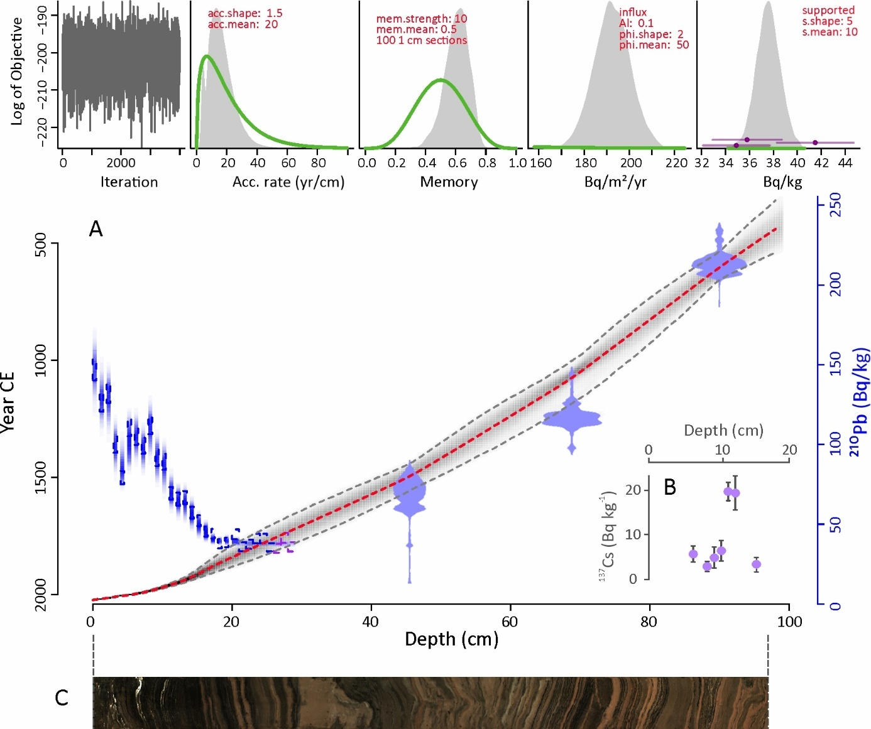

Figure 2. Age model of core LSMo22-1. (A) Plum age model combining total ²¹⁰Pb activity and three ¹⁴C dates. The main panel displays the distribution of ¹⁴C dates, mean age estimates (red dashed line) and 95% confidence intervals (grey shaded area) as well as total (blue) and supported (purple) ²¹⁰Pb values. The upper panel shows Markov Chain Monte Carlo (MCMC) iterations together with prior (green) and posterior (grey) distributions of the Bayesian parameters. Radiocarbon data are reported in Table 1. (B) ¹³⁷Cs activity in core LSMo22-1. (C) Color photograph of core LSMo22-1.

Table 1. Radiocarbon AMS ages and calibrated dates from core LSMo22-1.

4.2. Mineralogical assemblages and sediment geochemistry
Bulk mineralogy of core LSMo22-1 (Fig. 3, data in Table S2) is dominated by clay minerals (77±6%), quartz (7±2.4%), feldspars (4.9 ±1.9%, with albite as the main plagioclase and orthoclase as K-feldspar), calcite (7.7±5.7%), aragonite (2.7±5.6%), traces of Fe-Mg silicate minerals (amphibole, augite), and gypsum (< 1%) only in the upper 15 cm of the core.
The core has three distinct sections (units) based on its mineral assemblage. (1) The lower section (unit 1, 97-64 cm, 470-1155 CE) is enriched in clay minerals (mean 69%) and calcite (mean 10%) but presents the lowest abundance of aragonite (mean 3%). (2) The middle section (unit 2, 63-16 cm, 1190-1890 CE) displays the highest abundance of clay minerals (mean 80%), quartz (mean 8.4%), feldspars (mean 5.6%), along with lower abundance of calcite (4±4%) and only traces of aragonite. (3) The upper section (unit 3, 15-0 cm, 1920-2021 CE) is marked by a decrease in clay minerals (67±5%), low quartz and feldspar contents (3-4%), a significant increase in aragonite (13±8%) and calcite (11±6%), and the occurrence of trace gypsum.
The soil (R1, SSMo22-1) and lake margin (R2, SSMo22-2) samples are composed of 69-73% clay minerals, 15% quartz, 11-14% feldspars (plagioclase and K-feldspars) and traces (1%) of Fe-Mg silicate minerals (Table S2). Their mineralogical composition is similar to that of core LSMo22-1 sediments, but they contain no carbonates or sulfates.

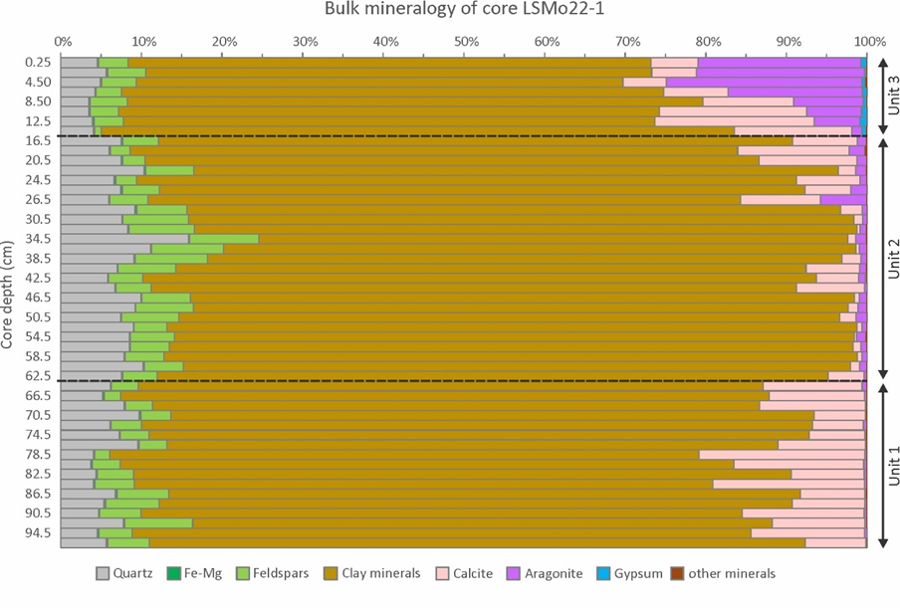
Figure 3. Mineralogical assemblage from the sediment of core LSMo22-1.

The clay minerals of core LSMo22-1 are dominated by smectite (53%) and illite (23%), with less contribution of kaolinite and chlorite. The expansion up to 16.8Å after ethylene-glycol saturation indicates a quite pure smectite. The decrease of the peak height at 14Å after heating indicates the presence of degraded chlorite (i.e. vermiculite), in addition to a few percent of fresh chlorite (not sensitive to heating). The similarity in the clay mineral composition of the catchment samples (Fig. S4) and the core samples is confirmed by SEM observations (Fig. 4). For instance, flaky particles are observed in the core samples LSMo22-1 42-43 and 58-59 cm (Fig. 4a-d) and in the catchment samples (Fig. 4e-h). In both samples, micrometric particles on the surface of primary magmatic minerals (plagioclase, pyroxene) were identified as Fe-rich smectites according to the EDS spectra (Université Bourgogne Europe, France).

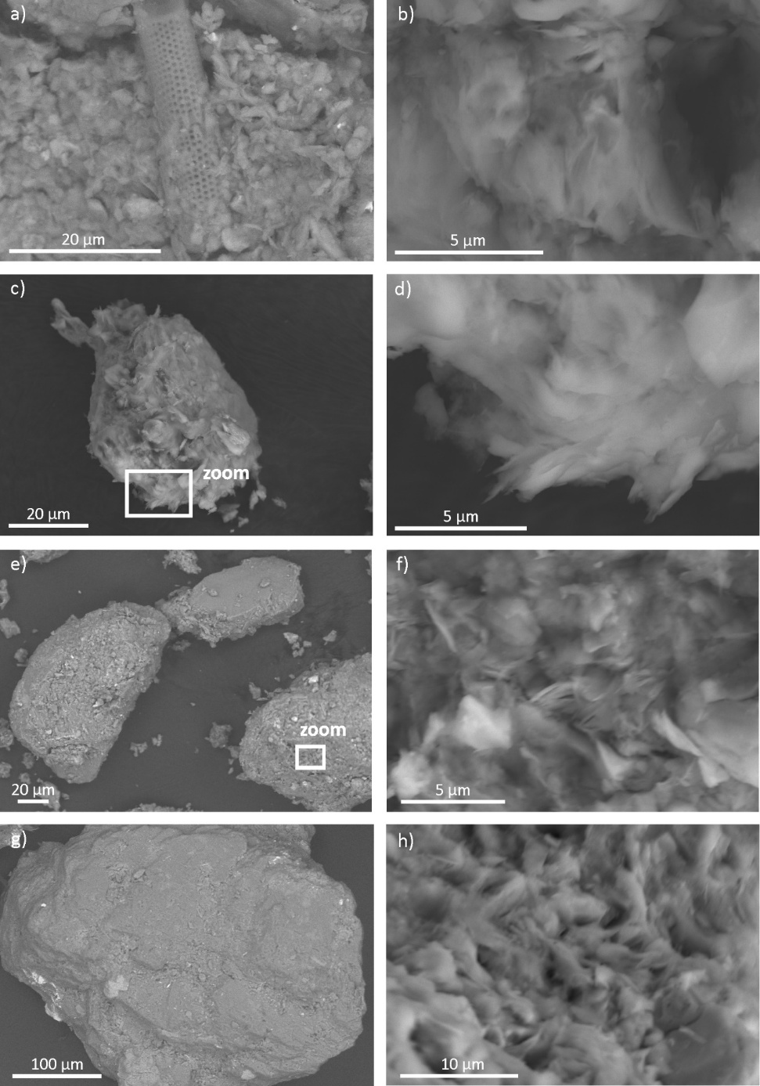
Figure 4. Scanning electron microscope (SEM) images of smectite particles in core LSMo22-1 at depths 42-43 cm (a-b), and 58-59 cm (c-d), and in soil sample SSMo22-1 (e-f) and in lacustrine margin sample SSMo22-2 (g-h). Note the presence of diatom frustule in (a).

To help identify the different sedimentary components of the LSMo22-1 core, key mineralogical and geochemical data, together with the abundance of the alga Botryococcus, are plotted in Fig. 5. The relative abundances of quartz, feldspars and clay minerals display trends similar to Ti, with the highest values of Ti observed in unit 2 (63-16 cm, 1190-1890 CE) (Fig. 5). Relative calcite abundance follows the profile of carbonate abundance based on LOI950 and the Ca/Ti ratio, with the lowest abundance of calcite and Ca/Ti observed in unit 2. A marked opposite trend is observed between the Ti and Ca/Ti profiles. An increase in organic matter (LOI550) is observed over the last 300 years.

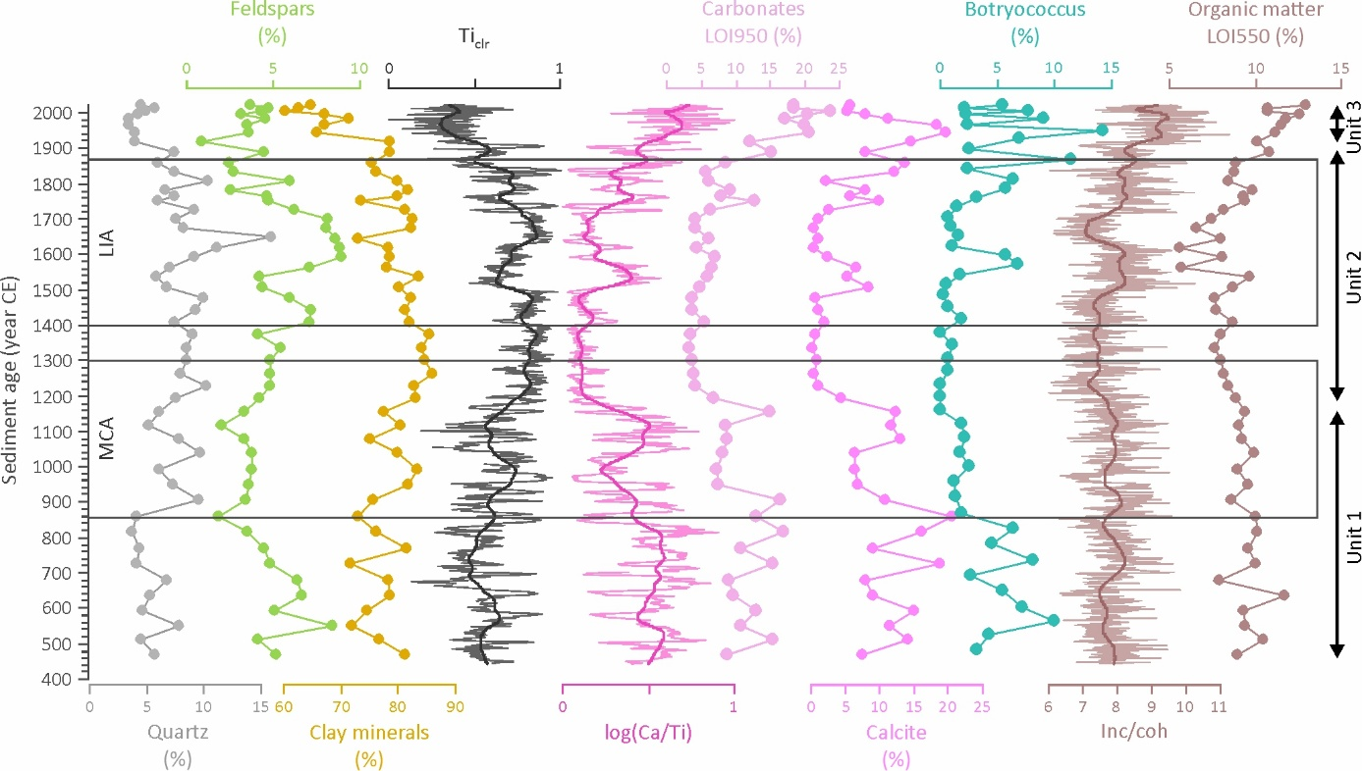

Figure 5. Temporal evolution of mineral (quartz, feldspar, clay minerals, calcite), organic matter (LOI550) and carbonate (LOI950) abundances together with clr-transformed and normalized titanium (Ti) intensity, normalized calcium to titanium log-ratio (Ca/Ti), incoherent to coherent scattering ratio (Inc/coh), and the relative abundance of Botryococcus in core LSMo22-1. Thick solid lines represent locally weighted smooth curves (loess span 0.05). The mineralogical units, i.e. unit 1 (97-64 cm, 470-1155 CE), unit 2 (63-16 cm, 1190-1890 CE) and unit 3 (15-0 cm, 1920-2021 CE) are shown. The two boxes mark the approximate timing of the Medieval Climate Anomaly (MCA, ~ 850-1300 CE) and the Little Ice Age (LIA, ~1400-1850 CE) following Metcalfe et al. (2015).

- Discussion
5.1. Origin of minerals in core LSMo22-1
In continental settings, lake sediments represent sensitive archives of environmental and/or climate changes, recording variable conditions and processes occurring within the lake column and in the lake catchment (Anselmetti et al., 2006). Mineralogical studies using lacustrine sediments as a proxy for paleoenvironmental and/or paleoclimate conditions first require identification of the origin of the minerals. Lake sediments contain three mineral types, including detrital, endogenic and authigenic minerals (Last, 2001). In the case of crater lakes, detrital minerals are delivered into the lake via catchment runoff and aeolian dust supply. Endogenic minerals are formed within the water column by biologically induced or chemical precipitation. Authigenic minerals result from early diagenetic processes occurring at the sediment/water interface.
The mineralogy of the catchment samples were analyzed to characterize the detrital supplies delivered to the lake bottom by surface runoff (Fig. 3), revealing a mineral assemblage dominated by clay minerals, accompanied by quartz, feldspars and traces of Fe-Mg silicate minerals (amphibole and pyroxene). Quartz, plagioclase and pyroxene were also identified by Vasquez-Castro et al. (2008) in a core collected along the southwestern margin of SMO in a water depth of 12 m. Notably, calcite, aragonite and gypsum observed in SMO core sediments are absent from the samples collected from the catchment. This absence indicates a biogenic and/or authigenic origin for these minerals, providing insights into the chemical and limnological conditions in the water column at the time of their formation (Last, 2001).
Among the detrital minerals, the nature of clay minerals reflects the degree of physical and chemical weathering of the bedrock, making them useful indicators for tracking climate change. The clay minerals of the soil and the lacustrine margin samples (Fig. S3) comprise both primary clay minerals, such as illite and fresh chlorite, derived from the volcanic bedrock and, secondary minerals, such as smectite, kaolinite, vermiculite, formed by pedogenetic processes. The presence of both smectite and kaolinite indicates variable degrees of hydrolysis under tropical warm and humid conditions (Chamley, 1989). SEM observations (Fig. 4) demonstrate that smectites result from a transformation of volcanic minerals, resulting in a partial leaching of cations and silica under moderate hydrolysis. Kaolinite, which neoforms by a recombination of Al₂O₃ and SiO_{2,} requires a complete leaching of cations under more intense hydrolysis (Meunier 2006).

5.2. Sedimentary components
The sediments of core LSMo22-1 consist of a mixture of detrital, biogenic and endogenic components. Minerals present in both the catchment samples and the core were classified as detrital, reflecting input from the surrounding basin.
The biogenic component consists of silica (diatom) and calcite (mainly ostracods), as observed in other cores from SMO (Vasquez-Castro et al., 2008, Caballero et al., 2013; Rodríguez-Ramírez et al., 2015). Calcite is also present as an endogenic mineral in the lake (Vasquez-Castro et al., 2008) and, overall, its formation appears tightly connected to lake primary production. This relationship is supported by the strong link between carbonate abundance, Ca/Ti ratio, spectrally inferred sediment chlorophyll a (Rantala et al., 2025), and the presence of Botryococcus—an autotrophic green algae indicative of enhanced algal productivity in the water column at the time of deposition (Guy-Ohlson, 1992) (Fig. 5).
Aragonite and gypsum probably represent endogenic sediment components. Thin aragonite-rich white laminations are typical of SMO sediments (Sosa-Nájera et al., 2010). According to sediment trap observations, aragonite is mostly precipitated during the wet and warm season (Caballero et al., 2013), with warmer temperatures favoring carbonate precipitation (Gierlowski-Kordesch and Kelts 1994), although algal blooms may also induce carbonate precipitation. Gypsum is a mineral favored by strong evaporative conditions in dry climates. Gypsum is the most common sulphate mineral (Deer et al., 1966), deposited in past (Andeksie et al., 2018; Bradford and Benison 2024) and recent (Spencer 2000) lacustrine sediments by precipitation from CaSO₄-rich waters, although available modern water samples do not suggest that the lake is of this type.

5.3. Sedimentary fluxes
Sedimentary fluxes reflect variations in the accumulation rates of the materials reaching the lake bottom. Therefore, they are not influenced by changes in the sediment matrix and dilution, unlike mineral abundances or geochemical element intensities. The calculated sedimentary fluxes (data in Table S3) are affected by age model uncertainty (± 50 up to 200 years (Fig. 2) and thus, only the global trend in the sedimentary fluxes should be considered.
Remarkably, whereas the ²¹⁰Pb and ¹³⁷Cs profiles in core LSMo22-1 (Fig. 2) show good consistency with the profiles of the four sediment cores investigated by Ruiz-Fernández et al. (2022), the ¹⁴C dates point to lower sedimentation rates in the older core sections when compared with previous studies on SMO (see core locations on Fig. 1). ¹⁴C analysis of multiple bulk sediment samples suggested that the long sediment sequence (i.e. MOLE SMO03, 894 cm) collected from the deep basin of SMO (Sosa-Najerá et al., 2010; Lozano-García et al., 2021; Fig. 1) covers approximately five millennia, indicating comparatively high sediment accumulation rates (mean ~0.2 cm/yr) across the late Holocene when contrasted with the ²¹⁰Pb and ¹³⁷Cs results. Sedimentation rates were low and stable during the early 20th century in LSMo22-1 (mean 0.08 ± 0.01 cm/yr), as well as in the four cores studied by Ruiz-Fernández et al. (2022), which range from 0.09 ± 0.04 to 0.13 ± 0.04 cm/yr). Rates intensified during the second half of the century due to growing human influence and catchment erosion (Ruiz-Fernández et al., 2022; Rantala et al., 2025). Ruiz-Fernández et al. (2022) also attempted ¹⁴C dating of bulk sediment samples, but the results were highly variable, leading to the conclusion that ¹⁴C dating of bulk sediments in SMO is problematic, probably due to a spatially and temporally variable reservoir effect. Rodríguez-Ramirez et al. (2015) and Vásquez-Castro et al. (2008) observed high sedimentation rates (mean 0.34 cm/yr; using peat and wood for ¹⁴C dating) in core SMO02V collected near the southwestern end of the lake (Fig. 1); however, sedimentation is likely to be much higher in the shallow bay area and near the lake margin. Although the reason for the very different ¹⁴C dates in the cores collected from the deep basin is unknown, the chronology of core LSMo22-1 is considered reliable taking into account the sample material used for ¹⁴C dating (Table 1), the well corroborated ²¹⁰Pb and ¹³⁷Cs dating results and the deep sedimentation environment.
The detrital component accounts for ~70% of the sedimentary flux, ranging from 11 to 54 mg/cm²/yr over the last 1500 years (Fig. 6). The detrital flux remains relatively constant in unit 1 (up to around 1150 CE) with an average value of 17.3±4.2 mg/cm²/yr. It displays high fluctuations in the intermediate interval 1190-1670 CE (30.5±9.4 mg/cm²/yr) that covers the LIA. The detrital flux decreases to lower values at the end of the 19th century and then increases over the 20th century to reach its highest value (> 50 mg/cm²/yr) in the uppermost two samples (2012-2021 CE). Low detrital fluxes (< 28 mg/cm²/yr) are observed in the lower section of core LSMo22-1 from ~500 to 1080 CE, with a slightly more pronounced minimum observed around 815-860 CE (11 mg/cm²/yr). Subsequently, detrital flux shows generally elevated values, especially around 1155-1340 CE, 1540-1565 CE and 1920-2012 CE, interrupted by transient periods of low detrital flux at ~ 1510-1540 CE and 1890-1920 CE.
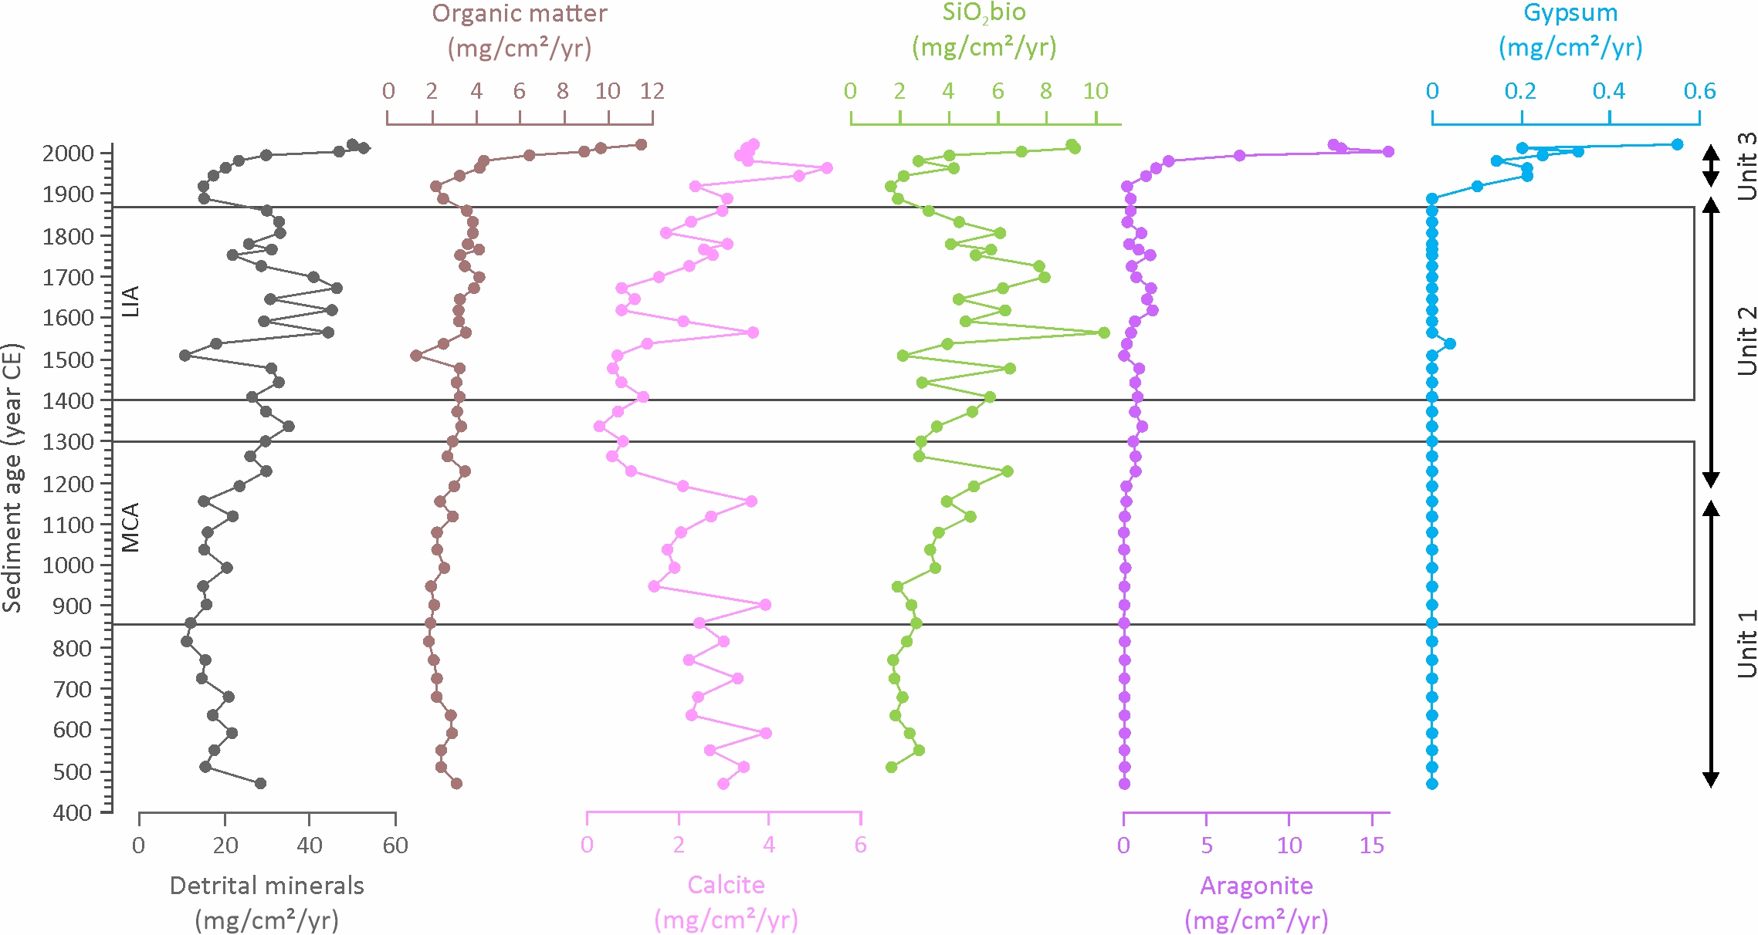

Figure 6. Temporal evolution of sedimentary fluxes in core LSMo22-1, including detrital, organic matter, biogenic silica (diatoms), total carbonates and sulphates. The mineralogical units, i.e. unit 1 (97-64 cm, 470-1155 CE), unit 2 (63-16 cm, 1190-1890 CE) and unit 3 (15-0 cm, 1920-2021 CE) are shown. The boxes mark the approximate timing of the Medieval Climate Anomaly (MCA, ~ 850-1300 CE) and the Little Ice Age (LIA, ~1400-1850 CE) following Metcalfe et al. (2015).

Biogenic silica, with an average flux of 4.2 mg/cm²/yr (11% of the total flux), represents the second-largest contributor to the sedimentary flux in core LSMo22-1. It displays a significant range of variations between 1.6 and 10 mg/cm²/yr, with the highest values observed at 1230 CE (6.4 mg/cm²/yr), 1565 CE (10.3 mg/cm²/yr), 1700 CE (7.9 mg/cm²/yr) and 2012 CE (9.1 mg/cm²/yr).
Organic matter represents on average 9% of the total sedimentary flux and remains relatively constant over most of the studied interval (3.4 ± 1.9 mg/cm²/yr). However, it increases from 1920 CE onward. The lowest fluxes are recorded at 1510 CE and 1920 CE (1.3 and 2.2 mg/cm²/yr, respectively), coincident with the lowest detrital fluxes.
As endogenic components, carbonate fluxes in core LSMo22-1 average 3.8 ± 3.9 mg/cm²/yr (10% of the total flux) and can be subdivided into calcite (6%) and aragonite (4%). The relative abundances of calcite and aragonite within the carbonate fraction, deduced by XRD, were applied to the total carbonate flux to estimate the respective fluxes of calcite and aragonite. The calcite flux (2.3 ± 1.2 mg/cm²/yr) displays lower values in the intermediate interval between ~ 1230 CE and 1670 CE (minimum of 0.30 mg/cm²/yr). Higher values are recorded at 900, 1155, 1565 CE (3.6-3.9 mg/cm²/yr), with the maximum flux observed at 1965 CE (5.3 mg/cm²/yr). The high calcite flux measured at 1565 CE coincides with the highest flux of biogenic silica, suggesting favorable conditions for biogenic productivity in the water column. Since both biogenic fluxes increase in parallel with the detrital fluxes, the high productivity may reflect increased nutrient supply into the lake by surface runoff.
Aragonite flux is characterized by a sharp increase in the uppermost section of core LSMo22-1, beginning around 1945 CE, with the highest values (12.6 to 16 mg/cm²/yr) recorded within the last two decades. Similarly, gypsum flux increases from 1920 CE, reaching its highest value (0.6 mg/cm²/yr) at the core surface.

5.4. Climate and anthropogenic forcing
Crater lakes like SMO are highly sensitive to climate variability, with a hydrological balance controlled by precipitation and evaporation (Barr et al., 2014; Safaierad et al., 2025). In core LSMo22-1, fluctuations in calcite flux (Fig. 7) are linked to changes in lake primary production, which over long time scales are controlled by climate. The elevated calcite flux between around 1100 and 1200 CE coincides with the warm MCA while the subsequent section, characterized by generally low calcite flux, between ca. 1200-1700 CE, is contemporary with the cooler climate of the LIA (Fig. 7). Previous research suggests spatially and temporally variable hydroclimatic conditions across Mexico during these distinct climate intervals (Metcalfe et al., 2015). However, both temperature/evaporation and precipitation may have contributed to the patterns in calcite flux through their effect on lake levels and chemistry (Rantala et al. 2025). Indeed, the consistently elevated calcite flux values in the lower section of the core (ca. 470-900 CE) occur at a time of drought across Mesoamerica (Davies et al. 2018), including the high-resolution speleothem δ¹³C record from Yok Balum cave (Braun et al. 2013) or the previous carbonate (ostracod and Ca/Ti) record from the shallow bay of SMO (Rodríguez-Ramirez et al., 2015) (Fig. 7). At a finer temporal scale, calcite flux depicts a pattern close to the evolution of solar activity during the last millennium (Fig. 7). Specifically, generally low calcite fluxes are observed during periods corresponding to the five known solar minima: Oort (1021-1060 CE), Wolf (1279-1349 CE), Spörer (1388-1558 CE), Maunder (1621-1718 CE) and Dalton (1797-1823 CE) (Brehms et al., 2021). This observation lends further support to the influence of temperature on biological productivity in the lake.

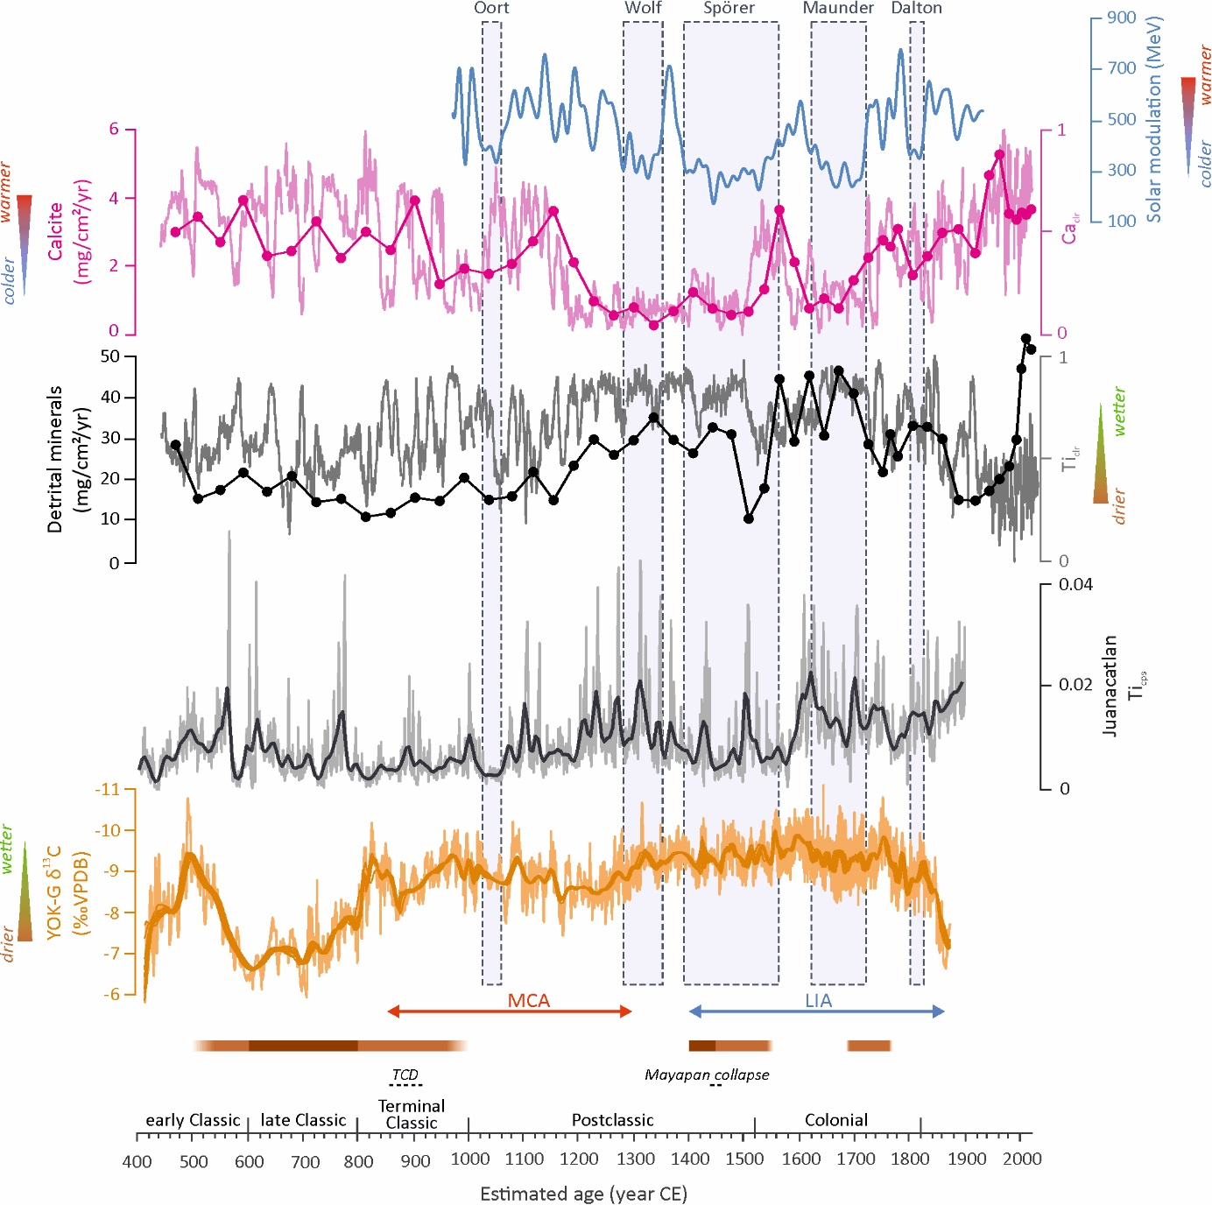

Figure 7. Compilation of paleoenvironmental trends in core LSMo22-1 and selected regional proxy records. Included are detrital and calcite fluxes as well as clr-transformed and normalized titanium (Ti) and calcium (Ca) intensities in core LSMo22-1, solar modulation (20-yr low-pass-filtered) trend indicative of solar activity variations (Brehm et al., 2021), titanium (counts per second) record from Juanacatlán (Metcalfe et al., 2015), and the Yok Balum speleothem carbon isotope record (YOK-G δ¹³C) (Braun et al., 2023), as well as major dry periods (horizontal bars with driest periods indicated in darker brown) identified by Rodríguez-Ramírez et al. (2015). The timing of the Medieval Climate Anomaly (MCA) and Little Ice Age (LIA) follows Metcalfe et al. (2015) and the division into early Classic (300-600 CE), late Classic (600-900 CE) and Postclassic (900-1520 CE) periods follow Kennett et al. (2012). TCD stands for the Terminal Classic Drought.

Besides calcite flux, the detrital flux may be used as a proxy for precipitation and runoff (Metcalfe et al., 2010). Higher detrital flux generally indicates wetter conditions resulting in higher surface runoff and erosion of catchment soils. The variations in detrital flux point to the driest and the wettest periods recorded in the core LSMo22-cover the last 1500 years. Reduced detrital flux in the lower sediments, between ca. 800-850 CE, suggests dry climate conditions that may correspond to a carbonate-rich interval dated to 600-800 CE (late Classic period) documented in lake Santa Maria del Oro sediments by Rodríguez-Ramirez et al. (2015). This time interval, according to Rodríguez-Ramirez et al. (2015), corresponds to the most severe drought across regions extending from the Caribbean Sea towards the eastern Pacific margin. While the low detrital fluxes in our core similarly point to prevailing dry climate conditions, our data indicate that the absolute minimum occurred at the beginning of the 16th century (1500-1520 CE). The drop in detrital flux occurs within a dry interval (1400-1550 CE) previously associated with the early LIA (Rodriguez-Ramirez et al., 2015). Tree ring records (Stahle et al., 2012) indicate that the mid-15th century was a period of intense, widespread drought across Mesoamerica. This timing is broadly consistent with the collapse of Mayapan (Fig. 7), i.e. the largest Postclassic Maya capital in Yucatan (Kennett et al., 2022).
Subsequently, the high elevated detrital fluxes, between 1575 CE and 1675 CE, most probably reflect wetter environmental conditions. In the Juanacatlán Ti record, Metcalfe et al. (2010) observed a relationship between runoff and solar activity, with low Ti intensity mostly occurring during colder and probably drier intervals. However, in core LSMo22-1, the solar forcing appears to be better recorded in the calcite flux. It is possible that during the cool conditions of the 17th century (within the Maunder minimum), high allochthonous inputs to the lake may have been driven by catchment disturbance with Colonial activity.
In addition to climate forcings, crater lake sedimentation may also be affected by anthropogenic activities, especially land-use changes (Neff et al., 2008). In a recent study, Ruiz-Fernández et al. (2022) attributed variations in recent sediment mass accumulation rates in SMO to a combination of land-use change and climate variability. The highest mass accumulation rates observed after the 1980s coincide with periods of precipitation minima but high human disturbance. Soil erodibility may increase during dry periods due to lower soil moisture and wildfire occurrence in the catchment. The highest detrital fluxes observed in the uppermost part of core LSMo22-1 (2004-2021 CE, Fig. 7) probably reflect growing human activity in the catchment.
Moreover, in the uppermost interval of core LSMo22-1 (1920-1945 CE onwards), the fluxes of authigenic minerals, aragonite and gypsum, display a sharp increase (Fig. 6), pointing towards drastic hydrological changes. The highest aragonite flux (16 mg/cm²/yr) at 2004 CE is consistent with the highest temperature (30.9°C) measured in 2006 CE at station Cerro Blanco during the interval 1965-2018 CE. Despite its low abundance (≤ 0.55 mg/cm²/yr), the presence of gypsum in the upper 15 cm of core LSMo22-1 (1920-2021 CE) suggests warmer conditions over the last 100 years. Decreases in lake level were previously reported for the second part of the 20th century (1959–1992 CE) in four crater lakes from the eastern TMVB (Silva-Aguilera et al., 2024). The water shortage in the region was driven by a combination of increased evaporation caused by rising temperatures and extensive groundwater depletion that began in the 1980s (Quintas et al., 2016). In addition, recurring droughts at the end of the 18th and early 19th centuries, along with the growth of agriculture, especially after the 1940s, disrupted the local water cycle, contributing to the drying of lakes in the Valle de Santiago region (Alcocer et al., 2000; Kienel et al., 2009). Similar recent declines in lake levels have been observed in other nearby lakes, primarily due to the combined effects of the changing climate and the expansion of land use, particularly irrigated agriculture (Quintas et al., 2016). In the Valle de Santiago area, frequent droughts in the late 19th and early 20th centuries, combined with the expansion of irrigated farming after the 1940s, severely altered the water balance of nearby crater lakes, ultimately leading to their desiccation (Alcocer et al., 2000; Kienel et al., 2009). While water abstraction and global anthropogenic forcing may have influenced sediment flux in SMO, particularly over the past century, our flux data suggest that natural factors, such as variations in solar activity, played a more significant role in regulating sediment fluxes before the 20th century.

- Conclusions
Using geochemical and mineralogical analyses of a ²¹⁰Pb- and ¹⁴C-dated sediment core from crater lake SMO, along with mineralogical analysis of catchment samples, we investigated the sources of sediment fluxes into the lake. This multifaceted approach uncovers an array of climate and human factors controlling allochthonous and autochthonous sediment fluxes over the past 1500 years.
A strong negative correlation between downcore variations in Ti and Ca indicates that these elements originate from different sources. This relationship is further supported by the mineralogical analysis, which reveals that Ti is primarily associated with detrital minerals, while Ca is associated with biogenic and endogenic minerals. Clay minerals, quartz, and feldspars are the main constituents of the lake sediment core, as well as of the surface soil and lake margin samples, confirming their detrital origin. In contrast, the absence of carbonate minerals in the surface samples indicates that these minerals in the lake sediment are of endogenic or authigenic origin.
Detrital fluxes were calculated to reconstruct runoff variability and infer wet and dry periods in the past. The elevated detrital flux between ~ 1200 and 1700 CE suggests predominantly wetter conditions, punctuated by intermittent dry periods, the most severe occurring at the beginning of the 16th century (1502-1516 CE). Colonial catchment disturbances may have further contributed to increased detrital flux.
Calcite flux, mainly reflecting biogenic activity and lake primary productivity, exhibits variability in response to temperature fluctuations and solar activity over the past 1100 years. Reduced calcite flux between ~ 1200 and 1700 CE aligns with the LIA and grand solar minima, whereas the highest fluxes correspond to warmer periods during the MCA and recent warming.
Elevated fluxes of authigenic aragonite, accompanied by traces of gypsum, suggest intensified evaporation in recent decades driven by ongoing warming. In summary, alongside natural climate forcing, human activities in recent decades have likely influenced sedimentary fluxes, with water abstraction facilitating the precipitation of authigenic minerals, such as aragonite and gypsum, and land use changes contributing to increased detrital flux.

Acknowledgements
Fieldwork was done in Mexico in April 2022 by N. Fagel, R. Safaierad, J. Auboiron, V. Piroton (University of Liege, Belgium) and I. Israde-Alcantara (Universidad Michoacana de San Nicolás de Hidalgo, Mexico), with the local help of Luis Matilde Gacia, Julio Cañas, David Sanchez and Angel Zamudio. Thanks to Arturo Chacon for providing a boat. Core slicing and XRF-CS measurements were done with the help of Arnaud De Coninck (Institut National de la Recherche Scientifique, Québec, Canada) and Jeanne Auboiron. Analysis costs were supported by FNRS funding (PDR T.0079.21, HolMecl 2020-2025). The authors thank Joel Otten and Nicolas Delmelle (Geology, University of Liege) for their technical support with mineralogical and geochemical analyses as well as Prof. Frédéric Hatert (Mineralogy, ULiege) for his support with the TOPAS software. SEM-EDS observations were made with the support of Régis Parvaud, ARCEN analytical platform of the University of Burgundy (Dijon, France). We also acknowledge the two anonymous reviewers for their comments and suggestions.

References
Anselmetti F.S., Ariztegui D., Hodell D.A., Hillesheim M.B., Brenner M., Gilli A. et al. (2006). Late Quaternary climate-induced lake level variations in Lake Peten Itza, Guatemala, inferred from seismic stratigraphic analysis. Palaeogeography, Palaeoclimatology, Palaeoecology 230, 52-69.
Amador J.A., Alfaro E.J. Lizano O.G., Magaña V.O. (2006). Atmospheric forcing of the eastern tropical Pacific: A review. Progress in Oceanography 69, 101-142.
Aquino-López M.A., Blaauw M., Andrés Christen J., Sanderson N.K. (2018). Bayesian analysis of ²¹⁰Pb dating. Journal of Agricultural, Biological, and Environmental Statistics 23, 317-333.
Barr C., Tibby J., Gell P, Tyler J., Zawadzki A., Jacobsen GE. (2014). Climate variability in south-eastern Australia over the last 1500 years inferred from the high-resolution diatom records of two crater lakes. Quaternary Science Review 95, 115-131.
Barrera-Rodríguez R. (2006). El proyecto arqueológico El Cajón, Nayarit,
In: Entre ríos y montañas sagradas: arqueología en El Cajón, Nayarit, Barrera-Rodríguez R., Consejo Nacional para la Cultura y las Artes, Instituto Nacional de Antropología e Historia, Comisión Federal de Electricidad., México, 13-28 (in Rodriguez-Ramirez et al., 2015).
Barron J.A., Metcalfe S.E., Addison J.A. (2012). Response of the North American monsoon to regional changes in ocean surface temperature. Paleoceanography 27, PA3206, 3201-3217.
Berger A.L. & Loutre M.F. (1991). Insolation values for the climate of the last
10 million years. Quaternary Science Reviews 10, 297-317.
Bertrand S., Charlet F., Charlier B., Renson V., Fagel N. (2005). Climate variability of southern Chile since the Last Glacial Maximum: a continuous sedimentological record from Lago Puyehue (40°S). Journal of Paleolimnology 39, 179-195.
Bertrand S., Tjallingii R., Kylander M.E., Wilhelm B., Roberts S.J., Arnaud F., Brown E., Bindler R. (2024). Inorganic geochemistry of lake sediments: A review of analytical
techniques and guidelines for data interpretation. Earth-Science Reviews 249, 104639.
Bish D.L. and Post J.E. (1993). Quantitative mineralogical analysis using the Rietveld full-pattern fitting method. American Mineralogist 78(9-10), 932-940.
Bond G., Kromer B., Beer J. et al. (2001). Persistent solar influence on North
Atlantic climate during the Holocene. Science 294, 2130-2136.
Boski T., Pessoa J., Pedro P., Thorez J., Dias J.M.A., Hall I.R. (1992). Factors governing abundance of hydrolysable amino acids in the sediments from the N.W. European Continental Margin (47-50°N). Progress in Oceanography 42, 145-164.
Bradbury J.P. (2000). Limnologic history of Lago de Patzcuaro, Michoacan, Mexico for
the past 48,000 years: impacts of climate and man. Palaeogoegraphy, Palaeoclimatology
Palaeoecology 163, 69-95.
Bradford M.Y. and Benison K.C. (2024). Gypsum lakes, sandflats and soils revealed from the Triassic Red Peak Formation of the Chugwater Group, north-central Wyoming. The depositional record 10, 260-278.
Braun T., Breitenbach S.F.M., Skiba V. et al. (2023). Decline in seasonal predictability potentially destabilized Classic Maya societies. Communication Earth Environment 4, 82.
Bremhs N., Bayliss A., Christl M. et al. (2021). Eleven-year solar cycles over the last millennium revealed by radiocarbon in tree rings. Nature Geosciences 14, 10-15.
Caballero M., Lozano-García S., Vazquez-Selem L., Ortega B. (2010). Evidencias de
cambio climatico y ambiental en registros glaciales y en cuencas lacustres del
centro de Mexico durante el último m aximo glacial. Boletin Sociedad Geologica de Mexico 62, 359-377.
Caballero M., Rodriguez A., Vilaclara G., Ortega B., Roy P., Lozano-García S. (2013). Hydrochemistry, ostracods and diatoms in a deep, tropical, crater lake in Western Mexico. Journal of Limnology 72(3), 512-523.
Chamley H. (1989) Clay Sedimentology. Springer-Verlag, Berlin, Germany,
623 pp.
Croudace I.W., Rindby A., Rothwell R.G. (2006). ITRAX: description and evaluation of a new multi-function X-ray core scanner. Geol. Soc. Lond. Spec. Publ. 267, 51-63.
Cuna E., Zawisza E., Caballero M., Ruiz-Fernandez A.C., Lozano-Garcia S., Alcocer J. (2014). Environmental changes during the last millennium recorded in subfossil Cladocera, diatoms and sediment geochemistry from Lake El Sol (Central Mexico). Journal of Paleolimnology 51(1), 1-14.
Da Silva A.C., Triantafyllou A, Delmelle N. (2023). Portable x-ray fluorescence calibrations: Workflow and guidelines for optimizing the analysis of geological samples. Chemical Geology 623, 121395.
Deer W.A., Howie R.A., Zussman, J. (1966). An introduction to the rock forming minerals. London, Longman, pp 469.
Endfield GH and O’Hara SL (1999). Degradation, drought, and dissent: an environmental history of colonial Michoacán, west Central Mexico. Annals of the Association of American Geographers 89, 402-419
Engelhart P.J. and Douglas A.V. (2002). Mexico's summer rainfall patterns: an analysis of
regional modes and changes in their teleconnectivity. Atmosfera 15, 147-164.
Faegri K. and Iversen J. (1989). Textbook of pollen analysis, 4th edn, by Faegri K, Kaland PE, Krzywinski K. Wiley, New York.
Fagel N. and Boës X. (2008). Clay-mineral record in Lake Baikal sediments: The Holocene
and Late Glacial transition. Palaeogeography, Palaeoclimatology, Palaeoecology 259, 230-243.
FAO (2001). Lecture notes on the major soils of the world. World Soil Resources Reports, 94. Rome: Food and Agriculture Organization of the United Nations, 334 pp.
Ferrari L., Petrone C. M., Francalanci L., Tagami T., Eguchi M., Conticelli S., Manetti P., Venegas-Salgado S. (2003). Geology of the San Pedro – Ceboruco Graben, western Trans-Mexican Volcanic Belt. Revista Mexicana De Ciencias Geológicas 20(3), 165-181.
Ferrari L., Orozco-Esquivel T., Manea V., Manea M. (2012). The dynamic history of the
Trans-Mexican Volcanic Belt and the Mexico subduction zone. Tectonophysics 522,
122-149.
Gálvez-Rosales M. (2006). Unidades habitacionales y ceremoniales en el paraje Los Ciruelos, Paso de San Juan, Nayarit, in: Entre ríos y montañas sagradas: arqueología en El Cajón, Nayarit, Barrera-Rodríguez R. (ed.), Consejo Nacional para la Cultura y las
Artes, Instituto Nacional de Antropología e Historia, Comisión Federal de Electricidad, México, 29-43 (in Rodriguez-Ramirez et al., 2015).
García E. (1973). Modificaciones al sistema de clasificación climática de Köppen (para adaptarlo a las condiciones de la República Mexicana). México, 217 pp.
Gierlowski-Kordesch E. & Kelts K. (1994). Global geological record of lake basins. Cambridge University Press, Cambridge, 464 pp.
Govindaraju K. (1994). Compilation of working values and sample description for 383 geostandards. Geostandard Newsletters 18, 1-158.
Gupta A.K., Anderson D.M., Overpeck J.T. (2003). Abrupt changes in the
Asian southwest monsoon during the Holocene and their links to
the North Atlantic Ocean. Nature 421, 354-357.
Guy-Ohlson,D. (1992). Botryococcus as an aid in the interpretation of palaeoenvironment and depositional processes. Review of Palaeobotany and Palynology 71(1-4), 1-15.
Haug G.H., Hughen K.A., Sigman D.M., Peterson L.C., Röhl U. (2001). Intertropical Convergence Zone through the Holocene. Science 293, 1304-1308.
Haug G.H., Günther D., Peterson L.C., Sigman D.M., Hughen K.A., Aeschlimann B. (2003). Climate and the collapse of Maya civilization. Science 299, 1731-1735.
Heiri O., André F. Lotter A.F., Lemcke G. (2001). Loss on ignition as a method for estimating organic and carbonate content in sediments: reproducibility and comparability of results. Journal of Paleolimnology 25, 101-110.
Hodell D.A., Curtis J.H., Brenner M. (1995). Possible role of climate in the collapse of
Classic Maya civilization. Nature 375, 391-394.
Hodell D.A., Brenner M., Curtis J.H., Guilderson T. (2001). Solar forcing of drought frequency in the Maya lowlands. Science 292(5520), 1367-1370.
INEGI (1974). Carta geológica, hoya Santa María del Oro, 1/50.000, Comisión de Estudios del Territorio Nacional. (CETENAL), Mexico.
Isono D., Yamamoto M., Irino T., Oba T., Murayama M., Nakamura T., Kawahata H. (2009). The 1500-year climate oscillation in the midlatitude North Pacific during the Holocene. Geology 37(7), 591-594.
Jauregui E. (1997). Climate changes in México during the historical and instrumented period. Quaternary International 43144, 7-11.
Jones M.D., Metcalfe S.E., Davies S.J., Noren A. (2015). Late Holocene climate reorganisation and the North American Monsoon. Quaternary Science Reviews 124, 290-295.
Kennett D.J., Breitenbach S.F.M., Aquino V.V. et al. (2012). Development and disintegration of maya systems in response to climate change. Science 338, 788-791.
Kennett D.J., Masson M., Lope C.P. et al. Drought-Induced Civil Conflict Among the Ancient Maya. Nature Communication 13, 3911 (2022).
Kienel U., Bowen S.W., Byrne R., Park J., Bohnel H., Dulski P., Luhr J.F., Siebert L., Haug G.H., Negendank J.F.W. (2009). First lacustrine varve chronologies from Mexico: impact of droughts, ENSO and human activity since AD 1840 as recorded in maar sediments from Valle de Santiago. Journal of Paleolimnology 42, 587-609.
Lachniet M.S., Asmerom Y., Polyak V., Bernal J.P. (2017). Two millennia of Mesoamerican monsoon variability driven by Pacific and Atlantic synergistic forcing. Two millennia of Mesoamerican monsoon variability driven by Pacific and Atlantic synergistic forcing. Quaternary Science Reviews 155, 100-113.
Last W.M. (2001) Mineralogical analysis of lake sediments. PP. 143-187 in: Tracking Environmental Change Using Lake Sediments. Physical and Geochemical Methods, vol. 2 (W.M. Last & J.P. Smol, editors). Kluwer Academic Publishers, Dordrecht, The Netherlands.
Leinen M. (1977). A normative calculation technique for determining opal in deep-sea sediments. Geochimica Cosmochimica Acta 41, 671-676.
Lozano-García S., Figueroa-Rangel B., Sosa-Nájera S., Caballero M., Noren, A. J., Metcalfe S. E., Tellez-Valdés O., Ortega-Guerrero B. (2021). Climatic and anthropogenic influences on vegetation changes during the last 5000 years in a seasonal dry tropical forest at the northern limits of the Neotropics. The Holocene 31, 802-813.
Magaña V.O., Vázquez J.L., Pérez J.L., Pérez J.B. (2003). Impact of El Niño on precipitation in Mexico. Geofísica Internacional 42, 313-330.
Manzanilla L. (2011). Metrópolis prehispánicas e impacto ambiental: el caso de Teotihuacan a través del tiempo. In: Escenarios de cambio climático: registros del Cuaternario en América Latina I, Caballero M. and Ortega B. (eds), Universidad Nacional
Autónoma de México, México, 287-320.
Mayewski P.A., Rohling E.E., Stager J.C. et al. (2004). Holocene climate
variability. Quaternary Research 62, 243-255.
Mendoza B., Jáuregui E., Díaz-Sandoval R., García-Acosta V., Velasco V., Cordero G. (2005). Historical droughts in central Mexico and their relation with El Niño. Journal of Applied Meteorology 44, 709-716.
Metcalfe S.E. (1987). Historical Data and Climatic Change in Mexico: A Review. The Geographical Journal 153(2), 211-222.
Metcalfe S.E., O’Hara S.L., Caballero M., Davies S.J. (2000). Records of Late Pleistocene/Holocene climatic change in Mexico - a review. Quaternary Sciences Review 19, 699-721.
Metcalfe S.E., Davies S.J., Braisby J.D., Leng M.J., Newton A.J., Terrett N.L.,
O'Hara S.L. (2007). Long and short-term change in the Patzcuaro Basin, central
Mexico. Palaeogoegr. Palaeoclimatol. Palaeoecol. 247, 272-295.
Metcalfe S.E., Jones M.D., Davies S.J., Noren A., MacKenzie A. (2010). Climate variability over the last two millennia in the North American Monsoon region, recorded in laminated lake sediments from Laguna de Juanacatlán, Mexico. The Holocene 20(8), 1195-1206.
Metcalfe S.E., Barron J.A., Davies S.J. (2015). The Holocene history of the North American Monsoon: ‘known knowns’ and ‘known unknowns’ in understanding its spatial and temporal complexity. Quaternary Science Reviews 120, 1-27.
Meunier A. (2006). Clays. Springer-Verlag, Berlin, Germany, 472 pp.
Moore D.M. and Reynolds R.C. (1989). X-ray diffraction and the identification and analysis of clay minerals. Oxford University press, Oxford.
Moy C.M., Seltzer G.O., Rodbell D.T., Anderson D.M. (2002). Variability of El Niño
Southern Oscillation activity at millennial timescales during the Holocene
epoch. Nature 420, 162-165.
Neff J.C., Ballantyne A.P., Farmer G.L. et al. (2008) Increasing eolian dust deposition in
the western United States linked to human activity. Nature
Geosciences 1, 189-195.
Ortega B., Vázquez G., Caballero M., Israde I., Lozano-García S., Schaaf P., Torres E. (2010). Late Pleistocene: Holocene record of environmental changes in Lake Zirahuen, Central Mexico. Journal of Paleolimnology 44(3), 745-760.
Park J., Byrne R., Bohnel H. (2019). Late-Holocene change in
Central Mexico and the decline of Teotihuacan. Annals of the
American Association of Geographers 109(1), 104-120.
Peterson L.C., Haug G.H., Hughen G.H., Röhl U. (2000). Rapid Changes in the Hydrologic Cycle of the Tropical Atlantic During the Last Glacial. Science 290, 1947-1951.
Quintas I., Gómez-Balandra M.A., Vervoort W. (2016). Rain variability and population growth to explain historical levels of the Patzcuaro lake in Mexico. Journal of Water Resource and Protection 08, 168-182.
Rantala M., Israde-Alcántara I., Safaierad R., Tylmann W., Lepoint G., FrancusP., Smol J.P., Meyer-Jacob C., Grooms C., Mattielli N., Metcalfe S., Etmański P., Fagel N. (2025). Anthropogenic increase in organic carbon production and burial in two tropical Mexican crater lakes. Science of Total Environment, in press.
Reimer P.J., Austin W.E.N., Bard E., Bayliss A., Blackwell P.G., Bronk Ramsey C., Butzin M., Cheng H., Edwards R.L., Friedrich M., Grootes P.M., Guilderson T.P., Hajdas I., Heaton T.J., Hogg A.G., Hughen K.A., Kromer B., Manning S.W., Muscheler R., Palmer J.G., Pearson C., van der Plicth J., Reimer R.W., Richards D.A., Scott E.M., Southon J.R., Turney CSM., Wacker L., Adolphi F., Büntgen U., Capano M., Fahrni SM., Fogtmann-Schulz A., Friedrich R., Köhler P., Kudsk S., Miyake F., Olsen J., Reinig F., Sakamoto M., Sookdeo A., Talamo S. (2020). The IntCal20 Northern Hemisphere Radiocarbon Age Calibration Curve (0–55 cal kBP). Radiocarbon 62, 725-757.
Rettke R.C. (1981). Probable burial diagenetic and provenance effects on Dakota group clay mineralogy, Denver Basin. Journal of Sedimentary Petrology 51(2), 0541-0551.
Riedinger M.A., Steinitz-Kannan M., Last W.M., Brenner M. (2002). A 6100 ¹⁴C yr
record of El Niño activity from the Galápagos Islands. Journal of Paleolimnology 27(1), 1-7.
Rodríguez-Ramírez A., Caballero M., Roy P., Ortega B., Vázquez-Castro G., Lozano García S. (2015). Climatic variability and human impact during the last 2000 years in western Mesoamerica: evidence of late Classic (AD 600–900) and Little Ice Age drought events. Climate of the Past 11, 1239-1248.
Rothwell R.G. (2006) New techniques in sediment core analysis. Special Publications, Geological Society of London, pp 266.
Rothwell R.G. & Rack F.R. (2006) New techniques in sediment core analysis: an introduction. In: Rothwell R.G. (ed.). New techniques in sediment core analysis. London, UK, Geological Society of London 1-29, 266pp. (Geological Society Special Publication, 267).
Ruiz-Fernández A.C., Sanchez-Cabeza J.A., Blaauw M. et al. (2022). Historical reconstruction of sediment accumulation rates as an indicator of global change impacts in a tropical crater lake. Journal of Paleolimnology 68, 395-413.
Safaierad, R., Israde-Alcántara, I., Rantala, M., Domínguez-Vázquez, G., Mohtadi, M., Schefuß, E., Tylmann, W., Francus, P., Mattielli, N., Metcalfe, S., & Fagel, N. (2025). Late Holocene hydroclimate variability and human–environment interactions in the Cuenca Oriental, Mexico: Multiproxy evidence from Lake Alchichica. Quaternary Science Reviews 369, 109618. https://doi.org/10.1016/j.quascirev.2025.109618
Serrano D., Filonov A., Tereshchenko I. (2002). Dynamic response to valley breeze circulation in Santa María del Oro, a volcanic lake in Mexico. Geophysical Research Letters 29(13), 1649.
Sigala I., Caballero M., Correa-Metrio A., Lozano-García S., Vázquez G., Pérez L., Zawisza E. (2017). Basic limnology of 30 continental waterbodies of the Transmexican
Volcanic Belt across climatic and environmental gradients. Boletín de la Sociedad Geológica Mexicana 69(2), 613-670.
Silva-Aguilera R A., Escolero O., Alcocer J., Correa Metrio A., Vilaclara G., Lozano García S. (2024). Long-term responses of maar lakes water level to climate and groundwater variability in central Mexico. Journal of South American Earth Sciences 139, 104861.
Sosa-Nájera S., Lozano-García S., Roy P.D., Caballero M. (2010). Registro de sequías históricas en el occidente de México con base en el análisis elemental de sedimentos lacustres: El caso del lago de Santa María del Oro. Boletín de la Sociedad Geológica Mexicana 62(3), 437-451.
Spencer R.J. (2000). Sulfate Minerals in Evaporite Deposits. Reviews in Mineralogy and Geochemistry 40(1), 173-192.
Srodón J. (2002). Quantitative mineralogy of sedimentary rocks with emphasis on clays
and with applications to K-Ar dating. Mineralogical Magazine 66, 677-687.
Stahle DW., Cleaveland MK., Grissino-Mayer HD., Griffin RD., Fye FK.,
Therrell MD., Burnette DJ., Meko DM., Villanueva Diaz J., (2009). Cool- and
warm-season precipitation reconstructions over western New Mexico. Journal of Climate.
22, 3729-3750.
Stahle D.W., Villanueva Diaz J., Burnette D.J., Cerano Paredes J., IEM Jr. RR, Fye F.K., Acuna Soto R., Therrell M.D., Cleaveland M.K., Stahle D.K. (2011). Major Mesoamerican droughts of the past millennium. Geophysical Research Letters 38, L05703.
Stahle D.W., Burnette D.J., Villanueva Diaz J., Heim Jr. R.R., Fye F.K., Cerano
Paredes J., Acuna Soto R., Cleaveland M.K. (2012). Pacific and Atlantic influences on Mesoamerica climate over the past millennium. Climate Dynamics 39, 1431-1446.
Stahle D.W., Cook E.R., Burnette D.J., Villanueva J., Cerano J., Burns J.N., Griffin D., Cook B.I., Acuña R., Torbenson M.C.A., Szejner P., Howard I.M. (2016). The Mexican Drought Atlas: Tree-ring reconstructions of the soil moisture balance during the late pre-Hispanic, colonial, and modern eras. Quaternary Science Reviews 149, 34-60.
Vázquez-Castro G., Ortega-Guerrero B., Rodríguez A., Caballero M., Lozano-García S. (2008). Mineralogía magnética como indicador de sequía en los sedimentos lacustres de los últimos ca. 2600 años de Santa María del Oro, occidente de México. Revista Mexicana de Ciencias Geológicas 25, 21-38.
Vazquez G., Ortega B., Davies S.J., Aston B.J. (2010). Registro sedimentario de los
últimos ca. 17000 anos del lago de Zirahuén, Michoacán, Mexico. Bol. Soc. Geol.
Mex. 62, 325-343.
Versteegh G.J. (2005). Solar forcing of climate. 2: evidence from the past. Space Sci.
Rev. 120, 243-286.
Weltje G.J. and Tjallingii R. (2008). Calibration of XRF core scanners for quantitative geochemical logging of sediment cores: theory and application. Earth Planetary Sciences Letters 274, 423-438.
Wogau K.H., Arz H.W, Böhnel H.N., Nowaczyk N.R., Park J. (2019). High resolution paleoclimate and paleoenvironmental reconstruction in the Northern Mesoamerican Frontier for Prehistory to Historical times. Quaternary Science Reviews 226, 106001. https://doi.org/10.1016/j.quascirev.2019.106001.
Żarczyński M., Wojciech T., Goslar T. (2018). Multiple varve chronologies for the last 2000 years from the sediments of Lake Żabińskie (northeastern Poland) – Comparison of strategies for varve counting and uncertainty estimations. Quaternary Geochronology 47, 107-119.

