Epidemiology and genetic landscape of hyperkinetic movement disorders in a Belgian tertiary care centre

Introduction
Hyperkinetic movement disorders (MD) are rare neurological conditions characterised by involuntary movements or postures, with a substantial proportion due to genetic causes (1,2). In Belgium, epidemiological data remain scarce but are essential for diagnosis and policy (3).

Methods
We conducted a two-year observational study at the MD clinic of the University Hospital of Liege, Belgium. Clinical and demographic data were collected. Genetic investigations included a comprehensive Next-Generation Sequencing (NGS) panel targeting MD genes, with escalation to whole-exome sequencing (WES) or comparative genomic hybridisation (CGH) when indicated.

Results
A total of 488 patients with hyperkinetic MD were included; dystonia was the most frequent subtype (66%) (Figure 1). Among patients with dystonia (n=323), a confirmed genetic diagnosis was established in 14.6%, higher in paediatric-onset cases (40.4%; 36/89) than in adults (5,1%; 12/234). NGS panels yielded 10.3% overall, rising to 27.7% in paediatric cases. WES and CGH, applied in selected cohorts, achieved high yields (>75%). The most frequent genes were SGCE and THAP1, followed by MYH3, PANK2, TOR1A, KMT2B, ATP7B and FA2H.

Conclusion
Dystonia was the predominant hyperkinetic MD in our centre, contrasting with neighbouring countries (3–5), likely reflecting our tertiary referral setting with a dedicated botulinum toxin clinic. The higher solve rate in paediatric cases reflects systematic NGS with escalation to WES for novel gene discovery (6,7) and CGH when intellectual disability or neurodevelopmental disorder are present (8). These findings highlight the importance of local epidemiology and comprehensive genetic strategies to optimise diagnosis, personalise care, and inform health policy.

Figure 1
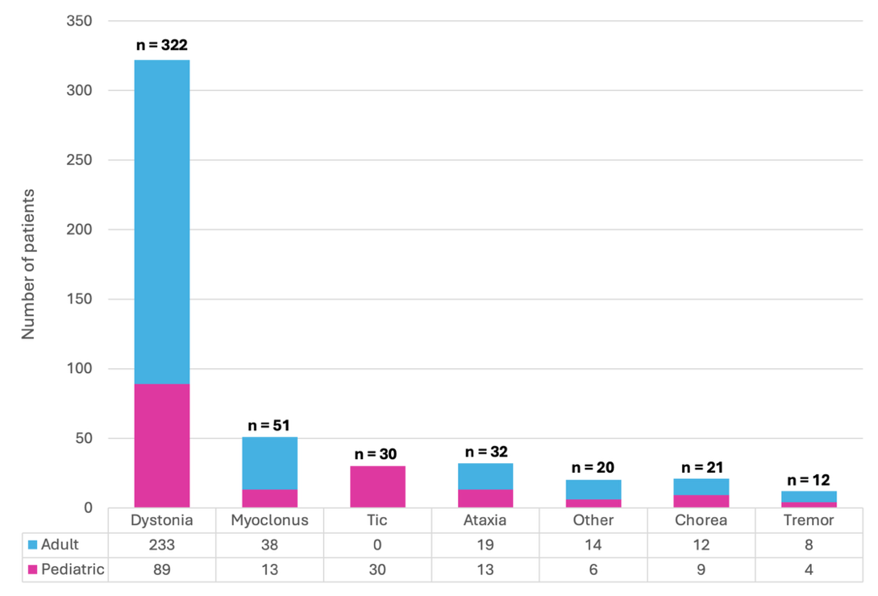
Distribution of the 488 patients by subtype of dominant hyperkinetic MD phenotype, classified by age at onset. The low number of tic cases likely reflects their management in general paediatrics, with our clinic seeing mainly refractory cases.

References
1. Fahn S. Classification of movement disorders. Mov Disord. mai 2011;26(6):947‑57.
2. Albanese A, Bhatia KP, Fung VSC, Hallett M, Jankovic J, Klein C, et al. Definition and Classification of Dystonia. Mov Disord. 2025;40(7):1248‑59.
3. Jinnah HA, Balint B, Fung VSC. The Dystonias. New York: Oxford University Press; 2025. 421 p.
4. Dressler D, Altenmüller E, Giess R, Krauss JK, Adib Saberi F. The epidemiology of dystonia: the Hannover epidemiology study. J Neurol. déc 2022;269(12):6483‑93.
5. Williams L, McGovern E, Kimmich O, Molloy A, Beiser I, Butler JS, et al. Epidemiological, clinical and genetic aspects of adult onset isolated focal dystonia in Ireland. Eur J Neurol. janv 2017;24(1):73‑81.
6. Ceraolo G, Spoto G, Consoli C, Modafferi E, Di Rosa G, Nicotera AG. Pediatric Genetic Dystonias: Current Diagnostic Approaches and Treatment Options. Life. juin 2025;15(7):992‑992.
7. Mouraux C, Fouquet C, Durkin K, Dideberg V, Bulk S, Aktan D, et al. Homozygous Pathogenic MYH3 Variants Associated With Arthrogryposis and Lingual Dystonia. Tremor Hyperkinetic Mov. oct 2025;15:53‑53.
8. Dale RC, Grattan-Smith P, Nicholson M, Peters GB. Microdeletions detected using chromosome microarray in children with suspected genetic movement disorders: a single-centre study. Dev Med Child Neurol. juill 2012;54(7):618‑23.

