Engineering serine metabolism to enhance AOX1 promoter self-Induction in a formate dehydrogenase-deficient Komagataella phaffii

Rocio Cozmar¹², Julio Berrios² and Patrick Fickers¹

¹ Microbial Processes and Interactions, TERRA Teaching and Research Centre, Gembloux Agro-Bio Tech, University of Liege, Gembloux, Belgium
² School of Biochemical Engineering, Pontificia Universidad Católica de Valparaíso, Av. Brasil 2085, Valparaiso 2340000, Chile

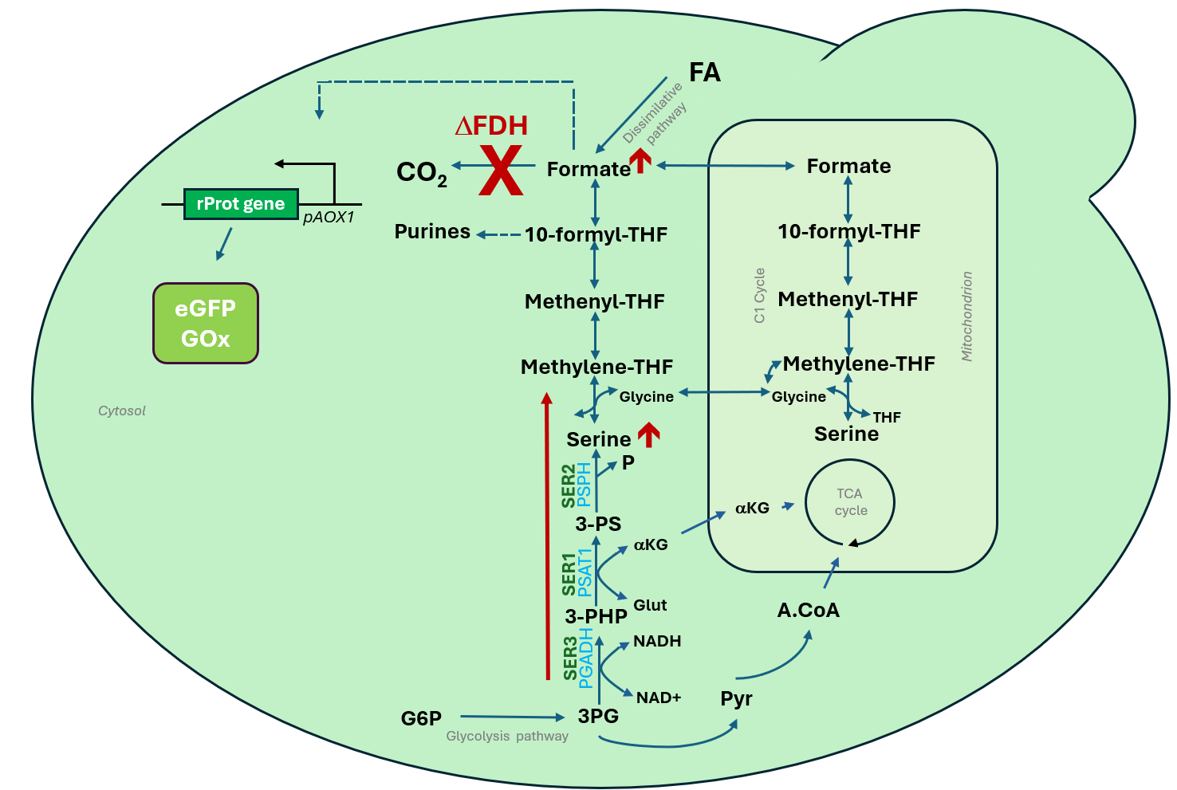
Figure S1: Schematic diagram illustrating the targeting serine biosynthesis pathway in a formate dehydrogenase-deficient K. phaffii. Formate from THF-C1 metabolism induces the P_{AOX1} promoter.

Figure S2: Biomass for eGfp strain (FdhKO P_{AOX1}-eGFP) expressing gene SER1 (panel A), SER2 (panel B), SER3 (panel C) and SER1-SER3 (panel D) under the control the P_{GAP} (strains marked with g) and P_{MDH3} (strains marked with m) during growth in sorbitol medium (YNBS). Cells were grown in microbioreactors in batch mode as described in Materials and Methods. Biomass is the mean value (colored lines) and standard deviation (grey shades) of biological triplicates. Arb units: arbitrary unit.

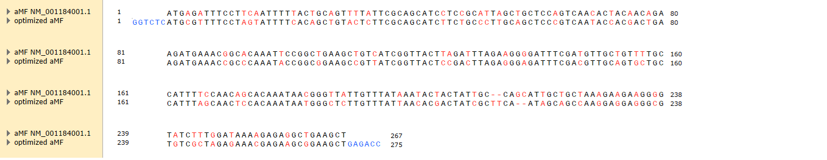
Figure S3: Codon optimized sequence of the alfa mating factor (αMF) from Saccharomyces cerevisiae (NM_001184001.1). Modified codons are in red, BsaI sequence is blue. Optimization was made using SnapGene software.
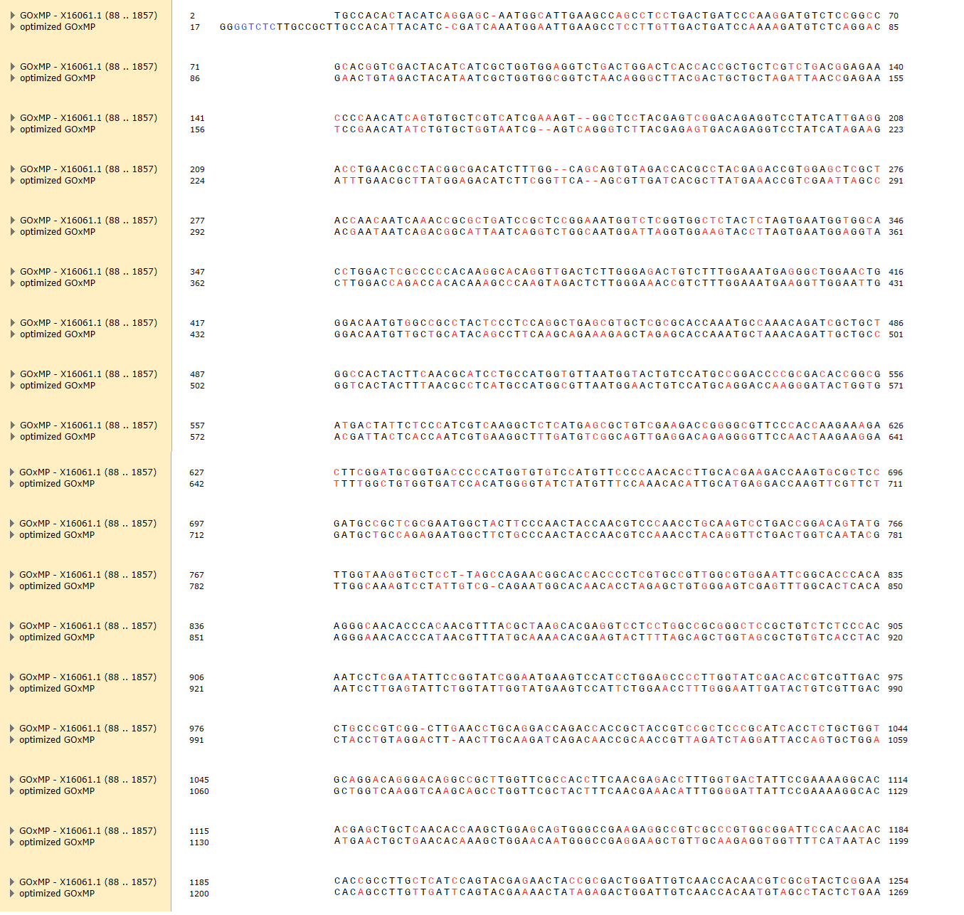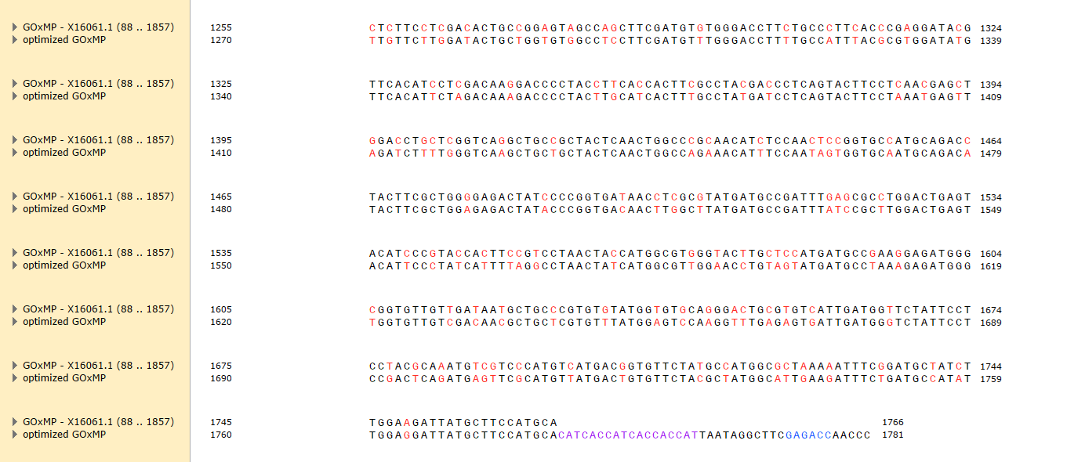Figure S4: Codon optimized sequence of the intron-less glucose oxidase gene (Gox) from Aspergillus niger (x60601.1). Modified codons are in red. BsaI sequence is blue. Sequence is purple correspond to a histidine tag fuse to the Gox protein for purification. Optimization was made using SnapGene software.

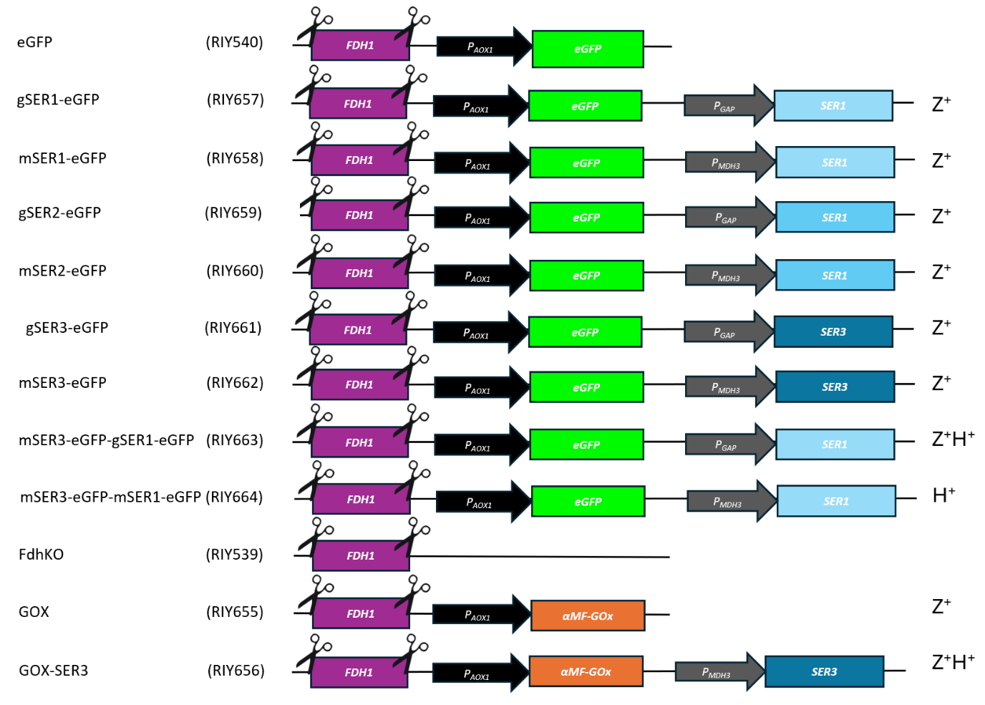
Figure S5: Schematic representation of the strain genotype used in the study.

Assessment of single-copy integration of recombinant gene expression cassettes in the yeast genome
The occurrence of a single-copy genome integration of the GOX and the SER gene expression cassettes was inferred indirectly, based on the assumption that variation in copy number among three randomly selected transformants would result in different phenotypes, reflected by differences in eGFP fluorescence or GOX-specific activity. To test this, the relevant proxy was measured in three randomly selected transformants of a given strain after 48 h of growth in a microbioreactor in YNBS medium. The consistency of these signals indicates an identical number of insertion events across the transformants, most likely a single integration. Indeed, the probability of multiple independent integration events leading to identical eGFP fluorescence or Gox activity in three randomly chosen transformants is very low.
In practice, three randomly selected transformants of strains gSER1-eGfp (fdh1Δ, P_{AOX1}-eGFP, P_{GAP}-SER1), mSER1-eGfp (fdh1Δ, P_{AOX1}-eGFP, P_{MDH3}-SER1), gSER2-eGfp (fdh1Δ, P_{AOX1}-eGFP, P_{GAP}-SER2), mSER2-eGfp (fdh1Δ, P_{AOX1}-eGFP, P_{MDH3}-SER2), gSER3-eGfp (fdh1Δ, P_{AOX1}-eGFP, P_{GAP}-SER3), mSER3-eGfp (fdh1Δ, P_{AOX1}-eGFP, P_{MDH3}-SER3), mSER3-gSER1 eGfp (fdh1Δ, P_{AOX1}-eGFP, P_{MDH3}-SER3, P_{GAP}-SER1), and mSER3-mSER1-eGfp (fdh1Δ, P_{AOX1}-eGFP, P_{MDH3}-SER3, P_{MDH3}-SER1) were cultivated for 48 h in a microbioreactor in YNBS medium, and their eGFP-specific fluorescence was measured. As shown in Figure S5, the consistent eGFP signals observed suggests monocopy integration of the SER gene expression cassettes. Similarly, GOX-specific activity was used as a proxy instead of eGFP fluorescence for GOX (fdh1∆, P_{AOX1}-αMF-GOX) and GOX-SER3 (fdh1∆, P_{AOX1}-αMF-GOX, P_{MDH3}-SER3) strains to evaluate GOX or SER3 monocopy integration. As shown in Figure S6, the GOX expression cassette integrated as a single copy in the GOX strain, while one copy of the SER3 expression cassette integrated in the GOX-SER3 strain. Based on this, one transformant of each strain was selected.
Figure S6: Specific eGFP fluorescence of the different eGFP constructed strains. Histogram color is specific for a constructed strain, each histogram bars representing one of the three transformants tested. Data represent the mean and standard deviation of triplicate cultures. sFU: specific fluorescence unit.

Figure S7: Specific glucose oxidase activity of the different GOX constructed strains. Histogram color is specific for a constructed strain, each histogram bars representing one of the three transformants tested. Data represent the mean and standard deviation of triplicate cultures.

Table S1: Enzymes involved in serine biosynthesis pathway in GS115 strain.
Enzyme | Gene name | uniProtID GS115 | Gene ID
PGADH | SER3 | C4R1C8_KOMPG | PAS_chr2-1_0657
PSAT1 | SER1 | F2QSD3_KOMPC | PAS_chr3_0566
PSPH | SER2 | C4R7E7_KOMPG | PAS_chr4_0285

Table S2. Escherichia coli strains used in this study.
Strain name (plasmid) | Plasmid, genotype,  (integration locus) |  | Source/Reference
A2, GoldenPiCS kit |  | BB1_23 | (Prielhofer et al., 2017)
D12, GoldenPiCS kit |  | BB3aZ_14 (AOX1tt, AOX1 terminator PP7435_Chr4-013) | (Prielhofer et al., 2017)
E1, GoldenPiCS kit |  | BB3eH_14 (ENO1, PP7435_Chr3-1154) | (Prielhofer et al., 2017)
E8, GoldenPiCS kit |  | BB3rN_14 (RGI2, PP7435_Chr1-0725) | (Prielhofer et al., 2017)
A4, GoldenPiCS kit |  | BB1_12_P_{GAP} | (Prielhofer et al., 2017)
A9, GoldenPiCS kit |  | BB1_12_P_{MDH3} | (Prielhofer et al., 2017)
B8, GoldenPiCS kit |  | BB1_12_P_{AOX1} | (Prielhofer et al., 2017)
C1, GoldenPiCS kit |  | BB1_34_ScCYC1tt | (Prielhofer et al., 2017)
RIE396 (RIP396) |  | pKTAC-Cre | (Bustos et al., 2024)
RIE457 (RIP457) |  | pUC57-aMF (codon optimized) | This work
RIE485 (RIP485) |  | pGEM®-T-GOX (codon optimized) | This work
RIE504 (RIP504) |  | A2_BB1_23_aMFGOX | This work
RIE507 (RIP507) |  | BB3aZ_14-P_{AOX1}-aMFGOX-SsCy1tt, integration at AOX1tt locus | This work
RIE508 (RIP508) |  | TOPO_SER1 | This work
RIE509 (RIP509) |  | TOPO_SER2 | This work
RIE510 (RIP510) |  | TOPO_SER3 | This work
RIY511 (RIP511) |  | BB3aZ_14-P_{GAP}-SER1-ScCYC1tt, assembly of parts 1, 8,14, D12 | This work
RIE512 (RIP512) |  | BB3aZ_14-P_{MDH3}-SER1-ScCYC1tt, assembly of parts 4, 9, 14, D12 | This work
RIE513 (RIP513) |  | BB3aZ_14-P_{GAP}-SER2-ScCYC1tt, assembly of parts 2, 10, 16, D12 | This work
RIE514 (RIP514) |  | BB3aZ_14-P_{MDH3}-SER2-ScCYC1tt, assembly of parts 5, 11, 16, D12 | This work
RIE515 (RIP515) |  | BB3aZ_14-P_{GAP}-SER3-ScCYC1tt, assembly of parts 1, 12, 17, D12 | This work
RIE516 (RIP516) |  | BB3aZ_14-P_{MDH3}-SER3-ScCYC1tt, assembly of parts 6, 13, 17, D12 | This work
RIE517 (RIP517) |  | BB3eH_14-P_{GAP}-SER1-ScCYC1tt, assembly of parts 1, 8, 15, E1 | This work
RIE518 (RIP518) |  | BB3eH_14-P_{MDH3}-SER1-ScCYC1tt, assembly of parts 4, 9, 15, E1 | This work
RIE519 (RIP519) |  | BB3rN_14-P_{MDH3}-SER3-ScCYC1tt, assembly of parts 7, 4, 18, E8 | This work

Table S3: Primers used in this study
Name | Sequence 5´to 3´
M13-Fw | gtaaaacgacggccagt
M13-Rv | aacagctatgaccatg
SER1-Fw | atggcaaaaactttggaaagagaa
SER1-Rv | tcaagaatgagcttcagcaa
SER2-Fw | atgagttatcgtttaactgc
SER2-Rv | ctattcgttaagaaatccct
SER3-Fw | atggcttctccccaagatat
SER3-Rv | ctagtatagcagacgggtga
1.pGAP.SER1-Rv | caaagtttttgccatggtgttttgatagttgttcaattgatt
2.pGAP.SER1-Fw | ctatcaaaacaccatggcaaaaactttggaaagagaagaacca
1.pMDH3.SER1-Rv | caaagtttttgccatgttgttattgttcgttggttgtaactctaaagtct
2.pMDH3.SER1-Fw | gaacaataacaacatggcaaaaactttggaaagagaagaacca
3.SER1.C1-Rv | aaaaggggcctgaagctcaagaatgagcttcagcaaattcgatg
4.SER1.C1-Fw | gaagctcattcttgagcttcaggccccttttcctttgtcgatatca
1.pGAP.SER2-Rv | taaacgataactcatggtgttttgatagttgttcaattgatt
2.pGAP.SER2-Fw | ctatcaaaacaccatgagttatcgtttaactgctatttcaaag
1.pMDH3.SER2-Rv | taaacgataactcatgttgttattgttcgttggttgtaactctaaagtct
2.pMDH3.SER2-Fw | gaacaataacaacatgagttatcgtttaactgctatttcaaag
3.SER2.C1-Rv | aaaaggggcctgaagctctattcgttaagaaatccctcaatttcg
4.SER2.C1-Fw | cttaacgaatagagcttcaggccccttttcctttgtcgatatcat
1.pGAP.SER3-Rv | tggggagaagccatggtgttttgatagttgttcaattgatt
2.pGAP.SER3-Fw | ctatcaaaacaccatggcttctccccaagatattaagcagtta
1.pMDH3.SER3-Rv | ttggggagaagccatgttgttattgttcgttggttgtaactctaaagtct
2.pMDH3.SER3-Fw | gaacaataacaacatggcttctccccaagatattaagcagtta
3.SER3.C1-Rv | aaaaggggcctgaagctctagtatagcagacgggtga
4.SER3.C1-Fw | tctgctatactagagcttcaggccccttttcctttgtcgatatcat
4.BB3rN14.C1-Rv | cattatacgaagttatggcatgccggagcgagcgagcttgcaaattaaagcc
1.BB3rN14pMDH3-Fw | cagggcggggttttttcgcgatcggaggtagcttgggtaggacttgacaagt
4.BB3eH14.C1-Rv | attctgggcctccatgtccatgccggagcgagcgagcttgcaaattaaagcc
2.pGAP-Fw | gggcggggttttttcgcgatcggaggatccttttttgtagaaatgtctt
2.pMDH3-Fw | gggcggggttttttcgcgatcggagtagcttgggtaggacttgacaagt
4.CYC1-Rv | tcgacctgcagcgtaccatgccggagcgagcttgcaaattaaagccttc
CkBB3aZ14-Fw | tgacagggcggggttttttcgcgatcggag
CkBB3aZ14-Rv | tcgacctgcagcgtaccatgccggagcg
1.BB3rN14-Rv | ctccgatcgcgaaaaaaccccgccctgtca
4.BB3rN14-Fw | cgctccggcatgccataacttcgtataat
1BB3aZ14-Rv | ctccgatcgcgaaaaaaccccgccctgtcaggggcggggttttttg
4.BB3eH14-Fw | cgctccggcatggacatggaggcccagaataccctccttgaca
Overlap sequence for hifi assembly is in bold

