Sorbitol uptake and oxygen transfer shape AOX1 promoter induction in Komagataella phaffii lacking formate dehydrogenase

Cristina Bustos^{1,2*}, Rocio Cozmar^{1,2*}, Julio Berrios² and Patrick Fickers¹

¹ ﻿Microbial Processes and Interactions, TERRA Teaching and Research Centre, Gembloux Agro-Bio Tech, University of Liege, Gembloux, Belgium
² ﻿School of Biochemical Engineering, Pontificia Universidad Católica de Valparaíso, Av. Brasil 2085, Valparaiso 2340000, Chile
*Equal contribution

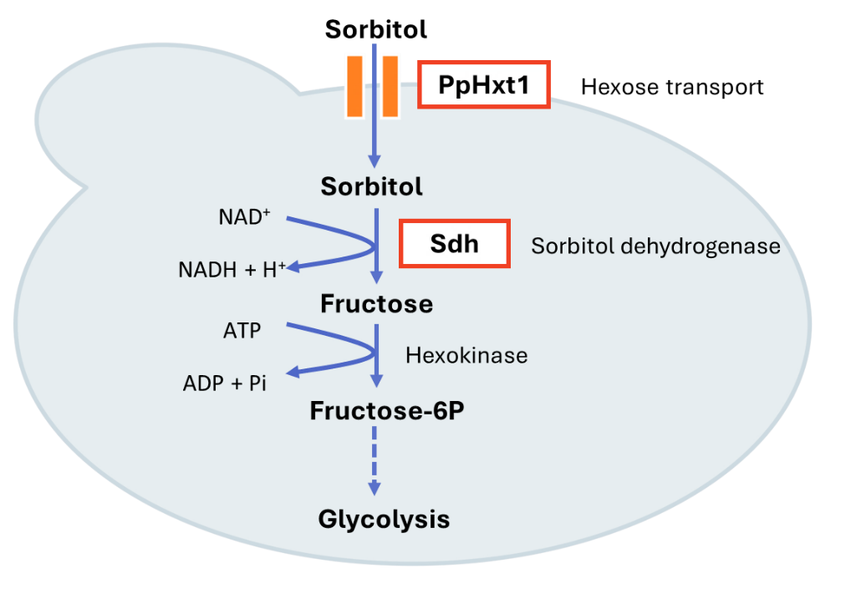
Figure S1. Sorbitol metabolism in K. phaffii: PpHxt1, a hexose transporter, is evaluated in this investigation as a putative sorbitol transporter; Sdh refers to sorbitol dehydrogenase.
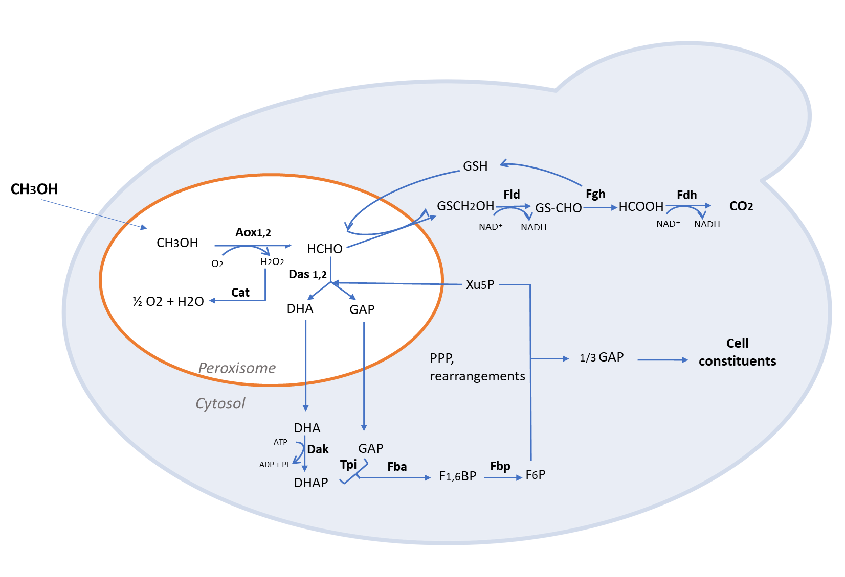
Figure S2. Methanol utilization pathway in Komagataella phafﬁi. Aox1, 2: alcohol oxidase1 and 2; Cat: catalase; Das1, 2: dihydroxyacetone synthase; Fld: formaldehyde dehydrogenase; Fgh: S-formylglutathione hydrolase; Fdh: formate dehydrogenase; Dak: dihydroxyacetone kinase; Tpi: triose phosphate isomerase; Fba: fructose-1,6-bisphosphate aldolase; Fbp: fructose-1,6-bisphosphatase; GS(H): glutathione; DHA: dihydroxyacetone; DHAP: dihydroxyacetone phosphate; GAP: glyceraldehyde-3-phosphate; F1,6BP: fructose-1,6-bisphosphate; F6P: fructose-6-phosphate; Xu5P: xylulose 5-phosphate.

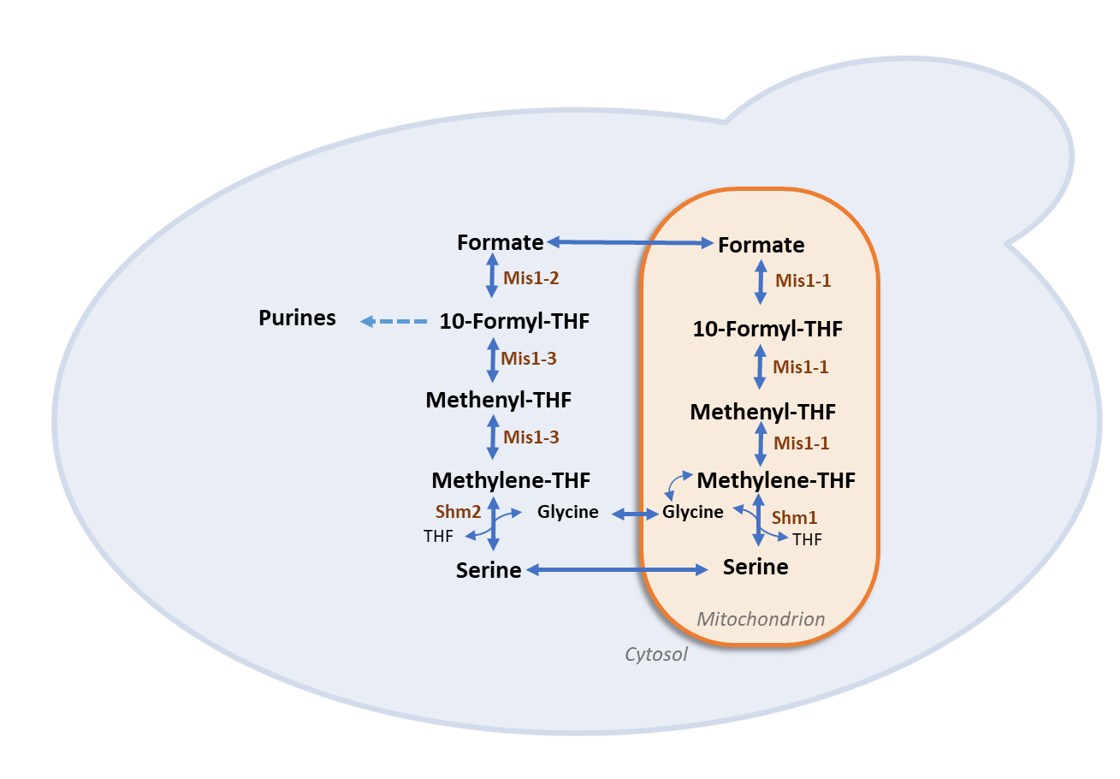
Figure S3. Tetrahydrofolate (THF) mediated one-carbon (THF-C1) metabolism in yeast. Fdh, formate dehydrogenase; Shm1, mitochondrial serine hydroxymethyltransferase; Shm2, cytosolic serine hydroxymethyltransferase; Mis1-2, formate-tetrahydrofolate ligase; Mis1-3, methylenetetrahydrofolate dehydrogenase & methenyltetrahydrofolate cyclohydrolase; Mis1-1, trifunctional enzyme: formate-tetrahydrofolate ligase, methenyltetrahydrofolate cyclohydrolase and methylenetetrahydrofolate reductase; THF, tetrahydrofolate. Figure adapted from (Bustos, et al.2024).

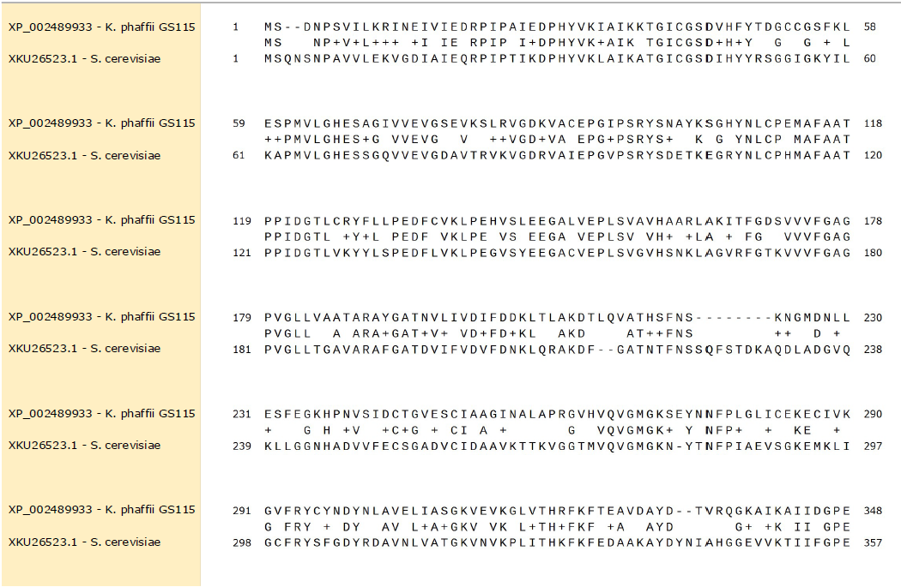
Figure S4. Sorbitol Dehydrogenase enzyme. Protein alignment. XP_002489933.1 corresponds to (gene PAS_chr1-1_0490) protein sequence K. phaffii, and XKU26523.1 corresponds to Saccharomyces cerevisiae.
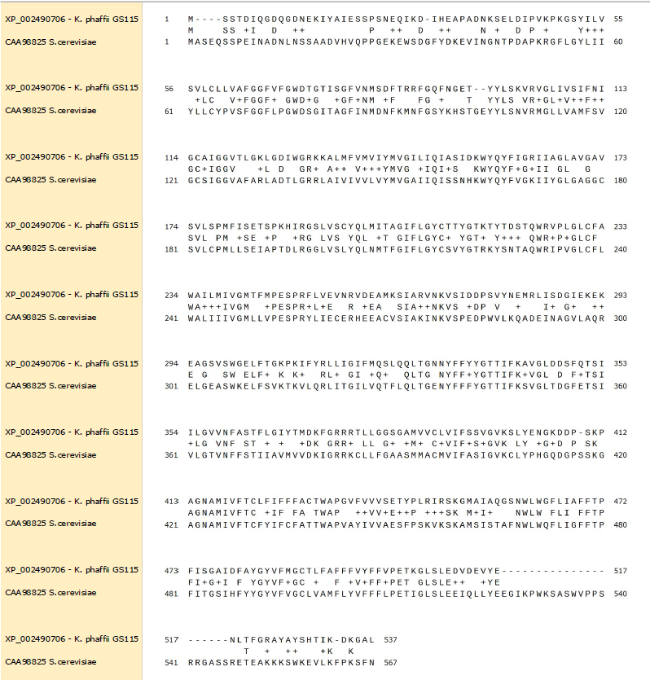
Figure S5. Hexose transporter protein. Protein alignment. XP_002490706.1 corresponds to (gene PAS_chr1-4_0570) protein sequence K. phaffii, and CAA98825.1 corresponds to Saccharomyces cerevisiae.

Figure S6. Schematic representation of the genotype of yeast strains.

Figure S7. Glycerol and sorbitol concentration during the growth of FdhKO eGfp strain (blue colors, Panel A) and FdhKO SdOE eGfp strain (orange colors, Panel B) in YNB minimal medium containing different mixtures of glycerol and sorbitol (YNBG0, 1.75 g L⁻¹ glycerol; YNBGS2, 1.75 g L⁻¹ glycerol and 1.75 g L⁻¹ sorbitol; YNBGS4, 1.75 g L⁻¹ glycerol and 3.5 L⁻¹ sorbitol). The data show one representative culture.

Fig S8. Sorbitol concentration after 22 h of growth of strains SdhKO eGfp (blue) and SdhKO SdOE eGfp (orange) in the YNBS2 medium under different OTC (low, K_{L}a 10 h⁻¹; medium, K_{L}a 10 h⁻¹; high, K_{L}a 100 h⁻¹). Data are the mean and standard deviation of triplicate cultures conducted in in shake flasks.

Figure S9. eGFP gene expression level for FdhKO eGfp and FdhKO-SdOE eGfp strains cultured strains grown under different OTC (low, K_{L}a 10 h⁻¹; high, K_{L}a 100 h⁻¹), in shake-flask cultures. Culture samples were taken at the mid-exponential growth phase (i.e. after 22 h). Data are means and standard deviations of triplicate cultures. Gene expression levels were normalized according to that of actin gene.

Table S1. Escherichia coli strains used in this study.
Strain name  (plasmid) | Plasmid - genotype | Source/Reference
A2 | BB1_23 | (Prielhofer et al., 2017)
D12 | BB3aZ_14 | (Prielhofer et al., 2017)
A4 | BB1_12_pGAP | (Prielhofer et al., 2017)
C1 | BB1_34_ScCYC1tt | (Prielhofer et al., 2017)
C9 | BB1_34_RPS3tt | (Prielhofer et al., 2017)
C12 | BB3aK_AC | (Prielhofer et al., 2017)
D4 | BB2_AB | (Prielhofer et al., 2017)
D5 | BB2_BC | (Prielhofer et al., 2017)
RIE341  (RIP341) | A2_BB1_23_SOR1 | This work
RIE343  (RIP343) | A2_BB1_23_PpHXT1 | This work
RIE354  (RIP354) | BB3-P_{GAP}- PpHXT1-SsCy1tt | This work
RIE355  (RIP355) | BB3-P_{GAP}-SOR1-SsCy1tt | This work
RIE370  (RIP370) | BB3-AC-LoxP-Zeo-loxP | This work
RIE372  (RIP372) | BB2(AB)-P_{GAP}-SOR1- SsCy1tt | This work
RIE374  (RIP374) | BB2(BC1)-P_{GAP}-PpHXT1-RPS3tt | This work
RIE378  (RIP378) | BB3a-P_{GAP}-SOR1-SsCy1tt, P_{GAP}- PpHXT1-RPS3tt | This work

Table S2. Primers used in this study
Name | Sequence 5´to 3´ | Restriction site/gene
M13-Fw | GTAAAACGACGGCCAGT
M13-RV | AACAGCTATGACCATG
pGAP.Int-Fw | CGTCGCTGGCAATAATAGCGG
ScCYC1tt.Int-Rv | GGGACCTAGACTTCAGGTTGTC
Rps3tt.Int-Rv | GACGAGTCCAGGGCTATCTTAAG
SOR1-Fw | CGGTCTCACATGTCCGATAACCCAAGTGTTATCTTAAAAGGATTAATGAGATTGTCATAGAAGATAGACCAATTCCAGCCATTGAGGATCCTCACTATGTGAAAATAGCAATCAAAAGACCGGAATTTG | BsaI
SOR1-Rv | CGGTCTCCAAGCTTTACTCTGGGCCGTCAATGATAG | BsaI
qAct‐F | AGATGGCTCCGAGAAGTTCA | ACT1
qAct‐R | GTTGCTCAGAGGGCTTCAAC | ACT1
qeGFP-F | ATCATGGCCGACAAGCAGAA | eGFP
qeGFP-R | TCTCGTTGGGGTCTTTGCTC | eGFP
ST_qPCR_Fo | CCAGGTGTTTTCGTCGTTGT | PpHxt1
ST_qPCR_Rev | AGGCGAACAGAGTACATCCC | PpHxt1
SDH_qPCR_Fo | CCCGTCTCGTTACAGCAATG | SOR1
SDH_qPCR_Rev | GCATGGACAGCAACACTCAA | SOR1

