European Geriatric Medicine https://doi.org/10.1007/s41999-026-01509-8

RESEARCH PAPER
A cross‑sectional analysis of multidimensional clinical profiles of older adults engaged in structured post‑ICU follow‑up: age is not the whole story
Anne‑Françoise Rousseau^{1,2} · Bertrand Guidet³ · Camille Colson¹ · Pauline Minguet¹ · Sarah Neis‑Gilson¹ ·

Aurélie Wagener^{2,4} · Bernard Lambermont¹
Received: 20 February 2026 / Revised: 7 May 2026 / Accepted: 18 May 2026
© The Author(s), under exclusive licence to European Geriatric Medicine Society 2026

Key summary points
Aim To examine whether older ICU survivors (≥ 65 years) experience a worse multidimensional post-ICU health profile at three months than younger survivors.
Findings Among 257 ICU survivors, older adults did not present a globally poorer profile in physical function, frailty, sleep, or quality of life compared with younger patients. Age was independently associated only with slightly lower cognitive performance and fewer post-traumatic stress symptoms.
Message Chronological age alone does not define post-ICU vulnerability and should not replace multidimensional, agesensitive assessment in geriatric survivorship care.

Abstract
Purposes Older patients are often perceived as being at higher risk of poor post-ICU outcomes, yet data describing their multidimensional clinical profile within structured follow-up programs remain limited.
Methods We conducted a retrospective analysis of prospectively collected data from a single-center, post-ICU follow-up clinic. All ICU survivors attending a standardized 3-month (M3) consultation between 2022 and 2025 were eligible. Patients were divided into geriatric (≥ 65 years) and non-geriatric (< 65 years) groups. Outcomes included cognitive function (MoCA), psychological symptoms (HADS, IES-R), sleep quality (PSQI), functional status (Barthel Index), physical activity (IPAQSF), frailty (Clinical Frailty Scale), and health-related quality of life (EQ-5D-3L). Multivariate linear regression was used to explore associations between age and post-ICU outcomes.
Results A total of 257 patients were analyzed, including 107 older and 150 younger survivors. Functional independence, physical activity, frailty, and return to daily activities were comparable between groups. Geriatric survivors reported fewer anxiety, depressive, and post-traumatic stress symptoms, despite slightly lower cognitive performance. Quality of life was preserved and modestly higher in geriatric patients. In multivariate analysis, age was independently associated only with

* Anne-Françoise Rousseau afrousseau@chuliege.be
- Department of Intensive Care, University Hospital of Liège, Sart-Tilman B35, 4000 Liège, Belgium
- Research Unit for a Life-Course Perspective On Health & Education-RUCHE, University of Liège, Liège, Belgium
- Sorbonne Université, INSERM, Institut Pierre Louis d’Epidémiologie Et de Santé Publique, Equipe PEPITES, AP-HP, Hôpital Saint Antoine, Paris, France
- Department of Psychology, Faculty of Psychology and Science of Education, University of Liege, Liège, Belgium
Vol.:(0123456789)
cognitive performance (lower MoCA scores) and post-traumatic stress symptoms (lower IES-R scores), and not with other PICS domains.
Conclusion At M3 after ICU discharge, older and younger survivors engaged in structured follow-up care showed broadly similar clinical and functional profiles although older age was selectively associated with lower cognitive performance and fewer post-traumatic stress symptoms. While these findings do not reflect recovery trajectories, they support comprehensive, individualized assessment beyond chronological age in post-ICU care.
Keywords Post-intensive care syndrome · Follow-up · Older adults · Survivorship · Geriatrics

Abbreviations
BMI Body mass index
ICU Intensive care unit
PICS Post-intensive care syndrome
PTSD Post-traumatic stress disorder HR-QoL Health-related quality of life

Introduction
Advances in critical care medicine have led to substantial improvements in short-term survival, resulting in a growing population of intensive care unit (ICU) survivors worldwide [1]. In parallel, demographic ageing has profoundly reshaped ICU case-mix, with older adults now representing an increasing proportion of critically ill patients. In many high-income countries, patients aged 65 years and older account for more than half of ICU admissions [2], a trend expected to intensify over the coming decades as population ageing accelerates [3]. While older patients frequently survive the acute phase of critical illness, their post-ICU trajectories raise major clinical and societal concerns.
Survival after critical illness is increasingly recognized as being accompanied by long-term sequelae affecting multiple domains of health [4]. These persistent impairments, collectively referred to as post-intensive care syndrome (PICS), encompass physical disabilities, cognitive dysfunction, psychological distress, and reduced health-related quality of life [5]. PICS has been shown to affect a substantial proportion of ICU survivors [6], often persisting for months or years after hospital discharge and leading to increased healthcare utilization, loss of autonomy, and impaired social reintegration [4]. As a result, structured post-ICU follow-up programs have emerged to better characterize and manage these longterm consequences [7].
Older ICU survivors may be particularly vulnerable to PICS due to pre-existing comorbidities, frailty, reduced physiological reserve, and age-related cognitive and functional decline [8]. However, despite the growing number of older patients surviving critical illness, data specifically describing their post-ICU outcomes remain limited and heterogeneous. Most studies on PICS have included wide age ranges without dedicated analyses focusing on older adults [9–11], while others have relied on selected outcomes, mainly functional capacity [12–14], providing an incomplete picture of the multidimensional burden experienced by this population. Consequently, the specific characteristics, severity, and pattern of PICS in older ICU survivors remain insufficiently understood.
The objective of the present study was therefore to describe the multidimensional clinical profile of post-intensive care syndrome in older patients followed in a structured post-ICU clinic, and to compare their physical, cognitive, psychological, functional, and quality-of-life status with that of younger ICU survivors at three months after ICU discharge. Importantly, our aim was not to describe longitudinal trajectories or the evolution of outcomes attributable to the ICU stay, but rather to characterize the cross-sectional health status at follow-up that may guide tailored post-ICU care.

Methods

Study design and setting
This exploratory study is a retrospective analysis of data collected prospectively in a tertiary post-ICU follow-up clinic. In our department, all patients surviving an ICU stay of at least 7 days are systematically invited to attend a structured post–intensive care follow-up program at 3 months (M3) after ICU discharge. These consultations are conducted in person and coordinated by a multidisciplinary team comprising intensivists, ICU nurses, physiotherapists, dietitians, and psychologists, at minimum evaluating physical, cognitive, and psychological status, sleep quality, as well as healthrelated quality of life (HRQoL). The consultation is cancelled in case of ongoing hospitalization in acute care or in inpatient rehabilitation facilities, if patients are unable to communicate in French, the local language, or if they refuse to enter this post-ICU trajectory of care.

Patients, ethics and data source
All consecutive patients who attended the M3 consultation during the 4 past years (from 2022 to 2025) were included if they completed the functional, cognitive, psychological and sleep status assessment, as well as the HRQoL evaluation. Patients were secondarily excluded if they had been admitted to ICU for severe burns. Included patients were divided into two groups: a geriatric group (Groupe G, older patients, aged ≥ 65 years, according to the National Health Service definition) and a non-geriatric group (Group NG: younger patients).
M3 outcomes, demographic data, and data related to the ICU stay were extracted from the medical charts.
In accordance with Belgian legislation, informed consent was waived as the study was observational, did not alter standard care, and relied on anonymized data. This approach was validated by the Ethics Committee of the University Hospital of Liège (reference 2020/424).

Clinical outcomes
Global cognitive function was assessed using the Montreal Cognitive Assessment (MoCA), which evaluates visuospatial abilities, executive function, attention and working memory, episodic memory, and language. Total scores range from 0 to 30, with lower scores indicating poorer cognitive performance. A validated threshold of < 26 was used to define objective cognitive impairment. [15]
Psychological status was evaluated using the Hospital Anxiety and Depression Scale (HADS) and the Impact of Event Scale–Revised (IES-R). The HADS consists of two seven-item subscales assessing anxiety (HADS-A) and depression (HADS-D), with scores > 7 indicating borderline or clinically significant symptoms [16]. The IES-R is a 22-item questionnaire measuring post-traumatic stress symptoms across three domains (intrusion, avoidance, and hyperarousal); a score > 33 was considered indicative of severe psychological distress [17].
Sleep quality was assessed using the Pittsburgh Sleep Quality Index (PSQI), a validated self-administered questionnaire covering seven components of sleep over the preceding month. Global scores range from 0 to 21, with values > 5 reflecting poor sleep quality [18].
Functional independence was measured using the Barthel Index of activities of daily living, which evaluates ten basic activities. Scores range from 0 to 100, with a score of 100 indicating full autonomy [19].
Physical activity level was remotely quantified using the French version of the International Physical Activity Questionnaire-Short Form (IPAQ-SF). Patients were asked to report their typical weekly activity types, including vigorous-intensity activities (e.g., heavy lifting, digging, aerobics, or fast bicycling), moderate-intensity activities (e.g., carrying light loads, bicycling at a regular pace, or doubles tennis), walking, and sitting that are undertaken during work, transport, housework, or leisure activities. The total score is the summation of the duration and frequency of walking, moderate- and vigorous-intensity activities, reported as the “metabolic equivalent of task-min per week (MET-minute/ week)” [20]. The IPAQ-SF scores of < 600, 600–3000, and > 3000 MET-min/week were, respectively, categorized as low, moderate, and high physical activity levels (www. ipas. ki. se).
HRQoL was evaluated using the EQ-5D-3L, which consists of a short questionnaire that assesses 5 health domains (mobility, self-care, usual activities, pain/discomfort, and anxiety/depression) using 3 levels (no problems, some problems, and severe problems). Each of the 243 possible health states resulting from this questionnaire can be assigned a utility based on societal preference for that particular health state. These utilities are determined in representative samples of the population of different countries. Utilities typically range from < 0 to 1, where lower scores represent worse health states and higher scores better health states (1 representing perfect health and negative values representing a health state considered to be worse than death). For this study, Belgian valuation was used to assign utilities to each health state [21]. The supplementary EQ-VAS is used to measure survivors' self-rated health on a scale between 0 (“The worst health you can imagine”) and 100 (“The best health you can imagine”).
Frailty was assessed using the 9-point Clinical Frailty Scale (CFS), a clinical judgement-based instrument evaluating comorbidity, function, and cognition to generate a frailty score ranging from 1 (very fit) to 9 (terminally ill). Patients were classified as living with frailty when the CFS score > 3 [22].
Finally, patients were interviewed regarding their living situation, return to previous occupational or leisure activities, physiotherapy, falls, fractures or hospital readmission occurring between hospital discharge and follow-up. The presence of pain, fatigue, non-healed wounds, and loss of appetite was also assessed, as well as patients’ recollection of their ICU stay.

Data analysis
Statistical analysis was performed using Graphpad Prism (version 10.6.1 for Mac OS, Graphpad Inc., San Diego, CA, USA). Qualitative parameters were expressed as counts and percentages. Normality of the distribution of the quantitative variables was investigated graphically with histograms and quantile–quantile plots and assessed using Shapiro–Wilk hypothesis test. As some datasets did not pass the normality test, results were expressed as medians with lower and upper quartiles (P25–P75) for quantitative parameters. Missing values were not replaced. Comparisons between groups were made using Chi‐square test for categorical variables and using Mann–Whitney test for continuous variables. A p value < 0.05 was considered statistically significant. The association between M3 outcomes and baseline or ICU parameters was tested using a multivariate linear regression model.

Results

Study population
Between 2022 and 2025, 361 ICU survivors attended the 3-month (M3) post-ICU follow-up consultation. After exclusion of patients with incomplete assessments or meeting secondary exclusion criteria, 257 patients were included in the final analysis. Of these, 107 patients (41.6%) were aged ≥ 65 years (Group G) and 150 patients (58.4%) were younger than 65 years (Group NG) (Fig. 1).

Baseline and ICU characteristics
Baseline characteristics and ICU-related variables are presented in Table 1. As expected, patients in Group G were significantly older than those in Group NG (median age 72 [67–77] vs. 56 [46–60] years, p < 0.0001). Sex distribution and body mass index were similar between groups.
The primary reason for ICU admission differed significantly between groups (p < 0.0001), with cardiovascular failure being more frequent in older patients. Patients in Group G had lower illness severity at ICU admission, reflected by a lower SOFA score, and experienced shorter durations of mechanical ventilation (median 5 [1–11] vs. 10 [3–19] days, p = 0.0005) and shorter ICU length of stay (11 [8–17] vs. 13 [9–25] days, p = 0.014).

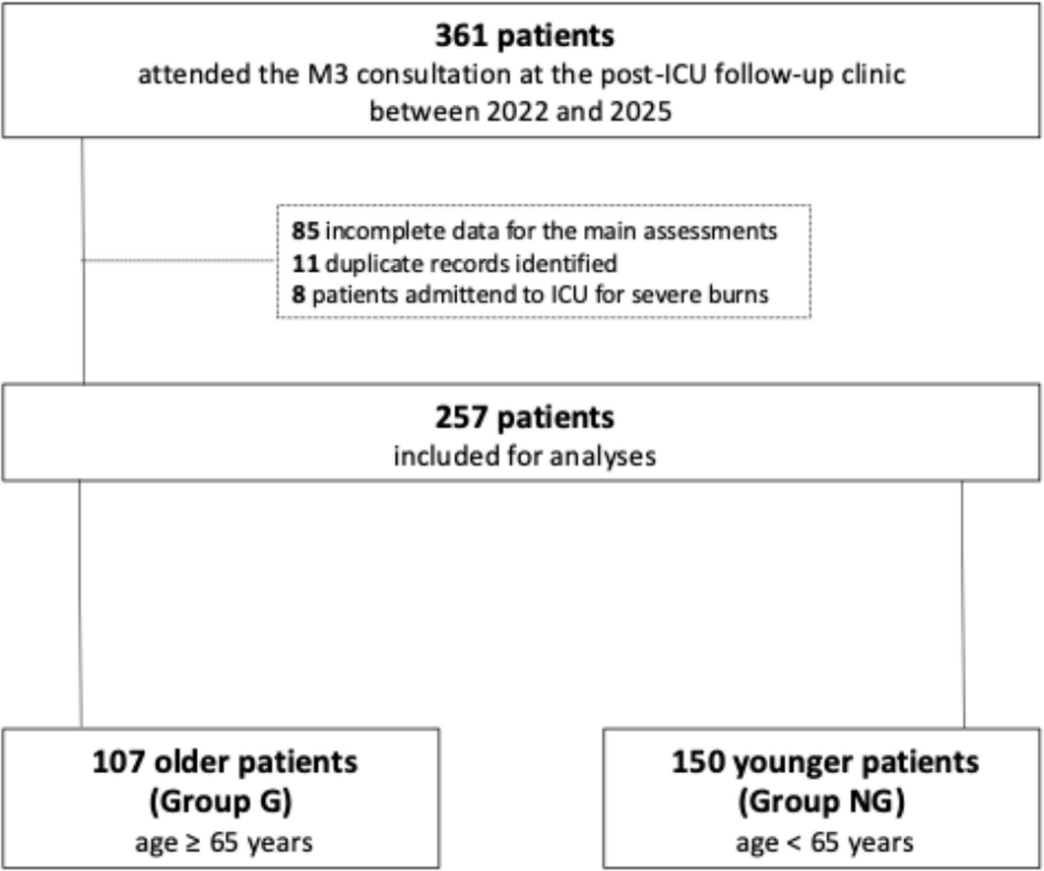
Fig. 1 Flow chart Data are expressed as medians with lower and upper quartiles [Q1–Q3] or as counts and percentages
BMI: body mass index; CRP: C-reactive protein; ICU: intensive care unit, LOS: length of stay; SOFA: Sequential Organ Failure Assessment

Exposure to major ICU interventions, including vasopressor therapy, renal replacement therapy, extracorporeal membrane oxygenation, and midazolam-based sedation, was comparable between groups, although the duration of midazolam infusion was shorter in Group G (p = 0.0005). Hospital length of stay and peak inflammatory response, assessed by maximum CRP levels, did not differ significantly between groups.

Post‑ICU outcomes at M3
Post-ICU outcomes are summarized in Table 2 and Fig. 2. ICU recollection, living setting at M3, and rates of return to previous levels of activities were similar between older and younger survivors. The proportion of patients reporting falls, fractures, or hospital readmissions between hospital discharge and M3 did not differ significantly between groups.
Table 1 Demographics and ICU-related data in the two groups of the cohort
 |  | Group G n = 107 | Group NG N = 150 | P value
Age, y |  | 72 (67–77) | 56 (46–60) | < 0.0001
Female, n (%) |  | 26 (24.3) | 51 (34) | 0.099
BMI, kg/m² |  | 27 (23.8–29.7) | 27.5 (23.7–31.1) | 0.532
Primary failure, n (%) | Cardiovascular | 58 | 39 | < 0.0001
 | Pulmonary | 36 | 61
 | Neurologic | 6 | 16
 | Digestive and hepatic | 1 | 17
 | Other | 6 | 17
SOFA at ICU admission |  | 4 (3–8) | 6.5 (4–9.2)
Mechanical ventilation > 24 h, n (%) |  | 70 (65.4) | 111 (74) | 0.166
Duration of mechanical ventilation, d |  | 5 (1–11) | 10 (3–19) | 0.0005
Norepinephrine, n (%) |  | 72 (67.3) | 103 (68.7) | 0.892
Duration of norepinephrine, d |  | 2 (1–5) | 3 (1–5) | 0.366
Renal replacement therapy, n (%) |  | 7 (6.5) | 20 (13.3) | 0.099
Duration of renal replacement therapy, d |  | 8 (6–11) | 9 (7–16.5) | 0.488
Extracorporeal membrane oxygenation, n (%) |  | 5 (4.7) | 14 (9.3) | 0.227
Duration of extracorporeal membrane oxygenation, d |  | 6 (4.5–16) | 7 (5.7–22) | 0.693
Midazolam-based sedation, n (%) |  | 54 (50.5) | 86 (57.3) | 0.301
Duration of midazolam infusion, d |  | 1 (1–2) | 2 (-7) | 0.0005
Maximum serum CRP level during the ICU stay, mg/L |  | 215.9 (119.8–299.6) | 237.4 (132.4–343.5) | 0.099
ICU LOS, d |  | 11 (8–17) | 13 (9–25) | 0.014
Hospital LOS, d |  | 31 (20–50) | 36 (22–60) | 0.066
At M3, cognitive performance assessed by the MoCA was slightly but significantly lower in older patients (median score 26 [23–28] vs. 27 [24–29], p = 0.006). However, objective cognitive impairment (MoCA < 26) was more frequently observed in younger patients (65.3% vs. 51.4%, p = 0.029). Psychological burden was consistently higher in
younger ICU survivors. Group NG reported slightly higher anxiety (HADS-A median 6 [3–10] vs. 5 [2–7], p = 0.003) and depressive symptoms (HADS-D median 4 [2–8] vs. 3 [1–6], p = 0.039), with a greater proportion exceeding clinically relevant thresholds for both anxiety and depression. Similarly, post-traumatic stress symptoms assessed by the IES-R were more severe in younger patients, both in terms of median score (p = 0.006) and prevalence of severe symptoms (IES-R > 33: 15.3% vs. 5.6%, p = 0.016). Sleep quality was impaired in both groups but was significantly worse in younger patients, who had higher PSQI scores and a higher prevalence of poor sleep quality (PSQI > 5: 58% vs. 43%, p = 0.022). Health-related quality of life was modestly but significantly better in older survivors, both in terms of utility scores and EQ-VAS self-ratings.
Functional independence was largely preserved in both groups, with no difference in Barthel Index scores or in the proportion of patients with incomplete autonomy. Physical activity levels assessed by the IPAQ-SF were low in the majority of patients and did not differ significantly between groups.
Frailty, assessed using the Clinical Frailty Scale, was frequent in both groups, with approximately 40% of patients
Table 2 Multidimensional assessment at M3 in the two groups of the cohort
Group G
Group NG
P value
n
n
Recollection from the ICU stay |  | 107 | 89 (83.2) | 150 | 121 (80.7) | 0.629
Living setting, n (%) | Home | 107 | 105 | 150 | 140 | 0.213
 | Nursing home |  | 0 |  | 2
 | Rehabilitation hospital |  | 1 |  | 1
 | Other |  | 1 |  | 7
Return to previous level of activities, n (%) |  | 107 | 46 (43) | 150 | 59 (39.3) | 0.607
At least one fall, n (%) |  | 107 | 21 (19.6) | 150 | 23 (15.3) | 0.403
At least one fractures, n (%) |  | 107 | 0 | 150 | 4 (2.7) | 0.143
At least one hospital readmission, n (%) |  | 107 | 19 (17.8) | 150 | 23 (15.3) | 0.612
PT between discharge and M3, n (%) |  | 79 | 62 (78.5) | 99 | 78 (78.8) | > 0.999
Pain, n (%) |  | 107 | 51 (47.7) | 150 | 83 (55.3) | 0.255
Fatigue, n (%) |  | 107 | 56 (52.3) | 150 | 96 (64) | 0.072
Loss of appetite, n (%) |  | 107 | 28 (26.2) | 150 | 38 (25.3) | 0.886
Unhealed wound, n (%) |  | 107 | 7 (6.5) | 150 | 10 (6.7) | > 0.999
MOCA |  | 107 | 26 (23–28) | 150 | 27 (24–29) | 0.006
HADS-A |  | 107 | 5 (2–7) | 150 | 6 (3–10) | 0.003
HADS-D |  | 107 | 3 (1–6) | 150 | 4 (2–8) | 0.039
IES-R |  | 107 | 6 (2.7–15) | 150 | 10 (3–22) | 0.006
PSQI |  | 107 | 5 (1–8) | 150 | 7 (3–10) | 0.016
EQ-5D-3L utility score |  | 107 | 0.691 (0.587–1) | 150 | 0.681 (0.504–0.765) | 0.011
EQ-5D-3L VAS |  | 107 | 75 (60–80) | 150 | 70 (50–80) | 0.024
IPAQ-SF (MET-min/week) |  | 81 | 805.5 (237,8–1715) | 100 | 1017 (210–2772) | 0.588
IPAQ-SF, low level of physical activity, n (%) |  | 81 | 67 (82.7) | 100 | 77 (77) | 0.361
Barthel Index |  | 83 | 100 (100–100) | 111 | 100 (100–100) | 0.962
CFS |  | 105 | 3 (3–4) | 144 | 3 (3–4) | 0.649

Data are expressed as medians with lower and upper quartiles [Q1–Q3] or as counts and percentages. CFS: Clinical Frailty Scale; HADS: Hospital Anxiety and Depression scale; ICU: intensive care unit; IES-R: Impact of Event Scale – Revised; IPAQ-SF: International Physical Activity Questionnaire-Short Form; MoCA: Montreal Cognitive Assessment; PSQI: Pittsburgh Sleep Quality Index; PT: physiotherapy; VAS: visual
analogue scale
classified as living with frailty, without significant intergroup differences.

Factors associated with post‑ICU outcomes
Multivariate linear regression analysis is presented in Supplementary Table 1. Age was independently associated with cognitive and psychological outcomes only. Increasing age was associated with lower MoCA scores, whereas it was associated with lower IES-R scores. Age was not independently associated with anxiety, depressive symptoms, sleep quality, functional status, physical activity, frailty, or healthrelated quality of life at 3 months.
Other ICU-related variables showed limited and inconsistent associations with post-ICU outcomes. Female sex was associated with higher anxiety and post-traumatic stress symptom scores, while higher peak C-reactive protein levels were associated with greater depressive symptoms and PTSD severity. Exposure to major ICU therapies, including mechanical ventilation, vasopressor use, renal replacement therapy, or sedation, was not independently associated with most post-ICU outcomes.

Discussion
In this study, we provide a cross-sectional snapshot of ICU survivors who attended a structured post-ICU follow-up consultation at M3. When comparing younger and older survivors within this population—independently of any causal link with the pre-ICU status or initial critical illness—we observed that older patients did not present with a globally worse post-ICU health status, contrary to common intuitive assumptions. Functional independence, physical activity levels, frailty, and return to daily activities were comparable between age groups. Moreover, older survivors reported

Fig. 2 Multidimensional post-ICU impairments at 3 months according to age group. Bar chart showing the proportion of patients presenting clinically relevant alterations across major M3 outcomes. Numbers displayed within the bars represent absolute patient counts.
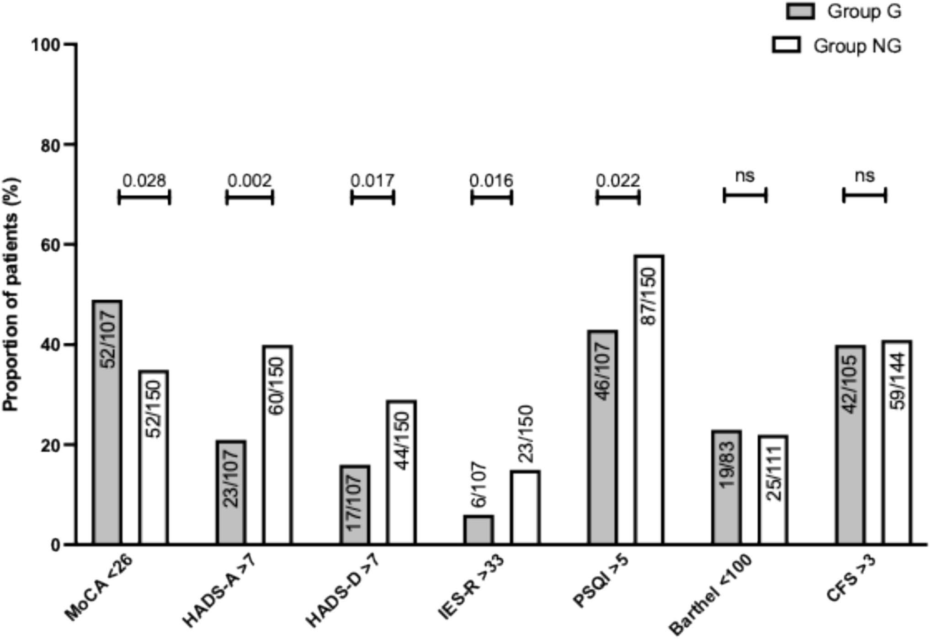
CFS: Clinical Frailty Scale; HADS: Hospital Anxiety and Depression scale; IES-R: Impact of Event Scale – Revised; MoCA: Montreal Cognitive Assessment; PSQI: Pittsburgh Sleep Quality Index

fewer psychological difficulties, including anxiety, depressive symptoms, and post-traumatic stress, while exhibiting slightly greater objective cognitive impairment. Despite this cognitive burden, health-related quality of life was preserved and even modestly higher in older patients. In that sense, this study provides pragmatic insight into the respective domains of care needs in older versus younger survivors, helping to identify which dimensions are most likely to require attention within structured post-ICU programs.
Increasing age was independently associated with fewer PTSD at three months. This inverse relationship between age and PTSD burden has been inconsistently reported in the PICS literature [23] but has been described in other traumaexposed populations [24]. Several hypotheses may explain this finding. Older individuals may have greater emotional regulation, more adaptive coping strategies, or different illness representations shaped by life experience [25, 26]. In addition, generational differences in symptom reporting, recall, and expectations regarding health and survival may influence PTSD assessments [27]. Alternatively, younger patients may experience ICU admission as a more disruptive and identity-threatening event, particularly in relation to professional, family, and social roles, thereby increasing psychological vulnerability. Taken together, these observations suggest that psychological support strategies after ICU discharge should not be age-neutral but rather tailored to the specific vulnerability profiles of survivors. Importantly, a lower prevalence of PTSD in older survivors may also partly reflect diagnostic challenges, as PTSD in older adults may present with more fluctuating, atypical, or less overt symptom patterns compared with younger patients [28]. As a result, standard PTSD screening tools may underestimate the true psychological burden in older ICU survivors, highlighting the need for age-sensitive assessment strategies and longitudinal follow-up to better capture the dynamic nature of post-traumatic stress symptoms in this population.
In our cohort, the proportion of older ICU survivors presenting with cognitive impairment at three months was consistent with that reported in the existing literature [29], and older age was associated with worse objective cognitive performance at M3. This association remained independent of illness severity. Our findings are not fully consistent with previous studies in which age was not identified as an independent predictor of post-ICU cognitive impairment [30]. The disparity between our observations and prior literature likely reflects differences in study populations and selection processes, particularly as our cohort consisted exclusively of patients engaged in a structured post-ICU followup pathway. Altogether, the available observations reinforce the need for systematic and broad cognitive screening after ICU discharge, irrespective of age, as reliance on age-based assumptions alone may fail to identify a substantial proportion of patients with clinically relevant cognitive deficits.
Despite differences in cognitive and psychological outcomes, functional independence, physical activity, frailty, and health-related quality of life were remarkably similar between older and younger survivors at three months. This finding challenges the common perception that older age necessarily translates into poorer functional recovery after ICU [13, 31, 32]. The high prevalence of frailty in both groups underscores that vulnerability after critical illness extends beyond chronological age and supports a shift toward a more individualized, phenotype-based approach to survivorship care.
It is also important to interpret the present findings in light of the ICU course of the geriatric group. In our cohort, older patients were not more severely ill at admission, did not receive greater intensity of organ support, and did not experience longer ICU or hospital stays, a pattern that has also been reported in other cohorts of selected older ICU patients [33]. This pattern may partly reflect upstream selection processes at ICU admission, whereby the frailest or most severely ill older individuals are less frequently admitted, as well as potential limitations of life-sustaining treatments implemented during the ICU stay in accordance with patients’ goals of care [34]. Consequently, the older survivors evaluated at follow-up may represent a subgroup selected both at ICU entry and during the course of care, which should be considered when interpreting the apparent resilience observed at three months.
Taken together, these findings suggest that advanced age per se does not preclude a satisfactory post-ICU outcome and support the notion that, when intensive care aligns with patients’ values and goals of care, survivorship after critical illness may be meaningful, even in older populations, thereby reinforcing the importance of shared decision-making in critical care [35, 36].
This study provides a detailed, real-world snapshot of ICU survivorship by focusing on patients who actually attended a structured post-ICU follow-up consultation, reflecting routine clinical practice rather than selected research cohorts. The use of a standardized, multidisciplinary follow-up program allowed for a comprehensive and simultaneous assessment of multiple PICS domains. The parallel evaluation of objective outcomes (such as cognitive performance and functional independence) and patientreported outcomes provides a nuanced and patient-centered perspective on recovery after critical illness. However, this study has some limitations. First, its single-center design may limit the generalizability of the findings to other healthcare settings with different ICU case-mix, followup structures, or cultural approaches to survivorship care. The second limitation is the absence of systematic pre-ICU assessments of cognitive, psychological, and functional status. As a result, we were unable to quantify the magnitude of decline associated with critical illness or to compare the extent of deterioration between younger and older patients. This limitation is particularly relevant given that younger patients in our cohort presented with higher illness severity at ICU admission, suggesting a potentially greater burden of acute insult. Conversely, older patients who survived and attended follow-up may represent a relatively robust and selected subgroup. These combined factors may contribute to the apparent similarity in outcomes observed at three months. Similarly, the lack of formal delirium assessment during the ICU stay precludes limits causal interpretation of post-ICU outcomes. Third, selection bias is inherent to the study design, as only patients who attended the postICU follow-up consultation were included. In addition, our data system does not allow systematic tracking of all ICU survivors after hospital discharge. We were therefore unable to compare patients who attended the follow-up clinic with those who did not, nor to identify the reasons for non-attendance. It is thus possible that older patients seen in consultation represent a relatively preserved subgroup, introducing a potential “healthy attendee” bias and leading to an underestimation of post-ICU morbidity in the broader population of older survivors. Consequently, our results do not provide a comprehensive picture of outcomes among all older ICU survivors. Rather, they reflect the health status of those who were able and willing to engage in structured post-ICU care. Nevertheless, this perspective remains clinically relevant as it characterizes a population that actively integrates follow-up pathways and thus represents the group for whom post-ICU planning, shared decision-making, and survivorship-oriented interventions are most immediately applicable.

Conclusion
This study provides a cross-sectional description of the multidimensional post-ICU profile of older survivors engaged in a structured follow-up pathway. At three months, older and younger survivors showed broadly similar clinical and functional status, although older age was selectively associated with lower cognitive performance and fewer post-traumatic stress symptoms. While these findings do not reflect preICU status or recovery trajectories after critical illness, they delineate the domains most likely to require attention at follow-up. They highlight the importance of comprehensive, individualized assessment beyond chronological age in post-ICU care.
Supplementary Information The online version contains supplementary material available at https://doi .org /10 .1007 /s41999 -026 -01509- 8.
Acknowledgements None
Author contributions AFR: conceptualization; AFR: methodology; AFR, CC, PM, SNG: investigation, AFR, AW: formal analysis; AFR: visualization; AFR: writing – original draft; BG, CC, OM, SNG, AW, BL: writing – review and editing.
Funding The present study has not been supported by any funding.
Availability of data and material The datasets used and/or analyzed during the current study are available from the corresponding author on reasonable request.

Declarations
Ethics approval and consent to participate Not applicable.
Consent for publication Not applicable.
Conflict of interest All authors declare that they have no competing interests.

References
- Beil M, Jacobs JM, Guidet B (2025) The (un)surprising resilience of octogenarians in intensive care. Intensive Care Med
51:140–142
- Flaatten H, Beil M, Guidet B (2021) Elderly patients in the intensive care unit. Semin Respir Crit Care Med 42:10–19
- Vincent JL, Creteur J (2022) Appropriate care for the elderly in the ICU. J Intern Med 291:458–468
- Rousseau AF, Prescott HC, Brett SJ, Weiss B, Azoulay E, Creteur J, Latronico N, Hough CL, Weber-Carstens S, Vincent JL, Preiser JC (2021) Long-term outcomes after critical illness: recent insights. Crit Care 25:108
- Herridge MS, Azoulay E (2023) Outcomes after critical illness. N Engl J Med 388:913–924
- Butcher BW, (2026) Post-Intensive Care Syndrome. JAMA
- Nakanishi N, Liu K, Hatakeyama J, Kawauchi A, Yoshida M, Sumita H, Miyamoto K, Nakamura K (2024) Post-intensive care syndrome follow-up system after hospital discharge: a narrative review. J Intensive Care 12:2
- Vallet H, Guidet B, Boumendil A, De Lange DW, Leaver S, Szczeklik W, Jung C, Sviri S, Beil M, Flaatten H (2023) The impact of age-related syndromes on ICU process and outcomes in very old patients. Ann Intensive Care 13:68
- Pohl R, Wolff D, Ozkan E, Sprenger AA, Hasenpusch C, Wesenberg J, Duzel E, Apfelbacher C (2025) Prevalence and incidence of cognitive impairment following acute respiratory distress syndrome of any cause: a systematic review and meta-analysis. Crit Care 29:164
- De Silva S, Urwin A, Grimwood C, Goh EKE, Higgins AM, Hodgson CL (2025) Health-related quality of life of adult sepsis survivors following critical illness: a systematic review. Crit Care Explor 7:e1238
- Righy C, Rosa RG, da Silva RTA, Kochhann R, Migliavaca CB, Robinson CC, Teche SP, Teixeira C, Bozza FA, Falavigna M (2019) Prevalence of post-traumatic stress disorder symptoms in adult critical care survivors: a systematic review and metaanalysis. Crit Care 23:213
- Jung C, Marschall U, Hennig B, Giemsa M, Heramvand N, Parco C, Kelm M, Jacobs JM, Beil M (2025) Five-year mortality and functional trajectories in older survivors of intensive care compared to the general population. Intensive Care Med 51:2329–2340
- Heyland DK, Garland A, Bagshaw SM, Cook D, Rockwood K, Stelfox HT, Dodek P, Fowler RA, Turgeon AF, Burns K, Muscedere J, Kutsogiannis J, Albert M, Mehta S, Jiang X, Day AG (2015) Recovery after critical illness in patients aged 80 years or older: a multi-center prospective observational cohort study. Intensive Care Med 41:1911–1920
- Ball IM, Bagshaw SM, Burns KE, Cook DJ, Day AG, Dodek PM, Kutsogiannis DJ, Mehta S, Muscedere JG, Turgeon AF, Stelfox HT, Wells GA, Stiell IG (2017) Outcomes of elderly critically ill medical and surgical patients: a multicentre cohort study. Can J Anaesth 64:260–269
- Nasreddine ZS, Phillips NA, Bedirian V, Charbonneau S, Whitehead V, Collin I, Cummings JL, Chertkow H (2005) The Montreal Cognitive Assessment, MoCA: a brief screening tool for mild cognitive impairment. J Am Geriatr Soc 53:695–699
- Zigmond AS, Snaith RP (1983) The hospital anxiety and depression scale. Acta Psychiatr Scand 67:361–370
- Weiss D, Marmar C (1997) The impact of event scale - revised. In: Wilson J, Keane T (eds) Assessing pschycological trauma and PTSD. Guilford, New-York, pp 399–411
- Buysse DJ, Reynolds CF 3rd, Monk TH, Berman SR, Kupfer DJ (1989) The Pittsburgh Sleep Quality Index: a new instrument for psychiatric practice and research. Psychiatry Res 28:193–213
- Mahoney FI, Barthel DW (1965) Functional evaluation: the Barthel Index. Md State Med J 14:61–65
- Craig CL, Marshall AL, Sjostrom M, Bauman AE, Booth ML, Ainsworth BE, Pratt M, Ekelund U, Yngve A, Sallis JF, Oja P (2003) International physical activity questionnaire: 12-country reliability and validity. Med Sci Sports Exerc 35:1381–1395
- Cleemput I (2010) A social preference valuations set for EQ-5D health states in Flanders, Belgium. Eur J Health Econ 11:205–213
- Church S, Rogers E, Rockwood K, Theou O (2020) A scoping review of the Clinical Frailty Scale. BMC Geriatr 20:393
- Wang S, Allen D, Kheir YN, Campbell N, Khan B (2018) Aging and post-intensive care syndrome: a critical need for geriatric psychiatry. Am J Geriatr Psychiatry 26:212–221
- Havermans DCD, Hoeboer CM, Sobczak S, Primasari I, Coimbra BM, Hovnanyan A, Novakovic IZ, Langevin R, Aakvaag HF, Grace E, Dragan M, Lueger-Schuster B, El-Hage W, Olff M (2023) The mental health impact of the COVID-19 pandemic and exposure to other potentially traumatic events up to old age. J Trauma Stress 36:738–749
- Isaacowitz DM (2022) What do we know about aging and emotion regulation? Perspect Psychol Sci 17:1541–1555
- Grigoras G, Ilie AC, Turcu AM, Albisteanu SM, Lungu ID, Stefaniu R, Pislaru AI, Gavrilovici O, Alexa ID, (2025) Resilience and Intrinsic Capacity in Older Adults: A Review of Recent
Literature. J Clin Med 14
- Galambos NL, Krahn HJ, Johnson MD, Lachman ME (2020) The U shape of happiness across the life course: expanding the discussion. Perspect Psychol Sci 15:898–912
- Sobczak S, Orgeta V, Beenakker M, Boks M, Boltri M, Cations M, Coeur E, Cook JM, Corveleyn X, Dorame AN, van Dijk GC, Forresi B, Freel S, Gomez-Bautista D, Gunak MM, Havermans DCD, Hopwood M, O J, Lawrence KA, Lee LO, Maercker A, Marsman A, Olive I, Quaedflieg C, Ruisch J, Thorp SR, Woudsma
JS, Zabihi S, Olff M, Global Collaboration on Traumatic S, (2025) Post-traumatic stress disorder in older adults: a global collaboration on setting the future research agenda. Lancet Healthy Longev 6: 100720
- Perrella A, Geen O, Wang M, Rochwerg B, Molnar F, Frank C (2023) Cognitive changes in older adults following intensive care unit stays. Can Fam Physician 69:469–471
- Pandharipande PP, Girard TD, Jackson JC, Morandi A, Thompson JL, Pun BT, Brummel NE, Hughes CG, Vasilevskis EE, Shintani AK, Moons KG, Geevarghese SK, Canonico A, Hopkins RO, Bernard GR, Dittus RS, Ely EW, Investigators B-IS (2013) Longterm cognitive impairment after critical illness. N Engl J Med 369:1306–1316
- Villa P, Pintado MC, Lujan J, Gonzalez-Garcia N, Trascasa M, Molina R, Cambronero JA, de Pablo R (2016) Functional status and quality of life in elderly intensive care unit survivors. J Am Geriatr Soc 64:536–542
- Brummel NE, Balas MC, Morandi A, Ferrante LE, Gill TM, Ely EW (2015) Understanding and reducing disability in older adults following critical illness. Crit Care Med 43:1265–1275
- Boumendil A, Aegerter P, Guidet B (2005) Treatment intensity and outcome of patients aged 80 and older in intensive care units: a multicenter matched-cohort studyJ Am Geriatr Soc, United States, pp 88–93
- Boumendil A, Angus DC, Guitonneau AL, Menn AM, Ginsburg C, Takun K, Davido A, Masmoudi R, Doumenc B, Pateron D, Garrouste-Orgeas M, Somme D, Simon T, Aegerter P, Guidet B (2012) Variability of intensive care admission decisions for the very elderlyPLoS One, United States, pp e34387
- Guidet B, Vallet H, Flaatten H, Joynt G, Bagshaw SM, Leaver SK, Beil M, Du B, Forte DN, Angus DC, Sviri S, de Lange D, Herridge MS, Jung C (2024) The trajectory of very old critically ill patients. Intensive Care Med 50:181–194
- Jacobs JM, Rahamim A, Beil M, Guidet B, Vallet H, Flaatten H, Leaver SK, de Lange D, Szczeklik W, Jung C, Sviri S (2024) Critical care beyond organ support: the importance of geriatric rehabilitationAnn Intensive Care, Germany, pp 71
Publisher's Note Springer Nature remains neutral with regard to jurisdictional claims in published maps and institutional affiliations.
Springer Nature or its licensor (e.g. a society or other partner) holds exclusive rights to this article under a publishing agreement with the author(s) or other rightsholder(s); author self-archiving of the accepted manuscript version of this article is solely governed by the terms of such publishing agreement and applicable law.

