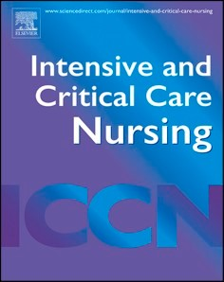
Editorial
Contents lists available at
ScienceDirec
t
Intensive
&
Critical Care Nursing
journal homepage:
www.sciencedirect.com/journal/intensive-and-critical-care-nursin
g
INTEN
S

CRI
T

CAR
E

NU
R

xx
x

(
xxxx
)

xx
x

Are we measuring too late? Rethinking muscle assessment across the peri-ICU pathway
ARTICLE INFO

Keywords:
Editorials Critical care outcomes Critical illness
Physical functional performance
Preoperative Exercise
Rehabilitation
Ultrasonography

Introduction
Critical illness is characterised by a rapid and profound metabolic response, driving early skeletal muscle loss and exposing underlying vulnerability in patients admitted to the intensive care unit (ICU) [1]. Over the past decade, muscle mass has emerged as a key determinant of outcomes, yet its routine assessment remains challenging at the bedside, often limited by feasibility, safety, and accessibility constraints. In this context, ultrasound has gained increasing attention as a non-invasive, reproducible, and readily available tool to quantify muscle mass in real time.
In a prospective cohort study of 400 critically ill patients, Burgel et al. [2] demonstrate that lower quadriceps muscle mass assessed within the first 24 h of ICU admission − whether measured as crude quadriceps muscle thickness (QMT), adjusted indices such as the Sonographic Thigh Adjustment Ratio (STAR), or estimated quadriceps muscle volume (QMV) − is independently associated with ICU mortality, but not with prolonged length of stay. Notably, more complex, body composition-adjusted metrics did not outperform the simple measurement of QMT, reinforcing the clinical value of a pragmatic, bedside- accessible approach.
These findings add to a growing body of evidence suggesting that skeletal muscle mass at ICU admission is not merely a consequence of acute illness but a key baseline determinant of outcomes [3]. Studies using computed tomography have demonstrated that reduced muscle mass on admission is independently associated with mortality and disability [4], further supporting the concept that muscle health represents a critical, yet under-recognised, component of physiological reserve in critically ill patients.
Beyond confirming the prognostic significance of muscle mass at ICU admission, the study of Burgel et al [2] invites a more fundamental reflection on timing. If a single, early and pragmatic measurement of quadriceps thickness already captures a patient’s physiological reserve and risk of death, it raises an essential question: are we assessing muscle
https://doi.org/10.1016/j.iccn.2026.104453 Received 23 April 2026; Accepted 7 May 2026
mass too late in the trajectory of critical illness?
This finding supports a paradigm shift toward anticipatory assessment across the peri-ICU pathway (Fig. 1). If QMT at ICU admission already captures a patient’s vulnerability, there is a strong rationale for moving this assessment upstream, particularly in patients for whom ICU admission is planned. In elective pathways, pre-admission quadriceps assessment could help identify individuals with limited physiological reserve who are at increased risk of adverse outcomes, not only mortality, but also poor functional recovery [5].
First, such an approach could meaningfully inform shared decision- making. In increasingly complex and ageing surgical populations, decisions are rarely binary and require a multidisciplinary perspective involving surgeons, anaesthesiologists, intensivists, physiotherapists, dieticians, and geriatricians. In this context, QMT could provide an objective, bedside-accessible marker of physiological reserve to complement clinical judgement. Beyond professional discussions, it may also facilitate patient-centred decision-making by making vulnerability more tangible and measurable. This could support more nuanced conversations about expected benefits, risks, and postoperative trajectories. In selected high-risk situations, it might also contribute to reconsideration of the surgical indication or to anticipating limitations of care in the event of complications [6].
Second, pre-admission muscle assessment could serve as a trigger for structured prehabilitation pathways [7]. Identifying reduced muscle reserve before ICU exposure opens a window of opportunity to implement targeted, multidimensional interventions combining physical training, nutritional optimisation, and functional conditioning [8,9]. Such strategies are increasingly feasible, even in cardiac surgery pathways, yet remain inconsistently applied. Simple, pragmatic tools, such as patient-completed screening instruments or (perhaps) ultrasound- derived muscle assessment, may support risk stratification for prehabilitation services [10]. While it remains unclear whether muscle mass itself represents a readily modifiable therapeutic target within the short timeframes available in most perioperative pathways [11], cohort

0964-3397/© 2026 Elsevier Ltd. All rights are reserved, including those for text and data mining, AI training, and similar technologies. Please cite this article as: Sabrina Eggmann et al., INTENS CRIT CARE NUR, https://doi.org/10.1016/j.iccn.2026.104453
Editorial Intensive & Critical Care Nursing xxx (xxxx) xxx
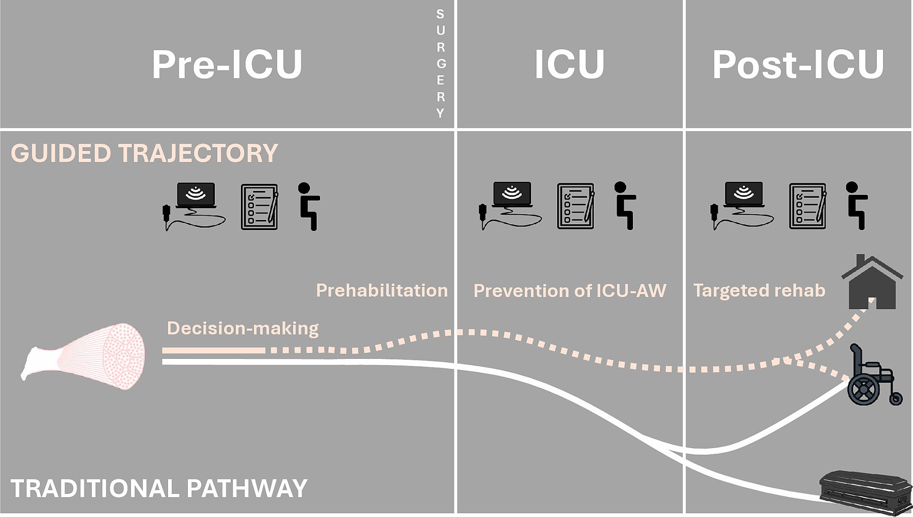
Fig. 1. Muscle ultrasound as a longitudinal “stethoscope of the muscle” across the peri-critical care pathway. This figure illustrates the potential integration of muscle ultrasound with a comprehensive assessment of physical function and activity throughout the entire patient trajectory, from the pre-ICU phase to post-ICU recovery. In contrast to traditional pathways, where muscle health and function is rarely assessed or incorporated into decision-making, muscle ultrasound enables a dynamic, bedside evaluation of physiological reserve. In the pre-ICU and perioperative setting, it may support risk stratification, inform admission decisions, and guide anticipatory strategies such as prehabilitation. During ICU stay, serial assessments combined with functional performance can help monitor muscle wasting to tailor interventions to prevent ICU-acquired weakness (ICU-AW) including tailoring of early mobilisation, and to refine prognostic evaluation. In the post-ICU phase, repeated assessments may contribute to tracking recovery trajectories and individualising rehabilitation strategies. Across these phases, muscle ultrasound emerges as a unifying tool to support clinical decision-making and personalise care pathways, shifting from a reactive to a proactive, function-centred approach to critical illness.

studies suggests that improvements in functional capacity can occur in the absence of measurable increases in muscle mass [12], reinforcing the importance of targeting the underlying drivers of low muscle mass [13]. In this context, muscle assessment may be most valuable as a signal for intervention, with strategies tailored to the underlying mechanisms of reduced reserve (e.g., sedentary behaviour, inflammation, reduced intake) to enhance functional capacity and physiological reserve, ultimately improving surgical outcomes.
Beyond the ICU, one may also anticipate a role for muscle ultrasound later in the care trajectory, particularly to guide rehabilitation strategies and refine long-term functional prognostication. Continuous ultrasound assessment, with quantitative and qualitative assessment throughout the ICU stay and the post-ICU trajectory, could guide prevention of ICU- acquired weakness through targeted early mobilisation [1]. Its combination with a comprehensive tool for physical function and activity, for example the Chelsea Critical Care Physical Assessment tool (CPAx), could help to individually target rehabilitation and facilitate interprofessional goal-setting [14]. This extended application of ultrasound remains largely unexplored, and substantial research is still needed to define its clinical relevance, optimal timing, and integration into post- ICU care pathways.
In this perspective, muscle ultrasound through simple measures such as QMT, could evolve into a true “stethoscope of the muscle”, providing a repeatable and clinically meaningful signal across the entire peri-ICU pathway. As a pragmatic tool, it offers a unique opportunity to stratify patients through early identification of vulnerability, potentially informing admission decisions and guiding prehabilitation when ICU exposure is anticipated. In addition, it could support monitoring during and after critical illness, fostering continuity between preoperative optimisation and ICU-based strategies, including early mobilisation [15], nutritional support, and functional training. Hence, QMT, combined with functional assessment, may serve as a unifying marker across phases of care from pre-, intra-, to post-ICU (Fig. 1), anchoring clinical decision-making in a dynamic assessment of physiological reserve and the potential for recovery, ultimately promoting a more proactive and function-centred approach to critical illness.
Ethical statement
Not applicable (Editorial commentary).

CRediT authorship contribution statement
Sabrina Eggmann: Conceptualization, Methodology, Validation, Visualization, Writing – review & editing. Chelsia Gillis: Conceptualization, Methodology, Writing – review & editing, Validation. Anne- Françoise Rousseau: Conceptualization, Methodology, Validation, Visualization, Writing – original draft.
Funding
Nil.

Declaration of competing interest
The authors declare that they have no known competing financial interests or personal relationships that could have appeared to influence the work reported in this paper.

References
- Eggmann S, Parry SM, Broadley T, Lynch GS, Bongetti AJ, Ridley EJ, et al. The

intensive care medicine research agenda for the management of ICU acquired
2
Editorial Intensive & Critical Care Nursing xxx (xxxx) xxx

weakness: a multinational, interprofessional perspective. Intensive Care Med 2025;
51(12):2199–212.
- Burgel CF, Carneiro JU, Hartmann AS, Freitas IM, Gonzalez MC, Silva FM. Lower quadriceps muscle mass assessed by ultrasound predicts intensive care unit mortality: a cohort study with prospective data collection. Intensive Crit Care Nurs 2026;95:104382.
- Zhang XM, Chen D, Xie XH, Zhang JE, Zeng Y, Cheng AS. Sarcopenia as a predictor of mortality among the critically ill in an intensive care unit: a systematic review and meta-analysis. BMC Geriatr. 21. England2021. p. 339.
- Jaitovich A, Dumas CL, Itty R, Chieng HC, Khan M, Naqvi A, et al. ICU admission body composition: skeletal muscle, bone, and fat effects on mortality and disability at hospital discharge-a prospective, cohort study. Crit Care. 2England2020. p. 566.
- Toledano N, Legacy N, Wijeysundera DN, Ku NW, Haase KR, Pitters E, et al. Recovery Experiences of Older Adults and Their Caregivers After Major Elective Noncardiac Surgery. JAMA Netw Open. 9. United States2026. p. e260692.
- Milks A, Rakotoarivony M, Saur N, Gillis C. Prehabilitation as a litmus test for surgery in frail nonagenarians: a case series. BMC Geriatr. England2026.
- Rousseau AF, Thierry G, Lambermont B, Bonhomme V, Berger-Estilita J. Prehabilitation to mitigate postintensive care syndrome in surgical patients: the rationale for a peri-critical illness pathway involving anaesthesiologists and intensive care physicians. Eur J Anaesthesiol 2025;42(5):419–29.
- McIsaac DI, Kidd G, Gillis C, Branje K, Al-Bayati M, Baxi A, et al. Relative efficacy of prehabilitation interventions and their components: systematic review with network and component network meta-analyses of randomised controlled trials.
BMJ (Clinical Research Ed) 2025;388:e081164.
- Corriveau J, St-Jacques M, Yeung S, Carli F, Liberman AS, Watson D, et al. Co- Developed Logic Model for Surgical Prehabilitation in an Acute Care Setting: A Qualitative Study of Stakeholders' Perspectives. Ann Nutr Metab. 81.
Switzerland2025. p. 284-300.
- Cruz-Jentoft AJ, Bahat G, Bauer J, Boirie Y, Bruyere O, Cederholm T, et al. Sarcopenia: revised European consensus on definition and diagnosis. Age Ageing. 48.
England2019. p. 16-31.
- Heymsfield SB, Prado CM, Gonzalez MC. Skeletal muscle-focused guideline development: hierarchical model incorporating muscle form, function, and clinical outcomes. Appl Physiol Nutr Metab 2023;48(10):751–6.
- Vongchaiudomchoke W, Morais JA, Kim DJ, Cho AR, Tsang J, Carli F. Rectus femoris ultrasound to evaluate muscle during prehabilitation for patients with cancer. J Surg Res 2025;313:187–97.
- Gillis C, Phillips SM. Protein for the pre-surgical cancer patient: a narrative review. Curr Anesthesiol Rep 2022;12:138–47.
- Eggmann S, Kindler A, Hilfiker R, Nydahl P. Reliability, validity and practicability of the Chelsea critical Care Physical Assessment tool (CPAx) following an e- learning programme: a clinimetric study. Intensive Crit Care Nurs 2025;87: 103959.
- Nydahl P, McWilliams D, Eggmann S. In critically ill patients ‘time is muscle’, isn’t it? Intensive and Critical Care Nursing 2024;81:103615.
Sabrina Eggmann^{a,b,c,*}, Chelsia Gillis^{d,e,f}, Anne-
Françoise Rousseau^{g,h,f}
ª Department of Intensive Care and Neonatology and Children’s Research
Center, University, Children’s Hospital Zurich, University of Zurich, Zurich,

Switzerland Switzerland Public Health and Preventive Medicine, Monash University, Melbourne,
- Department of Physiotherapy, Inselspital, Bern University Hospital, Bern,
- Australian and New Zealand Intensive Care Research Centre, School of

Australia
^{d} School of Human Nutrition, McGill University, Montreal, Quebec, Canada ^{e} Department of Surgery, McGill University, Montreal, Quebec, Canada ^{f} Department of Anaesthesia, McGill University, Montreal, Quebec, Canada ^{g} Department of Intensive Care, University Hospital of Li`ege, Li`ege, Belgium ^{h} Research Unit for a Life-Course Perspective on Health & Education-

RUCHE, University of Li`ege, Li`ege, Belgium
* Corresponding author at: Department of Intensive Care and
Neonatology and Children’s Research Center, University, Children’s Hospital Zurich, University of Zurich, Zurich, Switzerland. E-mail address: Sabrina.Eggmann@insel.ch (S. Eggmann).

3

