Supplementary Materials for
How often do we blank? A Bayesian meta-analysis and systematic review of mind blanking report rates during experience-sampling.

Paradeisios Alexandros Boulakis^{1,2}, Agustina Aragón Daud^{1,3}, David Stawarczyk², Athena Demertzi^{1,2+}

¹Physiology of Cognition Lab, GIGA CRC Human Imaging , GIGA Institute, University of Liège, Belgium
²Psychology and Neuroscience of Cognition Unit (PsyNCog), University of Liège, Belgium
³Applied Machine Learning Lab, Institute of Neuroscience and Medicine: Brain & Behaviour (INM-7), Forschungzentrum Jülich, Germany
⁺Corresponding author: a.demertzi@uliege.be

Supplementary Figure count: 6
Supplementary Table count: 3

Supplementary Table S1. MB meta-analysis access log
Database | Interface | Search terms | Date accessed | Author accessed | First access | Total Articles
MEDLINE | PubMed | ("mind blanking" OR "mind-blanking" OR "thinking of nothing" OR "thinking about nothing") AND ("experience-sampling" OR "experience sampling" OR "thought sampling" OR "spontaneous thinking" OR "probe-caught" OR "probe catch" OR "self-caught" OR "self caught" OR "mental state" OR "attentional lapses" OR "questionnaire" OR "thought probes") AND (english[lang]) AND ("1980/01/01"[Date - Publication] : "3000"[Date - Publication]) | 11/09/2025 | PAB | yes | 87
Google Scholar | Google Scholar | ("mind blanking" OR "mind-blanking" OR "thinking of nothing" OR "thinking about nothing") AND ("experience-sampling" OR "experience sampling" OR "thought sampling" OR "spontaneous thinking" OR "probe-caught" OR "probe catch" OR "self-caught" OR "self caught" OR "mental state" OR "attentional lapses" OR "questionnaire" OR "thought probes") | 11/09/2025 | PAB | yes | 744
Scopus | Scopus | ("mind blanking" OR "mind-blanking" OR "thinking of nothing" OR "thinking about nothing") AND ("experience-sampling" OR "experience sampling" OR "thought sampling" OR "spontaneous thinking" OR "probe-caught" OR "probe catch" OR "self-caught" OR "self caught" OR "mental state" OR "attentional lapses" OR "questionnaire" OR "thought probes") | 11/09/2025 | PAB | yes | 106
PsycINFO | EBSCOhost | TX("mind blanking" OR "mind-blanking" OR "thinking of nothing" OR "thinking about nothing") AND TX("experience-sampling" OR "experience sampling" OR "thought sampling" OR "spontaneous thinking" OR "probe-caught" OR "probe catch" OR "self-caught" OR "self caught" OR "mental state" OR "attentional lapses" OR "questionnaire" OR "thought probes") | 11/09/2025 | PAB | yes | 106
bioRxiv | bioRxiv | ("mind blanking" OR "mind-blanking" OR "thinking of nothing" OR "thinking about nothing") AND ("experience-sampling" OR "experience sampling" OR "thought sampling" OR "spontaneous thinking" OR "probe-caught" OR "probe catch" OR "self-caught" OR "self caught" OR "mental state" OR "attentional lapses" OR "questionnaire" OR "thought probes") | 11/09/2025 | PAB | yes | 67
PsyArXiv | PsyArXiv | ("mind blanking" | "mind-blanking" | "thinking of nothing" | "thinking about nothing") + ("experience-sampling" | "thought sampling" | "spontaneous thinking" | "probe-caught" | "probe catch" | "self-caught" | "self caught" |"mental state" | "attentional lapses" | "questionnaire" | "thought probes") | 11/09/2025 | PAB | yes | 5
ULIEGE | ULIEGE | ("mind blanking" OR "mind-blanking" OR "thinking of nothing" OR "thinking about nothing") AND ("experience-sampling" OR "experience sampling" OR "thought sampling" OR "spontaneous thinking" OR "probe-caught" OR "probe catch" OR "self-caught" OR "self caught" OR "mental state" OR "attentional lapses" OR "questionnaire" OR "thought probes") | 11/09/2025 | PAB | yes | 553

Supplementary Table S2. Model comparison of covariates relative to a null model with only priors
Covariate | BF₁₀ | ΔELPD | ΔLOO | ΔWAIC
Age Group | 82.4 | 3.61 | -7.22 | -0.9
Arousal State | 8.88 | 2.77 | -5.55 | -1.86
Clinical Population | 0.7 | -0.52 | 1.05 | -0.89
Drug Intake | 0.93 | -0.78 | 1.56 | -0.22
Multiple MB Presentations | 0.15 | 0.6 | -1.2 | -0.39
N Options | 0.07 | -1.32 | 2.65 | 0.76
N Probes | 0 | -1.08 | 2.16 | 0.51
Scales vs Forced-Choice Responses | 8.62 | 2.01 | -4.02 | -1.47
Sampling Density | 0.1 | -0.22 | 0.44 | 0.2
Instruction to silence thoughts | 25.5 | 0.5 | -0.99 | -2.12
rTMS Stimulation | 0.52 | -1.25 | 2.5 | 2.27
tDCS Stimulation | 0.2 | -1.06 | 2.12 | 1.98
Task Complexity | 0.17 | -1.78 | 3.56 | 1.68
Task Setting | 0.1 | 0.24 | -0.47 | 0.07
Experience Sampling Duration | 0.01 | 0.43 | -0.85 | -0.29
Note. BF = Bayes Factor; ELPD = Expected Log Pointwise Predictive Density; LOO = Leave One Out cross validation; WAIC = Widely Applicable Information Criterion

Supplementary Table S3. Control analysis of MB metaregressions using solely the adult population
Parameter | Median | CL Low | CL High | ROPE %
Joint: yes - no | -0,02 | -0,22 | 0,17 | 0,95
N Options | 0 | -0,09 | 0,09 | 0,99
N Probes | 0 | -0,01 | 0 | 1
Sampling Density | -0,07 | -0,19 | 0,05 | 0,67
Complexity: more-less | 0,03 | -0,22 | 0,27 | 0,85
Setting: ecological - rest | -0,1 | -0,66 | 0,45 | 0,43
Setting: ecological - task | -0,1 | -0,47 | 0,28 | 0,59
Setting: rest - task | 0,01 | -0,45 | 0,45 | 0,54
Exp Samp Duration | 0 | 0 | 0,01 | 1
Arousal state: exercise - base | 0,24 | -0,67 | 1,17 | 0,25
Arousal state: sleep deprivation - base | 1,03 | 0,41 | 1,63 | 0
Arousal: MB - ON | -1,11 | -1,3 | -0,91 | 0
Arousal: MB - MW | -0,19 | -0,36 | -0,03 | 0,12
Clinical: ADHD - neurotypical | 0,45 | -0,11 | 1,01 | 0,18
Clinical: Hippocampal Damage - neurotypical | 0,15 | -1,07 | 1,35 | 0,21
Drug Intake: yes-no | 0,54 | -0,34 | 1,43 | 0,18
rTMS: cTBS- no | 0,47 | -0,18 | 1,11 | 0,21
rTMS: iTBS- no | -0,74 | 1,09 | 0,62 | 0,27
tDCS: Anodal - no | 0,02 | -0,61 | 0,65 | 0,39
tDCS: Cathodal - no | -0,13 | -0,79 | 0,53 | 0,36
Thought Silence: yes - no | 1,4 | 0,45 | 2,35 | 0
Scale: yes - no | 0,49 | 0,16 | 0,82 | 0,01
Note. CL = 89% confidence limit; ROPE = region of practical equivalence

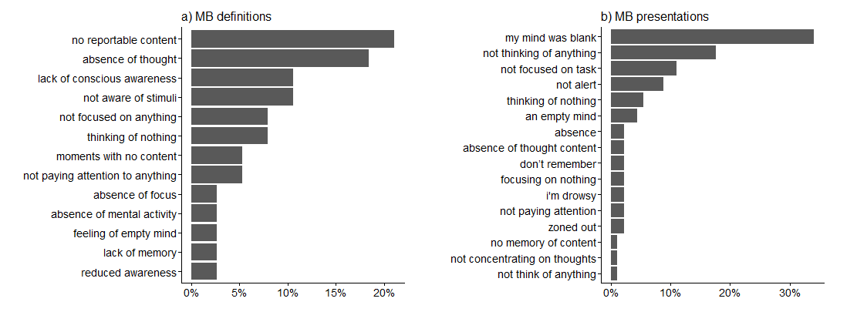
Supplementary Figure S1. Percentages of a) MB definitions and b) MB presentations to participants. MB was predominantly defined as “a state of no reportable content” or as “the absence of thought”. MB was predominantly presented to participants as moments where their “mind was blank”, they were “not thinking of anything” or “they were not focused on the task”. Note. Studies may have included multiple MB presentations, such as both “my mind was blank” and “I am not alert”.

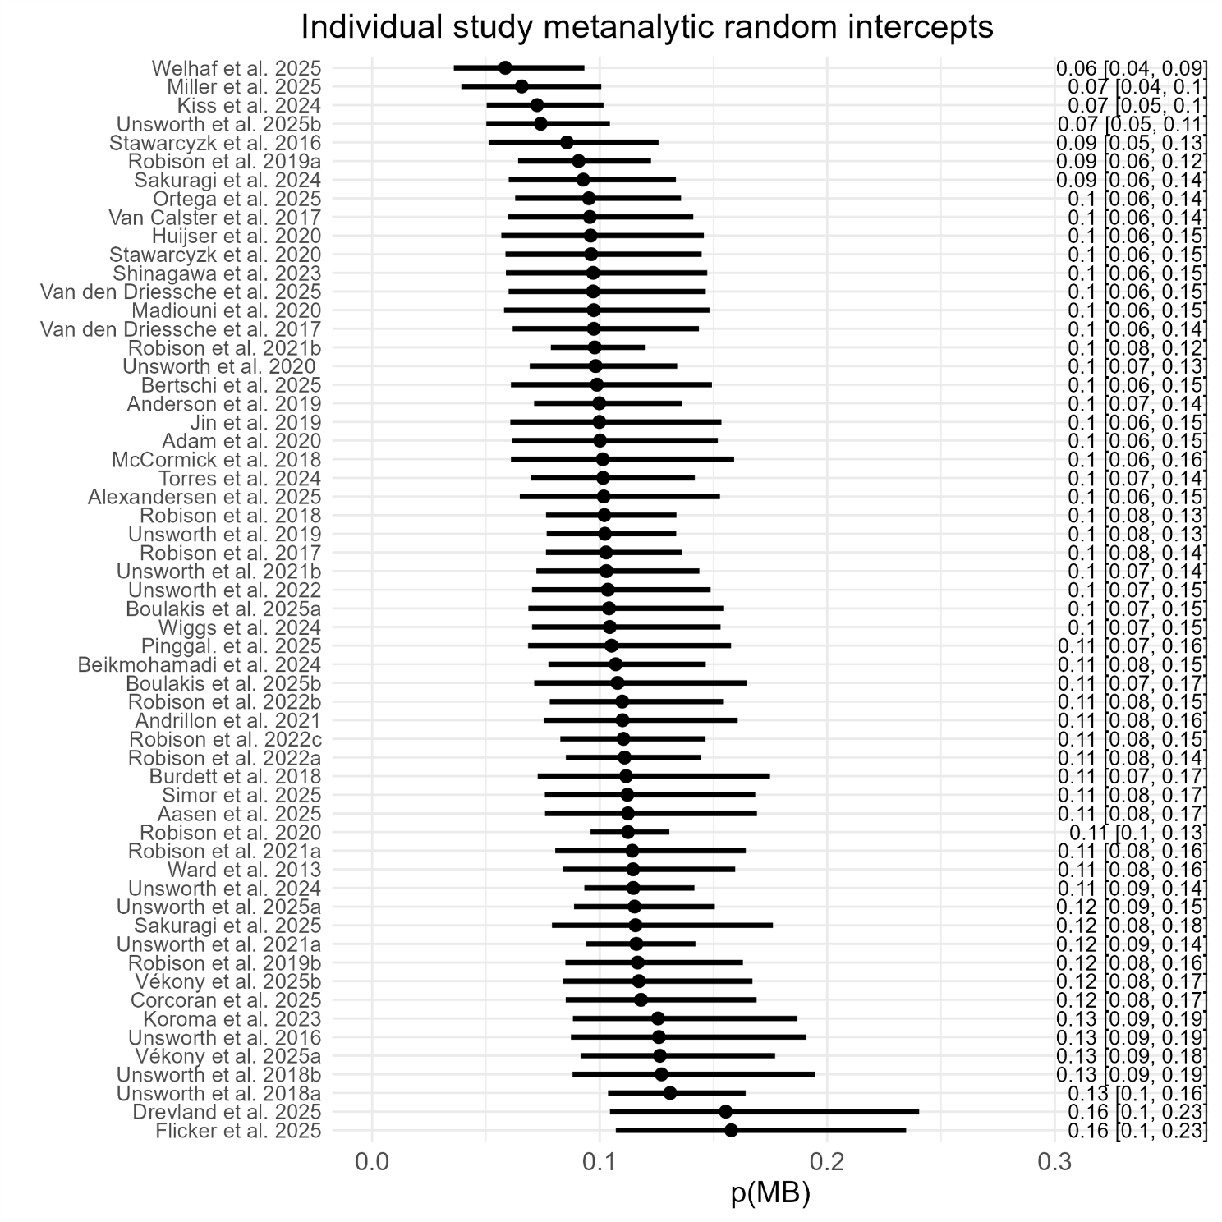
Supplementary Figure S2. Individual study MB report rate posterior distribution. Note. Interval line plots indicate median (point) and 89% HDI (line span). HDI = highest density interval.

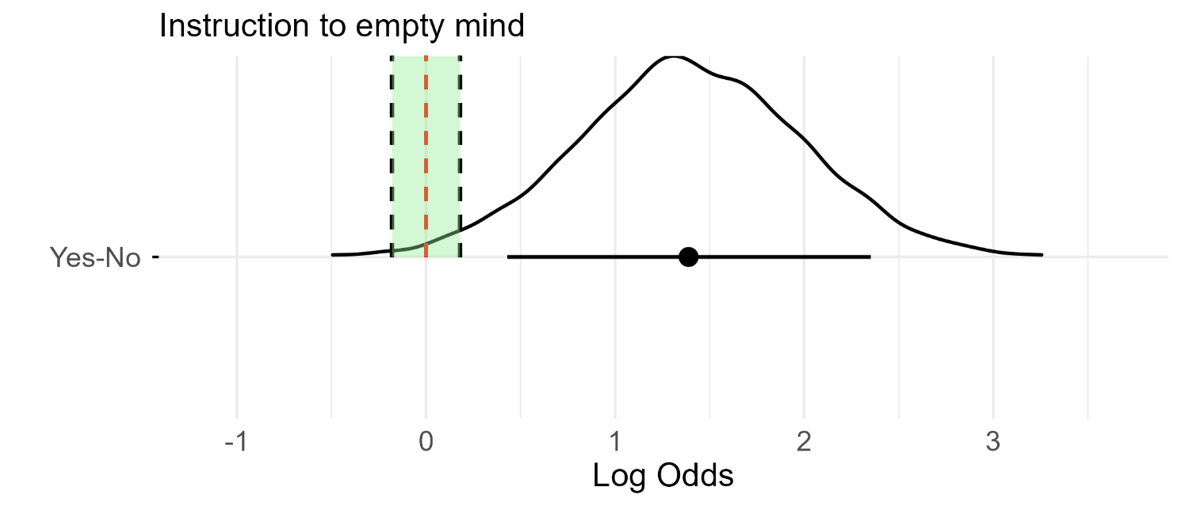
Supplementary Figure S3. The instruction to “empty your mind” significantly increases MB above baseline levels. We refit the baseline model by introducing one study that instructed participants to empty their mind as a unique categorical variable. We found very strong evidence for an increase in MB report rate. Note. Green shaded areas indicate a ROPE region at [-0.18,0.18]. Black dashed lines indicate the boundaries of the ROPE region. The red dashed lines indicate a log-odds difference of 0. Interval line plots indicate median (point) and 89% HDI (line span). HDI = highest density interval.

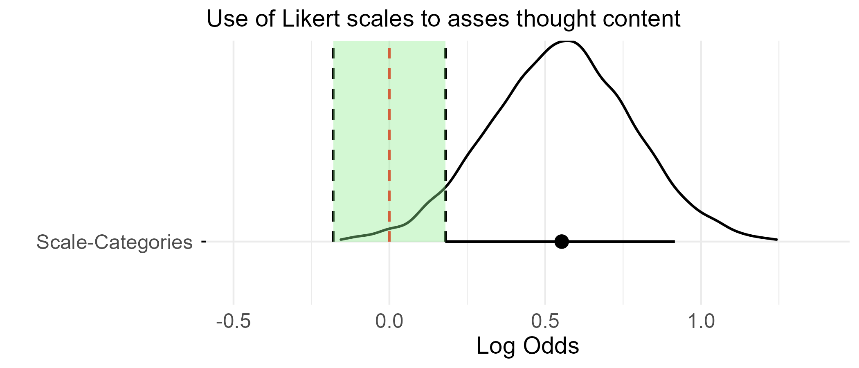
Supplementary Figure S4. Using Likert scales instead of thought categories significantly increases MB above baseline levels. We refit the baseline model by introducing studies that used a series of Likert scales to assess thought content. We found very strong evidence for an increase in MB report rate. Note. Green shaded areas indicate a ROPE region at [-0.18,0.18]. Black dashed lines indicate the boundaries of the ROPE region. The red dashed lines indicate a log-odds difference of 0. Interval line plots indicate median (point) and 89% HDI (line span). HDI = highest density interval

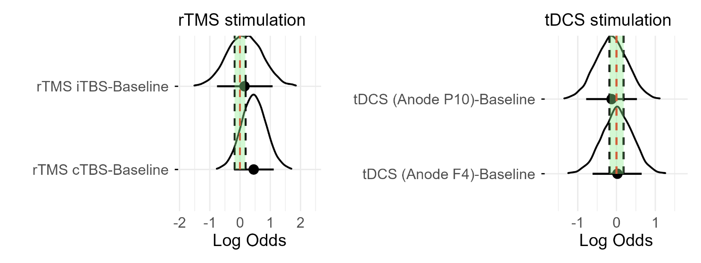
Supplementary Figure S5. No evidence that brain stimulation alters MB report rate. Intermittent and continuous rTMS stimulation at the left angular gyrus did not affect how often people experienced MB. Similarly, tDCS targeting the trigeminal nerve did not affect how often people experienced MB. Note. Green shaded areas indicate a ROPE region at [-0.18,0.18]. Black dashed lines indicate the boundaries of the ROPE region. The red dashed lines indicate a log-odds difference of 0. Interval line plots indicate median (point) and 89% HDI (line span). HDI = highest density interval; rTMS = repeated transcranial magnetic stimulation; tDCS = transcranial direct current stimulation; iTBS = intermittent theta burst stimulation; cTBS = continuous theta burst stimulation.
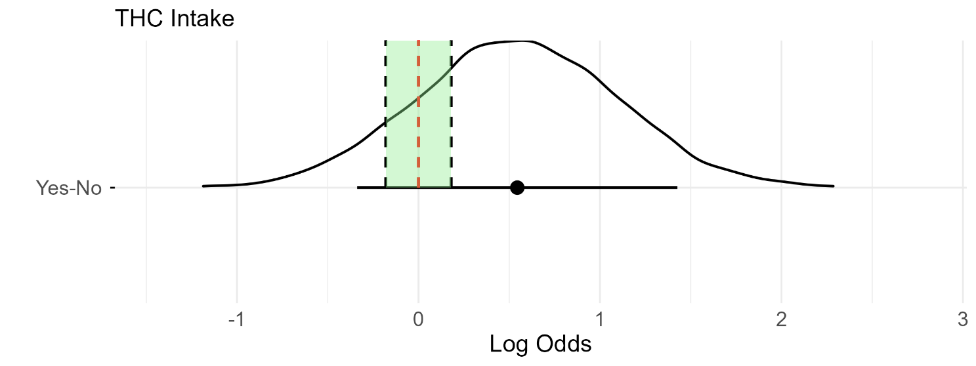
Supplementary Figure S6. No strong evidence that THC intake increases MB. We refit the baseline model by introducing one study that administered THC. The posterior distribution included zero, despite the overall positive shift. Note. Green shaded areas indicate a ROPE region at [-0.18,0.18]. Black dashed lines indicate the boundaries of the ROPE region. The red dashed lines indicate a log-odds difference of 0. Interval line plots indicate median (point) and 89% HDI (line span). HDI = highest density interval.

