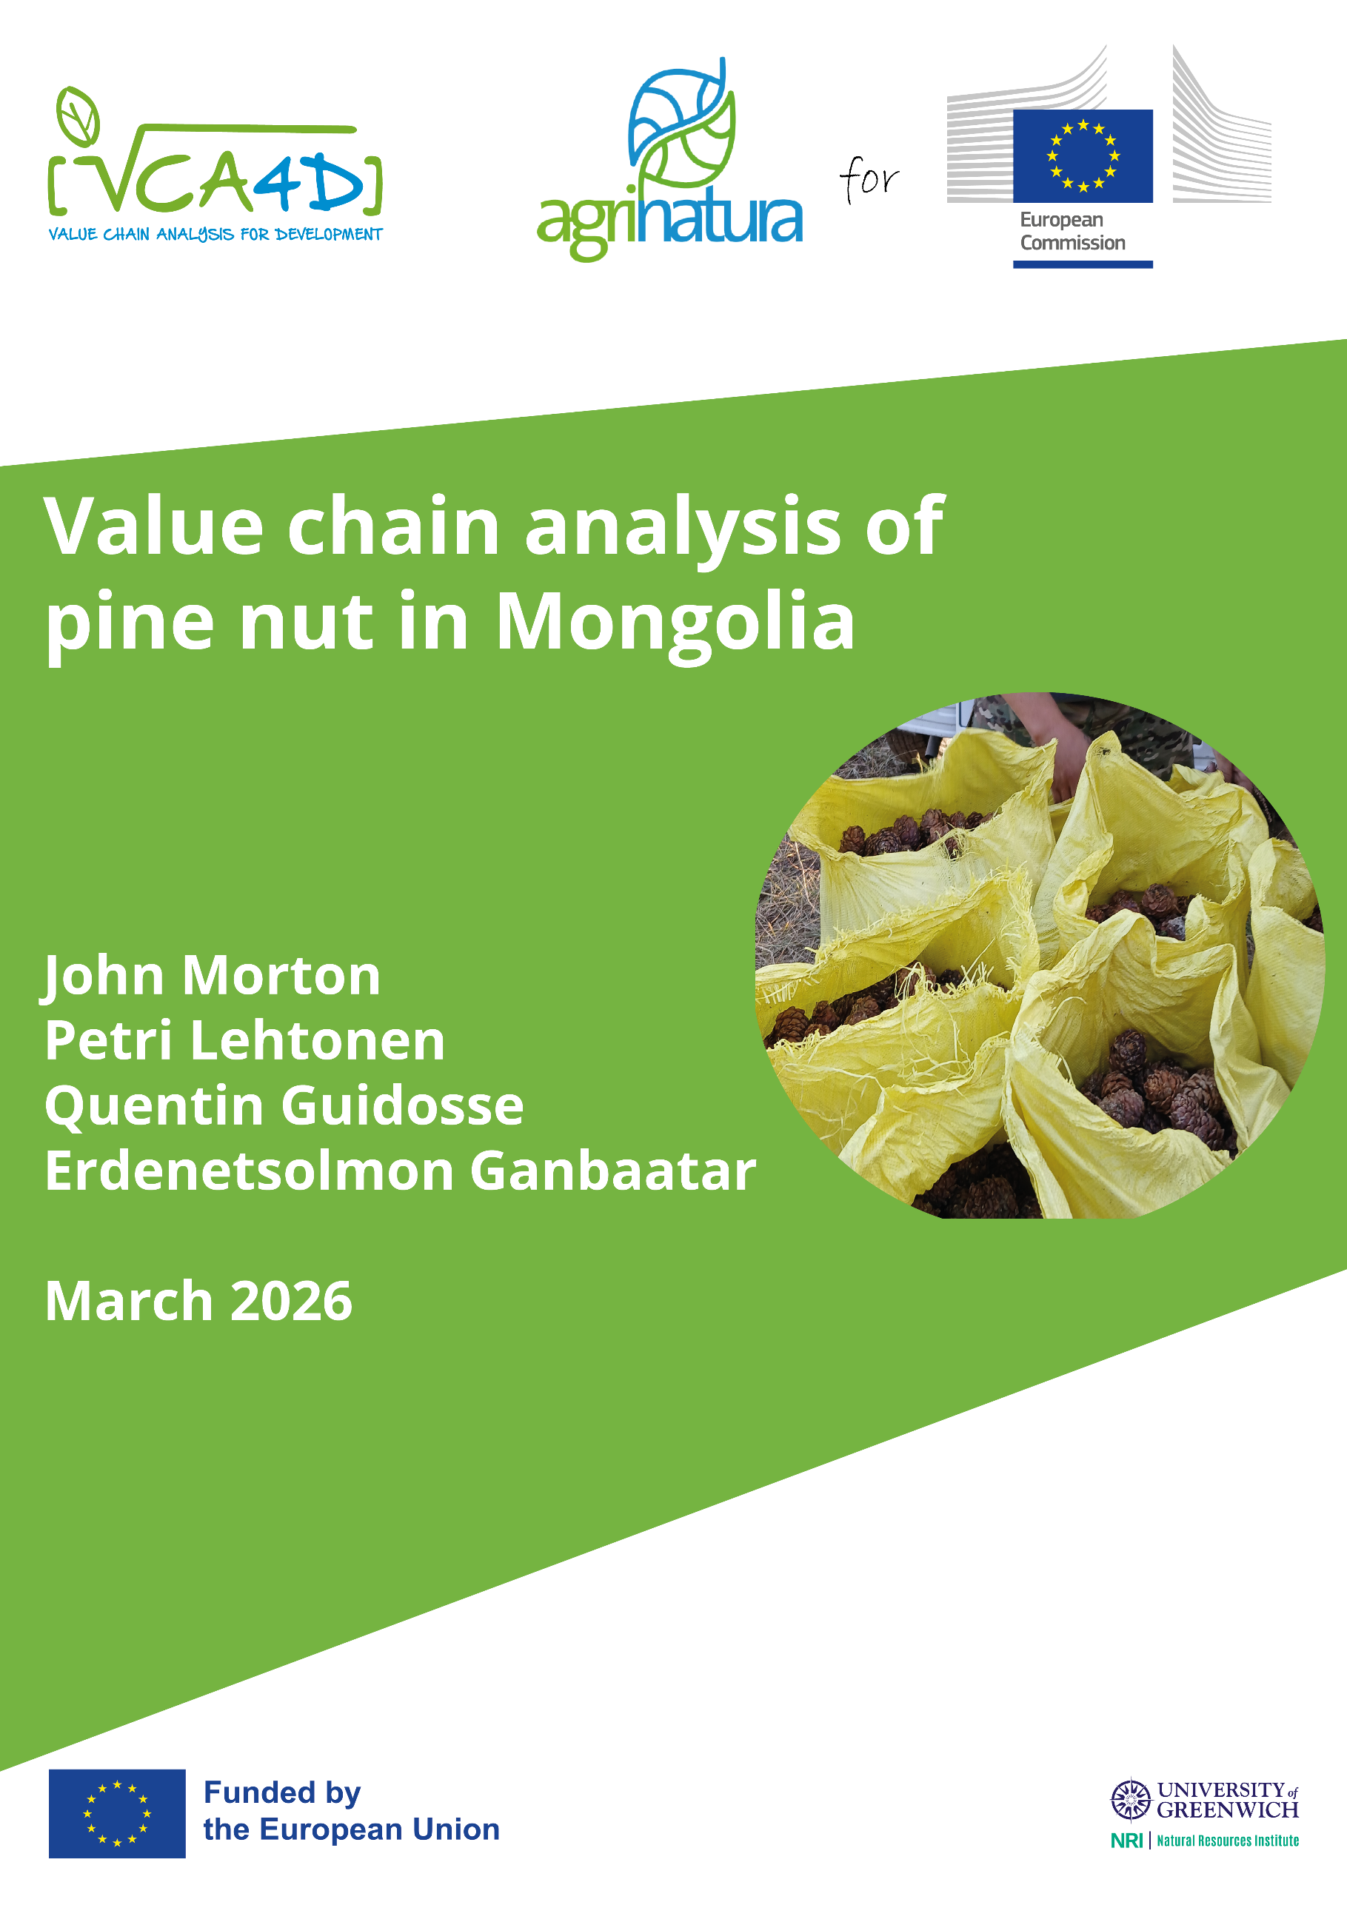
Value Chain Analysis for Development (VCA4D) is a tool funded by the European Commission / INTPA and is implemented in partnership with Agrinatura.
Agrinatura (http://agrinatura-eu.eu) is the European Alliance of Universities and Research Centers involved in agricultural research and capacity building for development.
The information and knowledge produced through the value chain studies are intended to support the Delegations of the European Union and their partners in improving policy dialogue, investing in value chains and better understanding the changes linked to their actions
VCA4D uses a systematic methodological framework for analysing value chains in agriculture, livestock, fishery, aquaculture and agroforestry. More information including reports and communication material can be found at: https://europa.eu/capacity4dev/value-chain-analysis-for-development-vca4d-

Team Composition

Team Leader and Social Expert: John Morton
Environmental Expert: Quentin Guidosse
Economic Expert : Petri Lehtonen
National Expert: Gaanbaatar Erdenetsolmon

The report was produced through the financial support of the European Union. Its content is the sole responsibility of its authors and does not necessarily reflect the views of the European Union.

The report has been realised within a project financed by the European Union (VCA4D CTR 2017/392-416).

Citation of this report: Morton, J., Guidosse, Q., Lehtonen, P., Erdenetsolmon, G., 2026. Pine nut value Chain Analysis in Mongolia. Report for the European Union, DG-INTPA Value Chain Analysis for Development Project (VCA4D CTR 2018/392-417), 122p + annexes

VCA4D Project Management Unit Support
Frédéric Lançon | Methodology and economic analysis software (AFA)
Giorgia Mei, Sara Baumgart| Project Management and Graphic Design

TABLE OF CONTENTS
TABLE OF CONTENTS 2
ACKNOWLEDGMENTS 6
ACRONYMS AND MONGOLIAN TERMS (in alphabetical order) 6
DEFINITION OF ECONOMIC TERMS 7
EXECUTIVE SUMMARY 9
1 INTRODUCTION 17
2 FUNCTIONAL ANALYSIS 19
2.1 General Description of Products 19
2.2 Global Production of Pine Nuts 19
2.2.1 Main Commercial Pine Nut Producing Species 19
2.2.2 Global Production and Trade 20
2.3 Siberian Pine Forests and Pine Nut Production in Mongolia 22
2.3.1 Siberian Pine Forests in Mongolia 22
2.3.2 Pine Nut Yields 25
2.3.3 Pine Nut Production 27
2.4 Pine nut Production Process in Mongolia 28
2.4.1 Government: Resource Owner and Regulator 29
2.4.2 Pine Nut Harvesters 30
2.4.3 Pine Nut Wholesalers 32
2.4.4 Processing Companies 34
2.4.5 Input Dealers and Support Services 36
2.5 Pine Nut Flows and Volumes 36
2.6 Organization and Governance 38
2.7 Major Market Trends 42
2.8 A SWOT matrix 43
3 WHAT IS THE CONTRIBUTION OF THE VALUE CHAIN TO ECONOMIC GROWTH? 44
3.1 Methodological Notes 44
3.2 Profitability & Sustainability of actors 44
3.2.1 Financial Accounts for Harvesters 44
3.2.2 Financial Accounts for Wholesalers 46
3.2.3 Financial Accounts for Processors 48
3.3 Total Effects within the National Economy 50
3.3.1 Structure of Intermediate Goods and Services (IGS) 50
3.3.2 Overall Cost Structure of the Value Chain 51
3.3.3 Direct and Indirect Effects of the Value Chain 52
3.3.4 Macroeconomic Contribution 54
3.4 Competitiveness and Viability within the International Economy 55
3.4.1 International Benchmarking Using ITC Export Unit Values 55
3.4.2 Import Market Prices (Mirror Data) 56
3.4.3 Competitiveness Based on AFA Parity-Price Analysis 56
3.4.4 Conclusions on Competitiveness and Market Position 57
3.5 Comparison of Sub-chains 57
3.6 Answer to the Framing Question 1 57
4 IS THIS ECONOMIC GROWTH INCLUSIVE? 61
4.1 Participation in Value Chain Governance 61
4.2 Income and Employment 61
4.2.1 Distribution of Profit and Value-Added 61
4.3 Answer to the Framing Question 2 69
5 IS THE VALUE CHAIN SOCIALLY SUSTAINABLE? 72
5.1 Working conditions 72
5.1.1 The national framework for working conditions 72
5.1.2 Working conditions and attitudes to work among harvesters 72
5.1.3 Working conditions among employees of wholesalers 74
5.1.4 Working conditions among employees of processors 75
5.1.5 Conclusion on Working Conditions 76
5.2 Land and water rights 76
5.2.1 Conclusion on Land Rights 78
5.3 Gender equality 78
5.3.1 National-Level Indicators 78
5.3.2 Evidence from interviews 80
5.3.3 Conclusion on Gender Equality 80
5.4 Food and nutrition security and living conditions 81
5.4.1 Food Security 81
5.4.2 National Indicators on Living Conditions 82
5.4.3 Evidence from interviews 83
5.4.4 Conclusions on Food and Nutrition Security, and Living Conditions 85
5.5 Social capital 86
5.5.1 Producer Organisations 86
5.5.2 Information, Trust and Perceived Fairness 87
5.5.3 Social Involvement 89
5.5.4 Conclusions on Social Capital 89
5.6 Answer to the Framing Question 3 89
6 IS THE VALUE CHAIN ENVIRONMENTALLY SUSTAINABLE? 92
6.1 Scope 92
6.2 Perceived Environmental Challenges in The Pine Nut Value Chain 92
6.3 Climate Change 96
6.3.1 Carbon Emissions 96
6.3.2 Forest Fires 96
6.3.3 Permafrost Thaw and Drought 97
6.3.4 Pests 97
6.3.5 Late Spring Frosts and Shifting Seasonal Patterns 98
6.4 Forest Health and Resource Depletion 98
6.4.1 The Impact of Harvesting Practices 99
6.4.2 Cone Production and Resource Monitoring 101
6.4.3 Lessons from Resin-Tapping 101
6.5 Ecosystem quality and Biodiversity 102
6.5.1 Ecosystem Quality 102
6.5.2 Wildlife 102
6.5.3 Flora and Fungi 104
6.5.4 Mongolian Siberian Pine Populations 104
6.6 Human Health 104
6.7 Forest Dynamics and Current Management 105
6.7.1 Natural Regeneration 105
6.7.2 Reforestation Efforts 106
6.8 Answer to the Framing Question 4 107
7 SYNTHESIS & RECOMMENDATIONS 109
7.1 Answering the Framing Questions 109
7.1.1 What is the Contribution of the Pine Nut Value Chain to Economic Growth? 109
7.1.2 Is this Economic Growth Inclusive? 109
7.1.3 Is the Pine Nut Value Chain Socially Sustainable? 109
7.1.4 Is the Pine Nut Value Chain Environmentally Sustainable? 109
7.2 The Risk Analysis 110
7.3 Summing up Benefits and Negative Impacts 112
7.4 Recommendations 112
7.4.1 Sustainable Harvesting Practices and Ecological Resilience 112
7.4.2 Forest Governance and Access Rights 115
7.4.3 Enabling Sustainable Investments and Financing 116
References 122
Annex 1: Interviews Held 126
Annex 2: Global Pine Nut Production Areas 129
Annex 3: Social Profile 130
Annex 4: Rationale for Risks Presented in Table 7.1 131

List of Tables

Table 2.1: Top Exporters And Importers Of Pine Nuts (Hs 0802.90), 2024. Source: International Trade Centre (Itc) Trade Map, 2024. Data Extracted For Hs 0802.90. 23
Table 2.2: Surfaces (In Hectares) Of Siberian Pine Forests By Region And Aimag, Disaggregated By Protection Status. Areas (Ha) Were Calculated From 2019 Geographic Information System Data Provided By National Expert And Sourced From The National Forest Agency (Nfa) 25
Table 2.3: Estimated Pine Nut Yields And Production Cycles By Region (Adapted From Tsogt, 2011) 27
Table 2.4: Approved Quotas For Domestic And Industrial Use In 2025. Source: Mecc Annual Approved Harvest Quotas For Industrial And Domestic Use 2025 30
Table 2.5: Estimated Number Of Pine Nut Harvesters And Harvest Volumes By Region, 2025. Source: Author’s Field Estimates From Selected Soums, Applied As Regional Averages For Analysis. 31
Table 2.6 : Pine Nut Prices Paid To Harvesters By Region, 2025 (Field-Based Estimates. Source: Author’s Field Estimates From Selected Soums, Applied As Regional Averages For Analysis. 32
Table 2.7: Estimated Transport Costs From Harvest Sites To Wholesalers’ Yards By Region, 2025. Source: Author’s Field Estimates From Selected Locations, Applied As Regional Averages For Analysis 33
Table 2.8: Pine Nut Prices Paid To Wholesalers By Region, 2025 (Field-Based Estimates. Source: Author’s Field Estimates From Selected Soums, Applied As Regional Averages For Analysis. 34
Table 2.9: Estimated Transport Costs Wholesalers’ Yards To Ulaanbaatar By Region, 2025. Source: Author’s Field Estimates From Selected Locations, Applied As Regional Averages For Analysis. 35
Table 2.10: Typical Products And Prices Of Pine Nut Processing Companies, 2025 (Field-Based Estimates) 36
Table 2.11: Indicative Investment Outlay And Equipment Profile Of Processing Companies, 2025. 37
Table 3.1: Aggregated Financial Accounts For All Harvesters (Regional Totals) In 2025. 46
Table 3.2: Financial Accounts For One Harvester (Individual Returns) In 2025. 46
Table 3.3: Aggregated Financial Accounts For All Wholesalers (Regional Totals) 2025 48
Table 3.4: Financial Accounts For One Wholesaler (Individual Returns) 2025 48
Table 3.5: Aggregated Financial Accounts For Processors 2025 50
Table 3.6: Coefficients Of The Imports And Va Embedded In Intermediate Consumption (Used For The Effect Calculations) 53
Table 3.7: Vc Direct And Indirect Effects (Million Mnt) 54
Table 3.8: Vc Macroeconomic Indicators And References. Source: Afa Analysis And National Statistics Office Of Mongolia 55
Table 4.1: Net Operating Profit Per Actor, Mongolia 2025 62
Table 4.2: Value Added By Regions 64
Table 4.3: Employment By Value Chain Activity, Gender And Employment Type 66
Table 4.4: Worker Income, Labour Days, And Estimated Daily Earnings 68
Table 4.5: Benchmarks Of Wages In Mongolia 68
Table 5.1 : Perceptions From Interviews On Forest Ownership, Choice Of Harvesting Sites, Nd Disputes 78
Table 5.2: Key Indicators Of Gender Inequality. Source: Nso 2018 And Nso 2023. Indicators Are National (Aggregated Urban And Rural) Unless Stated Otherwise. For Exact Definitions Refer To The Sources. 80
Table 5.3: National Indicators Of Malnutrition For Soum Centres And Rural Baghs. Source: Nso. 2019. Social Indicator Sample Survey-2018, Survey Findings Report. Ulaanbaatar, Mongolia: National Statistical Office Of Mongolia. 83
Table 5.4: National And Rural Indicators Of Living Conditions. Source: Mongolia Social Indicator Sample Survey 2023 Key Indicators Report, Nso 2023 84
Table 5.5: Evidence From Interviews On Harvester Wellbeing Relative To Non-Harvesters, And Nature Of Expenditure Of Harvesting Income. 85
Table 5.6: Interviewee Perceptions On Flows Of Information And Levels Of Trust Within The Value Chain 89
Table 6.1: Threats To The Pine Nut Value Chain, As Perceived By Interviewed Groups, Categorized By Type And Corresponding Solutions In Training, Enforcement, Or Restoration, With Estimated Suitability Indicated By Dots (● = Low, ●● = Medium, ●●● = High). 96
Table 6.2: Examples Of Pine Nut Harvesting Methods Across Countries And Regions 101
Table 6.3: Visited And Reported Nursery Production Patterns And Marginal Production Of Siberian Pine 107
Table 7.1: Presentation Of Key Risks 112

List of Figures

Figure 2.1: Global Pine Nut Production By Major Producers (2014/15-2023/24. Source: International Nut & Dried Fruit Council (Inc) Statistical Yearbooks 2023–2024. 22
Figure 2.2: Main Siberian Pine Forests Distribution In Mongolia 26
Figure 2.3: Estimated Harvesting Volumes Of Unshelled Pine Nuts In Mongolia (2015-2025) 29
Figure 2.4: Overview Of Key Actors And Activities In The Mongolian Pine Nut Value Chain (2025) 38
Figure 2.5: Pine Nut Flows Between Value Chain Actors, Volumes In Tons And Prices In Million Mnt/Tonne Of Unshelled Pine Nuts 38
Figure 2.6: Organigram Of Government Departments Involved In Forest Governance. Employees Numbers Were Given By An ISFU In The Khan-Khentii Region And Are Indicative For Other ISFUs And Soums. Source: Interviewees At Soum Level; The Diagram Reflects Their Perceptions And May Not Entirely Accord With The Official Position. 41
Figure 3.1: Intermediate Goods And Services Breakdown, 2025, Mongolia 51
Figure 3.2: Cost Structure, 2025, Mongolia 52
Figure 3.3: Total Value-Added Distribution, Million Mnt 56
Figure 4.1: Net Operating Profit Distribution Across Formal And Informal Value Chain Actors 63
Figure 4.2: Net Operating Profit Distribution Across Regions 64
Figure 4.3: Value Added Shares Across Regions 65
Figure 4.4: Distribution Of Net Operating Profit (Nop) By Agents (Actors) 66
Figure 4.5: Total Employment By Value Chain Function And Region 67
Figure 4.6: Gender Distribution Of Employment Across Value Chain Functions (Male/Female %) 67
Figure 4.7: Daily Earnings Comparison: Pine Nut Vc Vs. National Wage Benchmarks 69
Figure 4.8: Employment Type Breakdown: Temporary Vs. Permanent (Number Of Employed / Days Employed) 70
Figure 6.1: Interviewee’s Perceived Threats To The Pine Nut Value Chain Across Different Ranks Of Importance (Rank1 = First Mentioned, Rank4 = Fourth Mentioned, Overall = All Responses Combined). Unlabeled Bars Represent Values <5%. 94
Figure 6.2: Main Actions Categories Identified By Stakeholders To Address Current Threats In The Pine Nut Value Chain. 95
Figure 6.3: Traditional Cone Harvesting Technique On Pinus Sibirica Trees. A) Use Of A Wooden Hammer To Make The Cones Fall (Khövsgöl Mountains). B) Trunk Scars Caused By Repeated Harvesting Strikes (Khangai Mountains). 101
Figure 6.4: Scores Of Animals Frequenting Mongolian P. Sibirica Forests, Reported By Interviewed Groups. Participants Ranked Up To Six Animals Per Region. Each Animal’s Score = (7 − Rank); Scores Were Summed Across Interviews And Divided By The Number Of Interviews To Give The Final Regional Score. Grey Lines Connect Regional Scores; Diamonds Indicate Overall Scores. 104
Figure 6.5 : Environmental Impacts Scores From 0 (No Impact) To 5 (Extreme) Of The Pine Nut Value Chain. Solid Arrows Indicate Strong Environmental Pressure On The Value Chain Itself; Dashed Arrows Show Weaker Influence From The Value Chain On Environmental Constraints. 108

ACKNOWLEDGMENTS
We would like to thank all the harvesters, forest rangers and officials, wholesalers, processors and other value chain actors who gave up their time to be interviewed for this study and in some cases to travel with us. We also acknowledge support from the VCA4D PMU. Responsibility for the report remains with the authors.

ACRONYMS AND MONGOLIAN TERMS (in alphabetical order)
Aimag Province: Mongolia is comprised of 21 aimags and one province-level municipality
Bagh Smallest local government unit, a soum comprises several baghs
FUG Forest User Group
ISFU Inter-Soum Forest Unit
M million
MECC Ministry of Environment and Climate Change
MNT Mongolian tögrög
NFA National Forest Agency
NSO National Statistical Office
NTFP Non-Timber Forest Product
PFE Professional Forest Enterprise
Soum Intermediate local government unit: most aimags comprise 15-25 soum
SPA Strictly Protected Area
T tonne

DEFINITION OF ECONOMIC TERMS
Economic terms | Definition
Net operating profit (NOP) (without valuing unpaid family labour) | (Revenues – Expenses) – Depreciation
Direct value added (VA) | The sum of the VA generated by all the actors operating within the VC limits (i.e. actors producing, processing or channeling the VC product)
Indirect VA | The sum of the VA generated by all the suppliers external to the VC (i.e. actors providing intermediate goods and services to the VC actors, therefore not handling nor processing the VC products)
Total VA | The sum of the direct and indirect VA
Rate of integration within the domestic economy | The portion of the value of the VC production which eventually remains within the national economy  Rate of integration = Total VA / Production of the VC
Driving effect ratio | It informs on the involvement of domestic business in supporting the activities of the VC.  Driving effect ratio = Indirect VA / Direct VA
Public funds balance | Impact on public funds= Benefits [Total taxes + Total OP  of public companies] - Costs [Subsidies + other public outlays]
Balance of trade | Impact of the VC on balance of trade = VC exports – VC Total imports (inputs/ good and services/intermediate consumptions)
Nominal Protection Coefficient (NPC) | It compares the national and international prices of every VC product.  NPC= Domestic price of the product / International parity price of the product
Domestic Resource Cost Ratio (DRC) | It compares (i) the actual internal cost for the economy given by the actual remuneration of the domestic non-tradeable factors (e.g. labour, capital, land, environmental goods) mobilised in the VC, and (ii) the net value created within the economy: estimated using international parity prices (of IC and production), i.e. from the opportunity standpoint of international markets.  DRC= Non-tradeable domestic factors at market price (excluding transfers) / (Production at international price – Tradeable intermediate goods and services at international prices)

Exchange rate
USD1.00 = MNT 3592 (at the time of the mission)

EXECUTIVE SUMMARY
Functional Analysis
The Mongolian pine nut value chain is based entirely on the harvesting of cones from naturally regenerating Siberian pine forests covering approximately 612,000 hectares, located in the Khentii, Khövsgöl and Khangai regions. Production is determined by multi-year cone-bearing cycles, resulting in strong interannual variability in available volumes. The reference year for the economic analysis is 2025, with an estimated average harvest of 16,350 tons of unshelled pine nuts, representing a medium production year. The system boundaries include harvesting, wholesaling, processing (drying, shelling, sorting and packaging) and export of kernels.
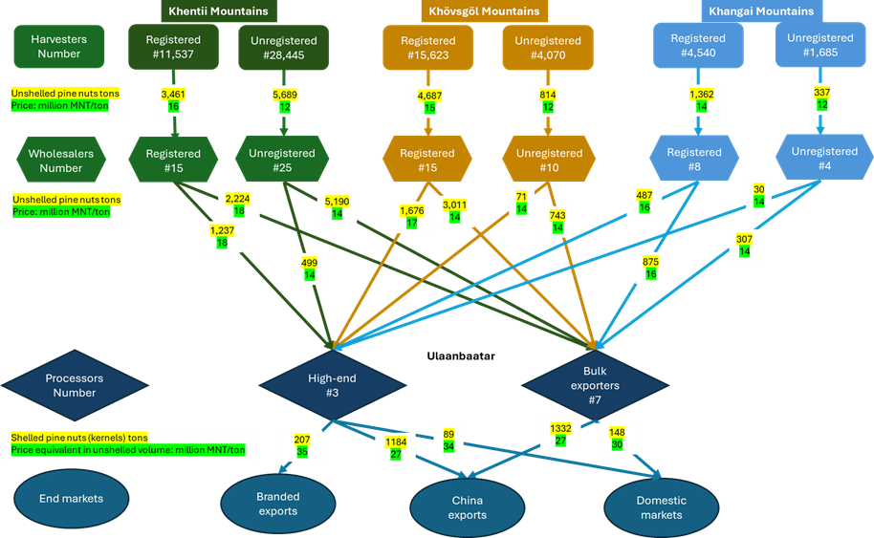
Figure ES 1: Pine nut flows between value chain actors (volumes and prices), 2025. Source: AFA modelling
The value chain comprises three principal categories of actors: harvesters, wholesalers and processors. An estimated 65,900 harvesters supply approximately 16,350 tons of unshelled pine nuts to 70–80 wholesalers, of whom 14 are registered Professional Forest Enterprises (PFEs) holding industrial quotas. Wholesalers consolidate volumes and transport unshelled nuts to Ulaanbaatar, where 10 processing companies operate – all registered as PFEs. All processed kernels are destined for export markets, while a small share of unshelled nuts and packaged kernels is sold domestically.
Processing companies are divided into three high-end exporters, accounting for about one quarter of total purchases, and seven bulk exporters handling roughly three quarters of total volume. High-end processors operate mechanized lines with year-round staff and, in addition to bulk exports to China, produce certified or branded kernels for niche markets. Bulk processors operate seasonally with simpler equipment and focus solely on bulk exports to China. Processing yields range between 35 and 40 percent, meaning that 2.5–2.8 kg of unshelled pine nuts are required to produce 1 kg of kernels.
Harvesting volumes exceed approved quotas. In 2025, total quotas amounted to 9,512 tons, while export-based estimates indicate an additional 6,840 tons harvested above quota, equivalent to about 40 percent of total volumes. Informal collection is present across all regions and reflected in both harvesting and trading channels.
More than 90 percent of kernels are exported, with China absorbing about 90 percent of export volume and 85 percent of export value, mainly as bulk kernels in 25–50 kg bags. Export prices for bulk kernels range between USD 15–21/kg, while certified or branded retail products exported directly to other markets reach USD 23–34/kg. A limited domestic market exists for unshelled nuts and packaged kernels in urban retail outlets.
The provisions of several laws (the Law on Natural Plants of 1995, the Forest Law of 2012 and the Law on Special Protected Areas of 1994) affect the pine nut value chain, but do not reflect the reality of large-scale harvesting of Siberian pine nuts, for commercial purposes, and in protected areas, including Pristine Zones. This presents legal contradictions at the heart of the value chain. Governance of the value chain is complex, with institutions at soum, inter-soum and aimag level have overlapping mandates and multiple line of reporting. These institutions, particularly the Inter-Soum Forest Units, establish yearly quotas and manage an online auction system, in which processing companies bid for harvesting rights. The quotas differentiate between household and commercial use, and between protected areas and production forests. However in practice the value chain structure of individual harvesters, mainly herders or residents of soum centres, selling to wholesalers who in turn sell to processors, applies across the producing regions. Soum governments can derive substantial financial benefits for auction proceeds and nature use fees. Mongolia has established a legal framework for Forest User Groups, of which there are 1200 nationwide, but in practice they are almost completely irrelevant to the pine nut value chain.
Economic Analysis
Harvesters receive 12–20 million MNT per tonne of unshelled pine nuts depending on region and whether transactions take place within quota or beyond quota. Processors pay wholesalers 14–21 million MNT per tonne, with similar differentiation between regulated and non-regulated channels. Transport is the main cash cost for harvesters and wholesalers and varies by distance and accessibility. Processing is the most capital- and energy-intensive stage, with investment outlays of 1–2 billion MNT for bulk processors and 2–3 billion MNT for high-end processors.
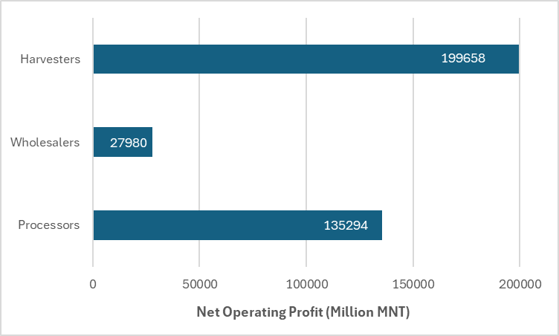
Figure ES 2: Net operating profit by actor (Million MNT, aggregated), 2025. Source: AFA financial accounts
The value chain generates direct value added across harvesting, wholesaling and processing activities and shows a high rate of integration within the domestic economy, as most intermediate goods and services are locally sourced.
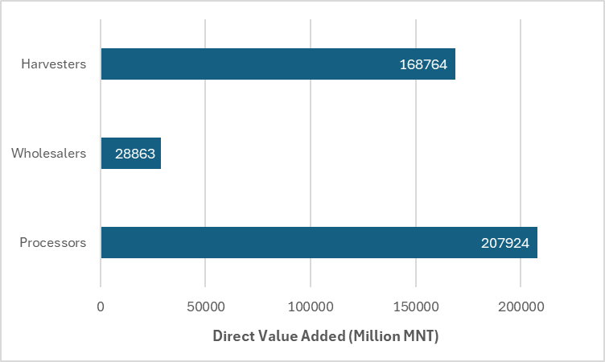
Figure ES 3: Distribution of direct value added by actor (Million MNT, aggregated), 2025. Source: AFA value added decomposition
In macroeconomic terms, the pine nut value chain accounts for 0.6% of national GDP and 7.8% of agricultural and forestry GDP. Total value added represents 95.3% of value chain output, indicating limited use of imported inputs. The value chain generates 0.1% of national wages and 0.5% of national gross disposable income. It contributes 0.1% of national exports, with no recorded imports, resulting in a positive trade balance equivalent to 0.2% of national imports. Net transfers to public funds represent 0.2% of the state budget.
Table ES 1: Macroeconomic contribution of the pine nut value chain (% of national aggregates), 2025. Source: AFA macroeconomic accounts
Indicator | %
VA Total / GDP | 0.6
VA Total / VC output | 95.3
VA Total / Agr & For GDP | 7.8
VC Imports / Total imports | 0.0
VC Export/Total Export | 0.1
VC Trade Balance/ National Imports | 0.2
VC Total Net transfers / State Budget | 0.2
VC Total Wages/National Wages | 0.1
VC Total Disposal Income / N. Income | 0.5
International competitiveness was assessed using ITC export unit values and AFA parity-price analysis. ITC data indicate that Mongolia records the lowest average export unit value (USD 12.6/kg) among major global suppliers, reflecting the predominance of bulk exports to China. Mirror import data show substantially higher price ranges in premium markets (EU, USA, Japan and the Republic of Korea). AFA parity-price indicators demonstrate strong structural competitiveness, with a Domestic Resource Cost of 0.04, NPC and EPC equal to 1.00, and no evidence of policy protection. These results indicate a clear comparative advantage at the production level combined with lower value capture due to the structure of export channels and limited domestic value addition.
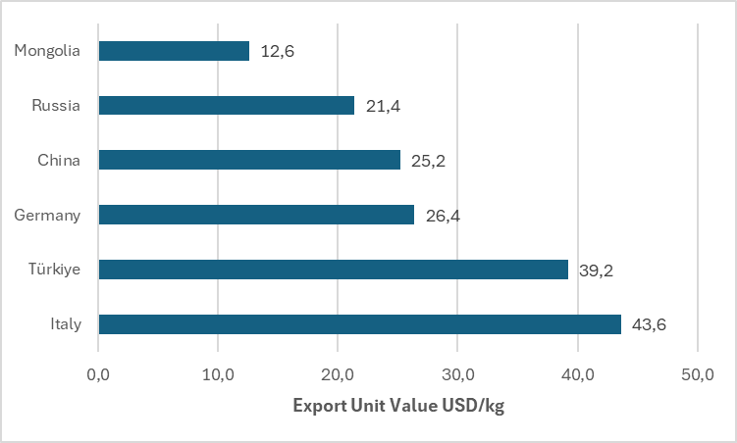
Figure ES 4: ITC export unit values of major pine nut suppliers (USD/kg), 2024. Source: ITC Trademap (2025).
Overall, the pine nut value chain is an export-oriented forest product system characterised by strong dependence on cone production cycles, a high concentration of exports to China, and a differentiated processing segment supplying both bulk and premium markets. It generates value added within the domestic economy, provides seasonal income in forest regions, and is structurally competitive in international markets, while current value capture is shaped by the predominance of bulk export channels.
Inclusiveness of the Value Chain
The pine nut value chain generates substantial and valuable seasonal income and employment for rural households, though the distribution of harvesting income is uneven, with a clear concentration of profits among downstream processors and limited stability or protection for most workers. Harvesters are in some cases able to make their livelihoods less vulnerable to debt and unemployment, and in other cases to actively invest in improving or diversifying those livelihoods. There is some evidence that food security and living conditions are better for harvesters than comparable non-harvesting households.
Social Analysis
Compared to the wholesale and processing businesses create a much smaller number of jobs in trade and processing. Within a generally good national-level environment for employment rights and working conditions, there is substantial respect of labour rights in the value chain. Child labour is not an issue in the wholesaling or processing enterprises, but there is some concern that children may be taken out of school to accompany parents harvesting. Job safety appears high, with some specific concerns relating to wholesaling. The attractiveness of working in factories and wholesale yards, compared to minimum wages and rural labour wages, is substantial,
There are neither legal nor customary constraints on choice of harvest sites, which works in the short-term in favour of harvesters and other actors (and causes few or no disputes), but does not favour the long-term environmental sustainability of the value chain.
National-level indicators for gender equality are generally high in Mongolia, but assessing gender equality within the value chain was difficult. Our overall estimate is that 70-75% of harvesters are men, and 25-30% are women, varying by locality, the remoteness of the harvesting sites and whether cones are likely to be available on the ground. The evidence suggests women take individual decisions to go harvesting, either as members of couples or families or on their own, and benefit from the experience financially and in terms of well-being, with decisions on how to spend the income from harvesting made at a household level and including use of income on food, clothing and paying off debts. Proportions of women among employees of wholesalers are very low, and among employees of processors high. Women can operate independently as owners or co-owners (with their husbands) of such enterprises. As noted above, women are visible in middle- and senior management of processing businesses and in public-facing positions.
Levels of information and trust in the value chain can only be described as moderate, which does not impede the operation of what is largely a spot-market between harvesters and wholesalers, but an opportunity is currently being lost by not integrating the network of recognised Forest User Groups into the value chain.
The VCA4D Social Profile for the value chain (see Annex 2), composed of responses to 63 questions, has been used to generate a radar diagram - Figure ES.5 below – on the social sustainability of the value chain under the six sub-domains of the VCA4D social analysis methodology.

Figure ES 5: Radar Diagram of the social sustainability of the pine nut value chain.

Environmental Analysis
The environmental analysis of the pine nut value chain in Mongolia shows that its sustainability depends primarily on the condition and management of Siberian pine forests rather than on downstream processing activities. Unlike most agricultural value chains, the pine nut sector is based entirely on the harvesting of a non-timber forest product collected in natural forests without plantations. Downstream activities such as cone crushing, processing, and domestic transport generate only limited environmental impacts. The environmental performance of the value chain is therefore mainly determined by upstream harvesting practices, forest governance, and broader ecosystem dynamics.
Overall, the value chain has a low direct environmental footprint in terms of greenhouse gas emissions, energy use, and pollution. Carbon emissions arise mainly from domestic transportation between harvesting areas, wholesale yards, and processing facilities, as well as seasonal heating of processing facilities. These emissions remain negligible compared with national emissions from coal consumption or with emissions generated by forest fires. However, the value chain is highly vulnerable to external environmental pressures, mainly related to climate change, which increasingly affects forest health, regeneration, and cone production.
Climate change represents the most significant long-term threat to the sustainability of the pine nut value chain. Mongolia has experienced a temperature increase of approximately 2.5 °C over the past 80 years, a rate higher than the global average. Rising temperatures contribute to disturbed masting cycles, increased forest fire risk, permafrost thaw, drought stress, and pest outbreaks, all of which affect Siberian pine forests.
Forest fires constitute the most immediate environmental hazard, affecting nearly 28 % of Mongolia’s forests. Most fires are human-induced, often linked to campfires, cigarette disposal, and other activities in forest areas. Siberian pine is particularly sensitive to fire due to its shallow root system and slow post-fire resilience. Repeated fires may lead to long-term shifts in species composition, favouring more fire-tolerant species such as Siberian larch. In addition, permafrost thaw and increasing drought may progressively reduce suitable habitats for Siberian pine in Mongolia, potentially shrinking its distribution to higher-altitude refuges. These pressures threaten the long-term availability of pine nuts, meaning that investments in the value chain must prioritise forest protection, fire prevention, and resource monitoring
The main environmental pressure generated by the value chain itself arises from current harvesting practices. Pine nuts are collected using heavy wooden hammers that are repeatedly struck against tree trunks to dislodge cones. This technique causes mechanical damage to the bark and stems of mature trees across entire forest stands. Although most trees survive, repeated injuries may weaken tree vitality and potentially reduce cone production over time, although this relationship has not yet been scientifically quantified in this context.
Harvesting pressure is further intensified by strong competition among harvesters and weak enforcement of regulations. Cones are frequently harvested before full maturity, which requires stronger impacts on trees and reduces the availability of seeds for natural regeneration and wildlife. Monitoring of pine nut resources remains limited, and harvesting quotas are set based on very limited field data, resulting in management decisions that are poorly aligned with ecological conditions.
The lack of systematic monitoring data makes it difficult to assess Siberian pine forests regeneration dynamics and population trends with confidence. Field observations suggest that in remote forests, particularly in the Khövsgöl Mountains, regeneration appears limited, with few young trees observed. In more accessible regions such as the Khangai Mountains, regeneration appears stronger. The species exhibits natural masting cycles, producing large cone crops every three to five years, which complicates short-term resource monitoring and harvesting management.
Natural regeneration of Siberian pine is closely linked to wildlife interactions, particularly with the Siberian nutcracker, which disperses seeds by caching them in the soil. Overharvesting of cones may therefore indirectly affect regeneration processes by reducing the food resources available to seed-dispersing animals.
Despite the ecological and economic importance of Siberian pine, the species is largely absent from national reforestation programmes mainly designed to fight forest fires and desertification. Tree nurseries overwhelmingly prioritise species such as Siberian larch, Scots pine, and broadleaved species which are faster and cheaper to produce. Siberian pine seedlings represent less than 1 % of total nursery production, creating a significant constraint for restoration and long-term resource sustainability.
Apart from harvesting activities, the value chain generates relatively limited direct disturbances to forest ecosystems. Some localised impacts occur in harvesting camps, including soil disturbance from vehicles, cone-scale waste accumulation, and occasional tree damage associated with cone-crushing equipment and vehicles. However, these impacts remain moderate compared with large-scale disturbances such as forest fires.
Siberian pine forests provide important habitats for wildlife, including brown bears, wild boar, deer, and numerous bird species. Pine nuts constitute a key food resource for several species, particularly the Siberian nutcracker, which plays a critical role in seed dispersal and forest regeneration. Excessive harvesting pressure may therefore affect ecological interactions and biodiversity associated with these forests.
Overall, the pine nut value chain can be considered environmentally low-impact in terms of emissions and pollution, but its long-term sustainability remains uncertain due to pressures on the forest resource itself. Climate change, forest fires, and unsustainable harvesting practices represent the main environmental risks.
Ensuring the long-term sustainability of the sector will require improvements in forest governance, monitoring of cone production and harvesting pressure, and the promotion of less damaging harvesting techniques. Strengthening forest restoration efforts, particularly through increased production of Siberian pine seedlings, will also be essential to maintain the ecological integrity of these forests and the economic viability of the pine nut value chain.
Recommendations
The following recommendations are made
Sustainable Harvesting Practices and Ecological Resilience
- Strengthen monitoring and knowledge of forest resources
- Promote low-impact and ecologically sensitive harvesting
- Implement zonation and rotational harvesting systems
- Enhance forest regeneration and resilience
- Enhance cone production through silvicultural techniques.
Forest Governance and Access Rights
- Study the current legal basis for pine nut harvesting with a view to harmonization
- Invest in Capacity-Building of Value Chain Actors
- Take Specific Measures to Enhance Working Conditions for Harvesters and Employees of Wholesalers
Enabling Sustainable Investments and Financing
- Prioritise value upgrading over volume expansion, focusing on existing processing companies investing in branding, packaging, and higher-value market positioning
- Concentrate high-end processing and branding where scale and connectivity exist, while strengthening upstream functions and supporting long-term investments in forest regeneration and resource sustainability
- Diversify export markets while improving value capture in existing ones, maintaining China as a key outlet while progressively increasing access to higher-value markets through improved quality, certification, and market positioning

INTRODUCTION
Pine nuts (the edible seeds of the Siberian pine, Pinus sibirica Du Tour) are one of Mongolia’s most important non-mineral exports, and as such of great importance for Mongolia’s economic diversification. Pine nuts are nutrient-dense foods, characterized by high levels of healthy fats, protein, and other nutrients, contributing to their appeal in health and wellness markets. Mongolia produces nuts of high quality and excellent taste which can potentially compete well on international markets. Some exporting companies have already been able to obtain organic certification. Pine nuts are harvested from wild forests, largely under some degree of Protected Area status, not from domesticated trees. The great majority of Mongolian pine nuts are currently exported as shelled kernels in bulk to China, where they are mixed with Chinese production for re-export onto world markets without any indication of Mongolian origin. There therefore exist important opportunities for adding value throughout the value chain (VC). There are however concerns both about the environmental impact of pine nut harvesting and the impact of environmental changes, particularly climate change, on pine nut harvesting.
In the light of all these factors, the European Union Delegation (EUD) in Mongolia commissioned a study of the pine nut VC within the framework of the Value Chain Analysis for Development (VCA4D) facility funded by the International Partnership (INTPA) Directorate of the European Commission, and following its methodology. This study was intended to:
- Provide additional information on the value chain to assist the implementation of the EU’s flagship STREAM+ programme, the forest component of which is implemented by GIZ,
- To aid future decisions on investment by the European Investment Bank and the European Bank for Reconstruction and Development
- And to contribute more generally to policy dialogue between the EUD and the Government of Mongolia.

Following the VCA4D framework and methodology, the study has produced a functional analysis of the VC, before addressing the four VCA4D framing questions:
- What is the contribution of the VC to economic growth?
- Is this economic growth inclusive?
- Is the VC socially sustainable?
- Is the VC environmentally sustainable?
The Government of Mongolia welcomed the study, and the team had constructive meetings early on with government stakeholders such as the National Forest Agency, the Ministry of Environment and Climate Change, and the Khan-Khentii Strictly Protected Area Authority.
The team selected by the VCA4D programme was composed of John Morton, social sector specialist and team leader, Petri Lehtonen, economist, Quentin Guidosse, environmental specialist, and Ganbaatar Erdenetsolmon, national consultant.
Unlike usual VCA4D practice, and because of weather constraints, only one mission by the international team members was carried out, though it was of five weeks duration, from 14.09.25 to 18.10.25. We held over 35 meetings/interviews involving over 80 individual stakeholders (see Annex 1). These included:
- The Director General of the National Forest Agency, and senior staff of the Ministry of Environment and Climate Change and the Khan Khentii Strictly Protected Area
- Aimag (province)-level authorities in Arkhangai and Khövsgöl
- Soum (county)-level authorities and/or Inter-Soum Forest Units in 7 soums over 5 Aimags
- 8 wholesalers
- 4 PFES involved in purchasing and/or processing pine nuts
- Local harvesters, Forest User Groups, Rangers and other
- Mongolian researchers
The great majority of interviews were carried out jointly by all the team members, with interpretation by Mr Ganbaatar. In each meeting, all three international team members asked questions from mental checklists relating to their respective components, with interpretation by Mr Ganbaatar, but there were no firm boundaries for who asked what, and we were all able to follow new lines of enquiry depending on responses. There was however a limit on the extent to which all three analyses could be covered in one meeting,
One important limitation on the mission was the relative lack of contact with harvesters while they were harvesting: because of low harvests in the Khan Khentii region, harvesters had generally left the forest by the time of the mission (and the very long distances from towns or roads to harvesting areas would have made it difficult to interview them in situ anyway). However, we interviewed harvesters in or near the forest in Övörkhangai and Arkhangai aimags and in soum-level towns in Selenge and were able to get a clear picture of their ways of working and perceptions of the value chain. The sample of formal processing enterprises was small, which may have affected the quality of information on working conditions at this stage of the value chain. Compared to the previous VCA4D report on cashmere in Mongolia, there is a relative scarcity of secondary data. The team were able to directly observe the state of Siberian pine forests in three locations, and we are confident that this report, which combines interview data, available statistics, and a range of secondary literature both official and academic, provides an accurate account of the VC that can be the basis for dialogue and further studies.

FUNCTIONAL ANALYSIS

General Description of Products
The main products derived from cones harvested from various pine species include unshelled pine nuts and pine nut kernels (shelled nuts), and a growing range of niche products such as pine nut oil, essential oils and extracts derived from shells or other by-products. Among these, pine nut kernels are the only product category reported in international trade statistics and are therefore the most important in commercial terms (INC, 2025; ITC, 2025).
Pine nut kernels are prized as gourmet ingredients for their delicate flavour and nutritional value, used to enhance a wide range of dishes, notably sauces such as pesto, salads, vegetable and meat preparations, bakery and confectionery products, and premium snack foods (Nutsforlife, 2024). Pine nut oil, obtained through cold pressing of the kernels, is a high-value specialty oil comparable to extra virgin olive oil in aromatic and culinary quality. Beyond gastronomy, it is also used in cosmetics and nutraceuticals (Özkan et al., 2018). Pine nuts are nutrient-dense foods, characterized by high levels of healthy fats (particularly unsaturated fatty acids), protein, vitamin E, magnesium, and antioxidants, contributing to their appeal in health and wellness markets (Takala et al., 2023).
By-products from cone processing are often underutilized but hold potential for value addition. Cone residues remaining after seed extraction are typically discarded, though they can be repurposed as bioenergy feedstock, soil amendment, or landfill cover material. Pine nut shells, which represent a substantial portion of the raw material volume, also accumulate in large quantities and are frequently wasted. Recent research, however, highlights opportunities to transform these shells into activated carbon, biochar, antioxidant and polyphenolic extracts, or even biodegradable materials, providing viable pathways for circular use of pine nut processing waste (Nolasco et al., 2024; Qin et al., 2019; Șen et al., 2024).
Globally, pine nuts are sourced from a variety of species, each with distinct ecological and market characteristics. The following section outlines these species and the geographic distribution of production, providing context for the Siberian pine and its associated value chain in Mongolia.

Global Production of Pine Nuts

Main Commercial Pine Nut Producing Species
Globally, edible pine nuts are obtained from a limited number of pine species with distinct ecological ranges and market characteristics. Most production still comes from natural forests rather than plantations, and harvest volumes fluctuate strongly because pine species produce large cone crops only every few years.
In Asia, three species provide most of the commercially traded pine nuts. Korean pine (Pinus koraiensis) dominates the temperate mixed broad-leaved–Korean pine forests of northeast Asia, extending across northeastern China, the Korean Peninsula, and the Russian Far East. In China, Korean pine has been widely used in afforestation and forest restoration, with roughly 270,000 hectares of forests established through planting, while suitable natural habitat across the region has been modelled at around 46 million hectares (Chen and et al., 2024; Jin et al., 2019). These forests constitute one of the region’s major natural forest formations. Although Korean pine is planted and managed in both pure and mixed stands, commercial nut collection occurs almost entirely in natural or semi-natural forests rather than in intensively managed plantations.
Farther west, Siberian pine (Pinus sibirica) – also called Siberian Stone pine and Siberian cedar - forms vast tracts of taiga forest throughout Siberia and parts of Central Asia. In Russia, the species covers tens of millions of hectares (around 45 million ha in total) forming one of the dominant canopy species of boreal forests (Farjon, 2013). In Mongolia, Siberian pine forests occupy about 612,000 hectares, marking the southernmost extent of the species’ range. On the arid slopes of the western Himalayas, Chilgoza pine (Pinus gerardiana) occurs in small, fragmented forest patches covering roughly 30,000–40,000 hectares across Afghanistan, Pakistan, and north-western India (Islam and et al., 2019; Malik, 2019).
In the Mediterranean region, stone pine (Pinus pinea) is the only species producing pine nuts at commercial scale. The species is widely distributed across the Mediterranean basin, with around 850,000 hectares of stone-pine-dominated planted and natural forests in southern Europe, particularly in Türkiye, Spain, Portugal, and Italy (Caliskan et al., 2024; Carrasquinho et al., 2017). These stands include both semi-natural woodlands and managed plantations supplying well-established domestic and export-oriented value chains.
In North and Central America, edible pine nuts are mainly harvested from native pinyon species, although production remains small and irregular compared to Asia and Europe. Two-needle pinyon (Pinus edulis) and single-leaf pinyon (Pinus monophylla) dominate the pinyon–juniper woodland ecosystem, which extends across an estimated 20–40 million hectares in the western United States (Board et al., 2018; USIBLM, 2024). While this woodland covers vast areas, nut collection is localized and takes place only during good cone years. In Mexico and the U.S. borderlands, Mexican pinyon (Pinus cembroides) and related species such as P. remota and P. orizabensis occur in scattered stands covering about 2.5 million hectares across northern and central Mexico, where they are harvested for local and regional markets (García-Zubia et al., 2019).
Together, these species illustrate the broad ecological diversity of pine nut production systems ranging from temperate and boreal conifer forests in Eurasia to semi-arid pinyon–juniper woodlands in North and Central America with most harvests still based on naturally regenerating forests rather than cultivated orchards . A table of the main species, their ranges and estimated areas is included in Annex 2.

Global Production and Trade
Global pine nut production remains highly concentrated in Asia and the Mediterranean basin. According to the International Nut and Dried Fruit Council (INC) Statistical Yearbook 2024, global pine nut output reached about 41,700 metric tons (kernel basis) in 2022/23, following a record high of roughly 42,000 tons in 2021/22. Year-to-year variation is considerable, reflecting the multi-year cone-bearing cycles characteristic of pine species and the dependence of most harvests on natural forests (see Figure 2.1)).
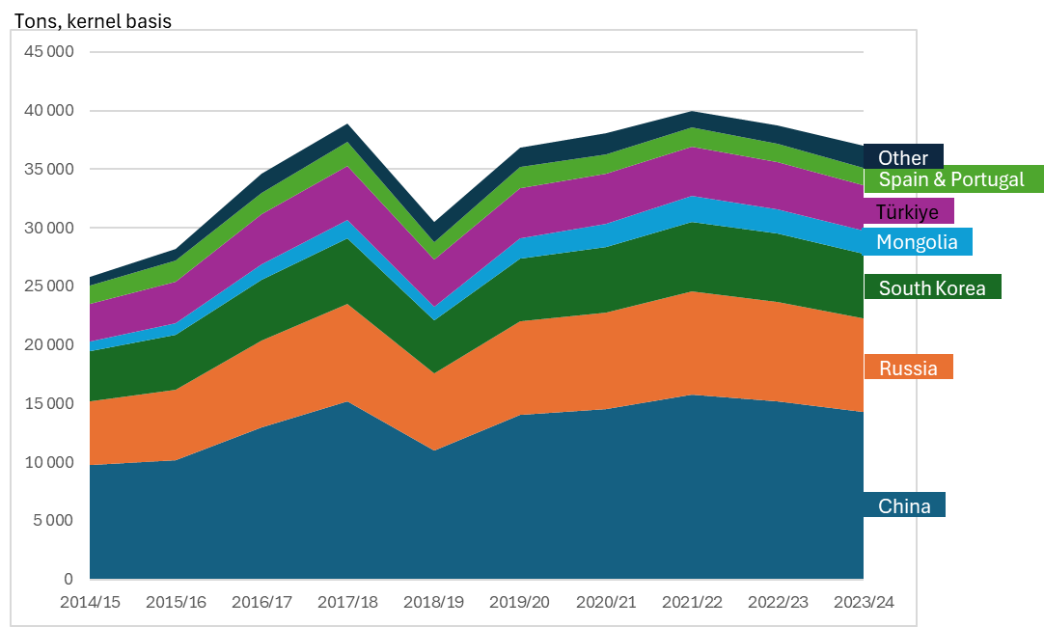
Figure 2.1: Global Pine Nut Production By Major Producers (2014/15-2023/24. Source: International Nut & Dried Fruit Council (Inc) Statistical Yearbooks 2023–2024.
Asia dominates global pine nut supply, accounting for roughly 60 percent of total production. China, Russia, and South Korea are the leading producers, supplying Korean pine and Siberian pine nuts that underpin much of the regional trade. Mongolia has also emerged as an important supplier. Based on the INC annual production estimates used in this study, Mongolia accounts for around 5 percent of global pine nut production, although its output has increased steadily over the past decade. Pine nut harvests fluctuate strongly due to the natural mast cycles of forest pine species, and after exceptional harvests in 2021/22, output in China and Russia declined somewhat but remained above pre-2020 levels.
In the Mediterranean region, production is centred on Türkiye, Spain, and Portugal, where stone pine nuts command premium prices in both domestic and export markets. Mediterranean production typically accounts for about 15–20 percent of global supply but has been constrained in recent years by the spread of the dry cone syndrome (caused by Leptoglossus occidentalis), which has reduced yields in Spain and Italy (Caliskan et al., 2024).
North American production remains relatively minor, derived mainly from wild collection of pinyon pine species (Pinus edulis and P. monophylla) in the western United States and of P. cembroides and related species in northern Mexico. Harvest volumes fluctuate sharply with weather and cone cycles, and most trade is domestic or informal (Board et al., 2018).
Global trade in pine nuts (HS 0802.92) remains highly concentrated among a few producer and consumer countries. According to ITC Trade Map data for 2024, China dominated global exports, followed by Germany, Türkiye, Russia, and Mongolia, which together accounted for 80% of total export value (see Table 2.1). On the import side, Europe and the United States were the largest markets, followed by China. It is important to note that some major exporting countries - most notably China - also re-export a share of traded volumes, which is not fully captured in the available trade statistics.
International trade is conducted almost entirely in shelled pine nut kernels, which are the only pine-derived product consistently reported in global trade statistics (ITC Trade Map, 2024). While pine nuts represent a relatively small share of total global nut trade, their high unit value and dependence on natural forest resources make them both an economically and ecologically significant commodity within the non-wood forest product sector.
Table 2.1: Top Exporters And Importers Of Pine Nuts (Hs 0802.90), 2024. Source: International Trade Centre (Itc) Trade Map, 2024. Data Extracted For Hs 0802.90.
Rank | Exporters | Export value (USD million) | Share of global exports (%) | Importers | Import value (USD million) | Share of global imports (%)
1 | China | 279 | 53.0 | Europe | 297 | 60.8
2 | Germany | 54 | 10.2 | Germany | 80 | 16.3
3 | Türkiye | 36 | 6.9 | Italy | 66 | 13.5
4 | Russia | 28 | 5.4 | Netherlands | 36 | 7.4
5 | Mongolia | 27 | 5.2 | UK | 19 | 4.0
6 | Czech Rep | 18 | 3.5 | France | 19 | 3.9
7 | Viet Nam | 17 | 3.1 | Other | 77 | 15.8
8 | Italy | 14 | 2.7 | USA | 79 | 16.1
9 | Netherlands | 11 | 2.1 | China | 31 | 6.3
 | Others | 42 | 7.9 | Others | 82 | 16.8
World total |  | 526 | 100 |  | 489 | 100

Siberian Pine Forests and Pine Nut Production in Mongolia

Siberian Pine Forests in Mongolia
Siberian pine has a global distribution covering approximately 45 million hectares, mainly across Russian Siberia, where it occurs from lowland areas (100-200 m a.s.l.) to mountainous zones reaching up to 2,400 m a.s.l. (Farjon, 2013). Depending on site conditions and elevation, the species forms distinct forest facies. In lowland taiga landscapes, Siberian pine occurs in association with Pinus sylvestris, Larix gmelinii or Larix sibirica, and Betula pendula on relatively dry and fire-prone sites. Under more humid conditions, it forms mixed stands with Abies sibirica, Picea obovata and Betula spp., characteristic of the so-called dark taiga coniferous forests (Farjon, 2013). The species is the slowest-growing conifer within these forest systems and is notable for its exceptional longevity, with individuals living up to 800–850 years.
In Mongolia, Siberian pine has a much more restricted distribution and occurs exclusively in subalpine mountain taiga ecosystems, generally between 1,500 and 2,400 m a.s.l. Of the country’s 21 aimags, 10 (and Ulaanbaatar municipality) covering 63 soums, contain Siberian pine forests, covering an estimated total area of approximately 612,000 ha. These forests are distributed across three main regions considered in this study: the Khentii Mountains (77% of the total area), the Khövsgöl Mountains (17%), and the Khangai Mountains (6%) (Table 2.2). The Altai Mountain range, covering the aimags of Bayan-Ulgii and Uvs, is excluded from the present analysis due to its marginal contribution, representing only 1,600 ha, or approximately 0.3% of the national Siberian pine forest area. Differences in forest accessibility, transport distances and the location of preliminary extraction activities across these regions form the basis for three distinct sub-value chains within the national pine nut sector. The spatial distribution of Mongolian Siberian pine forests is shown in Figure 2.2.
Based on NFA’s latest GIS data (2019) (Table 2.2), 65% lies within Strictly Protected Areas (SPAs), 13% within National Parks, less than 1% within Nature Reserves, and 22% in non-protected areas. These protection categories correspond to different legal regimes, with distinct rules governing access, harvesting rights and resource use, though these have little effect in practice on the pine nut value chain. Notably, nearly 60% of Mongolia’s total Siberian pine forest area is concentrated within the Khan-Khentii SPA, which is further subdivided into Limited Use, Conservation and Pristine Zones. This concentration highlights the critical importance of Khan-Khentii for the pine nut value chain, as well as for the conservation and environmental management of Siberian pine forests. Table 2.2 also indicates that GIS data (2019) recorded a total of 675,000 ha of Siberian pine. This is less compared to the most recent data from 2023 (612,000 ha), representing a decrease of 9.3%, though this figure should be interpreted with caution as it draws on two distinct data sources.
Near the upper forest limit, Siberian pine forms pure monospecific stands, where pine nut harvesting typically takes place. At lower elevations, the species is more commonly found in mixed stands, mainly with Larix sibirica, a widespread and ecologically dominant species that represents approximately 81% (92 m³/ha) of the national forest stock, compared to about 7% (7.6 m³/ha) for Siberian pine (Altrell, 2019; MET, 2019). In the southern parts of the Khentii Mountains, Betula platyphylla is also found in this forest association (Juřička et al., 2018).
In Mongolia, Siberian pine forests are primarily associated with moderately humid mountain taiga and forest–steppe transition zones. They develop under a continental and relatively dry climate characterised by long and severe winters and short growing seasons. Summers range from moderately wet and cold to relatively wetter conditions (Danilina et al., 2019; Grinin and Saandar, 2019). The species grows best on fresh to moderately moist, well-drained soils rich in organic matter. Persistent snow cover plays a critical protective role by preventing frost desiccation of young tissues during winter (Danilina et al., 2019).

Table 2.2: Surfaces (In Hectares) Of Siberian Pine Forests By Region And Aimag, Disaggregated By Protection Status. Areas (Ha) Were Calculated From 2019 Geographic Information System Data Provided By National Expert And Sourced From The National Forest Agency (Nfa)
Protection Status | Region | Khentii mountains |  |  |  | Khövsgöl mountains |  | Khangai mountains |  |  | Total | %
Protection Status | Aimag | Khentii | Selenge | Töv | Ulaanbaatar | Bulgan | Khövsgöl | Arkhangai | Ovorkhangai | Zavkhan | Total | %
Strictly Protected Areas | Bogd Khan Mountain |  |  |  | 7.560 |  |  |  |  |  | 7.560 | 1,12%
Strictly Protected Areas | Khan Khentii | 61.678 | 133.222 | 208.204 |  |  |  |  |  |  | 403.104 | 59,67%
Strictly Protected Areas | Khorgodol Saridag |  |  |  |  |  | 74 |  |  |  | 74 | 0,01%
Strictly Protected Areas | Ulaan Taiga |  |  |  |  |  | 6.885 |  |  |  | 6.885 | 1,02%
Strictly Protected Areas | Zed–Khantai–Buteeliin |  |  |  |  | 18.394 |  |  |  |  | 18.394 | 2,72%
Strictly Protected Areas | Subtotal SPAs | 61.678 | 133.222 | 208.204 | 7.560 | 18.394 | 6.960 |  |  |  | 436.018 | 64,54%
National Parks | Gorkhi–Terelj |  |  | 26.251 | 491 |  |  |  |  |  | 26.742 | 3,96%
National Parks | Khangai |  |  |  |  |  |  | 2.382 | 7.912 |  | 10.294 | 1,52%
National Parks | Khogno–Tarna |  |  |  |  | 53 |  |  |  |  | 53 | 0,01%
National Parks | Khovsgol |  |  |  |  |  | 983 |  |  |  | 983 | 0,15%
National Parks | Noyon Khangai |  |  |  |  |  |  | 194 |  |  | 194 | 0,03%
National Parks | Tarvagatain |  |  |  |  |  |  |  |  | 1.214 | 1.214 | 0,18%
National Parks | Tengis–Shishged |  |  |  |  |  | 49.876 |  |  |  | 49.876 | 7,38%
National Parks | Subtotal NPs |  |  | 26.251 | 491 | 53 | 50.859 | 2.576 | 7.912 | 1.214 | 89.356 | 13,23%
Nature Reserves | Dayandeerkhiin Cave |  |  |  |  |  | 3.689 |  |  |  | 3.689 | 0,55%
Nature Reserves | Khuisiin Naiman Nuur |  |  |  |  |  |  |  | 465 |  | 465 | 0,07%
Nature Reserves | Subtotal NRs |  |  |  |  |  | 3.689 |  | 465 |  | 4.154 | 0,61%
Non protected areas |  | 10.819 | 33.429 | 21.517 | 27.085 | 866 | 23.382 | 16.523 | 11.555 | 866 | 146.042 | 21,62%
Total |  | 72.497 | 166.651 | 255.972 | 35.137 | 19.313 | 84.889 | 19.099 | 19.932 | 2.080 | 675.570
% |  | 10,73% | 24,67% | 37,89% | 5,20% | 2,86% | 12,57% | 2,83% | 2,95% | 0,31%

Figure 2.2: Main Siberian Pine Forests Distribution In Mongolia
Unlike many other VCA4D-assessed commodities, Siberian pine in Mongolia is neither cultivated nor managed in plantations. It occurs exclusively as a naturally regenerating forest species, without external management interventions. For this reason, understanding its ecology is essential when analysing its value chain, as the availability, quantity and quality of pine nuts depend directly on natural forest dynamics and on forest management and silvicultural choices.

Pine Nut Yields
At the tree level, reliable data on Siberian pine cone and seed production in Mongolia remain very limited. Consequently, estimates based on long-term monitoring studies conducted in Russia provide the main reference for understanding expected yield ranges. Mature Siberian pine trees (180–220 years old) in Russia show averages typically ranging between 250 and 350 cones per tree (Goroshkevich et al., 2021; Velisevich and Popov, 2024). Extreme mast years, defined as production exceeding 500-600 cones per tree were observed mainly before the mid-2000s and have become less frequent over the past three decades. Conversely, low-production years (< 200 cones per tree) occur regularly and remain common throughout the observation period (Goroshkevich et al., 2021).
For seed characteristics, Ariunbaatar et al. (2023) report an average of 90 seeds (unshelled nuts) per cone and a 1,000-seed weight of approximately 220 g in Mongolia. They further note that seeds tend to be heavier in the Khangai Mountains (higher elevation) than in the Khentii Mountains (lower elevation), attributing this to altitudinal effects. Personal data shared by our national expert does not concur with this pattern: weight estimates suggest heavier seeds in Khentii (300–310 g) than in Khövsgöl (280–290 g) or Khangai (260–280 g), with significantly lower weights recorded in some years. Despite the discrepancy, these values are broadly consistent with Russian measurements for unshelled pine nuts, which typically ranging from 260 to 290 g per 1,000 seeds (Velisevich and Popov, 2022). Based on interviews, kernels are estimated to account for 30–35% of the weight of unshelled nuts.
In principle, additional Mongolia-specific information could be derived from annual forest inventories conducted for setting pine nut harvest quotas. However, access to these data remains limited and fragmented, constraining their use for this analysis despite repeated attempts to obtain them.
Table 2.3: Estimated Pine Nut Yields And Production Cycles By Region (Adapted From Tsogt, 2011)
Region | Area, ha | Pine nut yields tons/year over a 20 years period
Region | Area, ha | High  1 year per cycle | Good  2 years per cycle | Medium  4 years per cycle | Weak  5 years per cycle | Bad  5 years per cycle | Off  3 years per cycle | Weighted  average
Khentii Mountains
Töv | 242 256 | 24 226 | 19 380 | 14 535 | 9 690 | 4 845 | 0 | 9 206
Khentii | 66 752 | 6 675 | 5 340 | 3 752 | 2 670 | 1 335 | 0 | 2 486
Selenge | 146 269 | 14 627 | 11 702 | 8 776 | 5 851 | 2 925 | 0 | 5 558
Ulaanbaatar | 16 520 | 1 652 | 1 322 | 991 | 661 | 320 | 0 | 626
Subtotal | 472 053 | 47 205 | 37 764 | 28 070 | 18 882 | 9 430 | 0 | 17 886
Khövsgöl Mountain
Khövsgöl | 86 099 | 8 610 | 6 888 | 5 166 | 3 444 | 1 722 | 0 | 3 272
Bulgan | 17 665 | 1 767 | 1 413 | 1 060 | 707 | 353 | 0 | 671
Subtotal | 103 764 | 10 376 | 8 301 | 6 226 | 4 151 | 2 075 | 0 | 3 943
Khangai Mountains
Arkhangai | 13 102 | 1 310 | 1 048 | 786 | 524 | 262 | 0 | 498
Övörkhangai | 20 404 | 2 040 | 1 632 | 1 224 | 816 | 408 | 0 | 775
Zavkhan | 2 075 | 208 | 166 | 125 | 83 | 42 | 0 | 79
Subtotal | 35 581 | 3 558 | 2 846 | 2 135 | 1 423 | 712 | 0 | 1 352
Altaï Mountains (excluded from the analysis)
Bayan-Ulgii | 256 | 26 | 20 | 15 | 10 | 5 | 0 | 10
Uvs | 1 336 | 134 | 107 | 80 | 53 | 27 | 0 | 51
Subtotal | 1 592 | 160 | 127 | 95 | 63 | 32 | 0 | 61
TOTAL | 612 734 | 61 273 | 49 019 | 36 511 | 24 509 | 12 244 | 0 | 23 232
At the aimag and regional levels, yield estimates are adapted from the Atlas of Some Non-Timber Forest Products (Sepp and Schüler, 2016; Tsogt, 2011). Average annual pine nut production in Mongolia is estimated at approximately 23,000 tons, with strong interannual variability ranging from near-zero production in poor years to peak yields of around 61,000 tons in mast years. The average yield cycle and regional distribution of production are presented in Table 2.3.

Pine Nut Production
There is limited reliable data on actual pine nut production volumes in Mongolia, defined here as harvested quantities. Available data primarily comes from government-approved annual quotas for both industrial and domestic use. The domestic quota is further divided into allocations for Special Protected Areas (SPAs) and other forest areas, including production forests and less strictly protected categories. This quota data has been available only since 2022, when the current auction system was introduced (as explained in Section 2.6). Additionally, the National Forest Agency (NFA) has provided estimates of harvesting volumes, which appear to align with the volumes approved for industrial use.
However, actual harvesting volumes are consistently higher than the officially approved quotas. For instance, in 2025 the total quota amounts to 9,512 tons, while export-based estimates derived from average export volumes over recent years suggest that an additional 6,840 tons (+72%) are harvested above quota. This figure serves as a working proxy for the analysis. The gap partly reflects unclear implementation of the domestic quota, which in theory allows only up to 50 kg per household for domestic use, but in practice serves more like an entry fee for harvesters to collect quantities for commercial purposes.
Furthermore, export data for pine nut kernels are reported by the Mongolian Customs Service and can also be accessed through the ITC Trademap, which includes both direct data from Mongolian authorities and mirror data from importing countries. Given that over 90 percent of harvested pine nuts are exported, the trade records provide the most consistent time series available for assessing national harvest trends. A recent FAO economic assessment of Mongolia's forest sector (FAO, 2025) also provided estimates of pine nut harvesting based on data from the NFA and the Mongolian Customs Service.
Using these various data points, we have estimated annual pine nut harvesting volumes in Mongolia over the past decade (2015–2025), as illustrated in Figure 1.2. The FAO (2025) dots represent their assessment of total harvest volumes, while the NFA dots correspond to estimates presented by the National Forest Agency. The data labelled “Based on exports” are derived from Mongolian Customs Service records of pine nut kernel exports, converted to unshelled nut equivalents using a 37 percent kernel-to-nut ratio, and assuming that 94 percent of the harvest is exported. The quota data indicates the combined total of industrial and domestic quotas approved by MECC.
The continuous line in Figure 2.3 reflects an estimated trend in national pine nut harvesting volumes derived from these different data sources. While year-to-year figures are uncertain, the available evidence suggests an average harvest of about 15,000–16,000 tons per year over the period. This confirms that effective harvesting levels substantially exceed the approved quotas, driven both by informal collection and weak enforcement of domestic quota provisions. For analytical purposes in this report, we apply an estimated mean of 16,350 tons for the year of analysis (2025), representing an average season suitable for value chain assessment. Based on field observations, the 2025 season does not appear to be a high-yield year, with noticeable regional variation, and overall production likely closer to a medium level.

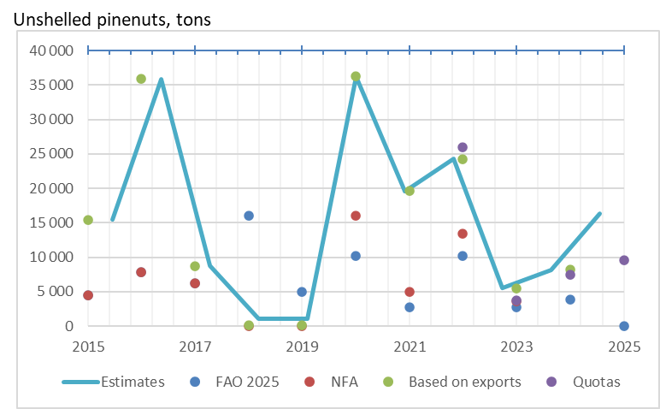
Figure 2.3: Estimated Harvesting Volumes Of Unshelled Pine Nuts In Mongolia (2015-2025)

Pine nut Production Process in Mongolia
Pine nut harvesting (including cone collection, extraction, and transport) follows a defined seasonal and technical sequence. The harvest typically takes place from September to February and is regulated by the Government, which sets official collection periods (see section 2.6). Local harvesters usually travel 20–200 km to forest sites, using private cars for nearby areas, while in more remote or difficult-to-access locations, transport is organized with vehicles suited to rough field conditions - most commonly Russian trucks, but also jeeps or other off-road vehicles as well as motorbikes and horses. They often camp for one to two weeks per trip and make several trips each season depending on yield.
Each person collects about 2–4 sacks of cones per day, and each 30 kg sack yields about 10 kg of unshelled pine nuts. Harvesters use heavy hand-made wooden hammers to knock down cones from trees - particularly for harvesting before cones are mature - or collect cones directly from the ground once they have matured and fallen naturally. After collection, preliminary extraction of pine nuts from the cones is carried out manually at the forest site using hand-made tools (simple graters or in some cases hand-cranked machines with sieves).
The resulting unshelled nuts are transported to wholesalers’ yards, generally located in soum or town centres. In some cases, particularly in the Khangai Mountains region, harvesters deliver whole cones to wholesaler collection points where mechanized cone-crushing equipment is available. Harvesters are paid by weight at these delivery points, marking the first formal transaction in the value chain. In some cases, they also receive advance payments prior to delivery.
Wholesaling and processing represent the next stages of the pine nut value chain. Wholesalers consolidate unshelled pine nuts from multiple harvesters and transport them primarily to Ulaanbaatar, where most processing companies are based. Processing facilities operate mechanized lines equipped with shelling machines, sorting systems, kiln dryers, and packaging units, enabling efficiency and product standardization. The processing stage adds value through quality control, grading, and packaging under different brands and sizes.
The marketing and distribution stage is largely export-oriented, with over 90% of the kernels sold to international markets, while a smaller share is distributed domestically. In some cases, wholesalers also sell unshelled nuts directly to local markets.

Government: Resource Owner and Regulator
The Government, through the Ministry of Environment and Climate Change (MECC), the National Forest Agency (NFA), and local aimag and soum authorities together with Forest Units or Inter-soum Forest Units (ISFUs), acts as the owner and regulator of Siberian pine forests. It establishes the legal framework, sets annual harvest quotas and rules for domestic and industrial use, and collects both nature-use fees based on quantities of un-shelled pine nuts harvested and export duties based on the quantity of kernels exported. Within this system, domestic quotas are allocated mainly for household use, while industrial quotas are licensed to Professional Forest Enterprises (PFEs) through competitive bidding for commercial lots. These measures define access rights, ensure resource control, and determine the flow of raw material from forests into the pine nut value chain. In practice, however, most pine nut harvesting operates on a commercial basis, and there is a gap between regulation and practice (see section 2.6).
In 2025 the MECC approved quotas for 9,512 tons of which 6,666 tons for industrial use and 2,846 tons for domestic use. The breakdown of quotas by use and region are presented in Table 2.4.
Table 2.4: Approved Quotas For Domestic And Industrial Use In 2025. Source: Mecc Annual Approved Harvest Quotas For Industrial And Domestic Use 2025
Region | Domestic quota |  | Industrial quota | TOTAL
Region | Special Protected Areas (SPA) | Other areas | Industrial quota | TOTAL
Khentii Mountain
Khentii | 385 | 0 | 608 | 993
Selenge | 1 078 | 362 | 1 028 | 2 468
Subtotal | 1 463 | 362 | 1 636 | 3 461
Khövsgöl Mountain
Khövsgöl | 155 | 649 | 3 519 | 4 324
Bulgan | 62 | 2 | 300 | 364
Subtotoal | 217 | 651 | 3 819 | 4 687
Khangai Mountains
Arkhangai | 8 | 42 | 599 | 649
Övörkhangai | 17 | 35 | 362 | 413
Zavkhan | 45 | 6 | 250 | 301
Subtotal | 70 | 83 | 1 211 | 1 363
TOTAL | 1 750 | 1 096 | 6 666 | 9 512

Pine Nut Harvesters
An estimated 60,000–70,000 harvesters collect pinecones each season, operating either individually or in informal family or friendship groups. In terms of the number of people working with pine nuts, they represent the largest group of value chain actors. As in many cases more than one household member, such as husband and wife, go harvesting, this might be estimated to represent 40,000 households, a significant number compared with for example the 190,000 households involved in cashmere production (Morton et al., 2024). As the work is seasonal, harvesters’ core livelihood activities are herding or other income-generating work in soum centres. Harvesters may be residents, rural or small-urban, of the soums where harvesting is carried out but also include people coming from other soums or even aimags.
Table 2.5 presents a regional breakdown of the estimated number of registered and unregistered pine nut harvesters and their corresponding harvest volumes in 2025. The estimates are derived from anticipated export-based total harvest volumes, distributed between the within-quota and above-quota components using a combination of quota data and field information collected at soum level on harvester numbers and average per-person collection volumes during 1–2 week harvesting trips. In practice, there is also a grey area within the quota system, as actual harvesting behaviour diverges from regulatory provisions; however, for the purpose of this analysis, these activities are treated as part of the formal segment to provide a consistent basis for comparison. The figures highlight that informal collection remains widespread across all regions, accounting for roughly 40 percent of total harvest volumes nationally. This reflects both limited enforcement of harvesting quotas and the practical challenges of distinguishing subsistence from commercial collection.
Table 2.5: Estimated Number Of Pine Nut Harvesters And Harvest Volumes By Region, 2025. Source: Author’s Field Estimates From Selected Soums, Applied As Regional Averages For Analysis.
Region | Number of harvesters |  |  | Total volumes of unshelled pine nuts, tons
Region | Registered | Unregistered | Total | Registered | Unregistered | Total
Khentii Mountains | 11,537 | 28,445 | 39,982 | 3,461 | 5,689 | 9,150
Khövsgöl Mountains | 15,623 | 4,070 | 19,693 | 4,687 | 814 | 5,501
Khangai Mountains | 4,540 | 1,685 | 6,225 | 1,362 | 337 | 1,699
TOTAL | 31,700 | 34,200 | 65,900 | 9,510 | 6,840 | 16,350

The harvesters sell their output to local wholesalers, some of whom are Professional Forest Enterprises (PFEs) or their representatives. Less than half of the harvesters obtain the required domestic collection permit, with the majority operating informally. Harvesters are paid by the net weight of unshelled pine nuts, based on prevailing market rates. In 2025, prices paid to harvesters ranged from 12 to 20 million MNT per tonne of unshelled pine nuts. The average prices observed were highest in the Khentii Mountains (about 16 million MNT/tonne), followed by the Khövsgöl Mountains (15 million MNT/tonne) and the Khangai Mountains (14 million MNT/tonne). These averages are derived from field-based estimates in selected soums and are considered representative of prevailing harvester prices in each region (see Table 2.6). In the case of informal trade, prices were estimated to be 20–30 percent lower than in formal channels, reflecting weaker bargaining power and the absence of official purchasing arrangements.
Transport represents the main cash cost for most harvesters, as pine cones are typically collected in remote forest areas and sold to wholesalers’ yards located between 30 and 180 km away, depending on the region. Many harvesters use their own vehicles or rely on friends or neighbours who own trucks, sharing expenses or paying per load. In the Khentii and Khövsgöl regions, harvesters often use horses or motorbikes, or walk to access deeper forest areas and crush the cones directly at forest sites, transporting only the unshelled pine nuts to points accessible by truck. In contrast, in the more accessible Khangai region, harvesters typically transport whole cones to the wholesalers’ yards. Based on field data, average transport costs range from about 100 MNT/kg in the Khangai Mountains to 250–300 MNT/kg in Khentii and Khövsgöl, where distances are longer and road conditions more challenging (Table 2.7).
Table 2.6 : Pine Nut Prices Paid To Harvesters By Region, 2025 (Field-Based Estimates. Source: Author’s Field Estimates From Selected Soums, Applied As Regional Averages For Analysis.
Region/Aimag/Soum | Price  million MNT per tonne
Khentii Mountains
Selenge, Baruunbuuren | 12
Selenge, Yeröö | 16
Selenge, Mandal | 20
Average for analysis | 16
Khövsgöl Mountains
Khövsgöl, Mörön | 15
Average for analysis | 15
Khangai Mountains
Övörhangai, Bat-Ölzii | 15
Arkhangai, Ikh-Tamir | 13
Arkhangai, Tsenkher | 14
Average for analysis | 14

Table 2.7: Estimated Transport Costs From Harvest Sites To Wholesalers’ Yards By Region, 2025. Source: Author’s Field Estimates From Selected Locations, Applied As Regional Averages For Analysis
Region | Distance: forest to wholesalers’ yard, km | Estimated transport cost,  MNT/kg
Khentii Mountains | 100-150 | 250
Khövsgöl Mountains | 120-180 | 300
Khangai Mountains | 30-50 | 100

In addition to transport, harvesters make small one-time investments in basic equipment such as wooden hammers (around 100,000 MNT) and locally made hand-operated cone-crushing machines (around 300,000 MNT), often produced within the community. These modest inputs, combined with household labour, help to minimize cash expenditures. Overall, the cost structure for harvesters remains relatively low compared to revenues, but transport costs are a key determinant of profitability and vary substantially by location.
Some harvesters are members of Forest User Groups (FUGs), which were established primarily to strengthen local forest protection and management. FUGs themselves do not play an active role in pine nut harvesting. They are voluntary associations of residents, often herders responsible for protecting and restoring assigned forest areas while sustainably using forest resources, but have no rights to prevent non-members harvesting pine nuts or other NTFPs in their areas, and play no role as FUGs in pine nut harvesting (though informal groups may be drawn from members of an FUG). This is discussed in more detail in section 2.6

Pine Nut Wholesalers
An estimated 70–80 wholesalers operate in the pine nut value chain, although not all are active every year. In 2025, 14 wholesalers were registered as Professional Forest Enterprises (PFEs) and obtained access rights to pine nuts through government-organized auctions. Most wholesalers are seasonal traders, engaging in the pine nut business during the autumn harvest and shifting to other commodities such as cashmere, livestock, or general trade throughout the rest of the year.
In the Khentii and Khövsgöl Mountains, wholesalers typically purchase pine nuts directly from harvesters who crush the cones at forest sites. In contrast, in the Khangai Mountains, where forests are closer to settlements, they buy whole cones delivered by harvesters to their yards. In the latter case, wholesalers operate cone-crushing machines, bag the unshelled nuts, and transport them to Ulaanbaatar by rented trucks.
In 2025, prices paid to wholesalers by processing companies ranged from 14 to 21 million MNT per tonne of unshelled pine nuts. The average prices observed were highest in the Khentii Mountains (about 18 million MNT/tonne), followed by the Khövsgöl Mountains (17 million MNT/tonne) and the Khangai Mountains (15 million MNT/tonne). These averages are derived from field-based estimates in selected soums and aimag centers and are considered representative of prevailing wholesaler prices in each region (Table 2.8)
Some wholesalers also act as agents for processing companies, coordinating purchases, advance payments, and logistics within specific supply areas. In the case of trade above quota, prices were estimated to be 20–30 percent lower than those within quota channels, based on the authors’ estimates informed by informal discussions with traders and harvesters.
Table 2.8: Pine Nut Prices Paid To Wholesalers By Region, 2025 (Field-Based Estimates. Source: Author’s Field Estimates From Selected Soums, Applied As Regional Averages For Analysis.
Region/Aimag/Soum | Price  million MNT per tonne
Khentii Mountains
Selenge, Baruunbuuren | 14
Selenge, Yeröö | 18
Selenge, Mandal | 21
Average for analysis | 18
Khövsgöl Mountains
Khövsgöl, Mörön | 17
Average for analysis | 17
Khangai Mountains
Övörhangai, Bat-Ölzii | 16
Arkhangai, Ikh-Tamir | 15
Arkhangai, Tsenkher | 15
Average for analysis | 15

Wholesalers incur substantial costs during the trading season, mainly related to labour and transport. They typically employ 5 to 10 temporary workers for sorting, bagging, and loading, paying around 100,000 MNT per day. With a workforce of ten people, approximately 40 working days are required to handle about 90 tons of pine nuts per season. Transport is a major cost item, as pine nuts must be moved from wholesalers’ yards to Ulaanbaatar. Depending on distance and road conditions, this cost ranges from about 300 MNT/kg in Khentii to 500 MNT/kg in Khövsgöl, where transport distances are longest (Table 2.9). While some wholesalers own 20-tonne or larger trucks and combine trading with transport operations, for the purpose of this analysis it is assumed that transport to Ulaanbaatar is rented. Smaller trucks are commonly used to move pine nuts from forest sites and to relocate temporary wholesaling points.
Table 2.9: Estimated Transport Costs Wholesalers’ Yards To Ulaanbaatar By Region, 2025. Source: Author’s Field Estimates From Selected Locations, Applied As Regional Averages For Analysis.
Region | Distance: wholesalers’ yard to Ulaanbaatar, km | Estimated transport cost,  MNT/kg
Khentii Mountains | 300-350 | 300
Khövsgöl Mountains | 600-800 | 500
Khangai Mountains | 400-500 | 400

In addition to hiring long-distance transport services for delivery to Ulaanbaatar, most wholesalers own smaller trucks with 1–3-tonne capacity, representing an investment of 14–20 million MNT per vehicle, used primarily for purchasing operations and short-distance transport from forest sites. In the Khangai Mountains, several wholesalers have also invested in Chinese-made mechanical cone-crushing machines (approximately 8.3 million MNT each), enabling them to process cones before shipment. These investments indicate a gradual move toward semi-mechanized operations in the more accessible regions.

Processing Companies
Ten processing companies were registered as Professional Forest Enterprises (PFEs) in 2025. All obtain access rights through forest auctions and mainly purchase unshelled pine nuts directly from wholesalers. With some wholesalers, they maintain contractual arrangements or provide advance payments to secure supply. In a few cases, processors also buy directly from harvesters, though such transactions remain limited.
For analytical purposes, processors are divided into two groups: high-end and bulk export companies. The three high-end companies account for roughly one quarter of total pine nut purchases. They favour formal sourcing channels and operate mechanized processing lines with year-round staff. While they still export most of their production as bulk kernels to China, they have begun to diversify by developing branded, packaged, and certified products for higher-value markets. The seven bulk processors handle about three quarters of total volume, focusing on bulk kernel (shelled nut) production for export to China. Their operations are largely seasonal, rely on informal sourcing arrangements, and use simpler shelling and sorting equipment.
Markets and products
Most of the processed output is sold as kernels (shelled nuts), with only a marginal share marketed as unshelled nuts for domestic consumption. A very small fraction - around 0.5-1% of total unshelled nut volume - is further processed into pine nut oil. More than 90% of kernels are exported. The Chinese market absorbs around 90% of Mongolia’s export volume and 85% of export value, purchasing bulk kernels in 25–50 kg bags. Export prices for bulk kernels typically range between USD 15–21 per kg, depending on quality, exchange rate conditions, and buyer relationships. We were unable to clarify whether or not Mongolian kernels sold in bulk to China and re-exported were mixed with kernels from P. koraiensis. High-end processors are gradually entering niche markets in Europe, the USA, Korea, Japan, and Taiwan, exporting smaller quantities of certified or branded kernels. Premium shelled products typically sell for USD 19–23 per kg, with branded, retail-packaged organic kernels priced higher at USD 23–34 per kg. There is growing interest in pine nut oil as a value-added product, with at least two processors in Mongolia already producing it. Export prices for pine nut oil range from USD 92–100 per kg, reflecting its premium positioning in specialty food and health-product markets. No data on export volumes are available, so this analysis does not include volume estimates, although earlier approximations indicate that pine nut oil represents only a very marginal share of total production.
Although exports dominate, a limited domestic market exists. Small quantities of unshelled pine nuts are sold locally for consumption, and some processors market kernels within Mongolia through urban retail outlets. Domestic prices for packaged unshelled pine nuts range from 25,000 to 28,000 MNT/kg, while packaged kernels sell for 80,000–100,000 MNT/kg (Table 2.10). Small volumes of pine nut oil are also sold domestically, complementing the export-focused production.
Table 2.10: Typical Products And Prices Of Pine Nut Processing Companies, 2025 (Field-Based Estimates)
Product type | Destination / buyer | Approx. price | Notes
 |  | USD/kg
Kernels (bulk, shelled) | China (main market) | 15–21 | Exported in bulk, 25–50 kg bags
Kernels (premium, shelled) | Korea, Japan, Taiwan | 19-23 | Selected high-quality lots
Kernels (retail, certified) | EU, USA | 23–34 | Branded, organic-certified retail products
Pine nut oil | Domestic/ export | 92-100 | Marginal volumes
 |  | MNT/kg
Kernels packaged | Domestic markets | 80,000-100,000 | Small quantities of packages kernels
Unshelled pine nuts | Domestic markets | 25,000-28,000 | Small quantities sold locally

Processing yields vary depending on nut size and quality but typically range from 35 to 40 percent, meaning that 2.5–2.8 kg of unshelled pine nuts is required to produce 1 kg of kernels.

Costs and investment outlay
Processing companies have the most capital- and energy-intensive operations in the pine nut value chain. Their main operating costs include raw material purchases (unshelled pine nuts), labour, energy and utilities, packaging, transport, and certification or quality control.
Investment requirements vary widely between processor groups. High-end processors have invested in complete shelling, sorting, drying, and packaging lines, with total outlays estimated at 2–3 billion MNT. Bulk processors, operating simpler facilities with limited drying and sorting capacity, typically invest between 1–2 billion MNT (Table 2.11).
Table 2.11: Indicative Investment Outlay And Equipment Profile Of Processing Companies, 2025.
Processor group | Main equipment and facilities | Typical investment outlay (million MNT) | Operation type
High-end | Shelling, sorting, drying, and packaging lines; branding and certification systems | 2,000–3,000 | Year-round, permanent staff; mainly bulk exports to China with emerging high-end product lines
Bulk exporters | Basic shelling and sorting units; limited drying capacity | 1,000–2,000 | Seasonal operations; bulk kernel exports to China

Input Dealers and Support Services
Input dealers and support services: The pine nut value chain relies on a range of supporting actors that provide tools, transport, finance, and technical services. Most hand-made hammers and basic cone-crushing equipment used at forest sites are produced or adapted by harvesters themselves, while more advanced pinecone crushing machines are imported from China. Similarly, processing factories use imported machinery, mainly from China but also from other countries, for shelling, sorting, drying, and packaging. Truck and horse owners provide essential transport services between forest sites, collection points, and processing centres. On the financial side, most processing company owners have backgrounds in trade and other commercial sectors (e.g., cashmere, livestock, or import–export) and typically rely on their own capital for investment rather than formal credit. Limited technical training and extension support is available through government programs and development projects, with growing attention to sustainable harvesting practices and product quality improvement.

Pine Nut Flows and Volumes
The Mongolian pine nut value chain operates through three regional sub-chains: the Khentii Mountains, the Khövsgöl Mountains, and the Khangai Mountains as described in Section 2.3.1. These regions form the geographic basis for the flow and interaction of actors across harvesting, trading, and processing stages. An overview of key actors and activities in the Mongolian pine nut value chain is shown in Figure 2.4, while the flows of pine nuts between actors are presented in Figure 2.5.
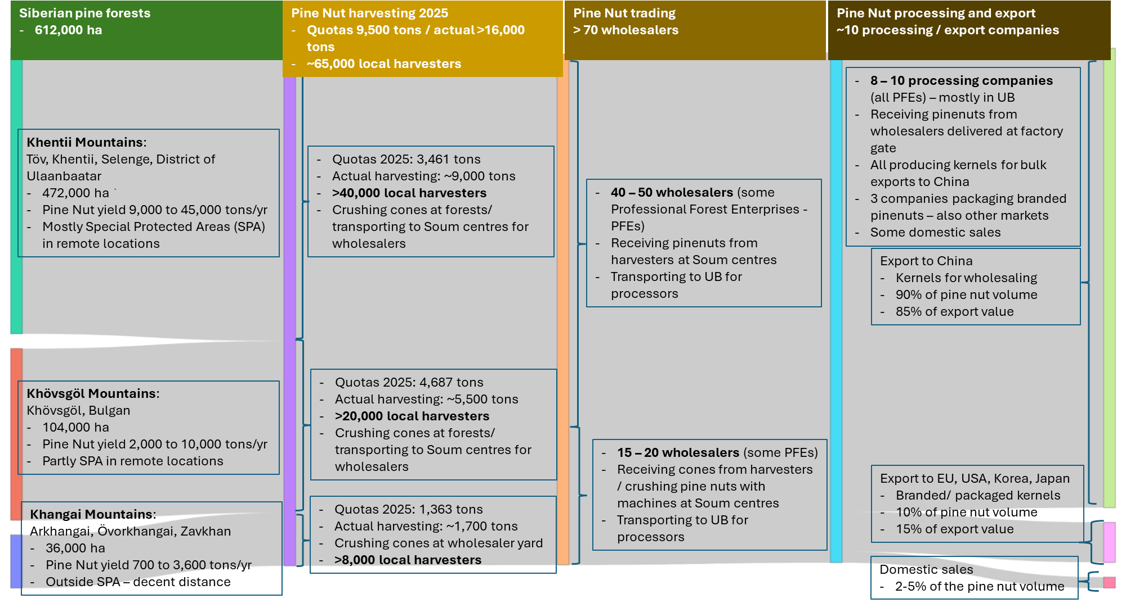
Figure 2.4: Overview Of Key Actors And Activities In The Mongolian Pine Nut Value Chain (2025)
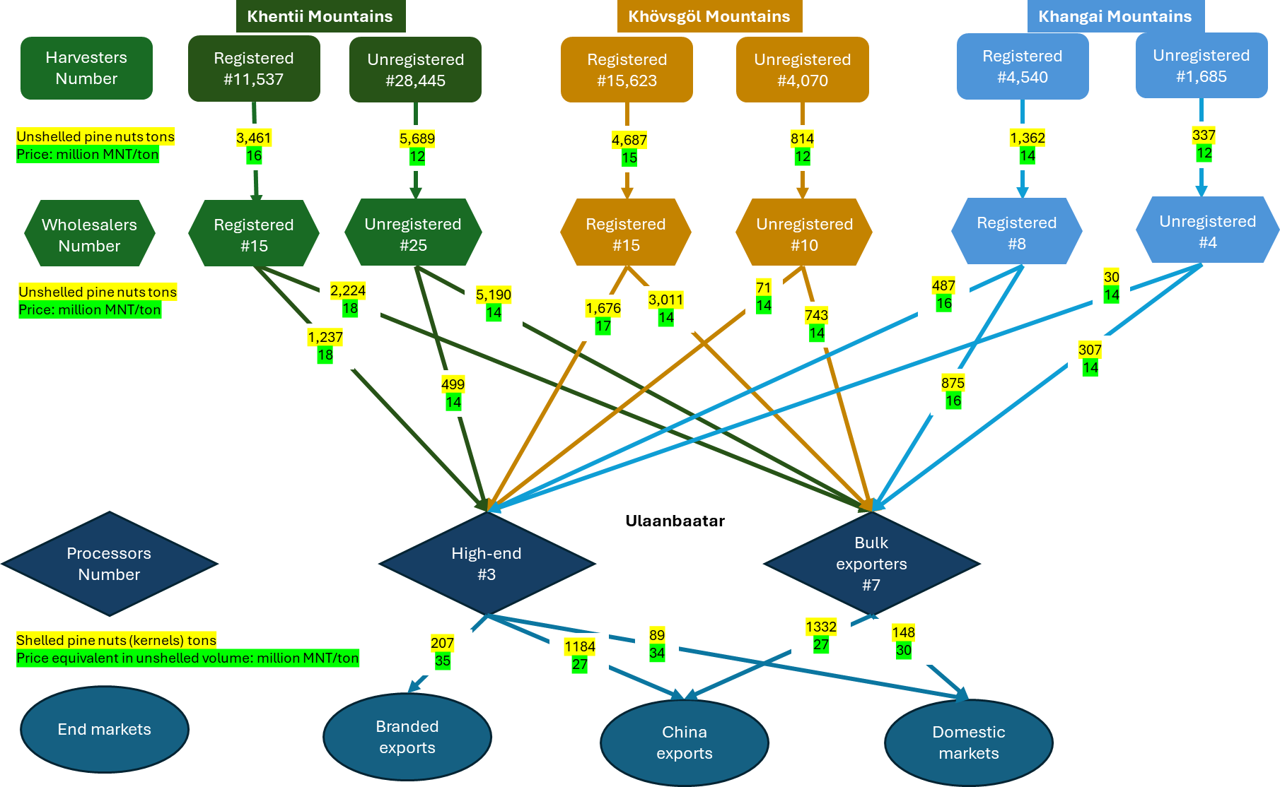
Figure 2.5: Pine Nut Flows Between Value Chain Actors, Volumes In Tons And Prices In Million Mnt/Tonne Of Unshelled Pine Nuts
As shown in Figure 2.5, the flow analysis distinguishes between within-quota and above-quota pine nut harvesting and trading. The within-quota chain reflects volumes captured under official quota allocations, while the above-quota chain represents estimated volumes based on anticipated use primarily exports and domestic consumption outside the quota system.
In all three regions - the Khentii Mountains, Khövsgöl Mountains, and Khangai Mountains - registered harvesters sell their harvests entirely to registered wholesalers, but there is no check whether these are within or above quota. Unregistered harvesters channel most of their harvests to unregistered wholesalers, with smaller amounts entering the within-quota chain through registered buyers. These wholesalers then channel about 38% of their volumes to high-end processors serving domestic and premium export markets, while the remaining 62% go to bulk export processors. Unregistered wholesalers sell roughly 9% of their volumes to high-end processors and 91% to bulk export processors, indicating a stronger orientation toward bulk export markets. The prices harvesters receive from the wholesalers range from 12 to 16 million MNT per tonne of unshelled pine nuts.
Both types of processors source pine nuts from all three regions, with regional variations in purchase prices. These prices, applied in the analysis, range from 14 to 18 million MNT per tonne of unshelled pine nuts. The processors then sell shelled pine nut kernels - amounting to roughly 37% of the weight of unshelled nuts - with final product prices ranging from 27 to 35 million MNT per tonne. For consistency in comparing value addition along the chain, these kernel prices are expressed on an unshelled-equivalent basis, allowing direct comparison with raw pine nut purchase prices.
It should be noted that these shares represent analytical estimates developed to support a consistent and transparent value chain analysis. Actual trade volumes and relationships are likely to vary between years, regions, and actors, and cannot be fully captured through available data.

Organization and Governance
The governance context for the pine nut value chain is complex, with a legal basis set out in at least three different laws, important articles of which are not observed, and an institutional landscape with multiple lines of responsibility.
The Law on Natural Plants of 1995, defines rare (khovor) species as having “limited natural regeneration capacities and limited distributions and reserves, and that are potentially at risk of extinction”. This is distinct from the category of extremely rare (nen khovor) species. Rare species can only be used for household and research purposes (Article 10). In a government list published the same year, Siberian pine is classified as rare at the national level, for the purposes of the Law. This presents a legal contradiction at the heart of the governance of the value chain. More generally, the Law on Natural Plants places a general duty on “Governors at all levels shall, using funds from the state budget, implement measures to protect flora from fire, diseases, harmful rodents and insects and from negative human impacts (Article 7).
Paragraphs of the Forest Law of 2012 (Article 38 on NTFPs) decree that:
38.1 Soums…shall issue NTFP utilization licenses to citizens, forest partnerships, business entities and organizations…
38.3 Citizens, forest partnerships, business entities and organizations shall utilize NTFPs on a paid basis [i.e. on payment of a fee]…
38.5 Collection of pine nuts is allowed for household purposes when the nut yield is medium and for any purpose when the nut yield is high.
The majority of the paragraphs of Article 38 clearly support harvesting and trade in NTFPs in general, but the provisions of paragraph 38.5, which would severely limit pine nut harvesting, are not currently implemented. This is an additional contradiction between current practice in the pine nut value chain and the law.
The Law on Special Protected Areas of 1994 sets out various categories and sub-categories of protected areas. Strictly Protected Areas (currently this applies only to Khan-Khentii) are divided into i) Pristine Zones, ii) Conservation Zones and iii) Limited Use Zones. National Conservation Parks are sub-divided into iv) Special Zones, v) Travel and Tourism Zones and vi) Limited Use Zones. In sub-categories i), ii) and iv) only protection, regeneration, and research activities are permitted. In sub-categories iii), v) and vi), which make up 80% of the total area of Special Protected Areas, other activities are permitted, including “in the case of local residents, the collection and use of associated natural resources and medicinal and food plants, according to established regulations, for household needs” (paragraphs 11.10 and 17.1). “Harvesting and processing secondary natural resources or plants of medicinal, nutritional or technical value for commercial purposes” are expressly forbidden in all sub-categories of both Strictly Protected Areas and National Conservation Parks (paragraphs 12.2 and 18.1).
The Regulations on the Protection and Proper Use of Forest Resources of 2023 stipulate that up to 40% of the total quotas established in a given year may be harvested from approved areas of specially protected areas for domestic purposes, and up to 60% from other forests for domestic and industrial purposes, and the maximum amount of usable quotas shall be approved by the central state administrative body. The mention of domestic purposes here appears to refer to the Law on Special Protected Areas, thus providing the legal justification for the establishment of domestic quotas in Special Protected Areas, which are the only quotas granted for those areas (both Strictly Protected Areas and National Conservation Parks – covering not only the Khan-Khentii Strictly Protected Area but also large parts of Övörkhangai, Arkhangai, Zavkhan and Bulgan Aimags). Given the actual operation of the harvesting system, it appears that the domestic quota system works as a legal fiction, allowing the issuing of permits to self-employed harvesters supplying commercial actors, with the value chain operating in very much the same ways (depending more on distance between harvesting areas and settlements) across Special Protected Areas (and clearly including the Pristine Zone of the Khan-Khentii Strictly Protected Area) and non-protected forests.
Other criminal laws from 2015 and 2017 specify confiscation of income, fines (albeit not high), restrictions of travel rights and imprisonment, for various offences involving the unauthorised harvesting of plants and forest products.
Responsibility for forest policy belongs to the Ministry for the Environment and Climate Change (MECC). This includes responsibility for pine nut export. The National Forest Agency (NFA), which was re-established in 2022, helps develop forest policy, is responsible for the Forest Inventory, and implements policy, though day-to-day regulation is the responsibility of local government. NFAalso has a mandate for planning forest-related research, including on pests and diseases, which is implemented by universities and private bodies. At the local level Aimag Environmental Departments oversee both the work of Soum Environmental Inspectors and their rangers, and also one or more Forest Units (FUs). All soums with significant forest cover, and a few soums interested in tree planting as an urban amenity, are covered by FUs or more commonly by Inter-Soum Forest Units (IFSUs), which can cover anything between two and nine Soums, and have a key role in setting pine nut harvesting quotas. The respective roles of Aimags, Soums and IFSUs are subject to some overlap, and multiple lines of reporting (Figure 2.6).
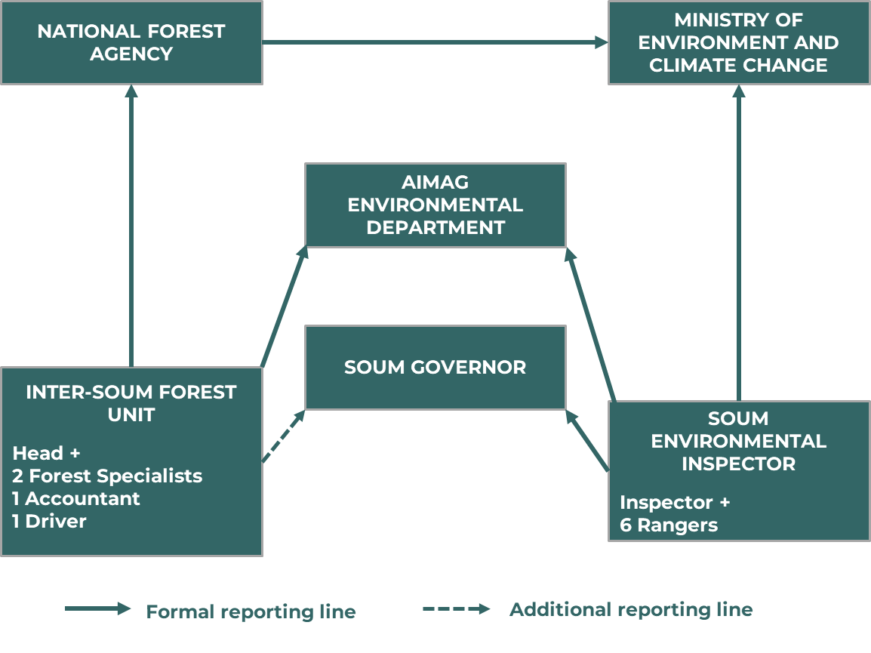
Figure 2.6: Organigram Of Government Departments Involved In Forest Governance. Employees Numbers Were Given By An ISFU In The Khan-Khentii Region And Are Indicative For Other ISFUs And Soums. Source: Interviewees At Soum Level; The Diagram Reflects Their Perceptions And May Not Entirely Accord With The Official Position.
Before 2022, pine nut harvesting in Mongolia was governed by a relatively ad hoc permit system. Quotas and permissions were issued inconsistently by local governments or forest units, often without standardized yield surveys or clear separation between household and commercial use. Harvesting rights were frequently allocated through direct permits or informal arrangements with traders and local officials, and monitoring of compliance was limited. This led to fluctuations in harvesting intensity, occasional overharvest, and weak incentives for forest protection.
In 2022, a more structured system was introduced under the MECC. IFSUs now propose annual quotas at soum level based on pine nut yield surveys before the harvesting season. Annual quotas are proposed by IFSUs for each of their respective soums by 1st August each year. Quotas distinguish between domestic (household) and industrial (commercial) harvesting. Only domestic collection is permitted in Special Protected Areas, and then only in the Limited Use Zones (LUZs). Industrial harvesting in Special Protected Areas is officially prohibited. Both sorts of quotas are established for non-protected forests. Soum-level quotas are aggregated by aimags and transmitted to NFA on the 10th August, and from NFA to MECC on 23rd August. They are endorsed by the Minister on 1st September and announced publicly on 7th September. 40% of total harvest can come from domestic quotas within Strictly Protected Areas (SPAs), and 60% from domestic and industrial quotas in other forests.
Industrial quotas are auctioned for successive soums on a digital platform in which licensed PFEs can bid. There was a government-set floor price of 700 MNT/kg in 2025. Successful bidders must then pay both the auction price and the nature use fee of 1,400 MNT/kg. For the 2025 harvest auction prices ranged from MNT 700/kg to MNT 18,187/kg, with an overall weighted average of MNT 1818/kg. PFEs are formally required to organize harvesting through registered harvester groups, but in practice this model is completely ignored, in favour of individual harvesters (herders or soum-centre residents) selling by the sack to wholesalers who sell to PFEs.
For domestic harvesters, the ceiling is 50 kg per person. They typically pay a fixed nature use fee of MNT 50,000, which is treated as covering the right to harvest up to that 50 kg, regardless of the actual volume collected, and the use to which it is put – in practice overwhelmingly going into the commercial value chain.
In 2025, total approved quotas amounted to 6,666 tons for industrial use and 2,846 tons for domestic use (1,750 tons in SPAs and 1,096 tons outside SPAs). The quota volumes have fluctuated considerably since the new system began from about 25,900 tons in 2022 (15,290 tons industrial; 10,630 tons domestic) to 3,700 tons in 2023, 7,400 tons in 2024, and 9,500 tons in 2025.
Soum governments can derive substantial financial benefits from auction proceeds and Natural Resource Fees. Total soum government income from pine nuts in 2025 was MNT 7.3 billion, giving a rough average of 116 million per soum, though of course this differs according to soum production. Interviewees from one soum showed us a kindergarten, and a cultural centre (whose construction cost MNT 500 million), that had been built with pine nut proceeds in previous years. It could be argued that soums may thus be subject to conflicts of interest in setting quotas, though these are subsequently checked at aimag and central government levels.
There are 1200 Forest User Groups nationwide, some active and some not. They are in theory an important part of the institutional landscape. They are defined as “voluntary associations of citizens” by the Forest Law of 2012, where their responsibilities and rights are set out under Article 21. The process for setting up a FUG is not detailed, but at least 80% of members “shall be permanent residents of the given territorial or administrative unit, [we assume this refers to a soum], capable of providing forest protection and monitoring on a continuous basis” (21.6). They can be granted rights to possession and use (these are legal categories subordinate to forest resources being the property of the state) to certain parts of the existing forest stock by a soum assembly, on a contractual basis indicating specific duration and conditions, with “consideration to the number of members and capability and the area size, resources and ecological characteristic of the forest claimed” (21.10). A FUG should set up a management plan for forest protection, sustainable use, restoration and reforestation of its possessed forest area, and report on implementation to the soum assembly. If all conditions are met, a FUG can use and sell timber and NTFPs from its possession forest (21.12.2). However, the law does not spell out that such rights should be exclusive.
FUGs can be contracted to undertake afforestation and reforestation work and may be granted limited forest-use rights by local authorities. They also contribute to monitoring illegal logging and unauthorized pine nut collection, reporting such cases to the relevant authorities. FUGs have strong potential to provide seasonal labour for reforestation and restoration efforts and to act as stewards of community forests and operate under agreements with soum governors, typically under the supervision of Forest Units (FUs) or Inter-Soum Forest Units (ISFUs). There is a presumption that FUGs should have a privileged role in the pine nut value chain, but in practice they are almost completely irrelevant, which gives rise to strong disillusionment among FUG members over their perceived responsibilities for forest management without corresponding rights. FUGs are further discussed in section 5.5.1 below.
The Forest Law (Article 23) makes provision for the registration and regulation of PFEs. In principle this requires the employment of at least one staff member technically qualified in forestry, though we understand this is not always observed. PFEs have a legal obligation to “provide professional and methodological advice to other entities and organizations, conduct trainings and develop and implement projects and programs” (paragraph 23.2.3) but these duties were not mentioned by any interviewees. Enterprises can be registered under several headings, and nationally 800 registrations have been granted to 500 companies and research institutes. Registration for buying and processing pine nuts is only a small part of this total. Seven active processing companies, and eight or so that have lost registration due to inactivity, are grouped in the “Cluster” NGO/trade association. We understand that some other registered processors may be legally owned by proxies for Chinese interests. Some of the larger wholesalers outside Ulaanbaatar also have PFE registration as suppliers.
We also received evidence from multiple sources of the existence of illegal wholesalers operating completely outside the quota and auction system.

Major Market Trends
Global demand for nuts and dried fruits continues to grow steadily, driven by consumers’ increasing interest in healthy snacks, plant-based diets, and minimally processed foods. The INC Nuts & Dried Fruits Statistical Yearbook 2024 reports sustained expansion in global nut trade and consumption.
In the case of pine nuts, international trade is concentrated among a few key players. According to ITC Trade Map data, global trade in shelled pine nuts reached USD 526 million in 2024, with China remaining the dominant exporter and processing hub. China not only supplies a large share of global kernels but also re-exports processed or re-packaged nuts to Europe and other premium markets. The top five exporters - China, Germany, Türkiye, the Russian Federation, and Mongolia - accounted for 80 percent of global export value, while European countries and the United States were the leading importers, together representing 77 percent of total imports (Europe 61 percent, United States 16 percent).
In Europe, demand for pine nuts continues to rise, and the region remains heavily reliant on Chinese-sourced kernels (Mundus Agri, 2025). Market research forecasts indicate that the global pine nut market will continue expanding, with Asia–Pacific (especially China) expected to record the fastest growth, and Europe maintaining a substantial market share (Cognitive Market Research, 2026).
Within the premium niche, organic, certified, and geographically indicated (GI) pine nuts are gaining traction among discerning buyers in Europe, Japan, Korea, and the USA, who are willing to pay a price premium for products with verified origin, traceability, quality, and sustainability attributes. Although most of the global kernel volume still passes through Chinese import and processing hubs, interviews with high-end Mongolian processors suggest that GI and organic differentiation strategies are emerging as viable pathways to capture higher margins in premium markets.
At the same time, domestic demand in Mongolia is increasing, with a gradual shift from the traditional consumption of unshelled nuts toward kernels as the preferred option. This observation, reported by interviewed processors and traders, reflects broader trends associated with convenience, urbanization, and rising household incomes.

A SWOT matrix
In accordance with the VCA4D methodology, we set out a table of the Strengths, Weaknesses, Opportunities and Threats presented by the pine nut value chain.
Strengths | Weaknesses
- Large Siberian pine resource base (612,000 ha) with strong regional concentration (Khentii and Khövsgöl Mountains regions)  - High natural yields and valuable, globally demanded product (premium kernel market)  - Well-established traditional knowledge and widespread participation in harvesting  - Processing capacity exists in Ulaanbaatar, including emerging high-end firms  - Strong export orientation with reliable demand from China and niche demand in premium markets | - Highly irregular and cyclical yields, creating unstable supply  - Significant informality and weak alignment between regulations and actual harvesting practices.  - Limited domestic value addition: most exports remain bulk kernels  - Poor data availability on yields, harvest volumes, and trade flows.  - Fragmented supply chain with weak bargaining power among harvesters  - Heavy dependence on wild forests; no plantation or managed production systems  - Climate change
Opportunities | Threats
- Development of premium, branded, certified, or organic products for Europe, USA, Korea, Japan.  - Strong potential for by-product utilisation (shells, cone residues) in biochar, extracts, oil.  - Upgrading of processing capacity and diversification (retail packaging, oil, nutraceuticals).  - Improved quota governance and traceability systems could enhance sustainability and market access.  - Potential for community-based forest management, stewardship roles for FUGs, and restoration jobs. | - Increasing pressure on forests from informal and over-quota harvesting.  - Policy misalignment and administrative complexity may undermine compliance and long-term sustainability.  - Dependence on a single dominant export market (China) exposes processors to price and demand shocks.  - Climate variability and forest health issues will exacerbate yield fluctuations.  - Risks of market capture by intermediaries or processors, limiting benefits for rural harvesters.

WHAT IS THE CONTRIBUTION OF THE VALUE CHAIN TO ECONOMIC GROWTH?

Methodological Notes
The economic analyses rely on the VCA4D methodological brief, which clearly outlines the objectives of the economic analyses and defines the main framing questions. The outputs presented here were generated with the assistance of the AFA software.
For the economic part, the data used are coming from various resources.
- Interviews with stakeholders: harvesters, wholesalers, processing companies, government representatives from national (MECC, NFA), aimag and soum levels (Aimag Environmental Protection Departments/Forest Divisions, Soum Governments, Soum and Inter-Soum Forest Units), development partners and research organizations
- Pine nut quota data from MECC
- International trade data from Mongolian Custom Service and ITC Trade Statistics

Profitability & Sustainability of actors
In the subsequent section, the study presents the financial accounts of the key entities involved in the Mongolian pine nut value chain. The analysis aims to assess the profitability and economic sustainability of the main actor groups, including harvesters, wholesalers, and processors. The first subsection focuses on harvesters across the three regional sub-chains – Khentii Mountains, Khövsgöl Mountains, and Khangai Mountains - followed by sections on wholesalers and processing companies.
For each actor type, the financial accounts are presented both as aggregated totals (computed using the AFA software) and as a breakdown of earnings and costs for an individual actor. This dual perspective enables comparability across actor types and regions and provides insights into value distribution, profit margins, and potential leverage points to improve efficiency and sustainability within the sector.

Financial Accounts for Harvesters
Table 3.1 presents the aggregated financial accounts for pine nut harvesters across the three regions and for both registered and unregistered operations, while Table 3.2 presents the financial accounts for an individual harvester, providing a clearer basis for comparing earnings and costs across regions and between registered and unregistered segments. Combining both perspectives makes it possible to distinguish between (i) the overall economic scale of harvesting activities at regional level and (ii) the financial returns that an individual harvester can expect during the season.

Table 3.1: Aggregated Financial Accounts For All Harvesters (Regional Totals) In 2025.
 | Registered |  |  | Unregistered
 | Khentii | Khövsgöl | Khangai |  | Khentii | Khövsgöl | Khangai
Number of harvesters | 11,387 | 15,623 | 4,540 |  | 28,445 | 4,070 | 1,685
Number of working days | 170,800 | 234,350 | 68,100 |  | 284,450 | 40,700 | 16,850
Production of unshelled pine nuts, tons | 3,461 | 4,687 | 1,362 |  | 5,689 | 814 | 337
Price of unshelled pine nuts  Million MNT/tonne | 16 | 15 | 14 |  | 12 | 12 | 12
Revenues, Million MNT | 54,656 | 70,305 | 19,068 |  | 68,268 | 9,768 | 4,044
Transport, million MNT | 3,416 | 4,687 | 1,362 |  | 5,689 | 814 | 337
Gov tax/ fees, Million MNT | 569 | 781 | 227 |  | - | - | -
Depreciation (hammers, crushers)  Million MNT | 1,253 | 1,719 | 227 |  | 3,129 | 448 | 84
Total Costs | 5,238 | 7,187 | 1,816 |  | 8,818 | 1,262 | 421
Net Operating Profit, Million MNT | 49,418 | 63,118 | 17,252 |  | 58,028 | 8,303 | 3,539
Value Added, Million MNT | 51,240 | 65,618 | 17,706 |  | 28,445 | 4,070 | 1,685

Table 3.2: Financial Accounts For One Harvester (Individual Returns) In 2025.
 | Registered |  |  | Unregistered
 | Khentii | Khövsgöl | Khangai |  | Khentii | Khövsgöl | Khangai
Production of unshelled pine nuts, kg | 300 | 300 | 300 |  | 200 | 200 | 200
Number of working days | 15 | 15 | 15 |  | 10 | 10 | 10
Revenues, MNT | 4,799,859 | 4,500,096 | 4,200,000 |  | 2,400,000 | 2,400,000 | 2,400,000
Transport, MNT | 299,991 | 300,006 | 300,000 |  | 200,000 | 200,000 | 200,000
Gov tax/ fees, MNT | 50000 | 50000 | 50000 |  | - | - | -
Depreciation (hammers, crushers), MNT | 1,253 | 1,719 | 227 |  | 3,129 | 448 | 84
Total Costs, MNT | 351,244 | 351,725 | 350,227 |  | 203,129 | 200,448 | 200,084
Net Operating Profit, MNT | 4,448,615 | 4,148,371 | 3,849,773 |  | 2,196,871 | 2,199,552 | 2,199,916
Net earnings per day, MNT | 296,583 | 276,552 | 256,652 |  | 219,687 | 219,955 | 219,992

At the aggregate level, revenues and operating profits vary widely between regions, primarily reflecting differences in the number of harvesters and total production volumes. Registered harvesters benefit from higher purchase prices -14 to 16 million MNT per tonne - compared with the assumed 12 million MNT per tonne in above-quota trade. As a result, aggregated revenues among registered harvesters range from 19.1 billion MNT in Khangai to over 70 billion MNT in Khövsgöl. Unregistered harvesters generate lower total revenues due both to smaller group sizes and lower prices in above-quota trade.
Transport constitutes the largest direct cash cost for harvesters. This is consistent with field observations indicating that distances between forest sites and wholesalers’ yards are substantially greater in Khentii and Khövsgöl than in the more accessible Khangai region. Accordingly, total transport expenditures reach 3.4–4.7 billion MNT in these two regions, compared with 1.4 billion MNT in Khangai. Depreciation costs - applied to simple equipment such as hammers and cone crushers - remain modest in all cases. Government taxes and fees appear only for registered harvesters, amounting to 570–780 million MNT in Khentii and Khövsgöl.
To avoid misinterpretation stemming from large differences in group size, Table 3.2 provides a breakdown of earnings and costs per individual harvester. These figures offer a clearer indication of livelihood outcomes. A typical registered harvester produces around 300 kg of unshelled pine nuts over 15 working days, earning between 4.2 and 4.8 million MNT in gross seasonal revenue. After deducting transport, permit fees, and depreciation, net operating profits range from 3.85 to 4.45 million MNT, equivalent to 257,000–297,000 MNT per day.
Unregistered harvesters, who are assumed to work roughly 10 days and produce 200 kg, earn about 2.4 million MNT in gross revenues. With lower purchase prices in above-quota trade but also fewer fees, their net operating profits amount to about 2.2 million MNT, corresponding to approximately 220,000 MNT per day.
Despite regional and registered–unregistered differences, both tables indicate that pine nut harvesting remains a high-return seasonal activity. Profitability is strongly influenced by purchase prices, production volumes, and transport distances. The relatively lower earnings of unregistered harvesters highlight the importance of improving access to within-quota trade or strengthening bargaining power within above-quota trade channels. Strengthening these mechanisms could raise individual incomes while reducing the vulnerabilities associated with above-quota trade.

Financial Accounts for Wholesalers
Table 3.3 presents the aggregated financial accounts for wholesalers across the three regional sub-chains, while Table 3.4 provides the corresponding financial accounts for an individual wholesaler. As with harvesters, this dual presentation separates the overall economic scale of wholesaling activities from the profitability of a single operator, thereby allowing clearer comparison across regions and between formal and informal segments.

Table 3.3: Aggregated Financial Accounts For All Wholesalers (Regional Totals) 2025
 | Registered |  |  | Unregistered
 | Khentii | Khövsgöl | Khangai |  | Khentii | Khövsgöl | Khangai
Number of wholesalers | 15 | 15 | 8 |  | 25 | 10 | 4
Volume of unshelled pine nuts, tons | 231 | 312 | 170 |  | 228 | 81 | 84
Price of unshelled pine nuts  Million MNT/tonne | 18 | 17 | 16 |  | 14 | 14 | 14
Revenues, Million MNT | 61,488 | 79,679 | 21,792 |  | 79646 | 13838 | 4718
Consumables: purchased pine nuts | 54,656 | 70,305 | 19,068 |  | 68,268 | 9,768 | 4,044
Services: transport, million MNT | 1,025 | 2,344 | 545 |  | 1,707 | 407 | 162
Wages, million MNT | 170 | 234 | 68 |  | 284 | 41 | 17
Gov tax/ fees, Million MNT | - | - | - |  | - | - | -
Depreciation (trucks, crushers)  Million MNT | 12 | 12 | 13 |  | 20 | 8 | 3
Total Costs, Million MNT | 55,863 | 72,895 | 19,694 |  | 70,279 | 10,224 | 4,226
Gross Operating Profit, Million MNT | 5,637 | 6,796 | 2,111 |  | 9,387 | 3,622 | 495
Net Operating Profit, Million MNT | 5,625 | 6,784 | 2,098 |  | 9,367 | 3,614 | 492
Value Added, Million MNT | 5,807 | 7,031 | 2,179 |  | 9,671 | 3,663 | 512

Table 3.4: Financial Accounts For One Wholesaler (Individual Returns) 2025
 | Registered |  |  | Unregistered
 | Khentii | Khövsgöl | Khangai |  | Khentii | Khövsgöl | Khangai
Volume of unshelled pine nuts, tons | 15 | 21 | 21 |  | 9 | 8 | 21
Revenues, Million MNT | 4,099 | 5,312 | 2,724 |  | 3,186 | 1,384 | 1,180
Consumables: purchased pine nuts | 3,644 | 4,687 | 2,384 |  | 2,731 | 977 | 1,011
Services: transport, million MNT | 68 | 156 | 68 |  | 68 | 41 | 41
Wages, million MNT | 11 | 16 | 9 |  | 11 | 4 | 4
Gov tax/ fees, Million MNT | - | - | - |  | - | - | -
Depreciation (trucks, crushers)  Million MNT | 1 | 1 | 2 |  | 1 | 1 | 1
Total Costs, Million MNT | 3,724 | 4,860 | 2,462 |  | 2,811 | 1,022 | 1,057
Gross Operating Profit, Million MNT | 376 | 453 | 264 |  | 375 | 362 | 124
Net Operating Profit, Million MNT | 375 | 452 | 262 |  | 375 | 361 | 123
Profit Margin, % | 9% | 9% | 10% |  | 12% | 26% | 10%

At the aggregate level, total revenues earned by wholesalers reflect both the volumes handled and the prices paid to harvesters. Registered wholesalers engaged in within-quota trade face higher input prices -16 to 18 million MNT per tonne depending on the region - while unregistered wholesalers operating in above-quota trade pay an estimated 14 million MNT per tonne. Although the value chain framework distinguishes between within-quota and above-quota trade, field observations indicate that wholesalers themselves are rarely registered as formal companies and seldom pay taxes or nature-use fees, even when sourcing within-quota volumes. In practice, nature-use fees are generally paid by processing companies, some of which maintain arrangements with selected wholesalers to supply within-quota trade pine nuts. Only a small share of wholesalers directly contributes these fees. As a result, aggregated revenues range from 21.8 billion MNT in Khangai’s within-quota trade segment to nearly 80 billion MNT in Khövsgöl’s, while above-quota trade revenues remain lower primarily due to the smaller volumes traded.
Across regions, wholesalers’ cost structures are dominated by the cost of purchased pine nuts, which accounts for over 90% of all expenditures. Additional operating costs include transport services, wages for seasonal labour, and depreciation related to trucks and processing equipment. Government taxes and fees are not reported in the wholesalers’ accounts, as the relevant charges are typically borne by harvesters and processors. Aggregate gross operating profits range from 2.1 to 6.8 billion MNT among registered wholesalers operating in within-quota trade and from 0.5 to 9.4 billion MNT among unregistered wholesalers operating in above-quota trade, depending on region and trading volume.
The individual financial accounts in Table 2.4 provide a clearer picture of profitability for a single wholesaler. A typical registered wholesaler operating in within-quota trade handles 15–21 tons of unshelled pine nuts per season, generating revenues of 2.7–5.3 million MNT and achieving profit margins of around 9–10%. Unregistered wholesalers operating in above-quota trade operate with similar or smaller volumes but benefit from lower purchase prices, resulting in higher percentage margins in some regions - up to 26% in the Khövsgöl above-quota trade segment. These values are based on average seasonal volumes used for modelling; in practice, the quantities handled by wholesalers fluctuate considerably from year to year. Field observations also suggest that many wholesalers operate simultaneously through both within-quota and above-quota trade channels, but because detailed data on mixed-channel behaviour are not available, the analysis presents the two channels separately for consistency.
Overall, the wholesalers’ accounts show that pine nut trading is a moderately profitable activity with relatively stable margins under present market conditions. Profitability is influenced primarily by the spread between purchase and sales prices, the volumes handled, and the extent to which traders operate within or outside quota-regulated trade channels. Field insights also indicate that wholesalers’ margins have narrowed in recent years, as prices paid to harvesters have risen significantly. In earlier years with higher pine nut availability and lower raw material prices, margins were likely considerably higher, though the absence of verified historical data prevents a quantitative reconstruction. The individual accounts therefore represent a current snapshot of wholesalers’ financial performance rather than a historical trend analysis.

Financial Accounts for Processors
Table 3.5 presents the aggregated financial accounts for the two categories of pine nut processors: high-end processors supplying domestic premium and branded export markets, and bulk exporters serving mainly regional commodity markets. As processors are few and operate at substantially larger scales than harvesters or wholesalers, the analysis focuses on aggregate figures rather than individual accounts. Presenting per-processor financial accounts would add limited value, given that the number of operators is small (three high-end processors and seven bulk exporters) and their production capacities differ significantly.
Table 3.5: Aggregated Financial Accounts For Processors 2025
 | High-end | Bull exporters
Number of processors | 3 | 7
Volume of unshelled kernels, tons | 1,480 | 4,570
Revenues, Million MNT | 126,077 | 352,907
Consumables, Million MNT | 71,125 | 199,935
Services, Million MNT
Wages, Million MNT | 6,338 | 5,231
Gov tax/ fees, Million MNT | 18,947 | 41,331
Depreciation: production lines, storage, etc  Million MNT | 346 | 437
Total Costs, Million MNT | 96,756 | 246,934
Gross Operating Profit, Million MNT | 29,667 | 106,410
Net Operating Profit, Million MNT | 29,321 | 105,973
Value Added, Million MNT | 54,952 | 152,972
Profit Margin, % | 23% | 30%

High-end processors handle approximately 1,480 tons of unshelled pine nuts annually, generating revenues of 126.1 billion MNT. Their cost structure is dominated by raw material purchases (71.1 billion MNT), wages for skilled processing labour, and government fees. Their net operating profit amounts to 29.3 billion MNT, corresponding to a 23% profit margin.
Bulk exporters, by contrast, handle larger volumes - around 4,570 tons - and achieve significantly higher revenues of 352.9 billion MNT. Their profit margin of 30% exceeds that of high-end processors. This difference reflects both larger operating scale and, importantly, their greater reliance on informal supply channels, which lowers purchasing prices for raw pine nuts and reduces government fee payments. Although bulk exporters incur higher total wage and depreciation costs, these are outweighed by the savings generated through informal sourcing.
An important distinction between the two processor groups concerns the seasonality of operations. Bulk exporters typically operate only during the pine nut harvesting and trading season, as their business model depends on rapidly purchasing, shelling, and exporting large volumes with minimal storage. By contrast, only a very small number of processors (those classified here as high-end processors) are able to operate year-round. Fieldwork identified only two processors with continuous operations, supported by adequate storage facilities that allow them to buffer pine nut supply fluctuations across years. This year-round model requires higher fixed costs, including permanent staff, facility maintenance, and storage management, which contributes to their lower profit margins compared with bulk exporters. However, these high-end processors provide more stable employment opportunities, offer safer and better-quality working conditions, and serve as more reliable trading partners for domestic and premium export markets due to their ability to maintain steady supplies. These social and employment aspects are discussed in greater detail in the social analysis section of the report.
Overall, the processors’ accounts illustrate that pine nut processing particularly for bulk export markets is a highly profitable activity within the value chain. Profitability is shaped by the combination of purchasing strategies (formal versus informal sourcing), processing efficiency, and access to different end markets. High-end processors contribute more substantially to domestic value addition through branding and quality upgrading, while bulk exporters capture higher absolute profits due to scale and lower input costs. The aggregated figures therefore provide a comprehensive snapshot of processor-level performance without the need for individual operator modelling.

Total Effects within the National Economy
This section examines the value generated within the pine nut value chain and how it is distributed among the main actors. The analysis follows the VCA4D methodology and is based on financial accounts constructed from field data and AFA outputs. Because pine nut harvesting and trading are largely informal and secondary data are limited, the results draw primarily on information collected directly from actors. In this framework, direct effects refer to the value added (VA) generated by harvesters, wholesalers and processors themselves, while indirect effects stem from the limited set of external goods and services purchased from outside the value chain.

Structure of Intermediate Goods and Services (IGS)
In the AFA framework, Intermediate Goods and Services (IGS) represent the goods and services purchased from outside the value chain. These expenditures reflect the chain’s linkages with other sectors of the national economy and form the basis for calculating indirect economic effects. AFA treats purchases of the main commodity (pine nuts) in process as internal transfers within the chain and therefore excludes them from IGS to avoid double counting during consolidation.

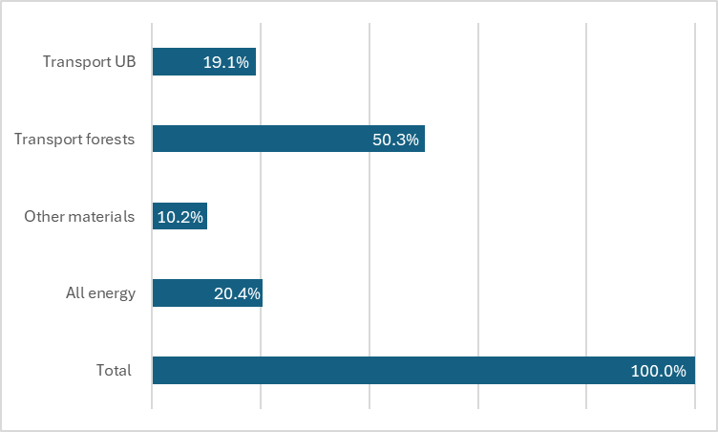
Figure 3.1: Intermediate Goods And Services Breakdown, 2025, Mongolia
Accordingly, Figure 3.1 includes only those external input categories for which reliable field data were available and that genuinely link the pine nut chain to other sectors:
- Transport services, used by harvesters to move pine nuts from forest sites to wholesalers’ yards and by wholesalers to transport pine nuts to Ulaanbaatar;
- Energy inputs, used by processing companies (electricity, heat, fuel);
- Other external materials purchased by processors beyond pine nuts (e.g., packaging, consumables).
These categories constitute the core IGS components in this value chain. Because the pine nut sector relies heavily on own labour, simple tools, and internal commodity flows, its use of external intermediate inputs is limited, and the IGS structure is correspondingly narrow.

Overall Cost Structure of the Value Chain
While Figure 3.1 presents the limited set of external intermediate inputs, Figure 3.2 provides the full cost structure used for calculating value added at each stage of the chain. The table consolidates all cost categories for which verifiable field data were available.

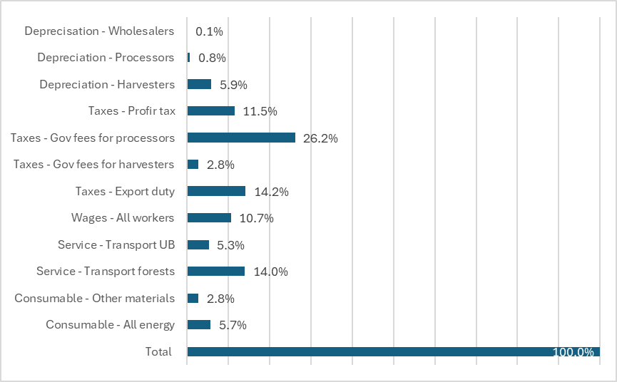
Figure 3.2: Cost Structure, 2025, Mongolia
Figure 3.2 includes:
- Intermediate Goods and Services (IGS) - the external inputs shown in Figure 3.1(transport, energy, other materials);
- Wages, mostly for seasonal workers employed by wholesalers and processors;
- Government taxes and fees, including profit tax, nature-use fees (domestic and industrial use permits), and export duties where applicable;
- Depreciation, covering basic tools at harvester level, trucks and simple machinery for wholesalers, and processing equipment and buildings for processors;
- Other operating costs, where reported.
Crucially, Figure 3.2 does not include the cost of purchased pine nuts. Pine nut purchases represent flows within the value chain - harvesters selling to wholesalers, wholesalers selling to processors - and AFA treats these as goods in process rather than external inputs. These internal flows are integrated later during the value-added calculation and consolidation steps, ensuring that costs and revenues are counted once and only once.
Field interviews indicate that some processing companies use bank loans to finance working capital or equipment purchases. However, because no consistent information on loan amounts, repayment terms, or interest rates was available, interest payments are not included in Figure 2.2.
The analysis shows that external inputs in the pine nut value chain are limited, consisting mainly of transport services and energy, with small amounts of other materials at processor level. Wages, taxes, and depreciation represent additional but modest costs. This forms the basis for examining indirect effects in the following section.

Direct and Indirect Effects of the Value Chain
Following VCA4D methodological guidelines, the contribution of the pine nut value chain to the national economy was assessed using input–output coefficients derived from Mongolia’s 2017 IO table at purchasers’ prices (Lenzen et al., 2012, Eora MRIO 2017). The analysis applies the standard decomposition of intermediate consumption into direct imports (IMP0), CIF import shares of supplying sectors (IMP1), and domestic value-added shares (VA1). These coefficients were matched to the specific intermediate consumption structure of the pine nut value chain, as shown in Table 3.6.
Table 3.6: Coefficients Of The Imports And Va Embedded In Intermediate Consumption (Used For The Effect Calculations)
Items  (AFA groups) | Description | IMP0  (Direct imports by VC actors | IMP1  (CIF import share) | VA1  (VA share in supplying sector)
Energy | Energy (electricity, heat, fuel) used by processors | 0.00 | 0.06 | 0.78
Packaging materials | Packaging and other external materials beyond nuts | 0.00 | 0.33 | 0.14
Transport | Domestic transport services (harvesters & wholesalers) | 0.00 | 0.18 | 0.20
Energy inputs include electricity and fuel used during processing and handling stages. Packaging materials represent external materials required for storage and export preparation. Transport services cover the movement of pine nuts from harvesting regions to wholesale markets and processing facilities.
The coefficients indicate that most intermediate consumption used by the pine nut value chain is generated domestically. Energy inputs show a high domestic value-added component (VA1 = 0.78), while packaging materials contain a moderate imported share (IMP1 = 0.33). Transport services, although locally provided, embody some imported inputs through upstream sectors (IMP1 = 0.18). Overall, the pine nut value chain relies only marginally on imported intermediate goods and services.
The resulting effects are summarised in Table 3.7. As is typical for natural-resource-based value chains assessed under the VCA4D framework, direct value-added accounts for the overwhelming share of total VA, reflecting the labour-driven nature of harvesting and the limited use of industrial upstream inputs. Indirect effects arise mainly through domestic service sectors such as transport and energy supply.
Table 3.7: Vc Direct And Indirect Effects (Million Mnt)
 | Direct effects | Indirect effects | Total effects
 | Million MMT
Imports | 0.00 | 5,623.42 | 5,623.42
IC not disaggregated | 0.00 | 5,075.26 | 5,075.26
Value added
Wages | 14,149.32 | 3,165.97 | 17,315.29
Taxes | 65,630.36 | 0.00 | 65,630.36
Subsidy | 0.00 | 0.00 | 0.00
Tax (+) Sub -) | 65,630.36 | 0.00 | 65,630.36
Interest of loan | 0.00 | 0.00 | 0.00
Depreciation | 7,789.26 | 0.00 | 7,789.26
Net Operating Profit | 362,426.54 | 0.00 | 362,426.54
VA not disaggregated | 0.00 | 2,205.58 | 2,205.58
VA Total | 449,995.48 | 10,446.81 | 460,442.29
Total direct value added amounts to 449,995 million MNT, while indirect value added generated through upstream sectors reaches 10,447 million MNT. Combined, this yields approximately 460,442 million MNT of total value added generated by the pine nut value chain.
Indirect effects represent only a small share of total value added, accounting for roughly 2–3% of the total. These indirect effects arise mainly from wages generated in supporting sectors such as transport and energy supply, as well as a smaller share of non-disaggregated value added in upstream activities.
Net operating profit constitutes the largest share of direct value added, followed by taxes and wages.

Macroeconomic Contribution
A broader assessment of macroeconomic indicators is presented in Table 3.8. These indicators position the pine nut VC within the national economy and highlight several important features.
First, the VC contributes 0.6% to national GDP, and a notable 7.8% of agricultural and forestry GDP, indicating a meaningful role within the broader rural economy despite the niche nature of the product.
Second, the VC demonstrates very strong domestic integration, with 95.3% of the total value of production retained within Mongolia. This high integration rate is characteristic of value chains dominated by domestic labour, locally provided services, and short processing stages.
Third, the VC delivers clear benefits to public finances, generating 65.6 billion MNT in net tax contributions, while imposing no fiscal cost through subsidies or transfers.
Finally, the VC makes a positive contribution to the national balance of trade, with a 67.7 billion MNT trade surplus, reflecting the export-oriented nature of pine nut processing and marketing.
Table 3.8: Vc Macroeconomic Indicators And References. Source: Afa Analysis And National Statistics Office Of Mongolia
Macroeconomic indicator % |  |  | Reference item, Million MMT
VA Total / GDP | 0.6 |  | Agriculture & forestry GDP | 5,881,104
VA Total / VC output | 95.3 |  | Gross disposal income | 73,039,024
VA Total / Agr & For GDP | 7.8 |  | GDP | 80,663,051
VC Imports / Total imports | 0.0 |  | National export | 53,505,658
VC Export/Total Export | 0.1 |  | National import | 39,373,697
VC Trade Balance/ National Imports | 0.2 |  | State budget (expenditure) | 30,591,084
VC Total Net transfers / State Budget | 0.2 |  | Wages | 23,953,495
VC Total Wages/National Wages | 0.1 |  | Total VC output | 482,986
VC Total Disposal Income / N. Income | 0.5 |  | VC export | 75,184
 |  |  | VC trade balance | 67,662

Overall, the pine nut VC shows a strong economic footprint relative to its size, with high retention of value, positive fiscal gains, and export earnings that support rural disposable income.
The distribution of total value added across VC actors is presented in Figure 3.3. As commonly observed in wild-harvested forest product value chains, harvesters capture the majority of VA, reflecting their central role and the high share of labour in total costs. Downstream actors (wholesalers and processors) account for smaller proportions, consistent with the limited degree of capital-intensive transformation in the pine nut sector.
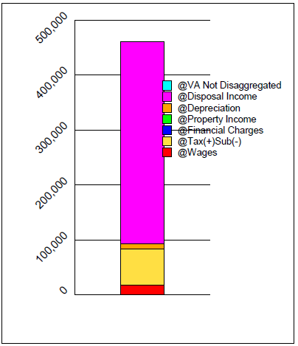
Figure 3.3: Total Value-Added Distribution, Million Mnt
This distribution underscores the importance of pine nut harvesting for rural household livelihoods, particularly in forested aimags where few alternative income sources exist.

Competitiveness and Viability within the International Economy
This section evaluates the international competitiveness of Mongolia’s pine nut value chain using two complementary approaches: (i) international price benchmarking through ITC export and import data, and (ii) assessment of free-trade competitiveness through the AFA parity-price analysis. Together, these provide a comprehensive view of both cost competitiveness and value capture in global markets.

International Benchmarking Using ITC Export Unit Values
ITC export unit values (ITC Trademap 2025) provide a standardized basis for comparing Mongolia’s position against major global suppliers. While these unit values are customs-reported averages rather than contract-level prices, they offer an important indication of relative price positioning in world markets. The available dataset shows that Mongolia exports at the lowest average unit value among the main global suppliers:
- Italy: ~USD 43.6/kg
- Türkiye: ~USD 39.2/kg
- Germany: ~USD 26.4/kg
- China: ~USD 25.2/kg
- Russian Federation: ~USD 21.4/kg
- Mongolia: ~USD 12.6/kg
It is important to note that the ITC export unit value for Mongolia (USD 12.6/kg) appears lower than the FOB prices reported by processors in Section 1.4.4 (USD 15–21/kg for bulk kernels and up to USD 23–34/kg for certified or premium products). This discrepancy is expected and arises from the nature of customs-reported data. First, more than 90 percent of Mongolia’s pine nut exports are bulk kernels sold to China, which consistently pays the lowest international prices and therefore pulls down the average unit value. Second, ITC unit values reflect customs declarations, which may include mixed consignments or shipments recorded at lower stated values. Third, processor-reported FOB prices refer to commercially negotiated lots with quality differentiation, whereas ITC unit values are aggregated averages that smooth these differences. For these reasons, ITC prices are used only as an international benchmark, while domestic value capture analysis relies on the field-based FOB prices presented in Section 1.4.4.
This indicates that Mongolia currently competes in the lower commodity-grade segment of the international market.

Import Market Prices (Mirror Data)
While export unit values indicate Mongolia’s relative market position among suppliers, import prices offer insight into what downstream markets are willing to pay for pine nuts of different qualities.
Mirror data from importing countries typically show higher prices than exporter-side unit values because they include freight, insurance, intermediary margins, and quality premiums. These data reflect the willingness-to-pay in high-value markets. Indicative import price ranges include:
- EU: 28–36 USD/kg
- USA: 26–34 USD/kg
- Japan: 30–40 USD/kg
- Korea: 25–33 USD/kg
These price levels illustrate that premium markets pay significantly more than what Mongolia currently receives, confirming the potential for upgrading especially through traceability, certification, and direct market access.

Competitiveness Based on AFA Parity-Price Analysis
The AFA viability analysis evaluates competitiveness under free-trade conditions. Key indicators include:
- Domestic Resource Cost (DRC): 0.04
- Nominal Protection Coefficient (NPC): 1.00
- Effective Protection Coefficient (EPC): 1.00
- Divergence between market and parity prices: 0
- Equivalent producer subsidy/tax: –0.14
The parity-price results clearly demonstrate that the pine nut value chain is structurally competitive in international markets. The exceptionally low Domestic Resource Cost ratio (DRC = 0.04) indicates that domestic production factors (labour, capital, and natural resource access) represent only a small fraction of the foreign exchange generated, confirming a very strong comparative advantage. This competitiveness is not dependent on policy protection, as shown by the Nominal and Effective Protection Coefficients (NPC and EPC both equal to 1.00), which signal that domestic prices align closely with international equivalents and that the sector receives neither protective tariffs nor subsidies. Moreover, profitability increases when assessed at parity prices, demonstrating that the value chain performs well under free-trade conditions. The analysis does show a modest negative producer subsidy, which reflects forest-use–related payments (including nature-use fees and auction-based access costs for PFEs) rather than taxes on operational performance. However, these fiscal obligations do not materially affect the sector’s overall competitiveness. Taken together, the indicators confirm that Mongolia’s pine nut value chain is inherently efficient and internationally competitive at the production level.

Conclusions on Competitiveness and Market Position
Taken together, the evidence shows that Mongolia is highly cost-competitive and enjoys a strong comparative advantage, with no policy distortions affecting competitiveness. Yet it captures the lowest prices among major global exporters. This underperformance in value capture arises not from production inefficiency but from structural factors, including dependence on Chinese buyers as intermediaries; limited domestic processing and quality differentiation; weak grading, sorting, or certification systems; minimal branding or origin-based marketing; and insufficient direct engagement with premium markets.
Premium import markets typically pay at least twice the unit values currently realised in Mongolia, underscoring the potential for increased value capture where quality upgrading, certification, processing capacity, and direct market access can be strengthened.

Comparison of Sub-chains
Although earlier sections distinguish three regional pine nut sub-chains and formal versus informal flows, these differences relate primarily to forest distribution, accessibility, and governance arrangements. They do not constitute distinct economic sub–value chains in terms of product transformation, cost structure, or market pathways. For this reason, no comparative sub–value chain analysis is included in the competitiveness chapter.

Answer to the Framing Question 1
The table below summarises the primary outcomes derived from the economic and financial analysis undertaken for the Mongolian pine nut value chain. All main actor groups in the Mongolian pine nut value chain operate profitably, with particularly high margins for processors and strong seasonal earnings for harvesters. Profitability is structurally linked to (i) access to raw materials, (ii) degree of formalisation, and (iii) position along the chain.
Summary table of indicators for framing question 1: What is the contribution of the VC to economic growth?
(See definitions of economic terms before the Executive Summary)
Framing Question 1: What is the contribution of the VC to economic growth? |  | INDICATORS |  | RESULTS
CQ1.1 | How profitable and sustainable are the VC activities for the entities involved? | Operating Accounts of every type of actor |  | See tables in the text (Table 2.1, Table 2.2, Table 2.3Table 2.4, Table 2.5)
CQ1.1 |  | Net operating profit by type of actor |  | Formal harvesters:  49,418–63,118 million MNT  Informal harvesters  3,539–58,028 million MNT  Formal wholesalers:  2,098–6,784 million MNT  Informal wholesalers  492–9,367 million MNT  High-end processors  29,321 million MNT  Bulk exporters:  105,973 million MNT
CQ1.1 |  | Return on turnover (operating profit/production) |  | Harvesters:  70–90%  Wholesalers:  9–12% for formal operators; up to 26% for informal ones  Processors  23% (high-end) and  30% (bulk exporters)
CQ1.1 |  | Benchmarks for farmers’ net income (minimum wage, livelihood needs, job opportunities…) |  | Individual harvesters earn 220,000–297,000 MNT/day, far above the 2024 national benchmarks:  Minimum wage equivalent: 38,000 MNT/day  Rural casual labour: 38,000–45,000 MNT/day  Average wage equivalent: 130,000 MNT/day
CQ1.2 | What is the contribution of the VC to the GDP? | Value of final VC production |  | 482,986 million MNT
CQ1.2 | What is the contribution of the VC to the GDP? | Direct VA |  | 449,995 million MNT
CQ1.2 | What is the contribution of the VC to the GDP? | Total VA |  | 460,442 million MNT
CQ1.2 | What is the contribution of the VC to the GDP? | Total VA creation per stage |  | Harvesters: 48%  Wholesalers: 6%  Processors: 47%  See Table 2.1, Table 2.2, Table 2.3Table 2.4, Table 2.5
CQ1.2 | What is the contribution of the VC to the GDP? | Total VA and components: |  | Wages/salaries:  14,149 million MNT  Taxes on operations:  65,630 million MNT  Depreciation:  7,789 million MNT  Total Net Operating profit  362,427 million MNT  - Harvesters: 199,380 million MNT  - Wholesalers: 27,941 million MNT  - Processors: 135,106 million MNT  See Table 2.7
CQ1.2 | What is the contribution of the VC to the GDP? | Total VA in percentage of the GDP |  | 0.6% of national GDP
CQ1.2 | What is the contribution of the VC to the GDP? | Rate of integration into the Economy (total VA/VC production) |  | 95.3% of total VC output is retained domestically
CQ1.3 | What is the contribution of the VC to the agriculture sector GDP? | VC agricultural actors’ Value Added in percentage of the agriculture sector GDP |  | 7.8% of agriculture & forestry GDP
CQ1.4 | What is the contribution of the VC to the public finances? | Receipts of the government (taxes, etc.) |  | 65.6 billion MNT
CQ1.4 | What is the contribution of the VC to the public finances? | Outlays of the government (subsidies, etc.) |  | No subsidies reported
CQ1.4 | What is the contribution of the VC to the public finances? | Public Funds Balance |  | +65.6 billion MNT
CQ1.5 | What is the contribution of the VC to the balance of trade? | VC exports |  | 75.2 billion MNT
CQ1.5 | What is the contribution of the VC to the balance of trade? | VC total imports (goods and services) |  | ~0 billion MNT (very low; mainly indirect imports via packaging/energy)
CQ1.5 | What is the contribution of the VC to the balance of trade? | Balance of trade of the VC |  | +67.7 billion MNT
CQ1.6 | Is the VC viable in the international economy? |  | Nominal Protection Coefficient (NPC) |  | 1.00
CQ1.6 |  |  | Domestic Resource Cost Ratio (DRC) |  | 0.04

IS THIS ECONOMIC GROWTH INCLUSIVE?

Participation in Value Chain Governance
The VC operates within a governance structure described in section 2.6, dominated by central, in particular the MECC, and a small number of processors. Central government has designed and oversees the setting of quotas at soum level, a system which as practiced is in conflict with several laws. The registered and active processors, limited by high entry costs in terms of investment in machinery and registration as PFEs, largely set prices (within limits set by Chinese and world prices). Local government institutions operate within this system, with interests both in sustaining the forest environment and in generating revenue for soum governments, as do harvesters and wholesalers. Harvesters, as set out below, gain a seasonal income which is very important for their livelihoods, but cannot be said to participate in the governance of the VC. The one mechanism by which ordinary rural citizens could participate in value chain governance, the FUGs, has been sidelined in the operation of the VC.

Income and Employment

Distribution of Profit and Value-Added
The distribution of net operating profit across the pine nut value chain reveals clear geographical and functional asymmetries, shaped primarily by the location and extent of Siberian pine forests, as well as differences in actor registration status and access to within-quota and above-quota trade channels. Total net operating profit generated by the chain amounts to MNT 362.4 billion, with notable variation across actor groups (Table 4.1; Figure 4.1).
Table 4.1: Net Operating Profit Per Actor, Mongolia 2025
Actor | Net Operating Profit,
Actor | Million MNT | Share, %
Khentii region registered harvesters | 49,418 | 13.6 %
Khentii region unregistered harvesters | 58,028 | 16.0 %
Khövsgöl region registered harvesters | 63,118 | 17.4 %
Khövsgöl region unregistered harvesters | 8,303 | 2.3 %
Khangai region registered harvesters | 17,252 | 4.8 %
Khangai region unregistered harvesters | 3,539 | 1.0 %
Khentii region registered wholesalers | 5,625 | 1.6 %
Khentii region unregistered wholesalers | 9,366 | 2.6 %
Khövsgöl region registered wholesalers | 6,784 | 1.9 %
Khövsgöl region unregistered wholesalers | 3,614 | 1.0 %
Khangai region registered wholesalers | 2,098 | 0.6 %
Khangai region unregistered wholesalers | 491 | 0.1 %
High-end processors (Ulaanbaatar) | 44,786 | 12.4 %
Bulk export processors (Ulaanbaatar) | 90,005 | 24.8 %
TOTAL | 362,427 | 100 .0 %

Registered and unregistered harvesters collectively capture a significant share of total profits. Registered harvesters in Khentii capture 14% of total profit and those in Khövsgöl 17%, while unregistered harvesters in Khentii capture 16% and those in Khövsgöl 2%. In contrast, the Khangai Mountains, where Siberian pine forests are far less extensive, generate only 5% of registered harvester profits and 1% of unregistered harvester profits. These differences reflect variations in forest area and market engagement. Overall, registered harvesters capture 36% of profits, and unregistered harvesters 19%.
Registered and unregistered wholesalers capture only a small share of total profit, together accounting for less than 8%. These thin margins reflect their primarily transactional role in aggregation, transport, and short-term intermediation rather than value creation. Downstream processing emerges as the most profitable segment of the value chain. Bulk export processors in Ulaanbaatar capture 25% of total net operating profit, while high-end processors capture 12%. Together, processors absorb over one-third of total profits, underscoring the strategic importance of processing capacity, quality control, and export channels. (Figure 4.1).

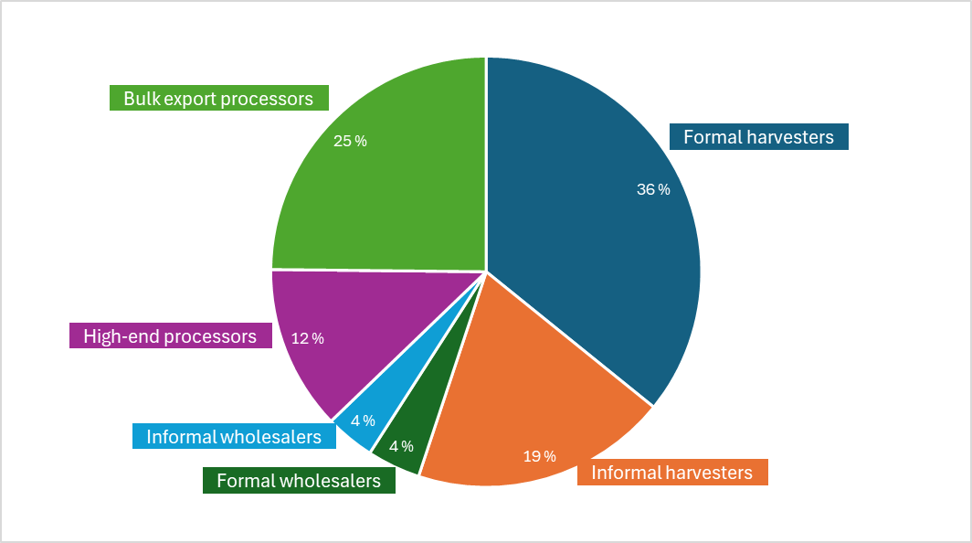
Figure 4.1: Net Operating Profit Distribution Across Formal And Informal Value Chain Actors
Figure 4.2 illustrates the regional dimension of this pattern. The regions with the largest Siberian pine forest areas - Khentii and Khövsgöl - also account for the highest shares of harvesting-related profits. This reflects the straightforward spatial reality that most of Mongolia’s commercially harvestable pine nut stands are in these two regions, allowing higher collection volumes and more regular participation in the market.
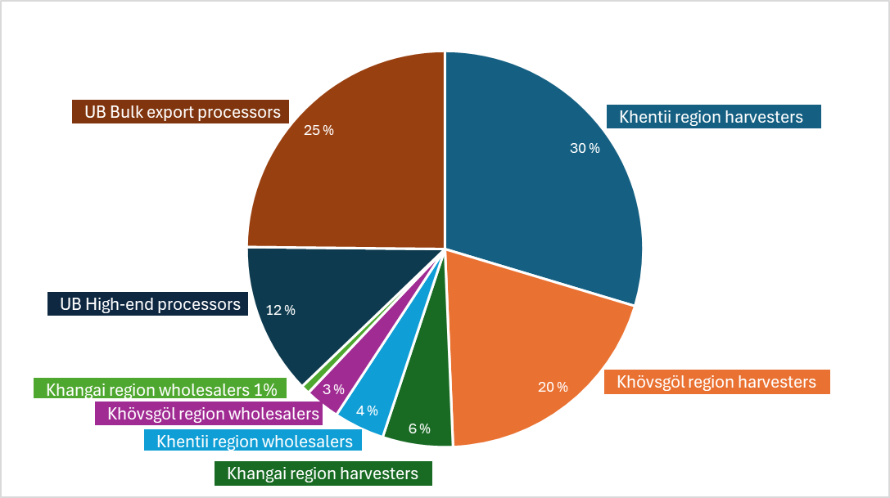
Figure 4.2: Net Operating Profit Distribution Across Regions
The geographic distribution of value creation is presented in Table 4.2 and visualised in Figure 4.3, which shows that Ulaanbaatar accounts for 47% of total value added due to its concentration of processing and export functions. The two regions with extensive pine forests - Khentii (29%), and Khövsgöl (19%) - together generate 48% of national value added, reflecting the volume and labour intensity of harvesting. The Khangai Mountains contribute the remaining 5%, consistent with their smaller forest area.
Table 4.2: Value Added By Regions
Region | Value Added
Region | Million MNT | Share, %
Khentii Mountains | 129,298 | 29 %
Khövsgöl Mountains | 85,266 | 19 %
Khangai Mountains | 24,104 | 5 %
Ulaanbaatar | 211,329 | 47 %
TOTAL | 449,995 | 100 %

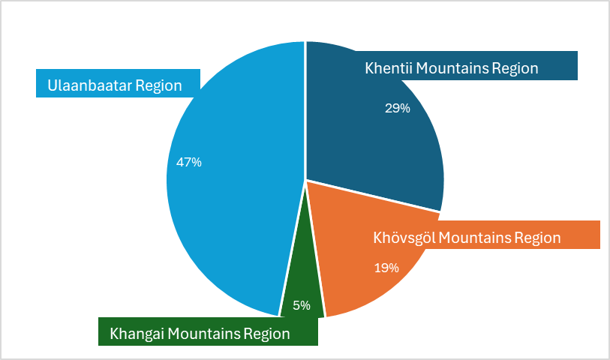
Figure 4.3: Value Added Shares Across Regions
Overall, the pine nut value chain is characterised by an upstream profit structure that closely follows the distribution of Siberian pine forests, while harvesters capture only a modest share of total profits, as their returns remain constrained by limited bargaining power and strong dependence on buyers. The distinction between registered and unregistered harvesters used in this analysis reflects observed differences in behaviour rather than strict legal categories: some harvesters pay forest user fees, while most do not, and even those who do typically harvest commercially despite permissions allowing collection only for domestic use. As a result, paying user fees does not confer meaningful advantages in income or market access, and many harvesters operate in loosely organised informal groups of relatives or neighbours without gaining significant leverage.
In contrast, downstream processors - particularly bulk exporters - are better positioned to benefit from above-quota trade through lower purchase prices and reduced compliance costs. Processing therefore remains the main profit centre, with Ulaanbaatar-based firms capturing more than one-third of net operating profit, resulting in a clear spatial separation between the forest-rich regions where raw material income originates and Ulaanbaatar where most downstream value added accrues.
Figure 4.4 illustrates the distribution of the Net Operating profit across the actors in the pine nut value chain. The resulting Gini coefficient of 0.6 indicates a highly unequal distribution of profit capture, with a substantial concentration of value accruing to a small number of downstream processors, while thousands of upstream harvesters share a comparatively modest portion of total profits. This level of inequality is consistent with the structural features described above: geographically concentrated raw-material access, weak bargaining power among harvesters, and the high profitability of processing and export activities located primarily in Ulaanbaatar. The Gini coefficient therefore provides a concise quantitative expression of the asymmetries already evident in the spatial and functional breakdown of profit and value added.
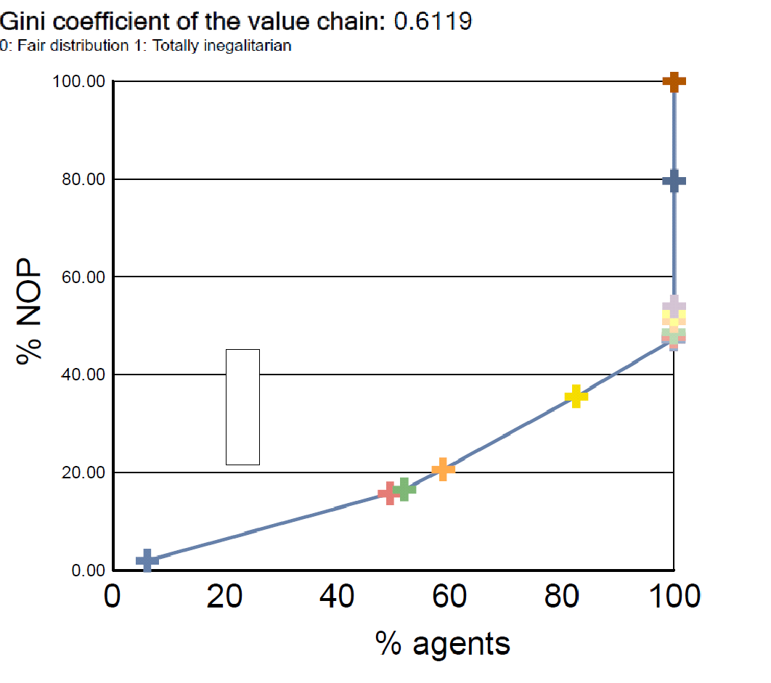
Figure 4.4: Distribution Of Net Operating Profit (Nop) By Agents (Actors)
The pine nut value chain (VC) is a highly labour-intensive seasonal system that generates substantial employment across Khentii Mountains, Khövsgöl Mountains and Khangai Mountains regions. Drawing on field data and AFA-model volume estimations, the pine nut value chain is estimated to engage approximately 70,000 people during the harvest period, including collectors, traders, and processing workers (Table 4.3). The overwhelming majority (nearly 99%) are temporary workers engaged for 10–90 days per year, reflecting the short harvesting window and lack of mechanisation. Only 560 workers are employed on a permanent basis, mainly in processing enterprises.
Table 4.3: Employment By Value Chain Activity, Gender And Employment Type
Actor | Number of employed thousands |  |  | Share by gender
Actor | Total | Temporary | Permanent | Male | Female
Khentii Mountains – registered harvesters | 12 | 12 | 0 | 70-80% | 20-30%
Khentii Mountains – unregistered harvesters | 28 | 28 | 0 | 70-80% | 20-30%
Khövsgöl Mountains – registered harvesters | 16 | 16 | 0 | 70-80% | 20-30%
Khövsgöl Mountains – registered harvesters | 4 | 4 | 0 | 70-80% | 20-30%
Khangai Mountains – registered harvesters | 5 | 5 | 0 | 70-80% | 20-30%
Khangai Mountains – unregistered harvesters | 2 | 2 | 0 | 70-80% | 20-30%
Khentii Mountains – registered wholesalers | 0.4 | 0.4 | 0 | 70-80% | 20-30%
Khentii Mountains – unregistered wholesalers | 0.7 | 0.7 | 0 | 70-80% | 20-30%
Khövsgöl Mountains – registered wholesalers | 0.6 | 0.6 | 0 | 70-80% | 20-30%
Khövsgöl Mountains – registered wholesalers | 0.1 | 0.1 | 0 | 70-80% | 20-30%
Khangai Mountains – registered wholesalers | 0.2 | 0.2 | 0 | 70-80% | 20-30%
Khangai Mountains – unregistered wholesalers | 0.04 | 0,04 | 0 | 70-80% | 20-30%
High-end processors | 0.2 | 0 | 0.2 | 50-60% | 40-50%
Bulk export processors | 0.4 | 0 | 0.4 | 50-60% | 40-50%
TOTAL | 69 | 68 | 0.6 | ~70% | ~30%

Harvesting is by far the dominant source of employment, accounting for over 90% of all labour inputs. Participation is particularly high in regions with extensive forest access such as Khentii and Khövsgöl Mountain regions. This distribution is illustrated in Figure 4.5, which shows the strong concentration of labour demand in the harvesting stage of the VC. The relative share of wholesalers and processors is small in comparison, but these actors play an important role in providing more stable year-round jobs.
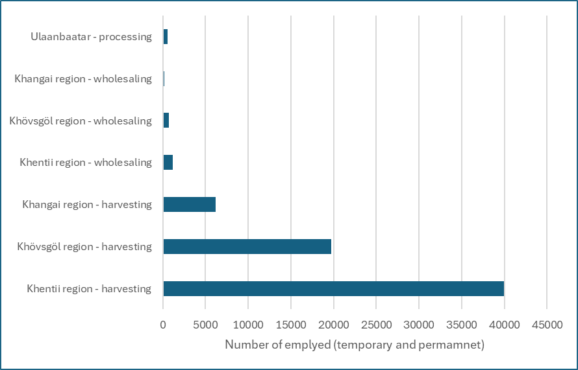
Figure 4.5: Total Employment By Value Chain Function And Region
Across the value chain, an estimated 70–75% of workers (including harvesters) are men, while 25–30% are women, based on field observations and stakeholder interviews. The gender imbalance is most visible in the harvesting stage, where men tend to dominate such tasks as travelling long distances to remote harvest sites and using wooden hammers to knock down cones. However, women also participate in harvesting, particularly in collecting cones from the ground.
In wholesaling, gender patterns follow the harvesting structure, with men representing the majority, although women are involved in sorting and handling, and in cooking and cleaning in larger enterprises. By contrast, processing plants report that roughly half of their permanent staff are women, reflecting the more stable nature of processing jobs.
This distribution is illustrated in Figure 4.6, which presents the male–female composition across harvesting, wholesaling and processing in the pine nut value chain.
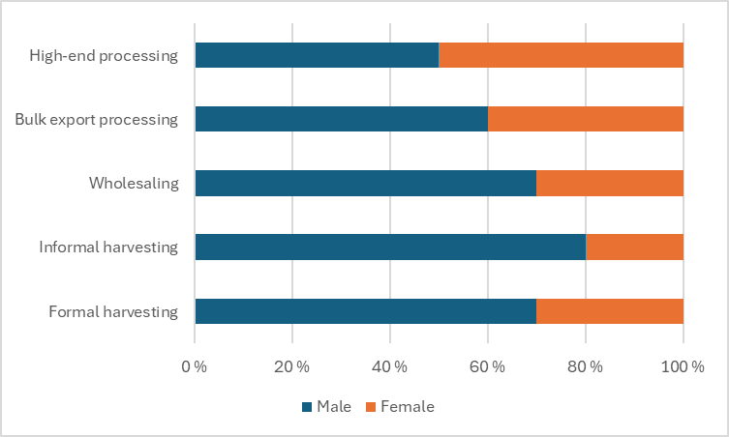
Figure 4.6: Gender Distribution Of Employment Across Value Chain Functions (Male/Female %)
Earnings in the pine nut VC vary widely by region and actor category. For harvesters, income is based on the volume of nuts collected rather than wages and thus represents net seasonal profit rather than remuneration for labour. Converting these seasonal incomes into daily equivalents (based on field estimates of labour days per season) shows decent returns to labour - consistently above rural casual labour benchmarks (Table 4.4; Table 4.5)
Table 4.4: Worker Income, Labour Days, And Estimated Daily Earnings
Actor | Wages /  worker income | Time equivalent | Daily earning
Actor | Million MNT | Days | MNT
Khentii Mountains – registered harvesters | 49,418 | 173,050 | 286,000
Khentii Mountains – unregistered harvesters | 58,028 | 284,450 | 204,000
Khövsgöl Mountains – registered harvesters | 63,118 | 234,350 | 269,000
Khövsgöl Mountains – registered harvesters | 8,303 | 40,700 | 204,000
Khangai Mountains – registered harvesters | 17,252 | 68,100 | 253,000
Khangai Mountains – unregistered harvesters | 3,539 | 16,850 | 210,000
Wholesalers (registered / unregistered | 17 - 284 | 168 - 2,850 | 100,000
High-end processors | 8,758 | 51,450 | 170,000
Bulk export processors | 4,577 | 45,500 | 101,000
TOTAL | 213,807 | 922,623
Weighted average |  |  | 232,000
A comparison with national wage benchmarks highlights the significance of pine nut income for rural households (Table 4.5).
Table 4.5: Benchmarks Of Wages In Mongolia
Benchmark (2024) | Renumeration per month | Daily equivalent | Source
Benchmark (2024) | MNT |  | Source
Minimum wage | 792,000 | 38,000 | Ministry of Family, Labour and Social Protection homepage Oct 2024
Average wage | 2,672,000 | 130,000 | National Statistics Office (NSO) Mongolia, 2024 Q4
Typical rural casual labour | 792,000 – 945,000 | 38,000 – 45,000 | VCA4D cashmere study in Mongolia 2024

Daily incomes for pine nut harvesters in all regions (204,000–286,000 MNT/day) are 2–7 times higher than standard rural casual labour, underscoring the importance of pine nut harvesting as a high-value livelihood opportunity, particularly for poorer households. This contrast is visualised in Figure 4.7, which compares pine nut daily earnings to national average and minimum wage benchmarks. This income is seasonal, but for herders, conveniently counter-seasonal with cashmere sales in spring and livestock sales in late autumn.
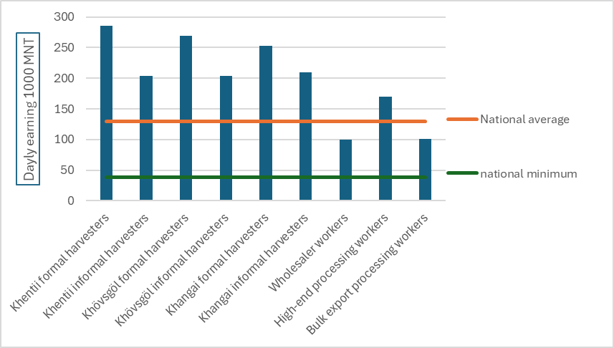
Figure 4.7: Daily Earnings Comparison: Pine Nut Vc Vs. National Wage Benchmarks
Although the pine nut value chain generates substantial employment, an estimated 99% of all jobs are temporary, reflecting the strongly seasonal nature of pine nut harvesting, trading and processing. Most workers are engaged for only 10–90 days per year, and very few operators offer written contracts, social protection or predictable annual income.
Figure 4.8 illustrates this imbalance using two pie charts: one showing the number of workers, and the other showing the distribution of total labour days. While temporary harvesters dominate in absolute numbers (about 96% of all workers), their share of total labour time is smaller (around 89%) because permanent processing workers - although representing only about 1% of the workforce - contribute roughly 11% of total annual labour days. This reflects the fact that some processing facilities operate longer seasons and rely on a more stable, often gender-balanced workforce.
This distinction is important: the value chain creates widespread and valuable but short-term and low-security employment for harvesters and traders, while only a small core of processing workers enjoys more regular and sustained employment. Any policy or investment aiming to strengthen rural incomes or promote decent work must therefore consider both the overwhelming prevalence of temporary jobs and the small but significant role of permanent processing employment.
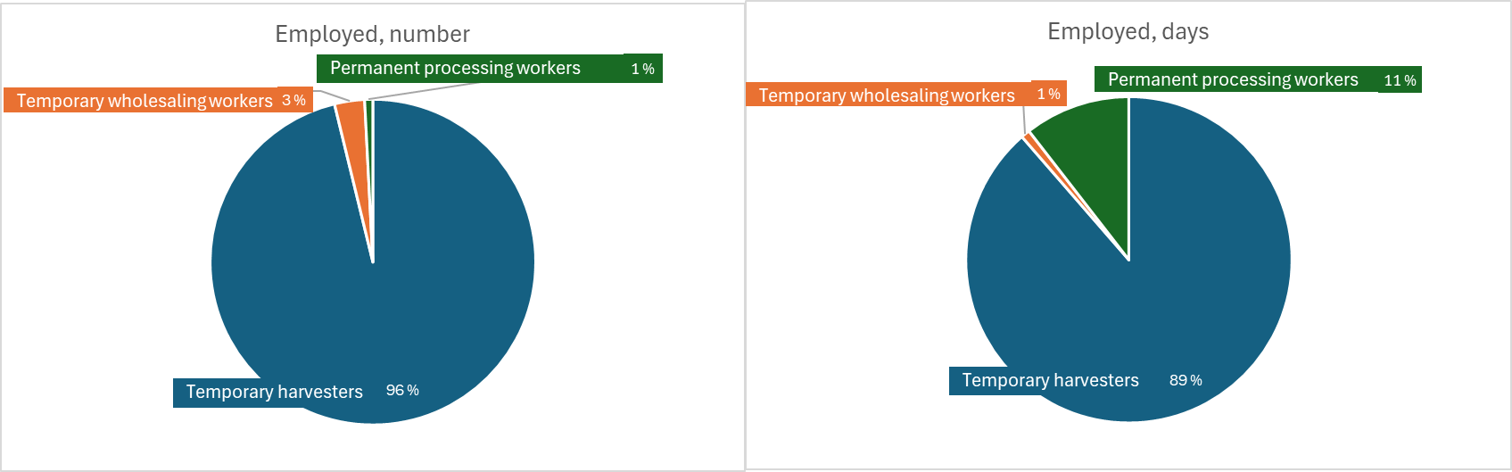
Figure 4.8: Employment Type Breakdown: Temporary Vs. Permanent (Number Of Employed / Days Employed)

Answer to the Framing Question 2
The table below summarises the primary outcomes derived from the inclusivity of economic growth analysis undertaken for the Mongolian pine nut value chain. The pine nut value chain generates substantial income and employment for rural households across Khentii Mountain, Khövsgöl Mountain, and Khangai Mountains regions, but the distribution of that income is uneven, with a clear concentration of profits among downstream processors and limited stability or protection for the majority of workers. The analysis below synthesizes the inclusiveness dimensions of the VC drawing on the economic results presented in Section 3.
Summary table of indicators for framing question 2: Is this economic growth inclusive?
(See definitions of economic terms before the Executive Summary)
Framing Question 2: Is this economic growth inclusive?  (To be completed with Social Analysis results) |  | INDICATORS | RESULTS
CQ2.1 | How is income distributed across actors of the VC? | Disaggregated Value Added | Total VA = 449,995 million MNT, of which:  - Harvesters: ~48%  - Wholesalers: ~6%  (Khentii + Khövsgöl + Khangai regions)  - Processors: 47%  (Ulaanbaatar)
CQ2.1 | How is income distributed across actors of the VC? | Total harvester income | - ≈200 billion MNT >50% of total operating profits (formal + informal combined)
CQ2.1 | How is income distributed across actors of the VC? | Wages and salaries (at every stage, all activities) | - ≈ 14.1 billion MNT (mainly wholesalers and processors; harvesters receive income as profit, not wages) - See Table 3.4
CQ2.1 | How is income distributed across actors of the VC? | Total income accruing to marginalized and vulnerable groups | - About 25–30% of workers are women, though concentrated in lower-paid activities (sorting, cleaning, processing).  - Harvesting represents over 90% of all jobs and is dominated by rural households reliant on seasonal cash flows
CQ2.2 | What is the impact of the governance systems on income distribution? | Income distribution among actors | - Structurally unequal distribution of total profit, with processors capturing 37% of NOP.  - However, because thousands of harvesters share the remaining upstream profit, the aggregate share appears modest despite high individual daily earnings. Profit inequality therefore reflects actor concentration rather than poor revenue generation at the harvesting level.
CQ2.2 |  | Share of harvester’s price in the final price (%) | - 40-50% of the final selling price of unshelled pine nuts
CQ2.3 | How is employment distributed across the VC? | Number of jobs (family, self- and formal employment) at different VC stages (permanent/ temporary, skilled/unskilled…) | Total employment ≈ 70,000 workers, of which:  - Harvesters: ~65,000 persons  - Represent 95% of all workers  - Work 10–90 days, totalling roughly 800,000 labour-days per year  - Wholesalers: ~2,000 temporary workers  - Mostly short-term manual handling and sorting  - Contribute approximately 8,000 labour-days per year  - Processors: ~560 permanent workers  - Small but essential year-round workforce  - Account for roughly 100,000 labour-days per year  Permanent vs temporary employment  - 99% temporary, 1% permanent (mostly processors)
CQ2.3 | How is employment distributed across the VC? | Employment of women | - Women represent 25–30% of total workers (including harvesters)  - Female participation is higher in processing (≈50% of permanent staff)  - In harvesting they mainly participate in ground collection of nuts.

IS THE VALUE CHAIN SOCIALLY SUSTAINABLE?
This section sets out findings on the six-sub-domains of the VCA4D methodology for the social analysis: Working Conditions, Land & Water Rights, Gender Equality, Food & Nutrition Security, Living Conditions (these two combined for the purposes of the narrative report) and social capital. The findings are based largely on interviews with value chain actors carried out jointly with the economist and environmental specialist, combined with use of published national statistics and some reference to academic literature. Because of timing, and logistical constraints to access harvesting sites while harvesters were there, the interviews with harvesters were relatively few and short.
Following findings on each sub-domain, a summary table visualizes results, evaluating social sustainability in aspects of the sub-domain in terms of High, Substantial, and Moderate/Low.

Working conditions
This sub-section will briefly review the overall framework for working conditions and employment rights in Mongolia, and then discuss the topic in relation to a) harvesters, b) the largely informal employees of wholesalers and c) the small number of mainly formal employees of processing companies. For categories b) and c) we did not have the opportunity to independently interview employees, but we have reasonable confidence in our findings, which are generally positive.

The national framework for working conditions
Mongolia is a signatory to the 8 fundamental ILO Conventions, having ratified them at various points between 1969 and 2005, and ratified the ICESCR and the ICCPR in 1974. Recent reports of the ILO Committee of Experts on the Application of Conventions and Recommendations (Committee of Experts on the Application of Conventions and Recommendations (CEACR), 2025, 2022, 2022, 2020) show a range of concerns about application of the conventions, with none directly related to the pine nut value chain. The major relevant concern noted in the 2020 report, and reiterated in 2023, was over delayed implementation of the Minimum Age Convention, especially as regards linking minimum age of employment to age for compulsory schooling and regulation of “light work”. From the 2023 Mongolia Social Indicators sample Survey Key Indicators Report (NSO (National Statistical Office), 2023) the national rate of children 5-17 involved in child labour above age-specific legal thresholds in 11.7% nationally and 22.5% for rural areas. This is discussed more fully below.
The new Labour Law passed in 2021, in force from January 2022, specifies that all employees should have a written contract stating as a minimum their job title, salary and location, but also specifies that all employment relations are governed by the law, whether the contract is written or not. The ILO CEACR report notes “with satisfaction” that the 2021 labour law “defines and prohibits both direct and indirect discrimination” on widely-defined grounds including gender, except where justified by the “inherent requirements of the work or duty performed and special protective measures”, decrees equal remuneration of the genders for equal work, with salary deemed to include allowances and bonuses, and defines and prohibits sexual harassment and sets out processes to prevent it. The report notes that the Labour Law in this regard is stronger and clearer than the Law on the Promotion of Gender Equality of 2011.

Working conditions and attitudes to work among harvesters
Harvesters are essentially self-employed and generally have no obligation to sell what they collect to any particular harvester. However, harvesters travel together to collection sites, in some cases making payments to a vehicle-owner or group leader, share some of the tasks around collection such as crushing cones, and in some cases are under informal or formal obligations to sell to a particular wholesaler as a group.
The proportion of harvesters who are women varies greatly between regions and in some cases between years, and informants’ accounts may differ even within a single location. We were told that women made up 50% or slightly less of harvesters in locations in Övörkhangai Aimag and the western part of Selenge Aimag. In such areas it is an established custom for both husband and wife to go harvesting – it may be the case, but not necessarily, that the husband uses the hammer while the wife collects from the ground. In Arkhangai (a location where harvesting sites were remote from the settlements) only a few women were reported to harvest. In Khövsgöl Aimag as a whole the proportion was estimated to be 30% women, but growing. In Eastern Selenge, estimates were lower, between 10 and 30%, though one interviewee recalled that in 2022, a year when there were a lot of fallen cones available for harvesting, the proportion of women harvesters had risen to 70%. We can assume that women are less likely to go when harvesting sites are remote from any settlement, and where the harvesting conditions or time of harvest favour the use of the hammer.
As harvesting is a highly seasonal occupation, harvesters may be herders, residents of small towns (referred to here as soum centres), or of larger towns or Ulaanbaatar. This distinction is important, as soum centres host numbers of people with precarious employment, and are also characterised by high levels of debt. Debt has been a major issue for ordinary Mongolians since the downturn in mineral exports in the mid-2010s (Empson, 2020) and is especially serious in small urban areas (Waters, 2023) where juggling debts from a variety of formal and informal sources, “debt stacking” or “repairing the front seam with the back seam” is a way of life for many. Without denying that herders are also subject to debt pressures, the particular design of the herder loans that cashmere-producing households can access, makes those pressures lighter for at least some herder households (Morton et al., 2024; Murphy, 2018; Waters, 2023). This is further explored in 5.4 below.
This issue was not systematically researched in all locations, and it is likely that soum centre residents account for at least some proportion of harvesters across all pine nut areas. However, in several locations in Selenge aimag we were told that soum centre residents made up half or “almost all” of the harvesters, or that 70% were non-herders. Many of these travel significant distances from their homes, across aimag boundaries, to harvest.
It is also the case that students, middle class people and other residents of larger towns may travel to pine nut areas to join the harvest, to supplement income, but also as it is regarded as a pleasurable activity. We were also told that there was concern that construction workers were leaving their jobs during the pine nut season to go harvesting.
Harvesters take possession of what they harvest, but associate in informal groups. Whether these groups are primarily for company in the forest, or share significant costs, depends primarily on the distance between their homes and the harvesting sites. In the Khangai mountains it appears to be more of the case that each harvester (or harvesting couple) is independent, using private cars, motorcycles or horses to reach the harvesting sites (one informant specifically said there was no renting of vehicles), while those harvesting in Khan-Khentii form more organised groups, either on a mutual cost-sharing basis, or around an individual who owns a Russian truck capable of driving into the forest. One former harvester spoke of harvesters giving 50% of profits to the truck owner, but his own group had divided all profits equally. One truck owner owns three trucks, and charges harvesters MNT 40,000 per head and 40,000 per sack of unshelled nuts harvested. His lorries make more than one hundred journeys into the forest each harvesting season.
Where harvesting distances are small and harvesters travel independently to the forests, they appear to have a fairly free choice of which harvester to sell to. In Övörkhangai it was clear that this was the case, and harvesters were switching between wholesalers as prices fluctuated. Where distances are greater, there are more likely to be informal obligations to sell to a particular wholesaler, either because they give advances to harvesters (sums of MNT 10-15 million were mentioned), or because they are associated with a truck owner or group leader: the wholesaler wife of the truck owner mentioned above said she would “punch any harvester who sold to another wholesaler!”.
Attitudes to the work of harvesting vary. Two women harvesters interviewed in the same location in Övörkhangai had different responses – one said simply, with feeling, that the work was “hard”, while the other explained at length that she enjoyed the work and being in the forest, that it benefitted her health, that she also took the opportunity to harvest herbs and mushrooms, and had become healthier over the seven years she had been harvesting, as she became closer to nature. A woman in eastern Selenge said it was nice and comfortable to be in the forest, especially when no hammers were used, as well as having the chance to earn money. These attitudes to work are not uncommon.
The income earned by harvesters is discussed in Sections 2 and 3. It is clear that for many harvesters, this income is an extremely valuable supplement to other earnings, as discussed more in 5.4 below, and whether or not the work itself is enjoyed, the activity is highly attractive to herding families and soum centre residents.
Most value chain stakeholders downplayed any possibility of child labour in harvesting. At a soum centre in Övörkhangai we were told that children could only be involved over the age of 16, with a very small number of younger children being involved, and then only at weekends, so not affecting their education. Other informants took the view that no children below the age of 18 were involved, unless there was no-one else to look after them. In contrast, FUG members in western Selenge said that children as young as 10 could go, for seven days at a time, but this was not a problem for education – despite the school term starting on September 1st, before the harvesting season, One woman harvester we met in Övörkhangai (on a Sunday) was accompanied by her daughters, possibly aged 16 and 10. It is worth noting that herders’ children are highly likely to be enrolled in boarding schools in soum centres, so if children are involved, they are more likely to be from soum centre families.
Harvesting may entail a variety of risks, during travel to harvesting sites and in the forests, especially in remote areas; risks of attack by brown bears and getting lost were mentioned. However, it is not generally perceived as a risky occupation by harvesters themselves or other value chain actors.

Working conditions among employees of wholesalers
We held seven interviews with wholesalers. Three, in Övörkhangai and Arkhangai, were highly informal in nature, and engaged in purchasing and crushing cones. One in Khövsgöl was a formal enterprise with multiple activities, including sale of building materials and formal-sector meat export (to Azerbaijan). In eastern Selenge, one was informal, one was formal in nature, mainly involved in purchasing unshelled nuts, and one was active both in purchasing and in processing (shelling nuts) – one of the few processors outside Ulaanbaatar. Across the informal-formal spectrum, wholesalers are also engaged in purchasing cashmere, livestock, meat and hides and skins. As cashmere is purchased in spring, and peak times for the other commodities are late autumn, pine nut purchasing is conveniently counter-seasonal for these enterprises.
The number of employees of wholesalers we interviewed varied between 5 and 40. Workers may be engaged for pine nut purchasing/processing only (for a period of 1.5 to 3 months), or kept on around the year for the other activities. The numbers of permanent employees are very small, and even for these, employment is informal, explained as “word of mouth contracts”, “employing family members” or “permanent means we trust each other”. Cone crushing work is done exclusively by men, with very small numbers of women employed as cooks and cleaners in the informal enterprises. In the more formal enterprises, the proportion of women is higher, 40-50% in Selenge and 70% in the Khövsgöl enterprise.
Across several enterprises MNT 100,000 per day was mentioned as the average remuneration: this is likely to apply to women as well as men in the more formal enterprises, it is less clear for the more informal. Bonuses and incentive payments were mentioned in some enterprises, in one case for working through the night, in one case where wholesaler employees were also expected to work as waged harvesters. The seasonal demands of pine nut harvests mean that work is seven days a week. This is substantially above the minimum wage, and the figure for typical rural casual labour reported by Morton et al. (Morton et al., 2024) (see Table 4.5).
We did not hear any evidence of formal staff associations in these enterprises. We saw no evidence of child labour, and one wholesaler expressed a preference for older workers.
Where harvesters bring cones rather than unshelled nuts to wholesalers, cone-crushing is done with large electrically powered crushing machines. As the machines are belt-driven, this gives rise to a health and safety concern. Of the three informal wholesalers we saw using such machines, only one had installed guards to prevent accidental contact with the belt-drive, which presented a significant safety risk. One of the informal wholesalers had installed guards and reported doing his own health and safety training. The wholesaler in Khövsgöl had prominently displayed posters on general health and safety, fire safety and kitchen safety, and also reported on carrying out wide-ranging health and safety training himself. The wholesaler/processor in Selenge employed a dedicated health and safety trainer, and also reported external inspections, including for fire risks in the factory.

Working conditions among employees of processors
Information on the small number of workers in processing factories was not easy to obtain but no causes for concern were identified. The largest factory visited had 70 permanent staff (50% female) and 30 temporary staff engaged for harvest and immediately after (all male). Another employed only 6 permanent staff and 70 temporary staff in a good year, but only 30 at the time of the interview. The balance here was 60-70% men. Men are more likely to seek for temporary work and tend to work on shelling, women on sorting and packing. As with other Mongolian formal enterprises, women were evident as part-owners, in middle management and in public-facing roles.
Average salary figures at the large factory for permanent staff were 3.5 million/month. Figures for temporary staff MNT 2.5 million/month at this factory, but MNT 120,000/day elsewhere – comparable to wages paid by wholesalers. There are some fringe benefits, such as food imported from China. These wages are comparable to benchmark national average wages (see Table 4.5).
Written contracts are issued to permanent workers and in at least some factories to temporary workers for six months. It was not easy to get a sense what rights these gave workers – one factory owner said he made no dismissals, another that he could move workers around other businesses he owned, and one that he could terminate workers when he liked – so that notice periods were irrelevant in each case.
In only one factory was there a staff association, described as being for “team capacity building” and playing little or no role in negotiation. There was no evidence of trade union activity.
Work in factories is prohibited by law for under-18-year-olds. Factory managers stated clearly that they did not employ workers under 18, and nothing we saw contradicted this. Two factories employed a permanent full-time worker on health and safety, who briefs workers daily.

Conclusion on Working Conditions
It is difficult to draw conclusions across three very different categories of workers: a large mass of self-employed harvesters, workers in very informal wholesaling enterprises, and workers in factories. Across all categories respect of labour rights can be judged as substantial (but not high). Child labour is not an issue in the wholesaling or processing enterprises, but there is some concern that children may be taken out of school to accompany parents harvesting, so this has also been rated substantial. Job safety appears high, but our evidence is limited, and the issue of lack of guards on belt-driven machines, while affecting a small number of workers, needs action. The attractiveness of working in factories and wholesale yards, compared to minimum wages and rural labour wages, is substantial, and in harvesting it is high, both for the financial rewards, and for many harvesters the contribution to well-being.
Working Conditions
Respect of Labour Rights | Substantial
Child Labour (harvesting) | Substantial
Child Labour (other) | High
Job Safety | Substantial
Attractiveness (harvesting) | High
Attractiveness (other) | Substantial

Land and water rights
According to paragraphs 1 and 2 of article 6 of the Constitution of Mongolia, as reiterated by the Forest Law of 1995, “forest resources are state property under the sole authority of the Mongolian people”. Within this overall conception, ownership can be delegate to aimags and soums. Soum assemblies can grant possession rights and rights to use to FUGs, business entities or organizations on a contractual basis (paragraph 4.2.2 of the law), but we did not encounter any example of this, or any other form of land acquisition, major or minor, by private entities, in relation to pine nut harvesting.
State ownership is the official position, but we asked harvesters and some other stakeholders who, in their view, owned the forests, how they chose which areas to harvest in, and whether they experienced any disputes. The responses, which are summarised in Table 5.1 were extremely varied, mentioning the state, local communities, and future generations as owners of the forests, and showing a wide range of distances between settlements and harvesting sites. One interviewee reported that harvesters believe the forest belongs to God. This was the only mention made of supernatural beliefs in relation to forests. Belief in spirits of place associated with forests has been discussed in anthropological studies of Mongolia (Bristley, 2026; Humphrey, 1995; Pedersen, 2011) and it is quite feasible that our rapid interviews did not uncover much more widespread beliefs of this sort.
Table 5.1 : Perceptions From Interviews On Forest Ownership, Choice Of Harvesting Sites, Nd Disputes
Interviewee(s) | Who owns the forest? | Where do you harvest and why? | Are there any disputes?
Female harvester, Övörkhangai | She doesn’t know, maybe the Special Protected Area. | Everywhere within a 30-100 km distance of the soum centre. | Not reported.
Female harvester, Övörkhangai | In her opinion, our children. It’s good that it is a National Park. | “Everywhere on this mountain”. | Never, she went Arkhangai last year and there was no problem.
FUG members, Arkhangai | The FUG, which they believe to own 2000 ha. They cannot stop outsiders harvesting legally. | On what they believe is FUG land. | They patrol to find those harvesting before the permitted date and sometimes they argue.
Members of four FUGs, western Selenge | They formed the FUGs in order to have ownership of forests, but cannot participate as FUGs in pine nut harvesting. | Distant areas. | Not reported.
Female ex-harvester, eastern Selenge | Local communities, but they cannot control forest use. | Not reported. | Outsiders may come and simply say “I am Mongolian” to assert right to harvest.
Male ex-harvester, eastern Selenge | The state. | Different places, up to 4-500 km away. | Not reported.
Female wholesaler and her husband, a harvest group leader, eastern Selenge | Local communities? | Different places, between 40 and 80 km away. | Not reported.
Male ex-Forest Ranger, eastern Selenge | In his view the state. He wants to protect it for the next generation. The harvesters believe it belongs to God, they pray to the Siberian pine forest, they consider themselves blessed. | Not reported. | Not reported.

In addition to the findings in the table, we were told in many locations, but particularly on the western edge of the Khan-Khentii Strictly Protected Area, that harvesters will come from Ulaanbaatar city or from several provinces away (for example Uvs in the far west, about 1500km away by road). There is no consistency in the views of harvesters and other local actors on who owns the forest, and no agreed customary view of land rights that would prevent harvesters harvesting anywhere they want. Harvesting locations depend rather on information on harvest conditions and willingness to travel. Despite this open access, serious disputes over harvesting rights seem not to occur.
The issue of water rights does not arise in the value chain.

Conclusion on Land Rights
The lack of constraints, legal or customary, on choice of harvesting locations, appears to work in favour of harvesters, and it is notable that disputes over territory were not reported. However, the freedom given by the lack of regulations or traditions must also be seen in the context of the de facto tolerance among value chain actors of infringement on protected areas, including the Pristine Zones (see Section 2.7) and the concern about over-harvesting, especially the use of hammers and harvesting before cones are mature, even though the importance of these factors relative to climate change and failure to reforest still need clarification (see Section 6). The table summarizes the social sustainability scores on land tenure and related topics.
Land & Water Rights
Existing land tenure system (equity and lack of conflict) | High
Existing land tenure system (environmental sustainability) | Substantial
Water rights | n/a
Large-Scale Land Acquisition | n/a

Gender equality
Mongolia enjoys a high degree of gender equality compared with many middle-income and low-income countries, and it has been observed that women have a wider range of employment options than men (Empson, 2020). Educational participation rates are better for girls than for boys and multiple sources state that especially in rural households there is an increasing gender gap in educational participation in favour of girls and women. This section will firstly examine national level indicators, drawing on the Social Indicator Sample Surveys of 2018 and 2023 (NSO, 2023, 2019, 2018), before reviewing findings from value chain actors. The evidence from interviews is neither wide nor deep, but leads to broadly positive conclusions.

National-Level Indicators
The VCA4D Mongolia Cashmere study of 2024 (Morton et al., 2024) reviewed national level indicators of gender (in)equality, largely drawn from the Social Indicator Sample Survey of 2018 (NSO 2018). Table 5.2 updates the indicators used there where it has been possible, using the Social Indicator Sample Survey of 2023. Indicators on women’s access to health services are presented in Section 5.4 below.
Table 5.2: Key Indicators Of Gender Inequality. Source: Nso 2018 And Nso 2023. Indicators Are National (Aggregated Urban And Rural) Unless Stated Otherwise. For Exact Definitions Refer To The Sources.
Indicator | 2018 |  | 2023
 | Female | Male | Female | Male
Indicators relating to children and adolescents
Lower Secondary Attendance (Rural) | 96.6% | 90.1% | -- | --
Lower Secondary Attendance (Urban) | 92.9% | 92.9% | -- | --
Lower Secondary Completion (National) | 95.6% | 89.3% | -- | --
Upper Secondary Attendance (Rural) | 86.1% | 66.7% | -- | --
Upper Secondary Attendance (Urban) | 93.5% | 89.9% | -- | --
Upper Secondary Completion (National) | 75.0% | 65.9% | -- | --
Lower Secondary Attendance (Rural) | 96.6% | 90.1% | -- | --
Involved in child labour (excluding household chores), 5-17 yo | 13% | 20% | -- | --
Involved in child labour in hazardous conditions, 5-17 yo | 5.4% | 10.0% | -- | --
Life satisfaction score, 15-17 yo | 7.0/10 | 7.0/10 | -- | --
Life satisfaction score, 18-19 yo | 6.4/10 | 7.1/10 | -- | --
Married before age 15 | 0.9% | 0.0% | 0.6% | 0.0%
Married before age 18 | 12.0% | 2.1% | 8.1% | 3.5%
Indicators relating to general population, 15-49 yo
Exposure to television on a weekly basis | 89.6% | 89.1% | -- | --
Use of mobile phone in past 3 months | 97.2% | 94.5% | 98.9% | 98.3%
Use of internet in past 3 months | 73.6% | 63.9% | 93.5% | 92.8%
Used at least one significant ICT skill in past 3 months | 32% | 30% | 69.9% | 70.9%
Prepared to justify domestic violence against women (national) | 9% | 5% | 3.5% | 2.9%
Prepared to justify domestic violence against women (urban) | 7% | 7% | 2.5% | 2.4%
Prepared to justify domestic violence against women (rural) | 15% | 4% | 6.7% | 4.6%
Perceive that their lives are improving | 64% | 63% | -- | --
Life satisfaction score (national) | 6.7/10 | 6.7/10 | -- | --
Life satisfaction score (urban) | 6.6/10 | 6.6/10 | -- | --
Life satisfaction score (rural) | 6.8/10 | 6.8/10 | -- | --
Experienced discrimination or harassment (national) | 16% | 15% | 20.3% | 17.7%
Experienced discrimination or harassment (urban) | 17% | 12% | 21.9% | 18.0%
Experienced discrimination or harassment (rural) | 14% | 16% | 15.0% | 15.0%
Married or partnered women using a modern contraceptive method | 45% |  | 64.8%

Gender-disaggregated indicators on education are not available for 2023, but available indicators show a positive gender gap in favour of girls and women at all educational levels. Other indicators in Table 5.2 from 2018 that were not reported in 2023 show that girls are less exposed to child labour and that females and males have similar indictors on “life satisfaction”. Girls are more at risk of child marriage, but the indicators improved between 2018 and 2023. The proportions of both women and men prepared to justify domestic violence against women are decreasing. Use of modern contraceptive methods has increased markedly since 2018. Regular use of mobile phones and the internet is extremely high, very slightly more so for women. Proportions of people experiencing discrimination or harassment, which are higher for women, are increasing.

Evidence from interviews
As discussed in 5.1.2 above, women make up a significant proportion of harvesters, which varies by locality, dependent on the remoteness of the harvesting sites and whether cones are likely to be available on the ground. Across the areas visited, our overall estimate is that 70-75% of harvesters are men, and 25-30% are women. All the evidence suggests they take individual decisions to go harvesting and benefit from the experience financially and in terms of well-being. Women go either as members of couples or families, or on their own. Where couples go, they may each obtain the relevant permit. Evidence suggests that decisions on how to spend the income from harvesting are made at a household level. The findings of the cashmere report (citing Voltolini et al., 2015) suggest that husbands and adult sons may dominate this decision-making, particularly where larger items are involved, but food, clothing and paying off debts were frequently mentioned as destinations for harvesting income, and these are seen as things women have influence over.
While FUGs are not as such involved as such in harvesting or processing, it appears that men participate in FUG decision-making more than women, a finding that also accords with the cashmere report and those of Voltolini et al. (2015) on Pasture User Groups and participation in bagh assemblies (the lowest level of local government.
Proportions of women among employees of wholesalers are very low, and among employees of processors high. Women can operate independently as owners or co-owners (with their husbands) of such enterprises. In one case a woman in eastern Selenge co-owned a wholesaling/small-scale processing enterprise with an Ulaanbaatar-based male partner, while her husband worked as a group leader for harvesters – the businesses were independent although participants in the husband’s harvesting group were expected to sell to the woman’s wholesaling business. As noted above, women are visible in middle- and senior management of processing businesses and in public-facing positions.

Conclusion on Gender Equality
As very few harvesters, by far the numerically most important category of value chain actors, were interviewed, conclusions of this section are tentative. Some findings from herding households reported by Morton et al. (2024) are relevant and give qualified support to conclusions of low to moderate female participation in household decision-making and leadership, but many harvesters are residents in small urban areas such as soum centres, and we have much less background information on them. Gender equality in formal enterprises, as elsewhere in Mongolia, is high.

Gender Equality
Economic Activities | Substantial
Access to Resources and Services | Substantial
Decision Making | Moderate/Low
Leadership and Empowerment | Moderate/Low
Hardship and Division of Labour | Substantial

Food and nutrition security and living conditions
The two VCA4D sub-domains of food and nutrition security are presented together here as the findings on them are interrelated, and because of the methodological difficulties of discussing either for pine nut value chain actors, in particular pine nut harvesters. As far as we are aware, there are no existing statistics on harvesters. Some national statistics on herders or people in rural areas give an insight into the living conditions of harvesters, but even then we know that harvesters may be either from herding households or from soum centres, and sources that disaggregate the categories are more difficult to find. We could not practically interview harvesters in their home environments, so it is hard to get any comparison with national levels. What follows is a) a brief discussion of food insecurity and nutrition in Mongolia, b) some key indicators, where possible disaggregated for soum centres (small towns) and rural (in other words herding) areas, c) the views of harvesters on whether their standard of living, including health and nutrition, is better than that of their non-harvesting neighbours, d) findings on what harvesters spend their income on and e) an analysis that sees harvesting as contributing for different people to different livelihood strategies: hanging in, stepping up and stepping out.

Food Security
Food insecurity in Mongolia is much less of a concern than in many of the countries that have been subject to VCA4D studies. Table 5.3 shows levels of different sorts of malnutrition among children under 5 years old in soum centres and rural baghs (rural areas not classed as soum centres).

Table 5.3: National Indicators Of Malnutrition For Soum Centres And Rural Baghs. Source: Nso. 2019. Social Indicator Sample Survey-2018, Survey Findings Report. Ulaanbaatar, Mongolia: National Statistical Office Of Mongolia.
Indicator | Percentage in soum centres | Percentage in rural baghs
Underweight: weight for age > 2 SD less than mean | 1.4 | 1.4
Stunted: height for age > 2 SD less than mean | 8.9 | 13.1
Wasted: weight for age > 2 SD less than mean | 0.7 | 1.0
Overweight: weight for age > 2 SD above mean | 10.4 | 11.6
The figures for underweight and wasting are very low. Figures for stunting, that can indicate chronic malnutrition, are higher, and higher in rural baghs than in soum centres, but still lower than in most Asian countries. Overweight figures are also high, slightly more so in rural baghs.
The VCA4D cashmere study (Morton et al., 2024), using an interview with FAO staff, noted that severe food insecurity, indicated by skipping meals, affected less than 5% of the population, and moderate food insecurity (indicated by anxiety about obtaining food) less than 25%, with both indicators being significantly higher in urban and peri-urban areas than in rural areas. Donor reports cited in that study express concern about the risks associated with a restricted and unvaried “wheat and meat” diets, high consumption of sweetened beverages, obesity and non-communicable diseases.

National Indicators on Living Conditions
Table 5.4, drawn from the 2023 Social Indicators Sample Survey (NSO, 2023), shows key social indicators on access to health services, housing, water and sanitation and communication. These are given at national and rural (encompassing soum centres and rural baghs) levels.
These indicators show the high level of social indicators achieved in Mongolia, even in rural areas with low population densities and mobile populations. Supporting evidence comes from the VCA4D cashmere report (Morton et al., 2024): there was very high satisfaction with health services, particularly maternity services, and rural health facilities are generally staffed by qualified doctors. Educational indicators are high, and as seen in section 5.3, there is a positive educational gender gap in favour of girls, growing larger with more senior educational provision.
While the available 2023 figures (NSO, 2023) do not distinguish between soum centres and rural baghs, soum centres by definition are locations for government services, and 2018 indicators (NSO, 2018, 2019) tend to be slightly higher for health and education, and significantly higher for water and sanitation.

Table 5.4: National And Rural Indicators Of Living Conditions. Source: Mongolia Social Indicator Sample Survey 2023 Key Indicators Report, Nso 2023
Indicator | National | Rural
Connectivity
Percentage households with access to electricity | 99.4 | 97.9
Percentage of households with a television | 95.4 | 91.0
Percentage of households with a telephone (fixed line or mobile) | 99.3 | 98.8
Percentage of households with a computer | 33.5 | 42.2
Percentage of households with internet | 60.3 | 30.4
Access to health services
Percentage of women giving birth receiving ante-natal care from skilled health provider | 99.0 | 98.8
Percentage of women giving birth doing so in a health facility | 99.9 | 99.7
Percentage of women giving birth receiving a n health check within 2 days | 99.4 | 98.9
Percentage of children with full recommended immunization coverage  12-23 mo  24-35 mo | 76.2  60.9 | 77.1  63.7
Percentage of households primarily reliant on clean fuels for cooking | 64.8 | 27.0
Education
Net attendance rate primary school | 97.1 | 97.0
Net attendance rate lower secondary school | 95.6 | 93.9
Net attendance rate upper secondary school | 90.5 | 86.9
Water and sanitation
Percentage households using improved sources of drinking water | 93.0 | 75.0
Use of improved sanitation facilities | 93.2 | 75.6

On other important indicators, evidence generated for the cashmere report reveals that of goat-owning households (the vast majority of herding households), the ownership of motorcycles, cars and trucks stood at 44.9%, 40.0% and 34.2% respectively, and that of solar generators at 67.6%. Herding households possess a ger, the traditional felt and wood dwelling which is well adapted to the climate and to mobility, or more substantive housing. Housing in soum centres is generally substantive.
One area covered by the VCA4D social questions is that of professional education and training, where findings from the pine nut value chain are less favourable. Formal training was not an issue that arose at any point in the value chain, except for the obligation for Professional Forest Enterprises to employ at least one person with a formal qualification in forestry (and some interviewees implied this was not always honoured). The question of information provision is covered in section 5.5 below.

Evidence from interviews
Harvesters interviewed were asked how their situation with regard to quality of diet, health, household income and other indicators of well-being compared to people they knew who did not go harvesting. Fings are summarised in Table 5.5 below.
Table 5.5: Evidence From Interviews On Harvester Wellbeing Relative To Non-Harvesters, And Nature Of Expenditure Of Harvesting Income.
Interviewees | Comparisons with non-harvesters | Expenditures of harvest incomes
Female harvester, Övörkhangai | It’s a seasonal business, but harvesters are richer. It depends on the individual whether they have better food or possessions. | With one harvesting season she can buy a car.
Female harvester, Övörkhangai | Those who collect are richer, of course it’s better. They have slightly better food and possessions, and are healthier, both from the money and from coming to the forest. | She will spend the money on food, university fees and a haymaker.
FUG members, Arkhangai |  | In a high production year, money is spent on domestic expenses and food, they could not buy a car. In 2017 one harvester bought a truck for MNT 7 million, the highest earner ever. Maybe some people use income to pay off bank loans.
Members of four FUGs, western Selenge | Harvesters make only a temporary profit, most are below the poverty line, they are not better off than their neighbours. | Paying off bank loans (very important), maintaining cars, additional school expenses.
Female ex-harvester, eastern Selenge | Not reported. | Income is spent as families (i.e. women and men do not spend differently) on student fees, paying off loans, food, clothes.
Male ex-harvester, eastern Selenge | Harvesters are definitely better off. | Paying off bank loans, food, returning the advances paid to wholesalers, buying cars, trucks and apartments. They have better food, he doesn’t know about health.
Female wholesaler and her husband, a harvest group leader, eastern Selenge | Not reported. | She thinks some harvesters are paying for university, big cars, and vodka, but she does not know.
Male ex-Forest Ranger, eastern Selenge | Not reported. | They spend money on their livelihoods: herders buy livestock, others buy houses, cars or pay off bank loans

In general but not universally, harvesters reported having better living conditions (food, access to education and material wealth) than those of their neighbours who did not go harvesting, but there was considerable variation, which matched the very different answers harvesters gave to the question of what they spend harvesting income on. It is useful here to see harvesters’ livelihood strategies in terms of Dorward et al.’s (2009) threefold distinction between “hanging in”, “stepping up” and “stepping out”.
Responses that could be classified as hanging in, or maintaining oneself in poverty or near-poverty included that of paying off bank loans, which was widely reported. Indebtedness, including “debt stacking” where informal loans are taken to service formal loans, is a major issue in rural and small-town Mongolia, and being able to pay off at least some debts is a major benefit of engaging in harvesting. Other hanging in expenditures reported included food, clothing, and extra school expenditures such as schoolbooks (school itself being free).
Responses that fit under stepping up, or investing to improve an existing livelihood strategy, include the use of harvesting income to buy productive assets such as vehicles, livestock and haymakers, which were reported surprisingly frequently. Under stepping out, we can classify the response of paying university fees for children and grandchildren, enabling them to pursue high-income urban occupations.
Our conclusion from an admittedly small set of interviews is that participation in the value chain through harvesting is at a minimum making harvesting households less vulnerable, and in a substantial proportion of cases allowing existing livelihoods such as herding to be pursued more effectively and lucratively, or funding social mobility in the next generation.

Conclusions on Food and Nutrition Security, and Living Conditions
Because there is no available secondary data on food security among harvesters, conclusions must be tentative. Based on national indicators for rural areas and some interview data, we conclude that food security for harvesters may be better than the already high indicators for other herder households and residents of soum centres. However, the national level concerns about diet quality and the “wheat and meat” diet are likely to be the case here also, and the highly seasonal income will not on its own bring about food stability.

Food and Nutrition Security
Availability of Food | High
Accessibility of Food | High
Utilisation and Nutritional Adequacy | Moderate/Low
Stability | Substantial

Harvesting income allows harvesters to become less vulnerable, and for at least a substantial minority of harvesters allows them to invest in improving herding livelihoods or in diversifying livelihoods for themselves and future generations. Quality of life in terms of access to health services, housing, household connectivity, and education is likely to be above the national levels which are already high for a middle-income country.
Living Conditions
Health Services | High
Housing | High
Education and Training | High

Social capital
This section will cover the issues of producer organisations, the flows of information to value chain actors, levels of trust in the value chain, and perceptions of equity and participation in value chain government.

Producer Organisations
The groups that travel together to harvest sites collaborate well and clearly constitute informal producer groups that participate in the value chain. As they are formed as far as we can judge from friends and neighbours, it is hard to gauge inclusivity, but women are included, especially where distance to travel is lower. Where groups have recognised leaders, this seems to be based on economic status – ownership of trucks or linkages to wholesalers. These groups are either tied to wholesalers through advances, or leave decisions on selling to individual members, so have little role in negotiating prices.
As far as formal producer organisations are concerned, there are 1200 Forest User Groups (FUGs) in Mongolia, which may cover forests both inside and outside protected areas. Details of their legal basis, rights and responsibilities are given in section 2.7 above. In Övörkhangai forest areas assigned to FUGs range between 300 and 2000 ha, with average membership of 20 households. In practice, there is little or no involvement of FUGs in pine nut harvesting. A FUG role was not mentioned as significant by government interviewees at various levels. In Övörkahgai, soum-level officials specifically stated that there was “no connection” between FUGs and the pine nut business, and we understood this to be the case in other aimags, particularly in eastern Selenge where harvest sites are remote from harvesters’ homes.
We interviewed leaders of a FUG in Arkhangai Aimag, and representatives of four FUGs jointly in western Selenge. The FUG in Arkhangai saw the mountain behind their homes as their land, an estimated 2000 ha. The benefit mentioned of having a FUG is the right to collect firewood for domestic use and sale, the main responsibilities are patrolling against illegal loggers and preventing forest fires. 30-40 people habitually harvest pine nuts from this forest, generally but not exclusively FUG members, but they go as individuals. It was implied that if they went in their capacity as a FUG they would not be able to use the hammer for harvesting.
In the western Selenge soum where we interviewed, there are 13 FUGs, of which 5 have management plans. We were shown one management plan, clearly produced with donor support, containing detailed maps. The groups represented in our meeting had been established at various points between 2005 and 2015, to “have ownership of forests” in the face of illegal logging. These were spontaneous decisions, but in one case members were already set up as a herders’ group. As FUGs, the groups have the rights to harvest NTFPs, carry out thinning, and harvest firewood – although it was also said that all local citizens had such a right. However, the FUG as such does not have the right to participate in pine nut harvesting. For them to get a quota for pine nuts would require them to register as a PFE, for which they do not have capacity. Although the soum administration wants to support FUGs, specifically outside protected areas, the members felt they had responsibilities without rights and were “at a disadvantage” compared to PFEs. When the FUGs were first established they were very active, Members are now disillusioned, though they still work on fire prevention. Men tend to participate more than women

Information, Trust and Perceived Fairness
Table 5.6 below summarises interviewee responses on questions of information flow, the level of perceived trust and fairness in the in the value chain as a whole, and particular value chain actors they trusted (or distrusted).
Responses on information flow in the table generally concern information about laws and regulations, and to some extent environmental issues such as the use of hammers. The level reported can be summarised as moderate. However, information circulates well on other topics. Even in areas where Siberian pine stands are distant from inhabited areas, harvesters are able to learn about harvesting conditions by word of mouth, in some case sending “scouts” in advance for information on harvest quantity and timing. Information on day-to-day price changes (from wholesalers to harvesters) circulates rapidly and is acted on, as we witnessed when news of higher prices offered by some wholesalers circulated in Övörkhangai and led to harvesters changing wholesalers over the course of a day. Facebook (both IFSU and personal accounts) was mentioned several times as a source of information. Information flows higher up the value chain, for example between wholesalers and processors, appear to function well.
Trust between value chain actors can be considered as moderately high – although transactions at the harvesting/wholesale level take the form of a spot market and do not depend on trust. However, we see an important tendency for harvesters to travel to harvesting sites early (in some case even before the official start of harvesting) to harvest early because others are likely to, which causes pressure on the resource, and incentivises use of hammers. Levels of trust are not high enough, or do not sufficiently reach across different groups of harvesters, so as to generate voluntary agreements to delay harvest.
While generally value chain actors portrayed the value chain as fair, some harvesters and FUGs felt the laws and regulations were not working well, around the issue of FUG rights, as mentioned above, and the setting of harvesting dates – the start date in Övörkhangai in 2024 had apparently been set for 20th October, when all cones had already been collected.
Forest surveys and calendars do not take account of local knowledge (e.g. of cone maturity dates): harvesters see the management of forests by soums and IFSUs as “controlling and monitoring” local forest users rather than collaborating with them. When asked, soum and IFSU officials downplayed the importance of local knowledge.

Table 5.6: Interviewee Perceptions On Flows Of Information And Levels Of Trust Within The Value Chain
Interviewees | Views on flow of information | Perception of trust and fairness in the value chain | Most trusted value chain actor
Harvesters
Female harvester, Övörkhangai | She has some information on laws and regulations. She gets information from Facebook. | The laws are not good, last year they prohibited collection until 20th October, when all cones had already been collected | She has to trust the wholesalers, they can buy cones and transport them
Female harvester, Övörkhangai | She has a little bit of information on laws and regulations | It’s good that it’s a National Park, she thinks people should protect the forest. | She trusts the wholesaler, but would change wholesaler for a difference of MNT500/kg cones.
FUG members, Arkhangai | They get a little information from TV, but he cannot think of anything else he wants to know. | There is an average level of trust, they would sell to a different wholesaler for a higher price. He has no idea whether the system is fair.
Members of four FUGs, western Selenge | The FUGs get OK information, wholesalers know everything. | The law is not working well. There is trust, but they face a lot of problems, e.g on calendars, with everyone wanting to harvest earlier.
Female ex-harvester, eastern Selenge | Harvesters know about laws and regulations. They contract with Forest Units and get training. | She doesn’t know about the level of trust. | She normally sells to wholesalers in the village – outside wholesalers may be liars.
Male ex-harvester, eastern Selenge | He does not know how the regulations were updated. | He does not know whether the laws are fair. There is a high level of trust. | He trusts the wholesaler (who he referred to as the sponsor) most.
Other value chain actors
Female wholesaler and her husband, a harvest group leader, eastern Selenge | Her son, a former environmental inspector, advises her on laws. The Forest Unit has conducted some training for local harvesters | The forest is well protected, more regulated than mining activities. The Forest Unit is very well organised. Value chain actors fully trust each other, because they have documentation.
Wholesaler, Övörkhangai |  | Illegal wholesalers are working in the business, they buy from harvesters who have no permission, they “hide from us” selling straight Ulaanbaatar.
Wholesaler husband and wife, Övörkhangai |  | This is a business of trust, wholesalers should trust harvesters, supply them with sacks and petrol. They need to focus on reforestation and do responsible business. | They trust local government.
Wholesaler, Arkhangai |  |  | He trusts other wholesalers. He is trying to support a national lead company.

Social Involvement
As harvesters were not observed within their communities, the issue of social involvement as defined for VCA4D purposes, could not be assessed easily – but the functioning of the lower levels of Mongolian local government has generally been seen as inclusive, including by the cashmere value chain study (Morton et al., 2024).

Conclusions on Social Capital
It is important to note that levels of solidarity within the harvesting groups are high, and that there is a lack of disputes between or within groups. However, this is despite the presence of formally and legally recognised producer groups, the FUGs, which play virtually no role within the value chain. Information flows within the value chain, especially to harvesters, can only be considered moderate. Levels of trust within the value chain can also be described as moderate, though this is mitigated by what is essentially a well-functioning spot-market at wholesaler level.
Social Capital
Strength of Producer Organisations | Moderate/Low
Information and Confidence | Moderate/Low
Social Involvement | Moderate/Low

Answer to the Framing Question 3
The pine nut value chain generates attractive seasonal employment for around 67,000 harvesters, who are in some cases able to make their livelihoods less vulnerable to debt and unemployment, and in other cases to actively invest in improving or diversifying those livelihoods. It creates a much smaller number of jobs in trade and processing. This happens in a generally favourable national-level environment in terms of living conditions, employment rights, food security, and (with qualifications) gender equality.
The situation with regard to land rights and social capital is more complex. There are neither legal nor customary constraints on choice of harvest sites, which works in the short-term in favour of harvesters and other actors (and causes few or no disputes), but does not favour the long-term environmental sustainability of the value chain. Levels of information and trust in the value chain can only be described as moderate, which does not impede the operation of what is largely a spot-market between harvesters and wholesalers, but an opportunity is currently being lost by not integrating the network of recognised Forest User Groups into the value chain.

The following key issues and mitigation measures have been identified.
 | Key issues identified in the VC | Mitigation measures
Working conditions | - Labour of young children in some harvesting groups  - Workplace safety in some wholesale enterprises | - Public awareness campaigns on keeping children in school  - Enhanced workplace inspection by relevant authorities
Land and Water Rights | - Need for regularisation of laws to legalise actually existing practice of regulated harvesting | - Study to detail possible amendments
Gender Equality | - Unequal rights for women to participate and lead in the value chain, related to gender norms in rural Mongolia | - No specific measures within the value chain
Food and Nutrition Security | - None specific to the value chain | - None specific to the value chain
Social Capital | - Lack of involvement of FUGs in the value chain  - Lack of recognition of local knowledge | - Review of FUGs rights and responsibilities within the value chain
Living Conditions | - None specific to the value chain | - None specific to the value chain

IS THE VALUE CHAIN ENVIRONMENTALLY SUSTAINABLE?

Scope
This environmental analysis assesses whether the pine nut value chain in Mongolia can be considered environmentally sustainable, in line with the VCA4D methodological framework. The assessment focuses on the environmental impacts generated by value chain operations in terms of resource depletion, ecosystem quality, and human health, as well as their contribution to climate change, while paying specific attention to potential risks to biodiversity.
The analysis does not rely on a Life Cycle Assessment (Zampori and Pant, 2019). In accordance with the simplified VCA4D approach requested by the European Commission, the methodology prioritises a combination of quantitative indicators, qualitative information, and expert assessment, in order to deliver robust results while remaining accessible and operational for policy dialogue and decision-making.
Evidence was collected through multiple sources, including field interviews with key stakeholders along the value chain, consultations with local authorities and forest users, and a review of secondary data. These sources include national statistics, scientific literature, project reports, and background studies provided by the national consultant and other stakeholders. Information was collected in both English and Mongolian.
Contrary to the majority of value chain analyses carried out under the VCA4D programme, the pine nut value chain in Mongolia is based on the harvesting of a non-timber forest product (NTFP) exclusively collected in a natural forest context, with no plantation involved. As a result, the environmental pressure of the value chain bears mainly on the resource and associated ecosystem themselves, in addition with external factors. Downstream operations (cone crushing, wholesaling, processing, trade), remain relatively simple and straightforward. Consequently, the environmental balance of the value chain is driven far more by the condition and functioning of the forest ecosystem and upstream harvesting practices than by downstream operations, whose impacts remain limited
Consequently, although the value chain is analysed at the level of pine nuts, the environmental assessment mainly focuses on Siberian pine stands themselves, considering cone production dynamics and harvesting pressures. This justifies a short analysis of the ecology of the species (see also the Functional Analysis) and the formulation of recommendations related to forest management, which are essential to ensuring the long-term sustainability of the value chain.

Perceived Environmental Challenges in The Pine Nut Value Chain
The following section draws on qualitative insights from interviews conducted with a wide range of stakeholders, including local harvesters, FUGs, rangers, forest units and ISFUs, as well as wholesalers and processors. Although interview guides were adapted to the role and expertise of each category of interviewee, all discussions explored perceptions of forest health and pine nut production in relation to assessed environmental threats and future risks. Two core questions were consistently addressed across interviews:

- “What is perceived as the most significant environmental challenge currently facing the pine nut sector?”
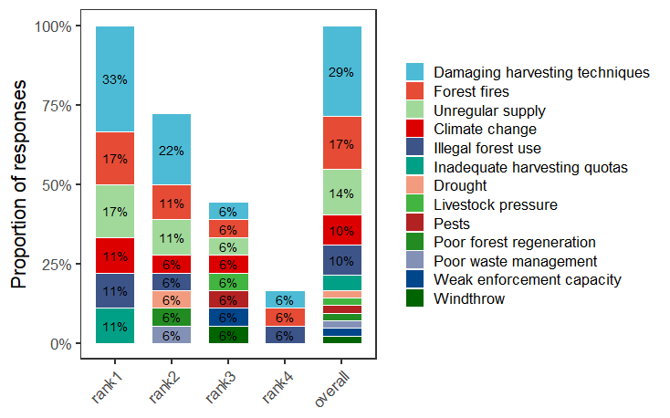
- “What single action is considered most critical to ensuring the long-term sustainability of the pine nut value chain?”
Figure 6.1: Interviewee’s Perceived Threats To The Pine Nut Value Chain Across Different Ranks Of Importance (Rank1 = First Mentioned, Rank4 = Fourth Mentioned, Overall = All Responses Combined). Unlabeled Bars Represent Values <5%.

Across all interviewed groups, 33% of respondents to the first question (Figure 6.1) identified damaging harvesting techniques (i.e. striking trees with a wooden hammer, See 6.4.1), as the main threat to the pine nut value chain, and accounted for 29% of all mentions across ranks. This indicates its perceived negative impact on cone production and forest health.
Climate change and related environmental factors (including forest fires, pest outbreaks, and drought) were the second most frequently cited causes of forest degradation and low cone production, representing collectively about 35% of responses. Among these answers, forest fires stand out as a significant concern, being the most commonly mentioned climate-related threat. This perception is consistent with the report of the National Forest Inventory, which identify wildfires as the current main environmental factor reducing forest tree biomass across Mongolia’s boreal forests (Altrell, 2019; MET, 2019). Notably, permafrost thaw and late spring frosts, although recognised as significant stressors, were never mentioned by interviewed stakeholders.
Irregular cones and pine nut supply represents a particular challenge for wholesalers and processors, who are unable to guarantee consistent production every year. This issue mainly results from the natural reproductive cycle of the species, but may be intensified by poor quota setting, climate change, and/or the effects of tree hammering. The latter was frequently cited by various stakeholders, regardless of education level. Some noted not only a lower number of cones but also smaller cones with fewer seeds as a result of hammering. However, this impact has never been studied.
The fourth group of threats includes issues related to weak enforcement capacity, which encompasses illegal forest use for pine nut harvesting, improper waste disposal in forests (including cones wastes or littering), and, to a lesser extent, illegal logging and hunting.
Finally, governance-related issues, such as inadequate harvesting quotas, were also mentioned, though less frequently.
Overall, the responses were consistent across regions and stakeholder groups, suggesting a shared national perception of these threats. This may also reflect education and capacity-building efforts, through public awareness campaigns on social media and television about tree hammering and forest fire risks.
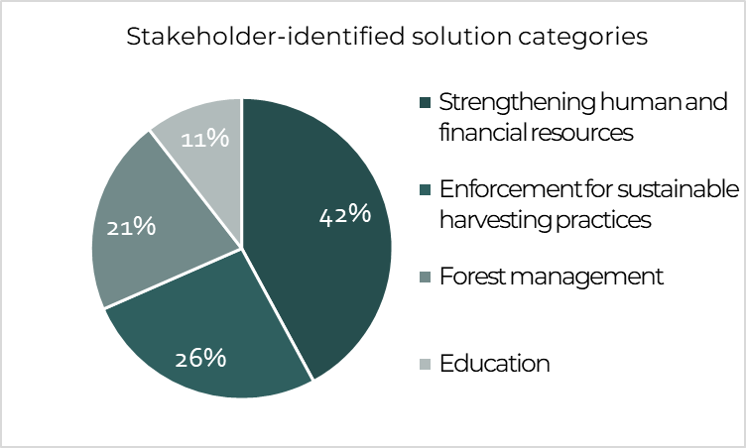
When discussing potential solutions to ensure the sustainability of the pine nut value chain, stakeholders primarily highlighted four main needs, as summarised in Figure 6.2. Each need corresponds to specific threats identified during the interviews, and for each threat, potential solutions were assessed in terms of their feasibility and effectiveness (Table 6.1).

Figure 6.2: Main Actions Categories Identified By Stakeholders To Address Current Threats In The Pine Nut Value Chain.

Among the needs identified, 42% highlighted a lack of financial and human resources. This constraint is most acute in forest management and harvesting, and less so downstream in wholesaling and processing. In the forest, limited manpower prevents effective enforcement of regulations. Thousands of hectares are monitored intermittently by a small number of forest units, ISFUs, rangers, and eco-police employees, which is widely insufficient to prevent illegal activities and natural hazards monitoring. This includes restricting access to protected areas or fire-risk zones, enforcing quotas, and controlling harvesting practices (tree hammering, littering, and camp fire safety).
Resource limitations also affect sustainable harvesting enforcement (26% of suggested solutions). While setting later official harvesting season dates could reduce damage to trees and encourage collection of mature cones on the ground, competition among harvesters leads to early harvesting that cannot be properly monitored.
Table 6.1: Threats To The Pine Nut Value Chain, As Perceived By Interviewed Groups, Categorized By Type And Corresponding Solutions In Training, Enforcement, Or Restoration, With Estimated Suitability Indicated By Dots (● = Low, ●● = Medium, ●●● = High).
Categories | Threat \ Solution | Training \ Education | Enforcement | Restoration
Human-induced threats | Damaging harvesting techniques | ●●● | ●●● | ●
Human-induced threats | Poor waste management | ●●● | ●●● | ●
Climate and natural hazards | Forest fires | ●● | ●● | ●●●
Climate and natural hazards | Climate change | ● | ● | ●●●
Climate and natural hazards | Drought | ● | ● | ●●●
Climate and natural hazards | Pests | ● | ● | ●●●
Climate and natural hazards | Poor forest regeneration (natural) | ●● | ●● | ●●●
Climate and natural hazards | Windthrow | ● | ● | ●●●
Governance and management issues | Illegal forest use | ● | ●●● | ●
Governance and management issues | Inadequate harvesting quotas | ●● | ●●● | ●
Governance and management issues | Weak enforcement capacity | ● | ●●● | ●
Governance and management issues | Poor forest regeneration (planting) | ●●● | ●●● | ●●●
Governance and management issues | Livestock pressure | ● | ● | ●●●

Improved forest management was also recommended (21% of responses). Measures include promoting natural regeneration and forest health through thinning and removal of deadwood, enhancing Siberian pine regrowth, and preventing forest fires. Artificial regeneration is also critical, through tree nurseries, identification of optimal replanting areas, and long-term monitoring of plantations. Despite being explicitly mandated in the Mongolian Forest Law of 1995, such efforts remain marginal.
Education (11%) is another key area for improvement. Forest workers should be trained in plantation management, and harvesters in sustainable collection practices, emphasizing that over-harvesting cones undermines long-term productivity and ecosystem health.

Climate Change
Based on stakeholder interviews, secondary data, and our own field observations, the next section examines both the impacts of the pine nut value chain on its environment, but also how the pine nut value chain itself is affected by external pressures challenging the sustainability of the sector. For instance, Mongolia is warming faster than the global average, with a temperature increase of 2.5 °C over the past 80 years (MET, 2024), a trend that is already affecting forest health, natural regeneration, and cone production through different phenomena.

Carbon Emissions
The value chain’s largest contribution to global warming comes from transportation. Heavy Russian trucks used to transport harvesters and pine nut sacks consume significant amounts of fuel, traveling from the forest and back to the wholesaler’s yard. Of course, these distances are small compared to transporting pine nuts from wholesale yards in the producing regions to processing facilities in Ulaanbaatar; this leg is substantially longer, with distances ranging roughly from 300-350 km (Khan Khentii SPA), 400-500 km (Arkhangai), to about 600-800 km (Khövsgöl) (Table 2.9). However, these trips represent a minor contribution compared to the emissions linked to export. Overall, the impact of the pine nut value chain on climate change is limited. Within the national scope of this study, exports are not considered, and the only carbon emissions arise from domestic transport, which remains relatively short-distance, and the seasonal heating of processing facilities. Consequently, the overall impact is small, especially when compared to national-scale emissions from coal use or to the emissions generated by forest fires.
Conversely, climate change poses a major pressure on the pine nut value chain. Forest fires are the most significant hazard, often considered to have a greater impact on production than unsustainable harvesting practices.

Forest Fires
In Mongolia, forest fires affect nearly 28% of forests (Altrell, 2019 ;MET, 2019). According to the Ministry of Environment and Climate Change, approximately 90% of forest fires in Mongolia are human-induced, with only 10% caused by lightning. Longer-term trends indicate a growing fire risk: the Second Assessment Report on Climate Change in Mongolia periods (MEGD, 2014) notes a 13.3% increase in forest area affected by fire (+64,000 ha) between 1999 and 2012 compared to previous periods. Fires in Siberian pine stands have been reported in all regions visited during fieldwork during the five last years.
Field interviews reveal a clear discrepancy between official data and stakeholder perceptions. Among ten interview groups across five aimags, 50% identified lightning as the main cause of forest fires, 33% cited human-induced causes, and 17% were unsure. Human-induced fires were more frequently mentioned by institutional actors, including heads of ISFUs, senior environmental specialists of SPAs, and aimag environment departments, as well as some FUGs. In contrast, lightning was predominantly cited by local harvesters and wholesalers. Notably, one environmental inspector reported lightning as the main cause based on information from the National Emergency Management Agency (NEMA), he said. This divergence points to limited awareness and the need for capacity building on fire prevention, particularly among actors operating directly in the forest.
Human behaviours contributing to fire risk include littering of cigarette butts, and the use of open fires on dry forest soils. While soum and aimag authorities may temporarily close forests during high-risk periods, enforcement remains weak, especially with regard to illegal harvesters, hunters, and loggers who continue to access forest areas. Some positive developments were nonetheless reported: in Arkhangai Aimag for instance, interviewees indicated a decline in fire incidence linked to awareness-raising efforts and the adoption of gas stoves by pine nut harvesters instead of open fires during camping.
Siberian pine is relatively fire-sensitive due to its shallow root system and low post-fire resilience, particularly when compared to Larix sibirica, which generally shows higher resistance and faster regeneration after fire (Danilin and Tsogt, 2014). In lower-altitude mixed stands, fire therefore tends to favour larch regeneration at the expense of Siberian pine, potentially accelerating shifts in species composition. As a result, fire constitutes one of the most serious threats to both the pine nut value chain and the long-term integrity of Siberian pine ecosystems. This risk is further exacerbated by permafrost thaw, which contributes to soil drying and reduced water availability, increasing forest flammability.
Finally, repeated years of low cone production reported by interviewees may also be linked to climate change, particularly through more frequent late spring frosts that damage flower buds and subsequently reduce cone yields. Combined with increasing fire frequency and intensity, these climatic pressures further undermine the resilience of Siberian pine forests and the sustainability of the pine nut value chain.

Permafrost Thaw and Drought
Mongolia lies on the southern margin of the Siberian permafrost zone. Permafrost distribution varies according to geomorphological and microclimatic conditions and covers nearly one third of the country, with a strong concentration in the Altai, Khangai, Khövsgöl, and Khentii mountain ranges and their surrounding areas (Yamkhin et al., 2022). These regions largely coincide with the fragmented forest “refuges” that host Siberian pine natural populations, suggesting a strong ecological linkage between the species’ distribution and permafrost presence.
Thawing permafrost initially releases water that constitutes a key source of groundwater for the species. However, as thawing intensifies, excessive melting disrupts soil water retention and drainage processes, ultimately reducing water availability. Climate warming, combined with the increasing frequency and intensity of forest fires (Munkhjargal et al., 2020), is accelerating permafrost thaw. As a result, habitats suitable for the natural development of Siberian pine are progressively shrinking. Moreover, continued degradation removes the frozen soil barrier that previously retained moisture, leading to increased drainage, surface runoff, and ultimately drier soils. This hydrological shift disproportionately affects Siberian pine, which is the least drought-tolerant among the dominant boreal conifers in Mongolia. In comparison, Scots pine is the most resilient to water stress, followed by Siberian larch.
Together, permafrost thaw, increasing drought, and shifting competitive dynamics among tree species pose a significant threat to Siberian pine forests and, by extension, to the sustainability of the pine nut value chain over the very long-term.

Pests
Climate change is also reported to increase the frequency and intensity of pest outbreaks in Mongolia’s forests (Altrell, 2019; Gerelsaikhan et al., 2025). In the Khentii region, a notable increase in pest and disease outbreaks has been documented in recent years (Gerelsaikhan et al., 2025), compounding the effects of abiotic stressors such as fire and drought and further reducing forest cover (Gradel et al., 2019). Warmer and drier conditions weaken tree vitality and favour the proliferation of defoliating insects, notably the Siberian gypsy moth (Pine caterpillar, Dendrolimus superans sibiricus), which can cause large-scale damage in Siberian pine stands. Note that Lymantria dispar (syn. Ocneria dispar), another moth, was also mentioned in an interviewed pine nut processor’s report. This trend also highlighted by interviewed researchers, and senior officials.
However, based on field-based observations collected mainly in the Khövsgöl, Khangai, and western Khentii regions, local harvesters did not report any pest damage on needles or on cones (or they estimated it to <2% of the cones), including when collected after falling to the ground, suggesting that pest impacts are currently perceived primarily at the forest ecosystem level rather than as a direct constraint on pine nut harvesting. Moreover, it might be a more important concern for the widespread Siberian larch forests.

Late Spring Frosts and Shifting Seasonal Patterns
When forest workers were asked whether they had observed changes in seasonal timing and whether these affected pine nut yields, most interviewees, regardless of their role, expressed no clear opinion. When views were expressed, they mainly referred to a general shift in seasons, with years becoming warmer and drier and cone maturity becoming earlier, taking place in September or even August rather than October. Some also mentioned harsher winters and prolonged snow cover. A more widely shared view among interviewees was that high production years have become less frequent, although this trend was rarely explicitly linked to climate change.
However, cone production in Siberian pine stands is strongly influenced by climatic conditions in both the year of harvest and the preceding year. The species naturally exhibits masting behaviour, with high seed yields occurring every 3-4 years, a cycle that may be increasingly disrupted by climatic anomalies, including late spring frosts (Velisevich and Popov, 2024). Cone initiation takes place in late summer, while developing reproductive organs overwinter and resume growth in spring, when they are particularly sensitive to frost events, leading to partial or complete crop failure even when cone initiation was favourable.
In the Tomsk region (Russia), located approximately 1,700 km northwest of Ulaanbaatar, long-term study suggest that the frequency of severe spring frosts has not increased over recent decades (1990–2020). Nevertheless, cone production declined by approximately one third over this period, primarily due to the disappearance of high-yield years (Goroshkevich et al., 2021). This decline is instead associated with increasing autumn temperatures and higher heat accumulation prior to frost events, which disrupt physiological processes required for mast years. Together, these findings indicate that changes in seasonal temperature patterns, rather than frost frequency alone, are contributing to a long-term reduction in Siberian pine cone production, at least in more northern regions.

Forest Health and Resource Depletion
Mongolian boreal forests are particularly exposed to climate change, with impacts already observed in terms of tree mortality, growth reduction, and increasing disturbance regimes that are affecting forest ecosystem functioning, especially in mountain regions where climatic thresholds are critical.
According to the National Forest Inventory, Mongolian forests are generally over-aged and understocked, a condition that increases vulnerability to environmental hazards such as pest outbreaks and forest fires, as ageing trees weaken and deadwood accumulates (Altrell, 2019; MET, 2019). Nevertheless, the overall health status of stocked boreal forests remains comparable to that of other natural boreal forests: 71% of the growing stock is classified as healthy, while only 6.8% is considered damaged. No significant differences in forest age structure or stocking levels were observed between protected and non-protected areas. Among the identified causes of damage, wildfires represent the dominant environmental hazard affecting growing stock (8.0 m³/ha), followed by snow and ice damage (3.7 m³/ha) (Altrell, 2019; MET, 2019). Although direct human-induced damage (e.g. mechanical damage to stems) was considered among potential causal agents, none was recorded during the NFI surveys. This limitation is particularly relevant when considering Siberian pine, the species of interest for the pine nut value chain.
Siberian pine contributes to the national growing stock, representing about 7.6 m³/ha (6.7%), compared to approximately 92 m³/ha (81%) for Siberian larch, which dominates timber production (Altrell, 2019; MET, 2019). However, Siberian pine wood is not considered a resource subject to depletion within the pine nut value chain analysis, as the species is not targeted for industrial logging. Harvesting pressures are therefore limited to cone collection rather than timber extraction. It is noteworthy that the area of Siberian pine forests has declined substantially over recent decades, from approximately 986,000 ha in 1994 (Ministry of Nature and Environment of Mongolia, 1994) to 675,750 ha in 2019 ,and 612,000 ha in 2023 reflecting long-term pressures on this species.

The Impact of Harvesting Practices
Pine nut harvesting practices in Mongolian Siberian pine forests are unique. They rely on the use of heavy wooden hammers, made directly in the forest and left on site. These hammers, sometimes weighing over 30 kg, are mounted on long handles (approximately 1.5–2.5 m) and are repeatedly struck against every tree in a stand, several times a year, to dislodge cones. This practice causes systematic damage to bark and affects entire forest stands (Figure 6.3). In remote forest areas, such as parts of the Khövsgöl Mountains, observed scars were generally hand-sized, whereas in more accessible regions of the Khangai Mountains, scars were occasionally observed to be larger, reaching sometimes one meter in length, reflecting more intensive and repeated harvesting pressure (Figure 6.3). While most damaged trees remain alive and continue to produce cones, many interviewees associated recurrent low-yield years with cumulative stem damage, even though this relationship has not yet been formally quantified and warrants further scientific investigation.
Similar pine nut harvesting practices likely came from Russia, where they have now largely disappeared and only persist marginally in remote traditional villages. According to interviewees, hammer use became widespread around 1996, whereas prior to that period, harvesting was most likely carried out by climbing.
Competition among harvesters is intense involving several thousand harvesters per region (Table 3.1, Section 3.2.1), and has led to earlier entry into forests each year. Cones are frequently collected before full maturity, when they adhere strongly to branches, requiring even heavier impacts and resulting in increased tree damage. As discussed in the governance analysis, harvesting quotas appear largely ineffective in practice, with estimates suggesting that 40-80% of harvesters sell through informal or semi-formal channels. Enforcement capacity remains very limited due to the remoteness of harvesting sites, combined with insufficient staffing, funding, and coordination among local authorities. Consequently, most violations are not detected, and the actual scale of overharvesting is likely underestimated.
Harvesting activities are carried out predominantly by men, while women, although fewer in number, mainly collect cones that have fallen to the ground during or later in the season. Mongolia is unique for striking trees in natural forests. In other pine nut–producing countries (Table 6.2), harvesting typically involves climbing trees or beating accessible branches with poles, methods reported only marginally in Mongolia. The advanced age and large size of Siberian pine trees make alternative techniques impractical, even though Russia and China also harbour old-growth Siberian pine forests.

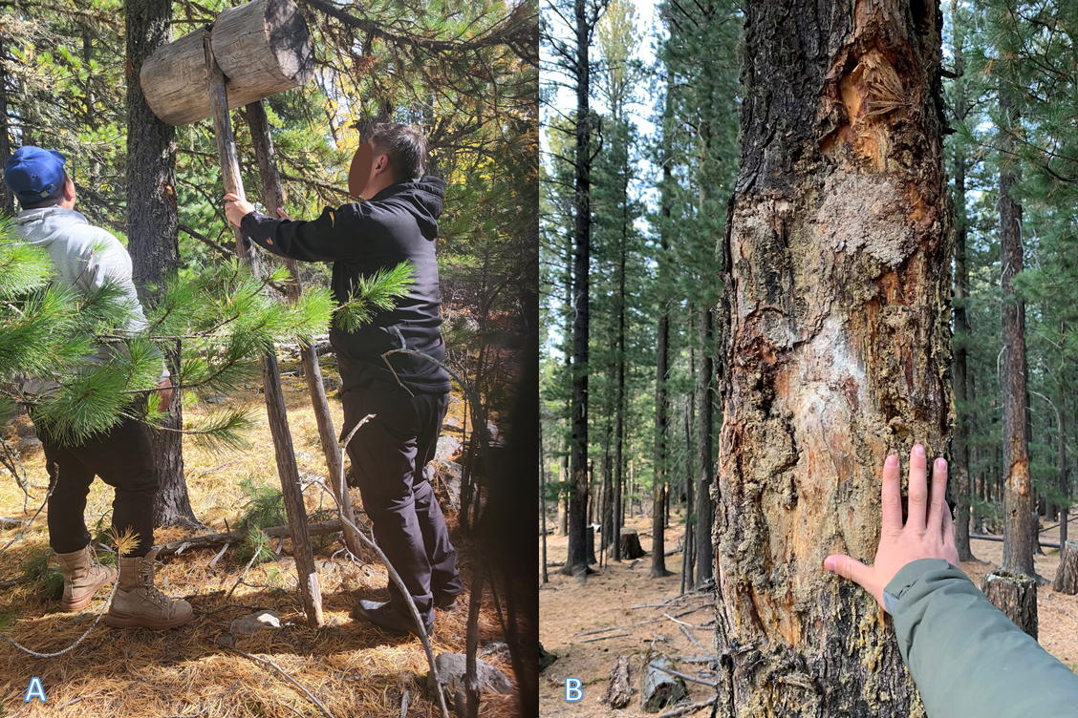
Figure 6.3: Traditional Cone Harvesting Technique On Pinus Sibirica Trees. A) Use Of A Wooden Hammer To Make The Cones Fall (Khövsgöl Mountains). B) Trunk Scars Caused By Repeated Harvesting Strikes (Khangai Mountains).

Table 6.2: Examples Of Pine Nut Harvesting Methods Across Countries And Regions
Country / Region | Forest Type | Pine species | Harvesting Method | References
Mongolia | Natural forests | P. sibirica | Striking standing trees with heavy wooden hammers | e.g., this report
Russia (Siberia) | Natural forests and plantations | P. sibirica, P. koraiensis | Climbing, branch cutting, collecting fallen cones | (e.g., Domènech et al., 2020)
Pakistan, Afghanistan | Natural forests | P. gerardiana | Climbing, branch cutting, hand collection of fallen cones | (Islam and et al., 2019; Peltier and Dauffy, 2009; Rahman et al., 2021)
Mediterranean (Spain, Italy, Portugal, ...) | Plantations | P. pinea | Climbing, pole mounted tools (traditionnal) or mechanical shaking (industrial) | (e.g., Gonçalves et al., 2016)
Alps (France, Italy, Switzerland) | Natural forests | P. cembra | Climbing (not commercial) | (Hoelzl, n.d.)

The pine nut value chain offers significant profit potential for stakeholders, though returns vary considerably depending on seasonal productivity. Consequently, resource depletion and ecosystem quality of Siberian pine stands themselves are two primary factors requiring close attention.

Cone Production and Resource Monitoring
Most interviewees report a decline in cone productivity in recent years, reflected in less frequent high-production years and/or smaller cones. This view is shared by senior environmental specialists. The decline is mainly attributed either to harvesting practices including not only mechanical damage, but also increased competition and the collection of cones when they are immature (reported by 75% of respondents), or to climate-related factors (reported by 25%). The advanced age of forest stands was never cited as a contributing factor, and it may not be a concern, as Siberian pine can live for several centuries.
Despite the importance of monitoring pine nut production, yield variability, and the potential impacts of harvesting practices, no quantitative evidence was identified, either from interviews or secondary data. Quota-setting is arguably politically driven, to generate revenue at the soum level, and remains poorly aligned with field realities due to insufficient funding and staffing. In practice, quotas for areas averaging 12,000 ha are based on drone-based assessments of only five trees per plot across twelve plots, targets that are rarely met. Moreover, tree selection is intended to be random, but medium-sized and easily visible trees are often preferred, introducing bias resulting in monitoring that provides only rough indications of cone presence and does not reliably reflect actual resource availability or harvesting impacts at the landscape scale.

Lessons from Resin-Tapping
In the absence of direct studies on tree hammering, cautious comparisons can be made with research on resin-tapping in other Pinus species, a form of repeated mechanical wounding that has been more extensively studied. Evidence shows contrasting effects on tree growth depending on species. In Poland, studies on Scots pine report a positive effect on radial growth at breast height (Magnuszewski and Tomusiak, 2013; Van Der Maaten et al., 2017). In contrast, studies from Greece, Spain, and China on other Pinus species indicate that resin extraction reduces tree growth, likely because carbohydrates are diverted from biomass accumulation towards resin production (Chen et al., 2015; Génova et al., 2014). Other research reports no significant growth effect, as observed for Pinus elliottii (Du et al., 2022).
Although no research specifically addresses cone production in Pinus species, studies on the Burseraceae family, encompassing resiniferous broadleaved tropical trees species, report that resin-tapping negatively affects reproductive success through reductions in flower, fruit, and seed production for most of the species of this family (Abad-Fitz et al., 2022). Similar effects have also been documented for Hevea spp. (Peters, 1994). While these species differ ecologically from Siberian pine, the consistency of observed reproductive impacts across resin-producing trees reinforces concerns regarding the potential effects of repeated mechanical damage associated with current pine nut harvesting practices.

Ecosystem quality and Biodiversity

Ecosystem Quality
Apart from cone harvesting itself, additional ecosystem disturbances attributable to the pine nut value chain remain relatively modest. In areas where cones are crushed directly in the forest, mainly in the Khövsgöl and the Khentii mountains, cone scales are often left in piles on the ground. These accumulations locally inhibit decomposition processes and can hinder natural regeneration beneath them. In the Khangai mountains, cones were also commonly crushed in the forest until 3-6 years ago. However, this practice has largely ceased as access and transport distances were shorter, making it more profitable to process cones outside forest stands.
Cone crushing in forest camps also involves additional impacts. Large cuts are often made on a single tree per camp to create a flat surface supporting the crushing machine, causing additional mechanical damage. By contrast, in Primorsky Province (eastern Russia), P. koraiensis cones are crushed using machines fixed to trees with chains, a method that avoids cutting or injuring the supporting tree and could serve as a potential alternative practice (Nat Geo Wild, 2016).
Access routes opened to reach remote harvesting areas also contribute to ecosystem degradation, although impacts remain moderate and largely inherent to commercial exploitation of forest-based products. Deep ruts created by heavy trucks and vehicles used to transport harvesters and pine nut sacks locally disturb soils and vegetation. These impacts are particularly problematic within strictly protected areas, where the entire pine nut harvesting process is inconsistent with conservation objectives. Anecdotally, we heard that ruts and other damage from trucks is regarded as a problem for high-end ecotourism in the Khan-Khentii Strictly Protected Area. In more accessible areas, where harvesters arrive by car, motorbike, horse, or on foot, pressures are more diffuse. However, horse grazing and browsing can locally alter vegetation structure and hinder Siberian pine natural regeneration. Anyway, grazing pressure remains weak and low soil moisture appears to be the main limiting factor for regeneration (Juřička et al., 2020)

Wildlife
During interviews in the study regions, wildlife sightings varied across groups. Based on the order in which animals were mentioned (rank 1 being the first cited). This approach is subject to perception bias, particularly favouring large mammals. A score was assigned to each species:
$${Score}_{animal, region}=\frac{\sum{}(7-{rank }_{animal, region})}{\sum{}interviews in region}$$
Scores were then summed for each animal per region and overall. The main wildlife reported in these forests includes wild boar (Sus scrofa), brown bear (Ursus arctos), squirrels (Sciuridae), Siberian musk deer (Moschus moschiferus, Vulnerable on IUCN’s redlist), red deer (Cervus elaphus), and numerous bird species (Figure 6.4).
However, interviewees rarely knew which species actually feed on Siberian pine nuts. This suggests a general lack of ecological knowledge among forest users and officials, who primarily perceive these forests as sources of products (e.g., nuts, berries, firewood, and game) rather than as habitats. Siberian pine is the only conifer in the region with seeds dispersed by animals, unlike other local conifers whose seeds are wind-dispersed (Parfenova et al., 2024). From a value chain perspective, this means that natural regeneration and seed distribution largely depend on the abundance and diversity of animal species.
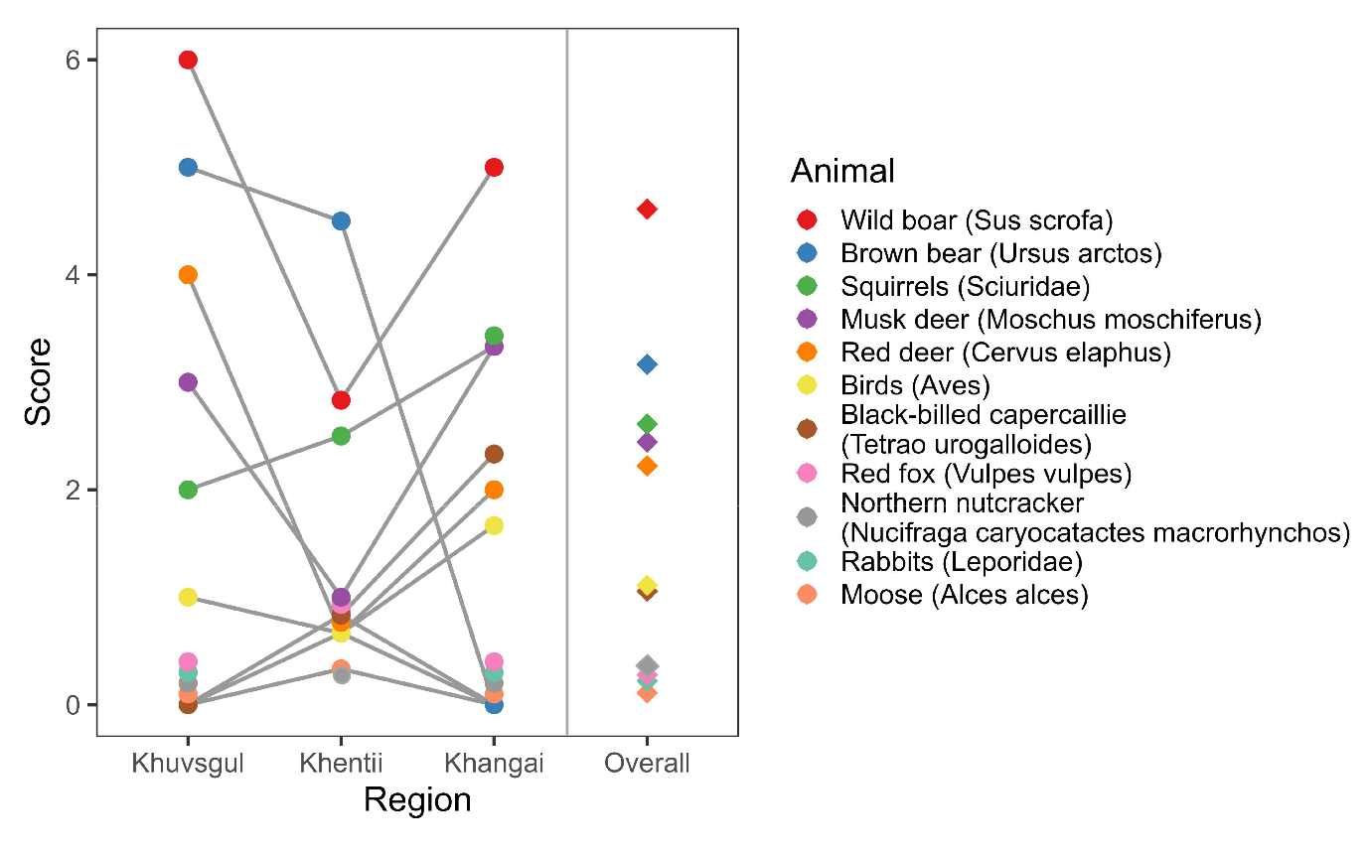
Siberian pine seeds are a key food resource for squirrels, chipmunks (likely included under Sciuridae), sable (not cited by interviewees), and bears (Ivanova et al., 2022). Excessive pressure on this high-calorie resource may explain reports of brown bears increasingly approaching human settlements in the Khövsgöl and Khentii Mountains in search of food, where they were most frequently mentioned. In contrast, bear populations are absent from the Khangai Mountains, as confirmed by National Park and SPA authorities.
Figure 6.4: Scores Of Animals Frequenting Mongolian P. Sibirica Forests, Reported By Interviewed Groups. Participants Ranked Up To Six Animals Per Region. Each Animal’s Score = (7 − Rank); Scores Were Summed Across Interviews And Divided By The Number Of Interviews To Give The Final Regional Score. Grey Lines Connect Regional Scores; Diamonds Indicate Overall Scores.

Birds were generally cited collectively by interviewees, without identification to species level, highlighting a major gap in ecological awareness among forest users. Among the avifauna present, jays, woodpeckers, and the black-billed capercaillie (Tetrao urogalloides) occur in these forests, with the latter reportedly observed mainly during low cone-production years.
The most ecologically significant species is the Siberian Nutcracker (Nucifraga caryocatactes macrorhynchos), a specialized consumer of Siberian pine nuts (see Section 6.7.1). Nutcrackers rely on pine nuts year-round. In autumn and winter, these seeds often constitute nearly their entire diet. They cache nuts for later consumption and to feed nestlings, which are provided exclusively with pine nuts (Reymers, 1959; Vorobyev, 1982; Cramp & Perrins, 1993, cited by Ananin and Sokolov, 2009). Consequently, their population density is closely linked to the cone production of Siberian pine forests in Mongolia, as observed in Russian plantations (Ananin & Sokolov, 2009). During interviews, the single mention of nutcrackers was to report that they appear primarily in high-production years. Interestingly, in the Swiss Alps, people historically followed the calls of nutcrackers to locate Pinus cembra trees with abundant cones (Hoelzl, n.d.).

Flora and Fungi
Regarding flora, the impact of pine nut harvesting appears limited. Siberian pine forests are largely monospecific, and collection methods have minimal effect on other plant species. Even though overgrazing by livestock is a national issue (Morton et al., 2024), high-altitude, remote Siberian pine stands are largely protected from grazing/browsing pressure. Some local disturbance occurs from pine nut harvesters traveling by horse, which can browse and trample herbaceous vegetation.
Mushroom collection occurs occasionally but has not shown noticeable variation in recent years, according to interviewees. This is noticeable because Pinus species, including Siberian pine, are obligate ectomycorrhizal trees, forming a symbiotic association between their roots and diverse fungi (Badar-Uugan and Burenjargal, 2015; Vaishlya et al., 2019). Consequently, any pressure on Siberian pine forests also affects associated fungal communities. While some ectomycorrhizal fungi are not strictly host-specific and may associate with other taxa such as Larix or Pinus sylvestris, such alternatives are absent in pure Siberian pine stands. In turn, Siberian pine itself depends on these fungi to persist, making forest disturbance relevant not only for tree populations but also for belowground fungal biodiversity.

Mongolian Siberian Pine Populations
From a global perspective, Siberian pine forests are not considered endangered, covering over 40 million hectares across Russian Siberia, with smaller populations in China and Kazakhstan. In Mongolia, however, the species is more vulnerable. For the purposes of the Plant Law, Siberian pine has been classified as rare since 1995 and it is listed as threatened in the national Red List. Mongolian populations may represent a unique genetic pool, warranting specific conservation attention.
Climate change is expected to further affect the species’ distribution. In Russia, the range of Siberian pine is projected to expand by 2050 (Parfenova et al., 2024), as insufficient soil moisture in southern areas pushes populations northward. In Mongolia, Siberian pine populations appear as isolated “refuge islands” mimicking the Siberian range, and their distribution is likely to contract, increasingly confined to higher-altitude areas with harsher climates.
On the other hand, seeds from the southern part of Siberian pine range tend to be larger (Parfenova et al., 2024), while northern provenances are more frost-resistant despite earlier flowering (Zhuk, 2025). In this context, collaboration could be advantageous: Russia could benefit from Mongolian seed material to enhance productivity, while Mongolia could gain access to frost-resistant provenances to strengthen its populations.

Human Health
Across the pine nut value chain, no major negative impacts on human health have been reported. On the contrary, forest visits are generally perceived as beneficial, with harvesters noting positive physical and social effects from pine nut collection. From gathering to processing, all operations rely exclusively on mechanical methods (cone crushing, nut shelling) and are free from chemicals or other pollutants, posing minimal risk to workers or local communities.
Pine nut kernels are usually dried and stored only briefly, which keeps microbiological contamination risk low. Wholesalers and processors generally report no contamination, although formal quality controls are rarely conducted. Only the one or two largest exporting companies hold EU or US organic certification.
Available evidence suggests that mycotoxin risks in pine nuts are generally low compared with other nuts, but not absent, even though no reports were retrieved for Siberian pine nuts specifically. From 2011 to 2021, among 3,000 EU-RASFF (Rapid Alert System for Food and Feed) notifications for mycotoxins in nuts and seeds, only one concerned pine nuts (Owolabi et al., 2023). Similarly, a comparative study of ten dried fruits and nuts in China found that pine nuts were the only commodity without detectable aflatoxins (Wang et al., 2018). Comparative studies likewise found no detectable aflatoxins in pine nuts, unlike pistachios or groundnuts, which show substantially higher risks, particularly when marketed in-shell (Owolabi et al., 2023). However, aflatoxin and ochratoxin A contamination has been reported in Pinus gerardiana (Chilgoza pine) nuts on 46% and 36% of samples, respectively, collected on an Indian market (Sharma et al., 2015). They exceeded the EU maximum limit of 4 μg/kg for ready-to-eat nuts. The same trend was also found in Pakistan (Luttfullah and Hussain, 2011). This indicates that while risks are lower than for many other nuts, moisture and contamination control remain necessary across the value chain.
In this study, some wholesalers monitor moisture content. Minor rot is occasionally observed (<5 %) but sorted carefully before sale. At least one of the leading processors use infrared sensors to measure moisture, helping prevent mold, aflatoxin formation, and spoilage during storage and transport. Despite these precautions, moisture and contamination controls are not applied systematically across the value chain, representing an area for improvement to fully meet EU sanitary standards.

Forest Dynamics and Current Management

Natural Regeneration
Siberian pine is a dark-needled, shade-tolerant species requiring fertile soils and adequate moisture, and typically regenerates under a closed canopy (Parfenova et al., 2024). While limited disturbance may favour regeneration, intense disturbances such as fire promote fire-resistant pioneer species like Siberian larch. Siberian pine itself has low fire survival, though its flammable needles can intensify fires and its seeds may occasionally persist and regenerate post-fire (Hong et al., 2024).
This situation places severe pressure on Siberian pine forests, which are largely composed of pure stands. Systematic cone harvesting hinders natural regeneration of these stands. However, our field observations show contrasting situations between regions: in the Khövsgöl Mountains, forests are very remote and regeneration is very limited, with only a few scattered seedlings and almost no saplings or mid-aged trees. In contrast, in Khangai Mountains, where forests are more accessible, regeneration appears much stronger, with abundant young seedlings and trees of various diameters and ages. The underlying causes of these regional differences remain to be further examined.
Regeneration dynamics are closely linked to cone and seed production, which directly underpins the pine nut value chain. Siberian pine exhibits irregular masting cycles, characterised by high seed yields every 3-4 years (Velisevich and Popov, 2024) followed by several years of low yield, although some seed production occurs annually (Farjon, 2013). Under favourable conditions, cone production can begin at around 20 years of age, while maximum seed productivity is typically reached at approximately 160 years and may persist for several centuries, in some cases up to 400 years (Kirsanov, 1981 (in Russian), cited in Ivanova et al., 2022).
Seed dispersal depends almost entirely on the Siberian nutcracker (Nucifraga caryocatactes macrorhynchos), a keystone mutualistic species. Nutcrackers collect seeds mainly from the ground and store them in numerous caches up to 15 km from parent trees (Bekh & Vorob’yev, 1998 (in Russian), cited in Ivanova et al., 2022). Seeds stored in caches do not exhibit prolonged dormancy and typically germinate the following growing season, with only a limited proportion remaining viable beyond that period. When cached seeds are not retrieved, seedlings may establish successfully, sometimes resulting in abundant regeneration even following years of poor cone production (Tantsyrev et al., 2023).

Reforestation Efforts
At the national level, reforestation programmes overwhelmingly prioritise Siberian larch (Larix sibirica Ledeb.) and Scots pine (Pinus sylvestris L.), while Siberian pine remains largely neglected. Across all nurseries surveyed or reported on, Siberian pine seedling production remains marginal. Table 6.3 records approximately 55,000 Siberian pine seedlings in total, representing less than 0.3% of an estimated national production of around 20 million seedlings, and visited nurseries produced almost none. This stark underrepresentation underscores the extent to which the species is sidelined in current reforestation efforts, despite its high ecological and economic importance.
Table 6.3: Visited And Reported Nursery Production Patterns And Marginal Production Of Siberian Pine
Type of actor | Organisation | Aimag | Total annual seedlings | P. sibirica seedlings | Share of P. sibirica | Main species produced
Government | Bat-Ulzii ISFU (5 soums) | Övörkhangai | 2,000,000 | 30,000 | 1.5% | Larix sibirica
Forest officer & PhD Candidate |  | Khövsgöl | 10,000 | 10,000 | 100.0%
PFE | Nugiin Khishig LLC | Selenge | 6,000,000 | 250 | <0.01% | Pinus sylvestris
PFE | Greenbelt | Selenge | 1,590,000 | 500-5,000 | <0.3% | Mixed
Government | Mandal ISFU | Selenge | 0 | 0 | 0.0%
PFE | Urshin | Ulaanbaatar | 10,000 | 10,000 | 100.0%
Government | Aimag Forest Dept. | Arkhangai | 500,000 | 0 | 0.0% | Larix sibirica
This is mainly because the other species are easier and cheaper to produce in nurseries. Moreover, appropriate reforestation sites for other species are generally more accessible. In contrast, Siberian pine grows only in specific environments, above 1,500 meters in altitude and within microclimates (See 2.3.1), making it more challenging for large-scale planting programs. Moreover, most national reforestation efforts focus on fighting desertification and preventing forest fires rather than restoring high-altitude ecosystems where Siberian pine naturally occurs. Furthermore, 78% of the resource is located within protected areas, with 60% in the Khan Khentii strictly protected area.
Overall, these findings reveal a structural mismatch between the ecological importance of Siberian pine and its very limited representation in public and private nursery systems. This shortage of seedlings directly constrains both private forest enterprises and forest units from reforesting with Siberian pine, undermining long-term regeneration, restoration efforts, and the sustainability of the pine nut value chain.

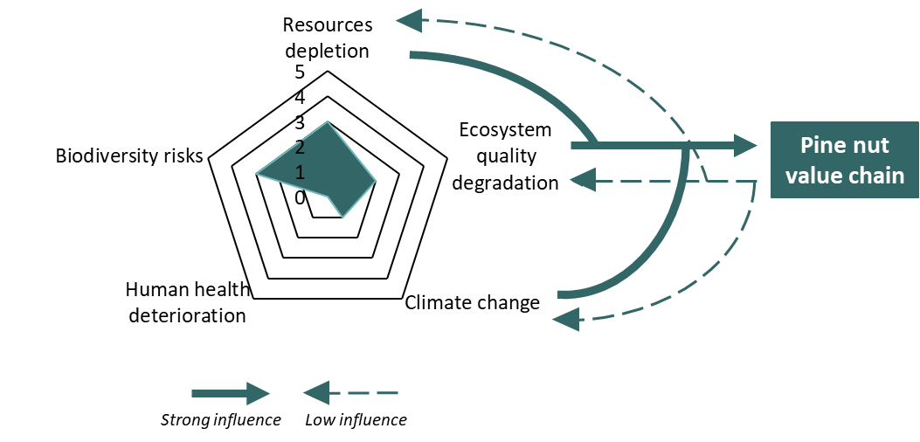
Answer to the Framing Question 4
Figure 6.5 : Environmental Impacts Scores From 0 (No Impact) To 5 (Extreme) Of The Pine Nut Value Chain. Solid Arrows Indicate Strong Environmental Pressure On The Value Chain Itself; Dashed Arrows Show Weaker Influence From The Value Chain On Environmental Constraints.
Figure SEQ Figure \* ARABIC 5: Estimated relative impacts of the value chain on environmental endpoint categories (0 = negligible; 5 = high) and illustration of low direct value chain impacts contrasted with high external pressures from these endpoints.
The environmental performance of the pine nut value chain in Mongolia is overwhelmingly determined by the condition, resilience, and management of Siberian pine forest ecosystems. Unlike most agricultural or plantation-based value chains, downstream operations (cone crushing, storage, processing, domestic transport) contribute only marginally to environmental pressures. The estimated relative impacts of the value chain on key environmental endpoints remain low, while these same endpoints are a source of external pressures on the value chain (Figure 6.5). As a result, the environmental sustainability of the value chain depends far more on upstream harvesting practices, forest governance, and external climatic pressures than on processing efficiency or input use.
From a climate change perspective, the pine nut value chain itself has a limited contribution to greenhouse gas emissions. Carbon emissions are largely confined to domestic transport and seasonal heating of processing facilities and remain negligible when compared to national emissions from coal use or to emissions generated by forest fires. Conversely, climate change represents the most significant external threat to the value chain. Increasing temperatures, rising fire frequency and intensity, permafrost thaw, drought, and changing seasonal patterns collectively undermine cone production, and long-term regeneration. Among these factors, forest fires emerge as the most critical hazard, both in terms of immediate biomass loss and long-term shifts in species composition that disadvantage Siberian pine in favour of more fire-tolerant species such as Larix sibirica (Siberian larch).
In terms of resource depletion and ecosystem quality, the main environmental pressure generated by the value chain arises from current pine nut harvesting practices. The widespread use of heavy wooden hammers to dislodge cones results in systematic mechanical damage at the stand level, as virtually all mature Siberian pine trees are struck repeatedly. While the relationship between stem damage and cone productivity has not yet been quantified through dedicated studies, evidence from comparable forms of repeated mechanical injury in other tree species indicates a high risk of negative effects on cone production. Combined with early harvesting of immature cones driven by intense competition and weak enforcement, these practices pose a significant threat to the long-term productivity and ecological resilience of Siberian pine forests.
The sustainability of the resource is further constrained by weak monitoring, governance, and education mechanisms. Quota-setting is poorly aligned with ecological realities, as it relies on limited and potentially biased field assessments and may be driven by fiscal considerations rather than resource availability. Enforcement capacity remains insufficient relative to the vast and remote forest areas concerned, allowing illegal and unsustainable practices to persist, while limited training and awareness among forest users and local authorities reduce compliance and the effectiveness of existing regulations.
Biodiversity considerations reinforce these concerns. Siberian pine forests play a key ecological role, supporting a range of wildlife species and relying on animal-mediated seed dispersal, particularly by the Siberian nutcracker. Pine nuts constitute a critical food resource for several mammals and birds, and excessive removal of cones may disrupt trophic interactions and regeneration dynamics. In Mongolia, Siberian pine populations are fragmented, potentially genetically valuable, and nationally redlisted, making them considerably more vulnerable than the extensive populations found in Russia. Climate change is expected to further reduce their suitable habitat in Mongolia, increasing the importance of effective conservation and restoration measures.
At present, forest regeneration and restoration efforts are poorly aligned with the ecological and economic importance of the pine nut value chain. Despite legal provisions, Siberian pine is largely absent from national reforestation programmes and nursery production, which overwhelmingly prioritise other species. This structural mismatch severely limits the capacity to restore degraded stands or compensate for long-term losses in productivity, particularly in high-altitude ecosystems where natural regeneration is already constrained.
Overall, the pine nut value chain in Mongolia has the potential to be environmentally sustainable, as its direct environmental footprint remains low and largely limited to cone harvesting and transport. This potential is currently constrained by climate-related pressures and by harvesting practices and governance arrangements that weaken forest resilience and regeneration. Improving sustainability will require a shift towards ecosystem-based management, including reducing damaging harvesting techniques, strengthening monitoring and enforcement, improving ecological knowledge among forest users, expanding Siberian pine regeneration and restoration, and integrating climate change adaptation into forest and value chain governance.

SYNTHESIS & RECOMMENDATIONS

Answering the Framing Questions

What is the Contribution of the Pine Nut Value Chain to Economic Growth?
The pine nut VC is an export-oriented forest product system characterised by strong dependence on cone production cycles, a high concentration of exports to China, and a differentiated processing segment supplying both bulk and premium markets. It generates direct value added across harvesting, wholesaling and processing activities and shows a high rate of integration within the domestic economy, as most intermediate goods and services are locally sourced.
In macroeconomic terms, the VC accounts for 0.6% of national GDP and 7.9% of agricultural and forestry GDP. Total value added represents 96.6% of value chain output, indicating limited use of imported inputs. The value chain generates 0.1% of national wages and 0.5% of national gross disposable income. Net transfers to public funds represent 0.2% of the state budget. The VC is structurally competitive in international markets, though current value capture is shaped by the predominance of bulk export channels. It contributes 0.1% of national exports, with no recorded imports, resulting in a positive trade balance equivalent to 0.2% of national imports.

Is this Economic Growth Inclusive?
The pine nut value chain generates substantial and valuable seasonal income and employment for rural households, though the distribution of harvesting income is uneven, with a clear concentration of profits among downstream processors and limited stability or protection for most workers.

Is the Pine Nut Value Chain Socially Sustainable?
The pine nut value chain generates attractive seasonal employment for around 67,000 harvesters, who are in some cases able to make their livelihoods less vulnerable to debt and unemployment, and in other cases to actively invest in improving or diversifying those livelihoods. It creates a much smaller number of jobs in trade and processing. This happens in a generally favourable national-level environment in terms of living conditions, employment rights, food security, and (with qualifications) gender equality.
The situation with regard to land rights and social capital is more complex. There are neither legal nor customary constraints on choice of harvest sites, which works in the short-term in favour of harvesters and other actors (and causes few or no disputes), but does not favour the long-term environmental sustainability of the value chain. Levels of information and trust in the value chain can only be described as moderate, which does not impede the operation of what is largely a spot-market between harvesters and wholesalers, but an opportunity is currently being lost by not integrating the network of recognised Forest User Groups into the value chain.

Is the Pine Nut Value Chain Environmentally Sustainable?
The environmental performance of the pine nut value chain in Mongolia is overwhelmingly determined by the condition, resilience, and management of Siberian pine forest ecosystems. The VC makes a very limited contribution to greenhouse gas emissions, with carbon outputs largely confined to domestic transport and seasonal processing. Some harvesting practices, in particular the widespread use of heavy wooden hammers and the harvesting of immature cones, pose a significant threat to the long-term productivity and ecological resilience of Siberian pine forests. Conversely, climate change represents the most significant external threat to the value chain. These climatic pressures, from more frequent fires and prolonged drought to permafrost thaw and disrupted seasonal patterns, are already translating into reduced cone yields and weakened forest regeneration capacity. The sustainability of the resource is further constrained by weak monitoring, governance, and education mechanisms. Forest regeneration and restoration efforts remain poorly aligned with the ecological and economic importance of the pine nut value chain, with Siberian pine almost entirely absent from national nursery and reforestation programmes.
Overall, the pine nut value chain in Mongolia has the potential to be environmentally sustainable, as its direct environmental footprint remains low. Realising this potential requires addressing structural weaknesses across the upstream end of the chain. Priority actions include phasing out damaging harvesting techniques, strengthening enforcement in remote forest areas, improving ecological literacy among forest users and local authorities, and urgently expanding Siberian pine representation in reforestation efforts. Climate change adaptation must also be embedded in both forest and value chain governance if the long-term viability of the sector is to be secured.

The Risk Analysis
Table 7.1 presents the key risks associated with the VC. Nine key risks are identified. The rationale for identifying and assigning values to those risks is set out in Annex 4. The probability assessment for seven of the nine risks is high, and moderate for the two others. The severity of the risk of climate change impacting on forest health and productivity is assessed as extreme (while its probability is regarded as high). All but two of the remaining risks have a severity assessed as high against at least one of the framing questions.

Table 7.1: Presentation Of Key Risks
Risk description |  |  |  | Probability | Severity
 |  |  |  | Probability | Growth | Inclusiveness | Social sustainability | Environmental sustainability
- Structural variability and uncertainty of pine nut yields
- Climate change impacts on forest health and productivity
- Persistence of inappropriate pine nut harvesting practices
- Persistent above-quota harvesting and participation of unregistered operators
- High income volatility and exposure of harvesters to seasonal and inter-annual yield variability
- Predominance of bulk export channels limiting value capture and market resilience
- Logistics and connectivity constraints limiting diversification
- Risk of public and development partner–supported investments reinforcing unsustainable or non-viable value chain structures
- Elevated investment risk resulting from ecological variability, governance constraints, and market structure
SEVERITY ASSESSMENT |  |  |  |  |  | PROBABILITY ASSESSMENT
Low | Moderate | High | Extreme |  |  | Low | Moderate |  | High

Summing up Benefits and Negative Impacts
The pine nut VC has significant benefits for Mongolia. Macro-economic benefits are indicated by the VC accounting for 7.9% of agricultural and forestry GDP. The contribution of 0.1% to national exports should be taken in the context of pine nuts being a leading non-mineral export (behind cashmere and other animal fibres, and oilseed rape) and Mongolia’s political need to maintain and diversify such exports. The VC provides significant seasonal employment to 67,000 herders and small-town residents, at a minimum making households less vulnerable, and in a substantial proportion of cases allowing existing livelihoods such as herding to be pursued more effectively and lucratively, or funding social mobility in the next generation.
Harvesting practices, which are themselves a product of ineffective governance within the VC, have negative impacts on the sustainability of the Siberian pine resource, and therefore on biodiversity. To some extent these impacts could be mitigated by better governance and education for value chain actors. In addition, these negative impacts are probably secondary to the impacts on the VC of climate change.

Recommendations

Sustainable Harvesting Practices and Ecological Resilience
Siberian pine forests in Mongolia face multiple pressures, including intensive harvesting using damaging techniques, climate-related hazards such as fires, drought, late spring frosts, and permafrost thaw, as well as governance and enforcement challenges. Given the species’ slow growth, irregular cone production, and reliance on wildlife such as the Siberian Nutcracker for seed dispersal, maintaining forest resilience is essential for sustaining the pine nut value chain.
Key Recommendation 1: Strengthen monitoring and knowledge of forest resources
Issue addressed
Currently, monitoring of Siberian pine forests in Mongolia relies on recently implemented annual inventories that are often inconsistent and insufficiently representative. Fewer than 10 trees are measured per plot across roughly 12 plots per tens of thousands of hectares. Although trees are intended to be randomly selected, medium-sized individuals are often chosen, resulting in unreliable quota settings and poor understanding of cone production variability. Surveys are typically conducted by ISFU staff without rangers’ presence, limiting oversight and efficiency. Cone monitoring relies mainly on drones, which have potential but seems inefficient for such small sample sizes.
Recommendations
A robust, representative, and standardized monitoring system must be implemented. Plots should be truly randomized and permanent to enable reliable year-to-year tracking of cone production and forest dynamics. The number of trees surveyed per unit area should at the very least double. For example, averaging at least 1 tree per 100 ha, ideally by increasing the number of plots (e.g., 24 per soum) rather than only 10 trees per plot, and distributed to capture the variability across soums and aimags would be a good starting point. ISFU staff and rangers, and ideally FUGs, should work together to improve oversight, efficiency, and sampling coverage. Ground observations for cone production could be complemented by the use of binoculars as a low-tech alternative. Theoretically, workers trained by ornithologists could improve monitoring by assessing the density of Siberian Nutcracker populations, as their density has been shown to correlate with cone availability. If combined with deep learning algorithms, drones have the potential to cover significantly larger areas to assess cone production at the stand scale (e.g., Del Río et al., 2025; Kefauver et al., 2022)
Monitoring should also integrate natural regeneration, interspecific competition, tree health, pest and disease outbreaks, and key wildlife populations as ecosystem indicators. Quota settings should be harmonized at the aimag level to prevent situations where one soum is closed due to low production while neighboring areas remain open under similar climatic conditions and cone production. Over time, meteorological data such as autumn temperatures and spring frosts could be incorporated to improve cone production predictions and enable proactive management. Implementing these measures will provide a reliable foundation for sustainable harvesting and strengthen the resilience of Siberian pine forests.
Key Recommendation 2: Promote low-impact and ecologically sensitive harvesting
Issue addressed
Current pine nut harvesting practices in Mongolia are a major source of concern, as the country remains largely unique in using hammers to detach cones.
Recommendations
Low-impact harvesting guidelines should therefore be promoted. Ideally, cones should be collected from the ground after natural abscission. This practice is already used by many women harvesters and allows better sharing with wildlife, supports seed dispersal and natural regeneration, and contributes to ecosystem stability. However, this approach is only effective if harvesting regulations are strictly enforced.
At a minimum, harvesting dates should be adjusted and respected to ensure cones are sufficiently mature and detach more easily. Although cone maturity is occurring earlier under changing climatic conditions, competition from illegal harvesters often pushes collection even earlier. In addition, the use of protective equipment such as rubber guards on both hammers and tree trunks should be made mandatory. These techniques, already tested during training programs, could be scaled up nationally to reduce bark scarring and potential threats to tree health, although their long-term effects should be further monitored.
Tree climbing, as practiced in many countries with long-established natural edible pine populations, is another possible harvesting method; however, it raises significant concerns related to harvester safety and health.
Key Recommendation 3: Implement zonation and rotational harvesting systems
Issue addressed
Uncoordinated harvesting across landscapes risks undermining regeneration, wildlife food availability, and long-term cone production. Current spatial planning does not sufficiently reflect the ecological dynamics of Siberian pine.
Recommendations
In authorized areas (low use zones of SPAs, national park buffer zones, and industrial forest zones), pine nut harvesting should be organized through annual harvesting units, similar to annual allowable cut in logging concessions. These units should remain flexible and be adjusted according to yearly cone production. At the inter-soum level, rotational harvesting cycles of 3-5 years should be implemented, reflecting the natural masting cycle of Siberian pine and allowing sufficient recovery time for cone production, forest regeneration, and wildlife subsistence. Within harvested areas, a minimum of 5 seed-bearing trees per hectare should be permanently marked and excluded from harvesting to support natural regeneration, wildlife food supply, and ecosystem stability in harvested zones.
Key Recommendation 4: Enhance forest regeneration and resilience
Issue addressed
Siberian pine regenerates slowly, is vulnerable to seed predation and climatic stresses, and takes considerably longer to produce mature seedlings in nurseries than most other conifers (4–5 years compared to 2–3 years). Together, these constraints explain why current reforestation efforts tend to prioritise faster-growing or more accessible species, undermining long-term pine nut productivity.
Recommendations
Nursery production must be largely strengthened. Revenues from the pine nut sector, whether accruing to PFEs or soum governments should be reinvested into Siberian pine regeneration itself. Despite legal reforestation obligations, current efforts often favour fast-growing or species with easily accessible habitats (e.g., broadleaved trees, Siberian larch, Scots pine), particularly near soum centres, undermining long-term pine nut productivity.
Enrichment planting of Siberian pine may be considered in degraded or low-density stands, but caution is needed in open areas where seedlings may be outcompeted by pioneer, light-demanding species from the soil seed bank. As a shade-tolerant, late-successional species, Siberian pine regenerates best under partial canopy cover, particularly in high-altitude, cold environments where competition is limited. Management should therefore prioritize natural regeneration supported by sanitary light canopy thinning and small gap creation, while avoiding large-scale canopy removal.
Seed predation, grazing, and climatic stresses (late spring frosts and summer droughts) often result in patchy regeneration, making active monitoring essential. Young seedlings should be protected during their first years from browsing and trampling by livestock (mainly horses brought by harvesters into remote Siberian pine forests) as well as from wildlife, using fencing or stem guards where necessary. Given the non-timber production objectives of these forests, intensive early thinning aimed at accelerating the access to canopy is unlikely to be appropriate.
Cone scale piles remaining after nut processing should be dispersed rather than concentrated, in order to avoid suppressing regeneration beneath dense heaps. Spreading the scales more evenly helps maintain natural litter dynamics, facilitates their gradual decomposition, and may also support regeneration from any remaining viable pine nuts within the piles.
Key Recommendation 5: Enhance cone production through silvicultural techniques
Issue addressed
Cone yields are naturally variable, limiting sustainable harvest and economic planning.
Recommendations
Research on other conifers, including Korean pine (Pinus koraiensis), shows that topping off, thinning, and pruning can be applied, alone or in combination, to significantly increase cone yield and quality while improving stand structure. These techniques implemented on well-established trees or stands aim to enhance crown development and reproductive output rather than accelerate timber production. Removing the apical meristem and upper crown (topping off), stimulates lateral branching and can double or triple cone production over time. At the same time, moderate, selective thinning improves light availability and nutrient access without inducing rapid canopy access, while pruning removes redundant branches to optimize crown architecture (Li et al., 2021).
These techniques could be tested for Siberian pine in Mongolia through pilot trials across ecological regions. Vigorous trees (10-30 m height) could be topped in late autumn or early spring, removing 20-25% of total height and progressively treating lateral branches over 2-3 years. Gradual thinning could reduce stand density by 30-40%, combined with selective pruning of 3-4 main branches per crown (Li et al., 2021). If adapted to local conditions, this integrated approach could enhance cone production while maintaining forest health and resilience.

Forest Governance and Access Rights
Key Recommendation 1: Study the current legal basis for pine nut harvesting with a view to harmonization
Issue addressed
Current laws on plants, forests and protected areas contain a number of clauses that are profoundly at variance with the actual operation of the value chain. For the purposes of the Law on Natural Plants Siberian pine is listed as a rare species that can only be used for household and research purposes; the Forest Law states that pine nuts can only be gathered for household purposes and in high production years; and the Law on Special Protected Areas prohibits commercial harvesting in protected areas and any harvesting in large sub-categories of them. Not only are these clauses at variance with a value chain giving employment to 70,000 people and of national economic importance, there are also grounds for thinking they are excessively strict and that sustainability of the Siberian pine resource could be assured in other ways.
Despite their status and governance being defined in detail by relevant legislation, Forest User Groups do not currently play any significant role in the pine nut value chain, and cannot claim exclusive harvesting rights on territories, even when members live in close proximity to forests. This is a contributing factor to the disillusionment of members, who see the FUGs as having responsibilities for forest conservation, without any corresponding rights. There is a risk that other activities and potential activities of FUGs in forest conservation (including fire prevention, early warning systems, and forest monitoring) may be adversely affected. Conversely, FUGs given more rights could play a role in controlling premature harvesting of cones.
Recommendation
The NFA, with the support of international donors, should institute a review of laws applicable to pine nut harvesting and make recommendations for amendment of laws and/or removing Siberian pine from schedules used in the implementation of those laws. One aspect of this review would be how amended laws and regulations could strengthen the role of FUGs.
Key Recommendation 2: Invest in Capacity-Building of Value Chain Actors
Issue addressed
While there are issues around the appropriateness of existing laws (see above), there is also a lack of resources at soum and IFSU level for monitoring, data collection, quota-setting and enforcement, and deficits of information among harvesters on best-practice harvesting techniques, and to a lesser extent on the laws and policies governing the sector.
Recommendation
International partners should invest in capacity-building of soum-level actors on monitoring, data collection, quota-setting and enforcement. Soum governments, which derive significant income from the value chain, should be encouraged to invest more in enforcement. Inter-agency coordination should also be improved, particularly for Special Protected Area (SPA) management and road access control, to reduce illegal harvesting and improve compliance. Education campaigns for harvesters should be intensified primarily on harvesting techniques, but also addressing laws and regulations regarding harvesting.
Key Recommendation 3: Take Specific Measures to Enhance Working Conditions for Harvesters and Employees of Wholesalers
Issue addressed
While harvesting remains an attractive activity for herders and soum-centre residents, because of the opportunity to earn a significant income to protect or enhance livelihoods, there are two specific issues regarding employment that the team recommend be addressed: child labour and safety within wholesaling yards. We do not wish to exaggerate the risk of child labour, but it is clear that some harvesters are taking their children, as young as ten years old, out of school in order to harvest. In Övörkangai and Arkhangai harvesters bring cones for crushing with belt-driven machines, in two cases we observed these lacked guards (which could relatively easily be welded on), and a casual attitude to health and safety, It is likely that occupational health and safety standards in wholesaling enterprises more widely, which are largely informal and lightly regulated, may be lax.
Recommendations
Motivational campaigns should be organised at soum level to discourage parents from taking children out of school to go harvesting. Soum-level authorities should increase inspections of wholesaler enterprises for health and safety.

Enabling Sustainable Investments and Financing
The pine nut value chain in Mongolia already demonstrates strong commercial potential, particularly in downstream processing and export. However, investment strategies premised on increasing raw material throughput are neither realistic nor appropriate. Siberian pine nut production is characterised by strong natural variability in yields, influenced by climatic conditions, fire risk, and ecological cycles. While sustainable harvesting is possible, future production levels remain uncertain, leaving no reliable basis for planning sustained increases in harvest volumes.
Previous recommendations - on Siberian pine forest protection and on making the pine nut value chain work for people and markets - define the foundations for sustainable investment, including improved forest governance, sustainable and legal sourcing, and other measures that strengthen ecological and social resilience. At the same time, pine nuts harvested above approved quotas or sourced through unregistered operators continue to undermine compliant actors, distort competition, and increase reputational and regulatory risks for investors, thereby constraining the scalability of higher-value and branded business models.

Key Recommendation 1: Focus investment on value upgrading and efficiency
Issue addressed
Given yield uncertainty, strategies aimed at increasing extraction or throughput are high-risk and misaligned with long-term sustainability objectives. At the same time, much of the value from Mongolian pine nuts is lost through bulk exports, limited quality differentiation, and weak market positioning. While field observations do not indicate significant post-harvest losses of pine nuts themselves, value is foregone due to the limited utilisation of processing residues, notably cone residues and shells, which are currently only partially valorised. Where sourcing exceeds approved quotas or involves unregistered harvesters or wholesalers, these losses are compounded by reduced access to premium markets, higher investment risk, and foregone public revenues.
Recommendation
Investment should explicitly prioritise value upgrading and efficiency gains per unit harvested, with particular emphasis on quality management and standards compliance, and market positioning. From an investment perspective, the most viable opportunities lie in supporting existing processing companies with proven business models that are already planning investments in branding, packaging, and improved market positioning to capture higher value from export markets beyond bulk channels. These investments are relatively low-risk, build on established operations, and are well aligned with the financing criteria of development finance institutions. This includes:
- storage and inventory management to smooth seasonality and stabilise supply;
- logistics and handling improvements to reduce quality losses;
- post-harvest handling, grading, and quality control systems;
- food safety compliance and selective sustainability or origin-based positioning;
- packaging, branding, and product differentiation for premium market segments;
- improved utilisation of cone residues through more centralised crushing and extraction where logistically feasible, recognising constraints in remote forest areas;
- increased valorisation of pine nut shells, which are currently underused, including exploration of higher-value applications (e.g. oils, extracts, bio-based materials), subject to technical and market feasibility.
These investments allow more value to be captured from the same - or even smaller - volumes of raw material, by increasing value recovery rather than extraction intensity. In this context, improving value capture refers to increasing the unit value of exports rather than expanding volumes, which are inherently constrained and unpredictable due to natural production cycles.
Roles of stakeholders
- EU/INTPA should prioritise value-oriented upgrading in its programmes, linking quality management, standards, and market positioning to investment support rather than volume expansion.
- DFIs and impact investors should finance upgrading investments (e.g. storage, quality systems, packaging, branding) only where business models are clearly decoupled from increases in harvest volumes and aligned with quota-compliant, registered, and sustainably sourced supply.
- Government should avoid incentives that implicitly encourage higher extraction volumes and instead support investments that reward quality, compliance, and value retention.
Key Recommendation 2: Concentrate high-end processing and branding where scale and connectivity exist, while strengthening upstream functions
Issue addressed
There is strong interest in increasing local value addition in forest regions, but limited scale, infrastructure, and connectivity make decentralised high-end processing economically fragile. At the same time, weaknesses in upstream handling and quality control – including inconsistent compliance with harvesting quotas and registration requirements – can undermine the performance of downstream investments. In addition, pine nut yields vary significantly not only from year to year but also across regions, meaning that reliance on a single sourcing area increases supply risk for processors and investors.
Recommendation
Investment in forest regions should focus on strengthening upstream functions that directly benefit harvesters and local actors, while remaining compatible with ecological constraints and logistical realities. In parallel, longer-term investments are needed to strengthen the resource base underpinning the value chain, particularly through Siberian pine regeneration, seedling production, and reforestation. These investments are essential for long-term supply sustainability, but involve extended time horizons and uncertain returns, making them more suitable for public support, blended finance approaches, or integration with carbon finance mechanisms. Some forest carbon initiatives already exist in Mongolia, although they were not fully captured within the scope of this study.
Investments should prioritise:
- sustainable and quota-compliant sourcing and primary handling,
- aggregation and initial quality control,
- mechanised cone crushing and primary separation of pine nuts from cones, where logistically feasible, to enable the use of cone residues in local or regional hubs.
These investments can improve quality, reduce value losses, and strengthen local participation in the value chain, while recognising that not all forest areas are suitable for mechanised processing due to remoteness and limited road access.
High-end processing, branding, certification, and export logistics should remain concentrated in strategic hubs (notably Ulaanbaatar), where economies of scale, specialised services, and international connectivity exist, while continuing to support upstream aggregation, quality management, and traceability in rural sourcing areas. In these hubs, investment should focus on high-value processing, advanced quality management systems, certification and compliance, branding and packaging, and export-oriented logistics and marketing.
Centralised hubs also enable processors to source pine nuts from multiple regions, create strategic stocks, and partially hedge inter-annual and spatial variability in cone yields, thereby supporting more stable, year-round operations without increasing extraction pressure.
This functional division allows quality and sustainability improvements upstream while preserving the competitiveness of downstream processing and branding.
Roles of stakeholders
- Government should align industrial, regional development, and transport policies with this division of functions, avoiding incentives for non-viable decentralised processing facilities.
- EU/INTPA and development partners should support upstream quality, registration and quota compliance and sustainability improvements without attempting to relocate branding and export activities prematurely.
- DFIs and private investors should scale proven processors with strong sourcing and quality linkages rather than financing fragmented local facilities.
Key Recommendation 3: Diversify markets while improving value capture in existing ones
Issue addressed
China has been the main destination for Mongolian pine nuts by volume to date, reflecting strong demand, established trade relationships, and significant logistical advantages, particularly rail connectivity. However, the predominance of bulk exports means that a significant share of downstream value - particularly from branding, packaging, and premium market positioning - is captured outside Mongolia through re-exports. At the same time, access to premium markets remains constrained by quality, standards, and positioning challenges rather than by raw supply. While the domestic market currently represents only a small share of total volumes, field observations indicate growing demand for pine nuts and pine nut–based products within Mongolia, suggesting untapped potential for value retention. Concerns related to sourcing above approved quotas and the involvement of unregistered operators further restrict access to higher-value market segments.
Recommendation
A dual market strategy should be pursued, combining gradual diversification toward new premium markets with improved value capture in existing ones, while maintaining China as a key outlet for stable volumes and cash flows:
- Diversification toward premium export markets (notably Europe, Japan, the Republic of Korea, and Taiwan), where quality, food safety, quota compliance, traceability, and origin-based positioning are critical;
- Selective upgrading within existing export markets, including China, by shifting from bulk trade toward premium retail, gifting, and health-food segments that reward quality, reliability, and branding; and
- Targeted development of the domestic market, focusing on branded, packaged, and value-added products for urban consumers and niche segments, recognising that even limited volumes can contribute disproportionately to value retention and visibility.
This approach recognises the continued importance of existing trade relationships while creating complementary pathways - export and domestic - to retain a greater share of value within Mongolia. Rather than reducing exports to China, the strategic objective is to progressively increase the share of exports directed to higher-value markets, while also upgrading value capture within existing trade channels. This approach reflects market realities and logistical constraints, including the cost advantages of rail transport to China compared to more distant markets such as the EU and the United States.
Roles of stakeholders
- EU/INTPA, working in close cooperation with the Government of Mongolia, should support market access through sanitary and phytosanitary (SPS) dialogue -that is, technical cooperation and regulatory exchanges on food safety, plant health, and compliance with importing-country requirements - as well as through dialogue on geographical indications (GIs) and other origin-based protection tools, trade facilitation, and targeted promotion focused on quality, reliability, regulatory compliance, and origin-based positioning.
- Government of Mongolia should lead on SPS and GI-related regulatory frameworks and implementation, including inspection, certification, and registration systems, while engaging in international dialogue and ensuring alignment with export and domestic market development objectives.
- Private sector actors should invest in branding, packaging, and quality narratives that enable greater domestic value retention and differentiation in both export and domestic markets.
- DFIs should support market diversification, branding, and domestic market development investments only where firms demonstrate credible strategies grounded in quality management and verifiable quota compliance and registration of sourcing operators.
Core message
Given the inherent variability and uncertainty of pine nut yields, sustainable investment in Mongolia’s pine nut value chain must follow a “more from less” logic. By focusing on quality management, value upgrading, efficiency, and market diversification, and by prioritising value over volume in a context of inherently variable supply – and by ensuring that quota compliance and the use of registered operators underpin all investment decisions – and building on the governance and sustainability foundations set out in earlier pillars, finance can increase incomes and value capture without relying on volume expansion or compromising the long-term resilience of Siberian pine forests.

References
Altrell, D., 2019. Multipurpose National Forest Inventory in Mongolia, 2014-2017 -A tool to support sustainable forest management. GES 12, 167–183. https://doi.org/10.24057/2071-9388-2019-36
Ariunbaatar, T., Temuujin, B., Lyankhua, B., 2023. Study of cone and seed characteristics of Pinus sibirica in difference between Khangai and Khentii mountains. Mong. J. Bot. 5, 171–181. https://doi.org/10.5564/mjb.v5i31.3273
Badar-Uugan, K., Burenjargal, O., 2015. Study on ectomycorrhizae of siberian pine (Pinus sibirica). Journal of agricultural sciences 15, 123–129.
Board, D.I., Chambers, J.C., Miller, R.F., Weisberg, P.J., 2018. Fire patterns in piñon and juniper land cover types in the Semiarid Western United States from 1984 through 2013 (No. RMRS-GTR-372). U.S. Department of Agriculture, Forest Service, Rocky Mountain Research Station, Ft. Collins, CO. https://doi.org/10.2737/RMRS-GTR-372
Bristley, J., 2026. On ‘Wise Cunning’ and ‘Clever Methods’: Framings of Environmental Protection in Rural Mongolia. Ethnos 91, 62–75. https://doi.org/10.1080/00141844.2025.2452516
Caliskan, S., Kartal, E., Balekoglu, S., Çalışkan, F., 2024. Using machine learning algorithms to cluster and classify stone pine (Pinus pinea L.) populations based on seed and seedling characteristics. Eur J Forest Res 143, 1575–1591. https://doi.org/10.1007/s10342-024-01716-7
Carrasquinho, I., Correia, A.C., Mutke, S. (Eds.), 2017. Mediterranean pine nuts from forests and plantations, CIHEAM. ed, Options Méditerranéennes, Series A: Mediterranean Seminars. Zaragoza, Spain.
Chen, Z., et al., 2024. Future suitable distribution of Pinus koraiensis under climate change. Frontiers in Forests and Global Change 7, 1352759.
Committee of Experts on the Application of Conventions and Recommendations (CEACR), 2025. Report of the Committee of Experts on the Application of Conventions and Recommendations (articles 19, 22 and 35 of the Constitution), in: Report III (Part A). Presented at the International Labour Conference, International Labour Office, Geneva, Switzerland, p. 1159.
Committee of Experts on the Application of Conventions and Recommendations (CEACR), 2022. Report of the Committee of Experts on the Application of Conventions and Recommendations (articles 19, 22 and 35 of the Constitution), in: Application of International Labour Standards 2022. Presented at the International Labour Conference, International Labour Office, Geneva, Switzerland, p. 870.
Committee of Experts on the Application of Conventions and Recommendations (CEACR), 2020. Report of the Committee of Experts on the Application of Conventions and Recommendations (articles 19, 22 and 35 of the Constitution), in: Application of International Labour Standards 2020. Presented at the International Labour Conference, International Labour Office, Geneva, Switzerland, p. 708.
Danilin, I.M., Tsogt, Z., 2014. Dynamics of structure and biological productivity of post-fire larch forests in the Northern Mongolia. Contemp. Probl. Ecol. 7, 158–169. https://doi.org/10.1134/S1995425514020036
Danilina, D.M., Nazimova, D.I., Konovalova, M.E., 2019. Diversity of Pinus sibirica forest types in different bioclimatic sectors of Sayan Mountains. BIO Web Conf. 16, 00045. https://doi.org/10.1051/bioconf/20191600045
Domènech, R., Lepeshkin, E., Mutke, S., Piqué, M., Rovira, M., Tracy, E., 2020. Pine nuts in Primorsky province: challenges and opportunities. Forest Science and Technology Centre of Catalonia (CTFC) and WWF Russia.
Dorward, A., Anderson, S., Bernal, Y.N., Vera, E.S., Rushton, J., Pattison, J., Paz, R., 2009. Hanging in, stepping up and stepping out: livelihood aspirations and strategies of the poor. Development in Practice 19, 240–247. https://doi.org/10.1080/09614520802689535
Empson, R.M., 2020. Subjective Lives and Economic Transformations in Mongolia. UCL Press. https://doi.org/10.14324/111.9781787351462
FAO, 2025. Global Forest Resources Assessment 2025 Mongolia. FAO, Rome.
Farjon, A., 2013. Pinus sibirica. The IUCN Red List of Threatened Species 2013 e.T42415A2978539. https://doi.org/10.2305/IUCN.UK.2013-1.RLTS.T42415A2978539.en
García-Zubia, L.C., Hernández-Velasco, J., Hernández-Díaz, J.C., Simental-Rodríguez, S.L., López-Sánchez, C.A., Quiñones-Pérez, C.Z., Carrillo-Parra, A., Wehenkel, C., 2019. Spatial genetic structure in Pinus cembroides Zucc. at population and landscape levels in central and northern Mexico. PeerJ 7, e8002. https://doi.org/10.7717/peerj.8002
Gonçalves, A.C., Dias, A.B., Afonso, A., Pereira, D.G., Pinheiro, A., Peça, J.O., 2016. Mechanical versus manual harvest of Pinus pinea cones. Biosystems Engineering 143, 50–60. https://doi.org/10.1016/j.biosystemseng.2016.01.004
Goroshkevich, S., Velisevich, S., Popov, A., Khutornoy, O., Vasilyeva, G., 2021. 30-year cone production dynamics in Siberian stone pine (Pinus sibirica) in the southern boreal zone: a causal interpretation. Pl. Ecol. Evol. 154, 321–331. https://doi.org/10.5091/plecevo.2021.1793
Grinin, P.D., Saandar, M. (Eds.), 2019. Ecosystems of Mongolia Atlas, Admon Print. ed. Ulaanbaatar.
Hoelzl, K., n.d. Swiss pine cones and their uses. Bushguide101. URL https://bushguide101.com/swiss-pine-cones-and-their-uses/
Humphrey, C., 1995. Chiefly and Shamanist Landscapes in Mongolia, in: Hirsch, E., O’Hanlon, M. (Eds.), The Anthropology of Landscape: Perspectives on Place and Space. Clarendon Press.
International Nut and Dried Fruit Council (INC), 2025. Statistical yearbook 2024. Reus, Spain. International Nut and Dried Fruit Council, Reus, Spain.
International Trade Centre (ITC), 2025. Trade Map – Trade statistics for international business development: HS Code 080290 (Pine nuts, shelled or in shell) [WWW Document]. International Trade Centre (UNCTAD/WTO). URL https://www.trademap.org
Islam, M., et al., 2019. Chilgoza pine management and value chain in Pakistan. ICIMOD, Kathmandu.
Jin, X., Pukkala, T., Li, F., Dong, L., 2019. Developing growth models for tree plantations using inadequate data – a case for Korean pine in Northeast China. Silva Fenn. 53. https://doi.org/10.14214/sf.10217
Lenzen, M., Kanemoto, K., Moran, D., Geschke, A., 2012. Mapping the Structure of the World Economy. Environ. Sci. Technol. 46, 8374–8381. https://doi.org/10.1021/es300171x
Luttfullah, G., Hussain, A., 2011. Studies on contamination level of aflatoxins in some dried fruits and nuts of Pakistan. Food Control 22, 426–429. https://doi.org/10.1016/j.foodcont.2010.09.015
Malik, S., 2019. Essential Oil Research: Trends in Biosynthesis, Analytics, Industrial Applications and Biotechnological Production. Springer, Cham.
Ministry of Environment and Green Development, 2014. Mongolia Second Assessment Report on Climate Change 2014. Ministry of Environment and Green Development (MEGD), Ulaanbaatar, Mongolia.
Ministry of Environment and Tourism (MET), 2024. Fourth National Communication (FNC) of Mongolia. United Nations Framework Convention on Climate Change, Ulaanbaatar, Mongolia.
Morton, J., Kotyza, P., Vigne, M., Dashbaal, B., 2024. Cashmere value Chain Analysis in Mongolia. Report for the European Union (No. VCA4D CTR 2017/392-417), DG-INTPA Value Chain Analysis for Development Project.
Murphy, D.J., 2018. “ We’re Living from Loan-to-Loan ”: Pastoral Vulnerability and the cashmere-debt Cycle in Mongolia, in: Individual and Social Adaptations to Human Vulnerability. Emerald Publishing Limited, pp. 7–30. https://doi.org/10.1108/S0190-128120180000038002
Nat Geo Wild, 2016. Pine Nuts Galore | The Forbidden River.
Nolasco, A., Squillante, J., Velotto, S., D’Auria, G., Ferranti, P., Mamone, G., Errico, M.E., Avolio, R., Castaldo, R., De Luca, L., Romano, R., Esposito, F., Cirillo, T., 2024. Exploring the Untapped Potential of Pine Nut Skin By-Products: A Holistic Characterization and Recycling Approach. Foods 13, 1044. https://doi.org/10.3390/foods13071044
NSO (National Statistical Office), 2023. Social Indicator Sample Survey-2023, Key Indicators Report. National Statistical Office of Mongolia, Ulaanbaatar, Mongolia.
NSO (National Statistical Office), 2019. Social Indicator Sample Survey-2018, Survey Findings Report. National Statistical Office of Mongolia, Ulaanbaatar, Mongolia.
NSO (National Statistical Office), 2018. Social Indicator Sample Survey-2018, Infographic. National Statistical Office of Mongolia, Ulaanbaatar, Mongolia.
Nutsforlife, 2024. Pine nuts [WWW Document]. URL https://www.nutsforlife.com.au/resource/pine-nuts/
Owolabi, I.O., Karoonuthaisiri, N., Elliott, C.T., Petchkongkaew, A., 2023. A 10-year analysis of RASFF notifications for mycotoxins in nuts. Trend in key mycotoxins and impacted countries. Food Research International 172, 112915. https://doi.org/10.1016/j.foodres.2023.112915
Özkan, G., Baydar, N.G., Bayder, H., 2018. Cold pressed pine (Pinus koraiensis) nut oil. Grasas y Aceites 69, e273.
Pedersen, M.A., 2011. Not quite shamans: spirit worlds and political lives in northern Mongolia. Cornell University Press, London.
Peltier, R., Dauffy, V., 2009. The Chilgoza of Kinnaur. Influence of the Pinus gerardiana edible seed market chain organization on forest regeneration in the Indian Himalayas. Fruits 64, 99–110. https://doi.org/10.1051/fruits/2009005
Qin, L., Hou, Z., Lu, S., Liu, S., Liu, Z., Jiang, E., 2019. Porous Carbon derived from Pine Nut Shell prepared by Steam Activation for Supercapacitor Electrode Material. International Journal of Electrochemical Science 14, 8907–8918. https://doi.org/10.20964/2019.09.20
Rahman, N., Salari, H., Wiar, A., 2021. Value Chain Analysis of Chilgoza Pine Nut at Southeastern Region of Afghanistan. EJFOOD 3, 43–49. https://doi.org/10.24018/ejfood.2021.3.4.340
Șen, U., Rodrigues, J.F.G., Almeida, D., Fernandes, Â., Gonçalves, M., Martins, M., Santos, D.M.F., Pereira, H., 2024. Pine Nutshells and Their Biochars as Sources of Chemicals, Fuels, Activated Carbons, and Electrode Materials. Processes 12, 1603. https://doi.org/10.3390/pr12081603
Sepp, S., Schüler, B., 2016. Value chain analyses for the NTFPs: Pine Nuts, Charcoal, Fuelwood (No. 1), GIZ-Programme „Biodiversity and Adaptation of Key Forest Ecosystems to Climate Change II“. ECO Consult, Ulaanbaatar, Mongolia.
Sharma, S., Gupta, D., Sharma, Y.P., 2015. Natural Incidence of Aflatoxins, Ochratoxin A, Patulin and Their Co-Occurrence in Chilgoza Pine Nuts Marketed in Jammu, India. Proc. Natl. Acad. Sci., India, Sect. B Biol. Sci. 85, 45–50. https://doi.org/10.1007/s40011-014-0326-7
Takala, R., Ramji, D.P., Choy, E., 2023. The Beneficial Effects of Pine Nuts and Its Major Fatty Acid, Pinolenic Acid, on Inflammation and Metabolic Perturbations in Inflammatory Disorders. IJMS 24, 1171. https://doi.org/10.3390/ijms24021171
Tsogt, Z., 2011. Atlas of some Non-timber forest products.
U.S. Department of the Interior Bureau of Land Management, 2024. Management and Conservation of Pinyon and Juniper Woodlands Public Comment Summary Report.
Vaishlya, O., Karbysheva, K., Sarsekova, D., Aidarkhanova, G., 2019. Ecological Aspects of Pinus sibirica Du Tour Mycotrophy in Forest Ecosystems of West Siberia. IOP Conf. Ser.: Earth Environ. Sci. 224, 012049. https://doi.org/10.1088/1755-1315/224/1/012049
Velisevich, S., Popov, A., 2024. Climate warming disturbances periodicity of Siberian stone pine seed production ( Pinus sibirica Du Tour). BIO Web Conf. 130, 01018. https://doi.org/10.1051/bioconf/202413001018
Velisevich, S., Popov, A., 2022. Evaluation of cone and seed quality of Siberian stone pine (Pinus sibirica Du Tour) for plus-tree selection. Turkish Journal of Agriculture and Forestry 46, 717–729. https://doi.org/10.55730/1300-011X.3037
Voltolini, F., Tserendorj, O., Sovd, K., Munkhtogoo, B., Ichinkhorloo, B., 2015. Gender Analysis in Pastoral Livestock Herding in Mongolia. : Swiss Agency for Development and Cooperation SDC. Ulaanbaatar, Mongolia.
Wang, Y., Nie, J., Yan, Z., Li, Z., Cheng, Y., Chang, W., 2018. Occurrence and co-occurrence of mycotoxins in nuts and dried fruits from China. Food Control 88, 181–189. https://doi.org/10.1016/j.foodcont.2018.01.013
Waters, H.A., 2023. Moral Economic Transitions in the Mongolian Borderlands. UCL Press. https://doi.org/10.14324/111.9781787358133
Zampori, L., Pant, R., 2019. Suggestions for updating the Product Environmental Footprint (PEF) method. Publications Office of the European Union, Luxembourg.

Annex 1: Interviews Held
Organization / place | Key Discussion Points / Topics
Development Partners
EUD | EU Delegation Expectations  Public policies and pinenut sector  The Forest Partnership  EU Mongolia Business Forum
GIZ / STREAM | Background of STREAM  Key SFM challenges  Pine nut harvesting impacts, recent developments
Korean Green Belt Project, Bugant, Nursery | Project and nursery  Overview of reforestation
National Government
MECC | Status of Siberian pine in Mongolia
MECC / Administration of Khan Khentii State Special Protected areas | Protected area overview
NFA | Institutional Role of NFA  Pine nut auction system  Siberian pine – forest ecology and research
Meeting NFA team at FU in Tsenkher | NFA monitoring, surveys, forest inventory  Siberian pine resources and pinenut trade
Local Government - Övörkhanghai
Bat Uzii Soum Government office, Övörkhangai | Pine nut production  Revenues and budget contribution
Intersoum forest unit  Bat-Ulzii, Övörkhangai | Seedling production and reforestation  Forest User Groups  Pine nut data on auctions
Local Government - Arkhanghai
Arkhangai Environmental Protection Dept, Intersoum FUs,Tsetserleg | Institutional roles, auction procedures, pinenut harvesting practices, FUGs
Arkhangai Environmental Protection Dept, Tsetserleg - ranger | Employment and Duties, challenges, observation on pinenut harvesting practices
Env. Dept Forest Specialist | Forest information systems, monitoring, reforestation
Local Government - Khövsgöl
Aimag Environmental Dept, Delgermurun ISFUs, Mörön, Khövsgöl | Geographic Scope and Forest Area  Auction quotas and permits  Revenue sharing from auction income  Harvesting and market dynamics
Mörön town - short interview on nursery | Personal Initiative and Nursery Setup
Tarialan Soum - forest site with Env Dept and ISFU officers and rangers | Training session organised by Tsooomoo on pine nut survey
Local Government - Selenge
Soum Government, ISFU, Baruunbüren, Selenge Aimag | Geographic coverage and forest area, pine nut harvesting and income. Market prices, forest management
Bugant village, Yeröö Soum, Yeröö ISFU, Selenge | Forest surveys, pine nut yields and quotas  Harvesting history and practices, challenges in forest management
Yeröö ISFU | Background and Role: - Previously worked as a ranger, responsible for patrolling pine nut harvesters and monitoring forest fires, pests, and other forest...
Mandal Soum  Local Government, ISFU | Pine Nut Harvest Management
Local Government – Töv
Local government and ISFU, Batsumber Soum; Töv Aimag | Institutional context, quotas and pine nut production, forest conditions and threats
Processing Companies
North Road LLC in UB | Company profile
Pine Joy Company in UB | Company profile
Urchin LLC - processing company in UB | Company profile
Mandal Soum/ Zuunharaa town, pinenut traders and processors  Kharaa Altan Us Co. Ltd | Company profile
Wholesalers / Traders - Övörkhanghai
Wholesaler at Bat Uzii | Business profile, operations, prices, margins  Challenges
Bat Uzii wholesalers yard | Business profile, operations, prices, margins  Challenges
Wholesalers / Traders - Arkhanghai
Wholesaler at Aimag center: Tsetserleg | Business profile, operations, prices, margins  Challenges
Wholesalers / Traders - Khövsgöl
Mörön town - wholesalers yard | Business profile, operations, prices, margins  Challenges
Wholesalers / Traders - Selenge
Baruumbüren: wholesaler | Business profile, operations, prices, margins  Challenges
Bugant village - meeting with wholesaler | Business profile, operations, prices, margins  Challenges
Nugiin Khishig Co Ltd Mandal Soum/ Zuunharaa town, | Business profile, operations, prices, margins  Challenges
Local harvesters - Övörkhanghai
Pinenut collectors, Bat Uzii forests | Harvesting practices, volumes, prices, challenges
Local harvesters - Arkhanghai
FUG members, pinenut collectors  Temeenechuluut FUG | Harvesting practices, volumes, prices, challenges
FUG members, pinenut collectors  Bayanbulag FUG | Harvesting practices, volumes, prices, challenges
Local harvesters - Selenge
Baruumbüren: FUGs | Harvesting practices, volumes, prices, challenges
Bugant, Green Belt Project, Nursery | Harvesting practices, volumes, prices, challenges
Mandal Soum office - meeting with local harvestor | Harvesting practices, volumes, prices, challenges
NGOs and Research Organizations
Cluster of pinenut companies | Role of the association
Nature and Environment and Sustainable Development | Research on Siberian pine
Other entities / companies
Bugant Nandin company nursery  - Selenge | Company profile, information on nursery and reforestation activities

Annex 2: Global Pine Nut Production Areas
Region | Countries | Common name | Scientific name | Estimated area | References
Asia | China, DPR Korea, Russian Far East | Korean pine | Pinus koraiensis | ≈ 272,400 ha of planted forests in NE China  Suitable habitat  ≈ 45.9 million ha across NE Asia | Jin et al. 2019  Chen et al. 2024
Asia | Russia, Mongolia, Kazakhstan | Siberian pine | Pinus sibirica | ≈ 45 million ha across Siberian taiga  612,000 ha in Mongolia | IUCN (2013)  (Farjon, 2013)
Asia | Afghanistan, Pakistan, India | Chilgoza pine | Pinus gerardiana | ≈ 2,000 ha in Kinnaur (India);  ≈ 26,000 ha in Balochistan (Pakistan) | Malik et al. 2012  Islam et al. 2019
Asia | China | Chinese white pine | Pinus armandii | Widespread in central and southern China – exact area not quantified | IUCN (2013)  Zhao et al. 2018
Europe/  Mediter-ranean | Türkiye, Spain, Portugal, Italy | Stone pine | Pinus pinea | ≈ 860,000 ha of forests dominated by stone pine (Spain ~450k ha, Portugal ~195k ha, Türkiye ~176k ha, Italy ~40k ha) | Caliskan et al. 2024  CIHEAM/FAO 2012  (Carrasquinho et al., 2017)
North and Central America | USA (South-west states) | Two-needle pinyon | Pinus edulis | ≈ 20.7 million ha (pinyon–juniper woodlands, U.S.) | Board et al. 2018
North and Central America | USA (Nevada, Utah, California) | Single-leaf pinyon | Pinus monophylla | Included in ≈ 20–24 million ha pinyon–juniper woodland extent | Board et al. 2018
North and Central America | Mexico, southern USA | Mexican pinyon | Pinus cembroides (and  P. remota, P. rizabensis) | ≈ 2.5 million ha in Mexico | García-Zubia et al. 2019

Annex 3: Social Profile
[to be provided]

Annex 4: Rationale for Risks Presented in Table 7.1
Explanation / rationale of risks:
- Structural variability and uncertainty of pine nut yields
- Siberian pine nut production is characterised by natural cone-bearing cycles, resulting in strong inter-annual variability in yields.
- Yield levels also vary significantly across regions, limiting predictability of supply.
- This variability affects harvester incomes, supply reliability for processors, and planning horizons for investors.
- Climate change impacts on forest health and productivity
- Increasing frequency and intensity of forest fires, pest outbreaks, and climate stress pose long-term risks to Siberian pine forests.
- Climate impacts may exacerbate yield variability and undermine regeneration and forest resilience.
- These risks are largely exogenous but have potentially irreversible effects.
- Persistence of inappropriate pine nut harvesting practices
- Inappropriate harvesting practices, including tree damage from cone hammering and poor management of temporary harvesting camps (e.g. littering, soil disturbance), continue to be observed in several forest areas.
- These practices can negatively affect tree health, regeneration capacity, and overall forest ecosystem condition over time.
- Impacts are cumulative and long-term, rather than immediately visible, and are therefore less likely to trigger short-term corrective responses.
- While the severity of impacts is lower than that of climate change or large-scale fires, continued persistence of poor practices can gradually reduce long-term productivity and undermine sustainability objectives if not addressed.
- Persistent above-quota harvesting and participation of unregistered operators
- Continued harvesting above approved quotas and widespread participation of unregistered harvesters and traders weaken forest governance and traceability.
- These practices undermine compliant actors, distort competition, and reduce public revenues.
- They also constrain access to premium markets and increase reputational and regulatory risks.
- High income volatility and exposure of harvesters to seasonal and inter-annual yield variability
- Harvester incomes are highly seasonal and fluctuate sharply from year to year due to yield variability.
- While earnings can be attractive in good harvest years, exposure to poor seasons creates income instability and vulnerability.
- Volatility affects livelihoods, local economic stability, and incentives for sustainable harvesting.
- Predominance of bulk export channels limiting value capture and market resilience
- China is a natural and likely enduring destination for Mongolian pine nuts due to geographic proximity and established trade links.
- However, the dominance of bulk export channels limits domestic value capture from processing, branding, and premium positioning.
- This trade structure weakens incentives for quality upgrading and increases exposure to price and market shocks.
- Logistics and connectivity constraints limiting diversification
- Dependence on rail routes to China, high costs of air freight, and limited alternative corridors constrain access to diversified export markets.
- Logistics constraints reduce competitiveness of higher-value products and complicate market diversification strategies.
- These constraints also raise transaction costs and risk premiums.
- Risk of public and development partner–supported investments reinforcing unsustainable or non-viable value chain structures
- Public investment decisions and development partner–supported financial instruments may unintentionally encourage non-viable decentralised processing or increased extraction pressure.
- Poorly aligned support can weaken incentives for quota compliance and sustainable sourcing.
- This risk is particularly relevant where investment decisions are not sufficiently grounded in ecological and market realities.
- Elevated investment risk resulting from ecological variability, governance constraints, and market structure
- Investment risk in the pine nut value chain is primarily a consequence of yield variability, governance challenges, and bulk-oriented market structures.
- These factors limit supply reliability, traceability, and scalability of higher-value business models.
As a result, private and development finance may remain cautious despite underlying commercial potential.

Extracted from NFA data from national Forest Inventory
The code in Harmonized Commodity Description and Coding System HS 0802.92
Extracted from NFA most recent data from National Forest Inventory (2023)
A list of PFEs successful in the 2025 auction was provided by the MECC. Companies engaged solely in trading (wholesaling) were identified from this list based on the consultants’ best knowledge.
A list of PFEs successful in the 2025 auction was provided by the MECC. Processing companies were identified from this list based on the consultants’ best knowledge.
https://faolex.fao.org/docs/pdf/mon77264E.pdf
Sometimes translated as “endangered”.
Due to its extensive range in Russia, it is classified internationally as of Least Concern.
https://legalinfo.mn/mn/detail/15624
https://www.uaipit.com/uploads/legislacion/files/1413197290_20._Ley_mongolia_zona_especial_proteccion_EN.pd
The terminology is confusing and not always used accurately, at least in English-language discussions.
Eora MRIO, Mongolia Input–Output Table, Year 2017 (Unit: USD, Purchasers’ Prices, Eora Version 199.82)
https://mlsp.gov.mn/eng/content/detail/1828#:~:text=The%20National%20Tripartite%20Committee%20for,into%20account%20several%20key%20factors
Based on NFA’s latest GIS data (2019)
Extracted from NFA most recent data from National Forest Inventory
Based on NFA’s latest GIS data (2019)

