Supporting Information
Composite polymer electrolytes based on silicon dioxide nanoparticles for lithium metal batteries
Ashish Raj,¥ Bruno Grignard, ^{Ψ, α} Maxime Bourguignon, ^{Ψ} Christophe Detrembleur, ^{Ψ,ρ} and Jean-François Gohy¥ *
¥Institute of Condensed Matter and Nanoscience (IMCN), UCLouvain, Place L. Pasteur 1, 1348 Louvain-la-Neuve, Belgium
^{Ψ}Center for Education and Research on Macromolecules (CERM), CESAM Research Unit, University of Liège, 13 Allée du 6 août, Building B6A, 4000 Liège, Belgium
^{α}Federation of Researcher in Innovation Technologies for CO₂ transformation (FRITCO2T research platform), University of Liège, 13 Allée du 6 août, Building B6A, 4000 Liège, Belgium
^{ρ} WEL Research Institute, avenue Pasteur, 6, 1300 Wavre, Belgium

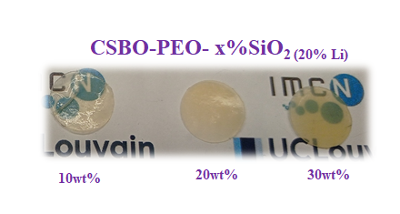
Figure S1: Picture of CSBO-PEO-SiO₂ electrolyte membranes with 20 wt% LiTFSI and loaded with different wt% of SiO₂ particles.

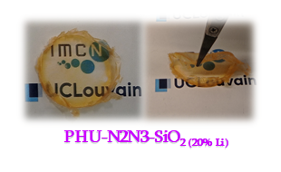
Figure S2: Picture of PHU-N2N3-SiO₂ electrolyte membrane with 20 wt% LiTFSI and 20 wt% of SiO₂ particles.

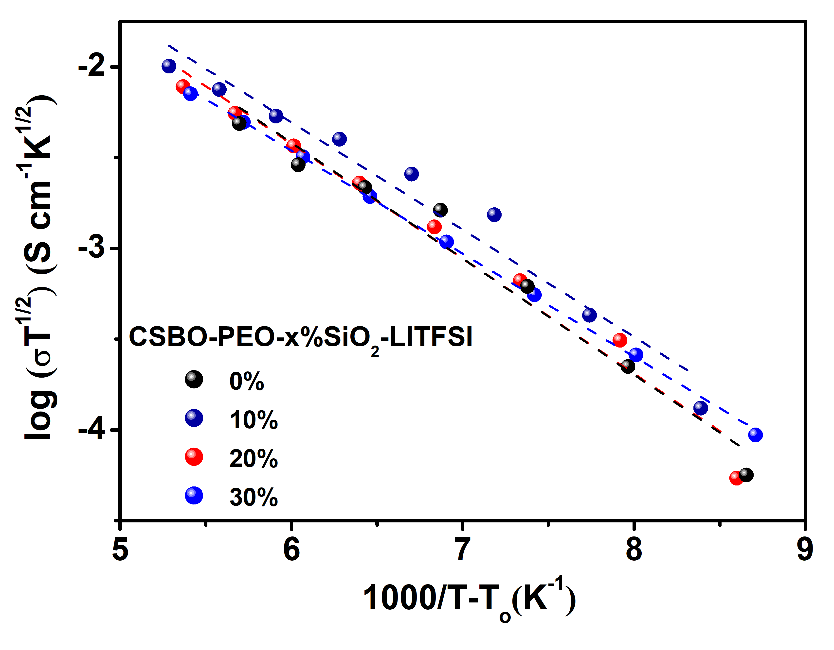
Figure S3: Temperature dependent ionic conductivity for investigated CPEs with VFT Model.

Figure S4: a) Survey spectrum, HR-XPS of b) Oxygen (O1s), and c) Nitrogen (N1s), at the surface lithium anode after cycling with LFP in Li|CSBO-PEO-SiO₂ CPE|LFP cell, respectively.

Table S1: Some macroscopic properties of the investigated electrolyte membrane (all loaded with 20 wt% LiTFSI). Adhesion has been qualitatively assessed during peeling off the electrolyte membrane from the mold after drying.
Sample | CSBO-PEO-10%SiO₂ | CSBO-PEO-20%SiO₂ | CSBO-PEO-30%SiO₂ | PHU-N2N3-20%SiO2
Physical nature | Gel-like | Soft solid | Rigid solid | Soft solid
Adhesion | Strong | Medium | Weak | Medium
Transparency | Transparent | Slightly hazy | Hazy | Transparent

