Supporting information
for
Palladium-Catalyzed Methoxycarbonylation of a Commodity CO₂-Sourced
δ-Valerolactone

Hussein Tabaja,ª Bruno Grignard,^{b} Christophe Detrembleur (ORCID: 0000-0001-7849-6796),^{b,c} Matthias Beller (ORCID: 0000-0001-5709-0965),^{d} Sophie M. Guillaume (ORCID: 0000-0003-2917-8657),^{a,*} Jean-François Carpentier (ORCID: 0000-0002-9160-7662)^{a,*}

ª Univ Rennes, CNRS, Institut des Sciences Chimiques de Rennes, F-35042 Rennes, France
^{b} Center for Education and Research on Macromolecules (CERM), CESAM Research Unit, University of Liege, Sart-Tilman B6a, 4000 Liege, Belgium
^{c} WEL Research Institute, Avenue Pasteur 6, 1300 Wavre, Belgium
^{d} Leibniz Institute for Catalysis e. V. at the University of Rostock, 18059 Rostock, Germany

Email: jean-francois.carpentier@univ-rennes.fr; sophie.guillaume@univ-rennes.fr

Table of Contents
General Conditions: Materials and methods, Instrumentation and measurements
Synthesis and characterization of EVP and compounds 6, 8, 11 and 12
List of Figures
Figure S1. ¹H, ¹³C{¹H}, and J-MOD NMR spectra of EVP (1).
Figure S2. ¹H, ¹³C{¹H}and J-MOD NMR spectra of dimethyl (Z)-2-ethylidene-5-methoxyoctanedioate (11).
Figure S3. ¹H-¹H COSY NMR spectrum of dimethyl (Z)-2-ethylidene-5-methoxyoctanedioate (11).
Figure S4. ¹H and ¹³C{¹H} NMR spectra of methyl (Z)-2-ethylidene-5-methoxyheptnoate (8-H₂).
Figure S5. ¹H-¹H COSY NMR spectrum of methyl (Z)-2-ethylidene-5-methoxyheptanoate (8-H₂).
Figure S6. ¹H and ¹³C{¹H} NMR spectra of methyl (Z)-2-ethylideneheptanoate (7-H₄).
Figure S7. ¹H NMR spectrum of the crude product 6 obtained from the methanolysis reaction of EVP.
Figure S8. ¹H NMR spectrum of compound 12 obtained from the hydrolysis reaction of EVP.
Figure S9. ¹H NMR spectra of the isolated compound 11 and of the crude reaction mixture (Table 1, entry 18).
Figure S10. Representative GC-MS trace (top) of an alcoholysis reaction of EVP and mass spectra (MS-EI) of the resulting product; compound 6.
Figure S11. Representative GC-MS trace of a crude reaction mixture (Table 1, entry 18) and mass spectra (MS-EI) of compounds 6-11 and 1/2.
Figure S12. GC-MS trace and mass spectrum (MS-EI, bottom) of isolated compound 11.
Figure S13. Details of the high resolution ESI-mass spectrum of a crude reaction mixture (Table 1, entry 18) showing signals for compounds 6, 2/3, 4 and 11.
Figure S14. Details of the high resolution ESI-mass spectrum of a crude reaction mixture (Table 1, entry 18) showing major signals for compound 11 and minor signals for compounds 8 and 10.
Figure S15. GC-MS trace of the crude reaction mixture (entry HT-90) resulting from the subsequent hydrogenation of a carbonylation reaction mixture (entry HT-87) and mass spectra (MS-EI) of compounds 6-H₂, 7-H₄, 8-H₂, 9-H₂ and 10-H₂.
Figure S16. Details of the high resolution ESI mass spectrum of the fourth fraction product resulting from the subsequent hydrogenation (entry HT-90) of a carbonylation reaction mixture (entry HT-87) showing major signals for compound 10-H₂.
Figure S17. GC-MS trace (top) of the fifth fraction obtained from column chromatography of the crude reaction mixture (entry HT-90) resulting from the subsequent hydrogenation of a carbonylation reaction mixture (entry HT-87) and mass spectra (MS-EI, bottom) of compounds 11-H₂ and 11.
Figure S18. Details of the high resolution ESI mass spectrum of the fifth fraction product resulting from the subsequent hydrogenation (entry HT-90) of a carbonylation reaction mixture (entry HT-87) showing major signals for compound 11 and minor signal for compound 11-H₂.
Scheme S1. Proposed “Pd-hydride” mechanism for the formation of 11 from EVP via the intermediacy of allyl ether 8 (L = py^{t}bpx).
Scheme S2. Ethoxycarbonylation of EVP showing the main products formed, as determined by NMR, GC-MS and ESI-HRMS (same conditions as Table 1, entry 18, using EtOH).
Figure S19. GC-MS trace of a crude reaction mixture resulting from the ethoxycarbonylation of EVP (same conditions as Table 1, entry 18, using EtOH) and mass spectra (MS-EI) of compounds 7-OEt, 6-OEt, 8-OEt, 10-OEt, and 11-OEt.
Figure S20. Details of the ESI-high resolution mass spectrum of a crude reaction mixture resulting from the carbonylation of compound 8-OEt (Scheme S2).
Figure S21. ¹H NMR spectrum (400 MHz, CDCl₃, 25 °C) of compound 8-OEt (Scheme S2).

General conditions
Materials and methods
All catalytic experiments were performed under an inert argon atmosphere using standard Schlenk line and/or in a dry, solvent‐free glovebox (Jacomex; O₂ < 1 ppm, H₂O < 3 ppm). All palladium precursors (Pd₂(dba)₃, Pd(acac)₂, Pd(OAc)₂, PdCl₂) and Pd/C (10 wt% Pd on C) were purchased from Aldrich or Strem Chem. and used as received. CO (CO₂ < 1 ppm, H₂ < 1 ppm, O₂ < 5 ppm and H₂O < 3 ppm), CO₂ (CO < 2 ppm, H₂ < 1 ppm, O₂ < 10 ppm and H₂O < 1 ppm) and H₂ gas bottles were purchased form Air Liquid Co. Commercially available phosphine ligands (PPh₃, 2-PyPPh₂, xantphos, 1,2-bis(di-tert-butylphosphinomethyl)benzene (1,2-DTBPMB) and tris(2-methoxyphenyl)phosphine (TOMPP) were all purchased and used as received. 1,2-Bis((tert-butyl(pyridin-2-yl)phosphanyl)methyl)benzene (py^{t}bpx, “LikatPhos”) was generously provided by LIKAT, Rostock, Germany. Toluene and acetonitrile were dried by distillation over calcium hydride (CaH₂) under an argon atmosphere, stored over activated 3Å or 4Å molecular sieves, and thoroughly degassed by multiple freeze–pump–thaw cycles prior to use. Methanol was distilled over Mg turnings under argon atmosphere and kept over activated 3–4 Å molecular sieves. NaOMe, NaOtBu and KOMe were prepared from the corresponding metal and alcohol, respectively. PTSA (para-toluenesulfonic acid) was dried using Dean-Stark technique and toluene. 2-Ethylidene-6-hepten-5-olide (EVP) was synthesized from 1,3-butadiene and CO₂ according to the reported procedures, and recovered as a pale yellowish oil after purification by column chromatography over silica (petroleum ether/EtOAc = 9:1 v/v).

Instrumentation and measurements
¹H (400 MHz) and ¹³C{¹H} (101 MHz) NMR spectra were recorded on a Bruker Avance AM Ascend 400 spectrometer in CDCl₃ at 25 °C, and referenced internally relative to SiMe₄ (δ 0 ppm) using the residual solvent resonances. Chemical shifts and coupling constants are reported in ppm and Hertz (Hz), respectively.
Mass spectra were recorded at CRMPO-ScanMAT (Rennes, France). High-resolution ESI mass spectra were recorded on an orbitrap type Thermo Fisher Scientific Q-Exactive instrument with an ESI source in positive mode by direct introduction of sample solutions prepared in CH₂Cl₂ or CH₃OH/CH₂Cl₂ (9:1 v/v) at ca. 5–10 mg mL⁻¹ with CF₃CO₂Na or NaI as cationizing agent (as a 10 mg mL⁻¹ solution in MeOH).
EVP conversions in carbonylation experiments were calculated from ¹H NMR spectra of samples of the crude reaction mixtures in CDCl₃ by using the integration (Int.) ratio [Int.product]/[Int.EVP] of the COO-CH methine (δ 4.78 ppm).
GC analyses were performed with a GC-2014 (Shimadzu) 2010 apparatus equipped with a 30-m capillary column (Supelco, SPBTM-20, fused silica capillary column, 30 m⊆0.25 mm⊆0.25 mm film thickness), using nitrogen/air as vector gas.
GC-MS analyses were performed with a GCMS-QP2010S (Shimadzu) apparatus equipped with a 30-m capillary column (Supelco, SLBTM-5ms, fused silica capillary column, 30 m⊆0.25 mm⊆0,25 mm film thickness), using helium as gas vector. The following GC conditions were used: initial temperature 80 °C for 2 min, then rate 10 °C min⁻¹ until 225 °C and 225 °C for 15 min.

Synthesis and characterization of EVP (1).¹
In the glove box, Pd₂(dba)₃ (12.8 mg, 0.014 mmol) and tris(o-methoxyphenyl) phosphine (TOMPP, 29.0 mg, 0.042 mmol) were loaded into a dry Schlenk flask equipped with a magnetic stir bar. On a Schlenk line, dry acetonitrile (30 mL) was syringed into the flask and the mixture was stirred until it completely dissolved. The resulting solution was cannulated into a degassed high-pressure, stainless-steel 50 mL-reactor equipped with a magnetic stir bar. Liquefied 1,3-butadiene (5.0 mL, 55.5 mmol) was added to the reactor at ‒78 °C using a metallic cannula. The reactor was closed and allowed to warm to room temperature and then pressurized with 30 bars of CO₂. The reaction mixture was magnetically stirred at 80 °C for 16 h. After cooling to room temperature, the reactor was vented to atmospheric pressure and volatiles were removed under vacuum. The brown crude residue was purified through a silica column (petroleum ether/EtOAc = 9:1 v/v) to give 3-ethylidene-6-vinyltetrahydro-2H-pyran-2-one (EVP, 1) as a pale-yellow oil (2.1 g, 50% yield). GC-MS: m/z = 152 (M^{.+}). ¹H NMR (400 MHz, CDCl₃, 25 °C): δ 7.13 (qt, J = 7.3 and 2.5, 1H), 5.88 (ddd, J = 17.3, 10.6 and 5.4, 1H), 5.34 (dt, J = 17.2 and 1.3, 1H), 5.23 (dt, J = 10.6 and 1.3, 1H), 4.82–4.72 (m, 1H), 2.65–2.53 (m, 1H), 2.50–2.36 (m, 1H), 2.11–1.99 (m, 1H), 1.83–1.69 (m, 5H). ¹³C{¹H} NMR (101 MHz, CDCl₃, 25 °C): δ 166.14 (C9), 141.00 (C7), 135.77 (C2), 125.89 (C6), 116.68 (C1), 78.82 (C3), 27.47 (C4), 21.83 (C5), 14.00 (C8) (Figure S1).

General procedure for the hydroesterification reaction of EVP (1).
In a typical experiment (Table 1, entry 18), under an inert atmosphere, the palladium precursor (Pd(OAc)₂, 4.5 mg, 0.020 mmol), the ligand (py^{t}bpx, “LikatPhos”, 9.6 mg, 0.022 mmol) and the additive (PTSA, 13.8 mg, 0.080 mmol) were loaded into a pre-dried Schlenk flask. In a separate Schlenk flask, a solution of the functionalized cyclic ester (EVP, 0.60 g, 4.0 mmol) in toluene (2 mL) and methanol (2 mL) was prepared, and degassed by freeze-pump-thaw. The deoxygenated EVP solution was then transferred via cannula to the flask containing the catalyst precursors, ensuring complete dissolution under stirring. The resulting solution was subsequently transferred to a pre-dried stainless steel 50 mL-autoclave using a stainless-steel cannula. The autoclave was purged with carbon monoxide (CO) gas three times to ensure an inert CO atmosphere and then pressurized to 40 bars. The reaction mixture was then stirred at the desired temperature for the specified duration. After the desired reaction time, the reactor was cooled to room temperature, vented, and the reaction mixture was analyzed by GC and GC-MS. An aliquot was sampled, dried under vacuum at room temperature and the oily residue was analyzed by NMR spectroscopy.

Isolation and characterization of dimethyl (Z)-2-ethylidene-5-methoxyoctanedioate (11).
The reaction was performed as described above at 100 °C for 22 h. The resulting brown crude oily residue was purified through a silica column (petroleum ether/EtOAc = 9:1 v/v) to recover in the fourth fraction pure dimethyl (Z)-2-ethylidene-5-methoxyoctanedioate (11) as a yellow oil (50 mg, 10% yield, unoptimized as 11 was also present in other fractions but in lower purity). ¹H NMR (400 MHz, CDCl₃, 25 °C): δ 6.85 (q, J = 7.1, 1H, -C=CH-CH₃), 3.72 (s, 3H, CH₃O-CO-C), 3.67 (s, 3H, CH₃O-CO-CH₂), 3.31 (s, 3H, CH₃O-CH), 3.20 (m, 1H, -CH-OCH₃), 2.38 (m, 4H, CH₂-CH₂-CH), 1.80 (d, J = 3.3, 3H, CH₃-CH=C + m, 2H, COCH₂), 1.56 (m, 2H, CH₂-C-CO). ¹³C{¹H} NMR (101 MHz, CDCl₃, 25 °C): δ 174.33 (C1), 168.32 (C2), 137.78 (C3), 132.99 (C4), 79.43 (C5), 56.39 (C6), 51.73 (C7), 51.67 (C8), 32.27 (C9), 29.94 (C10), 28.44 (C11), 22.15 (C12), 14.27 (C13) (Figures S2,S3). GC-MS(EI): ret. time = 10.625 min, m/z = 226 (M^{.+} ‒ MeOH) (Figure S11). HRMS-ESI: m/z(exp) = 281.1361 vs m/z(calcd for C₁₃H₂₂O₅Na, [M+Na]^{•+}) = 281.1365 (0 ppm) (Figure S13).

Synthesis of methyl (Z)-2-ethylidene-5-hydroxyhept-6-enoate (6).
EVP (1.00 g, 6.5 mmol) was dissolved in methanol (5 mL) with of NEt₃ (0.33 g, 3.25 mmol) and reﬂuxed at 70 °C for 24 h. Volatiles were removed by rotary evaporation, and the target product 6 was obtained with an 80.6% conversion as determined by ¹H NMR. The product was purified by column chromatography (petroleum ether/EtOAc = 9:1 v/v) and recovered as a colorless oil. GC-MS: m/z = 184 (M^{•+}, 4%). ¹H NMR (400 MHz, CDCl₃, 25 °C): δ 6.90 (q, J = 7.1, 1H, CH₃-CH=C), 5.95–5.88 (m, 1H, CH₂=CH-C(OH)H), 5.26 (d, J =17.2, 1H, CH₂=CH-C(OH)H), 5.10 (d, J = 9.0, 1H, CH₂=CH-C(OH)H), 4.07 (q, J = 9.5, 1H, CH-CH(OH)), 3.74 (s, 3H, CH₃-OCO), 2.43 (t, J = 7.6, 2H, CH₂-CH₂-C), 1.82 (d, J = 7.1, 3H, CH₃-CH=C), 1.62 (m, 2H, CH(OH)-CH₂-CH₂) (Figure S7). GC-MS(EI): ret. time = 8.037 min, m/z= 184 (M^{•+}, 3%) (Figure S10). HRMS-ESI (Na⁺): m/z(exp) = 207.0993 vs m/z(calcd for C₁₀H₁₆O₃Na, [M+Na]^{•+}) = 207.0997 (0 ppm) (Figure S12).

Synthesis of (Z)-2-ethylidene-5-hydroxyhept-6-enoic acid (12).
Sodium (0.138 g, 6.0 mmol) and EVP (0.912 g, 6.0 mmol) were dissolved in methanol (20 mL) and stirred at 70 °C for 15 h. After cooling to room temperature, the reaction mixture was concentrated under reduced pressure, and the residue was taken up in water (5 mL) and extracted with diethyl ether (3 × 20 mL). The aqueous phase was then acidified with concentrated hydrochloric acid (HCl) to reach pH = 2 and extracted again with diethyl ether (3 × 10 mL). The combined ether phases were washed with water and dried over anhydrous sodium sulfate. The product was recovered as a yellow oil (0.885 g, 87% yield). ¹H NMR (400 MHz, CDCl₃, 25 °C): δ 6.97 (q, J = 7.2, 1H, CH₃-CH=C), 5.78–5.68 (m, 1H, CH₂=CH-C(OH)H), 5.13 (dd, J = 8.9, 1H, CH₂=CH-C(OH)H), 4.95 (dd, J = 8.9, 1H, CH₂=CH-C(OH)H), 3.93–3.86 (m, 1H, CH-CH(OH)), 2.41 (t, J = 7.8, 2H, CH₂-CH₂-C), 1.63–1.54 (m, 2H, CH(OH)-CH₂-CH₂), 1.39 (d, J = 7.2, 3H, CH₃-CH=C) (Figure S8). HRMS-ESI: m/z(exp) = 193.0833 vs m/z(calcd for C₉H₁₄O₃Na, [M+Na]^{•+}) = 193.0841 (1 ppm).

Synthesis of methyl (Z)-2-ethylidene-5-methoxyhept-6-enoate (8).
The synthesis of 8 was performed as reported in the literature;³ the compound was recovered as a 93:7 mixture of 8 and EVP after column chromatography. GC-MS: m/z =198 (M^{•+}, 2%) (Figure S10). HRMS-ESI: m/z(exp) = 221.1146 vs m/z(calcd for C₁₁H₁₈O₃Na, [M+Na]^{•+}) = 221.1153 (1 ppm) (Figure S14). ¹H and ¹³C NMR data were identical to those reported earlier.³

Dimethyl 7-ethylideneoct-3-enedioate (10). Spectral data for this compound were similar to those reported in the literature. GC-MS(IE) and HRMS-ESI mass spectra are described in Figures S11 and S14, respectively.

Procedure for hydrogenation reaction of crude carbonylation mixtures.
Under an inert atmosphere, a suspension of Pd/C (10 wt% Pd on C, 12.5 mg, 2 mol% Pd vs substrate) was prepared by dispersion in methanol (20 mL). This catalyst suspension was then transferred via cannula to a separate Schlenk flask containing the crude hydroesterification reaction mixture (1.5 g, 6.0 mmol). The mixture was subsequently introduced into a pre-dried stainless steel 50 mL-autoclave using a stainless-steel cannula. The autoclave was purged with H₂ three times to eliminate residual oxygen and then pressurized to 50 bars with H₂. The reaction mixture was stirred at room temperature for 20 h. After cooling to room temperature, the reactor was vented to atmospheric pressure and all volatiles were removed under vacuum. The brown crude residue was purified through a silica column (petroleum ether/EtOAc = 9:1 v/v) to give 6 different fractions.

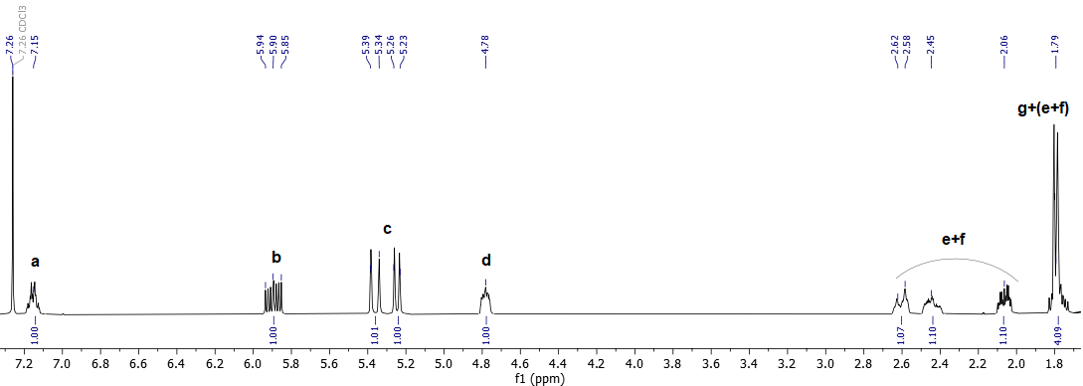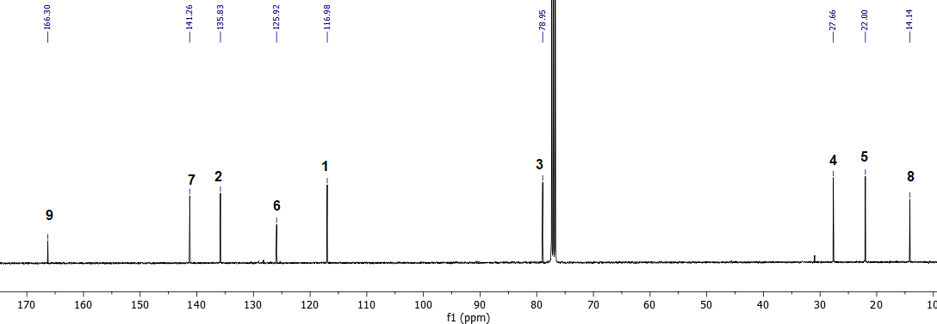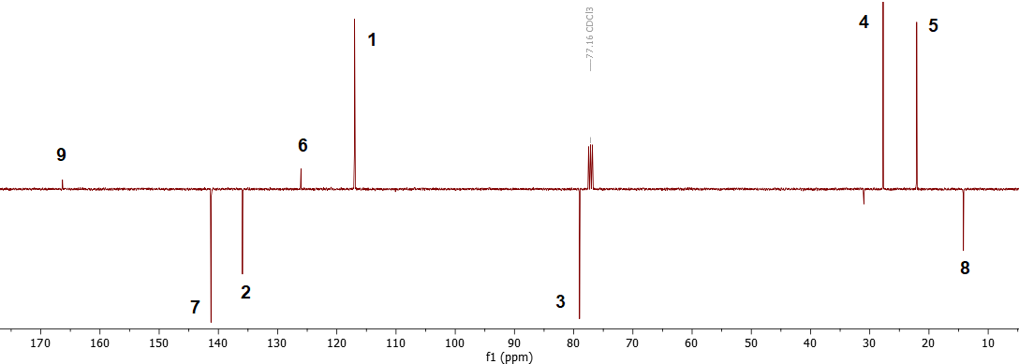
Figure S1. ¹H (400 MHz, CDCl₃, 25 °C), ¹³C{¹H} (101 MHz, CDCl₃, 25 °C), and J-MOD (125 MHz, CDCl₃, 25 °C) NMR spectra of EVP (1) (from top to bottom).

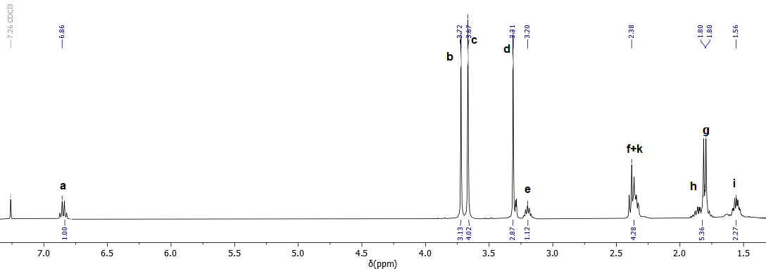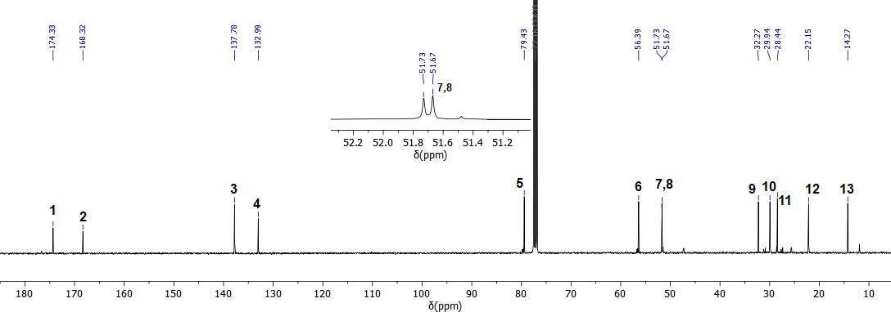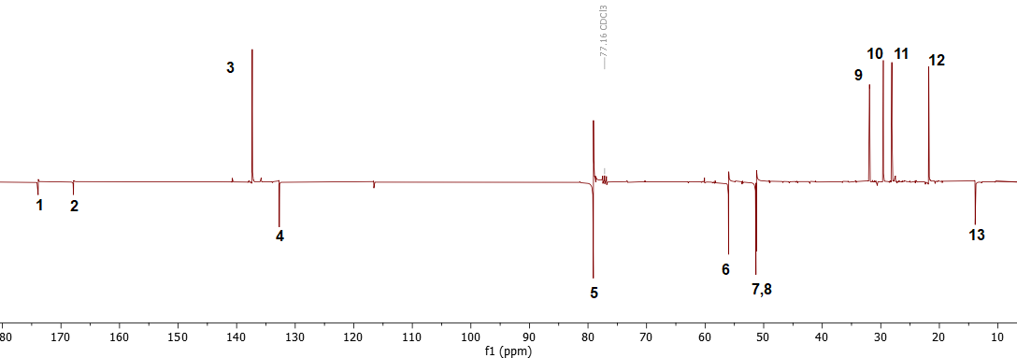
Figure S2. ¹H (400 MHz, CDCl₃, 25 °C), ¹³C{¹H} (101 MHz, CDCl₃, 25 °C) and J-MOD (125 MHz, CDCl₃, 25 °C) NMR spectra of dimethyl (Z)-2-ethylidene-5-methoxyoctanedioate (11) (from top to bottom).

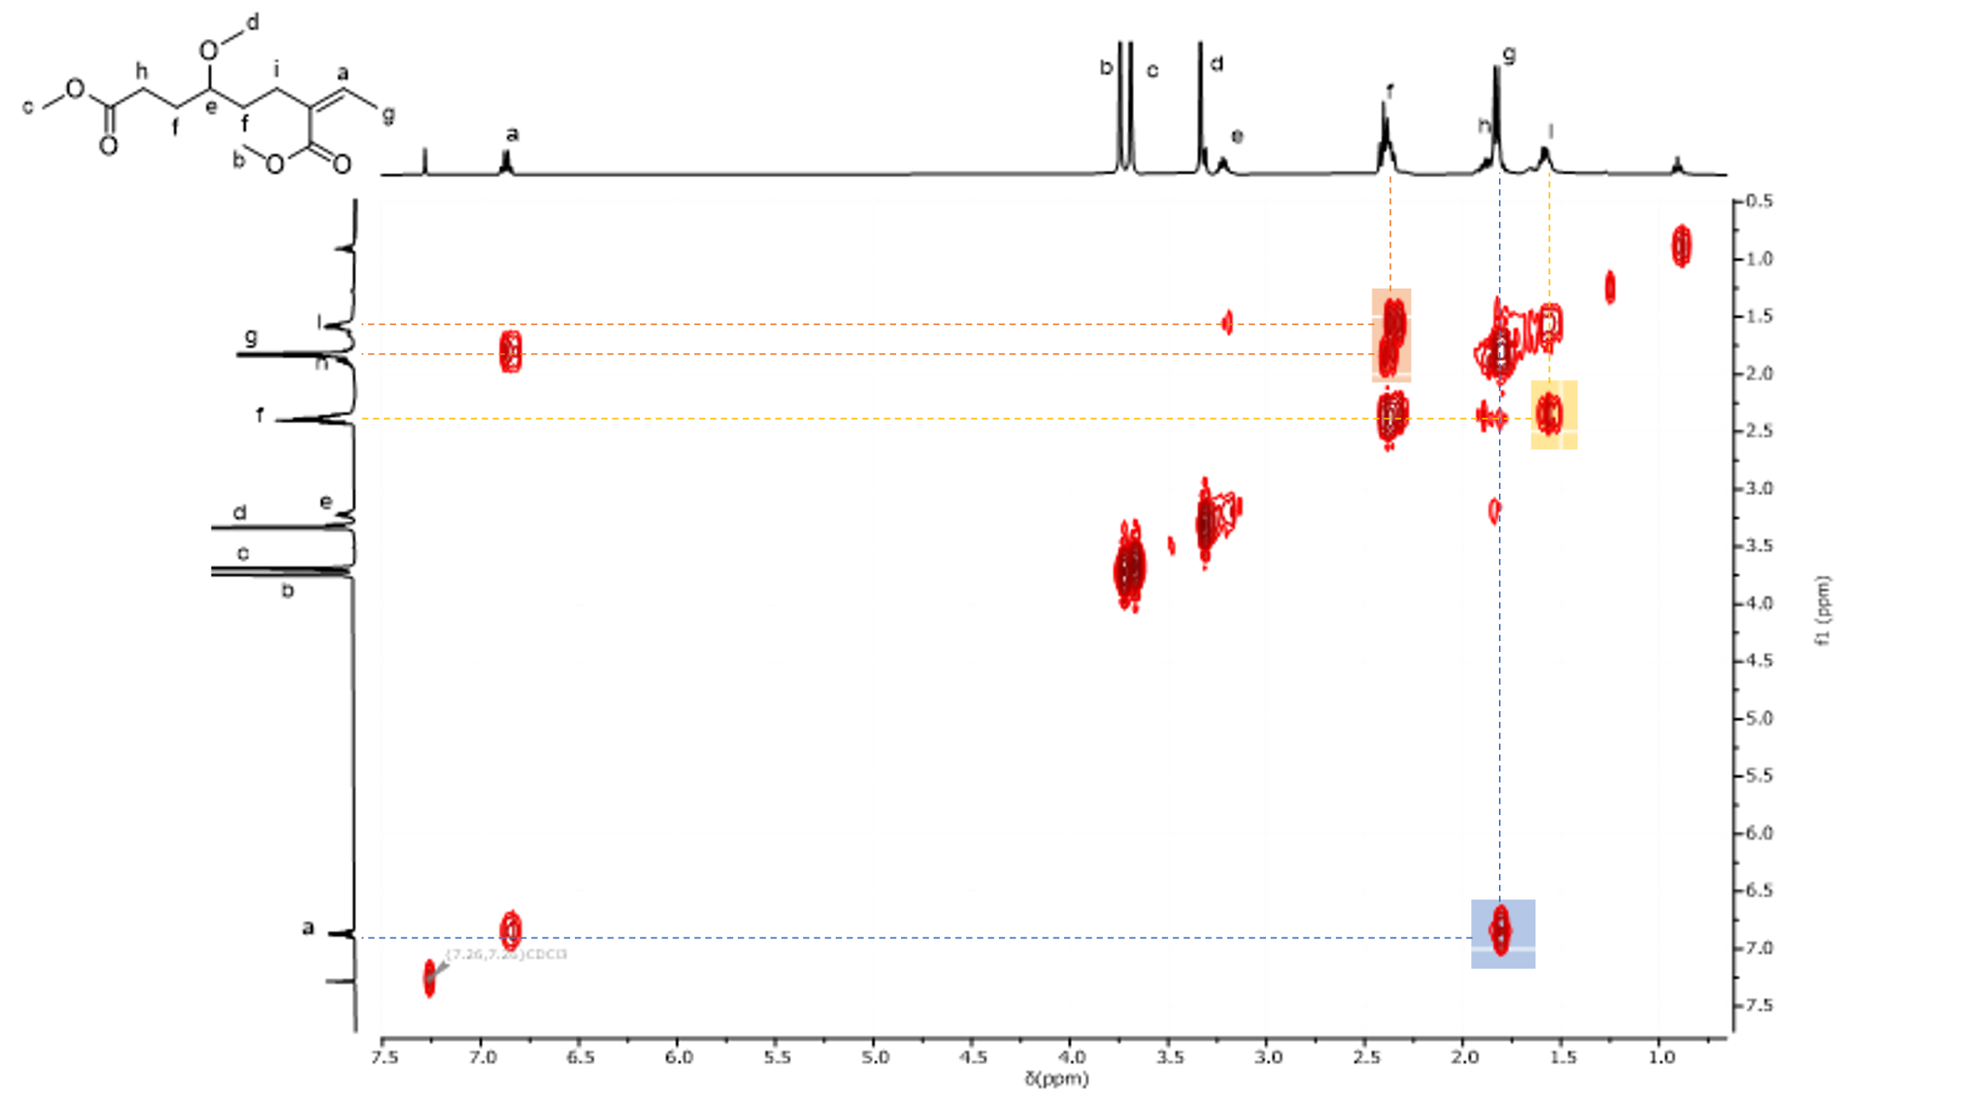
Figure S3. ¹H-¹H COSY NMR spectrum (400 MHz, CDCl₃, 25 °C) of dimethyl (Z)-2-ethylidene-5-methoxyoctanedioate (11).

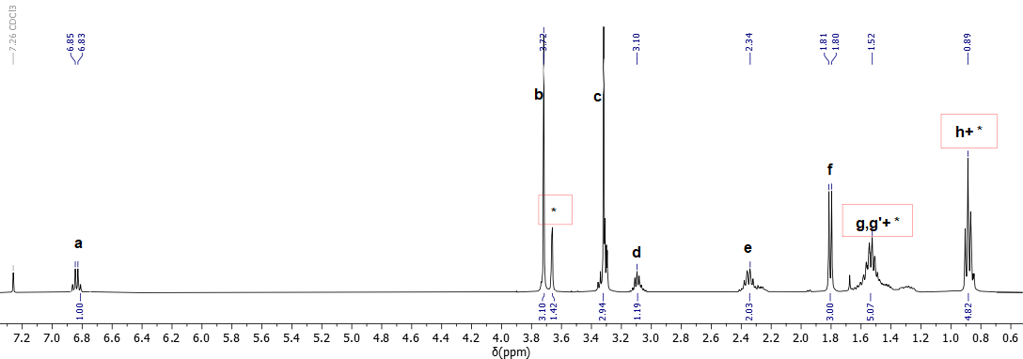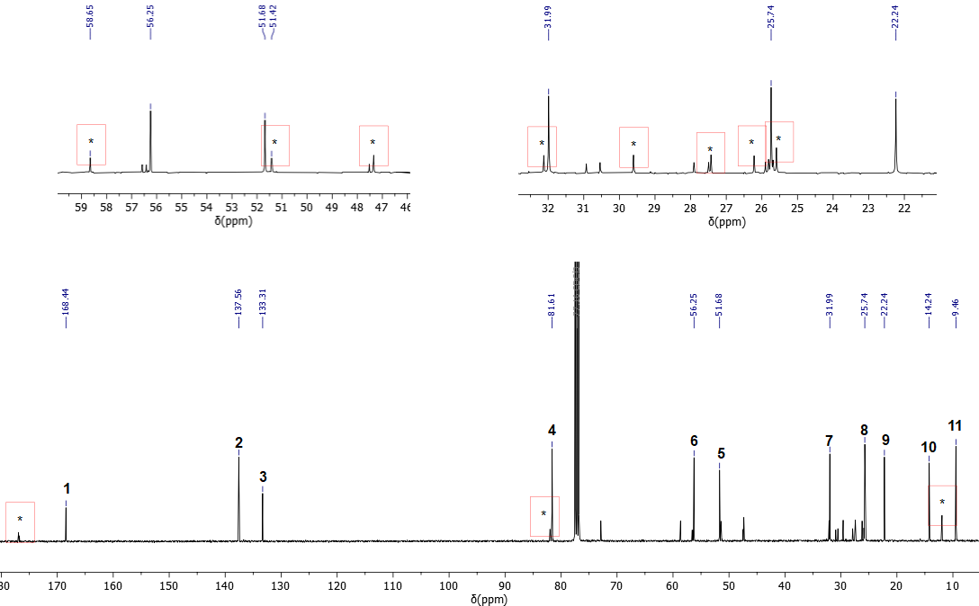
Figure S4. ¹H (400 MHz, CDCl₃, 25 °C) and ¹³C{¹H} (101 MHz, CDCl₃, 25 °C) NMR spectra of methyl (Z)-2-ethylidene-5-methoxyheptnoate (8-H₂) (from top to bottom) (small amounts of 8-H₄ are also observed).

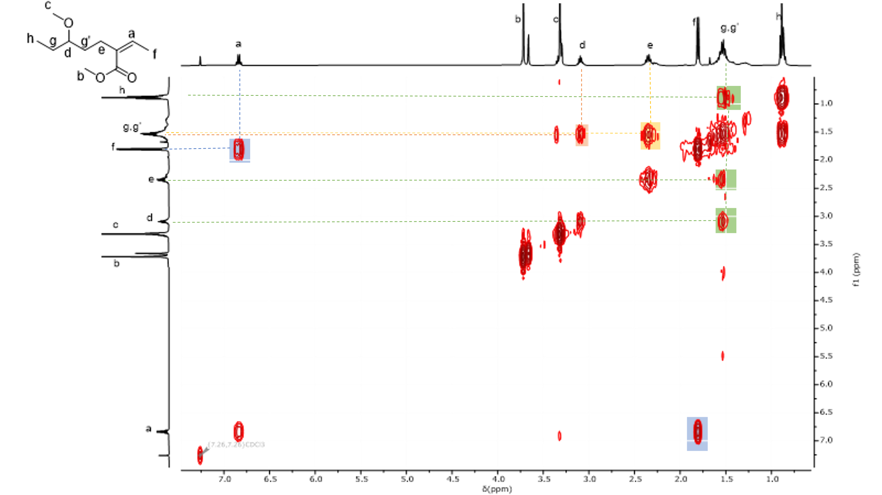
Figure S5. ¹H-¹H COSY NMR spectrum (400 MHz, CDCl₃, 25 °C) of methyl (Z)-2-ethylidene-5-methoxyheptanoate(8-H₂).

Figure S6. ¹H (400 MHz, CDCl₃, 25 °C) and ¹³C{¹H} (101 MHz, CDCl₃, 25 °C) NMR spectra of methyl (Z)-2-ethylideneheptanoate (7-H₂) (from top to bottom).
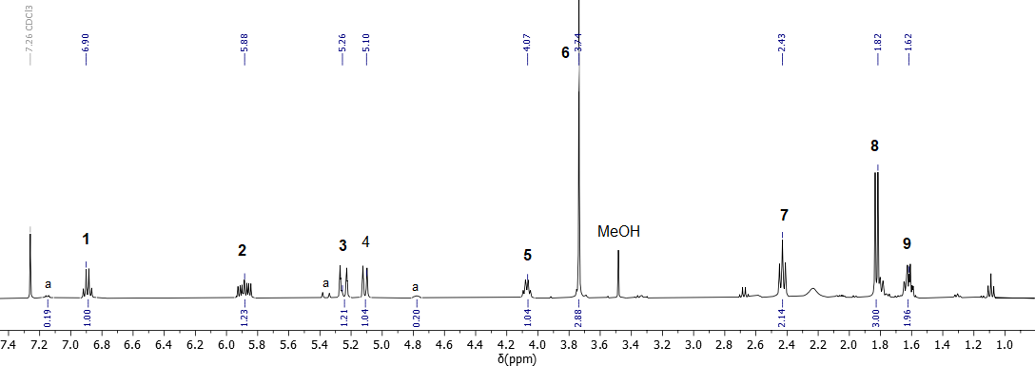
Figure S7. ¹H NMR spectrum (400 MHz, CDCl₃, 25 °C) of the crude product 6 obtained from the methanolysis reaction of EVP. The signals labeled a correspond to residual EVP in the mixture.

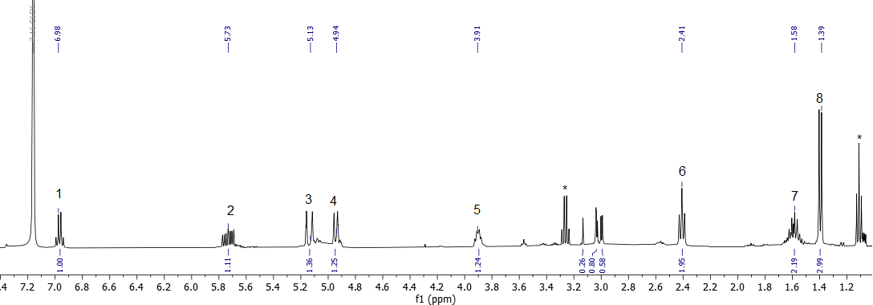
Figure S8. ¹H NMR spectrum (400 MHz, CDCl₃, 25 °C) of compound 12 obtained from the hydrolysis reaction of EVP. The signals labeled * correspond to residual diethyl ether solvent.

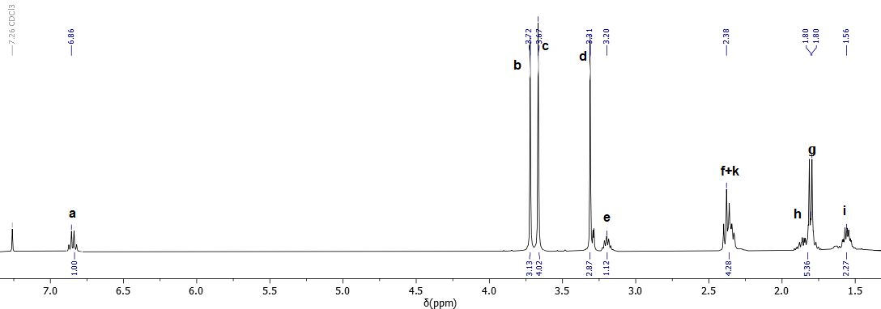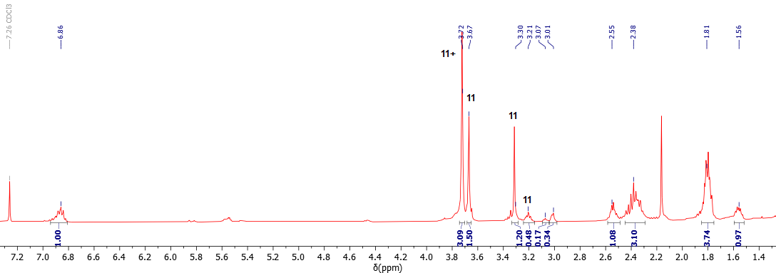
Figure S9. ¹H NMR spectra (400 MHz, CDCl₃, 25 °C) of the isolated compound 11 (top) and the crude reaction mixture (bottom) (Table 1, entry 18).

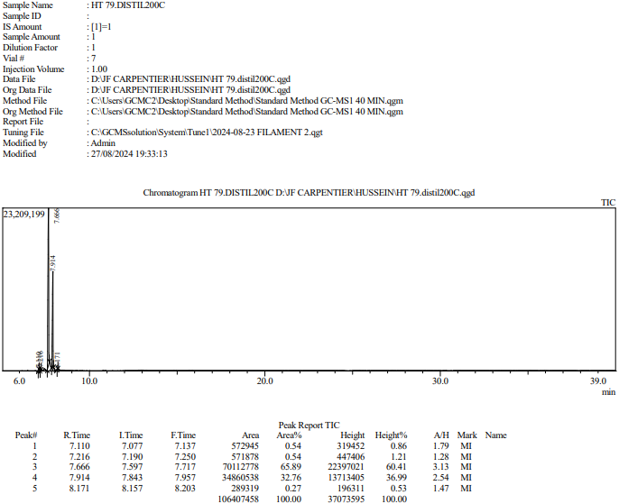
compound 6
EVP
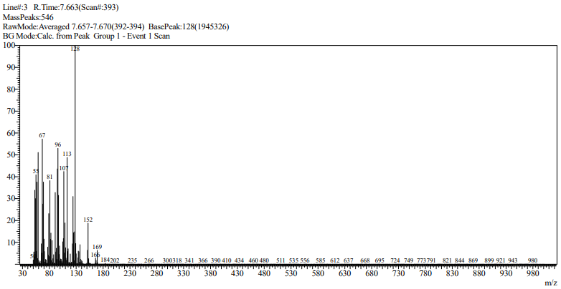
Figure S10. Representative GC-MS trace (top) of an alcoholysis reaction of EVP and mass spectra (MS-EI) of the resulting product; compound 6 (m/z = 184, M^{•+}).

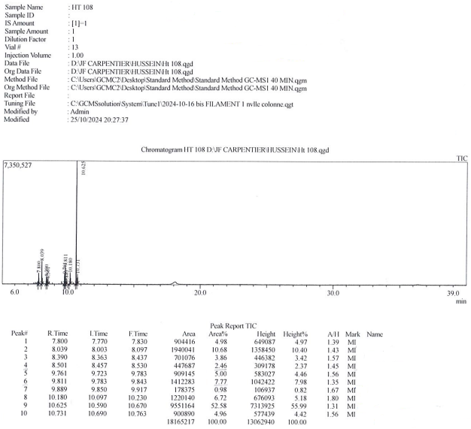
Compounds 9
Compound 1/2
Compounds 8
Compounds 10
Compound 7
Compound 11
Compound 6
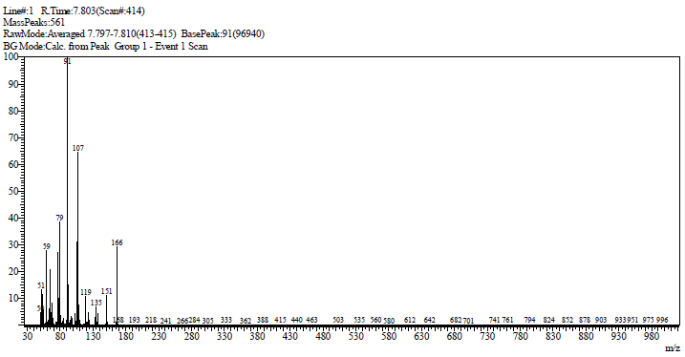
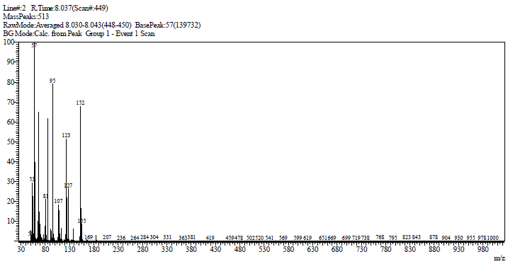
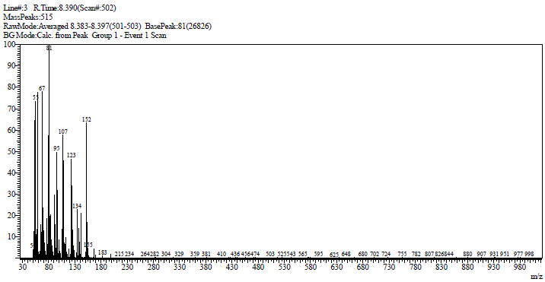
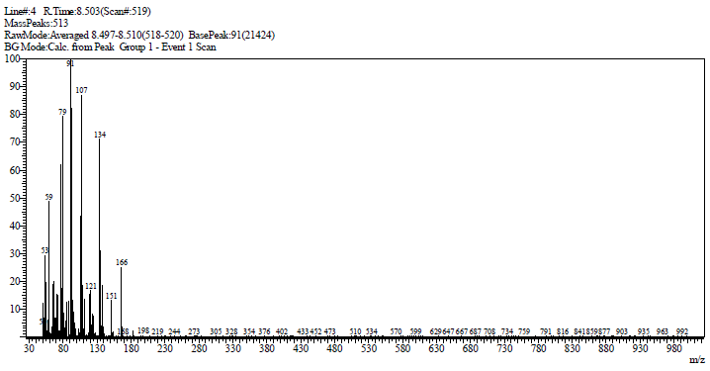
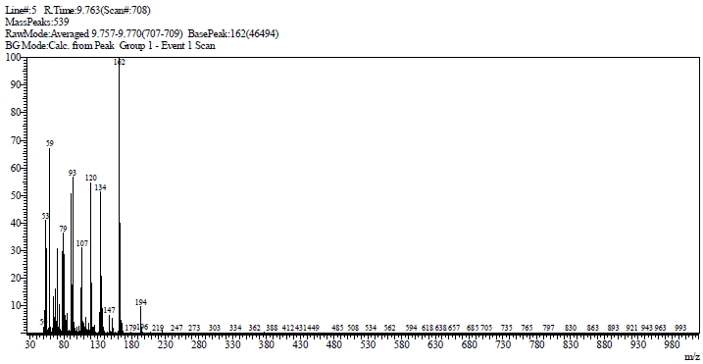
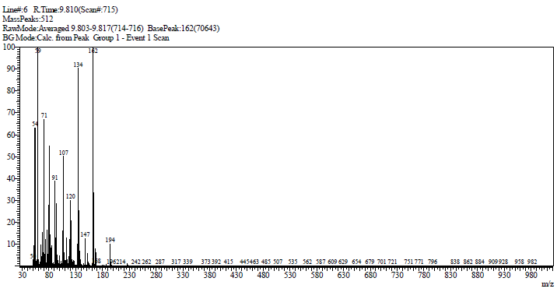
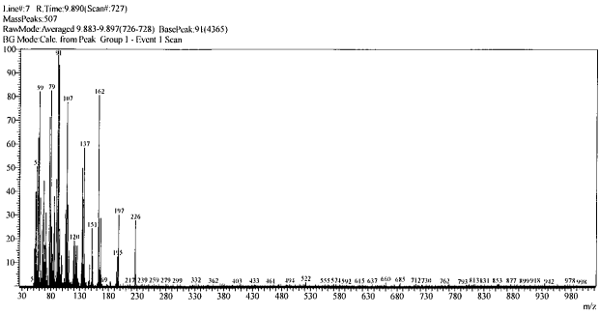
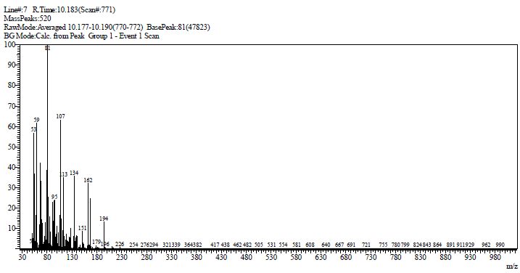
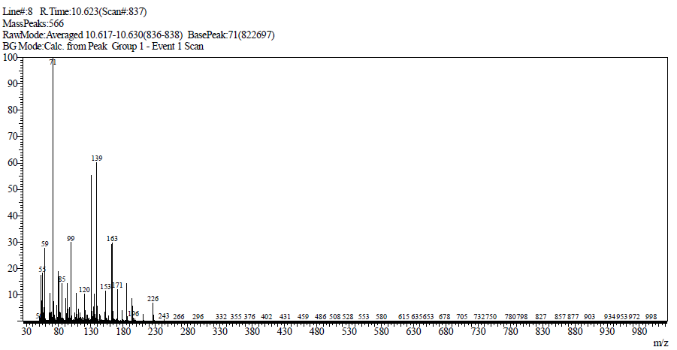
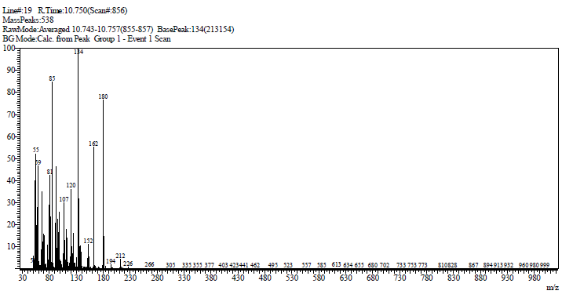Figure S11. Representative GC-MS trace (top) of a crude reaction mixture (Table 1, entry 18) and mass spectra (MS-EI) of compounds 7 (m/z = 166, M^{•+}), 6 (m/z = 184, M^{•+}), 8 (m/z = 198, M^{•+}), 9 (m/z = 194, M^{•+}), 10 (m/z = 226, M^{•+}), 11 (m/z_{theo} = 258, m/z_{obs} = 226, [M ‒ MeOH]^{•+}), and 1/2 (m/z = 212, M^{•+}) (from top to bottom).

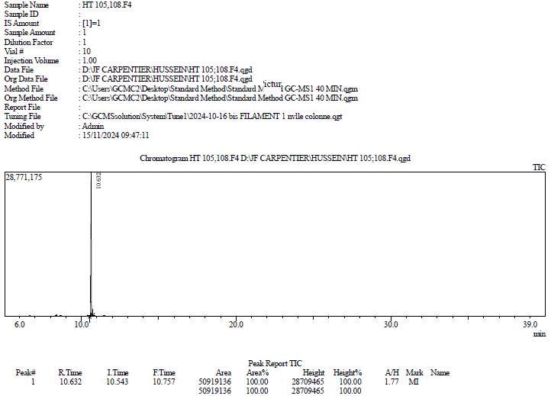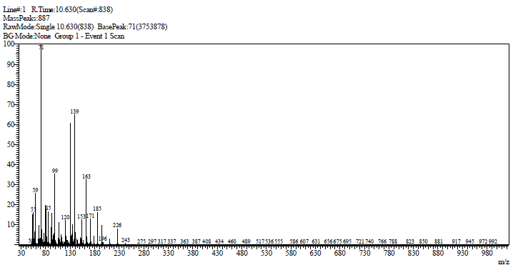
Compound 11

Figure S12. GC-MS trace (top) and mass spectrum (MS-EI, bottom) of isolated compound 11 (m/z_{theo} = 258, m/z_{obs} = 226, [M ‒ MeOH]^{•+}).

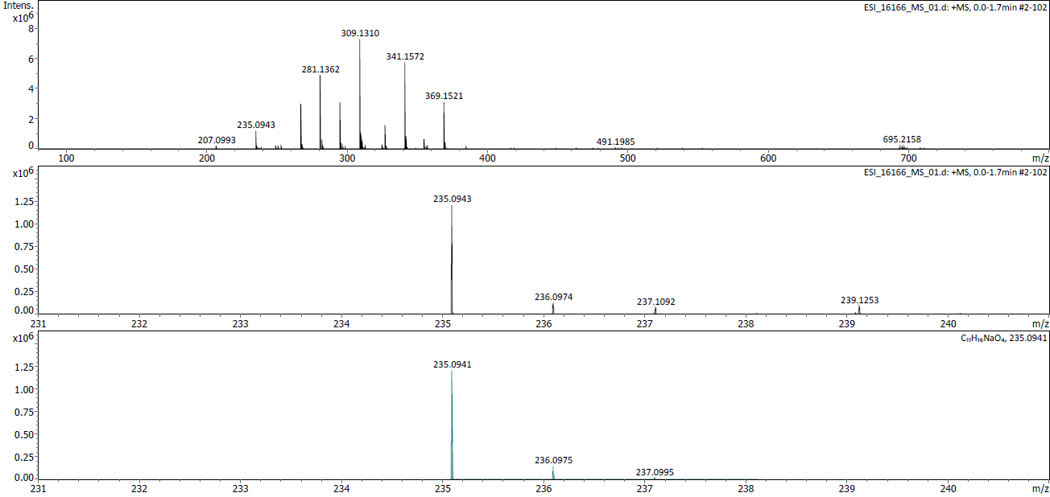
a)
b)
c)
6
3
2
11
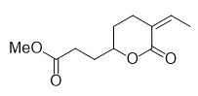
6
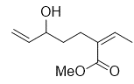
6
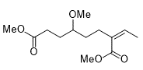
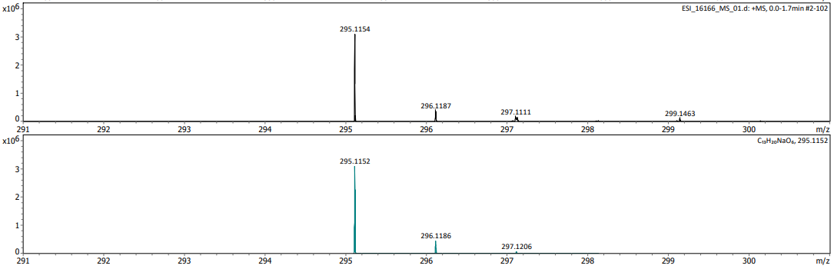
e)
d)
Figure S13. Details of the high resolution ESI-mass spectrum (CH₃OH/CH₂Cl₂, 9:1 v/v, Na⁺) of a crude reaction mixture (Table 1, entry 18) showing signals for compounds 6 (m/z = 207.0993), 2/3 (m/z = 235.0943), 11 (m/z = 281.1362) and 4 (m/z = 295.1154): (a) experimental spectrum for m/z = 100-800, (b) zoomed region for m/z = 235.0943 (compound 2/3, [M+Na]^{•+} = C₁₁H₁₆O₄Na), (c) calculated mass and isotopic distribution for C₁₁H₁₆O₄Na, (d) zoomed region for m/z = 295.1154 (compound 4, [M+Na]^{•+} = C₁₃H₂₀O₆Na), (e) calculated mass and isotopic distribution for C₁₃H₂₀O₆Na (from top to bottom),

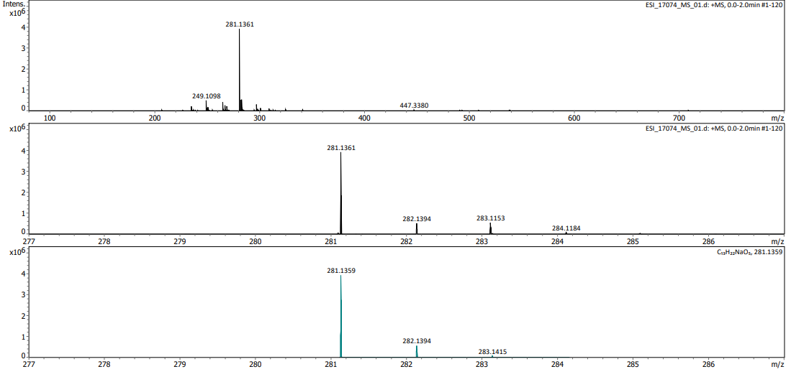
a)
b)
c)

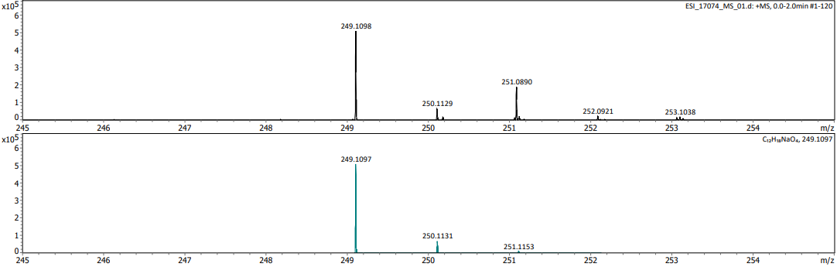
e)
d)
f)
g)
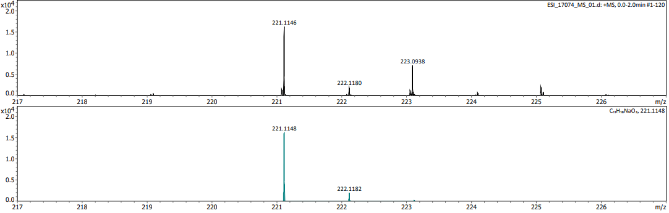

Figure S14. Details of the high resolution ESI-mass spectrum (CH₃OH/CH₂Cl₂, 9:1 v/v, Na⁺) of a crude reaction mixture (Table 1, entry 18) showing major signals for m/z = 281.1361 (compound 11, m/z = 281.1361, [M+Na]^{•+} = C₁₃H₂₂O₅Na): (a) experimental spectrum for m/z = 100‒800, (b) zoomed region for m/z = 281.1361, (c) calculated mass and isotopic distribution for C₁₃H₂₂O₅Na, (d) zoomed region of the experimental spectrum for m/z = 249.1098 (compound 10, [M+Na]^{•+} = C₁₂H₁₈O₄Na), (e) calculated mass and isotopic distribution for C₁₂H₁₈O₄Na, (f) zoomed region of the experimental spectrum for m/z = 221.1146 (compound 8, [M+Na]^{•+} = C₁₁H₁₈O₃Na), (g) calculated mass and isotopic distribution for C₁₁H₁₈O₃Na (from top to bottom).

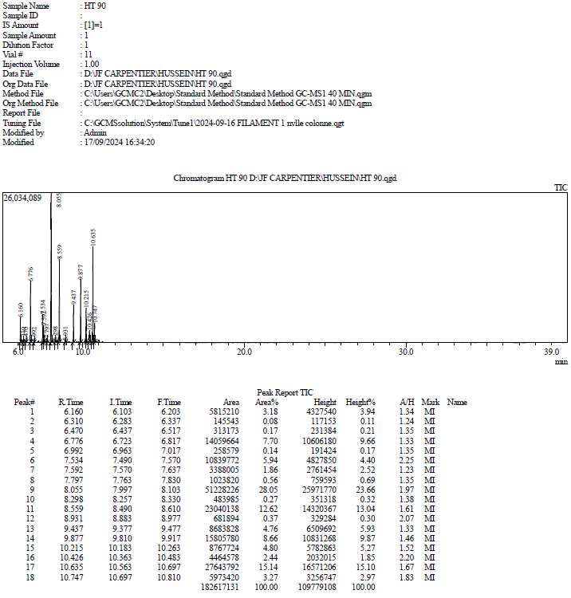
Compound 10.H2 or 11.H₂
Compound 7-H₄
Compound 6-H₂
Compounds 8-H₂
Compound 2 / 3
Compound 9-H₂
Compound 10
Compound 10-H₂
Compound 7
Compound 11
Compound 7-H₂
Compound 11-H₂
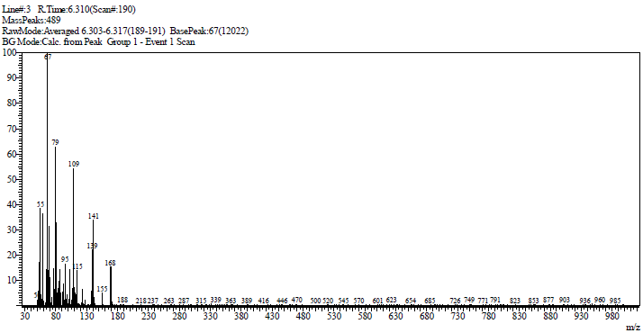
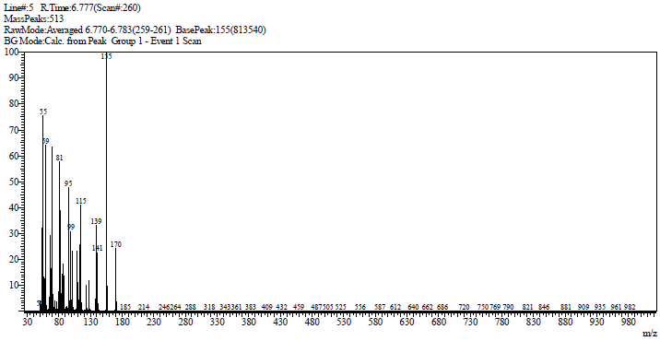
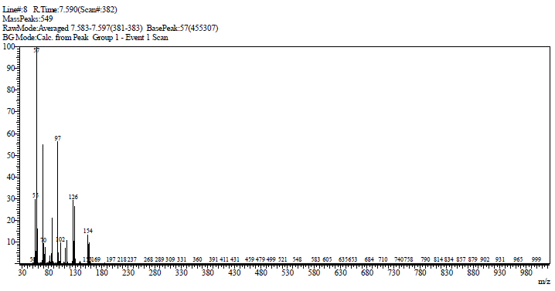
A
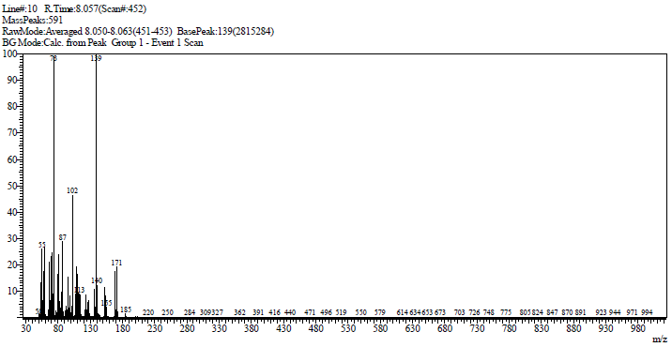
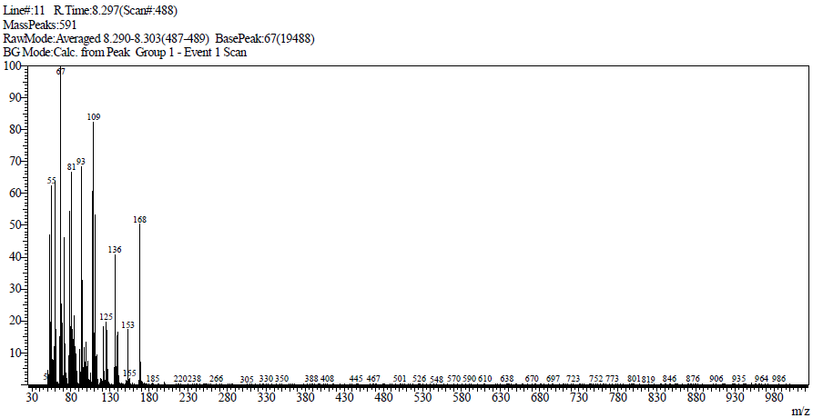
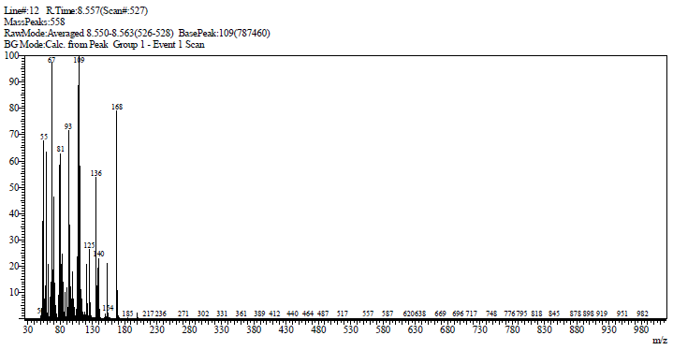

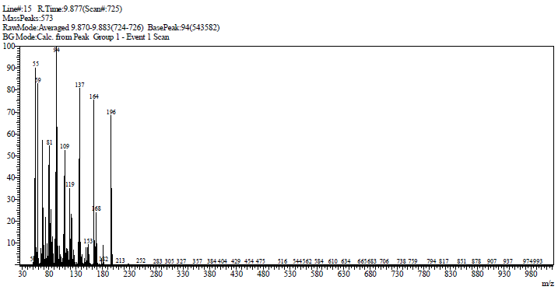
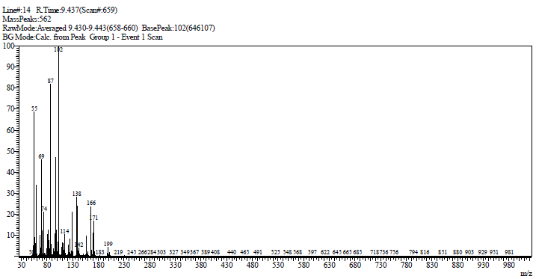
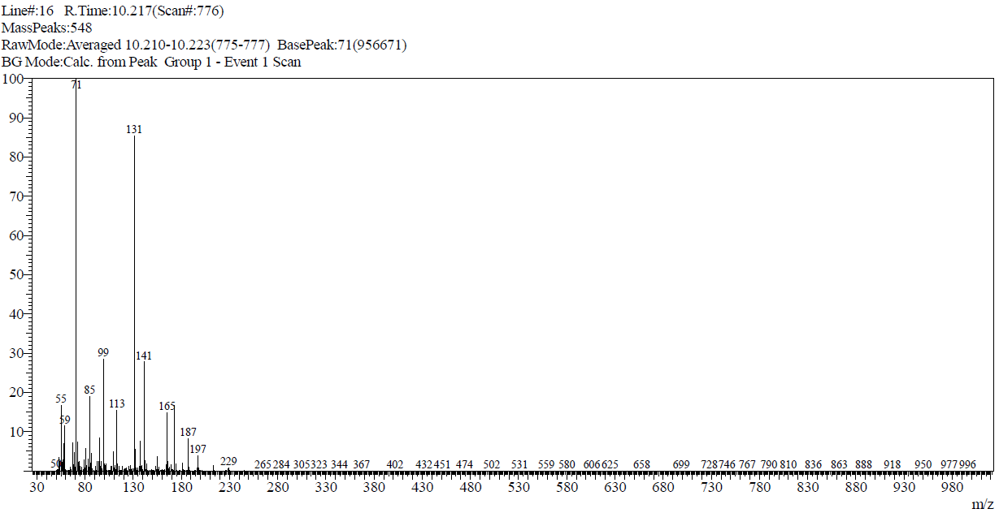
Figure S15. GC-MS trace (top) of the crude reaction mixture (entry HT-90) resulting from the subsequent hydrogenation of a carbonylation reaction mixture (entry HT-87) and mass spectra (MS-EI, bottom) of compounds 6-H₂ (m/z = 186, M^{•+}), 7-H₄ (m/z = 170, M^{•+}), 7-H₂ (m/z = 168, M^{•+}), 8-H₂ (m/z = 200, M^{•+}), 9-H₂ (m/z = 196, M^{•+}), 10-H₂ (m/z = 228, M^{•+}), and 11-H₂ (m/z = 260, [M ‒ MeO]^{•+}) (from top to bottom).

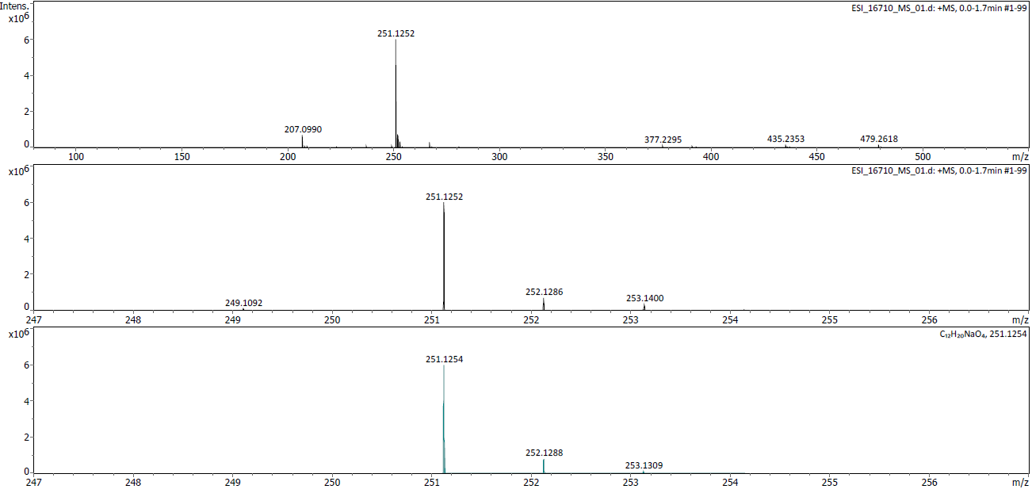
c)
b)
a)
Figure S16. Details of the high resolution ESI mass spectrum (CH₃OH/CH₂Cl₂, 9:1 v/v, Na⁺) of the fourth fraction product resulting from the subsequent hydrogenation (entry HT-90) of a carbonylation reaction mixture (entry HT-87) showing major signals for m/z = 251.1252 (compound 10-H₂, m/z = 251.1252, [M+Na]^{•+} = C₁₂H₂₀O₄Na),: (a) experimental spectrum for m/z = 100‒600, (b) zoomed region for m/z = 251.1252, (c) calculated mass and isotopic distribution for C₁₂H₂₀O₄Na (m/z = 251.1254)(from top to bottom).

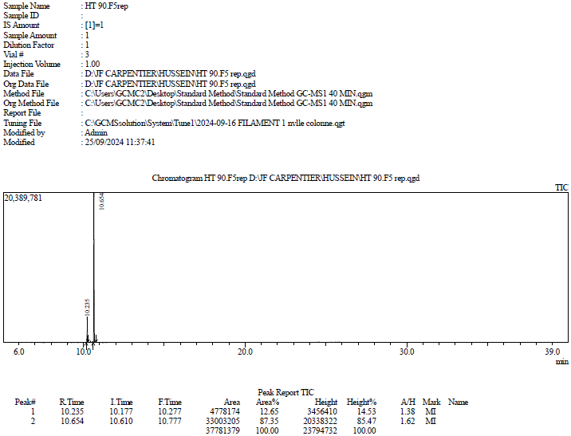
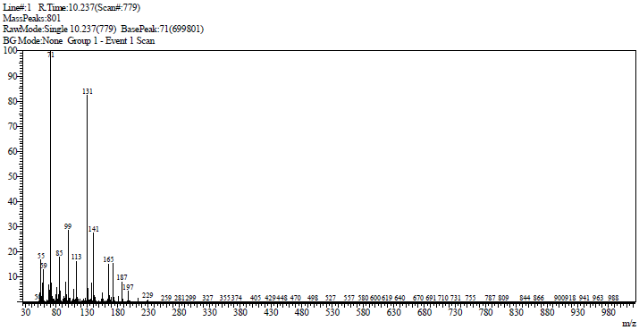
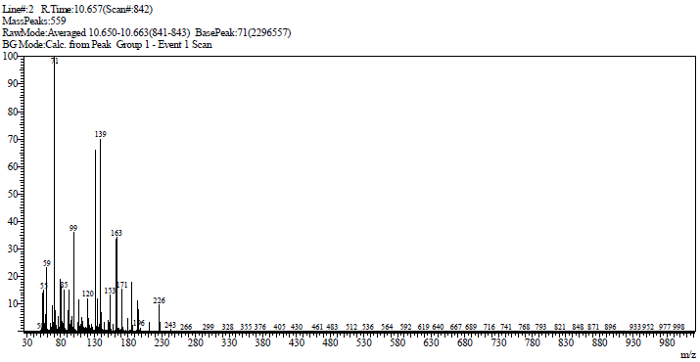
Figure S17. GC-MS trace (top) of the fifth fraction obtained from column chromatography of the crude reaction mixture (entry HT-90) resulting from the subsequent hydrogenation of a carbonylation reaction mixture (entry HT-87) and mass spectra (MS-EI, bottom) of compounds 11-H₂ (m/z_{theo} = 260, m/z_{obs} = 229, [M ‒ MeO]^{•+}) and 11 (m/z_{theo} = 258, m/z_{obs} = 226, [M ‒ MeOH]^{•+}) (from top to bottom).

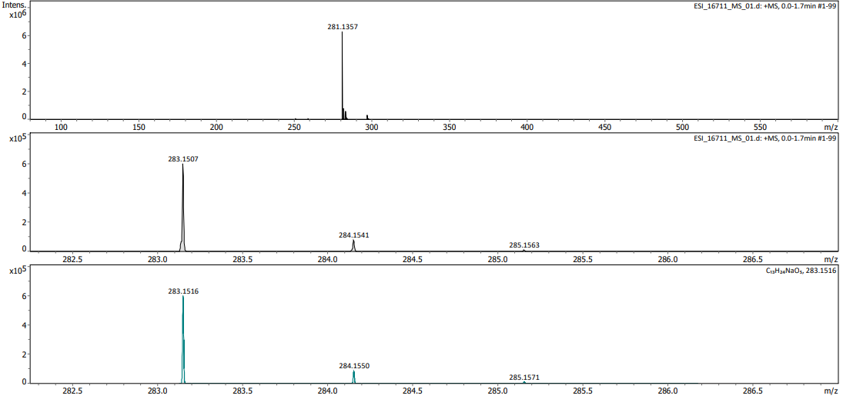
c)
b)
a)
Figure S18. Details of the high resolution ESI mass spectrum (CH₃OH/CH₂Cl₂, 9:1 v/v, Na⁺) of the fifth fraction product resulting from the subsequent hydrogenation (entry HT-90) of a carbonylation reaction mixture (entry HT-87) showing major signals for m/z = 281.1357 (compound 11, [M+Na]^{•+} = C₁₃H₂₂O₅Na) and minor signal for m/z = 283.1507 (compound 11-H₂, [M+Na]^{•+} = C₁₃H₂₄O₅Na),: (a) experimental spectrum for m/z = 100‒600, (b) zoomed region for m/z = 283.1507, (c) calculated mass and isotopic distribution for C₁₃H₂₄O₅Na (from top to bottom).

Scheme S1. Proposed “Pd-hydride” mechanism for the formation of 11 from EVP via the intermediacy of allyl ether 8 (L_{n} = py^{t}bpx).

Scheme S2. Ethoxycarbonylation of EVP showing the main products formed, as determined by NMR, GC-MS and ESI-HRMS (same conditions as Table 1, entry 18, using EtOH) (GC yields).

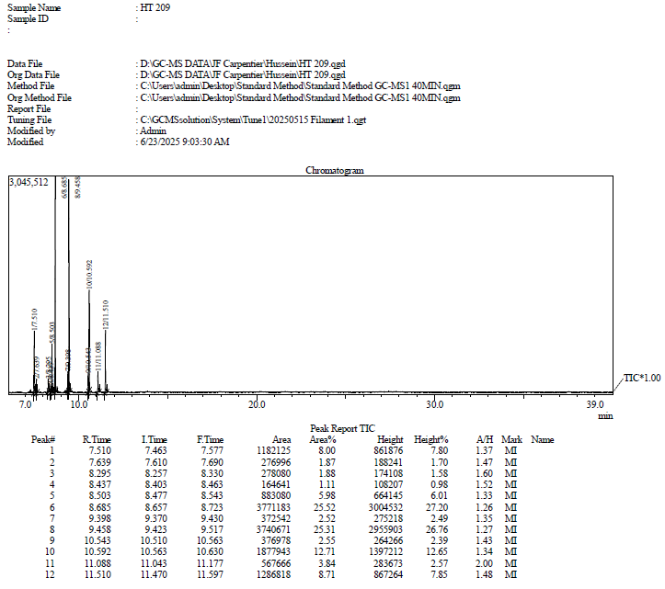
Compound 7-OEt
Compound 6-OEt
Compound 10-OEt
Compound 8-OEt
Compound 11-OEt
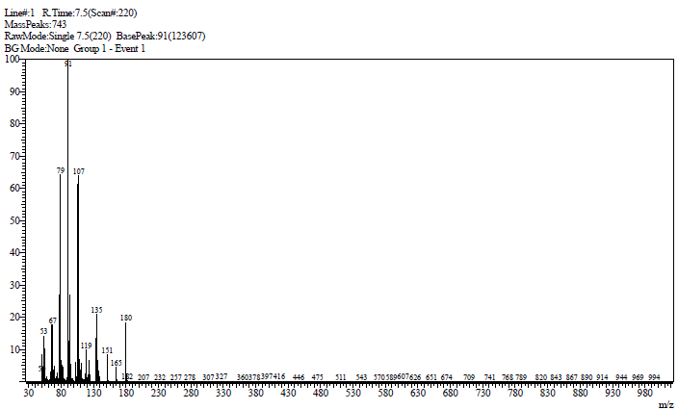
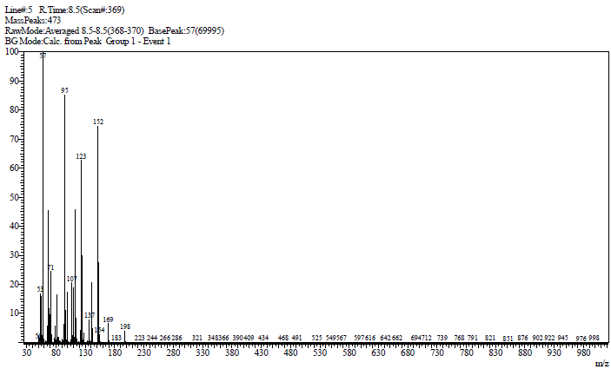
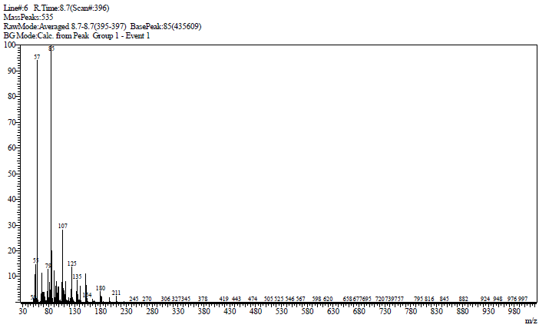
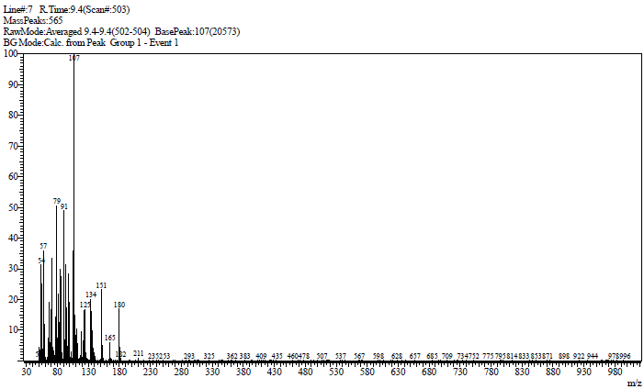
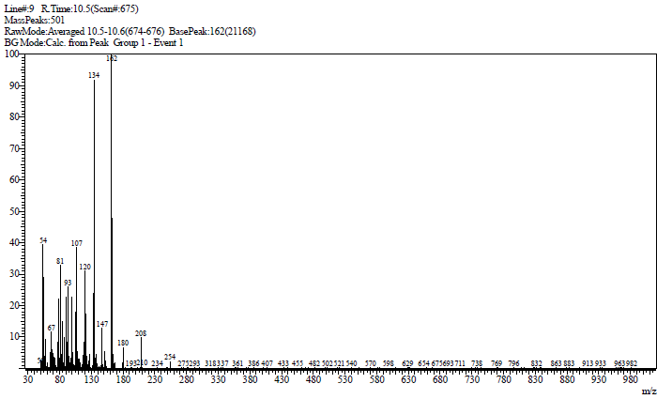
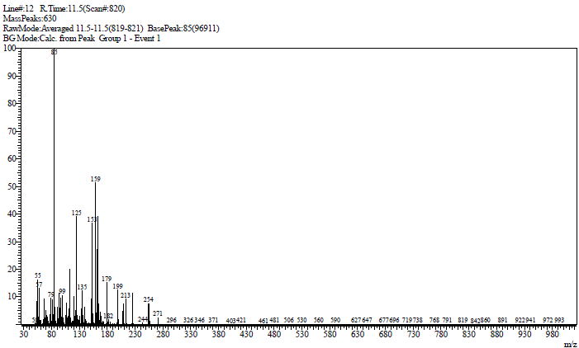
Figure S19. GC-MS trace (top) of a crude reaction mixture resulting from the ethoxycarbonylation of EVP (same conditions as Table 1, entry 18, using EtOH) and mass spectra (MS-EI) of compounds 7-OEt (m/z = 180, M^{•+}), 6-OEt (m/z = 198, M^{•+}), 8-OEt (m/z = 211, [M ‒ Me]^{•+}), 10-OEt (m/z = 254, M^{•+}), and 11-OEt (m/z_{theo} = 300, m/z_{obs} = 271, [M ‒ Et]^{•+}) (from top to bottom).

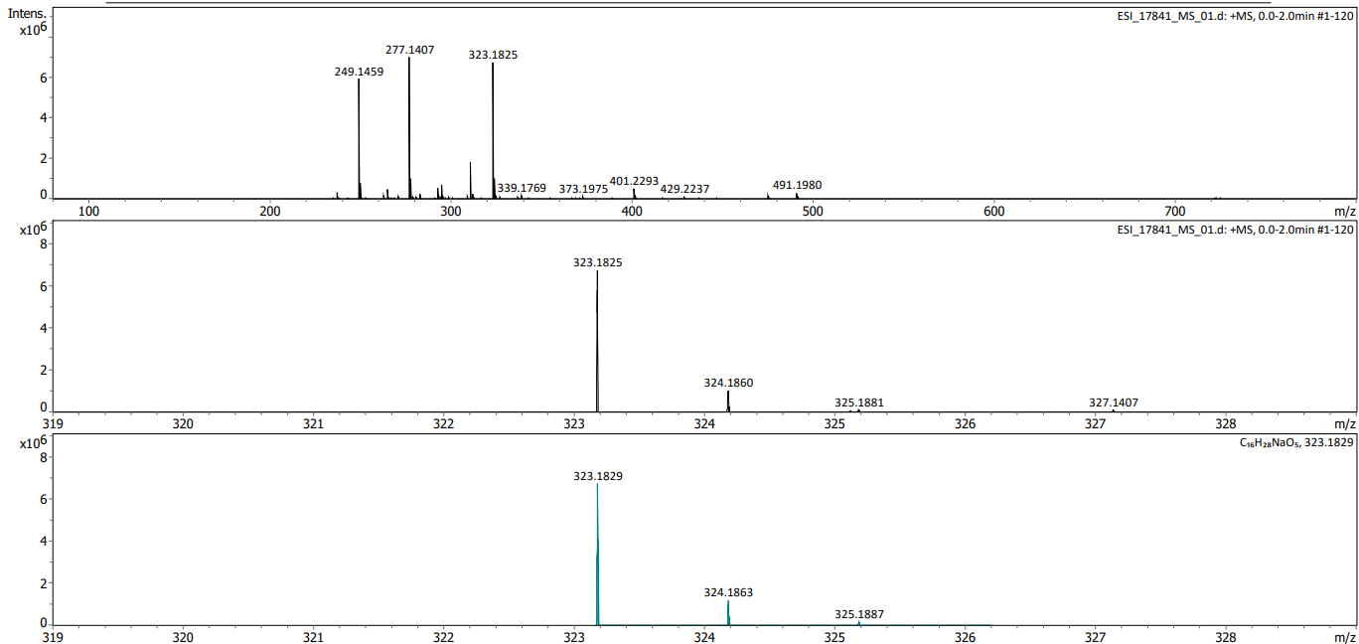
Figure S20. Details of the ESI-high resolution mass spectrum (CH₃OH/CH₂Cl₂, 9:1 v/v, Na⁺) of a crude reaction mixture resulting from the carbonylation of compound 8-OEt (Scheme S2), showing main signals for compounds 8-OEt ([M+Na]^{•+}, C₁₃H₂₂O₃Na, m/z (calcd) = 249.1459, m/z (obsd) = 249.1467), 10-OEt ([M+Na]^{•+}, C₁₄H₂₂O₄Na, m/z (calcd) = 277.1415, m/z (obsd) = 277.1407), and 11-OEt ([M+Na]^{•+}, C₁₆H₂₈O₅Na, m/z (calcd) = 323.1829, m/z (obsd) = 323.1825): (a) experimental spectrum for m/z = 100-800, (b) zoomed region for m/z = 323.1852 (11-OEt), (c) calculated mass and isotopic distribution for C₁₆H₂₈O₅Na (11-OEt, ([M+Na]^{•+}), (from top to bottom).

Figure S21. ¹H NMR spectrum (400 MHz, CDCl₃, 25 °C) of compound 8-OEt (Scheme S2) (* corresponds to remaining EVP).

References M. Sharif, R. Jackstell, S. Dastgir, B. Shishi, M. Beller, ChemCatChem. 9 (2017) 542–546.
A. Behr, G. Henze, Green Chem. 13 (2011) 25–39.
A. Behr, K.D. Juszak, Z. Chem. 25 (1985) 220.
F. Ferretti, M. Sharif, S. Dastgir, F. Ragaini, R. Jackstell, M. Beller, Green Chem. 19 (2017) 3542–3548.

