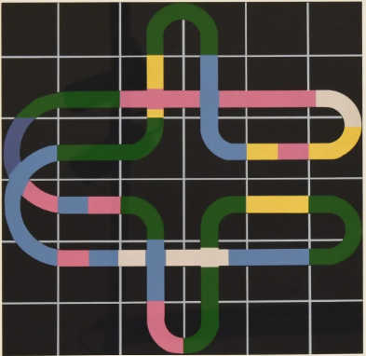
Impactology.
Readings on academic statistics
in paleo-oncological historiography

Daniel Droixhe
Université Libre de Bruxelles - Université de Liège
15-05-2026

Figure : Jean-Pierre Husquinet, Sérigraphie. E. A., 2002, 65 x 50 cm.
Foreword
The historiography of cancer must be distinguished from the history of cancer proper, insofar as it applies to the representation of the object of study rather than to the study of the object itself. In other words, it concerns the way the disease is viewed through history, and not the knowledge of the disease and its constitutive aspects: causality, chronological frequency, geographical distribution, influence of the environment, etc. The historiography of cancer falls within an “external” line of research, whereas the history of the disease implies an “internal” one. It is sometimes understood under the designation of the “social history” of cancer. One may, to a certain extent, speak of a “paleo-oncological historiography.”
- A brief overview of paleo-oncological historiography
In fact, the two approaches to paleo-oncology are often intertwined. Physicians or practitioners apply their expertise to the interpretation of old documents, written or visual, in order to identify, authenticate, or interpret references to conditions likely to fall within the domain of cancer. Such identification must often take into account a lexical indeterminacy. As soon as 1993, Pierre Darmon wrote: “Within the immense family of abnormal tumors—whether, in the mindset of the time, they were considered cancerous or liable to become so—anatomists had indiscriminately grouped together a great variety of swellings, most of which had nothing to do with cancer.” Jean-Yves Bousigue adds that traditional humoral pathology placed side by side, within the old lexicon supposedly designating the disease, alongside terms such as “scirrhuses, ulcers, fungating growths, carcinomatous tumors,” a “most heterogeneous assemblage.” Readers of ancient medical texts encounter “phlegmons, boils, carbuncles, effusions of all kinds and in all locations (abdominal, articular, hydrocele), wens, exostoses, hydrocephalus,” and so on.
Among the physicians, surgeons, and practitioners who have applied their competence and expertise to the historiography of cancer, one will first mention those whose publications appeared between 1960 and 2000, such as Erwin Heinz Ackerknecht (Geschichte und Geographie der wichtigsten Krankheiten, 1963) or Daniel De Moulin (A Short History of Breast Cancer, 1983). As soon as 1989, Bernard Hoerni published an article on “Le cancer d’Ulysses S. Grant” (in Histoire des sciences médicales 23/4, 1989). A decisive impulse in the historiography of medicine is due to the pioneers William F. Bynum and Roy Porter (Companion Encyclopedia of the History of Medicine, 1994) and Mirko Grmek (Histoire de la pensée médicale en Occident, 1997).
In the same field, the years 2000–2010 were marked by the continuation of general publications by Roy Porter, William F. Bynum and Helen Bynum (Dictionary of Medical Biography, 2007). A research more particularly devoted to the medical history of cancer was led by: Leonard L. Weiss (“Metastasis of cancer: a conceptual history from antiquity to the 1990s,” in Cancer and Metastasis Reviews 19/3–4, 2000); Steven I. Hajdu (“Greco-Roman thought about cancer,” in Cancer 100, 2004; “A note from history: landmarks in history of cancer 1–3,” in Cancer 117–118, 2011); William L. Donegan (“History of breast cancer,” in Breast Cancer, 2006); Wolfgang U. Eckart and Robert Jütte (Medizingeschichte. Eine Einführung, 2007); Arthur I. Holleb (“Peyrilhe’s quest and modern oncology,” CA: A Cancer Journal for Clinicians 21/6, 2008); D. J. Th. Wagener (The History of Oncology, 2009).
The decade 2010–2020 opened with the publication of two significant works by major cancer specialists: The Emperor of All Maladies: A Biography of Cancer by Siddhartha Mukherjee (2010; French translation 2011) and Une histoire du cancer en Occident by Jacques Rouëssé (2011). The historiography of oncology then experienced a remarkable development in France. Rouëssé also published Une autre histoire du cancer, des Lumières au stéthoscope (2014). He collaborated with Bernard Hoerni. They published a Dictionnaire historique des cancers d’Hippocrate à nos jours (2014) and Hoerni published “Cancer et littérature Cancer and literature” (in Histoire des sciences médicales 50/2, 2016). An important French volume presented a state of research : Lutter contre le cancer (1740–1960) by Jean-Yves Bousigue and Didier Foucault (2012). In English, the most significant historical book due to a physician was The Conquest of Cancer. A Distant Goal by Guy B. Faguet (2015).
From a different point of view, authors more strictly engaged in an “external,” “sociological,” or “cultural” study of the history of cancer present a discontinuous, circumstantial, and often disparate development of historiography. Thus, in the 1980s, Jacques Le Brun studied how cancer was received in a religious community of the seventeenth century (“Cancer serpit. Recherches sur la représentation du cancer dans les biographies spirituelles féminines du XVIIe siècle,” in Sciences sociales et santé 2/2, 1984). Pierre Darmon, already quoted, provided the first French book on the history of the disease (Les cellules folles. L’homme face au cancer de l’Antiquité à nos jours, 1993).
The development of “gender studies” surely contributed to the sharp rise in publications on the relationships between breast or uterine cancer and “uterine fury”. We may mention, without assessing their variable validity, works by: Karen Nolte (“Carcinoma uteri and ‘sexual debauchery’,” in Social History of Medicine 21/1, 2008); Marjo Kaartinen (Breast Cancer in the Eighteenth Century, 2013); Alanna Skuse (Constructions of Cancer in Early Modern England, 2015); Nahema Hanafi (“Le cancer à travers les consultations épistolaires envoyées au docteur Samuel Tissot, 1728–1797,” 2017).
Publication by Michael Stolberg are – sometimes in contrast - deeply rooted in a thorough knowledge of the history of medicine, typical of a German tradition that goes back to Jacob Wolff’s Die Lehre von der Krebskrankheit von der ältesten Zeiten bis zur Gegenwart (The Doctrine of Cancer Disease from the Earliest Times to the Present, 1907-1914). Stolberg’s A History of Palliative Care, 1500–1970 (2017) extends the approach of the history of medicine to the dynamic whole that organizes “concepts, practices, and ethical challenges”.
Special mention must be reserved for authors who have studied representations of cancer in the history of art: Raffaelle Bianucci, Philippe Charlier, Donatella Lippi, Antonio Perciaccante and Otto Appenzeller (« Earliest evidence of malignant breast cancer in Renaissance paintings », in History of Medicine 19, 2018).
- Readings on statistics in paleo-oncological historiography
An attempt is made here to draw lessons from the statistics recorded on ULiège-ORBI concerning my publications in the field of paleo-oncology historiography. I do not hold any doctorate in medicine, and my research on the history of cancer results from an intersection with work in the history of the book. I was led to take an interest in eighteenth-century medical periodicals, including the Gazette salutaire published in Bouillon (Walloon Country).
Research on the history of cancer led to the publication of a first work: Soigner le cancer au XVIIIe siècle. Triomphe et déclin de la thérapie par la ciguë dans le Journal de médecine (Treating Cancer in the Eighteenth Century. Triumph and Decline of Hemlock Therapy in the Journal de médecine, Paris, Hermann, 2015). The work was reviewed by Didier Foucault (Histoire, médecine et santé 9, 2016), Bernard Hoerni (Histoire des sciences médicales, May 2016, with an unfortunate misattribution due to Philippe Albou), and Édith Flammarion (Dix-huitième siècle 48, 2016). I then published Les charlatans du cancer. Offre thérapeutique et presse médicale dans la France des Lumières (The Charlatans of Cancer. Therapeutic Offer and Medical Press in Enlightenment France, Paris, Hermann, 2018), which was also reviewed by Bernard Hoerni.
All my other publications have been recorded on ULiège-ORBI. The statistics accompanying this registration (which is mandatory for members of University of Liège) are interpreted below with a view to identifying impact trends likely to provide preferred research directions. Levels of consultation or downloads, whether overall or by country, are supposed to give an idea of certain editorial prospects. For example, the question of the degree of impact linked to the language used often arises, and increasingly so, for the researcher: what is the effectiveness of using French as compared with English?
The reading of these statistics will be limited—on an experimental basis—to articles published in journals since 2015, leaving aside the volumes mentioned above and a brochure published by the Royal Academy of Belgium: Fer ou ciguë? Récits sur le cancer du sein au 18e siècle (Iron or Hemlock? Accounts of Breast Cancer in the 18th Century, 2015).
- From number to map: the nuns of Pau and cancer (2015)
The first published article appeared in a regional French journal and concerns only a limited case of “cancer”: “Raconter le cancer du sein. Le traitement par la ciguë de deux religieuses de Pau en 1759-1761 » (“Narrating breast cancer: The treatment with hemlock of two nuns in Pau, 1759–1761”, in Revue de Pau et du Béarn 42, 2015). The number of « views » or consultations by country as of 15-05-2026 is surprising. The United States holds first place with 148 views: more than seven times as many as France, which has only 19 views; Belgium 15 views; Germany 7; Great Britain, Spain and Romania 7, etc. But China already occupies 5th place with 11 views (Table 1).
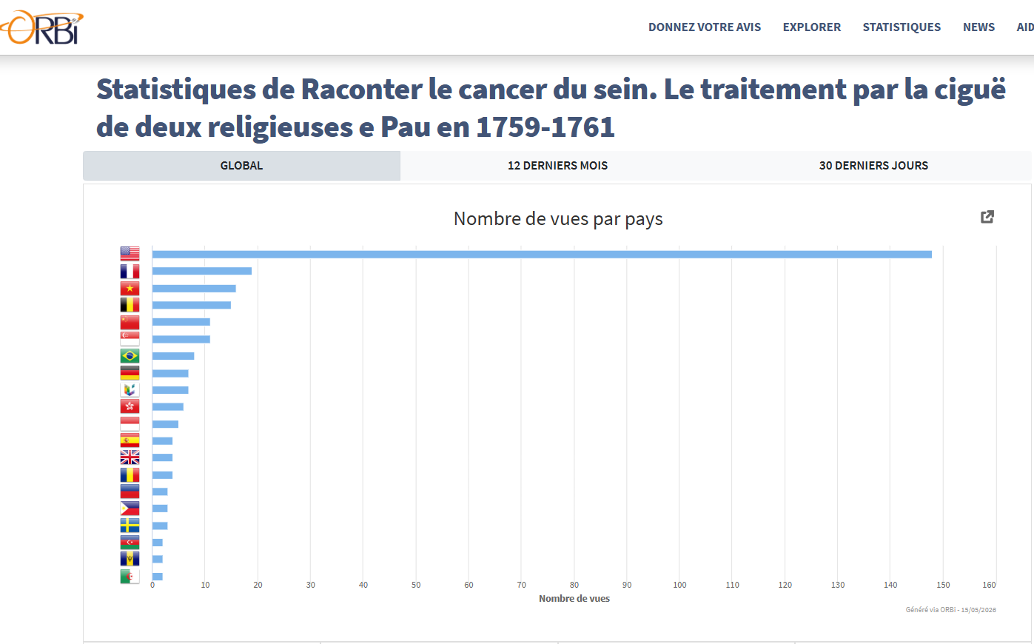
Table 1.
Article 2015. On ORBI 25-11-2016
The map of views by country makes the contrast visible (Table 2).
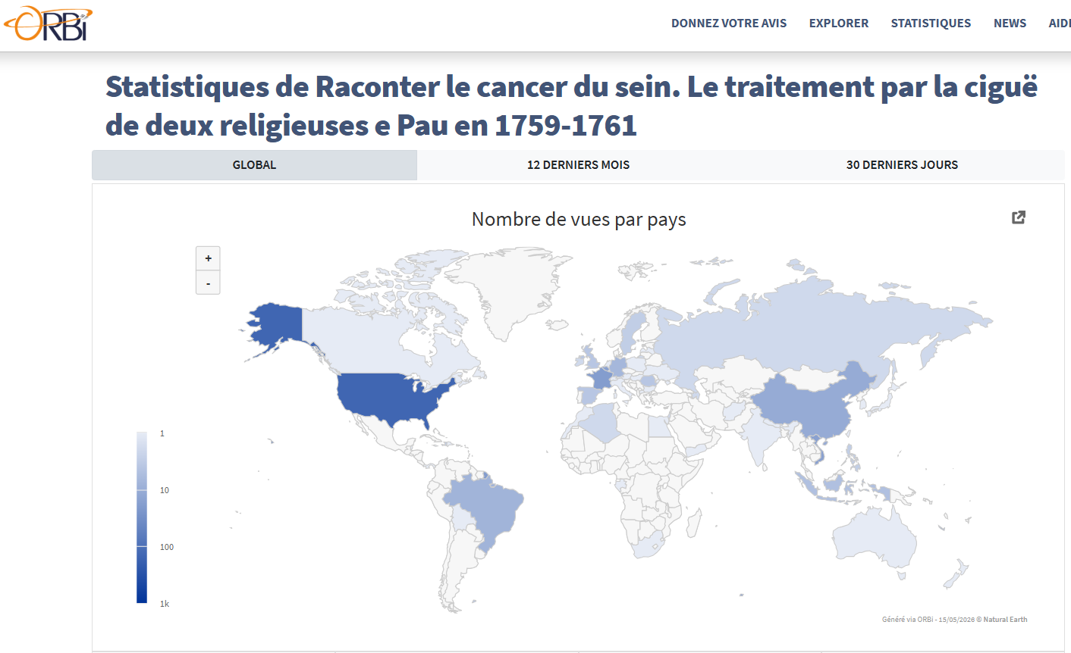
Table 2.
Article 2015. On ORBI 25-11-2016

- Channels of information: the statistics of “visitors”
One should question the meaning and value to be attributed to certain consultations, which may result from a mechanical procedure that is difficult to detect. What does the table of visitors’ origins tell us in this respect (Table 3)?
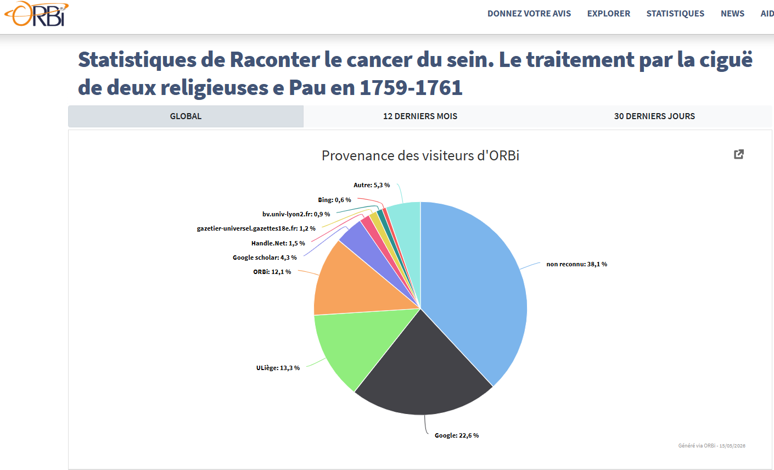
Table 3.
Article 2015. On ORBI 25-11-2016
The majority of visitors—more than a third—were led to consult this first article without any information about the way in which it aroused interest (38.1% in light blue). The statistics concerning “other” channels (5.3% in very light blue-green) must be added to this calculation.
Less than a quarter of visitors came via Google (22.6% in black). Google Scholar (4.3% in dark blue) complements the reference, so that Google constitutes at least a quarter of the information channels. A roughly equal number of consultations comes from University of Liège and more specifically from the ORBI system (12.3% in green and 12.1% in orange). The originality of the subject of the research perhaps attracted the attention of the academic community.
Minimal channels of information, extending from 0.5 to 1.5%, are provided by extremely varied sources: Bing (0.6% in red), bv.univ-lyon2.fr (0.9% in yellow), Handle.Net (1.5% in other red). One will note the share attributed to gazetier-universel.gazettes18e.fr (1.2% in yellow) refers to Index of the Esprit des journaux, a Liège periodical of the 18th century. This “excellent index” is due to Muriel Collart as a staff member of the Service de littérature wallonne of the ULiège (now affiliated with the Université libre de Bruxelles). This index was realized and made available online by the « Groupe d’étude du dix-huitième siècle de l’Université de Liège » (and not by the so-called “Groupe d’étude du dix-huitième siècle et des révolutions »).
3. Views / consultations and downloads
To what extent should one assess the difference between “views” or consultations and downloads, also recorded by the statistics? Casting an eye over a study is one thing, which sometimes responds only to curiosity and does not lead to research. Taking the time to download a study bears witness to a more determined commitment and perhaps to a higher scientific motivation. One then knows that the downloaded information forms part of a research process and that it may prove useful at a later stage.
In this respect, concerning the article on the nuns of Pau and cancer, the number of downloads by country shows a great difference from the number of views (Table 4). Downloads from France (19) almost match those from the United States (20). One might think that the attention of users from across the Atlantic was attracted by the subject, but that its overly local character discouraged them from pursuing a deeper reading through downloading. My presentation thus, as it were, sank into a narrow geography that made the medical case anecdotal.
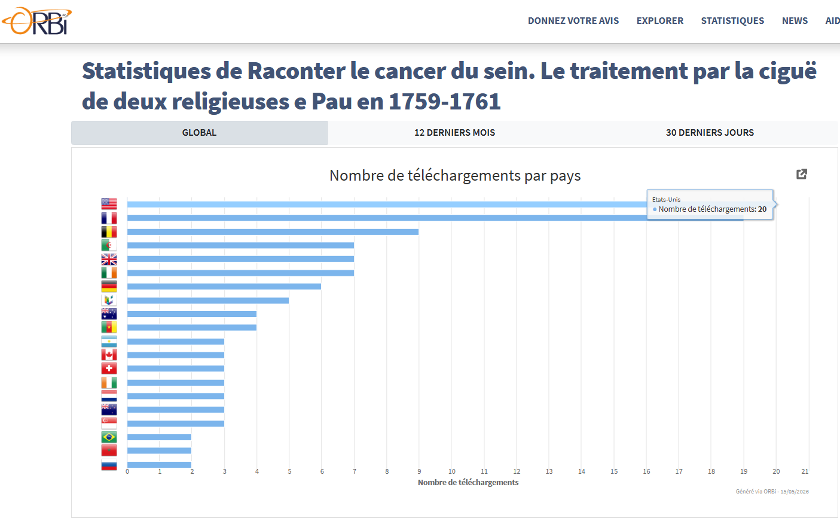
Table 4.
Article 2015. On ORBI 25-11-2016
Two countries which, in the Overview of paleo-oncological historiography (A), displayed a strong tradition of research and publications in the history of medicine here reach much more advanced positions when it comes to downloading a study that could be integrated even into a general inquiry. The United Kingdom reaches fifth place with 7 downloads and Germany seventh place with 6 downloads. No doubt the statistics involve numbers that are too small to draw general conclusions. But the fact that Russia, for example, is confined to the bottom of the ranking, with 2 downloads over about ten years, is not insignificant. Even more remarkable is the absence of China.
- A first change in time (2015-2020)
Do the statistics of publications issued between 2015 and 2020 testify to a change along the timeline? The number of views and the number of downloads once again show a significant chronological difference. The winter of 2015–2016 is marked by a sharp rise in views, but this quickly collapses and reaches a level close to zero in January 2019, before reaching a new peak from autumn 2025 onward. A renewed interest in cancer clearly emerges with regard to very regional or local cases. In their own way, downloads remain rather few from 2015 to 2025, but experience a spectacular rise in 2025 (Tables 5–6).
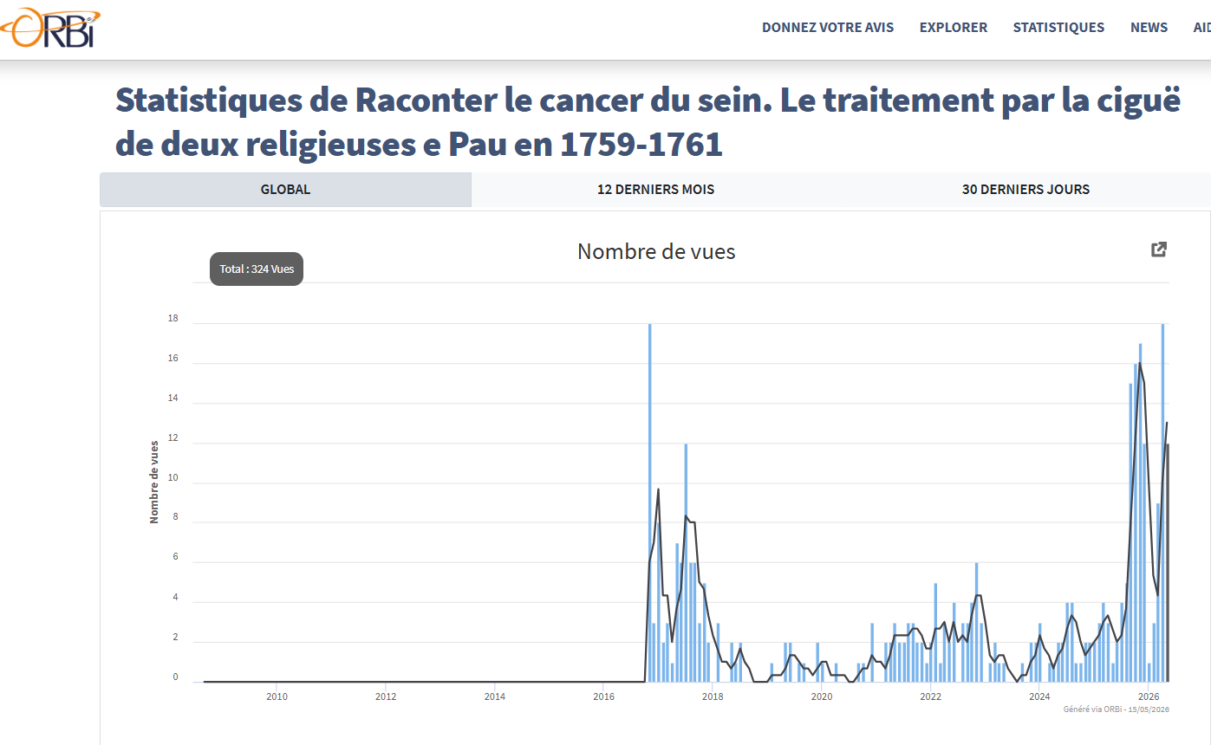
Table 5.
Article 2015. On ORBI 25-11-2016

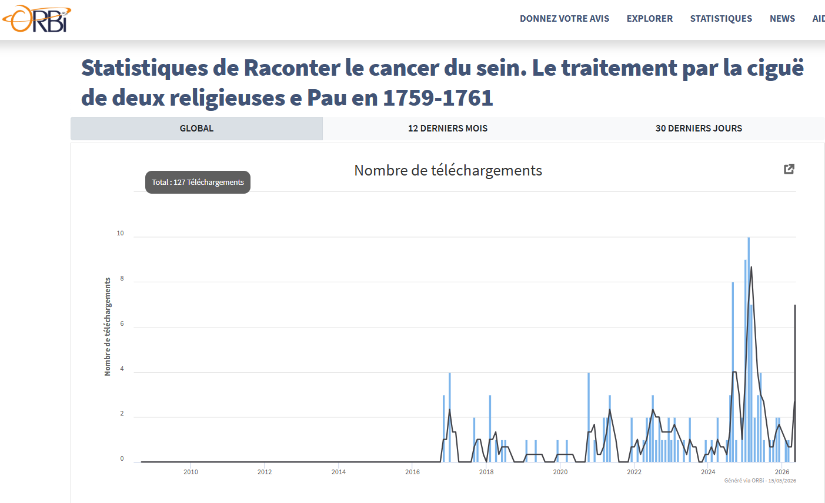
Table 6.
Article 2015. On ORBI 25-11-2016
Another article, published in 2016 in a more widely circulated journal, Histoire des sciences médicales, a publication of the Société française d’histoire de la médecine, was put online on ULiège-ORBI in March 2017. It dealt with the article “Anti-cancéreux” written by the famous French scholar and statesman Antoine-François Fourcroy (1755–1809). His article had appeared in an equally famous reference work, partly published in Liège: the Encyclopédie méthodique, where it is included in a volume from 1790.
The number of views highlights, in the first four places, the United States (83), Belgium (47), France (31), and Germany (22). The number of consultations for Belgium did not include those originating from the University of Liège, which amount to 21, so that Belgium accounts for a significant share (68) of the 296 consultations obtained by the article on Fourcroy. Did the location of this article within the Liège Encyclopédie influence the number of Belgian views? Did Fourcroy’s affiliation with the scientific—and revolutionary—institution play a role in the interest shown by France? Did the insertion of Fourcroy’s considerations into a systematic reference work arouse German curiosity, attentive to taxonomic organization and classification?
- Regionalism, pop culture and geopolitics: the quack in Brie (2016)
Two articles from 2016–2017 adopted a regional perspective and could benefit from an interest in popular culture and the circulation of old, more or less mysterious remedies. The first, published in 2016, put online in 2018, was entitled « Le charlatan et les pouvoirs. Fleury, thérapeute du cancer, en Brie champenoise au XVIIIe siècle » (« The charlatan and power. Fleury, cancer therapist, in Brie champenoise in the Eighteenth Century”). It was published in the Mémoires de la Fédération des Sociétés d’histoire et d’archéologie de l’Aisne.
Its statistics of views and downloads maintain a rather traditional ranking: in first place France (28 downloads), in second place United States (18), then Belgium (12), and Germany (6). But Russia (6) and China (4) make their appearance in the upper ranking. Did the social character of the inquiry presented in this article, which highlights popular remedies, influence the interest shown by these nations and their political system? The geographical table of downloads illustrates a shift in the world order (Table 7).
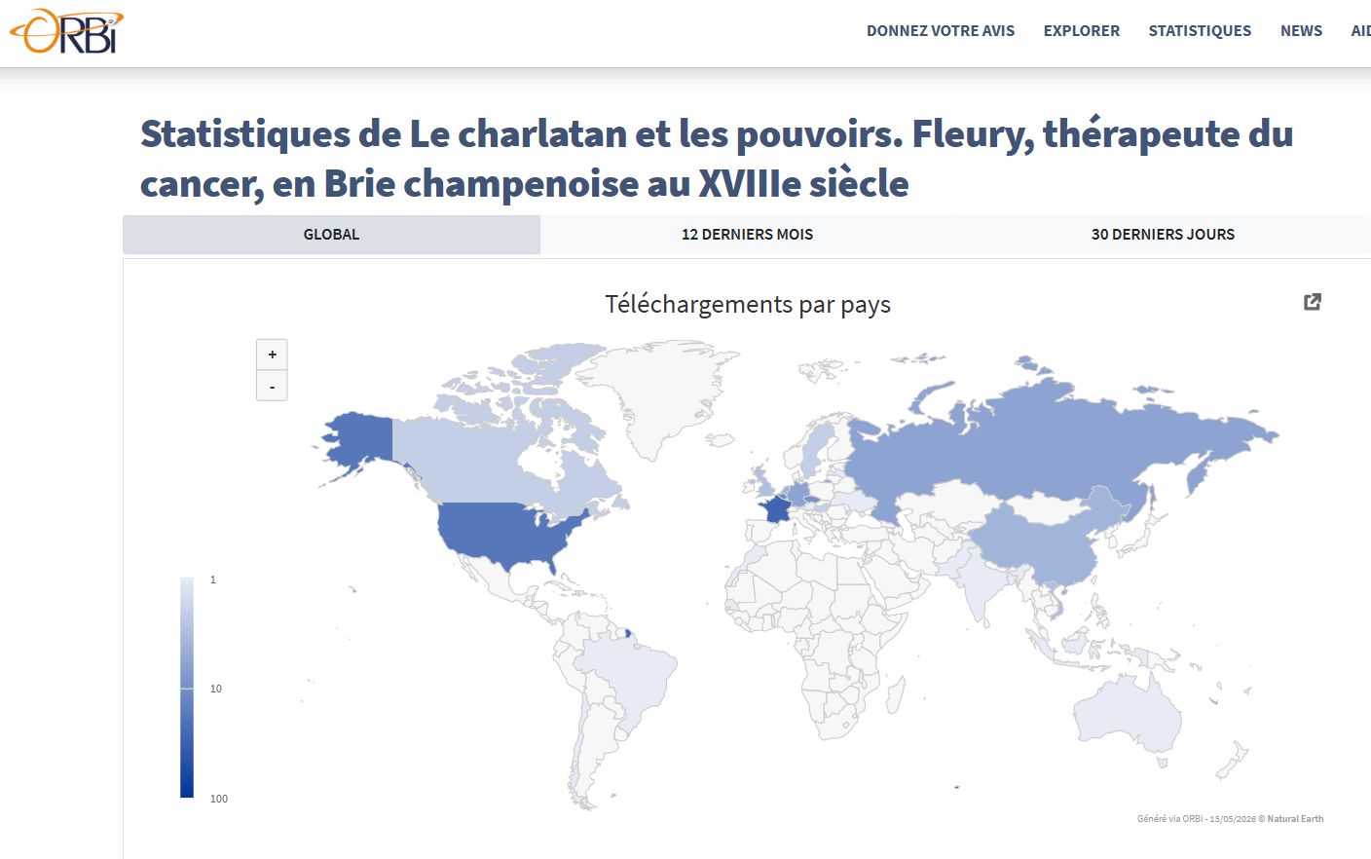
Table 7.
Article 2016. On ORBI 04-02-2018
- The growth of China: the quack in Brittany (2017)
In 2017, another article on a regional subject was published in the Annales de Bretagne et des Pays de l’Ouest : « Algaron. Itinéraires d’un charlatan en Bretagne au XVIIIe siècle. À la rencontre des thérapeutes du cancer » (« Algaron. Itineraries of a charlatan in Brittany in the Eighteenth Century. Encountering cancer therapists”). It was set online in 2019.
The map of downloads by country shows both an acceleration of the process initiated with the previous article and a reversal of the relationship between Russia and China. The change occurred with astonishing rapidity, since only one year separated the online publication of the article on the quack of Brie (04-02-2018) and that of the quack of Brittany (01-02-2019).
The first article had obtained 6 downloads in Russia and 4 in China. The statistics for the second article show that China, with 26 downloads, has largely surpassed Russia, which has only 2 downloads, and that it is moving toward the leading position still occupied by the United States, with 38 downloads (Table 8).
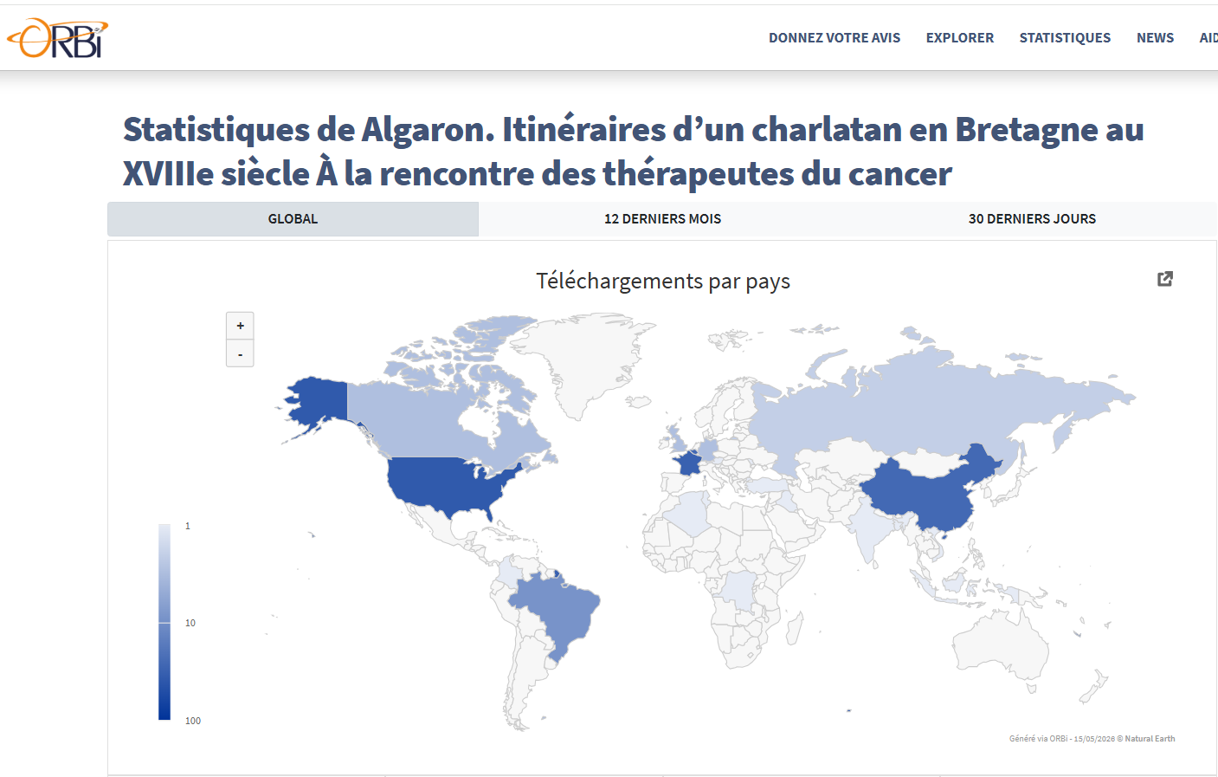
Table 8.
Article 2017. On ORBI 01-02-2019
- Decline and stagnation of consultations : the Ukranian war?
The chronology of consultations seems to support what may be assumed regarding their fading in Russia. The expansion and intensification of the Russo-Ukrainian War in February 2022 did not allow a general peak of interest, initiated in 2019, to continue in the form of a growth in consultations. On the contrary, one observes a general collapse of these from the spring of 2022 onwards—as if medical concerns had receded into the background (Table 9). Has academic research suffered the repercussions of a shift in public sentiment that had perhaps not yet penetrated the collective consciousness?
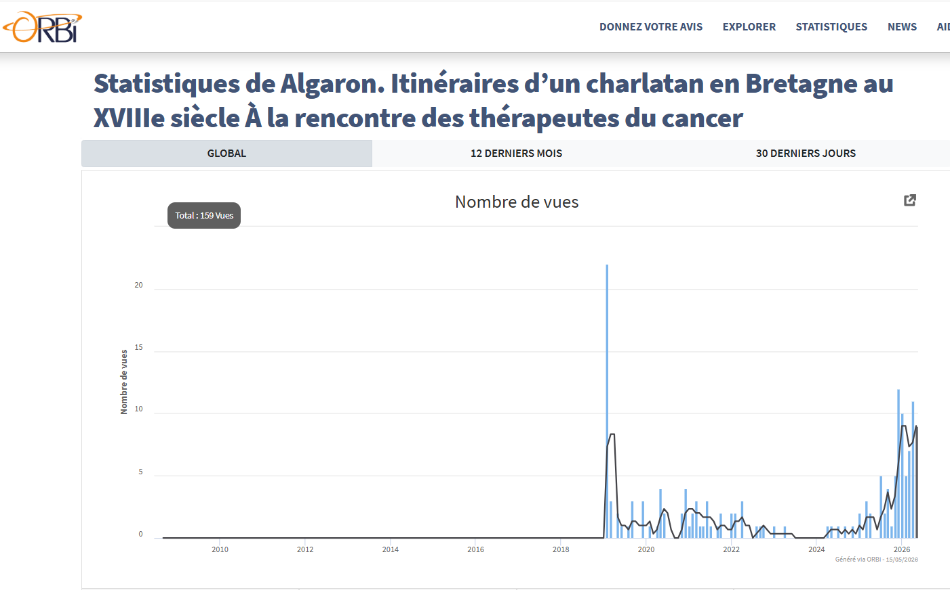
Table 9.
Article 2017. On ORBI 01-02-2019

- A prospective assessment: the idea of cancerous contagiousness (2020)
The last article considered here was published in 2020 in the journal History of European Ideas and was put online on 07-01-2023. It is entitled: “Tracing tradition. The idea of cancerous contagiousness from Renaissance to Enlightenment.” Its registration on ORBI includes abstracts and keywords in English and Chinese.
It first presents an apparently contradictory difference between the number of views by country and that of downloads by country. In terms of consultations, Belgium occupies first place with 47 consultations, and the United States third place, quite far behind, with 27 consultations (Table 10). But in terms of downloads, the United States takes first place with 117 downloads, that is to say almost five times more downloads than Belgium, which has only 24 (Table 11).
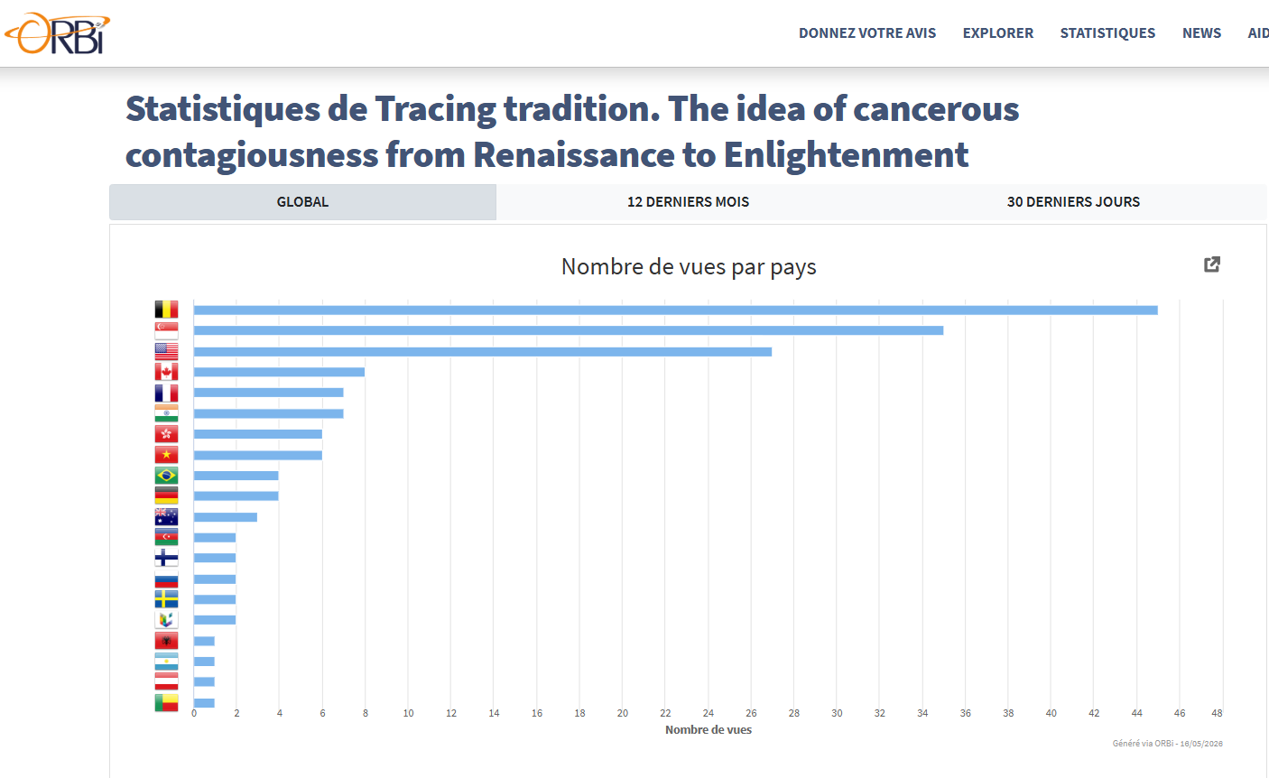
Table 10.
Article 2020. On ORBI 07-01-2023.

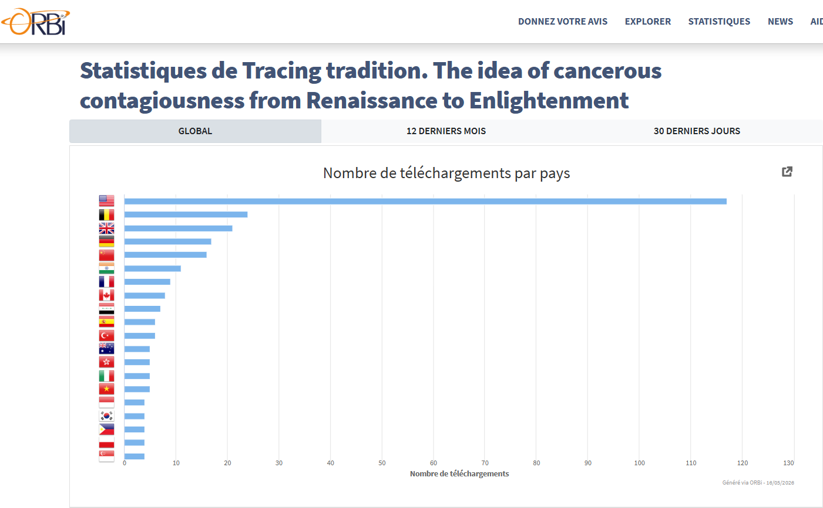
Table 11.
Article 2020. On ORBI 07-01-2023.

One does not see how to explain this difference other than in the following way: Belgium shows an interest in the article and/or its subject, but does not pursue its curiosity any further, whereas the United States demonstrates a firm engagement with the type of study concerned and with the theoretical question at issue in this study, namely the supposed contagiousness of cancer.
The ranking of the ten countries that have carried out the greatest number of consultations and downloads is even more significant. In terms of consultations, the only European countries represented are Belgium (1st place, 50 views), France (5th place, 7 views), and Germany (10th place, 4 views). One should not infer from this that the high number of views in Belgium signifies an exceptional attraction to the field of oncological historiography: intra-university dynamics have no doubt largely determined this rate of attraction. On the contrary, one cannot refuse a particular significance to the fact that neither the United Kingdom—a traditional center of this oncological historiography—nor Spain or Italy appear in this leading group of nations that have consulted the article.
In other words, Europe seems to have moved out of the primary field of regions that play a role in the type of scientific research concerned.
That this space is at the same time opening up to other countries is also remarkable: Singapore (2nd place, 35), India (6th place, 7), Hong Kong (7th place, 6), Vietnam (8th place), Brazil (9th place). One will not go so far as to say that the “Global South” and Asia are entering into the concert of nations appearing in the ranking of progression (if not of progress).
Downloads by country both confirm and at the same time correct the general trend, if one takes into account the top ten positions. The following table thus results:
USA | Belgi  um | Gr.-Brit. | Germ  any | China | India | France | Cana  da | Irak | Spain
117 | 24 | 21 | 17 | 16 | 11 | 9 | 8 | 7 | 6

- Conclusion
The ULiège-ORBI statistics ultimately show an exceptional growth in the visibility of an article in the case of that devoted to “the idea of cancerous contagion” from the Renaissance to the 18th century. The article on “Algaron. Itineraries of a Charlatan in Brittany in the Eighteenth Century,” published in 2017 and put online in February 2019, totaled in May 2026 160 views and 163 downloads; the 2020 article on “cancerous contagion,” put online in February 2023, totaled respectively 195 views and 329 downloads in May 2026.
The publication in French, in the first case, obviously limited the dissemination of the study; English, as the dominant international scientific language, proved favorable to a wide circulation. The abstract and keywords in Chinese may also have had an influence. The subject of the publication, which belonged to the history of ideas and of cultural conceptions transmitted over several centuries, undoubtedly also played an important role in the reception of the study.
The duration of online availability—more than three years—constitutes another factor enhancing the visibility of the 2020 article. The nature of the journal that published it also contributed to this prominence. The Journal of History of Ideas, published by Taylor & Francis / Routledge, has a Journal Impact Factor of 0.5 (2024 value, reported in 2025). Other bibliometric indicators commonly associated with the journal include: CiteScore (Scopus), SJR, SNIP and Quartile.
These elements, like the lesson of the statistics, may constitute determining factors in the choice of a subject of study or that of submitting the product of research to this or that journal. But the researcher must in all cases, in my view, be able to free itself from institutional constraints, submission to trends, etc. The personal choice of a publication intended for a limited audience, or even without any intention of public dissemination, should retain its full value.

Pierre Darmon, Les cellules folles : l’homme face au cancer de l’Antiquité à nos jours. Paris, Plon, 1993, p. 38.
Jean-Yves Bousigue, « Le traitement chirurgical des tumeurs au XVIIIe siècle : question académique et question de pratique », dans Didier Foucault (éd.), Lutter contre le cancer (1740-1960), Toulouse, Privat, 2012, p. 34-35.
The bibliographical references of the authors cited will be found in: Daniel Droixhe, Soigner le cancer au XVIIIe siècle. Triomphe et déclin de la thérapie par la cigüe dans le Journal de médecine, Paris, Hermann, 2015 ; Daniel Droixhe, « Tracing tradition. The idea of cancerous contagiousness from Renaissance to Enlightenment », History of European Ideas, 2020 - DOI: 10.1080/01916599.2020.1742451 [https://hdl.handle.net/2268/298209].
Daniel Droixhe, “The German sources of the Gazette salutaire (1761-1765). The hemlock treatment of cancer”, unpublished; Daniel Droixhe and Jacques Rouëssé, “Les tumeurs du scrotum dans la Gazette salutaire (1762-1773) », unpublished.
https://www.editions-hermann.fr/livre/soigner-le-cancer-au-xviiie-siecle-daniel-droixhe
https://doi.org/10.4000/hms.1005
https://shs.cairn.info/publications-de-edith-flamarion--766330?lang=fr
https://www.editions-hermann.fr/livre/les-charlatans-du-cancer-daniel-droixhe
https://www.editions-hermann.fr/livre/les-charlatans-du-cancer-daniel-droixhe; Hoerni, Compte rendu, in Histoire des sciences médicales 52/3, 2018, p. 396.
https://hdl.handle.net/2268/186884
https://hdl.handle.net/2268/203724
https://gazetier-universel.gazettes18e.fr/periodique/esprit-des-journaux-1772-1789
https://hdl.handle.net/2268/219768
https://hdl.handle.net/2268/232441
https://hdl.handle.net/2268/298209.

