Resistance and stability of cold-formed thin-walled beams with open cross-sections subjected to bending: experimental investigations

Marios-Zois Bezas^{a,*}, Maxime Vermeylenª, Helene Morch^{b}, Koenraad Ginckels^{c}, Jean-François Demonceauª

- Steel and Composite Construction, UEE Research Unit, Liège University, Belgium;
Marios-Zois.Bezas@uliege.be, Maxime.Vermeylen@uliege.be, jfdemonceau@uliege.be
- GDTech, Belgium; helene.morch@gdtech.eu
- Stow International, Belgium; Koenraad.Ginckels@stow-group.be

*Corresponding author: Université de Liège, Départment ArGEnCo, Quartier Polytech 1, Allée de la Découverte 9 B52/3, Liège 4000, Belgium

Abstract
Thin-walled cold-formed steel members are widely used in steel construction. However, members with cross-sections that are monosymmetric about their major axis exhibit characteristics that significantly influence their structural behaviour. These open sections possess low torsional rigidity and are susceptible to local and distortional buckling, as well as lateral–torsional buckling when not laterally restrained and subjected to major-axis bending. To investigate this complex stability behaviour and further enhance the knowledge of such members, an experimental program was conducted consisting of sixteen tests, comprising both 3-point and 4-point bending tests. The study included measurements of initial geometric imperfections and coupon tests in order to characterize the actual geometric and mechanical material properties. Finally, the member design resistance is assessed in accordance with the Eurocode provisions.

Keywords: Lateral-torsional buckling, Thin-walled members, Cold-formed profiles, Stability, Open sections.

Introduction
Thin-walled cold-formed steel members are frequently used as primary structural elements, such as in storage system structures or residential buildings, as well as secondary elements, including roof and wall systems and floor girders. Despite the significant advantages associated with cold-formed sections [1], monosymmetric sections about their major axis – such as the channel or sigma profiles considered in the present study – exhibit specific features that strongly influence their structural response. They are open sections with very low torsional rigidity, and due to their small thicknesses, they are prone to local and distortional buckling [2]. Moreover, they are susceptible to lateral-torsional buckling when they are not laterally restrained and loaded perpendicular to their axis of symmetry.
The design of thin-walled cold-formed unrestrained members subjected to bending should be carried out using EN 1993-1-3 [3], which is dedicated to the design of cold-formed profiles and refers, where necessary, to EN 1993-1-1 [4]. Following the Eurocode 3 provisions, local and distortional buckling are accounted for through the effective cross-sectional properties, whereas lateral-torsional buckling (LTB) is considered through the buckling reduction factor χ_{LT}. For the latter, EN 1993-1-3 prescribes the use of lateral buckling curve b, irrespective of the cross-section type. However, since the buckling curves account for the influence of the initial geometric imperfections and residual stresses on the buckling response of the member – and given that residual stresses patterns vary among different profile types, as clearly indicated in prEN 1993-1-14 [5] – this approach for cold-formed sections may be considered controversial, as the same buckling curve is currently proposed for doubly symmetric, monosymmetric or asymmetric cross-sections.
Several experimental studies have been conducted to investigate the stability behaviour of thin-walled cold-formed beams with channel or sigma sections subjected to bending. Wang et al. [6] performed major axis bending tests on single channels sections with different intermediate and edge stiffeners made of G500 and G550 steel grades and compare the experimental resistances with predictions obtained using the Direct Strength Method (DSM). Laim et al. [7] reported bending tests at both ambient and elevated temperatures on cold-formed Z275 steel beams made of single or built-up sigma sections, highlighting thus the influence of fire conditions to the bending resistance of the members. Chen et al. [8] studied lipped channel beams under non-uniform bending with local-distortional interaction, while Dinis et al. [9] examined distortional buckling in web-stiffened lipped channel columns. Wang et al. [10] investigated numerically and experimentally the bending strength and behavior of cold-formed steel Z275 C-section members with various edge stiffeners. Experimental bending tests on beams made of one or more cold-formed steel C or U profiles (S280GD+Z) are reported in Ref.[11], while Keerthan et al.[12] present experiments on hollow flange channel beams under bending and shear forces. Further experimental investigations on cold-formed sigma and channel beams subjected to bending and torsion, as well as on built-up members composed of channel or sigma cold-formed profiles, are reported in the literature [13]-[14]-[15]-[16]-[17]-[18]-[19]. Finally, experimental investigations were carried out by Young et al.[20] and Yu et al. [21], in order to evaluate the performance of cold-formed steel sections undergoing web crippling.
In addition to experimental work, a substantial amount of numerical and analytical research has also been performed. Schafer et al. [22] investigated cold-formed members with complex edge stiffeners using finite element methods, while Shan-shan et al. [23] proposed a complete analytical solution for the evaluation of the lateral–torsional buckling of cold-formed C-shaped beams subjected to combined compression and bending. Although this solution is rigorous, its complexity limits its practical applicability. Vermeylen et al. [24] validated the formulation provided in CEN/TR 1993-1-103 [25] for the elastic critical bending moment of monosymmetric about their major axis thin-walled sections and demonstrate its accuracy for various load application scenarios. Additional analytical and numerical studies addressing buckling behaviour, post-buckling response and design optimisation of cold-formed beams can be found in [26]-[27]-[28]-[29]. Finally, different research teams have also conducted numerical studies on the strength of sigma section beams subjected to bending [30]-[31].
To further investigate the complex stability behaviour of thin-walled cold-formed sections monosymmetric about their major axes subjected to bending, where local, distortional and global instabilities could occur simultaneously, an experimental campaign was carried out at the University of Liège. The experimental program aimed to expand existing database of experimental bending tests on cold-formed thin-walled C and sigma sections subjected to bending, particularly in view of the influence of stiffener geometry and location, as highlighted by Haidarali et al. [32]. Furthermore, the study incorporates the steel grade HX420LAD, which has not previously been investigated in this context.
More specifically, six 3-point and ten 4-point bending tests were performed in order to consider different bending moment distributions along the members. The bending tests were accompanied by measurements of initial geometric imperfections and coupon tests to characterize the actual geometrical and mechanical material properties. All the results are presented and discussed in the present paper. The experimentally obtained resistances have been then compared with the normative ones resulting from the application of EN 1993-1-3:2006 and EN 1993-1-1:2005 provisions. It should be also mentioned that there are no substantial differences between the current versions of the above mentioned standards and their new versions namely EN 1993-1-3:2024 [33] and EN 1993-1-1:2022 [34] regarding the design of laterally unrestrained members subjected to bending.
This study is part of the project ACTIONS: “Advanced Eurocodes Compliant Tools for Industrial Optimized Innovative Structures” involving the companies STOW group, GDTech and CRM, as well as the University of Liege. Relevant outcomes of this project related to the design of rack structures can be found in [35]-[36].

Description of the experimental campaign

Tested specimens
Both sigma and channel profiles with lips made of HX420LAD steel grade were considered in the experimental campaign. The selected profiles correspond to sections commonly used in racking structures and were chosen to represent both compact and slender sections for which local instability phenomena (local/distortional buckling) may or may not occur. According to EN 1993-1-3, cold-formed thin-walled profiles are not explicitly classified into cross-section classes; instead, effective cross-sectional properties are directly calculated to account both local and distortional buckling. Nevertheless, for the purpose of this study, the profiles were classified in order to have a first indication of their sectional behaviour. The adopted classification follows the criteria from EN 1993-1-1:2022, which slightly differ from the criteria found in EN 1993-1-1:2005 for major axis bending and only account for local buckling phenomena and not for the distortional ones.
The details of the tested specimens are summarised in Table 1, while the exact geometry of each cross-section is given in section 3.2. The designation of each specimen consists of two numbers followed by the letter a or b (e.g. Sp12a):
- the first number indicates the profile: 1 for SISB 130/60/2.0, 2 for SISB 180/70/1.5, 3 for SISB 160/60/2.0, 4 for C 240/65/15/1.5 and 5 for C 240/65/25/3.5;
- the second number refers to the type of the test: 1 for the 4-point bending test and 2 for the 3-point bending test;
- the letter a or b distinguishes repeated tests on the same specimen type.
For all specimens, the length between the end supports L (see §2.2) was kept constant and equal to 3000 mm, while the total length of each beam was L_{tot} = 3500 mm. This value corresponds to a quite common beam length met in racking structures, case study considered in the above-mentioned research project. Although the beam length is identical for all specimens, the global lateral-torsional slenderness varies due to differences in cross-sectional properties and intermediate boundary conditions associated with the different type of tests.
Table 1: Details of the tested specimens
Nº | Label | Profile | L [mm] | L_{tot} [mm] | Steel grade | Sectional behaviour | Type of test
1 | Sp11a | SISB 130/60/2.0 | 3000 | 3500 | HX420LAD | Compact | 4-point bending
2 | Sp11b | SISB 130/60/2.0 | 3000 | 3500 | HX420LAD | Compact | 4-point bending
3 | Sp12a | SISB 130/60/2.0 | 3000 | 3500 | HX420LAD | Compact | 3-point bending
4 | Sp12b | SISB 130/60/2.0 | 3000 | 3500 | HX420LAD | Compact | 3-point bending
5 | Sp21a | SISB 180/70/1.5 | 3000 | 3500 | HX420LAD | Slender | 4-point bending
6 | Sp21b | SISB 180/70/1.5 | 3000 | 3500 | HX420LAD | Slender | 4-point bending
7 | Sp22a | SISB 180/70/1.5 | 3000 | 3500 | HX420LAD | Slender | 3-point bending
8 | Sp22b | SISB 180/70/1.5 | 3000 | 3500 | HX420LAD | Slender | 3-point bending
9 | Sp31a | SISB 160/60/2.0 | 3000 | 3500 | HX420LAD | Compact | 4-point bending
10 | Sp31b | SISB 160/60/2.0 | 3000 | 3500 | HX420LAD | Compact | 4-point bending
11 | Sp32a | SISB 160/60/2.0 | 3000 | 3500 | HX420LAD | Compact | 3-point bending
12 | Sp32b | SISB 160/60/2.0 | 3000 | 3500 | HX420LAD | Compact | 3-point bending
13 | Sp41a | C 240/65/15/1.5 | 3000 | 3500 | HX420LAD | Slender | 4-point bending
14 | Sp41b | C 240/65/15/1.5 | 3000 | 3500 | HX420LAD | Slender | 4-point bending
15 | Sp51a | C 240/65/25/3.5 | 3000 | 3500 | HX420LAD | Compact | 4-point bending
16 | Sp51b | C 240/65/25/3.5 | 3000 | 3500 | HX420LAD | Compact | 4-point bending

To prevent local buckling of the caused by concentrate loads at the end supports and load application points, stiffeners were installed at these sections. The stiffeners were designed such that, in all cases, the total width b_{tot} of the stiffened cross-sections, including the stiffeners, remained constant and equal to 126mm (see Figure 1), while, for all tests, the load is introduced at mid-width of b_{tot}. Although an eccentricity exists between the load application point and the shear centre of the cross-section, the presence of forks and stiffeners at these positions (see §2.2) prevented inducing torsion to the member. All stiffeners had a thickness of 30 mm and were manufactured from S355J2H steel grade. In addition, they were attached to the beams through countersunk head bolts M8x45 (for SISB 130/60/2.0) or M10x45 (for all the other profiles) with 8.8 grade according to DIN 7991 [37]. The threaded length of the bolts was selected in line with the recommendations of prEN 1993-1-8, Table 5.10 [38].
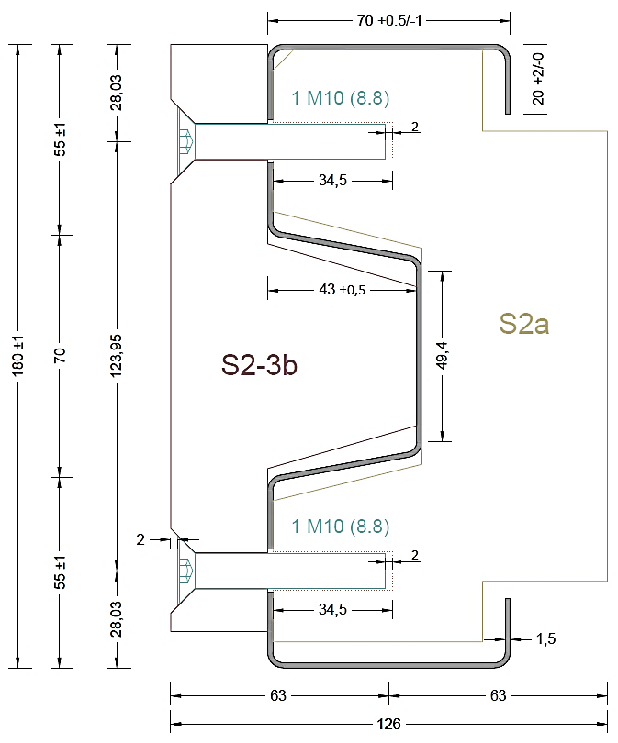
Figure 1: Indicative case of a sigma profile (nominal geometry) with stiffeners at the position of the load application
Furthermore, it was verified that, according to EN 1993-1-3, all specimens exhibited sufficient design shear resistance of their webs to sustain the expected applied forces.

Test setup configuration
All tests were performed using a hydraulic jack of 100 kN compression capacity and a stroke of 100 mm. The jack was always centred to the middle of the upper flange, while it was connected to the frame beam (orange upper beam, see Figure 2) through a bracket (ISO 8132/CBA40) which allows an out-of-plane rotation about Y axis. The set-up of the 4-point bending tests is schematically illustrated in Figure 2.
All specimens were pin-ended and laterally restrained at their extremities using forks (magenta elements in Figure 2) with a thickness of 18 mm. These forks allow rotation about Y axis (r_{y}) at both supports, while the horizontal displacement along the X axis (u_{x}) is permitted only at the left support (u_{x,right} is restrained). Obviously, the presence of forks and stiffeners at the load application points prevented twisting of the specimen resulting from unintentional eccentricities between the applied load and shear center of the cross-section. In addition, to ensure sufficient clearance between the specimen and the basement plate PL2, a small fillet plate PL1 (126x30x12) was installed, as illustrated in Figure 3.
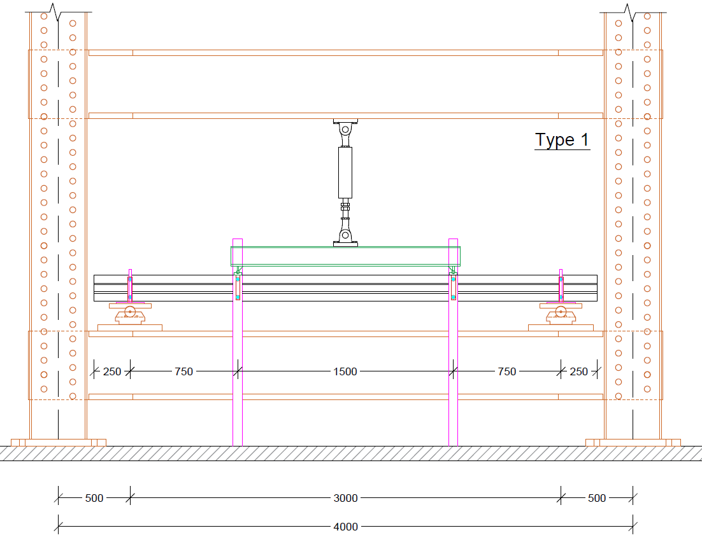
X
Z
Y
Figure 2: Drawing of the test set-up for the 4-point bending test
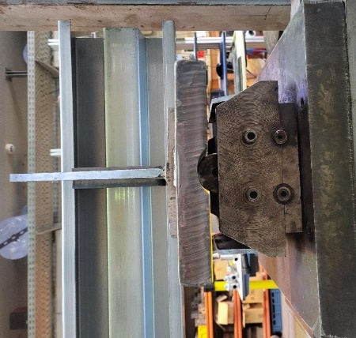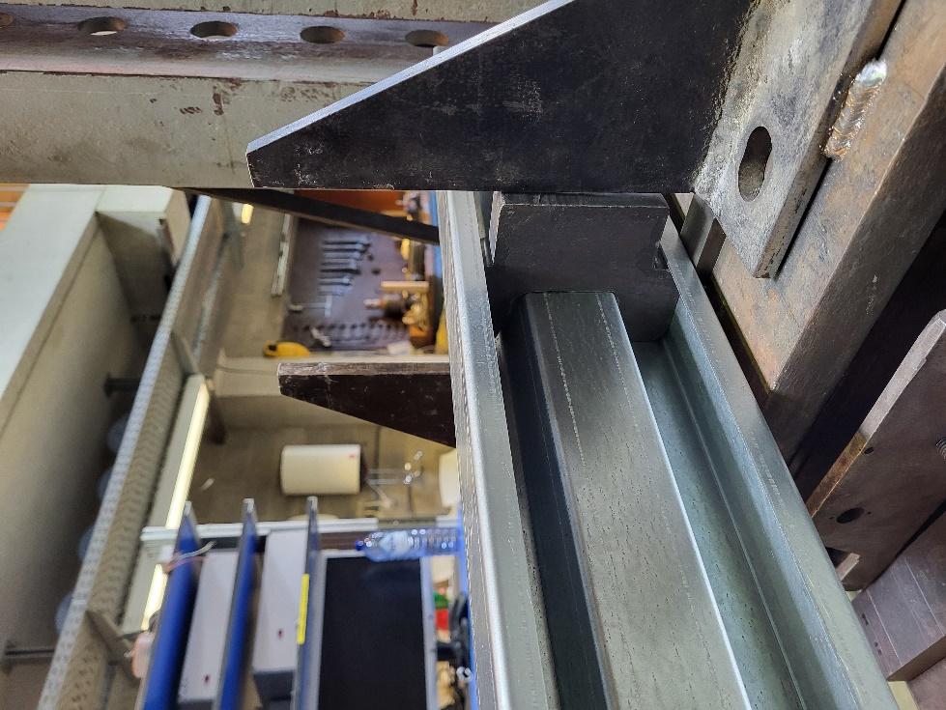
Pin support
PL1
Forks
Fork
Stiffener
Stiffener
PL2
PL2
Figure 3: Detail of the fork / pinned support at the extremity
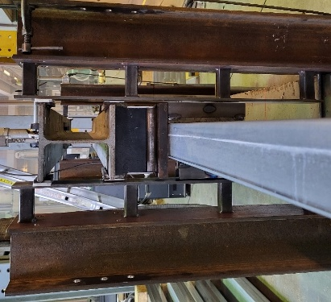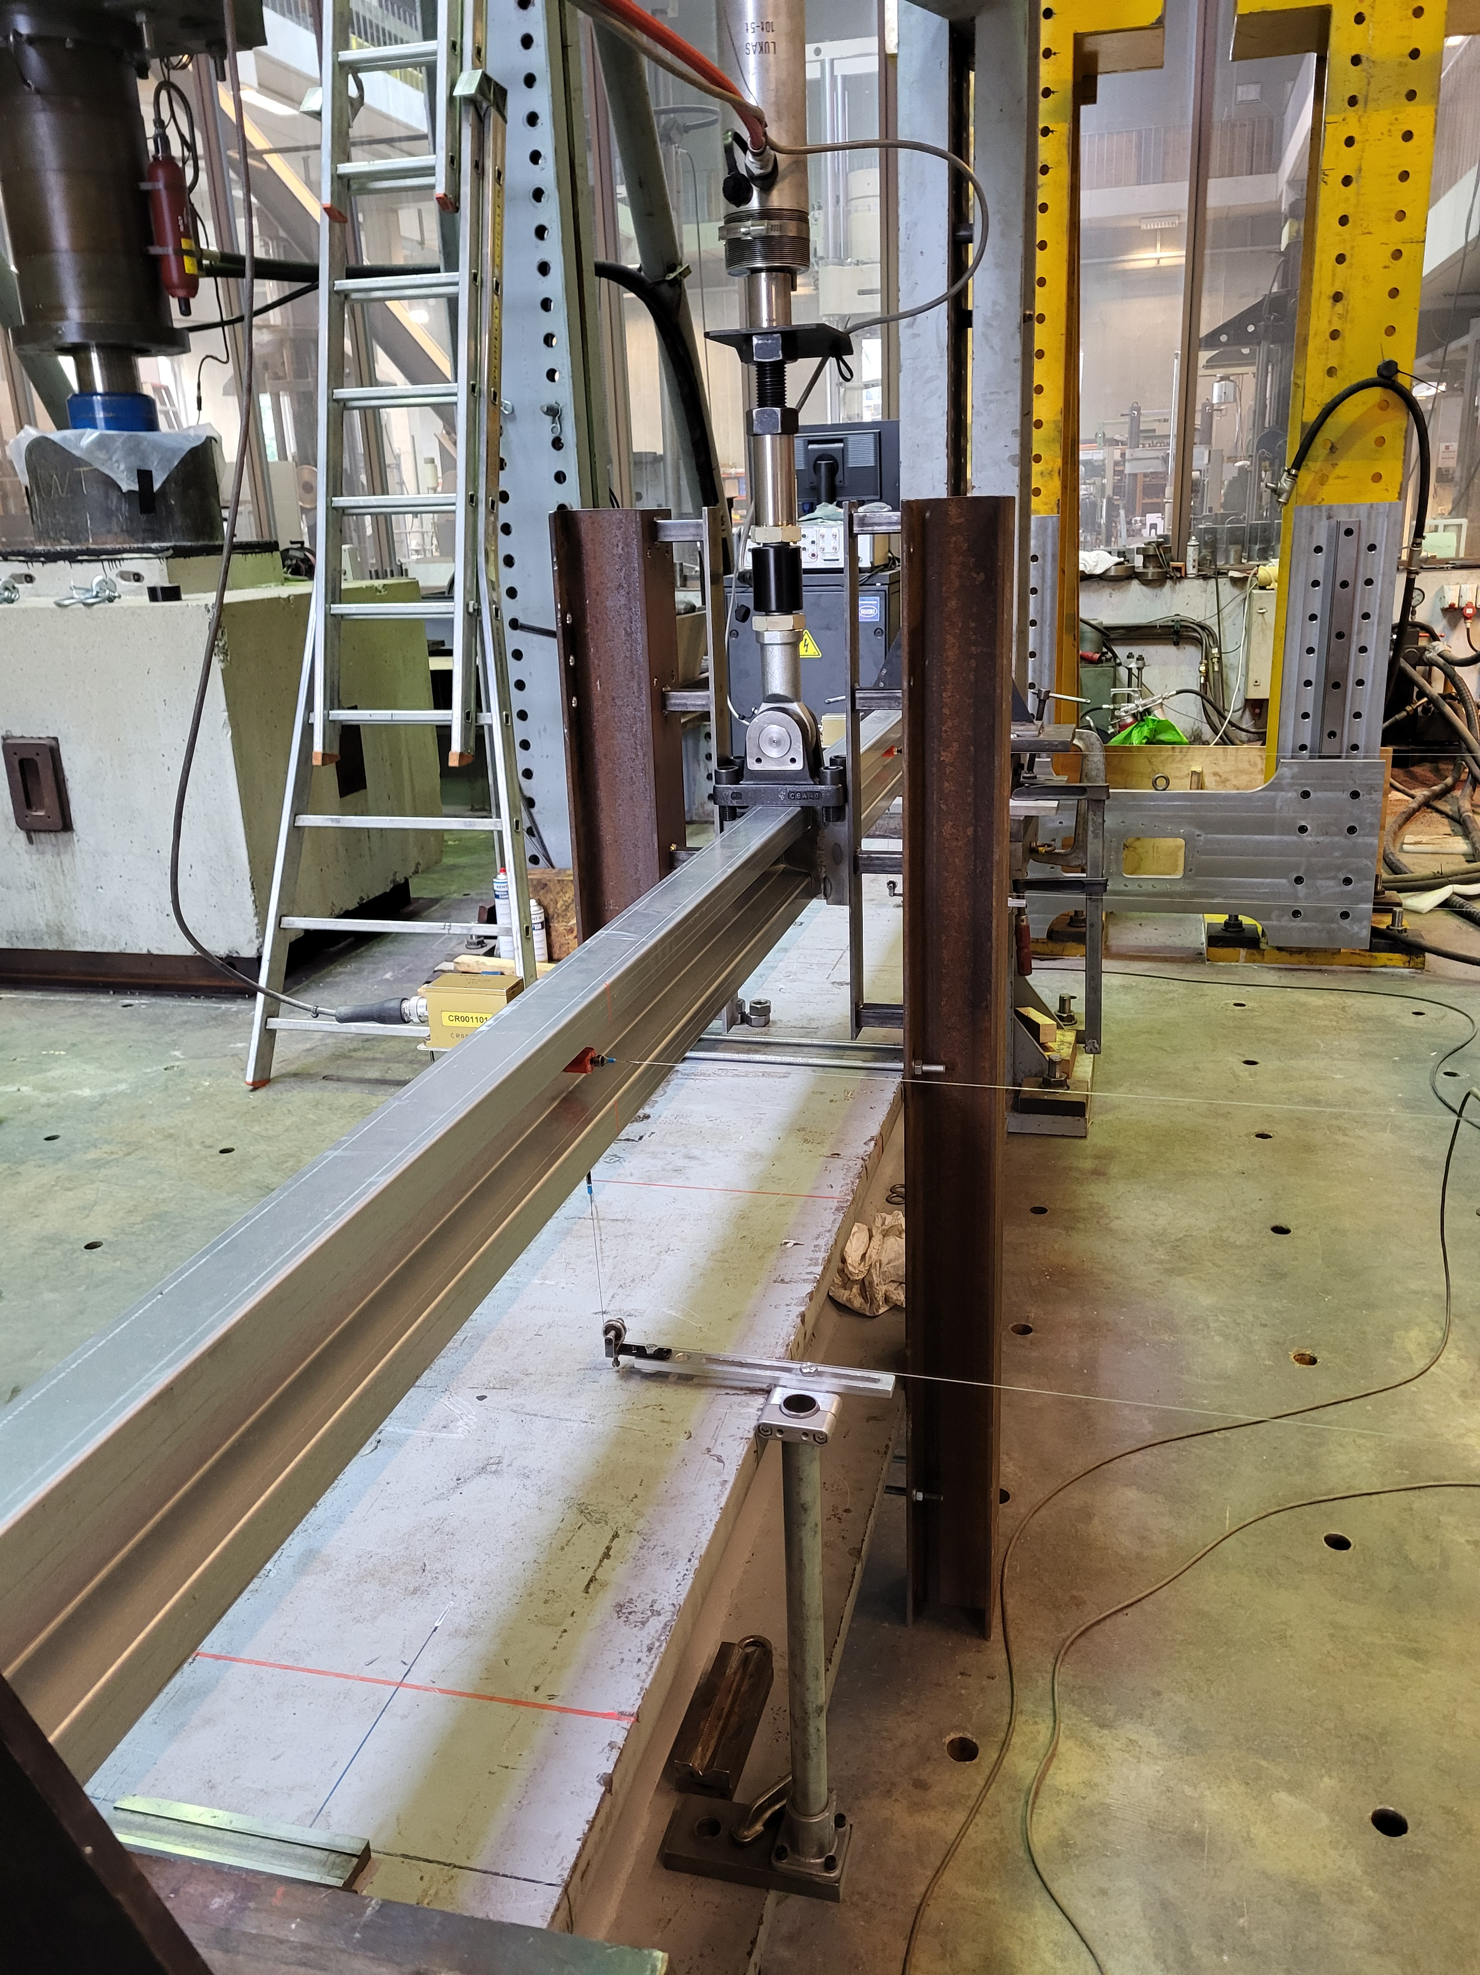
Forks
Stiffeners
Bracket
(b)
(a)
Forks
PL3
Stiffeners
HEB140
Pin
Figure 4: Detail of the intermediate fork of (a) 4-point and (b) 3-point bending tests
For the 4-point bending tests, a pin-ended HEB 140 beam (illustrated in green in Figure 2) was used to distribute the applied load into two concentrated forces acting on the upper flange of the specimens at a distance of 750 mm from each end supports. The jack was connected to the HEB 140 beam through the same bracket, again allowing out-of-plane rotation about the Y axis (see Figure 2). The connection of the HEB beam to the specimen was achieved through a small plate PL3 (160x52x18), to which the pin support is attached, as shown in Figure 4(a). Furthermore, at the positions of the applied loads, both the specimen and the HEB 140 were laterally restrained with forks. However, as the width of the HEB profile exceeds the total width b_{tot} = 126 mm of the stiffened cross-sections (see Figure 1), small plates have been welded onto the intermediate stiffeners so as to adjust their width to fit with the forks, as illustrated in Figure 4(a).
For the 3-point bending tests, the load was applied directly from the jack to the specimen through the same bracket, as shown in Figure 4(b); the specimen was also laterally restrained with forks at this position. Although, for these tests, the orientation of the bracket does not influence the response of the member due to the presence of the forks, it was arranged to allow rotation about the X axis (see Figure 2 for axis definition), ensuring proper alignment with the fork width.

Instrumentation of the bending tests
Several measurements were recorded during the bending tests, as summarized in Table 2 together with the corresponding measuring devices. Figure 5 and Figure 6 depict the instrumentation layouts for the two different test setups, while the illustrated numbers are in line with the numbering system (Nº) given in Table 2. The tests were force-controlled while the load applied by the jack was recorded by means of a load cell (Sensy, model 5100 of 100 kN). Furthermore, the lateral displacements were measured with displacement transducers (Novotechnik TS150, Siedle group) positioned at a distance from the specimen via a wire-bases system in order to minimize measurement errors caused by the potential rotation of the specimen. Vertical displacements at selected locations were also measured with a similar system, as shown in Figure 5 and Figure 6.
Table 2: Measurements during the bending test
Nº | Measurement | Device | Type of test
Nº | Measurement | Device | 4-point | 3-point
1 | Applied load (jack) | Load cell | ✓ | ✓
2 | Vertical displacement at L/4 (mid-width) | LVDT | ✓ | ✓
3 | Vertical displacement at L/2 (mid-width) | LVDT | ✓ | ✓
4 | Vertical displacement at 3L/4 (mid-width) | LVDT | ✓ | ✓
5 | Lateral displacement at L/4 (mid-height) | LVDT | X | ✓
6 | Lateral displacement at L/2 (mid-height) | LVDT | ✓ | X
7 | Lateral displacement at 3L/4 (mid-height) | LVDT | X | ✓
8 | Out-of-plane rotation at L/4 (mid-height) | Inclinometer | X | ✓
9 | Out-of-plane rotation at L/2 (mid-height) | Inclinometer | ✓ | X
10 | Out-of-plane rotation at 3L/2 (mid-height) | Inclinometer | X | ✓

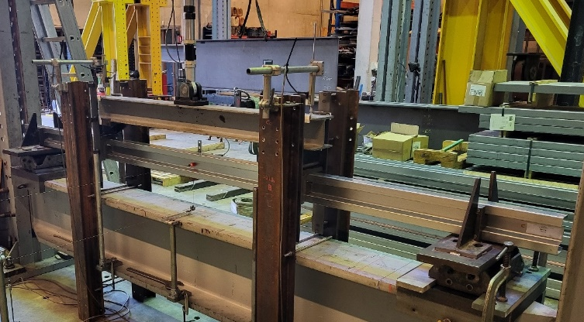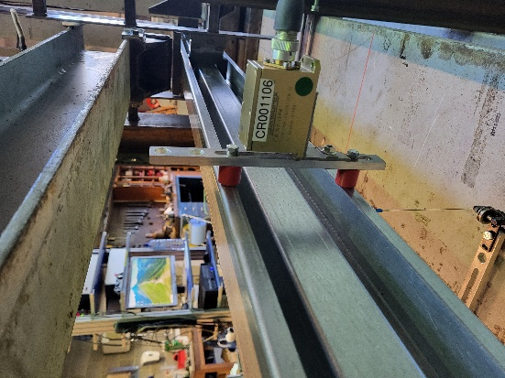
1
2
4
3
6
9
Back view
Figure 5: Instrumentation of 4-point bending tests
For the 4-point tests (see Figure 5), the lateral displacement at L/2 was always measured at mid-height of the specimens, while the vertical displacement at the same position was recorded at mid-width of the bottom flange. In addition, the vertical displacements at L/4 and 3L/4 were measured on the HEB 140 beam as it is expected to be the same in both the specimen and the HEB 140 at these positions due to the forks; these measurements allow to check if the HEB 140 beam remains parallel to the specimen during the test while their mean value provides the axial elongation of the jack.
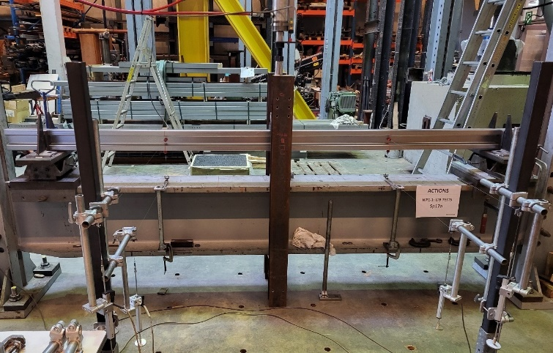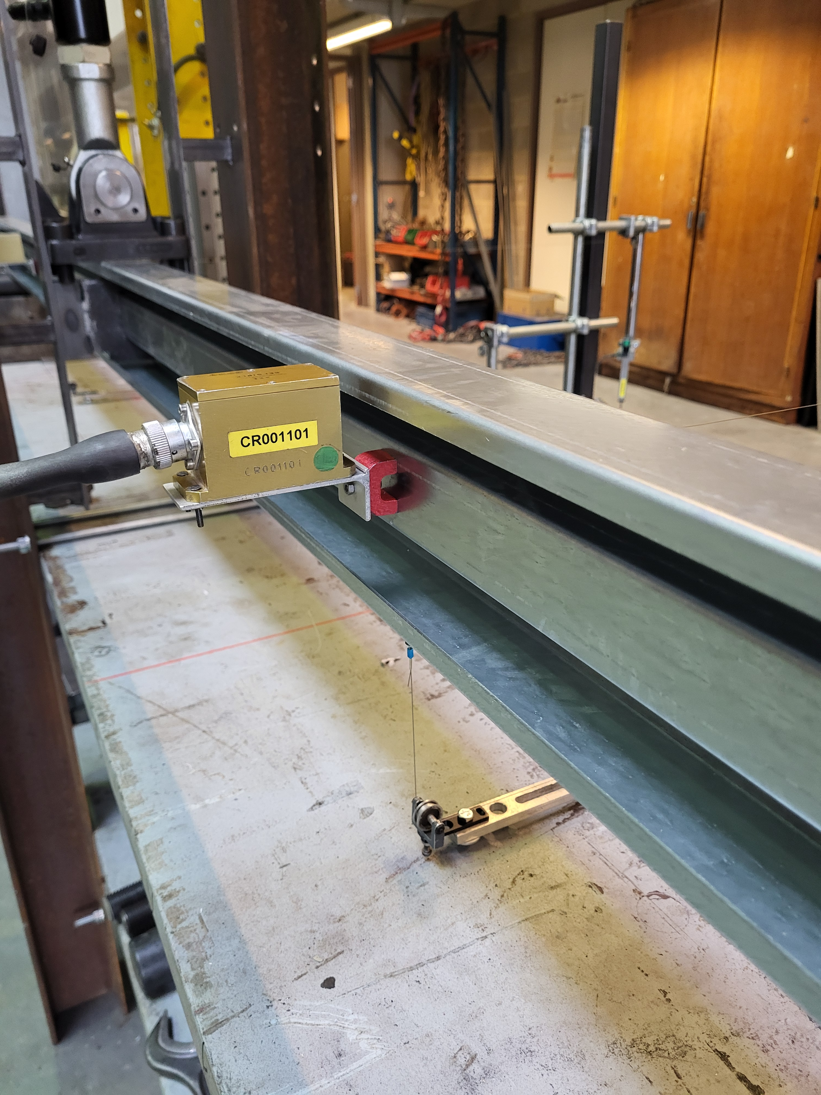
1
2
4
3
5
8, 10
Back view
7
Figure 6: Instrumentation of 3-point bending tests
For the 3-point tests (see Figure 6), the lateral displacements at L/4 and 3L/4 were measured at mid-height of the specimens, while the vertical displacements at the same positions were measured at mid-width of the bottom flange. The vertical displacement at L/2 was measured on the jack, as it is the same as its axial elongation due to the presence of the forks.

Preliminary tests and measurements

Actual material properties
The actual material properties of the specimens were determined through tensile tests. Since all specimens with the same cross-section originated from the same production batch, coupons were performed for each of the five considered profiles (see Table 1). The testing procedure followed ISO 6892-1 [39], which is referenced in Annex A2 of EN 1993-1-3:2024. According to the latter, coupons should be oriented in the longitudinal direction of the structural element. However, ISO 377 [40] states that the mechanical properties of extracted samples may vary depending on their position and orientation relative to the parent plate. This variability is attributed to the roll forming process, during which the steel coil undergoes repeated uncoiling and recoiling prior to final shaping. For this reason, 4 samples were extracted from each profile, one from each flange and two from the web, as illustrated in Figure 7; the two samples extracted from the transverse direction of the C profiles were selected solely for comparison purposes.
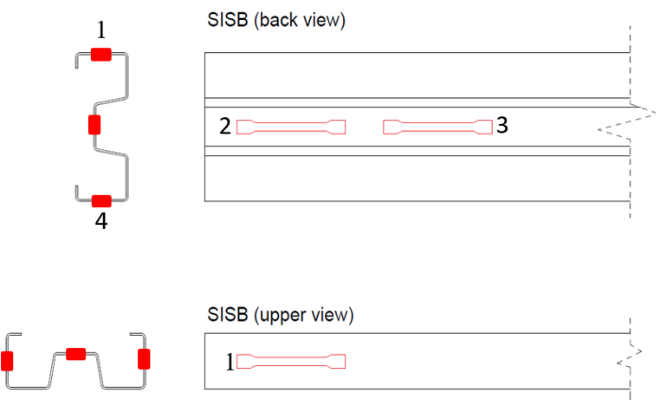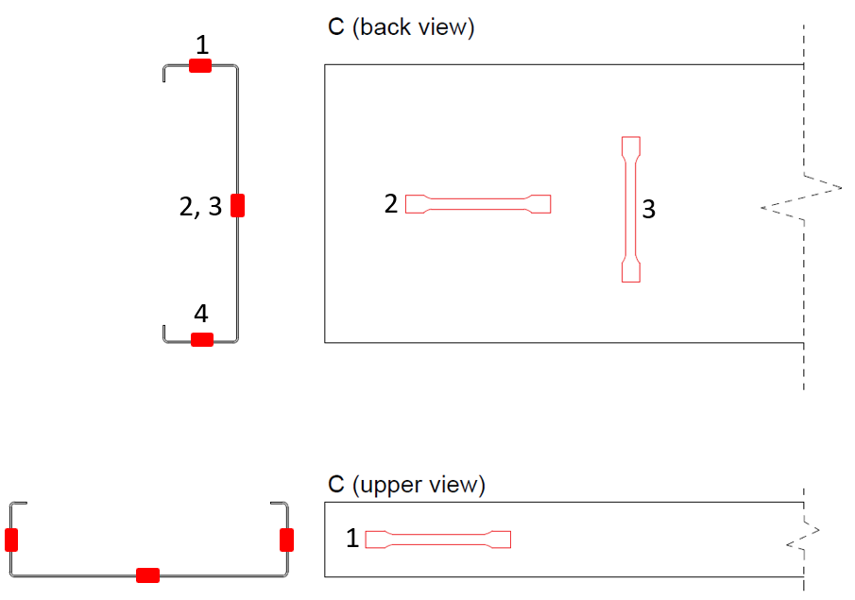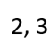
Figure 7: Sketch of the position, the orientation and the notation of the extracted samples for coupon tests for SISB and C profiles
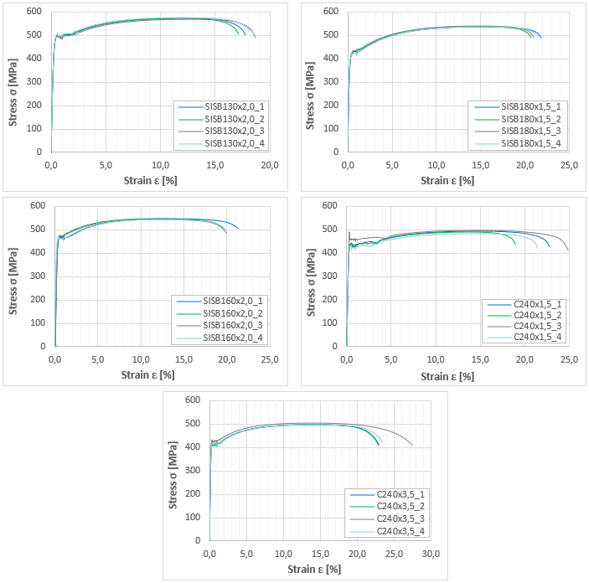
Figure 8: Engineering stress-strain curves for the considered profiles
The tensile tests were performed under extensometer control. Up to 1% elongation, a loading rate of 0.005 mm/s was adopted, followed by 0.5 mm/s until fracture. The stress-strain curves from all the coupon tests are presented in Figure 8. Each curve is identified by the type of the profile (SISB for Sigma and C for channel section) followed by the section height h and thickness t, while the last number indicates the position from which the sample was extracted according to Figure 7, i.e. C240x1.5_3 is the vertically orientated sample extracted from the web of the C 240/65/15/1.5 profile.
Table 3: Coupon test’s results
Profile | Sample | R_{eH} or R_{p0.2} [MPa] | R_{eL} [MPa] | R_{m} [MPa] | E [MPa] | R_{eH} or R_{p0.2} [MPa] | R_{eL} [MPa] | R_{m} [MPa] | E [MPa]
Profile | Sample | Values per sample |  |  |  | Average values per profile
SISB 130/60/2.0 | 1 | 502,64 | 492,31 | 574,20 | 203886 | 497,65 | 490,19 | 573,07 | 200041
SISB 130/60/2.0 | 2 | 499,85 | 490,38 | 571,82 | 200106
SISB 130/60/2.0 | 3 | 490,59 | 484,78 | 569,40 | 201662
SISB 130/60/2.0 | 4 | 497,51 | 493,29 | 576,87 | 194510
SISB 180/70/1.5 | 1 | 411,77 | 411,77 | 538,22 | 205028 | 413,88 | 413,88 | 538,39 | 204105
SISB 180/70/1.5 | 2 | 415,73 | 415,73 | 537,75 | 204376
SISB 180/70/1.5 | 3 | 417,68 | 417,68 | 539,98 | 195284
SISB 180/70/1.5 | 4 | 410,33 | 410,33 | 537,59 | 211730
SISB 160/60/2.0 | 1 | 471,39 | 459,67 | 549,18 | 199642 | 469,76 | 461,31 | 546,06 | 204940
SISB 160/60/2.0 | 2 | 471,94 | 461,43 | 547,41 | 207931
SISB 160/60/2.0 | 3 | 466,97 | 463,83 | 543,64 | 206122
SISB 160/60/2.0 | 4 | 468,75 | 460,29 | 544,01 | 206063
C 240/65/15/1.5 | 1 | 438,56 | 431,66 | 492,82 | 202244 | 435,06 | 424,44 | 488,06 | 208192
C 240/65/15/1.5 | 2 | 437,32 | 426,27 | 489,43 | 209798
C 240/65/15/1.5 | 3 | 490,95 | 451,79 | 499,15 | 227079
C 240/65/15/1.5 | 4 | 429,31 | 415,4 | 481,94 | 212533
C 240/65/25/3.5 | 1 | 417,34 | 413,56 | 496,37 | 208618 | 416,53 | 411,71 | 497,15 | 200864
C 240/65/25/3.5 | 2 | 412,61 | 408,01 | 497,56 | 195900
C 240/65/25/3.5 | 3 | 435,42 | 426,68 | 506,18 | 191530
C 240/65/25/3.5 | 4 | 419,64 | 413,55 | 497,51 | 198019

Table 3 summarizes the upper yield stress (R_{eH}) or the proof strength (R_{p0.2}), the lower yield stress (R_{eL}), the tensile strength (R_{m}) and the modulus of elasticity (E) for each sample; the mean values of these parameters are also presented for each profile. The modulus of elasticity was obtained as the slope of the initial linear (elastic) portion of the stress–strain curve for each profile, using a linear regression over the specified elastic strain range as recommended by ISO 6892-1 [39]. It can be seen from Table 3 and Figure 8 that both samples transversally oriented (C240x1.5_3 and C240x3.5_3) exhibit higher strengths compared to the ones longitudinally oriented. It should be also noted that these two tests were excluded from the calculation of the mean values.
Table 4: Comparison of actual and nominal material properties
No | Profile | EN 1993-1-3:2024^{*1} |  | EN 10346^{*2}
No | Profile | R_{eL}/f_{yb} [-] | R_{m}/f_{u} [-] | R_{eL}/f_{yb} [-] | R_{m}/f_{u} [-]
1 | SISB 130/60/2.0 | 1,23 | 1,27 | 1,17 | 1,22
2 | SISB 180/70/1.5 | 1,03 | 1,20 | 0,99 | 1,15
3 | SISB 160/60/2.0 | 1,15 | 1,21 | 1,10 | 1,16
4 | C 240/65/15/1.5 | 1,06 | 1,08 | 1,01 | 1,04
5 | C 240/65/25/3.5 | 1,03 | 1,10 | 0,98 | 1,06
^{*1} for steel HX420LAD [33]: f_{yb} = 400 MPa, f_{u} = 450 MPa
^{*2} for steel HX420LAD [41]: f_{yb} = 420 MPa, f_{u} = 470 MPa

Table 4 compares the mean value of the actual stresses with the nominal ones specified in the product standard EN 10346 [41] and the design standard EN 1993-1-3:2024 [33]; the actual basic yield stress – engineering stress – is determined by the lower yield stress R_{eL}. It can be seen that the material properties of all the profiles satisfy the design criteria provided in EN 1993-1-3:2024 and are consistently on the safe side, with deviations ranging from 3% to 23%. Furthermore, the results confirm that the SISB 130/60/2.0, SISB 160/60/2.0 and C 240/65/15/1.5 profiles were indeed made of HX420LAD steel grade. On the contrary, the material properties of the SISB 180/70/1.5 and C 240/65/25/3.5 profiles are 1-2% lower than the minimum ones provided by the product norm and thus these profiles finally exhibit an HX380LAD grade.

Actual geometry of specimens
The actual geometry of the profiles was measured in three cross-sections along each specimen: near both extremities (x ≈ 0 and x ≈ L) and at the midspan section (x = L/2), as shown in Figure 9. Measurements at the ends were taken approximately 5 cm from the edges to avoid local deformation caused by the cutting process. The total length of the specimen has also been measured, as well as the angles of the four corners. The mean values of these measurements are reported in Table 5.
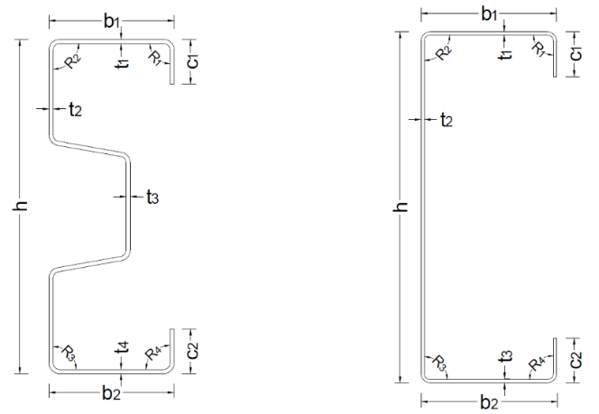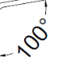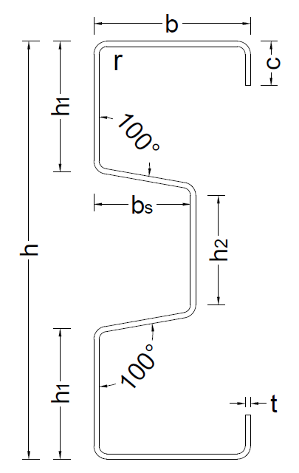
Figure 9: Notations for the actual geometry measurements
It should be also mentioned that the radius of the four fillets at the corners is equal to the thickness of the profile for the channel sections and twice the thickness for the sigma sections. In addition, the horizontal length of the longitudinal stiffener (reported as b_{s} in Figure 9) and the vertical length h₂ equal 37,0 mm and 41,9 mm respectively, for both SISB 130/60/2 and SISB 160/60/2; for SISB 180/70/1.5 these values are equal to 43,0 mm and 49,4 mm respectively.
Table 5: Measurements of the actual dimensions of the cross-sections
No | Specimen | L_{tot} [mm] | h [mm] | c₁ [mm] | c₂ [mm] | b₁ [mm] | b₂ [mm] | t [mm] | R₁ [deg] | R₂ [deg] | R₃ [deg] | R₄ [deg]
1 | Sp11a | 3500 | 129,0 | 14,7 | 14,7 | 60,0 | 60,0 | 2,04 | 89,8 | 89,8 | 90,0 | 89,7
2 | Sp11b | 3500 | 129,0 | 15,0 | 15,0 | 60,0 | 60,0 | 2,03 | 89,5 | 90,0 | 90,0 | 89,5
3 | Sp12a | 3500 | 129,0 | 15,0 | 15,0 | 60,0 | 60,0 | 2,03 | 89,8 | 89,7 | 89,8 | 89,8
4 | Sp12b | 3500 | 129,0 | 15,0 | 15,0 | 60,0 | 60,0 | 2,03 | 90,0 | 90,0 | 90,0 | 90,0
5 | Sp21a | 3500 | 179,0 | 20,0 | 20,0 | 70,0 | 70,0 | 1,53 | 91,0 | 90,3 | 90,3 | 90,7
6 | Sp21b | 3498 | 179,0 | 20,0 | 20,0 | 70,0 | 70,0 | 1,52 | 91,3 | 92,3 | 90,7 | 90,7
7 | Sp22a | 3499 | 180,3 | 20,0 | 20,0 | 70,0 | 70,0 | 1,53 | 90,3 | 92,3 | 92,0 | 90,3
8 | Sp22b | 3498 | 179,7 | 20,0 | 20,0 | 70,0 | 70,0 | 1,52 | 90,7 | 92,3 | 90,7 | 90,3
9 | Sp31a | 3500 | 159,7 | 17,0 | 17,0 | 60,0 | 60,0 | 2,01 | 90,0 | 90,0 | 90,3 | 95,7
10 | Sp31b | 3501 | 160,3 | 17,0 | 17,3 | 60,0 | 60,0 | 2,01 | 93,7 | 90,7 | 90,7 | 94,0
11 | Sp32a | 3501 | 160,0 | 17,0 | 17,3 | 60,0 | 60,0 | 2,00 | 93,7 | 90,7 | 90,7 | 95,7
12 | Sp32b | 3499 | 160,0 | 18,0 | 16,0 | 60,0 | 60,0 | 2,01 | 95,3 | 90,0 | 90,7 | 91,3
13 | Sp41a | 3501 | 239,0 | 18,0 | 18,0 | 64,0 | 64,0 | 1,43 | 90,0 | 90,0 | 90,0 | 90,0
14 | Sp41b | 3500 | 240,0 | 18,0 | 17,0 | 64,0 | 64,0 | 1,43 | 90,0 | 89,3 | 89,3 | 90,0
15 | Sp51a | 3500 | 239,7 | 24,0 | 24,0 | 65,0 | 65,0 | 3,40 | 90,0 | 90,0 | 90,0 | 90,0
16 | Sp51b | 3501 | 240,0 | 24,0 | 24,0 | 65,0 | 65,0 | 3,41 | 90,0 | 90,0 | 90,0 | 90,0
h = 1/3(h^{x=0} + h^{x=L/2} + h^{x=L}) ; c_{i} = 1/3(c_{i}^{x=0} + c_{i}^{x=L/2} + c_{i}^{x=L}) for i = 1, 2 ; b_{i} =1/3(b_{i}^{x=0} + b_{i}^{x=L/2} + b_{i}^{x=L}) for i =1, 2
t = 1/8(t₁^{x=0} +t₂^{x=0} +t₃^{x=0} +t₄^{x=0} +t₁^{x=L/2} +t₂^{x=L/2} +t₃^{x=L/2} +t₄^{x=L/2} +t₁^{x=L} +t₂^{x=L} +t₃^{x=L} +t₄^{x=L}) for SISB profiles
t = 1/6(t₁^{x=0} +t₂^{x=0} +t₃^{x=0} +t₁^{x=L/2} +t₂^{x=L/2} +t₃^{x=L/2} +t₁^{x=L} +t₂^{x=L} +t₃^{x=L}) for C profiles
R_{i} =1/3(R_{i}^{x=0} + R_{i}^{x=L/2} + R_{i}^{x=L}) for i =1 to 4

The measured dimensions indicate that, in general, the actual geometry of the cross-sections deviates only slightly from the nominal geometry. However, since the tolerances for the cross-sectional dimensions of cold-formed profiles are defined by the manufacturers according to ISO EN 10162 [42], no further quantitative comparison with nominal values is presented.

Initial geometrical imperfections of specimens
Two measurements M1 & M2 on the three external faces, i.e. A, B and C and along the member’s length were performed so as to evaluate the initial geometrical imperfections of all specimens. The use of the member’s length (L = 3000 mm) instead of the specimen’s length (L_{tot} = 3500 mm) results in more accurate measurements, as for all tests, these points are restrained by the end forks. The measurements allow the evaluation of global bow imperfections, the identification of local imperfections, and the assessment of the flange distortion.
Figure 10 shows the orientation of the specimen during the measurements as well as their notations. It should be mentioned that the distances between the displacement transducers (M1_i & M2_i) for the different profiles was constant and equal to 40 mm for measurements on Faces A and B. For Face C, this distances (d_{C,k}) varied for depending on the profile geometry: 115 mm for SISB 130/60/2.0, 150 mm for SISB 180/70/1.5, 125 mm for SISB 160/60/2.0, and 200 mm for both C profiles.
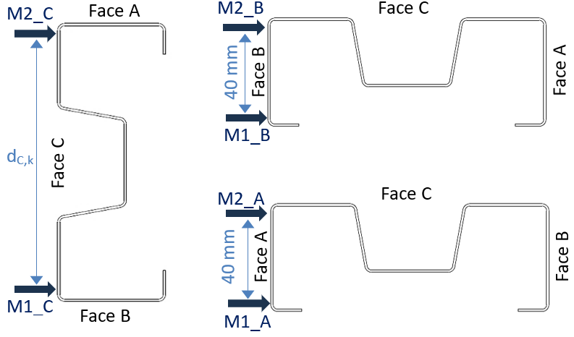
Figure 10: Positions and notations for the initial geometrical imperfection measurements
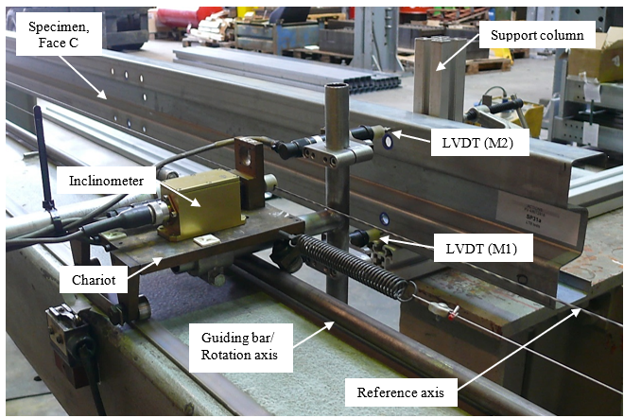
Figure 11: Measurement system for the initial geometrical imperfections
Figure 11 shows the details of the set-up configuration. The measuring system was made of a chariot equipped with two LVDTs moving on a beam approximately parallel to the specimen, so that the transducers (LVDTs) could measure the imperfections at two points on the external faces of the member. As the chariot is moving onto a horizontal guiding bar, a small rotation of the metric system can possibly develop. Given that this rotation can significantly affect the results, this rotation was measured by an inclinometer, allowing thus to correct the measurements during the post-treatment of the results. The reference axis for all measurements was the pretensioned wire shown in Figure 11, while a measurement has been taken every 50 mm along the member. Furthermore, two support columns were used to stabilize the specimen at the extremities, only when imperfections on face C were measured. Obviously these elements were not necessary for measurements on faces A and B. As these restraint points coincide with the positions of the end supports/forks where it is assumed that there are no imperfections, it can be concluded that they are not affecting the measured results.

Figure 12: Initial geometrical imperfections of specimen Sp22a
In order to obtain the final initial geometrical deformation of the specimens, some corrections of the rough measured values had to be made. The first correction to achieve concerns the non-parallelism and the rotation of the metric system, based always on the position of the reference cable, while the second correction has been done in order to have zero imperfection at the positions of the end supports/forks of the member. An example of the interpreted initial geometrical imperfections for specimen Sp22a is given in Figure 12.
Table 6 summarizes some maximum key values of the initial imperfection measurements such as:
- the maximum absolute value of the finally corrected initial bow geometrical imperfection |e_{0,max}| at the positions M1 or M2, as well as the face on which the latter is recorded;
- the maximum absolute value of the corrected twist imperfection of the web of the profile $|θ_{web,max}|=max\left[tan^{-1}\frac{M2_C_fin -M1_C_fin}{d_{C,k}}\right]$;
- the maximum absolute value of the distortional angle of the flanges $|α_{d,max}|=max\left[tan^{-1}\frac{M2_j_fin -M1_j_fin}{d_{j,k}}\right]$, where j is face A or B.
According to EN1993-1-3:2006, the execution of cold-formed steel structures should comply with EN 1090-4 [43], which refers to EN 10162 [42] for the fabrication tolerances. The latter specifies a maximum out-of-straightness bow imperfection of L[mm]/500 and a maximum twist of 1,0 degree per meter. Furthermore, for flanges with widths between 40-80 mm, the permissible distortional angle is 1,15º.
Table 6: Maximum values of the initial imperfections
No | Specimen | |e_{0,max}| [mm] | Face | θ_{web,max} [deg] | α_{d,max} [deg]
1 | Sp11a | 0,78 | C | 0,18 | 0,68
2 | Sp11b | 0,75 | C | 0,18 | 0,59
3 | Sp12a | 0,91 | C | 0,21 | 0,83
4 | Sp12b | 0,98 | C | 0,18 | 0,76
5 | Sp21a | 3,70 | C | 0,67 | 1,56
6 | Sp21b | 4,27 | C | 0,74 | 1,49
7 | Sp22a | 4,07 | C | 0,60 | 1,68
8 | Sp22b | 3,95 | C | 0,54 | 1,52
9 | Sp31a | 0,74 | C | 0,22 | 1,03
10 | Sp31b | 0,81 | B, C | 0,18 | 1,15
11 | Sp32a | 0,84 | B (local) | 0,34 | 1,04
12 | Sp32b | 0,75 | B (local) | 0,32 | 0,91
13 | Sp41a | 1,13 | A | 0,28 | 0,81
14 | Sp41b | 0,77 | A | 0,34 | 0,51
15 | Sp51a | 1,45 | C | 0,35 | 0,43
16 | Sp51b | 1,80 | C | 0,29 | 0,40

As shown in Table 6, all specimens satisfy the prescribed tolerance limits for bow imperfections, with maximum recorded value (e_{o,max} = 4,27 mm for Sp21b) remaining well below the allowable limit of 6,0 mm. In addition, for all specimens, the maximum twist θ_{web,max} was 0,74º, which is also within the specified tolerance. Moreover, the distortional angle of the flanges remained below the normative limit for the majority of the specimens, with exceedances observed only for the SISB180/70/1.5 profiles.
It should be noted that the reported imperfections correspond to specimens supported only at their extremities. When the specimens are installed in the test setup, the presence of intermediate forks, stiffeners and loading brackets further reduce the initial geometrical imperfections. This effect is particularly pronounced in the 3-point bending tests, where the forks at the mid-span significantly limits out-of-plane imperfections.

Test results and discussion
Prior to the experimental tests, two loading-unloading cycles were performed for each specimen. During the 1st cycle, the specimens were loaded approximately up to 33% of the estimated resistance calculated according to EN 1993-1-3:2006, and then, they were unloaded up to 10% of the resistance. This first loading cycle was aiming to ensure the full contact between all the elements of the testing set-up and absorb possible lack-of-fit, while it allows to better catch the initial elastic stiffness of the member. Subsequently, a 2nd loading cycle was applied up to the estimated specimen’s resistance, after which, the specimens were fully unloaded. In order to make the graphs presented in the section more readable, the first loading and unloading branches have been omitted from the presented graphs. It should be also noted that, as the experimental test was performed through force control protocol, the obtained experimental curves are valid only up to the maximum load, which corresponds to the final point on each curve.
Figure 13 presents the load-displacement and load-rotation curves of all the 4-point bending tests; the definition of the axis is in line with Figure 2. Although the vertical displacements u_{z,L/4} and u_{z,3L/4} have been measured on the upper flange of the load distribution beam HEB 140 (see Figure 5), it is expected to be the same at every point of this cross-section of the specimen due to the presence of the forks and the stiffeners at these positions. For all specimens, except Sp21a, both vertical displacements u_{z,L/4} and u_{z,3L/4} are almost identical, ensuring thus that the applied load is equally and symmetrically distributed to the two load application points on the specimen (4-point bending test); the failure is located between these two lateral restrains, as expected. However, for Sp21a, a small slip occurred at about 14,2 kN, after which the specimen is loaded more at the position of 3L/4 creating so an asymmetric loading; this explains why the failure mode differs from the one of Sp21b and located at the load application position (see Table 7). In addition, for all these tests, the vertical displacement at mid-section (u_{z,L/2}) has been measured at mid-width of the bottom flange, and as expected, it was higher than the vertical displacements at the quarter lengths (i.e. u_{z,L/4} and u_{z,3L/4}). Furthermore, the horizontal deflection u_{y,L/2} was measured at mid-height of the section and it was small for most of the specimens (maximum deflection 2,14 mm for Sp41a), except Sp51a and Sp51b that have deflections of 2,44 mm and 3,53 mm respectively. Obviously the lateral deflections of the upper flanges are a bit higher. The measured rotation of the mid-sections was also remained low with the maximum measured value equal to 2,75º. Finally, it is also interesting to mention that specimens Sp41a and Sp41b had visible local deformations of the web just before failure (see Figure 14) that afterwards disappeared.

Figure 13: Load-displacement and load-rotation curves of the 4-point bending tests
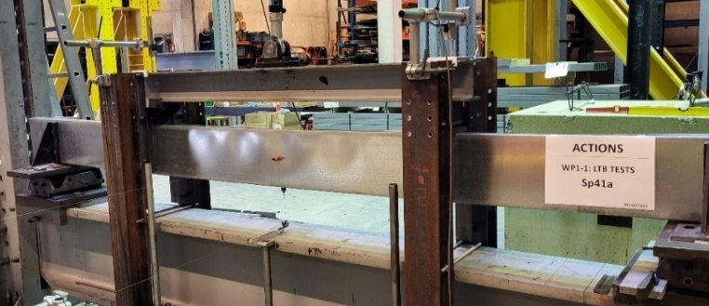
Figure 14: Local deformations of specimen Sp41a just before failure

Figure 15: Load-displacement and load-rotation curves of 3-point bending tests
Figure 15 presents the load-displacement and load-rotation curves of all 3-point bending tests; again, the definition of the axis is given in Figure 2. The vertical displacements u_{z,L/4} and u_{z,3L/4} have been measured at mid-width of the bottom flange and were almost equal for all specimens, while u_{z,L/2} at mid-section is expected to be the same as the elongation of the jack due to the presence of the forks and the stiffeners at this position. The horizontal deflections u_{y,L/4} and u_{y,3L/4} were measured at mid-height of the section and they were very small for all of these tests (less than 0,80 mm) except for Sp22a and Sp22b for which it was 1,50 mm and 1,84 mm respectively. The measured rotations were also small (less than 1,60º). Finally, it should be also mentioned that all specimens failed at their mid-section, and more specifically just next to the stiffener, and exhibit an almost symmetrical deformed shape about Z axis at L/2.
Table 7 summarizes the observed failure modes and the maximum load applied by the hydraulic jack (P_{exp}), while Figure 16 illustrated representative failure modes. It should be mentioned that Figure 16 (right) represents the deformation of the beam at the end of the test after failure occurs, while no indentation has been observed during all tests. Therefore, the final resistance of the members is not affected by the bearing effect which is avoided by the presence of the stiffeners at these positions (see Section 2).
For the 4-point bending tests, failure generally resulted from a combination of global and local instabilities accompanied by yielding of the critical cross-section. Exceptions were specimens Sp51a and Sp51b, for which lateral-torsional buckling (LTB) was more pronounced and governed the response. For all 3-point bending tests no global or local/distortional buckling was observed, but all the specimens reached their cross-sectional resistance under bending. This can be attributed to the relatively small initial geometric imperfections of the members, which were further reduced when the specimens were placed in the testing setup. In fact, the maximum measured out-of-plane and rotational imperfections were generally located near mid-span; however, the presence of the forks at mid-length, aligned with those at the extremities, imposed a straightened configuration on the specimens, thereby significantly limiting the initial geometrical imperfections.
Table 7: Experimental test results
Specimen | Profile | Type of test | P_{exp} [kN] | Failure mode
Sp11a | SISB 130/60/2.0 | 4-point bending | 30,51 | Local/global buckling + yielding
Sp11b | SISB 130/60/2.0 | 4-point bending | 30,42 | Local/global buckling + yielding
Sp12a | SISB 130/60/2.0 | 3-point bending | 18,06 | Yielding + crushing of the upper flange
Sp12b | SISB 130/60/2.0 | 3-point bending | 17,56 | Yielding + crushing of the upper flange
Sp21a | SISB 180/70/1.5 | 4-point bending | 29,42 | Yielding + crushing of the upper flange
Sp21b | SISB 180/70/1.5 | 4-point bending | 29,25 | Local/global buckling + yielding
Sp22a | SISB 180/70/1.5 | 3-point bending | 15,18 | Yielding + crushing of the upper flange
Sp22b | SISB 180/70/1.5 | 3-point bending | 15,12 | Yielding + crushing of the upper flange
Sp31a | SISB 160/60/2.0 | 4-point bending | 32,29 | Local/global buckling + yielding
Sp31b | SISB 160/60/2.0 | 4-point bending | 34,22 | Local/global buckling + yielding
Sp32a | SISB 160/60/2.0 | 3-point bending | 20,46 | Yielding + crushing of the upper flange
Sp32b | SISB 160/60/2.0 | 3-point bending | 21,44 | Yielding + crushing of the upper flange
Sp41a | C 240/65/15/1.5 | 4-point bending | 30,53 | Yielding + local buckling
Sp41b | C 240/65/15/1.5 | 4-point bending | 31,56 | Yielding + local buckling
Sp51a | C 240/65/25/3.5 | 4-point bending | 115,18 | LTB
Sp51b | C 240/65/25/3.5 | 4-point bending | 114,32 | LTB

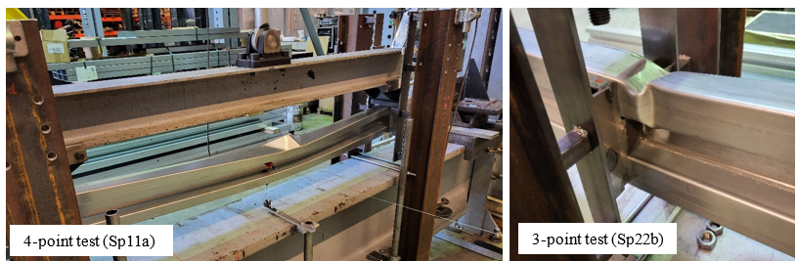
Figure 16: Indicative failure modes of local/global buckling interaction and yielding of the cross-section (left) and yielding with crushing of the upper flange (right)

Comparison with the Eurocode provisions
In the following sections, the experimentally obtained resistances are compared with the ones calculated by applying the provisions of EN1993-1-3:2006, considering actual geometrical and material properties of the tested specimens.

Resistance of members subjected to strong axis bending M_{y}
According to §6.2.4 of EN 1993-1-3:2006, the design resistance of a member in bending that is susceptible to lateral-torsional buckling should be determined according to EN 1993-1-1:2005, §6.3.2, using the lateral buckling curve b. Therefore, the design buckling resistance moment M_{b,Rd} of a laterally unrestrained beam should be taken as given by Eq.1.
$M_{b,Rd}=χ_{LT}\frac{W_{y,eff}f_{yb}}{γ_{M1}}$ (Eq. 1)
where f_{yb} is the basic yield stress, γ_{Μ1} is the partial factor for resistance of members to instability (equal to 1,0 as recommended in EN 1993-1-1) and W_{y,eff} is the effective section modulus according to EN 1993-1-3 using the effective width method, accounting for both local and distortional aspects; for compact sections W_{y,eff} is equal to W_{y} of the gross cross-section. The reduction factor for lateral torsional buckling χ_{LT} should be determined as a function of the relative slenderness ${\overline{λ}}_{LT}$of the member:
${\overline{λ}}_{LT}=\sqrt{\frac{W_{y,eff}f_{yb}}{M_{cr}}}$ (Eq. 2)
The elastic critical moment should be based on gross cross-section properties and considering the loading conditions, the actual moment distribution and the lateral restraints. As no ad hoc formulas is provided directly in EN1993-1-1 (or EN 1993-1-1:2022), a reference to the technical report CEN/TR 1993-1-103 is made, where the case of beams with uniform cross-sections symmetrical about the major axis is addressed. More specifically, the critical moment M_{cr} may be given by the following formula:
$M_{cr}=C_{1}⋅\frac{π^{2}⋅E⋅I_{z}}{{\left(k_{z}⋅L\right)}^{2}}⋅\left[\sqrt{{\left(\frac{k_{z}}{k_{w}}\right)}^{2}\frac{I_{w}}{I_{z}}+\frac{{(k_{z}⋅L)}^{2}⋅G⋅I_{T}}{π^{2}⋅E⋅I_{z}}+{\left(C_{2}⋅z_{g}\right)}^{2}}-C_{2}⋅z_{g}\right]$ (Eq. 3)
where:
C₁,C₂ are coefficients depending on the loading and support conditions;
E is the Young modulus of elasticity;
I_{z}, I_{T} and I_{w} are the moment of inertia about z-z axis, the torsional and the warping constants respectively;
k_{z}, k_{w} are effective length factors that depend on the support conditions at the extremities of the member. The factor k_{z} is related to rotations at the end sections about the weak axis z-z, and k_{w} refers to warping restraint at the same sections. These factors vary between 0,5 (restrained deformations) and 1,0 (free deformations);
z_{g} = (z_{a}-z_{s}) where z_{a} and z_{s} are respectively the z-coordinates of the point of application of the load and of the shear centre. These coordinates are positive if are in the compressed part and negative if located in the tension part.
Although the limitations of this simplified formulae are well-known [23]-[24]-[44], its application is allowed by the normative standards and, as such, its use is common among the practitioners. For this reason, it was decided to make comparisons based on its application, rather than using finite element tools to evaluate the elastic critical moment.

Cross sectional properties
The actual sectional properties of the tested profiles, considering the measured geometry, are summarized in Table 8. The gross cross-sectional inertias (I_{z}, I_{T} and I_{w}) have been calculated by taking into account the rounded corners using Calpro, a specific tool available in the FINELG software [45].
Table 8: Actual sectional properties of the tested profiles
Sectional property/Profile | SISB 130/60/2.0 |  | SISB 160/60/2.0 |  | SISB 180/70/1.5 |  | C 240/65/15/1.5 |  | C 240/65/25/3.5
I_{z} [mm⁴] |  | 239584 |  | 281895 |  | 344385 |  | 285494 |  | 709451
I_{T} [mm⁴] |  | 901 |  | 970 |  | 487 |  | 383 |  | 5180
I_{w} [mm⁶] |  | 1212670942 |  | 2056453073 |  | 3247028486 |  | 3174784765 |  | 8163941468
W_{y} [mm³] |  | 23368 |  | 30530 |  | 30764 |  | 38908 |  | 93981
W_{eff,y} [mm³] |  | 21827 |  | 28989 |  | 25573 |  | 24685 |  | 93981

The section moduli W_{y} are referring to the elastic ones (section moduli of the gross cross-section), while W_{eff,y} to the effective moduli accounting for both local and distortional buckling according to the provisions of EN 1993-1-3, §5.5. Obviously, the thinner the profile, the greater the difference between the two moduli. The notional flat widths of the plane elements have been taken according to EN 1993-1-3, §5.1(1). Although the rounded corners have been neglected according to EN 1993-1-3, §5.1(3), their influence is expected to be rather small (about 2-3%) according to [1], given that the radius and the thicknesses of the considered profiles are rather small. The effective widths of the compressed plates were determined following the provisions of EN1993-1-5, §4.4, as recommended in EN 1993-1-3, §5.5. The latter is also used to calculate the effective reduced thickness, which accounts for distortional buckling effects. A detailed example of this computation is provided in the relevant technical note [46].

Comparison of experimental and analytical resistances
For the analytical calculations, the critical length is defined as the length between two successive lateral restraints (i.e. L_{crit} = 1500 mm, in both configurations), while the C₁ coefficient is given in the National Belgian annex of EN 1993-1-1 [47] and reported in Table 9. Additionally, even if the load is implemented at the upper flange, it is assumed that z_{g} = 0 due to the presence of the lateral restraints and the stiffeners at these positions. Although during the design of the test the effective length factors k_{w} and k_{z} were conservatively taken equal to 1,0, it has been observed during the tests that the presence of the 30 mm thick stiffeners is not allowing warping to freely develop at these positions (see also Figure 1). Therefore, the actual k_{w} and k_{z} should be equal to 0,5 and 1,0 respectively; these values are adopted hereafter for the analytical computations. Table 9 presents the calculation of the critical moment M_{cr}, the normative characteristic buckling resistance moment of the specimen (M_{by,Rk}) as well as the cross sectional characteristic resistance (M_{y,Rk}), as those were described in §5.1.
Table 9: Calculation of characteristic buckling resistance moment
No | CS type | Type of bending test | C₁ [-] | M_{cr} [kNm | ${\overline{λ}}_{LT}$ [-] | M_{by,Rk} [kNm] | M_{y,Rk} [kNm]
1 | SISB 130/60/2.0 | 4-point | 1,00 | 30,16 | 0,596 | 8,98 | 10,70
2 | SISB 180/70/1.5 | 4-point | 1,00 | 59,98 | 0,420 | 9,72 | 10,58
3 | SISB 160/60/2.0 | 4-point | 1,00 | 43,51 | 0,554 | 11,49 | 13,37
4 | C 240/65/15/1.5 | 4-point | 1,00 | 55,06 | 0,436 | 9,55 | 10,48
5 | C 240/65/25/3.5 | 4-point | 1,00 | 135,04 | 0,535 | 33,59 | 38,69
6 | SISB 130/60/2.0 | 3-point | 1,77 | 53,38 | 0,448 | 9,70 | 10,70
7 | SISB 180/70/1.5 | 3-point | 1,77 | 106,16 | 0,316 | 10,14 | 10,58
8 | SISB 160/60/2.0 | 3-point | 1,77 | 77,02 | 0,417 | 12,29 | 13,37

Table 10: Ratio of the experimental to the analytical resistances
Specimen | Test Type |  | P_{exp} [kN] |  | M_{exp} [kNm] | M_{by,Rk} [kNm] | M_{y,Rk} [kNm] | m_{by} [-] | m_{y} [-]
Sp11a |  | 4-point bending tests |  | 30,51 | 11,44 | 8,98 | 10,70 | 1,27 | ---
Sp11b |  |  |  | 30,42 | 11,41 | 8,98 | 10,70 | 1,27 | ---
Sp21a |  |  |  | 29,42 | 11,03 | 9,72 | 10,58 | 1,14 | ---
Sp21b |  |  |  | 29,25 | 10,97 | 9,72 | 10,58 | 1,13 | ---
Sp31a |  |  |  | 32,29 | 12,11 | 11,49 | 13,37 | 1,05 | ---
Sp31b |  |  |  | 34,22 | 12,83 | 11,49 | 13,37 | 1,12 | ---
Sp41a |  |  |  | 30,53 | 11,45 | 9,55 | 10,48 | 1,20 | ---
Sp41b |  |  |  | 31,56 | 11,84 | 9,55 | 10,48 | 1,24 | ---
Sp51a |  |  |  | 115,18 | 43,19 | 33,59 | 38,69 | 1,29 | ---
Sp51b |  |  |  | 114,32 | 42,87 | 33,59 | 38,69 | 1,28 | ---
Sp12a |  | 3-point bending tests |  | 18,06 | 13,00 | 9,70 | 10,70 | 1,40 | 1,22
Sp12b |  |  |  | 17,56 | 12,64 | 9,70 | 10,70 | 1,36 | 1,18
Sp22a |  |  |  | 15,18 | 10,93 | 10,14 | 10,58 | 1,12 | 1,03
Sp22b |  |  |  | 15,12 | 10,89 | 10,14 | 10,58 | 1,12 | 1,03
Sp32a |  |  |  | 20,46 | 14,73 | 12,29 | 13,37 | 1,25 | 1,10
Sp32b |  |  |  | 21,44 | 15,44 | 12,29 | 13,37 | 1,31 | 1,15

Figure 17 presents the ratio m_{by} of the experimentally obtained moment (M_{exp}) to the analytical one (M_{by,Rk}) versus the global slenderness for all tests. The experimental resistance corresponds to the maximum first order bending moment developed in the specimen, while the analytical one is calculated in Table 9. For the 4-point tests, M_{exp}=P_{epx}·L/8, where L = 3,0 m, while for the 3-point tests, M_{exp} = (P_{exp}/2)·L_{e}, where L_{e} = 1,44 m is the distance from the end support up to the location of the observed beam failure, i.e. next to the zone strengthen by the stiffeners and the loading bracket. In addition, as the 3-point tests reached their cross sectional resistance under pure bending as explained in §4, the ratio m_{y} = M_{exp}/M_{y,Rk} is also presented; all these values are also reported in Table 10. It should be noted that, in accordance with EN 1993-1-3, §6.1.7.1.(3), when the local load is transmitted through a cleat/bracket that is arranged to prevent web distortion (as is the case with the installed stiffeners) and is designed to resist the local transverse force, the local resistance of the web to the transverse force does not need to be verified.

Figure 17: Comparison of the experimental and analytical resistances
It can be seen through Figure 17 and Table 10 that all the experimentally obtained resistances are on the safe side compared with the ones calculated analytically by applying the provisions of EN 1993-1-3 in combination with EN 1993-1-1 and considering actual geometrical and material properties.
More specifically, for the 3-point bending tests the mean value of the ratio m_{by} is 1,26 with a CoV of 10,8% (rectangular points in Figure 17). Obviously, these ratios are high as the analytical resistances are accounting for the effects of lateral-torsional buckling, while the latter does not occur during the tests for the reasons explained in §4. On the contrary, when comparing the experimental resistances with the cross-sectional resistances, the mean value of the ratio m_{y} is equal to 1,12 with a CoV of 7,1% (cross points in Figure 17). The latter comparisons could validate the assumptions of EN 1993-1-3 for the determination of the effective properties (i.e. middle line dimensions and neglect of the rounded corners) which provide in all cases safe results but also not too conservative. Obviously, part of the higher experimental resistances can be attributed to the increased yield strength at the corners of the cross-sections resulting from strain hardening effects, while the inherent conservatism of the effective width method, arising from its underlying assumptions [48], has already been reported by Dubina et al. [1].
For the 4-point bending tests, the mean value of the ratio m_{by} is equal to 1,20 with a CoV of 7,9%. The higher experimental resistances of these tests could be explained by the three following reasons. Firstly, due to the enhanced properties at the corners of the sections caused by strain hardening effects as explained before, and secondly, due to the assumptions adopted by the effective width method that Eurocode 3 recommends. Lastly, the fact that the small lengths between the external and the intermediate forks in combination with the stiffeners is slightly restraining the bending of the beam about z axis results to actual k_{z} factors slightly smaller than 1,0. However, the determination of the exact k_{z} value is not common in practice, where discrete design values are directly adopted depending on the boundary conditions. Therefore, no further investigations are made here.

Conclusions
The resistance and stability behaviour of small to medium range slenderness beams (${\overline{λ}}_{LT}<1.0$) with monosymmetric thin-walled cold-formed sections that are subjected to bending has been investigated through experimental and analytical studies. The experimental campaign comprises six 3-point and ten 4-point bending tests on sigma- and C-section beams. Measurements of initial geometric imperfections and cross-sectional dimensions revealed that the specimens were generally very straight and that the deviations from nominal geometry were limited. Furthermore, the influence of the testing setup to the initial geometrical imperfections of the specimens is highlighted, demonstrating that the final imperfections are smaller than the ones measured on the specimen before its placement to the setup. Tensile coupon tests were also performed in order to characterize the actual material properties, showing some variations between actual and nominal material properties.
Amongst the tested specimens, the majority of those tested through a 4-point bending failed due to a combination of global and local instabilities accompanied by limited yielding of the critical section, while for some others, lateral-torsional buckling was more pronounced. In contrast, none of the specimens tested under 3-point bending exhibit global or local/distortional buckling; instead, all specimens reach their cross-sectional bending resistance.
The experimentally obtained resistances were compared with analytical predictions based on the provisions of Eurocode 3. The comparisons demonstrate that EN1993-1-3 provides safe resistance predictions for laterally unrestrained thin-walled cold-formed beams subjected to bending. Furthermore, the results of the 3-point bending tests validate the assumptions adopted in EN 1993-1-3 for the determination of the effective cross-sectional properties, such as the use of mid-line dimensions and the neglect of rounded corners, which lead to safe yet not overly conservative predictions.

Acknowledgments
The authors of this publication acknowledge the Logistics in Wallonia ASBL, the Walloon Region and the Pôle MecaTech for their support in the framework of the project n°8528 entitled ACTIONS “Advanced Eurocodes Compliant Tools for Industrial Optimized Innovative Structures”. The partners of the project are STOW Group, CRM and GDTech companies, as well as the university of Liège.

References
- Dubina, D.; Ungureanu, V.; Landolfo, R. (2012) Design of Cold-formed Steel Structures (book), ECCS-European convention for constructional steel, ISBN: 978-92-9147-107-2.
- Hancock, G.J. (2003) Cold-formed steel structures, Journal of Constructional Steel Research, Vol. 59, Iss. 4, pp. 473-487, https://doi.org/10.1016/S0143-974X(02)00103-7.
- EN 1993-1-3. Eurocode 3: Design of steel structures - Part 1-3: General rules - Supplementary rules for cold-formed members and sheeting, Brussels, Comité Europeen de Normalisation (CEN), 2006.
- EN 1993-1-1: Design of steel structures - Part 1-1: General rules and rules for buildings, Brussels (CEN), Comité Européen de Normalisation, 2005.
- prEN 1993-1-14. Eurocode 3: Design of steel structures - Part 1-14: Design assisted by finite element analysis, Brussels, Comité Europeen de Normalisation (CEN), 2023.
- Wang, L.; Young, B. (2014) “Design of cold-formed steel channels with stiffened webs subjected to bending”. Thin-Walled Struct. 85, 81-92.
- Laim, L.; Rodrigues, J.P.; Craveiro, H.D. (2015) “Flexural Behaviour of Beams made of Cold-Formed Steel Sigma-Shaped Sections at Ambient and Fire Conditions”. Thin-Walled Struct. 87, 53-65, https://doi.org/10.1016/j.tws.2014.11.004.
- Chen, M.T.; Young, B.; Martinis, A.D.; Camotim, D.; Dinis, P.; (2021) “Experimental investigation on cold-formed steel lipped channel beams affected by local-distortional interaction under non-uniform bending”. Thin-Walled Struct. 161, 107494.
- Dinis, P.; Young, B.; Camotim, D. (2014) “Strength, interactive failure and design of web-stiffened lipped channel columns exhibiting distortional buckling”. Thin-Walled Struct. 81, pp.195-209. https://doi.org/10.1016/j.tws.2013.09.016.
- Wang, H.; Zhang, Y. (2009) “Experimental and numerical investigation on cold-formed steel C-section flexural members”, Journal of Constructional Steel Research, Vol. 65, Iss. 5, pp. 1225-1235, https://doi.org/10.1016/j.jcsr.2008.08.007.
- Laim, L.; Rodrigues, J.P.; Silva, L.S. (2013) “Experimental and numerical analysis on the structural behaviour of cold-formed steel beams”. Thin-Walled Struct. 72, 1-13.
- Keerthan, P.; Hughes, D.; Mahendran, M. (2014) “Experimental studies of hollow flange channel beams subject to combined bending and shear actions” Thin-Walled Struct. 77, 129-140, https://doi.org/10.1016/j.tws.2013.12.003.
- Ismail, M.; Hammad, A.; Ibrahim, S. (2025) “Experimental and Numerical Investigation of Cold-Formed Sigma Sections subjected to Bending and Torsion Moments”. Thin-Walled Struct. 214, 113422, https://doi.org/10.1016/j.tws.2025.113422.
- Wan, H.X.; Huang, B.; Mahendran, M. (2021) “Experiments and numerical modelling of cold-formed steel beams under bending and torsion”. Thin-Walled Struct. 161, 107424.
- Obst, M.; Kurpisz, D.; Paczos, P. (2016) “The experimental and analytical investigations of torsion phenomenon of thin-walled cold formed channel beams subjected to four-point bending”. Thin-Walled Struct. 106, 179–186. https:// doi. org/ 10. 1016/j. tws. 2016. 05.002.
- Wang, L.; Young. B. (2016) “Behavior of Cold-Formed Steel Built-Up Sections with Intermediate Stiffeners under Bending. I: Tests and Numerical Validation”, Journal of Structural Engineering, Vol. 142, No. 3, https://doi.org/10.1061/(ASCE)ST.1943-541X.0001428
- Meza, F. J., J. Becque, and I. Hajirasouliha. 2020. “Experimental study of cold-formed steel built-up beams.” J. Struct. Eng., 2020, 146(7): 04020126.
- Li, Q.Y.; Young, B. (2022) “Structural performance of cold-formed steel built-up section beams under non-uniform bending”. Journal of Constructional Steel Research, Vol. 189, 107050, https://doi.org/10.1016/j.jcsr.2021.107050.
- Ma, D.; Rasmussen, K.; Zhang, H. (2023) “Test and Design of Cold-Formed Steel Closed Built-Up Beams with Double Sigma Sections and Triple Lipped Channel Sections”, Thin-walled structures, Vol. 192, 111192, https://doi.org/10.1016/j.tws.2023.111192.
- Young, B.; Ellobody, E.; He, J. (2023) “Web crippling tests on cold-formed high strength steel channel sections having different stiffened flanges and stiffened web”. Thin-walled structures, Vol. 190, 110995.
- Yu, W.W.; Hetrakul, N. (1978). “Webs for cold formed steel flexural members structural behavior of beam webs subjected to web crippling and a combination of web crippling and bending”. Civil Engineering Study: 78-4, Final Report, Univ. of Missouri-Rolla, Rolla, Missouri, USA.
- Schafer, B.W.; Sarawit, A.; Peköz, T. (2006). “Complex edge stiffeners for thin-walled members”. Journal of Structural Engineering, 132(2), 212-226.
- Shan-shan, C.; Boksun, K.; Long-yuan, L. (2013) “Lateral–torsional buckling of cold-formed channel sections subject to combined compression and bending”, Journal of Constructional Steel Research, vol.80, pp. 174–180.
- Vermeylen, M., Bezas, M., Crispin, M., Jaspart, J., & Demonceau, J.-F (2023). “Lateral‐torsional buckling of beams made of mono‐symmetrical thin‐walled sections”. ce/papers, 6(3–4), 1649–1654. https://doi.org/10.1002/cepa.2358
- CEN/TR 1993-1-103: Design of steel structures - Part 1-103: “Elastic critical buckling of members”, Brussels, Comité Européen de Normalisation (CEN), 2019.
- Lindner, J.; Aschinger, R. (1994) “Load-carrying capacity of cold-formed beams subjected to overall lateral–torsional buckling and local plate buckling”. Journal of Constructional Steel Research, 31 (2-3), pp. 267-287.
- Wang, L.; Jiang, X.; Guo, W.; Lyu, F. (2025) “Intelligent design of web-stiffened cold-formed steel channel beam section oriented by load-carrying efficiency”. Structures, Vol.74, 108571.
- Basaglia, C.; Camotim, D. (2012) “Buckling, Postbuckling, Strength, and DSM Design of Cold-Formed Steel Continuous Lipped Channel Beams”. Journal of Structural Engineering, Vol. 139, Iss. 5, https://doi.org/10.1061/(ASCE)ST.1943-541X.0000651.
- Basaglia, C.; Camotim, D.; Coda, H. (2014) “Behaviour, failure and DSM design of cold-formed steel beams: Influence of the load point of application”. Thin-walled structures, Vol. 81, pp. 78-88. https://doi.org/10.1016/j.tws.2013.07.007
- Hossam, M.; El-Aghoury, I.M.; Ibrahim, S.M.; Hassan, S. (2021) “The Strength of Sigma Section Subjected to Bending Moment According to the Direct Strength Method”, International journal of Scientific & Technology research, Vol. 10, Iss. 03.
- Ananthi, G.B.G.; A, P., Kanthasamy, E.; Poologanathan, K. (2024) “Section Moment Capacity of Cold-Formed Steel Sigma Sections”. High-performance Sustainable Materials and Structures. ICAMMS 2024. Sustainable Civil Infrastructures. Springer, Cham. https://doi.org/10.1007/978-3-031-72527-2_26.
- Haidarali, M. R., & Nethercot, D. A. (2012). “Local and distortional buckling of cold-formed steel beams with both edge and intermediate stiffeners in their compression flanges”. Thin-Walled Structures, 54, 106-112.
- EN 1993-1-3. Eurocode 3: Design of steel structures - Part 1-3: General rules - Supplementary rules for cold-formed members and sheeting, Brussels, Comité Europeen de Normalisation (CEN), 2024.
- EN 1993-1-1: Design of steel structures - Part 1-1: General rules and rules for buildings, Brussels, Comité Européen de Normalisation (CEN), 2022.
- Bezas, M.-Z.; Vermeylen, M.; Morch, H.; Ginckels, K.; Demonceau, J.-F. (2024) “Design guidelines for SHS thin-walled columns with large holes at their extremities”. Steel Construction. https://doi.org/10.1002/stco.202400024.
- Vermeylen M., Bezas M.-Z., Ginckels K., Morch H., Demonceau J.-F., (2025), “Experimental investigations on the fatigue resistance of thin-walled cold-form Z-sections”, Journal of Structural Engineering, Vol. 337, 120502, https://doi.org/10.1016/j.engstruct.2025.120502.
- DIN 7991: Hexagon socket countersunk head cap screws, 1986.
- prEN 1993-1-8: Design of steel structures - Part 1-8: Design of joints, Brussels, Comité Europeen de Normalisation (CEN), 2021.
- ISO 6892 – 1: Metallic materials – Tensile testing – Part 1: Method of test at room temperature, Brussels, Comité Europeen de Normalisation (CEN), 2016.
- EN ISO 377: Steel and steel products — Location and preparation of samples and test pieces for mechanical testing, Brussels, Comité Europeen de Normalisation (CEN),1997.
- EN 10346: Continuously hot-dip coated steel flat products for cold forming — Technical delivery conditions, Brussels, Comité Europeen de Normalisation (CEN),2015.
- ISO EN 10162: Cold rolled steel sections – Technical delivery conditions – Dimensional and cross-sectional tolerances, Comité Europeen de Normalisation (CEN), 2003.
- ISO 1090-4: Execution of steel structures and aluminium structures - Part 4: Technical requirements for cold-formed structural steel elements and cold-formed structures for roof, ceiling, floor and wall applications, Comité Europeen de Normalisation (CEN), 2018.
- Beyer, A., Boissonnade, N.; Khelil, A.; Bureau, A. (2017) “Elastic instability of U-shaped members in bending considering pre-buckling displacements”, Journal of constructional steel research, Vol. 135 pp. 230-241.
- FINELG: Non-linear finite element analysis program, User’s manual, Version 9.0, Greisch Ingeniere, 2003.
- Bezas, M.-Z.; Vermeylen, M.; Demonceau, J.-F. (2025) “Calculation of the effective modulus of a thin-walled cold-formed section under bending according to EN1993-1-3”. University of Liege, https://hdl.handle.net/2268/342431
- NBA EN 1993-1-1 ANB: Design of steel structures - Part 1-1: General rules and rules for buildings – National Annex, Brussels, Comité Européen de Normalisation (CEN), 2018.
- Schafer, B.W. (2008) “Review: The Direct Strength Method of cold-formed steel member design”, Journal of constructional steel research, Vol. 64 pp. 766-778.

