Supplementary Material

Supplementary Methods

Selection of focal species
Selection of focal species was based on two criteria: (1) the species was of commercial importance or undesirable and (2) survey data indicated they were locally common. For trap data, Pinkas’ index of relative importance (IRI) was used to assess the importance of species (Pinkas et al., 1971). We considered species with an IRI >1000 and probabilities of occurrence frequencies greater than 20% as important. From the underwater visual census data, we counted the number of each species detected by video. Combining biological data of trap and underwater video, three local dominant economically-important species - Charybdis japonica, Sebastes schlegelii, and Hexagrammos otakii and two undesirable species - Asterina pectinifera and the relatively rare Asterias amurensis (later combined into a single taxa – Sea star) were selected as the four focal species. The two Sea star species occupy a similar ecological niche (Byrne et al., 1997; Takeo, 1999). This subset of species, and our species composition in general, have also been observed in other coastal areas (Burt et al., 2016; Glynn, 1993; Vercelloni et al., 2017), including those with ARs (Di et al., 2009; Lowry and Suthers, 1998). The undesirable species were selected because they are able to displace other benthic organisms on reefs and have little economic value. We deliberately included undesirable species into our analysis so we could include them as a negative effect of an AR.

Updated Dis.5 variable
To maintain consistency with the Best-fit species distribution model (SDM), we retained the other filtered variables but updated the Dis.5 (distance from each cell to its nearest AR) variable to produce bell-shaped response curves across different extents within the SDMs. This adjustment was intended to illustrate the effects of competition (too close to each other) and reduced connectivity (too far apart) between ARs that cause negative effects on species occurrence probabilities. Based on the Best-fit SDM for each species, we developed a series of gradient extreme scenarios (ranging from 10% to 100%) to investigate potential interaction effects of the distance to artificial reefs (ARs). These scenarios were constructed by systematically modifying the Dis.5 variable used different proportions of selected observations. Under the higher interaction conditions, species occurrence probability peaks at an optimal distance between neighboring ARs and declines sharply to zero closer and father distances away.
Framework for constructing gradient extreme scenarios:
Step 1: Identification of critical distance and splitting observations into two groups
We first predicted the species occurrence probability of observation sites by the Best-fit SDM. Then, we identified the critical distance that is the threshold at which ARs show the peak of positive effects on species occurrence probability. We use C. japonica to illustrate the calculations. The critical distance (denoted as 𝜆 in Table S2) for C. japonica was determined to be 150 m. We split the observation dataset into two groups based on this threshold:
Group A: Observations with Dis.5 < 150m.
Group B: Observations with Dis.5 > 150m.
The Figures shown below are separate parts of the process of updating Dis.5. For the full version of updating the Dis.5 variable, please refer to Figure SA1 below.
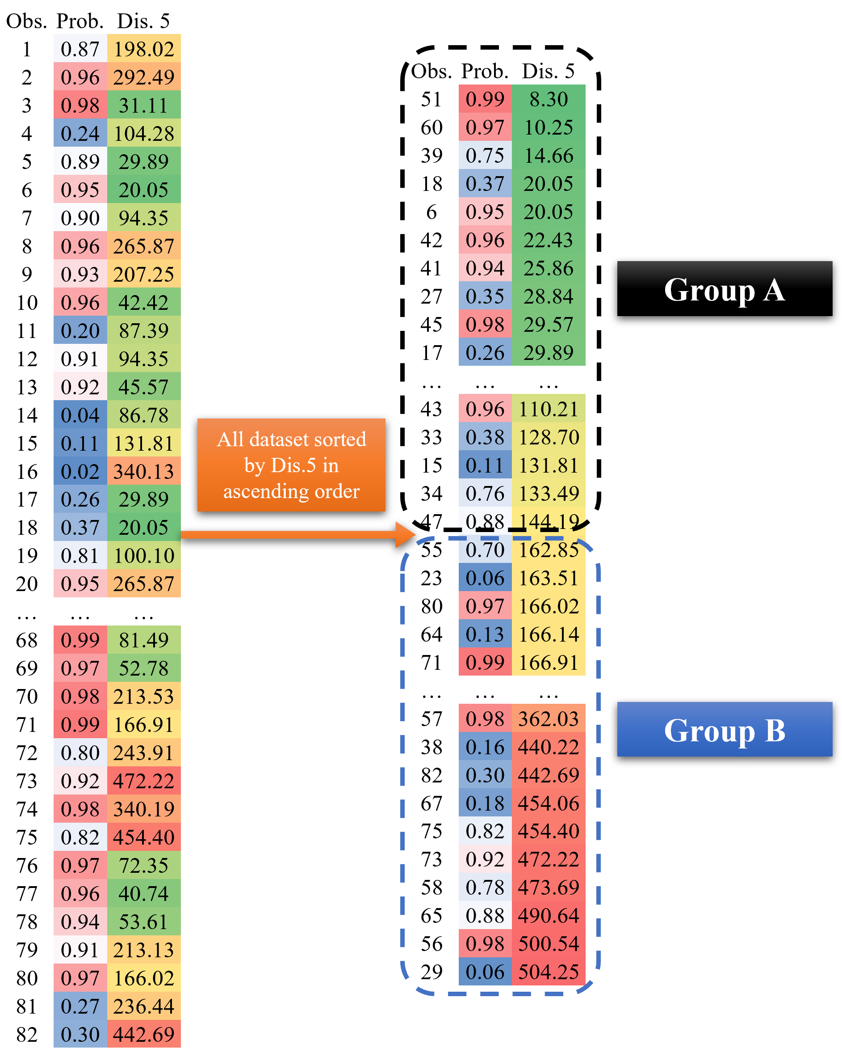

Step 2: Separately update Dis.5 for groups A and B
In Group A:
First, the Group A dataset was resorted in ascending order by the predicted occurrence probabilities.
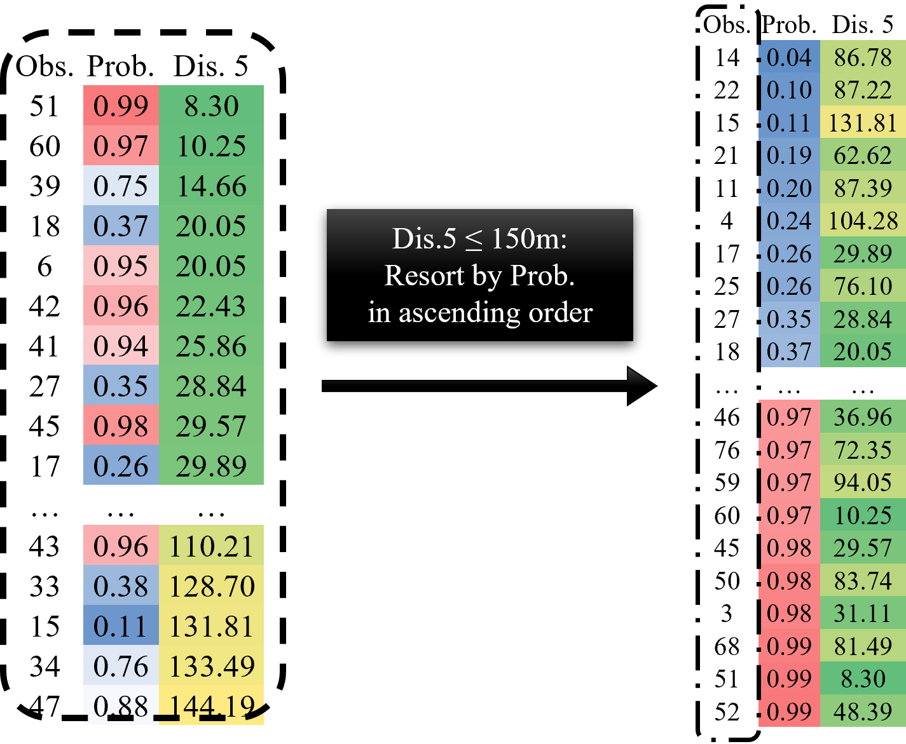

Second, we assessed whether observations with occurrence probabilities below 0.3 existed (typically 4–8 sites) in Group A. This step ensures that the predicted species occurrence probabilities near the AR approach zero. If insufficient low-probability observations were present, selected points from Group B were moved to Group A, but only if they were among those selected for Dis.5 updates (especially in the 10% - 90% Extreme scenarios).
Third, we verified that occurrence probabilities did not exhibit excessive gaps (i.e., no minimum difference > 0.5) to ensure that the response curve displayed a dome shape in the upper 50% Extreme scenarios.
Fourth, we generated gradient scenarios by varying the proportion of updated observations. For instance, in Group A with 42 eligible rows, the 20% Extreme scenario involved updating 8 rows (42 × 20% = 8). Rows were selected based on a resorted dataset by choosing observations corresponding to the minimum, maximum, and the 2nd, 3rd, 4th, 5th, 6th, and 7th octiles of occurrence probability. The Dis.5 values for these selected rows were then updated accordingly. This gradient approach enables a smooth transition from the original dataset to the most extreme condition (100% Extreme), allowing for the assessment of how varying levels of spatial modification influence species occurrence probability.
Fifth, to model the ecological response to AR interference, the selected Dis.5 values were systematically transformed using an exponential function:
For example, in Group A, for the 100% Extreme case of C. japonica, 42 available rows were assigned sequential indices (x₁ = 1, 2, 3, …, 42).
An arithmetic progression (x₂) ranging from 0 to 0.025 was generated (applied for all species), with the number of elements matching the number of available rows.
An exponential function was applied:
y₁ = -λe^{-λx2} + λ (λ = critical distance = 150m)
The resulting y₁ values were scaled from 0 to 1 for y_{_scaled}, and then rescaled to the range between 0m and critical distance (150m):
y_{_new} = y_{_scaled} λ
Therefore, the finally updated new Dis.5 values (y_{_new}) range from 0 to 150m.

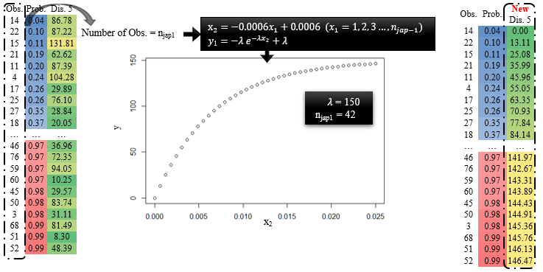
In Group B:
The same approach was applied with modifications to account for distances exceeding the critical threshold:
An arithmetic progression (x₂) ranging from 0 to 0.01 (or 0.005 for H. otakii) was generated.
The following exponential function was used:
y₂ = (M-λ)e^{-(M-λ)x2} + λ (λ = 150m, M = original maximal Dis.5 = 504m)
Then, the output y₂ values were scaled from 0 to 1 to get y_{_scaled}, and then :
y_{_new} = y_{_scaled} (M-λ) + λ
This resulted in the finally updated Dis.5 values (y_{_new}) ranging from 504m to 150m (Figure SA1).

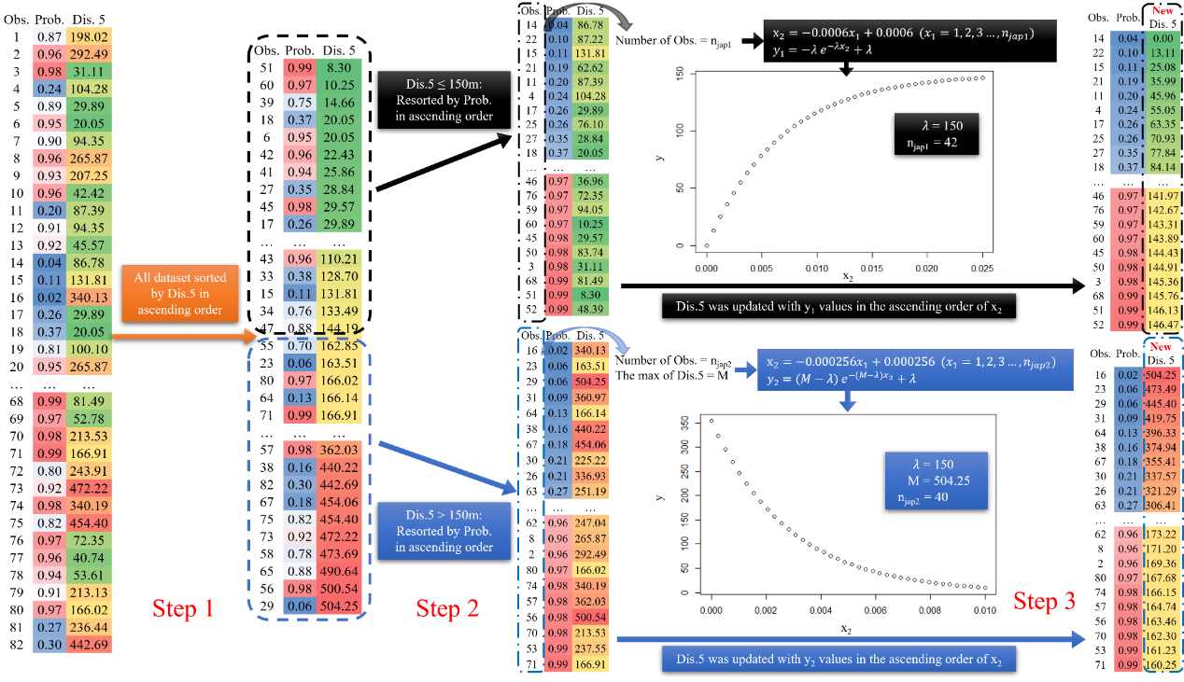
Figure SA1. Transformation Steps for New Dis.5 (distance to nearest AR) variable using C. japonica as an example for 100% Extreme. Step 1: Sort data by current Dis.5 in ascending order. Step 2: Divide data based on the positive responding peak of Dis.5 (𝜆 = 150m for C. japonica) and sort by predicted occurrence probability in ascending order in each divided dataset. Step 3: Apply an exponent function to transform the current Dis.5 into new Dis.5 in each dataset.

Step 3: Results of selected observations from different Extreme scenarios
Comparison of the original (Best-fit) and updated Dis.5 values across various adjusted Extreme versions (10%-100%) for different focal species. "Moved points" refers to cases where there were either insufficient low-probability observations in Group A or excessive gaps in the occurrence probability distribution (with a minimum difference greater than 0.5). In such cases, some points were moved from Group B to Group A.
C. japonica
The black dashed line represents the critical distance = 150m
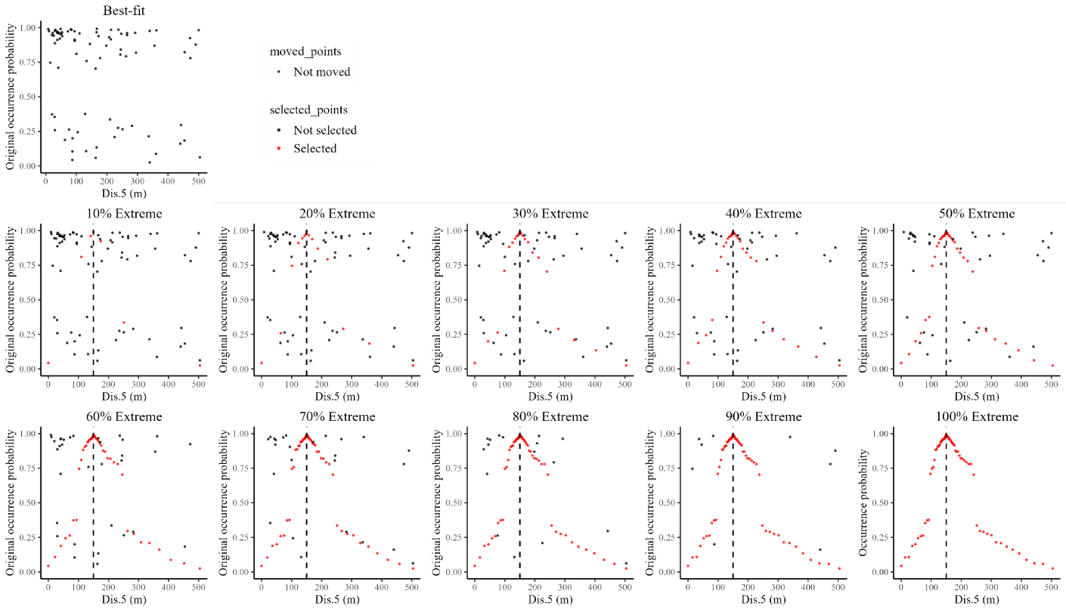
Figure SA2: Comparison of original and updated values of Dis.5 across different Extreme versions (10%–100%) for C. japonica. Black points represent original values not selected for updating; red points indicate the selected updated values used in the Extreme versions.

S. schlegelii
The black dashed line represents the critical distance = 150m
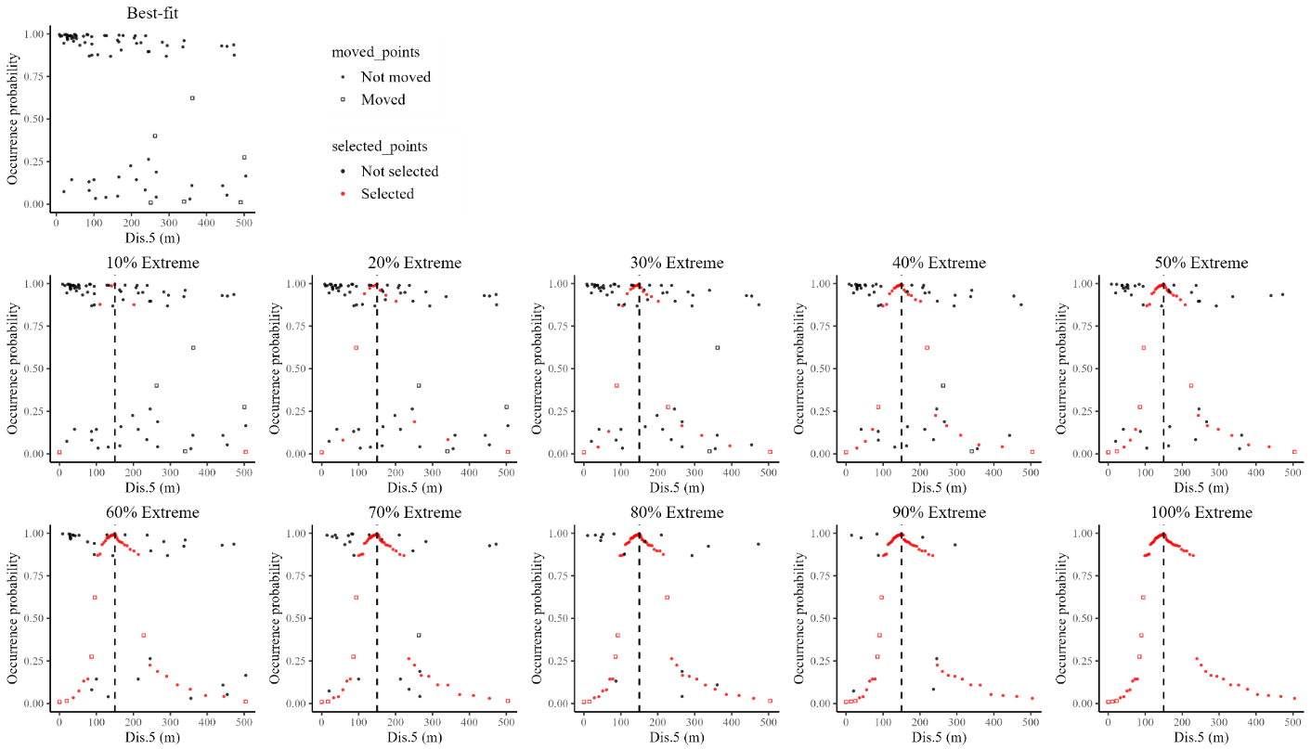
Figure SA3: Comparison of original and updated values of Dis.5 across different Extreme versions (10%–100%) for S. schlegelii. Black points represent original values not selected for updating; red points indicate the selected updated values used in the Extreme versions.

H. otakii
The black dashed line represents the critical distance = 100m
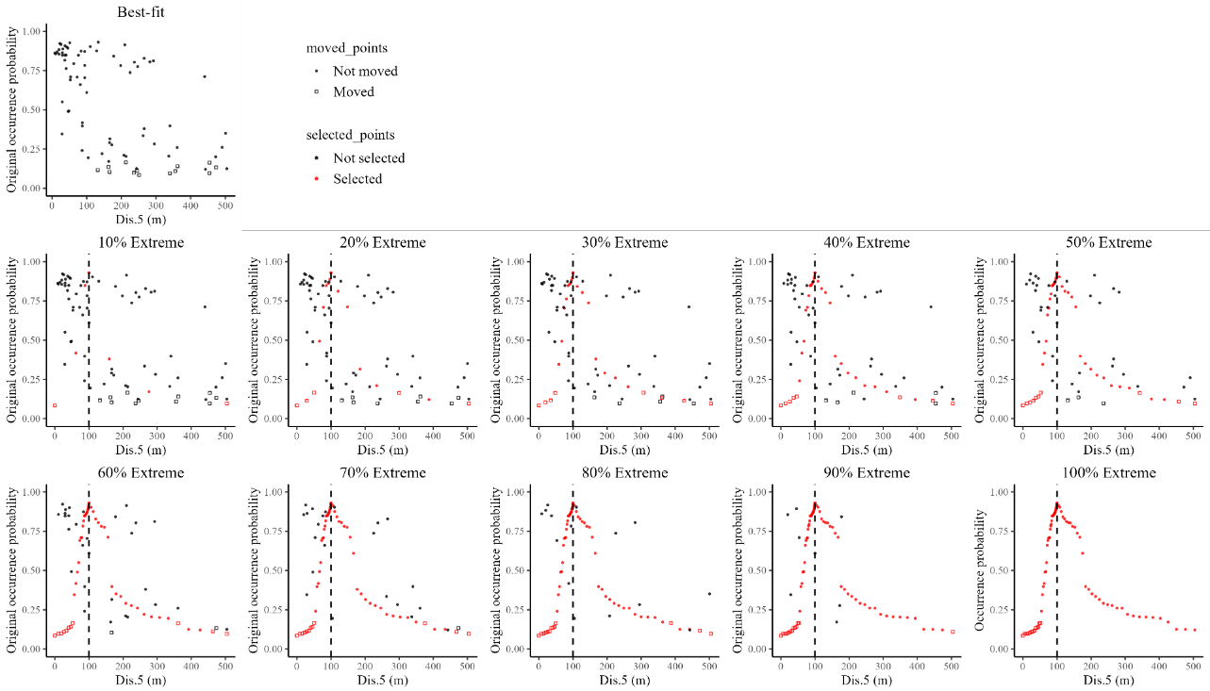
Figure SA4: Comparison of original and updated values of Dis.5 across different Extreme versions (10%–100%) for H. otakii. Black points represent original values not selected for updating; red points indicate the selected updated values used in the Extreme versions.

Sea star
The black dashed line represents the critical distance = 100m
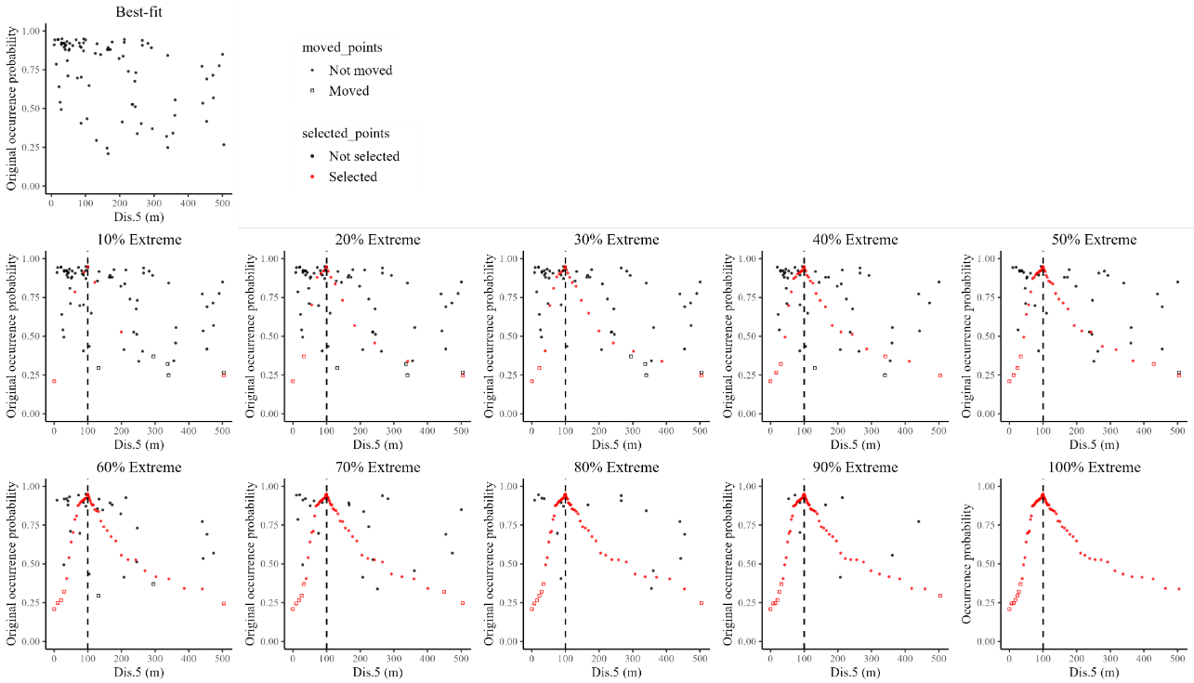
Figure SA5: Comparison of original and updated values of Dis.5 across different Extreme versions (10%–100%) for Sea star. Black points represent original values not selected for updating; red points indicate the selected updated values used in the Extreme versions.

Reference
Burt, J.A., Coles, S., Lavieren, H.V., Taylor, O., Looker, E., Samimi-Namin, K., 2016. Oman's coral reefs: A unique ecosystem challenged by natural and man-related stresses and in need of conservation. Mar. Pollut. Bull. 105, 498-506. https://doi.org/10.1016/j.marpolbul.2015.11.010
Byrne, M., Gall, M., Wolfe, K., Agüera, A., 2016. From pole to pole: the potential for the Arctic seastar Asterias amurensis to invade a warming Southern Ocean. Glob. Chang. Biol. 22, 3874-3887. https://doi.org/10.1111/gcb.13304
Di, F.A., Bussotti, S., Navone, A., Panzalis, P., Guidetti, P., 2009. Evaluating effects of total and partial restrictions to fishing on Mediterranean rocky-reef fish assemblages. Mar. Ecol. Prog. Ser. 387, 275-285. https://doi.org/10.3354/meps08051
Glynn, P.W., 1993. Coral reef bleaching: ecological perspectives. Coral Reefs 12, 1-17. https://doi.org/10.1007/BF00303779
Lowry, M.B., Suthers, I.M., 1998. Home range, activity and distribution patterns of a temperate rocky-reef fish, Cheilodactylus fuscus. Mar. Biol. 132, 569-578. https://doi.org/10.1007/s002270050422
Pinkas, L., Oliphant, M., Iverson, I., 1971. Food habits of albacore, bluefin tuna and bonito in California waters. Fish Bull. 152, 1105.
Takeo, K., 1999. Effects of sediment type and food abundance on the vertical distribution of the starfish Asterina pectinifera. Mar. Ecol. Prog. Ser. 181, 269-277. https://doi.org/10.3354/meps181269
Vercelloni, J., Caley, M.J., Mengersen, K., 2017. Crown-of-thorns starfish undermine the resilience of coral populations on the Great Barrier Reef. Glob. Ecol. Biogeogr. 26, 846-853. https://doi.org/10.1111/geb.12590

Supplementary Figures
Figure S1. Interpolated water depth in the study area and used for the model grid. Depths were interpolated using the IDW method.

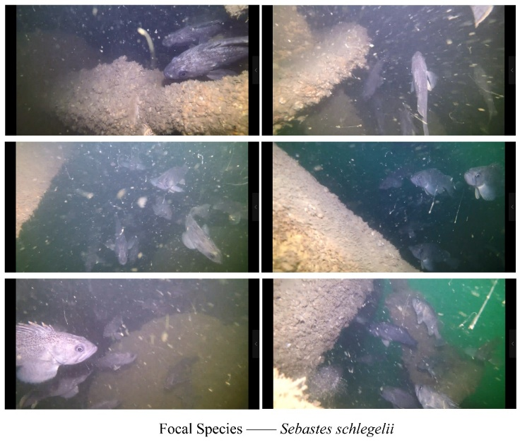
Figure S2. The attraction of the AR monomer for one of the focal species black rockfish (Sebastes schlegelii).
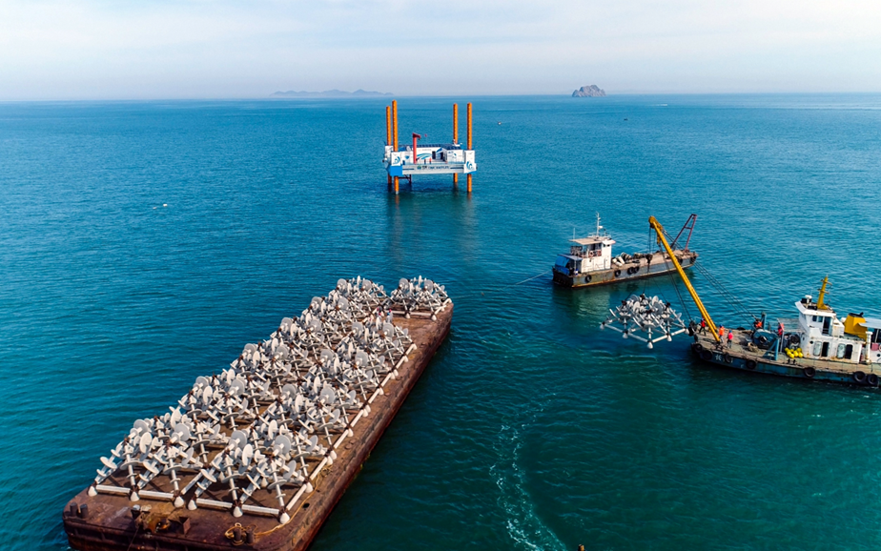
Figure S3. Aerial image of partly 24 ARs deployment in the study area.
Figure S4. Spatial locations of trapping (circles) and visual sites (stars).
Figure S5. Bottom substrate types and their scoring value used in analyses. Each of the screenshots was extracted from the actual video, and the assigned score was shown on the right.

Figure S6. The marginal effects of Charybdis japonica in response to Environmental variables. Values of the environmental variables (excluding depth and substrate type) corresponding to zero on the y-axis were assigned to each cell in the simulation analysis.

Figure S7. The marginal effects of Sebastes schlegelii in response to Environmental variables. Values of the environmental variables (excluding depth and substrate type) corresponding to zero on the y-axis were assigned to each cell in the simulation analysis.

Figure S8. The marginal effects of Hexagrammos otakii in response to Environmental variables. Values of the environmental variables (excluding depth and substrate type) corresponding to zero on the y-axis were assigned to each cell in the simulation analysis.

Figure S9. The marginal effects of Sea stars (Asterina pectinifera & Asterias amurensis) in response to Environmental variables. Values of the environmental variables (excluding depth and substrate type) corresponding to zero on the y-axis were assigned to each cell in the simulation analysis.

Figure S10. Environmental variables importance in the four SDMs for each focal species. Weighted importance values were calculated by dividing each original importance of an environmental variable by the average importance of all variables within a single SDM. A, Charybdis japonica; B, Sebastes schlegelii; C, Hexagrammos otakii; D, Sea star (Asterina pectinifera & Asterias amurensis).

Figure S11. Relationship between CPUE and fitted baseline occurrence probability estimated at each of the sampling sites for each focal species.

Figure S12. Best-fit SDMs: Cell sensitiveness categorized into good, moderate-good, medium, moderate-bad, and bad performance categories (rows) based on the layout-specific average occurrence probability of C. japonica for the addition of 5, 10, 25, and 50 ARs (columns). Each category had 20% of the layouts, with Good having the 20% with highest average probability of occurrence and the bad category having the 20% lowest average probability of occurrence. Sensitivity was computed for each cell as the fraction of layouts in a category that had a deployed AR.

Figure S13. Intermediate SDMs: Cell sensitiveness categorized into good, moderate-good, medium, moderate-bad, and bad performance (rows) based on the layout-specific average occurrence probability of C. japonica for the addition of 5, 10, 25, and 50 ARs (columns). Each category had 20% of the layouts, with Good having the 20% with highest average probabilities of occurrence and the bad category having the 20% lowest average probabilities of occurrence. Sensitivity was computed for each cell as the fraction of layouts in a category that had a deployed AR.

Figure S14. Extreme SDMs: Cell sensitiveness categorized into good, moderate-good, medium, moderate-bad, and bad performance (rows) based on the layout-specific average occurrence probability of C. japonica for the addition of 5, 10, 25, and 50 ARs (columns). Each category had 20% of the layouts, with Good having the 20% with highest average probabilities of occurrence and the bad category having the 20% lowest average probabilities of occurrence. Sensitivity was computed for each cell as the fraction of layouts in a category that had a deployed AR.

Figure S15. Best-fit SDMs: Cell sensitiveness categorized into good, moderate-good, medium, moderate-bad, and bad performance (rows) based on the layout-specific average occurrence probability of S. schlegelii for the addition of 5, 10, 25, and 50 ARs (columns). Each category had 20% of the layouts, with Good having the 20% with highest average probabilities of occurrence and the bad category having the 20% lowest average probabilities of occurrence. Sensitivity was computed for each cell as the fraction of layouts in a category that had a deployed AR.

Figure S16. Intermediate SDMs: Cell sensitiveness categorized into good, moderate-good, medium, moderate-bad, and bad performance (rows) based on the layout-specific average occurrence probability of S. schlegelii for the addition of 5, 10, 25, and 50 ARs (columns). Each category had 20% of the layouts, with Good having the 20% with highest average probabilities of occurrence and the bad category having the 20% lowest average probabilities of occurrence. Sensitivity was computed for each cell as the fraction of layouts in a category that had a deployed AR.

Figure S17. Extreme SDMs: Cell sensitiveness categorized into good, moderate-good, medium, moderate-bad, and bad performance (rows) based on the layout-specific average occurrence probability of S. schlegelii for the addition of 5, 10, 25, and 50 ARs (columns). Each category had 20% of the layouts, with Good having the 20% with highest average probabilities of occurrence and the bad category having the 20% lowest average probabilities of occurrence. Sensitivity was computed for each cell as the fraction of layouts in a category that had a deployed AR.

Figure S18. Best-fit SDMs: Cell sensitiveness categorized into good, moderate-good, medium, moderate-bad, and bad performance (rows) based on the layout-specific average occurrence probability of H. otakii for the addition of 5, 10, 25, and 50 ARs (columns). Each category had 20% of the layouts, with Good having the 20% with highest average probabilities of occurrence and the bad category having the 20% lowest average probabilities of occurrence. Sensitivity was computed for each cell as the fraction of layouts in a category that had a deployed AR.

Figure S19. Intermediate SDMs: Cell sensitiveness categorized into good, moderate-good, medium, moderate-bad, and bad performance (rows) based on the layout-specific average occurrence probability of H. otakii for the addition of 5, 10, 25, and 50 ARs (columns). Each category had 20% of the layouts, with Good having the 20% with highest average probabilities of occurrence and the bad category having the 20% lowest average probabilities of occurrence. Sensitivity was computed for each cell as the fraction of layouts in a category that had a deployed AR.

Figure S20. Extreme SDMs: Cell sensitiveness categorized into good, moderate-good, medium, moderate-bad, and bad performance (rows) based on the layout-specific average occurrence probability of H. otakii for the addition of 5, 10, 25, and 50 ARs (columns). Each category had 20% of the layouts, with Good having the 20% with highest average probabilities of occurrence and the bad category having the 20% lowest average probabilities of occurrence. Sensitivity was computed for each cell as the fraction of layouts in a category that had a deployed AR.

Figure S21. Best-fit SDMs: Cell sensitiveness categorized into good, moderate-good, medium, moderate-bad, and bad performance (rows) based on the layout-specific average occurrence probability of Sea star for the addition of 5, 10, 25, and 50 ARs (columns). Each category had 20% of the layouts, with Good having the 20% with highest average probabilities of occurrence and the bad category having the 20% lowest average probabilities of occurrence. Sensitivity was computed for each cell as the fraction of layouts in a category that had a deployed AR.

Figure S22. Intermediate SDMs: Cell sensitiveness categorized into good, moderate-good, medium, moderate-bad, and bad performance (rows) based on the layout-specific average occurrence probability of Sea star for the addition of 5, 10, 25, and 50 ARs (columns). Each category had 20% of the layouts, with Good having the 20% with highest average probabilities of occurrence and the bad category having the 20% lowest average probabilities of occurrence. Sensitivity was computed for each cell as the fraction of layouts in a category that had a deployed AR.

Figure S23. Extreme SDMs: Cell sensitiveness categorized into good, moderate-good, medium, moderate-bad, and bad performance (rows) based on the layout-specific average occurrence probability of Sea star for the addition of 5, 10, 25, and 50 ARs (columns). Each category had 20% of the layouts, with Good having the 20% with highest average probabilities of occurrence and the bad category having the 20% lowest average probabilities of occurrence. Sensitivity was computed for each cell as the fraction of layouts in a category that had a deployed AR.

Figure S24. Intermediate SDMs: Distribution of D_{k} values (left y-axis) and B_{k} values (right y-axis) for good (top 20% of the layouts, in black) and bad (bottom 20% of the layouts, in red) categories based on the averaged occurrence probabilities of layouts with C. japonica (A-D), S. schlegelii (E-H), H. otakii (I-L), and Sea star (M-P). Rows represent different species, and columns correspond to the addition of 5, 10, 25, and 50 ARs. Boxplots display the overall mean as a diamond-shaped point. The box represents the interquartile range (IQR), with the lower edge corresponding to the 25th percentile and the upper edge to the 75th percentile. The whiskers extend from the box to show the range of data within a certain distance from the quartiles (1.5 times the IQR), and any data points beyond this range are plotted individually as dots.
Figure S25. Extreme SDMs: Distribution of D_{k} values (left y-axis) and B_{k} values (right y-axis) for good (top 20% of the layouts, in black) and bad (bottom 20% of the layouts, in red) categories based on the averaged occurrence probabilities of layouts with C. japonica (A-D), S. schlegelii (E-H), H. otakii (I-L), and Sea star (M-P). Rows represent different species, and columns correspond to the addition of 5, 10, 25, and 50 ARs. Boxplots display the overall mean as a diamond-shaped point. The box represents the interquartile range (IQR), with the lower edge corresponding to the 25th percentile and the upper edge to the 75th percentile. The whiskers extend from the box to show the range of data within a certain distance from the quartiles (1.5 times the IQR), and any data points beyond this range are plotted individually as dots.
Figure S26. Intermediate SDMs: Usage percentages of original substrates (mud, gravel, rubble, boulder) for layouts in the good and bad performing categories for C. japonica (A-D), S. schlegelii (E-H), H. otakii (I-L), and Sea star (M-P). Rows represent the different species, and columns correspond to the addition of 5 ARs, 10 ARs, 25 ARs, and 50 ARs. Bar heights represent the mean values, with error bars representing the mean plus one standard deviation.

Figure S27. Extreme SDMs: Usage percentages of original substrates (mud, gravel, rubble, boulder) for layouts in the good and bad performing categories for C. japonica (A-D), S. schlegelii (E-H), H. otakii (I-L), and Sea star (M-P). Rows represent the different species, and columns correspond to the addition of 5 ARs, 10 ARs, 25 ARs, and 50 ARs. Bar heights represent the mean values, with error bars representing the mean plus one standard deviation.

Supplementary Tables
Table S1. Number of trap and visual sites sampled by month in the surveys during 2017 and 2018. We consider May and June as Spring; August and September as Summer; November as Autumn; and December as Winter.
Year | Month | Trap sites | Video sites
2017 | June | 3 | 5
2017 | August | 4 | 11
2017 | December | 6 | 0
2018 | May | 9 | 2
2018 | June | 3 | 6
2018 | September | 9 | 9
2018 | November | 8 | 7

Table S2. Numeric transformation Functions for updating Dis.5 in Intermediate and Extreme Models. New Dis.5 values were updated using the combination of scaled y₁ and y₂ values. M = 504.25, representing the maximum Dis.5 value from field surveys. Positive responding peaks (𝜆) were set at 150, 150, 100, and 100 for C. japonica, S. schlegelii, H. otakii, and Sea star, as shown in the responding curves for Best-fit SDM estimation (Figure S5-S8). Parameters n_{jap1}, n_{sch1}, n_{ota1}, and n_{sea1} represent the number of observations with Dis.5 values lower than 𝜆 for C. japonica, S. schlegelii, H. otakii, and Sea star, respectively; Parameters n_{jap2}, n_{sch2}, n_{ota2}, and n_{sea2} represent the number of observations with Dis.5 values greater than 𝜆 for different corresponding species.
Focal species | Threshold of Dis.5 | functions of transformation | To be scaled
C. japonica | ≤ 150 m | $$x_{2}=-0.0006x_{1}+0.0006 (x_{1}=1, 2, 3…,n_{jap1})$$  $$y_{1}=-λe^{-λx_{2}}+λ$$ | y₁
C. japonica | > 150 m | $$x_{2}=-0.000256x_{1}+0.000256 (x_{1}=1, 2, 3…,n_{jap2})$$  $$y_{2}=\left(M-λ\right)e^{-(M-λ)x_{2}}+λ$$ | y₂
S. schlegelii | ≤ 150 m | $$x_{2}=-0.000319x_{1}+0.000319 (x_{1}=1, 2, 3…,n_{sch1})$$  $$y_{1}=-λe^{-λx_{2}}+λ$$ | y₁
S. schlegelii | > 150 m | $$x_{2}=-0.000256x_{1}+0.000256 (x_{1}=1, 2, 3…,n_{sch2})$$  $$y_{2}=\left(M-λ\right)e^{-(M-λ)x_{2}}+λ$$ | y₂
H. otakii | ≤ 100 m | $$x_{2}=-0.00053x_{1}+0.00053 (x_{1}=1, 2, 3…,n_{ota1})$$  $$y_{1}=-λe^{-λx_{2}}+λ$$ | y₁
H. otakii | > 100 m | $$x_{2}=-0.000151x_{1}+0.000151 (x_{1}=1, 2, 3…,n_{ota2})$$  $$y_{2}=\left(M-λ\right)e^{-(M-λ)x_{2}}+λ$$ | y₂
Sea star | ≤ 100 m | $$x_{2}=-0.00061x_{1}+0.00061 (x_{1}=1, 2, 3…,n_{sea1})$$  $$y_{1}=-λe^{-λx_{2}}+λ$$ | y₁
Sea star | > 100 m | $$x_{2}=-0.000256x_{1}+0.000256 (x_{1}=1, 2, 3…,n_{sea2})$$  $$y_{2}=\left(M-λ\right)e^{-(M-λ)x_{2}}+λ$$ | y₂

Table S3. Results of the RDA analysis for filtering the environmental and ecological constraint variables. Results are based on permutation tests with 999 realizations and variables retained with VIF < 6.
Formula |  | Focal species ~ S.Chla + S.sus + S.WQI + B.Chla + B.sus + B.Temp + B.Sal + B.pH + B.WQI + Depth + Trans + method + BotType + Dis.2 + Dis.5
Constrained (%) |  | 0.40 | VIF values
Unconstrained (%) |  | 0.60 | S.Chla | 2.23 | B.pH | 3.87
R-square |  | 0.26 | S.sus | 2.09 | B.WQI | 3.22
Permutation test | df | 15 | S.WQI | 4.46 | Depth | 3.44
Permutation test | Variance | 0.00013 | B.Chla | 1.87 | Trans | 2.06
Permutation test | F value | 2.88 | B.sus | 1.53 | Method | 1.30
Permutation test | p value | 0.001 | B.Temp | 6.11 | BotType | 3.78
Permutation test |  |  | B.Sal | 3.98 | Dis.2 | 3.92
Permutation test |  |  | Dis.5 | 8.63
Note: df, degree of freedom.

Table S4. Final selection of 13 environmental variables (first identified with RDA) based on mean decrease accuracy (MDA) using a random forest analysis for each focal species.
Focal Species | Charybdis japonica | Sebastes schlegelii | Hexagrammos otakii | Sea star (Asterina pectinifera & Asterias amurensis)
S.Chla | 5.43 | 3.02 | 8.57 | 11.89
S.sus.solid | 0.76 | -4.10 | 7.87 | 4.37
S.WQI | 7.37 | -3.10 | 0.51 | 4.19
B.Chla | 0.17 | 35.60 | 4.04 | -4.77
B.sus.solid | 22.75 | 4.46 | 7.42 | 3.04
B.Temp | 24.89 | 3.37 | 7.97 | 19.84
B.Sal | 11.61 | 3.45 | 13.13 | 12.96
B.pH | 7.14 | 6.32 | 4.19 | 16.01
B.WQI | 1.85 | -2.31 | 19.68 | 1.13
Depth | 14.81 | 2.47 | 20.00 | 2.73
Trans | 17.09 | -5.36 | -1.06 | 11.08
method | 31.12 | 42.86 | 5.31 | 40.05
BotType | 31.31 | 35.52 | 42.30 | 50.83
Note: Values < 2 were eliminated and the final retained environmental variables were indicated in bold.

Table S5. Evaluation index of five SDMs tested for each focal species fitted by 13 environmental variables. RMSE and AUC were calculated separately using a 1,000 times cross-validation. CI, confidence interval.
Species | Index | RF |  | BRT |  | SVM |  | MAR |  | Ensemble Model
Species | Index | mean | 95% CI | mean | 95% CI | mean | 95% CI | mean | 95% CI | mean | 95% CI
S. schlegelii | RMSE | 0.40 | (0.33~0.48) | 0.39 | (0.33~0.46) | 0.43 | (0.37~0.48) | 0.40 | (0.32~0.49) | 0.38 | (0.29~0.46)
S. schlegelii | AUC | 0.79 | (0.69~0.85) | 0.79 | (0.77~0.85) | 0.74 | (0.66~0.81) | 0.81 | (0.72~0.89) | 0.82 | (0.74~0.89)
H. otakii | RMSE | 0.47 | (0.41~0.53) | 0.46 | (0.4~0.52) | 0.47 | (0.41~0.53) | 0.55 | (0.48~0.62) | 0.48 | (0.43~0.55)
H. otakii | AUC | 0.78 | (0.72~0.83) | 0.79 | (0.73~0.84) | 0.78 | (0.72~0.83) | 0.70 | (0.62~0.77) | 0.76 | (0.69~0.82)
C. japonica | RMSE | 0.50 | (0.43~0.56) | 0.48 | (0.41~0.53) | 0.42 | (0.35~0.51) | 0.50 | (0.41~0.56) | 0.46 | (0.38~0.53)
C. japonica | AUC | 0.68 | (0.6~0.77) | 0.70 | (0.64~0.79) | 0.74 | (0.64~0.81) | 0.71 | (0.61~0.81) | 0.73 | (0.64~0.81)
Sea Star | RMSE | 0.48 | (0.41~0.53) | 0.50 | (0.46~0.55) | 0.52 | (0.48~0.56) | 0.52 | (0.44~0.58) | 0.51 | (0.46~0.55)
Sea Star | AUC | 0.68 | (0.59~0.77) | 0.60 | (0.52~0.67) | 0.56 | (0.5~0.63) | 0.62 | (0.52~0.71) | 0.62 | (0.54~0.69)

