Navigating architectural process:
tracking architects’ and user-clients’ habitus shock in private dwelling design
Audrey Mertens
Department of UEE, Faculty of Applied Sciences, Inter’Act Lab, University of Liege,
Liege, Belgium and Department of MechE, Ideation Lab, MIT, Cambridge, Massachusetts, USA
Mylène Bourguignon
Department of UEE, Faculty of Applied Sciences, Inter’Act Lab, University of Liege,
Liege, Belgium
Catherine Elsen
Department of UEE, Faculty of Applied Sciences, Inter’Act Lab, University of Liege,
Liege, Belgium

Abstract
Purpose – This article explores how habitus shock manifests and evolves in the relationship between architects and user-clients during private dwelling projects.
Design/methodology/approach – Drawing from Bourdieu’s theory of habitus, Adler’s concept of culture shock and Siva and London’s habitus shock in architectural processes, we adapt these frameworks to describe the shock occurring when user-clients encounter architectural processes for their home, and its equivalent on the architects’ end. Drawing on two in-depth case studies of private dwelling renovations in Belgium, we identify key trajectories. We use a set of indicators – comfort, discomfort, enthusiasm and loss of enthusiasm – to characterize these interactions over time. These trajectories are visualized through habitus shock curves, covalidated with participants. -
Findings – Our findings reveal that adaptation is often non-linear, asymmetrical, and shaped by both interpersonal dynamics and systemic constraints. Rather than unfolding in fixed stages, habitus shock takes on cyclical or iterative forms, with moments of rupture and re-engagement. This refined model provides a more nuanced understanding of how alignment or misalignment between social dispositions impacts the design process.
Originality/value – The article offers practical and pedagogical insights for architectural practice, emphasizing the need to recognize, anticipate and support these affective dynamics as part of user-centred design – especially in emotionally and financially invested residential contexts.
Keywords: Architectural practice, User involvement, Habitus shock, Retrofitting

To cite: Mertens, A., Bourguignon, M., & Elsen, C. (2026). Navigating architectural process: tracking architects’ and user-clients’ habitus shock in private dwelling design. International Journal of Architectural Research Archnet-IJAR, 1-18. https://doi.org/10.1108/arch-09-2025-0391

1. Introduction
Interactions between architects and user-clients [1] are a complex and dynamic process shaped by communication strategies and friction points. Especially in private dwelling projects, these interactions are critical determinants of the user’s experience, yet these relationships remain marked by communication difficulties and asymmetrical expectations (Tidafi, 1996; Bogers et al., 2008; Siva and London, 2011; RIBA, 2015; Uhl and Boyd Whyte, 2016; Defays and Elsen, 2018; Angral, 2019; Shao and Nagai, 2018 in Mertens et al., 2023). While recent calls for participatory and usercentred approaches stress the need for better dialogue and mutual understanding (Sanders and Stappers, 2008; Siva and London, 2012), the emotional and socio-cultural frictions that emerge throughout these encounters remain insufficiently addressed in current research. -
Luck and McDonnell (2006) emphasize that conversational strategies and contextual framing significantly influence the depth of user input. They advocate for structured meetings and targeted prompts to elicit richer insights. McDonnell and Lloyd (2014) explore how clients articulate experiential aspects of the design differently before and after construction. While architects use abstract, symbolic language early on, clients tend to engage more meaningfully with lived spaces after experiencing them, suggesting that architectural expertise involves timing discussions to align with clients’ cognitive readiness (McDonnell and Lloyd, 2014).
Ethnographic studies further reveal the socio-material nature of design knowledge. Van der Linden et al. (2019) describe architects’ experiential knowledge as “fragile knowing”, implicit, situated and rarely focused on symbolic meaning. They call for fostering shared references to enhance user-centredness.
Tensions and frictions [2] (Tsing, 2005) remain inherent to architectural practice. Issues such as personality mismatch, misunderstandings, budget constraints and time management complicate collaboration (Mertens, 2025). Moreover, architects’ peer orientation (Siva and London, 2011; Angral, 2019) and reliance on personal experience (Cuff, 1991; Heylighen and Dong, 2019) can alienate clients. These challenges can elicit emotional and cognitive responses, often culminating in “habitus shock” (Siva and London, 2009, 2011), especially when user involvement dynamics blur boundaries and shared ownership must be negotiated (Casakin and Badke-Schaub, 2017).
This study builds on ethnographic research to explore how tensions and adaptations emerge when architects and user-clients encounter [3] one another, particularly in the context of private dwellings in Belgium. Using habitus shock as a conceptual lens, we examine how clashes between professional and lay dispositions generate emotional ruptures and communication breakdowns throughout the design process. By tracing how comfort and enthusiasm fluctuate over time, we reveal how these shape interactions, influence trustbuilding and affect user experience. The study also investigates how both user-clients and architects navigate and learn from these frictions, and what role the architect plays in mediating, amplifying or softening this process of mutual adjustment.

2. Context

2.1 Specificities of the Belgian context
Architect-client interactions are central to project outcomes and client satisfaction, especially in Belgium, where the engagement of an architect is mandatory under the Law of 20 February 1939, which regulates the title and profession. This law stipulates that any architectural project involving structural alterations or requiring a building permit must be overseen by a registered architect, thereby legally embedding the architect’s role in private construction processes. Architects in Belgium are not only technical designers but also key intermediaries between regulatory authorities, construction stakeholders and private clients. Enhancing these relationships can foster trust, knowledge sharing and more informed design decisions (Mertens et al., 2023).

2.2 Focus on private dwellings
The private residential context offers a highly focused and emotionally charged context that brings to light key challenges in architect-client dynamics. User-clients are both personally and financially invested in these endeavours, often entering the process with high expectations and emotional stakes (Angral, 2019; Arora et al., 2021), as they will ultimately inhabit the spaces being designed. Such projects tend to expose complex interpersonal dynamics, including power imbalances between clients and professionals (Frimpong and Dansoh, 2018).
Adad (2004) emphasizes that user participation in housing design improves satisfaction, affordability and architectural coherence. This author advocates a shift in professional attitudes, urging architects to act as facilitators who revive communication and empower users to shape their own living environments.
Huang and Wang (2012) argue that the client constitutes the starting point of any architectural design, yet their needs are rarely fully articulated at the outset. As the design process unfolds, new expectations and requirements emerge, often evolving throughout the project. This fluidity in client needs – understood by architects as design problems – necessitates ongoing dialogue (Huang and Wang, 2012). From the client’s perspective, initial ideas frequently shift through conversations with the architect, who often possesses a more comprehensive understanding of what the project entails (Huang and Wang, 2012). For architects, this evolution can render proposed solutions obsolete, leading to frustration and wasted effort (Huang and Wang, 2012). Many clients must navigate a steep learning curve, grappling with unfamiliar architectural processes, terminology and expectations (Siva and London, 2012).
Given that private dwellings constitute the majority of architectural commissions in Belgium (ACE, 2024), these settings are both practically significant and analytically rich for examining architect/user-client interactions. Local survey data illustrate the friction inherent in such projects: a large-scale study involving 1,330 individuals found that only half were satisfied with their architect at the end of the process, and nearly half reported experiencing considerable stress, with 27% describing irritability and anxiety during the project (Nauwelaers and Rossini, 2014). A complementary national survey revealed that architects themselves rank client requests among the top five factors that complicate their day-to-day practice (Stals et al., 2018).

3. Framework

3.1 Habitus shock
Derived from Bourdieu’s theory of habitus (1977) and Adler’s (1975) reconceptualization of culture shock as a developmental experience, the concept of habitus shock describes the disorientation or frustration clients may feel when their internalized dispositions and social expectations come into conflict with the unfamiliar logics and practices of the architectural field (Siva and London, 2009, 2011; Payne et al., 2015). This clash, akin to cross-cultural transition, may provoke emotional turbulence such as confusion, discomfort and resistance. However, Adler (1975) frames these transitional shocks not merely as setbacks, but as necessary phases for developmental growth, provided they are appropriately supported, a perspective that proves valuable when transferred to the architect-client relationship.
Habitus shock resonates with the broader literature on adjustment curves, including the U-curve (Black and Mendenhall, 1991), Adler’s five-stage model of transitional experience. According to these models, clients often begin in a honeymoon phase, marked by curiosity and optimism, followed by disintegration, where unfamiliar norms become overwhelming. This may lead to reintegration, in which clients express frustration or retreat to familiar attitudes, before reaching autonomy and eventually interdependence, where new and old values are integrated (Adler, 1975; Black and Mendenhall, 1991; Siva and London, 2009).
Siva and London (2011) identify similar shifts in their five habitus shock profiles, drawn from empirical studies of architect-client interactions. Their work illustrates how clients, over time, transition through phases of joy and expectations (during the honeymoon phase), disintegration (along with confusion), reintegration and eventual adaptation/autonomy (Figure 1).
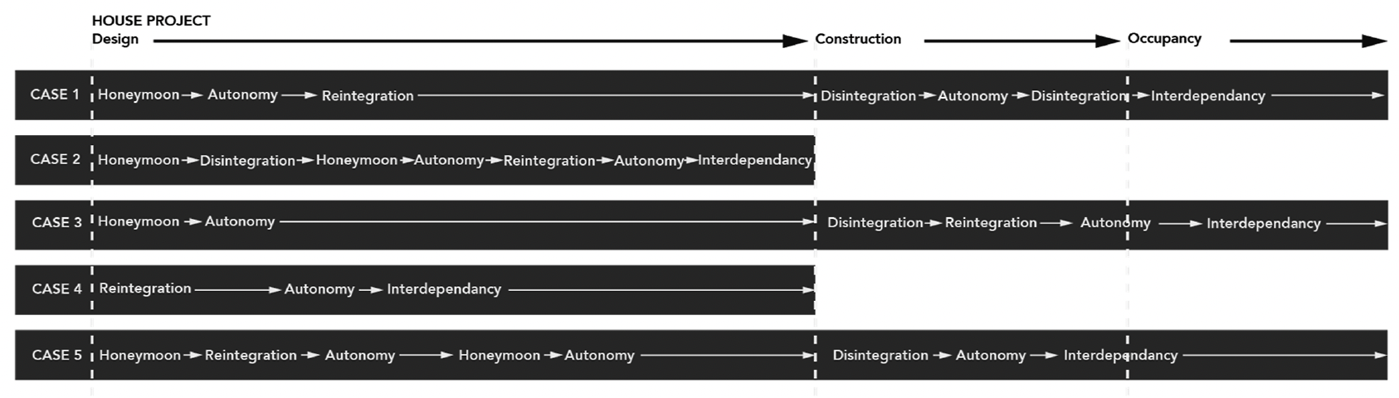

Figure 1. Reproduction of Siva and London’s (2011, p. 183) five case studies of habitus shock profiles (of the clients).

3.2 Architectural habitus
Ahuja et al. (2020, p. 590, citing RIBA, 2015) note the persistent portrayal of architects as “spiritual leaders” of design projects, a notion reinforced by professional training and culture. Despite a steady decline in professional authority over clients (Waite and Braidwood, 2017), architectural education continues to valorize individual creativity and aesthetic originality (Winch and Schneider, 1993), frequently at the expense of client engagement (RIBA, 2015). While architects may occupy multiple roles (Cohen et al., 2005), the dominant stereotype remains that of the passionate, solitary genius (Heynen, 2014), a view internalized by many emerging professionals (Ahuja et al., 2019) and perpetuated by accolades such as the Pritzker Prize (Wiscombe, 2006; Cuff, 2012; Pelkonen, 2012; Heynen, 2014; Ahuja et al., 2020). Gray (2013) underscores that habitus theory reveals how peer interactions and studio norms shape architectural identity from the earliest stages of training.
In this context, a clash arises from the collision of distinct habituses: clients and architects hold different social and cultural structures (Siva and London, 2011). When clients enter into a relationship with architects, their habitus may be ill-equipped to navigate the specialized and codified environment of architectural practice, resulting in a form of disorientation akin to culture shock (Siva and London, 2011). This misalignment is exacerbated by the way architects are socially trained during formal education, which is often disconnected from the multi-organizational and collaborative contexts that now characterize much of contemporary practice (Dainty et al., 2007; Caven and Diop, 2012; Ahuja et al., 2020).

3.3 Translating into curves
To understand how these encounters affect user-clients and architects, habitus shock can be mapped using trajectory models originally developed to describe cultural transitions.
One of the earliest and most influential frameworks is the U-curve, which outlines a threestage adjustment pattern: initial excitement, followed by crisis and eventual recovery (Lysgaard, 1955; Black and Mendenhall, 1991). This trajectory is mirrored in many first-time engagements with architecture: early enthusiasm often gives way to confusion and dissatisfaction as clients encounter the technical, communicative and procedural complexities of the design process.-
Building upon this, Gullahorn and Gullahorn’s (1963) W-curve extends the U-shaped trajectory by incorporating a second dip during re-entry, originally used to describe the resocialization shock experienced upon return to one’s home culture. This model aligns closely with architectural projects, especially in private residential contexts, where clients face recurring cycles of excitement, disruption, partial adjustment, and renewed disillusionment as each project phase unfolds. Notably, Gullahorn and Gullahorn (1963) emphasize evaluating habitus shock through indicators such as comfort, satisfaction and effectiveness, which are relevant to assessing the client’s adaptation over time. Zeller and Mosier (1993) later validated the W-curve in educational transitions, reinforcing its broader applicability to any emotionally significant new environment.
Complementing these models, Flynn and Feeney (2020) propose a trust-over-time curve to visualize the dynamic fluctuations of trust between architects and clients (Figure 2). Their research shows that trust levels rise and fall at each design stage, responding to moments of progress, misunderstanding, conflict and resolution.
This non-linear trust trajectory captures the emotional intensity of architectural collaboration, mirroring the unpredictable rhythm of habitus adjustment. Similarly, Billiau’s reinterpretation of the W-curve (Figure 3) humorously yet accurately illustrates how performance and positive feelings fluctuate in cycles driven by structural and contextual changes, underscoring the potential for recovery even after deep troughs (Billiau, 2021).
Taken together, these models emphasize that habitus shock in architectural contexts is not a linear decline or recovery but a cyclical and multi-peaked journey, deeply tied to expectations, interpersonal trust and the emotional labour of navigating professional-cultural boundaries.
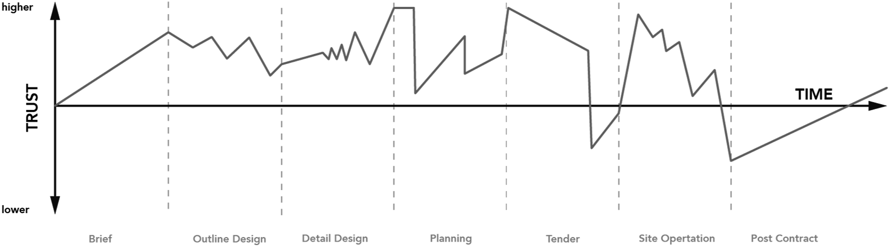
Figure 2. Reproduction of Flynn and Feeney’s curve of trust over time (2020, p. 21).
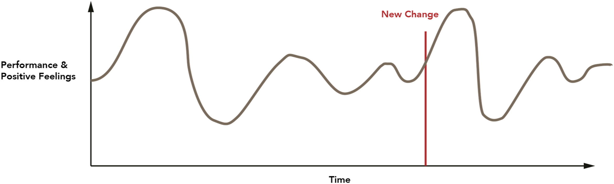
Figure 3. Reproduction of Billiau, 2021 model of change (2021, para. 20).

3.4 Indicators of habitus shock
Several key indicators offer insight into how user-clients emotionally, cognitively and behaviourally respond to architectural environments that misalign with their internalized dispositions. Drawing from Adler’s (1975) model of cultural transition and its application to architectural settings by Siva and London (2009), habitus shock can be tracked through affective and performative cues, both positive and negative.

3.4.1 Indicator 1: comfort and discomfort
The most immediate signals of habitus alignment or misalignment are emotional and embodied states of comfort or discomfort. As theorized by Gullahorn and Gullahorn (1963) and more recently Dovey (2002), comfort emerges when clients’ dispositions (social background, cultural capital, or communication style) resonate with the implicit rules and expectations of the architectural field. This alignment often results in smooth social interaction, confident participation, emotional equilibrium, and ease of navigation within project tasks or conversations.
Conversely, discomfort arises when the client’s habitus clashes with the unfamiliar logics, language, or hierarchies of the architectural setting. Symptoms include over-awareness, anxiety, confusion, behavioural withdrawal, or social clumsiness, particularly in disintegration phases (Adler, 1975; Zeller and Mosier, 1993).
Siva and London (2009) found that discomfort is often exacerbated by cognitive overload, especially for clients when confronted with opaque jargon or complex design reasoning. Here, the architect’s role in scaffolding understanding becomes critical to restoring agency.

3.4.2 Indicator 2: enthusiasm and loss of enthusiasm (or withdrawal)
A second major indicator lies in the client’s level of emotional engagement. Enthusiasm reflects not only excitement about novelty but also a form of curiosity and adaptive resilience. Often linked to the honeymoon or autonomy phases of transitional models, enthusiasm manifests as proactive engagement, joyful participation and openness to unfamiliar ideas, sometimes even masking latent discomfort.
In contrast, a lack of enthusiasm can suggest a stalled or regressive adaptation. This may take the form of disengagement, passive participation, emotional flatness, sarcasm, or defensive critique. These responses frequently surface during problematic reintegration phases, indicating deeper resistance or coping mechanisms such as denial or stereotyping. Siva and London (2009) observed that such disengagement is not merely emotional withdrawal but a signal of arrested learning, one that architects must actively address to re-establish mutual understanding. Ultimately, comfort/discomfort and enthusiasm/withdrawal are not merely surface emotions; they are embodied responses to the degree of alignment between the client’s habitus and the architectural field. Monitoring these indicators throughout the project timeline allows architects to anticipate, interpret and productively respond to habitus shock, fostering deeper collaboration and client learning.

3.5 Research questions
Building on these foundations, this study is guided by a main research question that aims to deepen our understanding of architect-client dynamics in private dwelling projects:
How does habitus shock manifest in architectural processes, both for user-clients and architects?
Sub-research questions include:
- How do architects and user-clients perceive and interpret critical turning points differently throughout the design process?
- What comfort or enthusiasm variations emerge in long-duration architectural collaborations, and how do these affect project engagement?

4. Materials and methods
This study employs an ethnographic approach combining document analysis, semi-conducted interviews and non-participant observations (Ciesielska et al., 2018). It is based on two case studies of two private dwelling renovation projects in Belgium (Beaud et Weber, 2010). Both case studies involve urban renovations carried out under restrictive budgetary conditions. The projects were selected opportunistically (Strumi�nska-Kutra and Koładkiewicz, 2018; Flyvbjerg, 2006), based on the timing of the design phase’s onset and the willingness of all parties to share data for research. Recruitment was conducted amongst architects previously interviewed in an earlier study (Mertens, 2025).

4.1 Ethical considerations and researcher positioning
This research adhered to ethical standards for qualitative inquiry, including informed consent, confidentiality and the right to withdraw at any point. All participants were fully informed about the aims of the study and how their data would be used. Identifying details have been anonymized, and pseudonyms are used throughout to protect participant privacy. This study was granted with ethical approval by the Human and Social Sciences Ethics Committee of the University of Liège (Comité d’éthique en Sciences Humaines et Sociales) on April 22, 2019 (File number: 20200103).
The researcher in charge of collecting the data maintained a non-interventionist stance during observations, aiming to document rather than influence the project dynamics. However, prolonged engagement inevitably shaped trust between the participants and research in interviews, particularly in emotionally charged or uncertain project phases. The researchers’ background in architecture and engineering informed their interpretations while requiring reflexivity to mitigate bias – especially when navigating moments of alignment or disagreement with either party. Participant validation interviews served to triangulate findings and to correct potential misinterpretations.

4.2 Data collection and analysis
The data, collected over 26 months (Case 1) and 31 months (Case 2), includes transcripts of interviews with the various stakeholders; email correspondences; attachments to those emails (e.g. photographs, drawings, sketches and measurements); copies of documents exchanged or presented during meetings; and audio recordings of meetings involving clients and architects. These recordings were primarily obtained through direct non-participant observation, but occasionally through indirect observation when logistical constraints or scheduling conflicts arose – using audio recordings initiated by the participants themselves (Ciesielska et al., 2018). Progress reports were also written by the lead researcher (first author) following telephone conversations with participants in order to document developments on both sides.
The data was analysed through thematic analysis (Lejeune, 2019), focusing on episodes of interaction characterized by friction (Tsing, 2005) leading to variations of comfort and enthusiasm. To ensure consistency in the identification of these friction episodes, three criteria guided the selection of moments for in-depth analysis:
(1) actor-reported significance, when participants explicitly highlighted a situation as frustrating, disappointing or impactful emotionally or for the project;
(2) emotional intensity, observed in tone, bodily cues or expressions of discomfort and enthusiasm;
and
(3) recurrence, when themes resurfaced across multiple interactions or stages.
These episodes were identified across data sources, contrasting interviews with meeting observations, email traces and design artefacts, to verify how each stakeholder experienced the situation and to limit interpretive bias.
Comfort and enthusiasm indicators can be mapped as suggested in Figure 4 below. Someone highly enthusiastic, perhaps in the midst of the honeymoon phase, while neither particularly comfortable nor uncomfortable with the structure, can be represented as Example 1. In contrast, someone experiencing an intense habitus shock, characterized by high discomfort and a significant loss of enthusiasm, corresponds to Example 2. It is also possible for an individual to be uncomfortable yet highly enthusiastic, as illustrated by Example 3.
Example 4 represents a different configuration: someone relatively comfortable with the process (for instance, due to prior exposure to architectural projects) but displaying low enthusiasm. This may be a client who, occupied with professional responsibilities, prefers minimal involvement and finds frequent interaction with the architect burdensome. Alternatively, Example 4 could describe an architect who is at ease with the process and accustomed to client interactions, yet lacks strong engagement with the project itself, which they may perceive as routine or uninspiring.
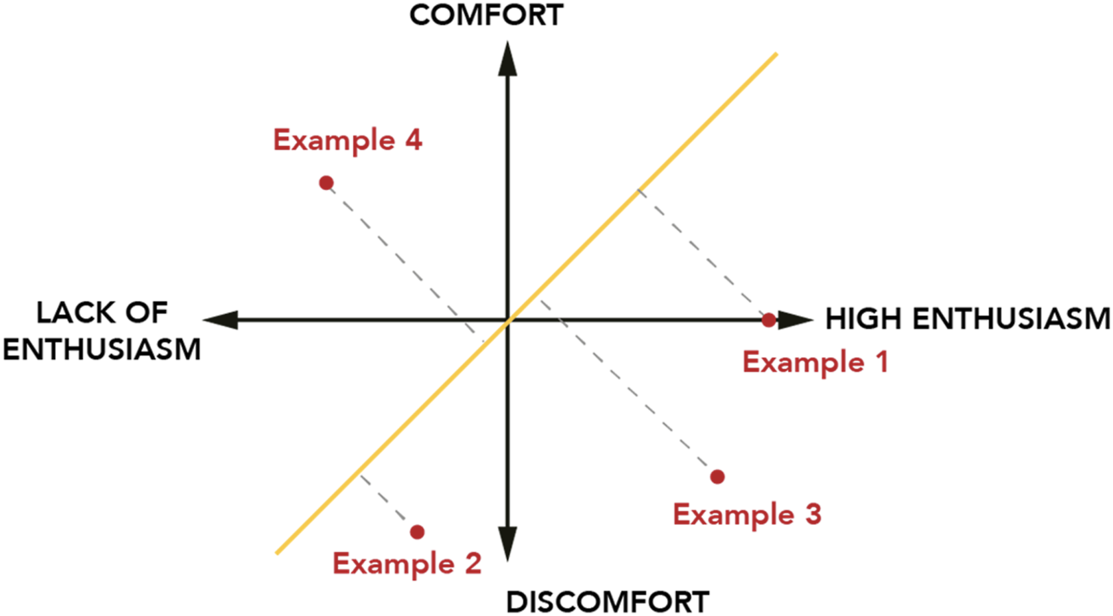
Figure 4. Habitus shock indicators (schematic depiction of the principle).
For the purpose of mapping habitus shock over time, we have chosen to simplify this multidimensional space by projecting these examples onto a single axis, represented by the (yellow) diagonal in Figure 4. Examples 1, 2, 3 and 4 can each be projected onto this axis.
This principle serves as ground to merge these two indicators. Comfort and Enthusiasm levels are drafted over time, using a Likert scale (Tanujaya et al., 2022). This method facilitates the qualification and visual representation of emotional and cognitive responses throughout the project. These temporal habitus shock curves (see Figure 5) allow us to trace how participants’ levels of comfort and enthusiasm fluctuate over time in response to key project phases and interactions.
These curves were developed collaboratively within the research team, using timelinebased mapping to trace how participants’ engagement and comfort evolved. Researcher 1 (first author) collected the data; a second organized these over a timeline. Researcher 1, “familiarized with the field” (Lejeune, 2008, p. 595, translated from French) analysed, coded and mapped the habitus shock. Particular attention was paid to transitions during phases such as design decisions, contractor engagement, or architectural turnover. Researcher 3 independently did the same coding and mapping process solely based on document analysis. Researchers 1 and 3 then compared and discussed their maps to discuss, converge and adjust their curves to form one draft curve. -
A post-analysis validation phase was conducted with participants from both cases. Preliminary interpretations (including habitus curves and key observations) were presented and discussed in a final interview. Participants were invited to reflect on the process, on friction points and learning episodes, on their impact on their own comfort and enthusiasm, and on identifying if it was their responsibility or the other party’s. The Likert scale enables intuitive and accessible interpretation of participants’ subjective experiences (Tanujaya et al., 2022). They were then asked to validate, nuance, or correct the curve drafts, which allowed for refinement and increased reliability of the findings.

4.3 Methodological limitations
Despite the depth of analysis, several methodological limitations must be acknowledged:
(1) Small sample size, limiting generalizability;
(2) Potential desirability bias, especially during interviews;
(3) Politeness bias or reluctance to criticize architects (or researchers), counterbalanced by prolonged engagement and trust-building over time;
(4) Context-specificity: findings may not translate to larger-scale or non-residential projects.

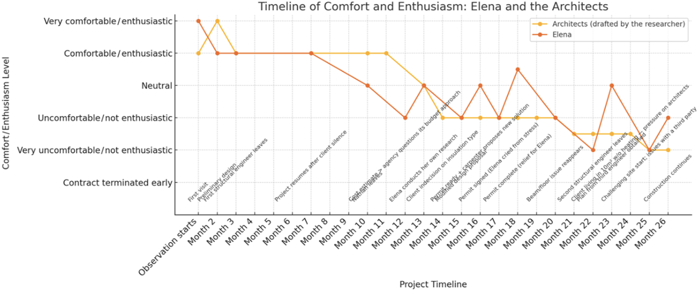
Figure 5. Diagram of enthusiasm/comfort - Case study 2.

5. Results

5.1 Presentation of the case studies

5.1.1 Case 1 – Chloe and Ben (data collected over 26 months, from 2021 to 2023)
Chloe inherited the house from her family. She held prior knowledge of the construction world and a clear interest in heritage preservation (e.g. defending the original windows and fireplaces). Ben, less confident with technical jargon, gradually became more involved, especially during site stages. His growing curiosity, particularly around reuse solutions, sparked new couple dynamics and collaborative decisions.
The architectural team was composed of Cedric, Clara and later Camille. Cedric had previously met Chloe through a professional encounter, and they got along quite well. As the lead architect of the firm, Cedric initially oversaw the project alongside Clara, who was in charge during the early phases. Together, Cedric and Clara conducted the first home visit to meet the clients and explore their needs. However, Clara’s unexpected departure (due to an unrelated career shift) just before the building permit phase created a destabilizing moment for the clients, who only learned of the change belatedly and felt abandoned. Camille, a young intern architect, was hired to step in as Clara’s replacement. She was initially overwhelmed, as Clara had left no transition support apart from a folder. Cedric, in his more senior role, intervened strategically during high-stakes moments, particularly for major decisions and to ensure continuity during the handover between architects.

5.1.2 Case 2 – Elena (data collected over 31 months, from 2021 to 2024)
Elena purchased her house with the intention of undertaking a self-renovation. She participated in hands-on workshops (e.g. clay plaster techniques), engaged directly in demolition work and actively sought meaningful, feasible ecological solutions. Although deeply involved, she faced several disappointments: some related to architectural turnover (such as an architect who never visited the site), others to unrealistic proposals or unexpected costs. Despite these challenges, Elena remained attentive throughout the process, documenting the project and striving to balance her ideals with practical constraints.
The architectural team consisted of Gabrielle, the lead architect of the firm and two successive interns. Nathan was first entrusted with the day-to-day management of the project but withdrew early in the process due to a job change, without notifying the client. This lack of communication created the first rupture in the relationship and left Elena uncertain about continuity and accountability. Adrian then replaced Nathan, taking over the operational aspects of the project. Gabrielle delegated responsibility to him while continuing to supervise the project and attending meetings as needed. She stepped in as a stabilizing figure, balancing technical oversight with a more relational posture. In her own words, she had to “bring out the very social and maternal side of the architect’s role,” particularly in managing Elena’s emotional ups and downs. Gabrielle also developed coping strategies to maintain professional boundaries, later admitting that she had become more emotionally detached over time. The change in project leads (from Nathan to Adrian), combined with Gabrielle’s partial presence, contributed to Elena’s fragmented experience and her ongoing struggle to feel consistently supported and understood throughout the process.
Table 1 sums up both case studies.
Table 1. Case studies actor overviews (pseudonyms)
Category | Case 1 | Case 2
Project Type | Energy-focused retrofit of an urban house. Initially planned as two units (main house rental duplex), but the duplex plan was later abandoned | Ecological retrofit of an urban property, balancing sustainability goals with legal and technical constraints
Client(s) | Chloe – Professional in sustainable construction and long-time acquaintance of the architect. Strong opinions on heritage and reuse. Ben – Her partner, a graphic designer. Less at ease with technical aspects but increasingly engaged and curious throughout the project | Elena – Motivated project owner with DIY experience and interest in ecological materials. Pragmatic and rigorous in her involvement, prone to anxiety, marked by frustration, doubts
Architects | Cedric (lead architect of the office), Clara (initial architect), Camille (took over after Clara’s departure). Architecture office specializes in sustainable approaches | Gabrielle (lead architect of the office), Nathan (initial architect, later left), Adrian (led final phases). Architecture office committed to natural materials and value alignment with clients
Other Actors mentioned | Contractors, notaries, banks, reuse specialists, technical suppliers (e.g. reused insulation, bat boxes) | Elena’s friend, engineers, a recommended carpenter

5.2 Timelines of comfort and enthusiasm
The following timeline broadcasts the curves drafted by researchers. This diagram (Figure 6) reflects the evolution of enthusiasm and comfort experienced by the project actors across key phases.

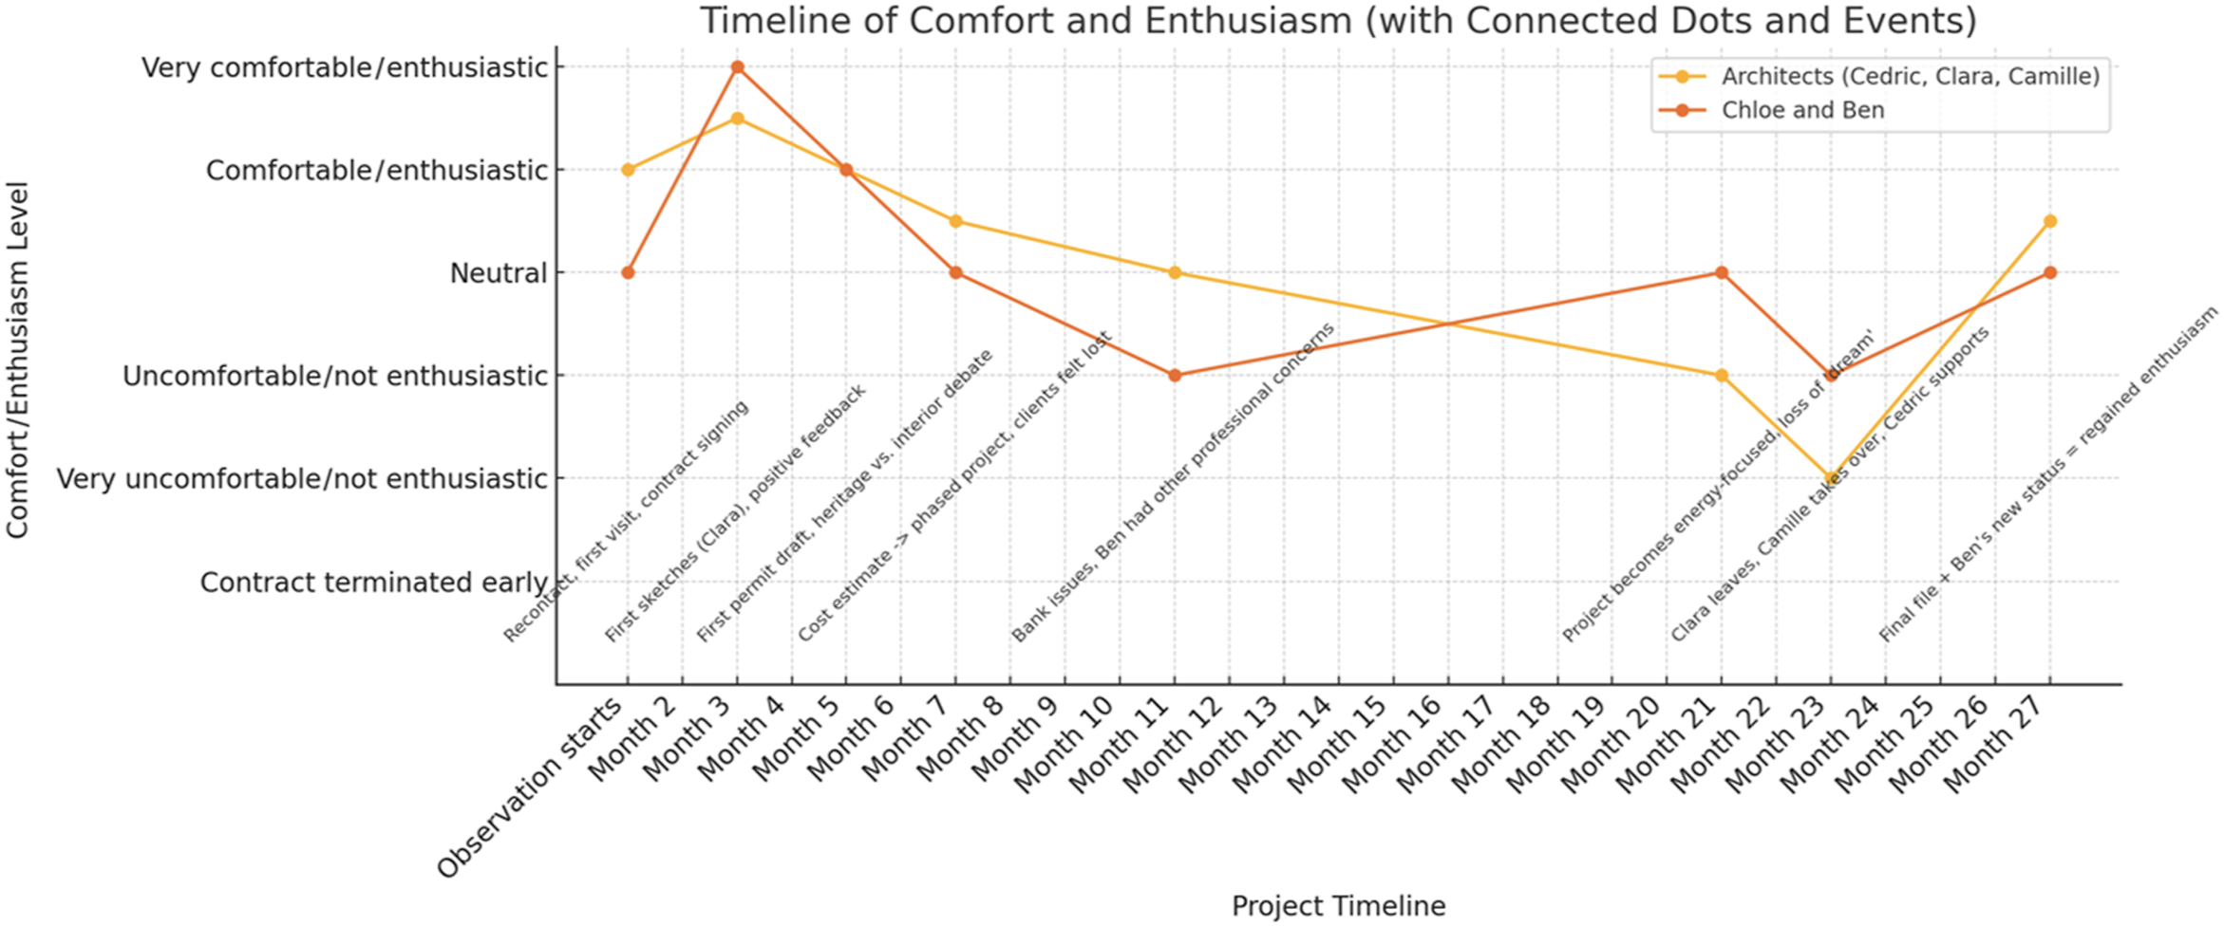
Figure 6. Diagram of enthusiasm/comfort as drafted by researchers & validated by the participants (Case study 1).

5.2.1 Case 1
Separately, Cedric and Camille (architects) and Chloe (user-client) were presented with a curve drafted by the researchers during post-analysis interviews to gather feedback and refine interpretations. They validated the proposed trajectory and did not request any corrections or modifications. Their comments confirmed the researchers’ understanding of the emotional transitions throughout the project.
Chloe added nuance by distinguishing her own position from her partner’s (Ben), noting that her technical background allowed her to navigate complexity more comfortably, whereas he often felt lost. The user-clients’ curve should have been updated to reflect this differentiated experience between co-clients. However, Ben was not available for an interview in the timeframe of our study.
Several excerpts illustrate the clear downward spike at month 23 (Figure 6) enthusiasm and comfort sharply declined. The sudden departure of Clara created a rupture, as Chloe recalled “confusion when Clara left suddenly,” signalling a loss of continuity and trust. Camille, who took over shortly after starting her first job as an architect, admitted: “I made mistakes, worked slowly, and often felt lost,” indicating professional uncertainty. Later, Camille progressively rebuilt trust and helped restore the clients’ sense of comfort, marking a transition into a reintegration phase within the habitus shock trajectory.

5.2.2 Case 2
When presented with their diagram, Gabrielle and Adrian commented on the discontinuity of their involvement and the intensity of this user’s engagement. Gabrielle emphasized how Elena’s high level of questioning, sometimes extending beyond her actual involvement, created fatigue and even led to more systemic professional changes. Adrian noted the irregular rhythm of decision-making and the cognitive load it imposed. These insights prompted several corrections to the original curve, especially in the post-permit and early construction phases.
The revised timeline (Figure 7) reflects (1) a sharper decline in the architects’ comfort/ motivation curve during the period of high questioning and delayed response; (2) a longer adaptation period, where the architects adjusted their deliverables and billing methods in response to this project.
When presented with her curve (Figure 8), Elena confirmed several key phases identified by the researchers but emphasized a deeper and more prolonged sense of solitude and burden, especially after the permit was granted. She said it felt more like a rollercoaster than what researchers had drafted. She expressed frustration at having to take over coordination tasks and a sense of being left alone to handle highly technical decisions, despite not being a construction professional. Her attempts to introduce alternative materials were met with scepticism or confusion, intensifying her impression of disconnection with the architects. The revised curve reflects this, as well as the intermittent relief brought by contractors’ inputs and the architects’ on-site availability – though that support was felt as occasional rather than continuous.
The curves in Figure 9 reveal pronounced downturns during key friction episodes. For example, Elena’s curve spikes down particularly when she felt her priorities were minimized or misunderstood. One sharp decline occurred when she perceived the architects to “side with the carpenter” instead of supporting her preferences, undermining her trust in their role as advocates. Another drop emerged from the delayed acceptance of technically feasible shutters, which made her question “why (the architects seem to be) working against me.” The transition between architects intensified this discomfort, as Elena noted Adrian, the new architect, “had never set foot on the site” after weeks of taking on the project, reinforcing feelings of being poorly considered. Approaching the permit stage generated heightened anxiety: “(it’s) a stage after which you can’t go back”, culminating in an emotional collapse during a meeting where she unexpectedly cried. These episodes, which she later described as “draining and scary,” reflect sharp downward inflections on the curve tied to unfamiliarity, power asymmetries and the burden of repeatedly asserting her needs. At the same time, her persistence in having ideas accepted represents small recoveries in the curve, demonstrating cyclical movement between rupture and renewed engagement.
Overall, Case 2 reveals a fragmented and fluctuating emotional trajectory (Figure 9), marked by high involvement of a user too distant from their architects (perhaps too autonomous), professional repositioning and misaligned expectations. The architects began with enthusiasm but faced a growing sense of fatigue and discontinuity as the project unfolded. Gabrielle and Adrian experienced difficulty sustaining engagement due to Elena’s extensive questioning, delayed decision-making and redefinition of the mission scope. In parallel, Elena initially felt empowered by her involvement but progressively entered a phase of isolation and cognitive overload, particularly when her proposals for alternative materials were poorly received or misunderstood, or when her demands were disregarded. The architects’ flexibility – especially their willingness to adjust their estimation methods and scope – mitigated some tensions, but the emotional valleys were much more numerous than in Case 1. This case illustrates how intense user participation, without shared reference points or continuous mediation, can produce emotional wear and role confusion on both sides of the relationship.

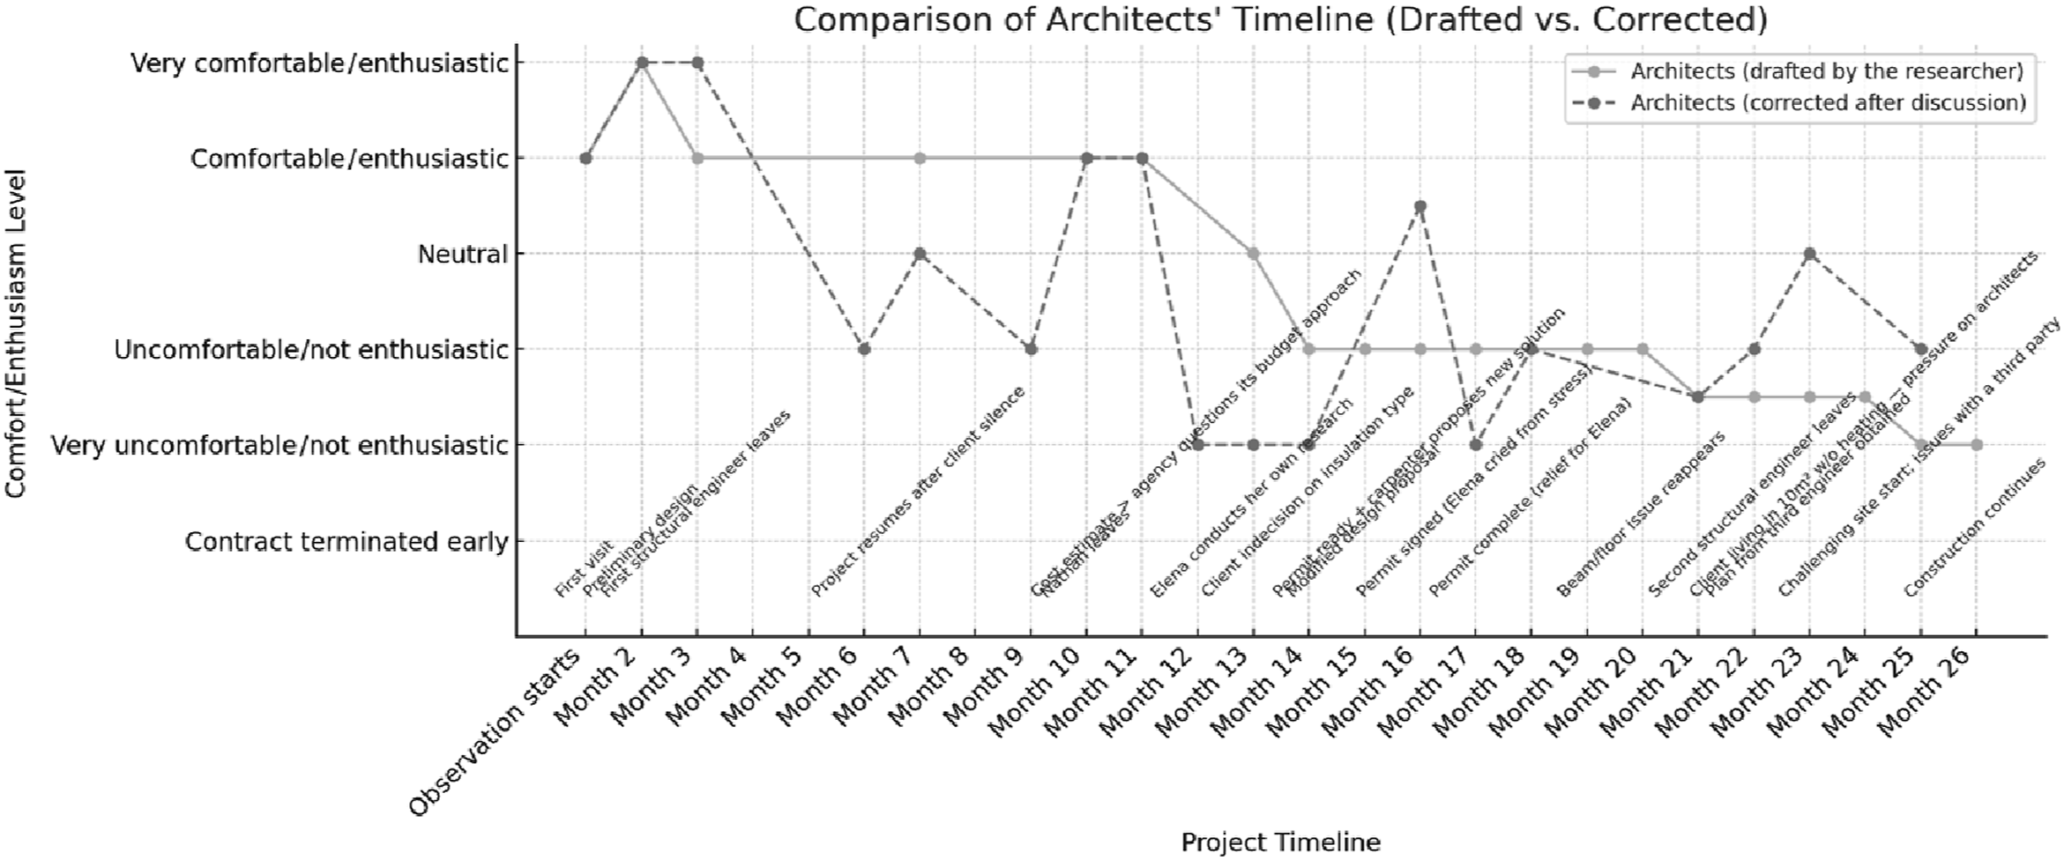
Figure 7. Diagram of enthusiasm/comfort – Case study 2 (rectified after architects’ feedback).
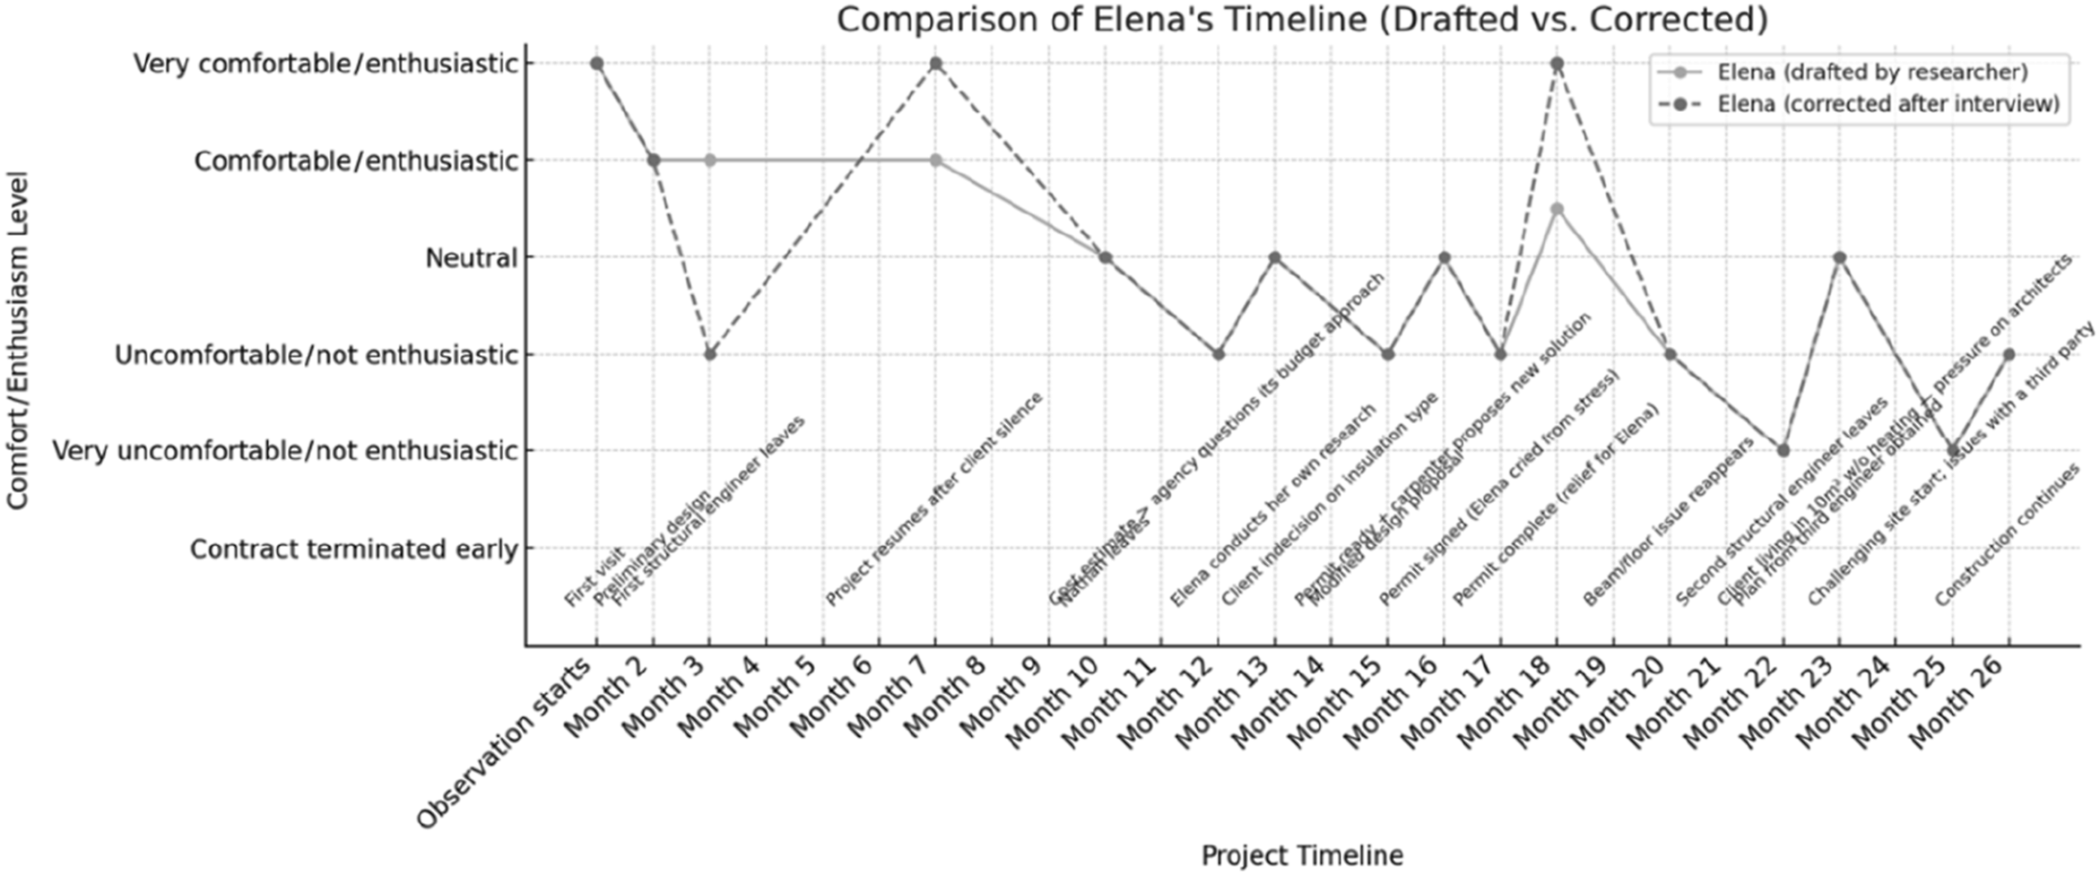
Figure 8. Diagram of enthusiasm/comfort – Case study 2 (rectified after user-client’s feedback).
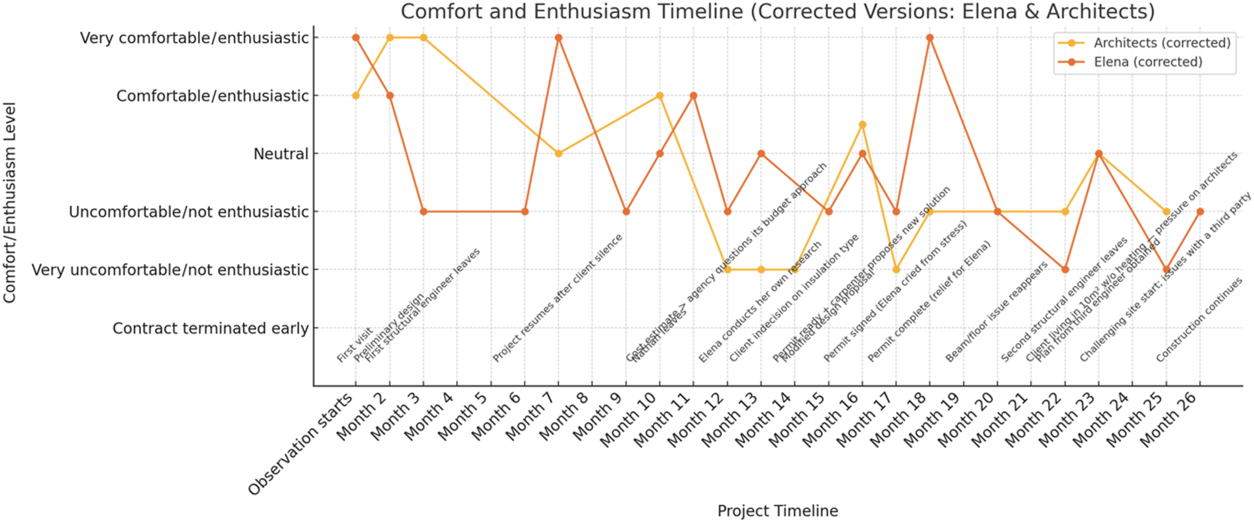
Figure 9. Diagram of enthusiasm/comfort – Case study 2 synthesis (rectified after participants’ feedback).

6. Discussion

6.1 Interpreting the curves through Siva and London’s Cycle (2011)
Across both case studies, we observe repeated episodes where expectations, values and emotional registers clash between clients and architects, and between imagined futures and tangible constraints. These emotional trajectories can be aligned with the Habitus Shock model and are further enriched when viewed through the lens of a four-stage cycle: Honeymoon, Shock, Adjustment and Adaptation (Siva and London, 2011).
In Case 1, the participants’ curves align relatively closely with a linear version of Siva and London’s model. The Honeymoon phase was marked by shared excitement and strong alignment between clients and architects during the early design phase. The Shock phase coincided with budget issues (external/loan rejected) and the need to downsize the ambition of the project. The Adjustment emerged when concerns were voiced and support was reactivated. A second shock was felt when Clara left the project. This shock is followed by Adjustment and Adaptation manifested as the project regained momentum and all actors re-engaged constructively.
By contrast, Case 2 reflects a more non-linear and fractured progression. The user-client (Elena) experienced a first decline as soon as the first design presentation, where she felt her concerns were not strictly met and then a proper shock as the engineer withdrew from the project. This shock is followed by a spike of enthusiasm (second honeymoon) quickly disturbed again by another shock. On the client’s end, this cycle of Honeymoon-Shock (Disintegration, Reintegration) keeps happening.
On the architects’ end, the enthusiasm fluctuated decreasingly until the shock when the estimated budget did not meet the clients’ budget, and then the client started doing her own research studies. After this episode, the rift/distance between architects and user-client slowly grew, with a small second honeymoon for architects when Elena chose the insulation type. In time, architects detached themselves emotionally to stabilize to a rather uncomfortable/not enthusiastic stance – a fatigue stemming from intense client questioning and delayed decisions. In this case, the cycle was not strictly sequential: moments of Adaptation (e.g. Gabrielle adjusting her estimation methods) overlapped with repetitive shocks for the client. This confirms Siva and London’s proposition that the cycle can be non-linear and recursive.

6.2 Extending the frameworks: five contributions
Our findings suggest six key extensions to existing theoretical frameworks of habitus shock, drawing attention to the nuanced dynamics at play in architect/user-client interactions over time.

6.2.1 Asymmetry of experience
Architects and user-clients can experience “shocks” at different times and interpret events through distinct emotional and professional lenses. In Case 2, for instance, Elena’s steep drop in comfort in Month 3, following the abrupt departure of the structural engineer, was a turning point for her – which was barely registered on the architects’ radar. Time lags in affective perception highlight a possible desynchronization of professional and personal experiences, complicating design alignment.
In Case 1, by contrast, Chloe and the architects experienced a more synchronized dip in motivation and rhythm.

6.2.2 Emotional Ambiguity
Emotions across the project lifecycle are not unidimensional or neatly stage-bound. Instead, participants frequently reported layered and contradictory affective states: enthusiasm paired with exhaustion, or relief followed by anxiety. In Case 2, Elena expressed both empowerment through her deep involvement and fatigue from shouldering unexpected responsibility. These emotional paradoxes complicate the effort to map clean emotional transitions and invite a more granular, situated reading of habitus evolution.

6.2.3 Agency and mutual learning
Despite the tensions, both case studies revealed episodes of learning and adaptation on both sides. In Case 1, Chloe progressively gained autonomy, becoming a more assertive client who shaped design choices. In Case 2, Gabrielle, initially overwhelmed by the volume and type of client requests, revised her practice, shifting toward more flexible estimation models (e.g. hourly billing) and rethinking how she communicated technical information. These mutual learning loops emerged through friction rather than harmony, suggesting that discomfort can catalyse professional evolution.

6.2.4 Structural constraints
Many emotional valleys and disruptions in both cases stemmed not from interpersonal failure but from external constraints: financial uncertainty, unexpected contractor changes, administrative delays, or unanticipated planning demands. In Case 2, the postponed façade painting, banks’ reluctance to release funds and inconsistent contractor availability shaped Elena’s priorities more forcefully than any architectural dialogue. These findings challenge models that overemphasize internal habitus conflict, pointing instead to systemic and infrastructural pressures that often override personal learning or adjustment.

6.2.5 Presence and withdrawal
Finally, we observed the significant emotional impact of architectural presence and its withdrawal. Periods of silence, staff turnover (e.g. Clara – Case 1/Nathan – Case 2 leaving) and infrequent communication were experienced by clients as abandonment. In Case 2, Elena felt left alone for long stretches or overwhelmed by highly technical emails with no support in decision-making. In contrast, presence – especially through site visits or informal check-ins – helped rebuild trust and motivation. These findings position strategic withdrawal or availability as critical variables in the emotional ecology of architectural collaboration and underscore the need to account for rhythms of contact, attention and continuity in long-duration projects.

7. Contributions and perspectives
This study makes several key contributions – methodological, practical and educational – that open up new leads for understanding and supporting architect-client dynamics in private dwelling projects.

7.1 Methodological contribution
A central contribution of this research lies in the development and use of comfort/enthusiasm trajectory curves, also described as habitus shock curves, co-constructed and validated with participants. These diagrams proved to be more than analytical devices: they functioned as relational tools that allowed architects and clients to visualize, reflect on and discuss their evolving emotional states, misalignments and learning moments throughout the project.
This method could perhaps facilitate a more empathetic and temporally sensitive reading of architectural collaboration, offering potential as a low-tech accompaniment tool in participatory or reflective practices. The curves encouraged a meta-dialogue during postanalysis interviews and prompted participants to identify turning points they had previously overlooked, thereby reinforcing the value of reflexive visualization in architectural ethnography.

7.2 Implications for practice
While this study did not directly evaluate the use of habitus shock curves as tools during projects, the results suggest their potential future value as prompts for reflection and communication. In particular, the visualization of emotional trajectories could help architects and clients retrospectively identify turning points, clarify how misunderstandings emerged and recognize moments of renewed engagement as an in-depth feedback technique to improve future practice. If developed into a participatory tool, shock curves could support project reviews or early collaborative meetings by making explicit the affective dimension of decisionmaking that often remains implicit. Future design research could therefore explore how such curves might be adapted into an anticipatory practice, allowing architects to routinely check alignment at key milestones and adjust their communication strategies accordingly.

7.3 Implications for architectural education
Although the present work focuses on completed projects, habitus shock curves suggest a potential for future pedagogical use. Integrated into design studios, they could serve as reflective instruments to discuss the emotional dynamics of real residential projects and help students understand how design decisions intertwine with client adaptation, uncertainty and vulnerability. At the same time, the findings reinforce the need to embed user-centred competencies within architectural curricula, including negotiation, conflict management, affective literacy and the ability to guide clients through complex regulatory processes. Together, such approaches would prepare future architects not only as proficient designers but also as sensitive intermediaries capable of navigating relational complexity and fostering more transparent, durable architect-client relationships, particularly in private dwelling projects.

7.4 Perspectives for future research
This study opens several paths for future inquiry. Expanding the analysis to larger comparative samples, across varied national and cultural contexts, could test the robustness of our five extensions and refine the habitus shock framework.
Researchers should also explore alternative tools to track affective trajectories, such as diaries, mobile apps, or collaborative mapping workshops, especially for longer-term or collective housing projects.
Finally, there is value in further investigating the emotional implications of architectural absence and presence, particularly in contexts of precarious labour, time fragmentation and post-pandemic hybrid work practices.

Disclosure statement
This article is part of a two-part inquiry into architect-user-client dynamics in private dwelling projects. While this piece focuses on habitus shock trajectories, it is complemented by a companion article titled From Authorship to Stewardship: Adjustments Between Architects and User-Clients in Private Dwelling Design, submitted concurrently. Both articles draw from the same ethnographic case studies but address distinct aspects: one explores habitus shocks experienced throughout the process on both sides, while the other focuses on learning and role transformation. They are designed as standalone but mutually enriching contributions to usercentered architectural research.

Data availability statement
Due to confidentiality agreements with participants, the datasets generated and analysed during the current study are not publicly available.

Acknowledgments
This research was supported by the F.R.S.-FNRS Incentive Grant for Scientific Research (Grant No. MIS/ PGY F.4513.20). We gratefully acknowledge all anonymous participants for their valuable contributions. We also thank Prof. Alan Lewis for hosting the first author during the data analysis phase at the University of Manchester, and Dr. Cigdem Yonder for her related work and generous knowledge sharing, which greatly enriched this study.

Notes
- In the context of private dwelling design, user-clients is used to underscore the dual role of clients as both decision-makers and future users.
- Based on Tsing (2005), friction can be defined as the awkward, unequal and transformative encounter that occurs when differing cultural logics, aspirations and practices meet, generating both resistance and movement through their interaction. Tsing highlights “the importance of interaction in defining movement, cultural form and agency (…) The effects of encounters across difference can be compromising or empowering.” (2005, p. 6).
- Understood as per Little (2016): “Social interaction is the process of reciprocal influence exercised by individuals over one another during social encounters. Usually, it refers to face-to-face encounters in which people are physically present with one another for a specified duration. However, in contemporary society we can think of social encounters that are technologically mediated” (p. 914).

References
Adad, C. (2004). Les effets du rapport architecte et usager sur l’habitat. Sciences Humaines, 21, 13.
Adler, P. (1975). The transitional experience: An alternative view of culture shock. Journal of Humanistic Psychology, 15(4), 13–23.
Ahuja, S., Heizmann, H., & Clegg, S. (2019). Emotions and identity work: Emotions as discursive resources in the constitution of junior professionals’ identites. Human Relations, 72(5), 988-1009. https://doi.org/10.1177/0018726718785719
Ahuja, S., Nikolova, N., & Clegg, S. (2020). Professional identity and anxiety in architect-client interactions. Construction Management and Economics, 38(7), 589–602. https://doi.org/10.1080/01446193.2019.1703019
Angral, A. (2019). Architect-client relationship and value addition in private residential projects. Archnet-IJAR: International Journal of Architectural Research, 131, 58–71. https://doi.org/10.1108/arch-12-2018-0026
Architects’ Council of Europe. (2024). The architectural profession in Europe 2024: A sector study.
Arora, O., Das, S., Siva, J. P. S., A, S., & Nagdeve, S. (2021). Client expectations in the purview of architecture. International Journal of Students’ Research in Technology and Management, 9(4), 40–53. https://doi.org/10.18510/ijsrtm.2021.944
Beaud, S., & Weber, F. (2010). Guide de l’enquête de terrain: Produire et analyser des données ethnographiques (4th ed.). La Découverte.
Billiau, J. (2021). Does the change curve explain what we are all feeling right now? The Medium. https://medium.com/@jbilliau/does-the-change-curve-explain-what-we-are-all-feeling-right-now-9bc1b94688ba
Black, J. S., & Mendenhall, M. (1991). The U-curve adjustment hypothesis revisited: A review and theoretical framework. Journal of International Business Studies, 22(2), 225–247. https://doi.org/10.1057/palgrave.jibs.8490301
Bogers, T., Van Meel, J. J., & Van der Voordt, T. J. M. (2008). Architects about briefing: Recommendations to improve communication between clients and architects. Facilities, 26(3/4), 109–116. https://doi.org/10.1108/02632770810849454
Bourdieu, P. (1977). Outline of a theory of practice. Cambridge University Press.
Casakin, H., & Badke-Schaub, P. (2017). Sharedness of team mental models in the course of design-related interaction between architects and clients. Design Science, 3, e14. https://doi.org/10.1017/dsj.2017.15
Caven, V., & Diop, M. (2012). Architecture: A ‘rewarding’ career? An anglo-French comparative study of intrinsic rewards in the architecture profession. Construction Management and Economics, 30(7), 513–523. https://doi.org/10.1080/01446193.2011.627356
Ciesielska, M., Boström, K. W., & Ohlander, M. (Eds.). (2018). Observation methods. In Qualitative methodologies in organization studies (pp. 33–52). Palgrave Macmillan.
Cohen, L., Wilkinson, A., Arnold, J., & Finn, R. (2005). ‘Remember I’m the bloody architect!’ Architects, organizations and discourses of profession. Work, Employment and Society, 19(4), 775–796. https://doi.org/10.1177/0950017005058065
Cuff, D. (1991). Architecture: The story of practice. MIT Press.
Cuff, D. (2012). Introduction: Architecture’s double-bind. In C. G. Crysler & H. Hilde (Eds.), The Sage handbook of architectural theory (pp. 385–393). Sage.
Dainty, A., Green, S., & Bagilhole, B. (2007). People and culture in construction: Contexts and challenges. In A. Dainty, S. Green, & B. Bagilhole (Eds.), People and culture in construction: A review (pp. 3–25). Taylor & Francis.
Defays, A., & Elsen, C. (2018). Architecte et maître d’ouvrage: Main dans la main, ou dos à dos. Archinews, 18, 15–21.
Dovey, K. (2002). The silent complicity of architecture. In J. Hillier & E. Rooksby (Eds.), Habitus: A sense of place (pp. 280–294). Routledge.
Flynn, M., & Feeney, D. (2020). Measuring the (un)happy client. Iterations: Design Research & Practice Review, University of Limerick, Ireland, 8, 20–23.
Flyvbjerg, B. (2006). Five misunderstandings about case-study research. Qualitative Inquiry, 12(2), 219–245. https://doi.org/10.1177/1077800405284363
Frimpong, S., & Dansoh, A. (2018). Marginalization and invasion of architects’ role on house projects: Institutional intervention inadequacy and super wicked problems. Frontiers of Architectural Research, 7(3), 292–303. https://doi.org/10.1016/j.foar.2018.04.001
Gray, C. M. (2013). Informal peer critique and the negotiation of habitus in a design studio. Art, Design and Communication in Higher Education, 12(2), 195–209. https://doi.org/10.1386/adch.12.2.195_1
Gullahorn, J., & Gullahorn, J. (1963). An extension of the U-curve hypothesis. Journal of Social Issues, 19(3), 33–47. https://doi.org/10.1111/j.1540-4560.1963.tb00447.x
Heylighen, A., & Dong, A. (2019). To empathize or not to empathize? Empathy and its limits in design. Design Studies, 65, 107–124.
Heynen, H. (2014). Genius, gender and architecture: The star system as exemplified in the Pritzker Prize. In Women, practice, architecture (pp. 124–138). Routledge.
Huang, M. L., & Wang, Y. Y. (2012). The communication feedback creates a two-winner – cognitive model for explaining client-architect interaction. Advanced Materials Research, 430–432, 1248–1252. https://doi.org/10.4028/www.scientific.net/amr.430-432.1248
Lejeune, C. (2008). Au fil de l’interprétation. L’apport des registres aux logiciels d’analyse qualitative. Schweizerische Zeitschrift für Soziologie, 34(3), 593–603.
Lejeune, C. (2019). Manuel d’analyse qualitative: Analyser sans compter ni classer (2e éd.). De Boeck.
Little, W. (2016). Introduction to sociology – 2nd Canadian edition. OpenEd, BCcampus.
Loi du 20 février 1939 sur la protection du titre et de la profession d’architecte. (1939). https://www.ejustice.just.fgov.be/cgi_loi/change_lg.pl?language5fr&la5F&cn51939022030&table_name5loi1939022050
Luck, R., & McDonnell, J. (2006). Architect and user interaction: The spoken representation of form and functional meaning in early design conversations. Design Studies, 27(2), 141–166. https://doi.org/10.1016/j.destud.2005.09.001
Lysgaard, S. (1955). Adjustment in a foreign society: Norwegian Fullbright grantees visiting the United States. International Social Science Bulletin, 7, 45–51.
McDonnell, J., & Lloyd, P. (2014). Beyond specification: A study of architect and client interaction. Design Studies, 35(4), 327–352. https://doi.org/10.1016/j.destud.2014.01.003
Mertens, A. (2025). From barriers to bridges: Understanding and improving interactions between architect and user-client in dwelling design (Doctoral dissertation). Universite de Liege. ProQuest Dissertations & Theses.
Mertens, A., Hamarat, Y., & Elsen, C. (2023). Interactions between architects and end-users during housing design processes: A systematic literature review. Archnet-IJAR: International Journal of Architectural Research, 17(4), 703–724. https://doi.org/10.1108/ARCH-03-2022-0079
Nauwelaers, I., & Rossini, C. (2014). Construire, une brique dans le ventre pas toujours digeste. Magazine TestAchats, 584, 10–16.
Pelkonen, E. (2012). Architect as organizer or the way the world works. Perspecta.
Payne, S. R., Mackrill, J., Cain, R., Strelitz, J., & Gate, L. (2015). Developing interior design briefs for health-care and well-being centres through public participation. Architectural Engineering and Design Management, 11(4), 264–279. https://doi.org/10.1080/17452007.2014.923288
RIBA. (2015). Client and architect: Developing the essential relationship. Royal Institute of British Architects.
Shao, D., & Nagai, Y. (2018). Old building, new usage: A case study of a creative practice for an art studio space design based on users’ mental needs. In DS 89: Proceedings of the Fifth International Conference on Design Creativity (Bath, UK). University of Bath.
Siva, J. P. S., & London, K. (2009). Habitus shock: A model for architect-client relationships on house projects based on sociological and psychological perspectives. In Future Trends in Architectural Management, International Symposium CIB-W096 2009 (Taiwan).
Siva, J. P. S., & London, K. (2011). Investigating the role of client learning for successful architect-client relationships on private single dwelling projects. Architectural Engineering and Design Management, 7(3), 177–189. https://doi.org/10.1080/17452007.2011.594570
Siva, J. P. S., & London, K. (2012). Client learning for successful architect-client relationships. Engineering, Construction and Architectural Management, 19(3), 253–268. https://doi.org/10.1108/09699981211219599
Stals, A., Jancart, S., & Elsen, C. (2018). Influence of parametric tools on the complexity of architectural design in everyday work of SME’s. Archnet-IJAR, 12(3), 206–227. https://doi.org/10.26687/archnet-ijar.v12i3.1665
Strumińska-Kutra, S., & Koładkiewicz, I. (2018). Observation methods. In Qualitative Methodologies in Organization Studies (pp. 33–52). Palgrave Macmillan.
Tanujaya, B., Prahmana, R. C. I., & Mumu, J. (2022). Likert scale in social sciences research: Problems and difficulties. FWU Journal of Social Sciences, 16(4), 89–101.
Tidafi, T. (1996). Moyens pour la communication en architecture: Proposition de la modélisation d’actions pour la figuration architecturale (Doctoral dissertation). Université de Montréal.
Tsing, A. L. (2005). Friction: An ethnography of global connection. Princeton University Press.
Uhl, O., & Boyd Whyte, I. (2016). Democratized aesthetics. Art in Translation, 8(4), 483–491. https://doi.org/10.1080/17561310.2016.1277104
Van der Linden, V., Dong, H., & Heylighen, A. (2019). Tracing architects’ fragile knowing about users in the socio-material environment of design practice. Design Studies, 63, 65–91. https://doi.org/10.1016/j.destud.2019.02.004
Waite, R., & Braidwood, E. (2017). Q&A: Architects on marginalization and what can be done about it. The Architects’ Journal. https://www.architectsjournal.co.uk/news/architectsonmarginalisation-and-what-can-be-done-about-it-
Winch, G., & Schneider, E. (1993). The strategic management of architectural practice. Construction Management and Economics, 11(6), 467–473. https://doi.org/10.1080/01446199300000052
Wiscombe, T. (2006). Emergent models of architectural practice: Architecture after all. Perspecta: The Yale Architectural Journal, 38, 57–68.
Zeller, W. J., & Mosier, R. (1993). Culture shock and the first-year experience. The Journal of College and University Student Housing, 23(2), 19–23.

Corresponding author
Audrey Mertens can be contacted at: audrey.mertens@uliege.be

