Precising regional signals of recent environmental changes in Northern Patagonia through the sediment record of a small lake: evaluating natural and anthropogenic drivers
Abstract
Northern and Central Patagonia represent a crucial area for studying past climate variability, volcanic activity, and human impacts on aquatic ecosystems. While significant progress has been made, important questions remain regarding how volcanic deposits interact with lake systems and how to distinguish natural climate signals from anthropogenic influences in sediment records. This research addresses these gaps through a multiproxy analysis of sediment cores from Lake Maldonado, located in the Baker River basin. Cores collected in the austral summer of 2013 and 2022 from the lake's deepest point were analyzed for diatom assemblages, elemental geochemistry (XRF scanning), and basic sedimentological properties. A robust age model was built using ²¹⁰Pb and ¹³⁷Cs dating, complemented by two tephra ages. The results reveal three environmental phases over the past three centuries: The earliest (1840-1880 CE) shows dominance of the diatom Pseudostaurosira brevistriata and elevated Si/Ti ratios, suggesting increased wind activity during a Little Ice Age-type event. The intermediate period (1890-1970 CE) reflects higher fire frequency, evidenced by increased charcoal and organic matter, linked to spontaneous colonization of the territory. The most recent period (1971-2014 CE) is markedly influenced by two major eruptions from Hudson Volcano, evidenced by distinct peaks in magnetic susceptibility and total phosphorus, shifts in diatom communities toward planktonic species and decreases in organic matter and biogenic silica. This study not only corrects previous misinterpretations of tephra layers in the region but also provides a clearer understanding of how natural and human drivers have collectively shaped the limnological evolution of Patagonian lakes.
Keywords: Paleolimnology, Diatoms, XRF, Wildfires, Westerlies, Patagonia.

- Introduction
Northern and Central Patagonia have been an interesting site to study past climate variability (i), volcanic activity (ii) and recent anthropogenic impacts (iii). That is because Patagonia intersect the circulation belt of the Southern Westerly Winds (SWW), is surrounded by active volcanic centers and has undergone important human impacts probably since the Holocene and later on, during the modern settlement of the area
Environmental setting
SWW are responsible of bringing precipitation for western southern South America; generating a peak in precipitation west of and aridity east of the Andes centered around latitudes 48°-50° S. It also regulates nutrient inputs, heat balance and gases fluxes between surface and deep waters of the Southern Ocean, playing an important role in past atmospheric CO₂ variations and in turn on global climate (Kilian & Lamy, 2012; Koffman et al., 2023; Lamy et al., 2010; Tamhane et al., 2023). Hence many researchers have focused on understanding its variations at different timescales, like during the last glacial (Gilli et al., 2005; Mayr et al., 2013), the Holocene (Fletcher & Moreno, 2012; Gilli et al., 2005; Moreno et al., 2010; Villa-Martínez et al., 2012) and the last millennium(Mayr et al., 2013; Moy et al., 2008; Schimpf et al., 2011). Besides, to understand SWW variability and its forcing is key for facing future climate change in this part of South America (Zolitshka et al., 2019).
According to Garreaud et al. (2013) the interception that the Austral Andes produced on the SWW flux, provoked one of the most dramatic precipitation gradients on Earth. While western Patagonia is characterized by a hyperhumid climate with mean annual precipitation ranging between 5,000 and 10,000 mm yr-1, eastern Patagonia, located in the rain shadow of the Andes, shows a dramatic reduction in precipitation reaching less than 300 mm yr⁻¹ and extremely windy and highly evaporative conditions (Garreaud, 2009). Such condition generates the forest-steppe ecotone of Southern South America, one of the most dynamic regions of the world that is highly sensitive to environmental and climate change (Fang et al., 2025; Shumilovskikh et al., 2018), being it a key area to monitoring it (Castri, 1988; Kitzberger, 2012; Neilson, 1991).
Ecotones represent ideal ecosystems for assessing ecological resilience (Desjardins et al., 2015), given their sensitivity to climate variability and disturbance regimes (Allen & Breshears, 1998; Myster, 2012; Zaret & Holz, 2024). Their spatiotemporal dynamics emerge from complex interactions among microclimate conditions, fire disturbances, and forest recovery capacity (Iglesias et al., 2018; Iglesias et al., 2014; McCulloch et al., 2023; Nanavati et al., 2019), being particularly sensitive to minor latitudinal shifts in the Southern Westerly Winds (Mansilla et al., 2018; McCulloch et al., 2023).
i) Climate variability
The variability of the SWW exerts significant climatic control over mid- and high-latitudes, regulating both the amount and source of annual precipitation, wind speeds, eolian sediment transport, and regional thermal (Fletcher & Moreno, 2012; Spoth et al., 2023; Toggweiler et al., 2006). This influence, combined with their fundamental role in moisture balance, has shaped landscape evolution and wildfire frequency (Perren et al., 2025).
Studies of the short term / low magnitude climate events of the late Holocene in Patagonia are scarce, most studies of past climate in Patagonia are related to the beginning of the last termination or about the climate of the entire Holocene. Although the natural variability range of the Southern Hemisphere Westerlies (SWW) during warm and cold periods remains poorly constrained (Perren et al., 2025), paleoclimatic records provide evidence of latitudinal displacements. It has been suggested that the SWW were located in a more poleward position before 1200 CE. It gradually shifted towards the equator in 1200–1500CE, where it remained in a sustained position until 1950 CE (Bertrand et al., 2014). Evidence suggests the Southern Hemisphere's Little Ice Age (LIA) was associated with both a northward migration and an intensification of this westerly wind belt (Chassiot et al., 2024).
Probably, the scarce number of studies focused in the climate of the last millennium in Patagonia is explained due to the low magnitude of the changes, being difficult to find sensitive proxies and sensitive locations to trace such fluctuations.
Biological proxies stored in the sediment record have been used worldwide to track different environmental changes (Battarbee, 2000; Gregory-Eaves & Smol, 2024). Pollen have been applied to evaluate vegetational changes (Birks & Birks, 1980), chironomids have been used as a paleothermometer (Brooks et al., 2007) and diatoms have been used to track several impacts on lakes (Smol & Stoermer, 2010), like eutrophication, acidification, contamination and even climate events.
However, as climate fluctuations in southern Patagonia are related to an intensification/weakness of the SWW and wind events are particularly significant in shallow lakes, where they rapidly alter light, nutrient, and thermal conditions; diatoms have something to say! (de Souza Cardoso & da Motta Marques, 2009; Kuha et al., 2016; Ongun Sevindik et al., 2022). Increased wind intensity enhances turbulence in the water column, inducing a tychoplanktonic behavior in highly silicified benthic diatoms. This hydrodynamic mechanism enables the temporary retention of these taxa in the euphotic zone, altering their vertical distribution (Cardozo et al., 2014). This phenomenon enables the use of specific species as indicators of wind dynamics and hence westerlies fluctuations. Turbulence suspends diatoms with high sinking rates, resuspending cells from deep water layers (Huisman et al., 2002; Moreno-Ostos et al., 2009). Recent studies highlight the indicator value of: Discostella pseudostelligera, associated with stable stratified waters, and Aulacoseira spp., linked to vertical mixing by strong winds (Egan et al., 2022). Analyses in Lake Huguang Maar in southeastern China confirm this relationship, where Aulacoseira and Cyclotella reflect winter monsoon intensity (Wang et al., 2008). In Lake Potrok Aike (eastern Argentina), the dominance of Fragilarioides suggests a higher westerlies influence (Zimmermann et al., 2015).
ii) Volcanic activity
Volcanic eruptions significantly alter lacustrine ecosystems through tephra deposition, affecting water turbidity, light penetration, and nutrient availability (Hickman & Reasoner, 1994). While increased silica (SiO₂) may stimulate diatom growth (Telford et al., 2004; Cruces et al., 2006), ash sedimentation can limit other nutrients like phosphorus, creating complex productivity responses (Hickman & Reasoner, 1994), both consequences would be temporary, while the effects of the volcanic material entering the ecosystem remain. Hudson Volcano, the southernmost center in the Southern Volcanic Zone (SVZ), has experienced at least 12 explosive events during the Holocene. Three major eruptions stand out: H1 (~7,750 cal yr BP), H2 (3,920 cal yr BP), and H3 (1991 CE; VEI=5), along with minor events in 1971 (VEI=3) and 2011 (VEI=1-2) (Delgado et al., 2014; Kratzmann et al., 2010; Weller et al., 2014). Although their identification in lacustrine sediments presents challenges(Naranjo & Stern, 1998), these deposits enable reconstruction of both eruptive history and environmental impacts.
iii) Recent anthropogenic impact (wildfires)
During the spontaneous colonization at the end of the 19th century, and particularly between 1910 and 1940, a pronounced fire regime was established in Northern Patagonia, linked to the practice of "field clearing" through indiscriminate burning (Martinić, 2011). Historical records indicate that approximately 25% of forests near the steppe were consumed (Moreno-Gonzalez et al., 2021; Rothkugel, 1916), with particularly devastating events between 1930 and 1950 that affected around three million hectares (Martinic, 2005; Quintanilla, 2008).
Wildfires have been a key driver of change in lacustrine ecosystems, as evidenced by the sedimentary record from Lake Lubińskie (Poland), which documents 23 fire events with a frequency of up to 4.8 fires per 500 years (Bonk et al., 2024). These disturbances drastically altered vegetation composition and biogeochemical cycles in lacustrine ecosystems whose effects are still evident in some of them (Markgraf et al., 2007, Araneda et al., 2013). After a burning event, runoff enhances soil erosion, which promotes the input of sediments into aquatic ecosystems, increasing the entry of ash, nutrients, and organic matter into the water body. Additionally, inputs may occur through subsurface flows or the atmosphere, depending on the form and biogeochemistry of each material (Clark, 1988; Moody et al., 2013; Peters & Higuera, 2007; Vachula et al., 2019; Waters et al., 2023). Combustion releases nutrients such as phosphorus into adjacent aquatic systems (Waters et al., 2023). For example, in Lake Francis (Canada), phosphorus concentrations increased and even doubled during fire events, which can lead to lake eutrophication (Markgraf et al., 2007; Whitlock, 2001).
Fire regimes in Patagonia have been primarily studied through paleoenvironmental approaches, such as paleolimnological and paleoecological (Abarzúa & Moreno, 2008; Álvarez-Barra et al., 2024; De Porras et al., 2012; Martel‐Cea et al., 2024; Moreno-Gonzalez et al., 2021; Nanavati et al., 2021) , tree rings (Mundo et al., 2017), and remote sensing (Oddi & Ghermandi, 2016), as well as through archaeological records. Some studies have integrated multiple disciplines, such as the work by (Méndez et al., 2016), which combined archaeological, pollen, and charcoal data to reconstruct historical fire trends. However, these approaches have largely overlooked local ecological knowledge regarding traditional fire use and management (Bonk et al., 2022). In this context, oral history (Fogerty, 2001) represents a key tool to complement paleoenvironmental records, enabling a more comprehensive understanding of land cover changes based on local ecological knowledge (Robertson & McGee, 2003).
Despite the great potential of this area, high-resolution multiproxy records with reliable chronologies covering the last 300 years in lakes remain scarce. This highlights the need for further study of this time interval, as it could provide key information about climatic and environmental transformations in the region. This is especially important in Lake Maldonado, a small shallow lake located in the watershed of a binational lake (shared by Chile and Argentina, Lake Cochrane/L. Pueyrredon, respectively) in Northern Patagonia. Its location in the middle of the forest-steppe ecotone makes it an excellent site to record and amplify short term climatic fluctuations of the late Holocene, volcanic and human influences.
Therefore, this study aims to reconstruct the environmental history of the last 300 years of Lake Maldonado using a multiproxy approach. The key research questions are: What are the main climatic and environmental variations recorded in the lake sediments over the past three centuries? Is it possible to determine which drivers of change (climatic, volcanic, or anthropogenic) diatoms are most sensitive to? And hence, can specific changes in diatoms assemblages be used to track westerlies intensification?

- Materials and methods

  - Study area
Lake Maldonado (47°15'16.37"S, 72°30'52.93"W; 328 m.a.s.l.) is a small, shallow lake (0.6 km² surface area, 7 m maximum depth) located in the Aysén Region, approximately 4 km east of the city of Cochrane (Fig. 1). It lies within the large hydrological basin of the Baker River, specifically in the Cochrane River sub-basin. The area forms part of the Eastern Andean Metamorphic Complex, which originated during the Ordovician and Carboniferous periods (De La Cruz et al., 2004). The region is characterized by significant tectonic and volcanic activity, most notably the proximity of Hudson Volcano, located approximately 50 km to the northeast. As the southernmost volcano in the Southern Volcanic Zone (SVZ) of the Andes, Hudson lies within a 10 km depression atop the Patagonian Batholith (Gutiérrez et al., 2005). Hudson is an ice-filled caldera 10 km wide and nearly 2 km in elevation that has been active for up to 1 million years (Delgado et al., 2014; Naranjo, 1993; Orihashi et al., 2004; Stern, 2004). According to the Köppen climate classification, the area has a temperate climate characterized by cool, short summers (fewer than four months with temperatures above 10°C) and cold, dry winters (Peel et al., 2007). The vegetation belongs to the Andean Patagonian Forest Region. The distribution pattern of plant communities is primarily driven by altitude and precipitation, though local topography also plays a significant role. Transitional vegetation includes mixed ecotonal forests dominated by Nothofagus pumilio (lenga) and Nothofagus betuloides (coihue), along with patches of Nothofagus antarctica (ñirre) and Berberis buxifolia, as well as low shrub formations and species typical of the steppe (Gajardo, 1995).
Fig. 1. Location of the study area. (a) Aysen region and Baker river watershed showing land use, volcanic groups and glacial areas. (b) Cochrane river catchment showing the geological units and the position of Lake Maldonado. (c) Bathymetry of Lake Maldonado showing the sampling point.
  - Sampling and dating
Sediment cores were collected from the deepest zone of Lake Maldonado using a UWITEC® gravity corer with a hammer system by the Sedimentology Laboratory team of the EULA-Chile Center. In January 2014, three cores were obtained, and two additional cores were collected in January 2022. All cores were preserved at 4°C and analyzed through non-destructive radiography and standardized visual sedimentological description. The sediment cores exhibited similar stratigraphic variability, suggesting a unified preservation of the lake's history in the sedimentary records. This interpretation was further supported by the diatom assemblages analyzed in both the 2014 and 2022 cores, which showed strong agreement.
The Mal13-A core was sectioned at 1-cm intervals. Samples for ²¹⁰Pb analysis were dried at 60°C and homogenized before being sent to the Environnements et Paléoenvironnements Océaniques et Continentaux (EPOC) laboratory at the University of Bordeaux, France, where gamma spectrometry analyses were performed using a high-efficiency detector. To validate the age model, ¹³⁷Cs measurements were conducted. Two tephra dates associated with the 1971 and 1991 eruptions of Hudson Volcano were incorporated. The chronological model for the Lake Maldonado core was constructed based on ²¹⁰Pb, ¹³⁷Cs results, and tephra ages using the statistical package rplum (Aquino-López et al., 2018) and package serac (Bruel & Sabatier, 2020)
  - Sedimentological analysis
Magnetic susceptibility (MS) measurements were performed on intact cores using a Bartington® MS2E sensor, with three replicates per sample. For X-ray fluorescence (XRF) analyses, cores were scanned at 2-mm intervals using an Avaatech instrument, after covering with a 4-μm Ultralene® film. XRF measurements were configured in three modes: 10 kV (for light elements such as Al, Si, and K), 30 kV (intermediate elements), and 50 kV (heavy elements). Organic matter was quantified through loss on ignition (LOI) at 550°C for 3 hours, following Heiri et al. (2001).
For charcoal analysis, samples were processed at 0.5-cm intervals using 20% KOH digestion, filtration through a 125-μm sieve, and counting under a stereomicroscope (35×). Biogenic silica (BSi) content was determined via digestion with H₂O₂ and HCl, followed by the molybdenum blue method (Mortlock & Froelich, 1989) Total phosphorus was analyzed according to (Jackson, 2005). For grain-size analysis, samples were sequentially treated with H₂O₂, HCl, and NaOH before measurement with a Malvern Mastersizer 3000 (range: 0.01–3500 μm; error <2%). All analyses were conducted at the laboratories of the University of Concepción.
  - Diatom analysis
Samples were processed according to Battarbee (1988), oxidizing 0.1 g of dry sediment with H₂O₂ at 70°C and mounted in Naphrax resin (RI=1.7). Diatom identification was performed using an optical microscope (Olympus CX31) and a scanning electron microscope (Jeol JSM-6380LV, CESMI-UdeC). At least, 400 valves were counted, and the species abundance was expressed with percentages. Diatom taxonomy followed Bey & Ector (2013), Lange-Bertalot et al. (2013), Lavoie et al. (2008), Round et al. (1990), and Rivera et al. (1982), among others.
  - Data analysis
Diatom data were analyzed in R Studio using the riojaPlot package (Juggins, 2022) to generate stratigraphic diagrams displaying the most abundant species (>2% relative abundance). Using the Vegan package (Oksanen et al., 2020), the following analyses were performed: CONISS analysis with a broken stick evaluation to identify significant stratigraphic zones. Detrended Correspondence Analysis (DCA) to determine the type of environmental gradient (linear or unimodal). Redundancy Analysis (RDA) with a Monte Carlo permutation test to assess relationships between diatom communities and environmental variables. Finally, we conducted variance partitioning to quantify the relative contributions of climatic, anthropogenic and volcanic drivers to diatom community variation.
  - Environmental history
To reconstruct historical fire dynamics in the study area, we analyzed primary documentary sources, including travel accounts, exploration records, and administrative reports. Due to limited written records, we supplemented this with on-site interviews of the oldest local residents (mostly sons of the first settlers). Two types of interviews were applied: "semi-structured" and/or so-called "life histories" (Varela et al., 1999). To ensure the reliability of the information obtained from field interviews, a validation process through data triangulation was applied (Álvarez-Gayou, 2003; Janesick, 1999), cross-referencing oral testimonies with documented historical records (Meyer & de Bonfil, 1971). Additionally, contemporary historical and scientific studies were used, primarily from landscape ecology, archaeology, ethnology, and anthropology, thereby complementing the original evidence. Furthermore, the identified historical burns were georeferenced in the Geographic Information System (GIS), allowing for the analysis of spatial and temporal patterns. Finally, all the historical data were systematized in a table including: dates, event descriptions, and references. Combining all this information and employing the method of historical progression and regression (Bolós, 1992), we reconstructed the zonal fire occurrence dynamics of anthropogenic origin between the late 19th and mid-20th centuries. Through the methodological procedure described above, it was possible to compensate for the inherent gaps in the temporal and spatial coverage of the historical record, integrating local ecological knowledge—understood as the wisdom of a specific group (Robertson & McGee, 2003).
- Results

  - Geochronology
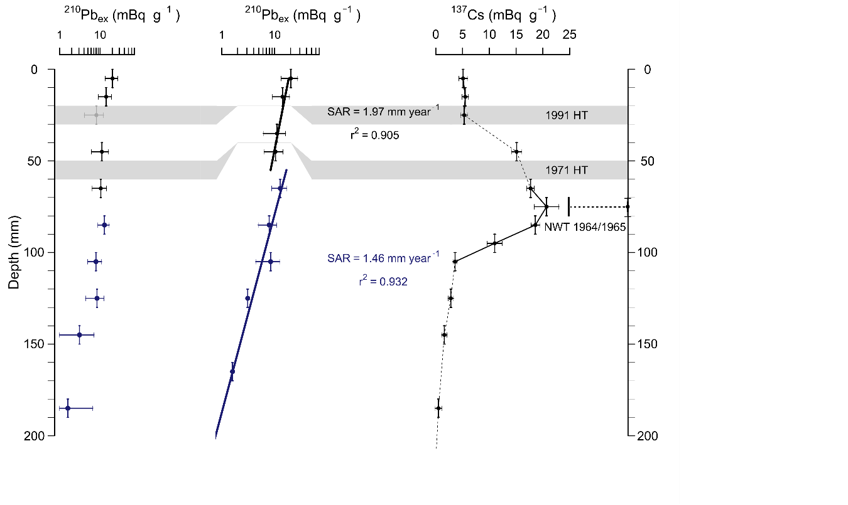
Fig. 2. ²¹⁰Pb and ¹³⁷Cs activity profiles, sediment accumulation rate (SAR) generated with the Serac package (RStudio). HT: Hudson tephra.

The sediment record revealed an exponential decay of ²¹⁰Pb activity with depth, showing two distinct sediment accumulation rates (SAR): 1.97 mm/yr (r² = 0.905) in the upper 30 mm and 1.46 mm/yr (r² = 0.932) in deeper strata (Fig. 2). Deviations from the expected lead decay pattern were associated with deposition of HU1971 and HU1991 tephra layers, which caused detectable dilution of ²¹⁰Pb activity. The chronology was validated by ¹³⁷Cs peak at 7 cm depth corresponding to the period of maximum atmospheric nuclear fallout in the Southern Hemisphere (1964-1965), and two tephra layers chemically correlated to documented eruptions of Hudson Volcano in 1971 and 1991. The ²¹⁰Pb activity profile became undetectable below 20 cm depth, corresponding to an approximate age of ~110 years. Application of the rplum package in RStudio to these data enabled extension of the age model to span 240 years (Fig. 3).
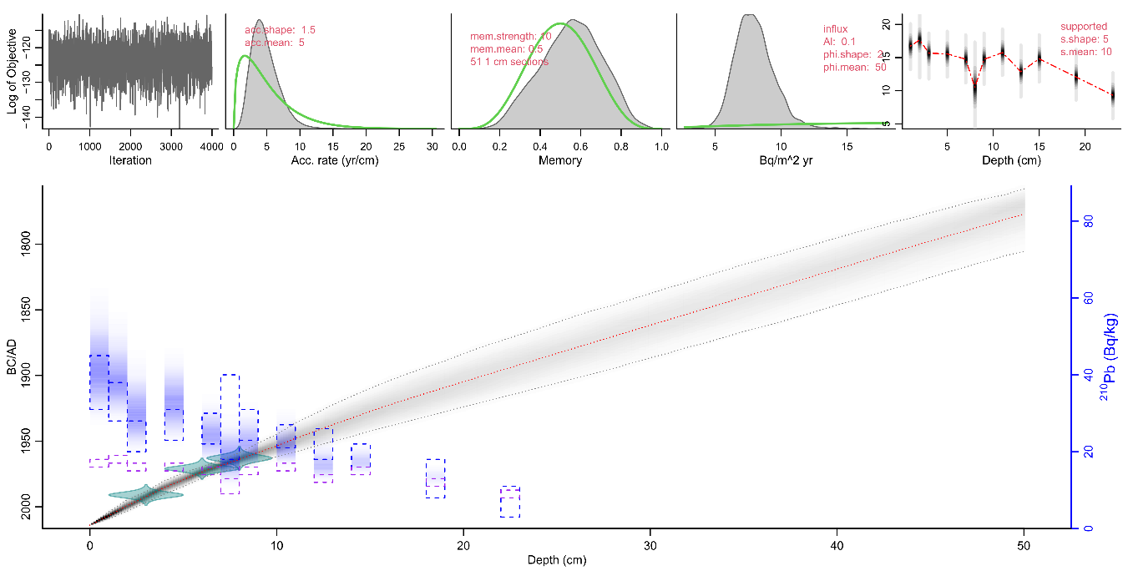
Fig. 3. Chronological model of Lake Maldonado based on ²¹⁰Pb, ²²⁶Ra, ¹³⁷Cs, and tephra data (Hudson eruptions 1971/1991), generated with rplum (Blaauw et al., 2021).
  - Sedimentological parameters
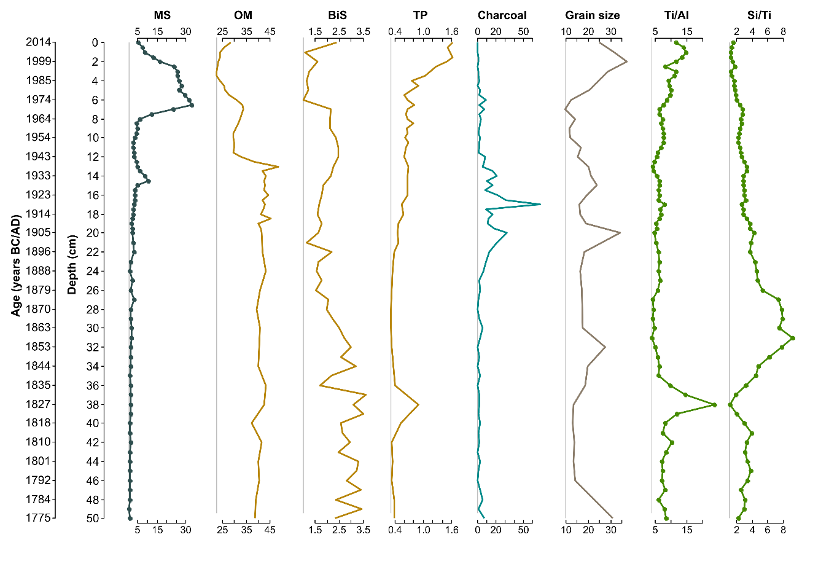
Fig. 4. Stratigraphic profile of Lake Maldonado showing magnetic susceptibility (SI), charcoal particles (particles/cm²/yr), organic matter (% LOI₅₅₀), biogenic silica (mg/L), total phosphorus (mg/g), (Ti/Al) and (Si/Ti) ratios.
The sediment from Lake Maldonado (0–50 cm) provides insights into environmental changes over the last 240 years (1774–2014 CE) through various proxies (Fig. 4). Magnetic susceptibility (MS) shows low and relatively stable values in the lower section of the core, with a gradual increase toward the surface. This increase peaks at 6 cm (~1973 CE) reaching a value of 32.8 SI × 10⁻⁸, suggesting enhanced input of ferromagnetic minerals probably due to a tephra deposition. Organic matter content (% LOI₅₅₀) ranges from 22.6% to 48.4%, with an average of 35.6%, reaching its highest level at 13 cm (~1948 CE), indicating a period of high biological productivity. Biogenic silica (BSi) extractions has an average value of 2.2 mg/L, peaking at 37 cm with a value of 3.6 mg/L , while the lowest values (~1 mg/L) coincide with MS maxima between 7 and 1 cm. Total phosphorus (TP) fluctuates between 0.31 and 1.62 mg/g⁻¹, reaching its highest concentration at 2 cm (~2006 CE), with an earlier peak between 40 and 32 cm (~1818–1853 CE) likely linked to watershed erosion. Charcoal concentrations peak between 24 and 12 cm (~1896–1954 CE), with notable spikes at 20, 17, and 14 cm (~1900s, 1920s, and 1930s, respectively). Mean grain size peaks at 2 cm (~1999 CE) with a size of 37.3 μm at correlated with the MS maximum, suggesting intensified erosion in recent decades. Geochemical ratios also reflect significant changes: Ti/Al reaches its maximum (23.73) at 38 cm (~1827 CE), coinciding with elevated TP levels and indicating increased terrigenous input due to erosion, while Si/Ti records a peaks of 9.21 at 31 cm (~1856 CE), marking a phase of high diatom productivity.
  - Diatoms
Sediment core analysis from Lake Maldonado revealed a diatom assemblage comprising 14 species across 12 genera, with clear dominance of benthic forms (Fig. 5) Cluster analysis using the CONISS method, validated by the broken-stick criterion, identified three significant diatom zones reflecting environmental changes throughout the sedimentary sequence. These shifts in community composition and structure are illustrated in the stratigraphic relative abundance diagram (Fig. 6) and summarized in Table 1.
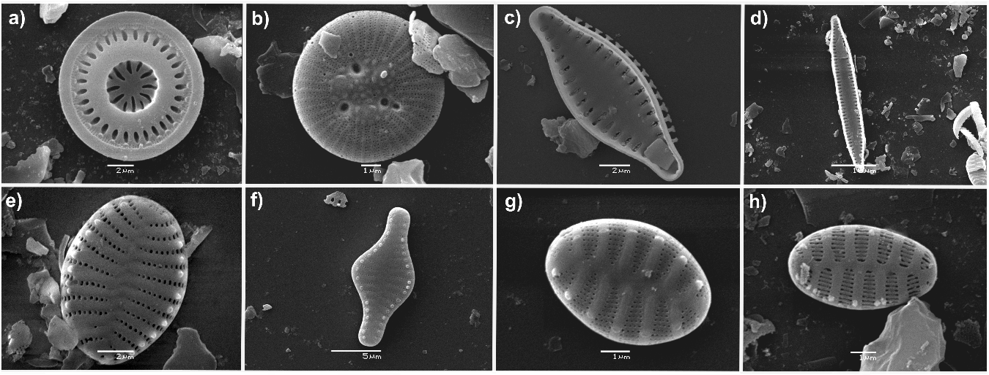
Fig. 5. Micrographs obtained using scanning electron microscopy (SEM). a) Discostella stelligera. (b) Pantocsekiella ocellata. (c-h) Small fragilarioid diatoms. (c-d) Pseudostaurosira brevistriata (in d, a larger morphotype forming chains during the intensification of the westerlies). (e) Staurosira construens var. venter. (f) Staurosira construens. (g) Punctastriata lancettula. (h) Staurosirella neopinnata.
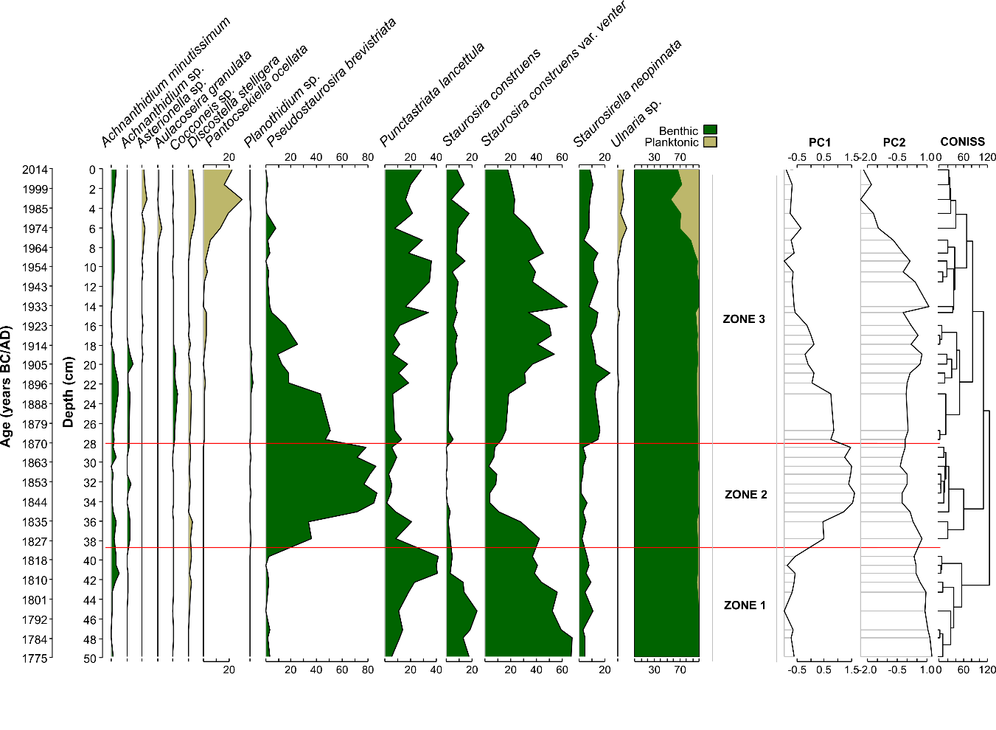Fig. 6. Diatom stratigraphy from Lake Maldonado (riojaPlot/RStudio), showing relative abundances (>2%) of dominant species. Ecological trends reflect environmental changes, supported by PCA (community shifts) and CONISS clustering.

Table 1. Stratigraphic zones of Lake Maldonado based on CONISS analysis: estimated age, representative diatoms, and ecological interpretation.
Depth (cm) | Age (CE) | Main Diatoms | Interpretation
20 - 0 | 1905 - 2013 | The diatom community was dominated by S. construens var. venter. An increase in small planktonic centric diatoms, such as P. ocellata and D. stelligera, was observed. Other taxa included Ulnaria, Asterionella, and Aulacoseira granulata. | Increased abundance of P. lancettula and S. construens var. venter: Associated with post-fire erosional processes in the watershed.Rise in planktonic centric species: Linked to elevated phosphorus availability from watershed erosion following the 1971 and 1991 Hudson volcano eruptions.  A. granulata dominance: Serves as an indicator of eutrophic conditions and high energy environments in the lake.
34 - 20 | 1844 - 1905 | This zone differs from the previous one by showing a marked decrease in benthic fragilarioid diatoms, with the notable exception of P. brevistriata, which reached its peak abundance (%) in the sediment | High abundance of P. brevistriata: Indicates wind intensification, possibly correlated with the Little Ice Age (LIA).  Decline in S. construens var. venter, S. construens, and S. neopinnata: Associated with the transition from mesotrophic to oligotrophic conditions.
50- 34 | 1774 - 1844 | The assemblage was dominated by small fragilarioid species, particularly Staurosira construens var. venter, S. construens, and P. lancettula. | Small fragilarioids thrive in cold environments and are considered generalist species.
  - RDA results
The RDA analysis showed that the abundance and community composition of diatoms varied as a function of climatic (Si/Ti), volcanic (TP, P_{(XRF)}, MS, Ti/Al), and anthropogenic (Bsi, Charcoal, OM) drivers (Fig. 7). The RDA model was highly significant (p < 0.001; R²adj = 0.67), and the first two axes represented 70.7% of the variance in diatoms. RDA1 was positively correlated with the Si/Ti ratio and was therefore associated with a higher relative abundance of P. brevistriata in Zone 2. Meanwhile, RDA2 was related to a higher abundance of Pantocsekiella ocellata and was positively correlated with TP, P_{(XRF)}, MS, and the Ti/Al ratio, and negatively correlated with OM, Bsi, and Charcoal. The variance partitioning analysis indicated that the climatic forcing best explained the diatom community structure at 36%, followed by anthropogenic (12%) and volcanic (9%) drivers, respectively.
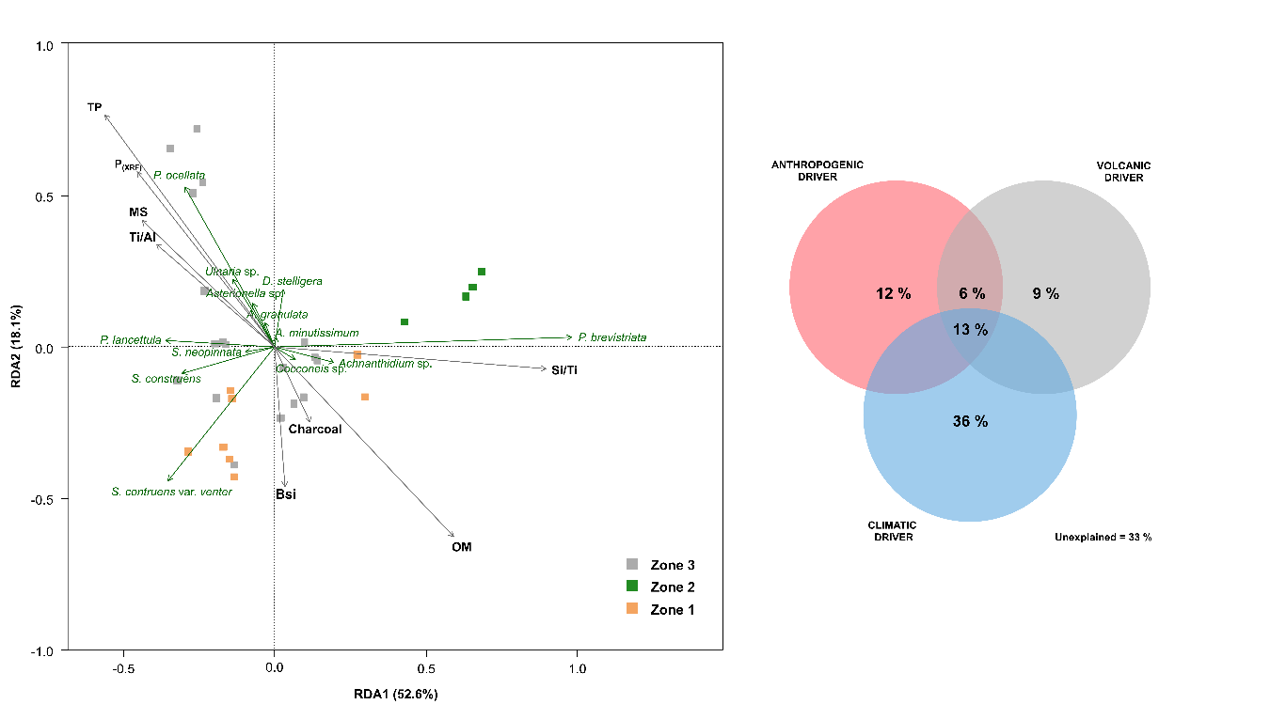
Fig. 7. Redundancy Analysis (RDA) examining relationships between diatom communities and sedimentological variables. The accompanying Venn diagram (right) results from variance partitioning, quantifying the explanatory power (%) of grouped variables as distinct environmental drivers.

  - Tracing fire history through settlers' descendant interviews
Interviews with residents allowed the identification of historical fire events in the study area, which support the data obtained from sedimentological parameters, particularly the charcoal record detected between 1900 and 1970 CE. Table 2 presents relevant data from the fire events documented through oral histories.
Table 2. Historical reconstruction of wildfires (1920-1977) through oral interviews: affected areas, chronology, descriptions, and references.
ID | Affected area | Date | Documentary record | Source (eyewitness accounts)
1 | Sector los Ñadis (Río Baker) | 1953–1955 | Reports massive forest fires: "Smoke clouds lasted for days, the sun turned deep red, and ash fell." | Fresia Jerez, daughter of settlers. San Lorenzo-Cochrane sector interviewed 25-Jan-2013. Originally from Lago Cochrane/Puyredon (Chile-Argentina border). Arrived in the area in 1963.
2 | Sector San Lorenzo - Cochrane | 1960s | Upon arrival (pre-1963): "Everything was burned—standing charred trees and others felled by wind. We piled and burned them to clear land. After preparation, we sowed grass for cattle, later sheep."
3 | Sector Lago Vargas | 1935 – 1940 | "A major fire burned for three summers." | Pedro Muñoz, late settler. Laguna Confluencia-Cochrane sector interviewed 25-Jan-2013. Birthplace unknown.
4 | Sector Laguna Maldonado | ~1950 | "Forest burns were staggered by area and year. Laguna Maldonado was burned around 1950."
5 | Sector Lago Vargas - Cochrane | ~1935 | Fire allegedly started by Reinaldo Sandoval (father): "He lit a cigarette to test flammability on Cerro Petizo." The blaze spread across the Baker River due to wind-carried embers. "The original forest was entirely burned; regrowth is new." Grass was later sown for livestock. | Julia Sandoval F., settler’s daughter. Lago Vargas-Cochrane sector interviewed 17-Jan-2014. From El Maitén, Argentina. Arrived in 1935.
6 | Los Ñadis sector | 1930s | Notes a pre-1935 fire (smaller than the 1935 event) and subsequent fires, including one in 1938.
7(a,b,c) | Los Ñadis-Lago Vargas-San Carlos | 1950s | Recalls other significant fires in the zone.
8 | Los Ñadis sector | 1945 / 1960 | Reports a 1945 fire and witnessed the "last major wildfire" in 1960. | Arturo Arriagada, settler’s son. Los Ñadis-Cochrane sector interviewed 17-Jan-2014. Birthplace unknown.
9 | San Carlos sector | 1949 | Describes large forest fires. | Olga Ganga R., settler’s daughter Los Ñadis – Cochrane sector, 18-01-2014.
10 | San Carlos sector | 1957  (Jan–Feb) | A fire destroyed her brother’s home, killing 4 horses and equipment.
11 | San Carlos sector | 1957 | Upon arrival, the area was "completely burned—livestock grazed on hills now bare of trees." Fire crossed the Baker River, allegedly started by a settler named Muñoz. Luis Ganga Roa lost everything; his family survived by sheltering in a river. | Felicia Mancilla M., settler’s daughter. San Carlos-Cochrane sector interviewed 07-Jan-2015. Born in Cochrane (1939).
12(a,b) | Río Tranquilo sector | ~1948 | At age 12, witnessed a fire that began at Laguna Confluencia (Pedro Muñoz’s land) and spread to Lago Brown: "Flames advanced along mountain slopes for months, reigniting with wind." | Carlos Ibáñez O., settler’s son. Río Tranquilo Valley (Fundo Las Canoas), interviewed 07-Jan-2015. Birthplace unknown.
13 | Río Colonia | 1954 | Recalls "major fires" in the Río Colonia watershed. | Alfonso Quintana E., settler’s son. Cochrane, interviewed 08-Jan-2015.
14* | Cerro El Vazco | 1950 and 1952 | "The entire Cerro El Vazco burned."
15 | San Carlos sector | 1950s | Notes the Sánchez family’s land (Baker River’s west bank) was "fully burned."
16 | Calluqueo sector (Cochrane) | 1920s | Possible fires linked to land clearance by Juan Calluqueo (father). | Ana Calluqueo N., settler’s daughter. Cochrane, interviewed 23-Jan-2016. Likely born in Calluqueo (1929).
17 | Calluqueo sector (Cochrane) | 1940s | Upon arrival (1945), fires had occurred near Calluqueo, possibly coinciding with Carlos Ibáñez’s 1948 account.
18(a,b) | Sector Colonia Norte - Valle grande | 1928–1929; 1932–33 | Two fires: the first in 1928/29; the second (more intense) burned for 6 months, spreading from Río Colonia to Cerro Negro. Motive: land clearance and preventing cattle from going feral. Likely ignited by settler Juan Ayapan. | Neftalí Barros A., settler’s son. Colonia Norte (Piedra Blanca), interviewed 24-Jan-2018. Born in Piedra Blanca (1954).
19 | Lago Brown sector | 1940s | Upon arrival (1942), "the great fires had already occurred," but later witnessed localized burns (possibly the 1948 Río Tranquilo fire). | Alamiro Pizzarro A., settler’s son. Lago Brown-Cochrane interviewed 26-Jan-2016. Born in Río Oro, Argentina (1937).
20 | Baker River’s north bank (Lago Juncal) | 1940s | "The fire burned for 3 months—like a city at night. Smoke blotted out the sun; the stench of burning ñirre Nothofagus antartica was everywhere." | Leoncio Escobar M., settler’s son. Lago Juncal-Cochrane interviewed 26-Jan-2019. Born in Río Oro, Argentina (1932).
21 | Los Ñadis (Río Ñadis) – Los Canelos | 1969 | Her husband (Pablo Pizzaro G., age 15) witnessed a fire that jumped the Río Ñadis near Mizael Maldonado’s land: "The last major fire in the area." | Orfelina Casanova M., settler’s daughter. Lago Vargas-Cochrane interviewed 29-Jan-2019. Born in Laguna Larga (1960).
22 | Los Ñadis (opposite Las Lengas creek) | 1977 | "The hillsides were grasslands—no forest remained; all was burned."
23 | Baker River banks (San Carlos) | 1940–1942 | "The great fires of 1940–42 burned everything." | Cristian Arratia V., settler. Lago Vargas-Cochrane interviewed 31-Jan-2018. Born in Vilcún, Temuco (1939).
24 | Paso las Llaves (San Carlos) | 1954 | At age 15: "The fire where Ganga lost everything, even the ranch’s fence burned."
14*: site location not very precise.
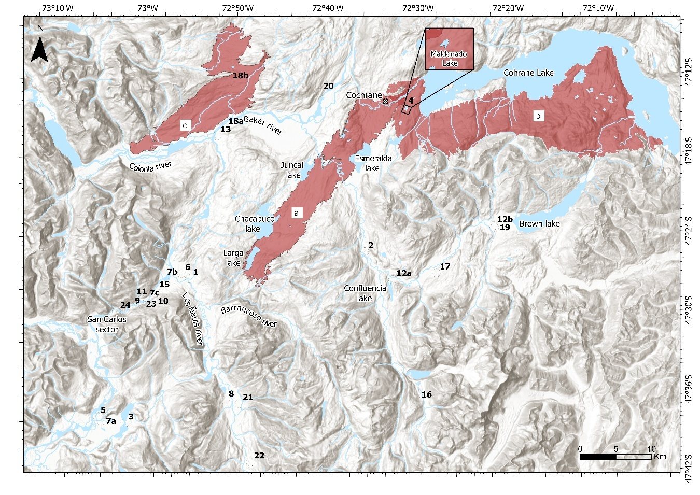
Fig. 8. Spatial distribution of historical fire events in the study area. Fires (a-c) represent reconstructed events from historical records. (a) Fire from Laguna Larga to the Cochrane River (Steffen, 1910). (b) Fire between the Cochrane River and the mouth of the Brown River (Steffen, 1910). (c) Fire in the Colonia River (De Agostini, 1945). Numbered events 1-23 correspond to fires documented through local interviews (Table 2), occurring between 1920 and 1977.
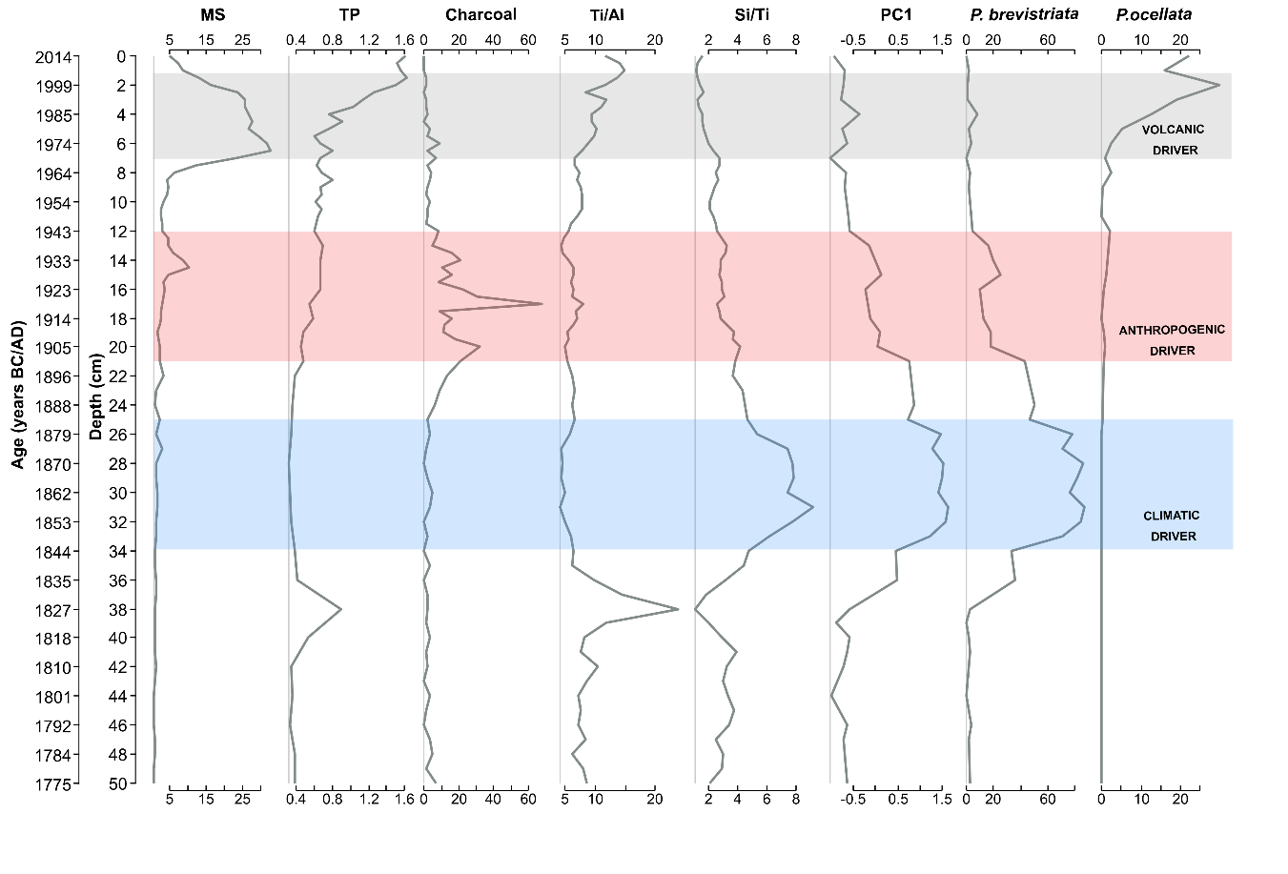Fig. 9. Key variables associated with the three main drivers identified in the sedimentary record: climatic (blue), anthropogenic (red), and volcanic (gray). The diagram summarizes their relative influence on the observed changes in the lake system.

- Discussion
This study reconstructs the environmental history of Lake Maldonado over the past 300 years through a high-resolution, multi-proxy analysis. Our results identify three primary drivers of environmental fluctuations along the sediment sequence, which triggered marked shifts in diatom communities; i) climate variability, expressed in wind intensification, ii) anthropogenic fires and iii) volcanic activity.
  - Climate variability
The diatom community in Lake Maldonado was dominated by small benthic fragilarioids (Fragilaria sensu lato). While these taxa (Staurosira, Pseudostaurosira, Staurosirella, Puntactriata and Pseudostaurosira) exhibit diverse responses to climatic shifts (Podritske & Gajewski, 2007), their autoecological data remain incomplete, complicating ecological interpretations. Nevertheless, studies highlight their potential for paleoenvironmental reconstructions (Finkelstein & Gajewski, 2008; Podritske & Gajewski, 2007; Westover et al., 2006). Stoof-Leichsenring et al. (2014) and Paull et al. (2008) emphasize that reliable paleoenvironmental reconstructions require accurate species level identification of diatoms. Consistent with previous studies (Smol, 1983; Smol & Douglas (2007)), this research successfully employed small fragilarioid taxa as ecological indicators of climate driven changes during the Little Ice Age (LIA). This approach is well-supported by Northern Hemisphere lacustrine studies, particularly in Canadian lakes where these diatom communities have proven to be effective in reconstructing cold environmental conditions (Karst-Riddoch et al., 2005) .
Between 1774 and 1840 CE, the diatom community in Zone 1 (Fig. 6) was characterized by the high dominance of benthic diatoms, particularly S. construens var. venter, S. construens, P. lancettula, and S. neopinnata. These non motile species, adapted to environments with moderate nutrient concentrations (Velez et al., 2021), are competitive under cold conditions (García et al., 2022; Hofmann et al., 2021). According to Cvetkoska et al. (2014), the dominance of benthic species would be associated to a shallow and unstable lacustrine environment, probably under cold and dry climatic conditions, which aligns with the inferred climatic conditions for Lake Maldonado during this period.
Zone 2 was dominated by the diatom P. brevistriata, which reached its highest relative abundances (∼80%) between ∼1840 and 1880 CE. This pattern is supported by the increase in the Si/Ti ratio, where elevated values indicate higher diatom productivity (Rodríguez-Miret et al., 2023; Wienhues et al., 2024). The strong correlation between these variables is evident in the RDA analysis (Fig. 7), where P. brevistriata is closely associated with high Si/Ti values.
In the PCA stratigraphic diagram (Fig. 6), this zone shows a trend toward positive values on PC1, contrasting with the negative values characteristic of Zone 1. This suggests a significant shift in the diatom community structure. The strong correspondence between high P. brevistriata abundances and positive PC1 values indicates that this specie is a key indicator taxon for this axis, contributing significantly to the variance explained by PC1 in Zone 2. The dominance of this species in Zone 2 would reflects intensified wind conditions, as supported by multiple lines of evidence. Strong winds promote nutrient transport, particularly phosphorus to the epilimnion, thereby stimulating primary production (Jennings et al., 2012). Wind-generated turbulence directly alters community composition (Yang et al., 2016; Szczerba et al., 2023), favoring diatoms that become resuspended in the water column under increased wind intensity, adopting planktonic behavior. These conditions particularly benefit species with high sinking rates that rely on turbulence to remain within the photic zone (Kilham et al., 1996; Ptacnik et al., 2003; Pannard et al., 2008; Rühland et al., 2008). P. brevistriata exhibited distinct morphological variations throughout the sedimentary profile. In Zones 1 and 3, it appeared as small, rounded cells (Fig. 5C), while in Zone 2 -characterized by stronger winds and greater turbulence, it primarily occurred as an elongated, larger morphotype that frequently formed chains (Fig. 5D). These morphological changes showing different morphotype, have been recorded for some diatom genus as a response to environmental changes (Manoylov et al., 2009).
  - Recent anthropogenic impact (wildfires)
Between 1905 and 1950 CE, the sedimentary record shows a significant increase in charcoal, coinciding with the spontaneous settlement of Chilean people in Northern Patagonia and the subsequent large-scale forest fires. In contrast to the alterations observed in sedimentological parameters (organic matter, phosphorus, and biogenic silica), the diatom community exhibited some moderate changes. This limited biological response could be attributed to the generalist nature of the dominant species (S. construens, S. neopinnata, and P. lancettula), which can adapt to various trophic ranges. These findings align with studies from other lacustrine systems, where biological responses to fire disturbances appear less pronounced than physicochemical changes, suggesting that each lake's unique hydrological and sedimentary characteristics mediate its ecological response to watershed (Paterson et al., 2002).
The first documented burns in the study area were recorded by geographer Hans Steffen during the summer of 1899 while exploring the region. He observed evidence of an earlier large-scale fire that extended approximately from the Cochrane River to Laguna Larga (Fig. 8A). Based on vegetation regeneration patterns among charred tree trunks, Steffen estimated this major fire event occurred between 1874 and 1879. The author attributed these ancient burns to the nomadic Tehuelche indigenous people (Steffen, 1910).
Indeed, the Tehuelche people used fire as part of an effective communal hunting strategy, driving groups of animals (“Guanaco”; Lama guanicoe and “Ñandú”; Rhea pennata pennata) toward a killing zone. Known as "el chaco", this method was highly efficient. However, due to the ecotone's biogeographical traits, fires often spread uncontrollably, as described by Musters between 1869 and 1870 while living among the Tehuelches (Musters, 1911). Historical records also show that fire was used by the Tehuelche people as a means of communication between different groups across the Patagonian territory (Moreno, 2007a, 2007b). In the eastern sector of the study area, Alamiro Pizarro reported the presence of archaeological sites likely associated with seasonal Tehuelche camps (personal interview, January 26, 2016, Table 1).
During Steffen's aforementioned expedition, a major fire broke out due to carelessness by his team members. Steffen witnessed the fire's progression from February 25 to March 11, 1899. Within days, the blaze engulfed the entire western basin of Lake Cochrane (Fig. 8B), forcing the suspension of geographical survey work due to dense smoke. The fire's rapid spread was fueled by strong westerly winds and the low-growing, resinous vegetation characteristic of the ecotone, with flames reaching up to the treeline. It was estimated to have burned approximately 35 kilometers in a straight line, originating on Lake Cochrane's western shore and extending to the mouth of Lake Brown (Steffen, 1910).
Oral testimonies indicate regional fires were predominantly anthropogenic, intentionally ignited to convert landscapes for crop production (oats, wheat, potatoes) and livestock pastures (primarily cattle and equines, secondarily sheep) (De Agostini, 1945; Oportus, 1928) . According to Neftalí Barros Arratia (see Table 2), burning was conducted to clear fields and prevent livestock from escaping (personal interview, 01-24-2018). The burning process was not random but methodical, requiring multiple stages. Leoncio Escobar detailed that field preparation involved burning 3 or 4 times, first small branches, then fallen logs, and finally the larger charred logs (personal interview, 01-26-2019). This systematic approach reflects accumulated knowledge of fire management techniques, enabling efficient land preparation for agriculture and more effective vegetation control.
Historical records corroborate these findings, as documented by (De Agostini, 1945) during his 1942 summer expedition to the confluence of the Colonia and Baker rivers. He recorded extensive wheat fields cultivated by settler Juan Ayapán, one of the earliest inhabitants of the area. Agostini noted large charred logs within the Ayapán’s crop fields, deducing the site had recently been a native Nothofagus forest prior to its conversion to agricultural use. According to field-collected testimonies, the first recorded fire in the Colonia River Valley occurred in 1928 or 1929 (Fig. 8C). A subsequent major fire took place between 1932 and 1933, notable both for its extensive burned area and prolonged duration (6 months), which was attributed to settler Juan Ayapán (Neftalí Barros, personal interview, January 24, 2018, Table 2).
  - Volcanic activity
The results obtained through sedimentological and biological parameters would indicate the presence of two recent tephra layers. The first located at the 6-centimeter mark and the second at the 3-centimeter mark (Fig. 4). Between these centimeters, high values of magnetic susceptibility were shown compared to the rest of the profile. At the same time, an increase in grain size and total phosphorus content is observed, while a decrease in biogenic silica and organic matter occurred simultaneously (Fig. 4). Those fluctuations marked an ecological change in the diatom community, increasing the abundance of planktonic species, mainly P. ocellata.
Following tephra deposition in Lake Sihailongwan (China), an increase in the P/B ratio (Planktonic/Benthic) was observed, highlighting the increase in species of the genus Pantocsekiella. This change in the diatom community, particularly the predominance of small centric planktonic species, suggests a possible nutrient enrichment in the lake water (Deng et al., 2023). Although less abundant, the presence of the diatom A. granulata in the tephra layer of L. Maldonado (Zone 3), stands out as an indicator of eutrophic, turbid conditions with low light penetration (Cvetkoska et al., 2014; Kilham et al., 1986). Studies such as indicate that volcanic ash provides Si and P for diatoms, which would have favored cyclotelloid and planktonic taxa through a persistent nutrient enrichment (e.g. tephra supply from the watershed).
The tephra fall from August 1991 eruption of Hudson Volcano, affected approximately 100,000 km² of Patagonia, being transported mainly southeastward by the intense prevailing winds during the eruption (Wilson et al., 2011). The identification of these tephras in Lake Maldonado is consistent with this dispersion pattern, as the lake is located about 130 km from Hudson Volcano, a distance that falls within the documented influence radius of volcanic deposits from this eruptive event (Scasso et al., 1994). The stratigraphic record has allowed us to identify not only the layer corresponding to the 1991 eruption but also evidence of previous eruptive events. These findings agree with recent studies demonstrating the preservation of Hudson tephras in nearby environments. For example, a recent study by Streeter et al. (2024) analyzed tephra deposits associated with the 1991 Hudson Volcano eruption collected from nearby lakes and terrestrial environments. Among their findings, they identified a thin tephra layer (0.5 to 1.5 cm thick) located approximately 2 to 3 cm below the deposits corresponding to the 1991 eruption. The researchers suggest this stratum may correspond to the 1971 eruption. Furthermore, this is consistent with both tephras recognized in Lake Jeinimini (Fagel et al., 2021).
In contrast to our results, studies of sediment cores from the same Lake Maldonado by Maldonado et al., (2022) and Stern et al., (2016) only recorded the H1 tephra from Hudson Volcano (0-10 cm depth), associated with an eruption that occurred about 5000 years ago. According to our results, there is no way that the H1 Hudson eruption appeared stored in the first 10 cm of the sediment record. Probably, such differences could result from the distinct locations where the cores were extracted, the techniques used, and errors in radiocarbon dating.
Between 39-36 cm (∼1822-1835 CE), we identified a distinctive sedimentary layer showing variations like tephra deposits. However, this layer is characterized by low magnetic susceptibility (MS), peaks in total phosphorus (TP), and an elevated Ti/Al ratio. This layer was also identified in previously mentioned studies Maldonado et al., (2022) described it as a sandy stratum, while Fagel et al., (2021) identified it as a pluricentimetric mass-wasting deposit between 34-38 cm.
These features suggest the layer may represent increased surface runoff resulting from higher precipitation during a wet phase of the Little Ice Age (LIA). This interpretation is supported by the high Ti/Al values, which according to recent studies (Lim et al., 2023; Ruiz-Fernández et al., 2022) serve as an indicator of intense precipitation events by reflecting increased transport of terrigenous material into the lake. The simultaneous TP peak further support this hypothesis, as runoff facilitates nutrient input from the watershed.
However, it is important to note that the Ti/Al ratio may also reflect eolian inputs (Bezrukova et al., 2023), and both Ti and Al are major components of tephra. Therefore, while the data predominantly suggest a hydrological origin, these interpretations should be made cautiously.
- Conclusions
This study reconstructed the environmental history of Lake Maldonado over the past 300 years, providing a high-resolution temporal record that identified three key periods of change associated to: the Little Ice Age (LIA), wildfires, and volcanic eruptions. The proxies exhibited differential responses to natural and anthropogenic stressors. Notably, the diatom community showed heightened sensitivity to climatic, anthropic and volcanic drivers (in this order), displaying abrupt shifts in relative abundance and species composition.
Our results suggest the occurrence of a two-phase Little Ice Age-type event during the Zones I and II. During the first zone, it is recognized by an increase in the abundance of P. lancettula, together with high values of phosphorus (P) and the Ti/Al ratio. Those changes suggest an increase in terrigenous material into the lake that in turn would have generated some increase in lake productivity, during a more cold and humid LIA conditions. During the zone II an increase in the abundance of P. brevistriata is recorded, likely related to a period of higher turbulence associated with an intensification in the westerlies. Although a westerly intensification is generally linked to increased precipitation, the sediment record of L. Maldonado does not reflect more humid conditions in this phase. This suggests that ecotone lakes may not correlate with the condition of enhanced winds-enhanced precipitation.
In Zone III, anthropogenic wildfires were more clearly reflected in sedimentological parameters, with marked increases in phosphorus, biogenic silica, and macrocharcoal. These changes indicate elevated lake trophic status and altered nutrient cycling, though the diatom community showed less pronounced responses compared to volcanic events, likely due to the generalist nature of some predominant species.
Later in Zone III, the 1971 and 1991 eruptions of Hudson Volcano triggered a significant shift in the diatom community, transitioning from a dominance of tychoplanktonic species to a greater presence of planktonic diatoms such as Pantocsekiella ocellata.
Finally, this study examined the influence of different forcing factors (climatic, anthropogenic and volcanic) on diatom composition and sedimentological parameters in Lake Maldonado. While each factor exerted a distinct impact, their interactions underscore the complexity of ecological responses in lacustrine systems. These results not only enhance our understanding of Patagonian environmental dynamics but also highlight the value of high-resolution paleolimnological studies for monitoring and managing aquatic ecosystems under accelerated global change particularly those located in ecotones, which exhibit heightened sensitivity to both natural and anthropogenic disturbances.
References

Abarzúa, A. M., & Moreno, P. I. (2008). Changing fire regimes in the temperate rainforest region of southern Chile over the last 16,000 yr. Quaternary Research, 69(1), 62-71.
Álvarez-Barra, V., Maldonado, A., de Porras, M. E., Nuevo-Delaunay, A., & Méndez, C. (2024). Postglacial landscape dynamics and fire regimes in west Central Patagonia, Chile (44° S, 72° W): Evidence from the Cisnes River Basin. Quaternary Science Reviews, 332, 108655.
Álvarez-Gayou, J. L. (2003). Cómo hacer investigación cualitativa. Fundamentos y metodología.
Allen, C. D., & Breshears, D. D. (1998). Drought-induced shift of a forest–woodland ecotone: rapid landscape response to climate variation.Proceedings of the National Academy of Sciences, 95(25), 14839-14842.
Aquino-López, M. A., Blaauw, M., Christen, J. A., & Sanderson, N. K. (2018). Bayesian analysis of 210 Pb dating. Journal of Agricultural, Biological and Environmental Statistics, 23(3), 317-333.
Araneda, A., Jana, P., Ortega, C., Torrejón, F., Bertrand, S., Vargas, P., Fagel, N., Alvarez, D., Stehr, A., & Urrutia, R. (2013). Changes in sub-fossil chironomid assemblages in two Northern Patagonian lake systems associated with the occurrence of historical fires. Journal of paleolimnology, 50, 41-56.
Battarbee, R. W. (1988). The use of diatom analysis in archaeology: a review. Journal of Archaeological Science, 15(6), 621-644.
Battarbee, R. W. (2000). Palaeolimnological approaches to climate change, with special regard to the biological record. Quaternary Science Reviews, 19(1-5), 107-124.
Bey, M. Y., & Ector, L. (2013). Atlas des diatomées des cours d’eau de la région Rhône-Alpes. Tome,5, 751-971.
Bertrand, S., Hughen, K., Sepúlveda, J., & Pantoja, S. (2014). Covariabilidad del Holoceno tardío de los ponientes australes y la temperatura superficial del mar en la Patagonia septentrional chilena. Revistas de Ciencias del Cuaternario, 105, 195-208.
Bezrukova, E. V., Amosova, A. A., & Chubarov, V. M. (2023). Geochemical Records of the Late Glacial and Holocene Paleoenvironmental Changes from the Lake Kaskadnoe-1 Sediments (East Sayan Mountains, South Siberia). Minerals, 13(3), 449.
Birks, H. J. B., & Birks, H. H. (1980). Quaternary palaeoecology (p. 289). London: Edward Arnold.
Blaauw, M., Christen, J. A., Aquino-Lopez, M. A., Esquivel-Vazquez, J., Gonzalez, O. M., Belding, T., ... & Karney, C. (2021). rplum: Bayesian age-depth modelling of cores dated by Pb-210. R package version 0.2, 1.
Bonk, A., Słowiński, M., Żarczyński, M., Oliński, P., Kupryjanowicz, M., Fiłoc, M., & Tylmann, W. (2022). Tracking fire activity and post-fire limnological responses using the varved sedimentary sequence of Lake Jaczno, Poland. The Holocene, 32(6), 515-528.
Bolós, M. D. (1992). Manual de Ciencia del Paisaje. Teoría, métodos y aplicaciones. Colección de Geografía, Masson SA, Barcelona.
Bonk, A., Makohonienko, M., & Tylmann, W. (2024). Human-induced fires and land-use change in Lubusz Land (western Poland) derived from Lake Lubińskie sedimentary record. The Holocene, 34(2), 139-148.
Brooks, S. J., Langdon, P. G., & Heiri, O. (2007). The identification and use of Palaearctic Chironomidae larvae in palaeoecology. Quaternary Research Association Technical Guide, (10), i-vi.
Bruel, R., & Sabatier, P. (2020). serac: an R package for ShortlivEd RAdionuclide chronology of recent sediment cores. Journal of Environmental Radioactivity, 225, 106449.
Cardozo, A., Gomes, D. F., da Silva, E. M., Duque, S., Rangel, J. C., Sifeddine, A., Turcq, B., & Albuquerque, A. L. S. (2014). Holocene paleolimnological reconstruction of a high altitude Colombian tropical lake. Palaeogeography, Palaeoclimatology, Palaeoecology, 415, 127-136.
Castri, D. (1988). A new look at ecotones: emerging international projects on landscape boundaries. Biol Int, 1-163.
Clark, J. S. (1988). Particle motion and the theory of charcoal analysis: source area, transport, deposition, and sampling. Quaternary Research, 30(1), 67-80.
Chassiot, L., Chapron, E., Michel, E., Jomelli, V., Favier, V., Verfaillie, D., ... & Van der Putten, N. (2024). Late Holocene record of subantarctic glacier variability in table fjord, Cook ice cap, kerguelen islands. Quaternary Science Reviews, 344, 108980.
Cruces, F., Urrutia, R., Parra, O., Araneda, A., Treutler, H., Bertrand, S., ... & Chirinos, L. (2006). Changes in diatom assemblages in an Andean lake in response to a recent volcanic event. Archiv für Hydrobiologie, 165(1), 23-35.
Cvetkoska, A., Levkov, Z., Reed, J. M., & Wagner, B. (2014). Late glacial to Holocene climate change and human impact in the Mediterranean: the last ca. 17 ka diatom record of Lake Prespa (Macedonia/Albania/Greece). Palaeogeography, Palaeoclimatology, Palaeoecology, 406, 22-32.
De Agostini, A. M. (1945). Andes Patagónicos: Viajes de exploración a la cordillera patagónica austral. tall. Gráf. de G. Kraft.
De La Cruz, S., Welkner, R., Suárez, D., & Quiroz, P. (2004). Geología del area oriental de las hojas Cochrane y Villa O'Higgins, region Aisén del General Carlos Ibáñez del Campo.
De Porras, M. E., Maldonado, A., Abarzúa, A. M., Cárdenas, M. L., Francois, J. P., Martel-Cea, A., Stern, C. R., Méndez, C., & Reyes, O. (2012). Postglacial vegetation, fire and climate dynamics at Central Chilean Patagonia (Lake Shaman, 44 S). Quaternary Science Reviews, 50, 71-85.
Delgado, F., Pritchard, M., Lohman, R., & Naranjo, J. A. (2014). The 2011 Hudson volcano eruption (Southern Andes, Chile): Pre-eruptive inflation and hotspots observed with InSAR and thermal imagery. Bulletin of Volcanology, 76, 1-19.
Deng, Y. N., Rioual, P., Jones, V. J., Sun, C., & Mingram, J. (2023). A palaeoecological study investigating the impacts of multiple tephra depositions on a lacustrine ecosystem in Northeast China, using diatoms as environmental indicators. Journal of paleolimnology, 70(1), 1-22.
Desjardins, E., Barker, G., Lindo, Z., Dieleman, C., & Dussault, A. C. (2015). Promoting resilience. The Quarterly review of biology, 90(2), 147-165
de Souza Cardoso, L., & da Motta Marques, D. (2009). Hydrodynamics-driven plankton community in a shallow lake. Aquatic ecology, 43, 73-84.
Egan, J., Fletcher, W. J., & Allott, T. E. (2022). Diatom-inferred centennial-millennial postglacial climate change in the Pacific Northwest of North America. Journal of Paleolimnology, 68(2), 231-248.
Fagel, N., Pedreros, P., Alvarez, D., Tylmann, W., Namur, O., Da Silva, A., Jana, P., Araneda, A., Billy, I., & Schmidt, S. (2021). Last millennium climate variability of the varved Lake Jeinimeni geochemical record from NE Chilean Patagonia. Quaternary Science Reviews, 269, 107134.
Fagel, N., Pedreros, P., Alvarez, D., Israde Alcantara, I., Vega Alay, I., Namur, O., Araneda, A., Schmidt, S., Lepoint, G., & Urrutia, R. (2023). Volcanic, tectonic and climate controls on lacustrine sedimentary supplies over the last millenia in NE Chilean Patagonia (Lake Esponja, Aysen, 45° S). The Holocene, 33(5), 518-535.
Fang, Y., Yang, X., Zhao, Y., Li, Y., Ma, C., Chen, B., & Bunting, M. J. (2025). Assessing the suitability of pollen dispersal and deposition model: A model-empirical data comparison study in the spruce (Picea schrenkiana) forest edge of Tian Shan Mountains, northwestern China. Quaternary Science Reviews, 350, 109151.
Finkelstein, S. A., & Gajewski, K. (2008). Responses of Fragilarioid-dominated diatom assemblages in a small Arctic lake to Holocene climatic changes, Russell Island, Nunavut, Canada. Journal of paleolimnology, 40, 1079-1095.
Fletcher, M.-S., & Moreno, P. I. (2012). Have the Southern Westerlies changed in a zonally symmetric manner over the last 14,000 years? A hemisphere-wide take on a controversial problem. Quaternary International, 253, 32-46.
Fogerty, J. E. (2001). Oral history: a guide to its creation and use. The historical ecology handbook: A restorationist’s guide to reference ecosystems, 101-120.
Gajardo, R. (1995). La vegetación natural de Chile: clasificación y distribución geográfica. Editorial Universitaria Santiago, Chile.
García, M. L., Birlo, S., & Zolitschka, B. (2022). Paleoenvironmental changes of the last 16,000 years based on diatom and geochemical stratigraphies from the varved sediment of Holzmaar (West-Eifel Volcanic Field, Germany). Quaternary Science Reviews, 293, 107691.
Garreaud, R. D. (2009). The Andes climate and weather. Advances in geosciences, 22, 3-11.
Garreaud, R., López, P., Minvielle, M., & Rojas, M. (2013). Large-scale control on the Patagonian climate. Journal of Climate, 26(1), 215-230.
Gilli, A., Ariztegui, D., Anselmetti, F. S., McKenzie, J. A., Markgraf, V., Hajdas, I., & McCulloch, R. D. (2005). Mid-Holocene strengthening of the southern westerlies in South America—sedimentological evidences from Lago Cardiel, Argentina (49 S). Global and Planetary Change, 49(1-2), 75-93.
Gregory-Eaves, I., & Smol, J. P. (2024). Paleolimnology: Approaches and applications. In Wetzel's limnology (pp. 1015-1043). Elsevier.
Gutiérrez, F., Gioncada, A., Ferran, O. G., Lahsen, A., & Mazzuoli, R. (2005). The Hudson Volcano and surrounding monogenetic centres (Chilean Patagonia): An example of volcanism associated with ridge–trench collision environment. Journal of Volcanology and Geothermal Research, 145(3-4), 207-233.
Heiri, O., Lotter, A. F., & Lemcke, G. (2001). Loss on ignition as a method for estimating organic and carbonate content in sediments: reproducibility and comparability of results. Journal of paleolimnology, 25, 101-110.
Hickman, M., & Reasoner, M. A. (1994). Diatom responses to late Quaternary vegetation and climate change, and to deposition of two tephras in an alpine and a sub-alpine lake in Yoho National Park, British Columbia. Journal of paleolimnology, 11, 173-188.
Hofmann, A. M., Kuefner, W., Mayr, C., Dubois, N., Geist, J., & Raeder, U. (2021). Unravelling climate change impacts from other anthropogenic influences in a subalpine lake: a multi-proxy sediment study from Oberer Soiernsee (Northern Alps, Germany). Hydrobiologia, 848(18), 4285-4309.
Huisman, J., Arrayás, M., Ebert, U., & Sommeijer, B. (2002). How do sinking phytoplankton species manage to persist?. The American Naturalist, 159(3), 245-254.
Iglesias, V., Whitlock, C., Markgraf, V., & Bianchi, M. M. (2014). Postglacial history of the Patagonian forest/steppe ecotone (41–43 S). Quaternary Science Reviews, 94, 120-135.
Iglesias, V., Haberle, S. G., Holz, A., & Whitlock, C. (2018). Holocene dynamics of temperate rainforests in west-central patagonia. Frontiers in Ecology and Evolution, 5, 177.
Jackson, M. L. (2005). Soil chemical analysis: advanced course: a manual of methods useful for instruction and research in soil chemistry, physical chemistry of soils, soil fertility, and soil genesis. UW-Madison Libraries parallel press.
Janesick, V. J. (1999). A journal about journal writing as a qualitative research technique: History, issues, and reflections. Qualitative inquiry, 5(4), 505-524.
Jennings, E., Jones, S., Arvola, L., Staehr, P. A., Gaiser, E., Jones, I. D., ... & de Eyto, E. (2012). Episodic events in lakes: an analysis of drivers, effects, and responses using high frequency data. Freshwater Biol, 57, 589-601.
Juggins, S. (2022). riojaPlot: Stratigraphic diagrams in R, package version (0.1-20).
Karst-Riddoch, T. L., Pisaric, M. F., & Smol, J. P. (2005). Diatom responses to 20th century climate-related environmental changes in high-elevation mountain lakes of the northern Canadian Cordillera. Journal of paleolimnology, 33, 265-282.
Kilham, P., Kilham, S. S., & Hecky, R. E. (1986). Hypothesized resource relationships among African planktonic diatoms. Limnology and Oceanography, 31(6), 1169-1181.
Kilham, S. S., Theriot, E. C., & Fritz, S. C. (1996). Linking planktonic diatoms and climate change in the large lakes of the Yellowstone ecosystem using resource theory. Limnology and Oceanography, 41(5), 1052-1062.
Kilian, R., & Lamy, F. (2012). A review of Glacial and Holocene paleoclimate records from southernmost Patagonia (49–55 S). Quaternary Science Reviews, 53, 1-23.
Kitzberger, T. (2012). Ecotones as complex arenas of disturbance, climate, and human impacts: the trans-Andean forest-steppe ecotone of northern Patagonia. In Ecotones between forest and grassland (pp. 59-88). New York, NY: Springer New York.
Koffman, B. G., Goldstein, S. L., Winckler, G., Kaplan, M. R., Bolge, L., & Biscaye, P. (2023). Abrupt Changes in Atmospheric Circulation During the Medieval Climate Anomaly and Little Ice Age Recorded by Sr‐Nd Isotopes in the Siple Dome Ice Core, Antarctica. Paleoceanography and Paleoclimatology, 38(4), e2022PA004543.
Kratzmann, D. J., Carey, S., Scasso, R. A., & Naranjo, J.-A. (2010). Role of cryptic amphibole crystallization in magma differentiation at Hudson volcano, Southern Volcanic Zone, Chile. Contributions to Mineralogy and Petrology, 159, 237-264.
Kuha, J., Arvola, L., Hanson, P. C., Huotari, J., Huttula, T., Juntunen, J., ... & Karjalainen, J. (2016). Response of boreal lakes to episodic weather-induced events. Inland waters, 6(4), 523-534
Lamy, F., Kilian, R., Arz, H. W., Francois, J. P., Kaiser, J., Prange, M., & Steinke, T. (2010). Holocene changes in the position and intensity of the southern westerly wind belt. Nature Geoscience, 3(10), 695-699.
Lange-Bertalot, H. (2013). Diatomeen im Süßwasser-Benthos von Mitteleuropa: Bestimmungsflora Kieselalgen für die ökologische Praxis: Über 700 der häufigsten Arten und ihre Ökologie.
Lavoie, I., P. Hamilton, S. Campeau, M. Grenier & P. Dillon. 2008. Guide d’ identification des Diatomées des rivières de l’ Est du Canada. Presses de l’ Université du Quebec, Canada. 241 pp.
Lim, J., Kim, Y., Park, S., & San Ahn, U. (2023). Testing heavy rainfall change in Jeju Island, Korea and its linkage to typhoon activity over East Asia during the Holocene. Palaeogeography, Palaeoclimatology, Palaeoecology, 627, 111715.
Maldonado, A., de Porras, M. E., Martel-Cea, A., Reyes, O., Nuevo-Delaunay, A., & Méndez, C. (2022). Holocene environmental dynamics of the lago Cochrane/Pueyrredón valley, Central West Patagonia (47 S). Frontiers in Earth Science, 10, 833637.
Manoylov, K. M., Ognjanova-Rumenova, N., & Stevenson, R. J. (2009). Morphotype variations in subfossil diatom species of Aulacoseira in 24 Michigan Lakes, USA. Acta Botanica Croatica, 68(2), 401-419.
Mansilla, C. A., McCulloch, R. D., & Morello, F. (2018). The vulnerability of the Nothofagus forest-steppe ecotone to climate change: Palaeoecological evidence from Tierra del Fuego (~ 53 S). Palaeogeography, Palaeoclimatology, Palaeoecology, 508, 59-70.
Markgraf, V., Whitlock, C., & Haberle, S. (2007). Vegetation and fire history during the last 18,000 cal yr BP in Southern Patagonia: Mallín Pollux, Coyhaique, Province Aisén (45 41′ 30 ″S, 71 50′ 30 ″W, 640 m elevation). Palaeogeography, Palaeoclimatology, Palaeoecology, 254(3-4), 492-507.
Martel‐Cea, A., Abarzúa, A. M., González, M. E., Jarpa, L., & Hernández, M. (2024). Fire–climate–human dynamics over the last 1800 years in the mesic Araucaria‐Nothofagus forests. Journal of Biogeography, 51(8), 1490-1504.
Martinic, M. (2005). De la Trapananda al Aysén. Santiago: Pehuén.
Martinic, M., A. Prieto, M. Arroyo y R. Cárdenas. (2011). Río Verde: Su historia y su gente. Punta Arenas: Municipalidad de Río Verde.
Mayr, C., Lücke, A., Wagner, S., Wissel, H., Ohlendorf, C., Haberzettl, T., Oehlerich, M., Schäbitz, F., Wille, M., & Zhu, J. (2013). Intensified Southern Hemisphere Westerlies regulated atmospheric CO2 during the last deglaciation. Geology, 41(8), 831-834.
McCulloch, R. D., Mansilla, C. A., Roberts, S. J., & Tisdall, E. W. (2023). Late Quaternary climatic inferences from southern Patagonia (∼ 53° S): A holistic palaeoecological approach to tracking the behaviour of the southern westerly winds. Palaeogeography, Palaeoclimatology, Palaeoecology, 631, 111822.
Méndez, C., De Porras, M. E., Maldonado, A., Reyes, O., Nuevo Delaunay, A., & García, J.-L. (2016). Human effects in Holocene fire dynamics of central western Patagonia (~ 44 S, Chile). Frontiers in Ecology and Evolution, 4, 100.
Moody, J. A., Shakesby, R. A., Robichaud, P. R., Cannon, S. H., & Martin, D. A. (2013). Current research issues related to post-wildfire runoff and erosion processes. Earth-science reviews, 122, 10-37.
Meyer, E., & de Bonfil, A. O. (1971). La historia oral. Origen, metodología, desarrollo y perspectivas. Historia mexicana, 21(2), 372-387.
Moreno, F. P. (2007a). Exploración de la Patagonia sur: El lago Argentino y los Andes meridionales (1877) (Vol. 2). Continente.
Moreno, F. P. (2007b). Exploración de la Patagonia sur: Por las cuencas del Chubut y el Santa Cruz (1876-1877) (Vol. 1). Continente.
Moreno, P. I., Francois, J. P., Moy, C. M., & Villa-Martínez, R. (2010). Covariability of the Southern Westerlies and atmospheric CO2 during the Holocene. Geology, 38(8), 727-730.
Moreno-Gonzalez, R., Giesecke, T., & Fontana, S. L. (2021). Fire and vegetation dynamics of endangered Araucaria araucana communities in the forest-steppe ecotone of northern Patagonia. Palaeogeography, Palaeoclimatology, Palaeoecology, 567, 110276.
Moreno-Ostos, E., Cruz-Pizarro, L., Basanta, A., & George, D. G. (2009). The influence of wind-induced mixing on the vertical distribution of buoyant and sinking phytoplankton species. Aquatic ecology, 43, 271-284.
Mortlock, R. A., & Froelich, P. N. (1989). A simple method for the rapid determination of biogenic opal in pelagic marine sediments. Deep Sea Research Part A. Oceanographic Research Papers, 36(9), 1415-1426.
Moy, C. M., Dunbar, R. B., Moreno, P. I., Francois, J.-P., Villa-Martínez, R., Mucciarone, D. M., Guilderson, T. P., & Garreaud, R. D. (2008). Isotopic evidence for hydrologic change related to the westerlies in SW Patagonia, Chile, during the last millennium. Quaternary Science Reviews, 27(13-14), 1335-1349.
Mundo, I. A., Villalba, R., Veblen, T. T., Kitzberger, T., Holz, A., Paritsis, J., & Ripalta, A. (2017). Fire history in southern Patagonia: human and climate influences on fire activity in Nothofagus pumilio forests. Ecosphere, 8(9), e01932.
Musters, G. (1911). Vida entre los patagones (1871). Buenos Aires: Biblioteca de la Universidad de La Plata.
Myster, R. W. (Ed.). (2012). Ecotones between forest and grassland. Springer Science & Business Media.
Nanavati, W. P., Whitlock, C., Iglesias, V., & de Porras, M. E. (2019). Postglacial vegetation, fire, and climate history along the eastern Andes, Argentina and Chile (lat. 41–55 S). Quaternary Science Reviews, 207, 145-160.
Nanavati, W., Whitlock, C., Outes, V., & Villarosa, G. (2021). A Holocene history of monkey puzzle tree (pehuén) in northernmost Patagonia. Journal of Biogeography, 48(4), 833-846.
Naranjo, J. A. (1993). La erupcion del volcan Hudson en 1991 (46 ゜ S), Region XI, Aisen, Chile. Servicio Nacional de Geologia y Minera Boletin, 44, 1-50.
Naranjo, J. A., & Stern, C. R. (1998). Holocene explosive activity of Hudson Volcano, southern Andes. Bulletin of Volcanology, 59, 291-306.
Neilson, R. P. (1993). Transient ecotone response to climatic change: some conceptual and modelling approaches. Ecological applications, 3(3), 385-395.
Oddi, F. J., & Ghermandi, L. (2016). Fire regime from 1973 to 2011 in north-western Patagonian grasslands. International Journal of Wildland Fire, 25(9), 922-932.
Oksanen, J., Blanchet, F. G., Kindt, R., Legendre, P., Minchin, P. R., O’hara, R. B., ... & Oksanen, M. J. (2013). Package ‘vegan’. Community ecology package, version, 2(9), 1-295
Ongun Sevindik, T., Erdoğan, M., Tunca, H., Güzel, U., & Erturaç, M. K. (2022). The effects of inter-annual fluctuations in precipitation, lake surface area, and wind speed on phytoplankton structure in three shallow Mediterranean lakes (Sakarya, Turkey). Aquatic Ecology, 56(3), 697-718.
Oportus, C. (1928). Informe sobre el problema de colonización de la zona del río Baker. Departamento de Tierras y Colonización, Ministerio de Fomento, Santiago de Chile.
Orihashi, Y., Naranjo, J. A., Motoki, A., Sumino, H., Hirata, D., Anma, R., & Nagao, K. (2004). Quaternary volcanic activity of Hudson and Lautaro volcanoes, Chilean Patagonia: New constraints from K-Ar ages. Revista geológica de Chile, 31(2), 207-224.
Pannard, A., Bormans, M., & Lagadeuc, Y. (2008). Phytoplankton species turnover controlled by physical forcing at different time scales. Canadian Journal of Fisheries and Aquatic Sciences, 65(1), 47-60.
Paterson, A. M., Morimoto, D. S., Cumming, B. F., Smol, J. P., & Szeicz, J. M. (2002). A paleolimnological investigation of the effects of forest fire on lake water quality in northwestern Ontario over the past ca. 150 years. Canadian Journal of Botany, 80(12), 1329-1336.
Paull, T. M., Hamilton, P. B., Gajewski, K., & LeBlanc, M. (2008). Numerical analysis of small Arctic diatoms (Bacillariophyceae) representing the Staurosira and Staurosirella species complexes. Phycologia, 47(2), 213-224.
Peel, M. C., Finlayson, B. L., & McMahon, T. A. (2007). Updated world map of the Köppen-Geiger climate classification. Hydrology and earth system sciences, 11(5), 1633-1644.
Perren, B. B., Kaiser, J., Arz, H. W., Dellwig, O., Hodgson, D. A., & Lamy, F. (2025). Poleward displacement of the Southern Hemisphere Westerlies in response to Early Holocene warming. Communications Earth & Environment, 6(1), 164.
Peters, M. E., & Higuera, P. E. (2007). Quantifying the source area of macroscopic charcoal with a particle dispersal model. Quaternary Research, 67(2), 304-310.
Podritske, B., & Gajewski, K. (2007). Diatom community response to multiple scales of Holocene climate variability in a small lake on Victoria Island, NWT, Canada. Quaternary Science Reviews, 26(25-28), 3179-3196.
Ptacnik, R., Diehl, S., & Berger, S. (2003). Performance of sinking and nonsinking phytoplankton taxa in a gradient of mixing depths. Limnology and Oceanography, 48(5), 1903-1912.
Quintanilla, V. (2008). Estado de recuperación del bosque nativo en una cuenca nordpatagónica de Chile, perturbada por grandes fuegos acaecidos 50 años atrás (44º-45º S). Revista de Geografía Norte Grande(39), 73-92.
Rivera, P., Parra, O., González, M., Dellarossa, V., & Orellana, M. (1982). Manual Taxonómico del fitoplancton de aguas continentales. Editorial Universidad de Concepción, Concepción, 97.
Robertson, H. A., & McGee, T. K. (2003). Applying local knowledge: the contribution of oral history to wetland rehabilitation at Kanyapella Basin, Australia. Journal of environmental management, 69(3), 275-287.
Rodríguez-Miret, X., del Carmen Trapote, M., Sigró, J., & Vegas-Vilarrúbia, T. (2023). Diatom responses to warming, heavy rains and human impact in a Mediterranean lake since the preindustrial period. Science of the Total Environment, 884, 163685.
Round, F. E., Crawford, R. M., & Mann, D. G. (1990). Diatoms: biology and morphology of the genera. Cambridge university press.
Rothkugel, M. (1916). Los bosques patagónicos. Ministerio de Agricultura.
Rühland, K., Paterson, A. M., & Smol, J. P. (2008). Hemispheric‐scale patterns of climate‐related shifts in planktonic diatoms from North American and European lakes. Global Change Biology, 14(11), 2740-2754.
Ruiz-Fernández, A. C., Sanchez-Cabeza, J. A., Blaauw, M., Pérez-Bernal, L., Cardoso-Mohedano, J., Aquino-López, M., Keaveney, E., & Giralt, S. (2022). Historical reconstruction of sediment accumulation rates as an indicator of global change impacts in a tropical crater lake. Journal of paleolimnology, 68(4), 395-413.
Scasso, R. A., Corbella, H., & Tiberi, P. (1994). Sedimentological analysis of the tephra from the 12–15 August 1991 eruption of Hudson volcano. Bulletin of Volcanology, 56, 121-132.
Schimpf, D., Kilian, R., Kronz, A., Simon, K., Spötl, C., Wörner, G., Deininger, M., & Mangini, A. (2011). The significance of chemical, isotopic, and detrital components in three coeval stalagmites from the superhumid southernmost Andes (53 S) as high-resolution palaeo-climate proxies. Quaternary Science Reviews, 30(3-4), 443-459.
Shumilovskikh, L. S., Novenko, E., & Giesecke, T. (2018). Long‐term dynamics of the East European forest‐steppe ecotone. Journal of Vegetation Science, 29(3), 416-426.
Smol, J. P. (1983). Paleophycology of a high arctic lake near Cape Herschel, Ellesmere Island. Canadian Journal of Botany, 61(8), 2195-2204.
Smol, J. P., & Douglas, M. S. (2007). From controversy to consensus: making the case for recent climate change in the Arctic using lake sediments. Frontiers in Ecology and the Environment, 5(9), 466-474
Smol, J. P., & Stoermer, E. F. (Eds.). (2010). The diatoms: applications for the environmental and earth sciences. Cambridge University Press.
Spoth, M., Hall, B., Lowell, T., Diefendorf, A. F., Corcoran, M. C., & Brickle, P. (2023). Tracking the southern hemisphere westerlies during and since the last glacial maximum with multiproxy lake records from the Falkland Islands (52 S). Quaternary Science Reviews, 311, 108135.
Steffen, H. (1910). Viajes de esploracion i estudio en la Patagonia Occidental, 1892-1902 (Vol. 2). Impr. Cervantes.
Stern, C. R. (2004). Active Andean volcanism: its geologic and tectonic setting. Revista geológica de Chile, 31(2), 161-206.
Stoof-Leichsenring, K. R., Bernhardt, N., Pestryakova, L. A., Epp, L. S., Herzschuh, U., & Tiedemann, R. (2014). A combined paleolimnological/genetic analysis of diatoms reveals divergent evolutionary lineages of Staurosira and Staurosirella (Bacillariophyta) in Siberian lake sediments along a latitudinal transect. Journal of paleolimnology, 52, 77-93.
Streeter, R. T., Cutler, N. A., Lawson, I. T., Hutchison, W., Dominguez, L., & Hiles, W. (2024). Variable preservation of the 1991 Hudson tephra in small lakes and on land. Frontiers in Earth Science, 12, 1433960.
Szczerba, A., Rzodkiewicz, M., & Tylmann, W. (2023). Modern diatom assemblages and their association with meteorological conditions in two lakes in northeastern Poland. Ecological Indicators, 147, 110028.
Tamhane, J., Thomas, Z. A., Cadd, H., Harris, M. R., Turney, C., Marjo, C. E., ... y Brickle, P. (2023). Intensificación de los vientos del oeste en el hemisferio sur durante el Holoceno medio e implicaciones para la dinámica climática regional. Revistas de Ciencias del Cuaternario, 305, 108007.
Telford, R. J., Barker, P., Metcalfe, S., & Newton, A. (2004). Lacustrine responses to tephra deposition: examples from Mexico. Quaternary Science Reviews, 23(23-24), 2337-2353.
Toggweiler, J. R., Russell, J. L., & Carson, S. R. (2006). Midlatitude westerlies, atmospheric CO2, and climate change during the ice ages. Paleoceanography, 21(2).
Vachula, R. S., Russell, J. M., & Huang, Y. (2019). Climate exceeded human management as the dominant control of fire at the regional scale in California’s Sierra Nevada. Environmental Research Letters, 14(10), 104011.
Varela, J. G., Scogin, F. R., & Vipperman, R. K. (1999). Development and preliminary validation of a semi‐structured interview for the screening of law enforcement candidates. Behavioral Sciences & the Law, 17(4), 467-481.
Velez, M. I., Salgado, J., Brenner, M., Hooghiemstra, H., Escobar, J., Boom, A., Bird, B., Curtis, J. H., Temoltzin-Loranca, Y., & Patino, L. F. (2021). Novel responses of diatoms in neotropical mountain lakes to indigenous and post-European occupation. Anthropocene, 34, 100294.
Villa-Martínez, R., Moreno, P. I., & Valenzuela, M. A. (2012). Deglacial and postglacial vegetation changes on the eastern slopes of the central Patagonian Andes (47 S). Quaternary Science Reviews, 32, 86-99.
Wang, L., Lu, H., Liu, J., Gu, Z., Mingram, J., Chu, G., ... & Liu, T. (2008). Diatom‐based inference of variations in the strength of Asian winter monsoon winds between 17,500 and 6000 calendar years BP. Journal of Geophysical Research: Atmospheres, 113(D21).
Waters, M. N., Smoak, J. M., & Vachula, R. S. (2023). Linking prescribed fire, nutrient deposition and cyanobacteria dominance through pyroeutrophication in a subtropical lake ecosystem from the mid Holocene to present. Anthropocene, 44, 100420.
Weller, D., Miranda, C., Moreno, P., Villa-Martínez, R., & Stern, C. (2014). The large late-glacial Ho eruption of the Hudson volcano, southern Chile. Bulletin of Volcanology, 76, 1-18.
Westover, K. S., Fritz, S. C., Blyakharchuk, T. A., & Wright, H. E. (2006). Diatom paleolimnological record of Holocene climatic and environmental change in the Altai Mountains, Siberia. Journal of paleolimnology, 35, 519-541.
Whitlock, C. (2001). Variations in Holocene fire frequency: a view from the western United States. Biology and Environment: Proceedings of the Royal Irish Academy,
Wienhues, G., Lami, A., Bernasconi, S., Jaggi, M., Morlock, M. A., Vogel, H., Cohen, A. S., Mustaphi, C. J. C., Heiri, O., & King, L. (2024). Latest pleistocene and holocene primary producer communities and hydroclimate in Lake Victoria, eastern Africa. Quaternary Science Reviews, 330, 108599.
Wilson, T., Cole, J., Stewart, C., Cronin, S., & Johnston, D. (2011). Ash storms: impacts of wind-remobilised volcanic ash on rural communities and agriculture following the 1991 Hudson eruption, southern Patagonia, Chile. Bulletin of Volcanology, 73, 223-239.
Yang, Y., Colom, W., Pierson, D., & Pettersson, K. (2016). Water column stability and summer phytoplankton dynamics in a temperate lake (Lake Erken, Sweden). Inland waters, 6(4), 499-508.
Zaret, K., & Holz, A. (2024). Exploration of large-scale vegetation transition in wet ecosystems: a comparison of conifer seedling abundance across burned vs. unburned forest-peatland ecotones in Western Patagonia. Frontiers in Forests and Global Change, 7, 1385506.
Zimmermann, C., Jouve, G., Pienitz, R., Francus, P., & Maidana, N. I. (2015). Late Glacial and Early Holocene cyclic changes in paleowind conditions and lake levels inferred from diatom assemblage shifts in Laguna Potrok Aike sediments (southern Patagonia, Argentina). Palaeogeography, Palaeoclimatology, Palaeoecology, 427, 20-31.
Zolitschka, B., Fey, M., Janssen, S., Maidana, N. I., Mayr, C., Wulf, S., ... & Schäbitz, F. (2019). Southern Hemispheric westerlies control sedimentary processes of Laguna Azul (south-eastern Patagonia, Argentina). The Holocene, 29(3), 403-420.

