Ch 11 The STICS soil-crop model: a generic model to simulate the functioning of agroecosystems

Benjamin Dumont, ULiege – Gembloux Agro-Bio Tech & UMR Transfrontalière BioEcoAgro, TERRA Centre, Plant Sciences Axis, Belgium;
Marie-Odile Bancal, Université Paris-Saclay, INRAE, AgroParisTech, UMR EcoSys, France;
Nicolas Beaudoin, INRAE, UMR Transfrontalière BioEcoAgro, France;
Samuel Buis, INRAE, Avignon Université, UMR EMMAH, France;
Julie Caubel, EcoClimaSol, France/INRAE, US Agroclim, France;
Hugues Clivot, Université de Reims Champagne-Ardenne, INRAE, FARE, UMR A 614, France;
Julie Constantin, Université de Toulouse, INRAE, UMR AGIR, France;
Antoine Couëdel, CIRAD, Univ Montpellier, UPR AIDA, France;
Mathilde de Freitas, CIRAD, Univ Montpellier, UPR AIDA, France;
Mathieu Delandmeter, ULiege – Gembloux Agro-Bio Tech & UMR Transfrontalière BioEcoAgro, TERRA Centre, Plant Sciences Axis, Belgium;
Audrey Deheinzelin, INRAE, US Agroclim, France;
Gatien N. Falconnier, CIRAD, Univ Montpellier, UPR AIDA, France/ CIRAD, UPR AIDA, Zimbabwe/ International Maize and Wheat Improvement Centre (CIMMYT), Zimbabwe/ University of Zimbabwe, Zimbabwe;
Fabien Ferchaud, UMR Eco&Sols, Univ Montpellier, CIRAD, INRAE, IRD, Institut Agro Montpellier, France;
Iñaki García de Cortázar-Atauri, INRAE, US Agroclim, France;
Anne-Isabelle Graux, Agrocampus Ouest, INRAE, UMR PEGASE, France;
Guillaume Jego , Agriculture and Agri-Food Canada, Quebec Research and Development Centre, Canada;
Marie Launay, INRAE, US Agroclim, France;
Arthur Lenoir, ULiege – Gembloux Agro-Bio Tech & UMR Transfrontalière BioEcoAgro, TERRA Centre, Plant Sciences Axis, Belgium;
Patrice Lecharpentier, INRAE, US Agroclim, France;
Joël Léonard, INRAE, UMR Transfrontalière BioEcoAgro, France ;
Gaetan Louarn, INRAE UR P3F, France ;
Alain Mollier, INRAE, Bordeaux Sciences Agro, UMR1391 ISPA, France ;
Dominique Ripoche, INRAE, US Agroclim, France ;
Céline Schoving, Université de Toulouse, INRAE, UMR AGIR, France ;
Mounir Seghouani, INRAE, Bordeaux Sciences Agro, UMR1391 ISPA, France/ CIRAD, Univ Montpellier, UPR Recyclage et Risque, France ;
Loïc Strullu, Strullu Company, France ;
Remi Vezy, CIRAD, Univ. Montpellier, CNRS, INRAE, IRD, UMR AMAP, France;
Tiphaine Vidal, Université Paris-Saclay, INRAE, UR BIOGER, France ;
Eric Justes, CIRAD, France*; and
Jean-Louis Durand*, INRAE UR P3F, France

(*Authors share senior co-authorship.)

(Corresponding author e-mail: benjamin.dumont@uliege.be)

Abstract: This chapter describes the STICS (Simulateur mulTIdisciplinaire pour les Cultures Standard) model. STICS is a deterministic functional process-based soil-crop model able to account for energy, water, carbon and nitrogen dynamic balances across the crop cycle. The STICS model allows for the simulation of a wide variety of annual crops, intercropping of two species, and perennial crops at the cropping scale or over multiple cropping seasons (crop succession on the long term). The chapter describes the key features of STICS, crop species parameterized, outputs simulated, recent enhancements and areas for further improvement.

Key words: soil-crop model, crop growth, cropping system, GxExM interactions, ecosystem services, agroecology.

Contents:

1 Introduction
2 The STICS model: overview
3 Accounting for genetic differences at species and cultivar levels
4 STIC simulated crop species
5 Current applications: accounting for Genotype x Environment x Management (GxExM) interaction6 The contribution of STICS to the international Agriculture Model Intercomparison and Improvement Project (AgMIP)
7 Recent STICS model improvements: crop related features
8 Recent STICS model improvements: soil-process related features
9 Recent STICS model improvements: new modules and tools
10 Areas for further model enhancement
11 Conclusion
12 Acknowledgements
13 References

1 Introduction
The STICS model was developed in the mid-90’s by a group of INRA crop scientists from diverse research units in France. This acronym stands for “multidisciplinary standard crops simulator” (Simulateur mulTIdisciplinaire pour les Cultures Standard, in French). Behind STICS lies a story, based on a collective project that owes a lot to the first coordinator of the STICS “adventure”, the late Nadine Brisson. The STICS model was born from the project ECOSPACE - “heterogeneity of cultivated environments,” an INRAE’s (Institut national de recherche pour l'agriculture l'alimentation et l’environnement, France) AIP program (Action Incitative Programmée), which provided an opportunity to combine the expertises of three former departments of Bioclimatology, Agronomy and Soil Sciences. At that time, there were already agronomic models available at the international level with different orientations: photosynthetic production models (e.g. SUCROS), biogeochemical models (e.g. PASTIS, CENTURY), and more generalist soil-crop models (e.g. CERES, EPIC, APSIM, CROPSYS). While some of these models were in the process of being adapted to the French context, a bunch of French researchers sought to merge the most recent crop science knowledge in a new agro-ecosystem model: STICS.
The first version of STICS resulted from the merging of three dynamic models, namely GOA - a plant growth model (Ruget et al., 1994), BYM - a water balance model (Brisson et al., 1992), and LIXIM - a model dedicated to simulate or to calculate, using measured data, the soil water and nitrogen balances (Mary et al., 1999). As many other models presented in this book, STICS is a daily time-step crop model with input variables relating to atmosphere, soil, crop and system management. Its output variables relate to crop growth and yield elaboration – both in terms of quantity and quality - and to the environmental changes related to the agrosystem-water, -nitrogen and -carbon balances. STICS simulates the response of the soil–crop system over one crop cycle, but also allows, as few other models (Basso et al., 2018 ), to simulate complex rotations of annual and perennial crops over several crop cycles, including fallow periods between crops.
STICS was originally applied to simulate wheat and maize crop growth (Brisson et al., 1998, Brisson et al., 2002). The model then evolved, driven by new and very diverse issues, such as:
- i) estimation of regional production potential;
- ii) water and nitrogen requirements of crops;
- iii) effect of agricultural practices on N losses;
- iv) precision agriculture, including remote sensing data assimilation;
- v) scenarios of French forage production monitoring and projections;
- vi) climate change impacts and adaptation;
- vii) effects of cover crops on succeeding main crops
In recent years, the topics covered by the model have expanded to include the evaluation of agroecological cropping systems, intercropping of bispecific mixtures and companion crops, perennial crops (i.a. for bioenergy), greenhouse gas emissions, and long-term soil carbon sequestration.
Early in its infancy, the idea emerged that STICS should not be a fixed model but rather an interactive modeling platform, able to evolve according to the needs and interests of researchers. Since then, STICS has always been developed collaboratively, at the intersection of scientific and practical concerns. The genesis and first evolution of the model were made possible by the exceptional leadership of Nadine Brisson and her ability to establish collaborations with researchers of diverse disciplines and affiliations, as well as technical experts. After Nadine's passing in 2011, the STICS Project Team (SPT) took over the maintenance and development of the model.

Since the beginning of its development, STICS was designed to meet four main criteria (Brisson et al., 1998):
- Balance in the complexity and description of the processes involved in the soil-plant-atmosphere continuum. This balance aims at having a model that can be applied in a wide variety of agricultural contexts.
- Genericity of the algorithms used to describe the plant functioning using non-specific eco-physiological concepts in order to have a single model able to simulate the growth of a wide variety of plants.
- Robustness of its algorithms and parameter setting to provide realistic results in a wide range of agri-environmental conditions.
- Simplicity of the input data required to run the model as well as model parameters readily accessible with small sensitivity to changes in scale. This simplicity in the use of the model was designed to facilitate any operational use of the STICS model in the real conditions of the agricultural sector.
The design of a dynamic and functional model with a strong agri-environmental focus has led to the emergence of a fifth quality: scalability. This is illustrated by the development of new algorithms over time to simulate perennial cropping or intercropping systems (Brisson et al., 2004). This scalability also resulted in the model being used at different spatial scales, from the plot scale to the macro-regional scale.

2 The STICS model: overview
The equations, algorithms and formalisms behind the STICS model are fully described in a recent dedicated book (Beaudoin et al., 2023). This section will describe the main concepts behind the model. We invite the readers to have a look at the book (freely available as ebook and pdf formats) for more details. The term “formalism/formalization” will be preferably used in this chapter to refer to equations, algorithms or conceptualization of real-life processes as implemented in the model.
The STICS model is a deterministic functional process-based soil-crop model that allows to describe the energy, water, C and N dynamic balances across the crop cycle and during fallow periods (Figure 1). The STICS model allows for the simulation of annual crops, intercropping of two species, and perennial crops (i.e. pasture, vineyard, miscanthus), at the cropping scale or over multiple cropping seasons (crop rotations).
Using a 1D description of the agrosystem (pseudo 3D for some specific crop and for intercropping) within given boundaries, STICS simulates the processes occurring in a cropping system. The model allows users to simulate the dynamic evolution of a large range of agronomic and environmental variables of interest at daily time-step, over the soil profile and across the whole plant cycle (or even multiple cycles).
The upper boundary of the simulated system is delimited by the low layer of the atmosphere (2 m height), where standard weather variables are characterized (radiation, minimum and maximum temperatures, rainfall, reference evapotranspiration (ETP) and possibly wind and humidity). The lower boundary of the simulated system corresponds to the soil/sub-soil interface where water and nutrients are leached out of the crop rooting system. The soil compartments discretization depends on the soil parameterization and on the simulated process. Soil properties are defined at the pedologic layer; the discretization of the simulated processes ranges from centimetric (elementary layer) for water and solute contents and transfers to decimetric (pedologic layer) for waterlogging.

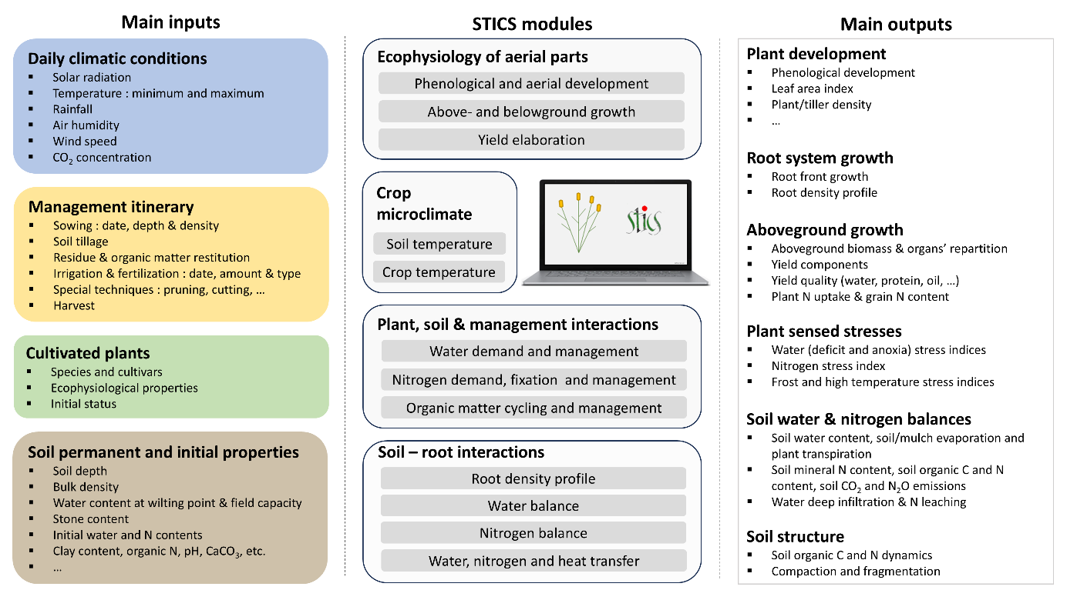
Figure 1: Schematic representation of the organization of the STICS model. It represents the main inputs, outputs and modules of the model, following Beaudoin et al. (2023) – adapted from Lenoir (2024).
Phenology, which refers to the plant development, governs the crop cycle time period. Depending on plant type, crop development is driven either by i) a thermal index (degree-days), ii) a photo-thermal index which also takes photoperiod into account or iii) a vernal-photo-thermal index which also takes vernalization into account. The crop development module drives the kinetics of other processes, such as the leaf area index (lai) or the root growth, and defines the harvested organ filling phase (Brisson et al., 1998).
Foliar apparatus setting relies on the concept of a simple ‘big leaf’ model; it can also be simulated using a pseudo 3D light capture submodel (mandatory for intercropping). Crop growth is driven by energy interception by the leaf apparatus and results in plant carbon accumulation (de Wit, 1978). Solar radiation absorbed by the foliage is transformed into aboveground biomass (concept of radiation use efficiency). Biomass is allocated to the different crop organs, and some fraction can be remobilised to the harvested organs when they become sinks (Figure 2). Crop organs are defined as plant compartments to which generic ecological functions are assigned. Here, the distinction between the structural and temporary pool of carbohydrates is a key point. Only the structural aspect is assigned to the leaves, stems, fruits, perennial reserves and roots. Conversely, the temporary reserves are not physically located into the crop organs, to allow for keeping the model genericity for all crops. The storage organs and harvested organs can be grains, fruits, tubers or even stems. The STICS V10 (last version published in 2023) considers the C and N fluxes to and from temporary and perennial storage organs.

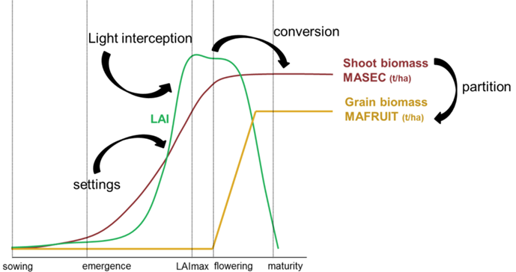
Figure 2: Schematic representation of the main processes related to crop growth (MASEC and MAFRUIT are STICS output variable names) - From Artru (2017).

The crop nitrogen uptake depends upon i) carbon accumulation in the crop and ii) mineral nitrogen availability in the soil. Biological nitrogen fixation of N2 fixed from the atmosphere can be accounted for in the case of legumes.
The model simulates the water and nitrogen elements balances in soil, to assess their availability for plant and potential environmental losses. Their descriptions are based on the classic compartmental approach, which defines different pools in the system, their evolution and their relationships. The functions encompass physical, physico-chemical and bio-chemical processes.
Computed from water and nitrogen balance modules, stress indices will allow to simulate reduction of crop growth. Other abiotic stresses, such as thermal (frost or high temperatures), trophic or waterlogging stresses can also be taken into account, as limiting factors of growth and yield formation. The response function to environmental constraints can also integrate global enzymatic activities, such as nitrate uptake. Biotic stress is not simulated per se, however it can be accounted for through coupling of STICS with other models (e.g. Caubel et al., 2012).
The strong effect of crop management on the dynamics of the soil-crop-microclimate systems is also given particular attention. Indeed, crop specificities influence both ecophysiology and crop management (e.g. accounting for the impact of fertilizers or the various management of forage such as grazing or cutting, etc.). The links between the main routines and formalisms of the model are presented in Figure 3.
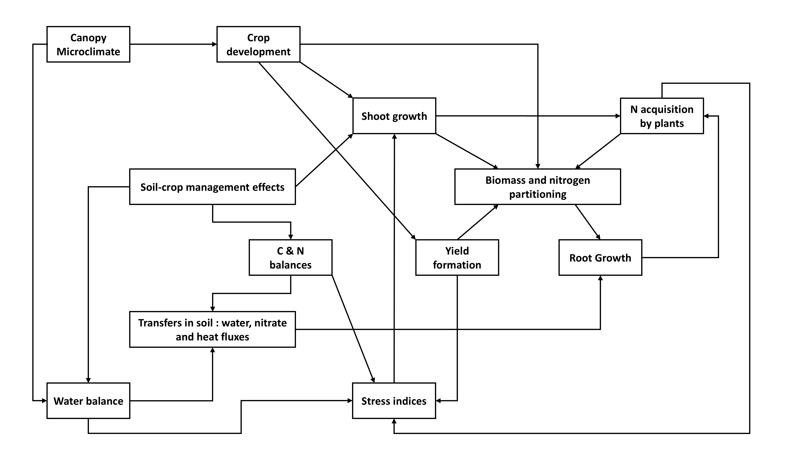
Figure 3: Main functional links between STICS model routines and formalisms - From Beaudoin et al. (2023)

Finally, at the daily scale, STICS model can be considered as a functional or process-based model and not a pure mechanistic model (see next section). At the crop cycle scale, since it deals with the main interactions between the agrosystem components, STICS can be considered as a mechanistic model. Moreover, it allows to design and simulate the emergent properties at the crop cycle and crop rotation scales.
The processes implemented in the model are described in a way which can be qualified as functional and process-based. It aims to favor a simple integration of all the processes interacting in the soil-crop system. The most iconic illustrations of this conceptual choice in STICS are listed here below :
- The interception efficiency of the total solar radiation uses Beer’s law (1852), as an exponential response of the shadowing effect of leaves, in the case of a homogeneous canopy ;
- The conversion of photosynthetically active radiation (PAR) in aerial biomass is based on the concept of radiation use efficiency (RUE), assuming a specific potential linear response of biomass accumulation, at a stable radiation level (Monteith, 1972) ;
- The nitrogen uptake and accumulation in the plant is based on the concept of N dilution curve in the aerial biomass of the crop, both for isolated plants or dense canopies crop (Lemaire and Gastal, 1997) ;
- Fruit filling includes the concept of dynamic harvest index, as proposed by Spaeth and Sinclair (1985), for crop species with determinate development.
- Based on the hypothesis of infinite hydric conductivity, the downward soil water storage uses the tipping bucket concept at the elementary layer infiltration scale, which is known to converge towards the convective-dispersive equations of Richard-Darcy law (Van Der Ploeg et al., 1995), when resolution is small enough (~1cm - Mary et al., 1999) ;
- Nitrate content in the soil solution is simulated using a mixing cell model (Mary et al., 1999);
- Soil C and N mineralisation are simulated using a compartmental approach, with only three pools of organic matter, similarly to the AMG model (Clivot et al., 2019). The compartmental approach allows an independent parameterisation linked to a residue typology (Nicolardot et al., 2001), which uses the C/N ratio of residues to drive their mineralization and humification rates.
These processes are selected by default when users download the standard STICS version. When the basic hypothesis of implemented processes is not met, an alternative process can usually be chosen, involving a more complex conceptual approach. For instance, for a heterogeneous canopy (e.g. row crops such as vineyard or cereal-legume intercropping systems), the simple ‘big leaf’ model associated with the Beer’s law and the Priestley-Taylor (1972) or Penman-Monteith (Monteith, 1965, 1972) ETP functions can be replaced with a more complex energy balance based on crop simplified architecture and a resistive ETP approach (Wallace, 1995).

3 Accounting for genetic differences at species and cultivar levels
Globally speaking, the genetic dimension of plant production is implicit within STICS. Yet a distinction is made at the inter- and intra-specific levels. Indeed, some parameters are considered as species-dependent - i.e. common to the different cultivars of a same species - while others are considered as cultivar-dependent. The number and list of specific or cultivar parameters vary in function of options activated for the simulation of a given crop or the need to be more or less accurate on specific processes (e.g. root growth).
Overall, parameters involved in the equations of physical processes (e.g. base temperature, etc.) or trophic relationships (e.g. radiation use efficiency, nitrate affinity in the rhizosphere, etc.) are considered species dependent. Parameters involved in most of processes known to be genetically variable are ascribed to cultivar particularities. They are linked to the different processes simulated by the model: crop phenology, leaves growth, radiation interception, biomass partitioning, yield components and elaboration, root front growth, sensitivity to thermal and water stress.
It is important to note that not all parameters have the same genetic variability. Specific and cultivars parameters’ nominal ranges - i.e. boundaries within which parameters may vary - were determined by expert knowledge (or within known physical boundaries).
The list of parameters is not exhaustive and could evolve, with future model releases, in function of user’s needs and knowledge. In the future, while the STICS model is a functional process-based model, we are confident that it still could help define theoretical ideotypes, through dedicated sensitivity analysis and the exploration of crop response across the parameters known to be genetically variable.

4 STICS simulated crop species
The STICS model can be downloaded with a set of pre-parameterized crops. STICS allows for parameters to be defined at specific and cultivar levels. The files containing the set of plant parameters can be qualitatively distinguished and include crop species ranging from officially validated to prototypes:
- Officially validated crop means the plant file is currently released after being tested in routine against a large dataset consolidated over time by the core team behind the STICS model development. Such sets of parameters were partly parameterised based on literature review and went through a calibration phase against a specific database, before being tested and validated against an independent database. Each new release of STICS version is documented following a specific procedure regarding this aspect. Some of the species are awaiting for publication or for greater documentation of their validation phase, prior official release ;
- Prototype crop refers to a set of parameters whose performance quality is uncertain, for two main reasons: calibration was performed using either a limited dataset or an old STICS version. In these cases, old parameterised crops were adapted to be compliant with the current model version including the newest development (e.g. see section 5), but users should proceed with caution as the set of parameters was not validated under new model formalization. Users running a prototype parameterisation are invited to test it and, when possible, improve it through proper calibration/validation procedure. They are invited to share back the results of improvements - and ideally their dataset - so that they can be spread within the STICS community - or be included in the official validation procedure.
Figure 4 shows the diversity of plant files that are considered within STICS. Note that some species, such as turmeric and strawberry crops, which are perennial in botanical terms, can be parameterised as annuals based upon how farmers manage them. Additionally, the parameterisation of triticale, white clover, finger-millet, pigeon pea and winter faba bean are waiting for documentation.
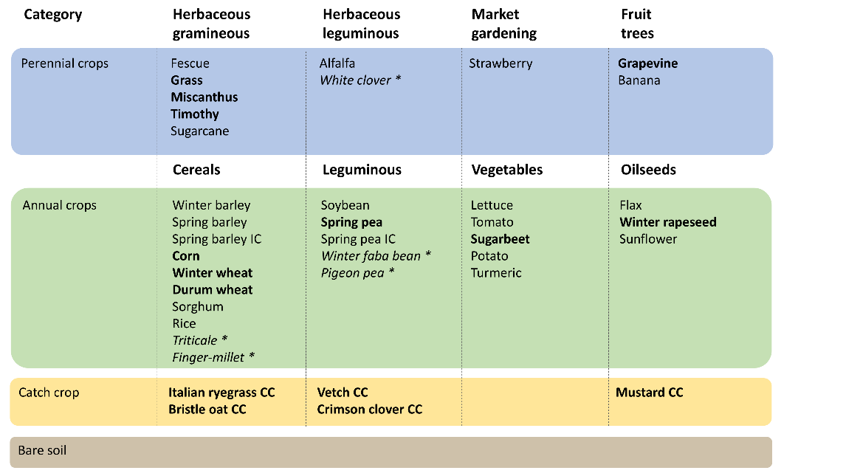
Figure 4: List of currently parameterised plant species. The species given in bold have been officially validated by the team maintaining STICS, those in regular font are yet considered as prototypes considering the recent model developments, while those in italic marked with a “*” are awaiting for greater documentation prior to their official release. “IC” refers to plant files that require specific parameterisation when used to simulate intercropping, while “CC” refers to plant files that have been parameterised to simulate cover crops.

Unlocking simulations of perennials with undetermined growth and fruits: Grapevine simulations

In 2006, the STICS crop model was adapted to grapevines (Garcia de Cortazar-Atauri, 2006). The objective was to add a perennial crop to the list of existing crops in STICS. A preliminary analysis allowed to identify the necessary integrations and modifications in the existing formalisms to allow representing the functioning of the grapevine, including different grape varieties or management systems.
Among the different modifications new formalisms were introduced to calculate budbreak, inspired from the BRIN model (Garcia de Cortazar-Atauri et al., 2009a, 2009b). This model has the particularity to calculate budbreak taking into account the dormancy period, allowing for a more accurate physiological representation. The set of parameters representing the main other phenological stages of the grapevines (flowering and veraison) were also calibrated. The grape ripening process was completely revised to account for water and carbon dynamics and their asynchrony. A new mathematical description of berry carbon growth, in line with the existing literature and confirmed with three years of experimental data, was introduced (Garcia de Cortazar-Atauri et al., 2009a, 2009b).
Special focus was given to the management of carbon and nitrogen reserves. The relationships between canopy structure, viticultural practices, and radiation interception were examined in detail. The model was adapted to account for specific technical management (such as planting density). The nitrogen demand of the vine was described to consider low planting density and rapid nitrogen stress variations. The nitrogen dilution curve, typically used for annual crops, was defined to allow for the vine's nitrogen demand to be managed (Celette and Gary, 2013). The control between sinks strength within indeterminate crops was solved to allow the simulation of leaf and fruit competition. This point was very important in order to avoid an imbalance between vegetative and reproductive biomass. The effects of photoperiod and vine vigor on leaf senescence were included, questioning the genetic nature of leaf senescence (previously defined by a lifespan in STICS). It allowed to simulate the critical period between harvest and leaf fall, which is crucial for the plant's reserve buildup. In addition, new pruning techniques (such as single or double Guyot, or Royat cordon) were proposed to manage leaf density and canopy structure.
Finally, measuring the water balance of grapevine systems and soils was a major challenge, grapevine being usually cultivated on soils with a high density of stones and having a deep root system. To overcome these limitations the calculation of the leaf water potential, a variable commonly measured in viticultural experiments. The integration allowed retro-adjustment of soil parameters in the model, some of which remaining difficult to measure in the field, such as rooting depth.
To ensure robustness, the model was validated against experiments conducted in a wide range of pedoclimatic contexts (seven vineyards) and with a great diversity of varietal conditions (eight grape varieties), over two years. Garcia de Cortazar-Atauri (2006) and Fraga et al., (2016) successfully applied the model to explore climate change impacts in France and Europe respectively. These studies revealed different regional variations in phenological stages, harvest dates, vegetative biomass, and water stress sensed by the plant. Work is currently underway to adapt the vineyard to the new version of the model, which represents the different reserve compartments more explicitly, and takes advantage of the latest improvements introduced to the model in recent years (see Strullu et al., 2014, 2015, 2020 and section 4).
Grassland simulation: Relying on the concept of functional types
Multispecies grassland vegetation can be described simply by the formation of groups of species with similar functions and sharing common biological characteristics known as functional traits. Cruz et al (2010) have proposed a classification of these grasslands into four and then six functional groups, grouping together grass species with similar growth strategies (capture or conservation of resources), phenology (early or late) and capacity to accumulate biomass. Although this functional classification was only established on aerial functional traits, it seems that species with a conservative strategy have a deep, coarse root system and species with an acquisitive strategy have a shallow, fine root system (Fort et al., 2013). These groups form in response to environmental and management factors, and are found in more or less fertile environments, and under more or less intense pasture management conditions.
The functional diversity of grasslands has been taken into account in some multispecific grassland simulation models by using this functional classification of grasslands and parameterising the models with the value of functional traits describing groups of species, which often correspond directly or indirectly to model parameters (Duru et al., 2010; Jouven et al., 2006). These models therefore use a functional representation of grasslands assuming that grasslands can be modeled as one or a combination of these groups.
This approach is currently used to parameterize the STICS model for some of the functional groups in the Cruz et al. (2010) classification corresponding to rather intensive productive grasslands (groups A and B). This is done by entering each functional group as a "cultivar" in the STICS sense, and also by modifying the value of some of the model's plant parameters according to the functional group under consideration (Graux et al., 2024). This approach has several advantages in terms of modeling. Parameterization of grassland functional groups rather than grass species present in grasslands greatly simplifies model parameterization. Taking into account the role of functional diversity of multispecific grasslands in models can help to better simulate changes in forage production and soil organic matter, which are key issues for grasslands in the context of climate change. The approach also has its limitations, and is not easily applicable in the absence of grassland data to verify that the development and growth dynamics of the functional group under consideration are simulated correctly.

5 Current applications: accounting for Genotype x Environment x Management (GxExM) interactions

Sensitivity analysis of cultivar parameters in different environments: an alfalfa case study
In an attempt to parameterize different cultivars of alfalfa, data were collected by INRAE Lusignan’s genetic team. Results revealed that the cultivars were characterized by variable biomass production during the whole growing season and notably at spring and autumn harvests. Such results led to hypothesize that the observed variability could be explained by a difference of sensitivity of the cultivars to the photoperiod.
The STICS model was used to conduct a sensitivity analysis of the Alfalfa aboveground biomass production to two parameters linked to the photoperiod sensitivity of the crop (namely, sensiphot and phobase parameters). A tool called OptimiSTICS, allowing to conduct sensitivity analysis and perform optimization of parameters value, was used to perform the study. The tool is described in Buis et al. (2011) (OptimiSTICS is not maintained anymore and has since be replaced by CroptimizR - See Buis et al. (2023) and section 4.D)
Variation of the parameter sensiphot, which corresponds to the sensitivity to the photoperiod sensu stricto, was allowed between a value of 0 (very sensitive) to 0.6 (less sensitive) while the parameter phobase, which corresponds to the base photoperiod of the crop in hour, ranged from 10 to 14 hours. Those thresholds were defined following the analysis of Major et al. (1991). Furthermore, in order to isolate the effect of photoperiod sensitivity on aboveground biomass production from other stresses, the sensitivity analysis was performed with a deactivation of water or N stresses. The sensitivity analysis was performed over two French sites with different latitude and climatic conditions : Avignon (43°57’N) and Fagnières (48°57’N). The crop was sown on July 28 and harvested a first time on November 10. During the second year of growth, four cuts were applied, namely on : June 11 (DOY 527), July 23 (DOY 569), September 03 (DOY 611) and finally October 15 (DOY 653 – “Day Of the Year” are here cumulated over the two growing seasons, starting from January 01 of the sowing year).
Results revealed that aboveground biomass harvested in autumn were very sensitive to these two parameters, with yield variation of more than 57% in September and over 83% in October, with a more pronounced effect at the lower latitude. Biomass production in spring appeared less sensitive to those parameters with a yield variation of 28%, with no effect of latitude (Figure 5). Biomass production appeared only sensitive to the phobase parameter in spring (Figure 5a) while it was sensitive to both parameters in autumn (Figure 5b), due to the model formalization.
In view of these results, measurements of biomass production made in autumn (September and November) were used to estimate the parameters sensiphot and phobase for the different cultivars studied at Lusignan (Table 1). Results of parameter estimation were consistent with the empirical knowledge; by example Anik - which is a cultivar known as very sensitive to photoperiod - had the highest base photoperiod with 13.7 hours and the highest sensitivity with 0.08. On the contrary, cultivar Magali, which is a mediterranean cultivar, had a base photoperiod of 11 hours and a sensitivity of 0.50.

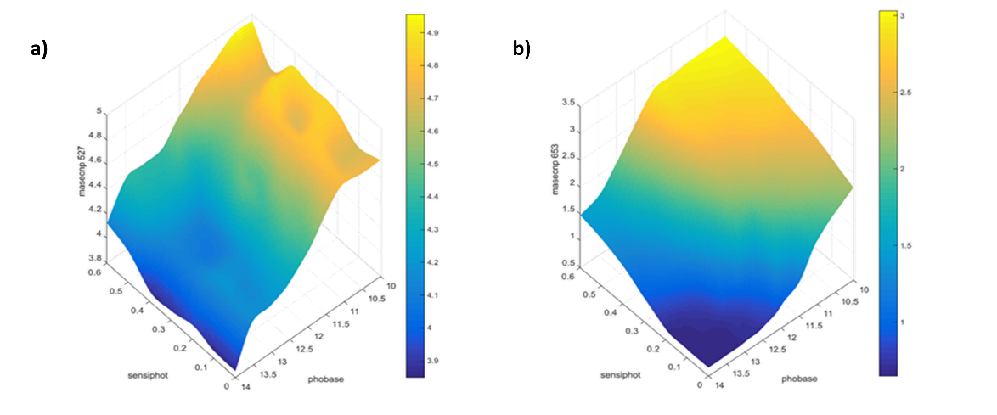
Figure 5: Sensitivity analysis of the aboveground biomass production in t DM ha⁻¹ in spring (a), at DOY 527 (masecnp527) or in autumn (b) at DOY 653 (masecnp653) for various combinations of the parameters related to photoperiod base hour (phobase) and crop sensitivity to photoperiod (sensiphot).

However, even if the model was able to reproduce with accuracy the biomass production of some cultivars, it still tended to overestimate or underestimate biomass for others, meaning that more parameters should be calibrated to simulate with accuracy the large diversity existing within Alfalfa cultivars. To do this, sufficient data are needed to allow an estimation of all the parameters considered as cultivar-dependent within the STICS model.

Table 1: Alfalfa cultivars for which photoperiod related parameters (phobase [hour] and sensiphot [-]) were optimised.

Cultivar/Genotype | Sensiphot [-] | Phobase [hour]
Villa  Monte  Pancrudo  D15  Pool3  Pool5  Flamande  Provence  Lucon  Anik  Magali  Maron  Malzeville  Krasnostkaya  Europe  Coerulea  Romanica  Quasifalcata  Gabes  Tunetana  Aragon  Mediterraneo  Tierra  Ampurdan | 0.53  0.29  0.35  0.51  0.47  0.48  0.51  0.51  0.52  0.08  0.50  0.54  0.54  0.54  0.51  0.29  0.17  0.15  0.13  0.51  0.50  0.44  0.51  0.47 | 13.2  13.1  13.0  11.3  11.1  11.5  11.2  11.4  11.5  13.7  11.0  13.1  13.0  13.1  11.4  13.1  12.6  12.9  10.6  11.4  11.4  11.6  11.5  11.2

Assessing ExM interaction to improve wheat N fertilization at the Walloon territorial scale

Recently, the STICS model has been used at the subfield scale to develop strategic approaches of N fertilization that precisely optimize agronomic and environmental objectives (Lenoir, 2024). The procedure was based on the concept of management zones delineation. Inspired by the work of Basso et al. (2019), Lenoir et al. (2024) proposed a methodology to advance Blackmore’s delineation of management zones (Blackmore, 2000) and to transpose it to the use of sentinel-2 images. This work served as a basis to deploy the methodology at the territorial scale of Wallonia, southern part of Belgium (Figure 6). It led to the successful characterization of uniform zones of management at the sub-field scale, differentiating between zones in field with more frequent higher-than-average yield potential (HS zones), with more frequent lower-than-average yield potential (LS zones), and unstable zones within which yields could strongly shift from year to year (U zones). Only fields having at least 3 occurrences in the crop rotation of a winter cereal crop (winter wheat, winter barley, spelt or triticale) over the period 2016 – 2021 were considered, as required by the delineation method.
The territorial map of delineated fields was crossed with the soils profiles contained within the Aardewerk database (Tavernier and Maréchal, 1958, Legrain et al. 2011). As a result, a total of 10 fields whose soil profiles intersected at least two different management zones were selected to carry out the modeling analysis.
The STICS model was then used to perform simulations to capture the influence of climate (over 26 years) and its interaction with soils, under varying N fertilization schemes. Following the study of Dumont et al. (2015a, 2015b, 2016), N fertilization schemes were simulated on each soil profile to concomitantly assess their agronomic and environmental performances and determine the most adapted management of nitrogen regarding the potential of each zone. A total of 10 fertilization schemes were carried out, ranging from 0 to 270 kg.ha⁻¹, split into 3 equal applications of N at critical growth stages, namely “tillering”, “stem elongation” and “flag leaf”.

Complementary, The STICS model was parameterized as follows :
- Soils properties from the Aardewerk database were used to compute pedotransfer functions and parameterized the model;
- Climatic conditions were retrieved from the Agromet dataset, using API request (https://www.agromet.be/fr/pages/home/), over the period 1995-2021;
- Plant files were calibrated from a local experiment dataset dedicated to N fertilization (Dumont et al., 2014).
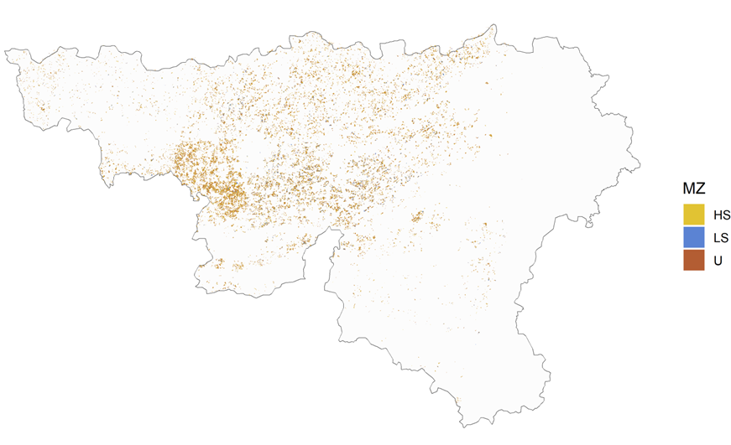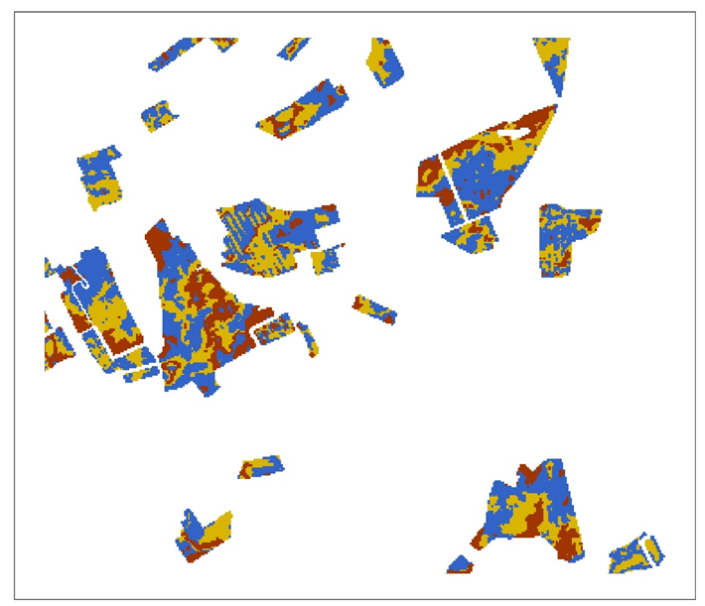
Figure 6: Spatial distribution of the satellite-based delineation conducted at the scale of Wallonia, Southern region of Belgium (left) and zoom on a group of fields where management zones were delineated using advanced Blackmore approach (right). MZ stands for “management zones”, HS stands for “high and stable yielding zones”, LS stands for “low and stable yielding zones”, U stands for “unstable zones”. Extracted from Lenoir PhD thesis (2024).

Yields simulated under the different N fertilization schemes were represented as a function of N left in the soil after harvest (Figure 7). Overall, increasing fertilization resulted in higher yields and higher nitrate levels in each management zone. Yield differences between HS and LS zones were consistent with the features of the management zones, with higher yields in HS than LS. However, yield differences between the two zones under similar fertilizations did not systematically indicate an opportunity to spatially differentiate N management at the subfield scale. Also, N left in the soil after harvest in HS and LS highlighted an inconsistent pattern among management zones, contradicting the idea of a higher efficiency in HS than LS zones. While the results proved interesting to advance fertilization redesign in management zones, further analysis should explore the effect of varying N supplies at the different growth stages on each zone.
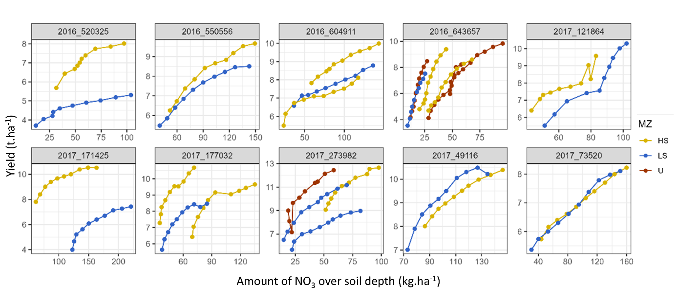
Figure 7: Median yields obtained in HS (yellow), LS (blue) and U (red) zones as a function of soil nitrate content (NO₃) simulated at harvest. Points from left to right correspond to increasing nitrogen fertilizer inputs. Graphic titles correspond to the first year of remotely sensed wheat data and soil index in the database.

Using STICS to better understand, assess and optimize GxExM interactions: example with soybean

Positioning the cycle of an adapted soybean genotype in a given environment is a strategy often suggested in Europe to avoid water and heat stress during the most sensitive phases. Schoving et al (2022) evaluated different sowing strategies (from very early to late) for contrasting soybean genotypes (Maturity Group 000 to II) in environments with different water constraints in south-western France, resulting in 157 contrasted situations. This assessment was carried out by combining statistical analysis of experimental data and modeling. GxExM interactions were highlighted by the statistical analysis, but an explanation of early sowing performance in certain sites and years was needed. STICS crop model was used to (i) complete experimental data with phenology key stages and growth dynamics, (ii) calculate stress dynamics (e.g. water stress indicator), (iii) virtually evaluate the effect of avoiding water stress by sowing soybean early in three contrasting situations in south-west France, two soil available water contents, with maturity group I soybean and under 28 historical years.
The output variables produced by STICS were used to calculate ecoclimatic and agrophysiological indicators for three phenological phases between crop emergence and harvest (VE-R1, R1-R5, R5-harvest) for the 157 simulations corresponding to one site-year-genotype-sowing date-water management. A pls regression was used to select the indicators with the greatest weight in explaining grain yield. Reduced centered values of these indicators were used to classify the treatments simulated into 5 environments (ward method then k-means) which were then characterized by the mean field observations (e.g. yield, oil content, number of plants) of the corresponding experiments (Figure 8). The poor performance of soybean in classes 1 and 2 was mainly explained by major water stress from flowering onwards and high temperatures at the end of the cycle.
Secondly, a detailed analysis of the dynamics of water stress indicator, aerial biomass and N₂ fixation was used to validate the differences in performance between early sowing and conventional sowing. The water stress (intensity and duration) in the flowering-harvest phase was partially avoided in the case of early sowing. This avoidance was also demonstrated for an early genotype compared to a late genotype for the same sowing date.
Finally, the scenarios simulated on three sites across the oceanic to mediterranean climatic gradient showed the success of early sowing for maturity group I soybean. Its efficacy clearly increases with water stress level in the flowering-harvest phase in conventional sowing. This study could be completed on earlier genotypes, or by simulating the impact of early sowing date under future climatic conditions. This study demonstrated the interest of STICS to simulate environmental variables and stress dynamics to better understand GxExM interactions, identify the best genotype for a given environment and design more adapted crop management and/or ideotypes.
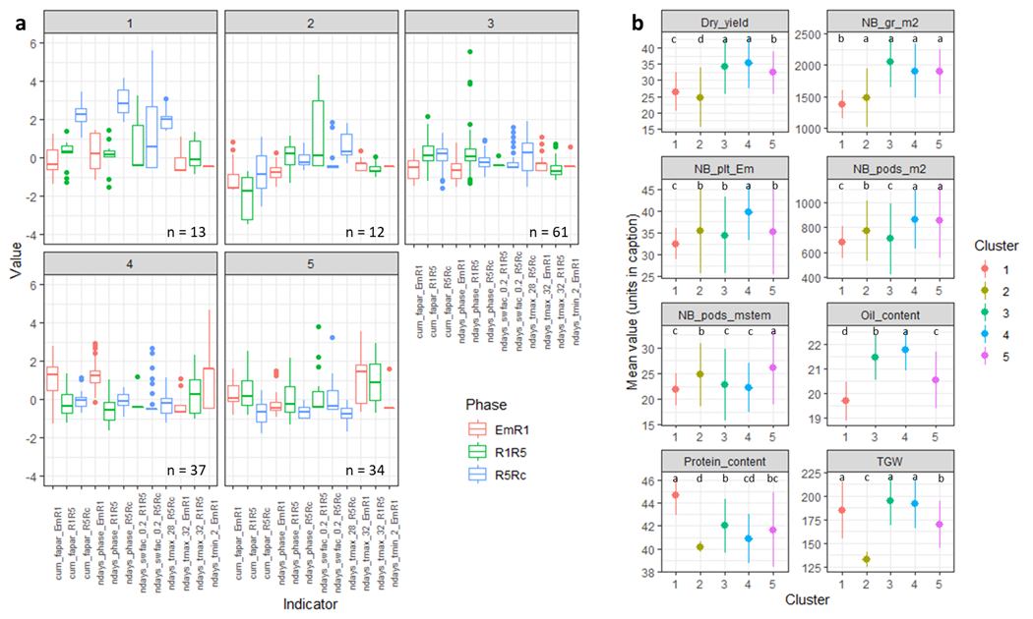
Figure 8: Graphical representation of (a) the centered-reduced values of the indicators characterizing each class for the different phases of the crop cycle: EmR1 (emergence to first flower), R1R5 (first flower to beginning of grain filling), and R5Rc (beginning of grain filling to harvest) (n = number of USMs per class), and (b) the mean observations in the field and their standard deviation for each class. The data originate from field trials conducted in the south of France (Mauguio, Béziers, Mondonville, Rivières, En Crambade, and Auzeville-Tolosane), spanning Mediterranean to altered Mediterranean climates from 2010 to 2018. The effect of the classes on the observations is highly significant at the p < 0.001 threshold. Means with a common letter are not significantly different at p < 0.01 according to the Student Newman Keuls test. Indicators are calculated per phase as follows: cum_fapar = cumulated fraction of intercepted photosynthetically active radiation; ndays_phase = phenophase duration in days; ndays_swfac_0.2 = number of days with stomatal water stress below 0.2 (1 = no stress; 0 = high stress); ndays_tmax_28 = number of days with max temperature above 28°C; ndays_tmax_32 = number of days with max temperature above 32°C; ndays_tmin_2 = number of days with min temperature below 2°C. Additional variables include: Dry_yield: dry grain yield (q/ha), NB_gr_m2: number of grains per m², NB_plt_Em: number of plants per m², NB_pods_m2: number of pods per m², NB_pods_mstem: number of pods on the main stem, Oil_content: oil content in the grain (%), Protein_content: protein content in the grain (%), TGW: thousand grain weight (g).

6 The contribution of STICS to the international Agriculture Model Intercomparison and Improvement Project (AgMIP)
The international Agriculture Model Intercomparison and Improvement Project (AgMIP, Rosenzweig et al., 2013 - https://agmip.org/ ) is an initiative launched by the NASA (National Aeronautics and Space Administration) and the University of Florida following the line of CMIP (Coupled Model Intercomparison Project), the scientific tool of IPCC (Intergovernmental Panel on Climate Change). Modeling groups across the world were asked to join and analyze the source of uncertainty in the assessment of climate change impacts on yields of main cultivated crops.
STICS was soon involved in many exercises such as the ones on wheat (Asseng et al., 2019), maize (Bassu et al., 2014), rice (Confalioneri et al. 2016), soybean (Kothari et al., 2022), calibration (Wallach et al., 2023), evapotranspiration (Kimball et al., 2019), low input farming systems (Couedel et al., 2024) or on soils and crop rotations (Basso et al., 2018). The exercises gathered between 16 and more than 40 models, depending on the study. In all cases, the first step consisted in breaking down the yield estimate’s uncertainty into different components, such as parameter values, parameterization, input data. Detailed datasets from different regions were used for that purpose and the adaptation of model parameters to the cultivar use was a challenge.
In STICS, the phenology parameters such as temperature or photoperiod thresholds, as well as freezing and drought stress coefficients were modified for each situation to improve the model calibration. From those calibrated values, projections using simulated projected climatic time series were computed. Finally, the variability between models was compared to the uncertainties linked to climate input. In general, STICS performed relatively well for predicting yields or nitrogen use by crops. Results on leaf area, or water consumption were less accurate.
In a second step, several intercomparison exercises aimed at isolating some modules of models to compare their specific contribution to simulated uncertainties. For instance, this was done for wheat, to further study the response of phenology to temperature or the response of biomass and yield to the air concentration in CO₂. Globally, STICS was relatively reliable in simulating experimental wheat or maize data gained in Free Air Carbon Enrichment (FACE) experiments. Although, like most other models, the water x CO₂ interaction was very difficult to simulate using the available inputs data. In Maize in particular, the high sensitivity of maize yields to water deficiency at the silking stage appeared challenging to reproduce. The main difficulty lies in the variations in phenological development and the occurrence of the sensitive stages within the time course of soil water deficits. One of the main issues remaining to address consists in converting this knowledge into specific calibration of parameters controlling the formalisms such as implemented in the current models versions. This remains a topic to be addressed more systematically in AgMIP.
Furthermore, in general, crop models are validated using well spread genetic material, while their ability to reproduce newly released or projected genetics remains highly uncertain. Given the magnitude of the genetic progress achieved over the last 80 years, important efforts should be put to better consider new genetic material into study aiming at simulating projected yields and assessing the use of resources. To do this, it would be desirable for geneticists to use the model to allow parameterization of the various varieties with automated methods based on plant traits and phenotyping information.
Recently, the very rich routines built around STICS in the R environment (see section 5.C), that are used for data handling, multi-simulations, sensitivity analysis, parameter optimisation and data reporting (with automatic graphs construction), were adopted by AgMIP as a common tool for model calibration in different exercises, especially for wheat. The corresponding packages initially developed by the STICS team can be used with any crop model, provided a wrapper function is built to interface it.

7 Recent STICS model improvements: crop related features

Improving root system simulation
Originally in the STICS crop model, the root system development was simulated in two steps: (i) first the root front growth in soil depth was simulated, (ii) then the growth in root length density by soil layers was accounted for (Beaudoin et al., 2023). At the infancy of STICS, the root system was considered only as an exchange interface for water and nitrogen uptake, and its growth was simulated independently from the shoot growth. Recently, this conceptualization has been enhanced with the addition of several formalisms in order to simulate the major roles that the root system plays, notably in soil C-N storage (Wichern et al., 2008), or in response to mineral availability in the soils (Wedin et Tilman, 1990). Until recently, STICS only calculated the amount of recycled C-N at the end of the crop cycle, which allowed simulation of C-N storage for annual crops, but jeopardized the model relevance for perennial crops. Fortunately recents works improved the root description as described in the STICS V10 version, provided appropriate options are activated.
First, roots are described in terms of front depth and density profile, with a potential growth function of degree-days. Their growth begins now starting at germination (for sown plants), at planting or at the bud break stage for perennial crops, and stops at a given stage defined by the user (end of leaves growth, flowering or senescence); this first step remained unchanged in STICS V10. Second, actual growth depends on the soil environment (bulk density, humidity, etc.) and is linked to daily biomass production. Third, when growing, the root system uses a part of the plant nitrogen uptake for its own demand, which allows it to simulate the evolution of root N content. Fourth, two root classes are simulated in order to simulate the root system turn-over, which is mandatory for simulation of perennial crops like miscanthus (Strullu et al., 2015). These classes differ by their diameter, root tissue density and lifespan, following the principles of the ArchiSimple model (Pagès et al., 2014).
An example of the simulation of Miscanthus x giganteus root system growth and turn-over is given in Figure 9. Simulated root C and N inputs to the soil vary between years, with annual inputs varying between 1.5 and 3.2 t C ha⁻¹ y⁻¹ for C and between 21 and 73 kg N ha⁻¹ y⁻¹ for N when the crop is fully established. Further evaluation of the model will be done in the near future to improve parameterization of root turn-over to reproduce soil C-N storage under perennial crops like Miscanthus x giganteus or Switchgrass thanks to newly acquired observed data on root growth or C-N stocks in the soil.
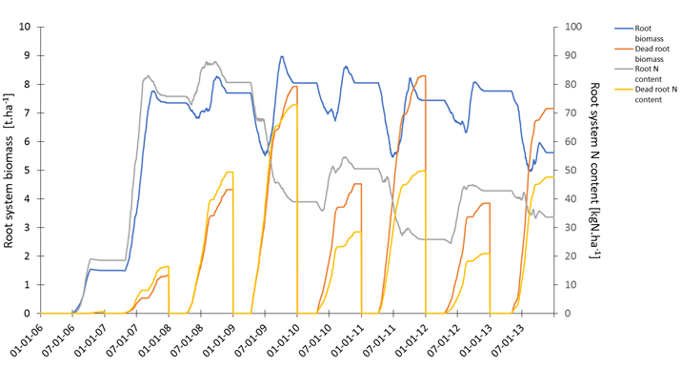
Figure 9: Simulation of Miscanthus root biomass and N content and its turn-over in the entire soil profile (until 210 cm depth) from rhizome planting in 2006 until the end of 2013, at Estrées-Mons in Picardie region, France.

Allocation of C and N to perennial and non-perennial organs
Under the pressure of climate change, the increasing interests for the use of perennial crops as forage, as a means for bioenergy production or second generation biofuels production, as well as a mitigation lever of climate change impacts by soil C sequestration, reinforced the need for developments of the STICS model to better simulate perennial crops over the long term.
Prior model versions could not accurately simulate biomass or nitrogen dynamics within perennial or non-perennial organs, and the remobilisation between those organs were not taken into account. As a consequence, the model was not able to simulate long-term perennial crops functioning, including C and N recycling from one year over the other.
The STICS modules were substantially modified to account for the allocation of C and N assimilates in the plant. Miscanthus x giganteus was used as a reference crop for development of new equations (Strullu et al., 2014, 2015). Ultimately, novel equations were tested and adapted, when necessary, for the simulation of other perennial crops like Medicago sativa L. (Strullu et al., 2020) or grapevine. Table 2 provides the results of model evaluation on independent data for biomass partitioning between perennial and non-perennial organs, as well as biomass partitioning between stems and leaves. For each crop, datasets used for the model evaluation included different climatic conditions, various soil types (in terms of texture, water availability and organic matter content), variable durations (from four to 20 years for Miscanthus, from one to three of four growing seasons, respectively for Alfalfa and grapevine), as well as different crop management practices (i.e. harvest date, irrigation and fertilization for Miscanthus; cutting rate, irrigation and fertilization for Alfalfa; pruning and fertilization for grapevine). For Miscanthus only one cultivar was parameterized, Miscanthus x giganteus. For Alfalfa, although different cultivars were used in the different experimentations, due to a lack of data to allow a finer parameterization, we chose to parameterize only one virtual cultivar corresponding to the Flemish gene pool. Finaly, for grapevine, three cultivars were parameterized: Pinot Noir, Chardonnay and Meunier. For more information about each specific dataset used, please refer to the references (Strullu et al., 2014 and 2015 for Miscanthus; Strullu et al., 2020 for alfalfa and Strullu et al., 2023 for grapevine).
These studies allowed to verify the genericity of the novel equations across different species and ensure a proper simulation of biomass and nitrogen partitioning between perennial and non-perennial organs, as well as between different vegetative organs (stems, leaves and temporary reserves). The recent parameterization of grapevine simulation with such novel equations permitted to evaluate and improve the simulation of biomass and N allocation to the reproductive organs (Strullu et al., 2023).
Finally, another advantage in simulating perennial organs biomass and N content of perennial organs is the model ability to reproduce the rear effect of perennial crop destruction (like Alfalfa) on mineral N availability in the soil, which is mandatory to simulate cropping systems integrating such perennial crops (Strullu et al., 2020).

Table 2: Evaluation of model ability to simulate biomass partitioning between organs for different perennial crops. masecnp = non-perennial organs biomass (t.ha⁻¹); maperenne = perennial organs biomass (t.ha⁻¹); mafeuilverte = structural part of green leaves biomass (t.ha⁻¹); matigestruc = structural part of stems biomass (t.ha⁻¹). All details related to the datasets used for model validation, including pedoclimatic conditions and management itineraries, can be found in Strullu et al., 2014, 2015, 2020 and 2023).

Variable | masecnp | maperenne | mafeuilverte | matigestruc
Miscanthus
Mean obs.  Mean sim.  R²  rRMSE  EF  IPQ | 15.0  15.5  0.81  22  0.80  Very good | 15.1  14.5  0.51  28  0.24  Good | 2.4  1.9  0.73  41  0.60  Good | 11.6  11.4  0.84  24  0.83  Very good
Alfalfa
Mean obs.  Mean sim.  R²  rRMSE  EF  IPQ | 2.6  2.4  0.77  33.8  0.75  Very good | 4.8  4.8  0.65  20.0  0.45  Good | 0.7  0.7  0.54  52.9  0.52  Acceptable | 1.3  1.0  0.70  56.6  0.61  Acceptable
Grapewine
Mean obs.  Mean sim.  R²  rRMSE  EF  IPQ | 2.1  2.5  0.88  38  0.80  Very good | -  -  -  -  -  - | 0.9  1.1  0.56  43  0.45  Acceptable | 0.9  1.0  0.73  42  0.61  Good

Ability to simulate intercropping
STICS was adapted 20 years ago for the simulation of intercropping (Brisson et al., 2004). It stimulates the competition between two species for light, water and nitrogen. The competition for light is computed either simply as a Beer-Lambert inspired light extinction computation adapted for intercrops in the case of homogenous canopies, or using a more complex energy transfer module between a main crop and an understory crop that takes into account the extinction coefficient of the plants, the row spacing and the shape of the canopy, as a pseudo 3D submodel (Brisson et al., 2004). STICS calculates the water and nitrogen uptake in intercropping, taking into account the distribution of the roots of each of the two cultivated species along the soil profile. Water demand is calculated with a daily time step using the resistance analogy to account for the microclimatic effect between the two species. The model has been proven to perform reasonably well in temperate (Launay et al., 2009, Shili-Touzi et al., 2010), Mediterranean (Kherif et al., 2022) and tropical conditions (Traoré et al., 2022).
In a recent study, STICS has been proven to well reproduce cereals and legumes intercrops competition and complementarity effects in contrasting tropical conditions (de Freitas, 2023). STICS well reproduced the partial Land Equivalent Ratio (pLER) of cereals (maize, millet and sorghum) and legumes (cowpea and pigeon pea) but couldn’t reproduce the facilitation effects when observed pLER were higher than one (Figure 10). Some other discrepancies were identified in several cases. Corre-Hellou et al. (2007, 2009) had difficulties in calculating light competition related to insufficient simulation of plant height, while Shili-Touzi et al. (2010) found a tendency to overestimate N uptake by a red fescue when intercropped with winter wheat.
To overcome these limitations, Vezy et al. (2023) proposed new equations and algorithms that improve the simulation of important processes such as development phases, light interception, plant growth, nitrogen and water balance and yield formation in intercropping. The model was found consistent and generic under a large range of bispecific spring and winter intercrops, including Faba Bean-Wheat, Pea-Barley, Soybean-Sunflower, and Wheat-Pea mixtures (nRMSE = 25% for maximum leaf area index, 23% for shoot biomass at harvest, and 18% for grain yield). Several tropical intercropping systems are also currently being evaluated using these new STICS formalisms (de Freitas, 2023).

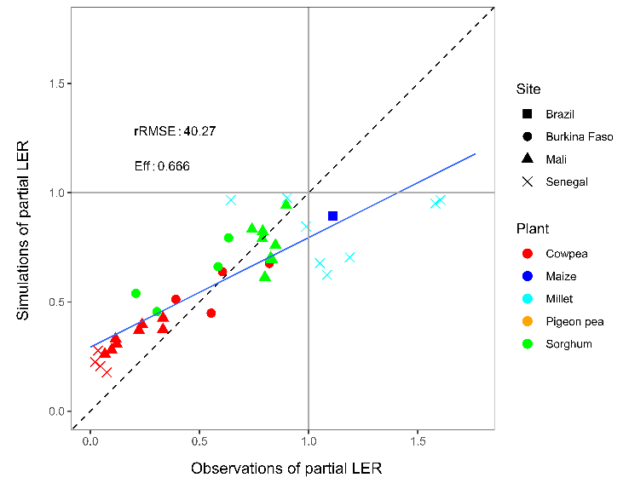

Figure 10: STICS simulations of partial Land Equivalent Ratio (LER) of grain yield for tropical sites in several cereals and legumes intercrops - From de Freitas (2023).

8 Recent STICS model improvements: soil related process

Mineralization of soil organic matter
The mineralisation of humified soil organic matter (SOM) into mineral N (NH₄⁺ and NO₃⁻) and CO₂ in STICS is assumed to occur in an upper soil layer (profhum) considered biologically active and to be negligible below that layer. The humified organic matter is divided into: i) an active pool that is fed by the decomposition of fresh organic residues and affected by the mineralisation process, and ii) a stable pool considered to be inert at the century scale. In STICS, the SOM mineralisation depends on the amount of active soil organic N and C and on an actual mineralisation rate constant. This latter depends on soil temperature and moisture and on a potential mineralisation rate constant (Khum) which depends on soil properties. The considered soil properties affecting Khum were updated from the STICS V9.0 version according to the study on N mineralization in bare fallow (BF) soils published in Clivot et al. (2017). Khum thus integrates the influences of clay and CaCO₃ contents (already considered in previous versions) and also the additional effects of soil pH and C:N ratio of organic matter (within profhum layer).
Integrating these new mineralization formalisms improved the model performances for simulating soil mineral N contents (and particularly for near-surface layers) under BF soils in 566 simulation units from the STICS evaluation database. This improved model version has also demonstrated its ability to predict satisfactorily long-term soil organic carbon (SOC) dynamics across BF sites in Europe (Farina et al., 2021). Ensuring the validity of model simulations under BF conditions is crucial to ensure a robust and independent parameterization of the model soil submodel. It is important to avoid situations where plants interact, sometimes strongly, with N, C and water cycles in soils and for which inadequate model parameterization would potentially allow to compensate for errors between soil and plant sub models.
The improved prediction of long-term SOC dynamics were then also confirmed in diverse arable cropping systems, not only for STICS but also for the more simple AMG model (Clivot et al., 2019, 2020), both models sharing a common representation of the influence of soil properties on SOM mineralization.

N₂O emissions
In recent years, the description of N₂O emissions has been improved on the basis of the concepts described in Bessou et al. (2010). Nitrification and denitrification processes, and the N₂O emissions associated with each process, are simulated separately. Coupling of nitrification and denitrification exists through the production of nitrate by nitrification, which then serves as substrate for denitrification and N₂O emissions associated with this pathway. Processes are described using a functional approach which is similar to that used in other models such as DayCent (Del Grosso et al., 2001) or Ecosse (Smith et al., 2010).
Nitrification rate is considered to be proportional to NH₄⁺ content, which proved to be a good approximation over the typical range of ammonium content in soil. It is affected by temperature, increasing until an optimum rate and then decreasing again (Benoit et al., 2015). Water filled pore space (WFPS) strongly influences the rate of nitrification as its intensity increases until field capacity is reached, then decreases because of the decline of soil aeration (Khalil et al., 2004). pH values decreasing below neutrality progressively constrain nitrification, before stopping it at a pH of 4. N₂O emission associated with the nitrification pathway is calculated as a variable fraction of the nitrification rate. That fraction remains low for WFPS values below 60% (< 0.3%) but strongly increase with WFPS afterwards to reach a maximum of 2.5% of nitrified N in the top soil at 100% WFPS, as a consequence of the resulting decline in oxygen availability (Khalil et al., 2004).
Denitrification is calculated as the product of a soil dependent potential rate and functions expressing the effects of nitrate concentration, soil temperature and soil water content (Brisson et al, 2008). Denitrification rate increases with NO₃⁻ content following a Michaelis-Menten kinetics (Bessou et al., 2010), and it increases with temperature over most of the typical range of temperature as the optimum rate is 47°C (Benoit et al., 2015). As in the NEMIS model (Hénault and Germon, 2000), the denitrification rate is null when WFPS is below a threshold whose default value is 62% and then increases exponentially with WFPS. N₂O emission from denitrification is calculated as a variable fraction of the denitrification rate which mainly depends on pH and WFPS. Acid pH strongly inhibits N2O reduction to N2 (Rochester, 2003): for pH values below 6, denitrification has N₂O as main end-product. Finally, soil water content values close to saturation favor N₂O reduction to N₂. This is due to the development of anoxia (Vieten et al., 2008) and to the increase in the residence time of N₂O into the soil associated with lower gaseous diffusion rates. This effect is taken into account through a linear decrease of the denitrification end-product ratio between the threshold WFPS for the onset of denitrification and maximal soil saturation (Bessou et al., 2010).
One main area for future development of the N₂O emission model is to better couple the simulation of denitrification to carbon availability in the soil (Chaves et al., 2024). This would avoid using a denitrification potential parameter which remains difficult to measure while at the same time dealing better with the temporal dynamics of denitrification, in particular regarding the influence of practices which influence carbon availability in the soil.

9 Recent STICS model improvements: new modules and tools

Considering grazing impacts on pasture simulations through an internal module

A grazing module was developed within STICS to account for animal returns to the soil in grazed grasslands (Graux et al., 2020) with a parameterisation available for dairy and suckling cows. This grazing module is a simplified but useful representation of animal returns during grazing period in which animals are assumed to be fed with grazed grass, without concentrates’ supply. Grassland intake is simulated as a cutting event, with all of the herbage removed being assumed to feed a fluctuating number of animals that have a uniform and fixed dry matter intake. Animal feces and urine are represented by an application of cattle liquid manure and urea, respectively, to the soil surface on the day of herbage defoliation. This module is based on known relationships between animal N returns during grazing, animal herbage dry matter intake and herbage N content, all of which respond to N availability (including fertilization). Decomposition of animal feces uses existing STICS equations for simulating mineralisation of organic residues, with grazing-related parameter values. Urea return is represented as an application of mineral fertilizer, of which up to 15% can be volatilised, taken up by plants, nitrified, leached, denitrified and immobilized in soil organic matter.
In STICS, animal stocking density and the length of each grazing period are thus model outputs instead of inputs, but it is possible to calculate grazing days. This simplification makes it difficult to compare predictions to observations, as simulated herbage growth may differ from reality, and simulated grazing days may not reflect the stocking density or grazing period length observed. Yet, based on this methodology, Delandmeter et al. (2024) successfully simulated the response of Brazilian integrated crop and livestock systems over 18-years, and assessed their potential to mitigate climate change impacts.
Performing multi-simulation, sensitivity analysis and parameter optimization with external tools
In recent years, new applications of the STICS model have emerged, necessitating large-scale simulations and finer control over its inputs and outputs. This requires the use of software tools that enable efficient, flexible, and reproducible management of the model and its data via scripts.
For many years, an existing graphical interface has allowed users to define the model's input files, initiate simulations, and display corresponding results. Supplementary tools were also developed in Matlab to facilitate the simulation of large experimental designs and model calibration by coupling with optimization methods available in that language (Wallach et al., 2011). New software tools have been developed since 2018 under the SticsRPacks project to drive the STICS model from R, aiming to facilitate and extend its usage. The objective was to create open-source, modular, well-documented tools using a programming language accessible to a wide audience.
SticsRPacks comprises four R packages. Two of them, SticsRFiles (Lecharpentier et al., 2024a) and SticsOnR (Lecharpentier et al., 2024b), are designed to interface with the STICS model from R. SticsRFiles provides functions for creating and managing STICS inputs, as well as importing and pre-formatting its simulated outputs. SticsOnR facilitates running STICS simulations from R, optionally distributed over different CPUs.
The remaining two packages, CroptimizR (Buis et al., 2023) and CroPlotR (Vezy et al., 2024), aim to simplify the implementation, comparison, and automation of parameter estimation and evaluation processes for crop models. They offer a generic interface for connecting crop models with contemporary parameter estimation algorithms, and for generating customized plots and statistics for evaluation purposes. These packages have been so far integrated as standard tools in STICS, APSIM NextGen, and SiriusQuality2, and have been utilized with over 12 different crop models to implement and compare calibration protocols within the AgMIP international project (Wallach et al., 2023).
All SticsRPacks packages are open-source and freely available on Github under the LGPL license. They adhere to a strict development workflow, including shared concepts, enforced code style, and automated tests for both their functions (unit tests) and workflows (functional tests). Detailed documentation, including a tutorial and examples of application on several crop models for the generic packages, is provided. Interested users can refer to each package via the link to the dedicated Github pages.
10 Areas for further model enhancement
Phosphorus stress
Crop phosphorus (P) nutrition is one of the key sustainability challenges of the 21st century and especially in low inputs agriculture (Cordell and White, 2014). Crop models are relevant tools to study and manage phosphorus in agro-ecosystems. However, P modeling has lagged behind nitrogen and carbon modeling. A major reason for this delay is the difficulty in developing a semi-mechanistic model that adequately predicts the temporal evolution of soil P availability and crop uptake (Das et al., 2019), as well as the P nutritional status of crops and the feedback of P deficiency on crop growth. Based on the FUSSIM-P model (Mollier et al., 2008), a new phosphorus module is currently developed and will soon be integrated into the STICS model. This P module allows the simulation of the P availability in the soil, the P demand of the crop, the P uptake by the roots and the feedback effects of P deficiency on crop growth.
Plant-available soil P in the ploughed layer is calculated daily for each 1 cm soil layer (z). It has been evaluated by a functional and process-based approach, which consists in determining together the orthophosphate ions (oPions) concentration (C_{P}, mg P L⁻¹) and the oPions quantity (Q_{w}) in solution, and the amounts of diffusive oPions bound to soils (P_{r}, mg P kg⁻¹ soil) that equilibrate the solution over time (t in minutes) (Morel et al. 2000).
Daily plant P demand is determined by plant growth and biomass production. The aerial part demand is based on the concept of dilution curves as presented for N by Lemaire et al. (2008) and extended to P (Lemaire et al., 2019; Morel et al., 2021). The root P demand is calculated on the basis of a constant optimal root P content.
The root P uptake submodule uses the formalisms of the FUSSIM-P root P uptake module (Mollier et al. 2008) adapted to the one-dimensional soil description of STICS. The microscopic model for nutrient uptake developed by De Willigen and Van Noordwijk (1987) is used for each soil layer according to root length density and plant available soil P. Phosphorus transport within the soil solution around the root is driven by mass flow and diffusion. The maximum P uptake rate is equal to the maximum possible transport rate (by diffusion and mass flow) to the root, i.e. the root acts as a zero sink. The maximum nutrient uptake rate per unit root area is derived from the steady-state approximation of the concentration profile around the root for the zero-sink condition (De Willigen and Van Noordwijk, 1994). Root P uptake is determined by crop P demand. The actual root P uptake may or may not meet the crop P demand. It is assumed that the actual P uptake rate is equal to the required P uptake rate as long as it is less than the maximum P uptake rate, otherwise it is equal to the maximum P uptake rate. Total P uptake by the whole root system is the sum of P uptake from all soil layers.
The Phosphorus Nutrition Index (PNI) is calculated as a function of P uptake and is used to apply feedback to crop growth. The main processes affected by P deficiency are plant development, root elongation and leaf production and senescence.
A first version of the STICS P model was evaluated using a dataset from four field trials with deficient to excessive plant-available soil P at different sites in mainland France (Seghouani et al., 2025). Briefly, the trials consisted of fertilizing maize with a mineral fertilizer at three application rates (P0, P1, P2), corresponding to no P added or P added at one or two times the crop yield. Model predictions of both crop P uptake and plant growth indicators (yield, LAI and biomass) were evaluated. The model has shown great ability in predicting P uptake both dynamically and at the end of the growing season for the whole data set (EF > 0.75). The model has satisfactory predictions of crop biomass accumulation (EF >0.5) and leaf area index. Considering each fertilization level separately, the evaluation showed that the model had predicted the fertilized treatments better than the unfertilised ones (EF of 0.73, 0.75 and 0.64 for P2, P1 and P0 respectively). However, the evaluation of the latter remains satisfactory for both P uptake and plant growth.
The good performance of the model is promising as it shows that the model is sufficiently robust to simulate maize P uptake over a range of soil P availability under contrasting temperate climatic conditions. Despite the relative simplicity of the model, which does not include all rhizosphere mechanisms, it appears to perform well even at low P levels under the conditions considered. However, the fact that the model predicted the fertilized treatment better than the unfertilised treatment raises the question of model performance under conditions of more severe P deficiency or even lower soil P availability status (e.g. in tropical soils). Further validation on different crop species and soil and climatic conditions is therefore needed.

Towards biotic stress simulation: the case of airborne fungal diseases

Although the STICS model does not directly include the impacts of diseases on crop growth, it can be coupled with disease models thanks to simulation outputs such as phenology, LAI, biomass and canopy microclimate variables, including hourly reconstitution of temperatures and humidity.
Previous works (Caubel et al., 2012; Caubel et al., 2017) have coupled STICS with a generic disease model called MILA (MILA is not an acronym, just the regular model name). MILA-STICS simulates the development of pathogenic fungi and their impacts on plant organs and crop growth for a range of polycyclic airborne fungal diseases. MILA’s conceptual design is organized around several connected modules representing the processes involved in the dynamics of an epidemic, namely:
- dispersal of spores and interception by plant organs,
- infection by intercepted spores,
- latency of deposited spores,
- secondary inoculum production by infectious lesions,
- lesion and spore lifespan.
MILA runs at a daily time step with feedback to and from STICS’ daily loop (Figure 11). Each day, cohorts of spores and lesions are created and/or transferred from one state to the next (available, dispersed, infectious, etc) depending on crop phenology, canopy microclimate and pathogen parameters, which all increment a transition variable until it reaches a given threshold. The components of the relevant organs of the plant are updated depending on status (healthy, diseased or dead tissues) and a severity index is provided as an output. In the case of leaves, severity is a percentage of diseased LAI which is removed from the photosynthetic area used in STICS. Hence the simulations from MILA are directly connected to plant function processes handled in STICS.
Until the creation of the coupled model MILA-STICS, little work had been conducted on modeling the relationships between climate, soils, plants, their microclimate and diseases in an integrated, mechanistic manner, while remaining generic enough to be applied to a number of various diseases and crops. Several works have used the MILA-STICS coupled model to study disease-crop systems such as wheat with brown rust and vine with mildew (Caubel et al, 2012).
Since STICS can also run long term simulations, climate change studies are possible. For example, results have already shown that changing weather patterns affect the phenology of both pathogens and crops as well as the microclimate of the canopy, thereby desynchronizing the developmental phases and increasing damages on crop tissues (Caubel et al, 2017). Current research projects include a case study on yellow rust and the adaption of MILA to STICS intercropping.

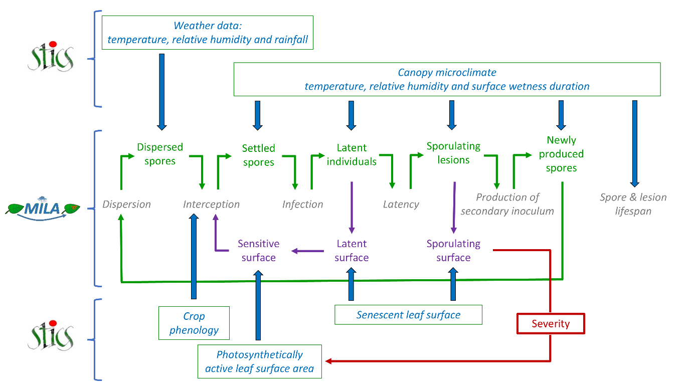
Figure 11: Schematic representations of the coupling between STICS and MILA models (from Caubel et al., 2012; Caubel et al., 2017).
Pasture simulations: the need to better account for C sequestration

The capacity of grasslands to mitigate climate change by storing carbon in soils is well known, but difficult to quantify because it depends on soil and climate conditions, nature of the vegetation and grassland management. Modeling the evolution of soil organic carbon (SOC) stocks requires that models are sufficiently robust and accurate in their prediction. The ability of the STICS model to simulate SOC stocks has already been evaluated in arable cropping systems, with satisfactory results (Autret et al., 2020; Yin et al., 2020; Clivot et al., 2020), but only few have explored this aspect under rotations that include temporary grassland (Autret et al., 2020), or under permanent grassland soils. Work in this area has been proposed by Graux et al. (2023, 2024).
A new research version of the model derived from STICS V10 was calibrated and used to evaluate SOC simulation using data from three long-term (14-27 years) French experimental trials, located in contrasted pedoclimatic conditions in France (Lusignan, Kerbernez and Theix sites), and offering data for arable crops alone, arable crops alternating with temporary grassland and permanent grassland. These sites include several treatments with different grassland duration, different levels of N fertilization and with mown and grazed situations. Some grassland shoot parameters were adjusted based on the literature to better represent the productive grassland functional groups present in the experimental trials (see § 2D). Then, part of the data from the Lusignan trial were used to calibrate parameters involved in simulating the allocations of biomass to shoots and roots and the roots lifespan and N demand. The final grassland parameterisation was then evaluated against observations in the remaining treatments in Lusignan, and in the Kerbernez and Theix trials. We evaluated the model's performance by calculating statistical criteria and comparing the root variables with the orders of magnitude known from the literature (Freschet et al. 2017; Legay et al. 2016; Mokany et al. 2006).
With the final grassland parameterization, SOC dynamics at Lusignan and Kerbernez trials are well simulated under both temporary and permanent grassland (Graux et al., 2024). It also makes it possible to accurately simulate root C and N in grasslands, variables that were not previously simulated. At Theix, the SOC stock evolution under permanent grasslands is less well simulated, with a tendency towards destocking where observations indicate storage or slight destocking. However, SOC observations for this site were only available for a rather short period (7 years) and with a high spatial variability, even at the start of the simulation. In general, the order of magnitude of the grass biomass, root/shoot ratio, root N content and root C/N ratio is in line with the expected values according to literature and experimental data. Evaluation of the STICS model shows that it is able to reproduce observed trends in SOC evolution in rotations including temporary grassland and in permanent grassland soils.

A generic external module to simulate a complete CO₂ balance from model outputs: illustration with STICS
Taking the most of croplands potential to mitigate climate change requires a deep understanding of (i) soil-plant CO₂ fluxes and (ii) how agricultural management and environmental variables affect them. Originally, STICS does not explicitly compute all CO₂ fluxes within the agro-ecosystem. STICS computes Heterotrophic Respiration (HR), i.e. the carbon losses from the decomposition by microorganisms of soil organic matter. However, it uses the concept of radiation use efficiency which combines photosynthesis and respiration to directly convert photosynthetically active radiation in aerial biomass. An external module was recently develop around STICS (Delandmeter et al., 2023) to explicitly compute (i) Gross Primary Productivity (GPP), i.e. carbon fixed by plants, and (ii) Autotrophic Respiration (AR), i.e. carbon lost by internal plant metabolisms for plant growth and maintenance. With these additions, the whole Ecosystem Respiration (RECO) and the Net Ecosystem Exchange (NEE) can be computed, enabling to assess the balance between photosynthesis and respiration.
The methodology is extensively described in Delandmeter et al., (2023). In brief, GPP is computed from the daily change in all plant carbon pools, i.e. the net primary productivity (NPP), to which we subtract AR. This latter is itself computed by differentiating, on the one hand, maintenance respiration (MR), derived from plant nitrogen concentration and plant biomass, and, on the other hand, growth respiration (GR), which is estimated as a fixed fraction of the available carbon for growth (GPP-MR, where GPP is here the one of the previous day). RECO is logically the sum of AR and HR; AR is the sum of MR and GR, and NEE is the sum of GPP and RECO. The generic approach is transferable to most soil-crop process-based models.
Based on the data collected on a field experiment situated in Lonzée (Belgium), which is part of the ICOS (Integrated Carbon Observation System) international network, the methodology was calibrated and validated over a 16-years crop sequence, comprising winter wheat, sugar beet, maize, potato and cover crops. It globally proved to be able to simulate accurately daily CO₂ fluxes, as illustrated on Fig. 12. The model also allows to evaluate GPP and RECO budgets accurately, with the contribution of each of their components. Yet cumulated NEE fluxes are overestimated, due to slight underestimation of respiration and slight overestimation of photosynthesis, indicating that more precise estimations of heterotrophic respiration are required to obtain reliable net C budgets.
The STICS outputs integrated in the C budget model also demonstrated its ability to successfully capture the variability of CO₂ fluxes due to various environmental factors, allowing to estimate the CO₂ fluxes associated to different crop rotations, under different pedo-climatic contexts and/or management strategies. We believe that it opens the door to better exploration of the climate change impacts on cropping systems and their potential of mitigation of climate change due to CO₂ fluxes . Yet the whole methodology would benefit from further validation on contrasted agricultural systems (including e.g. grasslands) and/or under various pedoclimatic contexts, such as the ones offered by ICOS sites.

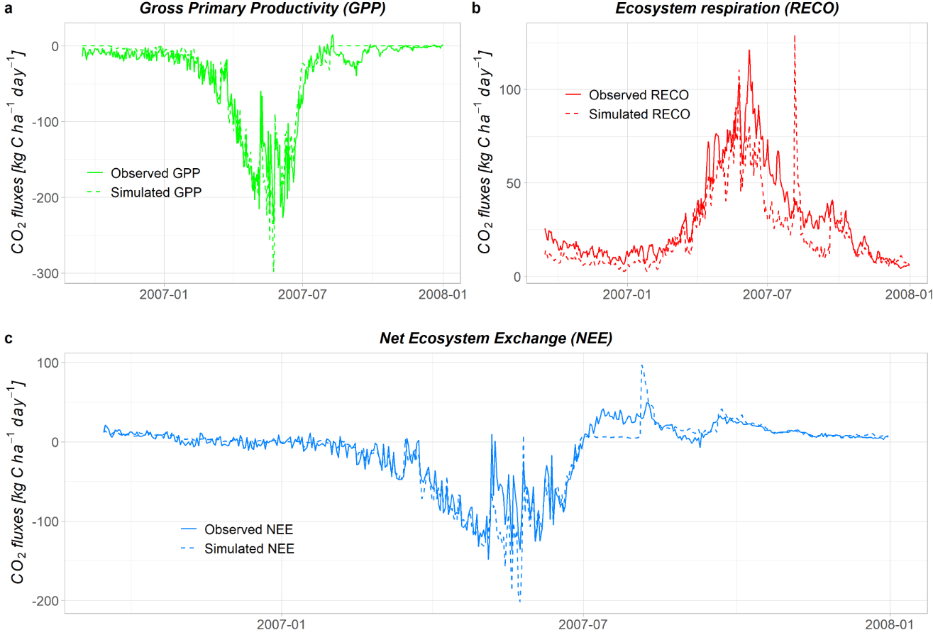
Figure 12: Dynamics of the CO₂ fluxes related to NEE (c), GPP (a) and RECO (b), observed and simulated, for a winter wheat cropping season at the BE-LON ICOS site of Lonzée (Belgium) - From Delandmeter et al., 2023.

11 Conclusion
Throughout this chapter - constructed around a general presentation and numerous illustrations of STICS model uses - the reader would have the opportunity to discover the STICS soil-crop model abilities and performances. This was also a great occasion to present an overview of the wide domain of validity of the model, which has demonstrated its potential for a wide range of agronomic and environmental applications. Since the beginning of its story in the early 90’s, STICS has been able to remain a generic and robust model that allows to simulate the functioning of a wide range of agro-ecosystems, both in temperate and tropical environments.
As highlighted in this chapter, and particularly in the last two sections, many efforts were, and are still, put to keep the model up-to-date and in a permanent state of evolution towards better representation of cropping systems, allowing to analyze novel research and applied questions. This is made possible thanks to a strong collaboration between the team of engineers and researchers associated to (re)design and enhance the model and a large community of users with complementary expertises. The users’ community is well organized and freely opened to any contributors willing to improve STICS. We believe that STICS will be valuable to help support the design of innovative cropping systems, meeting tomorrow’s future challenges of an ever-changing world, in particular for the necessary ecological transition of agriculture and to sustain the adaptation (and mitigation) to climate change.
The STICS model and its graphical user interface, JavaSTICS, are freely accessible at https://stics.inrae.fr/eng/download under the CeCILL-B license Compiled versions are available for Windows, Mac and Linux users. Comprehensive documentation is provided to guide users through the installation process and the use of the interface. The source code of the STICS model is also available under the CeCILL-C license and can be downloaded from the same link. The full text of the CeCILL-B and CeCILL-C licenses can be found at: https://cecill.info/licences/Licence_CeCILL-B_V1-en.html and https://cecill.info/licences/Licence_CeCILL-C_V1-en.html.
The model’s equations and instructions for use are extensively detailed in Beaudoin et al. (2023), which is available as a free ebook or PDF at https://stics.inrae.fr/eng/resources/documentation. Additionally, the SticsRPacks R packages are open-source and come with detailed documentation. These packages are freely available on GitHub under the LGPL license at https://github.com/SticsRPacks. Links to each specific pack out of the four R packs can be found directly in the reference section: Lecharpentier et al. (2024a) for SticsRFiles, Lecharpentier et al. (2024b) for SticsOnR, Buis et al. (2023) for CroptimizR and Vezy et al. (2024) for CroPlotR.

12 Acknowledgements
The authors would like to thank the INRAE AgroEcoSystem department for providing financial support to the STICS Project Team. The authors thank all physiologists and modelers whose work and publications enabled the modelling of plant processes. The authors would like to thank all the people and institutes involved in acquiring the experimental data used for the development of the STICS model. The authors also thank the F.R.S.-FNRS (Belgian Fund for Scientific Research) which awarded a Research Fellow grant (number 44221) to M. Delandmeter.

13 References
Artru, S., 2017. Impact of spatio-temporal shade on crop growth and productivity, perspectives for temperate agroforestry. Doctoral thesis, ULiège - Université de Liège. ORBi-University of Liège. https://hdl.handle.net/2268/211276

Asseng, S., Martre, P., Maiorano, A., and others, 2019. Climate change impact and adaptation for wheat protein. Global Change Biology, 25 (1), 155-173. doi:10.1111/gcb.14481

Autret B., Mary B., et al., 2020. Long-term modelling of crop yield, nitrogen losses and GHG balance in organic cropping systems. Science of the Total Environment, 710, 134597. https://doi.org/10.1016/j.scitotenv.2019.134597
Basso, B., Dumont, B., Maestrini, Á., Shcherbak, I., Robertson, G. P., Porter, J. R., Smith, P., Paustian, K., Grace, P. R., Asseng, S., Bassu, S., Biernath, C., Boote, K. J., Cammarano, D., De Sanctis, G., Durand, J.L., Ewert, F., Gayler, S., Hyndman, D. W., Kent, J., Martre, P., Nendel, C., Priesack, E., Ripoche, D,. Ruane, A. C., Sharp, J., Thorburn, P. J., Hatfield, J. L., Jones, J. W., Rosenzweig,C., 2018. Soil Organic Carbon and Nitrogen Feedbacks on Crop Yields under Climate Change. Agricultural & Environmental Letters, 3: 180026.
Basso, B., Shuai, G., Zhang, J., Robertson, G.P., 2019. Yield stability analysis reveals sources of large-scale nitrogen loss from the US Midwest. Sci Rep 9, 5774. https://doi.org/10.1038/s41598-019-42271-1

Bassu, S., Brisson, N., Durand, J.L., Boote, K., Lizaso, J., Jones, J.W., Rosenzweig, C., Ruane, A.C., Adam, M., Baron, C., Basso, B., Biernath, C., Boogaard, H., Conijn, S., Corbeels, M., Deryng, D., De Sanctis, G., Gayler, S., Grassini, P., Hatfield, J., Hoek, S., Izaurralde, C., Jongschaap, R., Kemanian, A.R., Kersebaum, K.C., Kim, S.H., Kumar, N.S., Makowski, D., Müller, C., Nendel, C., Priesack, E., Pravia, M.V., Sau, F., Shcherbak, I., Tao, F., Teixeira, E., Timlin, D., and Waha, K., 2014. How do various maize crop models vary in their responses to climate change factors? Glob. Change Biol. 20(7): 2301–2320. DOI: 10.1111/gcb.12520

Beaudoin, N., Lecharpentier, P., Ripoche-Wachter, D., Strullu, L., Mary, B., Léonard, J., Launay, M., Justes, É., 2023. Stics Soil Crop Model. éditions Quae. https://doi.org/10.35690/978-2-7592-3679-4

Beer, A., 1852. Ann. Physik (Poggendorf), 86, 78

Benoit, M., Garnier, J., Billen G., 2015. Temperature dependence of nitrous oxide production of a luvisolic soil in batch experiments. Process Biochem., 50, pp. 79-85. DOI: 10.1016/j.procbio.2014.10.013

Bessou C., Mary B., Leonard J., Roussel M., Grehan E., Gabrielle B., 2010. Modelling soil compaction impacts on nitrous oxide emissions in arable fields. European Journal of Soil Science 61, 348–363. https://doi.org/10.1111/j.1365-2389.2010.01243.x

Blackmore, S., 2000. The interpretation of trends from multiple yield maps. Computers and Electronics in Agriculture 26, 37–51. https://doi.org/10.1016/S0168-1699(99)00075-7

Brisson, N., Bussière, F., Ozier-Lafontaine, H., Tournebize, R., and Sinoquet, H., 2004. Adaptation of the crop model STICS to intercropping. Theoretical basis and parameterisation. Agronomie 24, 409–421. DOI: 10.1051/agro:2004031

Brisson N., Mary B., Ripoche D., Jeuffroy M.H., Ruget F., Nicoullaud B., Gate P., Devienne-Barret F., Antonioletti R., Durr C., Richard G., Beaudoin N., Recous S., Tayot X., Plenet D., Cellier P., Machet J.-M., Meynard J.M., Delécolle R., 1998b. STICS: A generic model for the simulation of crops and their water and nitrogen balances. I. Theory and parameterization applied to wheat and corn. Agronomie 18, 311–346. https://doi.org/10.1051/agro:19980501

Brisson Nadine, Ruget F., Gate P., Lorgeou J., Nicoullaud B., Tayot X., Plenet D., Jeuffroy M.-H., Bouthier A., Ripoche D., Mary B., Justes E., 2002. STICS: A generic model for simulating crops and their water and nitrogen balances. II. Model validation for wheat and maize. Agronomie 22, 69–92. https://doi.org/10.1051/agro:2001005

Brisson N., Seguin B., Bertuzzi P., 1992. Agrometeorological soil water balance for crop simulation models. Agricultural and Forest Meteorology 59, 267–287. https://doi.org/10.1016/0168-1923(92)90097-N
Buis, S., Lecharpentier, P., Vezy, R., & Giner, M., 2023. CroptimizR: A Package to Estimate Parameters of Crop Models. Zenodo. https://doi.org/10.5281/zenodo.4066451, https://github.com/SticsRPacks/CroptimizR.
Buis, S., Wallach, D., Guillaume, S., Varella, H., Lecharpentier, P., Launay, M., Guérif, M., Bergez, J.-E., Justes E., 2011. The STICS Crop Model and Associated Software for Analysis, Parameterization, and Evaluation. In Methods of Introducing System Models into Agricultural Research, Volume 2, Chapter 14, Eds Laj R. Ahuja, Liwang Ma. https://doi.org/10.2134/advagricsystmodel2.c14

Caubel, J., Launay, M., Lannou, C. and Brisson, N., 2012. Generic response functions to simulate climate-based processes in models for the development of airborne fungal crop pathogens. Ecological Modelling 242: 92-104. DOI:10.1016/j.ecolmodel.2012.05.012
Caubel, J., Launay, M., Ripoche, D., Gouache, D., Buis, S., Huard, F., Huber, L., Brun, F. and Bancal, M. O., 2017. "Climate change effects on leaf rust of wheat: Implementing a coupled crop-disease model in a French regional application." European Journal of Agronomy 90: 53-66. https://doi.org/10.1016/j.eja.2017.07.004
Celette, F., Gary C., 2013. Dynamics of water and nitrogen stress along the grapevine cycle as affected by cover cropping. Eur. J. Agron., 45, pp. 142-152, DOI : 10.1016/j.eja.2012.10.001

Chaves, B., Léonard, J., Ferchaud, F., Schmatz, R., Recous, S., Giacomini, S.J., 2024. Modelling decomposition of crop residue mulches and the associated N2O emissions in a no-till system in southern Brazil. Soil and Tillage Research 240, 106065. https://doi.org/10.1016/j.still.2024.106065

Clivot, H., Mary, B., Valé, M., Cohan, J. P., Champolivier, L., Piraux, F., and others, 2017. Quantifying in situ and modeling net nitrogen mineralization from soil organic matter in arable cropping systems. Soil Biology and Biochemistry, 111, 44-59. https://doi.org/10.1016/j.soilbio.2017.03.010

Clivot, H., Mouny, J. C., Duparque, A., Dinh, J. L., Denoroy, P., Houot, S.,and others, 2019. Modeling soil organic carbon evolution in long-term arable experiments with AMG model. Environmental modelling & software, 118, 99-113. https://doi.org/10.1016/j.envsoft.2019.04.004

Clivot, H., Ferchaud, F., et al., 2020. Simulating soil organic carbon dynamics in long-term bare fallow and arable experiments with STICS model, in: Book of Abstracts. Montpellier (France), pp. 70–71. https://hal.inrae.fr/hal-02737949

Confalonieri, R., Bregaglio, S., Adam, M., Ruget, F., Li, T., Hasegawa, T.,and others, 2016. A taxonomy-based approach to shed light on the babel of mathematical models for rice simulation. Environmental Modelling & Software, 85, 332-341.

Cordell, D., White, S., 2014. Life’s Bottleneck: Sustaining the World’s phosphorus for a food secure future. Annual Review of Environment and Resources, Vol 39 39, 161-188. https://doi.org/10.1146/annurev-environ-010213-113300

Corre-Hellou G, Brisson N, Launay M and others, 2007. Effect of root depth penetration on soil nitrogen competitive interactions and dry mat- ter production in pea–barley intercrops given different soil nitro- gen supplies. Field Crop Res 103:76–85. https://doi org/10. 1016/j.fcr.2007.04.008

Corre-Hellou G, Faure M, Launay M and others, 2009. Adaptation of the STICS intercrop model to simulate crop growth and N accumula- tion in pea–barley intercrops. Field Crop Res 113:72–81. https://doi.org/10.1016/j.fcr.2009.04.007

Couëdel, A., Falconnier, G.N., Adam, M., Cardinael, R., Boote, K., Justes, E., and others, 2024.Long-term soil organic carbon and crop yield feedbacks differ between 16 soil-crop models in sub-Saharan Africa. European Journal of Agronomy, 155, 127109. https://doi.org/10.1016/j.eja.2024.127109

Cruz, P., Theau, J.-P., Lecloux, E., Jouany, C., Duru, M., 2010. Functional typology of perennial forage grasses : a classification based on several characteristics. Fourrages 11–17.

Das, B., Huth, N., Probert, M., Condron, L., Schmidt, S., 2019. Soil phosphorus modeling for modern agriculture requires balance of science and practicality: a perspective. Journal of Environmental Quality 48, 1281–1294. https://doi.org/10/gf9x6d
De Freitas Mathilde. 2023. Intercropping cereals and legumes to stabilise yield in the tropics: evaluation of the STICS soil-crop model to simulate bi-specific intercrops. Montpellier : AgroParisTech, 57 p. Mémoire d'ingénieur : Produire et innover dans les systèmes techniques végétaux (PISTv) : AgroParisTech
Delandmeter, M., Léonard, J., Ferchaud, F., Heinesch, B., Manise, T., Faurès, A., Bindelle, J., Dumont, B. (2023). A comprehensive analysis of CO2 exchanges in agro-ecosystems based on a generic soil-crop model-derived methodology. Agricultural and Forest Meteorology, 340, 109621. https://doi.org/10.1016/j.agrformet.2023.109621
Delandmeter, M., de Faccio Carvalho, P. C., Bremm, C., dos Santos Cargnelutti, C., Bindelle, J., & Dumont, B., 2024. Integrated crop and livestock systems increase both climate change adaptation and mitigation capacities. Science of the Total Environment, 912, 169061. https://doi.org/10.1016/j.scitotenv.2023.169061
Del Grosso, S.J., Parton, W.J., Mosier, A.R., Hartman, M.D., Brenner, J., Ojima, D.S., Schimel, D.S., 2001. Simulated interaction of carbon dynamics and nitrogen trace gas fluxes using the DAYCENT model. In: M. Schaffer, M., L. Ma, L. S. Hansen, S. (Eds.), Modeling Carbon and Nitrogen Dynamics for Soil Management. CRC Press, Boca Raton, Florida, pp. 303-332.
De Willigen, P., Van Noordwijk, M., 1987. Roots, plant production and nutrient use efficiency (PhD). Wageningen Agricultural University, Wageningen, The Netherlands.
De Willigen, P., Van Noordwijk, M., 1994. Mass flow and diffusion of nutrients to a root with constant or zero-sink uptake. II. Zero-sink uptake. Soil Science 157, 171–175.
de Wit C.T. (Ed.), 1978. Simulation of assimilation, respiration and transpiration of crops, Centre for Agricultural Publishing and Documentation., Simulation monographs. Pudoc, Wageningen, The Netherlands.

Dumont, B., Basso, B., Bodson, B., Destain, J.-P., Destain, M.-F., 2015a. Climatic risk assessment to improve nitrogen fertilisation recommendations: A strategic crop model-based approach. European Journal of Agronomy 65, 10–17. https://doi.org/10.1016/j.eja.2015.01.003

Dumont, B., Basso, B., Leemans, V., Bodson, B., Destain, J.-P., Destain, M.-F., 2015b. Systematic analysis of site-specific yield distributions resulting from nitrogen management and climatic variability interactions. Precision Agric 16, 361–384. https://doi.org/10.1007/s11119-014-9380-7

Dumont, B., Basso, B., Bodson, B., Destain, J.-P., Destain, M.-F., 2016. Assessing and modeling economic and environmental impact of wheat nitrogen management in Belgium. Environmental Modelling & Software 79, 184–196. https://doi.org/10.1016/j.envsoft.2016.02.015

Dumont,B., Leemans, V., Mansouri, M., Bodson, B., Destain, J.-P., Destain, M.-F., 2014. Parameter optimisation of the STICS crop model, with an accelerated formal MCMC approach. Environ. Model. Softw., 52, pp. 121-135. https://doi.org/10.1016/j.envsoft.2013.10.022

Duru, M., Cruz, P., Martin, G., Desange, M., Jouany, C., Zerourou, A., 2010. Herb’sim, a model for a rational management of grass production and grass utilization. Fourrages 201, 37–46.

Farina, R., Sándor, R., Abdalla, M., Álvaro‐Fuentes, J., Bechini, L., Bolinder, M. A., and others, 2021. Ensemble modelling, uncertainty and robust predictions of organic carbon in long‐term bare‐fallow soils. Global Change Biology, 27(4), 904-928. https://doi.org/10.1111/gcb.15441

Fort, F., Jouany, C., Cruz, P., 2013. Root and leaf functional trait relations in Poaceae species: implications of differing resource-acquisition strategies. Journal of Plant Ecology 6, 211–219. https://doi.org/10.1093/jpe/rts034

Fraga, H., García de Cortázar Atauri I., Malheiro, A.C., Santos, J.A., 2016. Modelling climate change impacts on viticultural yield, phenology and stress conditions in Europe. Global Change Biology 22(11):3774-3788. DOI: 10.1111/gcb.13382

Freschet, G.T., Valverde-Barrantes, O.J., et al., 2017. Climate, soil and plant functional types as driv-ers of global fine-root trait variation. J Ecol 105, 1182–1196. https://doi.org/10.1111/1365-2745.12769

García de Cortázar Atauri I., 2006. Adaptation du modèle STICS à la vigne (Vitis vinifera L.) : Utilisation dans le cadre d’une étude d’impact du changement climatique à l’échelle de la France. Doctoral Thesis. École nationale supérieure agronomique de Montpellier. http://www.theses.fr/2006ENSA0030

García de Cortázar Atauri, I., Brisson, N., Gaudillere, J.P., 2009a. Performance of several models for predicting budburst date of grapevine (Vitis vinifera L.). International Journal of Biometeorology 53, 317–326. https://doi.org/10.1007/s00484-009-0217-4

García de Cortázar Atauri, I., Brisson, N., Ollat, N., Jacquet, O., Payan, J.C., 2009b. Asynchronous dynamics of grapevine ("Vitis vinifera") maturation: Experimental study for a modelling approach. Journal International des Sciences de la Vigne et du Vin 43, 83–97. https://doi.org/10.20870/oeno-one.2009.43.2.801

Graux, A.I., Cadéro A., Buis S., Casellas, E., Decaud M.L., Lecharpentier P., Louault F., Vertès F., Ferchaud F., 2023. STICS ability to simulate long-term soil organic matter dynamics in crop-grassland rotations. XIII Séminaire STICS, Bordeaux, 13-16 novembre 2023. https://hal.inrae.fr/hal-04637939

Graux, A.I., Cadéro A., Buis S., Casellas, E., Decaud M.L., Lecharpentier P., Louault F., Vertès F., Ferchaud F., 2024. Calibration and evaluation of the STICS model for long-term simulation of soil organic carbon dynamics in grassland soils (in prep.)

Graux, A.-I., Resmond, R., Casellas, E., Delaby, L., Faverdin, P., Le Bas, C., Ripoche, D., Ruget, F., Thérond, O., Vertès, F, Peyraud, J.-L., 2020. High-resolution assessment of French grassland dry matter and nitrogen yields. Eur. J. Agron., 112, 125952. https://doi.org/10.1016/j.eja.2019.125952

Hénault, C. and Germon, J.C., 2000. NEMIS, a predictive model of denitrification on the field scale. European Journal of Soil Science, 51 (2), 257-270. https://doi.org/10.1046/j.1365-2389.2000.00314.x

Jouven, M., Carrere, P., Baumont, R., 2006. Model predicting dynamics of biomass, structure and digestibility of herbage in managed permanent pastures. 1. Model description. Grass and Forage Science 61, 112–124. https://doi.org/10.1111/j.1365-2494.2006.00515.x

Khalil K., Mary B., Renault P., 2004. Nitrous oxide production by nitrification and denitrification in soil aggregates as affected by O2 concentration. Soil Biology and Biochemistry 36, 687–699. https://doi.org/10.1016/j.soilbio.2004.01.004

Kherif, O., Seghouani, M., Justes, E., Plaza-Bonilla, D., Bouhenache, A., Zemmouri, B., et al., 2022. The first calibration and evaluation of the STICS soil-crop model on chickpea-based intercropping system under Mediterranean conditions. Eur. J. Agron. 133, 126449. DOI: 10.1016/j.eja.2021.126449

Kimball, B.A.; Boote, K.J.; Hatfield, J.L.; Ahuja, L.R.; Stockle, C. and others, 2019. Simulation of maize evapotranspiration: An inter-comparison among 29 maize models. Agricultural and Forest Meteorology, 271, 264-284. DOI: 10.1016/j.agrformet.2019.02.037

Kothari, K., Battisti, R., Boote, K., Archontoulis, S., Confalone, A., Constantin, J., and others, 2021. Are soybean models ready for climate change food impact assessments? European Journal of Agronomy, 135, 126482. https://doi.org/10.1016/j.eja.2022.126482

Launay, M., Brisson, N., Satger, S., Hauggaard-Nielsen, H., Corre-Hellou, G., Kasynova, E., et al., 2009. Exploring options for managing strategies for pea-barley intercropping using a modeling approach. Eur. J. Agron. 31, 85–98. DOI: 10.1016/j.eja.2009.04.002

Lecharpentier, P., Vezy, R., Buis, S., & Giner, M., 2024a. SticsRFiles: Read and Modify 'STICS' Input/Output Files. https://doi.org/10.5281/zenodo.4443206, https://cran.r-project.org/web/packages/SticsRFiles/index.html .
Lecharpentier, P., Vezy, R., Buis, S., & Giner, M., 2024b. SticsOnR: Manage STICS Simulations Running the Executable or JavaStics. https://doi.org/10.5281/zenodo.4443130, https://github.com/SticsRPacks/SticsOnR.
Legay, N., Lavorel, S., et al., 2016. Influence of plant traits, soil microbial properties, and abiotic pa-rameters on nitrogen turnover of grassland ecosystems. Ecosphere 7, e01448. https://doi.org/10.1002/ecs2.1448

Legrain, X., Demarcin, P., Colinet, G., Bock, L., 2011. Cartographie des sols en Belgique : aperçu historique et présentation des travaux actuels de valorisation et de révision de la Carte Numérique des Sols de Wallonie. Biotechnologie, Agronomie, Société et Environnement, 15 (S2), 647-656.

Lemaire G., Gastal F., 1997. N uptake and distribution in plant canopies, in: Lemaire, G. (Ed.), Diagnosis of the Nitrogen Status in Crops. Springer, Berlin, Heidelberg, pp. 3–43. https://doi.org/10.1007/978-3-642-60684-7_1

Lemaire, G., Jeuffroy, M.H., Gastal, F., 2008. Diagnosis tool for plant and crop N status in vegetative stage theory and practices for crop N management. Eur J Agron 28, 614–624. https://doi.org/10.1016/j.eja.2008.01.005

Lemaire, G., Sinclair, T., Sadras, V., Bélanger, G., 2019. Allometric approach to crop nutrition and implications for crop diagnosis and phenotyping. A review. Agron. Sustain. Dev. 39, 27. https://doi.org/10.1007/s13593-019-0570-6

Lenoir, A., 2024. Opportunité des outils numériques pour optimiser la fertilisation azotée du blé à l’échelle d’un territoire Doctoral thesis, ULiège - Université de Liège. ORBi-University of Liège. https://hdl.handle.net/2268/318782

Lenoir, A., Vandoorne, B., Siah, A., Dumont, B.., 2024. Advancing Blackmore’s methodology to delineate management zones from Sentinel 2 images. Precision Agric 25, 1360–1385. https://doi.org/10.1007/s11119-024-10115-2.

Major, D, Hanna, M.R., Beasley, B.W., 1991. Photoperiod response characteristics of alfalfa ( Medicago sativa L.) cultivars. Canadian Journal of Plant Science 71(1):87-93. DOI: 10.4141/cjps91-010

Mary, B., Beaudoin, N., Justes, E., & Machet, J. M., 1999. Calculation of nitrogen mineralization and leaching in fallow soil using a simple dynamic model. European journal of soil science, 50(4), 549-566. https://doi.org/10.1016/0168-1923(92)90097-N

Mokany, K.l, Raison R. J., Prokushkin, A. S., 2006. Critical Analysis of Root : Shoot Ratios in Terrestrial Biomes. Global Change Biol 12, no 1: 84‑96. https://doi.org/10.1111/j.1365-2486.2005.001043.x.

Mollier, A., De Willigen, P., Heinen, M., Morel, C., Schneider, A., Pellerin, S., 2008. A two dimensional simulation model of phosphorus uptake including crop growth and P response. Ecological Modelling 210, 453–464. https://doi.org/10/bkqvbc

Monteith J.L., 1965. Evaporation and environment. Cambridge University Press, pp. 205–234.

Monteith J.L., 1972. Solar Radiation and Productivity in Tropical Ecosystems. The Journal of Applied Ecology 9, 747–766. https://doi.org/10.2307/2401901

Morel, C., Plénet, D., Mollier, A., 2021. Calibration of maize phosphorus status by plant-available soil P assessed by common and process-based approaches. Is it soil-specific or not? European Journal of Agronomy 122, 126174. https://doi.org/10.1016/j.eja.2020.126174

Morel, C., Tunney, P., Plenet, D., Pellerin, S., 2000. Transfer of phosphate ions between soil and solution: Perspectives in soil testing. J Environ Qual 29, 50–59. ttps://doi.org/10.2134/jeq2000.00472425002900010007x

Nicolardot B., Recous S., Mary B., 2001. Simulation of C and N mineralisation during crop residue decomposition: A simple dynamic model based on the C:N ratio of the residues. Plant and Soil 228, 83–103. https://doi.org/10.1023/A:1004813801728

Pagès, L., Bécel, C., Boukcim, H., Moreau, D., Nguyen, C., Voisin, A.-S., 2014. Calibration and evaluation of ArchiSimple, a simple model of root system architecture, Ecological Modelling, 290 76-84.
https://doi.org/10.1016/j.ecolmodel.2013.11.014.

Priestley C.H.B., Taylor R.J., 1972. On the assessment of surface heat flux and evaporation using large-scale parameters. Monthly Weather Review 100, 81–92. https://doi.org/10.1175/1520-0493(1972)100%3C0081:OTAOSH%3E2.3.CO;2

Rochester, I.J., 2003. Estimating nitrous oxide emissions from flood-irrigated alkaline grey clays. Austr. J. Soil Res., 41 (2). DOI: 10.1071/SR02068

Rosenzweig C et al. 2013 The agricultural model intercomparison and improvement project (AgMIP): protocols and pilot studies Agric. Forest Meteorol. 170 166–82. https://doi.org/10.1016/j.agrformet.2012.09.011

Ruget,F., King, D., Brisson, N., Daroussin, J., Nicoullaud, B., Ngongo, M., 1994. Principes generaux du systeme GOA. Le module mais. Application a l'estimation des potentialités agroclimatiques dans la Communauté Européenne. Délimitation de zones aux potentialités agricoles équivalentes en France et dans la Communauté pour optimiser les réseaux d'expérimentation des variétés, INRA. ⟨hal-02845413⟩

Schoving, C., Champolivier, L., Maury, P., Debaeke, P., 2022. Combining multi-environmental trials and crop simulation to understand soybean response to early sowings under contrasting water conditions. European Journal of Agronomy, 133, 126439. https://doi.org/10.1016/j.eja.2021.126439

Seghouani, M., Bravin, M. N., Lecharpentier, P., Mollier, A., 2025. Simulating phosphorus dynamics between the soil and the crop with the STICS model: Formalization and multi-site evaluation on maize in temperate area. European Journal of Agronomy, 164, 127475.

Shili-Touzi I, De Tourdonnet S, Launay M, Dore T, 2010. Does inter- cropping winter wheat (Triticum aestivum) with red fescue (Fes- tuca rubra) as a cover crop improve agronomic and environmental performance? A modeling approach. Field Crop Res 116:218– 229. https://doi.org/10.1016/j.fcr.2009.11.007

Smith J, Gottschalk P, Bellarby J, Chapman S and others, 2010 Estimating changes in Scottish soil carbon stocks using ECOSSE. I. Model description and uncertainties. Clim Res 45:179-192. https://doi.org/10.3354/cr00899

Spaeth S.C., Sinclair T.R., 1985. Linear Increase in Soybean Harvest Index during Seed-Filling. Agronomy Journal 77, 207–211. https://doi.org/10.2134/agronj1985.00021962007700020008x

Strullu, L., Beaudoin, N., García de Cortázar-Atauri, I., Mary, B., 2014. Simulation of biomass and nitrogen dynamics in perennial organs and shoots of Miscanthus * giganteus using the STICS model. BioEnergy Research 7, 1253–1269. https://doi.org/10.1007/s12155-014-9462-4

Strullu, L., Ferchaud, F., Yates, N., Shield, I., Beaudoin, N., Garcia de Cortazar-Atauri, I., Besnard, A., Mary, B., 2015. Multisite Yield Gap Analysis of Miscanthus × giganteus Using the STICS Model. Bioenerg. Res. 8, 1735–1749. https://doi.org/10.1007/s12155-015-9625-y

Strullu, L., Beaudoin, N., Thiébeau, P., Julier, B., Mary, B., Ruget, F., Ripoche, D., Rakotovololona, L., Louarn, G., 2020. Simulation using the STICS model of C&N dynamics in alfalfa from sowing to crop destruction. European Journal of Agronomy 112, 125948. https://doi.org/10.1016/j.eja.2019.125948

Strullu, L., Deheinzelin, A.,García de Cortázar Atauri, I., Demestihas, C., 2023. Improvement of grapevine yield simulation in Champagne with the STICS model. 13th Seminar of the STICS users, Nov. 13-16, 2023, Bordeaux, France. https://stics.inrae.fr/content/download/4009/47243?version=1

Tavernier, R. and Maréchal, R., 1958. Carte des Associations de Sols de la Belgique. Pédologie 8: 134-182.

Traoré, A., Falconnier, G. N., Ba, A., Sissoko, F., Sultan, B., and Affholder, F., 2022. Modeling sorghum-cowpea intercropping for a site in the savannah zone of Mali : Strengths and weaknesses of the Stics model. F. Crop. Res. 285. DOI: 10.1016/j.fcr.2022.108581

Van Der Ploeg R.R., Ringe H., Machulla G., 1995. Late Fall Site‐Specific Soil Nitrate Upper Limits for Groundwater Protection Purposes. Journal of Environmental Quality 24, 725–733. https://doi.org/10.2134/jeq1995.00472425002400040025x

Vezy, R., Munz, S., Gaudio, N., Launay, M., Lecharpentier, P., Ripoche, D., and others, 2023. Modeling soil ‑ plant functioning of intercrops using comprehensive and generic formalisms implemented in the STICS model. Agron. Sustain. Dev. DOI: 10.1007/s13593-023-00917-5.
Vezy, R., Buis, S., Midingoyi, C., Lecharpentier, P., & Giner, M., 2024. CroPlotR: A Package to Analyze Crop Model Simulations Outputs with Plots and Statistics. https://doi.org/10.5281/zenodo.4442330, https://github.com/SticsRPacks/CroPlotR
Vieten, B., Conen, F., Seth, B., Alewell, C., 2008. The fate of N2O consumed in soils. Biogeosciences, 5, pp. 129-132 DOI : 10.5194/bg-5-129-2008
Wallace J.S., 1995. Towards a coupled light partitioning and transpiration model for use in intercrops and agroforestry.
Wallach, D., Buis, S., Lecharpentier, P., Bourges, J., Clastre, P., Launay, M., Bergez, J.-E., Guerif, M., Soudais, J., Justes, E., 2011. A package of parameter estimation methods and implementation for the STICS crop-soil model. Environmental Modelling & Software, 26(4), 386-394. https://doi.org/10.1016/j.envsoft.2010.09.004
Wallach, D., Palosuo, T., Thorburn, P., Mielenz, H., Buis, S., Hochman, Z., Gourdain, E., Andrianasolo, F., Dumont, B., and others, 2023. Proposal and extensive test of a calibration protocol for crop phenology models. Agronomy for sustainable development, 43(4), 46. https://doi.org/10.1007/s13593-023-00900-0
Wedin, D.A., Tilman D., 1990. Species effects on nitrogen cycling: a test with perennial grasses. Oecologia, 84, 433–441.

Wichern, F., Eberhardt, E., Mayer, J., Joergensen, R.G., Müller, T., 2008. Nitrogen rhizodeposition in agricultural crops: methods, estimates and future prospects. Soil Biology and Biochemistry, 40(1), 30-48. https://doi.org/10.1016/j.soilbio.2007.08.010

Yin, X., Beaudoin N., et al., 2020. Long-Term Modelling of Soil N Mineralization and N Fate Using STICS in a 34-Year Crop Rotation Experiment. Geoderma 357: 113956. https://doi.org/10.1016/j.geoderma.2019.113956.

