MXene-based composite aerogel materials as passive thermal shields at Moon conditions using 3D modelling
Aniello Zabatta^{a*}, Hatim Machrafi^{a,b}, Carlo Saverio Iorioª, Sebastien Vincent-Bonnieu^{c}

ªCentre for Research and Engineering in Space Technologies, Université Libre de Bruxelles, 1050 Brussels, Belgium; aniello.zabatta@ulb.be, hatim.machrafi@ulb.be, Carlo.Iorio@ulb.be
^{b}GIGA-In Silico Medicine, Université de Liège, 4000 Liège, Belgium; hatim.machrafi@ulb.be
^{c}ESA/ESTEC, European Space Research and Technology Centre, Keplerlaan 1, 2201 AZ Noordwijk, the Netherlands; Sebastien.Vincent-bonnieu@esa.int
*To whom Correspondence may be addressed.

Abstract
Thermal protection systems that integrate management capabilities of thermal radiation are essential to not jeopardize payload operativity and survivability, and to secure shelters and Moon bases when astronauts are operating on the Moon’s surface. This work envisions the potentiality of lightweight, high-performance insulation material, exploring the role of a composite aerogel material based on MXenes, lunar regolith, and polyimide (PI) as a passive thermal protection system for payloads during lunar exploration. Advanced numerical simulations were conducted to assess the thermal performance of these composites under lunar environmental conditions, modelling temperature fluctuations across both lunar day and night. The results indicate that lunar regolith and MXenes enhance the heat retention properties of the insulation aerogel material, minimizing heat loss during the lunar night, suggesting the importance of having composite materials to provide solutions for maintaining the integrity and operability of payloads in the harsh lunar environment, extendable to harsh environments on Earth.
Keywords: Aerogel composite material; MXenes; ISRU; Lunar regolith; Passive protective shield
Highlights
- Aerogel composites using lunar regolith as ISRU offer a suitable thermal shielding solution
- MXenes offer superior thermal regulation in the harsh conditions of the Moon
- MXenes with lunar regolith balance heat transfer, retaining heat during the night and preventing overheating during the day

1 Introduction
The moon has the potential to become a catalyst for future space explorations, offering the opportunity to advance in science, technology, and growing our understanding of the universe. Ambitious lunar exploration missions are currently on-going, involving both government institutions and private sectors, suggesting the Moon’s pivotal role for the next space missions. To translate these ambitions in accomplished missions, it is fundamental to provide adequate means, which aims to support the long-term lunar exploration, threatened by the Moon’s hostile environment. In particular, the thermal cycling is extreme due to lunar day/night cycle, characterized by about 14 days of continuous sunlight and 14 days of continuous darkness. Temperature variations, ranging between 120°C (lunar day) and -180°C (lunar night), can be experienced on the Moon’s surface, with even colder temperatures down to -250 °C if we consider some permanent shadowed regions[1].
Thermal protection systems are essential for not jeopardizing payload operativity and survivability and securing shelters and Moon bases when astronauts are operating on the Moon’s surface. Passive solutions are oriented toward the development of lightweight, high-performance thermal insulation materials that require superior thermal management capabilities. Although the use of these solutions cannot be used to actively heating or cooling, they act as a protective layer to insulate heat flow and dampen temperature oscillations and act as a synergistic support for active systems, reducing the overall energy required. In space, especially in severe vacuum environments like on the Moon (p = 10⁻¹² mbar)[2], the heat transfer is dominated by conduction and radiation. For this reason, the thermal properties of solid materials (thermal conductivity, heat capacity, etc.) and their radiative properties (surface emissivity, absorptivity, etc.) should be accurately investigated. For example, a thermal protection system for the moon must provide adequate thermal insulation through low thermal conductivity, trying to minimize dissipation during the lunar night (e.g., low emissivity) and allow heat storage during the lunar day. All these features are not easy to find in a single material type, therefore a composite material concept should be preferred to face the thermal protection challenge on the Moon’s surface (Figure 1).
As promising approach to design a composite material suitable for Moon environment, aerogel-based materials can constitute a baseline structure thanks to their ultralightweight and outstanding thermal insulation properties, superior to the traditional insulator materials[3]. They show low thermal conductivity attributed to the unique porous structure, consisting of up to 90% of the total volume and a solid network that effectively minimizes heat transfer through conduction, convection, and radiation. Moreover, aerogels have a remarkably low density, often between 0.01 to 0.5 g/cm³[4], making them some of the lightest solid materials available, which is advantageous for weight-sensitive applications. Aerogels are not only exceptional as standalone thermal insulators but also have the unique ability to be turned into composite materials, further enhancing their versatility. Due to their porous structure and tuneable properties, aerogels can be combined with other materials, such as polymers, fibers, ceramics or metals, to create composites with enhanced thermal properties without compromising their lightweight nature or thermal insulation performance. By forming composites, aerogels extend their suitability to a broader range of environments, enhancing their integration into high-performance thermal insulation systems. They have found many potential applications, namely thermal applications (e.g., insulation, fire retardant, etc.), catalysis, electronics, sensors, waste containment, energy storage capacitors, acoustics, and pharmaceuticals[5].
To achieve an aerogel with thermal protection and heat retention capabilities, lunar regolith can be identified as potential in-situ element to build a composite material with substantial thermal inertia. Several studies have been performed using lunar regolith as In-Situ Resource Utilization (ISRU) thermal mass for heat storage on the Moon's surface[6–8], suggesting its potential to be embedded in an aerogel structure. Several substrates can be employed to generate aerogel composite materials. Recently, organic and polymeric substrates have gained attention due to their intrinsic properties. Polyimide-based (PI) aerogels have emerged as one of the most promising organic aerogels due to their superior properties, overcoming the inherent fragility of silica aerogels, offering excellent mechanical strength while maintaining high resistance to both extreme high (T_{g}>250°C) and low temperatures[9]. These enhanced characteristics make PI aerogels a more robust and versatile alternative to traditional inorganic aerogels, while maintaining the ultralight density and low thermal conductivity of an aerogel (0.020 g*cm⁻³; 0.020 W*(m*K)⁻¹)[10,11]. These aerogels are promising for diverse applications in the fields of aerospace such as thermal insulation, extravehicular activity (EVA) suits, thermal protective systems (TPS), and so on. Moreover, these aerogels can be manufactured using the sol-gel process and dried via supercritical drying, freeze-drying or ambient drying[10–12]. These processes could in principle allow aerogels to be produced in situ by exploiting the environmental conditions of the lunar surface, taking advantage of the low temperature for freezing and the vacuum for drying (freeze-dried aerogels), avoiding the negative impact on transportation costs and concern for material integrity during ascent/landing.

The idea of producing aerogels on the Moon, while ambitious, is increasingly plausible in light of the advancements of ISRU technologies[13]. Current efforts—such as NASA’s PRIME-1[14] and other initiatives within the Artemis and PROSPECT programs[15]—aims to develop technical solutions for extracting water on the Moon, reducing the supply of valuable consumables from Earth. These projects represent a significant step forward, but substantial work remains before such technologies can support complex manufacturing processes. Once water extraction becomes reliable, a feasible path opens for producing aerogels directly on the lunar surface. Fine-grained lunar regolith, readily available across the Moon’s surface, could be transported by ad-hoc conveyance systems[16] to a processing unit where it is mixed with water and a small quantity of Earth-supplied polymer (less than 5 wt.%)[17]. The mixture could then be freeze-dried, taking advantage of the Moon’s natural cold traps to minimize energy use. This would make aerogel production energy-efficient—provided ISRU technologies continue to mature and are successfully deployed in upcoming missions.
Finally, another element is needed to enhance the radiative properties of composite aerogel material, providing the capacity to absorb heat from sunlight and controlling heat dissipation by radiation. As an emerging solution, MXenes, a class of 2D materials, have gained attention due to their radiation properties. Two-dimensional transition metal carbides and nitrides have shown diverse light-matter interactions in a broad frequency range, owing to their highly anisotropic electronic and optical properties[18]. MXenes have the general chemical formula M_{n+1}X_{n}T_{x} and can be described as comprising n+1 layers (n=1–4) of one or more group 3–6 early transition metals (M), interleaved by n layers of carbon and/or nitrogen atoms (X), with T_{x} denoting surface terminations (for example, –F, –O, –OH) on the outermost exposed M layers[19]. Ti₃C₂T_{X} MXenes are mostly studied for their stability and availability. Their behaviour with electromagnetic radiation has shown high solar absorptance up to 90% and a low IR emissivity down to 10%, yielding a high spectral selectivity for intrinsic solar absorbing materials[18–21]. It has also been shown that the emissivity of MXenes can be tuned by combining different transition metals, which suggests the possibility of employing them for different thermal control systems[21]. Thanks to these properties these materials are widely studied in applications such selective heating/cooling, IR camouflage, thermal circuits, and others[20]. Unlike traditional multilayer insulation (MLI) materials, which only mitigate heat loss in vacuum environments by reflecting radiant heat, MXene offers the ability to control both heat gain and loss, making it a more adaptable option for specific applications (e.g., low solar irradiation areas).
MXenes can be integrated as a surface layer on the PI/regolith aerogel, serving as a thermal regulation component by modulating heat exchange by radiation. Due to their excellent dispersibility in water [22], MXenes are well-suited for ISRU-compatible processing and can be incorporated into the manufacturing workflow with minimal Earth-supplied quantities—similar to the polymer component.

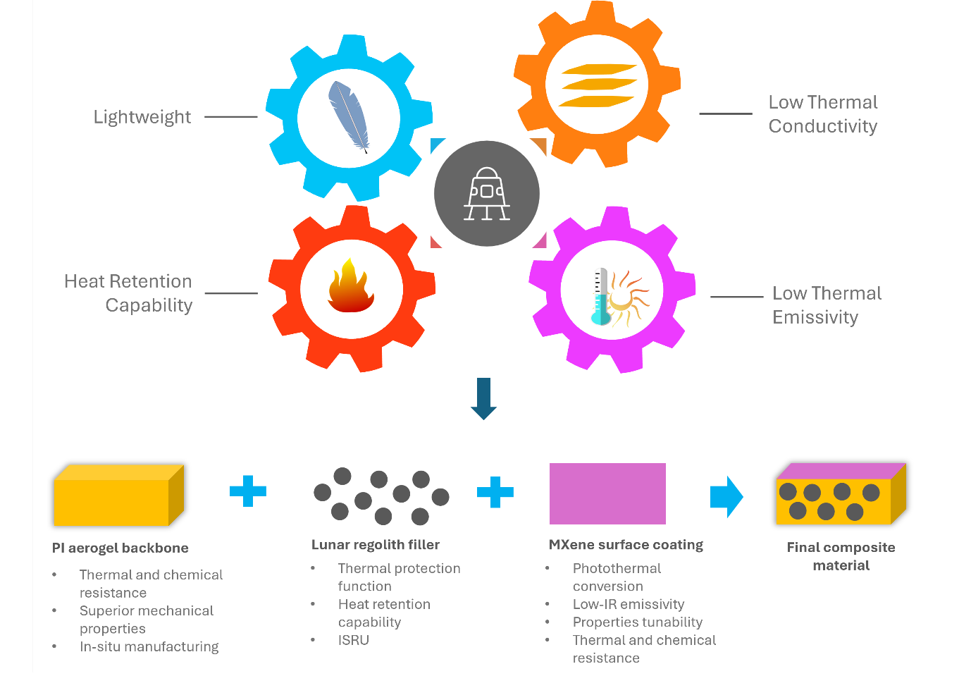
Figure 1. Essential characteristics of composite material suitable as a thermal protection system on the Moon. A composite material characterized by lunar regolith embedded in a continuous porous network of polyimide with a surface layer of MXene can cover all these characteristics.

This work develops a modelling approach to investigate the potential of aerogel-based material characterized by MXenes, lunar regolith, and polyimide (PI), given as a passive thermal protection solution for safeguarding payloads on the Moon, ensuring their structural integrity and functionality throughout the extreme temperature fluctuations of lunar day and night. The combination of aerogels with lunar regolith represents one of the advantages of thermal insulation (aerogel property) and heat storage (regolith property), enhanced by MXene as thermal radiation regulator. By simulating the behaviour and performance of these materials under lunar environmental conditions, an analysis of their thermal shielding capabilities is provided.

2 Modelling of aerogel-based composite material
This section details the assumptions, data, and equations used to build the model in order to assess thermal insulation and protection of the system concept. The model has been implemented in COMSOL.

2.1 Modelling solar position on Moon surface
The paragraph outlines the approach we used to estimate solar position across different selenographic latitudes. Our calculations were focused on obtaining preliminary global data, and thus, did not consider shadowing effects from terrain features or diffuse radiation, but only direct solar radiation. We based our analysis on an average TSI (Total Solar Irradiance) value of 1367.6 W/m²[23]. Our computations were conducted for the northern hemisphere, spanning latitudes from 0° to 80° at 20° intervals. We did not investigate higher latitudes due to the significant impact of local terrain topography on illumination at low Sun altitudes. The data we obtained are symmetrical about the equator.
The solar zenith (θ) and azimuth (φ) are the key angles to estimate the solar position on celestial body surfaces. These angles can be converted into a direction vector I_{s} = (I_{sx}, I_{sy}, I_{sz}) in Cartesian coordinates assuming that the west, the north, and the up directions correspond to the x, y, and z directions, respectively, in the model (Figure 2)[24]. The relation between θ, φ, and I_{s} is given by:
$\left\{\begin{aligned}I_{sx}=-\cos\left(φ\right)\sin\left(θ\right) \\ I_{sy}=\sin\left(φ\right)\sin\left(θ\right) \\ I_{sz}=-cos\left(θ\right)\end{aligned} (1)\right.$
The direction (in radians) of the Sun vector has been calculated for each latitude, converted as function of time, and shown in figure 3.

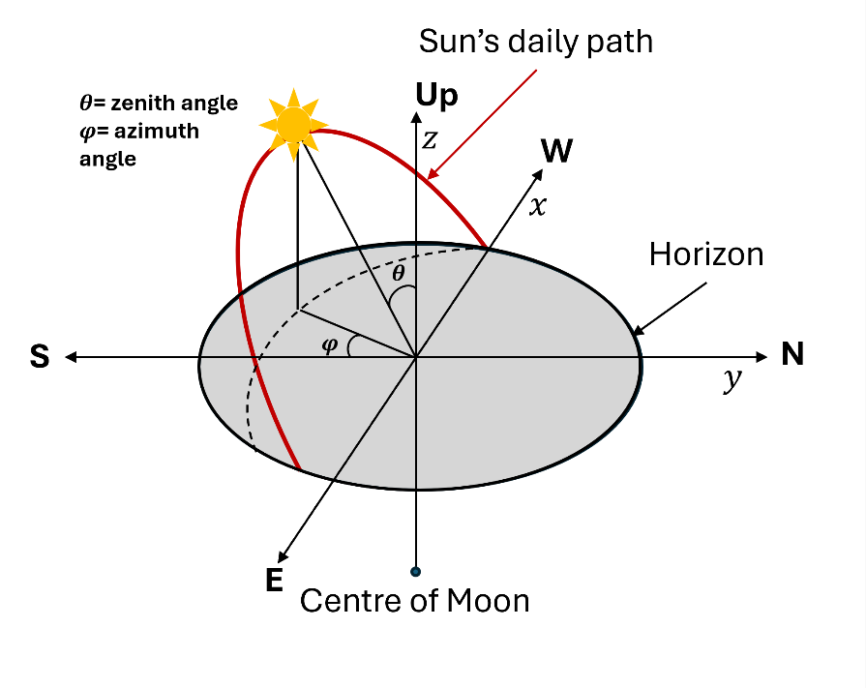
Figure 2. Apparent daily path of the sun across the sky from sunrise to sunset. The x, y and z axis are pointing in the west, north and zenith (up) direction, respectively.

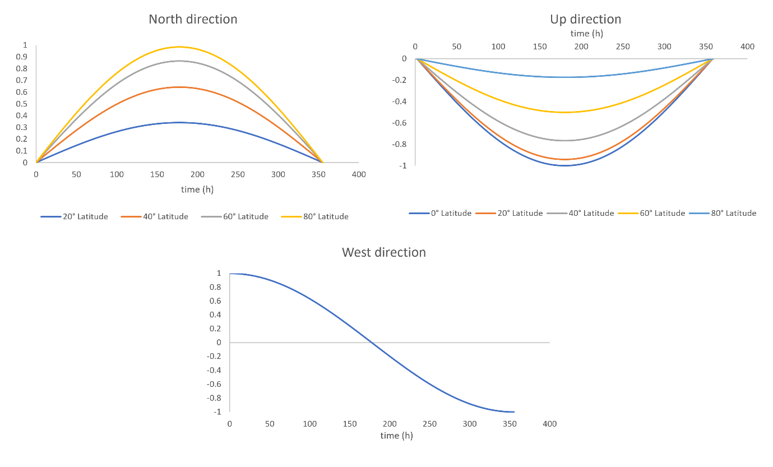
Figure 3. Direction (in radians) of solar vector as function of time calculated at different Moon latitudes of northern hemisphere. The figure shows the Sun direction for one lunar day expressed in hours.

2.2 Modelling the thermal mass of lunar surface
The lunar regolith on the moon’s surface has been modelled according with two-layer model proposed by Vasavada et al.[25], that has been introduced to simulate lunar surface temperatures at near-equatorial latitudes with high accuracy.
The model consists of a 2 cm-thick, highly insulating upper layer and a denser, more conductive lower layer. The upper layer extends from the surface to a depth of 2 cm and has a bulk density of 1300 kg m⁻³. The lower layer has a bulk density of 1800 kg m⁻³ (see Figure 4). The total depth of lunar regolith mass has been set to 90 cm. This choice has been made based on Apollo 15 measurements, which revealed a constant temperature at 90 cm of 252 K[26]. In the model, the regolith surface has been conveniently placed at 90 cm in the coordinates of the model, while the regolith beneath the surface (at 90cm depth) has been placed at 0 cm (see Figure 4). In table 1, the properties of lunar regolith used for the simulations are reported. The regolith properties have been selected by literature based both on experimental data and models obtained from lunar regolith samples (Apollo missions’ samples) and lunar regolith simulants. In particular, the thermal conductivity properties have been taken from the work of Vasavada et al., while the heat capacity value is obtained from Schreiner et al.[27], in which a set of models for a wide range of lunar regolith material properties are presented, including composition, density, specific heat and thermal conductivity.
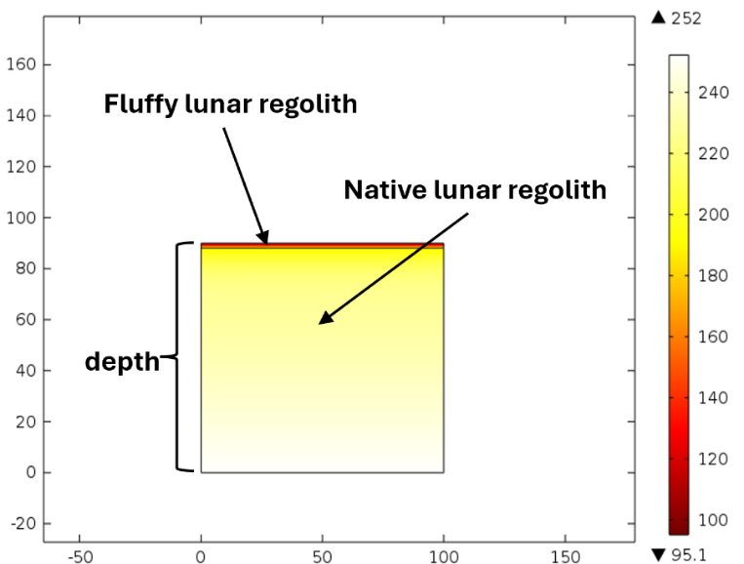
Figure 4. 2D representation of 2-layer model of lunar regolith mass. The image shows the colour distribution of temperature (K) inside the regolith at the end of the lunar night.
COMSOL built-in tool Heat Transfer with Surface-to-Surface Radiation has been set up as Multiphysics to create the model. The model accounts for heat gain from a radiative source, such as the Sun, setting absorptivity and emissivity for radiative gains and losses. The associated partial differential equation solved for the conductive heat transfer within the regolith is:
$$ρCp\frac{dT}{dt}=-∇∙\left(-k∇T\right) (2)$$
where $ρ$ is the density of the body, Cp its specific heat, T is the body temperature and, $k$ its thermal conductivity. The term $(-k∇T)$ corresponds to heat flux by conduction according to Fourier’s Law.
In a severe vacuum environment like on the Moon, radiation becomes the only mechanism of heat transfer between the surface under consideration and the surroundings. The radiation boundary condition can be expressed as an energy balance on the surface[28]:
$$Heat transfer at the surface=Radiation exchange at the surface$$
That is for an opaque surface:
$$-\left(k∇T\right)=ε_{i}σ\left(T_{i}^{4}-T_{surr}^{4}\right)- α_{i}Q_{sun} (3)$$
where $ε_{i}$ is the surface emissivity, $σ$ is the Stefan-Boltzmann constant, $T_{i}$ and $T_{surr}$ are the temperature of the surface and the surroundings, respectively, $α_{i}$ is the surface solar absorptivity and $Q_{sun}$ is the incident solar irradiance.
Fluffy lunar regolith | Native lunar regolith
Density: 1300 Kg/m³ | Density: 1800 Kg/m³
Specific heat:  2.0814*10⁻⁶*T³-0.0048*T²+4.0456*T-71.7390 J*Kg /K | Specific heat:  2.0814*10⁻⁶*T³-0.0048*T²+4.0456*T-71.7390 J*Kg /K
Thermal conductivity:  9.22*10⁻⁴*(1+1.48*(T/350)³) W/m*K | Thermal conductivity:  9.30*10⁻³*(1+0.73*(T/350) ³) W/m*K
Surface emissivity[29]: 0,97 | Surface emissivity[29]: 0,97
Surface absorptivity[29]: 0,87 | Surface absorptivity[29]: 0,87
Table 1. Physical and thermal properties of modelled lunar regolith.
The radiation settings used account for the wavelength dependency of emissivity, selecting solar and ambient spectral bands. When solar radiation is part of the model, it is possible to enhance an opaque/grey surface model by considering two spectral bands: one for short wavelengths and one for large wavelengths, i.e. a solar band for wavelengths shorter than 2.5 µm and an ambient band for wavelengths above 2.5 µm[24]. Figure 5 shows that typically the solar radiation falls under an ambient band with wavelengths shorter than 2.5 µm, while those for radiation to the surroundings are longer.
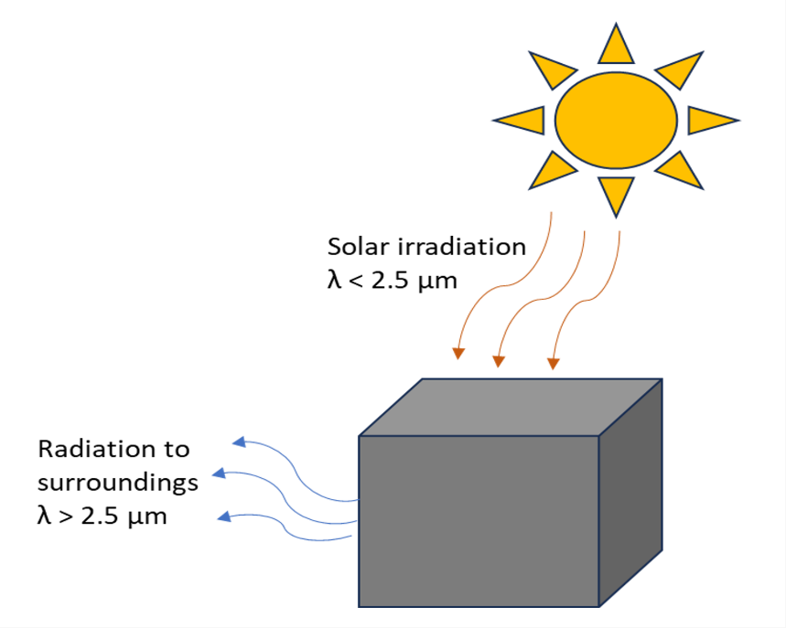
Figure 5. Visuals of Solar and ambient radiation settings. The image shows the absorption of solar radiation at shorter wavelengths and emission to surroundings at larger wavelengths.

Simulations have been run to determine the temperature distribution inside the regolith mass, performing both steady state and transient studies (Figure S2 and S3 in the supporting information). These have been performed using a radiation source temperature at 5780 K (Sun) and setting the solar irradiance as function of time. The lunar night has been simulated putting 0 W/m² as solar irradiance. To define the boundary conditions for the regolith, we assumed no heat flux on the vertical edges of the modelled regolith mass, considering the surrounding regolith as effectively infinite. This implies that horizontal heat diffusion beneath the Moon's surface is negligible compared to the vertical heat exchange. All boundary conditions are depicted in figure 6.
Transient studies have been concluded once the temperature distribution inside the regolith mass was constant over lunar day and night cycles (Figure S2 and S3 in the supporting information).
As example, in figure 7 the temperature distribution of lunar regolith mass at equator latitude is reported. This result has been determined for each latitude and used as initial value for the simulations that followed in modelling aerogel-based composite material.
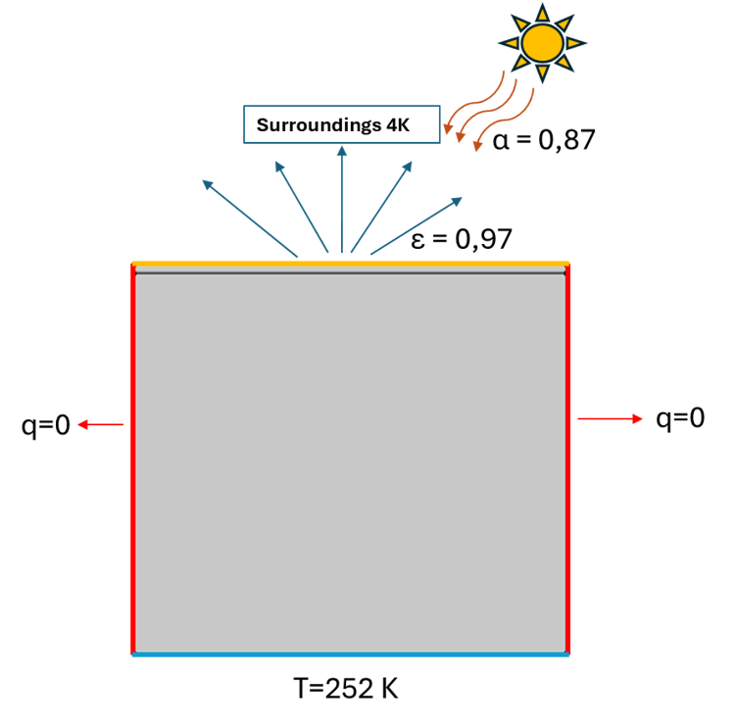
Figure 6. Depiction of boundary conditions of regolith thermal mass.

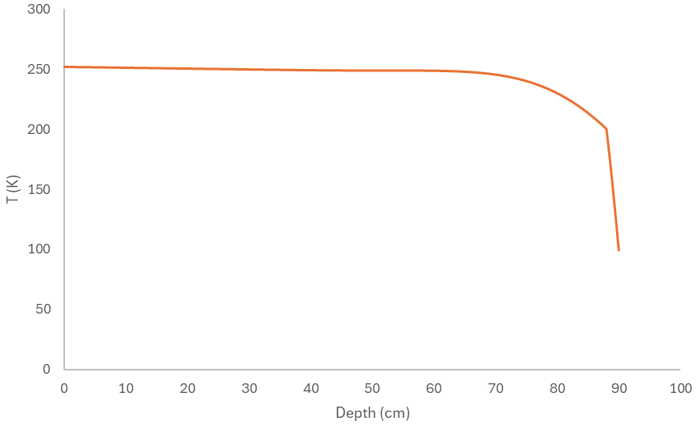
Figure 7. Temperature distribution inside modelled regolith mass after lunar night. The image shows the results considering Moon equator.

2.3 Modelling thermal protection composite material on Moon surface
A 3D model has been set up to build a box (140x140x140cm) placed on the modelled lunar regolith mass (1000x1000x90cm) to represent the thermal protection system, by placing an aluminium mass (25x25x25cm) (representing a hypothetical payload to be protected) inside (see Figure 8). Different boxes have been built in turn, characterized by different material properties. The choice of using this geometry assumes to manufacture the thermal protection system in situ, exploiting the freeze-casting technique[30] to produce squared panels assembled in a box-like configuration. A thickness of 50 cm was selected as an optimal starting point to evaluate the thermal protective capacity of the composite material. Previous simulations with greater thicknesses exhibited overly conservative behaviour, suggesting that they were over-engineered for the intended application. In contrast, the 50 cm thickness produced borderline results, making it a more balanced choice and used as a critical threshold, offering sufficient limit to evaluate the material performance.
The PI aerogel material constitutes the continuous porous matrix of the composite material, while lunar regolith is the component embedded in different quantities in the aerogel matrix (disperse phase) (see figure 9). MXene has also been considered as a surface coating of the aerogel material. MXenes with emissivity values of 0.1 and 0.4 have been investigated. The first one is representative of the most effective and known MXenes (Ti₃C₂X), the second one is representative of many other transition metals MXenes (e.g., V, Nb, Mo, etc.)[21]. Materials properties are reported in table 2.
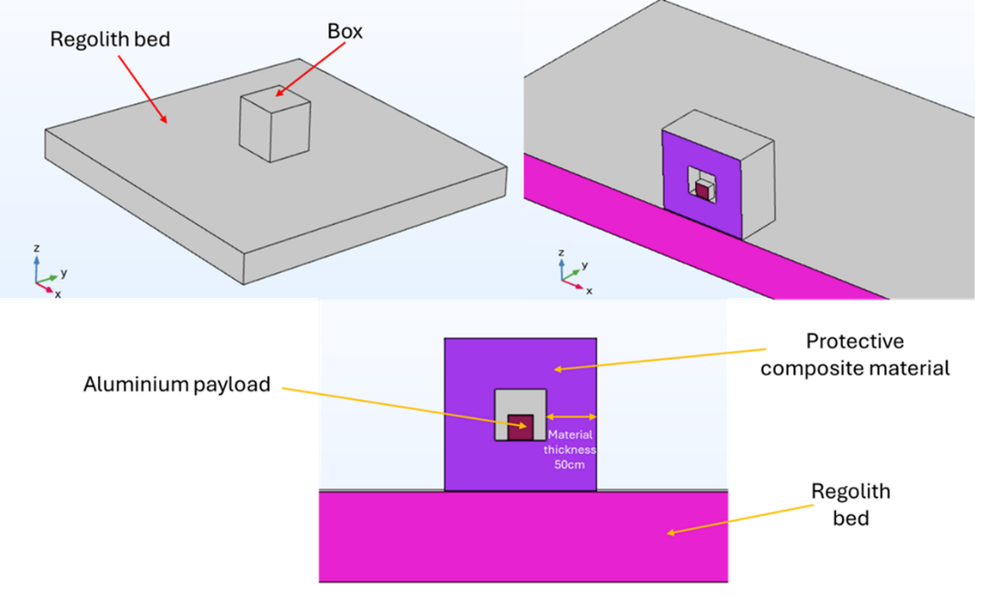
Figure 8. Composite material configuration with layered (upper left), a representative cut in the middle displaying the payload within the protective box (upper right) and a zoom of the latter (lower).
The quantities of lunar regolith investigated inside the PI matrix are 20, 40 and, 60% (w/w) with respect to the hydrogel substrate. This choice derives from a precedent study on regolith-based aerogels[31], in which quantities of regolith higher than 60% could jeopardize the characteristic properties of aerogels (e.g., porosity, surface area, and low thermal conductivity, etc.), and not assure a proper filling of the aerogel matrix. MXene, instead, has been investigated as surface coating of 20µm thickness[21].
The PI aerogels properties have been chosen by literature, selecting those better suited to the simulated Moon environment. Feng et al.[32] characterized PI aerogel thermal properties in function of pressure and temperature, giving indications on PI aerogel insulation performance in vacuum and at cryogenic temperatures (e.g., -150 °C). A quasi-linear dependency of the thermal conductivity in function of temperature and pressure can be deducted for the reported data. This assumption aligns with the inherent properties of polyimide (PI), which is characterized by a rigid backbone and an amorphous state[33], with a glass transition temperature above 250°C[34]. Given these characteristics, the mean free path of phonons could be considered approximately constant. As the temperature increases, this results in a proportional increase in thermal conductivity[35].
Regarding heat capacity at constant pressure, Song et al.[36] characterized thermochemical properties of polyimide, reporting measurements of heat capacity in the temperature range from 80 to 380K. The experimental data showed a nearly linear trend of heat capacity with the temperature, and the interpolating function to the reported data has been built to simulate heat capacity of PI aerogel mass. The PI bulk density has been estimated considering 5wt.% polymer concentration in hydrogel solution, widely reported in preparing PI aerogels and PI composite aerogels, both obtained using freeze-drying and super critical drying[37–41]. The physical and thermal properties of aerogel/regolith composite materials have been determined by weighing the properties of individual materials according to their selected percentage in the PI aerogel matrix. The assumptions made consider isotropic properties of composite materials. As an example, consideration is given for an aerogel composite material characterized by 20wt.% of regolith in a hydrogel solution of 5wt.% polyimide. The amount of regolith is 4 times the amount of polyimide, so the final composite aerogel will consist of 80wt.% regolith and 20wt.% polyimide. Instead, the volume fractions of PI aerogel and regolith are 0.88 and 0.12, respectively. The mass density of the composite material can be estimated by weighing the mass densities of the individual components by their respective volume fractions while the specific heat capacity by weighing the specific heat capacity of the individual components by their respective mass fractions:
$$\left\{\begin{aligned}ρ_{B }= ρ_{PI}*V_{PI}+ρ_{R }*V_{R} \\ C_{p }(T)= C_{PI}(T)*m_{PI}+C_{LR }(T)*m_{R}\end{aligned}\right. (4)$$
where, $ρ$_{B} is the bulk density of composite material, ρ_{PI} and V_{PI} are the bulk density and volume fraction of PI aerogel matrix and, ρ_{R} and V_{R} are the bulk density and volume fraction of lunar regolith; C_{p}(T) is the specific heat of composite material, C_{PI}(T) and m_{PI} are the specific heat and mass fraction of PI aerogel matrix, and m_{LR} and C_{LR}(T) are the specific heat and mass fraction of lunar regolith. The density of lunar regolith chosen has an average value of 1500 Kg/m³ since this property depends on depth and soil compaction and it can vary from 1200 Kg/m³ to 1800 Kg/m³[27].
Regarding thermal conductivity, that of aerogel/regolith composite materials was determined using the Maxwell-Eucken model[42], which estimates the effective thermal conductivity of composite materials when a dilute dispersion of spherical particles of conductivity K₁ is embedded in a continuous matrix of conductivity K₂. Particle interactions are ignored in this model.
The assumption is made by considering that the particle sizes of the lunar regolith are microscale[43], while those of the PI matrix are nanoscale[44] and, based on other works that have predicted the thermal conductivity of nanoporous aerogel composite materials incorporating micrometer-scale fillers[45,46], the effective models are a good approximation, using the effective thermal conductivity of the matrix (PI aerogel that accounts the effect of the porous structure) and the effective thermal conductivity of the lunar regolith. Therefore, it is possible to approximate the porous PI matrix as a continuous phase in which the regolith particles are embedded (Figure 9).
The approximation of lunar regolith as spherical particles, simplifying the modelling of thermal conductivity, has been employed to primarily capture the key heat transfer mechanisms involved in its integration within an aerogel matrix and MXene, focusing the study on understanding how their inclusion influences the thermal conductivity, radiative heat transfer, and overall insulation performance of the composite material. This simplification can be further supported by the morphological characterization of some lunar regolith samples, which have been found to exhibit relatively regular shapes with limited elongation[47–50]. Recently, the analysis of Chang’e-5 lunar samples reported an average 3D sphericity of 0.817, indicating a generally compact morphology of the collected particles[51]. However, the Hamilton–Crosser model[52], which incorporates a shape factor to account for non-spherical particle inclusions, might be used as an alternative effective approach for modelling such cases. The differences observed in predicting the effective thermal conductivity when compared to the Maxwell–Eucken model are reported and discussed in detail in Supporting Information S1 and are shown to not alter the overall thermal management performance presented in the section 3. The regolith particles can be considered non-interacting with each other because of the low-volume fractions between regolith and the PI matrix (Table 2).
The expression of the effective thermal conductivity according to the Maxwell-Eucken method is the following:
$$Keff=\frac{K_{1}*V_{1}+K_{2}*V_{2}*\frac{3*K_{1}}{2*K_{1}+K_{2}}}{V_{1}+V_{2}*\frac{3*K_{1}}{2*K_{1}+K_{2}}} (5)$$
where, K₁ and K₂ are the thermal conductivities of the continuous and disperse phase and, V₁ and V₂ are the volume fractions of the continuous and disperse phase. The temperature dependence of thermal conductivities by Maxwell-Eucken model is shown in Table 2.

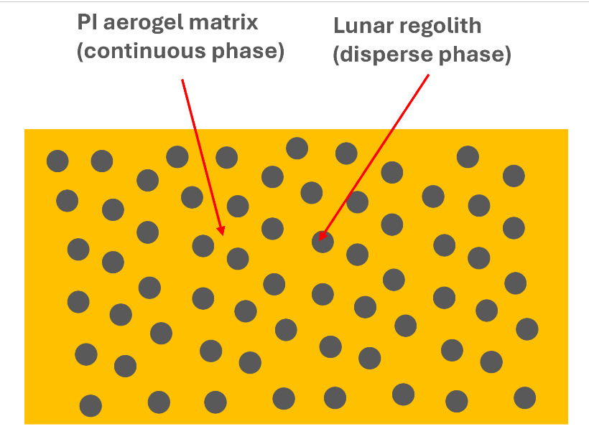
Figure 9. Representation of PI/regolith composite aerogel for thermal conductivity estimation according to the Maxwell-Eucken model. The PI represents the continuous porous matrix with effective thermal conductivity K₁, while the lunar regolith is the dilute disperse phase with effective thermal conductivity K₂, considering the low volumetric fractions investigated in this work.
It is worth noting that the thermal conductivity value of lunar regolith embedded in the aerogel matrix is at the same order of magnitude as that of anorthosite rock (1.6 W/m*K)[53], which characterizes the main mineralogy of the lunar highlands chosen as reference for this work[54].
The physical and thermal properties of MXenes were obtained from the literature, considering a thin coating (20µm thick) covering the composite surface[55].
Material | Bulk density (Kg/m^3) | Volumetric fraction (LR) | Mass fraction (LR) | Thermal conductivity (W/m*K) | Specific Heat capacity (J/Kg*K)
PI | 100[38] | - | - | 8*10⁻⁰⁵T - 0.0032[26] | -0.0024T² + 4.23T + 67.46[36]
LR | 1500[27] | - | - | 1.6[53] | 2.08*10⁻⁰⁶T³-0.0048T²+4.04T-71.74[27]
PI/20LR | 260 | 0.12 | 0.80 | -5*10⁻⁰⁹T² + 0.0001T - 0.0045 | 2*10⁻⁰⁶T³ - 0.0043T² + 4.08T - 43.90
PI/40LR | 390 | 0.21 | 0.89 | -1*10⁻⁰⁸T² + 0.0001T - 0.0057 | 2*10⁻⁰⁶T³ - 0.0045T² + 4.06T - 56.43
PI/60LR | 500 | 0.29 | 0.92 | -2*10⁻⁰⁸T² + 0.0002T - 0.0069 | 2*10⁻⁰⁶T³ - 0.0046T² + 4.06T - 60.60
Table 2. Physical and thermal properties estimated for the composite materials. The thermal conductivity of PI/LR composite materials has been estimated using the Maxwell-Eucken model, while the heat capacity by weighting the component specific heat capacity by the mass fraction.
Simulations have been run to determine payload temperature and temperature distribution inside the thermal protection system, performing transient studies for one lunar day and night. These have been performed using the built-in external radiation source temperature at 5780 K (Sun) and setting solar irradiance as function of time and latitude. The solar absorptivity and emissivity values of the composite material have been selected according to the literature[18,21,56], assuming diffuse surfaces (no wavelength dependency of radiative properties on direction) due to opaque nature of the investigated materials[57,58]. The initial temperature distribution of the lunar regolith is taken as the temperature profile at the end of the lunar night, determined for each latitude. This was obtained through simulations conducted only on the modelled regolith. All boundary conditions are depicted in Figure 10.
It’s worth noting that the initial temperature of payload at the beginning of lunar day has been chosen as 243 K, deemed to be an acceptable target temperature to keep payloads functionality at the end of the lunar night[59].
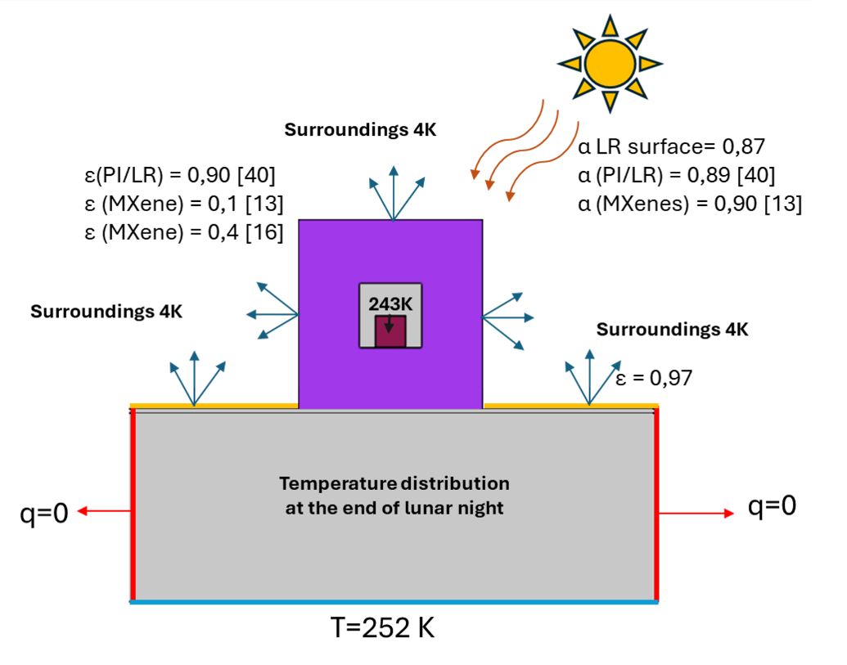
Figure 10. Depiction of boundary conditions of regolith thermal mass and thermal protection composite system

A mesh sensitivity study was conducted to minimize numerical errors and ensure that simulation results are not affected improperly by mesh size, thereby improving the accuracy and reliability of heat transfer predictions. This process involved systematically refining the mesh by reducing the size of the elements and increasing their number to assess the impact of mesh resolution on simulation results.

3 Results and discussion
In Figures 11-15, results are reported on simulations performed for one lunar day and night, modelling the composite materials described above. The evaluation of the thermal protection capacity has been done by plotting the temperature profile of the aluminium payload.
In Figure 13, the payload temperature profile has been reported at 20° of latitude for the different material compositions, together with the maximum and minimum payload temperatures at the end of, respectively, the lunar day and night.
The results show that the composite aerogel materials embedding lunar regolith enhances the thermal performance of the material by increasing its density and, consequently, its thermal inertia. This higher density, provided by the inclusion of lunar regolith, slows the cooling rate of a payload compared to using polyimide aerogel alone. The added mass from the regolith particles increases the overall heat capacity of the composite material, allowing it to absorb and retain more heat, also noticeable by the shift in maximum payload temperature after the end of the lunar day (figure 11). As a result, the heat is released more gradually, providing a more stable thermal environment. The best performance can be observed in aerogel with 40% and 60% lunar regolith which show comparable results.
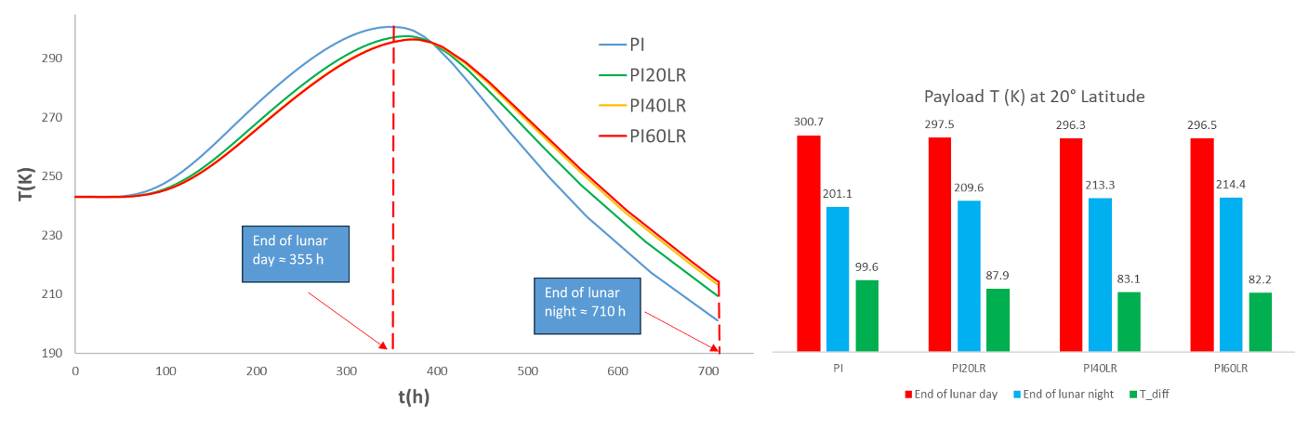
Figure 11. Payload temperature profile after one lunar day and night for different composite PI/LR aerogels together with maximum (end of lunar day) and minimum value (end of lunar night) of payload temperature.

Instead, applying a MXene coating with an emissivity of 0.1 to a payload can help reduce severe cooling by minimizing heat loss through radiation. However, while this low emissivity is effective at preventing rapid cooling, it is not an ideal solution for protecting the payload from overheating, as it also limits the material's ability to dissipate excess heat (see Figure 12).

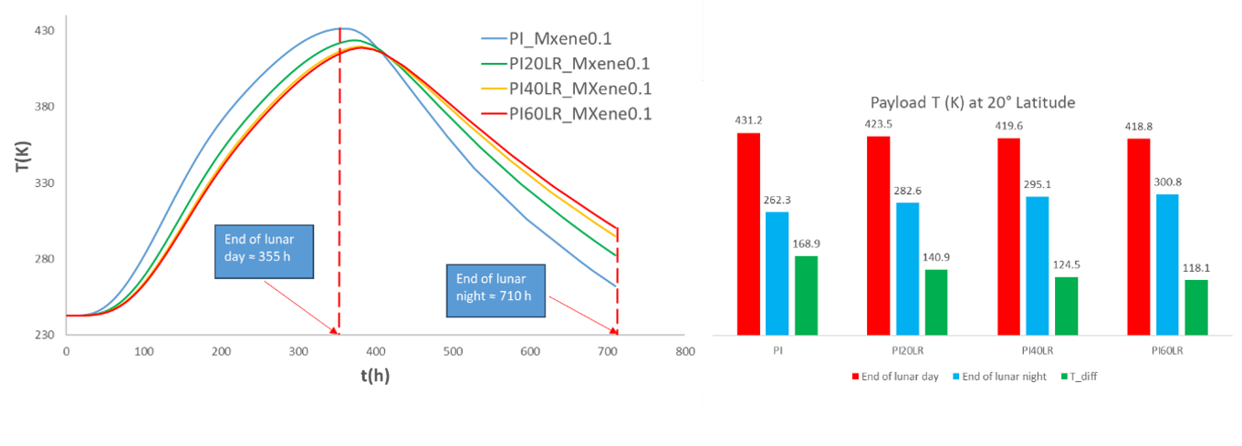
Figure 12. Payload temperature profile after one lunar day and night for different composite PI/LR aerogels with MXene coating of 0.1 emissivity together with maximum (end of lunar day) and minimum value (end of lunar night) of payload temperature.

In contrast, using a MXene coating with an emissivity of 0.4 offers a more balanced thermal management approach (Figure 13). This higher emissivity allows the material to release enough heat to prevent overheating during the lunar day while still retaining sufficient thermal energy to avoid extreme cooling during the lunar night. As a result, a coating with an emissivity of 0.4 maintains the payload temperature closer to the target value, providing effective thermal protection across the lunar cycle. Figure 13 also compares the thermal performance of pure lunar regolith layers (MXene-coated) of equal thickness, showing that sintered and compacted regolith (as alternative ISRU product) is less effective than both PI and PI/LR aerogels. This highlights the advantage of the aerogels’ highly porous structure, which achieves thermal conductivities an order of magnitude lower (∼10⁻² W/m*K) compared to sintered regolith (∼10⁻¹ W/m*K)[60], resulting in enhanced thermal management.
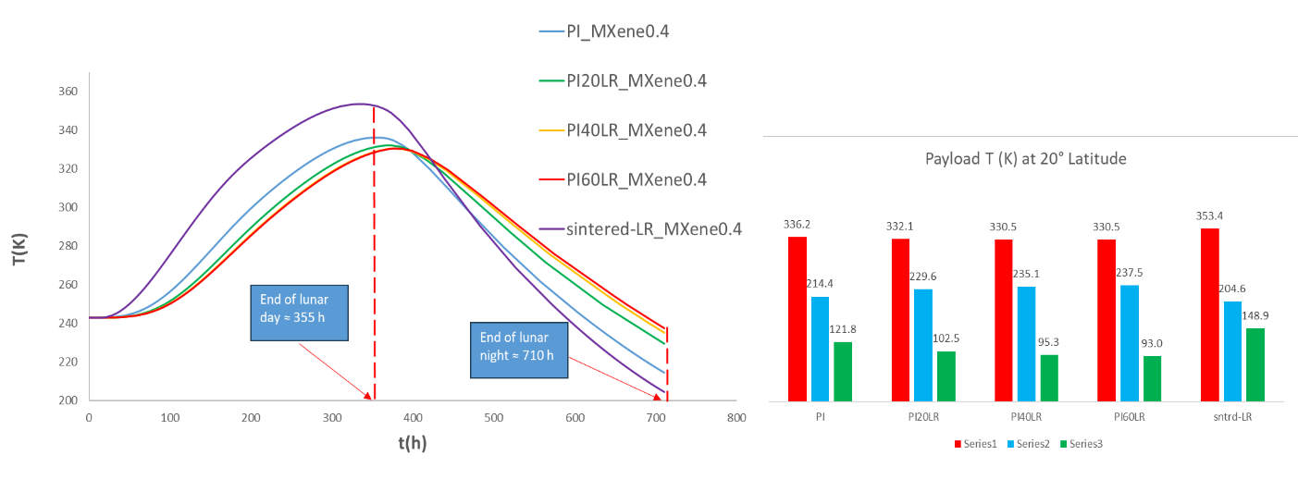
Figure 13. Payload temperature profile after one lunar day and night for different composite PI/LR aerogels and sintered lunar regolith with MXene coating of 0.4 emissivity together with maximum (end of lunar day) and minimum value (end of lunar night) of payload temperature.

At different lunar latitudes, the cooling of a payload varies significantly, with higher latitudes experiencing more severe cooling than lower ones (see Figure 14). This effect is particularly noticeable at latitudes of 60° and 80°, where the prolonged exposure to the lunar night and lower solar incidence angles results in more extreme temperature drops.
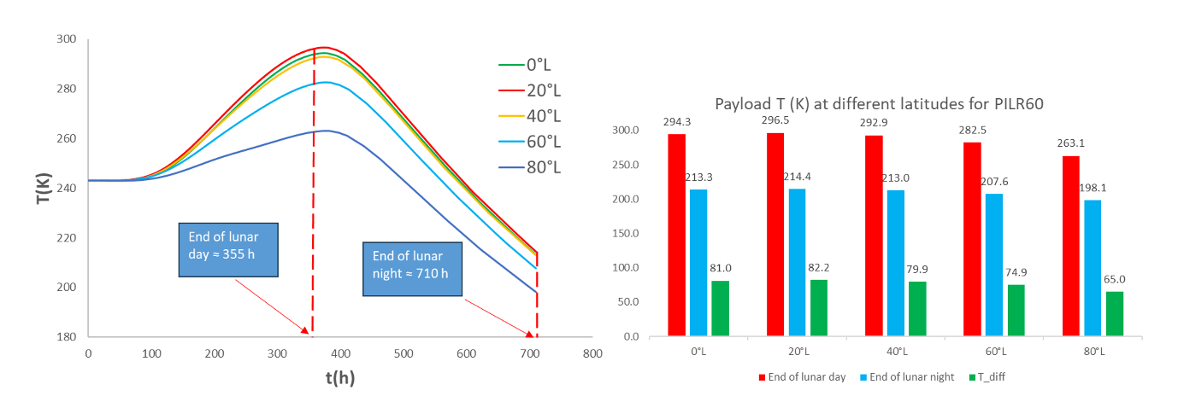
Figure 14. Payload temperature profile after one lunar day and night for PI/LR aerogels with 60wt.% of lunar regolith as function of latitude together with maximum (end of lunar day) and minimum value (end of lunar night) of payload temperature.

Applying a MXene coating mitigates these cooling effects, having more critical impact only at 80° latitude due to the harsher thermal environment, as shown in Figure 15. Here, the MXene coating effectively reduces heat loss and helps maintain the payload's temperature closer to the desired range, demonstrating its usefulness in managing thermal conditions, especially in regions where cooling is most severe.
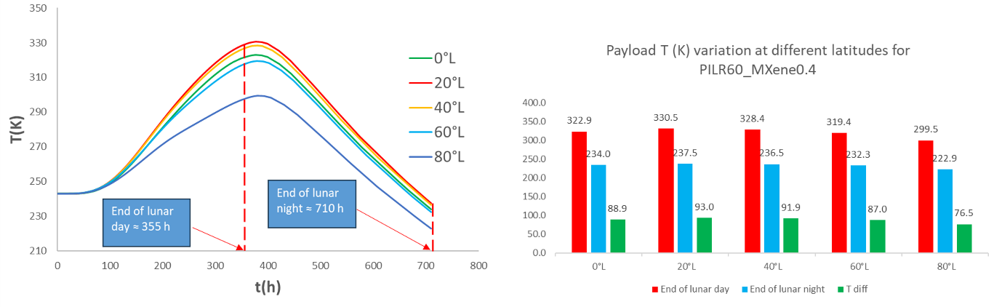
Figure 15. Payload temperature profile after one lunar day and night for PI/LR aerogels with 60wt.% of lunar regolith with MXene coating of 0.4 emissivity as function of latitude together with maximum (end of lunar day) and minimum value (end of lunar night) of payload temperature.

Considering a box-shaped geometry for the payload protection, it is interesting to note that the maximum heat gain does not occur at 0° latitude, as might be expected. This anomaly is likely due to the geometry of the box, where higher latitudes result in more surface area being exposed to the sun's rays, leading to greater solar absorption. In fact, there seems to be an optimum at around 20° latitude, where the balance between exposure and heat gain is most favourable. This finding suggests that the geometry and orientation of the payload play a significant role in thermal management, and optimizing these factors can help achieve the desired thermal conditions.
The iso-surface results obtained from the thermal simulations at 20° of latitude (Figures 16-18) illustrate the insulating properties of the aerogel composite material. Notably, by the end of the lunar night Figure 18 shows a significant temperature gradient of up to 50°C between the surface and the core of the insulated box, visible by the densely packed iso-surfaces. This indicates a rapid change in temperature across the thermal insulation composite material. This substantial difference highlights the material's ability to effectively limit heat loss during the lunar night. The outward heat flux direction is evident from the shape of the iso-surface, which represents a temperature distribution following a bell-curve pattern. The central peak corresponds to a region of high temperature that gradually decreases outward as the surface cools.
In Figure 17, the iso-surfaces illustrate the direction of heat flux entering the material during the lunar day. Most of the heat flux originates from the south-zenith direction, which is consistent with the Sun's trajectory at a latitude of 20° in the northern hemisphere.
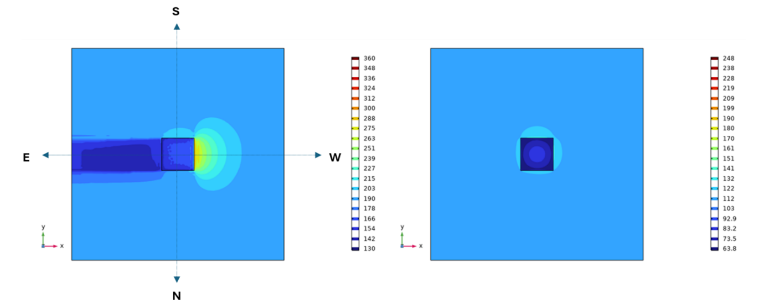
Figure 16. Top view of iso-surface results of thermal protection system on regolith surface plotted at 20° of latitude at the end of lunar day (sunset) (illuminated surface exposed to west direction, on the left) and at the end of lunar night (on the right).

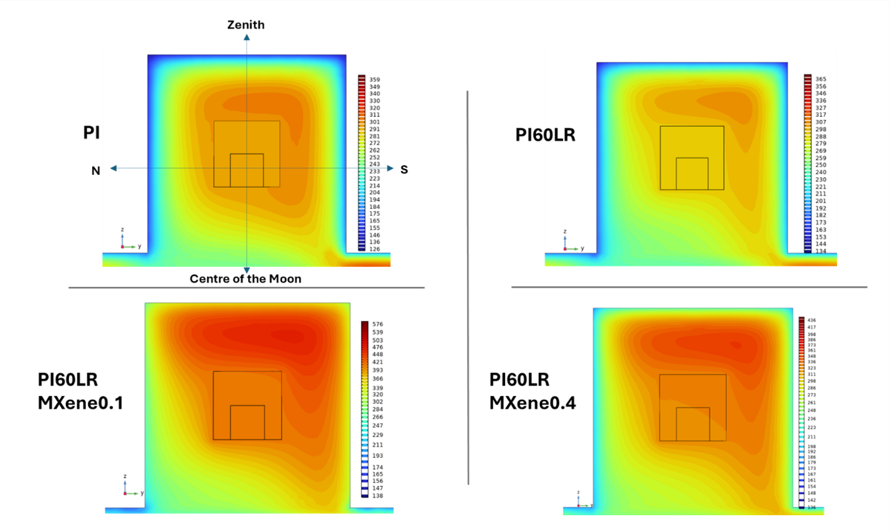
Figure 17. Iso-surface results of the thermal protection system with different material composition modelled at 20° of latitude at the end of lunar day (sunset). The picture shows the temperature distribution after vertically cutting the modelled box. This front view is relative to a face exposed to west (sunset). The right and left edges of each figure point towards south and north direction, respectively. The top and bottom edges point towards zenith and centre of the Moon, respectively (top left picture).

Furthermore, the iso-surfaces in Figure 18 show the benefit of integration of regolith and a MXene coating of 0.4 emissivity in the insulating system playing a crucial role in maintaining thermal equilibrium. These materials help to achieve an optimal balance between heat retention during the lunar day, where solar radiation is intense, and heat dissipation during the prolonged lunar night. The regolith provides natural insulation, while the MXene layer enhances thermal control of composite material, preventing overheating and ensuring gradual cooling. Together, they contribute to a more stable thermal environment, mitigating extreme temperature fluctuations.
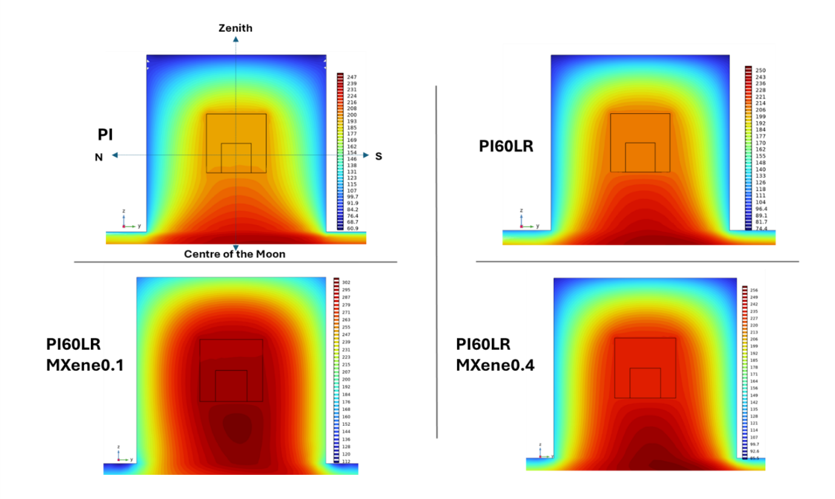
Figure 18. Iso-surface results of the thermal protection system with different material composition modelled at 20° of latitude at the end of lunar night (before sunrise). The picture shows the temperature distribution after vertically cutting the modelled box. This front view is relative to a face exposed to the west. The right and left edges of each figure point towards south and north direction, respectively. The top and bottom edges point towards zenith and centre of the Moon, respectively (top left picture).

These results are further strengthened by examining Figure 19, which presents transient heat fluxes through the outer and inner surfaces for various thermal protection system configurations at 20° of latitude, capturing the dynamic response of the materials and, providing useful insights for evaluating the thermal performance in actual applications[61]. Specifically, the figure illustrates data for the aerogel containing 60 wt.% lunar regolith with a MXene coating of emissivity 0.4 (graphs A and B), the PI aerogel (graphs C and D), and the aerogel with 60 wt.% lunar regolith without MXene (graphs E and F).
The inclusion of lunar regolith in the composition of the aerogel plays a significant role in regulating heat flux changes within the protection system, particularly compared to pure PI aerogel. This stabilization effect results in a more gradual heat accumulation, extending the net heat gain beyond the end of the lunar night, as evident in Graphs B and F.
In addition, the integration of a MXene layer is found to be a crucial improvement. By significantly reducing heat losses-about half as much as aerogel with only lunar regolith-the MXene contributes to improved thermal efficiency. Furthermore, when considering the total heat flux on the interior surfaces, the MXene layer facilitates a sustained net heat gain, further improving the effectiveness of the thermal protection system against the lunar night.
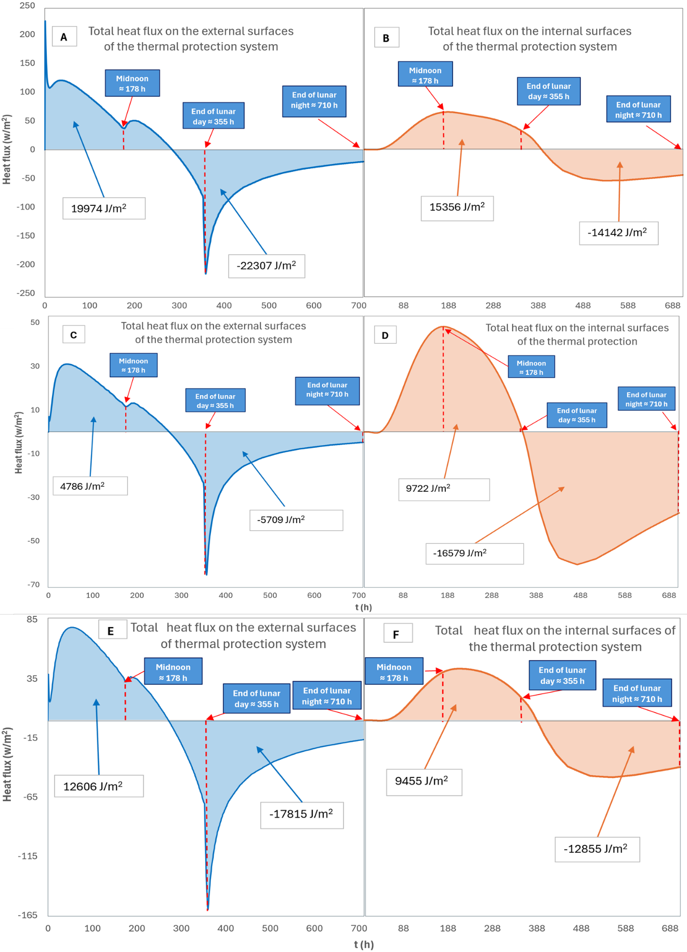
Figure 19. Total transient heat fluxes for the thermal protection system with different material composition: PI/LR 60 wt.% + MXene with 0.4 emissivity (graphs A and B); PI aerogel (C and D); PI/LR 60wt.% (graphs E and F).
Figure 20 shows the temperature profile and distribution of the thermal protection system and payload, highlighting the composite material's remarkable insulation capability. In particular, a temperature difference of more than 100°C is observed between the outer surface and the inner regions of the material at the end of the lunar day (graph B). In addition, the graph A reveals the extreme thermal fluctuations experienced by the surface of the material containing 60 wt.% lunar regolith with a MXene coating of emissivity 0.4, which reaches a peak temperature of about 470 K at lunar noon and subsequently drops to about 130 K at the end of lunar night.

Graph B compares the temperature distribution among different material compositions at the end of the lunar day, taking as reference the west-facing surface, which is directly exposed to solar radiation at that time. The data further emphasize the critical role of integrating lunar regolith into the aerogel matrix. Although the composite material initially exhibits a steeper temperature gradient within the first ~30 cm from the surface - compared to the polymer insulation (PI) alone - the temperature gradient then smooths out, indicating greater heat retention and mitigation of rapid changes in heat flow. This observation is consistent with trends observed in both the payload temperature profile and heat flux results.

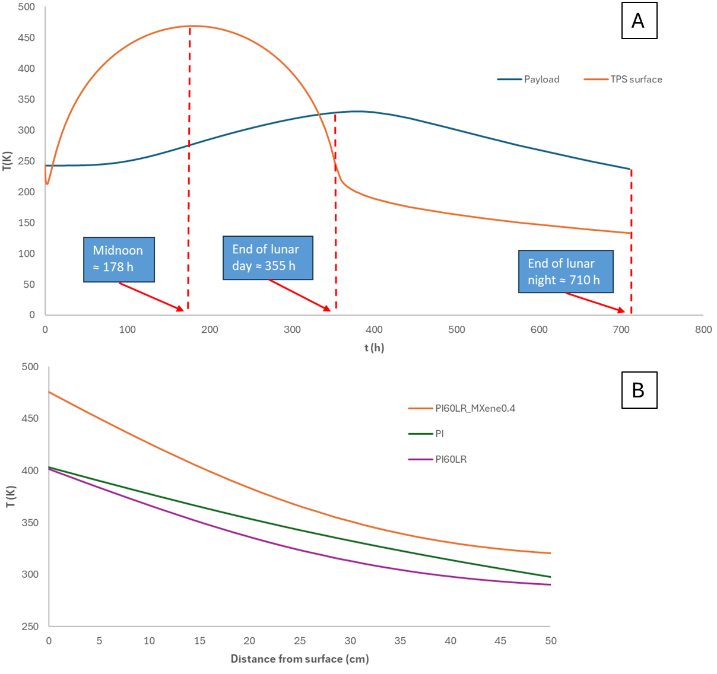
Figure 20. Temperature of TPS surface and payload over one lunar day and night for a material containing 60 wt.% of lunar regolith with a MXene coating of emissivity 0.4 (graph A). Temperature distribution across the material thickness of different material compositions at the end of the lunar day, taking as reference the west-facing surface (graph B).

The iso-surfaces in Figures 17 and 18 also provide information on the contact surface of the insulating box placed on the lunar regolith, which exhibits distinct thermal behaviour, with the lowest temperature observed at the end of the lunar day and the highest temperature at the end of the lunar night. They show that throughout the lunar day and night cycle, the temperature profile of this contact area remains relatively stable (Figure 21). This suggests that the interaction between the composite material of the box and the lunar regolith forms an effective insulating layer, helping to provide passive thermal support and acting as a thermal buffer, slowing slightly down the heat loss within the system, especially at the latest hours of lunar night. Figure 19 illustrates, as an example, the temperature variation of the payload and the bottom surface of the PI aerogel, modelled at a lunar latitude of 20°. The figure highlights a shift in the temperature trend, particularly evident for this material after the temperature drops below that of the bottom surface.

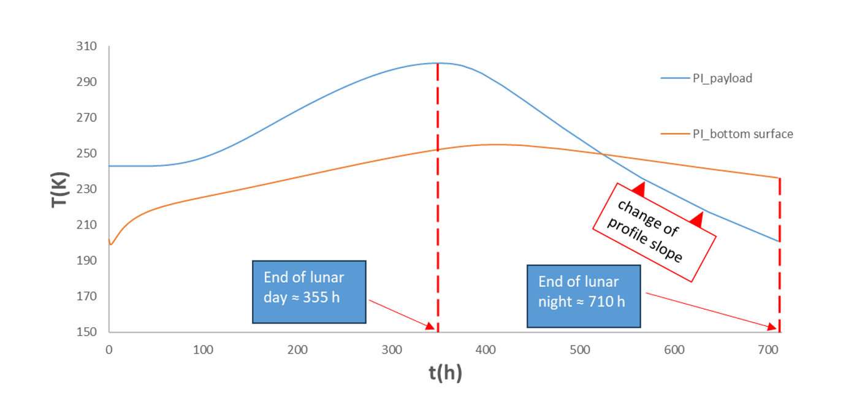
Figure 20. Temperature variation of the payload and bottom surface of protection system for PI aerogel, modelled at 20° of latitude. The figure highlights a shift in the temperature trend, particularly evident for this material after the temperature drops below that of the bottom surface.

3.1 Discussion on long-term stability of the thermal protection system
It is evident from the simulation results that the composite material undergoes drastic variations and high temperature gradients, and although the thermal stability of the PI matrix usually maintains structural integrity over a wide range of temperatures (4 K < T < 600 K)[62–64], as well as MXenes [65,66], this may not guarantee the material's durability and mechanical integrity under lunar conditions, posing limitations in terms of long-term performance and reliability over time. However, the durability of MXene-based composite materials has recently been studied in extreme temperature environments. Changhua Yang et al. demonstrated significant stability of ANF/MXene aerogels under extreme temperature conditions, maintaining their EMI shielding performance even after exposure to high (200 °C) and cryogenic (-196 °C) temperatures[67]. Similar results were found by Kang Sun et al. who studied the EMI and Joule heating properties of polyimide/MXene fibre films after immersing the composite films in liquid nitrogen, annealing at 150 °C and repeated bending cycles, noting excellent durability and structure integrity[68].
Also the fatigue performance of PI and various MXene/polymer composite aerogels has been studied, revealing their exceptional mechanical resilience under extreme thermal conditions ranging from –196 °C to 300 °C [69,70]. In particular, both pure PI and PI-based composite aerogels demonstrate remarkable durability, withstanding up to 10.000 compression cycles and maintaining structural integrity and excellent mechanical properties, remaining consistent even under significant temperature gradients, comparable to those encountered by the composite material in the simulated lunar environment (Figure 20). Among these, rGO/PI aerogels stand out for their superior performance in cryogenic environments. Under 50% cyclic compression, some rGO/PI variants exhibited peak performance in liquid nitrogen (–196 °C), achieving a maximum compression strength of 160.1 kPa, an exceptionally low energy loss coefficient of 34.16%, and complete height recovery after 20 cycles. This behaviour is particularly significant, as most polymer materials tend to become brittle and lose elasticity at such low temperatures. The excellent cryogenic fatigue resistance of r-GO/PI aerogels highlights their robustness and adaptability in demanding low-temperature environments. At elevated temperatures, the aerogels still demonstrate strong fatigue resistance, although some mechanical degradation is observed. For instance, at 180 °C, the stress and height retention rates remain high—88.5% and 74%, respectively—after 20 compression cycles [69]. Even at an extreme temperature of 300 °C, PI aerogels maintain 70% of their original compressive strength after enduring 10.000 cycles, with a plastic deformation of only 12.6%[70]. Another study evaluated the compressive fatigue of PI aerogels conducting a compression cycling test of at least 20.000 loading–unloading cycles at a compression strain of 50%, reporting maintained 94% of its initial height, demonstrating only a limited plastic deformation at 6.33% at 50% compression, even after 20.000 cycles, and noting negligible effects on the measured thermal conductivity[71]. These findings underscore the thermal and mechanical stability of PI-based aerogels, making them promising materials to manage repeated stress under harsh lunar thermal conditions. Nevertheless, the reduction in compressive strength, which eventually leads to the collapse of the porous structure, may compromise the overall thermal management after several lunar days and should be evaluated in future numerical and experimental works.
Recent studies on the low-temperature fatigue properties of PDMS/MXenes composites have shown a marked decline in performance at -40 °C compared with room temperature[72]. This deterioration is mainly due to the increased stiffness of PDMS at low temperatures, which hinders its ability to dissipate strain energy. As a result, stresses accumulate at the PDMS/MXenes interface, leading to the breakdown of interfacial bonds and reduction in fatigue strength. To solve this issue, it has been shown to be effective to improve interfacial bonding through the formation of strong hydrogen and covalent bonds at the PDMS/MXenes interface. These stronger interactions promote more efficient stress transfer across the interface, reducing the probability of interfacial debonding and limiting polymer chain mobility and breakage. As a result, the fatigue performance of the material is significantly improved, even under challenging thermal conditions[73]. Similarly, hydrogen bonding at the interfaces between MXenes and other polymers, such as PI[74] and lunar regolith[75], can provide enhanced structural stability and mechanical resilience.

Leveraging the knowledge gained about the mechanical strength of these materials, the thermal model proposed in this paper can be used with confidence to evaluate the protective capabilities of the proposed composite system.
Final considerations concern to the radiation resistance of MXenes in the lunar environment, particularly under direct exposure to high-energy particles such as galactic cosmic rays (GCRs) and solar particle events (SPEs) [76]. While some studies have reported the tolerance of MXenes and their precursors to various forms of energetic radiation, including gamma rays and neutrons [77–79], comprehensive investigations are still required. In particular, assessing the long-term functional stability of MXene-based composites under sustained lunar radiation exposure is critical, as this is considered one of the most significant challenges to the prolonged operational performance of the proposed thermal protection system.

4. Conclusions
The thermal performance of regolith-based aerogel composite insulation materials was evaluated using advanced numerical simulations. These simulations provided insights into the material's ability to optimize thermal protection, focusing particularly on the role of lunar regolith and MXenes. Composite materials characterized by simply different lunar regolith amounts showed heat retention capacity, contributing to mitigate payload cooling compared to the sole PI aerogel. Composite material made of 60 wt.% lunar regolith prevented payload cooling by approximately 13°C. Additionally, aerogels containing 40 and 60 wt.% lunar regolith exhibited nearly identical results, with a minimal difference in payload temperature of approximately 1°C. This indicates that an optimal balance between mass and thermal performance can be achieved within this range of regolith content.
By analysing transient heat fluxes across external and internal surfaces, it is noticeable that incorporating lunar regolith into aerogel-based insulators effectively stabilizes heat flux variations, mitigating extreme temperature fluctuations. This stabilization extends net heat gain beyond the lunar night, ensuring prolonged thermal efficiency.
However, MXenes played a crucial role in enhancing the thermal regulation of the composite material. While MXenes with a low emissivity of 0.1 led to payload overheating during the lunar day, those with an emissivity of 0.4 provided an optimal balance, offering robust thermal protection throughout an entire lunar cycle and across various latitudes. The integration of a MXene coating with an emissivity of 0.4 significantly enhances thermal regulation by reducing heat losses compared to aerogel with lunar regolith alone. Composites composed of 60 wt.% lunar regolith and MXenes with an emissivity of 0.4 prevented excessive cooling of the payload by approximately 23°C at the end of the lunar night, compared to composites made solely of PI and MXene coating. This underscores the importance of incorporating MXenes alongside lunar regolith to achieve a fine-tuned balance between heat transfer and dissipation, effectively retaining heat during the cold lunar night while preventing overheating during the day.
These findings highlight the potential of composite materials with 40-60 wt.% lunar regolith in a PI matrix, combined with MXene coatings with an emissivity of 0.4, as a promising solution for thermal management in lunar exploration, ensuring effective payload preservation.
The central role of MXene in maximizing heat gain and heat loss paves the way for the development of new composite materials (regolith-based and non-regolith-based) that can be exploited especially in low-irradiance and shadowed environments, such as the lunar poles, leading the way for sustained exploration and long-term human presence in these harsh environments.
Future works should address several key improvements, such as refining the geometric assumption of regolith particles accounting the actual morphology to improve the accuracy of thermal conductivity estimation, exploring different thermal protection system geometries to optimize heat gain and heat loss at various latitudes, and strengthening these theoretical and numerical results with experimental validation. The thermomechanical and radiation stability of the thermal protection system should also be investigated to get insights of its long-term performance and reliability over time.

CRediT authorship contribution statement
Aniello Zabatta: Writing-original draft, Investigation, Conceptualization, Visualization.
Hatim Machrafi: Writing-review and editing, Supervision.
Carlo Saverio Iorio: Supervision, Resources.
Sebastien Vincent-Bonnieu: Supervision, Project administration, Funding acquisition.

Acknowledgements
The research was financially supported by European Space Agency (4000141524/23/NL/MGu/my)

References

[1] J.-P. Williams, D.A. Paige, B.T. Greenhagen, E. Sefton-Nash, The global surface temperatures of the Moon as measured by the Diviner Lunar Radiometer Experiment, Icarus 283 (2017) 300–325. https://doi.org/10.1016/j.icarus.2016.08.012.
[2] G.A. Landis, Degradation of the lunar vacuum by a moon base, Acta Astronaut. 21 (1990) 183–187. https://doi.org/10.1016/0094-5765(90)90110-7.
[3] B.P. Jelle, Traditional, state-of-the-art and future thermal building insulation materials and solutions – Properties, requirements and possibilities, Energy Build. 43 (2011) 2549–2563. https://doi.org/10.1016/j.enbuild.2011.05.015.
[4] H.M. Duong, D.K. Le, Q.B. Thai, T.P. Luu, N.H. Do, S.T. Nguyen, P.K. Le, Chapter 9 - Advanced thermal properties of carbon-based aerogels, in: D.V. Papavassiliou, H.M. Duong, F. Gong (Eds.), Therm. Behav. Appl. Carbon-Based Nanomater., Elsevier, 2020: pp. 221–269. https://doi.org/10.1016/B978-0-12-817682-5.00009-X.
[5] T. Linhares, M.T.P. de Amorim, L. Durães, Silica aerogel composites with embedded fibres: a review on their preparation, properties and applications, J. Mater. Chem. A 7 (2019) 22768–22802. https://doi.org/10.1039/C9TA04811A.
[6] B. Climent, O. Torroba, R. González-Cinca, N. Ramachandran, M.D. Griffin, Heat storage and electricity generation in the Moon during the lunar night, Acta Astronaut. 93 (2014) 352–358. https://doi.org/10.1016/j.actaastro.2013.07.024.
[7] P. Fleith, A. Cowley, A. Canals Pou, A. Valle Lozano, R. Frank, P. López Córdoba, R. González-Cinca, In-situ approach for thermal energy storage and thermoelectricity generation on the Moon: Modelling and simulation, Planet. Space Sci. 181 (2020) 104789. https://doi.org/10.1016/j.pss.2019.104789.
[8] Z. Liu, J. Wang, Z. Wang, T. Yan, K. Cheng, J. Xu, J. Qin, Numerical analysis on lunar heat storage system: Multi-objective optimization, heat storage capacity, and thermal insulation performance, J. Energy Storage 59 (2023) 106508. https://doi.org/10.1016/j.est.2022.106508.
[9] N. Bheekhun, Abd.R. Abu Talib, M.R. Hassan, Aerogels in Aerospace: An Overview, Adv. Mater. Sci. Eng. 2013 (2013) 1–18. https://doi.org/10.1155/2013/406065.
[10] M.A.B. Meador, E.J. Malow, R. Silva, S. Wright, D. Quade, S.L. Vivod, H. Guo, J. Guo, M. Cakmak, Mechanically Strong, Flexible Polyimide Aerogels Cross-Linked with Aromatic Triamine, ACS Appl. Mater. Interfaces 4 (2012) 536–544. https://doi.org/10.1021/am2014635.
[11] W. Chen, X. Zhou, M. Wan, Y. Tang, Recent progress on polyimide aerogels against shrinkage: a review, J. Mater. Sci. 57 (2022) 13233–13263. https://doi.org/10.1007/s10853-022-07505-0.
[12] M. Liu, Y. Wang, J. Ji, X. Chang, Q. Xu, X. Liu, J. Qin, A facile method to fabricate the polyimide aerogels with controllable microstructure by freeze-drying, Mater. Lett. 267 (2020) 127558. https://doi.org/10.1016/j.matlet.2020.127558.
[13] P. Zhang, W. Dai, R. Niu, G. Zhang, G. Liu, X. Liu, Z. Bo, Z. Wang, H. Zheng, C. Liu, H. Yang, Y. Bai, Y. Zhang, D. Yan, K. Zhou, M. Gao, Overview of the Lunar In Situ Resource Utilization Techniques for Future Lunar Missions, Space Sci. Technol. 3 (2023) 0037. https://doi.org/10.34133/space.0037.
[14] NASA’s Polar Ice Experiment Paves Way for Future Moon Missions - NASA, (n.d.). https://www.nasa.gov/centers-and-facilities/kennedy/nasas-polar-ice-experiment-paves-way-for-future-moon-missions/ (accessed April 17, 2025).
[15] R. Trautner, S.J. Barber, R. Fisackerly, D. Heather, B. Houdou, C. Howe, S. Iacobellis, M. Leese, A. Mariani, G. Meogrossi, N. Murray, C. Panza, P. Reiss, A. Rusconi, F. Abernethy, N. Cann, H. Chinnery, C. Gscheidle, P. Landsberg, R. Lindner, A.D. Morse, J. Mortimer, L. Nicolae, P. Picchi, S. Sheridan, A. Verchovsky, PROSPECT: A comprehensive sample acquisition and analysis package for lunar science and exploration, Front. Space Technol. 5 (2024) 1331828. https://doi.org/10.3389/frspt.2024.1331828.
[16] K.M. Cannon, C.B. Dreyer, G.F. Sowers, J. Schmit, T. Nguyen, K. Sanny, J. Schertz, Working with lunar surface materials: Review and analysis of dust mitigation and regolith conveyance technologies, Acta Astronaut. 196 (2022) 259–274. https://doi.org/10.1016/j.actaastro.2022.04.037.
[17] W. Fan, X. Zhang, Y. Zhang, Y. Zhang, T. Liu, Lightweight, strong, and super-thermal insulating polyimide composite aerogels under high temperature, Compos. Sci. Technol. 173 (2019) 47–52. https://doi.org/10.1016/j.compscitech.2019.01.025.
[18] Y. Li, C. Xiong, H. Huang, X. Peng, D. Mei, M. Li, G. Liu, M. Wu, T. Zhao, B. Huang, 2D Ti3C2Tx MXenes: Visible Black but Infrared White Materials, Adv. Mater. 33 (2021) 2103054. https://doi.org/10.1002/adma.202103054.
[19] K.R.G. Lim, M. Shekhirev, B.C. Wyatt, B. Anasori, Y. Gogotsi, Z.W. Seh, Fundamentals of MXene synthesis, Nat. Synth. 1 (2022) 601–614. https://doi.org/10.1038/s44160-022-00104-6.
[20] X. Li, M. Li, X. Li, X. Fan, C. Zhi, Low Infrared Emissivity and Strong Stealth of Ti-Based MXenes, Research 2022 (2022) 2022/9892628. https://doi.org/10.34133/2022/9892628.
[21] M. Han, D. Zhang, A. Singh, T. Hryhorchuk, C. Eugene Shuck, T. Zhang, L. Bi, B. McBride, V.B. Shenoy, Y. Gogotsi, Versatility of infrared properties of MXenes, Mater. Today 64 (2023) 31–39. https://doi.org/10.1016/j.mattod.2023.02.024.
[22] D. Dhamodharan, M.A. Al-Harthi, B. Ramya, A. Bafaqeer, F. Alam, MXenes: A promising material with multifunctional applications, J. Environ. Chem. Eng. 12 (2024) 112316. https://doi.org/10.1016/j.jece.2024.112316.
[23] T.G. Wasilewski, Lunar thermal mining: Phase change interface movement, production decline and implications for systems engineering, Planet. Space Sci. 199 (2021) 105199. https://doi.org/10.1016/j.pss.2021.105199.
[24] Heat Transfer Modeling Software for Analyzing Thermal Effects, COMSOL (n.d.). https://www.comsol.com/heat-transfer-module (accessed September 30, 2024).
[25] A. Vasavada, Near-Surface Temperatures on Mercury and the Moon and the Stability of Polar Ice Deposits, Icarus 141 (1999) 179–193. https://doi.org/10.1006/icar.1999.6175.
[26] R.B. Malla, K.M. Brown, Determination of temperature variation on lunar surface and subsurface for habitat analysis and design, Acta Astronaut. 107 (2015) 196–207. https://doi.org/10.1016/j.actaastro.2014.10.038.
[27] S.S. Schreiner, J.A. Dominguez, L. Sibille, J.A. Hoffman, Thermophysical property models for lunar regolith, Adv. Space Res. 57 (2016) 1209–1222. https://doi.org/10.1016/j.asr.2015.12.035.
[28] Y.A. Çengel, A.J. Ghajar, Heat and mass transfer: fundamentals & applications, Fifth edition, McGraw Hill Education, New York, NY, 2015.
[29] object Object, Transient Thermal Model and Analysis of the Lunar Surface and Regolith for Cryogenic Fluid Storage, (n.d.). https://core.ac.uk/reader/10545383 (accessed September 30, 2024).
[30] K.-Y. Chan, X. Shen, J. Yang, K.-T. Lin, H. Venkatesan, E. Kim, H. Zhang, J.-H. Lee, J. Yu, J. Yang, J.-K. Kim, Scalable anisotropic cooling aerogels by additive freeze-casting, Nat. Commun. 13 (2022) 5553. https://doi.org/10.1038/s41467-022-33234-8.
[31] L. Borella, A. Rozo, C. Perfetti, C.S. Iorio, Characterization of Composite Freeze-Dried Aerogels with Simulant Lunar Regolith for Space Applications, Materials 16 (2023) 5797. https://doi.org/10.3390/ma16175797.
[32] J. Feng, X. Wang, Y. Jiang, D. Du, J. Feng, Study on Thermal Conductivities of Aromatic Polyimide Aerogels, ACS Appl. Mater. Interfaces 8 (2016) 12992–12996. https://doi.org/10.1021/acsami.6b02183.
[33] M. Liu, M.D. Nothling, S. Zhang, Q. Fu, G.G. Qiao, Thin film composite membranes for postcombustion carbon capture: Polymers and beyond, Prog. Polym. Sci. 126 (2022) 101504. https://doi.org/10.1016/j.progpolymsci.2022.101504.
[34] C. Wen, B. Liu, J. Wolfgang, T.E. Long, R. Odle, S. Cheng, Determination of glass transition temperature of polyimides from atomistic molecular dynamics simulations and machine-learning algorithms, J. Polym. Sci. 58 (2020) 1521–1534. https://doi.org/10.1002/pol.20200050.
[35] W.N. dos Santos, J.A. de Sousa, R. Gregorio, Thermal conductivity behaviour of polymers around glass transition and crystalline melting temperatures, Polym. Test. 32 (2013) 987–994. https://doi.org/10.1016/j.polymertesting.2013.05.007.
[36] Y.-J. Song, S.-H. Meng, F.-D. Wang, C.-X. Sun, Z.-C. Tan, Thermochemical study on the properties of polyimide BPADA-m-PDA, Thermochim. Acta 389 (2002) 19–24. https://doi.org/10.1016/S0040-6031(01)00848-6.
[37] W. Fan, X. Zhang, Y. Zhang, Y. Zhang, T. Liu, Lightweight, strong, and super-thermal insulating polyimide composite aerogels under high temperature, Compos. Sci. Technol. 173 (2019) 47–52. https://doi.org/10.1016/j.compscitech.2019.01.025.
[38] C. Simón-Herrero, X.-Y. Chen, M.L. Ortiz, A. Romero, J.L. Valverde, L. Sánchez-Silva, Linear and crosslinked polyimide aerogels: synthesis and characterization, J. Mater. Res. Technol. 8 (2019) 2638–2648. https://doi.org/10.1016/j.jmrt.2019.02.016.
[39] D. Pei, B. Lv, J. Wang, S. Qi, G. Tian, D. Wu, Structure and properties of polyimide aerogels with different skeleton flexibilities, Soft Mater. (2021). https://www.tandfonline.com/doi/abs/10.1080/1539445X.2020.1740735 (accessed September 6, 2024).
[40] Y. Guo, S. Qin, X. Yao, S. Liu, Z. Ji, Z. Ma, X. Wang, Preparation of polyimide aerogels by freeze-extraction and chemical imidization for 3D printing, J. Appl. Polym. Sci. 139 (2022) e52891. https://doi.org/10.1002/app.52891.
[41] S. Ma, C. Wang, B. Cong, H. Zhou, X. Zhao, C. Chen, D. Wang, C. Liu, C. Qu, Anisotropic all-aromatic polyimide aerogels with robust and high-temperature stable properties for flexible thermal protection, Chem. Eng. J. 431 (2022) 134047. https://doi.org/10.1016/j.cej.2021.134047.
[42] J. Wang, J.K. Carson, M.F. North, D.J. Cleland, A new structural model of effective thermal conductivity for heterogeneous materials with co-continuous phases, Int. J. Heat Mass Transf. 51 (2008) 2389–2397. https://doi.org/10.1016/j.ijheatmasstransfer.2007.08.028.
[43] J. Goguen, A. Sharits, A. Chiaramonti, T. Lafarge, E. Garboczi, Three-dimensional characterization of particle size, shape, and internal porosity for Apollo 11 and Apollo 14 lunar regolith and JSC-1A lunar regolith soil simulant, Icarus 420 (2024) 116166. https://doi.org/10.1016/j.icarus.2024.116166.
[44] B. Shi, B. Ma, C. Wang, H. He, L. Qu, B. Xu, Y. Chen, Fabrication and applications of polyimide nano-aerogels, Compos. Part Appl. Sci. Manuf. 143 (2021) 106283. https://doi.org/10.1016/j.compositesa.2021.106283.
[45] Y.-J. Dai, Y.-Q. Tang, W.-Z. Fang, H. Zhang, W.-Q. Tao, A theoretical model for the effective thermal conductivity of silica aerogel composites, Appl. Therm. Eng. 128 (2018) 1634–1645. https://doi.org/10.1016/j.applthermaleng.2017.09.010.
[46] J.-J. Zhao, Y.-Y. Duan, X.-D. Wang, B.-X. Wang, An analytical model for combined radiative and conductive heat transfer in fiber-loaded silica aerogels, J. Non-Cryst. Solids 358 (2012) 1303–1312. https://doi.org/10.1016/j.jnoncrysol.2012.02.037.
[47] J. Nie, Y. Cui, K. Senetakis, D. Guo, Y. Wang, G. Wang, P. Feng, H. He, X. Zhang, X. Zhang, C. Li, H. Zheng, W. Hu, F. Niu, Q. Liu, A. Li, Predicting residual friction angle of lunar regolith based on Chang’e-5 lunar samples, Sci. Bull. 68 (2023) 730–739. https://doi.org/10.1016/j.scib.2023.03.019.
[48] R. Li, G. Zhou, K. Yan, J. Chen, D. Chen, S. Cai, P.-Q. Mo, Preparation and characterization of a specialized lunar regolith simulant for use in lunar low gravity simulation, Int. J. Min. Sci. Technol. 32 (2022) 1–15. https://doi.org/10.1016/j.ijmst.2021.09.003.
[49] S.R. Deitrick, K.M. Cannon, CHARACTERIZING DETAILED GRAIN SHAPE AND SIZE DISTRIBUTION PROPERTIES OF LUNAR, (n.d.).
[50] H. Zhang, X. Zhang, G. Zhang, K. Dong, X. Deng, X. Gao, Y. Yang, Y. Xiao, X. Bai, K. Liang, Y. Liu, W. Ma, S. Zhao, C. Zhang, X. Zhang, J. Song, W. Yao, H. Chen, W. Wang, Z. Zou, M. Yang, Size, morphology, and composition of lunar samples returned by Chang’E-5 mission, Sci. China Phys. Mech. Astron. 65 (2022) 229511. https://doi.org/10.1007/s11433-021-1818-1.
[51] A. Luo, Y. Cui, J. Nie, G. Wang, Effects of adhesion and particle shape on mechanical behaviors of lunar regolith under low stress condition-3D DEM study, Comput. Geotech. 175 (2024) 106661. https://doi.org/10.1016/j.compgeo.2024.106661.
[52] R.L. Hamilton, O.K. Crosser, Thermal Conductivity of Heterogeneous Two-Component Systems, Ind. Eng. Chem. Fundam. 1 (1962) 187–191. https://doi.org/10.1021/i160003a005.
[53] D.J.W. Roy, J.D. Merriman, A.G. Whittington, A.M. Hofmeister, Thermal properties of carbonatite and anorthosite from the Superior Province, Ontario, and implications for non-magmatic local thermal effects of these intrusions, Int. J. Earth Sci. 110 (2021) 1593–1609. https://doi.org/10.1007/s00531-021-02032-w.
[54] P.N. Peplowski, A.W. Beck, D.J. Lawrence, Geochemistry of the lunar highlands as revealed by measurements of thermal neutrons, J. Geophys. Res. Planets 121 (2016) 388–401. https://doi.org/10.1002/2015JE004950.
[55] M. Wang, Y. Liu, H. Zhang, Y. Wu, L. Pan, Thermal conductivities of Ti3C2Tx MXenes and their interfacial thermal performance in MXene/epoxy composites – a molecular dynamics simulation, Int. J. Heat Mass Transf. 194 (2022) 123027. https://doi.org/10.1016/j.ijheatmasstransfer.2022.123027.
[56] Solar absorptance and thermal emittance of some common spacecraft thermal-control coatings - NASA Technical Reports Server (NTRS), (n.d.). https://ntrs.nasa.gov/citations/19840015630 (accessed October 9, 2024).
[57] X. Liu, W. Zhang, X. Zhang, Z. Zhou, C. Wang, Y. Pan, B. Hu, C. Liu, C. Pan, C. Shen, Transparent ultrahigh-molecular-weight polyethylene/MXene films with efficient UV-absorption for thermal management, Nat. Commun. 15 (2024) 3076. https://doi.org/10.1038/s41467-024-47432-z.
[58] P.L.G. Ventzek, R.M. Gilgenbach, C.H. Ching, R.A. Lindley, W.B. McColl, Copper vapor laser machining of polyimide and polymethylmethacrylate in atmospheric pressure air, J. Appl. Phys. 72 (1992) 3080–3083. https://doi.org/10.1063/1.351466.
[59] R. Mishra, The Temperature Ratings Of Electronic Parts, Electron. Cool. (2004). https://www.electronics-cooling.com/2004/02/the-temperature-ratings-of-electronic-parts/ (accessed September 13, 2024).
[60] M. Fateri, R. Sottong, M. Kolbe, J. Gamer, M. Sperl, A. Cowley, Thermal properties of processed lunar regolith simulant, Int. J. Appl. Ceram. Technol. 16 (2019) 2419–2428. https://doi.org/10.1111/ijac.13267.
[61] A. Delfini, R. Pastore, F. Santoni, F. Piergentili, M. Albano, O. Alifanov, S. Budnik, A.V. Morzhukhina, A.V. Nenarokomov, D.M. Titov, M. Marchetti, Thermal analysis of advanced plate structures based on ceramic coating on carbon/carbon substrates for aerospace Re-Entry Re-Useable systems, Acta Astronaut. 183 (2021) 153–161. https://doi.org/10.1016/j.actaastro.2021.03.013.
[62] Z. Chen, J. Chen, X. Hou, L. Chen, Mechanically robust and thermal-insulated polyimide aerogel films by polymerization-regulated strategy for flexible thermal protection, Chem. Eng. J. 496 (2024) 154251. https://doi.org/10.1016/j.cej.2024.154251.
[63] W. Jang, J. Seo, C. Lee, S.-H. Paek, H. Han, Residual stress and mechanical properties of polyimide thin films, J. Appl. Polym. Sci. 113 (2009) 976–983. https://doi.org/10.1002/app.29558.
[64] E. Tschegg, K. Humer, H.W. Weber, Mechanical properties and fracture behaviour of polyimide (SINTIMID) at cryogenic temperatures, Cryogenics 31 (1991) 878–883. https://doi.org/10.1016/0011-2275(91)90021-N.
[65] B. Zhou, Y. Li, Z. Li, J. Ma, K. Zhou, C. Liu, C. Shen, Y. Feng, Fire/heat-resistant, anti-corrosion and folding Ti2C3Tx MXene/single-walled carbon nanotube films for extreme-environmental EMI shielding and solar-thermal conversion applications, J. Mater. Chem. C 9 (2021) 10425–10434. https://doi.org/10.1039/D1TC00289A.
[66] D.-Y. Qu, F.-L. Guo, W.-D. Hou, T. Guan, Y.-T. Fu, J. Hao, C.-Y. Peng, Y.-C. Zhang, Y.-Q. Li, S.-T. Liu, S.-Y. Fu, Effects of introducing MXene nanosheets on the mechanical properties of carbon fiber reinforced epoxy composite at cryogenic temperature, Compos. Sci. Technol. 263 (2025) 111102. https://doi.org/10.1016/j.compscitech.2025.111102.
[67] C. Yang, P. He, W. Wang, R. Han, H. Zhang, M. Nie, Y. Liu, Layer-by-layer assembled aramid nanofiber/MXene aerogel: Exceptional resistance to extreme temperatures and robust anisotropy for advanced applications, Compos. Sci. Technol. 257 (2024) 110833. https://doi.org/10.1016/j.compscitech.2024.110833.
[68] K. Sun, F. Wang, W. Yang, H. Liu, C. Pan, Z. Guo, C. Liu, C. Shen, Flexible Conductive Polyimide Fiber/MXene Composite Film for Electromagnetic Interference Shielding and Joule Heating with Excellent Harsh Environment Tolerance, ACS Appl. Mater. Interfaces 13 (2021) 50368–50380. https://doi.org/10.1021/acsami.1c15467.
[69] M. Xie, G. Qian, Q. Ye, Y. Zhang, M. Wang, Z. Deng, Y. Yu, C. Chen, H. Li, D. Li, Dual-crosslinked reduced graphene oxide/polyimide aerogels possessing regulable superelasticity, fatigue resistance, and rigidity for thermal insulation and flame retardant protection in harsh conditions, J. Colloid Interface Sci. 676 (2024) 1011–1022. https://doi.org/10.1016/j.jcis.2024.07.095.
[70] R. Yuan, Y. Zhou, X. Lu, Z. Dong, Q. Lu, Rigid and flexible polyimide aerogels with less fatigue for use in harsh conditions, Chem. Eng. J. 428 (2022) 131193. https://doi.org/10.1016/j.cej.2021.131193.
[71] K. Yao, C. Song, H. Fang, F. Wang, L. Chen, S. Jiang, G. Zha, H. Hou, Freezing-Extraction/Vacuum-Drying Method for Robust and Fatigue-Resistant Polyimide Fibrous Aerogels and Their Composites with Enhanced Fire Retardancy, Engineering 21 (2023) 152–161. https://doi.org/10.1016/j.eng.2021.08.024.
[72] H.-J. Men, J.-Y. Song, J.-C. Li, Temperature-Dependent Fatigue Properties of MXene-Based Flexible Pressure Sensor with Hollow Structure, ACS Appl. Nano Mater. 8 (2025) 5412–5419. https://doi.org/10.1021/acsanm.4c06981.
[73] H.-J. Men, B.-J. Huang, J.-C. Li, Effect of Interfacial Modification on the Low-Temperature Fatigue Properties of Polymer/MXene Flexible Pressure Sensors, ACS Appl. Mater. Interfaces 16 (2024) 7489–7499. https://doi.org/10.1021/acsami.3c15243.
[74] J. Liu, H.-B. Zhang, X. Xie, R. Yang, Z. Liu, Y. Liu, Z.-Z. Yu, Multifunctional, Superelastic, and Lightweight MXene/Polyimide Aerogels, Small 14 (2018) 1802479. https://doi.org/10.1002/smll.201802479.
[75] Z. Huang, K. Nomura, A. Nakano, J. Wang, Molecular Dynamics Simulations of Dielectric Breakdown of Lunar Regolith: Implications for Water Ice Formation on Lunar Surface, Geophys. Res. Lett. 48 (2021) e2020GL091681. https://doi.org/10.1029/2020GL091681.
[76] B. Liu, J. Guo, Y. Wang, M.I. Dobynde, The Radiation Impact of Solar Energetic Particle Events on the Moon: A Statistical Study Using Data-Based Modeling Results, Space Weather 22 (2024) e2024SW004086. https://doi.org/10.1029/2024SW004086.
[77] S. Mondal, B.K. Min, Y. Yi, V.-T. Nguyen, C.-G. Choi, Gamma-Ray Tolerant Flexible Pressure–Temperature Sensor for Nuclear Radiation Environment, Adv. Mater. Technol. 6 (2021) 2001039. https://doi.org/10.1002/admt.202001039.
[78] D.J. Tallman, E.N. Hoffman, E.N. Caspi, B.L. Garcia-Diaz, G. Kohse, R.L. Sindelar, M.W. Barsoum, Effect of neutron irradiation on select MAX phases, Acta Mater. 85 (2015) 132–143. https://doi.org/10.1016/j.actamat.2014.10.068.
[79] K.R. Whittle, M.G. Blackford, R.D. Aughterson, S. Moricca, G.R. Lumpkin, D.P. Riley, N.J. Zaluzec, Radiation tolerance of Mn+1AXn phases, Ti3AlC2 and Ti3SiC2, Acta Mater. 58 (2010) 4362–4368. https://doi.org/10.1016/j.actamat.2010.04.029.

