Abstract
Research suggests that humans recognize familiar faces reliably but struggle to learn new ones. Uncontrolled variations—in facial appearance and viewing conditions—facilitate learning new faces in lab-based studies. Conversely, stability in appearance seems to support early learning stages in the real-world and changes in appearance disrupt recognition regardless of familiarity. To reconcile these findings, we examined the specific role of variability in appearance, based on a cost-efficient learning framework in which stability in appearance would shape initial coarse representations, while variability would refinement over time. We conducted five pre-registered experiments manipulating appearance and exposure, using strictly controlled but ecological stimuli. Participants in different exposure groups learned two stable and two variable faces (3, 6, 9, or 12 videos/face), via interleaved learning episodes (Experiments 1, 2 and 5) or in a blocked manner (Experiments 3 and 4). The correspondence between test and learning materials varied across experiments. Stable faces were recognized better than variable ones, but only when test images corresponded to stable learning material. Recognition improved with additional exposure but only in interleaved learning experiments. This set of studies highlights multiple factors that affect face learning and open new research avenues to refine current theoretical accounts of face learning.

Keywords: face recognition, cost-efficiency, face learning, appearance, stability, within-person variability.

The role of variability in appearance, exposure and learning procedure in dynamic face learning
We often encounter people we know in unpredictable situations where viewing conditions (e.g. lighting, context, viewing angles) or aspects of their physical appearance (e.g. hairstyle and clothing) differ from previous encounters. While seminal research concluded that we recognize familiar faces easily despite such changes (Bindemann et al., 2013; Burton et al., 1999; Jenkins et al., 2011; Noyes & Jenkins, 2019), other studies suggest that changes in physical appearance or viewing conditions impair recognition, even for highly familiar faces learned in ecological fashion (Carbon, 2008; Devue et al., 2019).
A crucial question to answer thus concerns the factors that contribute to the development of robust facial representations when we learn and become familiar with faces. A body of studies have indicated that exposure to natural image variations during learning—including changes in lighting, camera lens, context, viewpoint, appearance, facial expression, age or weight—is a key driver to robust face learning, as it improves subsequent face processing performance compared to images that only include moment-to-moment changes (e.g. Andrews et al., 2017; Baker et al., 2017; Baker & Mondloch, 2019; Corpuz & Oriet, 2022; Jenkins et al., 2011; Koca & Oriet, 2023; Liu et al., 2015; Murphy et al., 2015; Ritchie & Burton, 2017; Zhou et al., 2022). From such observations and based on computer models, existing theories suggest that familiarity arises through increased reliance on stable inner facial features (e.g. eyes, nose, mouth). Somehow, we average out image differences associated with these natural variations to form reliable memory representations that retain only stable inner aspects (Burton et al., 2005; Kramer et al., 2018; Menon et al., 2018).
However, the advantage of exposure to variations is not always robust or consistent. In some studies, the benefits of variability are relatively small (e.g., Ritchie & Burton, 2017). In others, the advantage appears to depend on specific task conditions. For example, Baker et al. (2017) found that learning from highly variable images sets improved performance mainly on match trials but not on mismatch trials, suggesting that variability does not uniformly benefit all aspects of face processing.
Further, the type of variations that contribute significantly to learning is unclear since multiple parameters are confounded in natural ambient images (e.g. lighting, viewpoint, context, appearance, facial expression) or could vary across studies. Since seminal studies already showed that exposure to variations in lighting or viewpoints (e.g. Hill & Bruce, 1996; Hill et al., 1997) or to motion (Lander & Bruce, 2003; Lander & Davies, 2007; Pilz et al., 2006) helps learning new faces, we set out to investigate the specific role of another plausible candidate in shaping face learning, facial appearance. Facial appearance refers to the various ways in which individuals can present themselves, through changes in hairstyle, hair colour, make-up, or common facial accessories.
Recently, Devue and de Sena (2023) proposed a cost‑efficient face learning mechanism in which an individual face’s appearance (stable or variable) shapes how robustly it is encoded. Since the extent and frequency of appearance changes differ across individuals, the framework incorporates this factor to explain how people learn thousands of faces (Jenkins et al., 2018) despite memory constraints inherent to humans. By default, representations of new faces would be coarse and incorporate large-scale diagnostic features (e.g. hair colour, head shape or broad spatial relationships between facial features), sufficient for successful recognition in limited contexts at low cognitive cost. As exposure increases and individuation demands grow, representations would refine to incorporate finer-scale diagnostic information (e.g. shape of the nose or spacing between the mouth and chin). Exposure to changes in appearance would trigger further refinement, yielding more costly but more robust representations. Following seminal findings (e.g. Hill & Bruce, 1996; Hill et al., 1997), this framework assumes that variations in lighting or viewpoint primarily support the development of three-dimensional facial representations without necessarily altering the weighting of individual features. Consistent with the proposal, Devue and de Sena found that the recognition of celebrities learned over substantial timeframes in the real-world was affected by their facial appearance and the degree of media exposure they received. For actors with less media exposure, a stable appearance improved recognition compared to a more variable appearance, whereas the opposite pattern emerged for actors with more media exposure. Further, improvements from exposure were larger for those with a variable appearance than for those with a stable appearance. This suggests that stability in appearance supports a rapid development of coarse low-cost representations, whereas exposure to variable appearances promotes refinement.
Here, our first goal was to isolate the contribution of facial appearance when learning new faces, over and beyond ecological changes typical of daily life exposure to faces. In a series of five experiments, we thus manipulated variability in appearance (i.e. hairstyle, make-up and accessories) under rich but tightly controlled learning conditions (i.e. involving standardised movements and changes in lighting).
Our second goal was to examine whether appearance interacts with exposure when learning new faces, as with famous faces learned in the real world (Devue & de Sena, 2023). Recently, Baker and Mondloch (2023) examined the role of exposure on face learning and developed a task to measure learning slopes after participants were exposed to increasing numbers of different images (1, 3, 6 and 9 images). They found gradual improvements in sensitivity (d’) for each increment (except between 3 and 6 images), suggesting that exposure helps refine memory representations. The set of images they used (varying in appearance and settings) corresponds to the high variability condition of previous lab-based face learning studies, and so, potential advantages of stability in early stages of learning such as found in the real world were not assessed. In the present experiments, we thus used an approach similar to Baker and Mondloch (2023) in that participants were exposed to increasing number of stimuli during the learning phase. However, to prevent any additional uncontrolled learning during intermediate recognition tests, we used a between-subject design and compared four different groups of participants, each exposed to varying numbers of video clips per identity (3, 6, 9, or 12 videos) during the learning phase.
Finally, in contrast to Mondloch and Baker (2023), most lab-based studies, have presented all stimuli of a given identity consecutively in a single learning block (e.g. Baker & Mondloch, 2017; Honig et al., 2022; Koca & Oriet, 2023; Matthews et al., 2024; Ritchie & Burton, 2017). While this provides strong guidance for observers, it does not capture the unpredictability of real-world encounters and may overestimate benefits of exposure to variations. A third—more exploratory—objective was therefore to address this gap and extend previous lab-based studies, by comparing two learning procedures across experiments. In the interleaved learning procedure (Experiments 1, 2, and 5), subsets of three videos per identity were presented across separate learning episodes in which the four to-be-learned identities appeared in random order. In the blocked learning procedure (Experiments 3 and 4), all videos of an identity were presented consecutively within a single block, following the typical design of previous lab-based studies (e.g. Honig et al., 2022; Kramer et al., 2025; Lander & Bruce, 2003; Ritchie et al., 2021; Schwartz & Yovel, 2019).
To reach the strict experimental control needed to answer our two main research questions while preserving external validity, we used the DIVA-Face database (Li et al., 2025) in which actresses were filmed and photographed in conditions involving standardized changes in hairstyle, makeup (lipstick), accessories (glasses), lighting, viewing angle or gestures performed. This material allowed us to isolate the specific contribution of variability in appearance to face learning, over and beyond other changes in viewing conditions. In each experiment, participants were exposed to videos of four women’s faces before performing a recognition task. Two of these faces were learned with a stable appearance (i.e. consistent hairstyle, without makeup or glasses, except in Experiment 5). The other two faces were learned with a variable appearance (i.e. systematic changes in appearance from one clip to another). Dynamic cues such as gestures and moment-to-moment lighting varied in the same controlled manner in the two appearance conditions. To rule out any uncontrolled influence from idiosyncratic face properties, the appearance of each identity (stable or variable) was counterbalanced across participants. In order to assess the quality of representations of unchangeable facial features (i.e. inner features, cheeks and jawline) yielded by exposure to stable or variable appearances, recognition performance was assessed with novel images in which the hair was concealed and only those unchangeable features were visible. The use of such images was theoretically motivated by the following general prediction: Learning conditions that support a refined encoding of inner facial features and a lower reliance on large-scale peripheral features should lead to higher recognition rates than conditions that produce coarser representations.
We preregistered the following hypotheses. We expected that facial features of variable faces should be learned in more detail than those of stable faces after repeated exposure. However, this familiarization process should require more exposure for variable faces than for stable ones. In other words, we expected an interaction between Learning group (i.e. number of videos seen) and Appearance (stable, variable). Specifically, we predicted that in the early stages of the learning process (i.e. Group 1), stable faces should be better recognized than variable faces but that at later stages (i.e. Group 4), variable faces should be recognized better than stable faces.
General method
Sample size calculation and participants. Sample sizes for all experiments were determined through an a priori power analysis conducted with G*Power 3.1. The calculation was based on a two-way mixed analysis of variance (ANOVA) with Appearance (stable, variable) as a within-subject factor and Exposure group (3, 6, 9, 12 videos) as a between-subject factor and on relevant follow-up comparisons. Indeed, our primary interest were in detecting an interaction between Appearance and Exposure group and in the simple effect of Appearance within each exposure group. Based on previous studies (Devue & de Sena, 2023; Reedy & Devue, 2019), we anticipated an effect size (Cohen’s d) of approximately .25 for these paired sample comparisons. A conservative Bonferroni correction for multiple comparisons was applied, setting the significance threshold at .0125 (.05/4 comparisons of interest—stable vs. variable condition in each exposure group). To achieve a power of .8 for these effects, a total of 182 participants per experiment was required; raised to 184 participants to obtain 46 participants in each exposure group. Although our design also permitted paired comparisons between exposure groups, these were not central to our research questions beyond testing the Appearance by Exposure group interaction (see “Measures and analyses plan” below). Accounting for six possible pairwise comparisons per Appearance condition would have greatly inflated the required sample size. Accordingly, our sample size estimation did not include them, and any patterns observed in such comparisons should therefore be interpreted with caution.

We recruited Caucasian participants aged between 18 and 50 years old on Prolific between August 2024 and February 2025. As the materials consists of Caucasian faces, this was to prevent any other-race effect. They all had (corrected-to-) normal vision, spoke English as a first language and lived in English-speaking countries (United Kingdom, Ireland or United States). The study was approved by the local psychology ethics committee and participants all provided informed consent before taking part.
Material. The videos and image stimuli were extracted from the DIVA-Face database (Li et al., 2025) which consists of eight actresses—here, four targets and four foils, filmed and photographed in standardized conditions.
In each experiment, the learning material included 96 four-second video clips (960x540px resolution) from four different actresses, with up to 12 videos (each showing a different gesture) per actress in each appearance condition (stable or variable; Figure 1). The four actresses were grouped in two pairs based on pre-existing similarity and distinctiveness ratings and their appearance was counterbalanced across participants within those pairs. In the variable condition, actresses sported a different appearance in each video, derived from the combination of changes in hair (up to six wigs, specific to the actress), hairstyle (tied up or loose), lipstick (present or not) and glasses (worn or not)—except in Experiments 2 and 3 in which no lipstick or glasses were used. In the stable condition, actresses had a consistent appearance across videos, with the same wig (a different one for each actress), loose hair, and no lipstick or glasses—except in Experiment 5 in which glasses and lipstick’s presence varied. Importantly, viewing conditions varied systematically in the same way in variable and stable conditions within a learning event (i.e. identical combinations of lighting sources and performed gestures). This ensured that all faces were learned in rich but controlled viewing conditions and that the two categories of faces only differed in terms of their physical appearances.
Figure 1
Illustration of stable (top) and variable (bottom) appearances shown during the learning phase for a single actress.
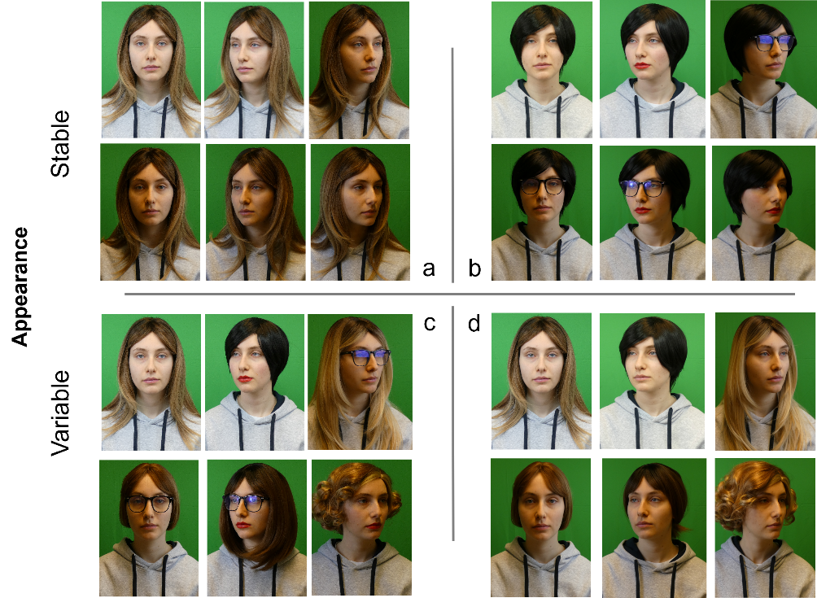
Note. In the stable condition, hairstyle remained constant across all video clips (a), though glasses and lipstick could appear in Experiment 5 (b). In the variable condition, hairstyle varied across video clips in all experiments. Glasses or make-up could appear in Experiments 1, 4 and 5 (c) but not in Experiments 2 and 3 (d). In (a) and (d), bare inner facial features correspond to the aspect of inner facial features in test images (see Figure 2), whereas in (b) and (c), lipstick and/or glasses may be added. Note that only a subset of possible appearances is shown and that participants saw videos of actresses performing up to twelve different standard actions rather than still images. The person depicted has provided permission.
The test material consisted of 72 images, with nine images (3 lighting x 3 viewing angle) per target or foil, photographed with a balaclava to only show inner facial features, the cheeks and jawline. Images were cropped, resized to 300x300px, and the balaclava and background replaced by a black field (Figure 2). Note that in the DIVA-face database, each target is paired with a foil based on similarity and distinctiveness ratings. This pairing was accounted for in sensitivity calculations (see analyses).
Figure 2
Illustration of images used in the recognition task.
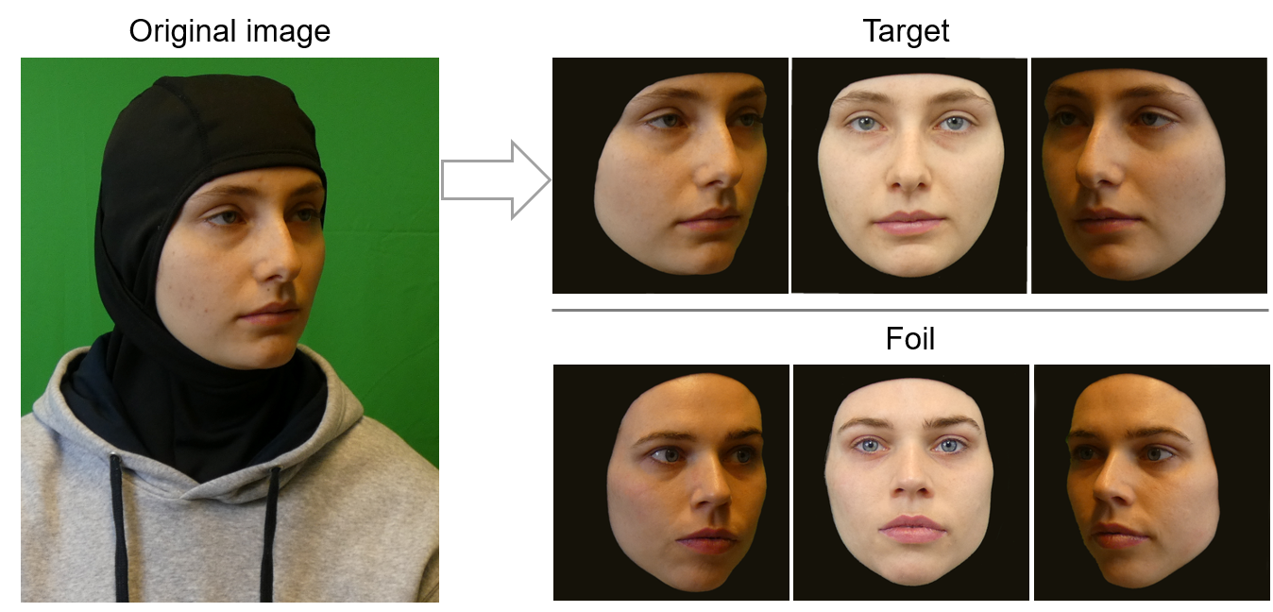
Note. Stimuli were constructed from pictures of actresses wearing a balaclava in standardised lighting (left, frontal, right) and viewing angle (right, frontal, left) combinations, of which only a subset is shown here. The top and bottom rows show one learned target and her paired foil, respectively. The persons depicted have provided permission.

Procedure. All experiments were programmed with Psychopy and conducted online via the platform Pavlovia.

Figure 3
Illustration of the two learning procedures used across experiments.
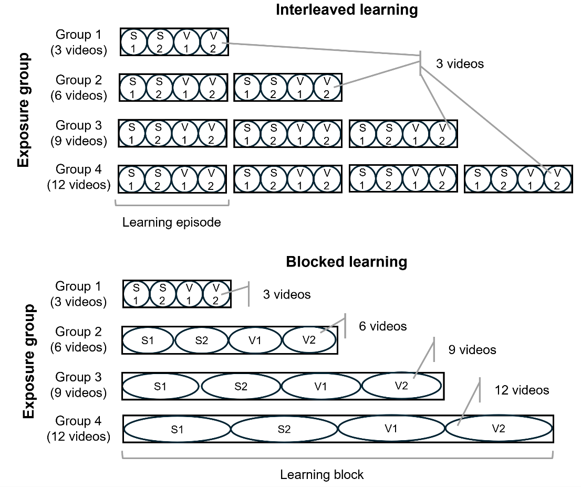
Note. Participants learned two stable (S1 and S2) and two variable (V1 and V2) faces. Different groups of participants were exposed to a total of 3, 6, 9 or 12 videos per individual face (Exposure group). In interleaved learning experiments (top; Experiments 1, 2, and 5), individual faces appeared within up to four learning episodes of three videos each (circles). In blocked learning experiments (bottom; Experiments 3 and 4), videos of individual faces were grouped in single learning blocks of up to 12 videos. The four to-be-learned identities appeared in a random order within each learning episode or block.

Learning phase. Participants were instructed to learn the faces of four women. Two had a stable appearance and two a variable appearance. The appearance was assigned randomly at the beginning of the experiment for predetermined pairs of actresses. Participants saw three 4-sec video clips per actress (12 videos in total) in Exposure Group 1, six in Group 2 (24 videos in total), nine in Group 3 (36 in total) and twelve in Group 4 (48 videos in total). Each video was preceded by a 500 ms fixation cross.
In different experiments, the videos were presented in one of two possible learning procedures: interleaved or blocked (Figure 3). In the interleaved learning procedure (Experiments 1, 2 and 5), videos were divided into learning episodes, each consisting of three videos, with breaks between episodes. In the blocked learning procedure (Experiments 3 and 4), all videos of a given actress were shown consecutively in a single block. Before each set of videos, participants were informed that all clips featured the same actress and were instructed to pay close attention even if the videos appeared similar. In the interleaved learning condition, participants were additionally reminded between learning episodes that they would be seeing the same four women again.
To ensure that only individual appearance varied within each learning episode or learning block, the selection of videos therein was pseudo-randomized: The four actresses were seen in identical viewing conditions (i.e. same combinations of lighting and gestures), unique to the block or learning episode. The order in which the four actresses appeared within each learning episode or block was also randomized.
Recognition test. Immediately after the learning phase, participants were instructed to judge as accurately and as fast as possible whether they had seen each face during the learning phase or not, by means of keys 1 and 2 (key mapping counterbalanced across participants). There were 72 trials in total, consisting of three blocks of 24 trials each. The four learned faces and four unfamiliar foils appeared three times per block (once per lighting condition and once per viewing angle, with the lighting/angle association counterbalanced) in a random order. Images were presented for up to 3 seconds on a uniform gray background, after a 1000-ms fixation cross, and replaced by a reminder of the response keys if no response was provided after 3 seconds. Each block contained one attention check asking participants to press a specific digit key. Participants had the opportunity to take a short break between each block.
Transparency and openness. We preregistered the study design and analyses plan for all studies prior to data collection on a public repository. To preserve the integrity of the double-blind review process, the aggregated data, analysis scripts, programming code, and materials for all experiments are available in an anonymized online repository (https://osf.io/wezxs/overview?view_only=f51e955ff45e41d88c8f1e7cf1dc3cca) and will be made available upon acceptance.
Measures and analyses plan. We planned to exclude and replace non-compliant participants who failed two or more of three attention checks or with a mean response time two standard deviations below the sample’s mean.
We calculated d’ in each exposure group using mean hit rates and false alarm rates computed separately for each appearance condition (variable, stable). All sensitivity results are shown in Figure 4. We conducted two-way mixed ANOVAs on d’ with Appearance as a within-subject factor and Exposure group as a between-subject factor with JASP (version 0.18.3.0). The four contrasts of interest were between stable and variable faces in each exposure group. Regardless of the presence of a significant interaction, we planned to assess the simple effect of Appearance in each group with Student’s t tests for paired samples, using Bonferroni corrections (alpha = .0125). Because exposure groups consisted of independent participants and face processing abilities vary widely across individuals, we did not plan to compare performance between every pair of exposure groups, as such comparisons would be of limited interpretive value. Nevertheless, we expected to observe a main effect of exposure group. Instead of conducting multiple paired comparisons, and in addition to the pre-planned analyses, we conducted linear analyses to formally assess a linear improvement of sensitivity with Exposure.
In addition to pre-registered analyses, Bayesian ANOVAs were conducted to complement the frequentist analyses. These results converge with the conclusions drawn from the primary analyses. For the sake of space and clarity, these results are reported in the Supplementary Materials, along complementary analyses of hit rates, false alarm rates, criterion C criterion and correct response times, which are also largely consistent with analyses of sensitivity reported below.

Experiment 1
This first experiment used interleaved learning in order to assess the reliability of facial representations created by participants after different levels of exposure to faces with a stable or a variable appearance. We expected an interaction between appearance and exposure group, with lower exposures to stable faces leading to better performance than for variable faces and higher levels of exposure leading to better performance with variable than with stable faces (see Devue & de Sena, 2023).
Method
Participants. One participant (mean RT < 2SD) from Exposure Group 4 had to be replaced. The final sample consisted of 184 participants (M_{age} = 34.76 ± 7.95; 67 men, 116 women and 1 non-binary), with 46 per group (M_{age - group1}= 34.43 ± 7.68, 16 men and 30 women; M_{age – group2}= 34.83 ± 8.07, 19 men and 27 women; M_{age – group3}= 33.80 ± 7.89, 16 men and 30 women; M_{age – group4}= 36.11 ± 7.94; 16 men, 29 women and 1 non-binary).
Material and procedure. Faces were learned in an interleaved manner (Figure 3, top panel). Participants in different groups were exposed to up to four learning episodes. Stable faces had a consistent appearance across all videos (Figure 1a). Variations in appearance of variable faces concerned hair and hairstyle, as well as the presence or absence of glasses and lipstick (Figure 1c).
Results
As expected, the main effect of Exposure group was significant, F(3,180) = 10.408, p < .001, $η_{p}^{2}$ = .148, suggesting that sensitivity to the inner features of target faces increased with additional exposure (M_{group1} = 0.91 ± 1.28; M_{group2} = 1.13 ± 1.14; M_{group3} = 1.79 ± 1.56; M_{group4} = 2.10 ± 1.52). A linear contrast confirmed a linear increase in sensitivity across exposure levels, t(180) = 5.486, p < .001 (quadratic and cubic trends, ps > .30). A significant main effect of Appearance was also found, F(1,180) = 19.455, p < .001, $η_{p}^{2}$ = .098. Unexpectedly, there was an overall sensitivity advantage for stable faces (M_{stable} = 1.72 ± 1.38; M_{variable} = 1.24 ± 1.37). The interaction between Appearance and Exposure groups was not significant, F(3,180) = 0.750, p = .524, $η_{p}^{2}$ = .012.
The follow-up t-test comparing stable and variable appearances that survived the Bonferroni correction was in Exposure group 4, t(45) = 3.488, p = .001, d = 0.514, 95% CI [0.204, 0.820], in which stables faces (M_{stable – group 4} = 2.48 ± 1.51) were recognized better than variable ones (M_{variable – group 4} = 1.73 ± 1.54). In contrast, there were no significant differences between stable and variable faces in Exposure group 1, t(45) = 1.629, p = .110, d = 0.240, 95% CI [-0.054, 0.532], group 2, t(45) = 2.069, p = .044, d = 0.305, 95% CI [0.008, 0.599], or group 3, t(45) = 1.682, p = 0.099, d = 0.248, 95% CI [-0.047, 0.540].
Figure 4
Sensitivity (d’) in each experiment as a function of Exposure group (3, 6, 9, or 12 videos seen) and Appearance (stable, variable) during the learning phase.
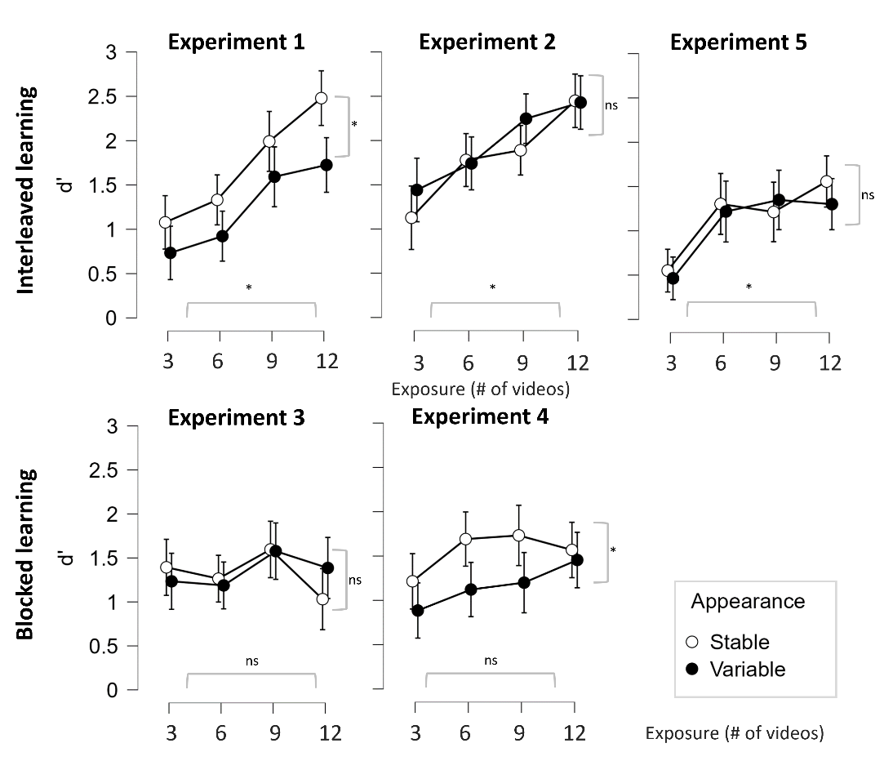
Note. Top panels gather experiments using an interleaved learning procedure, bottom panels show experiments using a blocked learning procedure. In all experiments, stable faces had a consistent hairstyle while it changed in variable faces. Differences in appearance were the most contrasted in Experiments 1 and 4 due to glasses and lipstick varying in variable faces. Experiment 5 used variations of glasses and lipstick with both stable and variable faces. Error bars represent 95% confidence intervals. *denotes significant main effects of Appearance or Exposure group.
Discussion
As expected, recognition performance improved with increased exposure to faces. However, there was an overall advantage for faces learned with a stable appearance compared to those learned with a variable appearance. There was a numerical advantage for stable faces in all exposure groups but this was only significant in exposure group 4 (exposed to 12 videos). These results contrasts with face learning experiments that observed better recognition performance following exposure to variable compared to stable learning materials (e.g. Menon et al., 2015; Matthews & Mondloch, 2018; Murphy et al., 2015; Ritchie & Burton, 2017; Robins et al., 2018). Importantly, however, the magnitudes of such benefits from variation was not always large, and was in some cases modest or even absent (e.g., Baker et al., 2017; Ritchie & Burton, 2017).
Nevertheless, our experiment departs from the previous literature in that we isolated the specific effect of variations in appearance. In most previous studies, faces learned in high variability conditions incorporated a mix of variations in appearance and in viewing conditions (context, lighting, etc.) while the low variability condition deprived observers from variations that should normally occur in real life (e.g. lighting, motion-related changes). It is thus possible that advantage for variable faces observed previously were partly driven by facilitating factors other than variability in facial appearance per se. Indeed, seminal studies had demonstrated that exposure to changes in lighting, viewpoints, or motion, can in and of themselves improve face learning (Hill & Bruce, 1996; Hill et al., 1997; Lander & Bruce, 2003; Pilz et al., 2006). An advantage for stable faces over variable faces in early stages of learning has also been found with famous faces learned in the real-world over longer time periods (Devue & de Sena, 2023). Therefore, it is possible that the current design only taps into early stages of learning, despite the use of gradually increasing levels of exposure.
Alternatively, the advantage for stable faces may be due to the aspect of inner
features in test images corresponding to facial appearances viewed during learning more often for stable faces than for variable faces. Indeed, there was only a chance to see those latter without lipstick and glasses during the learning phase in a third of cases. The lower proportion of bare faces, combined with partial occlusions or holistic changes introduced by such accessories during learning may have disadvantaged variable faces during the recognition test, which presented only bare inner features. Nevertheless, if exposure to appearance variability promoted the formation of generalized face representations, as suggested by previous face‑learning studies, then recognition of variable faces should have been immune to those factors.

Experiment 2
To address the possibility that variable faces were artificially disadvantaged in Experiment 1, we conducted a second experiment in which all faces, variable or stable, were learned with bare inner features.
Method
Participants. We recruited 184 participants (M_{age} = 36.09 ± 7.83; 76 men, 108 women), with 46 participants per exposure group (M_{age - group1}= 36.43 ± 8.41, 17 men and 29 women; M_{age – group2}= 37.00 ± 7.71, 19 men and 27 women; M_{age – group3}= 35.11 ± 7.06, 19 men and 27 women; M_{age – group4}= 35.83 ± 7.95, 21 men and 25 women).
Material and procedure. The material and procedure were identical to those described in Experiment 1 (i.e. interleaved learning procedure), except that video clips in the variable condition did not include lipstick or glasses and only included changes in hair and hairstyle, see Figure 1d. In other words, the appearance of inner facial features of all faces seen in the learning phase was comparable to their appearance in test images.
Results
The main effect of Exposure group was significant, F(3,180) = 5.853, p < .001, $η_{p}^{2}$ = .089, suggesting that sensitivity to the inner features of the target faces increased with additional exposure (M_{group1} = 1.28 ± 1.58; M_{group2} = 1.76 ± 1.56; M_{group3} = 2.07 ± 1.57; M_{group4} = 2.44 ± 1.51). A linear contrast confirmed a linear increase in sensitivity across exposure levels, t(180) = 4.174, p < .001 (quadratic and cubic trends, ps > .30). There was no significant effect of Appearance, F(1,180) = 1.972, p = .162, $η_{p}^{2}$ = .011, or interaction between Appearance and Exposure group, F(3,180) = 0.931, p = .427, $η_{p}^{2}$ = .015.
Follow-up t-tests showed no significant differences between stable and variable faces in exposure group 1, t(45) = -1.246, p = .219, d = -0.184, 95% CI [-0.821, 0.194], group 2, t(45) = .180, p = .858, d = 0.027, 95% CI [-0.263, 0.315], group 3, t(45) = -1.818, p = .076, d = -0.268, 95% CI [-0.561, 0.028], or group 4, t(45) = .090, p = .929, d = 0.013, 95% CI [-0.276, 0.302].
Discussion
Again, recognition performance improved with accumulated exposure. However, after reducing the variability level of variable faces (i.e. changes in hair and hairstyles only) and only showing them with bare features like in test images, there was no more significant differences in sensitivity between stable and variable faces.
Again, this departs from an advantage for variable face images reported in past literature (Kramer et al., 2016; Murphy et al., 2015). Unlike here, in most face learning studies, participants learn a given number of stimuli per identity in a blocked manner, providing strong learning supervision (Baker et al., 2017; Corpuz & Oriet, 2022; Honig et al., 2022; Matthews et al., 2024; Ritchie & Burton, 2017; Schwart & Yovel, 2019). This may quicken the process of extraction of finer grain diagnostic features when the level of variations is high. As participants may not readily recognize the person from one picture to another, they may be encouraged to look for features that are common in all the pictures, with the benefit of doing so on a set of pictures presented sequentially. In contrast, being exposed to similar exemplars of a given face in stable learning conditions may yield a “familiarity illusion” because participants easily recognize the face from one picture to another (Cavazos et al., 2019), discouraging them to look for finer diagnostic features and fostering coarse representations.
In contrast, in the two experiments above, identities were learned via smaller
learning episodes of only three videos, and showing four identities in a randomized order. This means that participants in exposure groups 2 to 4 had to go through the extra step of recognizing the four identities in each learning episode before they could start refining their representations of variable faces. It is possible that stable faces were more easily recognized from one learning episode to another based on their distinct wigs, providing more chance to learn their diagnostic features than in the case of variable faces. To test if interleaved learning may have contributed to the advantage for stable faces in Experiment 1, we conducted a third experiment in which learning material was grouped in a single block, similar to past lab-based face learning studies.

Experiment 3
We reproduced Experiment 2 but grouped all videos seen per identity (i.e. 3, 6, 9, or 12 as a function of exposure group) instead of exposing participants to separate learning episodes (i.e. 1, 2, 3 or 4 as a function of exposure group) of three videos each. We hypothesized that being exposed to all the variations in appearance at once should yield an advantage for variable faces for participants receiving the most exposure (Group 4).
Method
Participants. We recruited 185 participants (M_{age} = 35.01 ± 8.17; 82 men, 101 women and 2 non-binary), with 46 participants per exposure group except group 3 that counted 47 participants (M_{age - group1}= 35.61 ± 6.62, 21 men and 25 women; M_{age – group2}= 34.07 ± 8.86, 22 men and 24 women; M_{age – group3}= 33.70 ± 8.64, 20 men, 25 women and 2 non-binary; M_{age – group4}= 36.67 ± 8.01, 19 men and 27 women).
Material and procedure. The material and procedure were identical to those described in Experiment 2 (i.e. all faces displaying bare inner facial features during learning), except for the learning procedure. Videos for each identity were grouped in a single learning block instead of spread across multiple learning episodes, see Figure 3 (bottom panel).
Results
The main effect of Exposure group, F(3,181) = 0.840, p = .473, $η_{p}^{2}$ = .014, of Appearance, F(1,181) = 0.051, p = .821, $η_{p}^{2}$ = 2.830×10⁻⁴, and the interaction between Appearance and Exposure Group, F(3,181) = 1.052, p = .371, $η_{p}^{2}$ = .017, were all non-significant. The simple effects of Appearance within each exposure group were tested using Student’s paired-samples t-tests. There were no significant differences between stable and variable faces in any exposure group (Group 1, t(45) = .710, p = .481, d = 0.105, 95% CI [-0.186, 0.394]; Group 2, t(45) = .411, p = .683, d = 0.061, 95% CI [-0.229, 0.349]; Group 3 t(46) = .085, p = .932, d = 0.012, 95% CI [-0.274, 0.298] or Group 4, t(45) = -1.456, p = .152, d = -0.215, 95% CI [-0.506, 0.079]).
Discussion
In Experiment 3, we changed the learning procedure and presented faces in a blocked manner instead of interleaved, while keeping the rest of the design identical to Experiment 2. Unexpectedly, we found no significant effects of Appearance or Exposure group. It is possible that grouping images of the same identity reduces retrieval difficulty during learning. Participants may then rely on short-term or contextually supported representations, making it easier to recognize the identity without engaging in refined encoding of appearance. As such, variability in appearance may be ignored rather than integrated into the face representation (see Smith & Handy, 2014). To further investigate how variability and the presentation procedure influence face learning, we conducted Experiment 4 that again adopted a blocked learning procedure combined with maximal differences between the stable and variable appearance conditions, as in Experiment 1.

Experiment 4
We used the high-variability materials from Experiment 1 but presented the faces in a blocked manner instead of spread across learning episodes. This design makes the learning conditions more similar to previous studies on within-person variability—except that in our case, the variability only applied to appearance (instead of other factors like pose or lighting that varied in both conditions). Therefore, we hypothesized that recognition performance would improve with increased exposure, with the greatest benefit observed for variable faces at higher exposure levels.

Method
Participants. We recruited 185 participants (M_{age} = 35.58 ± 9.19; 75 men, 108 women and 2 non-binary), with 46 participants per exposure group except group 1 that counted 47 participants (M_{age - group1}= 34.53 ± 9.04; 21 men, 25 women and 1 non-binary; M_{age – group2}= 35.52 ± 8.80, 11 men and 35 women; M_{age – group3}= 37.89 ± 9.56, 16 men and 30 women; M_{age – group4}= 34.41 ± 8.94; 27 men, 18 women and 1 non-binary).
Material and procedure. The material and procedure were identical to those described in Experiment 3, except that variations in the variable condition were the same as Experiment 1. Namely, beyond hair and hairstyles, changes in appearance also concerned the presence or absence of glasses and lipstick.
Results
The main effect of Appearance was significant, F(1,181) = 11.972, p < .001, $η_{p}^{2}$ = .062, with an overall sensitivity advantage for stable faces (M_{stable} = 1.55 ± 1.47; M_{variable} = 1.17 ± 1.42). There was no significant effect of Exposure group, F(3,181) = 1.347, p = .261, $η_{p}^{2}$ = .022, and no significant interaction between Appearance and Exposure group, F(3,181) = 0.884, p = .451, $η_{p}^{2}$ = .014.
Simple effects of Appearance in each exposure group were tested with Student’s t tests for paired samples. There was a significant difference in exposure group 2, t(45) = 2.648, p = .011, d = 0.39, 95% CI [0.088, 0.688], due to stables faces (M_{stable – group 2} = 1.69 ± 1.26; M_{stable – group 3} = 1.73 ± 1.75) being recognized better than variable ones (M_{variable – group 2} = 1.12 ± 1.34; M_{variable – group 3} = 1.20 ± = 1.50). None of the other comparisons survived the Bonferroni correction, showing no significant difference between stable and variable conditions; Group 1, t(46) = 1.505, p = .139, d = 0.219, 95% CI [-0.071, 0.508], Group 3, t(45) = 2.231, p = 0.031, d = 0.329, 95% CI [0.030, 0.624], and Group 4, t(45) = .516, p = .608, d = 0.076, 95% CI [-0.214, 0.365].
Discussion
We used a blocked presentation procedure combined with high-variability
in the variable condition. Recognition performance was significantly better for stable faces than for variable faces, like in Experiment 1 in which the same materials were used, even though both experiments adopted different learning procedures. Interestingly, like in Experiment 3, there was no significant improvement in recognition performance with increased video exposure, which contrasts from the two experiments using a interleaved learning procedure (Experiments 1 and 2). This suggests that when observers are exposed to the full set of videos per identity at once, additional videos do not significantly help increase the reliability of facial representations.

Experiment 5
The previous experiments do not fully explain the advantage for stable faces compared to highly variable faces, that is faces varying in both external and internal facial features. It could be that such high degree of variations make variable faces too difficult to learn per se (e.g. because attention is drawn to salient changes in appearance rather than to diagnostic facial features) or that a consistent and more frequent exposure to bare facial features in the stable condition provides an advantage since test images also show bare inner features. We thus conducted a fifth experiment that removed the potential bias in favour of stable faces by making the appearance of their inner features vary in a similar way as in variable faces. We expected that performance with stable faces should drop compared to previous experiments if they were advantaged therein. Here, we used an interleaved learning procedure as it seems more efficient in fostering a refinement of facial representations compared to a blocked learning procedure.
Method
Participants. We recruited 184 participants (M_{age} = 36.78 ± 8.27; 74 men, 108 women and 2 non-binary), with 46 of them in each exposure group (M_{age - group1}= 36.63 ± 9.49, 17 men and 29 women; M_{age – group2}= 35.67 ± 7.68, 18 men and 28 women; M_{age – group3}= 36.69 ± 7.92; 21 men, 24 women and 1 non-binary; M_{age – group4}= 38.13 ± 7.65; 18 men, 27 women and 1 non-binary).
Material and procedure. The material and procedure were identical to those described in Experiments 1 and 2 (i.e. interleaved learning), except that both stable and variable identities could be shown with glasses and/or lipstick during the learning phase. The appearance of inner facial features of all faces thus varied in the same way compared to test images showing bare inner facial features. The difference between stable and variable faces only concerned hair and hairstyle—consistent in the former and changing in the latter.
Results
There was no significant effect of Appearance, F(1,180) = 0.466, p = .495, $η_{p}^{2}$ = .003, but the effect of Exposure group was significant, F(3,180) = 6.693, p < .001, $η_{p}^{2}$ = .100. A linear contrast confirmed a linear increase in sensitivity across exposure levels, t(180) = 3.883, p < .001 (quadratic and cubic trends, ps > .05). There was no significant interaction between Appearance and Exposure group, F(3,180) = 0.563, p = .640, $η_{p}^{2}$ = .009. Simple effects of Appearance in each exposure group were tested with Student’s t-tests for paired samples and showed no significant effect of appearance in either group (Group 1, t(45) = .515, p = .609, d = 0.076, 95% CI [-0.214, 0.365]; Group 2, t(45) = .353, p = 0.725, d = 0.052, 95% CI [-.237, .341]; Group 3 t(45) = -.577, p = .567, d = -0.085, 95% CI [-0.374, 0.205]; Group 4, t(45) = 1.264, p = .213, d = 0.186, 95% CI [-0.106, 0.477]).

Exploratory analyses
We conducted additional between-experiments exploratory analyses to investigate the impact of the material and of learning procedures.
Degrees of variations and learning-test correspondence.
Here, we compared subsets of experiments that used the same learning procedure but in which the aspect of inner facial features in learning materials partially or fully corresponded to test images.
We first compared the three experiments that used an interleaved learning procedure (Experiments 1, 2, and 5). In Experiment 2, all faces were learned with bare inner facial features like in test images. Lipstick and/or glasses could also vary for variable faces in Experiment 1 and for both stable and variable faces in Experiment 5. A three-way mixed ANOVA with Experiment (1, 2, 5) and Exposure group (1 to 4) as between-subject factors and Appearance (stable, variable) as within-subject factor revealed a significant main effect of Appearance (M_{stable} = 1.56 ± 1.41; M_{variable} = 1.43 ± 1.41), F(1,540) = 4.476, p = .035, $η_{p}^{2}$ = .008 and of Exposure group (M_{Group 1} = 0.90 ± 1.29, M_{Group 2} = 1.38 ± 1.35, M_{Group3} = 1.71 ± 1.53, M_{Group 4} = 1.99 ± 1.46), F(3,540) = 20.512, p < .001, $η_{p}^{2}$ = .102. There was a main effect of Experiment, F(2,540) = 18.358, p < .001, $η_{p}^{2}$ = .064, qualified by an interaction with Appearance, F(2,540) = 8.712, p < .001, $η_{p}^{2}$ = .031. Figure 5 (left panel) illustrates a significant difference between stable and variable faces in Experiment 1 only (as already described across experiments above). In addition, paired comparisons with Student t-tests for independent samples show a similar performance for stable faces in Experiments 1 and 2 (i.e. bare inner facial features in both), t(366)_{Exp. 1 vs 2} = -.559, p = .576, d = -0.058, 95% CI [-0.263, 0.146], with a significant drop in performance in Experiment 5—where lipstick and glasses could appear during learning—compared to the two others, t(366)_{Exp. 1 vs 5} = 3.849, p < .001, d = 0.401, 95% CI [0.195, 0.607], and t(366)_{Exp. 2 vs 5} = 4.233, p =< .001, d = 0.441, 95% CI [0.234, 0.648], respectively. Likewise, performance with variable faces was similarly low in Experiments 1 and 5 which included those inner features variations, t(366)_{Exp. 1 vs 5} = 1.098, p = .273, d = 0.115, 95% CI [-0.090, 0.319], and improved in Experiment 2 which did not, t(366)_{Exp. 1 vs 2} = -4.578, p < .001, d = -0.477 95%, CI [-0.684, -0.270], and t(366)_{Exp. 2 vs 5} = 5.717, p =< .001, d = 0.596, 95% CI [0.387, 0.805], respectively.
In other words, performance improved wherever the learning phase showed material fully consistent with test images (i.e. bare inner facial features) and decreased wherever learning materials included glasses and/or lipstick. No other interactions were significant (all ps > .15).
Figure 5
Sensitivity (d’) as a function of Appearance (stable, variable) during the learning phase in experiments using different materials.
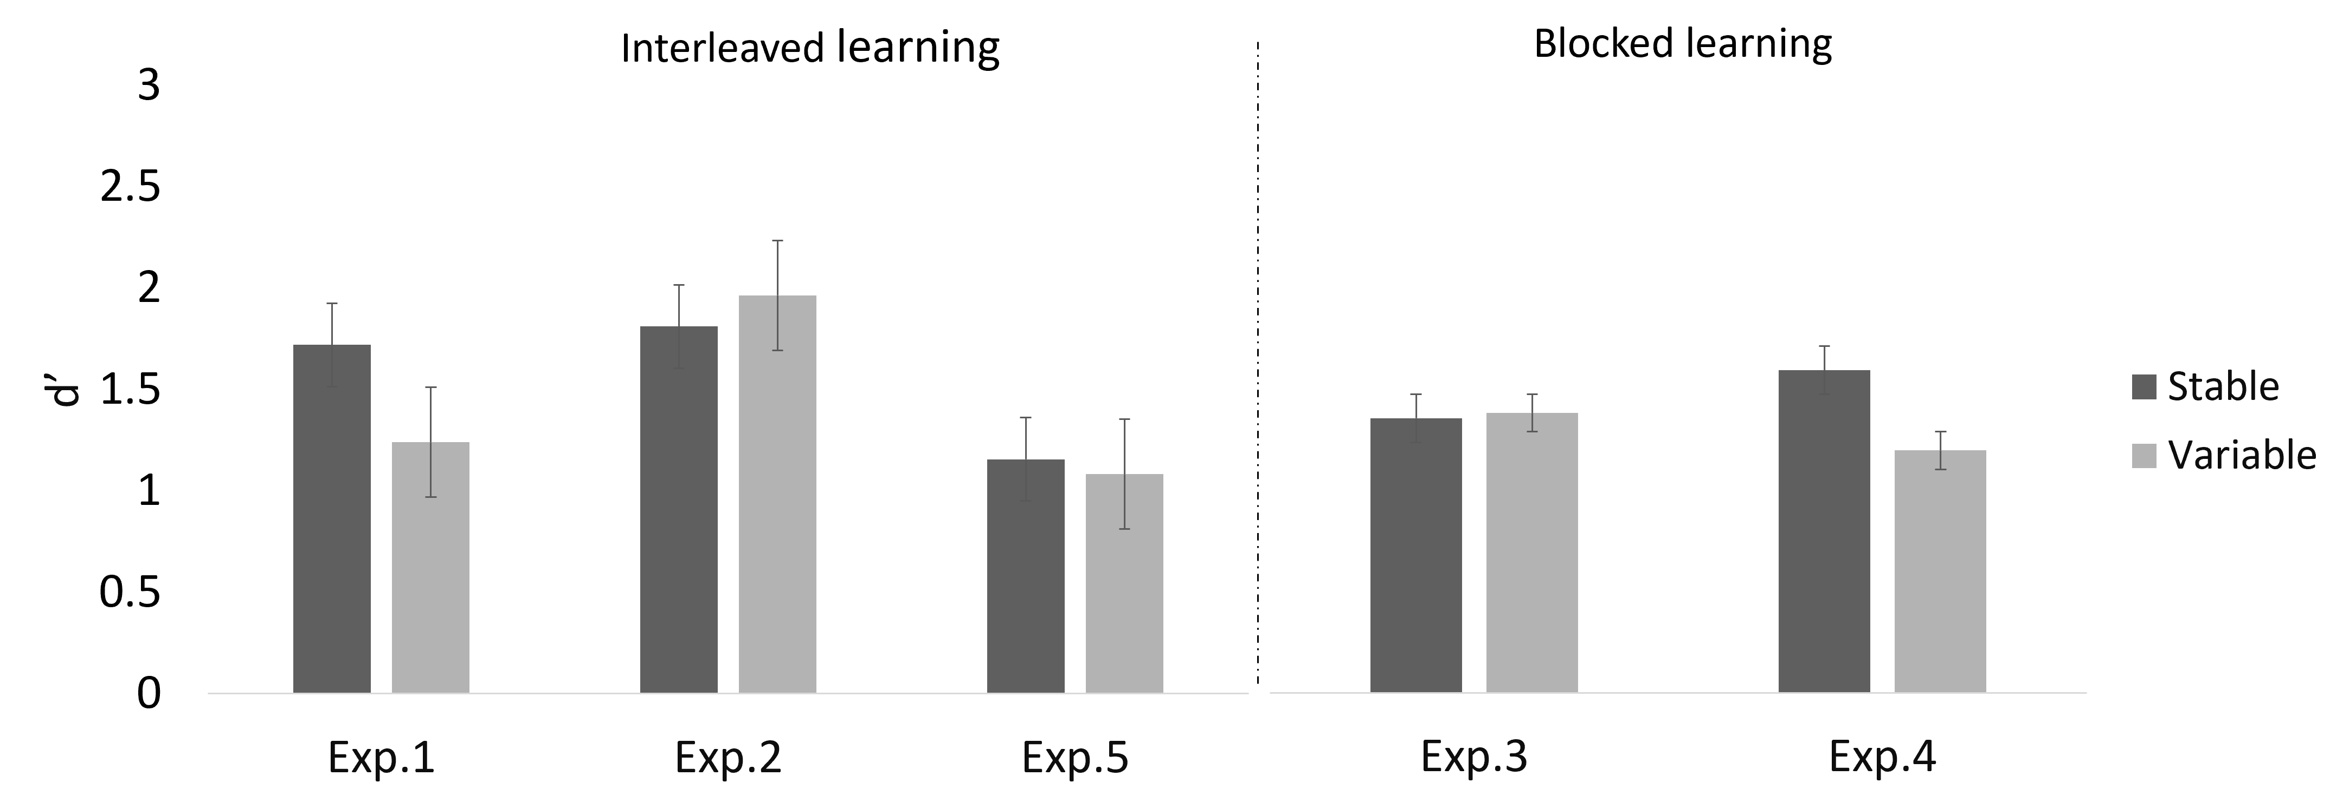
Note. Left panel shows interleaved learning experiments and right panel blocked learning experiments. In all experiments, stable faces had a consistent hairstyle while it changed in variable faces. Differences in appearance were the most contrasted between stable and variables faces in Experiments 1 and 4 due to glasses and lipstick varying in the latter in addition to hairstyle. In Experiments 2 and 3, stable and variable faces both had consistent bare inner features. In Experiment 5, variations of glasses and lipstick were shown for both stable and variable faces. Error bars represent 95% confidence intervals.
We then compared the two experiments that used a blocked learning procedure (Experiments 3 and 4) but different materials. In Experiment 3, all faces had bare inner features during learning, while lipstick and/or glasses could appear on variable faces in Experiment 4. We again found a significant main effect of Appearance (M_{stable} = 1.44 ± 1.47; M_{variable} = 1.26 ± 1.47), F(1,362) = 5.292, p = .022, $η_{p}^{2}$ = .014, but no main effect of Exposure group, F(3,362) = 1.162, p = .324, $η_{p}^{2}$ = .010. There was no significant main effect of Experiment, F(1,362) = .036, p = .850, $η_{p}^{2}$ = 9.881×10⁻⁵, but the main effect of Appearance was qualified by an interaction with Experiment, F(1,362) = 6.856, p = .009, $η_{p}^{2}$ = .019. Figure 5 (right panel) shows a significant difference between stable and variable faces in Experiment 4 only (as already described in individual experiments). Unsurprisingly, follow-up paired comparisons show no significant difference in performance for stable faces in both experiments that used the same materials, t(368)_{Exp. 3 vs 4} = -1.478, p = .140, d = -0.154, 95% CI [-0.358, 0.051]. Despite a numerical drop in performance for variable faces when lipstick and glasses could appear during learning (i.e. Experiment 4), the difference with Experiment 3 was not significant, t(368)_{Exp. 3 vs 4} = 1.192, p = .234, d = 0.124, 95% CI [-0.080, 0.328].
Altogether, these results indicate that the correspondence in appearance between learning and test material matters when assessing face learning (see also Honig et al., 2022). The advantage for stable faces primarily emerged when variable faces were learned through videos that included glasses or lipstick, absent in test images, and disappeared when stable faces also showed such extraneous features during learning. This suggests that exposure to variations in appearance does not necessarily lead to the formation of generalizable face representations (Corpuz & Oriet, 2022; Baker et al., 2017; Jenkins et al., 2011; Murphy et al., 2015; Zhou et al., 2022).
Learning procedure
Our results suggest that incremental exposure to videos improves recognition performance following interleaved presentations but not blocked presentations (Figure 4). To assess that trend formally, we compared pairs of experiments that used the same learning materials but different learning procedures.
We first compared the two experiments that used materials with the most variations in the variable condition (Experiments 1 and 4). Experiment 1 used interleaved learning and Experiment 4 used blocked learning. A three-way mixed ANOVA with Learning procedure (interleaved, blocked) and Exposure Group (1 to 4) as between-subjects factors and Appearance (stable, variable) as a within-subject factor revealed a significant main effect of Appearance (M_{stable} = 1.64 ± 1.43; M_{variable} = 1.20 ± 1.39), F(1,361) = 30.840, p < .001, $η_{p}^{2}$ = .079, and of Exposure group (M_{group1} = 0.98 ± = 1.37; M_{group2} = 1.27 ± 1.22; M_{group3} = 1.63 ± 1.59; M_{group4} = 1.81 ± 1.46), F(3,361) = 8.718, p < .001, $η_{p}^{2}$ = .068 . There was no main effect of Learning procedure, F(1,361) = 0.963, p = .327, $η_{p}^{2}$ = .003, but there was a marginal interaction between Exposure group and Learning procedure, F(3,361) = 2.599, p = .052, $η_{p}^{2}$ = .021, see Figure 6 (left panel). No other interactions were significant, all ps > .2.
Figure 6.
Sensitivity (d’) as a function of Exposure group (3, 6, 9, or 12 videos seen) and Learning procedure.
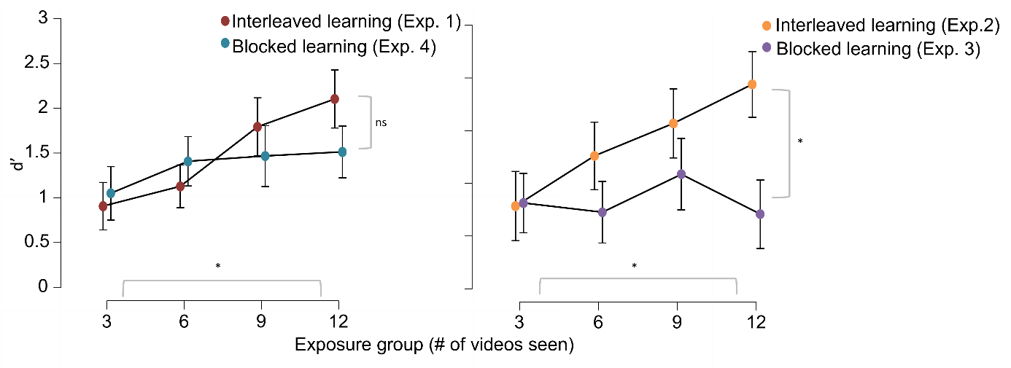
Note. Left panel shows experiments with highly variable videos in the variable condition (Exp. 1 and 4). Right panel shows experiments in which faces were all learned with bare inner features (Exp. 2 and 3). Error bars represent 95% confidence intervals.
The same ANOVA including the two experiments that used learning material with bare inner features (Experiments 2, interleaved learning, and Experiment 3, blocked learning) revealed no significant main effect of Appearance, F(1,361) = 1.319, p = .251, $η_{p}^{2}$ = .004, and a significant main effect of Exposure group (M_{group1} = 1.30 ± 1.47; M_{group2} = 1.49 ± 1.48; M_{group3} = 1.83 ± 1.61; M_{group4} = 1.82 ± 1.54), F(3,361) = 3.495, p = .016, $η_{p}^{2}$ = .028 . Here, the main effect of Learning procedure was significant (M_{Exp. 2-interleaved} = 1.89 ± 1.56; M_{Exp. 3-blocked} = 1.33 ± 1.50), F(1,361) = 15.848, p < .001, $η_{p}^{2}$ = .042, but it was qualified by a significant interaction with Exposure group, F(3,361) = 3.445, p = .017, $η_{p}^{2}$ = .028. Figure 6 (right panel) illustrates that learning improves linearly with additional videos if those videos are interleaved but not when they are blocked.
Altogether, these analyses confirm that performance gains from incremental exposure are specific to interleaved learning procedures.
General discussion
We used a new video database (DIVA-Face; Li et al., 2025) to better understand how the relative stability of appearance and exposure jointly shape the learning of newly encountered faces, over and beyond natural variations due to lighting and motion. Based on a cost-efficient encoding hypothesis and on previous observations with famous faces (Devue & de Sena, 2023), we expected that stable faces would be recognized better than variable faces at lower exposure levels, but that variable faces would be recognized better than stable faces after higher exposure levels. Our rationale was that increased exposure to variations in appearance would help refine facial representations. However, there was no such interaction between exposure and appearance.
Instead, in two different learning procedures, stable faces were recognized better than variable ones but only when the latter were learned with ad hoc addition of lipstick or glasses (Experiments 1 and 4). Further, while isolated changes in peripheral feature (i.e., hairstyle) did not significantly affect recognition relative to the stable condition (cf. Experiments 2, 3 and 5), additional variations in inner features seemed detrimental to learning for stable and variable faces alike (Experiments 1, 4 and 5). Finally, recognition improved with additional exposure only when individual faces were presented in an interleaved manner rather than in a blocked one. We note that results from frequentist analyses in the main text were consistent with interpretations from supplemental Bayesian analyses, reinforcing our findings.
Although not entirely unprecedented (e.g., Moore et al., 2024), an advantage for stable learning material diverges from results of most prior face learning studies in which exposure to uncontrolled within-person variability facilitated face learning (e.g., Kramer et al., 2017; Ritchie & Burton, 2017; Robins et al., 2018). One could have expected the highest performance in experiments that used the highest degrees of variations (i.e. Experiment 5) compared to experiments with the lowest degrees of variations (i.e. Experiments 2 and 3). However, our results show that recognition performance actually declined wherever variability in appearance increased, even if variable appearances included video clips with bare inner features as in the recognition phase. Our results thus seem to deviate from predictions derived from the averaging hypothesis, which posits that exposure to greater within-person variability increases the likelihood of successful recognition due to the development of more robust and generalizable averaged representations (Burton et al., 2005; Burton, 2013). If this was true, exposure to isolated changes in appearance should have helped create such representations, and allowed a more efficient recognition of variable faces than of stable faces, regardless of learning procedure or testing materials.
The type of variation that contributes to face learning and the conditions in which they do thus remain to be elucidated. Below, we discuss factors that may modulate face learning or subsequent recognition performance, as well as new research avenues opened by our results. While our study focused on face learning, prior work has shown that the cognitive and neural mechanisms supporting the individuation of faces can also extend to other domains requiring fine-grained discrimination, such as novel object categories (Gauthier et al., 1999; Wong et al., 2009). This suggests that our face learning findings may have broader implications for understanding how stability and variability interact in learning to recognize any category of objects at the individual level.
Learning and test materials correspondence
One possible explanation for the unexpected advantage for stable faces is that, in some experiments, test images corresponded more to learning materials in the stable condition than in the variable condition. Namely, even if test images all concealed hair with a balaclava, making this large-scale peripheral diagnostic feature unusable, they all showed bare inner features (i.e. without glasses or make-up) like stable faces while they were learned (except in Experiment 5). In contrast, a portion of to-be-learned videos in the variable condition introduced features that were absent in test images (i.e. lipstick or glasses), diminishing learning-test correspondence.
To address this issue, we conducted Experiments 2 and 3, where all faces were learned without lipstick or glasses, giving a total correspondence between learning and testing materials in all conditions. In this context, performance with variable faces increased, removing the recognition advantage for stable faces. Furthermore, when both stable and variable faces were learned with varying inner features (Experiment 5), recognition performance dropped in a similar manner in both conditions. Altogether, recognition thus seems hindered when the variability displayed during learning does not consistently align with facial features shown at test. This may also suggest that some level of repeated exposure to a given facial appearance, in other words, exposure to some level of stability, is helpful when learning new faces.
In previous studies that found an advantage for faces learned with higher degrees of variations, test materials often included novel images like here. Typically, these test images involve substantial changes in viewing conditions, in facial expressions and in appearance—of both internal and external features, creating potentially large disparities between study and test materials (e.g. Corpuz & Oriet, 2022; Davis et al., 2024; Koca & Oriet, 2023; Moore et al., 2024; Ritchie & Burton, 2017). While this allowed testing the robustness of facial representations developed at learning, it may have unfairly disadvantaged faces learned in stable conditions, particularly when learning materials for stable faces removed some of the richness found in real-world exposure (e.g. variations in lighting).
Another face learning study that shares some features with the current one highlights the importance of correspondence between learning and test materials (Devue et al., 2023). Typical observers and people with developmental prosopagnosia learned three different women’s faces with a stable appearance, via rich and ecological materials (i.e. video clips including changes in viewpoint, expression, lighting or context). In a subsequent recognition test, participants were presented with new images that showed the three women with the same or a different appearance to the learned one (e.g. different hairstyle or makeup) and three foils with similar (i.e. similar face shape, hairstyle, facial features and make-up) or different appearances. Participants in both groups failed to recognise learned faces more often when appearance in test images showed low correspondence with learned appearances, and committed more false alarms for foils which appearances were similar to that of targets. This pattern applied both with full headshots and images of cropped inner-feature such as used here. Therefore, while they used stable appearance at learning and introduced variations at test and we did the opposite, these two studies highlight the importance of learning-test correspondence. Likewise, Honig and colleagues (2022) showed that perceptual similarity ratings between learning and test images predicted recognition performance better than variability during learning. Further, Moore et al. (2024) found that learning unfamiliar faces under low within-person variability improved performance in a search task compared to learning under high variability, but only when study-test images were rated as more perceptually similar.
Taken together, these results suggest that the benefits of within-person variability may depend on how well the representations developed during learning correspond to perceptual features encountered during recognition. In line with recent evidence from ensemble coding (Davis et al., 2024), exposure to variability may be beneficial but only when it encompasses perceptual features encountered at test. These observations are compatible with the view that a cost-efficient face learning system should assume by default that physical appearance is stable, expect no drastic changes between encounters and rely on coarse representations, until changes are actually observed (see Devue & de Sena, 2023). Interestingly, links between perceived similarity and recognition performance may not be unidirectional. Indeed, other studies have shown that the perceived similarity between multiple images of an individual or perceived likeness of a photo with a person are also affected by familiarity (Hancock, 2021; Kramer et al., 2025; Ritchie et al., 2018). Future face learning research should therefore take learning-test correspondence into account to assess more comprehensively how stability and variability contribute to reliable and flexible facial representations.
Exposure and learning procedure
Across five experiments, recognition improved with additional exposure, but only in an interleaved learning procedure (Experiments 1, 2, and 5) and not in a blocked one (Experiments 3 and 4). This finding aligns with past studies, which have shown that seeing a face multiple times (e.g. Baker & Mondloch, 2023; Bonner et al., 2003) or for a longer duration overall (Reynolds & Pezdek, 1992) enhances recognition performance. We expand these findings by showing that this pattern applies to both stable and variable faces. The absence of additional exposure benefit under blocked learning is consistent with evidence that gains from additional within-identity exemplars can be limited. For instance, White et al. (2014, Exp. 2) reported gains from two images relative to one, but little additional benefit from three or four images. Such plateau could arise because participants pay less attention to additional videos due to some form of illusions of knowing (Jacoby et al., 2024). While humans and computer learning may share some features (Kramer et al., 2018; O’Toole & Castillo, 2021; O’Toole et al., 2018), such a decreased in attention to faces due to repeated exposure would distinguish human learners from computer algorithms, on which theorisation of face learning have often been based (Jenkins & Burton, 2008; 2011). Considering human attentional limitations could thus help further theoretical development.
Exploratory analyses further indicated that interleaved learning led to better recognition than blocked learning, but only when comparing experiments in which all faces were learned with bare inner features (Experiments 2 and 3). This advantage may arise because interleaved learning requires repeated discrimination between identities across episodes. This process may be facilitated when diagnostic features remain stable across encounters, as suggested by previous research on famous faces recognition (Devue & de Sena, 2023). The importance of learning procedure and benefits from interleaved learning is particularly relevant since most previous face learning studies presented faces in a blocked manner—showing all instances of a given identity in one single block—rather than distributing them across separate learning episodes (e.g. Baker & Mondloch, 2017; Honig et al., 2022; Matthews & Mondloch, 2024; Ritchie & Burton, 2017).
Moreover, our results are consistent with long-standing evidence from the distributed practice which has demonstrated that the temporal distribution of learning episodes significantly affects memory retention: learning is enhanced when repeated exposures to the same item are spaced over time or interleaved with other items, as opposed to being presented one by one in a massed way (Cepeda et al., 2006; Thios & D’Agostino, 1976). In our experiments, the interleaved learning procedure approached this distributed learning structure, where each face was encountered again after learning other identities, likely allowing for retrieval opportunities and deeper encoding across time. In contrast, the blocked procedure corresponded to massed exposure, which although it provided a continuous, unstopped study time for a single identity, may have led to short-term fluency without long-term retention, a pattern frequently reported in the spacing effect (Bjork, 1994; Kornell et al., 2010). The fact that the spacing benefit in the interleaved learning procedure was observed across both stable and variable appearance conditions strengthens the idea that the temporal structure of learning plays a crucial role in building robust facial representations. This finding bridges real-world and lab-based studies by showing that when encounters are distributed and unpredictable—as in everyday life—exposure benefits emerge. In contrast, massed learning, typical of many lab studies, maybe underestimate the role exposure plays. Future research should therefore aim at creating learning procedures that more intently mimic real-world exposure, in order to increase our understanding of human face learning.
Implementation of variations and learning demands
Unlike many previous studies that relied on unconstrained real-world images (e.g. Andrews et al., 2017; Jenkins et al., 2011; Ritchie & Burton, 2017), we used rich but tightly controlled dynamic face stimuli in both stable and variable appearance conditions, in order to isolate the specific contribution of stability and variations in appearance to face learning, over and beyond other naturalistic variations.
Compared to stable faces, variable faces exhibited additional changes in appearance across video clips, primarily via changes in hairstyle implemented with wigs, and in some experiments through the addition of lipstick or glasses. One could argue that such manipulations made variable faces excessively difficult to learn or distracted attention away from the face itself. Although such changes may occur less rapidly in everyday life, they are plausible and comparable to appearance variations commonly observed in uncontrolled images of celebrities across events or movies (such as used in e.g. Ritchie & Burton, 2017). People also routinely wear glasses or lipstick inconsistently from one moment to another. Importantly, in the present learning materials, lipstick and glasses were identical across all actresses, making them non-diagnostic. Concerns that wigs may introduce unnatural or disruptive effects are mitigated by evidence from the DIVA-Face database showing that wigs were not rated as more distinctive than natural hair (Li et al., 2025) and by the fact that we are routinely exposed to celebrities wearing wigs to change their appearance, men and women alike. The present results are therefore unlikely to be driven by the artificiality of hair manipulation. In fact, they show that changes in hairstyle alone did not significantly affect recognition performance, which was comparable for stable and variable faces when manipulation of hair was the only differentiating factor. While the present results do not support our rationale, whereby changes in superficial cues we implemented should orient attention to finer facial features (Devue & de Sena, 2023), it remains possible that exposure to increased numbers of videos may ultimately lead to the benefit from variations in appearance that we failed to find here.
Another factor that may have affected our results is the number of faces participants were asked to learn. This number was relatively small and on the lower end compared to previous studies (see e.g. Baker & Mondloch, 2023; Baker et al., 2017; Honig et al., 2022; Koca & Oriet, 2023; Kramer et al., 2017; Ritchie & Burton, 2017, with ranges between 4 to 20 faces to learn). Note that despite this, sensitivity remained far from ceiling in most cases. In combination with our implementation of variation, such low number of faces to learn may lead to specific learning strategies. According to resources-based models of visual working memory, individuals flexibly allocate cognitive resources based on task demands and according to the number of items to remember, such that increasing the number of items often reduces the encoding quality for each item (Fukuda, Awh, & Vogel, 2010; Zhang & Luck, 2008). This could create a trade-off: when fewer faces are learned, participants may dedicate more resources to each identity, potentially creating more robust or higher resolution representations sufficient for later recognition. In contrast, when more identities must be encoded—as in several other studies showing variability benefits—the cognitive load is higher, exploiting and overriding variability might become more crucial for building generalizable face representations (Hunnisett & Favelle, 2021). Thus, the limited set size in our experiments may have reduced the need for variability-based strategies. This could also apply at the individual face level, with participants initially treating different appearance of variable faces as distinct items, yielding lesser quality encoding of each one. In contrast, the consistent appearance of stable faces may make the different videos look like the same item, allowing for a consolidation of diagnostic information across repetition. Finally, the impact of increasing the number of videos may also depend on the learning procedure itself. Future research should thus examine whether and how the number of faces to learn and the number of exemplars presented, and the way they are presented, modulate learning strategies and recognition outcome.
Conclusion
We used a new ecological face database to isolate the role of variability in appearance and test the role of exposure in building cost-efficient facial representations. Contrary to our expectations, variability did not improve recognition at later stages of learning. Instead, stable faces were better recognized, but only when test images corresponded to the learning materials and displayed bare inner features. This suggests that within-person variability does not necessarily improve learning outcomes as one may have expected from dominant face learning models. Excessive variability may increase processing demands or yield learning strategies that hinder the extraction of invariant identity features. Further, recognition performance improved with increased exposure, but only after interleaved learning. Possibly, the blocked format, such as used in most previous face learning studies, may foster short-term fluency but results in poorer generalization than an interleaved procedure. These findings thus open multiple new research avenues that will help enhance our understanding of how humans may encode facial information efficiently in real-world settings.

References
Andrews S., Burton A. M., Schweinberger S. R., Wiese H. (2017). Event-related potentials reveal the development of stable face representations from natural variability. The Quarterly Journal of Experimental Psychology, 70, 1620–1632. https://doi.org/10.1080/17470218.2016.1195851
Andrews, S., Jenkins, R., Cursiter, H., & Burton, A. M. (2015). Telling faces together: Learning new faces through exposure to multiple instances. Quarterly Journal of Experimental Psychology, 68(10), 2041–2050. https://doi.org/10.1080/17470218.2014.1003949
Baker, K. A., Laurence, S., & Mondloch, C. J. (2017). How does a newly encountered face become familiar? The effect of within-person variability on adults’ and children’s perception of identity. Cognition, 161, 19–30. https://doi.org/10.1016/j.cognition.2016.12.012
Baker, K. A. & Mondloch, C. J. (2019). Two sides of face learning: Improving between-identity discrimination while tolerating more within-person variability in appearance. Perception 48(11), 1124–1145. https://doi.org/10.1177/0301006619867862
Baker, K. A., & Mondloch, C. J. (2023). Unfamiliar face matching ability predicts the slope of face learning. Scientific Reports, 13(1), 5248. https://doi.org/10.1038/s41598-023-32244-w
Bindemann, M., Attard, J., Leach, A. M. Y. & Johnston, R. A. (2013). The effect of image pixelation on unfamiliar-face matching. Appl. Cognit. Psychol. 27(6), 707–717.
https://doi.org/10.1002/acp.2970
Bjork, R. A. (1994). Memory and metamemory considerations in the training of human beings. In J. Metcalfe & A. P. Shimamura (Eds.), Metacognition: Knowing about knowing (pp. 185–205). MIT Press.
Bonner, L., Burton, A. M., & Bruce, V. (2003). Getting to know you: How we learn new faces. Visual Cognition, 10(5), 527–536. https://doi.org/10.1080/13506280244000168
Bruce, V. (1994). Stability from variation: The case of face recognition. Quarterly Journal of Experimental Psychology A, 47(1), 5–28. https://doi.org/10.1080/14640749408401141
Burton, A. M. (2013). Why has research in face recognition progressed so slowly? The importance of variability. Quarterly Journal of Experimental Psychology, 66(8), 1467–1485. https://doi.org/10.1080/17470218.2013.800125
Burton, A. M., Jenkins, R., Hancock, P. J. B., & White, D. (2005). Robust representations for face recognition: The power of averages. Cognitive Psychology, 51(3), 256–284. https://doi.org/10.1016/j.cogpsych.2005.06.003
Burton, A. M., Kramer, R. S., Ritchie, K. L., & Jenkins, R. (2016). Identity from variation: Representations of faces derived from multiple instances. Cognitive Science, 40(1), 202–223. https://doi.org/10.1111/cogs.12231
Burton, A. M., Wilson, S., Cowan, M., & Bruce, V. (1999). Face recognition in poor-quality video: Evidence from security surveillance. Psychological Science, 10(3), 243–248. https://doi.org/10.1111/1467-9280.00144
Carbon, C. C. (2008). Famous faces as icons: The illusion of being an expert in the recognition of famous faces. Perception, 37(5), 801–806. https://doi.org/10.1068/p5789
Cavazos, J. G., Noyes, E., & O'Toole, A. J. (2019). Learning context and the other-race effect: Strategies for improving face recognition. Vision Research, 157, 169–183. https://doi.org/10.1016/j.visres.2018.03.003
Cepeda, N. J., Pashler, H., Vul, E., Wixted, J. T., & Rohrer, D. (2006). Distributed practice in verbal recall tasks: A review and quantitative synthesis. Psychological Bulletin, 132(3), 354–380. https://doi.org/10.1037/0033-2909.132.3.354
Corpuz, R. L., & Oriet, C. (2022). Within-person variability contributes to more durable learning of faces. Canadian Journal of Experimental Psychology, 76(4), 270–282. https://doi.org/10.1037/cep0000282
Davis, E. E., Matthews, C. M., & Mondloch, C. J. (2024). Ensemble coding of facial identity is robust, but may not contribute to face learning. Cognition, 243, 105668. https://doi.org/10.1016/j.cognition.2023.105668
Devue, C., & de Sena, S. (2023). The impact of stability in appearance on the development of facial representations. Cognition, 239, 105569. https://doi.org/10.1016/j.cognition.2023.105569
Devue, C., Reedy, M., Godfrey, H. K., & Susilo, T. (08 September 2023). Face learning strategies in typical observers and in developmental prosopagnosia. Poster presented at the 23rd Conference of the European Society for Cognitive Psychology, Porto, Portugal.
Devue, C., Wride, A., & Grimshaw, G. M. (2019). New insights on real-world human face recognition. Journal of Experimental Psychology: General, 148(6), 994–1007. https://doi.org/10.1037/xge0000493
Dienes Z. (2024). Use one system for all results to avoid contradiction: Advice for using significance tests, equivalence tests, and Bayes factors. Journal of experimental psychology. Human perception and performance, 50(5), 531–534. https://doi.org/10.1037/xhp0001202
Fukuda, K., Awh, E., & Vogel, E. K. (2010). Discrete capacity limits in visual working memory. Current Opinion in Neurobiology, 20(2), 177–182. https://doi.org/10.1016/j.conb.2010.03.005
Gauthier, I., Tarr, M. J., Anderson, A. W., Skudlarski, P., & Gore, J. C. (1999). Activation of the middle fusiform 'face area' increases with expertise in recognizing novel objects. Nature neuroscience, 2(6), 568–573. https://doi.org/10.1038/9224
Hancock P. (2021). Familiar faces as islands of expertise. Cognition, 214, 104765. https://doi.org/10.1016/j.cognition.2021.104765
Hill, H., & Bruce, V. (1996). Effects of lighting on the perception of facial surfaces. Journal of Experimental Psychology. Human Perception and Performance, 22(4), 986–1004. https://doi.org/10.1037//0096-1523.22.4.986
Hill, H., Schyns, P. G., & Akamatsu, S. (1997). Information and viewpoint dependence in face recognition. Cognition, 62(2), 201–222. https://doi.org/10.1016/s0010-0277(96)00785-8
Honig, T., Shoham, A., & Yovel, G. (2022). Perceptual similarity modulates effects of learning from variability on face recognition. Vision Research, 201, 108128. https://doi.org/10.1016/j.visres.2022.108128
Hunnisett, N., & Favelle, S. (2021). Within-person variability can improve the identification of unfamiliar faces across changes in viewpoint. Quarterly Journal of Experimental Psychology, 74(11), 1873–1887. https://doi.org/10.1177/17470218211009771
Jacoby, V. L., Massey, C. M., & Kellman, P. J. (2024). Adaptively triggered comparisons enhance perceptual category learning: Evidence from face learning. Scientific Reports, 14, 19814. https://doi.org/10.1038/s41598-024-70163-6
Jenkins, R., & Burton, A. M. (2008). 100% accuracy in automatic face recognition. Science, 319, 435. https://doi.org/10.1126/science.1149656
Jenkins, R., & Burton, A. M. (2011). Stable face representations. Philosophical transactions of the Royal Society of London. Series B, Biological sciences, 366(1571), 1671–1683. https://doi.org/10.1098/rstb.2010.0379
Jenkins, R., Dowsett, A. J., & Burton, A. M. (2018). How many faces do people know? Proceedings. Biological sciences, 285(1888), 20181319. https://doi.org/10.1098/rspb.2018.1319
Jenkins, R., White, D., Van Montfort, X., & Burton, A. M. (2011). Variability in photos of the same face. Cognition, 121(3), 313–323. https://doi.org/10.1016/j.cognition.2011.08.001
Kho, S. K., Keeble, D. R. T., Wong, H. K., & Estudillo, A. J. (2025). Own- and other-race face learning in high and low variability. Quarterly Journal of Experimental Psychology, 0(0). https://doi.org/10.1177/17470218251346749
Koca, Y., & Oriet, C. (2023). From pictures to the people in them: Averaging within-person variability leads to face familiarization. Psychological Science, 34(2), 252–264. https://doi.org/10.1177/09567976221131520
Kornell, N., Castel, A. D., Eich, T. S., & Bjork, R. A. (2010). Spacing as the friend of both memory and induction in young and older adults. Psychology and Aging, 25(2), 498–503. https://doi.org/10.1037/a0017807
Kramer, R. S. S., Jenkins, R., Young, A. W., & Burton, A. M. (2016). Natural variability is essential to learning new faces. Visual Cognition, 25(4–6), 470–476. https://doi.org/10.1080/13506285.2016.1242522
Kramer, R. S. S., Jones, A. L., & Fitousi, D. (2025). Face familiarity and similarity: Within- and between identity representations are altered by learning. Journal of Experimental Psychology: Human Perception and Performance. Advance online publication. https://dx.doi.org/10.1037/xhp0001317
Kramer, R. S. S., Manesi, Z., Towler, A., Reynolds, M. G., & Burton, A. M. (2018). Familiarity and Within-Person Facial Variability: The Importance of the Internal and External Features. Perception, 47(1), 3–15. https://doi.org/10.1177/0301006617725242
Kramer, R. S. S., Young, A. W., & Burton, A. M. (2018). Understanding face familiarity. Cognition, 172, 46–58. https://doi.org/10.1016/j.cognition.2017.12.005
Lander, K., & Bruce, V. (2003). The role of motion in learning new faces. Visual Cognition, 10(8), 897–912. https://doi.org/10.1080/13506280344000149
Lander, K., & Davies, R. (2007). Exploring the role of characteristic motion when learning new faces. Quarterly journal of experimental psychology (2006), 60(4), 519–526. https://doi.org/10.1080/17470210601117559
Li, W., Legrand, R., & Devue, C. (2025). DIVA-Face - Dynamic and Image Variation Archive. ULiège Open Data Repository. https://dataverse.uliege.be/dataset.xhtml?persistentId=doi:10.58119/ULG/EFLCIJ
Liu, C. H., Chen, W., & Ward, J. (2015). Effects of exposure to facial expression variation in face learning and recognition. Psychological Research, 79(6), 1042–1053. https://doi.org/10.1007/s00426-014-0627-8
Matthews, C. M., & Mondloch, C. J. (2018). Finding an unfamiliar face in a line-up: Viewing multiple images of the target is beneficial on target-present trials but costly on target-absent trials. British Journal of Psychology, 109(4), 758–776. https://doi.org/10.1111/bjop.12301
Matthews, C. M., Ritchie, K. L., Laurence, S., & Mondloch, C. J. (2024). Multiple images captured from a single encounter do not promote face learning. Perception, 53(5–6), 299–316. https://doi.org/10.1177/03010066241234034
Menon, N., Kemp, R. I., & White, D. (2018). More than a sum of parts: robust face recognition by integrating variation. Royal Society open science, 5(5), 172381. https://doi.org/10.1098/rsos.172381
Menon, N., White, D., & Kemp, R. I. (2015). Variation in photos of the same face drives improvements in identity verification. Perception, 44(11), 1332–1341. https://doi.org/10.1177/0301006615599902
Moore, K. N., Nesmith, B. L., Zwemer, D. U., & Yu, C. (2024). Search efforts and face recognition: The role of expectations of encounter and within-person variability in prospective person memory. Cognitive Research: Principles and Implications, 9(1). https://doi.org/10.1186/s41235-024-00590-6
Murphy, J., Ipser, A., Gaigg, S. B., & Cook, R. (2015). Exemplar variance supports robust learning of facial identity. Journal of Experimental Psychology: Human Perception and Performance, 41(3), 577–581. https://doi.org/10.1037/xhp0000049
Noyes, E. & Jenkins, R. (2019). Deliberate disguise in face identification. Journal of Experimental Psychology: Applied, 25(2), 280. https://doi.org/10.1037/xap0000213
O'Toole, A. J., & Castillo, C. D. (2021). Face Recognition by Humans and Machines: Three Fundamental Advances from Deep Learning. Annual review of vision science, 7, 543–570. https://doi.org/10.1146/annurev-vision-093019-111701
O'Toole, A. J., Castillo, C. D., Parde, C. J., Hill, M. Q., & Chellappa, R. (2018). Face Space Representations in Deep Convolutional Neural Networks. Trends in cognitive sciences, 22(9), 794–809. https://doi.org/10.1016/j.tics.2018.06.006
Pilz, K. S., Thornton, I. M., & Bulthoff, H. H. (2006). A search advantage for faces learned in motion. Experimental Brain Research, 171(4), 436–447. https://doi.org/10.1007/s00221-005-0283-8
Reedy, M., & Devue, C. (2019). New perspective on face learning: Stability modulates resolution of facial representations in the optimal observer. https://doi.org/10.31219/osf.io/6s8c7
Reynolds, J. K., & Pezdek, K. (1992). Face recognition memory: The effects of exposure duration and encoding instruction. Applied Cognitive Psychology, 6(4), 279–292. https://doi.org/10.1002/acp.2350060402
Ritchie, K. L., & Burton, A. M. (2017). Learning faces from variability. Quarterly Journal of Experimental Psychology, 70(5), 897–905. https://doi.org/10.1080/17470218.2015.1136656
Ritchie K. L., Kramer R. S. S., & Burton A. M. (2018). What makes a face photo a ‘good likeness’? Cognition, 170, 1–8. https://doi.org/10.1016/j.cognition.2017.09.001
Ritchie, K. L., Kramer, R. S. S., Mileva, M., Sandford, A., & Burton, A. M. (2021). Multiple-image arrays in face matching tasks with and without memory. Cognition, 211, 104632. https://doi.org/10.1016/j.cognition.2021.104632
Robins, E., Susilo, T., Ritchie, K., & Devue, C. (2018). Within-person variability promotes learning of internal facial features and facilitates perceptual discrimination and memory. Open Science Framework. https://doi.org/10.31219/osf.io/5scnm
Schwartz, L., & Yovel, G. (2019). Independent contribution of perceptual experience and social cognition to face recognition. Cognition, 183, 131–138. https://doi.org/10.1016/j.cognition.2018.11.003
Smith, S. M., & Handy, J. D. (2014). Effects of varied and constant environmental contexts on acquisition and retention. Journal of Experimental Psychology: Learning, Memory, and Cognition, 40(6), 1582–1593. https://doi.org/10.1037/xlm0000019
Thios, S. J., & D’Agostino, P. R. (1976). Effects of repetition as a function of study-phase retrieval. Journal of Verbal Learning and Verbal Behavior, 15(5), 529–536. https://doi.org/10.1016/0022-5371(76)90047-5
White, D., Burton, A. M., Jenkins, R., & Kemp, R. I. (2014). Redesigning photo-ID to improve unfamiliar face matching performance. Journal of Experimental Psychology: Applied, 20(2), 166–173. https://doi.org/10.1037/xap0000009
Wong, A. C., Palmeri, T. J., & Gauthier, I. (2009). Conditions for face like expertise with objects: becoming a Ziggerin expert--but which type? Psychological science, 20(9), 1108–1117. https://doi.org/10.1111/j.1467-9280.2009.02430.x
Young, A. W., & Burton, A. M. (2018). Are we face experts? Trends in Cognitive Sciences, 22(2), 100–110. https://doi.org/10.1016/j.tics.2017.11.007
Zhang, W., & Luck, S. J. (2008). Discrete fixed-resolution representations in visual working memory. Nature, 453(7192), 233–235. https://doi.org/10.1038/nature06860
Zhou, X., Vyas, S., Ning, J., & Moulson, M. C. (2022). Naturalistic Face Learning in Infants and Adults. Psychological Science, 33(1), 135–151. https://doi.org/10.1177/09567976211030630

The preregistration specified that d’ would be calculated using mean hit rates per condition and overall false alarm rates. However, because target pairs (one stable pair, one variable pair) are associated with specific foil pairs, we instead calculated false‑alarm rates separately for the foils linked to each appearance condition. This provides a more accurate estimate of sensitivity by ensuring that d’ reflects discrimination between each target pair and its corresponding foils. Although this differs from the preregistration, it does not affect interpretation: false‑alarm rates did not differ across appearance conditions (see Supplemental Materials). This is expected given that the appearance of targets associated with foils was fully counterbalanced, so each foil pair was associated equally often to targets in both conditions.

