Paper Gallery.
Forgotten Works by Victor Servranckx in Avant-Garde Magazines (1920–1930)
Daniel Droixhe
Université Libre de Bruxelles – Université de Liège
Académie royale de langue et de littérature françaises de Belgique
The catalogue of the exhibition L’abstraction géométrique belge, organized in 2015 at the Espace de l’Art Concret in Mouans-Sartoux (France), defined the work of one of the masters of the genre as follows: “Servranckx’s fascination with machinery and the factory, translated into artistic thought, extends far beyond the canvas and encompasses a blending of artistic disciplines. Victor Servranckx exemplifies the artist’s versatility: Servranckx the painter, the writer of manifestos, the wallpaper designer, the architect, the cabinetmaker, and so on—in other words, how the modernism of the 1920s truly influenced all aspects of everyday life. His work evolves from mathematical constructions to the experimental use of materials and symmetrical structures, and then to abstract and surreal subjects. His contacts with René Magritte and Filippo Tommaso Marinetti contributed to these new directions.” .
Servranckx’s output (Diegem, 1897–Vilvorde, 1965) benefited from exceptional exposure when Merrill C. Berman donated part of his avant-garde collection to the Museum of Modern Art in New York, a collection that was subsequently made available online. It includes a section entitled Countries and Movements, within which a group devoted to Belgium stands out. Servranckx’s work appears there and may serve here as a preliminary reproduction, as it provides an excellent sense of his graphic style, as more generally exemplified at the time by the Antwerp-based journal Het Overzicht—that is, The Overview—which will be discussed later (fig. 1). From the outset, the Berman Collection emphasizes the very close link between Servranckx’s modernity and the press of his time. This aspect of the avant-garde will constitute the main subject of the present study.
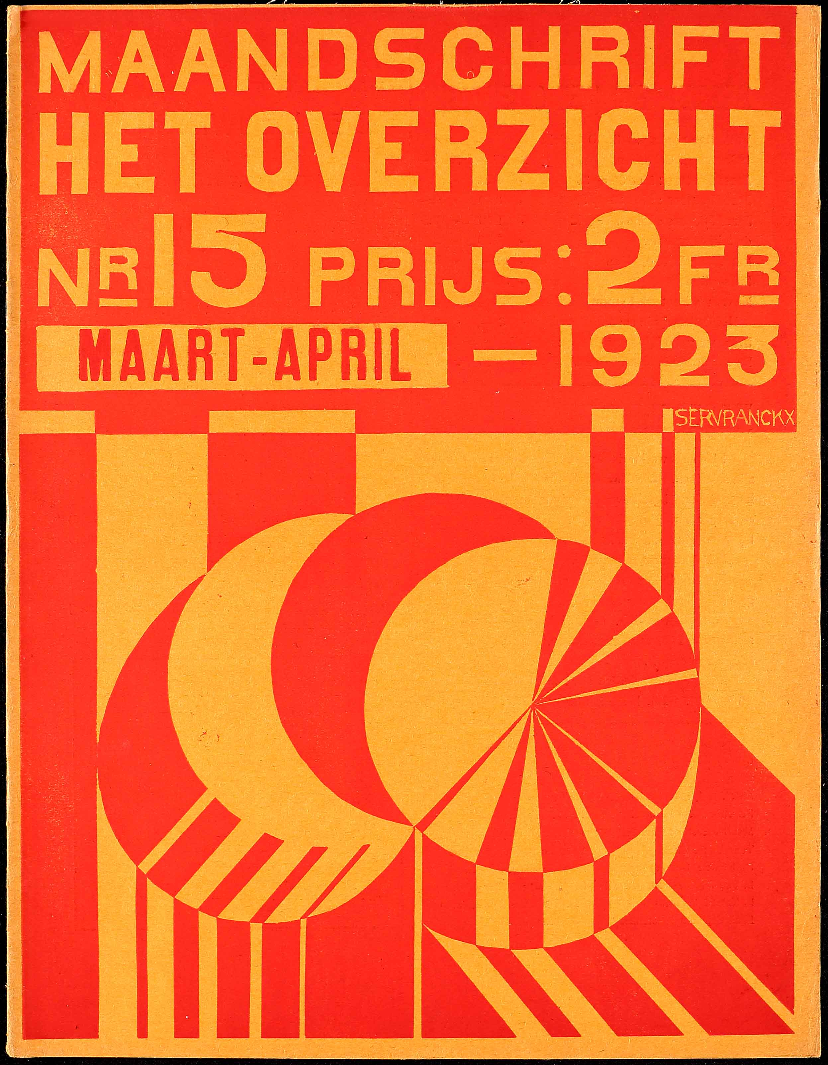
Figure 1.
Het Overzicht, no. 15 (March–April 1923).
Merrill C. Berman Collection, New York.
In the early 2010s, the recognition of Servranckx as a major artist was also marked by the publication of an important monograph, which served as a reference work in a previous study on the artist: Victor Servranckx. De jaren twintig (2012). One may assume that this volume catalogues a substantial part of his production. It is likely that previously unknown or forgotten works will be identified in the catalogue raisonné currently being prepared by X. Tricot in collaboration with the Galerie Gmurzynska (Zurich–New York), several of whose catalogues reproduce works that have not yet been recorded.
It nevertheless happens that a work previously known only through an old photograph reproduced in one or more magazines reappears, particularly at auction. Two such cases are presented as examples in the first section of this article. The following sections will highlight other works that have so far remained little known, whose existence is nevertheless attested in the press of the 1920s.
That press also refers to works that are already known. In general, it was not considered necessary to reproduce them, except when they mark a decisive stage in Servranckx’s artistic development or shed particular light on the direction taken by his research. The reader is therefore often invited to consult the monograph De jaren twintig for certain reproductions and related information. It goes without saying that reproductions from early magazines, in black and white, provide only a limited image of the works. With regard to these publications, use has been made of the substantial reference tool that is The Oxford Critical and Cultural History of Modernist Magazines, published in 2013, whose third volume is devoted to European magazines of the period 1880–1940.
Chapter 1. Two Rediscovered Works
In May 1923, the Italian Futurist journal Noi published a reproduction of a work by Servranckx entitled Costruzione meccanica or Construction mécanique (fig. 2). The painting was sold in April 2024 under the title Opus 8. Construction mécanique or L’Usine de papier peint by Christie’s. A reproduction also appeared in the catalogue of the exhibition Konstruktivismus. Entwicklungen und Tendenzen seit 1913, organized in Cologne in 1972 by the Galerie Gmurzynska in collaboration with the Galerie Bargera.
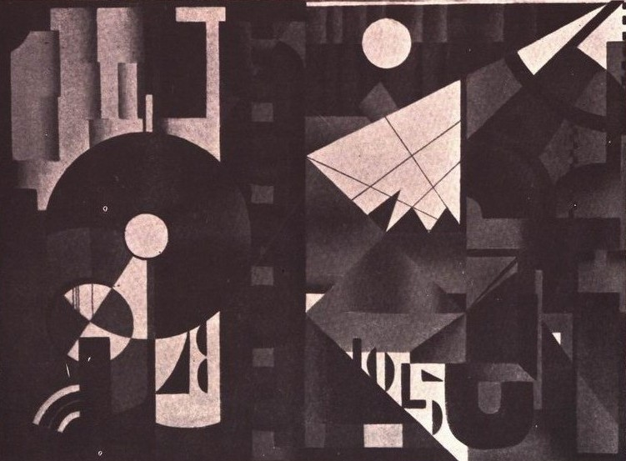
Figure 2.
Noi: Rivista d’arte futurista, vol. 2, no. II (1923): 11. Digitized copies available via Monoskop and CIRCE–Università di Trento digital archives.
https://monoskop.org/Noi and https://catalogocirce.lettere.unitn.it/fascicolo/794d8ec8-2d36-40ba-9ffb-2ec40e74642d <19-09-25>
The journal Noi had been founded by Enrico Prampolini and began publication in Rome in 1917. Servranckx’s painting appeared there between Ritmi meccanizzati by Prampolini and Ritmi meccanici by Vinicio Paladini. Servranckx probably came into contact with the journal through a friend of Paladini, Ivo Pannaggi, himself a Futurist and abstract artist, who had taken part in the Second Congress of Modern Art held in Antwerp in January 1922. One of the main organizers of this congress was Josef Peeters (Antwerp, 1895–1960). The Berman Collection emphasizes that he had participated, as secretary, in the founding of the Kring Moderne Kunst (Circle of Modern Art) in 1918, and that he “was a pioneer of a striking form of abstraction in print, as evidenced by his portfolios and his ‘constructive graphics,’ in which abstract and geometric forms compete with the communicative function of language.” In 1922, when Peeters joined the editorial board of the Flemish journal Het Overzicht (The Overview, 1921–1925), he transformed its appearance through his own dazzling covers as well as those of his collaborators”—among whom Servranckx was included, as noted above (fig. 1).
With regard to the painting that was brought back into the spotlight by its sale at Christie’s in 2024 under the title Opus 8, it should first be recalled that its subtitle—Construction mécanique or L’Usine de papier peint—referred to the work the artist carried out as a designer at the Peters-Lacroix wallpaper factory in Haren, near Brussels. It is known that he obtained this position after completing his studies at the Brussels Academy. More broadly, one could dwell at length on the place occupied by the theme of the machine in the art of the period. Particular attention will be paid here to the way the theme is treated by Ivo Pannaggi and Vinicio Paladini, for whom it represented an instrument of subjugation; see, for example, the former’s costume sketches for L’angoscia della macchina by Ruggero Vasari (1926–1927).
Another work was sold by Christie’s in December 2014 under the title Opus 9 – 1923. Its history is more complex. To trace its first reproduction, one must turn to the International Exhibition of Modern Arts organized in 1926–1927 at the Brooklyn Museum by the group known as Société Anonyme, founded by Katherine Dreier, Marcel Duchamp, and Man Ray. Servranckx took part in the exhibition as the representative of Belgium. The exhibition booklet (fig. 3) recalls that he first exhibited in Brussels in 1917 and quickly gained an international reputation, becoming the subject, after the war, of an exhibition that travelled throughout Europe. The booklet also mentions his participation in the 1925 Exposition internationale des Arts décoratifs in Paris, where he won a gold medal, noting that this “painter of distinction” was also “a designer of modern furniture, in which simplicity is emphasized.” In other words, according to a judgment by the poet Wies Moens quoted in the exhibition booklet: “With fullness and abundance, he embodies the artistic ideals of the new generation.” “This marks his first appearance in the United States.”
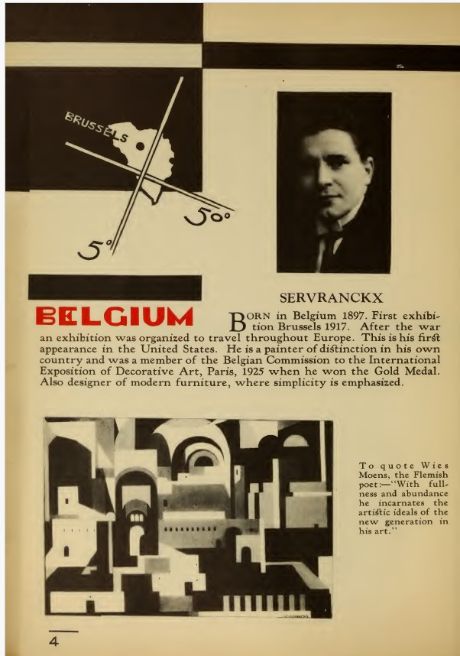
Figure 3.
International Exhibition of Modern Arts,
exhibition brochure (Brooklyn Museum, New York, 1926–1927), 4.
According to the exhibition catalogue, Servranckx exhibited three works in New York. He saw them hung alongside works by Ivo Pannaggi and Vinicio Paladini. The former presented paintings entitled Dynamic K and Dynamic P.M., which must be related to L’angoscia delle macchine by Ruggero Vasari mentioned earlier (nos. 150–151). For The Engineer’s Workshop (L’officina dell’ingegnere, bozzetto di scena), Pannaggi submitted a sketch composed of mechanical elements distributed across the entire alphabet. A costume drawing for The Condemned Man of the Machine 4K, precisely dated 1926, depicts the figure wearing a square bearing the inscription “4K.” Mechanical art was also represented for France by Fernand Léger (nos. 41–43). It should be noted that Georges Vantongerloo, although born in Antwerp, was classified among the Dutch artists alongside Piet Mondrian and César Domela.
Of the three works by Servranckx exhibited in New York, the first (No 5), entitled No. II. 1923, has not been identified, as far as we know. Another painting (No 7), listed under the title No. XLVI. 1922, corresponds to the work reproduced on the page of the exhibition booklet devoted to the artist (fig. 3). Subtitled The Town, it is now preserved as No. 46 – 1922 in the collection of the Yale University Art Gallery. It is too discreetly reproduced, even in black and white, in the chapter “A Model of Versatility,” by A. Clissen, included in the monograph Victor Servranckx. De jaren twintig. The third work (No 6) was listed under the title No. IX. 1923 and can be identified as corresponding to the painting later reproduced in 1928 by the German journal Der Sturm under the title Gemälde 9 – 1923 (fig. 5). This is the work sold in 2014 by Christie’s.
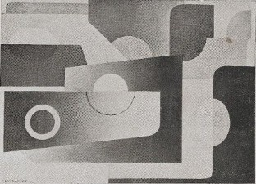
Figure 4.
Der Sturm, vol. 19, nos. 2–3 (April 1928).
https://doi.org/10.11588/diglit.47219#0122 <15-01-26>.
The body of Servranckx’s work exhibited in the United States in 1926–1927 received a favourable reception in the press. In 1926, the magazine The Arts published a review by the critic Jacques Maury, which stated: “Although all young artists have a Cubist tendency, there are very few purely Cubist paintings. In the paintings of Victor Servranckx, I see the beauty of steelmaking in a Belgian city described in a Cubist manner.” The reference to industry can scarcely be understood without the traditional image of Belgium conveyed by Camille Lemonnier or Constantin Meunier. Another art journal, Brooklyn Museum Quarterly, for its part, considered that these paintings depict “a city of rhythmic steps and repeated arches …”.
Chapter 2. “Pure Plasticity” according to Maurice Raynal and Servranckx
The German magazine that provided the early reproduction of a work long presumed lost did so as part of a series of paintings by Servranckx reproduced in 1928. The first issue of the nineteenth year (Heft 1) featured on its cover one of his works that has since become among the most well-known, as it is now held by the Centre Pompidou. The Opus 9 – 1922 bears the subtitle Rode rotatieve, which may be translated as Rotating Red or, more aptly, Red Rotation, as rendered by Michel Seuphor—that is, Ferdinand Louis Berckelaers (Antwerp, 1901–Paris, 1999)—in his monumental work on Abstract Art (fig. 5).
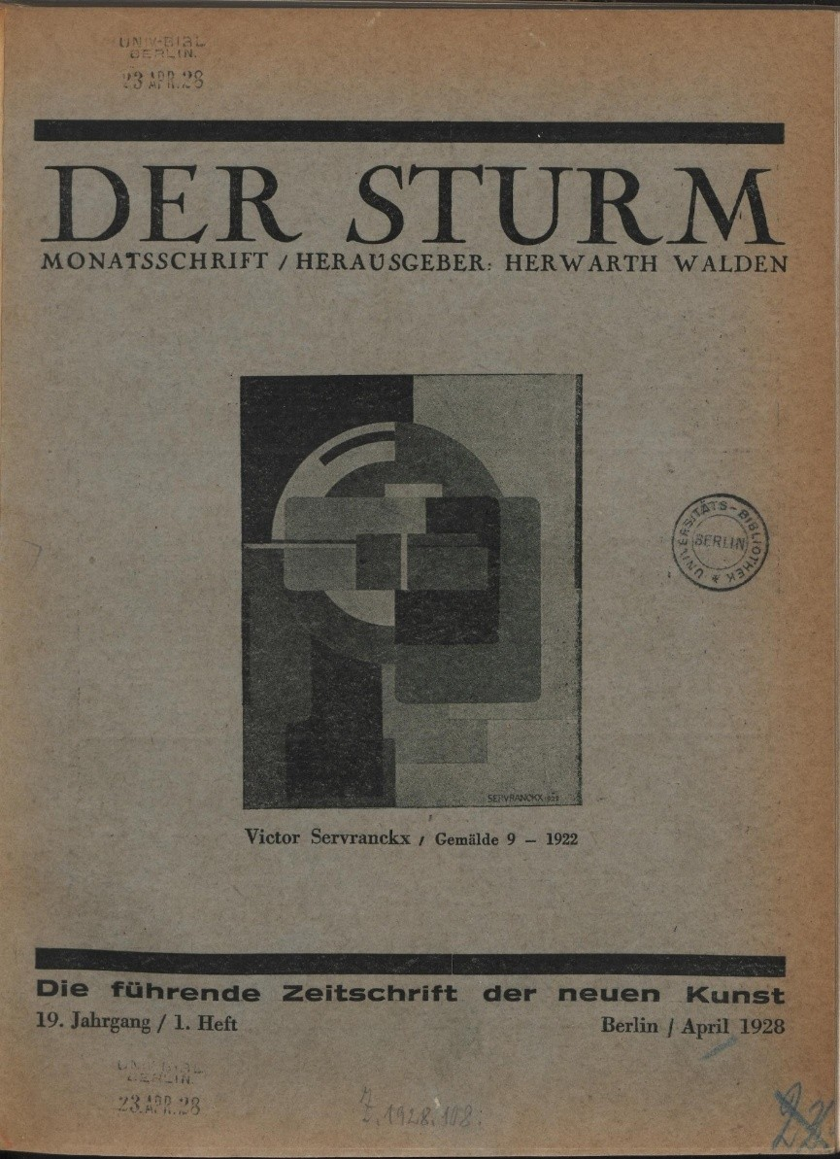
Figure 5.
Victor Servranckx, Gemälde 9 – 1922 (Rode rotatieve), reproduced in Der Sturm, vol. 19, no. 1 (April 1928).
https://doi.org/10.11588/diglit.47219#0005 <15-01-26>
It is important to clearly distinguish the Gemälde 9 – 1922 mentioned above from the Gemälde 9 – 1923 discussed earlier. The Gemälde 9 – 1923 may be discussed as it appears in Der Sturm, without colours. It illustrated a biographical presentation of Servranckx written by Georges Linze (Liège, 1900–1993), founder of the Groupe moderne d’Art de Liège. Since 1921, Linze had edited the journal Anthologie, which was mentioned at the beginning of this article.
For Linze, Servranckx transcended the mere evocation of “natural things” through a form of painting that opened onto “discoveries far more certain and more severe.” The Antwerp artist proposed a “tempting game” that invited viewers to consider his works in two ways: by focusing on “their raw expression, devoid of symbolism,” or by yielding to the temptation to discover within them “curves of celestial bodies, cosmic atmospheres” that generated “joy” and “serenity.” Yet the essential quality perhaps lay in an art “in which linear concern dominates, where everything is cadence, almost a beauty of the machine.” In this way, Servranckx took a leading role in the movement that carried Belgian modernity forward. “With pure plasticity,” Linze wrote, “there emerged here and there across the world a new art, eminently human—perhaps the most human of all,” through which “modern capitals inscribe in fresh rhythms their drama, their strength, their genius.”
The aim here is to evoke this movement—known in Belgium as zuivere beelding in Dutch and plastique pure in French—through articles published in a French journal to which Servranckx contributed, both as an artist and as a theorist. It is well known how van Doesburg founded the journal De Stijl in 1917, where, together with Mondrian, he formulated the principles of a Neoplasticism known as nieuwe beelding, which called for a radical emancipation from ornamental art through a return to elementary forms and colours of universal value. “Pure plasticity” belonged to a philosophical approach whose foundations and implications have been examined by T. Briault, according to whom plastique pure has its roots in Kant and extends into the phenomenology of Martin Heidegger and Jean-Paul Sartre. Mondrian’s treatise on Nieuwe Beelding became known in France through the translation published by the Galerie de l’Effort moderne, founded on rue de la Baume, in Paris, by Léonce Rosenberg to promote abstract art. There one could see exhibitions of Georges Braque, Joseph Csaky, Juan Gris, Auguste Herbin, Fernand Léger, Pablo Picasso, Gino Severini, and others—names that will, quite naturally, reappear in what follows.
The gallery’s publicity was handled through a Bulletin which, shortly after its founding, published in April 1924, in issue no. 4, an article by Marcel-Louis Baugniet (Liège, 1896–Brussels, 1999) entitled “Le beau ? et l’utile ?”. In June 1925, issue no. 16 of the same journal published further reflections by Baugniet under the title “Vers une synthèse esthétique et sociale,” which were reprinted as early as November in the journal Europe. There he defended a Belgian Cubism freed from all figuration, capable of rivaling that of the French, which he considered still too closely tied to representation and, as it were, to Impressionism. Baugniet named fellow artists whom he regarded as more faithful to the prescriptions of Doesburg and Mondrian: Felix De Boeck (Drogenbos, 1898–1995), Pierre-Louis Flouquet (Paris, 1900–Brussels, 1967), long established in the capital, Karel Maes (Mol, 1900–Brussels, 1974), Josef Peeters (Antwerp, 1895–1960), who had been the principal organizer of the 1922 Congress of Modern Art mentioned above, Georges Vantongerloo (Antwerp, 1886–Paris, 1965), of course Servranckx, and… René Magritte.
In June 1925, issue no. 16 of the Bulletin published simultaneously the continuation of Baugniet’s article “Vers une synthèse esthétique et sociale,” an article by Servranckx entitled “Les voies nouvelles de l’art plastique,” and another article by Maurice Raynal on Juan Gris.
It has seemed useful here to recall the respective conceptions of abstract art put forward by Raynal and by Servranckx. Maurice Raynal (Paris, 1884–Suresnes, 1954), like Baugniet, called for a truly abstract art, that is, one “stripped not only of the influence of contingencies but also of the overly burdensome influence of disordered passions.” After Cézanne had challenged narrative painting, Raynal advanced the idea of a reconciliation: “Between the banks of sensuality and those of reason flows a river, and in this river a stone which never remains long against either bank rolls along at the mercy of the waters, which always carry it toward some chosen Ocean.” It is upon such a pebble that “Juan Gris will attempt to build his church.”
What, then, would be the “truth” of representation, Raynal asks? Is it a matter of making representation and its object coincide “indistinctly”? Obviously not, “since, to begin with, a single representation may encompass several similar objects.” Does beauty reside “in the comparison between the object and the idea one has of it”? That idea depends on the “extrinsic circumstances” that accompany the object, and these alone “are capable of revealing its true nature.” In short, beauty resides on the one hand in “the idea the artist forms of the object he intends to represent,” but also, and more decisively, “in a relationship between this idea and something else.” Truth appears to him “at the moment it is grasped” and when “it immediately slips away.” Sensibility, however, retains it “where it is” and “points to it.” The encounter with beauty thus takes place between a presence and an absence, in the very brief moment in which there operates, within the true artist, “the nature of the fervour” he bears toward the vanished object.
Such an encounter cannot arise simply by chance. Were it merely fortuitous, it would fail to distinguish the artist from the ignorant or the madman. “Sensibility” must therefore be imprinted with reason—or with a reason. A “true emotion” must be accompanied by “the search for some tertium quid.” Artistic truth thus has nothing to do with scientific, objective truth. It proceeds entirely from the subjective and is judged according to no other law. Raynal concludes: “It is therefore necessary that, before the idea of my setting sun is judged false, it must first have been true. True because it was initially conceived outside time and space, and because there exists in every object a rigorously homogeneous whole of its true idea” (Raynal underscores the importance of this conclusion through italics). “Truth of error,” Spinoza would have said.
After Raynal, Servranckx would justify the permanence of a genuine apprehension of reality through a return to the history of Flemish art. For Servranckx intuitively understood that painting was, before any quest for representational adequacy, “the organization on a flat surface” of “coloured forms” governed by “rhythms,” “shapes,” and “lines” that construct “harmonious ensembles” pleasing to the eye. For Rubens, the “anecdotal element” is almost without importance, whether he is dealing with a “mythological subject” or required to depict “a hunt, a kermesse, a portrait.” His primary aim is to give form to a “formal and chromatic system” capable of expressing a “muscular, lyrical, and sensual dynamism.” It is true that, having thus in mind a kind of “plasticity” that constitutes his strength, he is in a certain sense constrained by the requirement to display “secondary forms,” which burden the painting with “their purely sensual and non-sensory value.”
In other words, Rubens is constrained by his commissions to move away from the “primary forms” advocated by van Doesburg and Mondrian by granting too much to the contingencies of an invasive sensuality. The relationship between the idea and something else—the tertium quid—is thus, as it were, altered. It falls to modern art to purify the “sensual” through a return to the “sensory.” Despite the great divide that separates our sensibility from that of the Ancients, “we can still, to a certain extent, take pleasure in their works” thanks to the bridge they establish with “pure plasticity.” The latter no longer requires the “pretext” of iconic or narrative representation—an “dazzling lie,” as Spinoza might have said—but rather makes simple and naked beauty its “true goal.”
Gothic painters, Servranckx writes, are “closer to our conception of pure plasticity,” for they sought to eliminate all “extra-plastic aims.” Unfortunately, “since the Renaissance, the painterly aspect was gradually relegated to the background” in favour of “the anecdotal aspect.” This evolution was accompanied by a form of “encroachment”: painting became discourse, and art came to believe itself literary. The “sterile” pretension that infected it led to the triumph of “academic formalism,” before this in turn had to yield to successive schools—Romanticism, Realism, Naturalism—which made possible the Impressionist flowering, the “first cry of revolt and rallying.”
Yet Impressionism did not fully liberate the artist from an “individualistic particularism” that perpetuated features of earlier painting. “This is what struck me,” Servranckx writes, “every time I came into personal contact with some notable representative of French Cubism, whether Léger, Juan Gris, or Picasso “.” One day—it was in 1923—while discussing painting with Picasso in his studio, I saw more clearly than ever everything that separates us: he, an Impressionist despite everything; we, the Constructivists. I recall that Picasso said to me more or less verbatim: ‘Draw a circle and inside that circle place two small horizontal strokes and a small vertical stroke; put these strokes in the middle of the circle, to the right or to the left, at the top or at the bottom—it makes no difference, one will always perceive a human head. Use forms without objectivist meaning, and the viewer will always seek such meaning in them. Art cannot dispense with a certain naturalism.’”
Chapter 3. A “Chrysalis Stage” (1919)?
Within the series of paintings reproduced by Der Sturm in 1928, two works date back to the early years of Servranckx’s career. The one entitled Gemälde 5 – 1919 is known as Opus 5 – 1919. The volume De jaren twintig reproduces it in colour, showing a diagonal bar crossing an ensemble of circular motifs from left to right, with a red circle in the lower left corner and a less visible circle occupying the upper right corner. The German journal, however, reverses the reproduction so that the circle originally located in the lower left corner now appears—darkened—in the upper right corner, and so forth (fig. 6).
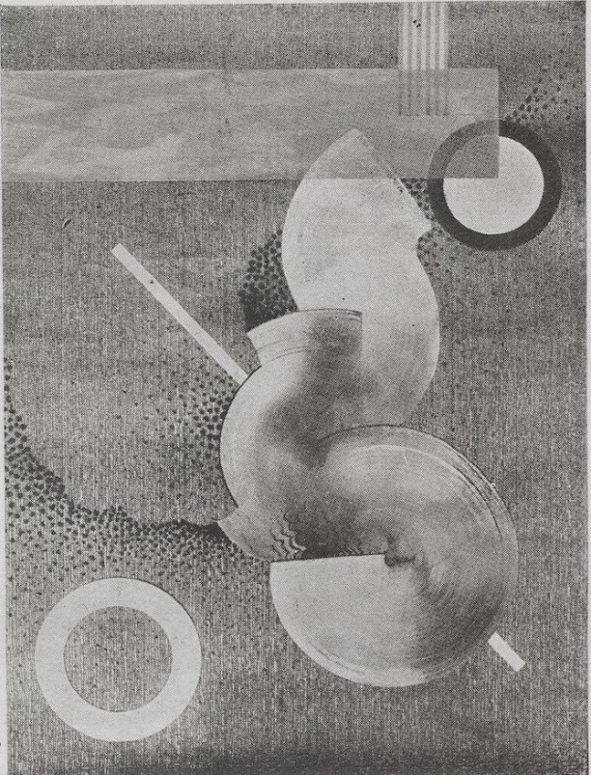
Figure 6.
Gemälde 5 – 1919, in Der Sturm, no. 19/8, 1928/29.
https://doi.org/10.11588/diglit.47219#0123 <31-05-25>.
The Opus 5 – 1919 was restored to the orientation shown in De jaren twintig in a Ukrainian journal. The magazine Nova generatsiia (or New Generation) featured Servranckx in its issue no. 11 of 1928, in which its editor, the poet Mykhailo Semenko (1892–1937), devoted a particularly laudatory article to the Belgian artist. This issue of the journal—described as a “monthly review for left-wing artistic formation”—also featured on its cover Servranckx’s sculpture entitled Opus 1 – 1921 (fig. 7).
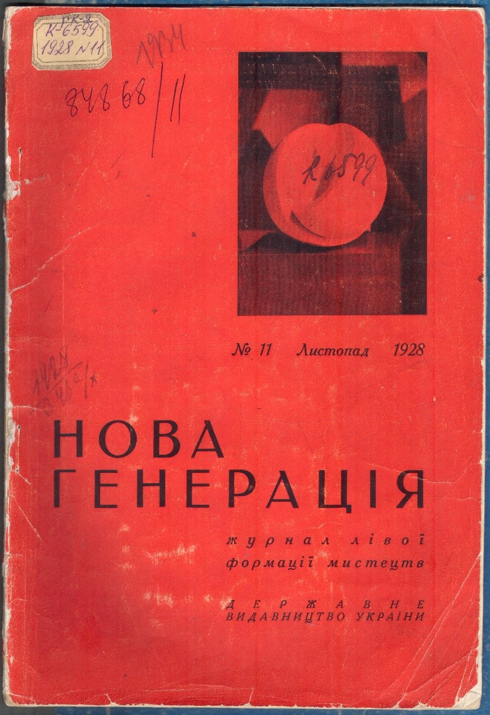
Figure 7.
Nova generatsiia, no. 11 (1928), cover featuring Victor Servranckx,
Opus 1 – 1921. Courtesy of Oleh S. Ilnytzkyj (University of Alberta).
The political nature of the magazine was far from insignificant. In line with the Marxist orientation that was natural in Ukraine at the time, it sought to articulate “questions of theory” with the “practice of artistic movements,” from the standpoint of the “constructive and destructive meanings” they offered in literature, painting, theatre, cinema, and so forth. The names of the authors and artists who contributed to it were equally noteworthy. Ukrainian figures were represented across the country, from Kharkiv to Kyiv and Odessa. Other, more familiar figures represented what is now Russia, such as Sergei Eisenstein, Vladimir Mayakovsky, Alexander Rodchenko, or Kazimir Malevich. Some contributors also embodied, in Western Europe, the international reach of the culture that emerged from the Revolution. The Italian Prampolini, founder of the journal Noi, represented Paris, where he was then residing, as did the filmmaker Yevhen Deslaw. Herwarth Walden, editor of Der Sturm, carried the banner of the German avant-garde, accompanied by writers such as Johannes R. Becher, who would later become Minister of Culture in the GDR, and Rudolf Leonhard, who would join the Marseille Resistance during the Second World War. Among the contributors to Nova generatsiia, Servranckx could also encounter the Hungarian artist László Moholy-Nagy, who had recently taken part in the Société Anonyme exhibition in New York.
By taking his place among the “most significant figures of modern art in Belgium,” Servranckx rose to the international level of the journal. Through him and his work, there was exalted a “small, highly industrialized country that has succeeded in gathering within itself the quintessence of the creative currents of the great neighboring capitalist nations—Germany, France, and England.” His paintings—regarded as expressions of a society bound to the world of labour—had not only conquered the Old World through exhibitions that took them “to Paris, Rome, Berlin, Warsaw,” but had also made Servranckx known to American audiences through further exhibitions in “New York, Chicago, Philadelphia.”
Does one discern here the outline of a continental and political rivalry, justified by the rooting of modern art in the Russian Revolution? In any case, Servranckx was engaged in a struggle of philosophical ideas from which, as the Ukrainian journal emphasizes, he could not escape when delivering lectures as a theorist of modern art at the Université libre de Bruxelles. Reference has already been made to the knowledge of Flemish art history that he could mobilize for this purpose, within the framework of a patriotic and popular claim that a so-called “Free” University was in principle meant to encourage. The Ukrainian magazine therefore notes, in Servranckx, an inquiry nourished by “currents of Bergsonism and energetic art,” before the Belgian artist turned to the teachings “of Expressionism, Futurism, and Cubism.”
Alongside Gemälde 5 – 1919, reproduced by Der Sturm and already displaying the features of an abstraction in the process of formation, a second work from 1919 is reproduced in the same issue of the German magazine and exhibits similar characteristics. Entitled Gemälde 13 – 1919, it likewise deserves attention, as it appears to be previously unknown (fig. 8).
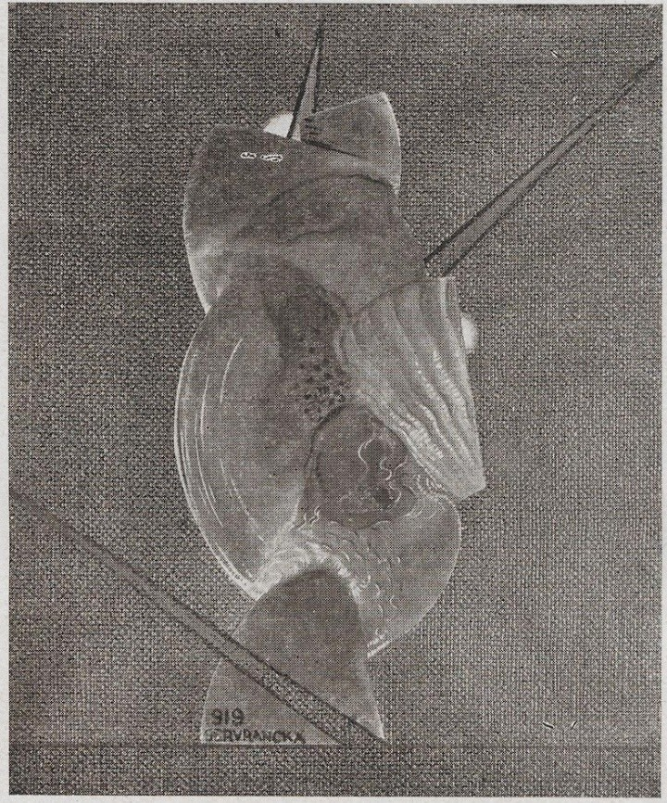
Figure 8.
Gemälde 13 – 1919, reproduced in Der Sturm, vol. 19, no. 8 (1928–1929).
https://doi.org/10.11588/diglit.47219#0124 <31-05-25>.
When Gemälde 13 is considered in relation to Servranckx’s earliest paintings as presented in De jaren twintig, a clear break with their figurative character becomes apparent. This figurative tendency still strongly marks works such as Stillleven met rode meloen en komkommers (Still Life with Red Melon and Cucumbers) from 1913, or Walg en bewondering (Disgust and Admiration) from 1917. A painting by Servranckx entitled Nature morte aux bananes et melon, dated 1918 and sold at auction, belongs to the same figurative group. By contrast, Gemälde 13 displays shell-like forms associated with primitive shapes featuring projecting antennae. Similar motifs of organic forms, with more pronounced arrows and marine or feminine undulations, reappear in another work entitled Opus 21, dated 1919. This work is reproduced in a catalogue published by the Galerie Gmurzynska for the exhibition De Boeck – Joostens – Servranckx – Vantongerloo. Pioneers of Abstract Art. Belgium 1915–60, held in 1976–1977, where the work appears as no. 34. A fourth work from 1919, reproduced in the Liège-based journal Anthologie, also features organic forms (fig. 9).
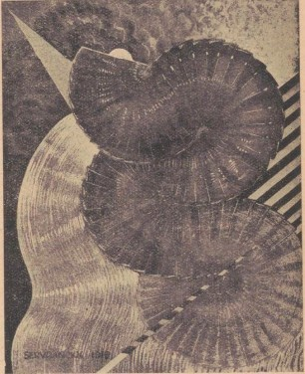
Figure 9.
Painting – 1919, reproduced in Anthologie, vol. 9, no. 2 (December 1928).
This fourth work accompanies a text by Servranckx entitled “Sur la plastique pure,” which extends in a particularly incisive manner the reflections published in 1925 in the Bulletin de l’Effort moderne under the title “Les voies nouvelles de l’art plastique.” The article published in Anthologie may well constitute the most fully developed testimony Servranckx left of his aesthetic thought, as he articulated it, for example, in his lectures at the Université libre de Bruxelles.
There he describes the “work of mutation” undergone in recent years by “sensibility” and by the art attached to it. This transformation required a “purification” that not only freed art “from what is impure and foreign to its own nature,” but also allowed it to recover its “very essence” and its “reason for being” through contact between the human and things. This “complete” and “integral” art would be released from the accidents of history and evolution, as well as from certain rules which, when erected into an “order,” represent “a kind of defilement.” These ideas must be related to a work from 1920 reproduced in the same catalogue of the Galerie Gmurzynska as no. 32 (p. 21). As in Gemälde 13 – 1919, one sees here a shell-like form—much larger in scale—which appears to obey a rotation around what might be the terrestrial globe or the sun. This piece, together with the one reproduced in Der Sturm, suggests the idea of a nature at the origins of life.
Servranckx’s article in Anthologie also led to the rediscovery of the “first principle of beings and things” and, through it, of an originary relationship that is, in human beings, fundamentally spiritual in nature. For art cannot only be matter; it is “matter in its supreme tension,” since, like the spirit, it aims to transform “primary realities.” The “play” enacted on the canvas by forms and colours would be devoid of all interest—or even of all meaning—in “imitative-naturalist paintings” reduced to “accidents,” that is, to contingency and chance. Art seeks fully to participate in the “creations of the spirit,” because these become “more real, more truly existing than the phenomena of the physical world.” In Servranckx’s work, the production of the years 1919–1920 thus emerges as the moment when pictorial representation becomes a spiritual endeavour capable of grasping reality in all its purity and, as it were, in its nakedness. This essential phase of his investigation into the meaning of abstraction might therefore be described as a “chrysalis stage.”
Chapter 4. 1920–1921: Toward Simplicity
Judging by the numbering of the works in De jaren twintig, these paintings initially display a certain unity of titles, dominated by the theme of the female figure. Opus 22 – 1920 is subtitled Zittende arbeidster, etend, op de binnen-plaats van de fabriek (Seated Female Worker, Eating in the Inner Courtyard of the Factory). Opus 29 – 1920 bears the subtitle Naakt met zwarte kousen (Nude with Black Stockings). The subtitle of Opus 1 – 1922 is less straightforward, more complex, or plays on words: Ik streel de paarden der vrouwen (I Stroke the Horses of Women). The great variety of forms and hues suggests that a balance was still being sought.
Yet other works from the same period confirm the aesthetic direction thus taken. Thus, the January 1927 issue of Anthologie reproduced what is now known as Opus 27 – 1922, subtitled Omhelzing (Embrace or Kiss), in which the feminine and marine undulations already present in Opus 3 – 1922, or Lichaamsgolving (Bodily Undulation), reappear.
At the same time, in 1920, the pursuit of a geometric abstraction appears clearly affirmed in Opus 11 – 1920. Here, profusion disperses forms and motifs in every direction. Circles are multiplied; the stripes constituting certain surfaces vary in thickness and colour; triangles echo one another like frames in a strip of film; shades of brown and beige are scattered, leading the viewer’s gaze back and forth across the surface. The viewer searches in vain for a point of unity on which to fasten the eye.
A work reproduced in Der Sturm, which bears no date as such but was assigned by the journal the title Gemälde 42 – 1920, extends the logic of the preceding paintings. Its forms, reduced to rectangles, along with one suggesting the scalloped or festooned rim of a plate, may testify—through their simplicity—to a process of progression (fig. 10). In the lower left corner, a discreet motif begins to emerge that will later be developed: a kind of Greek kappa or a column with a half-capital, more familiarly described as a “ship’s funnel.”
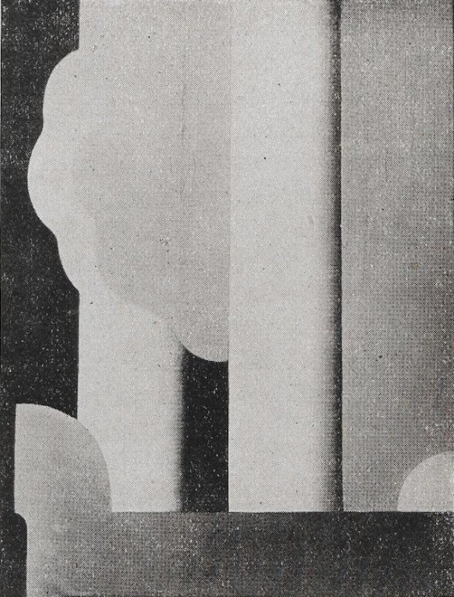

Figure 10.
Gemälde 42 – 1920, reproduced in Der Sturm, vol. 19, no. 1 (April 1928).
https://doi.org/10.11588/diglit.47219#0019 <15-01-25>
The Opus 38 – 1921, reproduced in the volume De jaren twintig, initiates the circular construction of Red Rotation, now held by the Centre Pompidou. The progression toward the essential is thus set in motion. It will subsequently open itself to experimentation and reflection.
Chapter 5. 1922: Eyes to See
A historical view of Servranckx’s trajectory first invites the reproduction of a work from 1922 that appears to have been forgotten, even though it represents a dead end—and above all insofar as it constitutes a failure. It was presented by a major French avant-garde magazine, L’Esprit nouveau, founded in Paris by Amédée Ozenfant and Le Corbusier. Issue no. 22 (1924) published several “Paintings by Victor Servranckx” without providing titles or dates, although the dates do appear on the canvases themselves. The work that concerns us here would later be given the title Opus 35 – 1922 (fig. 11).

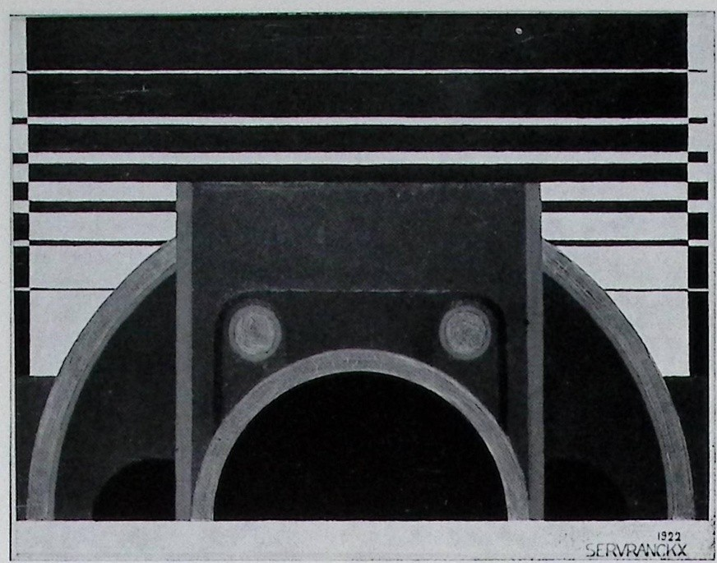
Figure 11.
Untitled, reproduced in L’Esprit nouveau, no. 22 (1924): 36 ; Opus 35 – 1922 in Konstruktivismus. Entwicklungen und Tendenzen seit 1913, Cologne, Galerie Gmurzynska + Bargera, 1972, no. 331. Coll. D. Droixhe & A. Piette .https://gallica.bnf.fr/ark:/12148/bpt6k6963631k/f36.item <31-05-25>.
The work features two circles—or two eyes—that appear to gaze at the viewer, while a horizon is layered in the background. Very different from Servranckx’s other paintings of the same year, it did not open up a specific path within the Antwerp artist’s oeuvre, perhaps because of its overly figurative suggestion. The Galerie Gmurzynska would later refer to it in the catalogue of the exhibition organized jointly by the Galerie Gmurzynska and the Galerie Bargera entitled Konstruktivismus. Entwicklungen und Tendenzen seit 1913, mentioned above.
By contrast with this work, another painting immediately places Servranckx’s production of 1922 under the sign of Mondrian and van Doesburg. It is entitled Zuivere Beelding, that is, Pure Imagery. It is true that it appeared, in issue no. 17 of the Bulletin de l’Effort moderne of July 1925, under the title Éléments mécaniques. As a milestone in the Antwerp artist’s career, it fully deserves to be reproduced here (fig. 12).
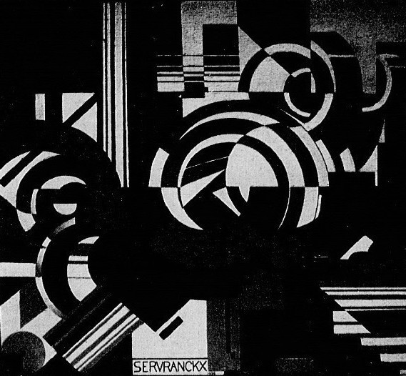
Figure 12.
Éléments mécaniques – 1922, reproduced in Bulletin de l’Effort moderne, no. 17 (1925): 25.
https://gallica.bnf.fr/ark:/12148/bpt6k57056343/f25.item# <19-09-25>.
The same title, Éléments mécaniques, is also given to another painting by Servranckx published in the Bulletin de l’Effort moderne: the work now known as Opus 55 – 1923, or De heerschappij van het gepolijste staal—that is, The Reign or The Age of Polished Steel—now held by the Musée de Grenoble. Like the preceding work, it deserves to be reproduced here, for it may be regarded as emblematic and sheds light on Servranckx’s entire production (fig. 13). It was also reproduced in the journal Anthologie.
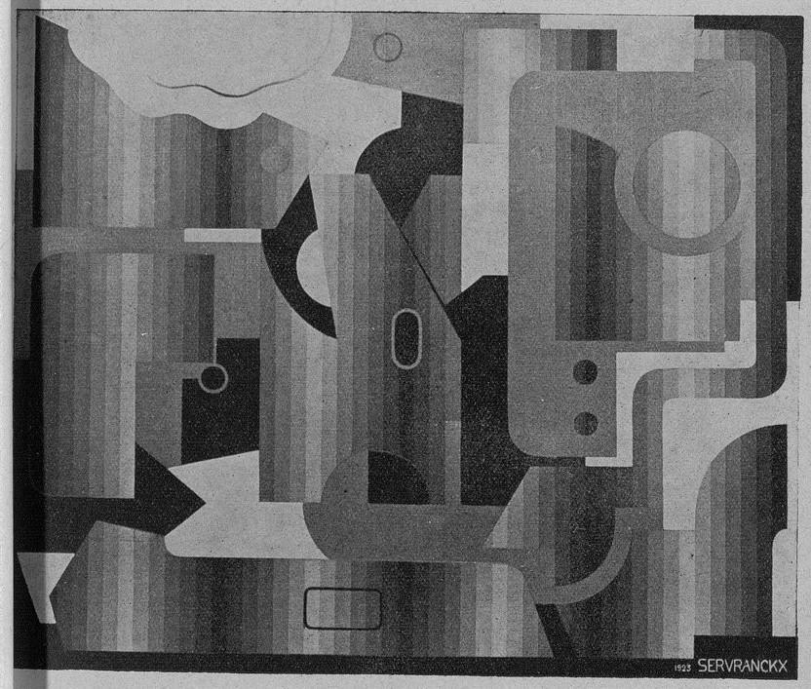
Figure 13.
Éléments mécaniques (Opus 55 – 1923), reproduced in Bulletin de l’Effort moderne, no. 17 (1925): 25. Musée de Grenoble.
https://gallica.bnf.fr/ark:/12148/bpt6k57056343/f25.item# <19-09-25>.
The presentation of the two paintings in the Bulletin de l’Effort moderne clearly derived its meaning from the fact that they echoed the work of a better-known artist, since the journal also reproduced Éléments mécaniques by Fernand Léger, dated 1925. In a sense, the respective datings suggested that Servranckx’s work constituted a kind of anticipatory advance.
The year 1922 is also punctuated by another type of work offering simpler geometric forms, more strongly centred on rectangles or angular surfaces, with a limited number of circles or semicircles. Such is the case with Opus 17 – 1922, now held by the Museo Thyssen-Bornemisza in Madrid. This painting is sufficiently well known that reproducing it here seems unnecessary. Organizing a number of markedly elongated rectangles—some with internal gradations, others without—that overlap one another, it still belongs to Servranckx’s early experiments in geometric abstraction. It invites, finally, a question: do publication in one of the most advanced Parisian avant-garde journals and inclusion in a major European museum necessarily and automatically determine a work’s value and interest—apart from that conferred by the sacrosanct “law of the market”?
Moreover, another work from 1922 is reproduced in the journal La Nervie, edited in Braine-le-Comte by Émile Lecomte, which devoted a special issue to La jeune architecture belge (fig. 14).
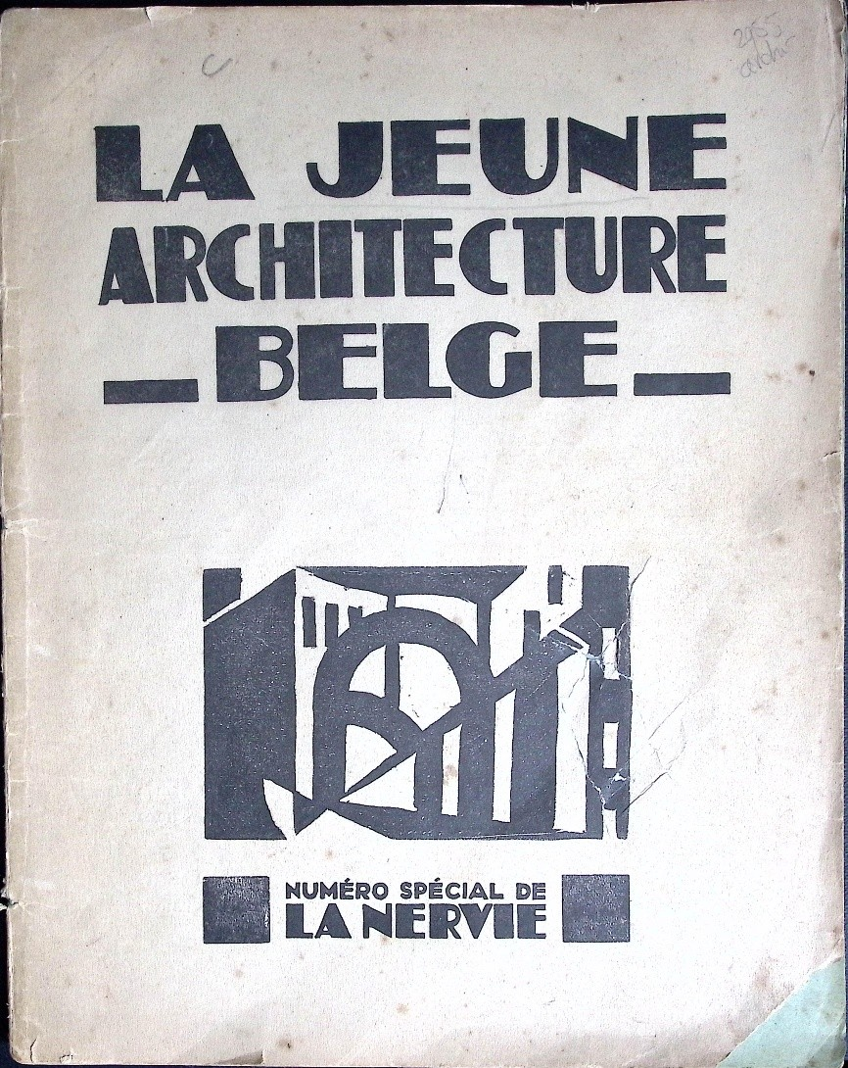
Figure 14.
Marcel-Louis Baugniet, engraving reproduced
in La Nervie, La jeune architecture belge, nos. 6–7 (1925).
Coll. D. Droixhe & A. Piette.
This special issue includes a review of the Exposition d’Arts décoratifs et industriels de la Province de Brabant, held in October of the same year at the Galerie Giroux in Brussels. The issue also republished Servranckx’s article on “Pure Plasticity” and presented five of his works, including the one reproduced below (fig. 15).
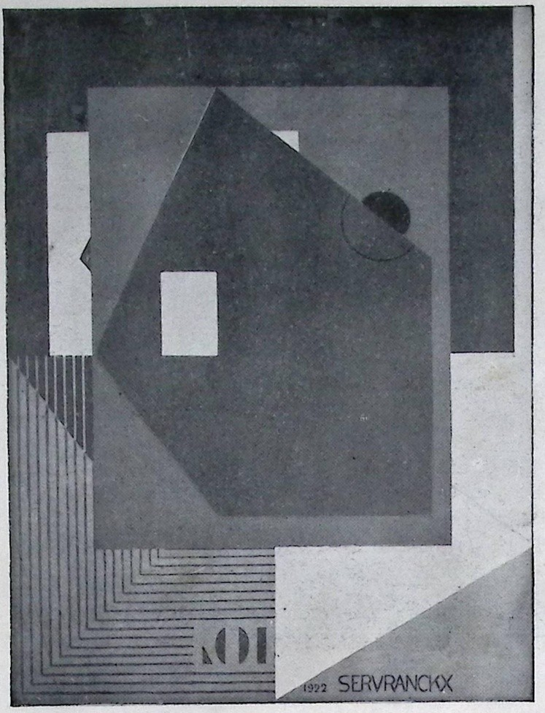
Figure 15.
Victor Servranckx, Painting, reproduced in La Nervie,
La jeune architecture belge, nos. 6–7 (1925): 58. Coll. D. Droixhe & A. Piette.
This work shows correspondences with two paintings reproduced in the catalogue De jaren twintig. The Opus 20 – 1922, subtitled Snaarinstrumenten—that is, String Instruments—features a black semicircle crossed by white lines that clearly evoke the designated object. The canvas belongs to the Royal Museum of Fine Arts Antwerp. The other painting, Opus 30 – 1922, or Fabriek, is preserved in the Museo Thyssen-Bornemisza in Madrid. It includes a similar network of lines within the setting of a large dark rectangle that also frames angular forms reproduced in the painting published in La Nervie. In Opus 30, a central axis running diagonally from the upper right to the lower left corner defines two pointed shapes, one of which rests on the base. A light-coloured form of the same type likewise rests by its point on the base in the work reproduced in the Braine-le-Comte magazine.
It should be noted that this journal—omitted from The Oxford Critical and Cultural History of Modernist Magazines—defined itself as being “the result of collaboration between writers and artists devoted to sound, clear, and new ideas, concerned with a sincere effort toward the realization of a lofty and disinterested work.” La Nervie was distributed in Brussels by the Agence Dechenne and in Paris by the Berger-Levault and Van den Bergh bookshops. As has been noted, the Oxford reference work also neglects the Liège-based journal Anthologie and places its emphasis instead on Flemish or Brussels-based periodicals. This is regrettable.
Chapter 6. A Reconstructed Opus 54 – 1923?
La Nervie also reproduced works from 1923. Two of them are identified and well known. Opus 45 – 1923, subtitled Het paar (The Couple), is preserved at the Museum moderner Kunst Stiftung Ludwig Wien. The other is Opus 4 – 1923, entitled Bruine brug (Brown Bridge). The latter, reproduced in a Galerie Gmurzynska catalogue, belongs to a group of works in which forms, sometimes organized in a very simple manner, take on trapezoidal shapes, either monochrome or bichrome, with or without gradation. It may be associated with Opus 16 – 1923, entitled Nachtelijk landschap met trainlawaai (Nocturnal Landscape with Train Noise). Does this painting convey a more complex sensation through an interweaving of trapezoids and variations of blue? Does its title designate an object—train, noise, darkness—capable of eliciting more readily this type of impression?
The “sensory” transposition of reality, to use Raynal’s terms, becomes in any case more clearly articulated in Opus 37 – 1923, entitled Muurgedeelten tegen de lucht (Sections of Walls against the Light). Forms suggestive of houses are set into perspective. The colours, laid on in flat areas, further justify this suggestion, such as the light-coloured diamond shape surmounting the building profiles, corresponding to the “light” evoked in the title. The work might well have constituted an interesting subject of debate in the discussion with Picasso mentioned above.
Another painting from 1923 reproduced by La Nervie is also of interest. Unnumbered, it precedes works by Karel Maes, Josef Peeters, Pierre-Louis Flouquet, Pierre Gailliard, Victor Xhrouet, and E.L.T. Mesens (fig. 16).
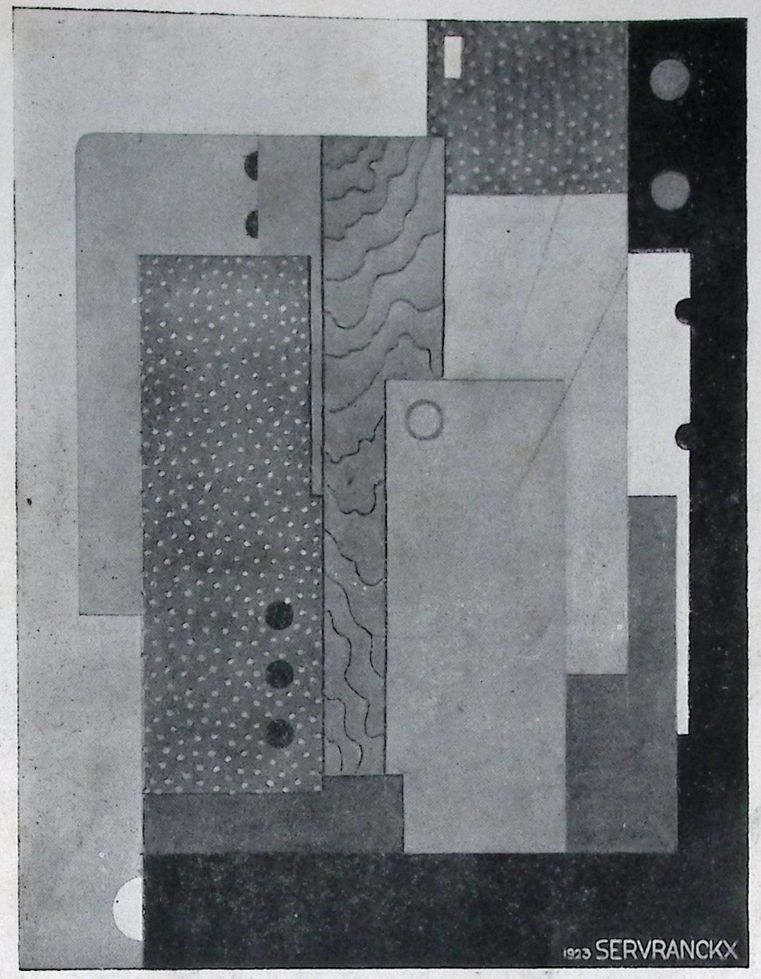
Figure 16.
Painting, reproduced in La Nervie, La jeune architecture belge, nos. 6–7 (1925): 55. Coll. D. Droixhe & A. Piette.
The work could be placed chronologically after the series that in 1923 brings together Opus 16, Opus 27, and Opus 37. In all of them, circles or round forms are lacking, before they are introduced in the series that begins with Opus 43 – 1923, subtitled De liefde voor de machine (The Love for the Machine), which multiplies, in a specific and somewhat redundant manner, rectangles and circles. Thus, the painting of the figure 16 seems to be momentarily set aside—apparently forgotten—and left open to conjecture.
Another work from 1923 reproduced in L’Esprit nouveau in 1924 lends itself more readily to hypothesis (fig. 17).
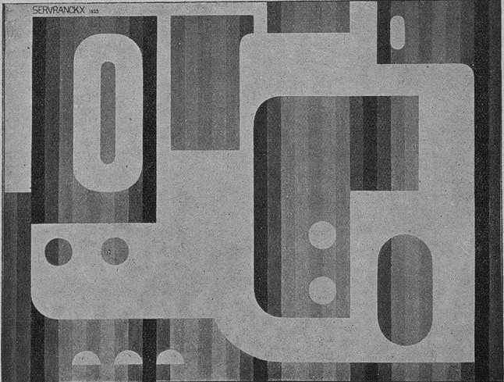
Figure 17.
Painting, reproduced in L’Esprit nouveau, no. 22 (1924): 36.
https://gallica.bnf.fr/ark:/12148/bpt6k6963631k/f36.item <31-05-25>.
One finds here one of the principal motifs of Opus 55 – 1923—that is, The Reign of Polished Steel, now in the collection of the Musée de Grenoble: a roughly square form provided with an extension and pierced by two circular openings, either light or dark, set against a background of stripes graded from light to dark. This type of striping occupies a similar pictorial field in both cases. In the work reproduced in L’Esprit nouveau, this field is pierced by circles, semicircles, and an oval, whereas in the painting reproduced in De jaren twintig it is traversed by a black semicircle, curves, and a form resembling the scalloped or festooned rim of a plate. It is difficult to determine whether the work reproduced in L’Esprit nouveau predates or postdates the one reproduced in De jaren twintig. All things considered, one might be inclined to designate it as Opus 54, insofar as De jaren twintig mentions an Opus 53 – 1923 now held by the Ixelles Museum.
Chapter 7. The “Ship’s Funnel” Motif
The reproductions of the “Paintings by Victor Servranckx” published in L’Esprit nouveau in 1924 first present a work now identified as Opus 46 – 1923, subtitled Tedere constructie (Tender Construction). This work, reproduced in De jaren twintig, features in its lower left section the motif known as the “ship’s funnel,” rendered in green lines. This motif had already appeared discreetly in an earlier work and would go on to become the dominant and characteristic element of several paintings from 1923–1924.
The motif was already central and doubled, in brown, in Opus 45 – 1923, whose subtitle likewise links it to the preceding work: Het paar (The Couple), now held by the Museum moderner Kunst Stiftung Ludwig Wien. This work was reproduced in 1925 in La Nervie, a magazine also overlooked among those considered by The Oxford Critical and Cultural History mentioned several times. La Nervie, in its special issue, indeed devoted considerable space to Servranckx, reproducing not only The Couple but also Opus 4 – 1923, entitled the Brown Bridge mentioned above, as well as his sculpture Opus 1 – 1921, previously discussed.
The “ship’s funnel” motif becomes more firmly established in other paintings: Opus 3 – 1924, subtitled Vrouw – schelp in haar toren (Woman – Shell in Her Tower), and Opus 8 – 1924, subtitled Heroïsche muziek. It is also present—multiplied—in an otherwise unknown painting reproduced by Der Sturm, entitled Gemälde 9 – 1924 (fig. 18).
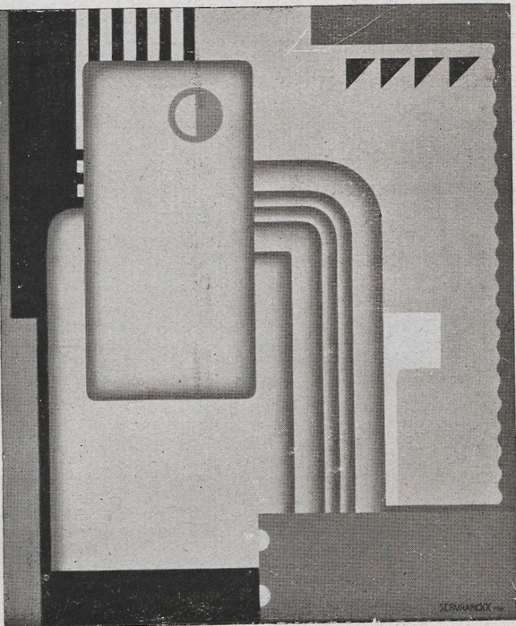
Figure 18.
Gemälde 9 – 1924, reproduced in Der Sturm, vol. 19, no. 8 (1928–1929).
https://doi.org/10.11588/diglit.47219#0125 <11-06-25>.
All three works set against the same black ground various types of bordered rectangular forms, edged—in Gemälde 9 as in Opus 3—with black-and-white hatching. Another element links Gemälde 9 to Opus 8: a motif composed of a series of small black triangles or half-squares forming a kind of cockscomb. In Opus 8, does the ascent toward red in the central column express the brilliance of a musical genre? Similar gradual transitions from light to dark characterize the squares in Opus 13 – 1924, whose title is likewise evocative: Koele weiden achter hete bakstenen gevels in zomerzon—that is, Cool Meadows behind Hot Brick Façades in the Summer Sun. The canvas is on view at Mu.ZEE, dedicated to the Belgian avant-garde.
The ship’s funnel motif becomes central in Gemälde 11 – 1924, which Der Sturm reproduced after Gemälde 8 and which likewise remains unidentified (fig. 19).
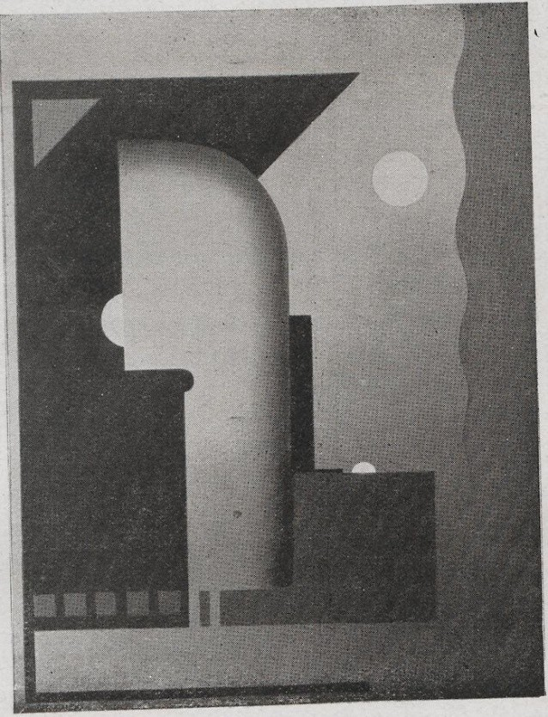
Figure 19.
Gemälde 11 – 1924, reproduced in Der Sturm, vol. 19, no. 8 (1928–1929). https://doi.org/10.11588/diglit.47219#0127 <31-05-25>.
This painting is very close to a work preserved at the Museum of Fine Arts Ghent: Opus 2 – 1926, entitled De haven (The Port).
Another work from 1924 appears relatively isolated within the production of the period: Gemälde 15, which likewise seems to be unknown (fig. 20). The painting is composed of quadrilaterals, some of which appear to float in space—a combination that is rare in Servranckx’s work—while others are rendered in perspective, with gradations that more generally constitute a significant element in his oeuvre. These gradations establish a three-dimensional relationship in contrast to surfaces whose coloration is applied in flat areas.
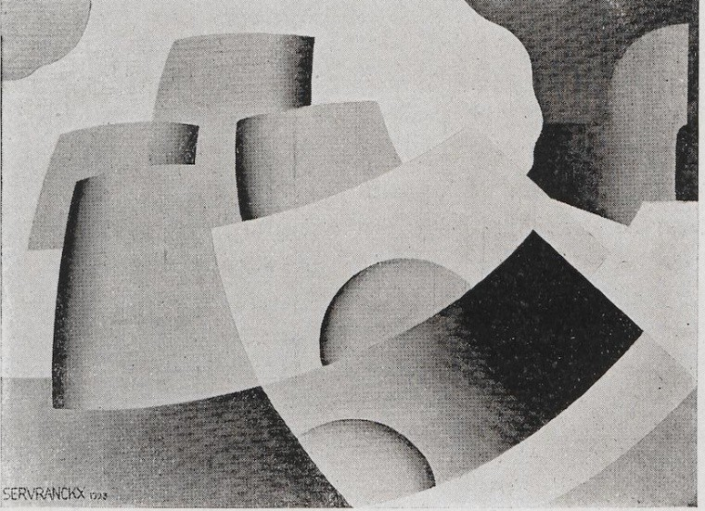
Figure 20.
Gemälde 15 – 1924, reproduced in Der Sturm, vol. 19, no. 1 (April 1928).
https://doi.org/10.11588/diglit.47219#0019 <31-05-25>.
We shall not dwell at length on a work in which Servranckx, in our view, reaches the summit of his art: Opus 15 – 1924, reproduced by Der Sturm without a title, at the end of an article by Franz W. Seiwert entitled “Amerikanische Wissenschaft und die neue Kunst” (“American Science and the New Art”). We leave it to the owners of the volume De jaren twintig the pleasure of appreciating its reduction to four basic colours and the subtle, seductive, and authoritative balance of equally elementary forms. This painting on cardboard mounted on panel, now in a private collection, deserves to be shown in a museum and—why not?—reproduced on T-shirts, as so many works by Magritte have been, works that call either upon a limited imagination or upon boundless exegetical efforts. Even simple reflections on the relationship between Servranckx and the avant-garde embodied by Seiwert, founder of the Cologne-based Progressive Artists of Cologne, would constitute a useful first approach, especially since the Antwerp artist is not mentioned in the otherwise stimulating monograph devoted to the German artist.
As early as 1922, Servranckx had begun collaborating with the architect Huib Hoste (Brugge, 1881–Antwerp, 1957), with whom he designed the furniture for the men’s room of the Villa Gudrun in Knokke. Together they presented a Bureau-fumoir at the International Exhibition of Decorative Arts in Paris in 1925, as documented in De jaren twintig. One may consult there the learned study by A. Verdonck entitled “Victor Servranckx’s Abstract Art: From the Two-Dimensional Canvas to Three-Dimensional Interventions.”
A general reorientation of artistic practice was thus taking place, and the press did not fail to note its effect on the Antwerp artist. In October 1925, the journal Le document published a review of the Provincial Exhibition of Decorative and Industrial Art of Brabant, then held at the Galerie Giroux.
Two pages highlighted Servranckx’s creations, alongside those of Baugniet. A tobacco jar by Servranckx was presented. A model entirely black is now at the Design Museum Gent, whereas the version reproduced in the magazine—does a surviving example exist?—includes white elements. The magazine commented on these reproductions as follows: “Victor Servranckx draws our attention through several studies for wallpapers of powerful and original composition, and through a tobacco jar whose character is as harmonious as it is daring, both in form and in colour.”
Regarding Baugniet, it stated: “His white parchment lampshade in the form of a quadrangular pyramid and its very rustic black wooden base once again proves to us that ‘beauty’ can be achieved through simple means and inexpensive materials.” The reference to the pyramid would merit further elucidation through recourse to Baugniet’s own writings and, more broadly, to those of Élie Faure (The Tree of Eden, 1922). The lamp was also reproduced on the cover of the journal.
Chapter 8. The Revenge of the Skyscrapers
We have seen how La Nervie also gave significant space to Servranckx in 1925 in connection with the same Brabant exhibition. Architecture, however, occupied pride of place in the illustrations. Photographs of buildings or domestic interiors—celebrating figures such as Henry van de Velde, Richard Acke, Jean de Ligne, or Lucien François—extolled opulence and comfort. Baugniet announced a turn toward the applied arts through an article on “Interior Architecture.” Stanislas Jasinski (Ixelles, 1901–1978) provided the key to such an adherence by writing on “Architecture, the Major Art: A Principal Source of Economic Recuperation.”
Undoubtedly, Servranckx’s talent as a plastic artist was still highlighted in the August 1926 issue of Le Document, which reproduced Opus 46 – 1923, or Tender Construction, in a glossy-paper supplement, along with Opus 3 – 1924, or Woman – Shell in Her Tower, and a drawing best left forgotten. Yet the financial opportunities offered by the applied arts were becoming increasingly clear—and increasingly pressing.
It took all of Pierre-Louis Flouquet’s patience before he finally decided, in 1929, to publish in Anthologie an indignant article entitled Poème du mépris, or Poem of contempt, addressed to the “parvenus of modernism” (May 1929, vol. 5). Who were these parvenus? Those who “build their horizon-devouring skyscrapers, stone tents uncomfortable for the travelling spirit of the poet.” Those whose vulgar art is destined for bourgeois and affluent patrons accustomed to “abandoning themselves to the good life—heavy backside, pasty mouth, eating copiously, drinking heavily, loving at length, sleeping much,” and, “apart from that, doing nothing.” These are the people who urge us to “leave these places where we slept with our wild dreams, these places where the air, suddenly rarefied, stinks for the first time—and forever”. Where were they when we had “the torments of joy and doubt,” in order to build and defend a pure and entirely new art?
“Well then, we shout it in the thick faces of you builders of sepulchres: our gentle and wild sylvan world, so deeply in love with the beasts and the stars that battle in its grass and in its sky, we carry it away with us.” The artist thus abandoned pure plasticity, so amazing designs and paintings to become a writer and poet. Baugniet has recalled this well-known memory: “Under the influence of the discouragement that Flouquet and I felt around 1935, when no one was interested in our work, we put all our abstract paintings in the cellar and returned to figuration.”
It is amusing to note that in 1947, Flouquet published in a magazine an “History of the Window,” in which he praises cement and “steel frameworks”. These, in skyscrapers, make possible the construction of “large windows rationally designed on the basis of climate, the path of the sun, and usual weather conditions.” Indeed, “hygienists have shown that solar radiation has an abiotic effect,” that it contributes to the “destruction of certain microbes,” and has an “anti-rachitic effect on the human body,” not to mention the pleasure provided by “sunlit dwellings.” “Translucent concrete” even heralds “the glass house, where for the first time the transparent element prevails over the opaque element.” A “triumph of air and light”! Reproduced here, among the illustrations provided, is the one in which Flouquet presents a table showing the historical progression of window surface area, culminating in the architecture of Francis Lloyd Wright and Antonio Sant’Elia (fig. 21).
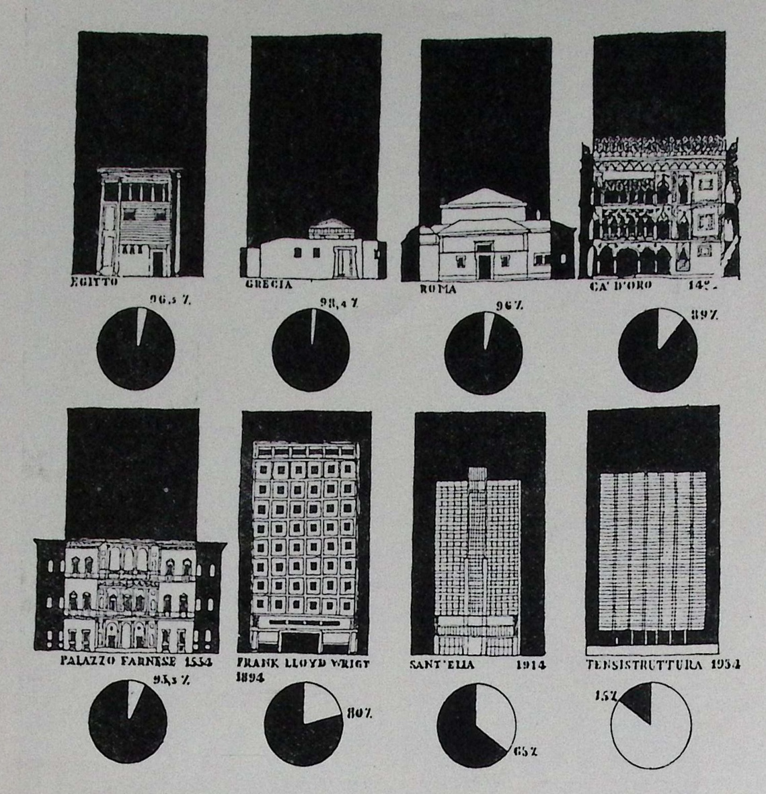
Figure 21.
Pierre-Louis Floquet, “Histoire de la fenêtre », in La maison. Revue mensuelle d’architecture de décoration, d’art ménager, 3e année, no. 2, February 1947, 45-48. Tableau montrant la progression historique de la surface moyenne totale des fenêtres, par rapport aux surface pleines des façades des batisses, 46.
Going back to the thirties, we understand why Servranckx’s career likewise took a new turn, under the influence of media that gradually diminished interest in his plastic works. While the March 1930 issue of Anthologie still mentioned “articles by Servranckx on painting,” this was in connection with the journal L’Équerre, devoted to architecture, which thus indicated, as it were, the direction to be taken. The November issue of Anthologie was already inclined to regard, alongside the Greek temple, the “mathematical esotericism of a Servranckx” as an “object for museums.” In March of the following year, R. Radelet, writing in the same magazine, granted Servranckx—alongside Pierre Gailliard and René Magritte—a “true greatness,” yet observed that the works they exhibited at the Galerie Giroux showed “very few manifestations of life,” for a painting that claimed to be living. Radelet nevertheless wished to retain confidence in these artists, even “after a failure.”
By February 1936, the verdict seemed to have been delivered in Anthologie. Even if some were still granted the benefit of fidelity “to the aesthetic principles they had adopted at the beginning of their careers,” the hopes once promised now appeared to belong to another age. “Servranckx continues to confine himself to the formal investigations of pure plasticity!” And “René Magritte has not renounced the strange compositions of an abyssal and vertiginous Surrealism.” Had not Servranckx himself reproduced, in April 1933, a work entitled Souffrance, then exhibited at the Musée des Beaux-Arts de Liège, a work that also glanced toward Surrealism, as if to test another path (fig. 22)?
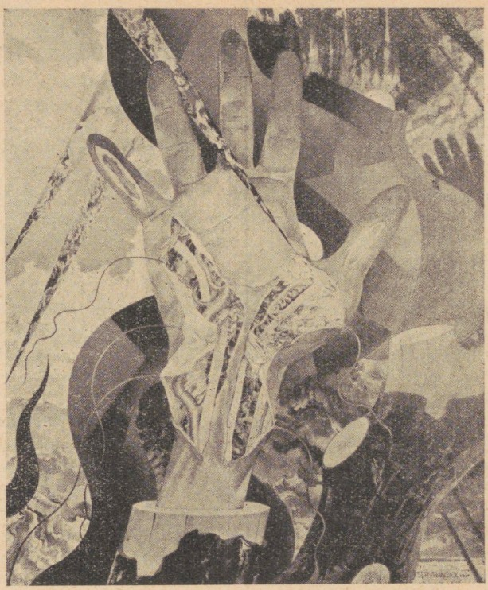
Figure 22.
Souffrance, reproduced in Anthologie, vol. 4 (March 1933): 11.
The Brussels-based journal Clarté, devoted to the decorative arts, also placed Servranckx in a distinctive perspective in July 1930. It included him within a group of architects, urban planners, and designers— Paul Bonduelle, Victor Bourgeois, Gaston Brunfaut, Louis-Herman De Koninck, Jean de Ligne, Maurice Gaspard, Antoine Pompe, and others—whom it questioned on the following issues: “What do you think of the role of the terrace in the architecture of tomorrow? Will ornament survive, or is it destined to disappear in the architecture of the future?”
The journal Clarté still hesitated in July 1935, concerning Servranckx’s place in Belgian art history. He shows such a strong “tendency toward diversity.” Will future remember him as a “painter, sculptor, architect”? In July 1937, it was Fernand Léger himself who, in the Brussels journal, congratulated Servranckx in an article devoted to his “Mural Art.” Yet a brief look backward leaves little doubt as to the position Servranckx was taking in the early 1930s. It is telling that he is not mentioned among the members of the association Art et Carré, whose manifesto was announced in the March 1930 issue of Anthologie. That group is known to have brought together several of his friends or acquaintances: Hoste, Léger, Prampolini, Schwitters, Seuphor, Vantongerloo. Nor did Servranckx join, in 1931, the anti-Surrealist collective Abstraction-Création, even though he must have been informed of its formation by Flouquet, who was in direct contact with Alfred Réth (Budapest, 1884–Paris, 1966). Réth appears there alongside the elite of the movement—the same names: Herbin, Moholy-Nagy, Prampolini, Schwitters, Michel Seuphor, Vantongerloo—not to mention Mondrian, van Doesburg, or Picasso. It therefore seems appropriate to reproduce here two works by Auguste Herbin and Alfred Réth (figs. 23–24).
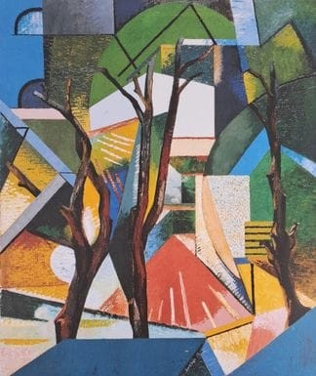  Figure 23.  Auguste Herbin, Les trois arbres, oil on canvas, 1913 (later reproduction).  Musée d’Art moderne de Céret, 2016. Coll. D. Droixhe & A. Piette. | 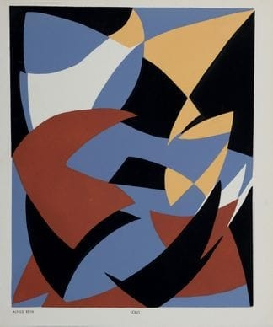  Figure 24.  Alfred Réth, Composition XXVI, stencil on paper, 1952.  Coll. D. Droixhe & A. Piette.

Chapter 9. Conclusion
In February 1931, Armand Sauvage published in the Brussels magazine Clarté
a lengthy article on Servranckx that provides one of the best images we have of the artist, with something like a conclusive prediction about his status. Sauvage conducts an interview with him. “Servranckx is there, near us, smoking cigarettes. Short and stocky, he looks at us sideways, smiling. The rascal! On this festive day, the Marolles district is in celebration. Rue Blaes is dense with people, splashed with bright shawls. In the taverns, voices shout loudly.” Servranckx speaks “of Americanism, of object-poetry, of Constructivism.” “He says things that are light and formidable.” And also somewhat paradoxical, or at least open to debate, at first glance: “art must be utilitarian,” and therefore “a painting, no more than a poem, has value in itself.” But also this: “A 12-horsepower car placed in a museum could return to scrap metal without any harm to humanity.” He also asserts: “Architecture must be the culmination of instinctive forces.” To verify what he tells, he says, look at “Picasso, Chirico, Le Corbusier, and Servranckx”, no less.
The journey to this audacious summit was, all things considered, rather quick.
Our investigation was originally intended to end in 1930. We have seen how Servranckx’s reputation evolved in magazines of the 1930s and 1940s, as well as the changing possibilities for the deployment of his talents. The volume De jaren twintig demonstrates that he did not cease painting after 1930. He even went so far, in 1948, as to copy one of his youthful works: Opus 17 of 1922, which became Compositie. This phase of his activity remains largely unexplored, as does the reception his painting continued to receive.
An unexpected moment occurred in 1949 with his participation in an exhibition devoted to the Glories of Modern Painting, organized in Ostend at the Palais des Thermes. The exhibition catalogue features a work by Servranckx on its cover (fig. 25).
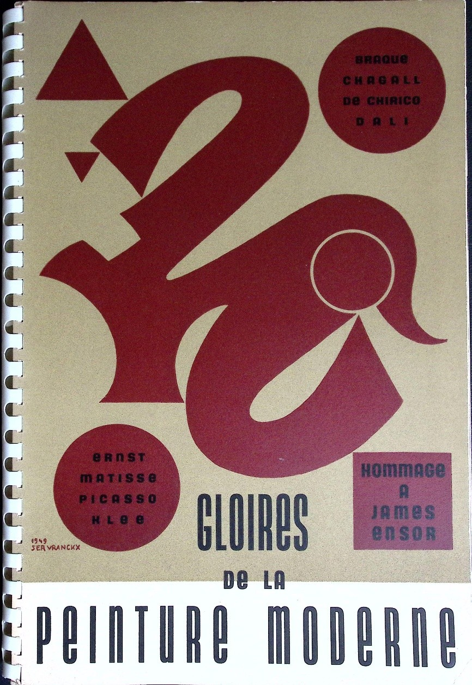
Figure 25.
Victor Servranckx, Untitled, reproduced on the cover of Gloires de la peinture moderne. Hommage à James Ensor (Brussels: Éditions de la Connaissance, 1949). Coll. D. Droixhe & A. Piette.
Yet the most surprising aspect of the publication lies in the works he lent from his own collection. That collection, to our knowledge, is no less forgotten than certain works reproduced long ago in early magazines.
The request for this illustration was undoubtedly due to the brilliant Émile Langui (Brussels, 1903–Anderlecht, 1980), then attached to the Fine Arts Department of the Ministry of Education, who would later be entrusted, in 1958, with organizing the exhibition Fifty Years of Modern Art at the Brussels World’s Fair—and who would again co-sign, in 1980, a volume devoted to Marcel-Louis Baugniet. For the exhibition, Servranckx lent three works. Two of them were by Ernst: an oil on canvas entitled Max Ernst Showing a Young Girl the Head of Her Father, dated 1926–1927, and A Vision Provoked by the Nocturnal Aspect of the Porte Saint-Denis dated 1927. The first painting is now preserved at the Scottish National Gallery of Modern Art (formerly the G. Keiller Collection); the second is close to, though distinct from, The Forest by Ernst, held at the Peggy Guggenheim Collection. Both canvases nevertheless feature a discreet geometric, circular figure, which in Max Ernst Showing a Young Girl the Head of Her Father assumes the dimensions of a large central motif. These works thus operated, in a sense, as a synthesis of the tendencies that—at least in the 1930s—divided the ambitions and perhaps the tastes of Servranckx.
Also from his collection came a watercolour and pen-and-ink drawing by Paul Klee entitled West-östliche Flora (1921), which reconciles the spirit of the Bauhaus with a poetic inquiry that follows the path of a formally and abstractly interpreted botanical poetry. Klee’s work thus likewise presented an effort of synthesis, echoing the stylistic choices available to Servranckx in the 1930s. It should be noted that Klee’s geometricism, as it was shown at the Palais des Thermes in Ostend through one of the works exhibited in 1949, Burg und Sonne (Castle and Sun, 1928), still lay ahead for the Swiss artist. On the same walls appeared a Gedenkblatt (Commemorative Sheet, 1924), in which this geometric tendency already appeared in germinal form.
The Ostend exhibition also presented several works belonging to a Liège-based collector considered one of the most important Belgian patrons of the twentieth century: Fernand Graindorge (1903–1985). He had pursued part of his commercial career in Russia as early as the 1920s and retained a vivid memory of his encounter with the avant-garde of the Revolution, to the point that he was sometimes described as a “red baron”—in reference to a clearly asserted political orientation. This discerning collector lent for the occasion works by Braque, Dalí and Matisse. The catalogue of his collection—donated to the French Community of Belgium after the City of Liège had declined to house it in suitable premises, which were (already) lacking—was established in 2009. It includes a work by Servranckx.
The request addressed to Servranckx by Émile Langui for the Ostend exhibition testifies to the importance the artist continued to hold. Did it signal the promise of a new impetus? We know, thanks to the notice written for the sale of Opus 9 – 1923, which had been shown in 1926–1927 at the International Exhibition of Modern Arts in New York, that the painting regained its full standing among collectors as early as the 1950s. It was exhibited in a Hommage à Servranckx held at the Galerie Les Contemporaines in Brussels from 11 to 29 May 1957, and then at the Concertgebouw Brugge from 12 to 28 April 1958. The United States rediscovered it in 1962: it was shown at the Arts Club / Notre Dame (Indiana), the Toledo Museum of Art, and the Contemporary Arts Center Cincinnati. The Federal Art Project, launched by Franklin D. Roosevelt as part of the New Deal in 1935, had promoted a form of cultural democratization whose effects Gustave Charlier, professor at the Université libre de Bruxelles, observed with a certain wonder during his trip to the United States in 1938. One had to acknowledge—despite the liberal Charlier’s implicit endorsement of the so-called theory of “capitalist trickle-down”—that the New World displayed an undeniable lead over the Old.
Needless to say, the early American interest in geometric abstraction underwent a decisive renewal with the arrival of Mondrian in New York in 1940, where he was reunited with Max Ernst. Mondrian’s death in February 1944 prompted a commemorative exhibition that was certainly admired by a “veteran” of the Abstraction-Création group: Josef Albers.
Albers’s celebrated Homage to the Square series (fig. 26) invites a broader question that far exceeds the scope of this article. Might Servranckx be situated within the tradition of hard-edge or colour-field painting? Should one even envisage a subcategory, as in the taxonomy of the natural sciences? Might it be a matter of distinguishing a tropological variant of the “incomplete square,” as in certain American works by Frederick Hammersley from 1959 (fig. 27), from the “broken square” in the work of Karl Georg Pfahler (fig. 28), or the “optical square” in that of Luitpold Domberger (fig. 29)? Such an exploration is dizzying when one surveys the Marli Hoppe-Ritter Collection. It might be more appropriate to place Servranckx within a hard-edge category defined as square + circle, as in the Rode rotatieve of the Centre Pompidou. In any case, does the artist truly need potential comparisons with later creators in order to secure a place entirely his own within the history of modern art?

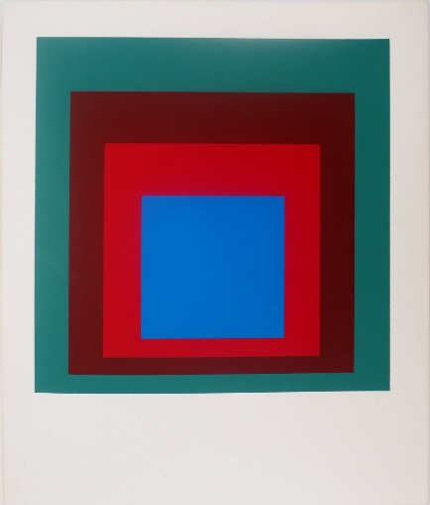  Figure 26.  Josef Albers, Homage to the Square: Protected Blue, screenprint. 19 x 23 cm,  Recklinghausen: Trautwein. Coll. D. Droixhe & A. Piette | 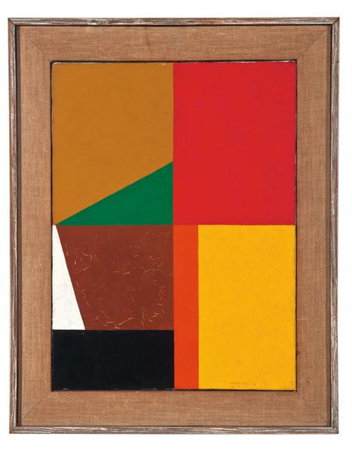  Figure 27.  Frederick Hammersley, Different Quarters #12, oil on canvas, 1959. Location unknown
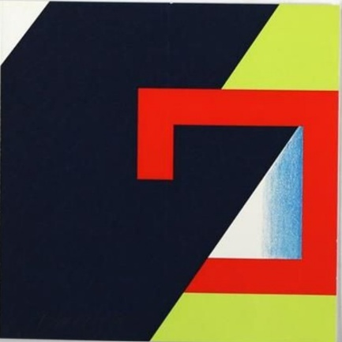  Figure 28.  Karl Georg Pfahler, Greeting Card, screenprint, 20,5 x 20,5 cm, signed and dated, Pfahler 95, EA XXI/30, 1999.  Coll. D. Droixhe & A. Piette. | 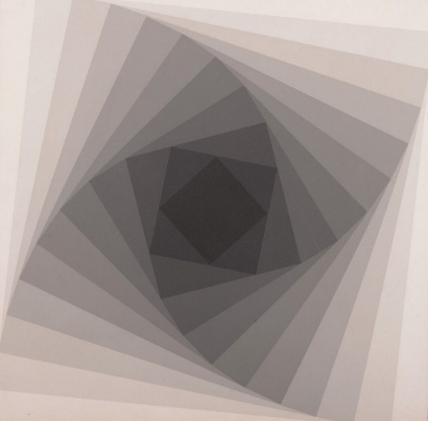  Figure 29.  Luitpold Domberger, Untitled, screenprint, white vellum paper mounted on a wooden frame, , 30 x 30 cm, from Domberger Siebdruck-Kalender Portfolio 1968. Coll. D. Droixhe & A. Piette.

Grasser, Fabienne, Deslys, Alexandra, Guigo, Elsa, Spada, Claire (eds), L’abstraction géométrique belge, Mouans-Sartoux, Espace de l’Art Concret. Centre d’art contemporain, 2015, 64. I thank Merrill C. Berman et Jolie Simpson (Merrill C. Berman Collection), Muriel Collart (Université Libre de Bruxelles), Margarita Derho (Edition Domberger GmbH), Femke Dooms (Nino Mier Gallery Brussels), Catherine Leclercq (Académie Royale de Belgique, Koregos), Matteo Smolizza (Bonino Atlantic Ltd, UK) and my wife Alice Piette (Société wallonne d’étude du dix-huitième siècle) for the help and interest shown in the completion of this study.
Berman, Merrill C., Berman, L. and Sudhalter, Adrian (eds), Merrill C. Berman Collection. New York, 2025 https://mcbcollection.com/ <15-01-26>.
Victor Servranckx. De jaren twintig, Ostende, Mu.ZEE, 2012, 145, from the Universiteitsarchief KU Leuven, fonds Victor Servranckx (very different colours).
See Droixhe, Daniel , « Victor Servranckx, la plastique pure et la revue liégeoise Anthologie (1921-1940) », Koregos, 338, 2025 https://hdl.handle.net/2268/327795 <15-01-26>.
Brooker, Peter, Bru, Sascha, Thacker, Andrew et Weikop, Christian (eds), The Oxford Critical and Cultural History of Modernist Magazine. Volume III. Europe 1880-1940. Part I, Oxford, Oxford University Press, 2013.
https://www.christies.com/en/lot/lot-6476753 <26-01-24>.
Konstruktivismus. Entwicklungen und Tendenzen seit 1913, Ausstellung vom 13. September bis Ende Dezember 1972, Köln, Galerie Gmurzynska + Bargera, 1972, n° 330. Coll. D. Droixhe & A. Piette.
Michaelides, Chris, « Futurist periodicals in Rome (1916-39): from effervescence to disillusionment », in Brooker et al., op. cit., 562-571. On Futurism in Belgium, see Van den Bossche, Bart, « Ceci n’est pas un futuriste. L’impatto del futurismo in Belgio », in Frassica, Pietro (dir.), Shades of Futurism. Futurismo in ombra. Atti del Convegno internazionale, Princeton, 9-10 ottobre 2009, Novara, Interlinea, 2011, 135-156.
Crispolti, Enrico (ed.), Pannaggi e l’arte meccanica futurista, Milano, Edizioni Gabriele Mazzotta, 1995, 272 sq. See also Vasari, Ruggeri, L’uomo e la machina, Raun / L’uomo e la macchina : Raun : spettacolo, Milano, Edizioni Il libro futurista / Cappuccio, 1933 ; Vasari, Ruggero, Raun, trad. Brendan and Anna Conwell, Roanoke, Snuggly Books, 2023; Verdone, Mario, Teatro italiano d’avanguardia: drammi e sintesi futuriste, Roma, Officina, 1970; Spengler, Oswald, Der Mensch und die Technik, Munich, Beck, 1931; Veit, Otto, La tragedia dell’ età della tecnica, Milano Bompiani, 1937.
Brooklyn Museum. Catalogue of an International Exhibition of Modern Art assembled by the Société Anonyme. November 19, 1926, to January 1, 1927. Belgium.
De jaren twintig, 28.
De jaren twintig, 29, 89.

