Xyyzz

Optimized carbon supports for durable and high performance PEMFC electrodes

Bryan Carré, Nathalie Job
Department of Chemical Engineering - NCE (Nanomaterials, Catalysis, Electrochemistry), University of Liège, 4000 Liège, Belgium;
Tel.: +32 4 3663541, Mobile: +32 4 71340514
bryan.carre@uliege.be

Abstract

Carbon xerogels are support materials that could serve as cost-effective substitutes to carbon blacks used in Proton Exchange Membrane Fuel Cells (PEMFC). Carbon gels are amorphous materials made of covalently-bonded carbon nodules [Figure 1]. Unlike carbon blacks, the size of the nodules is controllable by selecting the appropriate values of reaction variables, enabling a good adjustment of the carbon pore texture. However, carbon xerogels do suffer from the same issue as carbon blacks, namely a relatively poor resistance to corrosion, both carbons being very disordered at their surface.

Nevertheless, recent researches show that both performance and durability could be improved by adjusting the carbon surface properties. As a example, the surface of carbon xerogels can be covered by a graphitic carbon layer by chemical vapor deposition (CVD) [Figure 2], which should provide better resistance to corrosion. In a second step, this surface could be doped with nitrogen, which in turn increases the interaction forces between the catalytic metal (Pt) nanoparticles and the support, producing long-lasting active layers.

After thorough characterization, Pt and Pt-M (M being a transition metal) catalyst nanoparticles can be deposited onto these modified carbon xerogels. A comprehensive assessment of the catalyst performances and durability before and after graphitization and/or surface doping of the support was then performed on rotating disk electrode. In a final step, the catalyst will be assembled in Membrane-Electrode Assembly (MEA).
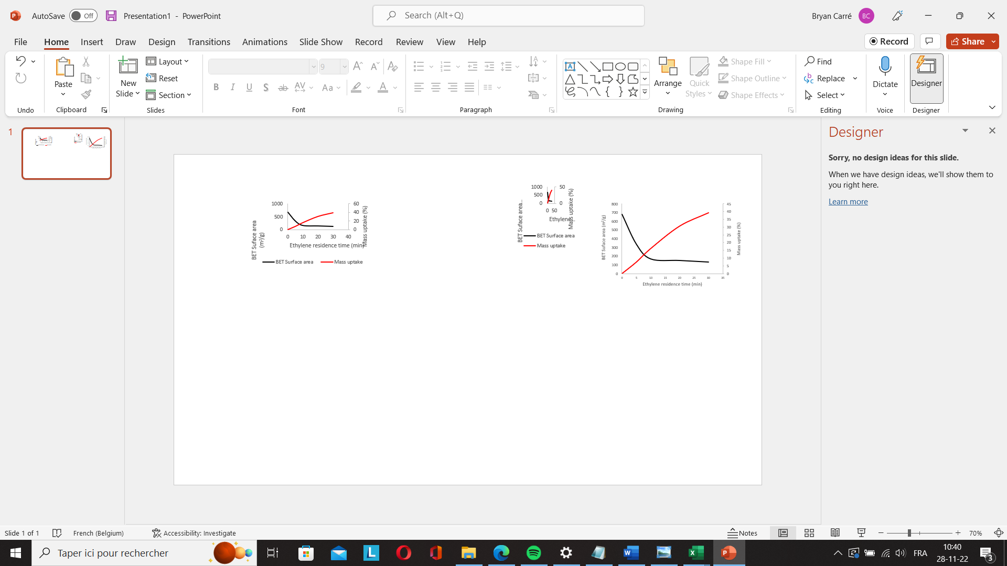
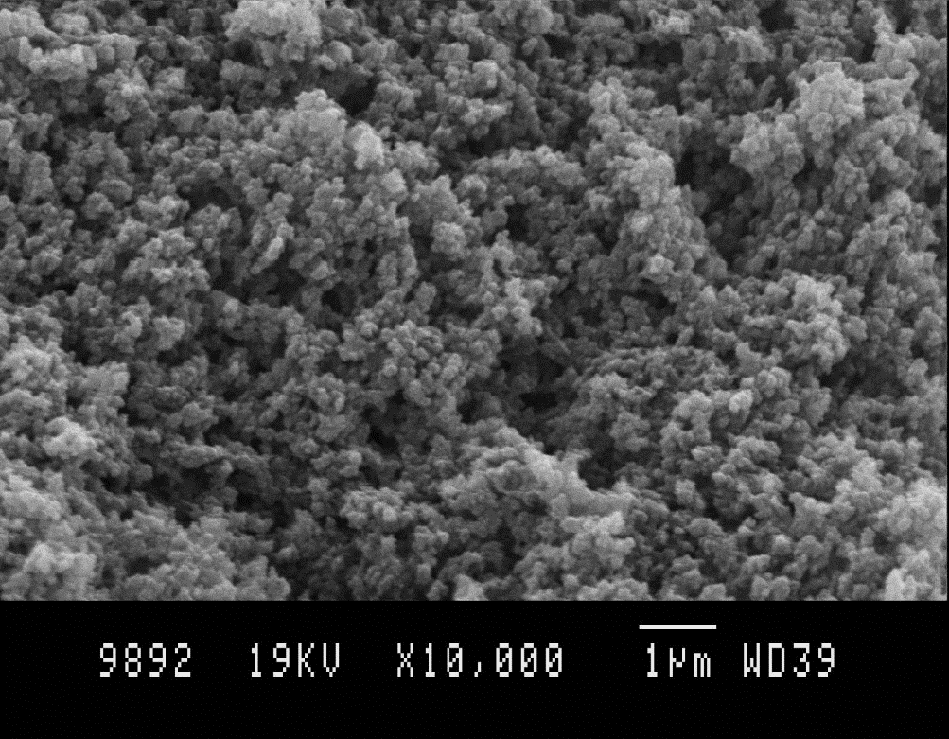
pH = 6.00
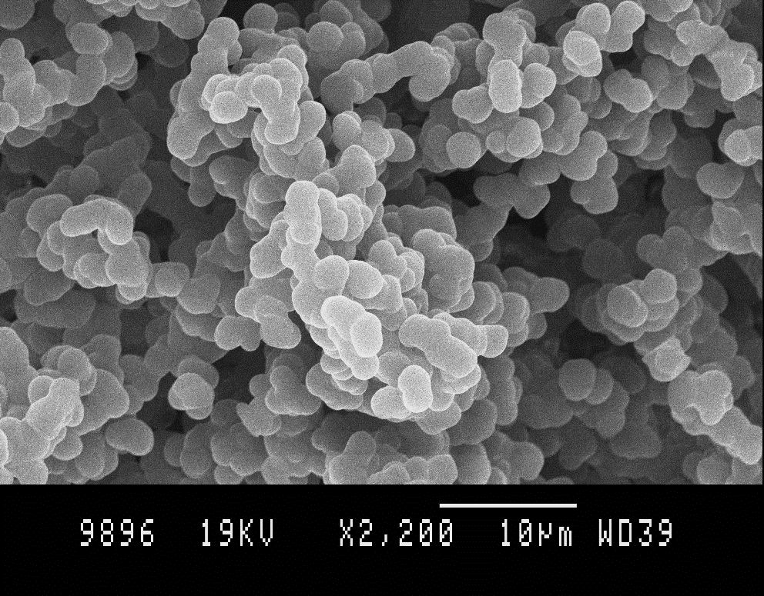
pH = 4.00


Figure 1: Overall structure of two carbon xerogels prepared under different synthesis conditions
Figure 2: Evolution of the specific surface area and mass of a carbon xerogel upon CVD treatment

