Supplementary materials of the manuscript “Lab-Scale insights into the environmental fate of emerging contaminants from airport runoff”

Robin Glaude¹, Serge Brouyère¹, Silvia Lacorte², Anna Jurado³, Estanislao Pujades³

¹ Urban and Environmental Engineering, Hydrogeology and Environmental Geology, University of Liège, 4000 Sart-Tilman, Belgium

² Chemometrics, IDAEA-CSIC, Carrer de Jordi Girona,18-26, 08034 Barcelona, Spain

³ Groundwater and hydrogeochemistry, IDAEA-CSIC, Carrer de Jordi Girona,18-26, 08034 Barcelona, Spain

Corresponding author: Robin Glaude (robin.glaude@uliege.be)

S1. Granulometry analysis
To characterize the soil used in our experiments, a granulometry analysis was conducted (See Figure S1). Given the presence of very fine particles, sieve analysis was performed for the coarser fraction of the sediments and sedimentometry for the smallest particles, to ensure a comprehensive particle size distribution analysis. These analyses were performed at the Building Materials Laboratory (LMC) within the Urban and Environmental Engineering (UEE) department at the University of Liège.
The analysis revealed that the soil consists of 14.5% clay (< 2 µm), 85% silt/loam (0.002 mm - 0.08 mm), and 0.5% sand (0.08 mm - 2 mm). Based on this particle size distribution, the soil is classified as a "loam."
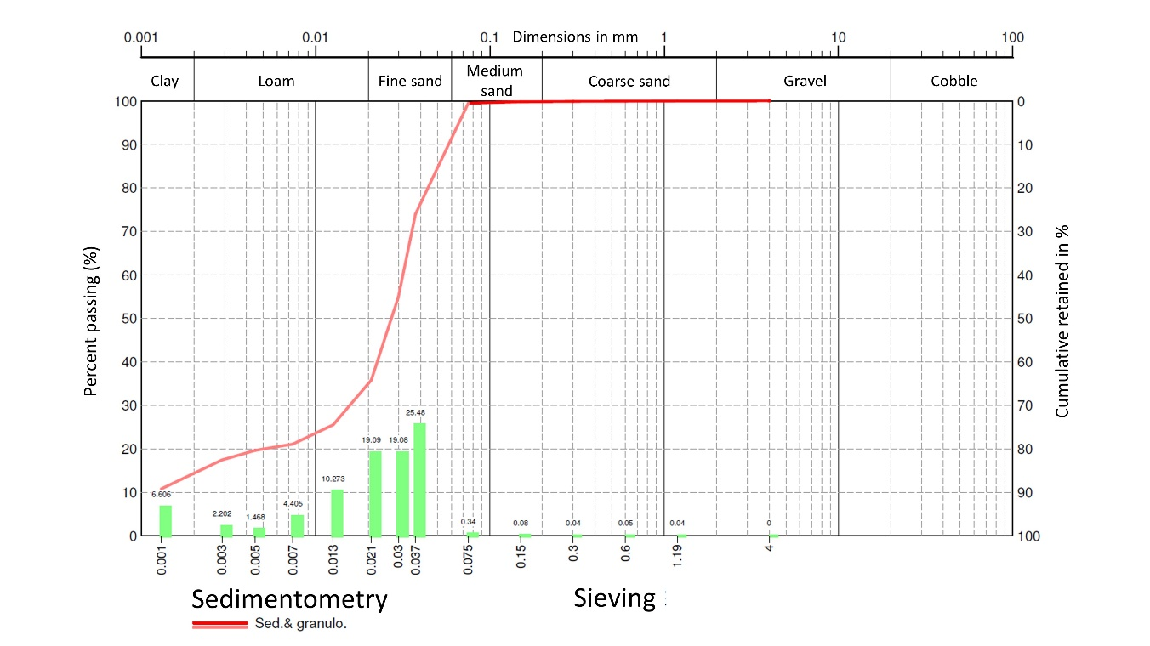
Figure S1. Granulometric analysis for one loess sample.

S2. Additional pictures of the experimental set-up
To support the section 2.2.1. of the main manuscript, additional pictures are displayed in this section to better visualize the whole experimental set-up. Figure S2 shows the stock solutions used to prepare the batch reactors, the triplicates after the addition of humic acid and soil, and the placement of the reactors in the incubator.
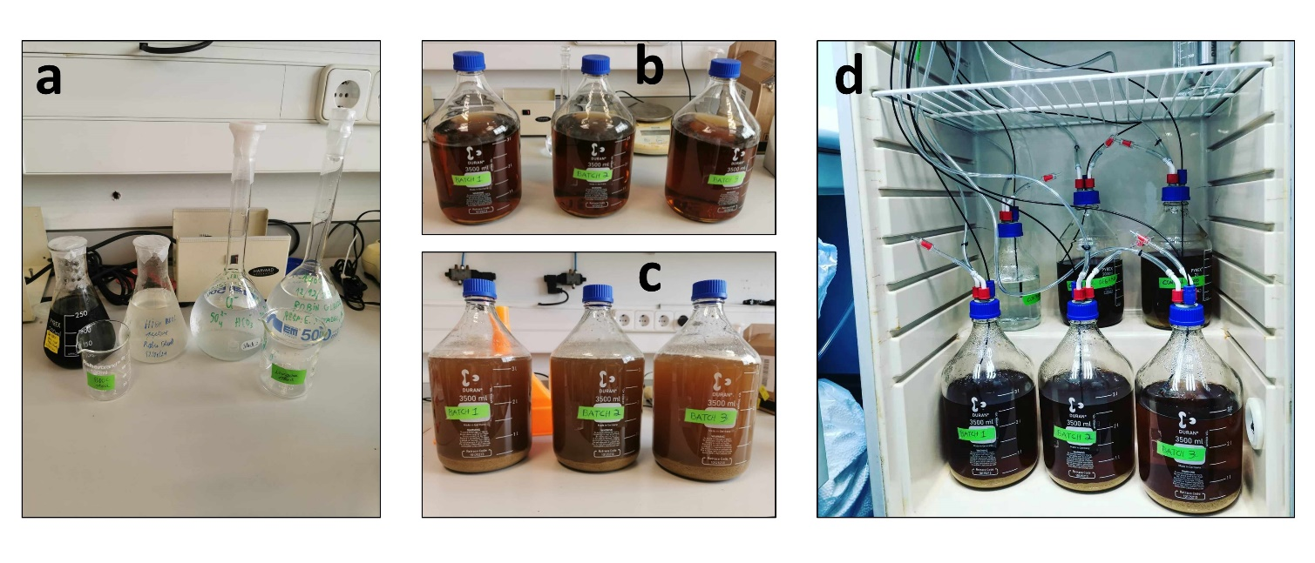
Figure S2. Additional pictures of the batch experimental set-up. a) Stock solutions for low and high BDOC (humic acid and peptone respectively) on the left and major ions on the right. b) Batch reactors after the addition of humic acid. c) Batch reactors after the addition of the soil. d) Triplicates (below) and control reactors (above) in the incubator. In this case, there is also the biotic reactor but as mentioned in the manuscript, this control proves to be not functioning.

S3. Synthetic water: resulting major ions
To achieve the target composition of major ions (Table S1), 6 different salts were dissolved in milliQ water: CaCl₂, MgSO₄.7H₂O, KCl, NaHCO₃, CaSO₄.2H₂O and NaNO₃. Table S1 provides a comparison of the major ion concentrations in the original runoff water, the theoretical concentrations expected from salt dissolution, and the measured concentrations in the three batch reactors and the abiotic control at the beginning of the experiment.
The overall concentrations in the batch reactors generally aligned with the expected values, except for potassium and sulfate, which were lower than anticipated. Calcium and bicarbonate concentrations were not quantified. Elevated concentrations of sodium and nitrate were detected in the abiotic control, likely due to the addition of sodium azide (NaN₃).
Table S1. Major ion composition in mg∙L⁻¹ in the studied runoff water (observed), in the synthetic water after salt dissolution (theoretical), and in each reactor at the start of the experiment (measured in R1, R2, R3 and C1).
 | Observed | Theoretical | R1 | R2 | R3 | C1  (abiotic)
Ca²⁺ | 30 | 30 | - | - | - | -
Mg²⁺ | 2 | 2 | 1.56 | 1.88 | 2.04 | 2.26
Na⁺ | 15 | 24 | 19.58 | 22.03 | 22.74 | 66.03
K⁺ | 10 | 10 | 3.13 | 3.22 | 3.41 | 4.13
Cl⁻ | 30 | 40 | 37.05 | 41.1 | 42.42 | 51.97
HCO₃⁻ | 60 | 60 | - | - | - | -
SO₄²⁻ | 30 | 38 | 10.31 | 13.59 | 14.89 | 17.7
NO₃⁻ | 5 | 5 | 4.66 | 4.95 | 5.09 | 59.92

S4. Flow injection analysis conditions
As described in the main manuscript, flow injection analysis (FIA) was employed to optimise the parameters for HPLC-MS/MS detection of various CECs used in batch experiments. For FIA, individual standard solutions of each compound were prepared at a concentration of 1 ppm. Each vial contained a total volume of 1000 µL, composed of a 50:50 methanol:water mixture. The methanol portion consisted of 400 µL of methanol and 100 µL of a 10 ppm native stock solution of the target compound. The aqueous portion comprised 420 µL of ultrapure water and 80 µL of a 125 mM ammonium acetate buffer solution. A volume of 10 µL was injected for each FIA run.
The initial step in method development involved optimising the cone voltage. Cone energies ranging from 10 to 80 V were tested to identify the setting that produced the maximum signal intensity for each analyte. Both positive and negative electrospray ionisation (ESI) modes were evaluated. The optimised cone voltages and ionisation modes selected for each compound are summarised in Table S2.
Table S2. Cone voltage optimisation during FIA.
Compound name | molecular mass (g mol⁻¹) | ESI | Parent  ion (m/z) | Cone (V)
Benzotriazole | 119.12 | + | 120 | 10
Tolyltriazole | 133.15 | + | 134 | 10
nonylphenol diethoxylate | 308.5 | + | 326 | 20
6:2 FTS | 428.17 | - | 427/407 | 20
PFECHS | 462.13 | - | 461 | 80

The second step involved optimisation of the collision energy for each compound, based on the previously determined optimal cone voltage. Collision energies were tested over a range of 10 to 50 eV to identify the value that yielded the highest intensity for the selected product ions. The final optimised collision energies and corresponding retention times for each target compound are reported in Table S3.
Table S3. Collision energy optimisation during FIA.
Compound name | Selected daughter 1 | Col. Energy (eV) | Selected daughter 2 | Col. Energy (eV) | t_{R} (min)
Benzotriazole | 120 > 65 | 20 | 120 > 92 | 10 | 1.23
Tolyltriazole | 134 > 79 | 10 | 134 > 106 | 20 | 1.62
nonylphenol diethoxylate | 326 > 183 | 10 | 326 > 121 | 20 | 12.63
6:2 FTS | - | - | - | - | 9.05
PFECHS | 461> 381 | 20 | 461 > 99 | 20 | 9.32

S5. Calibration curves for HPLC-MS/MS
As indicated in the main manuscript, calibration samples were prepared to construct a calibration curve spanning a concentration range of 0.0005 to 0.1 ng/µL. Each calibration point was prepared at a total volume of 1000 µL, using a solvent system consisting of a 50:50 (v/v) mixture of methanol and water.
The organic phase (500 µL) consisted of 50 µL of an internal standard solution at 1 ppm and an appropriate volume of native compound stock solution at 0.5 ppm, adjusted to the required target concentration, with methanol added to complete the total 500 µL of the organic phase. The aqueous phase (500 µL) consisted of 80 µL of 125 mM ammonium acetate buffer solution and 420 µL of HPLC-grade water. The detailed volumes used for each calibration level are provided in Table S4.
Table S4. Volumetric details for calibration samples preparation.
The calibration curves associated to each studied CECs and their linearity are depicted in Figure S3.
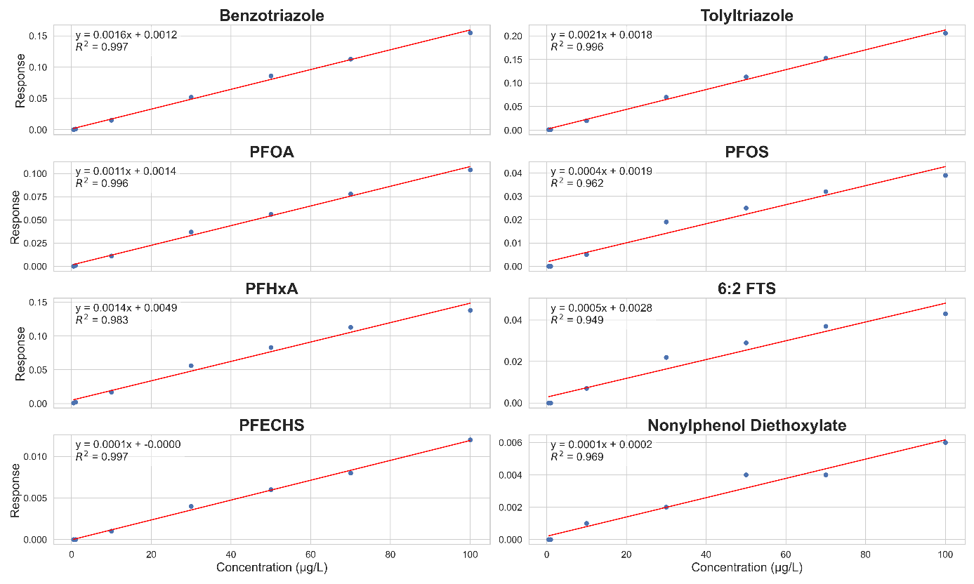
Figure S3. Calibration curves of the studied CECs.

S6. Modeled redox reaction and generic mass balance equations
This section presents the stoichiometric chemical reactions and the corresponding mass balance equations, expressed as ordinary differential equations (ODEs), used to represent the degradation of the target compounds under oxic and nitrate reducing conditions in the batch reactors. As mentioned in the section 3.3 of the paper, among all sources of organic matter, only peptone (high BDOC) was assumed to be biodegradable and its average formula stoichiometric formula is C₅H₁₀NO₂ (derived from its amino acid composition). In addition, analogous stoichiometric reactions were also defined for the target CECs and are presented in the table S7.
Table S7. Stoichiometric reactions considered in the reactive batch modeling.
Compound | Oxic conditions | Nitrate reducing conditions
Bzt | 4 C₆H₅N₃ + 35 O₂ → 24 CO₂ + 10 H₂O + 12 NO | C₆H₅N₃ + 4 NO₃⁻ + 6 H₂O → 2 N₂ + 3 NH₃ + 2 H⁺ + 6 HCO₃⁻
Tlt | 4 C₇H₇N₃ + 41 O₂ → 28 CO₂ + 14 H₂O + 12 NO | 5 C₇H₇N₃ + 26 NO₃⁻ + 27 H₂O → 13 N₂ + 15 NH₃ + 9 H⁺ + 35 HCO₃⁻
NP2EO | 2 C₁₉H₃₂O₃ + 51 O₂ → 38 CO₂ + 32 H₂O | 5 C₁₉H₃₂O₃ + 102 NO₃⁻ + 7 H⁺ → 51 N₂ + 36 H₂O + 95 HCO₃⁻
PFOA | 2 C₈HF₁₅O₂ + 7 O₂ + 14 H₂O → 16 CO₂ + 30 HF | 5 C₈HF₁₅O₂ + 14 NO₃⁻ + 28 H₂O → 61 H⁺ + 40 CO₂ + 75 F⁻ + 7 N₂
PFHxA | 2 C₆HF₁₁O₂ + 5 O₂ + 10 H₂O → 12 CO₂ + 22 HF | C₆HF₁₁O₂ + 2 NO₃⁻ + 4 H₂O → 9 H⁺ + 6 CO₂ + 11 F⁻ + N₂
PFOS | 2 C₈HF₁₇O₃S + 7 O₂ + 16 H₂O → 16 CO₂ + 34 HF + 2 SO₂ | 5 C₈HF₁₇O₃S + 14 NO₃⁻ + 33 H₂O → 71 H⁺ + 40 CO₂ + 85 F⁻ + 7 N₂ + 5 SO₂
PFECHS | C₈HF₁₅O₃S + 4 O₂ + 7 H₂O → 8 CO₂ + 15 HF + SO₂ | 5 C₈HF₁₅O₃S + 16 NO₃⁻ + 27 H₂O → 59 H⁺ + 40 CO₂ + 75 F⁻ + 8 N₂ + 5 SO₂
6:2 FTS | C₈H₅F₁₃O₃S + 11 O₂ + 8 H₂O → 16 CO₂ + 26 HF + 2 SO₂ | 5 C₈H₅F₁₃O₃S + 22 NO₃⁻ + 9 H₂O → 43 H⁺ + 40 CO₂ + 65 F⁻ + 11 N₂ + 5 SO₂
Peptone (C₅H₁₀NO₂) | 4 C₅H₁₀NO₂ + 23 O₂ → 20 CO₂ + 14 H₂O + 4 NH₃ | 10 C₅H₁₀NO₂ + 46 NO₃⁻ → 23 N₂ + 10 NH₃ + 8 H₂O + 50 HCO₃⁻ + 4 H⁺

In a closed batch system, the temporal change in the concentration of species A is described by equation 1 hereafter.
$$\begin{aligned}\frac{dC_{A}}{dt}=\sum_{r}{ν_{A,r}×R_{r}}\#\left(1\right)\end{aligned}$$
Where C_{A} is the concentration of species i (mol∙L⁻¹), $ν$_{A,r} is the stoichiometric coefficient of species A in reaction r (positive for products, negative for reactants) and R_{r} the rate of the reaction r (mol·L⁻¹·time⁻¹). Reaction rates R_{r} were expressed in Monod-type form (equations 2 and 3), limited by the availability of the electron acceptor.
$$\begin{aligned}r_{A, oxic}=-λ_{A,oxic}×C_{A}×\frac{C_{O_{2}}}{K_{O_{2}}+ C_{O_{2}}}\#\left(2\right)\end{aligned}$$
$$\begin{aligned}r_{A, NR}= -λ_{A, NR}× C_{A}×\frac{K_{inh,O_{2}}}{K_{inh, O_{2}}+C_{O_{2}}}×\frac{C_{{NO}_{3}^{-}}}{K_{{NO}_{3}^{-}}+C_{{NO}_{3}^{-}}}\#\left(3\right)\end{aligned}$$
In PHREEQC, the software internally integrates the ordinary differential equations derived from the defined stoichiometric reactions and kinetic rate laws. The explicit formulation provided here (equations 1–3) is intended to illustrate the general structure of the balances. In practice, PHREEQC calculates the coupled system of ODEs implicitly during the simulation.

S7. Calibrated parameters for the biodegradation and sorption chemical models
This section presents the full set of parameter values resulting from the calibration of the sorption and degradation models in PHREEQC, which were adjusted to reproduce batch experiments and abiotic control results. Table S5 presents the sorption parameters used to reproduce CECs observation in the abiotic control. Similarly, Table S6 depicts the biodegradation parameters used to reproduce CECs evolution in the batch experiments.
Table S5. Calibrated parameters for the sorption models of each CEC.
Table S6. Calibrated parameters for the biodegradation models of each CEC.

S8. Abiotic control results of nonylphenol diethoxylate
As mentioned in the main manuscript, nonylphenol diethoxylate did not show any evidence of sorption onto loamy sediments, as depicted with its standardized concentration evolution in the abiotic control (Figure S4).
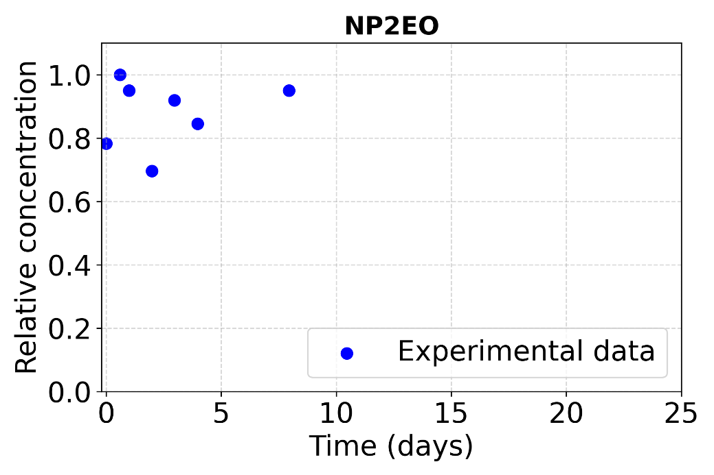
Figure S4. Abiotic control results of nonylphenol diethoxylates.

S9. Total attenuation per contaminant
The following section relates to section 3.4.4. of the manuscript, describing the total attenuation of the contaminants studied at the end of the batch experiments. Therefore, Table S7 describes the attenuation values for each of the contaminants described by the chemical model developed to reproduce the experimental results, as well as the contribution from sorption and biodegradation/biotransformation to total attenuation.
Table S8. Total attenuation per CEC, with contributions from sorption (linear isotherm + additional processes) and biodegradation/biotransformation.
CEC | Total attenuation (%) | Sorption – Linear isotherm (%) | Sorption – additional processes (%) | Biodegradation / biotransformation (%)
BZT | 38 | 16 | 0 | 22
TLT | 30 | 19 | 0 | 11
PFOA | 21 | 13 | 8 | 0
PFOS | 45 | 36 | 9 | 0
6:2 FTS | 33 | 26 | 7
PFECHS | 14 | 0 | 14 | 0
PFHxA | 24 | 15 | 9 | 0
NP2EO | 90 | 0 | 0 | 90

