Lab-Scale insights into the environmental fate of emerging contaminants from airport runoff

Robin Glaude¹, Serge Brouyère¹, Silvia Lacorte², Anna Jurado³, Estanislao Pujades³
¹ Urban and Environmental Engineering, Hydrogeology and Environmental Geology, University of Liège, 4000 Sart-Tilman, Belgium
² Chemometrics, IDAEA-CSIC, Carrer de Jordi Girona,18-26, 08034 Barcelona, Spain
³ Groundwater and hydrogeochemistry, IDAEA-CSIC, Carrer de Jordi Girona,18-26, 08034 Barcelona, Spain
Corresponding author: Robin Glaude (robin.glaude@uliege.be)

Abstract
Contaminants of emerging concern (CECs) present in runoff pose risks to groundwater quality during their infiltration. Understanding the processes that control their attenuation is therefore essential for designing effective mitigation strategies. This research investigates the attenuation capacity of loess sediments overlaying a major Cretaceous chalky aquifer in Belgium, as part of a pre-feasibility study of soil aquifer treatment (SAT) system using airport runoff. In particular, the study aims to assess the natural ability of these sediments to filter and biologically degrade detected contaminants in airport runoff, thereby reducing their concentrations to levels compliant with water quality standards. Controlled batch experiments were thus conducted to analyze the sorption and biodegradability of key CECs, including PFAS, alkylphenols and benzotriazoles. The experiments were performed in triplicate using batch reactors filled with sediments and synthetic runoff. An abiotic control was included to distinguish between sorption and biodegradation. Results revealed distinct attenuation behaviours. Nonylphenol diethoxylate showed the highest removal, driven entirely by biodegradation with no contribution from sorption. Benzotriazole, tolyltriazole, PFOS, and 6:2 FTS showed moderate attenuation, primarily due to sorption for PFAS compounds. The remaining PFAS, — PFOA, PFHxA, and PFECHS — exhibited low attenuation, limited by sorption and no biodegradation. These findings confirm that loess sediments can reduce loads of certain CECs and also highlight the persistence of PFAS in water during infiltration. The results provide critical parameters for modelling CECs transport during SAT operations and support the safe management of airport runoff as a recharge source.
Keywords: PFASs, Emerging Contaminants, Runoff, Soil Aquifer Treatment, attenuation processes, chemical modelling, batch experiments

Introduction
Managed Aquifer Recharge (MAR) is a promising strategy to address the increasing global water demand and groundwater depletion by artificially augmenting groundwater recharge, thereby enhancing storage capacity, groundwater quality and resource sustainability (Sprenger et al., 2017; Dillon et al., 2020). MAR also offers solutions to environmental challenges such as saltwater intrusion (Pyne, 2015) or land subsidence (Seidl et al., 2024). In addition, MAR can improve the quality of recharge water through Soil Aquifer Treatment (SAT) systems that rely on natural physical, chemical and biological processes in the soil and subsurface (Ringleb et al., 2016). Suitable water sources for MAR operations include treated wastewater, surface water and runoff water (Dillon et al., 2019). In particular, urban runoff water is notably accessible in urban and peri-urban areas (Han et al., 2022). Nevertheless, the use of runoff water as a recharge source necessitates rigorous quality assessment to prevent pollution risks to groundwater systems, as it frequently contains contaminants originating from anthropogenic activities (Masoner et al., 2019). Thus, selecting suitable water sources for recharge is critical for SAT efficiency and environmental safety.
Urban runoff is a complex matrix containing conventional pollutants (Zgheib et al., 2012; Gasperi et al., 2014; Launay et al., 2016; Spahr et al., 2020) and contaminants of emerging concern (CECs) such as pharmaceuticals, personal care products, and industrial chemicals (Gasperi et al., 2014, 2022; Pinasseau et al., 2020). Airport runoff, which is generated by the extensive impervious surfaces, is of particular interest due to its high volume and potential for resource recovery (Jaiyeola, 2017). Capturing and recharging this water through MAR could help mitigate flooding risks in airport areas while contributing to groundwater resources. However, the chemical quality of airport runoff raises concerns regarding its suitability for direct infiltration into aquifers. Airport areas are routinely exposed to de-icing agents, hydraulic fluids, fuel residues, and other pollutants associated with aviation activities (Sulej et al., 2011). This exposure results in a diverse range of contaminants on airport surfaces such as heavy metals, glycols, benzotriazoles, detergents, polychlorinated biphenyls, polycyclic aromatic hydrocarbons, formaldehydes, phenols and PFAS (Jia et al., 2018; Pressl et al., 2019; Sulej-Suchomska et al., 2021). During rainfall events, these contaminants are washed away and transported via runoff to stormwater basins. Recent studies, such as the review by Sulej-Suchomska et al. (2024), highlights the widespread occurrence of these contaminants in airport runoff. For instance, benzotriazoles and its derivatives have been detected at concentrations ranging from 0.083 to 156 µg∙L⁻¹. PFAS levels have also been found to be significant, with concentrations in runoff from Chinese airports ranging between 19 to 342 ng∙L⁻¹. Additionally, Ahrens et al. (2015) reported elevated concentrations of PFAS in a lake near a Swedish airport, with the sum of PFOA, PFHxA, PFOS and PFHxS ranging between 150 and 350 ng∙L⁻¹ during 2009–2013.
Understanding the factors that govern the fate and transport of CECs in soil during infiltration is thus crucial for assessing their potential impacts on groundwater quality. During infiltration, soil can act as a natural filtration barrier, attenuating pollutant concentrations through processes such as sorption, biodegradation and physical retention (Tedoldi et al., 2016). These mechanisms are central to SAT systems, where natural subsurface processes mitigate contaminants loads during MAR operations with surface-based infiltration systems (Sharma et Kennedy, 2017). The efficiency of these processes varies significantly depending on the physicochemical properties of CECs —such as solubility, polarity, and biodegradability (Lapworth et al., 2012) —as well as soil characteristics, including porosity, organic matter content, mineral composition, and the presence of microbial communities (Boyd et al., 1988; Semple et al., 2007; Cheng et al., 2012). For example, hydrophobic contaminants tend to bind strongly to soil particles, reducing their mobility, while hydrophilic and polar compounds, such as pharmaceuticals and pesticides, are more prone to leaching, posing a greater risk of groundwater contamination. The persistence of PFAS highlights the need for an in-depth evaluation of their behaviour in SAT systems (Mumberg et al., 2024). Gaining insight into these interactions can inform the design of SAT systems to enhance natural attenuation and prevent groundwater pollution.
Laboratory studies on CEC behaviour are often based on kinetic sorption experiments, where contaminants are introduced into soil in controlled environments such as polypropylene bottles or falcon tubes (Zhang et al., 2015, Askeland et al., 2020, Barth et al., 2021; Dai et al., 2023; Hubert et al., 2023). These experiments primarily aim to quantify sorption processes by measuring the equilibrium distribution of contaminants between the solid and liquid phases. Sorption tests are valued for their simplicity, cost-effectiveness, and ability to provide detailed data on specific interactions between contaminants and soil particles, such as adsorption isotherms and partition coefficients (Zhang et al., 2015). These results are fundamental for understanding contaminant behaviour and for informing predictive models of their transport (Kret et al., 2015). However, these simplified setups do not fully replicate the complexity of natural environments, as they often do not consider other attenuation mechanisms like biodegradation or chemical transformation, which can significantly reduce contaminant concentrations over time. Therefore, comprehensive batch experiments that incorporate multiple attenuation processes simultaneously are essential for a more accurate prediction of CEC behaviour in SAT settings.
This study is motivated by MARWAL project, which aims to assess the technical, regulatory, and economic feasibility of utilizing alternative sources like airport runoff for MAR in the Hesbaye chalk aquifer, with the goal of enhancing regional groundwater resilience (Brouyère, 2024). MAR through SAT systems is particularly relevant in Hesbaye, where the aquifer faced significant declines in groundwater levels and quality over the past decades (Hakoun et al., 2017; Goderniaux et al., 2023). In this context, the study involved designing comprehensive batch experiments to evaluate the attenuation capacity of loess sediments overlaying the Hesbaye chalk aquifer in Belgium when exposed to airport runoff water. Sampling campaigns carried out as part of this study revealed the presence of PFAS, alkylphenols, and benzotriazoles in airport runoff, originating from airport-related activities. The experiments were conducted in a laboratory setting to simulate the interactions between the sediments and the identified CECs in airport runoff water. The primary goal was to quantify the overall attenuation of each contaminant after the experiment. A secondary objective was to identify which contaminants were most sorbed or attenuated in contact with loess sediments. Finally, the influence of redox conditions on CECs degradation was analyzed. By simulating these soil-contaminant interactions in the laboratory, the study aimed to deepen our understanding of the natural attenuation potential of loess sediments. This is an essential consideration for evaluating the long-term safety and viability of SAT with airport runoff as a recharge source.

Materials and methods

Sampling

Runoff water
To assess the chemical quality of runoff water in the study area, samples were collected from stormwater retention basins connected to roads and the Liège airport. These grab samples were collected following rainfall events in spring 2022 and winter 2023, ensuring that the water was representative of potential contaminants mobilized during stormwater runoff. The timing of sampling at different seasons was chosen to partially account for seasonal variability.
The selection of the contaminants was based on a target screening approach using literature data, prioritizing compounds commonly found in urban runoff (Zgheib et al., 2012; Burant et al., 2018; Spahr et al., 2020; Gasperi et al., 2022). Special attention was given to persistent, mobile, and toxic (PMT) organic contaminants (Mutzner et al., 2023), which are of particular concern for groundwater contamination. Alkylphenol analyses were conducted by ISSEP (Belgium) using LC-MS/MS. Benzotriazoles and PFAS were analyzed by Celabor (Belgium), also using LC-MS/MS.
In addition, samples were collected to determine major ion composition, electrical conductivity, and pH. Major ion analyses were performed by the Hydrogeology and Environmental Geology Laboratory at the University of Liège using a Metrohm Professional 850 IC AnCat - MCS system. All this information is essential for formulating a synthetic water solution in the lab that mimics the composition of the sampled runoff water.

Loess sediments
To assess the interactions between runoff water and the sediments, loess sediment samples were collected at a depth of 50 cm from an infiltration basin in the Hesbaye region using a hand auger. Grain size distribution analyses were carried out in the Building Materials Laboratory (LMC) at the University of Liège to characterize the sediment texture, with detailed results provided in Section S1 of the Supplementary Material. The remaining sediments were then transported in cold conditions to IDAEA-CSIC laboratory (Barcelona), where they were frozen before the start of the batch experiments.
Additional loess sediment samples from the region were collected similarly and analyzed for their organic carbon content. These analyses were conducted by the BEAGx laboratory at the University of Liège using wet oxidation of humic substances.

Experimental set-up

Batch and control reactors
Batch experiments were conducted in triplicate to assess the attenuation of selected CECs present in airport runoff water when being in contact with loess sediments. The target compounds included benzotriazole, tolyltriazole, nonylphenol diethoxylate (NP2EO), PFOA, PFOS, PFHxA, PFECHS and 6:2 FTS. The experimental set-up consisted of three 3.5 L reactors, each operated for four weeks, as attenuation processes in static batch systems are expected to occur mainly during the initial phase of the experiment. Indeed, sorption equilibrates rapidly, and biodegradation is in principle most active under oxic conditions before slowing down significantly once oxygen is depleted. A volumetric ratio of 85:15 between the aqueous and the solid phases was selected to ensure sufficient water volume for repeated sampling during the experiment, while maintaining a stable solid–liquid balance (see Figure 1a). The solid to liquid ratio was also chosen as a compromise for being not too large to prevent the development of redox zoning within the sediments, and not too small to prevent a minimization of the effective surface available for sorption processes. This choice was made similarly to the approach employed by Villa et al. (2025) and Pujades-Garnes et al. (2025), where batch experiments were set-up to evaluate the fate of pharmaceuticals and gadolinium in groundwater, respectively. In practice, this ratio was approximated based on sediment density (grain density = 2.7 g·cm⁻³; wet density = 1.80 g·cm⁻³) and corresponds to an approximate liquid-to-solid mass ratio of 4:1. The aqueous phase comprised synthetic runoff water, formulated to mimic the chemical composition of the runoff water. The solid phase consisted of unconsolidated loess sediments collected from the Hesbaye region.
Each reactor bottle was equipped with a cap consisting of three screw connectors with ports (see Figure 1a). The first one was connected to the sampling tube, which was sealed between samplings events. The second one was connected to the nitrogen inlet, which was also closed between the collection of samples. The last one was connected to a pressure valve, which allowed pressure balance with the ambient air inside the incubator.
An additional 2.5 L abiotic control reactor was operated under identical conditions and duration. The objective of the abiotic control was to evaluate the sorption of CECs onto loess sediments, since any attenuation observed in the absence of microorganisms can only result from sorption processes. This single abiotic control design follows common practice in batch and column experiments, where one abiotic control is used to evaluate abiotic losses (sorption) in comparison to biotic reactors (Gulde et al., 2014; De Wilt et al., 2018; Schübl et al., 2021; Pujades-Garnes et al., 2025; Villa et al., 2025). To set-up the abiotic control, sediments were sterilized by autoclaving at 120°C for 20 minutes to eliminate all microbial activity. After sterilization, synthetic water was added to the reactor along with sodium azide (NaN₃) at a concentration of 100 mg∙L⁻¹ to ensure the inhibition of any remaining microbial activity (Lichstein et Soule, 1944; Cabrol et al, 2017; Suresh et al, 2020). Previous studies have reported that this sterilization method doesn’t significantly interfere with sorption behaviour of organic chemicals on similar soils (Roberts et al., 2014; Süßmuth et al., 2024). This approach ensures that the abiotic control focuses exclusively on sorption mechanism.
The experiment was conducted within a closed incubator maintained at 14°C in the dark to simulate typical surface water temperatures in Belgium, and to prevent light from affecting bacteriological activity (see Figure 1b). Samples were collected daily during the first week and weekly thereafter for a period of one month to monitor the concentrations of DOC (dissolved organic carbon), major ions and CECs. Dissolved oxygen (DO) was also measured regularly throughout the experiment. Sampling volumes were carefully controlled to maintain the solid-liquid ratio within a 5% margin by the end of the experiment. During each sampling time, nitrogen gas was purged through the system to compensate for the extracted volume and to preserve stable experimental conditions. Additional images of the experimental set-up are provided in the Section S2 of the Supplementary Material.
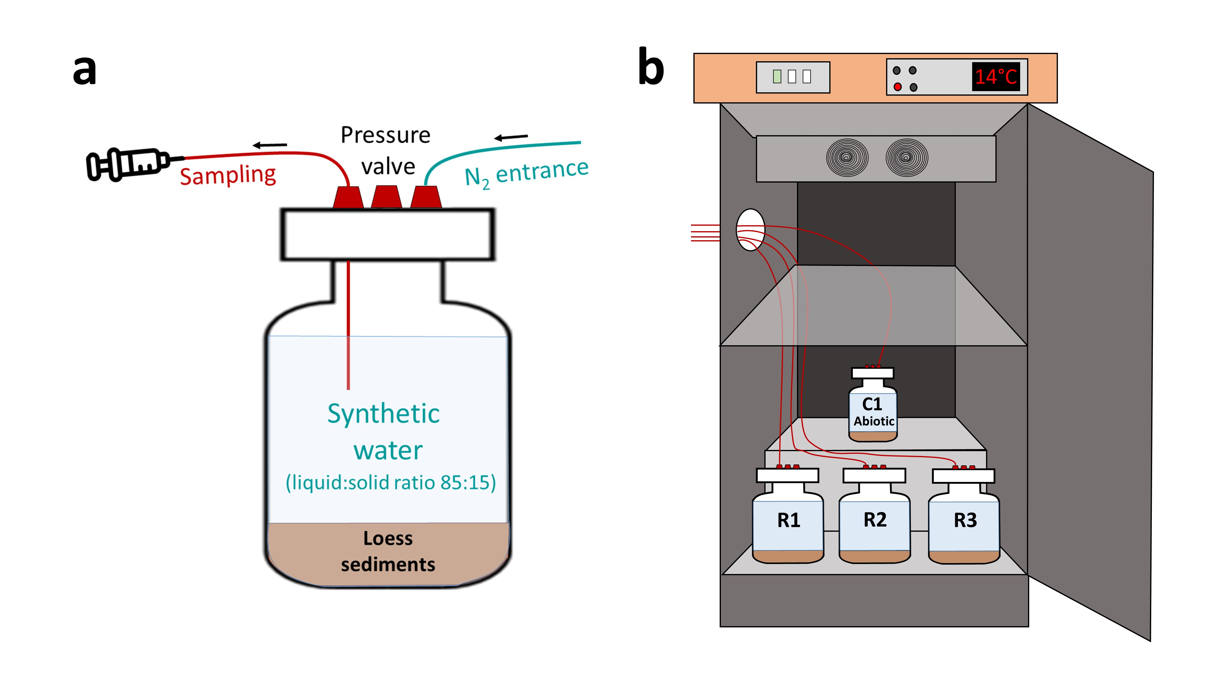
Figure 1. a) Individual batch reactor set-up, and b) arrangement of the batch reactors and the abiotic control in the incubator maintained at 14°C. Note that the nitrogen pipes are not represented in the entire experimental set-up for sake of clarity.

Synthetic runoff water preparation
Synthetic water was prepared by dissolving six different salts (MgSO4·7H2O, KNO3, NaHCO3, CaCl2, Ca(NO3)2·4H2O, CaSO4·2H2O) in Milli-Q water to mimic the major ion composition of runoff water. The resulting ionic composition is detailed in the section S3 of Supplementary Materials. Furthermore, the synthetic water was designed to reflect DOC contributions from both loess sediments and runoff water, targeting a concentration of 8 mg·L⁻¹. DOC measurements were of 3.2 mg·L⁻¹ from loess sediments and 4.8 mg·L⁻¹ from runoff. BDOC (biodegradable dissolved organic carbon) was assumed to consist of 60% easily biodegradable carbon (high BDOC) and 40% recalcitrant organic carbon (low BDOC), a reasonable estimate given that soil DOC is largely stabilized as humic substances (Ukalska-Jaruga et al., 2021). To replicate this composition, high BDOC (4.8 mg·L⁻¹) was introduced using peptone (mix of amino acids), while low BDOC (3.2 mg·L⁻¹) was represented by humic acid salt (C₉H₈Na₂O₄). To assess the evolution of total BDOC over time, samples were collected, acidified and analyzed with a total organic carbon analyzer (Multi N/C 3100 Analytical Jena) in the CCiTUB laboratory (Spain).

Acclimation phase and CECs spiking
Prior to the introduction of CECs, a 7-day acclimation phase was conducted to allow microbial communities to equilibrate and initiate the degradation of the DOC fraction. During this phase, reactors were bubbled with air twice daily to maintain oxic conditions. It was assumed that the high BDOC fraction (peptone) would be partially biodegraded, while the low BDOC (humic acid) remained largely stable.
At the end of the acclimation period, the same quantity of peptone was re-added to the reactors to restore the initial DOC concentration. Subsequently, target CECs were introduced into the batch reactors and the abiotic control at a final concentration of 0.05 µg·mL⁻¹ for each compound. Due to limited availability, PFECHS and NP2EO were added at a lower concentration of 0.0015 µg·mL⁻¹. Sodium azide was also added at the end of the acclimation period to the abiotic control at 100 mg·L⁻¹ to ensure continued inhibition of microbial activity.
Since the results from the batch experiments reflect both sorption and biodegradation processes, their comparison with the abiotic control enables the estimation of the biodegradation contribution to the overall attenuation, assuming that sorption and biodegradation are the primary attenuation mechanisms. Although a biotic control was initially included to isolate the effects of biodegradation, it was excluded from the analysis after no change in DOC concentration was observed, suggesting insufficient microbial activity to support biodegradation.

Extraction and analysis of CECs

Products acquisition
Standards of benzotriazole and tolyltriazole were purchased from A2S (France). The standard PFECHS, PFOA, PFOS, PFHxA, 6:2 FTS and the internal standards M-PFOA and M-PFOS were purchased from Wellington laboratory (Canada). Finally, nonylphenol diethoxylate (NP2EO) was purchased from Dr. Ehrenstorfer (Augsburg, Germany).

Sample preparation and HPLC-MS/MS analysis
Aqueous samples (20 mL) collected during the batch experiment were transferred into 40 mL polypropylene Falcon tubes and centrifuged at 3500 rpm for 10 minutes to separate fine loess particles. After centrifugation, 1 mL of the supernatant was transferred into 1.5 mL glass vials and stored in the freezer until analysis.
Samples were then thawed, and 500 µL of supernatant was transferred into chromatographic vials. To achieve a final volume of 1 mL with a 50:50 ratio of aqueous to organic solvent, 370 µL of methanol, 50 µL of isotopically labeled internal standard solution (m-PFOA and m-PFOS, 1 µg∙mL⁻¹), and 80 µL of ammonium acetate solution (125 mM) were added. The sample was then homogenised using a vortex mixer.
Once all the samples are collected, high performance liquid chromatography coupled to a triple quadrupole mass analyser (HPLC-MS/MS) with an electrospray ion source (Waters, Milford, USA) was used to quantify CECs concentration. A BEH C18 analytical column (100 mm x 2.1 mm, particle size 1.7 µm) (Acquity, Waters, Milford, USA) was deployed, with a flow rate of 300 µL∙min⁻¹ and a sample injection volume of 25 µL. The analysis method was adapted from the method reported for PFAS (Dulsat-Masvidal et al., 2022) to include triazoles and alkylphenols in a single analysis.
The mobile phase consisted of two mixtures: an organic mixture (A) containing methanol and acetonitrile in an 80:20 ratio with 10 mM ammonium acetate, and an aqueous mixture (B) containing water with 10 mM ammonium acetate. The gradient elution began with a 50:50 ratio of A and B, maintained for 3 minutes, and gradually increased to 100% of A over 7 minutes, held this condition for 3 minutes, and finally returned to the initial 50:50 ratio in 5 minutes. Blank samples were regularly included to verify the absence of carry-over and contamination. To eliminate the contribution of background PFAS from the mobile phase and LC tubing, a reused XBridge C18 column (50 × 4.6 mm, particle size 3.5 μm) was used as a trap column.
Flow injection analysis was conducted to optimize the HPLC-MS/MS parameters (cone collision energy, ionization mode, etc.) and ensure the detection of all compounds. The various parameters and experimental conditions are detailed in the section S4 of the supplementary materials. The target compounds were quantified using the internal standard method, with M-PFOA for all perfluorinated carboxylic acids (PFCAs), M-PFOS for perfluorinated sulfonic acids (PFSAs) and both M-PFOA and M-PFOS for compounds other than PFAS. Mass Lynx v.4.1 software was used for instrument setup, data acquisition, and data processing.

Quality control
To accurately quantify the CECs concentration from batch experiment samples, a calibration curve with seven points was built over a concentration range of 0.0005 to 0.1 ng.µL⁻¹ for each studied compound, with internal standards kept at a constant concentration of 0.05 ng.µL⁻¹. The selected concentration range was chosen to match the expected concentration levels of contaminants introduced into the batch reactors, ensuring analytical sensitivity and relevance to the experimental conditions. Calibration standards were prepared in methanol:water (50:50) and buffered with ammonium acetate. Details on samples preparations for the calibration curve are available in the section S5 of the Supplementary Materials.
Linearity was evaluated by calculating the coefficient of determination (R²), which was above 0.95 for all target analytes, indicating a strong correlation between instrument response and analyte concentration. The relative response factor (RRF) was calculated using the ratio of the analyte peak area to that of its corresponding internal standard. The different calibration curves for each CECs and their associated R² are also available in the section S5 of the Supplementary Materials.

Numerical modelling of the hydrochemical processes
Once the batch experiment results were obtained, they were reproduced numerically to gain deeper insights into the behaviour of the target CECs. In addition, the calibration of these models facilitated the determination of key parameters governing CECs attenuation, such as their maximum degradation rate and their sorption coefficient. The hydrochemical processes occurring in the batch reactors were simulated using PHREEQC (Parkhurst et Appelo, 2013), a geochemical modeling software particularly suited for simulating sorption and redox reactions. To refine the model and optimize parameter estimation, automated calibration was conducted using the PEST software (Doherty, 2010).

Sorption modeling
The sorption behaviour was evaluated using a linear reversible sorption model. The rate of adsorption/desorption for an aqueous species i is described by Tebes-Steven et al. (1998) by the following equation:
$$\begin{aligned}r_{sorption}=-k_{m}× {(C}_{i}-\frac{s_{i}}{K_{d}})\#\left(1\right)\end{aligned}$$
where k_{m} designates the mass transfer coefficient in h⁻¹, C_{i} the aqueous concentration of species i in mol∙g⁻¹, s_{i} the adsorbed concentration of species i in mol∙g⁻¹ and K_{d} the linear distribution coefficient for linear equilibrium adsorption. This formulation (Eq. 1) accounts for both adsorption and desorption processes driven by concentration gradients between the solid and liquid phases, with molecular diffusion controlling the mass transfer coefficient (Weber et al., 1991) in the absence of advection and dispersion. Desorption was not directly quantified in this study due to the lack of solid-phase concentration measurements.

Reactive modeling
The degradation of high BDOC and CECs was modeled considering the evolving redox conditions in the batch reactors using first-order Monod-type kinetics, accounting for oxygen availability and inhibition effects under nitrate reducing (NR) conditions (Barkow et al., 2021):
$$\begin{aligned}r_{A, oxic}=-λ_{A,oxic}×C_{A}×\frac{C_{O_{2}}}{K_{O_{2}}+ C_{O_{2}}} \#\left(2\right)\end{aligned}$$
$$\begin{aligned}r_{A, NR}= -λ_{A, NR}× C_{A}×\frac{K_{inh,O_{2}}}{K_{inh, O_{2}}+C_{O_{2}}}×\frac{C_{{NO}_{3}^{-}}}{K_{{NO}_{3}^{-}}+C_{{NO}_{3}^{-}}} \#\left(3\right)\end{aligned}$$
where A represents either high BDOC or a CEC, λ the maximum degradation rate (mol∙L⁻¹∙s⁻¹), C_{A} the concentration of high BDOC or a CEC (mol∙L⁻¹), C_{O2} the oxygen concentration (mol∙L⁻¹), C_{NO3} the nitrate concentration (mol∙L⁻¹), K_{O2} and K_{NO3} the half-saturation constants (mol∙L⁻¹) and K_{inh,O2} the inhibition coefficient of oxygen (mol∙L⁻¹). Additional details on the complete set of stoichiometric reactions and the corresponding ordinary differential equations (ODEs) are provided in Section S6 of the Supplementary Materials.

Model calibration
The calibration process was carried out to reproduce the redox evolution observed in the triplicates. A linear oxygen source term (d[O₂]/dt = λ∙t) was included to account for the gradual increase of dissolved oxygen measured in the biotic reactors. In addition, a conditional switch between oxic and nitrate-reducing conditions (see section 2.4.2) was implemented: the oxic rate expression was applied when [O₂] was superior to 4 mg·L⁻¹, whereas the nitrate-reducing rate expression was applied when [O₂] dropped below this threshold. This value was chosen based on experimental observations (see Section 3.2), where nitrate started to decrease right after [O₂] fell below 4 mg L⁻¹. This is consistent with the findings of Green et al. (2008), who reported that denitrification can occur even at dissolved-oxygen concentrations greater than 3 mg L⁻¹.
Calibration was then performed iteratively. First, oxygen consumption was adjusted by calibrating the maximum degradation rate and half-saturation constant for high BDOC under oxic conditions. Then, using these fixed parameters, nitrate depletion and nitrite production were reproduced by adjusting the corresponding parameters under nitrate-reducing conditions. At each stage, the oxygen source term (λ) was adjusted simultaneously to reproduce both O₂ and DOC dynamics. Finally, a global refinement of all parameters was carried out to ensure accurate reproduction of the overall redox evolution. Following this calibration of redox species, the second step focused on simulating the degradation of CECs under oxic and nitrate-reducing conditions. Similarly to high BDOC reproduction, the degradation rate constants, half-saturation constants, and inhibition coefficients of CECs were adjusted to reproduce their temporal evolution in the triplicates, while sorption parameters (Kₘ, K_{d}) were calibrated to fit the data from the abiotic control.

Results and discussion

Occurrence of CECs in runoff water
Table 1 summarizes the detected CECs in the runoff water and their potential source of contamination. Benzotriazole concentrations ranging from 360 to 1400 ng∙L⁻¹ were detected in winter, likely due to the seasonal use of deicing agents (Olds et al., 2021). Additionally, alkylphenols were detected in stormwater basins from both the traffic roads and the airport at concentrations from 42 to 126 ng∙L⁻¹, attributed to their common use as surfactants in cleaning products (Lamprea et al., 2018). Finally, various per- and polyfluoroalkyl substances (PFAS) were identified at concentrations between 13 and 590 ng∙L⁻¹, likely originating from multiple sources (Pramanik et al., 2020). These include their use in Aqueous Film-Forming Foams (AFFF) during fire response training at the airport, as well as their presence as surfactants in cleaning products and corrosion inhibitors in aircraft hydraulic fluids (Wang et al., 2016; Milley et al., 2018; Liu et al., 2022). Notably, these compounds were detected at higher concentration in winter. This seasonal pattern can be explained by two factors. First, winter season is characterized by greater precipitation and snowmelt events, increasing runoff volumes and subsequently, the mobilization of PFAS and other airport-related contaminants. Secondly, the exclusive use of deicing and anti-icing fluids in winter accounts for the elevated benzotriazole concentrations observed (Breedveld et al., 2002; Cancilla et al., 2003; Olds et al., 2021).
In addition, Figure 2 illustrates the molecular structures of the target compounds, including NP2EO, benzotriazole, tolyltriazole, and the selected PFAS. This figure provides a visual comparison of functional groups and chain lengths, which are later discussed in relation to sorption and biodegradation processes (see Section 3.4.4).
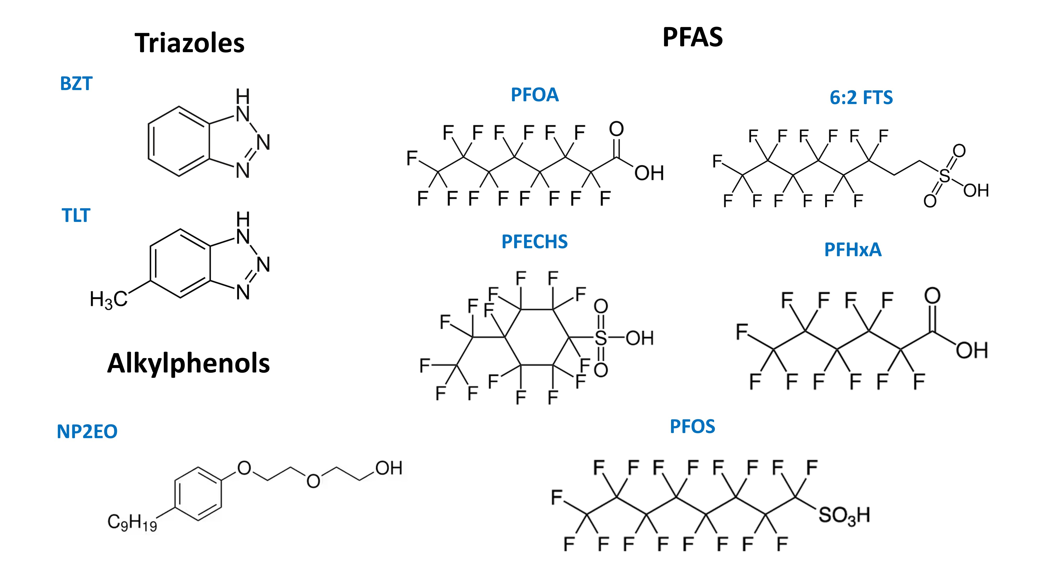
Figure 2. Molecular structures of the target contaminants.

Table 1. Concentration in ng∙L⁻¹ of the identified CEC in runoff water collected in four stormwater basins in spring 2022 and winter 2023 (n=8).
Name | Acronym | Family | CAS | Min | Max | Median | Origin
Benzotriazole | Bzt | Triazoles | 95-14-7 | 390 | 1400 | 895 | Corrosion inhibitors  in deicing fluids
Tolyltriazole | Tlt | Triazoles | 136-85-6 | 360 | 440 | 400 | Corrosion inhibitors  in deicing fluids
Nonylphenol diethoxylate | NP2EO | Alkylphenols | 2315-61-9 | 42 | 126 | 56 | Additives in industrial  surfactants and cleaning agents
Perfluorooctanoic acid | PFOA | PFAS | 335-67-1 | 19 | 19 | 19 | Surfactants
Perfluorooctanesulfonic acid | PFOS | PFAS | 1763-23-1 | 13 | 310 | 24 | Surfactants
Perfluorohexanoic acid | PFHxA | PFAS | 307-24-4 | 25 | 60 | 55 | Degradation product of 6:2 FTS
Perfluoroethylcyclohexane Sulfonate | PFECHS | PFAS | 335-24-0 | 190 | 490 | 210 | Corrosion inhibitor  in aircraft hydraulic fluid
1H,1H,2H,2H-Perfluorooctanesulfonic acid | 6:2 FTS | PFAS | 27619-97-2 | 63 | 590 | 180 | Additive in AFFF
In addition to runoff monitoring, groundwater samples collected from a piezometer located directly beneath the airport were analyzed. None of the target compounds (PFAS, benzotriazoles, alkylphenols) were detected in these samples. This observation is consistent with the current infrastructure, since the stormwater basins function as sealed retention basins with concrete bottoms, which discharge to WTTPs that release treated wastewater directly to the nearby Meuse River. As such, these basins are not hydraulically connected to the underlying groundwater system, and no contamination is expected under present conditions. In addition, drilling data indicate that the unsaturated zone consists of successively ≈ 10 m of loess, ≈ 10 m of flint conglomerate, and ≈ 10 m of unsaturated chalk before reaching the groundwater table at ≈ 30 m of depth. This stratigraphy provides a significant natural buffer, as infiltration through the loess cover alone delays the recharge by several months, allowing further attenuation processes to occur. Nevertheless, the potential for groundwater impact exists if infiltration pathways are created, such as with SAT operations, which justifies the following physico-chemical behavior evaluation performed in this study.

Redox conditions
To assess the evolution of redox conditions in the batch reactors, DO concentration was monitored during the experiment. Redox-related species such as NO₃⁻ and NO₂⁻ provide insights into potential denitrification processes occurring when DO becomes unavailable as an electron acceptor for bacteria to degrade organic matter. Figure 3 illustrates the mean concentration evolution of DO, NO₃⁻ and NO₂⁻ in the batch experiments.
As shown in Figure 3a, DO depletion occurred rapidly within the first four days, dropping from 8.8 to 4 mg∙L⁻¹. This depletion is expected, as oxygen is the first electron acceptor used by bacteria to degrade high BDOC. Afterward, the DO concentration decreased more slowly before increasing again in a linear way. Although the batch reactors were designed as closed systems, the consistent oxygen increase observed later on during the experiment is most likely explained by unintended entrance through the pressure valves, which were directly connected to the ambient air inside the incubator. Initially, this oxygen influx was not observable due to simultaneous oxygen consumption by bacteria at rates higher than the incoming oxygen. However, once the available BDOC was consumed, oxygen influx overcame consumption, leading to an increase in DO levels across the batch experiments. This results in three distinct phases: (i) oxic conditions (DO > 4 mg L⁻¹) during the first four days, (ii) nitrate reducing conditions (NR) (3 < DO < 4 mg L⁻¹) from day 4 to day 15, and (iii) a return to oxic conditions (DO > 4 mg L⁻¹) lasting until the conclusion of the experiment.
These observations are corroborated by nitrate and nitrite dynamics shown in Figure 3b. As O₂ concentrations decreased sufficiently, bacteria started using NO₃⁻ as an electron acceptor. Simultaneously, nitrate reduction led to the production of nitrite. Once DO levels exceeded 4 mg L⁻¹, denitrification is inhibited, leading to a cessation of nitrate consumption and thus, no further nitrite production. This observation is supported by Green et al. (2008), who reported that denitrification can persist even when measured DO concentrations exceeding 3.0 mg∙L⁻¹, a process known as aerobic denitrification.
The model calibration closely reproduced the observed O₂, nitrate, and nitrite concentrations (see Figure 3). The model successfully replicates the O₂ depletion and subsequent increase over time. The only significant deviation occurs at day 15, where the O₂ concentration measured was higher than predicted. Regarding nitrate and nitrite, the model accurately captures their consumption and depletion during the nitrate reducing phase. However, error bars indicate greater uncertainty in nitrite and nitrate measurements than for oxygen.
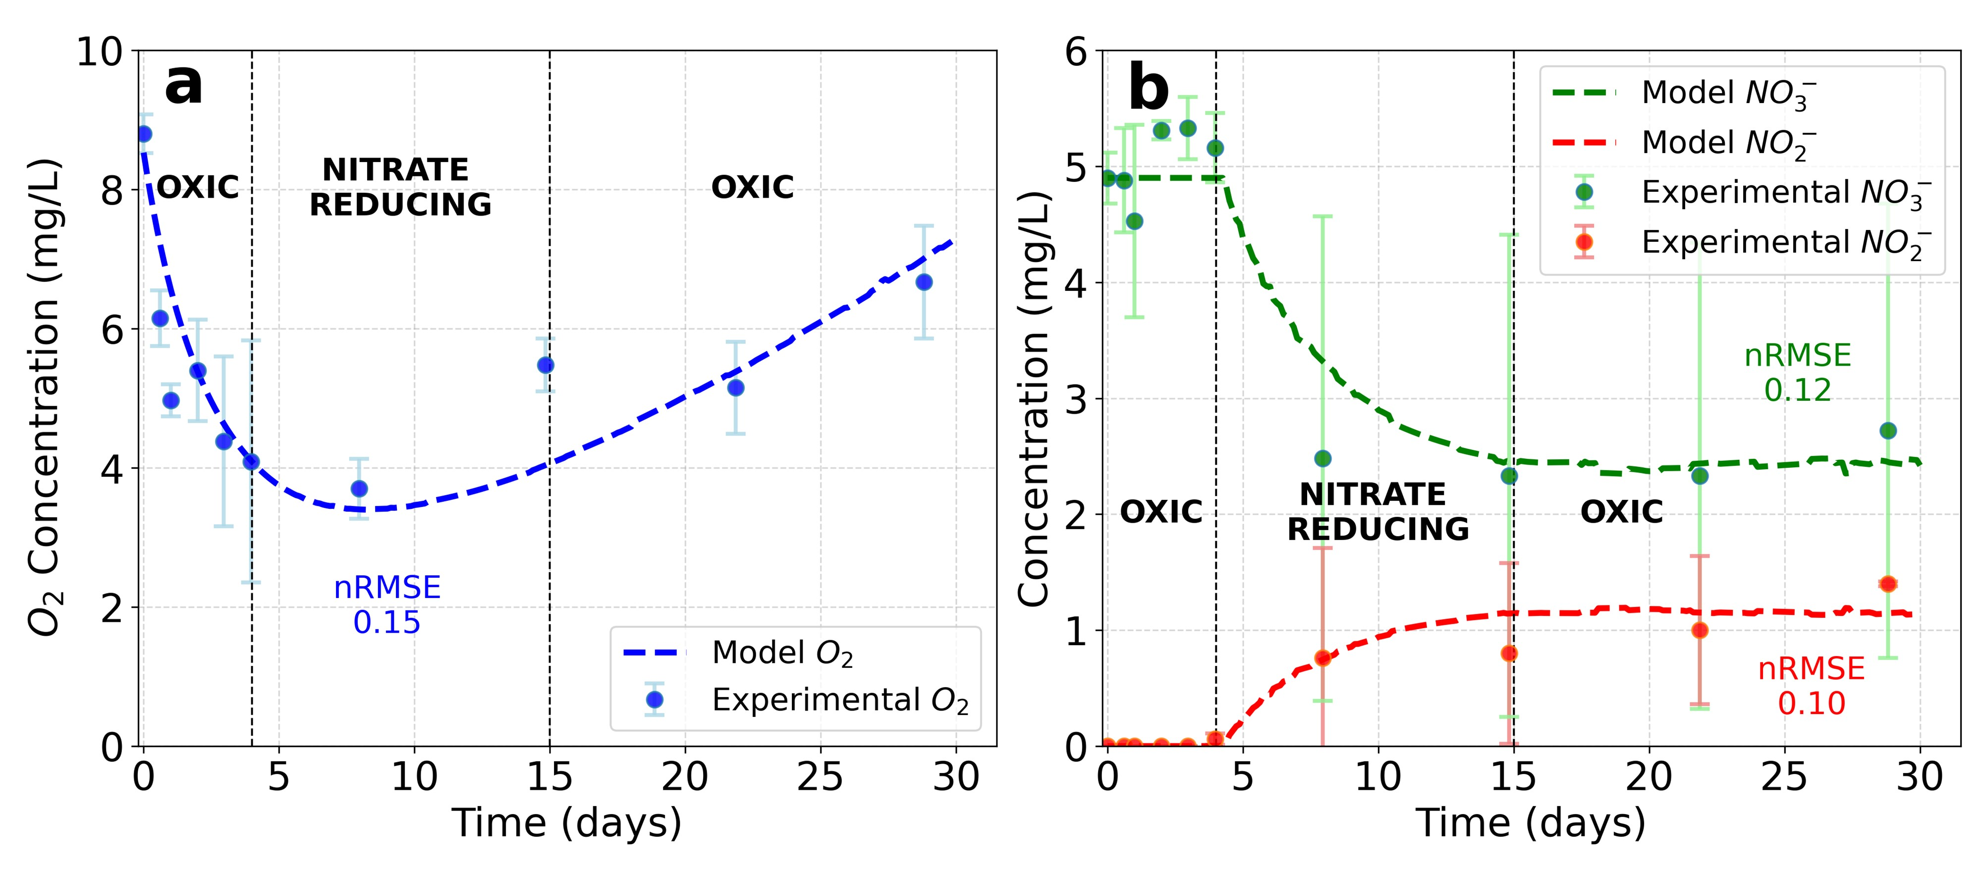
Figure 3. Temporal evolution of the mean concentrations in the batch experiments and corresponding chemical model predictions for a) oxygen and b) nitrate/nitrite.

BDOC evolution
Total BDOC concentration evolution was monitored in the batch experiments and in the abiotic control to assess bacteriological activity (see Figure 4). High BDOC introduced into the synthetic water was assumed to be biodegradable, while low BDOC remained recalcitrant. Under oxic conditions, bacteria consumed oxygen to degrade high BDOC. Once oxygen is sufficiently low, nitrate serves as an alternative electron acceptor under NR conditions, allowing biodegradation to continue. Figure 4a shows an initial rapid degradation of high BDOC under oxic conditions. In NR conditions, biodegradation continues but at a slower rate. Once oxic conditions are restored, most of the high BDOC (peptone) has already been biodegradaded, resulting in a constant BDOC concentration, which represents the total concentration of humic acid.
The model accurately reproduces the initial BDOC concentration the first days (see Figure 4a). However, the subsequent BDOC observations are underestimated. This discrepancy may be due to the model not accounting for the potential release of additional organic matter from the sediments. Despite higher variability at intermediate times (e.g., third and seventh observations), a clear overall decrease is visible across the three replicates, with the mean BDOC concentration declining from 18.3 to 12.9 mg·L⁻¹ between the start and the end of the experiment. Similarly, total BDOC concentration was also monitored in the abiotic control to assess its reliability (see Figure 4b). In contrast, the abiotic control showed BDOC concentrations fluctuating around a constant mean BDOC value without systematic decrease, confirming that sterilization effectively inhibited microbial activity.
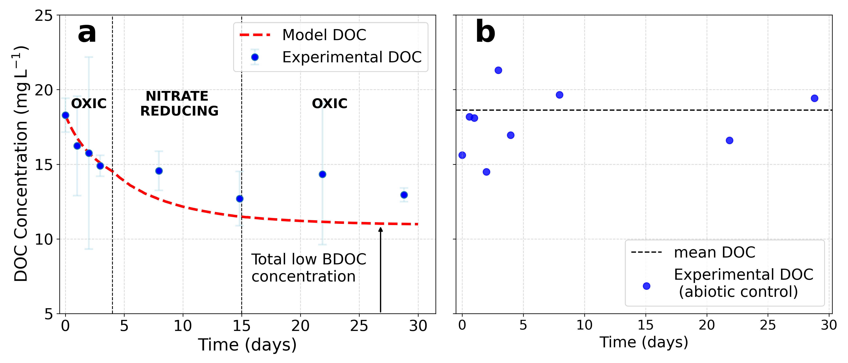
Figure 4. Total BDOC evolution in a) the batch experiments and b) the abiotic control.

CECs evolution
The following section describes the temporal evolution of each studied CECs in the abiotic control (see Figure 5) and in the batch experiments (see Figure 6). Additionally, the chemical models developed to reproduce the experimental results will also be presented, thereby highlighting the differences in physico-chemical behaviour between each CEC and how redox conditions affect it. A comparison between the fitted sorption parameters and those reported in the literature is included to assess consistency. Finally, total attenuation is quantified for each compound as the ratio between the model-predicted concentration at the end of the experiment (day 21) and the initial concentration. The complete set of calibrated parameters is available in the section S7 in the Supplementary Material.
The results will be represented in relative concentration form, i.e. by comparing the concentration of each contaminant to its initial value. Observation points showing concentrations higher than the initial concentration were excluded from the analysis. While such increases could, in principle, result from the transformation of precursor compounds into degradation products, as is the case for PFHxA potentially formed from the degradation of 6:2 FTS (Yang et al., 2014), this process is considered negligible in our system, since 6:2 FTS is predominantly removed through sorption rather than biodegradation. Notably, the observed increases are more likely attributable to analytical variability or measurement uncertainty, given the very low concentrations involved in these experiments.

Abiotic control
Benzotriazoles
Figure 5a-b illustrates the temporal evolution of benzotriazole and tolyltriazole relative concentrations in the abiotic control. Both compounds show a consistent decline over time, suggesting their removal from the aqueous phase through sorption onto the loess sediments. The integrated sorption models accurately closely match the experimental data, with RMSEs values of 0.019 for benzotriazole and 0.017 for tolyltriazole.
By the end of the experiment, approximately 16% of the initial benzotriazole mass and 19% of the tolyltriazole mass had been adsorbed onto the sediments. This higher sorption of tolyltriazole is consistent with its higher log K_{oc} compared to benzotriazole, as also reported by Hart et al. (2004) in different types of soils. This implies stronger interactions with the organic matter content of the loess sediments.
PFAS
PFAS also exhibited sorption onto loess materials, with the extent of sorption varying depending on the specific PFAS compound. Figure 5c-f illustrates the temporal evolution of different PFAS concentrations in the abiotic control. All compounds, except PFECHS, showed a decrease in concentration to varying extents.
Sorption of PFAS is particularly more complex than that of conventional organic compounds, as highlighted by Kookana et al (2022). This complexity arises from the unique properties of PFAS, including the exceptional strong C-F bond and the molecule’s amphiphilic nature, with a hydrophobic tail and a hydrophilic head (Itumoh et al., 2024). In this study, the PFAS were predominantly present in their anionic forms, which make them more soluble in water than under cationic or zwitterionic forms (Mejia-Avendaño et al., 2020). In saturated soils, factors influencing PFAS sorption include the physiochemical properties of the specific PFAS compounds, soil organic matter content, mineral composition, pH, and soil solution chemistry (Kookana et al., 2022). Nevertheless, in the abiotic control, these complex interactions are integrated all together, making it challenging to attribute the sorption behaviour of a particular PFAS compound to a single factor. Hypotheses can only be proposed to explain why some PFAS compounds exhibit stronger sorption than others. As such, a detailed comparison of our results with previous PFAS sorption studies is provided in Section 3.4.3.
It should also be noted that sodium azide addition in the abiotic control led to higher sodium and nitrate concentrations than in the biotic reactors (see Table S1 of the supplementary materials). However, previous studies indicate that such moderate changes in ionic strength or nitrate presence as a competing anion have only limited influence on PFAS sorption compared to dominant factors such as chain length, functional group, and sediment properties (Wanzek et al., 2023; Woke et al., 2025). Another possible source of uncertainty is sorption to reactor walls. Yet, glass containers are known to adsorb significantly less PFAS than polymeric materials such as polypropylene or HDPE, and adsorption to glass reaches equilibrium rapidly (Zenobio et al., 2022). Importantly, vessel sorption would affect all reactors equally and thus cannot explain the systematic concentration differences between abiotic and biotic treatments.
Finally, it is important to note that the sorption capacity of loess sediments is not unlimited. Under continuous exposure to contaminated water, the available sorption sites could progressively become saturated, leading to a decline in removal efficiency over time. This is particularly relevant in SAT systems, where the soil acts a reactive medium over extended periods. As this study focused on short-term batch conditions, the potential for sorption site exhaustion and contaminant desorption during repeated infiltration cycles in SAT systems was not addressed here.
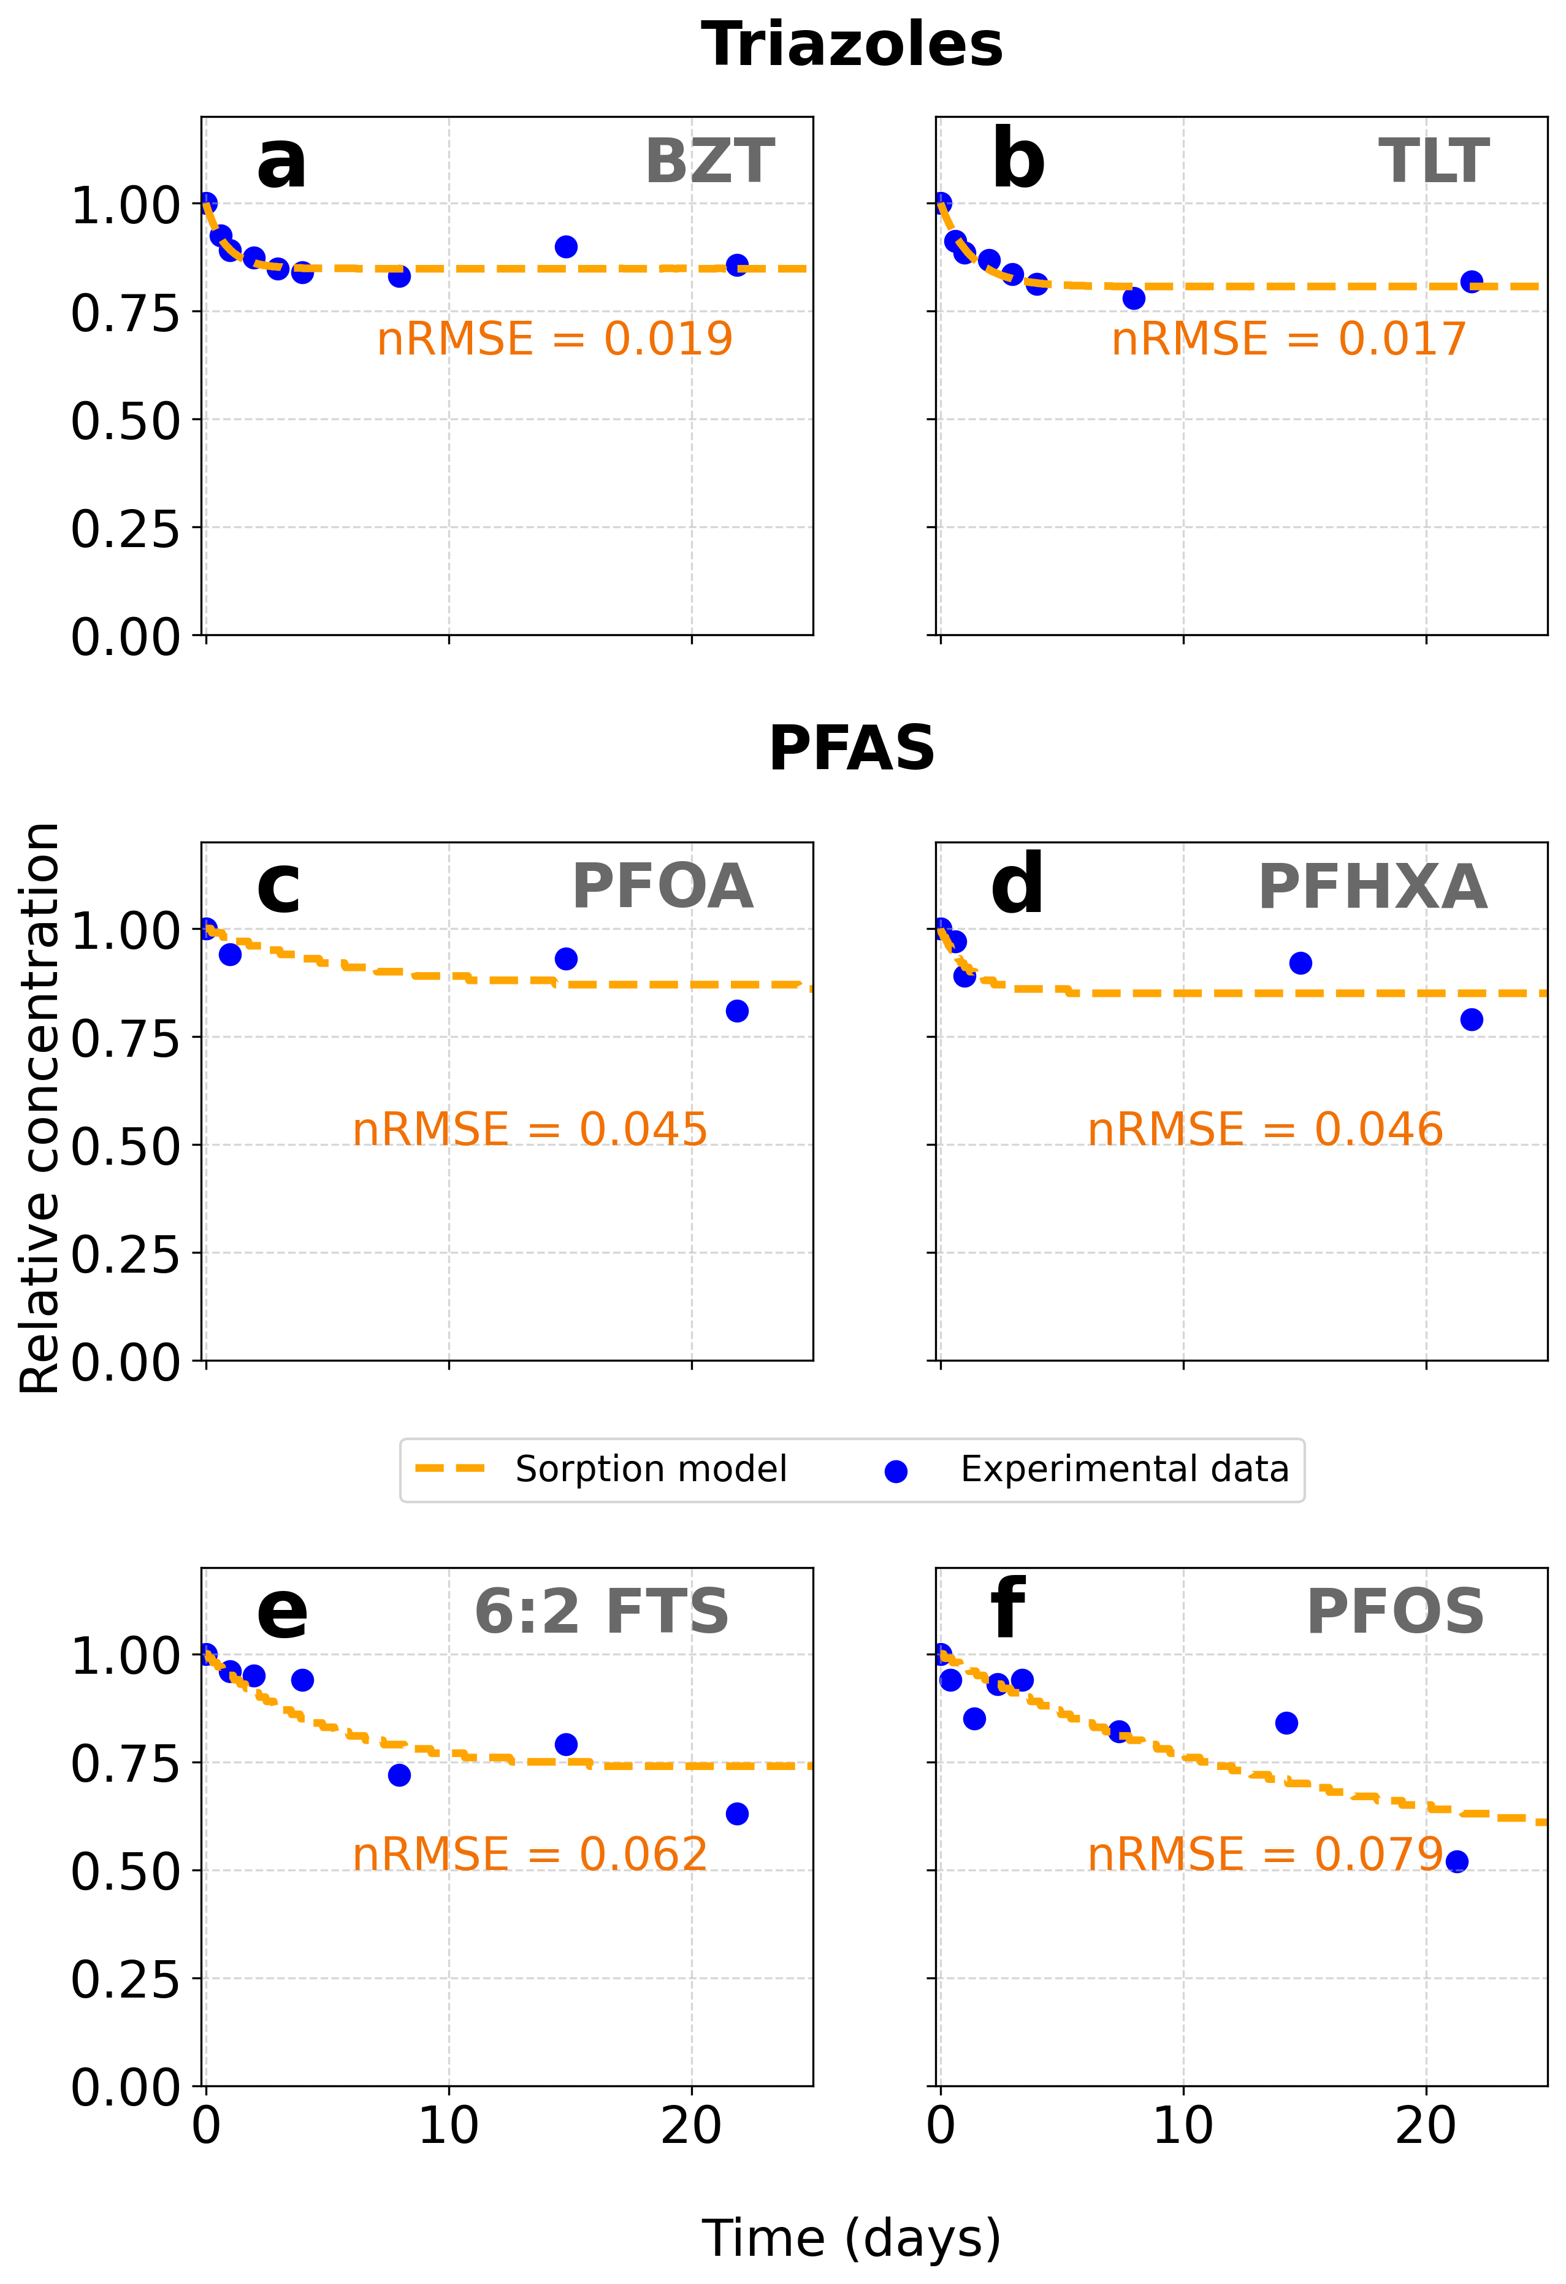
Figure 5. Concentration evolution of a) benzotriazole, b) tolyltriazole, c) PFOA, d) PFHxA, e) 6:2 FTS and f) PFOS in the abiotic control.

Batch experiments
Benzotriazoles
Figure 6a-b illustrates the total attenuation of triazoles across batch experiments. The developed chemical model integrates both sorption and degradation processes, as described in equations (2) and (3). For benzotriazole, a higher biodegradation rate was observed under oxic conditions compared to nitrate reducing conditions. Additionally, more pronounced attenuation was observed during the first four days. This was attributed to the sorption model being included in the overall attenuation model. The model fits the experimental data reasonably well, with a calculated RMSE of 0.078. However, the last experimental data point deviates from the predicted downward trend in concentration, indicating that the combined effects of sorption and biodegradation may diminish over time or be influenced by additional processes not captured by the model. Therefore, the estimated total attenuation for benzotriazole was based solely on the lower limit of the last observation point. A total attenuation of 38% is thus obtained, with sorption accounting for 16% of this total.
For tolyltriazole, a similar redox-dependent trend is observed. Biodegradation proceeds more efficiently under oxic conditions than under nitrate reducing conditions. As with benzotriazole, attenuation is more significant during the initial phase of the experiment, reflecting the influence of rapid sorption onto loess sediments. Note that the final observation point (day 22) was not included in the model calibration due to elevated uncertainty associated with that measurement.
PFAS
Figure 6c-g illustrates the evolution of PFAS concentration in the batch experiments. Both sorption and biodegradation models were applied to reproduce the observed concentration trends, as for the other contaminants. However, given the strong persistence of PFAS, the attenuation fraction theoretically attributed to biodegradation should be interpreted with caution.
Under oxic conditions, PFAS concentrations initially decreased rapidly, reflecting fast sorption processes that occurred during the early stage contact between the aqueous phase and the loess sediments. This was followed by a period of relative stabilization under nitrate-reducing conditions, when sorption reached near-equilibrium for most PFAS. The only exceptions were PFOS and 6:2 FTS, which showed an additional decrease in concentration attributed to continued sorption. After approximately 15 days, as the system returned to oxic conditions, a gradual decline in dissolved PFAS concentrations was again observed. Given the well-documented persistence of PFAS, this secondary attenuation phase may be explained by the development of new sorptive phases associated with oxic microbial activity. One possibility is that re-oxygenation stimulated the formation or restructuring of soil biofilms, which can act as effective sorbents (Flemming, 1995). Indeed, respiration and electron-acceptor availability are known to govern biofilm formation, with oxygen providing the highest energy yield and supporting pronounced biofilm development (Martín-Rodríguez, 2023). This interpretation is consistent with Muñoz-Vega et al. (2023), who observed increased contaminant sorption in systems (batch and columns) with higher biological activity due to biofilm formation. Such biofilm-induced sorption processes could explain the additional attenuation observed during the second oxic phase and is not captured by the linear sorption isotherm. However, as solid-phase PFAS and biofilm biomass were not quantified in this study, this mechanism remains a working hypothesis requiring further validation.
Consequently, PFAS attenuation in this study is best explained by sorption processes alone. For PFOS and 6:2 FTS, the linear isotherm model reproduces about 80 % of the total attenuation observed experimentally, while for PFOA and PFHxA it accounts for 62 % and 63 %, respectively. The remaining difference is likely associated to additional sorption mechanisms not represented by the simple linear model, particularly those associated with biofilm formation during the second oxic phase, as discussed above.
The only exception is 6:2 FTS, whose molecular structure includes two non-fluorinated carbon atoms (see Figure 2). Previous studies (Yan et al., 2024) have demonstrated its potential for partial biotransformation under oxic conditions. Therefore, while sorption fully explains the attenuation of all other PFAS studied, a minor contribution from biotransformation cannot be excluded for 6:2 FTS.
Alkylphenols
Figure 6h illustrates the evolution of NP2EO concentration in the triplicate. Unlike the other studied CECs, the total attenuation of NP2EO was nearly complete after 21 days, reaching 90%. This attenuation is entirely attributed to biodegradation, as no measurable sorption onto loess sediments was observed in the abiotic control (see section S8 of the Supplementary Materials). In addition, no significant difference were observed between oxic and nitrate-reducing conditions. Despite the higher solubility of NP2EO, it degrades relatively quickly, with 50% of its initial concentration disappearing within just 5 days. Therefore, if water containing NP2EO were to infiltrate through loess sediments, the compound, while not expected to undergo significant sorption, is likely to degrade rapidly. However, it is important to note that in this study, we did not account for the formation of degradation products, some of which may be of concern. For instance, NP2EO can degrade into nonylphenol (NP), a more persistent, hydrophobic, and toxic compound known for its endocrine-disrupting properties (Soares et al., 2008).
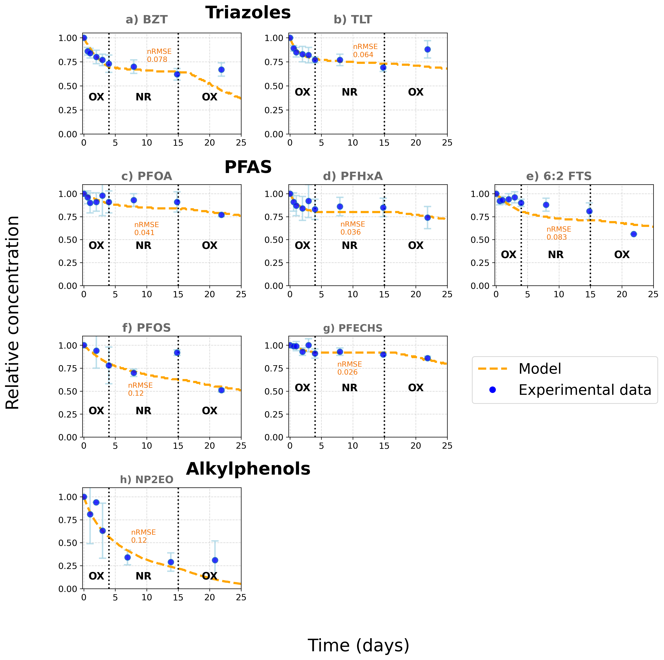
Figure 6. Concentration evolution of a) benzotriazole, b) tolyltriazole, c) PFOA, d) PFHxA, e) 6:2 FTS, f) PFOS, g) PFECHS and h) nonylphenol diethoxylate in the batch reactors.

Comparison of sorption parameters with literature data
For comparison with the scientific literature, the K_{d} values obtained from the calibration of chemical models were used to calculate K_{oc} values, based on the organic carbon fraction f_{oc} (Eq. 1). In this study, the organic carbon analysis of the loess indicated an organic carbon content of f_{oc} = 2.23%.
$$\begin{aligned}K_{oc}=\frac{K_{d}}{f_{oc}} \#(1\end{aligned})$$
Estimated log K_{oc} values of 1.34 and 1.47 were calculated for benzotriazole and tolyltriazole respectively, based on K_{d} values derived from the interpretation of abiotic control results. These values are lower than those documented in the literature for similar soils. Specifically, Hart et al. (2004) and Alotaibi et al. (2015) reported log K_{oc} of 1.66 for benzotriazole and 1.97 for tolyltriazole in soils with comparable grain size and carbon content. The discrepancy likely arises from differences in experimental conditions, as they used a 1:1 solid-to-liquid ratio and procedures that enhanced contaminant–sediment interaction, leading to higher sorption estimates.
For PFAS compounds, the differences in sorption behaviour per PFAS compound were assessed based on the fluorinated chain length. Table 2 presents a comparison of the K_{oc} values obtained from the abiotic control with those reported in the study of Fabregat-Palau et al. (2022). Their study compiles a dataset of K_{oc} values of 13 different PFAS from their own experiments and from a larger dataset reporting K_{oc} values from the literature. In addition, an equation correlating the log K_{oc} values with the number of CF₂ was developed in their study to predict K_{oc} based on PFAS physicochemical properties.
Table 2. Comparison of partition coefficients derived from the abiotic control with values of the compiled dataset of Fabregat-Palau et al (2022) and their correlation analysis.
¹For the fluorotelomer 6:2 FTS, it should be noted that its tail made of six –CF₂ groups is connected to it is sulfonate head with two –CH₂, which make it different from PFHxA, PFOA and PFOS.
Compound name | Number of –CF₂ | K_{d} (L kg⁻¹) | K_{oc} (L kg⁻¹)  f_{oc} = 2.23% | Log K_{oc} | Log K_{oc} derived from Fabregat-Palau et al. (2022) dataset | log K_{oc} obtained from correlation analysis
PFHxA | 5 | 0.47 | 21 | 1.32 | [1.11 – 1.23] | [0.85 – 1.85]
6:2 FTS¹ | 6 | 0.99 | 45 | 1.65 | - | -
PFOA | 7 | 0.44 | 20 | 1.29 | [2.01 – 2.05] | [1.59 – 2.75]
PFOS | 8 | 2 | 90 | 1.95 | [2.77 – 2.80] | [1.96 – 3.20]

The K_{oc} values derived from our experiments are overall lower than those reported by Fabregat-Palau et al. (2022). As with benzotriazoles, this discrepancy may be attributed to the static nature of our batch experiments, in contrast to most of sorption experiments conducted in small falcons that are agitated to enhance contact between sediments and contaminants (Zhang et al., 2015; Askeland et al., 2020; Barth et al., 2021; Dai et al., 2023; Hubert et al., 2023). A similar trend is observed with the K_{oc} values derived from correlation analysis, which is expected since this analysis is based on K_{oc} values from the same dataset.
Despite these differences, the sorption hierarchy observed in our study aligns with previous findings in the literature (Milinovic et al., 2015, 2016). As expected, PFOS exhibits the highest sorption due to its longer carbon chain and sulfonate functional group. The 6:2 fluorotelomer FTS ranks second, as its sulfonate group makes it more sorbable than perfluorocarboxylic acids, despite its fluorocarbon chain being one carbon shorter than PFOA. Interestingly, PFOA and PFHxA show surprisingly similar K_{d} values, despite a difference of two CF₂​ groups. The key distinction lies in the sorption kinetics: PFHxA reaches equilibrium within 2–3 days, while PFOA requires approximately 10 days to stabilize. Finally, PFECHS compound shows no noticeable sorption behaviour, which can likely be attributed to its distinct chemical structure. Unlike the other PFAS compounds studied, PFECHS features a cyclohexane ring instead of a linear fluorinated carbon chain.
It is important to remind that the sorption model presented in this study is a simple linear isotherm, which is commonly applied to conventional organic micropollutants present at low concentrations. However, such an approach may not fully capture the complex sorption behaviour of PFAS. As extensively discussed by Kookana et al. (2022), PFAS sorption is governed by multiple interacting mechanisms, including hydrophobic interactions, electrostatic forces, fluid–fluid interfacial adsorption (e.g. air–water and NAPL–water interfaces), and physical entrapment within soil micropores. These mechanisms are influenced not only by PFAS properties such as chain length, headgroup functionality, and ionic form, but also by diverse soil characteristics like mineral composition, pH-dependent surface charge, and the presence of polyvalent cations or organic matter. This is consistent with previous studies demonstrating that PFAS sorption correlates strongly with soil organic carbon but is also influenced by soil mineralogy and surface charge (Milinovic et al., 2015, 2016). In addition, as discussed in section 3.4.2, biologically mediated sorption through biofilm development under oxic conditions may contribute to additional retention pathways not accounted for in the linear model. Therefore, while linear sorption models provide a useful first-order approximation, they likely underestimate the complexity of PFAS retention under environmentally relevant conditions.

Total attenuation
Figure 7 compiles the total attenuation of the studied contaminants in the triplicates after 21 days, along with the relative contribution of the different attenuation mechanisms. Here, total attenuation refers to the overall decrease in concentration relative to the initial value. Although both sorption and biodegradation models were implemented for all compounds, the interpretation of these contributions differs depending on the contaminant class, as discussed in section 3.4.2. Note that in a dynamic system such as a column experiment or natural aquifer flow, sorption primarily contributes to contaminant retardation rather than permanent attenuation, unless the sorption is irreversible. Total attenuation values per CECs are detailed in the Section S9 of the Supplementary Materials.
For alkylphenols (NP₂EO), attenuation was almost complete and entirely due to biodegradation, with total removal close to 90%. Triazoles (benzotriazole and tolyltriazole) showed moderate attenuation (30-40%), resulting from a combination of sorption and biodegradation, the latter being favoured under oxic conditions. In addition, sorption contributed slightly more to the attenuation of tolyltriazole due to its higher hydrophobicity. These results can be partially explained by the chemical structure and functional groups of the studied compounds. NP2EO, a nonionic surfactant with a polyethoxylated chain (Figure 2), is known to be readily biodegradable under oxic conditions (Ekdal et al., 2022), explaining its rapid attenuation. Regarding benzotriazole compounds, benzotriazole and tolyltriazole are structurally similar (Figure 2), consisting of a 1,2,3-triazole ring fused to a benzene ring. However, the presence of a methyl substituent in tolyltriazole (primarily in the 4- or 5-position) increases its hydrophobicity, enhancing its affinity for organic matter and resulting in stronger sorption behavior (Hart et al., 2004). Both compounds are considered polar and relatively persistent, but benzotriazole tends to be slightly more biodegradable under aerobic conditions than tolyltriazole (Reemtsma et al., 2010). These structural and physicochemical characteristics explain the moderate attenuation observed for tolyltriazole, driven more by sorption than biodegradation.
For PFAS compounds, total attenuation was primarily attributed to sorption. In Figure 7, PFAS attenuation is therefore divided into two components: (i) the fraction of sorption reproduced by the linear isotherm model, and (ii) the additional retention processes not captured by that model. These additional mechanisms may include biologically mediated sorption such as the formation or restructuring of biofilms during oxygen renewal, as discussed previously. This representation better reflects the complex sorption behavior observed during the whole experiment. Among PFAS, PFOS and 6:2 FTS showed the highest overall attenuation, with roughly 80 % reproduced by the linear isotherm. For PFOA and PFHxA, the linear model accounted for about 60 %, suggesting stronger limitations of the linear isotherm approach for these compounds. PFECHS showed negligible sorption and correspondingly low total attenuation.
Differences in PFAS attenuation are closely related to their chain length and functional groups (Figure 2). PFOS (a sulfonate) and 6:2 FTS (a fluorotelomer sulfonate) showed higher sorption potential compared to PFOA and PFHxA (carboxylates), likely due to the higher hydrophobicity and lower polarity of sulfonates, as well as the presence of more fluorinated carbon atoms (Mejia-Avendaño et al., 2020; Fabregat-Palau et al., 2022; Kookana et al., 2022). PFECHS also displayed low attenuation, which may be attributed to its relatively high chemical stability, due to the presence of a cyclic ether moiety within the perfluorinated carbon chain, and its low sorption affinity in the tested sediment matrix (Wang et al., 2016).
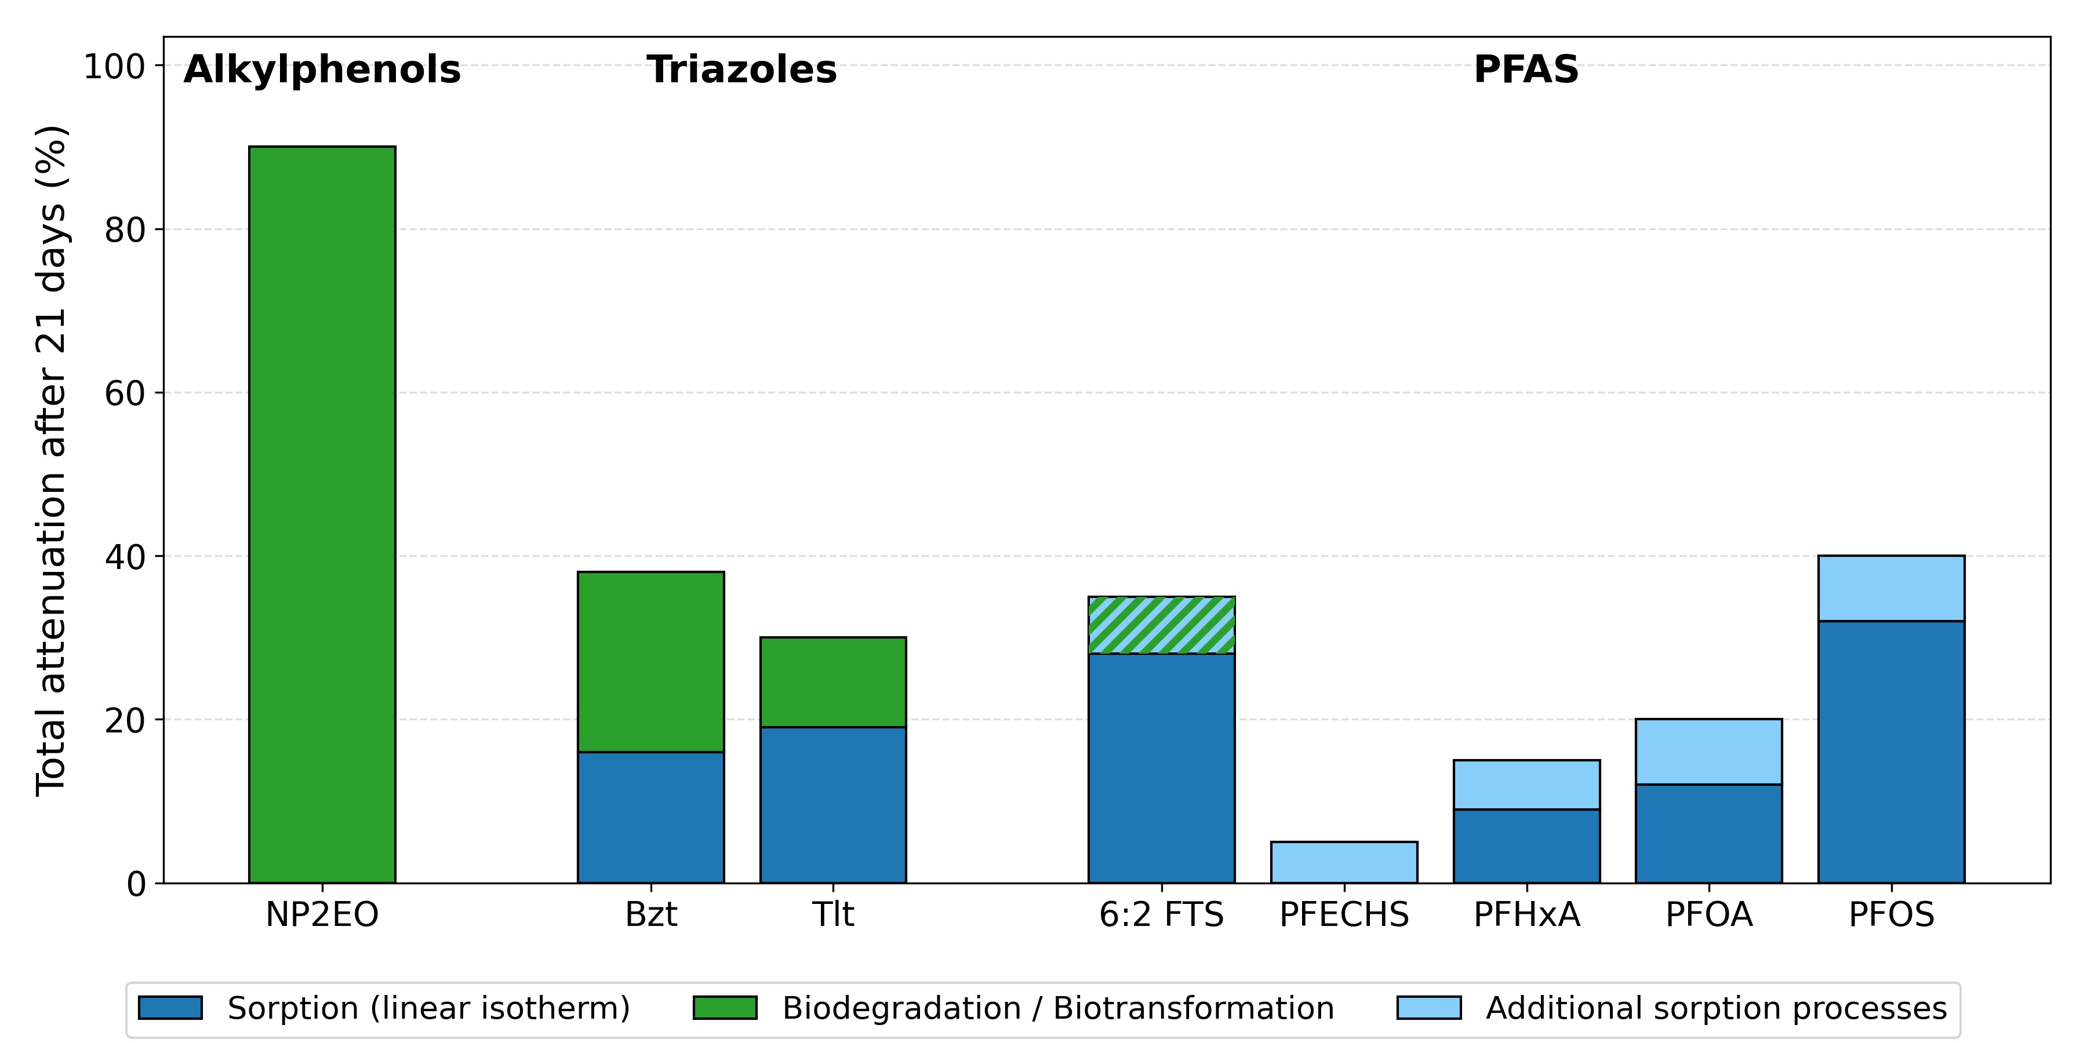
Figure 7. Total attenuation of individual contaminants after 21 days in the batch reactor, with contributions from sorption (linear isotherm + additional processes) and biodegradation/biotransformation. The blue–green diagonal pattern for 6:2 FTS represents a mixed attenuation mechanism.
When extrapolating these laboratory results to field conditions, it is important to consider the protective role of the thick unsaturated zone described in Section 3.1. This layer provides a significant delay and additional opportunities for contaminant attenuation before the recharge water reaches the aquifer (Brouyère et al., 2004). However, in the context of SAT operations, continuous recharge through infiltration basins is expected to establish a saturated reactive zone beneath the basin. The saturated batch experiments presented here therefore capture the main processes expected under such conditions, although dynamic column experiments would be needed for more representative field conditions. Indeed, the hydraulic regime can further influence CECs attenuation, as infiltration dynamics controls solute residence times and the spatial distribution of redox conditions, which in turn govern biodegradation. This has notably been highlighted by Gorski et al. (2019), who established a quantitative relationship between infiltration rate and denitrification. This implies that under SAT operations, degradation rates of organic contaminants may vary with recharge intensity through their control on redox evolution. To address these aspects, complementary studies using HYDRUS reactive transport modeling and the obtained parameters are currently in progress to quantify the influence of the vadose zone and infiltration dynamics on contaminant fate.

Conclusion
This study investigated the attenuation capacity of loess sediments overlying the Hesbaye chalk aquifer (Belgium) when exposed to airport runoff water contaminated with alkylphenols, triazoles and PFAS. Our findings reveal different behaviours among the target CECs, with attenuation processes varying by compound class. Sorption emerged as the dominant mechanism for PFAS compounds, while biodegradation played a major role in the attenuation of benzotriazoles and alkylphenols.
Among the studied compounds, NP2EO exhibited the highest total attenuation, reaching nearly 90%, with biodegradation accounting for the entirety of its removal. This suggests that, despite its solubility, NP2EO poses a low risk for aquifer contamination under the studied conditions. However, the potential formation of transformation products, such as nonylphenol, was not evaluated and may present additional risks.
Benzotriazole and tolyltriazole showed moderate attenuation levels of 38% and 30% respectively, with sorption contributing to 16% and 19% respectively. The stronger sorption of tolyltriazole suggests a greater potential for sediment accumulation compared to benzotriazole, which may be less concerning for groundwater quality. However, leaching of tolyltriazole could still occur if clean recharge water percolates through contaminated sediments. Additionally, biodegradation of these compounds was found to be redox-dependent, with higher degradation rates observed in oxic conditions.
As expected for persistent pollutants, PFAS compounds demonstrated limited overall attenuation, which was primarily attributed to sorption onto loess sediments. Among them, PFOS and 6:2 FTS showed the highest retention, while PFOA and PFHxA were less sorbed, and PFECHS displayed little interaction with the solid phase. Given their well-known resistance to microbial degradation, PFAS attenuation in this study is expected to result solely from sorption processes rather than biodegradation. The fraction of attenuation not reproduced by the linear isotherm may reflect additional sorption processes, such as biologically activated sorption occuring under oxic condition through the formation or restructuring of biofilms. The only compound for which biotransformation cannot be excluded is 6:2 FTS, which can undergo partial transformation under oxic conditions. Given that PFAS sorption potential is strongly dependent on soil composition, further research should investigate their behavior across a range of soil types. Moreover, investigating the formation of PFAS degradation products might be interesting, as partial breakdown may lead to smaller, more mobile, and potentially more hazardous compounds.
Even though the biotic control in our experiments did not function as intended, the results allow for an indirect estimation of biodegradation by considering total attenuation as the sum of sorption and biodegradation contributions. Furthermore, this study provides key parameters on sorption and biodegradation processes that will be valuable for modeling the transport and fate of CECs if SAT is implemented using airport runoff as a recharge source. Integrating these experimental results into transport models will allow for a more accurate assessment of contaminant mobility, persistence, and potential groundwater impacts, aiding in the development of sustainable SAT strategies. However, in the context of long-term SAT operations, the sorption capacity of loess sediments may progressively decline as sorption sites become saturated, reducing removal efficiency over time. Such long-term effects should be considered together with attenuation processes occurring in the unsaturated zone, which represents an additional natural buffer before recharge water reaches the aquifer. Future work, including unsaturated column studies and reactive transport modeling with HYDRUS, will help to assess the influence of this vadose zone on contaminant transport. Expanding similar experiments to a wider range of soil types and environmental conditions will be essential for improving risk assessments and ensuring the safe use of SAT for groundwater recharge. Improving experimental design to ensure effective biotic controls should also be a priority in future studies, enabling more precise quantification of biodegradation processes.
Finally, some methodological aspects should be improved in future studies to strengthen the robustness of the conclusions. In particular, the absence of solid phase measurements in this work prevents a complete mass balance and limits the ability to fully separate sorption from biodegradation. Minor differences in geochemical conditions between the abiotic control and the batch reactors, as well as potential sorption to glass vessels, represent additional sources of uncertainty. However, these effects are expected to be small and would apply equally to all reactors, meaning they cannot account for the systematic differences observed, but they cannot be fully excluded. In addition, although a single abiotic control was sufficient to support the interpretation of sorption processes, including replicate abiotic controls would reduce statistical uncertainty and allow a more rigorous assessment of differences with biotic reactors.

Acknowledgements
The preparation of samples for HPLC-MS/MS analysis and the HPLC-MS/MS analysis itself were carried out under the supervision of Maria Dulsat-Masvidal in IDAEA-CSIC (Chemometrics). I would like to express my sincere gratitude for her assistance and the knowledge she has shared to me on the subject.
Major ion analyses of the runoff samples were performed by Joël Otten at the Hydrogeology and Environmental Geology Laboratory of the University of Liège. We express our sincere gratitude for his technical support and expertise.
The granulometry analyses of loess sediment was carried out at the Building Materials Laboratory (LMC) within the Urban and Environmental Engineering (UEE) department at the University of Liège, under the supervision of Pierre Illing. We are sincerely grateful to him for his valuable assistance.

Funding
The experimental work of this research was supported by MCIU/AEI/10.13039/501100011033 and FEDER “one way to make Europe” through the grant PID2021-128995OA-I00. Furthermore, the Spanish Ministry of Science and Innovation is acknowledged for financial support [PID2022-137766NB-I00] of mass spectrometry equipment.
Robin Glaude is a beneficiary of the ASP-REN fellowship supported by the FNRS (Fonds de la Recherche Scientifique) Belgium. In addition, he was awarded a mobility grant (SOR/2023/550158) by WBI (Wallonie-Bruxelles International) to carry out batch experiments in Barcelona, Spain.

References
Ahrens, L., Norström, K., Viktor, T., Cousins, A. P., & Josefsson, S. (2015). Stockholm Arlanda Airport as a source of per-and polyfluoroalkyl substances to water, sediment and fish. Chemosphere, 129, 33-38. https://doi.org/10.1016/j.chemosphere.2014.03.136.
Alotaibi, M. D., McKinley, A. J., Patterson, B. M., & Reeder, A. Y. (2015). Benzotriazoles in the aquatic environment: a review of their occurrence, toxicity, degradation and analysis. Water, Air, & Soil Pollution, 226(7), 226. https://doi.org/10.1007/s11270-015-2469-4.
Askeland, M., Clarke, B. O., Cheema, S. A., Mendez, A., Gasco, G., & Paz-Ferreiro, J. (2020). Biochar sorption of PFOS, PFOA, PFHxS and PFHxA in two soils with contrasting texture. Chemosphere, 249, 126072. https://doi.org/10.1016/j.chemosphere.2020.126072.
Barkow, I. S., Oswald, S. E., Lensing, H. J., & Munz, M. (2021). Seasonal dynamics modifies fate of oxygen, nitrate, and organic micropollutants during bank filtration—temperature-dependent reactive transport modeling of field data. Environmental Science and Pollution Research, 28(8), 9682-9700. https://doi.org/10.1007/s11356-020-11002-9.
Barth, E., McKernan, J., Bless, D., & Dasu, K. (2021). Investigation of an immobilization process for PFAS contaminated soils. Journal of environmental management, 296, 113069. https://doi.org/10.1016/j.jenvman.2021.113069.
Boyd, S. A., Lee, J. F., & Mortland, M. M. (1988). Attenuating organic contaminant mobility by soil modification. Nature, 333(6171), 345-347. https://doi.org/10.1038/333345a0.
Breedveld, G. D., Roseth, R., Sparrevik, M., Hartnik, T., & Hem, L. J. (2003). Persistence of the de-icing additive benzotriazole at an abandoned airport. Water, Air and Soil Pollution: Focus, 3(3), 91-101. https://doi.org/10.1023/A:1023961213839
Brouyère, S. (2024) ‘Managed Aquifer Recharge in Wallonia (Belgium) The MARWAL Project’. Groundwater World Congress IAH 2024, Davos, Suisse, 10 September. Available at: https://orbi.uliege.be/handle/2268/322816 (Accessed: 9 July 2025).
Brouyère, S., Dassargues, A., & Hallet, V. (2004). Migration of contaminants through the unsaturated zone overlying the Hesbaye chalky aquifer in Belgium: a field investigation. Journal of Contaminant Hydrology, 72(1-4), 135-164. https://doi.org/10.1016/j.jconhyd.2003.10.009.
Burant, A., Selbig, W., Furlong, E. T., & Higgins, C. P. (2018). Trace organic contaminants in urban runoff: Associations with urban land-use. Environmental pollution, 242, 2068-2077. https://doi.org/10.1016/j.envpol.2018.06.066.
Cabrol, L., Quemeneur, M., & Misson, B. (2017). Inhibitory effects of sodium azide on microbial growth in experimental resuspension of marine sediment. Journal of microbiological methods, 133, 62-65. https://doi.org/10.1016/j.mimet.2016.12.021.
Cancilla, D. A., Baird, J. C., Geis, S. W., & Corsi, S. R. (2003). Studies of the environmental fate and effect of aircraft deicing fluids: Detection of 5‐methyl‐1H‐benzotriazole in the fathead minnow (Pimephales promelas). Environmental Toxicology and Chemistry, 22(1), 134-140. https://doi.org/10.1002/etc.5620220117.
Cheng, H., Hu, E., & Hu, Y. (2012). Impact of mineral micropores on transport and fate of organic contaminants: A review. Journal of contaminant hydrology, 129, 80-90. https://doi.org/10.1016/j.jconhyd.2011.09.008.
Dai, M., Yan, N., & Brusseau, M. L. (2023). Potential impact of bacteria on the transport of PFAS in porous media. Water research, 243, 120350. https://doi.org/10.1016/j.watres.2023.120350.
De Wilt, A., He, Y., Sutton, N., Langenhoff, A., & Rijnaarts, H. (2018). Sorption and biodegradation of six pharmaceutically active compounds under four different redox conditions. Chemosphere, 193, 811-819. https://doi.org/10.1016/j.chemosphere.2017.11.084.
Dillon, P., Stuyfzand, P., Grischek, T., Lluria, M., Pyne, R. D. G., Jain, R. C., ... & Sapiano, M. (2019). Sixty years of global progress in managed aquifer recharge. Hydrogeology journal, 27(1), 1-30. https://doi.org/10.1007/s10040-018-1841-z.
Dillon, P., Fernández Escalante, E., Megdal, S. B., & Massmann, G. (2020). Managed aquifer recharge for water resilience. Water, 12(7), 1846. https://doi.org/10.3390/w12071846.
Doherty, J. (2010) PEST, Model-Independent Parameter Estimation—User Manual. Brisbane: Watermark Numerical Computing (5th Edition, with Slight Additions).
Dulsat-Masvidal, M., Ciudad, C., Infante, O., Mateo, R., & Lacorte, S. (2022). Pilot monitoring scheme of water pollutants in Important Bird and Biodiversity Areas. Ecotoxicology and environmental safety, 237, 113562. https://doi.org/10.1016/j.ecoenv.2022.113562.
Ekdal, A., Okutman Tas, D., Zengin, G. E., Onay, I. B., Olmez Hanci, T., Orhon, D., & Cokgor, E. (2022). Co-metabolism of nonylphenol ethoxylate in sequencing batch reactor under aerobic conditions. Biodegradation, 33(2), 181-194. https://doi.org/10.1007/s10532-022-09974-1
Fabregat-Palau, J., Vidal, M., & Rigol, A. (2022). Examining sorption of perfluoroalkyl substances (PFAS) in biochars and other carbon-rich materials. Chemosphere, 302, 134733. https://doi.org/10.1016/j.chemosphere.2022.134733.
Fairbairn, D. J., Elliott, S. M., Kiesling, R. L., Schoenfuss, H. L., Ferrey, M. L., & Westerhoff, B. M. (2018). Contaminants of emerging concern in urban stormwater: Spatiotemporal patterns and removal by iron-enhanced sand filters (IESFs). Water Research, 145, 332-345. https://doi.org/10.1016/j.watres.2018.08.020.
Flemming, H. C. (1995). Sorption sites in biofilms. Water Science and Technology, 32(8), 27. https://doi.org/10.2166/wst.1995.0256.
Gasperi, J., Sebastian, C., Ruban, V., Delamain, M., Percot, S., Wiest, L., ... & Gromaire, M. C. (2014). Micropollutants in urban stormwater: occurrence, concentrations, and atmospheric contributions for a wide range of contaminants in three French catchments. Environmental Science and Pollution Research, 21(8), 5267-5281. https://doi.org/10.1007/s11356-013-2396-0.
Gasperi, J., Le Roux, J., Deshayes, S., Ayrault, S., Bordier, L., Boudahmane, L., ... & Gromaire, M. C. (2022). Micropollutants in urban runoff from traffic areas: target and non-target screening on four contrasted sites. Water, 14(3), 394. https://doi.org/10.3390/w14030394.
Goderniaux, P., Orban, P., Rorive, A., Brouyère, S., & Dassargues, A. (2023). Study of historical groundwater level changes in two Belgian chalk aquifers in the context of climate change impacts. https://doi.org/10.1144/SP517-2020-212.
Gorski, G., Fisher, A. T., Beganskas, S., Weir, W. B., Redford, K., Schmidt, C., & Saltikov, C. (2019). Field and laboratory studies linking hydrologic, geochemical, and microbiological processes and enhanced denitrification during infiltration for managed recharge. Environmental science & technology, 53(16), 9491-9501. https://doi.org/10.1021/acs.est.9b01191.
Green, C. T., Puckett, L. J., Böhlke, J. K., Bekins, B. A., Phillips, S. P., Kauffman, L. J., ... & Johnson, H. M. (2008). Limited occurrence of denitrification in four shallow aquifers in agricultural areas of the United States. Journal of environmental quality, 37(3), 994-1009. https://doi.org/10.2134/jeq2006.0419.
Gulde, R., Helbling, D. E., Scheidegger, A., & Fenner, K. (2014). pH-dependent biotransformation of ionizable organic micropollutants in activated sludge. Environmental science & technology, 48(23), 13760-13768. https://doi.org/10.1021/es5037139.
Hakoun, V., Orban, P., Dassargues, A., & Brouyère, S. (2017). Factors controlling spatial and temporal patterns of multiple pesticide compounds in groundwater (Hesbaye chalk aquifer, Belgium). Environmental Pollution, 223, 185-199. https://doi.org/10.1016/j.envpol.2017.01.012.
Han, S., Slater, L., Wilby, R. L., & Faulkner, D. (2022). Contribution of urbanisation to non-stationary river flow in the UK. Journal of Hydrology, 613, 128417. https://doi.org/10.1016/j.jhydrol.2022.128417.
Hart, D. S., Davis, L. C., Erickson, L. E., & Callender, T. M. (2004). Sorption and partitioning parameters of benzotriazole compounds. Microchemical Journal, 77(1), 9-17. https://doi.org/10.1016/j.microc.2003.08.005.
Hubert, M., Arp, H. P. H., Hansen, M. C., Castro, G., Meyn, T., Asimakopoulos, A. G., & Hale, S. E. (2023). Influence of grain size, organic carbon and organic matter residue content on the sorption of per-and polyfluoroalkyl substances in aqueous film forming foam contaminated soils-Implications for remediation using soil washing. Science of The Total Environment, 875, 162668. https://doi.org/10.1016/j.scitotenv.2023.162668.
ITUMOH, E. J., Data, S., Chen, J., Kah, M., Padhye, L. P., & Leitao, E. (2024). Addressing the persistence of per-and poly-fluoroalkyl substances (PFAS): current challenges and potential solutions. RSC Sustainability. https://doi.org/10.1039/D4SU00152D.
Jaiyeola, A. T. (2017). The management and treatment of airport rainwater in a water-scarce environment. International Journal of Environmental Science and Technology, 14(2), 421-434. https://doi.org/10.1007/s13762-016-1122-0.
Jia, Y., Ehlert, L., Wahlskog, C., Lundberg, A., & Maurice, C. (2018). Water quality of stormwater generated from an airport in a cold climate, function of an infiltration pond, and sampling strategy with limited resources. Environmental Monitoring and Assessment, 190(1), 4. https://doi.org/10.1007/s10661-017-6375-7.
Kookana, R. S., Navarro, D. A., Kabiri, S., & McLaughlin, M. J. (2022). Key properties governing sorption–desorption behaviour of poly-and perfluoroalkyl substances in saturated and unsaturated soils: a review. Soil Research, 61(2), 107-125. https://doi.org/10.1071/SR22183.
Kret, E., Kiecak, A., Malina, G., Nijenhuis, I., & Postawa, A. (2015). Identification of TCE and PCE sorption and biodegradation parameters in a sandy aquifer for fate and transport modelling: batch and column studies. Environmental Science and Pollution Research, 22(13), 9877-9888. https://doi.org/10.1007/s11356-015-4156-9.
Lamprea, K., Bressy, A., Mirande-Bret, C., Caupos, E., & Gromaire, M. C. (2018). Alkylphenol and bisphenol A contamination of urban runoff: an evaluation of the emission potentials of various construction materials and automotive supplies. Environmental Science and Pollution Research, 25(22), 21887-21900. https://doi.org/10.1007/s11356-018-2272-z.
Lapworth, D. J., Baran, N., Stuart, M. E., & Ward, R. S. (2012). Emerging organic contaminants in groundwater: a review of sources, fate and occurrence. Environmental pollution, 163, 287-303. https://doi.org/10.1016/j.envpol.2011.12.034.
Launay, M. A., Dittmer, U., & Steinmetz, H. (2016). Organic micropollutants discharged by combined sewer overflows–characterisation of pollutant sources and stormwater-related processes. Water research, 104, 82-92. https://doi.org/10.1016/j.watres.2016.07.068.
Lichstein, H. C., & Soule, M. H. (1944). Studies of the effect of sodium azide on microbic growth and respiration: I. The action of sodium azide on microbic growth. Journal of bacteriology, 47(3), 221-230. https://doi.org/10.1128/jb.47.3.221-230.1944.
Liu, M., Munoz, G., Vo Duy, S., Sauvé, S., & Liu, J. (2021). Per-and polyfluoroalkyl substances in contaminated soil and groundwater at airports: a Canadian case study. Environmental science & technology, 56(2), 885-895. https://doi.org/10.1021/acs.est.1c04798.
Martín-Rodríguez, A. J. (2023). Respiration-induced biofilm formation as a driver for bacterial niche colonization. Trends in Microbiology, 31(2), 120-134. https://doi.org/10.1016/j.tim.2022.08.007.
Masoner, J. R., Kolpin, D. W., Cozzarelli, I. M., Barber, L. B., Burden, D. S., Foreman, W. T., ... & Bradley, P. M. (2019). Urban stormwater: An overlooked pathway of extensive mixed contaminants to surface and groundwaters in the United States. Environmental science & technology, 53(17), 10070-10081. https://doi.org/10.1021/acs.est.9b02867.
Mejia-Avendaño, S., Zhi, Y., Yan, B., & Liu, J. (2020). Sorption of polyfluoroalkyl surfactants on surface soils: Effect of molecular structures, soil properties, and solution chemistry. Environmental science & technology, 54(3), 1513-1521. https://doi.org/10.1021/acs.est.9b04989.
Milinovic, J., Lacorte, S., Vidal, M., & Rigol, A. (2015). Sorption behaviour of perfluoroalkyl substances in soils. Science of the Total Environment, 511, 63-71. https://doi.org/10.1016/j.scitotenv.2014.12.017.
Milinovic, J., Lacorte, S., Rigol, A., & Vidal, M. (2016). Sorption of perfluoroalkyl substances in sewage sludge. Environmental Science and Pollution Research, 23(9), 8339-8348. https://doi.org/10.1007/s11356-015-6019-9.
Milley, S. A., Koch, I., Fortin, P., Archer, J., Reynolds, D., & Weber, K. P. (2018). Estimating the number of airports potentially contaminated with perfluoroalkyl and polyfluoroalkyl substances from aqueous film forming foam: A Canadian example. Journal of environmental management, 222, 122-131. https://doi.org/10.1016/j.jenvman.2018.05.028.
Mumberg, T., Ahrens, L., & Wanner, P. (2024). Managed aquifer recharge as a potential pathway of contaminants of emerging concern into groundwater systems–A systematic review. Chemosphere, 364, 143030. https://doi.org/10.1016/j.chemosphere.2024.143030.
Muñoz-Vega, E., Schulz, S., Rodriguez-Escales, P., Behle, V., Spada, L., Vogel, A. L., ... & Schüth, C. (2023). Role of soil biofilms in clogging and fate of pharmaceuticals: a laboratory-scale column experiment. Environmental science & technology, 57(33), 12398-12410. https://doi.org/10.1021/acs.est.3c02034.
Mutzner, L., Zhang, K., Luthy, R. G., Arp, H. P. H., & Spahr, S. (2023). Urban stormwater capture for water supply: look out for persistent, mobile and toxic substances. Environmental Science: Water Research & Technology, 9(12), 3094-3102. https://doi.org/10.1039/D3EW00160A.
Olds, H. T., Corsi, S. R., & Rutter, T. D. (2021). Benzotriazole concentrations in airport runoff are reduced following changes in airport deicer formulations. Integrated Environmental Assessment and Management, 18(1), 245-257. https://doi.org/10.1002/ieam.4468.
Parkhurst, D.L. and Appelo, C.A.J. (2013) Description of input and examples for PHREEQC version 3—A computer program for speciation, batch-reaction, one-dimensional transport, and inverse geochemical calculations. U.S. Geological Survey Techniques and Methods.
Pinasseau, L., Wiest, L., Volatier, L., Mermillod-Blondin, F., & Vulliet, E. (2020). Emerging polar pollutants in groundwater: Potential impact of urban stormwater infiltration practices. Environmental Pollution, 266, 115387. https://doi.org/10.1016/j.envpol.2020.115387.
Pramanik, B. K., Roychand, R., Monira, S., Bhuiyan, M., & Jegatheesan, V. (2020). Fate of road-dust associated microplastics and per-and polyfluorinated substances in stormwater. Process Safety and Environmental Protection, 144, 236-241. https://doi.org/10.1016/j.psep.2020.07.020
Pressl, A., Pucher, B., Scharf, B., & Langergraber, G. (2019). Treatment of de-icing contaminated surface water runoff along an airport runway using in-situ soil enriched with structural filter materials. Science of The Total Environment, 660, 321-328. https://doi.org/10.1016/j.scitotenv.2018.12.440.
Pujades-Garnes, E., Ekiz, M. Ç., Izquierdo, M., Scheiber, L., Salehi Siavashani, N., Jurado, A., ... & Foppen, J. W. (2025). Behaviour and Fate of Anthropogenic Gadolinium in Groundwater: Insights from Batch Experiments and Measured Concentrations in the Besòs River Delta (NE Spain). Environmental Processes, 12(3), 43. https://doi.org/10.1007/s40710-025-00784-0.
Pyne, R. D. G. (2015). Aquifer storage recovery: An ASR solution to saltwater intrusion at Hilton Head Island, South Carolina, USA. Environmental Earth Sciences, 73(12), 7851-7859. https://doi.org/10.1007/s12665-014-3985-z.
Reemtsma, T., Miehe, U., Duennbier, U., & Jekel, M. (2010). Polar pollutants in municipal wastewater and the water cycle: occurrence and removal of benzotriazoles. Water research, 44(2), 596-604. https://doi.org/10.1016/j.watres.2009.07.016.
Ringleb, J., Sallwey, J., & Stefan, C. (2016). Assessment of managed aquifer recharge through modeling—A review. Water, 8(12), 579. https://doi.org/10.3390/w8120579.
Roberts, S., Higgins, C., & McCray, J. (2014). Sorption of emerging organic wastewater contaminants to four soils. Water, 6(4), 1028-1042. https://doi.org/10.3390/w6041028.
Schübl, M., Kiecak, A., Hug, K., Lintelmann, J., Zimmermann, R., & Stumpp, C. (2021). Sorption and biodegradation parameters of selected pharmaceuticals in laboratory column experiments. Journal of Contaminant Hydrology, 236, 103738. https://doi.org/10.1016/j.jconhyd.2020.103738.
Seidl, C., Page, D., & Wheeler, S. A. (2024). Using managed aquifer recharge to address land subsidence: Insights from a global literature review. Water Security, 23, 100184. https://doi.org/10.1016/j.wasec.2024.100184.
Semple, K. T., Doick, K. J., Wick, L. Y., & Harms, H. (2007). Microbial interactions with organic contaminants in soil: definitions, processes and measurement. Environmental pollution, 150(1), 166-176. https://doi.org/10.1016/j.envpol.2007.07.023.
Sharma, S. K., & Kennedy, M. D. (2017). Soil aquifer treatment for wastewater treatment and reuse. International Biodeterioration & Biodegradation, 119, 671-677. https://doi.org/10.1016/j.ibiod.2016.09.013.
Soares, A., Guieysse, B., Jefferson, B., Cartmell, E., & Lester, J. N. (2008). Nonylphenol in the environment: a critical review on occurrence, fate, toxicity and treatment in wastewaters. Environment international, 34(7), 1033-1049. https://doi.org/10.1016/j.envint.2008.01.004.
Spahr, S., Teixidó, M., Sedlak, D. L., & Luthy, R. G. (2020). Hydrophilic trace organic contaminants in urban stormwater: occurrence, toxicological relevance, and the need to enhance green stormwater infrastructure. Environmental Science: Water Research & Technology, 6(1), 15-44. https://doi.org/10.1039/C9EW00674E.
Sprenger, C., Hartog, N., Hernández, M., Vilanova, E., Grützmacher, G., Scheibler, F., & Hannappel, S. (2017). Inventory of managed aquifer recharge sites in Europe: historical development, current situation and perspectives. Hydrogeology Journal, 25(6), 1909-1922. https://doi.org/10.1007/s10040-017-1554-8.
Sulej, A. M., Polkowska, Ż., & Namieśnik, J. (2011). Analysis of airport runoff waters. Critical Reviews in Analytical Chemistry, 41(3), 190-213. https://doi.org/10.1080/10408347.2011.588920.
Sulej-Suchomska, A. M., Szumińska, D., de la Guardia, M., Przybyłowski, P., & Polkowska, Ż. (2024). Airport runoff water: State-of-the-art and future perspectives. Sustainability, 16(18), 8176. https://doi.org/10.3390/su16188176.
Sulej-Suchomska, A. M., Przybyłowski, P., & Polkowska, Ż. (2021). Potential toxic effects of airport runoff water samples on the environment. Sustainability, 13(13), 7490. https://doi.org/10.3390/su13137490.
Suresh, A., Pan, C., & Ng, W. J. (2020). Sodium azide inhibition of microbial activities and impact on sludge floc destabilization. Chemosphere, 244, 125452. https://doi.org/10.1016/j.chemosphere.2019.125452.
Süßmuth, R., Shrestha, P., Navarrete, C. A. D., Wege, F. F., Achten, C., & Hennecke, D. (2024). Impact of different sterilisation techniques on sorption and NER formation of test chemicals in soil. Chemosphere, 357, 141915. https://doi.org/10.1016/j.chemosphere.2024.141915.
Tebes-Stevens, C., Valocchi, A. J., VanBriesen, J. M., & Rittmann, B. E. (1998). Multicomponent transport with coupled geochemical and microbiological reactions: model description and example simulations. Journal of Hydrology, 209(1-4), 8-26. https://doi.org/10.1016/S0022-1694(98)00104-8.
Tedoldi, D., Chebbo, G., Pierlot, D., Kovacs, Y., & Gromaire, M. C. (2016). Impact of runoff infiltration on contaminant accumulation and transport in the soil/filter media of Sustainable Urban Drainage Systems: A literature review. Science of the Total Environment, 569, 904-926. https://doi.org/10.1016/j.scitotenv.2016.04.215.
Ukalska-Jaruga, A., Bejger, R., Debaene, G., & Smreczak, B. (2021). Characterization of soil organic matter individual fractions (fulvic acids, humic acids, and humins) by spectroscopic and electrochemical techniques in agricultural soils. Agronomy, 11(6), 1067. https://doi.org/10.3390/agronomy11061067.
Villa, A., Siavashani, N. S., Pujades-Garnes, E., Montemurro, N., Pérez, S., Foppen, J. W., ... & Jurado, A. (2025). Exploring the influence of redox and temperature variations on the attenuation of pharmaceuticals in groundwater: Insights from parallel batch reactor experiments. Emerging Contaminants, 100537. https://doi.org/10.1016/j.emcon.2025.100537.
Wang, Y., Vestergren, R., Shi, Y., Cao, D., Xu, L., Cai, Y., ... & Wu, F. (2016). Identification, tissue distribution, and bioaccumulation potential of cyclic perfluorinated sulfonic acids isomers in an airport impacted ecosystem. Environmental science & technology, 50(20), 10923-10932. https://doi.org/10.1021/acs.est.6b01980.
Wanzek, T., Stults, J. F., Johnson, M. G., Field, J. A., & Kleber, M. (2023). Role of mineral–organic interactions in PFAS retention by AFFF-impacted soil. Environmental science & technology, 57(13), 5231-5242. https://doi.org/10.1021/acs.est.2c08806.
Weber Jr, W. J., McGinley, P. M., & Katz, L. E. (1991). Sorption phenomena in subsurface systems: concepts, models and effects on contaminant fate and transport. Water research, 25(5), 499-528. https://doi.org/10.1016/0043-1354(91)90125-A.
Woke, J. C., Maroli, A. S., Zhang, Y., & Venkatesan, A. K. (2025). Impact of coexisting nitrate and sulfate ions on per-and polyfluoroalkyl substances removal by anion exchange resins. Chemical Engineering Science, 122126. https://doi.org/10.1016/j.ces.2025.122126.
Yan, P. F., Dong, S., Woodcock, M. J., Manz, K. E., Garza-Rubalcava, U., Abriola, L. M., ... & Cápiro, N. L. (2024). Biotransformation of 6: 2 fluorotelomer sulfonate and microbial community dynamics in water-saturated one-dimensional flow-through columns. Water Research, 252, 121146. https://doi.org/10.1016/j.watres.2024.121146.
Yang, X., Huang, J., Zhang, K., Yu, G., Deng, S., & Wang, B. (2014). Stability of 6: 2 fluorotelomer sulfonate in advanced oxidation processes: degradation kinetics and pathway. Environmental Science and Pollution Research, 21(6), 4634-4642. https://doi.org/10.1007/s11356-013-2389-z.
Zenobio, J. E., Salawu, O. A., Han, Z., & Adeleye, A. S. (2022). Adsorption of per-and polyfluoroalkyl substances (PFAS) to containers. Journal of Hazardous Materials Advances, 7, 100130. https://doi.org/10.1016/j.hazadv.2022.100130.
Zgheib, S., Moilleron, R., & Chebbo, G. (2012). Priority pollutants in urban stormwater: Part 1–Case of separate storm sewers. Water research, 46(20), 6683-6692. https://doi.org/10.1016/j.watres.2011.12.012.
Zhang, R., Yan, W., & Jing, C. (2015). Experimental and molecular dynamic simulation study of perfluorooctane sulfonate adsorption on soil and sediment components. Journal of Environmental Sciences, 29, 131-138. https://doi.org/10.1016/j.jes.2014.11.001.

