When items become context: how retrieval questions shape memory

Abstract
In context-dependent memory research, focal objects are by default ascribed to item whereas backgrounds are considered the context. Questioning this assumption, it was proposed that context is reconstructed rather than encoded: any aspect of an event could become either item or context depending on the question asked. Here we provide evidence supporting this hypothesis across six experiments employing a context reinstatement paradigm. When the memory test focused on background scenes (Experiments 1-2), reinstating the original objects increased old responses to targets and lures. This effect remained when background scenes were task-irrelevant and objects task-relevant at encoding (Experiment 3). Finally, Experiments 4a-5 showed that, when objects are task-irrelevant at encoding, this effect exists but depends on the size of the objects on screen. Overall, these results support that context is reconstructed rather than encoded, although the perceptual properties of the stimuli can limit the effect of context on memory retrieval.

Keywords
Context reinstatement, recognition memory, item and context

Conflict of interest
The authors declare that no conflict of interest exist.

Acknowledgements
We thank [anonymized] and [anonymized] for valuable feedback on this research. This work was supported by the SAO/Fondation Recherche Alzheimer (Grants 2023-0010 and 2025-0020), and the University of [anonymized] (Grant FSR-S-SS-2023/08).
Introduction
Context plays a pivotal role in episodic memory, and is central to modern memory models (Bastin et al., 2019; Diana et al., 2007; Polyn et al., 2009; Yonelinas et al., 2019). According to the early encoding specificity principle, any information is encoded in a unique context, and the success of memory retrieval depends on the overlap between encoding and retrieval cues (Tulving & Thomson, 1973). This principle inspired extensive research on context-dependant memory, which examines memory accuracy for focal items while manipulating the correspondence between encoding and retrieval contexts. Objects are typically presented against background scenes that are either repeated or changed during a subsequent recognition memory test probing object memory, a design known as context reinstatement (Doss et al., 2018; Gruppuso et al., 2007). Retrieval is consistently facilitated when encoding and retrieval contexts match, relative to when they differ (for review, Smith & Vela, 2001).
In context-dependent memory paradigms, the context is typically assigned during the encoding phase, a design feature that rests on the theoretical assumption that item and context are established from the outset of an episode. Challenging this assumption, Easton et al. (2024) proposed that context is reconstructed rather than encoded. When encoding an episode, it is unknown which aspects of this episode will be central for future retrieval of the event, and which will be contextual. Therefore, context is not encoded as a separate part of a memory representation alongside the item; rather, context is only defined by the question asked at retrieval. Take the example of having a Guinness one evening during a conference taking place in Kildare, Ireland. If you were asked “when did you last have a Guinness?”, the conference and its location would constitute contextual information – features not directly targeted by the question. In contrast, when asked “where did the last conference you attended take place?”, the specific type of beer would in turn become contextual information. Thus, any aspect of an event can later become the focus of the memory search, and context is the information defined as incidental by the question asked at retrieval (Easton et al., 2024).
In the present research, we conducted six pre-registered experiments testing Easton et al.’s account. We used the context reinstatement paradigm designed by Doss et al. (2018), in which focal objects are presented against unique scene backgrounds at encoding and retrieval. At recognition, target objects and visually similar lures are presented either on the same background scene as during encoding, or on a different one. Participants must distinguish between old and lure objects, disregarding the background scene. Reinstating background scenes increases the rate of “old” responses to both target and lure objects (Doss et al., 2018; Racsmány et al., 2021; Szőllősi et al., 2023). This paradigm represents an ideal framework to test Easton et al.’s account, as memory for contextual features is tested indirectly. If context is only reconstructed, features typically considered context can become the focus of the memory test, while those features usually considered items become the context, depending on the instructions of the memory task (hypothesis 1). Thus, focal objects could act as contextual cues if the question at retrieval tested memory for the background scenes instead of the objects (Experiments 1-2). Furthermore, features task-irrelevant at encoding are typically considered contextual at retrieval (Racsmány et al., 2021), consistent with the definition of context as unattended information presented alongside attended items (Hayes et al., 2007). Yet, if any aspect of an event can later become the context, it should not be restricted to the features irrelevant at encoding. Task-relevant and -irrelevant features at encoding could thus become either the item or the context at retrieval (hypothesis 2). We tested this second hypothesis by examining whether object context effects depend on feature relevance at encoding (Experiments 3-5).

Research Transparency Statement
Preregistration: The hypotheses, study design, sample size, and analysis plan were preregistered prior to data collection (https://osf.io/5ks72). The six experiments reported here aimed to test the same general hypothesis, and the analysis plan was the same across these experiments. Therefore, we used a single preregistration in which it is mentioned that several variations of the study were planned. Openness: The study material, data, and analysis codes are publicly available (https://osf.io/tp6wh/). Ethics: This research was approved by the Ethics Committee of the Faculty of Psychology at the University of [anonymized] (approval #2324-090). In all experiments, participants gave their informed consent before taking part and received compensation according to the standard rate in Prolific (i.e., 9£/hour).
Experiment 1
Methods
Participants. A power analysis determined that the effect size η²_{p} = .31, estimated from pilot data, required a total sample of N=42 to achieve a statistical power >95% with α = .05 for a repeated-measures Anova. Forty-two young participants (mean age M=27.42, SD=4.89, 18 females) were recruited online through Prolific. Screeners were used to ensure that participants met the following inclusion criteria: age between 20 and 35, fluent English, no ongoing mental health issue (including neurodiversity), normal or corrected-to-normal vision, and no more than 300 previous studies completed on Prolific (as suggested by Greene & Naveh-Benjamin, 2022).
Stimuli. We used a set of 88 pairs of scene images and 88 unique scene images from previous studies (Racsmány et al., 2021; Szőllősi et al., 2023). The similarity of the scene pairs was validated by Szőllősi et al. (2023). In addition, a list of 180 objects from the mnemonic similarity task (Stark et al., 2019) were used. For each participant, 120 objects were randomly selected for the encoding phase, with each object paired with a randomly selected scene; the remaining 60 objects were used as new context at recognition. For half of the trials, the same scene was presented at encoding and recognition (i.e., targets), whereas for the other half, a visually similar version of the scene was presented at recognition (i.e., lures). For each participant, the 60 scene targets were drawn from the pool of unique scenes, and 60 target/lure scene pairs were drawn from the pool of scene pairs. Within each scene pair, the assignment of one image to the encoding phase and the other to the recognition phase was randomly determined. Half of the scenes were paired with the same object at encoding and recognition (same object context), whereas the other half was paired with a new -never seen- object (new object context). We decided to compare old and new object context conditions since a recent meta-analysis reported that context reinstatement effects are stronger in these conditions compared to when the contexts are switched between pairs (i.e., recombined) (Symeonidou et al., 2025). Overall, the recognition memory task included 120 trials divided into 4 conditions: Target scene – same object context, Target scene – new object context, Lure scene - same object context, and Lure scene - new object context. Scene and object images were 690 x 460 and 160 x 160 pixels, respectively. Objects were superimposed at the bottom center of the scenes (figure 1).
Procedure. Because we aimed to reverse the effect reported in traditional context reinstatement studies (i.e., to make focal objects the context for the background scenes), we adapted the presentation procedure designed by Doss et al. (2018). For each trial, the object was displayed alone for 500 ms, then the scene and object were presented together for 3000 ms, and finally the object was displayed alone again for 500 ms (figure 2a). The encoding included 120 trials, separated by a fixation cross displayed for 1000 ms. As in the original study, participants were instructed to judge whether each object belonged in the scene by using their keyboard (“y” key for yes, “n” key for no) while both the scene and object were displayed. Participants were not warned that a memory test would follow, to ensure incidental encoding. Then, at the end of the encoding phase, they were told that a memory test was about to start, explained why this could not have been disclosed at the beginning of the study, and given the opportunity to revoke their consent.
Before starting the recognition memory test, participants were told that some images would be visually similar to, but different from, images that they had seen during encoding, and provided with an example of scene pair. They were asked to indicate whether they had seen each scene before. They were explicitly instructed that their responses should relate to the background scenes only, not to the objects in the middle. The recognition phase was composed of 120 trials, with a maximum response deadline of 4000 ms, and separated by a 500 ms fixation cross. There were four experimental conditions, each including 30 trials: scene type (target/lure) x object context (same/new). Participants answered using their keyboard (“o” for old background, “n” for new background).
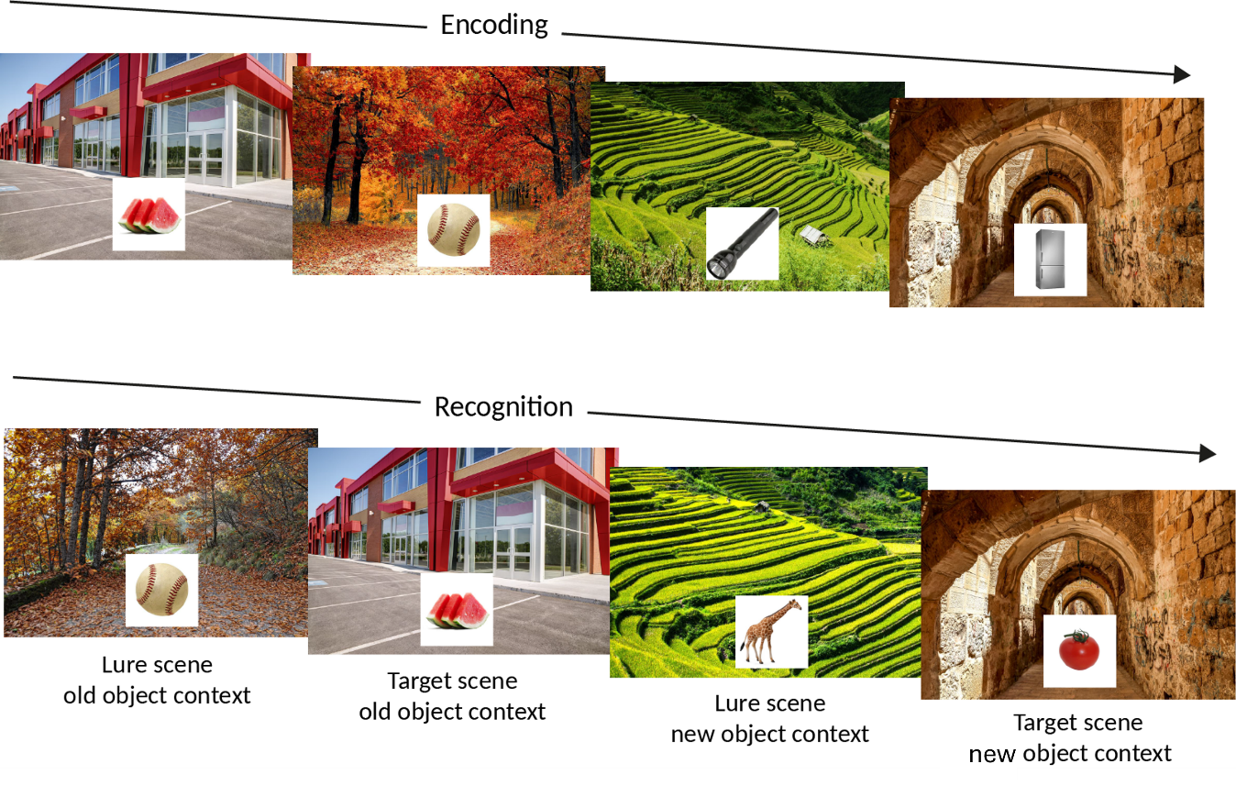
Figure 1. Schematic illustration of the experimental material in Experiments 1-4b.
Analyses. As pre-registered, we analyzed the proportion of old responses to background scenes as a function of Scene type and Object context. We opted for this approach, rather than analyzing hits and false alarms separately, because we did not expect the effect of object context to differ between scene targets and lures (Racsmány et al., 2021; Szőllősi et al., 2023). We therefore conducted a repeated-measures Anova on the proportion of old responses with both Scene type (target/lure) and Object context (same/new) as within-subject factors.
Results
We found a main effect of Scene type such that the proportions of old responses were greater for target than for lure scenes, F(1,41) = 55.25, p < .001, η²_{G} = .21. The main effect of Object context was also significant, with higher proportions of old responses to scenes associated with the same object context at encoding and recognition than to those associated with a new object context, F(1,41) = 23.42, p < .001, η²_{G} = .07. There was no Scene type x Object context interaction, p = .102, η²_{G} = .003. The results are illustrated in figure 2a.
Experiment 2
Experiment 1 showed that focal objects can serve as contextual cues during background scene recognition. In this first experiment, we reversed the encoding procedure used by Doss et al. (2018) such that the object appeared alone before and after the scene and object were presented together. Experiment 2 aimed (1) to replicate Experiment 1, and (2) to test whether its results depend on the encoding procedure. We therefore adopted the original encoding procedure while employing the background scene memory test as in Experiment 1.
Methods
Participants. Forty-two participants who did not take part in the other experiments were recruited online in Prolific (mean age M=26.16, SD=4.61, 27 females). This sample size was determined based on the same power analysis as in Experiment 1. The same screeners as in Experiment 1 were used.
Stimuli, procedure, and analyses. The stimuli and randomization procedure were the same as in Experiment 1. During the encoding phase, the scene was first displayed alone for 500 ms, then the scene and object appeared together for 3000 ms, and finally the scene was displayed alone again for 500 ms (Figure 2b). The rest of the procedures and the instructions were identical to those of Experiment 1. We conducted a repeated-measure Anova on the proportions of old responses, with Scene type (target/lure) and Object context (same/new) as factors.
Results
The main effect of Scene type was significant, with higher rates of old responses for target than for lure scenes, F(1,41) = 111,28, p < .001, η²_{G} = .48. The main effect of Object context was also replicated, F(1,39) = 20.55, p < .001, η²_{G} = .12. The Scene type x Object context interaction was not significant, p = .304, η²_{G} = .002. The results are illustrated in figure 2b.
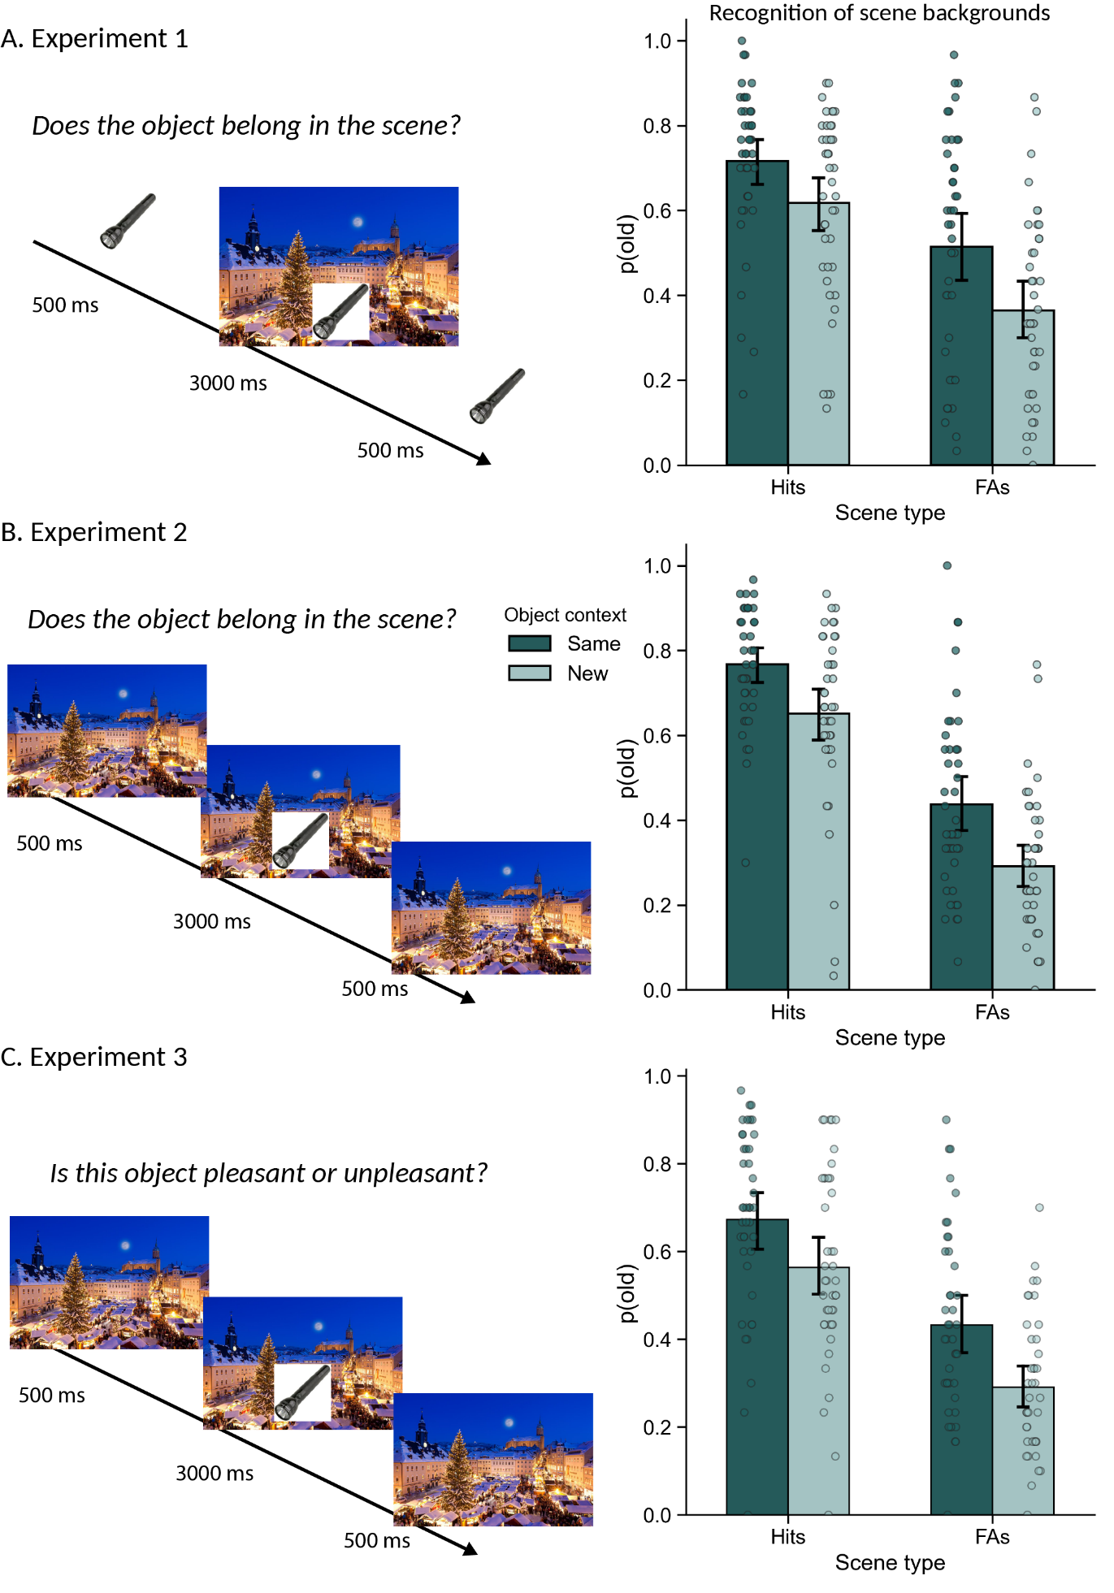
Figure 2. Encoding procedures and results of Experiments 1 (A), 2 (B), and 3 (C): proportion of old responses as a function of Scene type (Hits: target scenes, FAs: false alarms, lure scenes) and Object context. Means, 95% confidence intervals, and individual data points.
Experiment 3
Experiments 1 and 2 showed that object context reinstatement influences recognition memory decisions for background scenes (hypothesis 1). Experiments 3-5 tested hypothesis 2: task-relevant and task-irrelevant features at encoding can become either the focus of retrieval or the context depending on the memory task instructions. In Experiment 3, scenes were task-irrelevant at encoding and the focus of retrieval whereas objects were task-relevant at encoding and task-irrelevant at test.
Methods
Participants. As in Experiments 1 and 2, 42 new participants were recruited. One participant failed to complete the full study, resulting in a final sample of N=41 (mean age M=26.65, SD=4.00, 27 females). We note that the estimated statistical power with N=41 was >97% based on the effect size found in the first two experiments. The recruitment procedure and screeners were identical to those of Experiments 1 and 2.
Stimuli, procedure, and analyses. The stimuli and randomization procedure were identical to those of Experiments 1 and 2. Like in Experiment 2, in the encoding phase, the scene was first displayed alone for 500 ms, then the scene and object appeared together for 3000 ms, and finally the scene was displayed alone again for 500 ms (Figure 2c). To make background scenes task irrelevant, participants were asked to judge the objects as pleasant or unpleasant, using their keyboard (“f” for pleasant, “k” for unpleasant). They were explicitly told that their responses should “relate to the objects in the middle, not the backgrounds”. The rest of the procedures and the instructions were identical to those of Experiments 1 and 2. We conducted a repeated-measure Anova on the proportions of old responses, with Scene type (old/new) and Object context (same/new) as factors.
Results
As in Experiments 1 and 2, the main effect of Scene type was significant, with higher rates of old responses for target than for lure scenes, F(1,40) = 75.08, p < .001, η²_{G} = .34. We also found a significant main effect of Object context, with more old responses for old object context than new object context F(1,40) = 30.01, p < .001, η²_{G} = .11. The Scene type x Object context interaction was not significant, p = .199, η²_{G} = .002. The results are illustrated in figure 2c.
Experiment 4a
Experiment 3 showed that features relevant or irrelevant at encoding are not constrained to the role of item or context at retrieval. Experiment 4a tested whether task-irrelevant objects at encoding could influence subsequent recognition memory decisions for background scenes.
Methods
Participants. As in Experiment 3, 42 participants who did not take part in the other experiments were recruited and one participant was excluded because they failed to complete the full experiment, resulting in N=41 (mean age M=27.12, SD=4.67, 22 females). The recruitment procedure and screeners were identical to those of Experiments 1 to 3.
Stimuli, procedure, and analyses. The stimuli and randomization procedure were identical to Experiments 1 to 3. As in Experiment 1, in the encoding phase, the object was first displayed alone for 500 ms, then the scene and object appeared together for 3000 ms, and finally the object was displayed alone again for 500 ms (Figure 3a). To make focal objects task-irrelevant, participants were instructed to rate the pleasantness of the background scenes. Because most scenes were expected to be perceived as pleasant, pleasantness was rated on a four-point scale (from 0 - “very unpleasant” to 3 - “very pleasant”), to provide more response variability and keep the task engaging. Participants were explicitly told that their responses should “relate to the background, not the objects in the middle”. The rest of the procedures and the instructions were identical to those of Experiments 1-3. We conducted a repeated-measure Anova on the proportions of old responses, with Scene type (old/new) and Object context (same/new) as factors.
Results
As in the previous experiments, we found a significant main effect of Scene type, F(1,40) = 208.87, p < .001, η²_{G} = .71. In contrast, there was no main effect of Object context, p = .336, η²_{G} < .01. The Scene type x Object context interaction was not significant, p = .629, η²_{G} < .01. The results are illustrated in figure 3a.
Experiment 4b
Experiment 4a failed to replicate the object context reinstatement effects found in Experiments 1-3. Given that background scenes were task-relevant at encoding and the focus of the recognition memory task, these results may reflect an outshining effect (Smith & Vela, 2001): increased reliance on available memory cues that reduces the effect of context. In Experiment 4b, we shortened the encoding time of scene images and changed the instruction for a shallower encoding. If strong memory for scenes masked object context effects in Experiment 4a, the reduction of scene memory performance should allow the context reinstatement to manifest itself.
Methods
Participants. Forty-two new participants were recruited (mean age M=29.42, SD=3.64, 27 females). The recruitment procedure and screeners were identical to those of Experiments 1-4a.
Stimuli, procedure, and analyses. The stimuli and randomization procedure were identical to Experiments 1-4a. In the encoding phase, the object was first displayed alone for 1400 ms, then the scene and object appeared together for 1200 ms, and finally the object was displayed alone again for 1400 ms (Figure 3b). Participants were instructed to categorize each background scene as either indoor or outdoor using their keyboard (“f”: indoor, “k”: outdoor). They were explicitly told that their responses should “relate to the background, not the objects in the middle”. The rest of the procedures and the instructions were identical to those of Experiments 1-4a. We conducted a repeated-measure Anova on the proportions of old responses, with Scene type (old/new) and Object context (same/new) as factors.
Results
As in the previous experiments, we found a significant main effect of Scene type, F(1,41) = 107.83, p < .001, η²_{G} = .47. In contrast, there was no main effect of Object context, p = .127, η²_{G} = .006. The Scene type x Object context interaction was not significant, p = .84. The results are illustrated in figure 3b.
Experiment 5
The results of Experiments 4a cannot be attributed to an outshining effect, since weakening scene memory did not restore the object context effect. An alternative explanation is the degree of visual overlap: because scenes contain more visual information than individual objects, the perceptual overlap between the visual input at encoding and retrieval is stronger when scenes are manipulated as the context compared to when objects are manipulated. Therefore, scene context reinstatement influences object recognition even when scenes are task-irrelevant at encoding, but it is not the case when objects are the context. If this assumption holds, manipulating the size of objects and scenes on screen should reveal the effect of object contexts even though they are task-irrelevant at encoding. Experiment 5 tested this hypothesis.
Methods
Participants. Forty-two participants who did not take part to the other experiments were recruited (mean age M=26.42, SD=4.50, 20 females). The recruitment procedure and screeners were identical to those of Experiments 1-4.
Stimuli, procedure, and analyses. The stimuli and randomization procedure were identical to Experiments 1-4. Unlike the other experiments, scenes were 196 x 130.6 pixels and were superimposed at the bottom center of 480 x 480 pixels objects, both at encoding and recognition. In the encoding phase, the object was first displayed alone for 1000 ms, then the scene and object appeared together for 2000 ms, and finally the object was displayed alone again for 1000 ms. Participants were instructed to decide whether they felt each background scene was pleasant or unpleasant using their keyboard (“f”: pleasant, “k”: unpleasant). They were explicitly told that their responses should “relate to the scenes, not the objects behind”. The rest of the procedures and the instructions were identical to those of Experiments 1-4. We conducted a repeated-measure Anova on the proportions of old responses, with Scene type (old/new) and Object context (same/new) as factors.
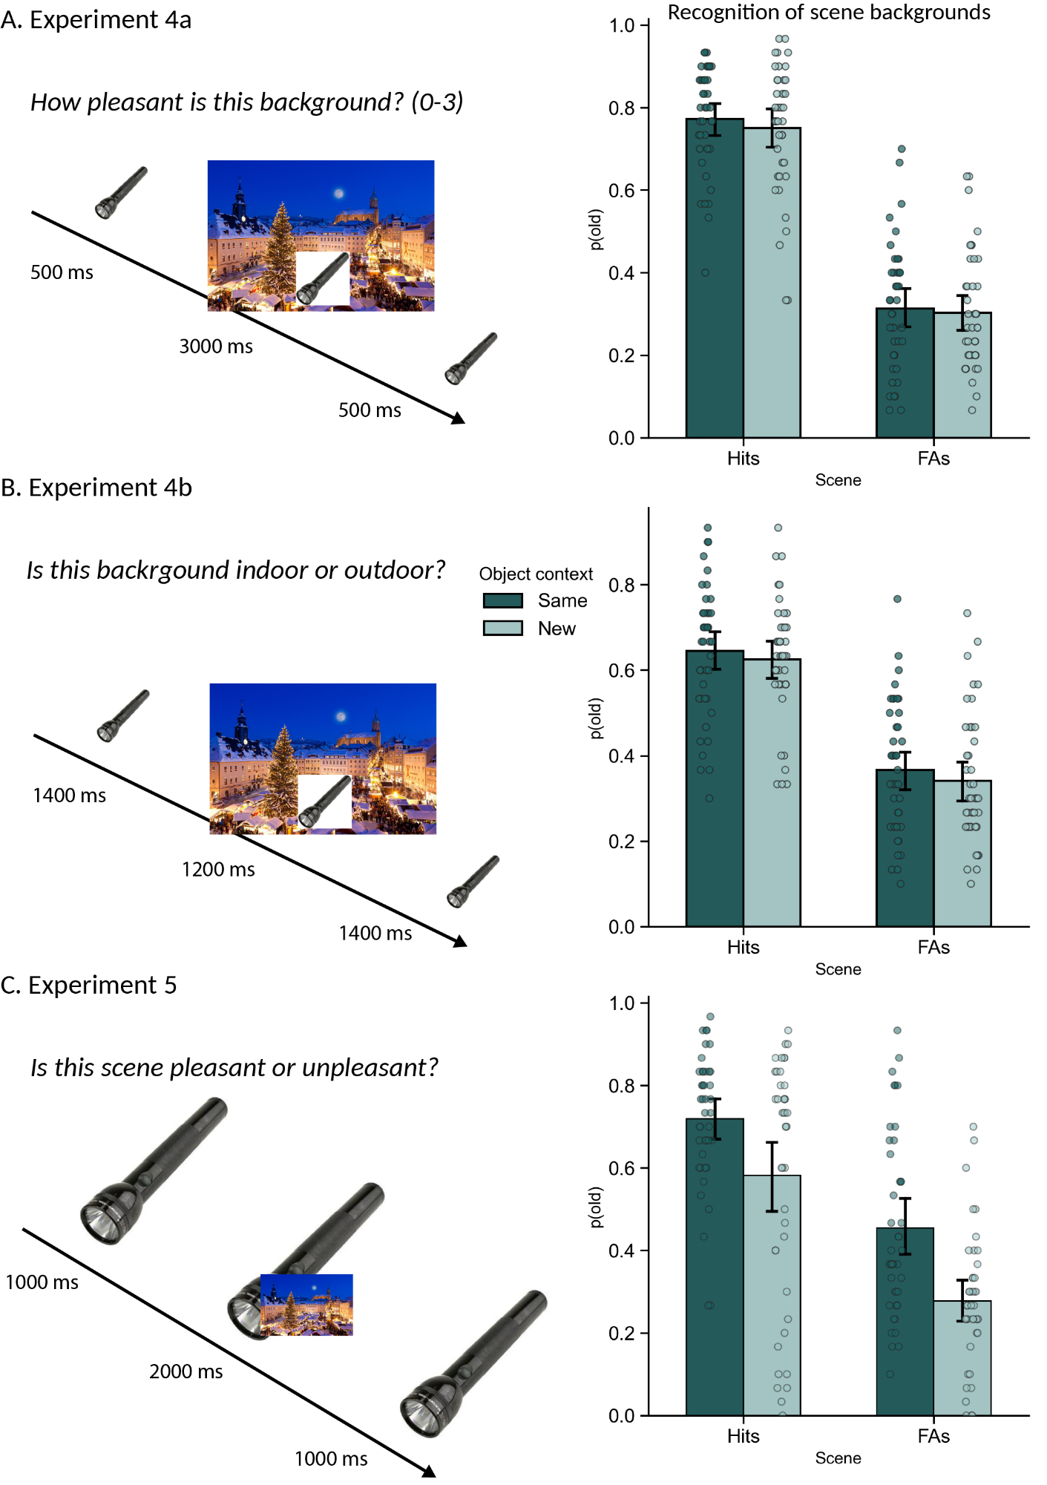
Figure 3. Encoding procedure and results of Experiments 4a (A), 4b (B), and 5 (C): proportion of old responses as a function of Scene type (Hits: target scenes, FAs: false alarms, lure scenes) and Object context. Mean, 95% confidence intervals, and individual data points.
Results
As in Experiments 1-4, the main effect of Scene type was significant, with higher rates of old responses for target than for lure scenes, F(1,41) = 77.03, p < .001, η²_{G} = .30. We also found a significant main effect of Object context, with more old responses for old object context than new object context F(1,41) = 12.89, p < .001, η²_{G} = .12. The Scene type x Object context interaction was not significant, p = .123, η²_{G} = .002. The results are illustrated in figure 3c.

Discussion
We tested the theoretical claim of Easton et al. (2024) that context is reconstructed rather than encoded. This account holds that any feature of an encoded event can become either the item or the context depending on the focus of memory retrieval. To test this hypothesis, we took advantage of the context reinstatement paradigm, in which unique background scenes are classically associated with focal objects at encoding and subsequently reinstated or switched during a recognition memory task (Doss et al., 2018).
In context reinstatement studies, focal objects and background scenes are by default ascribed to item and context, respectively. Based on the assumption that context is defined by retrieval questions, we predicted that focal objects could act as contextual cues if the recognition memory test pertained to the background scenes. Experiments 1 and 2 aimed to test this prediction by shifting the focus of the recognition memory task to the background scenes instead of the objects (hypothesis 1). The target and lure scenes paired with the same object at encoding and test were more often judged as old than those presented with a different object, indicating that objects served as contextual cues. This effect was unaffected by the encoding procedure, as reversing the order of object and scene presentation (between Experiments 1 and 2) did not alter the results. The results reported here closely mirror those of previous studies that used objects as items and backgrounds as context (Doss et al., 2018; Miao et al., 2023). Because we used the same encoding task as previous studies, the retrieval question alone defined objects as contextual and scenes as the items. Experiments 1 and 2 provide the first evidence that focal objects can become the context when memory for background scenes is tested, which supports the assumption that it is the focus of memory retrieval that defines the item and the context in memory (Easton et al., 2024).
In Experiments 1 and 2, participants judged whether each object belonged in the background scene during encoding, fostering object-scene associations. Recent studies reported context reinstatement effects when only objects must be process at encoding (Racsmány et al., 2021; Szőllősi et al., 2023), suggesting that contextual features are implicitly integrated into memory representations. In these studies, focal objects are task-relevant, and backgrounds scenes task-irrelevant both at encoding and retrieval. We hypothesized that features irrelevant at encoding could become the focus of retrieval, and task-relevant features become contextual, depending on the question of the memory task. In Experiment 3, encoding focused on the objects only, but the recognition memory task targeted the background scenes. Replicating Experiments 1 and 2, objects acted as contextual cues for scene recognition. Task-irrelevant scenes and task-relevant objects have thus become the focus of retrieval and the context, respectively. These results show that contextual features at retrieval need not be task-irrelevant at encoding, as assumed by some previous accounts (e.g., Hayes et al., 2007); rather, any feature of an event can become contextual at retrieval.
Experiments 4a and 4b did not reproduce the effect of object context when the background scenes were both task-relevant at encoding and the focus of the memory task. One explanation for the results of Experiment 4a was an outshining effect—increased reliance on available memory cues that diminishes context effects (Smith & Vela, 2001). In Experiment 4b, we shortened the encoding duration of background scenes and used a shallower encoding instruction (Baddeley & Hitch, 2017). This effectively decreased memory discrimination (figure 3a and 3b), but this was again not associated with an effect of object context, ruling out the hypothesis of an outshining effect. Alternatively, we investigated whether results from Experiments 4a and 4b were explained by the similarity principle, according to which the perceptual overlap between a probe and a memory trace determines the likelihood of retrieving this trace (Tulving & Thomson, 1973). Because scenes contain substantially more visual information than individual objects, scene reinstatement produces a greater perceptual overlap between encoding and retrieval inputs than object reinstatement. We tested this hypothesis in Experiment 5 by reversing the relative sizes of objects and scenes (figure 3c) while using the instructions of Experiments 4a. Experiment 5 replicated the object context reinstatement effect. Experiments 4-5 extend the findings of Experiments 1-3 by showing that although any feature of an event can become either the item or the context at retrieval, the impact of context on memory depends on the perceptual properties and relative salience of those features.
The present study provides converging evidence that item and context are reconstructed rather than encoded (Easton et al., 2024), challenging traditional assumptions about context in memory and open new avenues for future research. Some memory models propose that item and context are processed in distinct brain regions, respectively the perirhinal and parahippocampal cortices (e.g., Diana et al., 2007). Easton et al. hypothesized that when probing memory for the same event in different ways, the dedicated brain regions should respond to stimulus type rather than to its role as item or context. The parahippocampal cortex was associated with the reinstatement of background scenes serving as context for object recognition (Bencze et al., 2024). Applying our paradigm in an fMRI study would enable the comparison of brain activations underlying object and scene recognition across two conditions: when objects act as context for scene memory and vice versa. We predict that the perirhinal and parahippocampal cortices will respond preferentially to the processing of objects and scenes respectively (Gardette et al., 2022; Ross et al., 2018; Sanders & Cowell, 2023), regardless of their roles as item or context. Beyond visual representations of objects and scenes, episodic memories include emotional, social, narrative, temporal, or conceptual information. Future research should determine whether these different types of features can likewise serve as item or context depending on the retrieval question.

References
Baddeley, A. D., & Hitch, G. J. (2017). Is the Levels of Processing effect language-limited? Journal of Memory and Language, 92, 1‑13. https://doi.org/10.1016/j.jml.2016.05.001
Bastin, C., Besson, G., Simon, J., Delhaye, E., Geurten, M., Willems, S., & Salmon, E. (2019). An integrative memory model of recollection and familiarity to understand memory deficits. Behavioral and Brain Sciences, 42. https://doi.org/10.1017/S0140525X19000621
Bencze, D., Marián, M., Szőllősi, Á., Pajkossy, P., Nemecz, Z., Keresztes, A., Hermann, P., Vidnyánszky, Z., & Racsmány, M. (2024). Contribution of the lateral occipital and parahippocampal cortices to pattern separation of objects and contexts. Cerebral Cortex, 34(7), bhae295. https://doi.org/10.1093/cercor/bhae295
Diana, R. A., Yonelinas, A. P., & Ranganath, C. (2007). Imaging recollection and familiarity in the medial temporal lobe : A three-component model. Trends in Cognitive Sciences, 11(9), 379‑386. https://doi.org/10.1016/j.tics.2007.08.001
Doss, M. K., Picart, J. K., & Gallo, D. A. (2018). The Dark Side of Context : Context Reinstatement Can Distort Memory. Psychological Science, 29(6), 914‑925. https://doi.org/10.1177/0956797617749534
Easton, A., Horner, A. J., James, S. J., Kendal, J., Sutton, J., & Ainge, J. A. (2024). Context in memory is reconstructed not encoded. Neuroscience and Biobehavioral Reviews, 105934. https://doi.org/10.1016/j.neubiorev.2024.105934
Eichenbaum, H., Yonelinas, A. P., & Ranganath, C. (2007). The Medial Temporal Lobe and Recognition Memory. Annual Review of Neuroscience, 30(1), 123‑152. https://doi.org/10.1146/annurev.neuro.30.051606.094328
Gardette, J., Cousin, E., Bourgin, J., Torlay, L., Pichat, C., Moreaud, O., & Hot, P. (2022). Hippocampal activity during memory and visual perception : The role of representational content. Cortex, 157, 14‑29. https://doi.org/10.1016/j.cortex.2022.09.004
Godden, D. R., & Baddeley, A. D. (1975). Context-Dependent Memory in Two Natural Environments : On Land and Underwater. British Journal of Psychology, 66(3), 325‑331. https://doi.org/10.1111/j.2044-8295.1975.tb01468.x
Greene, N. R., & Naveh-Benjamin, M. (2022). Online experimentation and sampling in cognitive aging research. Psychology and Aging, 37(1), 72‑83. https://doi.org/10.1037/pag0000655
Gruppuso, V., Lindsay, D. S., & Masson, M. E. (2007). I’d know that face anywhere! Psychonomic Bulletin & Review, 14(6), 1085‑1089.
Hayes, S. M., Nadel, L., & Ryan, L. (2007). The effect of scene context on episodic object recognition : Parahippocampal cortex mediates memory encoding and retrieval success. Hippocampus, 17(9), 873‑889.
Miao, J., Weigl, M., Kong, N., Zhao, M.-F., Mecklinger, A., Zheng, Z., & Li, J. (2023). Electrophysiological evidence for context reinstatement effects on object recognition memory. Neurobiology of Learning and Memory, 206, 107861. https://doi.org/10.1016/j.nlm.2023.107861
Polyn, S. M., Norman, K. A., & Kahana, M. J. (2009). A context maintenance and retrieval model of organizational processes in free recall. Psychological review, 116(1), 129.
Racsmány, M., Bencze, D., Pajkossy, P., Szőllősi, Á., & Marián, M. (2021). Irrelevant background context decreases mnemonic discrimination and increases false memory. Scientific Reports, 11(1), Article 1. https://doi.org/10.1038/s41598-021-85627-2
Ross, D. A., Sadil, P., Wilson, D. M., & Cowell, R. A. (2018). Hippocampal Engagement during Recall Depends on Memory Content. Cerebral Cortex, 28(8), 2685‑2698. https://doi.org/10.1093/cercor/bhx147
Sanders, D. M. W., & Cowell, R. A. (2023). The locus of recognition memory signals in human cortex depends on the complexity of the memory representations. Cerebral Cortex, bhad248. https://doi.org/10.1093/cercor/bhad248
Smith, S. M., & Vela, E. (2001). Environmental context-dependent memory : A review and meta-analysis. Psychonomic Bulletin & Review, 8(2), 203‑220. https://doi.org/10.3758/BF03196157
Stark, S. M., Kirwan, C. B., & Stark, C. E. L. (2019). Mnemonic Similarity Task : A Tool for Assessing Hippocampal Integrity. Trends in Cognitive Sciences, 23(11), 938‑951. https://doi.org/10.1016/j.tics.2019.08.003
Symeonidou, N., Emmer, C., Wulff, L., & Kuhlmann, B. (2025). Context Reinstatement Effects in Younger and Older Adults’ Memory : A Meta-Analysis.
Szőllősi, Á., Pajkossy, P., Bencze, D., Marián, M., & Racsmány, M. (2023). Litmus test of rich episodic representations : Context-induced false recognition. Cognition, 230, 105287. https://doi.org/10.1016/j.cognition.2022.105287
Tulving, E., & Thomson, D. M. (1973). Encoding specificity and retrieval processes in episodic memory. Psychological Review, 80(5), 352‑373. https://doi.org/10.1037/h0020071
Yonelinas, A. P., Ranganath, C., Ekstrom, A. D., & Wiltgen, B. J. (2019). A contextual binding theory of episodic memory : Systems consolidation reconsidered. Nature Reviews Neuroscience, 20(6), 364‑375. https://doi.org/10.1038/s41583-019-0150-4

View-only link for peer-review: https://osf.io/tp6wh/overview?view_only=81219e07da0a43b69f7d3369904f3dd1

