Update on the microwave-assisted saponification conditions for mineral oil hydrocarbons determination in fats and oils
Aleksandra Gorska¹, Donatella Ferrara^{1,2}, Paula Albendea¹, Chiara Emilia Cordero², Giorgia Purcaro^{1,}*
¹ Analytical Chemistry Laboratory, Gembloux Agro-Bio Tech, University of Liège, Passage des Déportés 2, Gembloux, 5030, Belgium
² Dipartimento di Scienza e Tecnologia del Farmaco, Università degli Studi di Torino, Via Pietro Giuria 9, I-10125 Torino, Italy

* Corresponding author. Contact information:
Giorgia Purcaro, gpurcaro@uliege.be
Gembloux Agro-Bio Tech, University of Liège
Chemistry for Sustainable Food and Environmental Systems, Passage des Déportés 2,
5030 Gembloux, Belgium
Office phone: +32 (0)81 62 22 20

Abstract
The analysis of mineral oil saturated (MOSH) and aromatic (MOAH) hydrocarbons in edible fats and oils typically includes a saponification followed by liquid–liquid extraction. The official ISO 20122:2024 method has shown limitations, particularly due to inconsistent recoveries of MOAH internal standards (ISs), which compromise quantitative accuracy. A previously developed microwave-assisted saponification/extraction (MASE) method improved IS recovery consistency through optimized solvent composition but proved insufficient to fully saponify certain oils (e.g., extra virgin olive oil, hydrogenated fats) under its original conditions (60 °C, 30 min).
In this study, saponification parameters were reoptimized and validated by gravimetric control of residual fat and evaluation of ISs ratios, which are ideally 1.00. The final conditions (120 °C, 20 min) ensured complete saponification across a wide range of fats and oils with varying compositions and melting points. ISs ratios were consistently closer to 1.00 than with the ISO method, although matrix-dependent deviations persisted. These effects correlated with the fatty acid profiles of the oils, which affect the properties of the soaps formed during saponification and, in turn, the partition of MOAH ISs during extraction.

Keywords: mineral oil aromatic hydrocarbons; fats and oils; sample preparation; microwave-assisted extraction; saponification

Introduction
The extraction, isolation, and determination of mineral oil hydrocarbons (MOH) in fatty food matrices are particularly challenging. MOH are complex mixtures of structurally related, petroleum-derived compounds whose physico-chemical properties closely resemble those of matrix lipids, complicating their separation from endogenous components. The typical analytical workflow consists of a saponification/liquid–liquid extraction step, primarily to remove triglycerides, followed by purification via liquid chromatography (on aluminium oxide or silica) or chemical epoxidation, and final analysis by LC–GC–FID or (LC-)GC×GC with either FID or MS detection [1,2].
These sample preparation steps, although essential to achieve sufficiently low limits of quantification (<2 mg/kg), are imperfect, each contributing to some extent to the overall analytical bias or variability. In particular, the saponification/liquid–liquid extraction step has been shown to account for 15–25% of discrepancies in the quantification of the mineral oil aromatic hydrocarbons (MOAH) fraction when applying the ISO 20122:2024 method [3,4]. This issue is linked to the behaviour of MOAH internal standards (ISs), particularly those used for quantification – tri-tert-butylbenzene (TBB) and 2-methylnaphthalene (2MN) – which partition differently between the hydroalcoholic and organic phases [5]. Since either TBB or 2MN can be used for MOAH quantification, the final result may vary depending on the standard selected, due to differences in their recovery in the hexane phase. This differential partitioning also suggests that MOAH compounds themselves may be recovered unevenly based on their structure, further compromising quantification accuracy.
Our previously published method [5] addressed this variability by optimizing the microwave-assisted saponification/liquid-liquid extraction (MASE) conditions, focusing on the solvent system, in order to minimize the discrepancies between the standards. This adjustment brought the TBB/2MN ratio close to the target value of 1.00, achieving a ratio of 1.05 ± 0.01 across various edible oils tested, while previous saponification methods, such as the one presented in the ISO 20122:2024, yielded ratios going up to 1.15-1.25.
However, routine application of the newly proposed MASE method revealed additional challenges. In particular, the method did not achieve efficient saponification across all types of fats and oils, and in some cases resulted in unacceptable levels of involatile residues (i.e., unsaponified material), rendering the samples unsuitable for chromatographic analysis. High-melting fats, such as hydrogenated vegetable oils, proved especially problematic under the standard saponification and extraction conditions (60 °C for 30 minutes). This issue was also observed with the ISO 20122:2024 method. Moreover, consistent deviations from the expected TBB/2MN ratio were observed in specific matrices. This amendment, therefore, aims to refine the temperature and time conditions to reduce the level of involatile residues in various vegetable fats and oils, while minimizing discrepancies in partitioning between MOAH internal standards. Additionally, it seeks to clarify the origin of the observed TBB/2MN ratio deviations.

Materials and methods

Reagents and standards
Dichloromethane LiChrosolv®, methanol (≥ 99.9%, for HPLC), and a reference standard of fatty acid methyl esters (Supelco C37 FAME Mix) were provided by Merck (Darmstadt, Germany). n-Hexane, n-heptane, and acetone for HPLC were purchased from Biosolve Chemicals (Dieuze, France). n-Hexane was distilled before use. Ethanol (99.8%, for HPLC, absolute) was from Thermo Scientific Chemicals (Loughborough, United Kingdom). Potassium hydroxide (90%) and bis(2-ethylhexyl)sebacate (for synthesis) were from Merck-MilliporeSigma (Overijse, Belgium).
The MOSH and MOAH internal standard (ISs, Restek #31070) was kindly provided by Restek (Neukirchen-Vlun, Germany). The ISs consisted of 600 µg mL⁻¹ 5-α-cholestane, 300 µg mL⁻¹ n-C11, 150 µg mL⁻¹ n-C13, 300 µg mL⁻¹ cyclohexyl cyclohexane (CyCy), 300 µg mL−11-methyl naphthalene (1MN), 300 µg mL⁻¹ 2-methylnaphthalene (2MN), 300 mg mL⁻¹ tri‑tert‑butyl benzene (TBB), and 600 µg mL⁻¹ perylene (Per), in toluene.

Edible fats and oils
Fully hydrogenated palm kernel oleins, fully hydrogenated rapeseed oil, fully hydrogenated coconut oil, fully hydrogenated palm oil, crude palm oils, refined palm oils, rapeseed oil, and coconut oil were kindly provided by collaborators. Extra virgin olive oil (EVOO), and rice bran oil were brought from local shops. Fish oil from Menhaden was from Merck-MilliporeSigma (Overijse, Belgium).

Evaluation of residue and MOAH ISs
All glassware and materials were carefully washed with acetone and n-hexane prior to use.

Microwave-assisted saponification/liquid-liquid extraction (MASE)
All MASE were performed on the ETHOS™ X microwave equipped with an SR-12 eT TFM rotor (Milestone Srl, Bergamo, Italy).

Following ISO 20122:2024
The saponification method of the ISO 20122:2024 was adapted as following. One gram of oil was weighed in a Teflon microwave vessel, to which 10 µL of MOSH/MOAH ISs were added (only for the experiments aiming at evaluation of the MOAH ISs ratios), as well as 10 mL of n-hexane/ethanol (1/1 v/v), 3 mL of an aqueous KOH at 8.9 N, and a magnet for stirring. The microwave was then programmed to have 2 min of preheating until 60°C, a temperature that was kept for 30 min. After cooling down, 5 mL of n-hexane and 5 mL of a mixture of ethanol/water (1/1 v/v) were added and was ready for further steps (presented in sections 3.4.2 and 3.4.3).

Following Bauwens and Purcaro (2024)
One gram of oil was weighed in a Teflon microwave vessel, to which 10 µL of MOSH/MOAH ISs were added (only for the experiments aiming at evaluating the MOAH ISs ratios), as well as 10 mL of n-hexane, followed by 10 mL of a 2N KOH solution in EtOH/H2O 1/1 (v/v), and a magnet for stirring. The vessel was closed and placed in the microwave’s rotor. The temperature program consisted of a preheating of 2 min until the target temperature (between 60 and 120 °C), then the latter was maintained constant for a given period of time (10, 20, or 30 min), followed by a cooling period until 40°C. The temperature/time couples were either assessed in a monofactorial way (with only temperature changing, and the time kept constant at 30 min), or in a bifactorial way to evaluate both temperature and time, following a Doehlert design [6], with two replicates per experimental point. Once out of the microwave, 20 mL of ultrapure water were gently added (taking care not to create strong emulsions). Then, the content of the vessel was transferred to a glass vial (of sufficient volume) to have the interface clearly visible. One millilitre of ethanol was then added to the vial, which was stored for 20 min in the refrigerator, then taken out for further steps (presented in sections 3.4.2 and 3.4.3).

Evaluation of the residual mass
For the evaluation of the residue, the organic phase was transferred into a clean, previously weighed pear-shaped flask. Care was taken not to transfer any possibly emulsion formed at the liquid-liquid interface between the organic and hydroalcoholic phase, typically characterized by a foamy or bubbly appearance; the hexanic phase in the flask had to be transparent. Five extra millilitres of hexane were added to the vial, which was hand-agitated for 30 seconds, and then, if any emulsion was present, ethanol was added until all of it was destabilized. The organic phase was combined with the one present in the pear-shaped flask, and then fully evaporated in the rotary evaporator at 35°C. The flask was weighed again, and the residual mass (%) was calculated following Equation 1.
$Residual mass \left(\%\right)= \frac{mass of residual after evaporation [g]}{mass of vegetable fat or oil [g]}*100$ (1)

Evaluation of the MOAH ISs ratios
For the evaluation of the MOAH ISs ratios, the extraction procedure was similar, except that before the evaporation, 2 drops of bis(2-ethylhexyl)sebacate were added. The evaporation under vacuum was performed at 35 – 40 °C until a volume of 1 mL or less. This volume was then readjusted to 1 mL using n-hexane, and transferred to a clean vial. The vial was then centrifugated for 5 min, and if any solid residual was present at the bottom, the supernatant was transferred into a new vial, which was at that point ready for MOSH/MOAH fractionation by HPLC and GC×GC-FID analysis (section 3.4.4). The MOAH ISs ratios were calculated based on their peak areas.

Analysis by HPLC/GC×GC-FID
An off-line HPLC/GC×GC-FID/TOFMS, as reported in [7], was used to perform the fractionations/collections and analyses of samples.
The HPLC part was composed of the Agilent 1260 Infinity II HPLC, equipped with an isocratic pump G7110B and a Variable Wavelength Detector acquiring at 230 nm (Agilent Technologies, Waldbronn, Germany). The used HPLC column was an Allure silica 250 mm × 2.1 mm i.d. × 5 μm d_{p} (Restek). Mobile phases were A n-hexane and B dichloromethane. The elution gradient used for the fractionation of MOSH and MOAH was 0 min 100% A; 1.5–6 min 65% A 35% B at 0.3 mL min⁻¹. At 6.10 min the column was backflushed with 100% B for 9 min at 0.5 mL min⁻¹. The flow was then switched to forwarding mode to re-equilibrate the column with 100% A 10 min at 0.5 mL min⁻¹ and 5 min at 0.3 mL min⁻¹ until the following analysis. The MOAH fraction was collected into fresh vials between 4.4 and 5.9 min (corresponding to a volume of 450 µL), using the HPLC collection tool of the PAL3 Autosampler (PAL System from CTC, Switzerland). The injection volume into the HPLC system was 100 µL.
The GC × GC system consisted of a Pegasus BT 4D GC × GC ToFMS (LECO, St. Joseph, MI, USA). The latter is composed of an Agilent 8890 gas chromatograph, equipped with a secondary oven and a quad-jet dual-stage thermal modulator, a time-of-flight MS (TOFMS) and an FID. Only the FID line was used for this study. This line consisted of a cold on-column (COC) inlet connected to an Rxi Guard column (4 m × 0.53 mm i.d.), followed by a Rxi-17SilMS (15 m × 0.25 mm i.d. × 0.25 µm), itself connected to an Rxi-1MS HT (0.8 m × 0.15 mm i.d. × 0.15 µm). The columns were kindly provided by Restek.
Large volume injection was performed by direct on-column injection in the FID line (injection volume of 20 µL out of the 450 µL that were collected during the HPLC step). The delivery of the sample into the injection port was performed using the same autosampler as for the HPLC, but with a GC injection tool.
The oven program of the primary oven was 59 °C for 5 min, increased to 350 °C at 5 °C min⁻¹, and held 5 min at 350 °C. The secondary oven program was the same as for the primary oven, with a positive offset of 5 °C. A 15 °C positive offset was applied for the modulator. Modulation was performed every 6 s, applying variable hot and cold pulse durations. The carrier gas was helium, supplied in constant flow mode at 1.7 mL min⁻¹.
The parameters of the FID were 40 mL min⁻¹ for the H₂ flow, 400.0 mL min⁻¹ for the air flow, 30.0 mL min⁻¹ for the make-up gas flow, 370 °C temperature.
Data acquisition and integration were performed using ChromaTOF Version 5 for MOSH/MOAH (LECO, USA). The general procedure was similar to the one described by Bauwens et al. [8,9] and followed the recommendations of the updated JRC guidance [10].

Evaluation of FAMEs

Extraction and derivatization of fatty acids
In duplicate, one drop of each oil (maximum ~10 mg) was weighed in a glass tube, to which 2 mL of n-heptane and 0.2 mL of methanolic 2M KOH solution were added. The tube was capped, vortexed until matrix solubilization, and allowed to settle. The organic phase was recovered and transferred to a vial. The analysis of fatty acid methyl esters (FAMEs) was performed by gas chromatography with flame ionization detection (GC-FID, section 3.5). The identification of FAMEs was carried out using the Supelco C37 FAME Mix and literature data.

Analysis by GC-FID
The analyses were conducted with a Nexis GC-2030 (Shimadzu, Benelux), equipped with an AOC-30i autoinjector, a split/splitless injector, and an FID. A capillary fused silica column Stabilwax-DA 30 m × 0.5 mm i.d. × 0.25 µm (Restek, Germany) was operated under programmed temperature conditions: 40 °C held for 1 min, to 260 at 10 °C/min, and held for 5 min. The temperature of the injector was 240 °C. The injection volume was 1 µL in split mode (1:15). The carrier gas (helium) flow was 1.4 mL/min. The parameters of the FID were 35.0 mL min⁻¹ for the H₂ flow, 350.0 mL min⁻¹ for the air flow, 30.0 mL min⁻¹ for the make-up gas flow, 350 °C temperature. The data collection was performed at a frequency of 50 Hz. Data was acquired and elaborated by LabSolution Version 5.111 (Shimadzu).

Results and discussion

Influence of saponification method and temperature
Routine application of the MASE method proposed by Bauwens and Purcaro (2024) revealed that solid residues were noticed in some cases, particularly with high-melting fats. To better assess the saponification efficiency, the organic solvent containing the unsaponifiable fraction was completely evaporated – a practice not foreseen in the routine procedure, since small amounts of residue are easily removed by subsequent steps (notably the HPLC fractionation). After comparison of the ISO 20122:2024 and the developed MASE procedure [5], it was observed that the latter systematically yielded higher levels of non-saponified material. Furthermore, both gave up to 50% of solid residue in some fully hydrogenated fats. Consequently, the temperature and time conditions of the MASE method were re-evaluated to promote a more efficient reaction.
Seven vegetable fats and oils, covering a broad range of melting points, were selected to evaluate the impact of temperature and time on the residual extracted involatile mass. The selection included two fully hydrogenated (FH) samples (FH palm kernel olein and FH rapeseed oil), along with coconut oil, two palm oils with different degrees of refining, rice bran oil, and extra virgin olive oil. The impact of temperature was initially evaluated alone, by determining the residual extracted mass after MASE at 60, 90, and 120°C for 30 min. For comparison, the residual was also determined following the ISO 20122:2024 saponification method. These results are presented in Figure 1 (raw data available in ‘FIG 1 - Residue post sapo (%)’ of the Supplementary Material). It should be noted that the residue contains the standard ‘non-saponifiable’ fraction of the oil (usually up to 3% in vegetable oils [11]) and the non-saponified fat. Fats and oils showing residues <3% are therefore considered as fully saponified.

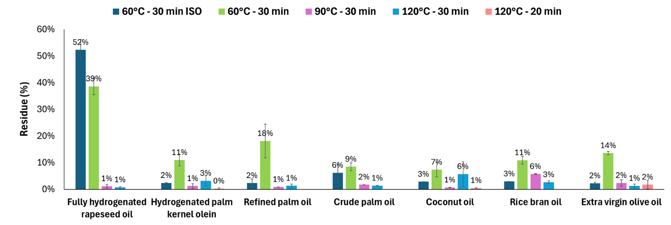
Figure 1– Average residual mass (%; n = 2) ± range (the extremes of the error bar indicate the lower and the higher value obtained) after microwave-assisted saponification/liquid-liquid extraction following the ISO 20122:2024 method or the one of Bauwens and Purcaro (2024) with various temperatures and times.

The outcomes highlight that both the solvent system and temperature influence saponification efficiency. Using the ISO 20122:2024 method, the residual mass averaged 2–3% for the studied oils (i.e., normal unsaponifiable residue), apart from FH rapeseed oil, which was not completely saponified. In contrast, excluding FH rapeseed oil, the developed MASE method yielded significantly higher residues under the same temperature/time conditions. This difference is likely due to the change in KOH concentration and solvent composition, which are illustrated in Figure 2. Specifically, the hydroalcoholic phase (water + ethanol) in the ISO 20122:2024 method had a KOH concentration of 3.4 M (27 mmol KOH in 8 mL of water + ethanol), while the new method used a lower concentration of 2.0 M (20 mmol KOH in 10 mL of water + ethanol).
Figure 2 – Solvent and KOH composition during saponification and extraction using A) ISO 20122:2024 method, B) Bauwens and Purcaro (2024) method.

Furthermore, the increased proportion of the organic phase (favored by the oil) relative to the hydroalcoholic phase (favored by KOH) in the new method could have contributed to the reduced saponification efficiency. The higher organic phase proportion likely led to decreased contact between the oil and the hydroalcoholic phase. Specifically, the water/ethanol/hexane ratio (v/v/v) changed from 3/5/5 in ISO 20122:2024 to 5/5/10 in the method of Bauwens & Purcaro [5], corresponding to hydroalcoholic/organic (v/v) ratios of 8/5 and 5/5, respectively.
In addition to solvent composition, temperature also had a significant impact on saponification efficiency. Increasing the reaction temperature led to a marked reduction in residual mass. At 90 °C, residue levels became comparable to those obtained with the ISO 20122:2024 method (excluding FH rapeseed oil, where the ISO 20122:2024 method was inefficient), with no further improvement observed at 120 °C. The effect was particularly pronounced for FH rapeseed oil, which has the highest melting temperature (~75°C), suggesting that higher temperatures are especially beneficial for more crystalline fats. To account for such matrix-dependent differences, the saponification temperature in the optimized method should therefore exceed 60 °C. However, exceeding this temperature is only feasible in pressurized systems, as the boiling point of hexane is 69 °C and conventional glassware cannot withstand the associated pressure – unlike the microwave-assisted system used here.
An alternative approach to improve saponification efficiency without pressurization could involve conducting the saponification step exclusively in a hydroalcoholic medium (e.g., water and ethanol) before adding hexane. This strategy would permit operation at temperatures above 60 °C, given the higher boiling points of ethanol (78 °C) and water (100 °C) at atmospheric pressure. However, this approach was not investigated in the present study.

Impact of saponification time
Following the observation that elevated temperatures significantly reduced residual mass, the next objective was to determine whether saponification time could be shortened without compromising efficiency. To systematically evaluate the combined effects of time and temperature on the residual involatile mass, response surface methodology (RSM) was applied using extra virgin olive oil (EVOO) as a model matrix.
EVOO was selected for three main reasons. First, because of its frequent occurrence in routine analyses in our laboratory (not only for MOSH/MOAH analysis). Second, because of its tendency to yield slightly elevated TBB/2MN ratios compared to other oils. Third, it occasionally produced higher-than-expected residues at 60 °C despite not having a high melting point. [5]
To build the RSM, a Doehlert experimental design was implemented, with saponification time (10–30 min) and temperature (60–120 °C) as independent variables. The choice of times was guided by reference values from established methods: 30 min, as used in the ISO 20122:2024 method, 20 min, as applied by Menegoz Ursol et al. [12] in previous work, and 10 min to explore the effect of shorter reaction times. In the Doehlert design, only three time points could be tested, making 10–20–30 min the only set compatible with the model requirements. The temperature range was similarly selected based on relevant literature: 60 °C corresponds to the ISO 1022:2024 method and to the minimum temperature proposed in the previously published MASE method [5], while 120 °C matches the maximum tested by Menegoz Ursol et al. [12]. The corresponding response surface for the residual mass is presented in Figure 3 (raw data available in ‘FIG 3AB - EVOO - Doehlert GRAVI’, ‘FIG 3C - EVOO - Doehlert IS’, and ‘FIG 3D - EVOO - Emulsion break’ of the Supplementary Material), along with the ISs ratios obtained at each experimental condition.
Among the two tested variables, temperature had the greatest influence on the residual mass. Its effect was markedly stronger than that of time. Beyond a critical temperature – approximately 100 °C in this study – the impact of further time reduction on the residual mass became negligible. This suggests that, as long as the temperature is sufficiently high, saponification time is no longer a limiting factor for efficient residue removal, although durations below 10 min were not evaluated.
Figure 3 – A) 3D and B) 2D response surfaces of residual mass (%) after saponification/liquid-liquid extraction of EVOO (n = 2); C) MOAH internal standard ratios after microwave-assisted saponification/liquid-liquid extraction of EVOO (n = 2); D) Same as C, but with complete emulsion destabilization at the liquid-liquid interface during the extraction process (n = 2).

Regarding the impact on the ISs ratios, no clear differences were noticeable for the 5B/2MN and 1MN/2MN, which was expected considering their closeness of chemical structure. For TBB/2MN and (Per/2)/2MN) (Per being twice more concentrated than 2MN), stronger variation is noticeable. Structurally, TBB is considerably more non-polar than 2MN due to the presence of three tert-butyl groups, which are bulky and highly hydrophobic, increasing both its steric hindrance and lipophilicity. As a result, TBB should exhibit a stronger affinity for the organic phase. On the other hand, Per, composed of five fused aromatic rings with no alkylation, is more polar, which should result in a slightly lower affinity for the organic phase compared to TBB.
Although the solvent composition used in the MASE method (i.e., optimized in the work of Bauwens and Purcaro (2024)) was optimized to yield MOAH ISs ratios close to 1.00, this outcome can be impacted by the strength of the matrix effect. While in our previous work, the average TBB/2MN ratio was of 1.05, in the case of the EVOO used for the DOE, this ratio ranged from 1.06 to 1.13. Additionally, the (Per/2MN)/2 ratio ranged from 0.74 to 0.89. Interestingly, the deviation from the optimal ratios was more pronounced under stronger saponification conditions. This led to the hypothesis that the soaps formed during saponification contributed to these discrepancies: the greater the soap formation, the stronger the emulsion, which in turn resulted in greater partitioning discrepancies of the standards, potentially trapping some of the standards within the emulsion.
Indeed, it was later confirmed that the emulsion formed at the hexane-water/ethanol interface had a significant impact on the partitioning of the internal standards. In the trials presented in Figure 3C, the emulsion formed during saponification was not fully broken, as its presence was difficult to monitor due to the limited visibility in the Teflon extraction vessels. To address this, selected trials were repeated (Figure 3D) with an additional step: after transferring the vessel contents to glass extraction flasks, full emulsion breaking at the liquid-liquid was ensured. This adjustment markedly improved the consistency of ISs partitioning across different temperature/time conditions. In particular, the recovery of Per increased substantially. However, the TBB/2MN ratio remained slightly elevated compared to the ideal value, suggesting that additional factors may still influence the partitioning behaviour of TBB.
In cases where particularly stable emulsions were obtained, the issue could be mitigated by omitting the addition of 20 mL water after the MASE run and proceeding directly to extraction. This modification did not affect MOAH IS ratios. However, if the resulting hexane extract appeared turbid, it required either washing with an additional 10–20 mL water or centrifugation.
In any case, the consistency of ISs partitioning across varying temperature conditions – provided that the emulsion at the liquid-liquid interface is fully disrupted – indicates that the temperature and time parameters can be selected with some flexibility, as long as saponification is sufficiently complete to eliminate triglycerides. Since the objective is to establish a MASE method robust against matrix variability, conditions of 120 °C for 20 min were selected for subsequent investigations. These parameters were considered stringent enough to ensure effective saponification, even for more recalcitrant matrices. It should be noted that this combination of temperature and time was also applied to EVOO in the study by Menegoz Ursol et al. [12], but using KOH in methanol which led to high ISs discrepancy compared to 1/1 (v/v) EtOH/H₂O, as demonstrated previously [5,13].

Evaluation of the reoptimized method
The reoptimized MASE protocol (120 °C, 20 min) was subsequently evaluated across a broader range of matrices, including fats and oils with varying melting points. Under these conditions, all samples were efficiently saponified. Table 1 (raw data available in ‘Table 1 - MOAH IS’ of the Supplementary Material) presents the resulting TBB/2MN and (Per/2MN)/2 ratios, alongside those obtained using the ISO 20122:2024 method for comparison.
As previously discussed, matrix composition affects ISs ratios in both methods. For the MASE protocol, TBB/2MN values ranged from 0.97 to 1.16, while the ISO method yielded values between 1.09 and 1.25. The (Per/2MN)/2 ratios were generally comparable between the two methods. Standard deviations were lower for both ratios with the MASE protocol. For TBB/2MN, the coefficients of variation were ~5% for MASE and 7.6% for ISO, suggesting a comparable or slightly improved repeatability. Importantly, despite some matrix-related deviations, the MASE method consistently produced ISs ratios closer to 1.00.
All samples were analyzed by GC×GC, and some representative chromatograms are shown in Figure 4. While not strictly required for every sample, this choice was made as it avoided the need for additional clean-up steps (e.g., epoxidation), even in cases where matrix components co-eluted with some of the ISs. This was particularly critical for perylene, which is lost during epoxidation and cannot be reliably quantified by one-dimensional GC due to natural interferences. Its evaluation is nevertheless important, as it reflects the extraction behavior of higher-ring MOAH, and GC×GC enables its accurate determination.

Table 1 – MOAH ISs ratios after microwave-assisted saponification/liquid–liquid extraction using reoptimized MASE conditions (120 °C, 20 min), compared with the ISO 20122:2024 method. Reported values are means ± standard deviation. (n = number of replicates; * = difficult to evaluate due to low saponification efficiency).
 | MASE (120°C, 20 min) |  |  | ISO 20122:2024
Sample | n | TBB/2MN | (Per/2)/2MN | n | TBB/2MN | (Per/2)/2MN
No matrix | 6 | 1.02 ± 0.02 | 1.02 ± 0.03 | 3 | 1.09 ± 0.13 | 1.01 ± 0.01
Crude Palm Oil | 4 | 0.97 ± 0.01 | 0.98 ± 0.06 | 1 | 1.17 | 0.92
FH Palm Oil | 2 | 1.02 ± 0.05 | 0.96 ± 0.03 | 2 | 1.19 ± 0.06 | 0.95 ± 0.01
FH Coconut Oil | 2 | 1.04 ± 0.02 | 1.03 ± 0.002 | 2 | 1.22 ± 0.09 | 0.91 ± 0.004
Rice Bran Oil | 7 | 1.05 ± 0.05 | 0.94 ± 0.05 | 1 | 1.17 | 0.87
Rapeseed Oil | 2 | 1.06 ± 0.01 | 0.92 ± 0.02 | 1 | 1.20 | 0.98
FH Palm Kernel Olein | 6 | 1.07 ± 0.02 | 0.97 ± 0.10 | 3 | 1.25 ± 0.15 | 0.94 ± 0.02
Coconut Oil | 3 | 1.07 ± 0.01 | 0.92 ± 0.01 | 1 | 1.18 | 0.96
Fish Oil | 2 | 1.07 ± 0.02 | 0.94 ± 0.04 | 1 | 1.17 | 0.77
Refined Palm Oil | 8 | 1.07 ± 0.05 | 0.96 ± 0.05 | 1 | 1.24 | 1.10
Extra virgin olive oil | 2 | 1.13 ± 0.01 | 0.91 ± 0.02 | 1 | 1.17 | 0.87
FH Rapeseed oil | 2 | 1.16 ± 0.004 | 0.93 ± 0.07 | 1* | 1.20 | 0.90
Average ± SDEV of all | 46 | 1.06 ± 0.05 | 0.95 ± 0.06 | 18 | 1.19 ± 0.09 | 0.93 ± 0.09

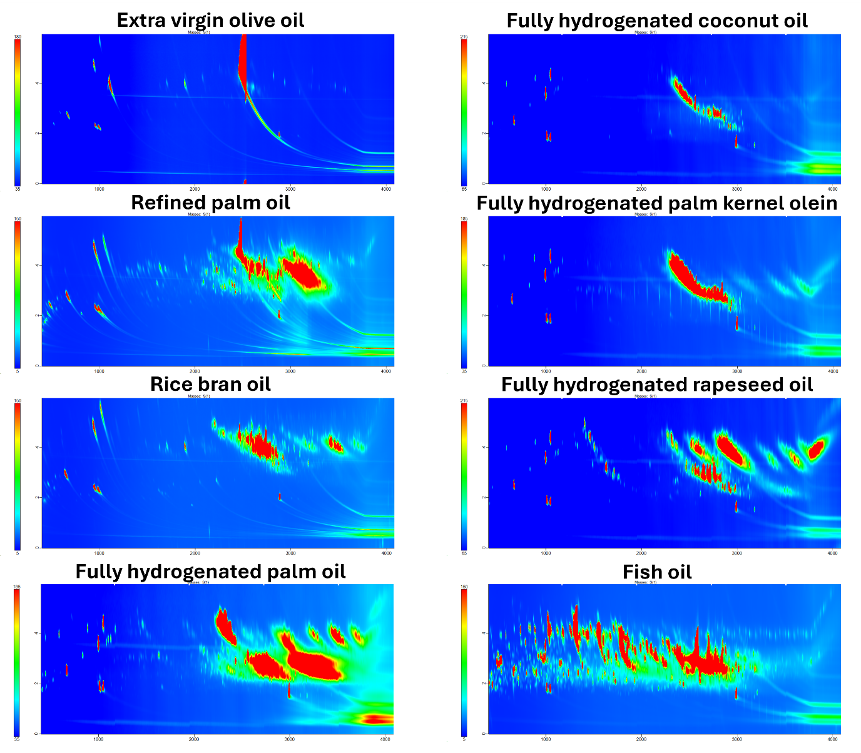
Figure 4 – HPLC/GC×GC-FID chromatograms of the MOAH fraction of different fats and oils. As visible, most of the oils are rich in biogenic interferences. GC×GC column configuration: mid-polar × non-polar.

Although the present study focused on MOAH ISs ratios, it is relevant to consider whether deviations in these ratios (e.g., TBB/2MN > 1.00) reflect a selective loss of 2MN, or a general loss of both compounds with disproportionate recovery. While this specific aspect was not directly investigated, data from other (unpublished) studies suggest two general trends: (1) the organic phase is sometimes incompletely recovered due to partial retention within the soap phase, reducing overall recovery for both MOSH and MOAH; and (2) in samples with elevated TBB/2MN ratios, absolute signal intensities for MOAH ISs were markedly lower than those of MOSH standards. For example, in a sample with a TBB/2MN ratio of 1.14 and a (Per/2MN)/2 ratio of 1.03, the peak area of TBB was approximately 30% lower than that of CyCy, the quantification standard for MOSH. These observations suggest that MOAH recovery is more adversely affected by matrix effects than MOSH, likely due to stronger interactions with or entrapment in the soap phase.

Correlation of MOAH ISs ratios with FAMEs profile
The observed dependence of the TBB/2MN and (Per/2MN)/2 ratios on the type of fat or oil suggested an influence of the matrix composition on the recovery of MOAH ISs. As triacylglycerols are the primary constituents of fats and oils, it was hypothesized that their fatty acid (FA) composition could modulate the physical properties of the soap formed during saponification [14] and, in turn, affect the partitioning behavior of aromatic ISs.
To investigate this, the FAME profiles of the tested oils were determined. Figure 5 (raw data available in ‘FIG 4 - FAMES’ of the Supplementary Material) shows the FAMEs profile of the various oils along with the corresponding MOAH ISs ratios. A first qualitative assessment identified four compositional groups (A–D), which helped highlight initial trends related to chain length and unsaturation.

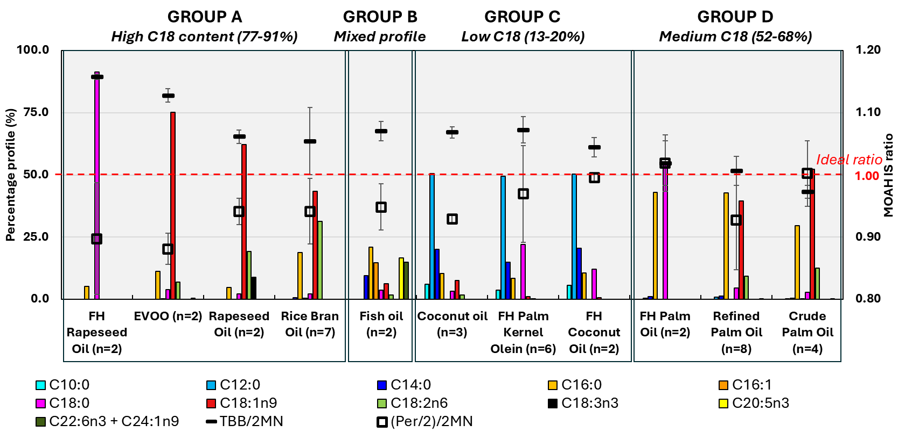
Figure 5 – FAME profile of different edible fats and oils (n = 2) and the obtained (average) MOAH ISs ratios after MASE at 120°C for 20 min (replicates indicated in the x axis). Letters A-D refer to compositional groups. The error bars represent the standard deviation of the IS ratios.

Group A included oils rich in long-chain FAs (C18), but differing in saturation. FH rapeseed oil, dominated by saturated C18:0, formed a solid soap layer at the water-hexane interface at room temperature. It also showed high TBB/2MN ratios, suggesting a lower recovery of 2MN (more polar) compared to TBB (very apolar), in agreement with the work of Menegoz Ursol et al. [12]. In contrast, EVOO, rich in unsaturated C18:1, did not form a solid soap layer in these conditions and showed a slightly decreased TBB/2MN ratio.
Group B only consisted of fish oil, as it has a very different profile from vegetable fats and oils. It is characterized by a complex profile, including long-chain polyunsaturated FA and medium-chain FA (both saturated and unsaturated), and shows lower TBB/2MN and higher (Per/2)/2MN ratios compared to group A.
Group C comprised oils rich in medium-chain FA (C10–C14), such as coconut oil, hydrogenated coconut oil, and hydrogenated palm kernel olein.[15] They all gave MOAH ISs ratios closer to 1.00 compared to group A, and similar to group B (fish oil). Noteworthy, FH coconut oil gave much better ISs ratios than non-hydrogenated coconut, suggesting an effect of unsaturated FAs.
Group D included oils with mixed C16 and C18 profiles. These exhibited the most balanced ISs ratios, closest to 1.00.
To more systematically assess the impact of FA composition, oils were regrouped according to total C18 FA content, excluding fish oil due to its distinct profile. Figure 6 shows the distribution of stearic, oleic, linoleic, and linolenic acids across three categories – high, medium, and low C18 content – and their relation to MOAH ISs recovery.
Figure 6 – Classification of oils based on total C18 fatty acid content (sum of C18:0, C18:1n9, C18:2n6, and C18:3n3): average FAME profile within each group, individual C18 fatty acid distribution per oil, and corresponding MOAH internal standard (IS) ratios. The optimal IS ratio is indicated in red.

Starting from the group of oils with high C18 content, a clear trend emerges in the TBB/2MN ratio as the level of unsaturation increases. FH rapeseed oil exhibits the highest ratio, indicating significantly lower recovery of 2MN compared to TBB. This ratio progressively decreases with increasing unsaturation, particularly with the introduction of polyunsaturated FAs such as linolenic acid (abundant in rice bran oil). Regarding the recovery of Per, it improves proportionally to 2MN (as (Per/2)/2MN remains constant), but it is still very slightly discriminated compared to 2MN. Generally, the increase in unsaturation seemed to improve the absolute recovery of more polar analytes, but kept a discrimination that was a function of the polarity.
In the 'medium C18' group, where approximately 30% of the C18 fraction is replaced by palmitic acid (C16:0) compared to the 'high C18' group, the best TBB/2MN ratios are observed, averaging values around 1.00. The presence of shorter-chain FAs in the soap matrix appears to be highly beneficial. In contrast, variations in the degree of unsaturation within this group have only a minor impact on the ratio. Although a slightly higher C18 unsaturation seems to slightly improve the TBB/2MN ratio, the changes in absolute quantities are likely too small – compared to those in the 'high C18' group – to observe a clear effect. Regarding Per, it appears to be slightly less discriminated than 2MN in this group, though the visible variability makes interpretation less straightforward.
In the 'low C18' group, composed of one non-hydrogenated (coconut) and two hydrogenated oils (coconut and palm kernel olein), a contrasting behavior was observed. The non-hydrogenated oil showed a markedly elevated TBB/2MN ratio and clear discrimination against more polar compounds, as indicated by a low (Per/2)/2MN ratio. In contrast, both ratios were closer to 1.00 in the hydrogenated samples. The main difference lies in the degree of unsaturation, which was higher in the non-hydrogenated oil. Unlike the 'high C18' group – where increased saturation was associated with stronger discrimination – here, increased saturation reduced discrimination. As a result, the predominant factor affecting analyte recovery appeared to be the presence of double bonds, likely facilitating π–π interactions, which preferentially affected more aromatic compounds such as 2MN and Per.
All in all, both chain length and degree of unsaturation influence soap properties and, consequently, analyte recovery. Saturated long-chain soaps tended to lead to higher discrepancies in compounds’ recoveries, whereas short-chain and unsaturated FAs minimized partitioning bias. However, unsaturation can also introduce specific interactions (e.g., π–π) with aromatic analytes, which may further modulate recovery.

Conclusion
This study aimed to reoptimize the microwave-assisted saponification/liquid–liquid extraction procedure previously developed for the analysis of MOSH/MOAH in fats and oils to ensure a broader applicability. While the original method, operating at 60 °C for 30 minutes, was designed to minimize discrepancies between MOAH ISs recoveries, it proved insufficient for complete saponification of certain matrices, such as fully hydrogenated rapeseed oil.
To address this, the influence of temperature and time was systematically evaluated. Temperature had the stronger effect, with optimal conditions set at 120 °C for 20 min. Although stronger than required for most matrices, these conditions ensured complete saponification across all tested samples without significantly affecting the TBB/2MN and (Per/2)/2MN ratios.
Compared to the ISO method, the optimized protocol consistently reduced discrepancies in MOAH IS ratios, although a slight matrix-dependent effect was observed. FAME profiling further revealed that fatty acid chain length, degree of unsaturation, and profile distribution influence soap properties, which in turn affect MOAH IS partitioning. However, this slight matrix effect does not compromise the method's applicability.
In light of these findings, several critical challenges for automation are evident. Differences in emulsion behavior, soap phase formation, and phase separation dynamics across fat and oil types directly impact extraction reproducibility. Fixed solvent handling and predefined aspiration depths, as often used in standard automated setups, may not be suitable when emulsions are thick or when a soap layer forms at the phase interface. Without matrix-specific programming or real-time interface detection, automated systems may yield biased results or reduced recoveries. Therefore, caution is advised when applying automation to matrices whose behavior during saponification has not been characterized.

Author contributions
Aleksandra Gorska: Writing – original draft, Conceptualization, Visualization, Validation, Software, Methodology, Investigation, Formal analysis, Data curation. Donatella Ferrara: Investigation, Formal analysis, Writing – review & editing. Paula Albendea: Methodology, Writing – review & editing. Chiara E. Cordero: Writing – review & editing, Supervision. Giorgia Purcaro: Conceptualization, Methodology, Validation, Writing – review & editing, Supervision, Resources, Project administration, Investigation, Funding acquisition.
Conflicts of interest
The authors report there are no competing interests to declare.
Data availability
The datasets generated and/or analyzed during the current study are available from the corresponding author on reasonable request.
Acknowledgments
This work is supported by Fonds de la Recherche Scientifique Belgique (FNRS) PDR projects-ToxAnaMOH T.0187.23. The authors thank LECO, Restek, Milestone, and Shimadzu for their support. This article is based upon work from the Sample Preparation Study Group and Network, supported by the Division of Analytical Chemistry of the European Chemical Society. This work is supported by ACESSS (Academic Center of Excellence for Separation Science and Sensing).

References
[1] Bauwens G, Gorska A, Purcaro G. The role of comprehensive two-dimensional gas chromatography in mineral oil determination. Anal Bioanal Chem 2023;415:5067–82. https://doi.org/10.1007/s00216-023-04718-3.
[2] Sdrigotti N, Collard M, Purcaro G. Evolution of hyphenated techniques for mineral oil analysis in food. J Sep Sci 2021;44:464–82. https://doi.org/doi.org/10.1002/jssc.202000901.
[3] ISO. ISO 20122:2024. Vegetable oils - Determination of mineral oil saturated hydrocarbons (MOSH) and mineral oil aromatic hydrocarbons (MOAH) with online-coupled high performance liquid chromatography-gas chromatography-flame ionization detection (HPLC-GC-FID) analysis - Method for low limit of quantification 2024.
[4] Bratinova S, Robouch P, Beldi G, Senaldi C, Karasek L, Oliveira GC, et al. Determination of MOAH in infant formula 2023. https://doi.org/10.2760/606967.
[5] Bauwens G, Purcaro G. Improved microwave-assisted saponification to reduce the variability of MOAH determination in edible oils. Anal Chim Acta 2024;1312:342788. https://doi.org/10.1016/J.ACA.2024.342788.
[6] Cerqueira UMFM, Bezerra MA, Ferreira SLC, de Jesus Araújo R, da Silva BN, Novaes CG. Doehlert design in the optimization of procedures aiming food analysis – A review. Food Chem 2021;364:130429. https://doi.org/10.1016/J.FOODCHEM.2021.130429.
[7] Gorska A, Bauwens G, Beccaria M, Purcaro G. Purification of mineral oil aromatic hydrocarbons and separation based on the number of aromatic rings using a liquid chromatography silica column. An alternative to epoxidation. J Chromatogr A 2025;1743:465684. https://doi.org/10.1016/J.CHROMA.2025.465684.
[8] Bauwens G, Barp L, Purcaro G. Validation of the liquid chromatography-comprehensive multidimensional gas chromatography-time-of-flight mass spectrometer/flame ionization detector platform for mineral oil analysis exploiting interlaboratory comparison data. Green Analytical Chemistry 2023;4:100047. https://doi.org/10.1016/J.GREEAC.2022.100047.
[9] Bauwens G, Pantó S, Purcaro G. Mineral oil saturated and aromatic hydrocarbons quantification: Mono- and two-dimensional approaches. J Chromatogr A 2021;1643:462044. https://doi.org/10.1016/J.CHROMA.2021.462044.
[10] Bratinova S, Robouch P, Hoekestra E. Guidance on sampling, analysis and data reporting for the monitoring of mineral oil hydrocarbons in food and food contact materials - 2nd Edition. JRC Technical Reports 2023. https://doi.org/10.2760/963728.
[11] Fontanel D. Unsaponifiable Matter in Plant Seed Oils. Berlin, Heidelberg: Springer Berlin Heidelberg; 2013. https://doi.org/10.1007/978-3-642-35710-7.
[12] Menegoz Ursol L, Conchione C, Srbinovska A, Moret S. Optimization and validation of microwave assisted saponification (MAS) followed by epoxidation for high-sensitivity determination of mineral oil aromatic hydrocarbons (MOAH) in extra virgin olive oil. Food Chem 2022;370:130966. https://doi.org/10.1016/J.FOODCHEM.2021.130966.
[13] Albendea P, Purcaro G. Study on the content and profile of MOSH and MOAH in unprocessed meat by LC/GC × GC-FID/MS. Food Chem 2025;480:143880. https://doi.org/10.1016/J.FOODCHEM.2025.143880.
[14] Hill M, Moaddel T. Soap Structure and Phase Behavior. Soap Manufacturing Technology: Second Edition 2016:35–54. https://doi.org/10.1016/B978-1-63067-065-8.50002-5.
[15] Fameau AL, Ventureira J, Novales B, Douliez JP. Foaming and emulsifying properties of fatty acids neutralized by tetrabutylammonium hydroxide. Colloids Surf A Physicochem Eng Asp 2012;403:87–95. https://doi.org/10.1016/J.COLSURFA.2012.03.059.

