Simulating SRSLY: Sensitivity Resolved SubvoxeL sepctroscopY
Mikhail Zubkov¹
¹Sleep and Health Lab, GIGA-CRC Human Imaging Unit, University of Liège, Liège, Belgium

Synopsis
Magnetic resonance spectroscopy employs localization in an approximately rectangular voxel, which commonly includes contributions from various tissues due to non-rectangular in-vivo tissues geometry. The suggested technique aims to resolve spectral contribution from different spatially distinct regions based on multichannel data, smilar to the imaging Sensitivity Encoding technique. Simulations are performed using spectral data acquired on a phantom and multichannel coil sensitivity profiles. Simulations show feasibility of the suggested spectral separation technique and demonstrate limitations related to chemical shift displacement. Real data does not yet show full spectral separation of the components.

Impact
The suggested technique can help improve existing MRS techniques by removing CSF signal from within a voxel, allowing arbitrary-shaped voxels, or ultimately by performing localized MRS-imaging via parcellation of the voxel into a limited number of smaller subvoxels.

Introduction
Magnetic resonance spectroscopy (MRS) localization methods commonly rely on combination of three or more excitation or refocusing radiofrequency (RF) pulses (e.g., Point-REsolved Spectroscopy (PRESS)¹, STimulated Echo Acquisition Mode (STEAM)², Localization by Adiabatic SElective Refocusing (LASER)³ etc.) with gradents in three orthogonal directions. This allows selection of an approximately rectangular voxel the resulting spectrum originates from. Biological tissues on the other hand are not localized within a rectangular volume, leading to several tissues being included into every voxel. This, in turn, leads to contamination of the acquired spectrum with tissue and metabolite peaks from outside the target brain region. Another source of cross-contamination of the acquired spectra in MRS is the chemical shift displacement⁴.
This contamination manifests as superposition of magnetic resonance (MR) signals originating from two or more spatial locations at each spectral frequency. The problem of untangling the signals occurring at the same frequency, but originating from different spatial locations, has been successfully solved in parallel MR-imaging via SENSitivity Encoding (SENSE) method⁵ and in multiband excitation⁶ via the use of data, acquired through independent coil elements and reception channels.
Here, the possibility of applying SENSE-like spectrum recovery to MRS data is explored with the aim of using multi-channel MRS data in conjunction with individual coil elements sensitivity profiles to extract data on subvoxel level, thus attempting Sensitivity Resolved SubvoxeL spectroscopy (SRSLY).

Methods
To test the possibility of subvoxel spectral resolution, sensitivity profiles and individual substance spectra were acquired on the 7T (Terra, Siemens Healthineers, Erlangen, Germany) scanner with the 32-Rx-1Tx Nova RF coil (supplied via Siemens Healthineers, Erlangen, Germany). To obtain the sensitivity profiles, a 3D-Gradient-Recalled Echo (GRE) sequence was used with a field of view of 200×200×176 mm³, and a corresponding acquisition matrix to obtain an isotropic resolution of 1mm. No parallel techniques were used. Echo (TE) and rerpetition (TR) times were set to 2.6 ms and 6 ms correspondingly. Flip angle of 10° was used. Next, three single-voxel spectra were acquired with the PRESS sequence with TE of 21 ms, TR of 3000 ms, 8192 points acquired at 6 kHz bandwidth. One voxel covered the volume of 20×20×20 mm³, while the other two were located within the first one, separated by 3 mm and encompassing the volume of 20×8×20 mm³ each. No water suppression and outer volume suppression was employed.
The voxels were used to obtain the spectra in a home-made phantom with two distinctive sections: one containing vegetable oil, the other containing water-ethanol mixture. The zero-frequency voxel are shown in Figure 1.
The acquired imaging data was used to calculate the coil elements sensitivity profiles with the adaptive coil combination algorithm⁷. For demonstration purposes, only magnitude sensitivity and spectral data was considered.
Next, a processing pipeline was implemented in MATLAB, comprising the steps demonstrated in Figure 2.
Three types of data processing were attempted: simulation of cross-contamination and spectra separation by using only data from individual smaller voxels and real values of chemical shift displacement, similar simulation but with reduced chemical shift displacement values, attempting spectral separation by using data from larger voxel, containing both phantom components.

Results
Simulation of the individual spectral separation with data only from two single-substance voxels and real chemical shift displacement has demonstrated chemical shift displacement-realted cross contamination existing in individual voxels. Contaminated spectrum was separated for one of the voxels, while non-contaminated spectrum was separated for the second voxel (Figure 3 A).
Simulation of the individual spectral separation with reduced chemical shift displacement has demonstrated clean individual spectra existing in individual voxels, which were successfully resolved by SRSLY method (Figure 3, B).
Separation of individual spectra from real data, originating form the voxel, encompassing both substances in the phantom showed results with partial contamination of individual spectra by spectral components from a different substance (Figure 3, C).

Discussion
The simulations have demonstrated the functionality of the SRSLY technique and numerical feasibility of the subvoxel spectral separation from multichannel data. Simulations have demonstrated the downsides of using sensitivity-based resolution of individual spectra: as combined spectra were acquired using larger voxel size (as compared to individual per-substance spectra), the chemical shift displacement was larger for combined spectra, thus producing cross-contamination even in the smaller subvoxels. This was demonstrated in simulation, and can potentially explain the inability of spectral separation in real data under current acquisition conditions.

Conclusion
Feasibility of recovering subvoxel spectra from multichannel MRS data with Sensitivity Resolved SubvoxeL sepctroscopY (SRSLY) technique has been demonstrated numerically. Further inverstigation is required to assess applicability of the technique to real spectra.

References
1. Zhong K, Ernst T. Localized in vivo human¹ H MRS at very short echo times. Magnetic Resonance in Med. 2004;52(4):898-901. doi:10.1002/mrm.20201
2. Frahm J, Bruhn H, Gyngell ML, Merboldt KD, Hänicke W, Sauter R. Localized high‐resolution proton NMR spectroscopy using stimulated echoes: Initial applications to human brain in vivo. Magnetic Resonance in Med. 1989;9(1):79-93. doi:10.1002/mrm.1910090110
3. Garwood M, DelaBarre L. The Return of the Frequency Sweep: Designing Adiabatic Pulses for Contemporary NMR. Journal of Magnetic Resonance. 2001;153(2):155-177. doi:10.1006/jmre.2001.2340
4. Kreis R. Issues of spectral quality in clinical¹ H‐magnetic resonance spectroscopy and a gallery of artifacts. NMR in Biomedicine. 2004;17(6):361-381. doi:10.1002/nbm.891
5. Pruessmann KP, Weiger M, Scheidegger MB, Boesiger P. SENSE: Sensitivity encoding for fast MRI. Magn Reson Med. 1999;42(5):952-962. doi:10.1002/(SICI)1522-2594(199911)42:5%3C952::AID-MRM16%3E3.0.CO;2-S
6. Larkman DJ, Hajnal JV, Herlihy AH, Coutts GA, Young IR, Ehnholm G. Use of multicoil arrays for separation of signal from multiple slices simultaneously excited. J Magn Reson Imaging. 2001;13(2):313-317. doi:10.1002/1522-2586(200102)13:2%3C313::AID-JMRI1045%3E3.0.CO;2-W
7. Walsh DO, Gmitro AF, Marcellin MW. Adaptive reconstruction of phased array MR imagery. Magn Reson Med. 2000;43(5):682-690. doi:10.1002/(SICI)1522-2594(200005)43:5%3C682::AID-MRM10%3E3.0.CO;2-G

Figures
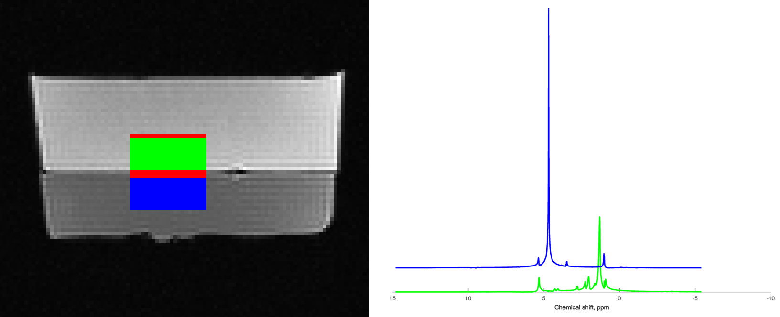
Figure 1. Individual voxel positioning and individual substance spectra. Top voxel (green) is positioned within the vegetable oil region and its spectrum contains multiple peaks from 1.0 to 5.4 ppm. Botttom voxel (blue) is positioned within the water-ethanol mixture, and its spectrum contains 4 peaks at 1.0, 3.5, 6.7, and 5.4 ppm.
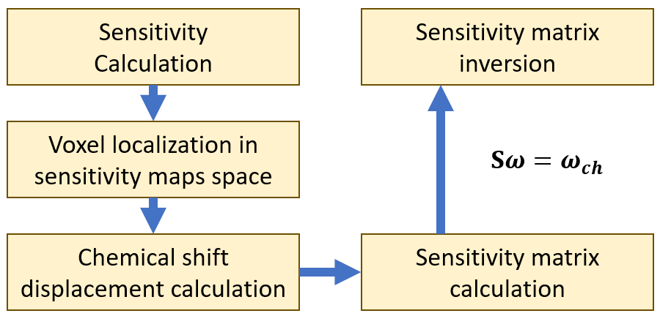
Figure 2. Processing pipeline comprises: Sensitivity estimation, MRS voxel coordinates localization in the coordinate space of sensitivity mapping; chemical shift displacement calculation per unit frequency; per-voxel sensitivity calculation for each channel; building and inverting the sensitivity matrix (S). According to the SENSE theory, the matrix inversion should then have provided individual voxel spectra (ω) without cross-contamination based on the multichannel mixed spectral data (ω_{ch}).

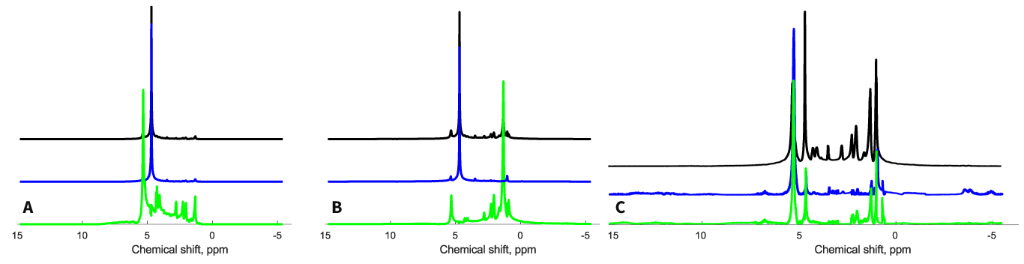
Figure 3. Spectral separation. Top spectrum shows combined spectral data, middle (blue) and bottom (green) spectra shows resolved data from subvoxels. A. Results in the simulation with realistic chemical shift displacement. Middle spectrum show cross-contamination in the 2 ppm region. B. Results of simulation with reduced displacement. No cross-contamination present. C. Results of spectral resolution on real data demonstrate cross-contamination in both subvoxels. Minor separation of lipid peaks present.

