
PSYCHOLOGY,
HEALTH
&
MEDICINE
https://doi.org/10.1080/13548506.2025.2569098

Post-intensive care syndrome perception: a look through the caregivers’ prism
Anne-Françoise Rousseau^{a,b}, Pauline Minguetª, Camille Colsonª, Sarah Neis-Gilsonª, Bernard Lambermontª and Aurélie Wagener^{b,c}
ªDepartment of Intensive Care, University Hospital of Liège, Liège, Belgium; ^{b}Research Unit for a Life-Course Perspective on Health & Education (RUCHE), University of Liège, Liège, Belgium; ^{c}Health Psychology,
Department of Psychology, Faculty of Psychology and Science of Education, University of Liege, Liège, Belgium
ABSTRACT
The critical illness, the stay in intensive care unit (ICU) and the post- intensive care syndrome (PICS) impact the patients and their caregivers. The aim of this observational study was to compare their respective perceptions of major post-ICU troubles. Patients who survived a prolonged ICU stay were routinely invited to a standardized post-ICU follow-up program including several visits scheduled during the year after ICU discharge. Patients were invited to a face-to-face interview, accompanied by a caregiver if needed. Using the same 10-item questionnaire, patients reported their perception of their current health status while caregivers reported how they perceived the patient’s current health status. A total score ranging from 0 to 100 expressed the perceived global health status. Caregivers’ anxiety was assessed using the anxiety subscale of the Hospital Anxiety and Depression Scale (HADS-A). From October 2022 to December 2024, a total of 105 follow-up consultations were conducted 105 days (IQR 85–211) after ICU discharge, during which patients were accompanied by a caregiver, and both completed the questionnaires. They represented 97 different pairs. The caregivers were mostly partners (70/97, 72.2%), living in the same home (81/97, 83.5%). The total score differed between patients and relatives (p = 0.003), respectively reaching 24 (12–40) and 25 (14–50). On average, the score was 5.3 ± 16.4 points lower when reported by caregivers. Items of the questionnaire were scored similarly in 23.8–45.8% of the cases. The scores obtained at the end of the consultation (59/105) were similar (p = 0.062), unlike those obtained at the beginning (46/105) (p = 0.029). The caregivers’ HADS-A did not correlate with the total scores differences but correlated with the patients total score (r_{s} = 0.29, p = 0.004). This study highlights that the perception of post-ICU troubles differed between ICU survivors and their caregivers. The impact of this different perception on PICS or PICS-family severity or management should be further studied.
ARTICLE HISTORY
Received 5 February 2025
Accepted 26 September 2025
KEYWORDS
Post-intensive care syndrome; survivors;
relatives; follow-up; perception
CONTACT Anne-Françoise Rousseau afrousseau@chuliege.be Department of Intensive Care, University Hospital of Liège, Sart-Tilman B35 Avenue de l’Hopital, 1, Liège, B-4000, Belgium
© 2025 Informa UK Limited, trading as Taylor & Francis Group

Introduction
The combination of complaints and alterations reported by the patients who survive a critical illness and a stay in an intensive care unit (ICU) has been defined as post- intensive care syndrome (PICS) (Rousseau et al., 2021). It typically includes physical (muscle weakness, denutrition, metabolic disorders, sleep disorders, fatigue, chronic pain, vulnerability), psychological (anxiety, depression, post-traumatic stress disorders) and cognitive impairments that appear or are worsened after this acute event (Herridge & Azoulay, 2023). PICS may subsequently result in reduced quality of life, increased health-related costs and a delayed return to previous professional or leisure activities (Su et al., 2025). However, there might be a discrepancy between measured health and perceived health among a significant proportion of survivors (Porter et al., 2025).
PICS does not only affect the patient but may also alter the mental health, the social status, and the financial position of patients’ family members or caregivers. The combination of these problems is known as PICS-family (Davidson et al., 2012). PICS-family affects about 20–40% of the caregivers, mainly family members (Shirasaki et al., 2024). Survivorship leads to emotionally challenging situations in both camps, intensified by the fact that patients and their relatives typically experience the critical illness, the ICU stay, and the recovery challenges differently. This potentially impacts the family functioning.
In many countries, formal follow-up of informal caregivers is not a routine part of intensive care service delivery. General practitioners often lack the knowledge and resources to improve care for ICU survivors’ relatives (Naaktgeboren et al., 2022). Ensuring relatives have access to the support and resources they need is thus essential. Up to now, there is little evidence regarding specific post-ICU interventions for PICS- family management, and subsequently no guidelines have been edited. In a pilot study, running health-promoting conversations with relatives of ICU survivors had beneficial effects on family wellbeing (Agren et al., 2019). The post-ICU follow-up clinics that are growing increasingly worldwide, seem to be a perfect place for the relatives to tell their own stories and listen to the patient’s experience, to discuss their troubles and to receive guidance on how to manage PICS-family.
To the best of our knowledge, the simultaneous perception of PICS by the patients on one hand, and by their caregivers on another hand, has never been studied. Consequently, the aims of the present observational study were (1) to compare the patients and their relatives’ perceptions of major post-ICU troubles, and (2) to assess the influence of PICS-family on these perceptions.

Methods

Participants - data sources
The study was conducted in a 7-unit adult intensive care department located in a university hospital. The 58-bed department includes 6 mixed medical and surgical units and a unit dedicated to critical burn care, admitting approximately 2,500 patients per year for all types of critical illness except lung transplantation. About one third of admissions originate from the emergency department and one quarter from the cardiovascular operating room.
Adults surviving an ICU stay ≥7 days are routinely invited to our post- intensive care follow-up clinic, at 1-, 3-, 6- and 12-months following ICU discharge. This follow-up is standardized and addresses the different components of PICS. Patients do not enter the post-ICU trajectory of our follow-up clinic if they are unable to communicate in French, the local language, if they have been transferred to another hospital, if we are unable to give them information about the post-ICU follow-up clinic. The follow-up takes place in a face-to-face consultation or via a teleconsultation, according to their preferences and their capabilities to come to the hospital. The follow-up consultations are generally cancelled if patients are still hospitalized in an acute care facility or in an inpatient rehabilitation facility, or if they refuse it.
In the face-to-face format, patients are invited to be accompanied by their closest caregiver. For 3 years now, the PICS-family has been routinely screened, using validated questionnaires addressing psychological distress. The caregiver is also asked to describe his/her perception of the patient’s evolution and clinical problems.
This observational study was conducted according to the guidelines of the Declaration of Helsinki (1964) and its later amendments. In accordance with Belgian law, informed consent was not required because the study did not modify patients’ management, and the data were anonymously collected. This interpretation was confirmed by the Ethics Committee of the University Hospital of Liege (local reference 2020/424, 2 February 2021).

Clinical variables
Patients reported their perception of their current health status while relatives reported how they perceived the patient’s current health status, using the same questionnaire (Table 1). They answered this questionnaire either at the beginning or at the end of the consultation, depending on the progress of the consultation. The questionnaire explored the perceived experience of post-ICU sequelae, namely the subjective feeling of fatigue, depression, anxiety, demotivation, bad mood, concentration or memory difficulties, sleep disorder, loss of appetite, and dependency. The five first items are related to subjective disorders, while the five last items are related to disorders that can be objectified by a third party. For each item, both patients and caregivers were asked to score, respectively, how they felt or how they think their patient felt, on a numeric scale (0: no disorder at all, 10: disorder perceived as extreme).

Table 1. Questionnaires exploring post-ICU disorders.
PICS perception
 |  | By the patient | By the accompanying loved one
 |  | “I . . . | “It seems to me that he/she . . .
Subjective items | Q1 | . . . feel tired | . . . feels tired
 | Q2 | . . . feel depressed | . . . feels depressed
 | Q3 | . . . feel anxious | . . . feels anxious
 | Q4 | . . . feel demotivated | . . . feels demotivated
 | Q5 | . . . feel in a bad mood | . . . feels in a bad mood
Objective items | Q6 | . . . have difficulty concentrating | . . . has difficulty concentrating
 | Q7 | . . . have memory trouble | . . . has memory trouble
 | Q8 | . . . have sleep disorder | . . . has sleep disorder
 | Q9 | . . . have a loss of appetite | . . . has a loss of appetite
 | Q10 | . . . feel dependent on others | . . . feels dependent on others

The global health status was then expressed as a total score ranging from 0 to 100, obtained by the addition of the 10 items. The difference between patient’s perception and caregiver’s perception was calculated: a negative difference showed that the caregiver over-estimated the troubles compared to the patient, while a positive difference showed that caregiver under-estimated the troubles perceived by the patient.
The accompanying person completed the Hospital Anxiety and Depression scale (HADS) and the Impact of Event Scale – Revised (IES-R) (Weiss & Marmar, 1997; Zigmond & Snaith, 1983). The HADS consists of two 7-item subscales evaluating symptoms of depression (seven items – HADS-D subscale) and symptoms of anxiety (seven items – HADS-A subscale) (Zigmond & Snaith, 1983). The standard cutoff threshold value of >7 out of 21 on either subscale was used to define an intermediate status (scores from 8 to 10) or clinically significant status (scores from 11 to 21) of depression or anxiety, respectively. The IES-R is a 22-item tool that detects symptoms indicating a post-traumatic stress disorder (PTSD) (Weiss & Marmar, 1997). It measures the severity of the three categories of PTSD symptoms: avoidance, intrusion and hyperarousal symptoms. A cutoff score ≥33 out of 88 was adopted to indicate severe psychological impact of the traumatic event.
Patients’ demographics and data related to the ICU stay were collected from the medical charts.

Sample size calculation
In the absence of relevant or similar results in the published literature, we based the sample size calculation on an interim analysis. We estimated that 57 patients were needed to demonstrate a difference of 1.1 point between patient’s perception and the relative’s perception in a given item of the questionnaire, at a significance level of 0.05 and a power of 80%.

Statistical analysis
Statistical analysis was performed using Graphpad Prism (version 10.4.0. for Mac OSX, Graphpad Inc., San Diego, CA, U.S.A.). Qualitative parameters were expressed as counts and percentages. Normality of quantitative parameters was assessed using the Shapiro– Wilk test. As quantitative parameters were not normally distributed, results were expressed as median (P50) and interquartile range (P25-P75). Some results were also expressed as mean and standard deviation, for clarity. Missing values were not replaced. Comparisons of paired data between patients and their caregivers (e.g. total scores and item-specific scores) were performed using the Wilcoxon signed-rank test. Comparisons between independent groups (e.g. patients whose caregivers under- vs over-estimated sequelae, or differences in patient – caregiver perceptions according to the time elapsed since ICU discharge) were made using the Mann–Whitney U test. Qualitative variables were expressed as counts and percentages and compared using the Chi-square test or Fisher’s exact test when appropriate. Correlations between continuous variables (e.g. caregiver anxiety scores and differences in perception) were assessed with Spearman’s rank correlation coefficient. A p value <0.05 was considered statistically significant.

Results
Between November 2022 and December 2024, 365 patients attended a face-to-face consultation at our post-ICU follow-up clinic. From them, 105 were accompanied by a family member or an informal caregiver: 105 questionnaires about PICS perception were thus analyzed. Eight patients and their relatives attended two consultations during the investigation period. The characteristics of the 97 patients and the 97 caregivers are described in Table 2.
The consultations took place 105 (85–211) days after ICU discharge. The results of the questionnaires exploring the post-ICU sequelae are detailed in Table 3. The total score significantly differed between patients and their caregivers, reaching respectively 24 (12–40) and 25 (14–50) (p = 0.003). Only 5/105 (4.8%) pairs rated all items similarly.

Table 2. Patients and relatives characteristics.
Characteristic |  | n = 97
PATIENTS Age, years |  | 64 (53.5–71.5)
Sex (female), n (%) |  | 28 (28.6)
SOFA at admission |  | 5.5 (3–8)
Primary failure, n (%) | Cardiovascular | 39 (40.2)
 | Pulmonary | 16 (16.5)
 | Neurologic | 13 (13.4)
 | Digestive and hepatic | 13 (13.4)
 | Other | 16 (16.5)
Organ supports on the audit day, n (%) | Invasive mechanical ventilation > 24 h | 58 (59.8)
 | Extracorporeal membrane oxygenation | 3 (2.9)
ICU length of stay, days |  | 12 (8–22)
Discharged at home from hospital, n (%) |  | 83 (85.6)
RELATIVES  Relationship with the patient, n (%) | Partner | 70 (72.2)
 | Child | 13 (13.4)
 | Parent | 11 (11.3)
 | Sibling | 2 (2.1)
 | Friend | 1 (1)
Living in the same house than the patient, n (%) |  | 81 (83,5)
Data are expressed as n (%) or median (P25-P75). SOFA: Sepsis-related Organ Failure Assessment.
Table 3. Post-ICU disorders perceived by patients and their caregivers.
Questions | n | Caregiver’s perception | Patient’s perception | Median difference patient – caregiver | Mean difference patient – caregiver |  | p value
Q1 | 105 | 6 (3–8) | 5 (2–7) | −1 (−2 – 0.5) | −0.7 ± | 2.3 | 0.0022
Q2 | 105 | 2 (0–6) | 1 (0–5) | 0 (−2 – 0) | −0.7 ± | 2.5 | 0.0120
Q3 | 105 | 3 (1–6.5) | 2 (0–5) | 0 (−3 – 1) | −1 ± | 2.8 | 0.0004
Q4 | 105 | 2 (0–5) | 1 (0–3) | 0 (−2 – 1) | −0.5 ± | 2.9 | 0.0580
Q5 | 105 | 1 (0–5) | 0 (0–3) | 0 (−3 – 0) | −0.9 ± | 2.8 | 0.0012
Q6 | 105 | 4 (1–5.5) | 2 (0–5) | 0 (−2 – 1) | −0.4 ± | 2.9 | 0.0856
Q7 | 105 | 3 (1.5–6) | 2 (0–5) | 0 (−2 – 1) | −0.6 ± | 3 | 0.0370
Q8 | 105 | 3 (0–6) | 3 (0–6) | 0 (−1 – 1) | −0.2 ± | 2.6 | 0.5289
Q9 | 105 | 0 (0–5) | 0 (0–3) | 0 (−1 – 0) | −0.5 ± | 2.6 | 0.0762
Q10 | 105 | 2 (0–5) | 2 (0–6) | 0 (−1 – 1) | 0.4 ± | 3.1 | 0.3082
Total | 105 | 25 (14–50) | 24 (12–40) | −3 (−14 – 5.5) | −5.3 ± | 16.4 | 0.0033
Total | 46  (beginning) | 32.5 (16.2–50) | 22.5  (11.7–41) | −7 (−18.2 – 4.5) | −7 ± | 19 | 0.0285
Total | 59 (end) | 24 (13–51) | 24 (12–39) | −3 (−13 – 6) | −4 ± | 14.2 | 0.0621
Data are expressed as median (P25-P75) or mean ± standard deviation.

A significant difference between patient and caregiver perceptions was observed mainly for subjective items (Table 3). Even though patient and the caregiver rated similarly the items in 24–45.8% of the pairs, the perception of post-ICU troubles was different in more than half of the pairs, with similar proportions of over- and under-estimations (Figure 1). In pairs in which the total score was underestimated by the caregivers (n = 62/105), the total score reported by the patients was significantly lower than in pairs in which the total score was similar or over-estimated by the caregiver (n = 38/105): 19 (7–33) vs 36 (22–55), respectively (p < 0.0001). To be partner or living in the same house did not influence how the patient and caregiver perceived the patient’s overall health (respectively p = 0.888 and p = 0.202). In addition, the time elapsed since ICU discharge did not significantly influence the difference in patient – caregiver perceptions: −3 (IQR −13 to 3) when the consultation occurred within 105 days (the median delay) versus −4.5 (IQR −16.2 to 7.5) when it occurred later (p = 0.885).
Among the 105 questionnaires, 46 were completed at the beginning of the consultation and 59 were completed at the end of the consultation. The global health status perceived by patients and by relatives was significantly different when the questionnaires were administered at the beginning of the consultation (respectively 22 (12–41) and 32 (16–50), p = 0.028). On the contrary, no difference of post-ICU trouble perception was observed between patients and relatives when the questionnaires were administered at the end of the consultation (respectively 24 (12–39) and 24 (13–51), p = 0.062).
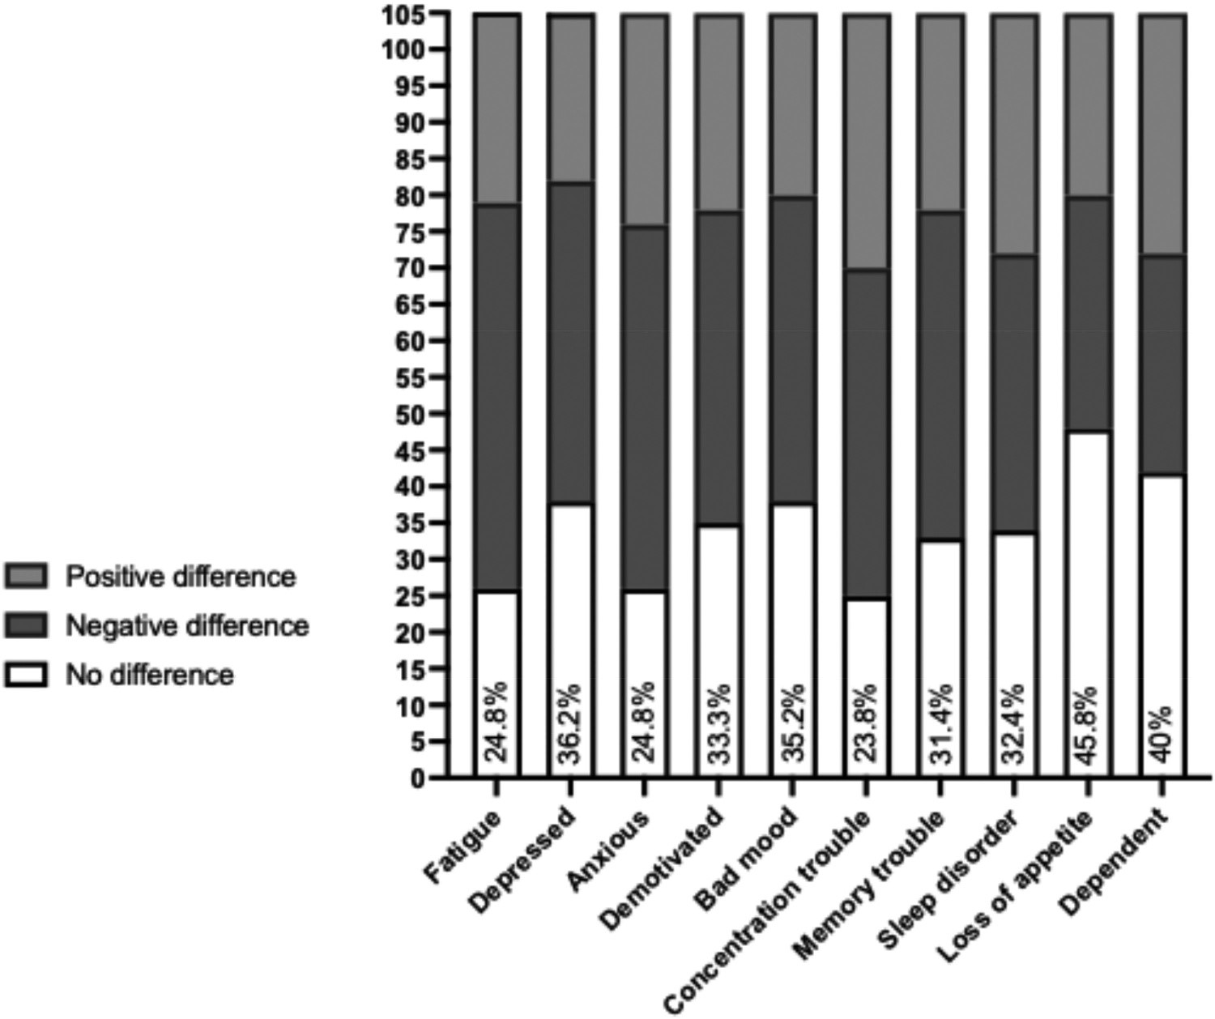
Figure 1. Counts and proportions of similar perception in relatives compared to patients for the ten explored post-ICU disorders. This figure highlights that in more than half of the pairs, caregivers’ perception of post-ICU sequelae differed from that of the patients, with both under- and over- estimation occurring in similar proportions. This illustrates that discordance is frequent and not unidirectional.

Significant troubles (rated as 5 or more on the numeric scale) were reported by 12.4– 54.3% of the patients: significant fatigue, sleep disorders and dependency were reported by at least one third of the patients (Figure 2). According to the caregiver’s perception, significant fatigue was the most reported trouble, in 68/105 (64.6%) patients, followed by concentrating difficulties and signs of depression, reported for respectively 45/105 (42.8%) and 44/105 (41.9%) patients.
The scores at the HADS-A, HADS-D and IES-R questionnaires evaluating the psychological troubles in the accompanying persons are detailed in Table 4. Signs of anxiety (HADS-A > 7) and depression (HADS-D > 7) were observed in respectively 53/100 (53%) and 17/99 (17.2%) caregivers. Signs of PTSD (IES-R ≥ 33) were reported by 20/94 (21.3%) caregivers. There was no correlation between the psychological status (namely the scores at HADS-A, HADS-D and IES-R questionnaires) of the accompanying persons and the difference of perceived global health status between patients and their caregivers (p = 0.137, p = 0.208, p = 0.500, respectively). A weak positive correlation was observed between the HADS-A of the accompanying persons and the global health status perceived by the patients (rs = 0.288, 95% confidence interval 0.092 to 0.463, p = 0.004), as well as the patients question 3 results about perceived anxiety (rs = 0.219, 95% confidence interval 0.017 to 0.403, p = 0.029).

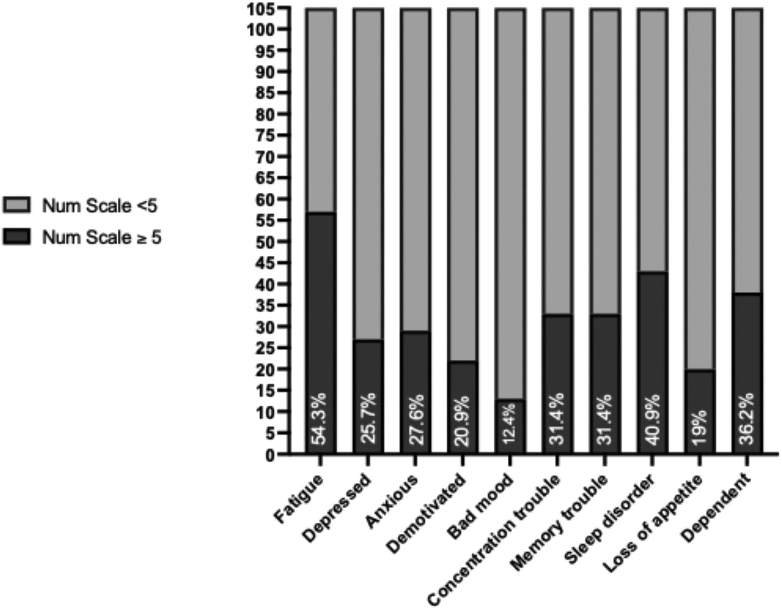
Figure 2. Counts and proportion of patients rating their post-ICU disorders at 5 or more on each of the 0–10 numeric scale. This figure highlights that the most frequently reported significant sequelae (score ≥5 on the numeric scale) were fatigue, sleep disturbances, and dependency, each present in at least one third of the patients.
Table 4. Scores at the questionnaires exploring psychological disorders in the accompanying persons.
Questionnaire | n | Score
HADS-A | 100 | 8 (4–11)
HADS-D | 99 | 3 (1–6)
IES-R | 94 | 15 (17.7 – 29.2)
Data are expressed as median (P25-P75).
HADS: Hospital Anxiety and Depression scale; IES-R: Impact of Event Scale – Revised.

Discussion
Although the burden of PICS and PICS-F has been increasingly recognized, little is known about how patients and their caregivers perceive post-ICU sequelae, and whether these perceptions align. The present study addressed this gap by comparing the perceptions of ICU survivors and their caregivers during post-ICU follow-up consultations. Our main finding is that in more than half of the studied pairs, patient and caregiver perceptions of post-ICU troubles diverged, especially for subjective symptoms such as fatigue, anxiety, or low mood. The relatively low median global scores should be interpreted with caution, as they do not necessarily indicate a limited burden of the ICU stay. These scores mask a substantial heterogeneity in both the nature of sequelae reported and in their severity across patients. This variability underlines the complexity of PICS and the importance of individualized follow-up strategies that take into account the wide spectrum of post-ICU trajectories.
The reasons for such discordance, although not specifically investigated in this study, are likely multifactorial, involving cultural, religious, social, familial, or psychological influences. In our cohort, we only demonstrated that no correlation was found between this discordance and the psychological domain of PICS-F, as assessed by the HADS and IES-R questionnaires. From a clinical standpoint, patients’ perceptions remain the most valid reflection of their own health, while caregivers inevitably provide an external perspective influenced by their own context. The purpose of our study was not to determine which perception was the ‘truth’, but rather to highlight the frequent mismatches between both perspectives. Yet, these discrepancies are not trivial. Overestimation by caregivers may lead to overprotection and loss of autonomy, whereas underestimation risks insufficient support and unmet needs for rehabilitation. Moreover, survivors may themselves fail to recognize or report certain problems, making the caregiver’s viewpoint valuable. Evidence from other populations, such as breast cancer, shows that differing illness perceptions between patients and spouses can directly influence psychological management, either positively or negatively (Li et al., 2025). To date, however, the impact of such perceptual differences on the evolution, management, and treatment of PICS remains unknown.
Post-ICU consultations thus represent a unique opportunity to confront both perspectives, raise awareness of discrepancies, and realign expectations. Our observation that patient – caregiver scores converged by the end of the consultation strongly argues for systematically involving caregivers in post-ICU follow-up. Similar to other chronic or acute conditions such as cancer or stroke (Maley et al., 2016), building a partnership between patients and caregivers may optimize recovery, reduce caregiver distress, and promote a more family-centered approach to ICU survivorship.
This study represents a first step in describing divergences between patient and caregiver perceptions after ICU. Future research should explore their trajectory over time, the factors that may influence them (e.g. predictable vs. unanticipated ICU admission, repeated ICU stays), and the interventions most likely to reduce their negative impact. Promising strategies could include structured communication tools (such as shared symptom checklists or guided joint debriefings), psychoeducational interventions for caregivers (e.g. education about PICS symptoms and coping strategies), and family-centered rehabilitation programs (e.g. resilience training or health-promoting conversations). Identifying such determinants and testing these approaches will be essential to better understand this heterogeneous experience and to design protective strategies tailored to both patients and caregivers.
The study also provides insights into the psychological burden experienced by caregivers. Anxiety was highly prevalent, affecting over half of them, while depression and PTSD symptoms were less frequent than in previous reports (van Beusekom I et al., 2016). The prevalence of PICS-family may be heterogeneous and varies depending on the timing of assessment (Smith et al., 2025). Importantly, we found a weak but significant correlation between caregiver anxiety and the severity of patient-reported disorders. This suggests that caregivers’ mental health may influence how patients experience their recovery, an effect already documented in other conditions (Liu et al., 2015; Zhao et al., 2021), but not yet studied after ICU discharge. Post-ICU clinics are probably well positioned to address this dual burden: they can offer information and support to relatives (Watland et al., 2024), acknowledge their role as informal caregivers (Op ‘t Hoog et al., 2020), and detect PICS-F symptoms at an early stage.
While our findings provide new insights into the divergent perceptions of ICU survivors and their caregivers, several limitations must be considered when interpreting these results. First, this is a single-center study; therefore, local factors may preclude its generalizability, such as the format of our post-ICU follow-up and the way the needs of relatives are addressed during the ICU stay or the transitions phases. Second, the questionnaire assessing the perception of the post-ICU disorders was firstly dedicated to clinical use and has not been validated as the perfect reflect of PICS and global health. On the contrary, the HADS and IES-R questionnaires are the most used tools to detect the psychological component of PICS (van Beusekom I et al., 2016). Third, the past medical history of the included accompanying persons and the past family functioning were not explored in the present study. They could have helped explaining the observed difference of PICS perception between patients and their relatives.

Conclusion
In the studied pairs of ICU survivors and their caregivers attending a face-to-face post-ICU consultation during the year after ICU discharge, the perception of post-ICU impairments experienced by patients differed from that of their caregivers for more than half of them, especially at the beginning of the consultation. Recognizing this difference may be important for survivors and their caregivers to manage either PICS or PICS-family: this impact deserves to be further studied. Post-ICU clinics is a key resource for families to receive information and support regarding their role of informal caregivers.

Abbreviations
HADS: Hospital Anxiety and Depression scale
ICU: intensive care unit
IES-R: Impact of Event Scale – Revised
PICS: post-intensive care syndrome
PTSD: post-traumatic stress disorder
Acknowledgments
We thank Pauline Smeets for her valuable help in data collection.

Authors’ contributions
AFR, PM, CC, SNG designed research; AFR, PM, CC, SNG conducted research; AFR analyzed data; AFR, AW wrote paper; PM, CC, SNG, BL critically reviewed paper. All authors approved the final manuscript.
Disclosure statement
No potential conflict of interest was reported by the author(s).
Funding
The author(s) reported there is no funding associated with the work featured in this article.

Availability of data and material
The datasets used and/or analyzed during the current study are available from the corresponding author on reasonable request.

Ethical approval
In accordance with Belgian law, informed consent was not required because the study did not modify patients' management and the data were anonymously collected. This was confirmed by the Ethics Committee of the University Hospital of Liege.

References
Agren, S., Eriksson, A., Fredrikson, M., Hollman-Frisman, G., & Orwelius, L. (2019). The health promoting conversations intervention for families with a critically ill relative: A pilot study. Intensive and Critical Care Nursing, 50, 103–110. https://doi.org/10.1016/j.iccn.2018.04.007
Davidson, J. E., Jones, C., & Bienvenu, O. J. (2012). Family response to critical illness: Postintensive care syndrome-family. Critical Care Medicine, 40(2), 618–624. https://doi.org/10.1097/CCM. 0b013e318236ebf9
Herridge, M. S., & Azoulay, E. (2023). Outcomes after critical illness. New England Journal of Medicine, 388(10), 913–924. https://doi.org/10.1056/NEJMra2104669
Li, M., Zhang, L., Zhang, L., Li, X., Xie, Y., Qiu, Y., Zhao, M., Chen, J., & Yan, J. (2025). The relationships among illness perceptions, dyadic coping and illness management in breast cancer patients and their spouses: A dyadic longitudinal mediation model. British Journal of Health Psychology, 30(1), 30. https://doi.org/10.1111/bjhp.12771
Liu, H. Y., Yang, C. T., Cheng, H. S., Wu, C. C., Chen, C. Y., & Shyu, Y. L. (2015). Family caregivers’ mental health is associated with postoperative recovery of elderly patients with hip fracture: A sample in Taiwan. Journal of Psychosomatic Research, 78(5), 452–458. https://doi. org/10.1016/j.jpsychores.2015.02.002
Maley, J. H., Brewster, I., Mayoral, I., Siruckova, R., Adams, S., McGraw, K. A., Piech, A. A., Detsky, M., & Mikkelsen, M. E. (2016). Resilience in survivors of critical illness in the context of the survivors’ experience and recovery. Annals of the American Thoracic Society, 13(8), 1351– 1360. https://doi.org/10.1513/AnnalsATS.201511-782OC
Naaktgeboren, R., Zegers, M., Peters, M., Akkermans, R., Peters, H., van den Boogaard, M., & van de Laar, F. A. (2022). The impact of an intensive care unit admission on the health status of relatives of intensive care survivors: A prospective cohort study in primary care. The European Journal of General Practice, 28(1), 48–55. https://doi.org/10.1080/13814788.2022.2057947
Op ‘t Hoog, S., Dautzenberg, M., Eskes, A. M., Vermeulen, H., & Vloet, L. C. M. (2020). The experiences and needs of relatives of intensive care unit patients during the transition from the intensive care unit to a general ward: A qualitative study. Australian Critical Care, 33(6), 526– 532. https://doi.org/10.1016/j.aucc.2020.01.004
Porter, L. L., Simons, K. S., Turnbull, A. E., Corsten, S., Westerhof, B., Rettig, T. C. D., Ewalds, E., Janssen, I., Jacobs, C., & van Santen, S. (2025). Discrepancy between functional outcomes and perceived health post-ICU: A prospective cohort study. Annals of the American Thoracic Society, 22(2), 255–262.
Rousseau, A. F., Prescott, H. C., Brett, S. J., Weiss, B., Azoulay, E., Creteur, J., Latronico, N., Hough, C. L., Weber-Carstens, S., Vincent, J. L., & Preiser, J. C. (2021). Long-term outcomes after critical illness: Recent insights. Critical Care, 25(1), 108. https://doi.org/10.1186/s13054- 021-03535-3
Shirasaki, K., Hifumi, T., Nakanishi, N., Nosaka, N., Miyamoto, K., Komachi, M. H., Haruna, J., Inoue, S., & Otani, N. (2024). Postintensive care syndrome family: A comprehensive review. Acute Medicine & Surgery, 11(1), e939. https://doi.org/10.1002/ams2.939
Smith, A. C., Ferguson, H. N., Russell, R. M., Savsani, P., & Wang, S. (2025). Post-intensive care syndrome family. Critical Care Clinics, 41(1), 73–88. https://doi.org/10.1016/j.ccc.2024.08.008
Su, H., Fuentes, A. L., Chen, H., Malhotra, A., Gallo, L. C., Song, Y., Moore, R. C., & Kamdar, B. B. (2025). The financial impact of post intensive care syndrome. Critical Care Clinics, 41(1), 103–
119. https://doi.org/10.1016/j.ccc.2024.08.003 van Beusekom I, Bakhshi-Raiez, F., de Keizer NF, Dongelmans, D. A., van der Schaaf M, van Beusekom, I., de Keizer, N. F., & van der Schaaf, M. (2016). Reported burden on informal caregivers of ICU survivors: A literature review. Critical Care, 20(1), 16. https://doi.org/10.1186/ s13054-016-1185-9
Watland, S., Solberg Nes, L., Ekeberg, O., Rostrup, M., Hanson, E., Ekstedt, M., Stenberg, U., Hagen, M., & Borosund, E. (2024). The caregiver pathway intervention can contribute to reduced post-intensive care syndrome among family caregivers of ICU survivors: A randomized controlled trial. Critical Care Medicine, 53(3), e555–e566. https://doi.org/10.1097/CCM. 0000000000006546
Weiss, D., & Marmar, C. (1997). The impact of event scale - revised. In J. Wilson & T. Keane (Eds.), Assessing pschycological trauma and PTSD (pp. 399–411). Guilford.
Zhao, J., Zeng, Z., Yu, J., Xu, J., Chen, P., Chen, Y., Li, J., & Ma, Y. (2021). Effect of main family caregiver’s anxiety and depression on mortality of patients with moderate-severe stroke. Scientific Reports, 11(1), 2747. https://doi.org/10.1038/s41598-021-81596-8
Zigmond, A. S., & Snaith, R. P. (1983). The hospital anxiety and depression scale. Acta Psychiatrica
Scandinavica, 67(6), 361–370. https://doi.org/10.1111/j.1600-0447.1983.tb09716.x

